COMMISSION STAFF WORKING DOCUMENT
On Defence
Accompanying the document
Communication
Towards a more competitive and efficient defence and security sector
Objective
This Staff Working Document accompanies the Communication on defence. Its objective is to provide some statistical background for EU defence industry and market and to better illustrate some of the points made in the Communication.
In particular, the Staff Working Document:
- Highlights the economic importance of the defence industry and its contribution to growth and jobs and the challenges it is facing;
- Analyses the evolution of defence spending in Europe and its consequences for the EU defence industrial base;
- Presents the challenges facing the internal market for defence;
- Describes the status and progress in consolidation in the defence industry ;
- Analyses defence industrial supply chains and the role of SMEs in the sector;
- Describes new business strategies in the defence industry in an evolving global setting.
1. Defence industry strongly contributes to growth and jobs
With a turnover of €96 billion in 2012, the European defence industry brings a major contribution to the growth of the wider economy. It provides thousands of highly skilled jobs, as it directly employs about 400,000 people. Moreover, driven by a multiplier effect of between 2.2 and 2.4, it generates up to another 960,000 indirect jobs.
The defence industry is a major industrial sector, generating innovation and centred on high-end engineering and technologies. Its cutting-edge research has created important knock-on effects in other sectors, such as electronics, space and civil aviation. Therefore, it is a sector that is essential to retain if Europe is to remain a world-leading centre for manufacturing and innovation. Many of what have become everyday technologies in use have their roots in the defence industry. Microwave technology, satellite navigation and even the internet can trace their origin back to research carried out by the defence industry.
There are also many examples of technologies invented in the civilian sector, which were subsequently nurtured in the military sector, and eventually found a mass-use in the civilian economy, such as jet engine propulsion and integrated circuits.
The defence sector has three main sub-sectors:
The aeronautics sector represents around 50% of Europe’s defence, with a turnover of €46.7 billion in 2010 (43% of this is generated from exports), and employs around 200,000 people. The sector has considerable experience of international collaborative projects, which involves the sharing of total Research and Development (R&D) costs and the pooling of production orders between partner countries. Some of these collaborative programmes have led to the formation of European companies such as MBDA and Eurocopter. The degree of collaboration reflects the high, and rising, costs of modern aerospace projects.
The sector has the capability to produce world class products in most categories of aircraft and helicopters. Europe currently builds three types of advanced fighter jets: Rafale (France), Gripen (Sweden) & EuroFighter (Germany, Italy, Spain & UK) with a number of countries also taking part in the Joint Strike Fighter programme of the US. These programmes are characterised by high R&D intensity and many technology spin-offs. However, recent cuts in Member States’ R&D investments are putting some important industrial capabilities and technologies at risk especially in the area of future combat aircraft and attack helicopters. Air power is an important element of national and European defence and Europe may rapidly reach the point where it will be dependent on other countries for critical technologies and capabilities in this respect.
Box 1: Case study – economic benefits of Eurofighter Typhoon
Eurofighter Typhoon is Europe's largest military aircraft programme. The programme currently supports around 100,000 jobs directly and indirectly in over 400 European companies, many of which being highly-skilled and high wage jobs. Many of the labour skills involved are highly transferable (e.g. to automobile and electronics industries). The programme has contributed to establishing world-class European companies in carbon fibre technology, sensor fusion and advanced glass fibre cables. Technology spin-offs were also identified, such as to civil aircraft, construction machining and mining equipment but also the automobile industries, including Formula 1 cars in Italy and UK. These spin-offs have been valued at €7.2 billion.
In 2010 the land defence sector had a turnover of around €30 billion and employed 128,700 people. It has the capability for delivering and sustaining key military capabilities in areas such as main battle tanks and armoured fighting vehicles, as well as for sustaining and upgrading platforms. Compared to military aeronautics, land defence is less technologically progressive and its systems are less R&D intensive with the exception of Unmanned Ground Vehicles, sensors, precision-guided ammunition and Chemical, Biological, Radiological and Nuclear (CBRN) protection. The sector has developed joint ventures and collaborative research with third parties, but not European collaborative projects similar to the aerospace sector.
The European land defence sector companies are much more dependent on defence-related activities than companies in other sectors, around 80% of their sales are defence-related. Whereas some of them have achieved notable export successes demonstrating its international competitiveness (e.g. German Leopard tank), there are reservations about the overall competitiveness of the sector. US firms tend to be 1.5 times larger on average than EU companies, achieving a larger output over fewer products (economies of scale) and are less dependent on defence.
The naval sector had a turnover of around €17 billion in 2010 and employed 83,200 people. The sector provides full services across the entire life cycle of a complex warship from design and construction to integration of systems and support. European companies rank among the world top four suppliers of warships. There are 5 main European shipyards with many other smaller producers and support services spread across the EU. A comparison with the US underlines however that the EU naval sector has over-capacity operating at a relatively small scale. The EU has 12 major warship building companies versus two in the US, and US naval firms are on average 3.4 times larger than the EU. For EU companies this means less economies of scale and the need to spread R&D costs over small production runs. The naval sector has only limited experience with European collaboration compared to the aerospace sector as, until recently, pressures of R&D and unit production costs tended to be lower than in the aerospace sector.
Besides the three main sectors, other segments can be distinguished such as for example defence electronics and missiles. Defence electronics is a key enabler in the land, air and naval sectors. It plays a crucial role in modern weapon systems, and there are a number of world class EU defence electronics firms. Nevertheless, this paper does not expand on these sectors, mainly due the lack of substantial data that would enable presenting them as separate entities, but also because they are to a certain degree already an integral part of the three main sectors.
In conclusion, despite an overall trend towards more consolidation in the defence sector, there is still a high level of fragmentation, in particular in the naval and land sectors, which in turn leads to overcapacities and duplication (see section 4). This is illustrated in the fact that platforms and systems in use and in production in the EU are more than 3 times as many as in the USA.
Figure 1: Platforms and systems in use and in production in the EU and USA, 2012
Source: CEPS Policy Brief No 297, July 2013
2. EU defence spending is decreasing, with a negative outlook for the future
2.1 European defence spending has been dramatically declining over the last decade…
Between 2005 and 2010 European defence spending has declined by almost 10% in real terms. It is forecasted that spending between 2010 and 2013 will show a further decline of about 10%. This stands in striking contrast to global trends. World total defence spending is expected to grow by 6.8% between 2011 and 2015 as austerity in the West will be more than offset by accelerated defence spending in emerging markets. The US is expected to see severe cuts in defence spending by at least 10% over the period, while other regions such as China and Russia will up to double their defence spending. In 2012 Asian defence spending overtook Europe’s defence spending for the first time. There is a risk that, by 2017, Europe will have lost 12% of its overall defence spending since the start of the economic crisis.
Figure 2: Regional Defence Spending fluctuation in %, 2011-2012
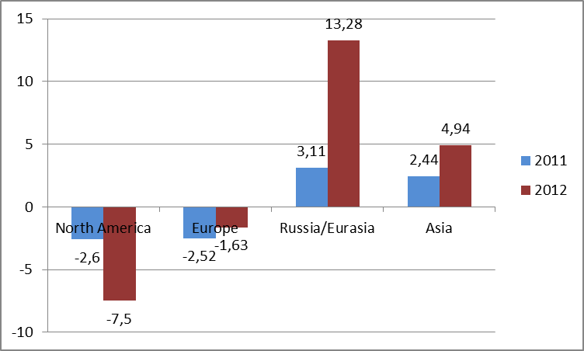
Source: Military Balance 2013 data, IISS
The budget cuts are not homogeneous at a national level. Most dramatic cuts of all are to be found amongst the smaller EU member states, with rates above 30%. The majority of middle-sized states implemented average cuts of 10% in their defence budgets. The situation seems to be different for the 6 countries which are the largest spenders in overall defence, procurement and R&D, representing 80% of total European defence and 75% of procurement spending in 2010. At one end of the spectrum, there have been sizeable cuts in defence budgets in Germany, the UK and Spain. Between 2008 and 2011 Spain cut spending on defence equipment by more than 50%. In Sweden the core defence spending has remained flat between 2010 and 2011, and a supplement of €4.8 billion per annum has been adopted to cover modernisation expenses. At the other end of the spectrum, although France and Italy have been strongly affected by the economic crisis, their spending remained largely unchanged. Nevertheless, in the case of France this has been mainly due to standing commitments, as the commitments for new equipment have decreased for a third consecutive year, reaching only €6.4 billion in 2012 (€19.3 billion in 2009).
Collaborative spending on equipment expenditure increased from 16% (2005) to 22% (2010). Yet, this means that still a lion share of equipment expenditure is taking place at a national level without significant coordination between Member States thus contributing to the overcapacity, duplication and gaps in European critical capabilities.
Moreover, while defence budgets are declining, defence equipment costs have been steadily increasing over time, up to 10% per year in real terms, resulting in a doubling of weapons costs every 7.25 years. As a result of these trends, defence capabilities in most European countries have already been significantly reduced. If this situation persists, the EU will have increasing difficulties in providing capacities to deal with future challenges. A key factor will be the impact of budget cuts on R&D spending which, in turn, is critical to the development of the current and future military capabilities Europe needs.
2.2 …adversely affecting R&D spending in the defence sector
R&D spending in the defence sector declined by 14% between 2006 and 2010 while the overall budgets diminished by 3.5%. This results from the fact that as R&D cuts can be made with no short term reduction in military capability, R&D spending is often seen as ‘discretionary’.
France and the UK are the largest R&D spenders, both in absolute terms and relative to overall defence spending, and represented 76% of European R&D spending in 2010. If German R&D expenditure is added, the three countries account for the 93% of overall European R&D spending. From a global perspective the gap between European and US R&D defence budgets increased between 2005 and 2010, the US budget(€58 billion) being 7 times larger than the European one(€8.5 billion) in 2010 .
Figure 3: R&D defence spending in EU/US, 2005-2010
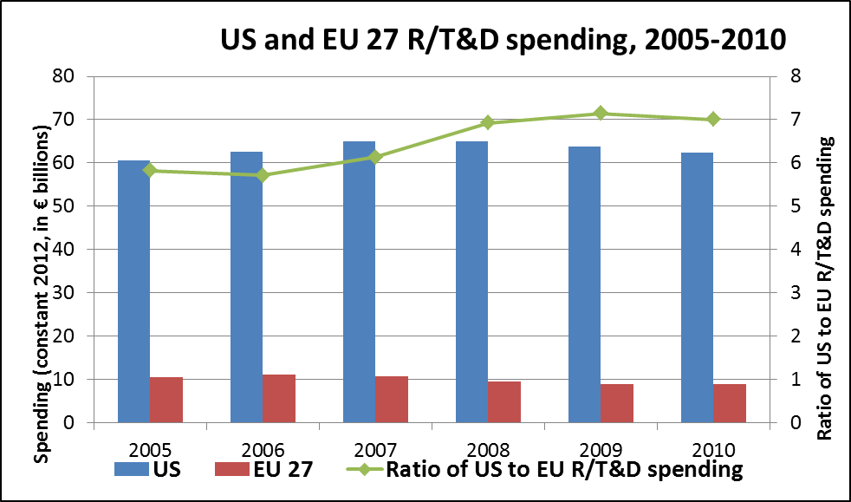
Source: RAND Europe analysis of HIS Jane's data
Moreover, the combined R&D spending of the BRIC countries (Brazil, Russia, India and China) is continuously growing and it is projected to be more than double than the combined R&D spending of the UK, France and Germany by 2013, whereas in 2008 it was almost equal.
Figure 4: R&D defence spending forecasts (FR, D, UK vs BRIC)
Source: RAND Europe analysis of HIS Jane's data
Almost all R&D in the defence sector is carried out at a national level. Only 12% of total R&T public expenditure carried out by EU EDA participating Member States is done on a European collaborative basis.
Box 2: Increasing defence R&D spending
A significant difference to the R&D spending can be made with a limited amount of money. If it were possible to rationalise spending on European land forces in line with stated military ambitions and reallocate the financial savings to R&D in the defence sector, this would contribute an additional 50% to aggregate R&D defence budget and lift it from 4.4% to 7.6% of overall 2010 defence spending.
2.3 At the same time European spending is dominated by personnel costs…
Between 2006 and 2010 European spending on personnel costs in the armed forces decreased by 17.5%. Cuts in personnel spending directly impacted the number of military and civilian personnel, bringing down the overall personnel number from 2.4 million in 2006 to just over 2 million in 2010.
Figure 5: military and civilian personnel numbers, 2006-2010
Source: EDA
However, this does not change the general picture: a high share of the European defence budget remains devoted to personnel. Almost half of the EU Member States are spending more than 60% of their respective defence budgets on personnel. As a result Member States spend at best 0.5% of their GDP on defence after personnel expenses have been excluded.

Figure 6: Defence expenditures of NATO member countries (% of GDP)
Source: Slovak Atlantic Commission, 2012
Whereas the EU may still have 500,000 soldiers more than the US, there is a substantial difference in terms of investment in equipment and R&D per soldier: in 2010 this amounted to €110,998 in the US versus only €26,458 in the EU. In the absence of further troop reductions, European spending per soldier is expected to follow the downward trend of total defence spending. This development is likely to result in smaller but progressively less capable European military forces, and will be further exacerbated should spending priorities continue to shift away from investment into equipment.
2.4 …whilst the increase of procurement spending is slow to emerge
Given the reduction in defence budgets it is perhaps surprising to note that procurement spending at the European level actually increased by 17% between 2005 and 2010. This corresponds to an absolute increase of over €5 billion, reaching €35.5 billion of total procurement spending in 2010. However, this increase may be also explained by a low base, as the growth was below one percentage point per year (from 14% in 2005 to 18% in 2010). At the same time, the large proportion of procurement budgets, especially in larger Member States, is contractually committed on long-term programmes which reduce short term fluctuations. It may be noted that, at this pace, it would take another 30 years before the combined share of procurement and R&D would reach a level of about 40% (compared with the 41% that US defence budget has devoted to investment into equipment procurement and R&D in 2010).
In reality, almost all Member States are considering either delaying procurement programmes or reducing their size. Most importantly, while the existing programmes will continue for the next 2-3 years, few new programmes are being launched. Some medium-sized and small Member States have decided to postpone decisions on the modernisation of key conventional capabilities, whilst others have prioritised their modernisation rather than tendering for a new generation of capacities. This will result in the dramatic decline of new programmes beyond 2015 which in turn will endanger the future of European Defence Technological and Industrial Base (EDTIB).
From a global perspective, the combined European and North American procurement budgets are expected to decline from 64% to 45% of 2015 global procurement spending. In contrast, procurement spending in Russia is forecast to total $58 billion and to climb by 33% from 2012 to 2016.
3. Fragmentation of the European Defence Market
3.1 Openness and competition before the transposition of Directive 2009/81/EC
The consequences of defence budgets reductions are exacerbated in Europe by the fragmentation of defence markets. This fragmentation persists at all levels – demand, supply and regulatory framework – and has led, amongst others, to costly duplications and protectionist procurement practices.
According to EDA estimates, roughly 80% of defence procurement expenditure is spent nationally, i.e. outside cooperative projects. This does not mean that these 80% are exclusively spent for equipment from national suppliers. However, before the entrance into force of the new defence procurement Directive 2009/81/EC, the degree of openness to suppliers from other Member States was relatively low.
EU-wide publication of business opportunities is the first criterion for market openness. From 2008 to 2010 included, more than 1500 notices for defence contracts of a value of roughly €4 billion were published on TED (Tenders Electronic Daily, the electronic platform of the EU’s Official Journal). On top of that, notices for contracts of roughly €4.76 billion were published on the Electronic Bulletin Board (EBB) of the European Defence Agency. Whereas the first category of contracts was awarded according to the rules of Directive 2004/18/EC, the second was exempted from EU law on the basis of Article 346 TFEU, but in principle also open to competition from suppliers from other Member States.
Figure 7: Contracts notified on TED and EBB
 | Values, € million 2010 Prices |  |  | Number
Publication source | 2008 | 2009 | 2010 | Total | 2008 | 2009 | 2010 | Total
TED | 513 | 2,626 | 885 | 4,024 | 415 | 447 | 686 | 1,548
EBB | 2,518 | 1,348 | 900 | 4,766 | 126 | 90 | 80 | 296
Total | 3,031 | 3,974 | 1,785 | 8,790 | 541 | 537 | 766 | 1,844

Hence, in the period 2008-2010, 1,844 defence contract notices were published EU-wide. The total value of these contracts was estimated to be €8.8 billion, which is equivalent to 3.3% of the EU’s total defence procurement expenditure in the same period.
Figure 8: Contracts notified on TED and EBB in relation to defence procurement expenditure
Of the €8.8 billion contract value published on TED and the EBB, €5.8 billion was awarded to national suppliers (66%), €2.3 billion to operators established in other Member States (26%), €0.4 billion to operators from third countries (5%).
Figure 9: Cross-border awards of contracts published on TED and EBB
Cross-border contracts not published on TED or EBB
Other defence contracts have been awarded to non-national suppliers without prior publication in TED or EBB. For the years 2008-2010, the SIPRI Arms Transfer Database reports of 63 such cross-border contracts with an estimated value of €3.9 billion, 32 of these contracts with a value of €2.2 billion were awarded in competition.
The total value of EU cross-border contracts awarded in competition was therefore €4.5 billion, which is 1.7% of total defence expenditure in the EU or 4.3% of the total defence equipment expenditure in the EU.
The total value of EU cross-border contracts – including those awarded without competition (e.g. follow-on contracts) – was €6.2 billion, equal to 5.9% of total EU defence equipment procurement or 2.3% of total EU defence procurement.
On top of that come contracts of a value of €0.4 billion which were awarded to suppliers from non-EU countries.
Figure 10: Estimated value of EU cross-border defence contracts 2008-2010
Cross-border awards in competition | € m / %
Reported by TED and the EBB  Estimated from SIPRI data  Total | 2,260  2,200  4,460
Expressed as a ratio of total defence procurement  Expressed as a ratio of total defence equipment procurement | 1.7%  4.3%
Total cross-border awards (competitive and non-competitive)  Reported by TED and the EBB  Estimated from SIPRI data  Total | 2,260  3,890  6,150
Expressed as a ratio of total defence procurement  Expressed as a ratio of total defence equipment procurement | 2.3%  5.9%

3.2 Openness and competition since the transposition of Directive 2009/81/EC
The new Directive 2009/81/EC applies to all defence procurement above a certain threshold and subject to Article 346 TFEU, which allows Member States to derogate from the rules of the Directive if this is necessary to protect their essential security interests.
Entering into force in 2009, the Directive had to be transposed by August 2011. However, transposition in all 27 Member States was accomplished in March 2013 only. It is therefore still too early to draw conclusions on the impact of the Directive on the openness of defence markets.
However, a first analysis of publication in TED gives some insights in Member States application of the Directive. The table below shows all notices published on TED by end of March 2013. It indicates in particular an important difference in numbers of published contract notices: up until now, a single Member State, France, has published alone 50% of all contract notices, whereas others (ES and NL) have not published a single one. Late transposition (alone) cannot explain these differences: Germany, which transposed late, has published a considerable number of contracts and ranks second behind France. The table shows also other specificities, such as the disproportion in Italy between contract notices and contract award notices. This indicates the frequent use of negotiated procedure without publication or the use of other procedures not foreseen in the Directive. The high number of voluntary ex ante notices in UK and DK could point into a similar direction.
Figure 11: Number of notices under Directive 2009/81/EC published on TED
(21-08-2011 until 31-03-2013)
Country | Buyer Profile | Contract Award | Voluntary ex ante Info Notice | Contract Notice | Prior Information Notice | Total
AT |  | 1 |  | 2 | 1 | 4
BE |  | 2 |  | 8 |  | 10
BG |  | 11 | 1 | 14 | 1 | 27
CY |  |  |  | 3 | 1 | 4
CZ |  | 10 |  | 36 | 36 | 82
DE | 1 | 163 |  | 235 | 7 | 406
DK |  | 26 | 59 | 42 | 3 | 130
EE |  | 1 |  | 1 |  | 2
ES | 1 |  |  |  |  | 1
FI |  | 37 | 25 | 63 |  | 125
FR | 1 | 132 | 44 | 515 | 3 | 695
HU | 1 | 23 |  | 11 |  | 35
IT | 2 | 194 | 11 | 23 | 82 | 312
LT |  | 3 | 3 | 12 |  | 18
LV |  | 2 |  | 3 |  | 5
NL |  | 6 |  |  |  | 6
PL | 2 | 3 | 2 | 7 |  | 14
RO |  | 1 |  | 5 |  | 6
SE |  | 4 | 1 | 17 |  | 22
SI |  |  |  | 1 |  | 1
SK |  | 5 | 3 | 6 | 3 | 17
UK |  | 43 | 187 | 79 | 10 | 319
Total | 8 | 667 | 336 | 1083 | 147 | 2241

EU-wide publication does not necessarily lead to cross-border competition or cross-border award of contracts. The table below shows that even in Member States with high publication rates like France and Germany, very few contracts are awarded to non-national suppliers. However, this does not necessarily indicate a persisting “buy national” policy on the side of the Member States. Also defence companies might be reluctant to operate outside their home markets (in particular if this would imply to compete with established national champions). In that case, a consistent practice of publication by Member States can be expected to change business practice over time, leading companies to be more active on other European markets.
Figure 12: Number of Contracts awarded under Directive 2009/81/EC (21-08-2011 until 23-03-2013)
 | Total contracts | Awarded cross- border | Awarded nationally | % cross border
AT | 1 | 0 | 1 | 0
BE | 2 | 1 | 1 | 50
BG | 19 |  | 19 | 0
CZ | 46 | 10 | 36 | 22
DE | 162 | 1 | 161 | 1
DK | 26 | 11 | 15 | 42
FI | 56 | 33 | 23 | 59
FR | 216 | 0 | 216 | 0
HU | 75 | 1 | 74 | 1
IT | 196 | 3 | 193 | 2
LT | 6 | 0 | 6 | 0
LV | 2 | 2 | 0 | 100
NL | 7 | 0 | 7 | 0
PL | 3 | 0 | 3 | 0
RO | 1 |  | 1 | 0
SE | 4 | 0 | 4 | 0
SK | 5 | 1 | 4 | 20
UK | 45 | 7 | 38 | 16
Total | 872 | 70 | 802 | 8
Note: For a significant number of contracts (83) the nationality of the contractor was not recorded. Based on the fact that the majority of contracts were awarded to national operators, we assume that this is the case for the contractors of which their nationality is unknown.
Figure 13: Values of contracts in € million Directive 2009/81/EC (21-08-2011 until 23-03-2013)
 | Total amount | Amount awarded cross-border | Amount awarded nationally | % Cross border
AT | 0,6 | 0,0 | 0,6 | 0
BE | 0,4 | 0,0 | 0,4 | 0
BG | 46,0 | 0,0 | 46,0 | 0
CZ | 20,3 | 0,0 | 20,2 | 0
DE | 308,6 | 0,6 | 308,0 | 0
DK | 40,2 | 3,4 | 36,8 | 8
FI | 37,6 | 16,6 | 21,0 | 44
FR | 129,8 | 0,0 | 129,8 | 0
HU | 58,9 | 0,0 | 58,9 | 0
IT | 277,4 | 20,5 | 256,9 | 7
LT | 1,4 | 0,0 | 1,4 | 0
LV | 1,4 | 1,4 | 0,0 | 100
NL | 1,6 | 0,0 | 1,6 | 0
PL | 4,4 | 0,0 | 4,4 | 0
RO | 1,7 | 0,0 | 1,7 | 0
SE | 1,1 | 0,0 | 1,1 | 0
SK | 6,4 | 3,5 | 2,9 | 55
UK | 839,1 | 6,9 | 832,2 | 1
Total | 1776,8 | 53,0 | 1723,9 | 3
Note: For a significant number of contract values (€ 720 million) the nationality of the contractor was not recorded. Given the fact that the majority of contracts went to national operators, we assume that this is the case as well for the contractors of which the nationality is unknown. Also, for roughly one out of six contracts the notices did not record the value of the contract.
Further monitoring and assessment over a longer period of time are necessary to measure the impact of the Directive on the European Defence Market. In this context, it will be important to analyse also:
- which equipment is procured under the Directive (the full spectrum of arms, munitions, war material, or only less sensitive and complex equipment);
- how are the Directive’s provisions on subcontracting applied (do SMEs get better access to non-national supply chains and thereby to other Member States’ defence markets);
- the use of the exclusions and of the negotiated procedure without publication.
Such an assessment would be more than a statistical exercise and goes beyond a quantitative approach. It necessitates for example a qualitative and detailed analysis of contract award notices, but also the use of other relevant sources, such as the specialised press.
4. Consolidation in the defence sector
4.1 Consolidation is taking place, but progress is slow
The EDTIB has experienced several waves of consolidation over the last decades. This process has led to the creation of "primes" such as EADS and MBDA. Driven by decreasing defence spending and increasing R&D costs, consolidation has also helped to reduce overcapacity and duplication across Member States; has created globally competitive companies; and has targeted R&D investments and programmes more effectively.
Box 3: Major consolidation factors for the EDTIB
European demand decline: The decreasing defence budgets in Europe after the end of the Cold War decreased the business opportunities in Europe and in many cases have driven companies to combine forces and merge structures in order to benefit from economies of scale and improve profitability.
International competition: The increasing size and capabilities of international competitors have been a major driver for consolidation, especially in aerospace (Lockheed Martin and Boeing competition for EADS) and missiles (Raytheon for MBDA).
Technological complexity/ R&D costs: Consolidation has been less reluctantly met where the high technological complexity and the consequent R&D intensity and cost were not bearable for entities below a certain size. On the contrary, in areas of lower technological complexity EDTIB is still highly fragmented.
Integration of civil and defence industry: It is observed that there is more fragmentation in areas where system providers share a common TIB with the civil sector (ICT, C4ISTAR, defence electronics etc). This could be explained by the increased profitability provided by the civilian activities and the common R&D base for sector specific military and civilian applications.
However, consolidation has not taken place to the same extent across sectors. This is especially the case in the naval and land sectors where fragmentation is not only observed at regional level, but also nationally. In the land sector, industrial capabilities are concentrated in a few countries (particularly France, Germany and UK), and the supply chains are complex. The process of consolidation, for example in the area of armed vehicles (see figure 13), has largely taken place along national lines. Within the UK the armed vehicles sector has been reduced from 5 prime contractors to one, namely BAE Systems.
Figure 14: Mergers and Acquisitions of the Armed Vehicles Sector in the EU
Source: “Anticipating restructuring in the European Defence industry”. BIPE. 2008.
Despite some national restructuring around national champions in the UK, France, Italy and Germany, the naval sector remains fragmented with a large number of relatively small firms and excess capacity. The EU continues to have, for example, eleven suppliers of frigates versus only one US supplier.
In the aerospace sector, consolidation efforts have led to the creation of European companies like EADS and Thales. Joint military programmes have also resulted in new European entities such as MBDA (missiles) and Eurocopter (helicopters). Yet, the sector continues to be characterised by the presence of too many relatively small firms, a lack of efficiency (in comparison to US), overcapacity and capability gaps (e.g. strategic bombers). The average US aerospace company is some 22 times larger than the similar top EU aerospace firms, indicating that there are considerable opportunities for creating much larger EU aerospace companies.
Overall, the defence industrial production is concentrated in 6 European countries. The defence industry in these countries accounts for 87% of European defence production. These countries are also hosting the 20 European defence companies that are highest ranked in the top 100 defence companies in the world.
Figure 15: Highest ranked European defence companies in global top-100
Source: Based on SIPRI data. Note: an “s” in the first column denotes a subsidiary company.
4.2 More consolidation is needed, but there are barriers to overcome
Defence companies need a critical size in order to be able to partially finance innovation (in particular in view of current cuts in EU defence budgets), operate globally and develop services.
Figure 16: Importance of reaching critical mass
Source: Roland Berger analysis
Yet few defence companies in Europe currently have this critical size, which implies constraints regarding their capabilities of self-financing future developments.
Figure 17: Aerospace and Defence & Security landscape in Europe, turnover 2011, US$ billion
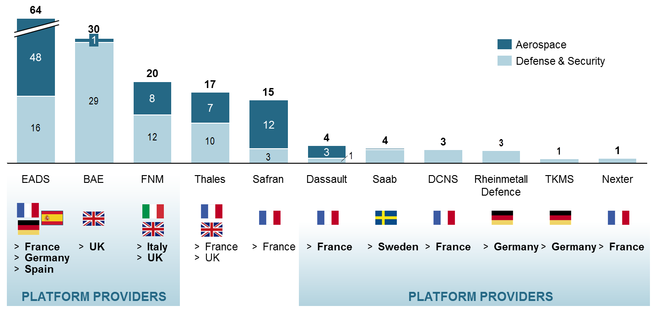
Source: Companies 2011 annual report, Roland Berger analysis
From this perspective, the defence market could evolve to a more segmented profile, distinguishing more clearly between local and global players.
Figure 18: Potential future scenario of the European Aerospace and Defence landscape
Source: Roland Berger
However, in order for European defence companies to reach a critical mass, different barriers towards further consolidation need to be tackled:
- Member States' preference to national producers over other European suppliers. In Europe some 80% of defence contracts are still awarded nationally.
- Misalignment of requirements and capabilities across Member States.
- State ownership, which is closely linked to restrictions on Mergers and Acquisitions, equity holdings by overseas investors and other forms of foreign investment.
- Impact of the "juste retour" principle. This refers to the rule whereby in multinational state based armament projects instead of market mechanisms the national work share equals the national financial investments.
5. Defence industrial supply chains and the role of SMEs in the sector
5.1 The specific role of SMEs in the defence industrial value chain and the potential for increased clustering
The EU defence industries are characterised by multiple supply chains. Many suppliers work in several of these supply chains for different defence contractors on different projects.
The structure of the supply chain may differ depending on the sector. Aerospace and electronics industries tend to have more globalised supply chains, while the naval and land industries are defined to a greater extent along national boundaries. This corresponds to the differences in size and technological complexity of the programmes.
Figure 19: Defence industrial supply chain
Source: BIPE
On top of the supply chains are the Prime Contractors (or ‘primes’). These are typically large companies, and in many cases national champions, which interact with Member States defence procurement authorities, or procuring bodies such as OCCAR and NATO agencies. These Prime Contractors work together with lower-tier suppliers in complex supply chains to produce specific defence products. Such a supply chain may involve many hundreds of companies. For example, to produce the UK Warrior AFV, over 200 first tier suppliers could be identified, whereas the German Leopard II tank combines the efforts of about 1,500 supplying companies.
SMEs have an important role, either as subcontractors to larger companies or as specialised product suppliers operating in niche markets. It is estimated that the 1,320 EU defence-related SMEs account for between 11 and 17% share of the EU's sales of defence equipment. Whereas a number of strong clusters reinforce the concentration of EU defence equipment production with 6 Member States hosting 87% of the total production, these countries account for only 52% of defence-related SMEs.
Supply chains are characterised by various emerging trends:
- National Ministries of Defence are increasingly using 'partnering contracts'. This means that they prefer to contract with one Prime Contractor who then takes full responsibility for the development and delivery of the equipment according to some previously defined time, costs and quality specifications.
- Subcontracting activities are increasingly based on the so-called 'risk-sharing partner' concept, whereby the development costs of new systems or equipment is distributed across the Prime Contractor and its partners. Under this concept, primes delegate the responsibility for conceptualising, designing, developing and producing a new system to lower-tier companies.
- European national authorities are increasingly open to outsourcing some of the logistical activities (i.e. transport, repair, health) to the private sector.
These trends are important factors in the evolution of the relationships and interaction between larger companies and SMEs in the supply chains. It entails a potential for increased risks and costs to be borne by the by default financially less resilient subcontractors, thereby reducing the competitiveness of SMEs vis-à-vis larger companies. Besides this issue, other factors challenging the competitiveness of defence-related SMEs are:
- Information problems, i.e. difficulties in obtaining information on future capability requirements and business opportunities but also a lack of visibility to large companies which results in a preference for existing suppliers or suppliers closely located to the contractor.
- Access to finance, particularly in Member States with less developed or efficient financial markets.
- Administrative burden and costs, such as for example the costs related to IPR protection.
Figure 20: Comparison between clustered and non-clustered firms
Source: European Commission, Innobarometer 2006
Networks of excellence are important drivers of innovation in the EU defence industries. Together with clustering, they can allow SMEs to achieve a critical mass, increase their visibility on the EU market and their ability to compete on international markets. However, strategies that foster the development of regional clusters tend to be driven and funded by the regions, for which defence is not a straightforward priority. Moreover, the current fragmented state of Europe’s defence industry limits the potential for more cross-border networking and does not favour more international cooperation between such clusters.
6. New business models in an evolving global setting
6.1 Defence industry has a specific business model…
The European defence industry has the capacity to develop, produce and export a wide range of competitive military equipment. Most of its investments in new equipment and defence R&D are linked to important military programmes launched by Member States in the previous decades. The reason why governments have to bear the part of R&D costs is that the time lag between initial investment in research and development through to in-service military capability can be up to twenty years. Moreover, the national orders are relatively small, guided by national specifications that limit the export potential and are subject to export controls. Consequently, there are few incentives for private investment given the timing and unpredictability of financial returns – thus R&D into new technologies relies, to a large extent, on government investment.
In view of decreasing demand and the reduced investment into defence R&D, defence industry companies have embarked on developing new or adapting the existing business models.
6.2 Faced with lack of orders companies are increasingly turning to third markets…
Between 2001 and 2011, industry revenues have increased at a higher rate than European defence procurement spending and despite decreasing global defence spending. Revenues of the top 21 publicly traded companies operating in the defence market have increased by 58%, from €58 billion to €91 billion (2011€). However, between 2003 and 2011, European-based revenues of major EU defence companies fell by 10%, while the reverse occurred for the North-American share of companies’ revenues. This suggests that industry has adopted the following strategies to increase its resilience during the economic downturn, in particular internationalisation and diversification.
- Internationalisation
The export of European defence equipment and services to third countries has been an important factor compensating the reduction in new programmes in the EU.
The following graph shows how major European industrial players have embarked on a process of internationalising their client base. Over half of 2011 sales for the top 15 European industry suppliers were to non-European buyers. Defence companies are increasingly developing new business models that allow them to work more effectively across national borders. They make acquisitions in other non-European markets and build partnerships with non-European producers. For example, BAE Systems established a joint defence venture with Mahindra & Mahindra Ltd in India, and DCNS and its Brazilian partner established a joint venture (ICN) for the construction of 4 submarines and a naval base.
Figure 21: Value of European and non-European sales for top 15 defence suppliers
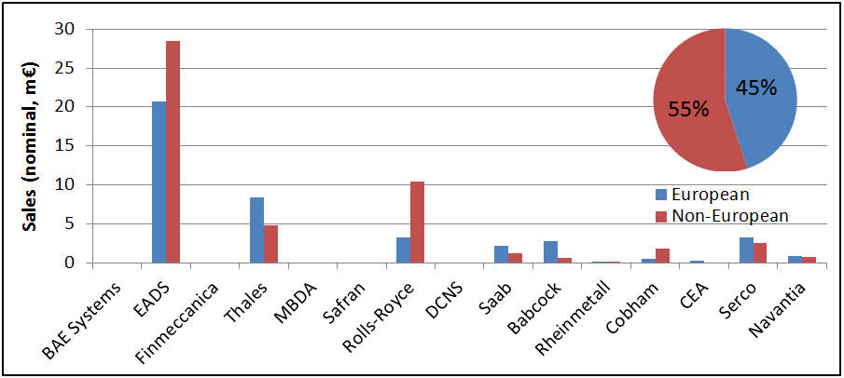
Source: RAND Europe analysis, 2013
In 2011 the Middle East was the destination for around one third of the European exports, accounting for €8 billion of the total export value of €23 billion. Other main trading partners included North America, South Asia, Southeast Asia and Africa.
Figure 22: European defence exports by destination, 2011
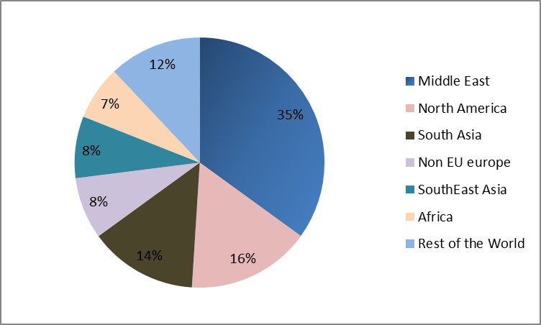
Source: European Council data
Looking ahead, the growth of markets in the Middle East, Asia and South America presents opportunities for European suppliers to offset the reductions in Member State demand.
Figure 23: Top 5 world’s arms importing countries 2007-2012 ($ million)
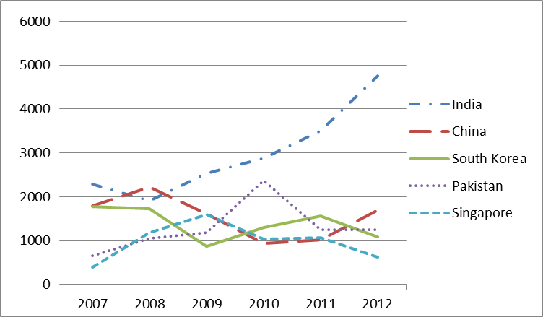
Source: SIPRI data
Figure 24: Top 6 world’s arms exporting countries 2007-2012 ($ million)
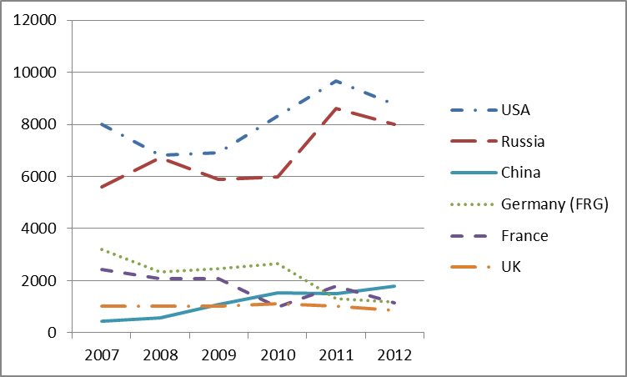
Source: SIPRI data
However, in the near future the global market will become increasingly competitive, with new countries being able to offer a variety of systems and platforms. With the defence budgets at the Asia Pacific area expected to grow at a much greater rate than in the rest of the world, the transfer of technology and the investment to the defence industries of the region could add new companies to the list of competitors of the European defence industry.
Box 4: Emerging markets
Besides the US and Russia which are already global players in the defence equipment markets, emerging economies can increase competition and seriously affect the exporting environment of the European defence industry. Countries such as China, Brazil, India and South Korea, combining strong economic growth, extensive and high-tech industrial capabilities, significant security and defence concerns, and aggressive industrial policies raise the challenge for European companies to sustain the current market share let alone to increase the exports’ volume. Although it is unlikely - with the exception of China - that the industry of these countries could offer a comprehensive package of defence products, it is certain that the growing self-sufficiency will decrease the margin of manoeuver in traditional export markets for European military equipment (Brazil, India). Furthermore, it is very likely that in specific market segments these countries will be increasingly presenting defence systems competitive to European ones.
- Diversification
Major industry suppliers are also diversifying their product portfolio to balance defence products with civilian activities in growth sectors. Civilian products represent a significant revenue share of the EDTIB. Based on 2011 data, around 39% of sales for the top 15 European industry suppliers were based on non-defence products. The equivalent distribution of revenues of the six major national defence industry associations indicates that 62% of revenues were from non-defence products. This suggests that the lower tiers of the European defence supply chain engage in a more diversified set of products than systems integrators.
In parallel, many large companies are increasingly profiling themselves as service providers able to present through-life care for defence capabilities.
6.3 ...but in a longer term this will result in the erosion of EU defence industrial base
European defence export agreements usually include transfers of technology and intellectual property rights and/or relocation of production, which entails risks to the longer-term competitiveness of the European defence industry especially if this coincides with declining R&D investment.
Moreover, despite efforts of EU defence companies to adapt to a changing business environment, the continuous decrease of national defence budgets is likely to weigh heavily on their profitability and competitiveness. The exports of today are often the result of R&D investments made 10 to 25 years ago. Therefore declining investment in R&D presents a particular threat to the long term future of the European defence sector, both in terms of its skills base and its potential to deliver new capacities.
Technological progress is a major goal for the industry in order to maintain its competitiveness; it is also a key factor to achieve autonomy in essential capabilities. EU defence companies generally devote a share of their total sales to R&D that is well above the European manufacturing sector: land sector (6%), naval (10%), aerospace (12%). Experts believe that in the near future the most revolutionary technological advances for military capabilities will come from R&D and innovation in the civil sector, which is expected to further encourage convergence of civil and military R&D.
Box 5: Dual use in ICT
Dual use, or even civil use, equipment is increasingly used in the armies worldwide. The constantly accelerating technological progress in the field of IT/ICT for the development of civil products and applications has made a broad variety of solutions and technical improvements available for military use. Over the last 20 years the armed forces have increasingly acquired and used equipment, electronic components and software, with or without modifications, originally developed for the civil sector in order to address emerging needs in a prompt and cost efficient way. A few years ago, USAF constructed a supercomputer running Linux out of 1760 Playstation3 processors. Today, aircrews use tablet PCs as electronic “flight bags” in military operations.
It is clearly important to co-ordinate and align dual use research and new programme investment to ensure long-term viability of key industrial capabilities. Action already taken at European level in certain technological areas could set the model for the years to come, such as for example in the area of Remotely Piloted Aircraft Systems.
Box 6: Remotely Piloted Aircraft Systems
RPAS - commonly known as drones or Unmanned Aircraft Systems (UAS) - are used in a growing number of civil and military applications such as in agriculture, border surveillance, infrastructure inspection, communications and broadcast services, digital mapping etc. Beyond the manufacturers and system integrators, the RPAS industry includes a broad supply chain providing a large range of enabling technologies (flight control, communication, propulsion, energy, sensors, telemetry etc.). Thus the development of RPAS technologies is creating spin-offs with significant impact in many sectors with both civilian and military applications.
The European Commission has long identified the potential of this emerging technology and supported the market by investing in research and innovation relevant for RPAS through the Framework Programme for Research. A broad stakeholders' consultation has demonstrated the necessity for action at EU level, setting as priorities the further development of RPAS civil applications and the integration of the systems into the European air space as soon as possible. The consultation has also called upon the European Commission to support the development of a Roadmap for the safe integration of civil RPAS into European Aviation System (RPAS Roadmap).
The Roadmap identifies the regulatory and R&D activities necessary to achieve RPAS airspace integration. It will also take into account the data protection and privacy concerns associated with the civil use of RPAS in order to ensure that such use complies with the right to privacy and the right to protection of personal data, as guaranteed in the Charter of Fundamental Rights of the EU and in line with other instruments forming the EU data protection framework. It will contribute to allow the manufacturing industry to produce similar platforms for civil and military applications, by developing harmonized civil / military safety objectives and hybrid standards. Furthermore, it will facilitate the coordination of future R&D activities. In order to fly across the European airspace, military and civil RPAS require the development of similar technologies, like for instance the capacity to detect and avoid other aircrafts. The Roadmap initiative led by the Commission will facilitate the establishment of the necessary synergies between civil and military projects like those supported by the European Defence Agency.
Moreover, the defence sector has a both highly skilled and highly specialised workforce. However, companies are starting to experience skill shortages and this trend might aggravate in the future. For example, studies in the naval sector highlighted difficulties in finding and recruiting naval architects, electrical engineers, systems engineers and mechanical engineers. The recruitment problems are particularly challenging for SMEs. An important reason why skills and competence deficits are developing relates to the fact that a significant percentage of the workforce is expected to retire in the coming 10 to 15 years. For example, in the manufacturing of weapons/ammunition sector, 16.6% of all workers are older than 55, in comparison to 12.4% in European manufacturing in general. The European defence industry has to retain its key skills in order to be able to deliver high-technology solutions in an increasingly competitive global market.
In conclusion, if not addressed by the Member States the declining investment into R&D, the lack of new procurement programmes, coupled with the risks linked to increasing internationalisation have the potential to significantly reduce the competitiveness of the EU defence industries in the longer term.

ASD data
A 2011 study on the economic impact of BAE Systems on the UK economy in 2009 estimated that, for every 10 people employed by BAE another 19 were employed elsewhere (12 in the supply chain and 7 in the wider economy). “The economic contribution of BAE Systems to the UK”, Oxford Economics, April 2011
“Study on the Perspectives of the European Land armament sector”, IndustriAll, October 2012.
This document will refer to Research and Development (R&D) and to the sub-component Research & Technology (R&T).
"The industrial and economic benefits of Eurofighter Typhoon". Hartley. University of York. February 2008. “The economics of defence policy: a new perspective”. Hartley. Routledge Studies. 2011.
"Facts and Figures", ASD. 2010
“Study on the Perspectives of the European Land armament sector”, IndustriAll, October 2012.
"Facts and Figures", ASD. 2010
BAE Systems (UK), DCNS (France), TKMS (Germany), Fincantieri (Italy) and Navantia (Spain).
“Armaments duplication in Europe: A quantitative assessment”, Valerio Briani, CEPS Policy Brief, No 297, 16 July 2013.
International Institute for Strategic Studies (IISS)
Speech President Van Rompuy – “Defence in Europe – pragmatically forward”, 21 March 2013.
France, Germany, Italy, Spain, Sweden and UK
“Bilan d’activités 2012”, DGA, French MoD
"European Defense Trends 2012". CSIS, December 2012.
« A single European market for defence equipment : organisation and collaboration ». Prof. Hartley, University of York.
“The evolution of the European Defence Sector”, RAND, January 2013
“Defence Data 2010”, EDA
“Study on the Perspectives of the European Land armament sector”, IndustriAll, October 2012.
“The evolution of the European Defence Sector”, RAND, January 2013
“Maintaining defence capabilities : European share”, SAC/CEPI Policy Brief, February 2013.
“Defence Data 2010”, EDA
"European Defense Trends 2012". CSIS, December 2012
EP Study "The impact of the financial crisis on European defence", April 2011 / “Military Balance 2013”, T&F Informa UK Ltd. 2013
IHS Jane's Defence Weekly, 19/12/2012
Contracts for the purchase of arms, munitions and war material, plus related services and works.
“Development of a European Defence Technological and Industrial Base”. TNO. 2009
France, Germany, Italy, Spain, Sweden and UK.
“European defence cooperation. Sovereignty and the capacity to act”. Advisory Council on International Affairs. January 2012.
"The economic significance of SMEs in defence". Europe Economics. November 2009.
“Study on the Perspectives of the European Land armament sector”. IndustriAll, October 2012.
CIS, 2012
IHS Jane's Defence Weekly, 20/7/2012
Rand Europe analysis of defence companies annual reports and ASD information, 2013
“A comprehensive analysis of emerging competences and skill needs for optimal preparation and management of change in the European defence industry”. Eurostrategies. 2009
“A comprehensive analysis of emerging competences and skill needs for optimal preparation and management of change in the European defence industry”. Eurostrategies. 2009
“Study on the Perspectives of the European Land armament sector”, IndustriAll, October 2012.

