COMMISSION STAFF WORKING DOCUMENT
Impact assessment
Accompanying the document
Proposal for a decision of the European Parliament and of the Council
on the participation of the Union in the Active and Assisted Living Research and Development Programme jointly undertaken by several Member States
Table of Contents
Introduction 5
1. Procedural Issues and Consultation of Interested Parties 7
1.1. Organisation and Timing 7
1.2. Consultation of the IA Board 7
1.3. Inter-service Impact Assessment Steering Group (IASG) 7
1.4. Consultation and Expertise 7
1.4.1. Consultation for the EIP AHA 8
1.4.2. Interim evaluation of the AAL JP 9
1.4.3. Public online consultation on the AAL JP 10
1.4.4. Consultation of the participating countries through the General Assembly AAL JP 11
1.4.5. Consultation of AAL JP participants on impacts and programme benefits 12
1.4.6. Consultation findings 12
2. Problem definition 13
2.1. Responding to the Demographic Challenge 13
2.2. Key problems and their drivers 15
2.2.1. Low market availability of innovative ICT products and services for Ageing Well 15
2.2.2. Fragmentation of Research Development & Innovation at European level 16
2.2.3. Limited adoption of innovation 16
2.3. Achievements and lessons learned from the current AAL JP 17
2.4. Baseline scenario 19
2.5. Changing EU Policy context 19
3. Objectives 21
3.1. General Objectives 21
3.2. Specific Objectives 21
3.3. Operational Objectives 22
3.4. How do objectives compare to the existing programme 22
4. Policy Options 23
4.1. Options 23
4.1.1. Option 1 - AAL JP2 identical to AAL JP1 23
4.1.2. Option 2 - No AAL JP2 23
4.1.3. Option 3 - AAL JP2 as reinforced and improved AAL JP1 24
4.2. Discarded options 24
4.2.1. No financial commitment EU to the ICT and ageing field 24
4.2.2. No financial commitment EU: just light coordination 24
4.2.3. AAL JP2 combined with JPI "More Years, Better Lives" 24
4.2.4. AAL JP2 combined with the follow-up Art. 185 EUROSTARs Initiative 25
4.3. The right to act 25
4.4. Subsidiarity 25
4.5. Sensitivity and risk analysis 25
5. Analysis of the Impacts of the Options 27
5.1. Option 1 - AAL JP2 identical to AAL JP1 27
5.1.1. Economic impacts of the Option 1 27
5.1.2. Social impacts of the Option 1 30
5.1.3. Environmental impacts of the Option 1 31
5.1.4. Other impacts of the Option 1 32
5.2. Option 2 - No AAL JP2 32
5.2.1. Economic impacts of the Option 2 32
5.2.2. Social impacts of the Option 2 34
5.2.3. Environmental impacts of the Option 2 35
5.3. Option 3 - AAL JP2, as reinforced and improved AAL JP1 35
5.3.1. Economic impacts of the Option 3 35
5.3.2. Social impacts of the Option 3 37
5.3.3. Environmental impacts of the Option 3 39
5.3.4. Other impacts of the Option 3 39
5.4. Assessment of the administrative costs 40
5.5. Assessments of the simplification potential 40
6. Comparison of Options 40
6.1. Comparison by the costs and benefits 40
6.2. Comparison by mix of the project participants. 41
6.3. Comparison by the distance to the market of the project results 42
6.4. Comparison by the impact on the EIP AHA 42
6.5. Overall comparison of the options 42
6.6. Preferred option 43
7. Monitoring and Evaluation 43
7.1. Monitoring 43
7.2. Evaluation 45
8. Annexes 46
8.1. Annex I: Table of figures 46
8.2. Annex II: List of current national public sources for the co-financing of the AAL JP calls in 2012 47
8.3. Annex III: Examples of AAL projects and their business plans 48

Introduction
This impact assessment (IA) report accompanies the Commission proposal for a decision on the participation by the European Union in the follow-up to the Ambient Assisted Living Joint Programme (AAL JP2). It details the findings of the impact assessment required for legislative proposals and represents the ex-ante evaluation of proposals for spending programmes occasioning budgetary expenditure. More specifically, this report addresses the EU participation in AAL JP2, including the renewal of the EU’s mandate and, funding, as requested by the participating EU Member States and European countries associated to the Framework Programme. The current Ambient Assisted Living Joint Programme has been established in 2008 jointly between 20 Member States and 3 countries associated to the 7th Framework Programme for Research and Technological Development (FP7).
AAL JP aims to create a critical mass of applied research, development and innovation at EU level for innovative ICT-based products, services and systems for ageing well. The time to market is 2 to 3 years. Each of the currently 100 funded projects involves at least three countries, one small or medium enterprise (SME), one research body and one organization representing older people. Thus a triple win is pursued: a higher quality of life for elderly people, lower cost and higher sustainability for health and social care systems, and innovation, growth and jobs for the economy. To improve conditions for industrial exploitation, AAL JP facilitates common solutions which are adaptable to varying social preferences and regulatory conditions across Europe. The application process is organised at national level, which substantially lowers the participation barrier for local organisations and SMEs.
Ambient assisted living solutions can play an important role in dealing with the challenges of an ageing Europe. They can help elderly adapt their personal lifestyle, health management, and workplace to their ageing, so that they can participate in the economy and society for higher number of years, and live longer at home, rather than in institutional settings. ambient assisted living solutions can help carers spend more time with their clients, by cutting red tape, facilitating data sharing and ensuring effective workflows. Up to now six calls have been issued within the AAL JP on topics such as ICT based solutions for prevention and management of chronic conditions, social interaction, independence and participation in the “Self-Serve Society", mobility, home care and solutions for supporting occupation in life – all for older persons. To give an impression of the type of projects that are being funded:
- Older people living by themselves run the risk of becoming lonely and isolated. The HOMEdotOLD project helps them stay in touch with the world around them and have a social life, even if they are not able to easily go out of the house. They can share a 'remote dinner' with distant friends, or exchange photos with relatives. They can keep their calendar and receive personalised news. All is done via their own trusted TV.
- Older people need care, but carers can't always be there. The ExCITE project allows an experience close to the real thing. A remotely controlled robot with videoconferencing system allows caregivers to virtually visit older people, move about and look around in their house, and talk with them.
- Ageing healthy and actively can become hard work, once you get older. Dietary constraints or an exercise regime do not sound like a lot of fun. The A2e2 project takes care of that. It is an easy-to-use and “fun-to-be-with” virtual coach that inspires and helps older people to keep up a healthy and active lifestyle. It reminds and admonishes them, and challenges them with digital gaming.
The current AAL JP engages 19 EU Member States and 3 associated countries. It is financed by participating countries, the EU, and the organisations participating in the AAL JP projects (approximately 25%, 25% and 50% respectively). The current programme will run from 2008 to 2013 and has a minimum total public budget of € 300 million and a total minimum budget of € 600 million. This includes up to € 150 million from the EU FP7, through Art. 185 of the Treaty on the Functioning of the European Union (TFEU).
The AAL JP is governed by the participating countries through a dedicated implementation structure, the AAL Association (AALA), with a Central Management Unit (CMU) for daily programme operations and a network of national contact points (see Figure 1). The supreme decision making body is the General Assembly, with representatives from all Partner Countries. It elects an Executive Board as the official legal representative of the Association, responsible for staffing, contracting and budget planning. Technical advice is provided by an Advisory Board of renowned people from business, innovative technology, research or politics. The Commission’s role in the AAL JP includes handling the EU co-financing, programme evaluation and an observer role in the AAL General Assembly, with a veto on the AAL JP annual work programme.
Figure 1- AAL JP governance and operational structure

1. Procedural Issues and Consultation of Interested Parties

1.1. Organisation and Timing
In 2011, the consultation for the launch of the European Innovation Partnership on Active and Healthy Ageing (EIP AHA) covering topics relevant to the AAL was conducted. In 2010, the Interim Evaluation of the AAL JP was carried out and it included an online public consultation. In 2012, General Assembly, the AAL participants and the Inter-service Impact Assessment Steering Group (IASG was based on the EIP AHA inter-service group) were consulted.

1.2. Consultation of the IA Board
[This section is reserved for including the opinion received from the IAB]

1.3. Inter-service Impact Assessment Steering Group (IASG)
Two IASG meetings in 2012 contributed at large to the planning and roadmap for the preparation of the Impact assessment report, in particular concerning the problem statement and the relevance of the AAL JP to other DGs. The Art. 185 Coordination Group lead by DG RTD contributed to the structure and argumentation of this report.

1.4. Consultation and Expertise
A comprehensive set of consultations with relevant stakeholders have been carried out at different stages of the preparation of this impact assessment (see Table 1). This impact assessment regards the follow up to an already existing programme. The consultations have been focussed on involving the key stakeholders and participants of the projects. Care has been taken to map the different consultation activities to involve stakeholders from industry, SME, civil society, citizens and decision makers from all levels of government. Care was also taken to avoid biased inputs because of an overrepresentation of non-stakeholder respondents.

Consultation | Date | Respondents
Public consultation on the EIP AHA | Nov 2010 – Jan 2011 | 524
Interim Evaluation on the AAL JP | May-Aug 2010 | 40
Public online consultation on the AAL JP, | Jun-Jul 2010 | 37
Consultation of the participating countries through the General Assembly AAL JP | Nov 2012 –Jun 2012 | 23
Consultation of AAL JP participants on impacts and programme benefits, | 2010-2011 | 23
Consultation by Finland on national participation in the AAL JP | 2011 | 64
Table 1 – Overview of the consultations relevant to the impact assessment

1.4.1. Consultation for the EIP AHA
The online Public Consultation on the EIP-AHA aimed to map the existing national, regional and local initiatives for active and healthy ageing; seek views on the weaknesses and barriers in the European innovation system and to suggest policy actions. The Synthesis report on the public consultation was published in 2011 and analyses the 524 contributions. This report and its large response from across the whole spectrum of EU stakeholders provides a good basis to assess where and how the Innovation Partnership and the Joint Programme can reinforce and complement each other. About 38% responses came from government institutions (G), 23% from the industry including SMEs (I), 7% from the health and social care sector (H/S), 17% from the research and academia (R/A) and 15% from the organisation representing the older people (O). See Figure 2:
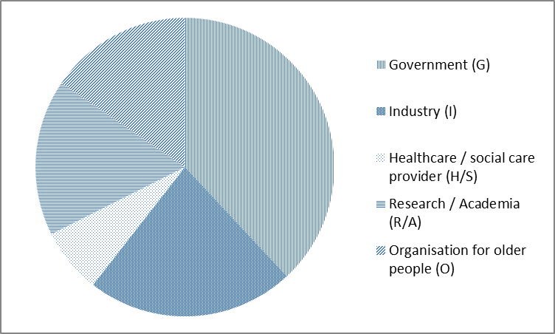
Figure 2 - Representation of different stakeholders in the consultation on the EIP-AHA
The EIP-consultation is of high relevance to the AAL Joint Programme as it sought to identify trends, barriers and opportunities for innovative applications and services in the EU for ageing well. It provides a thorough assessment of existing barriers that confirmed that the AAL JP is addressing the relevant problems in an effective way.
The consultation showed (Figure 3) that insufficient involvement of end-users in the development stage was identified as the most significant barrier to innovation in ICT and ageing. This view was mainly supported by the organizations representing the elderly and patients' organizations. The health and social care sector highlighted the lack of funding, while industry flagged the problem of selling the novel solutions to the public authorities. Research and academia found that the funding only covers part of the innovation process. Additionally, in the course of 2011 ideas for the EIP were collected through workshops, submissions of activities and commitments by stakeholders and the consultation, many of these directly relevant to AAL. All in all over 130 detailed work proposals have been received.
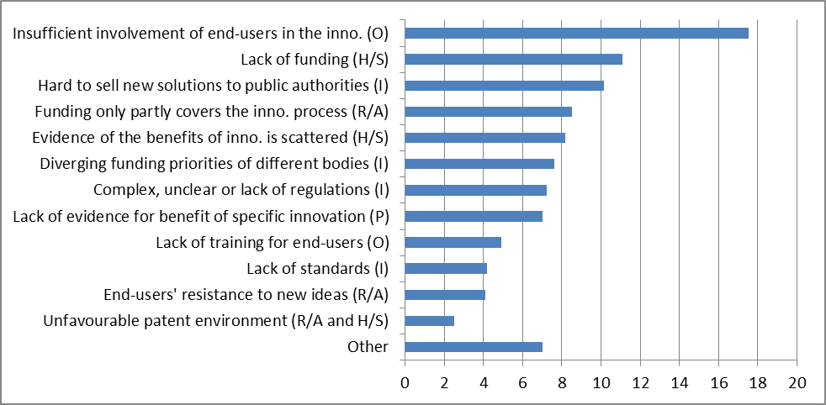
Figure 3 - Significance of the barriers to the innovation in the area ICT and ageing according to the stakeholders (percentage)

1.4.2. Interim evaluation of the AAL JP
An interim evaluation of the AAL JP was conducted two years after the start of the programme by a panel of five high level experts headed by former Commissioner M. Kuneva. The report was submitted to the Council in December 2010 and included interviews over 40 selected stakeholders across Europe directly involved in the AAL JP value-chain. About 33% of the stakeholders came from government institutions, 27% from the industry including SMEs, 2% from the health and social care sector, 27% from the research and academia and 11% from the organization representing the older people (Figure 4). 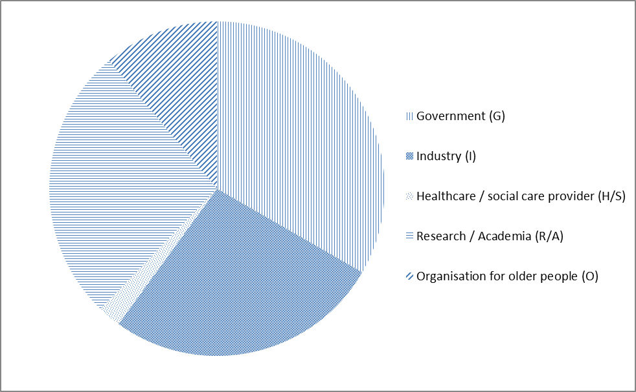
Figure 4 - Representation of different stakeholders in the interviews of the Interim evaluation of the AAL JP
The questionnaire covered six main areas: progress towards the objectives; financing measures by countries; integration with national programmes, European added value. The evaluation concluded that the programme was successfully meeting its objectives and stated that: "The AAL JP should be continued into FP8, as part of a coherent overall approach to research and innovation for demographic ageing." Most of the 45 recommendations are addressed in the options of this this Impact Assessment highlighting the following ones:
- ensure high operational performance
- further increase focus on technology in real life situations – implying a higher involvement of users in all stages of the R&D process.
- promote technology for carers and intermediaries as well as end-users – implying more focus on services and applications supporting (formal and informal) carers.
- focus more on broadly targeted solutions, usable by all;
- strengthen links with users and ensure deployment activities.
None of the options includes the recommendations concerning the harmonization of the financing and participation conditions as well as of project management.

1.4.3. Public online consultation on the AAL JP
The interim evaluation was complemented by an online public consultation from 1st June to 1st July 2010, to reach out to the wider public and other relevant stakeholders. Thirty-nine submissions were received (see Figure 5) of which 5% came from government institutions, 46% from the industry (e.g. Telephonica, Orange) including SMEs, 5% from the health and social care sector, 26% from the research and academia and 18% from the organisation representing the older people (e.g. AGE platform, European Federation of Retired and Elderly People, ONCE).
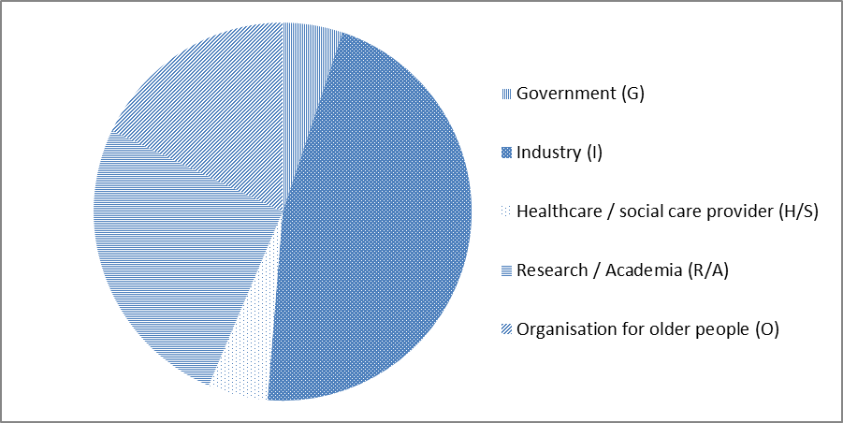
Figure 5 - Number of submissions to Public online consultation on the AAL JP by country
Key findings were that there is strong interest in participation in the programme and that
more emphasis is needed on end-user participation.

1.4.4. Consultation of the participating countries through the General Assembly AAL JP
As a follow-up to the Council conclusions on the Interim evaluation, a working group, was established to consult with participating countries on the options for a possible follow-up to the AAL JP under Horizon 2020. In February 2012 the AAL JP General Assembly in February 2012 concluded by vote that continuing the programme is of strategic importance, for the engagement of SMEs in the provision of effective solutions for active and healthy ageing, and as a major contribution to implementation of the EIP-AHA. In particular, 15 out of 23 currently participating countries expressed their preferred scenario recommended to improve the follow-up to the AAL JP with aligning its scope with that of the EIP-AHA, by broadening the basis of funding to all actors, and by improving the operational performance. The second preferred option was to continue the programme in its current form. Both of these options assumed co-financing from the EC. Only two countries would not support neither of these two options. As regards their ability to pay, it depends on the development of public finances. Nonetheless, so far only one of the AAL MSs had to withdraw from the calls. The current wave of consolidations of public finances in the EU seems to affect the level of financing in the AAL JP only marginally as the over-commitment by the MSs dropped to 30% this year.

1.4.5. Consultation of AAL JP participants on impacts and programme benefits
Two further consultations on the projects funded under the AAL JP (from end of 2010 and 2011) provide an early assessment of the projects, especially regarding the industrial sector. The first is an impact assessment provided by Finland on the rationale for national participation, based on contributions by 14 companies participating in AAL projects. The respondents to this consultation mainly stated that the AAL JP provides access to international market knowledge and partnerships, supports cooperation between demand and supply actors for innovation in ageing well, helps to develop new things and formulate the strategy of the participating organisations. The second consultation of AAL JP participants was carried out in 2011. A specific survey was conducted on the key indicators of 50 AAL JP projects from the first two calls, which were approaching the end of their funding cycle. It showed mainly that 25 % of respondents had gained access to funding beyond the project to commercialise the results and 50% of respondents had secured the IPR of their results for further exploitation. Further details are to be found in the section 5.1.1.

1.4.6. Consultation findings
The consultations and assessments gathered information across the whole AAL JP value chain: industry, SMEs, user associations, policy makers, research centres and universities, private individuals, project participants, and Member States. They all appreciated the added value of the AAL JP in balancing international governance and national needs, while increasing the critical mass of research on innovative ICT-based products and services for ageing well at the European level. The programme has reduced duplication of R&D efforts and improved the conditions for industry participation, in particular SMEs, - a key factor in establishing a critical mass in research at the European level.

The consultation process also helped to identify a number of barriers to innovation, especially regarding the possibility to participate for users and their organisations, the third sector and SMEs. These are:
- Lack of funding for trans-European innovation in the field
- Lack of (not locally limited) trans-European vision from participating SMEs
- Market fragmentation in terms of interoperability and standards;
- Legal uncertainty arising from the different national legal contexts;
- Fragmentation and insufficient coordination of the different financial instruments, eligibility rules and reimbursement systems.
- Insufficient user participation in two respects: their spread across EU (users came mainly from 4 MS) because of national funding restrictions, and user involvement in earlier phases of research, development and design of the applications and services.
- National funding criteria leading to non-eligibility for funding for users and their representative organisations in many Member States.
- A too long time-to-contract (9 weeks in the call 2) and time-to-pay (13 weeks in the call 2) for the AAL JP to be effective for some of the companies in the active and healthy ageing technology sector.

On the whole, the consultations generated several recommendations:
- Continue the Programme as it provides clear added value, in particular for SMEs, by creating the necessary critical mass in research at European level to help relevant products and services enter the market;
- Focus on how (mostly SME) regional innovation actors can understand and address the European market;
- Improve the operational efficiency, in particular regarding time to contracts and payments;
- Improve the involvement of users, service providers and in particular end users in call specification and evaluation, from the early stages of the project design.
The results of the consultations were taken into the account to shape the AAL JP2.

2. Problem definition

2.1. Responding to the Demographic Challenge
Demographic ageing accounts for an imminent and significant change in society and economy for which the EU is still not well-prepared. The age-dependency ratio (people under 19 or over 65 versus people between 20 and 64) is expected to rise from 63% to 95%." The resulting projected shortage of up to 2 million jobs in care and health by 2020 implies that 15% of work in the general healthcare sector is not covered. Ageing will significantly impact public as well as private finances. For the EU, it is projected that total government spending on pensions, healthcare, long-term care, unemployment benefits and education will increase by almost 20 per cent between 2010 and 2060. The actual costs for 2012 are already considerably higher than their projections in 2009. The expenditures for long-term care (1.8 % of GDP in 2010) would almost double between 2012 and 2060, including nursing and social care as well as medical components of long-term care. The AAL JP mainly focusses on these care segments.

EU-27 | % of GDP |  | growth % | GDP
 | 2010 | 2060 | 2010-2060 | 2010
Pensions | 11,3 | 12,9 | 22,5 | 1.384.045
Healthcare | 7,1 | 8,5 | 20,6 | 869.621
Long-term care | 1,8 | 3,4 | 84,6 | 220.467
Unemployment benefits and education | 5,7 | 5,2 | -4,1 | 694.472
Total | 25,9 | 30,0 | 19,8 | 3.168.605
Table 2 - EU government spending on pensions, healthcare, long-term care, unemployment benefits and education 2010 – 2060
Complementary to the ageing challenge are also the missed or underexploited market-opportunities. The markets for ICT-enabled products and services for ageing well are not mature enough to assess the full potential of their deployment. As an example, probably the most developed market is for social alarms and telecare. The highest penetration of such solutions among people over 65 years in 2010 was achieved in the UK and Ireland (16, resp. 14 %). Figure 6, covers those countries in which the market research was carried out.
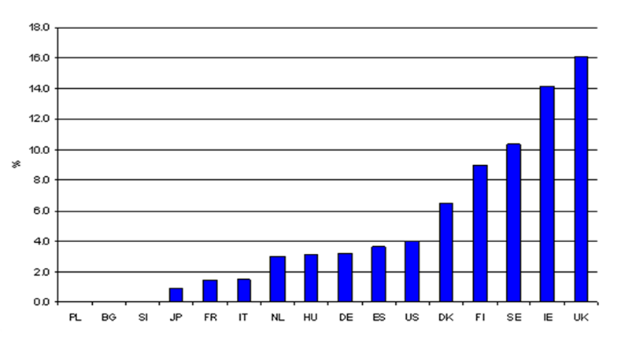
Figure 6 - Penetration of social alarms among people over 65 years old in %
There are no projections available of the full potential take up. Many solutions are still subject to research and development. Those that are actually deployed are most likely substantially more expensive than a fully realised market would allow, due to non-realisation of economies of scale. As monetary estimates would be too hypothetical, only the number of potential users has been estimated. According to Eurostat's population projections there were 87 million people over 65 years in the EU-27 in 2010. Two thirds of the causes of death of this cohort are diseases of the circulatory and the respiratory system, cerebrovascular diseases and diabetes. For all 56 million people suffering from these chronic conditions home telehealth solutions are available (from treatment to relieving the burden of living with such a condition). Experts however estimate that at present only 25% to 60% of this population might benefit from telehealth. The high spread is due to the varying levels of educational attainment and the legal environment across the EU Member States. The analysis also assumes that health conditions of some elderly allow the use of telehealth solutions. The estimated take up results in a potential market size of 14 to 33 million patients for 2010 in the EU-27, with an outlook to reach 24 to 59 million in 2060. This is only a lower bound as this is an example of telehealth and there are other types of solutions for the elderly. With more solutions becoming available, not only for telehealth, but also e.g. telecare and independent living, the market will grow further.
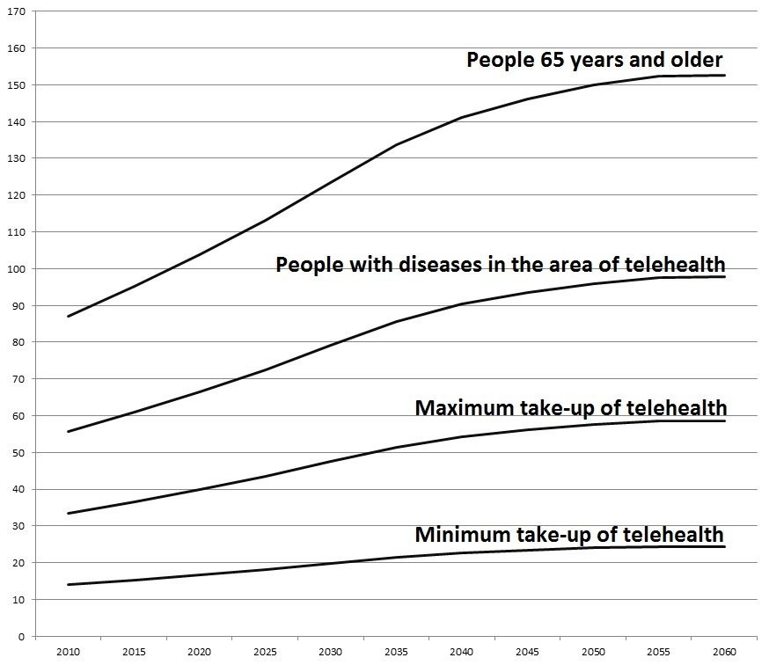
Figure 7 - Potential take-up of home telehealth solutions for the years 2010 to 2060 in millions of users

2.2. Key problems and their drivers
The findings on the key problems and their drivers have been corroborated during the Interim Evaluation and other consultations (see section 1.4).

2.2.1. Low market availability of innovative ICT products and services for Ageing Well
The actual scaling up of the take up and mainstreaming of innovative and relevant ICT-based products and services for ageing well in the EU market is low, and as a result prices stay high. Many players are SMEs that are mainly focussed on small scale solutions catering to local demand, enhancing the existing EU market fragmentation. According to the Interim Evaluation: most R&D and innovations of AAL JP appear also still to be taking place at the national rather than at European level and thus involve mostly actors with a national orientation and "There is still lack of real focus on a large scale European market […], there are still attitude barriers that limit progress as many actors remain orientated to national or local markets only."
The institutional embedding of ICT-based products and services for ageing well has not yet been established properly at national - let alone at a European - level. The required structures, prices and networks for trade to develop are hardly there and there is a lack of scalable business models and models for financing and reimbursement. Also lacking are international agreements on interoperability and international standards. These factors contribute to a fragmented AAL-market with high prices, high risks and consequently high transaction costs on the demand as well as supply side.
The immaturity of the market can also in part be attributed to a mismatch between supply and demand. Producers, companies and representative organisations lack information on the needs and demands of elderly. According to the Interim Evaluation Report (p.27) there is some concern, especially from SMEs and service providers that AAL JP is "too research-driven." To that can be added that this target group is rapidly changing as regards consuming habits, purchase power and technical capabilities. Main drivers of this problem are the fragmentation of the European market for ICT-based products and services for ageing well, a lack of real focus and vision on a large scale European or global market, and a lack of user involvement, especially in earlier stages of R&D and product development.

2.2.2. Fragmentation of Research Development & Innovation at European level
Also in the field of research and innovation at EU level on ICT for Ageing Well there is widespread fragmentation, with many local initiatives and a fragmented dissemination of results and unnecessary duplication or research endeavours. Current RTD efforts are not based on a comprehensive research agenda with critical mass, in spite of initiatives like BRAID and Futurage. The first is an EU-funded program to develop a comprehensive Research and Technological Development (RTD) roadmap for active ageing. Futurage was a Commission funded project to create the definitive road map for ageing research in Europe for the next 10 to 15 years, which was presented in October 2011.Especially SMEs can benefit from a well-established exchange of knowledge and R&D-results, as they do not have the means to accumulate this knowledge themselves.
Drivers of this problem are the high barriers for SMEs to participate in funding schemes, a lack of efficient dissemination of R&D results and the absence of a shared R&D agenda.

2.2.3. Limited adoption of innovation
For a wider adaptation and societal adoption of ICT based products and services for ageing well, it is necessary to overcome the lack of technical culture and low acceptance of new technologies by users (the primary users and other possible user groups). Their willingness to accept and accommodate new developments may also falter because of uncertainties around privacy, personal autonomy and information integrity. To solve this problem, AAL JP projects should involve users in the whole process (from research definition to system testing and dissemination).
In particular the role of the SMEs is a problem here. Their participation is high, but they lack a European perspective. As a consequence they do not deploy their products or services at a European scale and do not develop beyond small scale applications, often based on already existing technology. For AAL JP products and services to be competitive in global markets participants should engage in European-wide deployment, concentrating on high-quality sophisticated technologies and product concepts.
Finally the evidence on the results and effects of ICT for Ageing Well projects is not convincingly or sufficiently presented to the public authorities and insurance companies. As a consequence procurement or support for large scale market introduction is lagging.
Drivers for this problem are a lack of evidence building and sharing, the limited integration of SMEs in the business cycle (from RTD to market introduction), the lack of a European vision and the low acceptance of new technologies by users.

2.3. Achievements and lessons learned from the current AAL JP
The AAL JP has been designed to complement longer-term EU research on ageing in the upstream FP7, which focuses on advanced research with a time to market of 5-10 years. AAL JP addresses applied research on independent living systems and applications with a short-to-medium term horizon and a time to market of 2-3 years. The specific objectives of the current AAL JP are to:
- Foster the emergence of innovative ICT-based products, services and systems for ageing well at home, in the community, and at work, thus increasing the quality of life, autonomy, participation in social life, skills and employability of elderly, and reducing the costs of health and social care.
- Create a critical mass of research, development and innovation at EU level in technologies and services for ageing well in the information society, including the establishment of a favourable environment for participation by small and medium-sized enterprises (SMEs).
- Improve conditions for industrial exploitation by providing a coherent European framework for developing common approaches and facilitating the localisation and adaptation of common solutions which are compatible with varying social preferences and regulatory aspects at national or regional level across Europe.

The Interim Evaluation of 2010 showed a clear impact of the AAL JP in progress on its operational goals:
- A substantial progress to the development of innovative ICT-based products and services. Over 100 projects on ICT based solutions for older people and their carers have been launched.
- Extremely efficient leverage of financial means, with national financial contributions for the first 4 calls on average 36% above the required minimum of 50%, in spite of budgetary consolidations.
- High SME-participation of around 50% in the AAL JP in 2011 (compared to some 25%, in the FP7 ICT-programme), ensuring better support of economic growth. Under the first four calls 350 SMEs (of 1400 SMEs applying) were supported. The involvement of user organisations is also higher than in FP7, in spite of some Member States currently not allowing them to be eligible for funding.

Programme | AAL JP |  |  |  | FP7
Call | 1 - 2008 | 2 - 2009 | 3 - 2010 | 4 - 2011 | 7 - 2011
Large enterprises | 9% | 7% | 10% | 10% | 10%
SMEs | 38% | 46% | 49% | 52% | 25%
User and other organisations | 18% | 14% | 11% | 11% | 6%
Research organisations | 19% | 21% | 19% | 14% | 35%
Universities and other | 16% | 12% | 11% | 13% | 24%
Table 3 - Shares of organisation types in proposals submitted

- The network of AAL JP participants is a key factor in establishing a critical mass of research at European level. This new community has developed across Europe since the start of AAL JP, providing many contacts and opportunities for dissemination and commercialisation. The first four annual AAL JP Fora have gathered between 600 and 1200 participants and have become a major mobilisation of the actors in the value chain of ICT for Ageing Well.
- The volume of research and innovation generated across FP7, AAL JP and CIP (over one billion € from 2008 – 2013) makes the European ICT for Ageing Well initiative the world's largest in this area.

Call | 1 (2008) | 2 (2009) | 3 (2010) | 4 (2011) | 5 (2012) | Average
AAL MS (Mio. €) | 35 | 38 | 32 | 31 | 29 | 33
EC (Mio. €) | 24 | 23 | 23 | 23 | 23 | 23
Private (Mio. €) | 38 | 39 | 35 | 35 | 33 | 36
Total funding (Mio. €) | 97 | 100 | 90 | 89 | 85 | 92
AAL MS % | 36 | 38 | 35 | 35 | 34 | 36
EC % | 25 | 23 | 26 | 26 | 27 | 25
Private % | 39 | 39 | 39 | 39 | 39 | 39
Table 4 - The amounts and shares of financing of AAL JP calls from 2008 to 2012

A total co-financing of approximately 180 M € was committed by the participants in the first five AAL JP calls.

- Countries participating in AAL JP have developed an important set of good practices in open coordination and cooperation in innovation for ageing well. A number of national programmes and initiatives focused on ambient assisted living have emerged as a direct result of, or stimulated by, the AAL JP. These include the German national AAL programme, the Hungarian eVITA initiative for innovation opportunities in the healthcare system, the Spanish EVIA innovation platform and the UK Technology Strategy Board Assisted Living Innovation Platform (ALIP). For complete overview of national programmes co-financing the AAL JP see Annex II.

Apart from the achievements the Interim Evaluation provided some relevant lessons learned which have been taken into consideration when shaping the options (see section 4). Others will be covered by other initiatives on active ageing, in particular the EIP AHA. See section 2.5 on the Changing European Policy Context for a more extensive overview, and section 1.4 on consultations for lessons learned and recommendations.

2.4. Baseline scenario
The baseline or business as usual scenario is an AAL JP2 (follow-up of the AAL JP) for the period 2014 – 2020 identical to AAL JP1 (the current AAL JP) during the years 2008 – 2013. It entails a joint programme on innovation in ICT for ageing well, co-financed by the national participants and the EC under Horizon 2020. The scope of the AAL JP2 programme would remain the same as during the current period i.e. new ICT solutions supporting assisted and active ageing of older people. Continuation of the initiative beyond the current AAL JP co-decision would further accelerate the availability of innovative products and services for ageing well for citizens and public and private care providers. It would help scaling up the market and it would help Member States to attract European knowledge to their innovation environments, in particular for SMEs. It will help Europe to find new ways of tackling the ageing challenge through technological and social innovation. Continuation would prevent the emerging EU market for the technologies for ageing well from falling apart; as no other initiative to date helps sustain the eco-system for such a market to be viable and vital. The European Innovation Partnership on Active and Healthy Ageing would benefit from the AAL JP contribution to the delivery of innovative ICT based products and services ageing well, but only up to an extent, because only part of it area would be covered.

2.5. Changing EU Policy context
Since the launch of the AAL JP the ageing challenge has been put higher on the European policy agenda.
In 2010 demographic ageing has been identified in the Europe 2020 Strategy as both a challenge and an opportunity for smart, sustainable, and inclusive growth. The flagship initiatives “A Digital Agenda for Europe” and “Innovation Union” both address demographic ageing as a priority. The Digital Agenda focuses on ICT-enabled innovative services, products and processes, and includes several actions on eHealth and a specific action on reinforcing the AAL JP.
In the European Innovation Partnership on Active and Health Ageing (EIP AHA) digital solutions are to play an important role. Its Strategic Implementation Plan (SIP) sets out priorities for accelerating and scaling up innovation in active and healthy ageing across Europe, in the three domains prevention and health promotion, care and cure, and independent living and social inclusion. The launch by the Council of the EIP AHA enhances the future relevance of the AAL JP and it's follow up. AAL JP is a major component for implementing the SIP, as it focuses on the "Valley of Death" part of the innovation chain. Europe is usually weak in this segment and in particular SMEs have a clear need for public support in order to bridge the gap from research to market. The AAL JP-2 will also benefit from the EIP, because it contributes to market creation, large scale uptake and also to improved boundary conditions for the market: standardisation and interoperability for example, which are not covered by the AAL JP, but are mentioned in evaluation and consultations as barriers to deployment. For both initiatives to benefit from each other as much as possible a logical step is to align the scope of the AAL JP to that of the EIP AHA, as far as it is ICT and health-related.

Europe has a globally unique strength in ICT for ageing well with these inter-related programmes that jointly cover a significant part of the research and innovation ‘chain’.
With several research and innovation initiatives synergies can be further strengthened. Upstream, with the 7th Framework Programme’s ICT advanced research programme and the ICT Policy Support Programme of the Competitiveness and Innovation Programme (CIP ICT PSP), for which the AAL JP provides input for its innovation and market validation activities.
"More Years, Better Lives" is a Joint Programming Initiative (JPI) on demographic change that brings together 13 European Countries, to address new science based knowledge for future policy making on ageing, based on a wide range of research disciplines. The AAL JP can provide an application context for the JPI’s multi-disciplinary research and feed the JPI research agenda with user experience, while sharing research methodologies such as the life course approach.
In the Commission proposal for a Decision on the Strategic Innovation Agenda of the European Institute of Innovation and Technology (EIT) 2014-2020, "Innovation for healthy living and active ageing" is one of the priority themes for the EIT Knowledge and Innovation Communities (KICs) wave in 2014-2015.
Taken together, these initiatives cover a large part of the chain from fundamental research to market uptake, as recommended by a number of independent assessments on EU research and innovation programmes, as well as EU policy documents. This is further complemented by major national initiatives, like a major national initiative on AAL and ageing in Germany, an Assisted Living Innovation Platform in the UK and a platform on innovation in ageing in France.
The Commission's proposal for Horizon 2020, the Research Framework Programme for 2014-2020, has a specific section for societal challenges, with Health, Demographic Change and Wellbeing as one of the priorities. AAL JP is mentioned as one of the Article 185-initiatives that might get further support, if they meet a given set of criteria. In this respect the relevance of the AAL JP 2 objectives to Horizon 2020 are argued in section 3.1, while relevant information on EU added value, the efficiency of the art. 185-format (SME entrance barriers and leverage effect), as well as financial commitments and the critical mass of the programmes, is presented in the sections 1.4.2 and 1.4.6 on consultation findings. The sections 2.2.1 and 2.3 provide additional arguments on entrance barriers and critical mass.

3. Objectives
In line with the Europe 2020 strategy and its flagships Innovation Union and Digital Agenda for Europe and Horizon 2020, the overarching goal of the present initiative is to help address the ageing challenge and turn it into an opportunity for Europe. Thus the general objectives of the follow up to the AAL JP are:

3.1. General Objectives
In line with the Europe 2020 strategy and its flagships Innovation Union and Digital Agenda for Europe, as well as Horizon 2020, the overarching goal of the present initiative is to help address the ageing challenge and turn it into an opportunity for Europe. Thus the general objectives of the follow up to the AAL JP are:
- GO1: To improve conditions for the EU competitiveness in the field of ICT based products and services for active and healthy ageing by better exploiting the industrial potential of policies of innovation, research and technological development;
- GO2: To contribute to sound public finances and smart, sustainable and inclusive growth;
- GO3: To contribute to increasing R&D spending to 3% of GDP by 2020 (EU 2020 / H2020), as well as strengthening the European Research Area and scientific and technological bases in Europe;
- GO4: To focus future Union funding programmes more on Europe 2020 priorities by addressing societal challenges, in particular health and demographic ageing.

3.2. Specific Objectives
In order to meet the general objectives and help implementing the European Innovation Partnership on Active and Healthy Ageing, the following objectives must be pursued:
- SO1: Improve the quality of life for the elderly and their carers (and by doing so also benefit other people, in particular those with disabilities) and help increase the sustainability of care systems, by enhancing the availability of ICT based products and services for active and healthy ageing;
- SO2: Create a critical mass of trans-European research and innovation for ICT based products and services addressing active and healthy ageing, in particular involving SMEs and users;
- SO3: Leverage private investments and improve industrial growth potential by providing a framework for developing European approaches and solutions that meets varying national and regional social preferences and regulatory aspects.

3.3. Operational Objectives
In order to meet the specific objectives, the following operational objectives of the follow up to the AAL JP need to be applied:
- OO1: Further improve operational excellence and accountability for the programme;
- OO2: Reduce time to market, by facilitating user and industry-driven research
- OO3: Facilitate participation for all actors in the innovation chain, in particular SME, end-users and service providers, from the start and in all stages of the projects (e.g. through iterative and design and development approaches);
- OO4: To increase the number of participating Member States and to leverage private and national co-financing;
- OO5: To ensure complementarity with national programmes and EU level initiatives such as Horizon 2020, and align with the Strategic Implementation Plan of the European Innovation Partnership on Active and Healthy Ageing (EIP AHA).

3.4. How do objectives compare to the existing programme
The objectives continue those of the current AAL JP, but with some important additions:
- SO1 and SO3: implies looking into options for improving the continuation of projects downstream after funding has ended as well as looking for other funding options for projects with different times to market;
- SO2: implies improving the calls and projects to enhance their contribution to creating a trans-European vision on the products and services that are being developed or assessed;
- SO2 and OO3: implies including more end-users and service providers in all stages of the projects, en to ensure that all relevant stakeholders including end-user organisations are eligible for funding in all Member States.
- OO5: implies widening the scope of the Programme to match with the full scope of the EIP AHA (with a focus on ICT support).
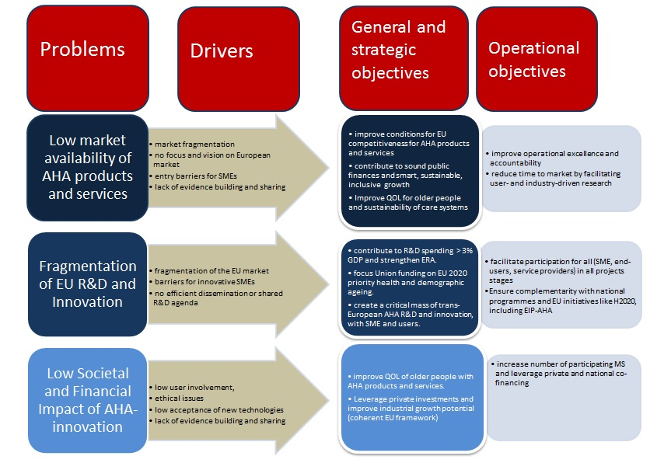 Figure 8: Problems, drivers and objectives for the AAL JP2

4. Policy Options

4.1. Options

4.1.1. Option 1 - AAL JP2 identical to AAL JP1
This business as usual option is the continuation of the AAL JP for the years 2014 – 2020, just as it has been done from 2008 to 2013. This option is set as a baseline as prescribed by the principles of consistency among all Article 185 initiatives.

4.1.2. Option 2 - No AAL JP2
This option would entail that there is no dedicated effort to bring together national programmes in the field of ICT for ageing well at the EU level for the years 2014-2020. The European dimension of actions in this field would have to be covered within the Horizon 2020 programme, while the leverage of the national and participant's including SME's co-funding would disappear.

4.1.3. Option 3 - AAL JP2 as reinforced and improved AAL JP1
This option of the follow-up to AAL JP1 would comprise adapted scope and improved implementation. It will be co-financed by the national participants and the EC (Horizon 2020). The scope of the AAL JP2 programme would be aligned to the full scope of the EIP on Active and Healthy Ageing i.e. covering the full range of ICT based innovation in active ageing and independent living and also eHealth care, including prevention. The implementation would be improved based on the recommendations of the Interim evaluation (see section 1.4.6) such as looking for other funding options for projects with different times to market or higher user-involvement. Due to the change of the scope, the name of the programme would change from Ambient Assisted Living JP to Active and Assisted Living JP.

4.2. Discarded options

4.2.1. No financial commitment EU to the ICT and ageing field
This option would mean that the EC would no longer dedicate financial resources to the ICT and ageing field, as neither AAL JP2 nor H2020 would foresee financing of the area. This would leave the financing of research to national and regional level authorities in the Member States, which would enhance the impact on the public finances and other aspects in the field of ageing. As in H 2020 financing for ICT and ageing has already been foreseen, this option is purely hypothetical. It has been introduced for the sake of consistency among all Article 185 initiatives.

4.2.2. No financial commitment EU: just light coordination
This option would require an ERA-net to coordinate of research activities on ICT and ageing in the Member States. This would be done through the networking of research activities, including the development of joint activities. This option was discarded as it would not offer a proper alternative to the actual running of a research programme.

4.2.3. AAL JP2 combined with JPI "More Years, Better Lives"
This option would combine the coordination activities of the existing Joint Programming Initiative "More Years, Better Lives" (JPI MYBL) and the AAL JP1. This option was discarded, because there are currently only 13 countries participating (11 EU Member States) to MYBL. Furthermore, the objective of MYBL is to produce new scientific knowledge on ageing related policy issues based on multi-disciplinary research being very different from AAL JP. This would require widening of the scope far beyond the AAL JP objectives. As the Member States organisations for MYBL are mostly very different from those involved in AAL JP, the combination of the two would require a far more complex governance structure. In their June 2012 meeting the AAL participating Member States have indicated that this is not their preferred option.

4.2.4. AAL JP2 combined with the follow-up Art. 185 EUROSTARs Initiative
This option would entail a merger between AAL JP and Eurostars JP. The Eurostars programme aims to stimulate R&D performing SMEs to lead international collaborative research and innovation projects, by easing access to support and funding. It is jointly funded by the EC and 33 EUREKA member countries. This option would offer SMEs an alternative to research-financing. However, the option was discarded as there would be no possibility to define any topic, so there would be no guarantee that research on ageing well would be funded. Up to now over 100 projects have been funded under the Eurostars Joint Programme. Although 40 % of the budget has been devoted to electronics, IT and telecoms technology, only one project can be identified as related to Ambient Assisted Living or ageing well. Furthermore, the projects financed under Eurostars would not offer the option to include 'big industry' players, academia, user organisations, and service providers. This mix is important to deliver results in a cross-cutting field like ICT and ageing, as has also been confirmed by the outcomes of the Interim Evaluation and consultations. The option was therefore discarded.

4.3. The right to act
Option 1 and improved AAL JP2 would require the preparation of a new co-decision by the European Parliament and the Council under Art 185 TFEU in order to provide for the continuity between the FP7/CIP and Horizon 2020 funding

4.4. Subsidiarity
The current AAL JP has provided a major opportunity to cooperate across Europe, to create critical mass and leverage investments. Technological barriers also have to be overcome by the development of interoperability standards at European international level. The Interim Evaluation strongly recommended continuing a similar programme beyond the FP7 timeframe as the ageing challenge and related opportunities require continuous efforts to be dealt with.
AAL JP2 would respect the proportionality principle, as the Member States themselves will be responsible for developing a joint strategic work programme and all operational aspects. The role of the Community is limited to providing incentives for improved coordination, as well as ensuring synergy with the relevant complementary activities in FP7 and the CIP. In the current AAL JP Member States have proven that a lightweight governance approach can be deployed with a large catalytic effect.
The budgetary impact and EU contribution of this initiative are already part of the Horizon 2020 proposal and budget. The actual budget allocation will be subject to the outcome of the H2020 decision and the financial commitments by participating countries.

4.5. Sensitivity and risk analysis
The sensitivity analysis takes into consideration the development of the crisis of the public finances in the EU as the major factor. The table 5 presents the various scenarios depending on the availability of the yearly funding of the AAL Member states for the period 2014 to 2020.

Scenario | AAL MSs | EC | Private | Total
Positive (Mio. €) | 50 | 23 | 49 | 122
Positive % | 41 | 19 | 40
Baseline (Mio. €) | 33 | 23 | 36 | 91
Baseline % | 35 | 25 | 40
Reference (Mio. €) | 23 | 23 | 31 | 77
Reference % | 30 | 30 | 40
Negative (Mio. €) | 12 | 12 | 16 | 40
Negative % | 30 | 30 | 40

Table 5 - Sensitivity analysis of contribution of the AAL Member states
The baseline scenario assumes that the willingness of the AAL Member states to contribute to the AAL JP2 would remain the same: 35% of the costs of the calls and projects. The EC contribution would remain 25% as stated in the Regulation. The remaining 40% would be private investment by project participants, which is the current pattern. The overall amount of financing would reach € 91 million.
The positive scenario assumes that the AAL Member states increase their contributions from the current € 33 million to 50 million. This would reduce the EC financing share to 19% as it is capped to € 23 million per year, which would increase the overall amount of financing to € 122 million.
The reference scenario assumes an equal share of financing by MS and EC, while utilising the maximum amount from the EC side, which is EUR 23 mil. Such scenario would generate an overall amount of financing of EUR 77 mil.
In the negative scenario the AAL Member states would be pressed by the consolidation of public finances to such an extent that they would have to halve their contributions. This would be comparable to the withdrawal from the call or programme of some half of the AAL Member states .That would reduce the overall amount of financing to € 40 million.
The sensitivity analysis of the impact of the economic crisis on the willingness of the programme participant to co-finance the projects was discarded, due to the great oversubscription of the proposals compared to the funds available. The calls of the AAL JP have been financing on the average one out of four projects. The economic crises even pronounced the interest in public funding which is confirmed in the call 5 of 2012, which allowed for financing of only one project out of five. Therefore the analysis is assuming in fact that there would be always some project participants that could afford and would be motivated to participate in the AAL JP call.

5. Analysis of the Impacts of the Options

5.1. Option 1 - AAL JP2 identical to AAL JP1
The Option 1 presents a baseline scenario, which assumes the AAL JP2 is implemented in the same form as AAL JP 2008-2013.

5.1.1. Economic impacts of the Option 1
Public authorities
GO2: To contribute to sound public finances and smart, sustainable and inclusive growth
ICT based products and services for active and healthy ageing can make care systems more efficient and sustainable. Evidence from the Scottish Telecare Development Programme suggests that telecare has resulted in the reduction of admissions to care homes and hospitals, and earlier discharges from the hospital, thus potential annual cost savings are substantial. As described in Section 2.1, especially long-term care costs are projected to rise dramatically in the future due to demographic ageing. ICT solutions could contribute to the containment of these costs and thus improve the long-term outlook for the sustainability of public finances.
SO1: Improve the quality of life for the elderly and their carers (and other people, in particular those with disabilities) and help increase the sustainability of care systems, by enhancing the availability of ICT based products and services for active and healthy ageing;
The current AAL JP generates fruitful approaches adopted by many industrial partners, service providers and user organisations to develop innovative ICT-based solutions, for example through integration into objects that elderly people already have and like to use. The focus is often on adapting simple and existing technology, like the TV, or a standard PC, and work with age-friendly interfaces like touch screen or talking to a camera. However, this does not mean that appropriate technology is necessarily available off the shelf. It often requires adaption in terms of reliability, interoperability and price. In addition, new ICT tools like smart phones for eHealth applications and tablets are being considered. Option 1 would support the further development of innovative ICT based products and services for the elderly, which might prove useful to other people, in particular those with disabilities. User involvement however would not improve, which would negatively impact the potential uptake.

Innovation and research
GO3: To contribute to increasing R&D spending to 3% of GDP by 2020 (EU 2020 / H2020), as well as strengthening the European Research Area and scientific and technological bases in Europe;
The Option 1 presents continued support to the research for ICT based products and services addressing active and healthy ageing. Besides leveraging public funding from the national level it also attracts a high share of private co-financing.
SO2: Create a critical mass of trans-European research and innovation for ICT based products and services addressing active and healthy ageing, in particular involving SMEs and users;
A critical mass of R&D and innovation implies a sufficient number of participants, sufficient cooperation, and sufficient total R&D and innovation activity to initiate a self-sustaining, productive and viable research environment. The current AAL JP booked progress mainly in already existing social or health care provision of professional carers. Much less research was related to the informal care sector or to new approaches such as community- or private-sector based care provision. As most R&D and innovation took place at the national rather than European level, mostly participants with a national orientation took part. The AAL JP 2 would attract new players and capacities for research and innovation. Convincing results would trigger more interest from policy makers and investors and thus enable larger scale deployment. It would be uncertain in case also new approaches would be part of it.

Competitiveness, trade and investment flows
SO3: Leverage private investments and improve industrial growth potential by providing a framework for developing European approaches and solutions that meets varying national and regional needs.
ICT for ageing offers huge opportunities for European industry and especially SMEs, as ageing has very predictable patterns, thus the long-term entrepreneurial risk is low. The development of ageing related markets across EU Member States is very asymmetric. Taking a closer look at the most developed markets can provide a picture of other markets in the foreseeable future. Early 2011 the market-readiness of the results of AAL JP projects of the first two calls was assessed. Given a 2 to 3 years time to market, it is still premature to conclude on the results. Nonetheless, the consultation of AAL JP participants carried out in 2011, provides indicators of the potential impacts of the projects:
Indicator | Findings
Industry as leader of AAL projects | On average 40% of projects are led by an industrial partner
SME participation | Over 50% of the project participants are SMEs
IPR secured | Nearly 50% of the projects have already secured IPR for results from the projects.
Financing secured for going to the market after the project end | Some 25% of the projects have already secured financing for going to the market
AAL related products and services emerging in the market | Many AAL projects intend to deliver new ICT products and services to the market, see Annex III
Table 6:Findings on the industrial exploitation of the AAL JP projects
The key indicators prove that the programme supports knowledge and experience sharing across sectors and borders, which stimulates larger scale industrial exploitation. They also indicate that AAL JP attracts many new entrants into the field, which contribute to create sufficient supply for mass deployment. However, the ageing outlook has worsened since the initial establishment of the Joint Programme, thus the research needs to advance to deliver results earlier (see Table 2 - EU government spending on pensions, healthcare, long-term care, unemployment benefits and education 2010 – 2060, and the accompanying comments). The focus on market exploitation would however not be strengthened under this option.

Functioning of the internal market and the competition
OO3: Facilitate participation for all actors in the innovation chain, in particular SME, end-users and service providers, in all stages of the projects;
The AAL JP has initialized establishing links among the key players in the field. The projects support cooperation among user organisations, policy makers, carer and user organisations, emergency services, venture companies, designers and ICT suppliers and producers. The AALA organises a whole set of workshops and seminars for interested professionals or those directly working the field of ageing. The growing number of participants to the annual AAL Forums since 2009 (from 600 to 1200) indicate that a genuine AAL community has formed. AAL JP2 would continue the annual forums and also the annual investment forums facilitating discussions between the solutions providers and funders. Still, these links are not mature enough to add up to a self-supporting working framework for financing the currently available solutions.
In the AAL JP 2 the programme participants would be encouraged to sustain this network. However the interim evaluation has pointed that users and service providers have not been sufficiently involved in all stages of the project and that the projects are probably too much technology driven. Under Option 1 these shortcomings would persist. Additionally, the current programme is marked by a lower participation of end-user organisations, due to their non-eligibility for funding under a research oriented programme in some Member States. Option 1 would not address this issue.

Consumers and households
OO2: To reduce further time to market, by facilitating user and industry-driven research.
The Joint Programme is based on co-financing. Initially half of the project costs should be financed by the project participants. As the Programme is driven by national participation rules, the funding rates can vary across the Member States. This has resulted in a lower level of financing as initially expected. The statistics for the first three calls show that the participants on average contribute 39% of the project costs. The current Programme would sustain that pattern, as it wouldn't impact any national rules.
Another aspect would be to support activities which help to exploit the project results in the market, by linking with Business Angels (e.g. the European Business Angel Network, EBAN), venture capitalists and institutional investors (like the EIB). For this purpose in 2011 the AALA launched the project AAL to business (AAL2B), which organised already five workshops attended with great interest. This project would be continued under the AAL JP2.

5.1.2. Social impacts of the Option 1
Employment and labour markets
GO1: To improve conditions for the EU competitiveness in the field of ICT based products and services for active and healthy ageing by better exploiting the industrial potential of policies of innovation, research and technological development
The field of ICT and ageing can have substantial effect on the job creation as it attracts professions with high added value. The direct impact of the AAL JP funding for the projects of the first three calls corresponds to 500 jobs for three years. There is a good perspective of these jobs being sustained beyond the project duration. If activities are terminated there is a high probability that project participants will be able to find another job, due to their enhanced educational or professional level. An indirect job creation effect stems from the employment related to large scale deployment of the solutions from the AAL JP projects.

Public health and safety
GO4: To focus future Union funding programmes more on Europe 2020 priorities by addressing societal challenges, in particular health and demographic ageing and OO5: To ensure complementarity with national programmes and EU level initiatives such as Horizon 2020, and align with the Strategic Implementation Plan of the European Innovation Partnership on Active and Healthy Ageing (EIP AHA), Under option 1, the scope of the AAL JP2 programme would remain the same. AAL JP2 would definitely contribute to the EIP AHA, but limited. AAL JP2 would continue to support ICT solutions for Alzheimer and other dementia diseases (see also section 2.1). Also the research of independent living solutions, telecare and smart environments that could mitigate costs associated with cognitive impairments would be continued. Secondly, the programme would support open and personalised solutions for the extension of active and independent living, thus improving their quality of life and employability. Thirdly, the programme would continue to support innovation, which improves the social inclusion of the elderly with the help of ICT solutions like communication applications or social networking. Nonetheless, the option to exploit synergies with the health care sector, including on prevention, would not be realized under this option.

Governance, participation, good administration, access to justice, media and ethics
OO4: To increase the number of participating Member States and to leverage private and national co-financing;
The AALA organised in 2012 an event for the Permanent Representations of the EU Member States to explain the benefits of participating in the AAL JP and thus stimulate their interest in the membership. AALA will dedicate a supporting measure to enlarging the AAL JP Membership. According to the design of the AAL programme National Funding Authorities (NFAs) and the European Commission should each provide a quarter of the project costs. The public funding should therefore caps to one half of the costs, which is much lower than the 75% FP7 financing rate. During the first five calls the average rate of national contribution has been substantially surpassing the EC contribution, showing strong support to the programme. The second half of the project budget should be financed by the project participants themselves. For the years 2014 to 2020 the annual EC contribution of € 25 million would remain the same as in the current AAL JP. As AAL JP2 would run for 7 years instead off 6, the EC contribution would amount to € 175 million. The current wave of consolidations of public finances in the EU will affect the level of financing in the AAL JP only marginally, as is evident from Figure 9. This is most likely due to the fact that research of new approaches in the long-term care canpotentially bring savings. If this distribution pattern of public financing is sustained, the Member States contribution could be expected to amount to more than € 200 million for the whole period. The AAL Member States contribution is part of the Sensitivity analysis in section 4.5.
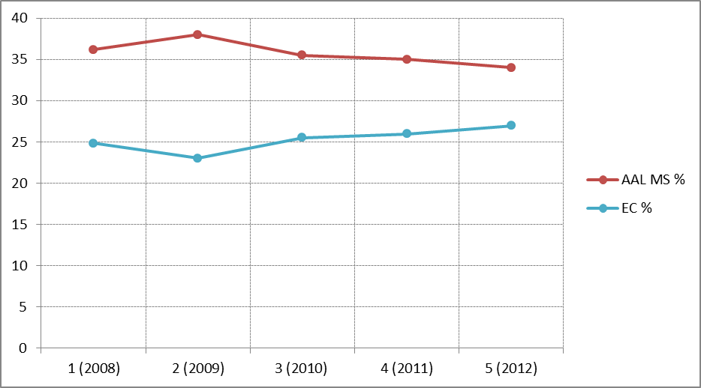
Figure 9 - The share of total costs of the financing of AAL JP projects by calls

5.1.3. Environmental impacts of the Option 1
Transport and the use of energy
SO1: Improve the quality of life for the elderly and their carers (and other people, in particular those with disabilities) and help increase the sustainability of care systems, by enhancing the availability of ICT based products and services for active and healthy ageing;
The deployed telecare and telehealth solutions imply less travel of patients and carers/doctors between homes, hospitals and institutions due to remote services like telemonitoring.

5.1.4. Other impacts of the Option 1
OO1: To achieve operational excellence and accountability for the programme;
The AAL Association (AALA) has set up a Central Management Unit (CMU) for daily programme operations. After the Interim evaluation has pointed to the understaffing and recruitment related delays, CMU staff has been doubled in 2012 and the post of director has been filled as well. This appears to be sufficient for its tasks. The CMU is further supported by the Executive and Advisory Board members, which are seconded and, in effect, paid for by their own organisations. The evaluation also indicated that times to contract and time to pay the projects were sometimes problematically long. The baseline scenario does not present a workable solution to this issue.

5.2. Option 2 - No AAL JP2
Option 2 would entail that there will be no dedicated effort to bring together national programmes in the field of ICT for ageing well at the EU level for the years 2014-2020. The leverage of the national funding would disappear, and actions with a European dimension would have to be covered within the Horizon 2020 programme.

5.2.1. Economic impacts of the Option 2
Public authorities
GO2: To contribute to sound public finances and smart, sustainable and inclusive growth
If the AAL JP is terminated, the progress of research related to cost saving with ICT solutions, especially in long-term care, would slow down. This would have an adverse effect on the long-term outlook for the sustainability of public finances.

SO1: Improve the quality of life for the elderly and their carers (and other people, in particular those with disabilities) and help increase the sustainability of care systems, by enhancing the availability of ICT based products and services for active and healthy ageing;
The quality of life of the elderly would improve later as the development of the new solutions would slow down.

Innovation and research
GO3: To contribute to increasing R&D spending to 3% of GDP by 2020 (EU 2020 / H2020), as well as strengthening the European Research Area and scientific and technological bases in Europe;
Under Option 2 the support for research on ICT based products and services for ageing well would stop. This would reduce substantially the overall amount of the finances available for the research projects (see section 6.1). There would be no leveraging of public funding from the national level and the share of private co-financing within the Horizon 2020 funded projects would be substantially lower.
SO2: Create a critical mass of trans-European research and innovation for ICT based products and services addressing active and healthy ageing, in particular involving SMEs and users;
The programme has built up a substantial community of participants, many of them currently cooperating on research projects. With termination of the AAL JP the links between the stakeholders across sectors and countries would weaken or disappear. This would have a detrimental effect on the field of ICT and ageing, especially regarding SME involvement. The EU would be left with a patchwork of local, regional and national initiatives on ambient assisted living, which would not be able to acquire the scope and scale needed for a structural contribution to tackling the ageing challenge and the creation of economic growth and jobs.

Competitiveness, trade and investment flows
SO3: Leverage private investments and improve industrial growth potential by providing a framework for developing European approaches and solutions that meets varying national and regional needs.
Presently the exploitation of ICT based products and services for active and healthy ageing only takes place in social alarms and telecare. Though earlier generations of social alarm systems are well-established in several Member States, the development of more advanced ICT solutions for an ageing population is still seen as a high risk field. Without a follow up to the AAL JP on many topics the step from research to more market and deployment-oriented activities will not be made. This is especially the case with respect to the transition to the service sector, while NGOs And SMEs which may find it difficult to grow beyond specific and local markets.

Functioning of the internal market and the competition
OO3: Facilitate participation for all actors in the innovation chain, in particular SME, end-users and service providers, in all stages of the projects;
The AAL JP has been organising annual AAL Forums since 2009, which gathered from 600 to 1200 participants. If no alternative to these events could be found, the links between participants would weaken. As the AALA would not organise workshops and seminars for professionals interested or directly working in the field of ageing, lots of fruitful cooperation could weaken or disappear. AAL JP projects would no longer serve as a platform for the multi-disciplinary discussions, which a field like ambient assisted living needs. In particular the participation of the SMEs was valued due to its potential for deployment. The termination of the AAL JP would negatively affect user-driven innovation. The feedback from older people is a necessary part of the design process, as they do not represent a homogeneous population group with regards to aspects like their health situation, personal needs, aspirations and living circumstances.

Consumers and households
OO2: To reduce further time to market, by facilitating user and industry-driven research.
The deployment of the ICT for active ageing products would be delayed as there would be fewer money and efforts invested into their research and development.

5.2.2. Social impacts of the Option 2
Employment and labour markets
GO1: To improve conditions for the EU competitiveness in the field of ICT based products and services for active and healthy ageing by better exploiting the industrial potential of policies of innovation, research and technological development
Much lower effect on the employment compared to the Option 1 due to the much lower level of funding available for the ICT based products and services for active and healthy ageing.

Public health and safety
GO4: To focus future Union funding programmes more on Europe 2020 priorities by addressing societal challenges, in particular health and demographic ageing.
Option 1 would address the health and demographic ageing by supporting research in this area with the employment of the ICT only at the EU level.
OO5: To ensure complementarity with national programmes and EU level initiatives such as Horizon 2020, and align with the Strategic Implementation Plan of the European Innovation Partnership on Active and Healthy Ageing (EIP AHA),
The AAL JP is currently based on pooling national and EU resources for joint calls, which enhances the coherence of strategy development on the national level. The national programmes in their turn bring the programme participants closer to national innovation clusters, getting them more involved. The benefits of joint calls as well as of build-up of the critical mass would weaken substantially if the programme were discontinued. Given the current economic climate, the AAL Member States would be unlikely to continue the trans European cooperation. Without follow-up of the AAL JP, one of the main providers of building blocks for the EIP AHA would disappear. EU level research and innovation on active and independent living, and also prevention and other synergies with the health care would have to be covered by other funding schemes like H2020, Structural Funds or Public Private Partnerships. Even if national funding would provide support to these topics, the European dimension would be lacking.

Governance, participation, good administration, access to justice, media and ethics
OO4: To increase the number of participating Member States and to leverage private and national co-financing;
Participation and leverage would be reduced to zero.

5.2.3. Environmental impacts of the Option 2
Transport and the use of energy
SO1: Improve the quality of life for the elderly and their carers and help increase the sustainability of care systems, by enhancing the availability of ICT based products and services for active and healthy ageing;
The deployed telecare and telehealth solutions imply less travel of patients and carers/doctors between homes and hospitals due to remote services like health monitoring. Under option 2 these savings would be limited compared to other options.

5.3. Option 3 - AAL JP2, as reinforced and improved AAL JP1
Under Option 3 the AAL JP2 would be continued with an adapted scope (to align with the EIP AHA) and an improved implementation. The Option 3 would be co-financed by the national participants and the EC (Horizon 2020). The scope of the AAL JP2 programme would widen compared to AAL JP1, and would cover the full range of ICT based innovation in active ageing and independent living and would also seek synergies with the health care sector including prevention. The name of the Joint Programme under this option could be changed to Active and Assisted Living, to accentuate this change of scope. The implementation would be improved in the light of the recommendations of the Interim evaluation (see sections 1.4.2 and 1.4.6).

5.3.1. Economic impacts of the Option 3
Public authorities
GO2: To contribute to sound public finances and smart, sustainable and inclusive growth
The positive impact of Option 3 on the long-term sustainability of public finances would be at least the same, but probably larger than under Option 1.
SO1: Improve the quality of life for the elderly and their carers (and other people, in particular those with disabilities) and help increase the sustainability of care systems, by enhancing the availability of ICT based products and services for active and healthy ageing;
See GO2 under this Option.

Innovation and research
GO3: To contribute to increasing R&D spending to 3% of GDP by 2020 (EU 2020 / H2020), as well as strengthening the European Research Area and scientific and technological bases in Europe;
Same as in Option 1.
SO2: Create a critical mass of trans-European research and innovation for ICT based products and services addressing active and healthy ageing, in particular involving SMEs and users;
The evaluation suggests that under the current AAL JP most progress takes place in already existing professional social or health care provision, as that is the everyday reality of professionals. There appears to be currently rather less progress in the informal care sector or in new approaches to elderly care and elderly services such as community- or private-sector based ones. Most R&D and innovation appear also still to be taking place at the national rather than at European level and thus involve mostly actors with a national orientation.
Building on the often successful community development at national level, research and development community development at European level should be further addressed. The AAL JP will continue organising conferences, workshops and support to the Programme users. Focus will be put on collaboration of different stakeholders in innovation also in view of the alignment to the EIP AHA.

Competitiveness, trade and investment flows
SO3: Leverage private investments and improve industrial growth potential by providing a framework for developing European approaches and solutions that meets varying national and regional needs.
Same as in Option 1

Functioning of the internal market and the competition
OO3: Facilitate participation for all actors in the innovation chain, in particular SME, end-users and service providers, in all stages of the projects;
The AAL JP serves as a platform for sharing experiences and disseminating research results as described in the baseline. The Programme would continue organisation of annual AAL-forums, as well as workshops to sustain the current level of fruitful cooperation, while the Investment Forum has opened the discussion with stakeholders important for the deployment. As the links are still not mature enough (see sections 1.4.4 and 1.4.5), Option 3 would strive for strengthening them. The mix of project participants has been improving throughout the Programme, with SME participation surpassing 50% in the fourth call, which seems to be optimal share for the deployment and exploitation of the project impacts. The programme participants would then be encouraged to sustain this level.
The interim evaluation (see sections 1.4.2 and 1.4.6)has pointed out the that the Programme does not sufficiently involve users and service providers in all relevant stages of the projects. The Option 3 would focus more on technologies developed in real life situations, possibly also in a living labs context. Appropriate technologies have to match technological and ambient assisted solutions with the actual ability of elderly people to use them in their daily routines. The AAL JP2 will stress working more closely with users in real life situations, while products and services should be developed with real user involvement to avoid missing the market. Appropriate technology will have to take account of real life and factor this into the development from the start of the project.

Consumers and households
OO2: To reduce further time to market, by facilitating user and industry-driven research.
The co-financing principle would be sustained in the AAL JP2 in order to ensure continued sufficient involvement of the industry. As the funding rates vary across the Member States, the Programme would sustain the current pattern of 60% of public and 40% of private funding. The AALA's supporting action AAL2B will continue supporting introduction of their results into the market.

5.3.2. Social impacts of the Option 3
Employment and labour markets
GO1: To improve conditions for the EU competitiveness in the field of ICT based products and services for active and healthy ageing by better exploiting the industrial potential of policies of innovation, research and technological development
Same impacts as in the Option 1.

Public health and safety
GO4: To focus future Union funding programmes more on Europe 2020 priorities by addressing societal challenges, in particular health and demographic ageing.
Under option 3 the health and demographic ageing challenge would be addressed earlier of more effective than under Option 1, as it aims at a closer time to market.
OO5: To ensure complementarity with national programmes and EU level initiatives such as Horizon 2020, and align with the Strategic Implementation Plan of the European Innovation Partnership on Active and Healthy Ageing (EIP AHA),
The scope of AAL JP2 under Option 3 programme widens compared to the business as usual option. This re-focussing would make the best use of synergies between the experiences from the current AAL JP activities and the new areas of intervention. This option would then cover the full scope of EIP AHA with regard to ICT solutions in the following way:
1) Active Ageing and Independent Living theme would be covered same as under Option 1.
2) The Option 3 could additionally cover the ICT support to the Theme Prevention, screening and early diagnosis. This includes topics like health literacy, patient empowerment, ethics and adherence programmes, using innovative tools and services The WHO suggests that additional costs of limited health literacy range from 3-5% of the total health care cost per year. The Option 3 could focus on support to innovative tools and applications for delivering a prescription and adherence action at regional level as well as promotion of health literacy and patient empowerment for informed lifestyle choices. The programme could also contribute to a pan-European online community using ICT based solutions and social marketing methods. Furthermore, there would be attention paid to personalised health management Recent UK-based research, exploring outcomes of a range of co-produced interventions, demonstrated that the health-related quality of life of older people improved by between 3-12%, whilst reducing hospital stays by 47%. The Option 3 could contribute to the implementation of validated and operational programmes for prevention and early diagnosis of specific chronic conditions e.g. cardiovascular, diabetes, Alzheimer’s/dementia, Parkinson’s Disease and fall prevention. Lastly, prevention and early diagnosis of functional decline, both physical and cognitive, in older people could be supported as the prevalence of disabilities increases dramatically with age, from 30% in those aged 65 to 74 to 50% in the 75-84 age group and 80% for those over 85. The Option 3 could support validation of programmes for prevention of functional decline and frailty (with first action focused on physiological frailty and malnutrition) among older people supported by tools, networks and information reaching care providers across the EU.
3) The Option 3 would additionally cover the ICT support to the Theme Care and Cure
This includes protocols, education and training programmes for health professionals, care personnel, informal/family carers. Chronic conditions, such as heart failure, respiratory and sleep disorders, diabetes, obesity, depression, pain, dementia, and hypertension affect 80% of people over 65, and often occur simultaneously (multimorbidity). The Option 3 could support projects focused on developing protocols for management of co-morbidities including polypharmacy. Furthermore it could facilitate the implementation of education and training programmes and dissemination of teaching manuals for health professionals, care personnel and informal/family carers with special attention to emerging roles and case management programmes, for example on frailty, multi-morbidity and remote monitoring. There could be also training for end-users like carers and patients on how to use new tools for personalised case management. Furthermore, the Option 3 could support research and development in order to explore personalised case management and chronic care models which represent individual patients' profile and support self-care, based on optimal management and personalisation tools. This could include the exploration of IT support for patients and providers such as artificial intelligence for complex situations, including evidence based cost-effective/efficient assessment. Finally, the Option 3 could be also dedicated to replicating and tutoring integrated care for chronic diseases, including disease/case management models with remote monitoring at regional level. It could support the development of new generations of tools and services for more effective chronic conditions management, assisted self-management for home and integrated care.

Governance, participation, good administration, access to justice, media and ethics
OO4: To increase the number of participating Member States and to leverage private and national co-financing;
Same as in the option 1

5.3.3. Environmental impacts of the Option 3
Transport and the use of energy
SO1: Improve the quality of life for the elderly and their carers (and other people, in particular those with disabilities) and help increase the sustainability of care systems, by enhancing the availability of ICT based products and services for active and healthy ageing;
The deployed telecare and telehealth solutions imply less travel of patients and carers/doctors between homes and hospitals due to remote services like health monitoring.

5.3.4. Other impacts of the Option 3
As regards to shortening the time to contract and time to pay, under the improved AAL JP2 Member States will be asked to comply with the agreed performance targets for which will be regular monitoring. Regular check on the performance would be brought to the attention of the General Assembly of the AALA and to the EC for corrective action.

5.4. Assessment of the administrative costs
The AAL JP could serve for the EC as a model for outsourcing by using the indirect centralized management modality. The administration of the AALA accounts currently for seven employees with a budget composed of 6% of the EC contribution as well as AAL Member States membership contribution. The administration of EC dedicated to the AAL JP assumes two part-time employees which are also involved in other tasks.

5.5. Assessments of the simplification potential
The AAL JP is simple to use to for the project participants namely the SMEs compared to the FP7 and CIP as they have to follow the national rules. According to a study of the EC, more than half of the FP7 participants think that the national rules for participation in research and innovation programmes are less complex and difficult than the European ones (Table 7). As the AAL JP is based on the national rules of participation in the research programmes, it effectively lowers barriers for access to funding, especially for SMEs, with the added benefit that participating via national programs brings them in closer contact with national innovation clusters.
Complexity | 2008 | 2009
FP7 is less complex compared to the national rules of participation | 17 | 17
FP7 is about the same compared to the national rules of participation | 25 | 22
FP7 is more complex compared to the national rules of participation | 47 | 54
Table 7 - Complexity of the use of the Framework Programme 7 compared to the national rules of participation
The Interim Evaluation has also confirmed the user friendliness of the AAL JP compared to other funding schemes.

6. Comparison of Options

6.1. Comparison by the costs and benefits
The first criterion against which the options could be compared are the costs and benefits of the AAL JP. The costs are varying according to the levels of co-financing between the EC and the other two sources, which are AAL Member states and the programme participants. The first scenario pictures the programme being financed by all three sources. As the continued and improved AAL JP 2 options count on their financing, the yearly leveraged funds from the AAL Member states would amount to € 33 million €, compared to zero under the termination option. The continued and improved AAL JP2 options assume 35 % of financing by AAL Member States, 25 % by the EC and 40% by project participants. This means that the EC can leverage a total amount of € 91 million by investing its € 23 million. In the scenario of the termination option, the AAL Member States would not contribute to the AAL JP2 at all, and the participants contribution would be governed by H2020 rules. If this would be based on FP7 rules, with a participant's maximum contribution of 25%, the leverage would not be € 91 but € 31 million, given the same amount of EC investment of € 23 million.
 | Option 1 - AAL JP2 identical to AAL JP1  Option 3 - AAL JP2, as reinforced and improved AAL JP1 |  | Option 2 - No AAL JP2
 | 2014-2020 | yearly | 2014-2020 | yearly
AAL MS (Mio. €) | 228 | 33 | 0 | 0
EC (Mio. €) | 161 | 23 | 175 | 23
Private (Mio. €) | 249 | 36 | 58 | 8
Total funding | 637 | 91 | 233 | 31
Table 8: Level of co-financing

As the AAL JP is a research programme the benefits are not measurable as they depend on the projects outcomes and their take-up. However the emerging evidence suggests that the ICT solutions could contribute to the containment of these age-related health and long-term care costs and thus improve the long-term outlook for the sustainability of public finances. Evidence from the Scottish Telecare Development Programme suggests that implementation of telecare results in the reduction of admissions to care homes and hospitals, and in earlier discharges from the hospital. Potential annual cost savings as a result of avoiding hospitalisation of the elderly because of the implementation of telecare could be substantial. The AAL JP supports projects where ICT based solutions serve for prevention and management of chronic conditions as well as home care of the elderly. For example the Health @ Home AAL project focuses on the chronic disease management cost reduction by the use of personal health systems. Those can help save in lives and resources by focusing on prevention and prediction rather than on costly medical interventions after symptoms and disease have developed. The project explores the possibilities of cost reductions by enabling remote self-management of chronic disease and improving the care systems. Many other AAL JP projects (further examples can be found in the Annex II) deliver similar findings in the area of ICT and ageing. As presented in the section 2.1. the potential number of users of telecare and telehealth systems in the EU ranges between 24 to 59 million by 2060, which would have its cost saving effect on the public finances depending on the deployment.

6.2. Comparison by mix of the project participants.
The Interim evaluation highlighted positively the high proportion of the SME participation. Both the continued and improved option would retain the current level of their participation, which is 50%. Furthermore it pointed out the underrepresentation of user organisations in the Programme. The improved option suggests more than tripling the involvement of users or their respective organisations. As the AAL projects have usually at least five partners, at least one of them can be assumed to come from the user side, thus targeting 20%. Lastly the Interim Evaluation pointed out that projects are too research driven. Under the improved option involvement of research bodies would be lowered.
Option | Option 1 - AAL JP2 identical to AAL JP1 | Option 2 - No AAL JP2 | Option 3 - AAL JP2, as reinforced and improved AAL JP1
Large enterprises | 10% | 10% | 10%
SMEs | 52% | 25% | 50%
User and other organisations | 11% | 6% | 20%
Research organisations | 14% | 35% | 10%
Universities and other | 13% | 24% | 10%
Table 9: The mix of the project participants

6.3. Comparison by the distance to the market of the project results
Under Option 1 (AAL JP2 identical to AAL JP1) the distance to the market would be further reduced because of continuation of the AAL JP process would help achieve the critical mass of applied research and development needed to create a more mature market for products and services for ageing well.
Under Option 2 (termination) no coordinated and funded applied research at European level would take place. This would leave a gap in the innovation chain between upstream (more fundamental H2020) research and downstream (pilot)activities (such as CIPs). This would create a greater distance to market for products and services for ageing well.
Under Option 3 (AAL JP2, as reinforced and improved AAL JP1) the distance to market would be reduced the most, as the alignment with the EIP on Active and Healthy Ageing would lend focus to the AAL JP projects, which moreover could benefit from the deployment on topics like prevention, medication adherence and integrated care by the Action Groups.

6.4. Comparison by the impact on the EIP AHA
The Option 3 would present better alignment to the EIP AHA as it would cover its all three themes compared to Options 1 covering just one theme and Option 2 not covering any theme.

6.5. Overall comparison of the options
The overall comparison below illustrates whether the Options achieve the proposal objectives, and if they comply with the overarching objectives of EU 2020, H2020 and EIP.
Options | Option 1 - AAL JP2 identical to AAL JP1 | Option 2 - No AAL JP2 | Option 3 - AAL JP2, as reinforced and improved AAL JP1
Economic impacts
Public authorities | + | - | ++
Innovation and research | + | - | +
Competitiveness, trade and investment flows | + | - | +
Functioning of the internal market and the competition | + | - | ++
Consumers and households | + | - | ++
Social impacts
Employment and labour markets | + | - | +
Public health and safety | + | - | ++
Governance, participation, good administration, access to justice, media and ethics | + | - | +
Environmental impacts
Transport and the use of energy | + | + | +
Summary | + | - | + / ++
Table 10: Overall comparison of the options

6.6. Preferred option
Option 3 is the preferred option.

7. Monitoring and Evaluation

7.1. Monitoring
The AAL JP2 would be monitored by the AALA continuous basis and by the EC on annual basis. The indicators would be used to check if implementation is on track and the extent to which the AAL JP is achieving its objectives. Most of the data for the indicators are already available by extracting it from the AALA evaluation and project monitoring system, to which the national contact point feed in the information. The remaining data will be provided by Market observatory, which will be set up by the AALA to follow-up more closely the exploitation of the project results and compare them with other on-going activities. Additionally, the EIP monitoring system will be used for the purposes of AAL JP monitoring. It will address among other some areas which are relevant to the Programme. Firstly, it will gather the evidence, reference examples create repository for age-friendly innovation in order to establish a shared basis of sound, robust data and reliable methodologies, to enable exchange and dissemination of tested and proven practices, as well as to help in replication and scaling up of successful cases. Secondly, the EIP monitoring system will set up an marketplace to facilitate cooperation among various stakeholders in order to link up interested stakeholders to create partnerships implementing innovative solutions; facilitate innovation and knowledge transfer by networking between individuals and organisations, in the EU and internationally. The monitoring results would be reported to the EC and the General Assembly of the AAL JP.
Indicators (in bold) have been grouped by their repose to the objectives (objective codes are corresponding to the Section 3):

Indicators related to the general objectives:
GO1: Percentage of projects lead by the industrial partner and Percentage of funds being spent by the SMEs in the projects (also applicable to OO2)– The target is to maintain the current level. Percentage of projects for which intellectual property has been secured and Percentage of projects for which financing beyond the funding from the AAL JP is secured for going to the market - The target is to either maintain or increase the current level. Number of Member States able to fund all types of participants (also applicable to OO3) – The target it to achieve that at least 10 Member States would be able to fund all types of participants. The data would be gathered by the AALA.
GO2: Amount of evidence on cost saving measures due to the use of ICT for aging – The target is to consolidate the evidence through the use of EIP monitoring system.
GO3: Total amount of co-financing by the project participants and the Member States contributing to R&D spending and realisation of the European Research Area in the field of ICT for ageing and Total amount of SME's funding in the projects and Number of participants in annual AAL JP Forum. The target is to either maintain or increase the current levels. The data would be gathered by the AALA.
GO4 and OO5: Contribution of AAL JP2 projects to implementation of Strategic Implementation plan of EIP-AHA – The target is to give the possibility to cover three themes of EIP-AHA.

Indicators related to the specific objectives:
SO1: Percentage of funds being spent by user organisations and service providers in the projects (also applicable to OO3) – Target will be increase the percentage and will be monitored by AALA. Increase in sustainability of care systems by enhancing the availability of ICT based products and services for active and healthy ageing – The target is to consolidate the evidence through the use of EIP monitoring system.
SO2: Number of participants in the AAL JP and Number of participants in annual AAL JP Forum (also applicable to OO3) –– Target will be achieve slight increase. Percentage of funds being spent by user organisations and service providers in the projects – Target will be increase the percentage. Percentage of funds being spent by the SMEs in the projects – Target will be to maintain the current level. The data would be gathered by the AALA.
SO3: Percentage of participant's funding in the projects (also applicable to OO4) - The target is to either maintain or increase the current level. The data would be gathered by the AALA.

Indicators related to the operational objectives:
0O1: Time between the approval of the evaluations ranking and the project contract signature (time to contract) and Time between the receipt of the request of the payment form the project and the payment realisation (time to pay). The target is that all Member States' maximum time span is lower than average of all plus 10 %.
0O2: Percentage of projects resulting in new products, systems and services in the market - The current projects are scheduled to deliver to the market earliest by 2015, therefore the target would be to reach a least 25% of all running projects by 2020. The data would be gathered by the Market observatory of the AALA.
0O4: Number of participating Member States - The target it to achieve an increase from the current number of Member States of 23. The information would be gathered by the EC. Percentage of Member States' funding in the projects - The target it to achieve the same level or increase. The data would be gathered by the AALA.

7.2. Evaluation
A mid-term evaluation will be carried out after 3 years with independent experts as it was done from the AAL JP1 in 2010. This means that an assessment of the AAL JP2 will take place in 2017 in order to evaluate the quality and efficiency of the implementation, including scientific, management and financial integration of the AAL Joint Programme. Particular attention will be paid to the possible continuation of projects downstream after funding has ended, to the trans-European dimension of the products and services, to the inclusion of end-users and service providers in different stages of the projects as well as to the alignment of the scope of the Programme to that of the EIP AHA. In its proposal for Horizon 2020, the Commission has identified a number of criteria for assessing potential initiatives under Article 185.

8. Annexes

8.1. Annex I: Table of figures
Figure 1- AAL JP governance and operational structure 4
Figure 2 - Representation of different stakeholders in the consultation on the EIP-AHA 6
Figure 3 - Significance of the barriers to the innovation in the area ICT and ageing according to the stakeholders (percentage) 7
Figure 4 - Representation of different stakeholders in the interviews of the Interim evaluation of the AAL JP 8
Figure 5 - Number of submissions to Public online consultation on the AAL JP by country 9
Figure 6 - Penetration of social alarms among people over 65 years old in % 12
Figure 7 - Potential take-up of home telehealth solutions for the years 2010 to 2060 in millions of users 13

8.2. Annex II: List of current national public sources for the co-financing of the AAL JP calls in 2012
 | AAL Member State | Source of the funding
1 | Austria | BMVIT – Austrian Federal Ministry for Transport, Innovation and Technology.
2 | Belgium | IWT – Agency for Innovation by Science and Technology,. Flemish funding programme "O&O Bedrijfsprojecten".
3 | Switzerland | Federal Office for Professional Education and Technology.
4 | Cyprus | Research Promotion Foundation.
5 | Germany | Federal Ministry for Education and Research.
6 | Denmark | Danish Agency for Science, Technology and Innovation.
7 | Greece | Currently not participating in the calls.
8 | Spain | Ministry of Science and Innovation/ ISCIII – Instituto de Salud Carlos III. "Strategic Action for Health Research within the R+TF+I National Plan 2008-2011" and Ministry of Industry, Tourism and Trade.
9 | Finland | Tekes – Finnish Funding Agency for Technology and Innovation.
10 | France | ANR – French Research Agency and CNSA – French National Fund of Solidarity for Autonomy.
11 | Hungary | The National Office for Research and Technology
12 | Ireland | Enterprise Ireland.
13 | Israel | Ministry of Industry, Trade and Labour. "Encouragement of Industrial Research & Development law 57744-1984".
14 | Italy | MIUR - Ministero dell'Istruzione, dell'Università e della Ricerca. FAR (Fondo Agevolazione alla Ricerca).
15 | Luxemburg | Luxinnovation – Agènce Nationale pour la Promotion de l'Innovation e de la Recherche. Fond National de la Recherche. INTER/AAL Programme.
16 | The Netherlands | Ministry of Health, Welfare and Sport.
17 | Norway | The Research Council of Norway. IT Funk.
18 | Poland | National Centre for Research and Development.
19 | Portugal | UMIC - State Organization Knowledge Society Agency.
20 | Romany | Ministry of Education, Research, Youth and Sport. programme "Partnership".
21 | Slovenia | Ministry of Higher Education, Science and Technology.
22 | Sweden | VINNOVA – Governmental Agency for Innovation Systems.
23 | United Kingdom | Technology Strategy Board. programme "Assisted Living Innovation Platform".

8.3. Annex III: Examples of AAL projects and their business plans
SOFTCARE
Many elderly have a 'classic' alarm button they have to push themselves. With ICT more than that can be done. SOFTCARE project develops a system that alarms them or their carers (professionals or family) if something bad happens like for example falling asleep in bath. Even better, it also warns them on long-term trends that could indicate future problems (proneness to falls). These issues could be identified early enough to reduce admissions to care homes and hospitals. The SOFTCARE business plan estimated revenues for 2013 to 2018. Three devices are required: a wrist worn device, a static node and a main node. Users will pay for directly or indirectly for the devices, installation, call and data centre, testing, market research, sales and marketing. This would require an initial investment of € 4.5 million and € 4 to 8 million operational costs per year. If the project develops as planned, in 2018 there will be 100 000 users, with a projected revenues of € 66 million.

HOMEdotOLD
Older people living by themselves run the risk of becoming lonely and isolated. The HOMEdotOLD project helps them stay in touch with the world around them and have a social life, even if they are not able to easily go out of the house. The can share a 'remote dinner' with distant friends, or exchange photos with relatives. They can keep their calendar and receive personalised news. All on their own trusted TV, via existing services and protocols (e.g. Picasa, Skype, RSS feeds). This increases marketability for a family context where other family members already make use of these popular services. For the business plan of HOMEdotOLD it is assumed that the user pays a standard fee to the NET TV service provider (either cable company or ISP) for a HOMEdotOLD social service bundle. It is estimated that in 2017 there will be total revenue of €1.427.000.

ExCITE
Older people need care, but carers can't always be there due to substantial costs. The ExCITE project allows an experience close to the real thing. A remotely controlled robot with videoconferencing system allows caregivers to virtually visit older people, move about and look around in their house, and talk with them. The project has deployed currently 25 Giraff robots in 6 countries (Sweden, Denmark, Norway, Germany, Italy, and Spain) and will soon deploy 15 more. In 2012, the robot producer Giraff Technologies AB estimated in its five-year financial forecast revenue of 7.5 million SEK with 119 units sold in the European AAL market alone. By 2015 the revenue is projected to be 378.1 million SEK with 5,123 units sold.

IS-ACTIVE
The IS-ACTIVE system helps people with chronic diseases (like COPD) lead an active life. Via a sensor network it monitors their physical activity and condition and gives practical feedback, to inspire them to manage their own health and life. The IS-ACTIVE system consists of an activity sensor node, a mobile application on smart phone and a web-based application. Initially it will be sold to the health care institutions treating people with chronic disorders for which an active life style is relevant. The project is targeting the fast growing a market of COPD, with 44 million patients in Europe, 24 million in USA and 56 million in Asia.

Article 21 of Commission Regulation (EC, Euratom) No 2342/2002 laying down detailed rules for the implementation of Council Regulation (EC, Euratom) No 1605/2002 on the Financial Regulation applicable to the general budget of the European Communities (OJ 2002/L 357/1).
See http://www.aal-europe.eu
? http://www.a2e2.eu/5
As of October 2012 the AAL JP consisted of 19 EU Member States: Austria, Belgium, Cyprus, Denmark, Finland, France, Germany, Hungary, Ireland, Italy, Luxembourg, the Netherlands, Poland, Portugal, Romania, Slovenia, Spain, Sweden and the United Kingdom and 3 associated countries: Israel, Norway and Switzerland. Greece is currently not taking part in the calls for proposals.
Decision no 742/2008/EC of the European Parliament and the Council of 9th July 2008
See http://ec.europa.eu/health/ageing/consultations/ageing_cons_01_en.htm, for the full report, the list of respondents and the questionnaire.
See http://ec.europa.eu/information_society/activities/einclusion/docs/aal/interim_evaluation_report.pdf
Conclusions of the Competitiveness Council of 30 May 2012
http://www.tekes.fi/fi/gateway/PTARGS_0_201_403_994_2095_43/http%3B/tekes-ali1%3B7087/publishedcontent/publish/fi_content/news/aal/aal_mid_term_evaluation_net_effect_final.pdf
Source: Finnish Involvement in the Ambient Assisted Living Joint Programme: Mid-Term Evaluation, 2010
Source, p 56 of The 2012 Ageing Report; Economic and budgetary projections for the 27 EU Member States (2010-2060) [European Economy 2|2012 (provisional version).] Http://ec.europa.eu/economy_finance/publications/european_economy/2012/pdf/ee-2012-2_en.pdf
European Commission’s preliminary own estimates based on EUROSTAT and OECD data
COM(2009) 545, 17 Sept 2009
The 2012 Ageing Report; Economic and budgetary projections for the 27 EU Member States (2010-2060) [European Economy 2|2012 (provisional version).] Http://ec.europa.eu/economy_finance/publications/european_economy/2012/pdf/ee-2012-2_en.pdf
Empirica and WRC (2005): Various Studies on Policy Implications of Demographic Changes in National and Community Policies. LOT 7: The Demographic Change – Impacts of New Technologies and Information Society, Final Report
Quotations on respectively page 27 and 32.
See http://auseaccess.cis.utas.edu.au/ for publications, outcomes, final conference and summary.
See http://futurage.group.shef.ac.uk/resources.html.
FP7 report, Spring 2010, European Commission, DG-Research
Average SME participation in the whole FP7 ICT programme is 14.4% (FP7 report, Spring 2010, European Commission, DG-Research).
The data shown for both programmes are for submitted proposals. As the data for ranked proposals (i.e. those eligible for funding) are not presented as they are very similar.
COM(2010)2020, 3 March 2010
COM(2010)1161, 6 Oct 2010
COM(2008) 468, towards Joint Programming in research
E! 5287 DIYA project Digital Inclusion Youth & Ageing. It concerns a 'Platform for digital inclusion of Europe’s ageing population with a Mobile Social Software turnkey solution and platform designed to reduce social isolation, improve quality of life, and provide services with user-friendly tools in a context of digital equality.'
Empirica and WRC, ICT & Ageing European Study on Users, Markets and Technologies; January, 2010
Haynes RB. Interventions for helping patients to follow prescriptions for medications. Cochrane Database of Systematic Reviews, 2001, Issue 1. Cited in the report Adherence to long term therapies: evidence for action, WHO, 2003
Windle, K., Wagland, R., Forder, J., D’Amico, F., Janssen D and Wistow, G. (2009) National evaluation of partnerships for older people projects: final report Personal Social Services Research Unit, University of Kent, Canterbury.
Hebert, R., Brayne, C., and Spiegelhalter, D. Incidence of Functional Decline and Improvement in a Community-Dwelling, Very Elderly Population. Am.J Epidemiol. 5-15- 1997;145(10):935-44.
F. Luppi, F. Franco, B. Beghe, L. M. Fabbri (2008): 'Treatment of chronic obstructive pulmonary disease and its comorbidities', ProcAm Thorac Vol 5, states that conditions such as chronic heart failure and COPD often develop together with one or more co-morbid conditions. More than half of all older people have at least 3 chronic medical conditions and a significant proportion has 5 or more; and these are often unrecognised and untreated.
European Commission DG Research and Innovation, Assessing the Effectiveness of Simplification Measures under FP7, pg. 75
Interim Evaluation of the Ambient Assisted Living Joint Programme, Meglena Kuneva, Jeremy Millard, 09/2010, pg. 38

