TABLE OF CONTENTS
1. Procedural Issues and Consultation of Interested Parties 1
1.1. Background for the development of the legislative proposal 1
1.2. Organisation and timing 1
1.3. Opinion of the Impact Assessment Board 2
1.4. Consultation and expertise 2
1.5. Main stakeholder views 2
2. Problem definition 3
2.1. European health problems are associated with high cost 4
2.2. Life science industries: a key economic sector for Europe 5
2.3. Key Problems 7
2.3.1. Low productivity in drug development and high failure risk 7
2.3.2. European citizens are not getting the biopharmaceutical interventions they need 9
2.4. Problem Drivers 10
2.4.1. Incomplete understanding of diseases 10
2.4.2. Market failures discourage industrial firms to invest in R&D 11
2.4.3. Fragmentation of knowledge on drug development 12
2.5. Need for public intervention 13
2.6. The EU’s right to act and the application of the subsidiarity principle 15
2.6.1. The kind of public intervention required can only be provided at European level 16
2.6.2. Investing at EU level can produce savings for healthcare costs and services 17
2.7. Who is affected and how? 17
2.8. Related EU legislation and initiatives 17
2.9. IMI Key achievements and lessons learned 18
2.9.1. Key achievements 19
2.9.2. Areas for improvement 21
2.9.3. Challenges with respect to complexity and cost-effectiveness 21
3. Objectives 22
3.1. Overall objectives 22
3.2. Specific objectives 23
3.3. Operational objectives 25
4. Policy Options 26
4.1. Option 1: Business-As-Usual 26
4.2. Option 2: No Public-Private Partnership (‘zero option’) 27
4.3. Option 3: Contractual PPP 27
4.4. Option 4: Modernised JTI 28
4.5. Discarded options 28
5. Analysing the Impacts and Comparing the Options 29
5.1. How the options were compared 29
5.2. Output impacts 29
5.2.1. Public health impacts 29
5.2.2. Social impacts 30
5.2.3. Economic and competitiveness impacts 31
5.2.4. Innovation impacts 32
5.3. Input impacts 33
5.3.1. Effectiveness 33
5.3.2. Efficiency, administrative cost; governance structure and implementation 37
6. Preferred Option 39
6.1. Proposed budget 41
6.2. Risk mitigation strategy 43
7. Evaluation and monitoring 44
8. ANNEXES 47

COMMISSION STAFF WORKING DOCUMENT
IMPACT ASSESSMENT
Accompanying the document
Proposal for a Council Regulation
on the Innovative Medicines Initiative 2 Joint Undertaking

1. Procedural Issues and Consultation of Interested Parties

1.1. Background for the development of the legislative proposal
This document is the impact assessment (IA) for the Joint Technology Initiative (JTI) on innovative medicines (IMI) established as a joint undertaking (JU) under the 7th Research Framework Programme (FP7). It represents the ex-ante evaluation required for legislative proposals occasioning budgetary expenditure of the type which it accompanies.
The proposal is made in the context of the Multiannual Financial Framework (2014-2020), as part of the implementation of the EU Framework Programme for Research and Innovation, Horizon 2020 which may in part be implemented with Public-Private Partnerships (PPP) provided certain criteria are fulfilled. Funding for the proposal is pending decisions on the multi-annual financial framework 2014-2020.
For a description of the current IMI programme, scope, mandate and governance, refer to annex 2.
The procedure which was followed for this IA is in accordance with the Commission’s guidelines for ex-ante impact assessment.

1.2. Organisation and timing
The Directorate General for Research and Innovation (DG RTD) led the preparation of this document with the assistance of a Commission Inter-Service Group (ISG) from June 2012. The ISG oversaw the preparation of impact assessments for this and other PPP (Bio-based economy, Fuel Cells and Hydrogen, CleanSky, Electronics components and systems, and SESAR), was jointly established by DGs CNECT, MOVE and RTD, and included DGs AGRI, BUDG, CLIMA, COMP, ECFIN, EMPL, ENER, ENTR, ENV, ESTAT, JRC, HR, MARKT, REGIO, SANCO, SG and SJ. Meetings of the ISG concerning this impact assessment were held on 8 June, 20 July, 20 September, 22 November, and 12 December 2012.
A variety of sources and data comprised the evidence base for this IA, including results of on-going IMI projects, the first interim evaluation of IMI, the results of various public consultations (sections 1.4 and 1.5), as well as the “Sherpas” Report.

1.3. Opinion of the Impact Assessment Board
Following the opinion of the Impact Assessment Board (15 March, 2013), this IA has been revised as follows. Chapter 1 and annex 2 provide further details on the on-going IMI programme and on links with Horizon 2020, including reference to the criteria for the establishment of PPP. Chapter 2 sees an improved problem definition highlighting lessons learned and the drivers influencing consideration of the options. These options (chapter 4) are better linked to the specific problems and objectives (chapters 2 and 3), as well as to the pending decision on the Multi-Annual Financial Framework 2014-2020. The business-as-usual scenario has been strengthened and a comparison of options in terms of effectiveness, efficiency and coherence is improved. The expected impact of an increased budget has been highlighted, and the underlying assumptions for the level of matching funding have been further clarified. Finally, the presentation of the stakeholders' views has been improved.

1.4. Consultation and expertise
A public consultation was held from 11 July to 4 October 2012, with 134 responses received, and analysis published in February 2013. An online consultation for participants in on-going IMI projects was also conducted. The IA also takes into account the current JTI evaluation, the work of an expert group advising on the impact assessment and dedicated meetings with other IMI stakeholders, including SME in the life sciences, and medical imaging and information technology industries (Annex 3).

1.5. Main stakeholder views
Public consultation confirmed stakeholders’ very positive disposition towards a PPP with expanded scope and simplified structure with all types of stakeholder broadly agreeing that neither Member States nor industry alone can address the research challenges to be addressed by such a PPP, e.g. the need for a better understanding of treatment efficacy at earlier stages in clinical testing and the need for better diagnostics. SME in particular identified the difficulty in translating discoveries to marketable products. Member States shared this viewpoint, recommending a greater involvement of SME in any future PPP. Academia highlighted a lack of public and private funding, as well as a lack of co-operation between the two as an important barrier to success in this field.
The majority of IMI participants surveyed indicated their satisfaction in their statement that they would consider participating in further IMI activities. Critical viewpoints reflected the need to simplify and render any follow up more flexible. This applied both to the ability of any follow up to respond to emerging or currently unconsidered scientific issues or domains, and to respond to the particular needs of participants (e.g. VAT as a non-eligible cost presenting a problem for NGOs, or the difficulty for non-SME non-EFPIA companies to participate).
For a detailed presentation of all relevant stakeholder group views, see annex 3.

2. Problem definition
The key challenges and barriers to effective biomedical R&D are summarised in the Commission’s proposal for a regulation establishing Horizon 2020, which proposes IMI2 as a means to address some of these. In short, these challenges and barriers are those which prevent the achievement of lifelong health and wellbeing for all; including the increasing and potentially unsustainable cost of health and care systems, driven largely by an ageing population; the associated increase in chronic and degenerative diseases; the emergence and possible re-emergence of infectious disease (including through the increase in anti-microbial resistance and the threat posed by zoonoses); the increasing cost and decreasing productivity of the drug and vaccine development processes and the lack of economic incentives to develop some such interventions. Linked to this, both in relative and absolute terms, is the significant underspend in Europe on public biomedical R&D by comparison with our competitors.
To be able to maintain its citizens’ health and wellbeing, Europe has no choice but to innovate and provide earlier, more accurate diagnostics and effective new drugs. Only a bold, focused and well-coordinated intervention at EU level will enable Europe to reverse a trend of declining R&D productivity of new drug development, patent expiry and a loss of opportunities to create jobs in highly dynamic economic sectors.

Box 1: Rationale for EU intervention
- The pharmaceutical industry is important for Europe’s growth and competitiveness – currently generating an annual turnover of €157 billion and employing 660,000 people of whom 110,000 are researchers - but its future competitiveness will depend on its innovation performance.  - The development of new treatments for diseases that affect public health faces important challenges: declining R&D productivity of new drug development despite large investment, patent expiry and lack of return on investment.  - A mismatch still remains between public health needs (e.g. treatments for Alzheimer's) and where industry chooses to invest (many ‘me-too drugs’).  - The rapid introduction of new and more effective diagnostics and treatments is needed to improve the health and well-being of Europe's (ageing) citizens, to contain rising healthcare costs, and to ensure the future competitiveness of the European pharmaceutical industry. | - However, the development of such diagnostics and treatments is complex, expensive and risky.  - Industry is not willing to invest alone in public goods such as shared databases and networks that could speed up development, or in disease areas that require complex and costly R&D with uncertain financial returns [market failures].  - Biopharmaceutical capabilities and data are dispersed across Europe, therefore assembling the required databases and building networking tools are virtually impossible through only public intervention at individual Member State level. Mobilising the necessary critical mass of knowledge and financial resources can only be undertaken at the EU level [EU added value].  - To develop an effective supra-structure (networks, databases, etc.), consensus and collaboration must take place across the entire sector. This cannot be done through traditional EU collaborative research. A Joint Technology Initiative is needed.

2.1. European health problems are associated with high cost
Over the past century a combination of better medical interventions and better living and working conditions (better nutrition, sanitation, a healthier work place), have contributed to increased life expectancy (from below 50 years in 1900 to 79.8 years in 2010 in OECD countries), and to improvements in quality of life. Despite this progress, the health problems which remain in Europe are associated with high costs to healthcare systems and society at large.
Chronic diseases afflict millions of European citizens (fig. 1) and are the leading cause of death (fig. 2). Their treatment has seen a shift in emphasis in healthcare practice from acute to chronic care, which is more expensive, and is responsible for the consumption of the vast majority of healthcare resources (more than 70% in developed countries).

Figure 1: Disease burden (measured as ‘disability-adjusted life years’ (DALYs)) from non-communicable diseases in the WHO Europe region by cause, 2005
Disease burden | DALYs in millions | Proportion from all cases in %
Cardiovascular diseases | 34.32 | 23
Cancer | 17.03 | 11
Digestive diseases | 7.12 | 5
Respiratory diseases | 6.84 | 5
Neuropsychiatric conditions | 29.37 | 20
All non-communicable diseases | 115.34 | 77
All causes | 150.32 | 100

Figure 2: Causes of Death in Europe
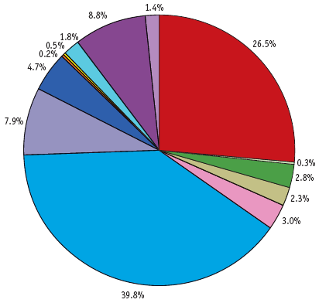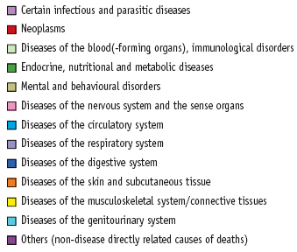
The indirect cost for society is also high. For example, the cost of brain disorders for Europe has been estimated at close to €800 billion per year. Cardiovascular diseases are responsible for 40% of all deaths in EU and cost the EU economy €196 billion a year. Whilst much progress has been made in the treatment of cancer, it continues to be the second most frequent cause of death in Europe, at 28.4%. About 10% of EU citizens suffer from diabetes and with increasing overweight and obesity combined with the lack of physical activity, the rate of diabetes rises rapidly. A recent WHO review claims that these health problems are largely preventable and can be avoided when linked by common risk factors and opportunities for intervention through research advancement. In addition, we are witnessing dramatic changes in demographics in Europe. The proportion of European citizens aged 65 and above is projected to account for more than 30% of the population by 2060 compared to 18% in 2010, an increase by two thirds (fig. 3).
Figure 3: Projection of change in the structure of the population by main age group, EU 27 (percentage of the population in different age brackets)
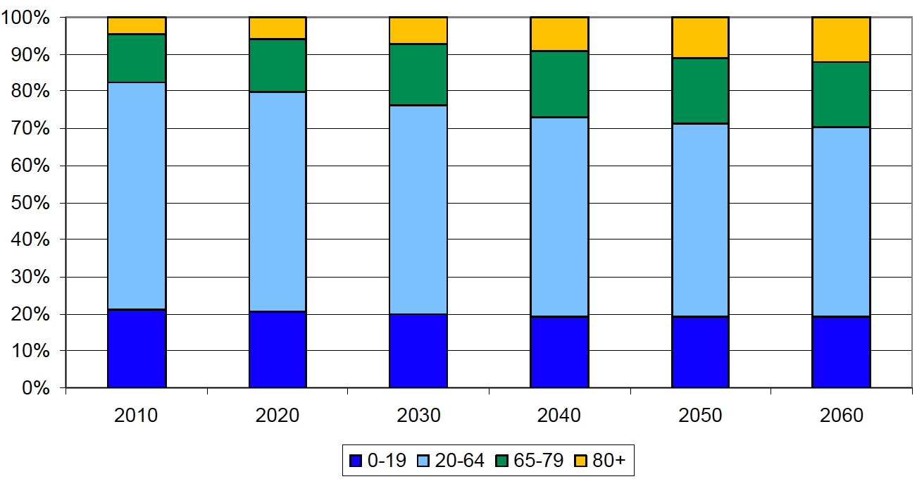
As the burden of chronic diseases and associated healthcare costs rises with the ageing of the European population, it is expected that the 9.5% GDP spending on healthcare costs on average across OECD countries in 2010 will increase significantly. However, “whilst ageing per se has a non-negligible effect on expenditure growth, it is rather moderate. In effect, much depends on whether gains in life expectancy are spent in good or bad health”.
Spending on medicines represents about 19% of all spending on healthcare costs in Europe where the largest cost item is spending on in-patient care in hospitals. Spending on medicines per capita ranges from €164 in Romania to €528 in Ireland, representing between 1 and 2% of GDP (with 1.6% average). For a number of years growth in healthcare spending was partially driven by increased spending on medicines but the spending on healthcare overall has turned negative in several countries in 2010.

2.2. Life science industries: a key economic sector for Europe
Life science industries encompass biopharmaceutical, biomedical imaging, medical information technology, and medical device industries as well as agro-food and industrial biotechnology industries (fig. 4).
Figure 4: Structure of life science industry sector
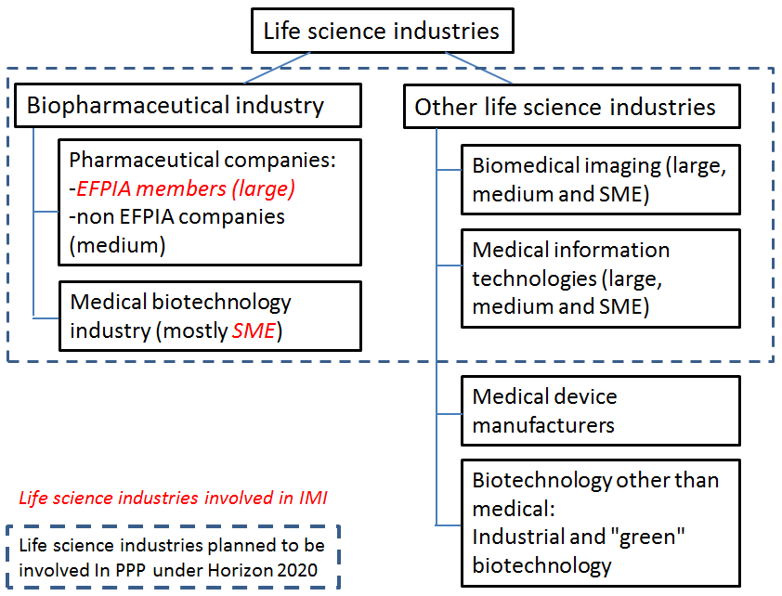
Studies indicate the value of biomedical research to the European economy with the pharmaceutical industry having an annual turnover of €157 billion, and employing 660,000 people of whom 110,000 are researchers, and achieving a large positive trade balance of €48.3bn (based on 2011 data). The biomedical imaging and medical information technologies industries are also important for Europe, though the contribution of the biotechnology industry to the EU's economic performance is lower than in the US (Table 1).
Table 1: Situation of biotechnology industry sector in the Europe and the US
Year 2011 | Europe | US
Number of companies | 1,883 | 1,726
Number of public companies | 167 | 315
Revenues | $18,911m | $58,800m
R&D expense | $4,921m | $17,200m
Net income (loss) | ($0.3m) | $3,300m
Market capitalisation | $71,519m | $278,000m
Number of employees | 48,330 | 98,560
Capital raised by public companies | $1,570m | $25,400m
Number of IPOs | 6 | 10
Capital raised private companies | $1,321m | $4,400m

The European biopharmaceutical, biomedical imaging and medical information technology industries are experiencing pressure from i) increasingly cost-constrained healthcare systems, ii) major losses of revenues due to patent expirations (the so-called ‘patent cliff’), and iii) more demanding regulatory requirements.
Price/earnings ratios of pharmaceutical companies have significantly declined and despite ever increasing investment the flow of new products reaching the market has not changed over decades.
Pharmaceutical companies have in recent years reacted by reducing R&D spending (including abandoning entire therapeutic areas, closing sites and lay-offs of research staff) and directing investments at less risky projects. Companies are risk-averse (section 2.4.3) which means they will only invest time and money where there is a reasonable expectation of success and the ability to exploit the benefits of the new knowledge they generate.
At the sectorial level, ‘me-too drugs’ competition has led to a suboptimal market situation with mimetic business strategies and duplication of R&D investment. 85 to 90% of new drugs approved emerge from the same chemical class with similar pharmacological profile. Another trend is restructuring production and research through partial re-location to emerging markets with rapidly increasing public research investment, such as Singapore and China. On the basis of a strong position in generic medicines, companies in these world regions have started to develop branded drugs, thus becoming strong competitors to the EU pharmaceutical industry.

2.3. Key Problems
The challenges and barriers to be addressed are related to the increasing cost, lack of incentives and decreasing productivity of the drug and vaccine development processes. Outcomes should contribute to the sustainability of health and care systems as well as to the increased quality of life of European citizens, and thus to the overall goals of societal challenge 1 of Horizon 2020.

2.3.1. Low productivity in drug development and high failure risk
Maintaining and expanding the position of the European bio-pharmaceutical industry on the world market depends on its ability to bring a constant stream of new innovative medicinal products to the market. The overall success of the industry in achieving this has been limited in recent years, with the output of new medicines remaining steady over many decades despite increased investments and a revolution in scientific data. Furthermore, many new medicines reaching the market have limited innovative value.
Developing and testing a new intervention (drug, vaccine, or other therapy) is time consuming, with no guarantee of success. This is shown in figure 5 representing the traditional pharma innovation value chain. This risk of failure applies throughout all phases of the innovation value chain and thus, there is little incentive to take too many risks. Hence the prevalence of so called ‘me too’ interventions entering the market.
Figure 5:Traditional pharma innovation value chain
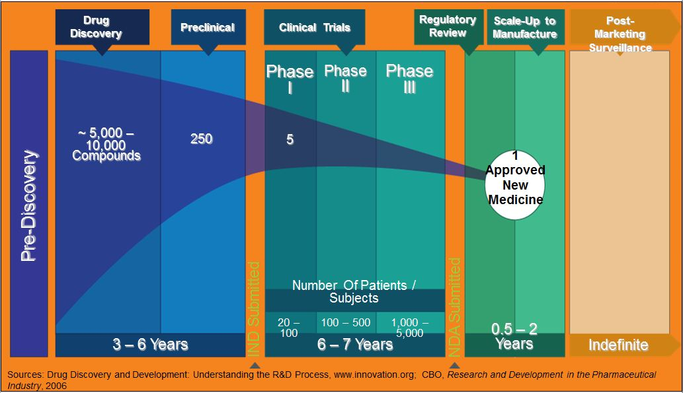
The European market is becoming less attractive and rapidly shrinking as a share of the world market, due to government restrictions on market access and reimbursement combined with an expensive pharmaco-vigilance system. With patent expiry of many marketed products and consequent loss of sales and profits, the capacity of the European industry to sustain the necessary investments is in danger.
Europe is also lagging behind the US dramatically in the number of development projects: in 2009: 3000 in the US, fewer than 1000 in Europe. A detailed analysis of the innovative quality of new drugs developed by pharmaceutical companies demonstrates that European companies develop mostly less innovative chemical drugs and lag behind competitors from the US in the development of breakthrough biotechnology medicines. Figure 6 shows that over the years the number and share (above 40% before 2001, less than 35% after 2001) of new chemical or biological entities approved that are originating in Europe have declined. While European companies still enjoy the fruits of research performed in the past, their future competitiveness is at risk and will depend on their innovation performance.
Figure 6:Number of new chemical or biological entities being approved in 5 year spans from 1992 – 2011, by world region of origin of the molecule
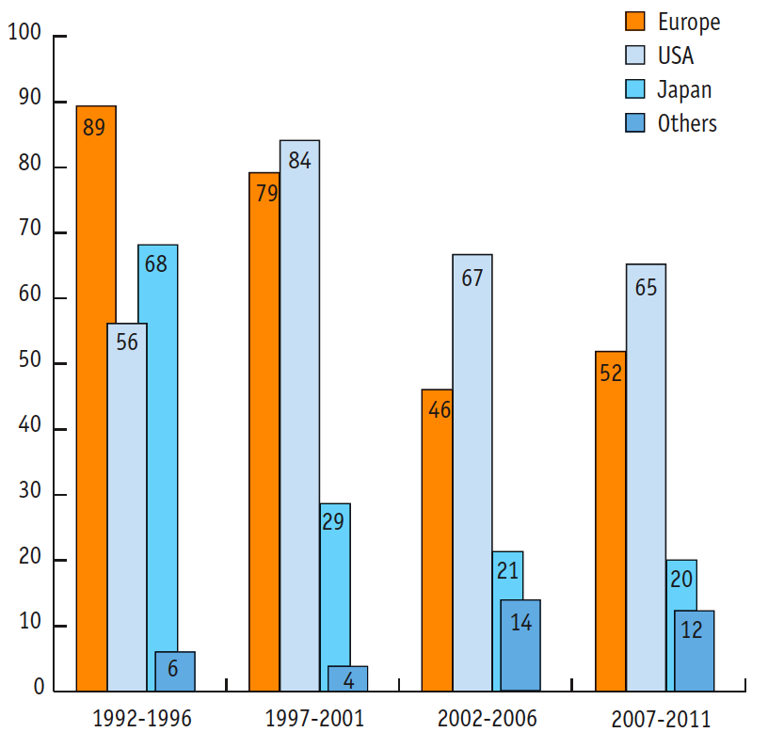

Further compounding these problems are the assignment of negative value to many European pharmaceutical companies’ pipelines. This poses risks to the capacity of pharmaceutical firms to raise the necessary capital for further R&D and the risk remains that industrial research capacity for development of new medicines will be lost from Europe.
This productivity challenge is so complex that the life sciences industries concerned cannot, alone, pool and coordinate the required knowledge, technologies, financial resources and stakeholders to tackle it. Addressing it would require sustained, long-term, large-scale investments in complex and interdisciplinary research and innovation activities.

2.3.2. European citizens are not getting the biopharmaceutical interventions they need
The high risk for developing new interventions means that many projects for developing treatments fail. The risk of drug development combined with its high cost leads to companies undertaking projects for developing a pharmaceutical product only if they expect large sales. For many medical conditions the necessary sales cannot be achieved and hence there is no economic incentive. An example is the area of antibiotics, where only two classes of new medicines have been developed in the last thirty years. Yet with rising levels of resistance against existing classes of antibiotics, society urgently needs new treatments. Once developed, such medicines would be used sparingly (small market) to preserve their efficacy. Citizens in Europe and worldwide are not being provided with the interventions they need and the potential for biomedical and life science research to help addressing societal challenges is not harnessed.

2.4. Problem Drivers

2.4.1. Incomplete understanding of diseases
Drug development is risky and takes a long time, in part because we do not know enough about the fundamental causes of disease: they are today understood and classified on the basis of ‘signs and symptoms’, in the same way that prior to molecular genetics was developed, we did not have a proper understanding of the relationship between species, classifying them (often incorrectly) on the basis of morphology, not true phylogeny,.
This means that while clinical trials may assemble a group of patients all of whom seem to have the same disease (the intention being to test the safety and efficacy of intervention in question on this disease), the likelihood is that there is a diverse group with a variety of diseases, some of whom may respond treatment, and some of whom may not. Not only must large groups be assembled, with the associated cost implications, some persons in the clinical trial may be exposed to possible adverse effects, with no benefit; likewise, if the intervention is approved, some persons receiving it may be in a similar position.
Yet the research required to produce the kind of molecular classification needed to avoid the status quo is expensive and risky, and cost and risk sharing with academia in an uncontrolled environment creates risks of no return on investment for the industrial partner (concerns the later, clinical stages of the innovation value chain). The same is true of research which is intended to better understand the targets of potential interventions.
A lack of co-operation also renders clinical trials inefficient, with companies typically recruiting sites for each study and often similar studies undertaken by various entities running at the same time each recruiting a control group. It is also important to better incorporate new technologies and to better cooperate with other industries that converge with the classic drug R&D paradigm.
A controlled, risk sharing environment for the co-operation of industry and academia (open innovation) on these challenges which are either too complex or costly for any individual group to work on alone is therefore required. It must present the possibility of allowing competition to occur between industrial entities, but based on a new and better knowledge base that has been generated in collaboration.
The impact of changing the business model from wasteful duplication and divergent efforts to addressing the complex challenges in a coordinated and well-orchestrated manner is potentially tremendous. Any improvement in the rate of success of clinical development of new treatments from its current level around 10% will change the fundamental economics of the biopharmaceutical industry in a positive direction.

2.4.2. Market failures discourage industrial firms to invest in R&D
Addressing the issues listed above requires risky research. Yet industry does not engage in sustained, large-scale, complex research and innovation activities because of the existence of market failures. With respect to R&D activities, market failures stem from uncertainty, resource constraints, and the inability to internalise knowledge spill over effects. These spill over effects prevent the private sector from investing in health research at the socially optimum level. In recent years, these risks have increased due to the intrinsic complexity of drug development, the more multi-disciplinary nature of R&D and the fact that disease areas such as Alzheimer’s disease require long and costly R&D with uncertain financial returns.
A first market failure concerns risk and uncertainty. At the beginning of a research project it is not all sure that the research efforts undertaken to develop a drug or clinical trial will result in new knowledge and innovation. Such uncertainty stems from technical complexity, time considerations and capital intensity. This issue is particularly important in the development of diagnostics and new drugs, which carries a high degree of scientific risk, as multiple new directions in research are explored, before stable trajectories can be established. The challenge of risk and uncertainty is exacerbated by the fact that it is becoming more expensive to carry out research (see box 2).
Even if the research conducted produced new knowledge and innovation, it is not certain that the researcher or company will be able to appropriate the benefits. This is due to significant knowledge spill overs. The appropriation issue is exacerbated in the case of public goods and paradigm shift. In other words, knowledge and innovation have the features of a public good which means that can be consumed simultaneously by everybody in a society. A good example is the fact that private pharmaceutical companies carry out comparatively little research on the development of vaccines for diseases such as malaria, tuberculosis or HIV. This leads to private underinvestment in health research and justifies public intervention. Companies may also be unwilling to invest as they fear that the new products may make obsolete the products they currently profit from. The provision of public funding may affect their calculation. An example is provided in the NBER study which examines why pharmaceutical companies carry out very little research on the development of vaccines.

Box 2: EU survey on Cost of Research
A recent EU survey on "costs of research" has been conducted among 200 R&D intensive private companies and public research organisations equalling over 115,100 R&D employees in Europe's ICT, pharmaceutical and chemical sectors.
The surveyed companies unanimously judge R&D labour costs to be by far the largest cost component of undertaking R&D (50%), followed by capital costs (such as infrastructures, 17%) and purchased R&D (14%). Although relocation intensities differ per sector, surveyed companies agree that relocating abroad is not an important action to reduce R&D costs. R&D labour costs is not only the largest cost component of R&D, it is also the cost factor most difficult to contain as it is governed by a global demand offering globally comparable wages.
The activities considered by the surveyed companies to be most important in bringing down the cost of research, are aligning R&D with business strategies, joining R&D projects, and technological efficiency of the R&D process.

The activities considered by the surveyed companies to be most influential in driving up the cost of research, are complexity of the R&D process, and regulation of product markets.
To the question whether the cost of research has increased in the past five years, surveyed firms reported an increase of 47% in R&D expenditures or total R&D costs over the last five years. Thereby, 87% of companies report that this growth is primarily based on an increase of the volume of R&D, while the 13% said that it is due to rising prices.
To the question whether the cost of research will continue to increase in the next 5 years, the companies reported to expect an increase of 30% on average. Given that the major cost component is R&D labour, costs of research in the longer term (20 years) are unlikely to fall in relative terms.
Source: COST, 2011
Another market failure results from resource constraints. Investment in the biotechnology sector in Europe is dramatically lower than in the US (more than 10-fold, see table 2). This is due to the fragmented financial sector leading in particular to a lack of access to early stage venture capital in Europe. The situation has been exacerbated by the financial crisis. While access to finance per se is not a problem for large pharmaceutical companies, many actors in the life science innovation ecosystem are suffering from resource constraints, and the industry as a whole is affected.
The need for public support for research also stems from the system nature of innovation and from the importance to invest in networks to ensure the absorption of knowledge. The literature shows that what matters for the innovation performance of a given sector are the linkages and flows of information between the different actors in the innovation system. These linkages and flows are today suboptimal in life science industry sector and government can play a role in strengthening them.

2.4.3. Fragmentation of knowledge on drug development
To the extent that research is being conducted, it is taking place in a fragmented manner. For a long time the pharmaceutical industry was focusing its R&D activities on a closed innovation model with vertically integrated approaches, where all key activities were performed inside the company. While public-sector researchers were performing the upstream, basic research that elucidated the underlying mechanisms of disease and identified promising points of intervention, the pharmaceutical industry researchers were performing the downstream, applied research resulting in the discovery of drugs for the treatment of diseases and were carrying out development activities to bring them to market. Because drugs working against a new target can be very attractive, often several companies work in parallel on drugs acting on that new target. If a target fails, the efforts of an entire cohort of companies will have been in vain.
Furthermore, instead of the previous paradigm of industry ‘picking up’ and expanding on results from academic research or ‘using’ academic clinical centres for conducting clinical trials, much closer pre-competitive collaboration between industry and academia is necessary if the scientific, resource and organisational challenges of developing new diagnostics, treatments and vaccines are to be tackled. For regulatory sciences and to incorporate work on determining the value of interventions involvement of regulatory agencies and reimbursement organisations is needed. Tools such as shared databases and networks that could speed up development are needed.
Research to arrive at a better classification of disease cannot be conducted by individual firms or by a consortium of firms. Neither can it be done by publicly funded academic research because the combined analysis of data held by private and public entities is essential.
The change towards an open innovation model has started to avert an innovation cliff. Boundaries between the roles of the public and private sectors have shifted since the dawn of the biotechnology era, and the public sector now has a more direct role in drug discovery. Publicly funded research contributes especially to the discovery of drugs responding to unmet medical needs.
As the development of new treatments, diagnostics or preventive approaches becomes more challenging, it is more important to look beyond traditional biopharmaceutical research to successfully move forward. For example, biomedical imaging has made tremendous progress and can deliver precise diagnosis for many diseases. Further developments are needed to bring the power of imaging to bear on translating biomedical research results to patients. Typically the pharmaceutical industry and the imaging/ICT industries do not collaborate because of their vastly different business models and timelines. Except for work on companion diagnostics for targeted treatments (mostly for cancer indications, pioneer Herceptin®, the required research is not taking place, thus depriving European citizens of tremendous benefit, healthcare systems of potential savings and industry of new business opportunities. A public-private partnership incorporating biomedical imaging and healthcare IT in life science research has the potential to significantly enhance the quality of care delivery for patient populations.

2.5. Need for public intervention
Industry by itself does not engage sufficiently in risky, collaborative research. Public intervention at Member State level cannot support the kind of risky, collaborative research needed. If different players share resources, data and expertise (academia, industry, bio-tech SMEs, clinicians, regulators, patients), this can help reduce risks and decrease costs.
There is good evidence that public support for cooperation helps to generate trust between the key players. For example, public projects promote prior agreement on ownership of research output, and thus reduce the chance of opportunistic behaviour or bargaining over research outcomes. Monitoring and evaluation by public bodies also eases and promotes cooperation, generating greater trust, and leading to more knowledge sharing and knowledge spill overs.
Public sponsorship of R&D partnerships is needed to further increase the incentives for partnering and to address fully the market failures stemming from resource constraints, uncertainty, and the inability to appropriate significant spill-overs (section 2.4.1). By providing extra financial resources, for instance, the public sector reduces financial constraints and risks beyond what purely private R&D partnerships are able to achieve and ‘reimburses’ industrial firms for public spill overs. By resolving systemic failures that arise from mismatches in the incentives for cooperation among the various actors in the innovation system (e.g. private sector and public sector institutions) and that impede collaboration in R&D and technology, for instance, the public sector reduces skill, knowledge and data constraints and risks. By sponsoring the development of consensus-based strategic research agendas and market development scenarios, for instance, the public sector reduces wasteful exploration and produces strong public and private sector demand signalling effects both of which reduce uncertainty.
Box 3: Role of public intervention in the US
"Innovation in Medicine Has Depended Upon a Thriving Ecosystem and Partnership Comprised of Researchers, Industry, and Regulators. These innovations have been brought forth by a remarkable ecosystem consisting of three major components: (1) academic researchers who have unlocked secrets of basic biology and revealed mechanisms that underlie disease, as well as the Federal and other funders who support their research; (2) a robust bio-pharmaceutical industry, which has developed molecules to treat disease and conducted clinical trials to demonstrate their efficacy; and (3) government regulators, who have balanced the benefits and risks that are inherent in any medical innovation. The United States has consistently led the world in all these areas. Importantly, patients themselves have played a critical role in propelling advances by focusing attention on the urgency of developing therapies and spurring creative approaches, and by participating in clinical trials. Others including physicians, health care payers, pharmacists, and consumer groups have also played crucial roles. Medical progress depends on a successful partnership among these sectors."
Source: "Report to the President on propelling innovation in drug discovery development and evaluation", Executive Office of the President? President's Council of Advisors on Science and Technologies, Sept. 2012

As to emerging countries, they are struggling with the same constraints as the EU, i.e. aging populations, growing incidence of chronic disease, and the rising cost of increasing access to healthcare for their citizens. India and China alone account for almost 2.5 billion people and represent a vast market for life sciences companies seeking new revenue opportunities. For many pharmaceutical companies, targeting the emerging markets has become one of the industry’s key strategies for growth.

Box 4: Role of public intervention in BRIC countries
The emerging markets - China, India, Brazil and Russia – are being targeted by the life sciences industry as the primary source of sales growth in the coming years.
By 2020, the BRIC economies alone will account for 33% of the world’s GDP, measured in terms of purchasing power parity – up from 25% in 2009. Emerging economies are improving access to healthcare. China is on track with a $125 billion programme to extend health insurance cover to more than 90% of the population by the end of 2012 and by the end of 2010 Chinese drug-makers had 39 compounds with US or European patents in clinical trials. China’s Five Year Plan (March 2011) foresees $300 billion in biomedical R&D innovation funding and seeks to make China the second largest pharmaceutical market by 2020. E.g. with $1.5 billion from government funding, China’s Beijing Genomics Institute has become the world’s largest sequencer of genomes. It is initiating new collaborations with private and public institutions at a rapid rate.
India’s National Rural Health Mission has achieved considerable progress in the seven years since it was launched. India has established a thriving pharmaceutical industry and a rapidly growing biotech sector that excels at producing low-cost copies of off-patent innovator drugs. Indian companies produce 20% of the world’s supply of generic drugs and 30% of the US consumption of generics.
Brazil’s drug market, at $22.9 billion (7th largest in the world) is growing at a rate of about 12% a year. Government policy has encouraged the growth of generics, which account for more than three quarters of its total spending on drugs. To reduce its reliance on imported drugs, the government has allocated more than $734 million since 2007 to support development of a domestic pharmaceutical industry. It has also worked to improve good manufacturing practices so it can compete in the global drug market and toughened its patent laws to encourage domestic innovation.
Russia is using its oil revenue to build its life sciences sector through internal investment in infrastructure and external investment in innovation. The country’s drug market is expected to grow at a compounded annual growth rate of 13% and is forecast to reach $60 billion by 2020. In 2010 the government has pledged about $12 billion over ten years to increase the country’s capacity to produce drugs and medical equipment (including the establishment of innovation and training centres) and reduce the country’s dependence on imports.
Source: From vision to decision, pharma 2020 - www.pwc.com/pharma2020 and Biotech 2012: innovating in the New Austerity, Burrill & Company’s 26th annual report on the Life Science Industry.

R&I in health research is increasingly a global undertaking. Member States, the private sector and the EU must be able to cooperate in order to compete in the global environment. Public intervention at individual Member State level is therefore insufficient to mobilise the necessary critical mass of knowledge and financial resources to overcome this research challenge. Biopharmaceutical capabilities and data are dispersed across Europe and it is prohibitively expensive to build the required databases and networking tools. To develop an effective supra-structure (networks, databases, etc.), consensus and collaboration must take place across the entire sector. The compartmentalisation of stakeholders is not just in different sectors but also in different countries. So far public funders at Member State and/or regional level are not yet coordinating their funding. There is a need for public intervention at the EU level to encourage firms to invest in these areas and to share knowledge and expertise with other key players in different countries and sectors.
Large scale public intervention in research and innovation stimulates private R&D in health research in three ways: (i) it enhances the ability of private firms to obtain the latest scientific and technological knowledge; (ii) it enables the use of experimental facilities and allows cost-sharing; and (iii) commissioned R&D signals future demand in public goods and this demand is diverted to the private sector which increases the expected return on R&D investment. Another channel whereby public funding benefits R&D is the promotion of trust among collaborative R&D players ('institutional-building trust') which enhances their scientific network for innovation. In health research on top of generic innovation barriers (i.e. locked-in investments, vested interests and high risks), there are additional barriers such as lack of qualified research personnel, high cost of clinical trials and difficulties in accessing and providing finance which slow down the development of new drugs and better treatments and that justify additional policy efforts at European level.

2.6. The EU’s right to act and the application of the subsidiarity principle
The right for the EU to act in this field is provided by Article 187 TFEU, which specifically authorises to "set up joint undertakings or any other structure necessary for the efficient execution of Union research, technological development and demonstration programmes".
The industrial challenge of bringing biomedical research and innovation to new products and thereby impacting the health of EU citizens is so large and complex that Member States acting alone do not have the necessary framework for establishing transnational collaborative platforms for strategic industrial research. The kind of public intervention required needs to be sustained (long-term), large-scale and able to facilitate the required cross-border, cross-sector, interdisciplinary research and innovation consensus-building and implementation.
The goal for active and healthy ageing expressed in the Innovation Union as a grand challenge for the EU as a whole, justifies EU-level intervention, which is in line with the principle of subsidiarity.
The legal basis for addressing competitiveness is provided by Article 179 TFEU, As stated in the Council Regulation 73/2008, IMI "should provide socio-economic benefits for European citizens, contribute to the health of European citizens, increase the competitiveness of Europe and help to establish Europe as the most attractive place for biopharmaceutical research and development".
Several Member States have PPPs addressing health-related industrial research and innovation. The most ambitious one has been TI Pharma in the Netherlands, launched in 2006 funded with €300 million but now beyond its active funding phase. In 2011 the UK started the strategy for life sciences, which includes investing £310m to support the discovery, development and commercialisation of research. A number of further funding measures and concrete actions have been planned. Furthermore, the National Health Service for England and Wales has started the innovation health and wealth programme to significantly ramp up the pace and scale of change and innovation. In Germany the Pharmainitiative für Deutschland was launched in 2007, restructuring existing funding measures and launching a competition for three consortia receiving a total of €100 million. In France the national alliance for life science and health AVIESAN promotes collaborations with industry. In Belgium regional initiatives to promote collaboration between academic and pharmaceutical research have been launched. Apart from the Dutch and UK initiatives, the on-going actions either provide a framework that will be filled with concrete actions or they are overall rather limited in scope and ambition and address specific issues such as screening or re-purposing of compounds.
While the work done at Member State and regional level is important and is producing relevant results, the overall challenges to be addressed have been identified as Europe-wide: national intervention would not create a long-term structural improvement. Moreover, actions at Member States level are likely to have less leverage on private investment as the necessary critical mass of resources (i) cannot be achieved, (ii) would be limited in terms of industrial and academic expertise available in any given country; and (iii) would lack coordination and risk duplication.

2.6.1. The kind of public intervention required can only be provided at European level
The EU is well positioned to add value by providing sustained (long-term), large-scale public sponsorship able to facilitate the kind of cross-border, cross-sector, interdisciplinary research and innovation consensus-building and implementation required. Intervening at EU level by supporting trans-national cooperation between firms on long-term strategic research agendas produces the following added value over and above what Member States acting alone can achieve. Joint undertakings achieve best the critical mass, in particular through the implementation of joint agenda setting, mobilisation of additional funding and larger leverage effect on industrial R&D investment. In addition, action at European level contributes to more effective co-ordination and therefore to a reduction of the risk of duplication of other actors’ activities.
By creating a framework for exchange of previously proprietary data and of open collaboration amongst diverse participants in the life science research eco-system, the performance of the entire sector can be enhanced, which in turn can contribute to the competitiveness of the European economy. Through bringing together the key stakeholders European research funding, academia, SMEs and life sciences industries – the PPP would allow a concise and co-ordinated targeting of the prevalent structural problems that may only be addressed at European level.

2.6.2. Investing at EU level can produce savings for healthcare costs and services
The research programme to be undertaken will lead to a better classification of diseases, which in turn will significantly improve diagnosis. This will spare patients unnecessary exposure to side effects from ineffective treatments during clinical development or medical practice. In the latter case savings result because an ineffective or inappropriate intervention is no longer applied by trial and error. The monetary benefit of molecular diagnosis of cancer patients has been proven in an analysis in France. By investing €1.7 million for molecular diagnosis, €34 million in savings of not administering the cancer drug Iressa® to patients for whom it is ineffective were achieved. Even larger savings can be expected from the classification of chronic diseases.

2.7. Who is affected and how?
The preferred option, an expanded scope IMI2 initiative, will affect a wide range of stakeholders throughout Europe. It will directly affect large and small industry in the biopharmaceutical and wider life sciences sector. By establishing networks for open innovation, the IMI2 JTI will bring together the main stakeholders along the whole innovation cycle of novel medical research and technologies, in particular public research institutions, academia, life science industries, SMEs, patient organisations, regulators, payers, public health authorities and the animal health sector. By advancing the development of new approaches and technologies for the prevention, diagnosis and treatment of diseases with high impact on public health, it will also indirectly affect non-governmental organisations, private/public foundations, policy makers and European citizens.
By bringing together different industry sectors IMI2 will open up new business opportunities in the health-related industries, which will be essential for safeguarding European employment and economic activity in this highly innovative sector.

2.8. Related EU legislation and initiatives
The societal challenge of the ageing population is so large that the PPP under Horizon 2020 cannot address it alone. The future IMI will be complementary to the Ambient Assisted Living Article 185 initiative which is focused on deploying technology solutions for helping elderly citizens live independently. The Active and Healthy Ageing innovation partnership (AHA IP) is one of the flagship initiatives of the Innovation Union and aims at increasing by two the number of healthy life years of European citizens by 2020 through the coordination of many different activities. Results from IMI2 will support this AHA IP. Research actions conducted under IMI2 will be tightly coordinated with research funded from the ‘Health, demographic change and wellbeing challenge’.
The planned initiative is fully aligned with the proposed EU Regulation on Clinical Trials, which addresses current shortcomings in Europe resulting from different national legislations hampering product development. It should advance other aspects of regulatory science in the framework of EU level legislation for the marketing authorisation of medicinal products, for in vitro diagnostics and medical devices. It is also consistent with the relevant health policies at EU level, including the Commission Communication on Combatting Antimicrobial Resistance, the European contribution to the global One Health Initiative, the European Pact for Mental Health, and the European Partnership Action Against Cancer. Education and training aspects should be addressed fully in line with the Communication on 'Better Careers and More Mobility: a European Partnership for Researchers' as well as with the Commission Communication regarding "A Stronger European Industry for Growth and Economic Recovery".

2.9. IMI Key achievements and lessons learned
The IMI objectives are to address bottlenecks limiting the efficiency, effectiveness and quality of the drug development activities needed to bring innovative medicines to the market. So far IMI has launched 8 calls for proposals and 39 projects are on-going, associated with a commitment of 75% of the total funding. Figure 7 shows the number of projects addressing different types of bottlenecks, which have a measurable impact on European pharmaceutical research.
Figure 7: Type of hurdles in drug development addressed by IMI projects
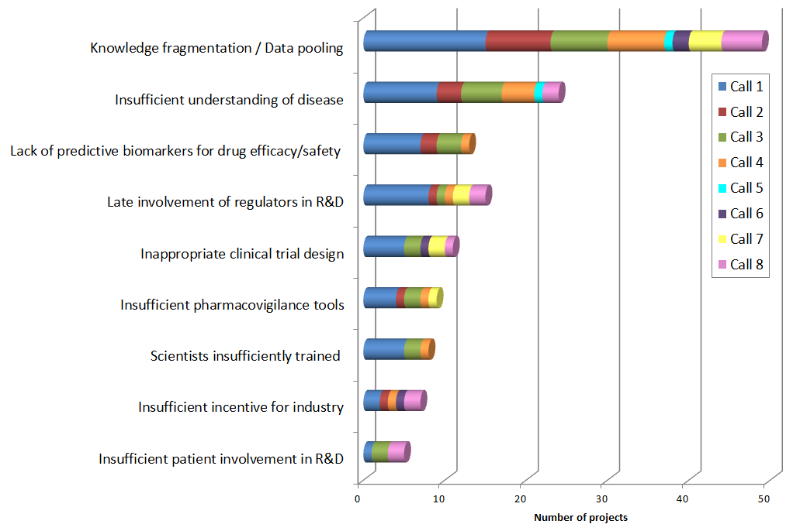
The first interim evaluation concluded that the scientific scope of the initiative is well targeted and that IMI is a welcome addition and improvement to the European R&D landscape. Data, surveys and other assessments highlight the scientific excellence of the research that IMI supports and the positive impact of those projects in addressing IMI’s objectives.
IMI exceeds the FP7 target of 15% of the EU financial contribution going to SMEs. It invests 19% of funds with SMEs, without providing specific incentives. In contrast, in the FP7 Health Theme the SME involvement has been raised to 15.2% through dedicated measures. In the public consultation a large majority of respondents (81%) wished for an even stronger involvement of SMEs in the future PPP.

2.9.1. Key achievements
Mobilisation of resources
The on-going IMI projects bring together a large number of partners from the pharmaceutical industry, academia, SMEs, patient organisations and regulators in focused projects that mobilise significant resources (average project size €25 million). The large pharmaceutical industry participates strongly in IMI (50% of resources, 30% of staff – total commitment to projects by large industry of €720 million), whereas its participation in European research programmes outside IMI is very low (0.78% of participations in FP7 Health, total contribution to all of FP7 about €80 million, ¼ of which to FP7 Health). This means that IMI achieves a substantial leverage effect on industrial R&D investment. The IMI participant survey also demonstrates that IMI has had positive spill over effects in the industry as a whole.
Enhanced cooperation
The results of the IMI project survey show that IMI significantly contributes to strengthening the links between the different stakeholders in the health research and innovation field by opening access to other partner’s expertise and increasing collaboration between the pharmaceutical industry and other stakeholders in Europe (fig.8).
Respondents acknowledge the EU added value of IMI projects pointing out that the scale and scope achieved in IMI projects would not have been possible at national/regional level and 73% indicating that they would apply again to participate in an IMI project. Enhanced collaboration can also be demonstration from the bibliometric analysis (Annex 5).
Figure 8: Interest in collaboration amongst SME, pharmaceutical industry or academic researcher participants in IMI projects
The first interim evaluation underlined that IMI enables mutual learning and the opportunity to build understanding of rationales and approaches of the different stakeholders, with benefit to all parties, which is considered powerful.
Focusing and developing strategic research agendas, horizontal policy coordination
In a number of areas IMI is creating comprehensive research agendas that have a structuring effect on European life science research, notably in research on neuropsychiatric diseases, where a cluster of projects has been created re-shaping the way research is conducted in this area; in antimicrobial resistance (AMR), where the New Drugs for Bad Bugs programme has been launched, responding to a key action of the Commission’s Action Plan on combatting AMR; by establishing the European screening centre and compound collection for industrial-type drug screening; in stem cell research; and through the creation of a cluster of projects on education and training of the next generation of researchers with pharmaceutical research expertise.
IMI also achieves a measure of horizontal policy coordination by coordinating the involvement of patient organisations and - in projects addressing regulatory sciences - of regulatory agencies, which was considered a rare achievement in the interim evaluation.
Figure 9 represents the new model of open innovation that is replacing the traditional approach to drug development (see fig. 5).
Figure 9: Model of open innovation in pharmaceutical development
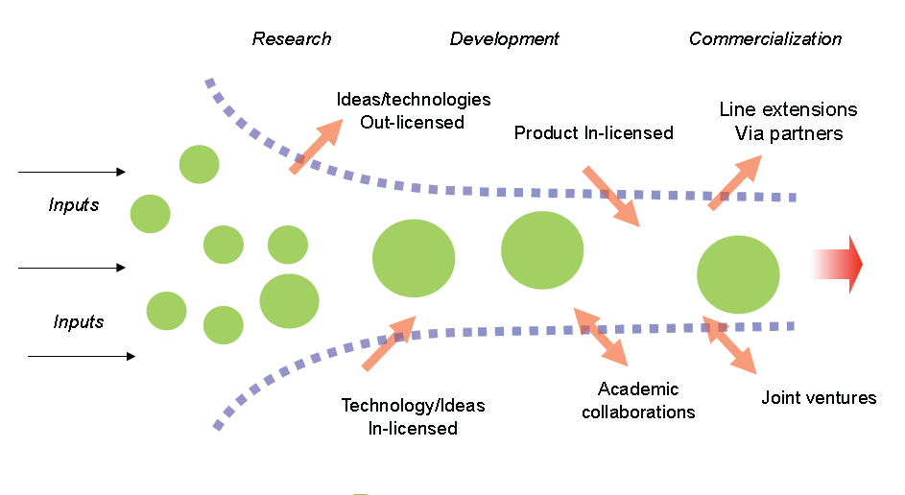
The on-going Innovative Medicines Initiative has demonstrated that bringing together relevant partners can lead to a new model of innovation and can address key bottlenecks in biomedical and pharmaceutical research. As emphasised in the first interim evaluation, “IMI has significantly contributed to the transition from a closed to an open innovation model in biopharmaceutical research. No other European programme has enabled cross-company collaboration within the pharmaceutical sector on the scale that has been achieved with IMI. This step is very important in developing open innovation in the health sector as it has enabled an unprecedented pooling of industrial research assets allowing scientific challenges to be tackled in a manner that could not be done otherwise”.

2.9.2. Areas for improvement
In the context of an overall very positive assessment, the first interim evaluation commented on areas for improvement. Notably, it was pointed out that internal governance structures had not yet been working optimally, that proactive communication activities had been lacking, that the advisory potential of several stakeholders such as the European Medicines Agency (EMA) was not exploited fully by the IMI JU and that key performance indicators (KPIs) were not yet established and used fully.
These concerns have been addressed by IMI by establishing and reporting on a set of KPIs, the advisory role of stakeholders is used extensively and for example a representative of EMA is an observer on the IMI scientific committee. Communication activities have been significantly strengthened evidenced by the number of publications written by IMI and the number of articles that make reference to IMI. Since the interim evaluation, the decision making processes within IMI have been streamlined to the extent possible in the framework of its legal setup. For the planned IMI2 significant simplification is foreseen in this regard.
In the IMI participant survey, 75% of respondents consider the administrative burden of IMI funding to be equal or greater to other EU-funding programmes, nevertheless 73% of respondents indicate that they are likely to reapply to IMI calls. This underlines the added-value of the initiative and that the benefits of the programme outweigh the identified burden.
The limited participation of relevant industry sectors in IMI has been raised in the public consultation with the comment: “In relation to the participation of SMEs, a big problem is the omission of companies that no longer meet the criteria for SMEs, but are also not among the EFPIA companies. These companies could partner theoretically in IMI projects, however, the incentive is relatively low, as there is no funding option (such as SMEs), but also no possibility of participation (such as for EFPIA companies). Here a change would be desirable to allow either a promotion or a right of co determination for these companies."

2.9.3. Challenges with respect to complexity and cost-effectiveness
JTI JUs were set up as an innovative instrument under FP7. The first experiences gathered with implementing the JTI instrument via the Joint Undertaking – dedicated administrative structure – have highlighted a number of challenges with respect to complexity and cost-effectiveness, as noted by the Sherpa’s report, the interim evaluation, and the CoA reports on JTIs.
These challenges are mainly related to a lack of suitability of the general legal framework to the specificities of JTI JUs, lack of options for tailoring in the JU establishment act, statutes, staff and financial rules and the delegation of overall responsibility for day-to-day management of the JU to the Executive Director. These identified shortcomings stem from the initial design and constitute a starting point for an improved design for the Horizon 2020 JTI JUs.
The notable examples of the abovementioned shortcomings are:
Lack of tailored legal framework. The legal framework governing a JU is essentially composed of four elements: the Council Regulation, the Statutes, the JU’s own Financial Regulation and the EU Staff Regulations. These are largely based on rules applicable to the European Institutions with little regard to the size of the JUs, the fact that they are partnerships with an industrial sector, and nature of their activities. According to the interim evaluations of the JUs, this legal framework is not conducive to the efficient management of a small JU.
Human resources. Due to the demanding legal and financial rules applying to the current JUs on the one hand, and the small overall size of the current JUs on the other hand, the structure of the JUs is one-sided when comparing administrative human resources with operational human resources: on average 50% of the JUs’ staff is dedicated to work on administrative tasks. This percentage is high compared to the 22% ratio of the somewhat bigger European Agencies, also set up as union bodies.
Recruitment rules. Under current regulation, due to the fact that JTI JUs are Union bodies, their staff recruitment rules follow the EU Staff Regulation. Accordingly, when planning recruitment, the grades and functions of new staff must be foreseen in the multi-annual staff policy plan and the annual budget. These require approval from the Governing Board and the European Commission as well as compliance with the multi-annual planning cycle starting at end of year N-2. Therefore, the recruitment procedures take a significant amount of time.
Public procurement rules. The public procurement rules applied by the JU are similar to those used by the European Institutions. Moreover, the financial regulation does not permit a JU to conclude a Service Level Agreement with another JU. Consequently, this prohibits the sharing of services between JUs in order to reduce costs (for instance, sharing the internal auditor function between two or more JUs).
Delegation rights to the Executive Directors. Under the statutes governing the JU, the Executive Director is responsible for the day-to-day management of the JTI JU. While the financial regulation perhaps should give the authorising officer, i.e. the Executive Director, the overall responsibility for the financial management of the JU, their regulations require also the approval of the Governing Board - this delays decision-making. As a consequence, recurrent administrative decisions are brought up to the level of the Governing board, thus hampering its focus on strategic issues.
The participation rules applied to/by JTI JUs, which have to reflect the needs of both the public and private partners, as compared to mainstream FP7 legal framework have an impact on accessibility (new rules have to be learned) of the JTIs.

3. Objectives

3.1. Overall objectives
The overall objective is to improve European citizens´ health and wellbeing by providing new and more effective diagnostics and treatments while helping safeguard the future international competitiveness of the European biopharmaceutical and life science industries such as diagnostics, vaccines, biomedical imaging and medical information technologies. These objectives directly relate to the objective of the ’Health, demographic change and wellbeing’ societal challenge of Horizon 2020 to improve lifelong health and wellbeing of all, as well as to the public health challenges identified in the World Health Organisation report on priority medicines for Europe and the world.
The current IMI aims to overcome bottlenecks in drug development. With the focus on public health and on enhancing the competitiveness of the entire health-related life science industries the objectives of the new initiative go significantly beyond those of IMI.
As regards the biopharmaceutical research and development value chain Figure 10 illustrates the relationship of the priorities addressed by the on-going and planned future initiative. Accordingly, the objectives of IMI2 reach further towards innovation. Calls launched by IMI in the last 18 months have started to expand from the original remit, to build a bridge towards a possible new initiative under Horizon 2020.

3.2. Specific objectives
The specific objectives for the development of better treatments are:
- First, by 2020, to increase the success rate in clinical trials by 30% in diseases identified from the ‘Priority Medicines for Europe and the World Report’ that has been prepared by the WHO in 2004 and is currently being updated. Taking this report as the baseline for the activities of IMI2 ensures that public health needs are identified in an impartial manner. The WHO list of diseases will certainly include the major chronic-degenerative diseases that afflict European citizens, i.e. cardio-vascular disease, cancer, neurological, immunological, neurodegenerative and respiratory diseases and osteoarthritis (fig. 10).
Figure 10: Link between IMI2 specific objectives and WHO priority diseases
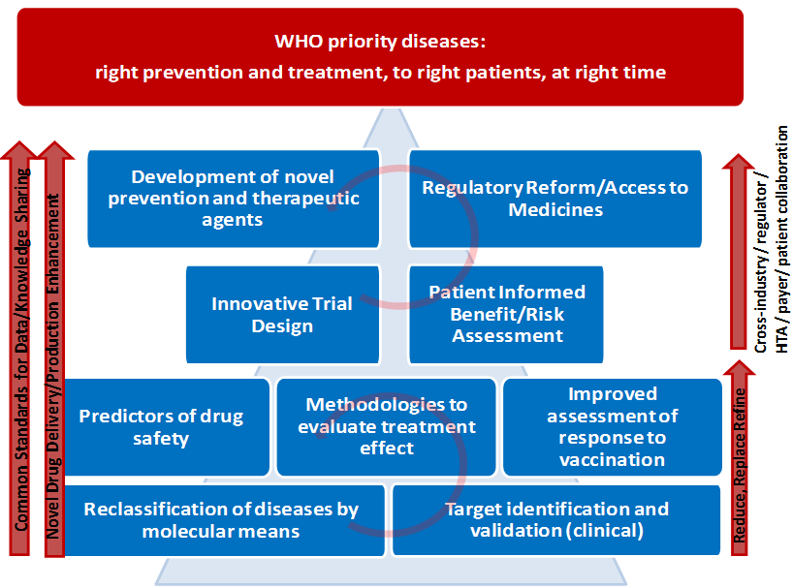
The goal of improving the success rate in clinical trials will be achieved by:
- validating 12 novel drug targets (i.e. clinical proof of concept demonstrated in a phase 2b clinical trial);
- improving from 70 to 80% the predictive capacity of early stage (non-human) safety testing models;
- establishing two new clinical trial networks in areas of high unmet need.
Second, to reduce to 5 years (from the current 7) the time to reach clinical proof of concept in immunological, respiratory, neurological (including neurodegenerative) diseases by:
- reclassifying these four major disease groups, thereby allowing a significantly better diagnosis and simplifying the conduct of clinical trials.
Third, to develop at least two new therapies for diseases for which there is a high unmet need and limited market incentives: antimicrobial resistance (two new classes in the past 30 years) or Alzheimer's disease (only two treatments of limited efficacy have been developed until now).
1. For diagnostics the specific objective is to develop diagnostic and treatment biomarkers for four diseases (from diseases mentioned above) clearly linked to clinical relevance, approved by regulators; the current rate of development of such markers is lower than that of validating targets.
2. In the area of vaccines the specific objectives are to:
  - develop a transparent and comprehensive infrastructure model to gather data on disease incidence and medico- and socio-economic burden of major infectious diseases;
  - develop tested novel biomarkers to predict vaccine efficacy and safety (two markers each) early in the process to improve multiple candidates screening leading to a 50% reduction in the failure rate in phase III clinical trials;
  - develop two novel adjuvants for human use, which will allow increasing the body’s immune response to the vaccine, boosting in particular reaction in specific target groups, such as the elderly and non-responders.
  - identify for two major infectious diseases and for two types of cancer or chronic disorders (e.g. autoimmune diseases) at least: two novel predictive models for efficacy; two novel predictive models for safety. Also contribute to strengthening the link between human and veterinary vaccine research.
Finally, to improve the current drug development process by providing support for the development of tools, standards and approaches to assess efficacy, safety and quality of regulated health products.
3. The specific objectives are interlinked with the overarching goal to convert science into effective prevention and treatment, so that the right prevention, diagnosis or therapy is delivered to the right patient at the right time (fig. 11).
Additional specific objectives could be added should other health related industries join this initiative.

3.3. Operational objectives
The operational objectives are to:
- provide structures that facilitate partnerships along the entire life science research and innovation cycle, such as from early discovery to product development, to pharmacovigilance research and surveillance, in an effective innovation-driven collaborative setting that is focused on optimising life sciences research and innovation for diagnostics, prevention and therapeutic agents and approaches, and support for the development of evidence-based regulation;
- establish networks for open innovation along the whole innovation cycle of novel medical research and technologies, bringing public research institutions, academia, life science industries, SMEs, patient organisations, regulators, payers, public health authorities and the animal health sector;
- reduce the fragmentation of research and innovation and increase the level of private-sector spending in Europe;
- develop and implement strategic agenda setting in a pan-European structure with the necessary critical mass and budget, ensuring continuity and allowing life science industries to make long term investment plans;
- facilitate research that provides evidence earlier in the drug and vaccine development process through risk-sharing mechanisms.
Figure 11: Schematic representation of the objectives' relation to problems and problem drivers

4. Policy Options
The Horizon 2020 proposal addresses the no-EU option in its impact assessment, recognises the need to continue with research and innovation in health and proposes a ‘Health, demographic change and wellbeing challenge’ to be addressed. The Horizon 2020 programme will be implemented via collaborative research projects complemented by PPPs. Consequently, four main policy options remain.

4.1. Option 1: Business-As-Usual
The Business-As-Usual scenario relies on continuing the IMI JU under Horizon 2020 as it currently exists under FP7, i.e. retaining its current scope of objectives and its current implementation arrangements (governance, financial rules, funding rules, etc.), in particular:
- regarding the governance structure – same division of powers and responsibilities between the Executive Director, the Governing Board, the Commission, and the private participants;
- regarding the financial rules – same (updated) financial legal framework;
- regarding the funding rules – the funding and participation rules would continue to diverge from the mainstream rules under Horizon 2020.
In this scenario, a new EU decision continuing the EU participation and financial contribution to a successor initiative would be adopted based on the same terms as for the current IMI with Article 187 of the TFEU providing the legal basis. In this respect IMI would remain focused on building a more collaborative system for biomedical R&D in Europe and speeding up the development of more effective and safer medicines for patients. Current IMI objectives - (a) improving the ability to predict the safety and efficacy of an investigational compound as early as possible in drug development through improved knowledge sharing and management, (b) addressing challenges in drug discovery and development and (c) accelerating the development of better medicines for diseases affecting millions of patients in Europe and worldwide would be maintained while the financial commitment - would remain the same. Accordingly, the duration and financial commitment from the pharmaceutical industry represented by EFPIA is foreseen to €1 billion for 7 years, matched by the EU funding subject to the outcome of the Horizon 2020 decision.
As in option 3, a JTI in the life sciences sector would accommodate the formulation and cross-project execution of strategic research agendas. As JTIs constitute a structured approach towards PPPs, they produce thematic visibility, are launched with a budget that is earmarked, and involve substantial commitment from and ownership by industry. Industry contributes to management costs and project funding and is involved in the implementing organisation and management.
While the IMI organised according to a business as usual scenario would continue to present achievements of the kind described in section 2.9, it would nevertheless struggle to respond to the challenge presented by demographic ageing, both in terms of the scientific and budgetary implications, and would fail to address the recommendations made during the various consultation and evaluation exercises.

4.2. Option 2: No Public-Private Partnership (‘zero option’)
In this scenario, collaborative projects would mean that no EU decision to continue the EU participation and financial contribution to this initiative after the end of its current funding phase in 2017 will be adopted. European efforts to support the biomedical sector would rely on collaborative projects under Horizon 2020. This would facilitate the formulation of common objectives at the project level as well as joint project execution. However, they do not accommodate the formulation and cross-project execution of strategic research agendas. Scientific objectives would be specific for each funded project and focus on tools for improving the drug development process. Support for the specific area of biopharmaceutical research and innovation would be competing with other specific areas to be addressed by the ‘Health, Demographic Change and Wellbeing Challenge’ of Horizon 2020. There will be no commitment from industrial sectors to invest in specific research projects. Industry participation would take place on a project-by-project basis.

4.3. Option 3: Contractual PPP
In this scenario, no EU decision to continue the EU participation and financial contribution to this initiative after the end of its current funding phase in 2017 will be adopted. European efforts to support the development of strong and globally competitive health industries in Europe would rely on one or a series of contractual PPPs. Specific provisions in Horizon 2020 would allow EU funding for actions falling under the ‘Health, democratic change and well-being’ societal challenge. An industry partnership agreement is concluded and industry proposes a strategy and advises on work programmes. Horizon 2020 comitology and Rules for Participation apply and the Commission is responsible for management. Although they accommodate the formulation and cross-project execution of strategic research agendas, these investments constitute a ‘lighter’ approach towards public-private partnership. Their thematic visibility comes under the one of H2020, and they are launched with a budget that is indicative, associated to the commitment from and ownership by industry. Whilst EU commitment and contribution is set at launch of PPP, financing amounts and topics are subject to approval of annual or multi-annual work programmes.

4.4. Option 4: Modernised JTI
The ‘Modernised JTI’ option would consist of a new EU decision continuing the EU participation and financial contribution to a successor programme of the IMI, adopted on the same legal basis, i.e. Article 187 of the TFEU. However, in line with the conclusions of the public and expert consultations, the scope of the successor initiative would be expanded to build-up on the achievements and lessons-learned from the implementation of currently on-going IMI initiative and would therefore be marked by: realistic initial technical programmes; proper scientific and technological management including a well-developed initial time planning, strong monitoring and evaluation, and proactive time management including reprioritisation and reallocation of resources; wide horizontal policy coordination; a suitable legal framework; and appropriate outreach.
The ‘Modernised JTI’ keeps the basic elements of an EU body: legal status, application of the Staff Regulations (with some possible derogations), application of the Protocol on Privileges and Immunities, liability, jurisdiction and applicable law, protection of the financial interests of the Members, rules on confidentiality and transparency; it also keeps basic elements of the Statutes such as the JU bodies and their responsibilities. At the same time ‘Modernised JTI’ simplifies a series of other important elements: reference to the PPP-specific financial rules, harmonized principles on control and audit, application of the Horizon 2020 rules for participants receiving EU funding (not for the industrial partners), set-up under the responsibility of the existing JTI JUs, no mandatory host agreement, streamlined financial and operational planning and reporting, and harmonized approach to internal audit.
In the future legal environment tailor-made for the JTI JUs, the ‘Modernised JTI’ could contribute to: addressing part of and expanding the objective and activities of the JTI JU in view of Horizon 2020, expanding the current programmes, improving their shared governance, providing a stable long term perspective to the stakeholders and simplifying the administration and operations of the JTI JU.
This option further improves the design and suitability of the instrument to the new challenges under Horizon 2020 by simplifying administration, introducing lighter financial procedures, exploring possibilities of establishing common services/functions, and increasing stakeholder commitment to the JTI.

4.5. Discarded options
Further policy options could be considered, such as a regulatory approach. This option does not however allow the problem drivers of market failure and fragmentation to be addressed. To have any appreciable impact, a regulatory approach would have to be far-reaching, exceeding the legal basis provided by the European treaties.
In the online public consultation respondents were able to express their views on each option. Option 4 received the highest level of favourable responses (73% preferred or very much preferred). The regulatory action option was the second most popular with 55% followed by Option 3 (50%). Option 2 was seen as the least preferred alternative (28%) while Option 1 received support from 32% of the respondents. 32% opposed Option 2 and 28% Option 1.

5. Analysing the Impacts and Comparing the Options

5.1. How the options were compared
The four policy options identified and presented in Chapter 4 – 'Business-As-Usual', 'No PPP', 'Contractual PPP' and 'Modernised JTI' – were compared along a range of key input and output parameters selected for their relevance in assessing public intervention in life sciences research and innovation. The comparison along these parameters was carried out in an evidence-based manner using a range of quantitative and qualitative evidence, including ex-ante and interim evaluations; review of academic literature (e.g. on market failures, the impact of public funding for research and innovation); statistical analyses of FP implementation and participation data; public consultations and expert hearings. For the purpose of clarity the chapter is structured around impacts and addresses the direct public health, social and economic impacts for each option.

5.2. Output impacts

5.2.1. Public health impacts
Public health impacts include impacts on health and safety of population, including increase or decrease of health risks. The key driver for supporting biopharmaceutical and life science research is the impact on public health, measured by the number of new approaches for preventing, diagnosing and treating disease and of new products reaching the market and the patient. For pharmaceuticals, this number has been constant for decades despite dramatically increasing R&D investments by industry. The scale and complexity of public health challenges in Europe requires open science and open innovation approaches and new ways of thinking and collaboration in the life sciences sector. With the low productivity in drug development and the high failure risk, in the current economic situation important public health issues are not being addressed. A striking example is the dearth of new antibiotics.
Business-As-Usual Option: Based on the early results of IMI it can be expected that the continuation of IMI would have positive public health impacts as it addresses individual problems of immediate relevance to future public health needs. However, IMI is mostly focussed on addressing bottlenecks in early phases of drug development, whereas the low success rate and high cost are generated in later stages of the innovation cycle, notably in clinical development. The industrial partners in IMI are limited to EFPIA companies and SMEs eligible for IMI funding. To address the IMI objectives during H2020, other industry sectors need to be involved, notably medium sized companies that are not SMEs, vaccine manufacturers, industries from in vitro diagnostics and imaging as well as information technologies and/or animal health. Moreover, the entire innovation cycle needs to be addressed, including regulatory sciences and health technology assessment for incorporating early in clinical development the gathering of information about the value of new interventions.
No PPP Option: Ex-post evaluations have shown that project funding through EU health research programmes creates critical mass at project and programme level and addresses in particular academic fragmentation of research (European Commission, 2011). This has a positive impact on public health but only indirectly, as the results have to be taken forward and exploited. The complex and multidisciplinary technological problem behind the decline in drug R&D productivity is not addressed by this option. With large industry participating only to a small extent in EU health research programmes, the stakeholders in the innovation system with the resources and expertise for bringing new interventions to patients are missing. This means that patients would be deprived of the potential benefits of life science research.
Contractual PPP Option: A contractual PPP would be focused on a narrow area of improving the drug-development process, limiting the participation of relevant companies and hence the translation into biopharmaceutical products. For research on diagnostics including imaging methods public health impact can be expected. Overall, moderately positive public health impacts are expected. Also, the rules – notably on IP – are not adapted to the specific needs of areas of the health-related industries where the biopharmaceutical sector has very long innovation cycles.
Modernised JTI Option: With the current cost, duration and low success rate of pharmaceutical development, a new programme is economically feasible only if the product delivers profits of €500 million per year. Only few pharmaceutical products achieve this high value. As a consequence a low number of products are being developed, many of which have limited interest from a public health point of view. The Modernised JTI Option will deliver improvements that will make it economically feasible to undertake a drug development programme if a product promises to deliver profits of €250 million (Annex 3). This increases the number of new drugs and broadens the scope for drug development programmes, with significant impact on public health.
Better classification of diseases will have an immediate public health benefit on patients eliminating unnecessary exposure to side effects from ineffective treatments, either during clinical development programmes or in established medical practice. This would produce immediate savings for healthcare systems (section 2.6.2). By bringing together the relevant stakeholders from different industries beyond large pharmaceutical companies in a partnership that is designed for the needs of the life science research area can best address the considerable health challenges identified in section 2.1. Overall, the impact on public health under this option would be significantly larger than under the Business-As-Usual option because of its focused objectives on diseases presenting a high public health need, and the multidisciplinary and cross-cutting approaches that would deliver prevention measures, more targeted diagnosis, and earlier treatments.

5.2.2. Social impacts
Business-As-Usual Option: This option means that the continuation of the IMI JU would have positive social impacts on employment overall and training and employment of researchers. IMI currently supports several dedicated education and training projects that fill a critical gap in training on pharmaceutical sciences. The unmatched interaction between researchers from academia, and small and large industry, as well as regulators and patient organisations provides training opportunities in all IMI projects. The positive effect on employment of researchers is twice the effect of FP6 and FP7 health projects. Considering the large commitment of the pharmaceutical industry partners (up to now €720 million in IMI) positive effects on overall employment in the industry are expected. The participant survey has shown that IMI has already created 1,500 direct research jobs (30% in industry; on industry side each direct job supports three indirect jobs).
No PPP Option: The social impacts of this option as regards employment of researchers would revert to the value of FP6 and FP7 health funding, albeit benefiting from specific measures provided in Horizon 2020. Collaborative projects in life sciences sector would bring moderate positive impacts training and employment of research workers. Training of research personnel would be maintained but the specific training in pharmaceutical sciences provided by IMI (missing from university curricula) would be lost, as would be the specific interactions between the different types of stakeholders.
Contractual PPP Option: For the area of biopharmaceutical research the social impact of this option will be similar to the No PPP Option. Effects are however expected for the industry sectors that will engage, notably diagnostics industries. Some specific training activities beyond the No PPP Option can also be expected.
Modernised JTI Option: Positive social impacts will include those associated with job creation, social inclusion resulting from a healthier ageing population and increased productivity. In addition to the positive impacts identified in the Business-As-Usual Option, greater results should be achieved by the Modernised JTI option as it addresses important societal needs of individuals and public health. Training and employment of researchers would also be positively impacted as IMI2 could achieve a paradigm shift in the biopharmaceutical business model.
Eighty-five per cent of the respondents to the online public consultation supported the positive impact of a renewed PPP on jobs, public health, education and mobility of research workers.

5.2.3. Economic and competitiveness impacts
Business-As-Usual Option: As discussed in section 2.9.1, the Business-As-Usual option produces strong economic impact. Indications from IMI project results and the publication and citation analysis (Annex 5) point to highly competitive results. This option will not have a sustained economic impact because it is only focussed on overcoming bottlenecks in drug development and because no other industries beyond the large pharmaceutical industry are included, limiting the effectiveness of the intervention. With the difficult outlook for new product development, the share of the pharmaceutical industry in European economy is expected to remain constant or decline.
No PPP Option: Framework Programme-funded research produces a substantial number of micro-economic benefits. According to the FP6 Impact study, a great majority of FP participants reported at least one form of commercial output (new or improved processes, products, services, standards) stemming from their FP project and a large number even recorded more than one output. FP funding has a positive economic impact on critical mass, addressing fragmentation and strengthening European research capacities (European Commission, 2011). The impact will be in particular on academic and SME-driven research (currently 15% of EU contribution going to SMEs). However, in most cases the take-up and further development is required for products to reach the market and thereby the patient (section 5.1). A prolonged lag-phase for the economic impact of this option can be expected. Despite careful planning of the annual work programmes, the individual projects funded under this option do not address comprehensively the identified challenges, thus limiting their impact on the competitiveness of the bio-pharmaceutical and life science industries.
Contractual PPP Option: Given its focused scope and the participation level of the pharmaceutical industry, the Contractual PPP Option has similar effects on European competitiveness compared to the No-PPP Option. The research and innovation strategic agenda is agreed with industry, but limits the emergence of a sustainable open-innovation ecosystem involving equally industry, SMEs and academia.
Modernised JTI Option: This option makes it economically feasible to launch new drug development programmes, each of which should have a shorter duration and a higher success rate. Based on the value calculations of drug development programmes (Annex 3), it is estimated that this option would lead to additional pharmaceutical sales as from 2025, which will peak at €7.5 billion from 2030, supporting 20,000 additional jobs in Europe. By creating a framework for exchange of previously proprietary data and of open collaboration amongst diverse participants in the life science and biopharmaceutical research eco-system, the performance of the entire sector can be enhanced, which in turn can contribute to the competitiveness of the European economy.
Life sciences industries are characterised by a highly regulated framework and in the pharmaceutical sector by extremely long innovation cycles. The Modernised JTI would have positive economic impacts, as it would address the productivity challenge in biopharmaceutical research.
In the online public consultation a very large share of respondents expected a positive impact of a renewed PPP on the competitiveness of the European biopharmaceutical and other life science industries. The impact is expected to be highest in a time-frame of about 10 years.

5.2.4. Innovation impacts
Business-As-Usual Option: IMI has demonstrated significant impact on innovation by creating a new business model for open innovation recognised for example in an OECD study. It attracts innovative SMEs to a considerable extent (without specific measures having been undertaken) and this will continue under this option (currently 89 SMEs participating, of which 79 unique). The biotechnology industry is the source for a large share of the innovative products being developed by the pharmaceutical industry.
The effectiveness of IMI JTI in terms of innovation is confirmed by the results from the interim evaluation which concluded that although too early to provide definitive assessments, IMI seemed to be on track to achieve the expected impacts.
In the participant survey, significant innovation impact of IMI is demonstrated with 62% of respondents stating that ‘New or improved protocols/methods’ have been developed and 55% of respondents stating that ‘Research field significantly expanded beyond the initial state of the art’, and this after three year maximum duration of projects in a research area that is characterised by long innovation cycles.
No PPP Option: The key challenge for projects funded under EU Framework Programmes lies in translating the results to application, which has been coined ‘overcoming the valley of death of innovation’. An econometric analysis shows that the FP produced a positive impact on the innovative sales of firms participating in the FP. Small and medium-sized enterprises indicated the most positive results in terms of innovation in FP projects.
Horizon 2020 is designed to maximise innovation impacts by providing "seamless support from research to innovation, from idea to market" in a number of ways: by increasing the emphasis on research project output; by pro-actively supporting research result dissemination, demonstration, and piloting; by strengthening support for market take-up; by funding projects that cover a number of stages in the innovation chain; by supporting SME research and innovation throughout; and by including supply as well as demand measures. This is achieved through a number of flexible funding schemes including research and innovation grants.
Even Horizon 2020 collaborative research and innovation projects, however, will be unable to accommodate the various dimensions of critical mass needed for implementing sustained, large-scale, complex research and innovation activities and achieving ambitious transversal targets and specific objectives. As a result, this option provides less of a guarantee for achieving the expected innovation impacts and thereby the specific objectives formulated.
Contractual PPP Option: In its areas of remit the Contractual PPP Option can have positive impacts on innovation, to the extent that relevant industries participate.
Modernised JTI Option: The Modernised JTI option involves all relevant stakeholders and industrial sectors, engaging other industries than solely the pharmaceutical industry and medium enterprises to develop early diagnosis or criteria for success or failure for diseases such as Alzheimer's, thus producing a large innovation impact. The Modernised JTI option is well designed to accommodate the various dimensions of critical mass needed for implementing sustained, large-scale, complex research and innovation activities and thus achieve the expected innovation impacts. The unique contribution this JTI would make is that it would help transition new technologies out of the lab into the firm. Through stronger innovation impact the Modernised JTI option will produce stronger impact on competitiveness than collaborative research or contractual PPPs.

5.3. Input impacts

5.3.1. Effectiveness
Critical mass of resources
Business-As-Usual Option: Joint undertakings achieve best the critical mass, in particular through the implementation of joint agenda setting, mobilisation of additional funding and larger leverage effect on industrial R&D investment.
The survey of IMI project participants shows that respondents' first motivation to join an IMI project derives from the added value provided by large collaborations, which are not possible at institutional/organisational or national level. With 75% of respondents scoring with a mark of ‘important’ or ‘very important’ the items 'Get involved in large, pre-competitive research projects' and 'Large scale or scope of the research objectives that cannot be achieved within your own country or institution', respondents clearly underline the relevance and added value of running such large and ambitious initiatives at European level.
No PPP Option: It is not expected that under this option it will be possible to mobilise a high critical mass of resources, again based on experience from FP7. While some large ‘High Impact Projects’ have been funded under the Health programme, the project size of IMI projects (on average €12.7 million EU contribution, matched by an about equal EFPIA contribution for total average project size of €25 million) is significantly higher than in FP7 Health projects (€4.6 million EU contribution) and thereby higher resources are mobilised. Furthermore, under this option only very limited coordination between projects is possible, whereas under the three other Options such coordination takes place.
Contractual PPP Option: It is expected that the impact on mobilising a critical mass of resources will be between the No PPP and the Business-As-Usual Option.
Modernised JTI Option: While overall similar to the Business-As-Usual option, with the expanded scope and the involvement of all relevant industry sectors the impact on mobilising a critical mass of resources is expected to be even larger. In addition, this option would lower the technical risks thus enabling vital research to take place; would allow resources to be shared between the participants, thus reducing costs; would help to reduce duplication and increase efficiency by coordinating funding around joint strategic research agendas; would reduce resource uncertainty by providing a long-term commitment of both funding and of participation by the key players; would allow sharing of knowledge and expertise between the players, in particular inter-disciplinary and inter-organisational knowledge transfers; and would lead to faster uptake of results because of the participation of all the key players (academia, industry, bio-tech SMEs, clinicians, regulators, patients).
Leverage effect
Business-As-Usual Option: IMI Joint Undertaking has managed to mobilise substantial industrial investment in R&D. The European Commission has committed to make a financial contribution up to an amount of EUR 1 billion from FP7 and the private sector (EFPIA and its member companies) shall provide resources in-kind equal to this contribution. In IMI 1€ of EU funding directly leverages another €1.23. This represents the contribution of the EFPIA partners who do not receive any EU funding and owe contributions to the recipients of IMI funding. With this leverage of funds the projects mobilise a large workforce, on average 100 researchers per project, with 30% coming from EFPIA companies (Annex 2). That is beyond the size of a typical research project in most companies.
In addition to the direct leverage, IMI projects also have a measurable leverage effect on R&D investment, with 35% of respondents of the IMI project participant survey reporting that IMI funding facilitated access to other funds to expand or continue their work, including extra pharmaceutical industry funding outside IMI projects. This is double the leverage observed in ‘traditional’ FP projects. Furthermore, IMI has been able to attract private foundations from outside Europe such as the Juvenile Diabetes Research Foundation and Autism Speaks Organisation. Leverage also relates to the question where industry will place its investments. Without the PPP investment from industry may not happen at all. Other world regions are competing with Europe by creating conditions to attract innovative life science companies (including with financial grants, tax arrangements, etc.). The leverage effects of IMI are expected to continue for the Business-As-Usual Option under Horizon 2020.
No PPP Option: The direct leverage of this option will be limited to the non-reimbursed part of indirect costs going beyond the 25% flat rate under Horizon 2020. The indirect leverage will be as identified in the FP6/FP7 health project participant survey, which is half that of IMI.
Contractual PPP Option: The direct leverage will be as for the No PPP Option. However, indirect leverage can be quite significant, since concrete commitments are needed for launching a contractual PPP.
Modernised JTI Option: The leverage effects of the Business-As-Usual option also apply to the Modernised JTI Option.
Participation of industry and SMEs
Business-As-Usual Option: The participation of industry and SMEs in this option will be as in IMI, with 50% of total funding and 30% of all staff resources coming from large industry and EU contribution to SMEs between 15 and 20% (currently at 18.9%).
No PPP Option: Industry and SME participation under this option is expected to be similar to the current participation in FP7 Health projects, which consists practically exclusively of SME participation (receiving 15% of EU contribution), with pharmaceutical industry representing only 0.78% of participants, receiving 0.5% of EU funding.
Contractual PPP Option: SME participation will be similar to the other options. Large biopharmaceutical companies would still not participate because they expect some targeted rules, which is not possible under this option.
Modernised JTI Option: Large industry will participate in the Modernised JTI Option to an extent similar to the Business-As-Usual Option but the type of industry will be different, since only biopharmaceutical companies that are full members of EFPIA participate in IMI to a measurable extent. Other medium (but not SME) and large companies, for example from the biomedical imaging, medical information technology, diagnostic and/or animal health industries will participate in the Modernised JTI Option.
Strategic agenda
Business-As-Usual Option: Through a strategic research agenda that has been widely consulted on and revised at the appropriate time, IMI has set the basis for impacting research agendas beyond the programme. This has happened for several disease areas and for a number of overarching technologies such as screening of compounds at industry standard and in the field of stem cell research, notably with the establishment of an infrastructure for induced pluripotent stem cells. This impact will be continued under the Business-As-Usual Option.
No PPP Option: With its annual work programmes and having to address a wide range of topics under the ‘Health, demographic change and wellbeing challenge’ the impact on agenda setting of this option will be possible but limited. Through the creation of Joint Programming Initiatives this is happening in the areas of neuroscience and antimicrobial resistance research. For rare disease research the international IRDiRC consortium has been created. Where appropriate the programme will continue to contribute to international activities, thus also contributing to setting of strategic research agendas.
Contractual PPP Option: On setting of strategic agendas this option can have significant impact for the industry sectors and related research areas that it covers.
Modernised JTI Option: Compared to the Business-As-Usual Option an even higher impact in the area of strategic agenda setting is expected because the renewed IMI will expand in scope and thus bring in the research areas of vaccines, diagnostics, biomedical imaging and medical information technologies, that will not be addressed otherwise.
Addressing fragmentation
Business-As-Usual Option: In the areas that have been addressed by IMI, a significant impact is overcoming fragmentation. This concerns in particular research on neuropsychiatric and neurological diseases, where each project has pooled significant amount of data never shared before. In the cluster of projects this aspect is reinforced while similar clusters of IMI projects exist in respiratory disease and in diabetes. The education and training projects overcome fragmentation of training programmes in pharmaceutical sciences, which has been recognised for example through the award of the education technology prize to the Eu2P project. The impact of the Business-As-Usual Option on addressing fragmentation will therefore build from the current IMI.
No PPP Option: The effect of European level funding on addressing fragmentation has been assessed. In the area of the ‘Health, demographic change and wellbeing challenge’ this occurs through creation of research networks in given areas, many of which form nodes in world-wide consortia (such as cancer genome consortium, mouse phenotyping consortium etc.). Furthermore, fragmentation between academic and industrial research actors is addressed. However, the pharmaceutical industry participates only to a small extent in projects and hence fragmentation between industry, industry sectors, and academia is not addressed.
Contractual PPP Option: For research areas of interest to participating industry sectors this option could have an important impact on overcoming fragmentation. Since as for the No PPP Option the pharmaceutical industry remains unlikely to participate in this option, fragmentation into biopharmaceutical research and other life science research will not be addressed.
Modernised JTI Option: With the reinforced focus on overcoming public health challenges the Modernised JTI Option will have a higher impact on addressing fragmentation than the Business-As-Usual Option, as it will focus on the most urgent needs. Furthermore, it can address fragmentation between biopharmaceutical research and other relevant sectors, notably diagnostics including medical imaging and medical information technologies.
All options: Coherence with Member State programmes will be ensured through consultation and coordination via the relevant structures. No large differences between the options are expected on this point.
All PPP options: Through the funded projects the Business-As Usual, Contractual PPP and Modernised JTI Options are expected to have overall similar impacts on horizontal policy coordination (see for example the IMI topic on framework for rapid assessment of vaccination benefit/risk in Europe). As publicly funded bodies the JTI or the contractual PPP will have to refrain from trying to actively influence policies. However, by offering a platform for relevant stakeholders to come together (from patient organisations, regulators, academia, SMEs to large industry), the PPP options encourage interaction that should promote the development of policies. Because the biopharmaceutical industry will likely not participate in a Contractual PPP, the impact of this option on this criterion is likely to be somewhat lower than that of the institutionalised PPPs. The No PPP Option does not have a high impact on this criterion.

5.3.2. Efficiency, administrative cost; governance structure and implementation
The implementation of JTIs under FP7 has been criticised for their cumbersome implementation. Major simplification is foreseen for the implementation of Horizon 2020. The simplifications will apply to all options considered.
From the perspective of the pharmaceutical industry the Business-As-Usual and Modernised JTI Options represent significant simplifications because they allow adapting to the specific needs of biopharmaceutical research, notably on intellectual property. This is demonstrated by the high level of EFPIA companies' participation in IMI. However, in the consultation of project participants, the administrative burden of IMI was overall considered to be slightly higher than that of FP7.
The Contractual PPP Option will produce a higher administrative burden than the No PPP Option because according to Horizon 2020 rules, coordination costs and reporting of the industry contribution will be required, in addition to project follow-up.
Cost neutrality and JTI JUs as effective means to achieve goals
The first experiences with the JTI JUs indicate that they constitute a highly effective means of implementing FP7. The use of a JU to implement the JTI has the following main benefits compared to using the standard means of implementation of a framework programme:
- a clear commitment of stakeholders;
- visible legal, contractual and organisational framework to structure the specific joint commitments to which stakeholders are ready to sign up;
- firm governance structure for the JU, including shared decision-making powers and management by the public and private partners, is visible to all stakeholders;
- budgetary certainty via the budget ceiling for EU contribution to cost of operations and the private partners' financial commitment;
- efficient use of public resources as the Commission passes operational roles to the JU, while retaining focus on regulation and supervision.
Furthermore, the use of a JU to implement the JTI with the current small-sized body is already at least cost neutral and probably more cost-effective for the Commission, as shown by the cost-benefit analysis performed in-house DG RTD, in comparison to direct implementation of FP7 by the Commission - including contractual PPPs - in terms of administrative, supervision, establishment and winding up costs because the private partner pays 50% of the running costs of the JU. Increasing the size of operations of the JTI JUs and simplifying their functioning on the basis of common participation rules for Horizon 2020 will make the JU a cost-effective means of implementation.
Possible improvements - efficiency
The ‘Business-As-Usual’ scenario relies on continuing the JTI JUs under Horizon 2020 as they currently exist under FP7. In contrast, the ‘Modernised JTI Option’ option simplifies and improves the legal framework, governance, and operational modalities of the current JUs.
In particular, in order to ensure cost-neutrality of the JTI JUs under Horizon 2020 and increase their cost-effectiveness, the following simplification measures are being considered:
- Foreseeing a single set of Rules for Participation and Dissemination for the beneficiaries that will, subject to derogations where appropriate, render participation easier and ensure a single and sufficiently flexible regulatory framework, create a more coherent set of instruments covering both research and innovation, enhance programme accessibility and attractiveness, and increase the scientific and economic impact while avoiding duplication and fragmentation.
- Introducing lighter financial procedures, which in particular will provide simplified procedures for the establishment and the adoption of the budget and corresponding reporting. This is due to the new Financial Regulation which permits bodies like JTIs adopt lighter financial rules based on a new, tailor-made, simplified ‘model’ Financial Regulation.
- Using common IT systems, including the proposal evaluation system for Horizon 2020 which increases harmonisation, reduces the costs for such services and allows JU staff members to better adapt to the common programme. Moreover, by using the ‘commons’ of the programme, the JUs coordinate better their internal processes regarding portfolio management, as well as monitoring and reporting towards the legislator and the Commission regarding management of programmes and projects.
- Exploring different options regarding establishing common services/functions (IT, Audit, Legal issues) for PPP/JTIs. These options are: a) Commission provides common services to JTIs JUs and requests from them the payment of a proportional contribution; b) JTI JUs set up their own common functions, which are specific and shared among them; c) Each JTI JU organises itself individually.
- Sharing functions in the context of the internal audit or for the accounting officer (the latter case being explicitly provided for by the Rules of Application), Service Level Agreements, common service and supply contracts and exchange of information among JU colleagues.
- Continuity of staff between the current and future JUs for the period when the current project portfolio is closed down and the future portfolio is built up.
Possible improvements - effectiveness
At the same time, the above simplifications envisaged for the Modernised JTI JUs to be set up under Horizon 2020 will also allow them to become more effective by:
- Clear stakeholder commitment to the JTI through i) a definition, in a dedicated annex to the regulation, of the contribution to the JTI of industrial members, rendering their contribution more visible, ii) improved representation of the public and private partners in governing bodies, iii) a balance of influence between the Commission and Industry in the appointment of the Executive Director, etc.).
- Introducing more flexible budgetary and procurement procedures through adjusted legislative framework building on the new Financial Regulation.
- Increasing the accessibility and attractiveness of the programmes. The Horizon 2020 JTI JUs shall apply the common set of rules of the Horizon 2020 Rules for Participation, thus providing a coherent legal framework. Derogations to reflect the public-private nature of the JU need to be duly justified and should be cost-effective for the implementation of Horizon 2020.

6. Preferred Option
Based on the aforementioned comprehensive in-depth comparison of the policy options, it emerges that 'Modernised JTI' option would be the most appropriate policy option, the preferred option, to achieve the objectives formulated in Chapter 3. Table 3 summarises the comparison of the 'Business-As-Usual', 'No PPP', 'contractual PPP' and 'Modernised JTI' options in terms of cost effectiveness, efficiency and coherence. Fully in line with the recommendations issued by the Sherpa Group and in the Court of Auditors' report, the Commission has developed a tailored legal framework (section 5.3.2) in consultation with all stakeholders involved, including industry, Court of Auditors and the Directorate-General for Budget.
Table 2: Summary comparison of options (impact compared with the BAU scenario)
 | No PPP | cPPP | Modernised JTI
Public health impacts | -- | - | +++
Social impacts | -- | - | ++
Economic and competitiveness impacts | - | - | ++
Innovation impacts | -- | - | ++
Critical mass of resources | -- | - | +
Leverage effect (overall R&I resource mobilisation) | -- | - | =
Participation of industry and SMEs | -- | - | ++
Strategic agenda | -- | - | ++
Addressing fragmentation | - | - | ++
Administrative cost and efficiency of governance | - | -- | =
Coherence | = | = | ++
Efficiency | -- | = | ++
Effectiveness | -- | = | ++
(‘-‘ indicates a reduction in impact; ‘=’ indicates a maintained impact and ‘+’ thereof indicates an increased, positive impact).
Compared with the 'Business-As-Usual' option, the 'Modernised JTI' option is cost neutral, therefore efficient (section 5.3.2). Like the 'Business-As-Usual' option, it would achieve critical mass at project and programme level. At the same time, it would allow for more flexibility and reduced administrative costs for applicants and participants. This would improve significantly accessibility, in particular for SMEs and increase levels of support from stakeholders. This option would address the identified problems (i.e. low productivity in drug development and high risk failure) in a comprehensive manner and is best aligned with the views expressed by stakeholders and experts (section 1.4.). Innovation impacts would be enhanced through the provision of financial support from scientific idea to the market, a stronger output orientation, a better dissemination of research results, as well as enhanced industrial and SME participation and thus, enhanced leverage.
The expansion in scope of the planned IMI2 concerns addressing the entire research and innovation value chain, rather than addressing bottlenecks in drug development, as was the case for IMI. Research under the planned IMI2 will address diseases based on the framework provided by the WHO priority medicines list (fig. 10).
In addition to the planned research activities, a potential investment (product development) scheme may be considered, among other options, which would be opened to all interested life science industries. Access to the Horizon 2020 financial instruments may be facilitated by the IMI2 Joint Undertaking. If considered necessary, the development of a specific IMI financial instrument can be envisaged.

As regards the eligibility for funding under the ‘Modernised JTI’ option, as a principle, the arrangement of the ‘Business-as-usual’ option should be continued. Funding is limited to SMEs, secondary and higher education establishments, non-profit legal entities, including those carrying out research or technological development as one of their main objectives or those that are qualified patient organisations, the Joint Research Centre and international European interest organisations. In addition, consistent with the expansion of the scope, in order to ensure a wider participation to the partnership, in limited cases, if foreseen by the work plan, in order to support emerging innovative companies encountering difficulties to access finance these entities could be eligible for funding.
The 'Modernised JTI' option would allow achievement of simplification producing positive feedback effects on administrative burden, accessibility, reach and leverage effects. This is also the only option where additional legal and financial commitments from industry can occur beyond those made in project grant agreements.
In addition to the impact of the 'modernised JTI' in terms of costs to the public health system, innovative medicines produce considerable indirect economic benefits including (i) increased total economic production value (e.g. avoiding temporary disabilities, or decreasing their length), (ii) reinforced employment, through research, production, and distribution of innovative medications, (iii) added value through highly trained people, (iv) eased burden on public health (e.g. reducing hospital stays), on pension systems (e.g. avoiding early pension eligibility), and (v) increased quality of life (e.g. reduced morbidity and mortality). Through participation in health research projects, access is granted to networks of experts and information. Approximately 20% of private sector innovations are partially based on public sector research.
An analysis by the European Commission's Directorate-General Economic and Financial Affairs found significant positive effects on the number of patents and business patents per million inhabitants for a number of independent variables related to public intervention: the public R&D stock, international research cooperation and international researcher mobility (through which access is provided to the stock of foreign R&D), and the share of R&D invested in basic research.
Public intervention for private research increases the amount of research expenditure (i.e. input additionality, crowding-in effect and leverage effect). Recent analysis shows that €1 of public spending of R&D leads to additional private R&D of €0.70-0.93 when allocated to business.
In terms of governance, a Governing Board with representation of the members of the JU provides oversight of an Executive Office responsible for the day-to-day management and of advisory groups established for each major research area. The advisory groups will be composed of representatives from the industry partners who take the lead in a given research area as well as scientific experts appointed by the Commission. The tasks of the advisory groups will be to provide dedicated strategic management and close follow-up of projects in each area. It will be ensured that the work between the different advisory groups is appropriately coordinated. Through the Commission services, coordination will also be ensured with funding under the 'Health, demographic change and wellbeing challenge'.
Figure 12: Comparison of priorities addressed under IMI and modernised JTI
4. 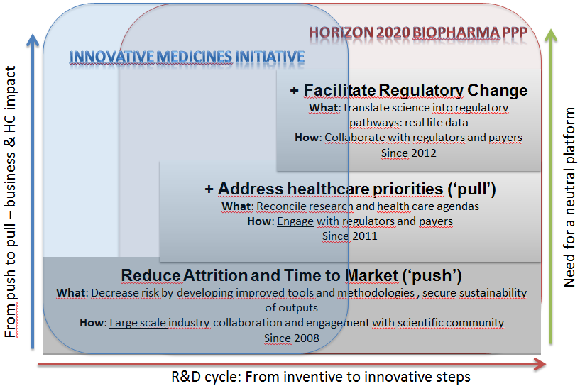

6.1. Proposed budget
The maximum initial EU contribution will be €1,725 billion, with €225 million of this being conditional on matching funds being provided by non-EFPIA participants. The remaining €1,5 billion EU contribution will be matched by EFPIA members. Table 4 illustrates the differences in scope and running costs that would result from application of this maximum budget to the four available policy options under Horizon 2020. Table 5 shows the differences in scope and objectives that would result from differing levels of EU contribution (and by implication, industry commitment). In addition the programme will benefit from further funding based on an investment (product development) scheme, using the financial instruments available under Horizon 2020.
The EU contribution to IMI has ramped up during FP7 and in 2012 and 2013 is €250 million per year on average. Compared with the EU contribution in the last years of FP7 this means that there is no increase in yearly contribution under Horizon 2020. This budget allows the engagement of relevant industry sectors and addresses a key criticism against IMI, that on the industry side it has been focussed on EFPIA only. The enlarged JU will reap significant economies of scale and the operations will be considerably more cost effective than the current set-up.
Table 3: policy options
Building Blocks | Business-As-Usual | No Public-Private Partnership | Contractual PPP | Modernised JTI
Legal basis | Art. 187 | Horizon 2020 | Horizon 2020 | Art. 187
Scope | Overcoming bottlenecks in drug development; partnership with EFPIA | Set by Horizon 2020 | In the frame of Horizon 2020 set by contractual agreement between Commission and private partners | Addressing public health challenges in partnership between EU and private industry; working on the entire life science value chain; partnership with EFPIA, vaccine manufacturers, medium-sized companies and other life science industries such as imaging companies, medical devices or diagnostics, animal/human health interface
Duration | As Horizon 2020:  7 years | Horizon 2020: 7 years | Funded from Horizon 2020: 7 years | As Horizon 2020:  7 years
Indi-cative overall budget | €3 billion, 50% coming from the EU and 50% from EFPIA. In addition, up to €450 million conditional on matching funds being provided by non-EFPIA participants (50% coming from the EU and 50% from non EFPIA participants). | Up to €1,725 billion share of the budget for the ‘Health, demographic change and wellbeing challenge’. | A €1,725 billion share of the budget for the ‘Health, demographic change and wellbeing challenge’. | A baseline budget of €3 billion, equally shared between EU and private partners (EFPIA, other life science industries, medium-sized companies) is foreseen. In addition, up to €450 million conditional on matching funds being provided by non-EFPIA biomedical industry participants (50% coming from the EU and 50% from non EFPIA partners).
Running costs | Maximum 4% of total budget | Not directly applicable, administration alongside remainder of Horizon 2020 | Not directly applicable, administration alongside remainder of Horizon 2020; for private partners coordination costs | Maximum 3% of total budget

Table 4: Modules of the Modernised JTI option depending on budget availability
Planned EU contribution (€ million) | Scope of partnership | Specific objectives
1,000 | EFPIA companies have committed to contribute up to €1.5 billion. Hence a budget at the level of the current IMI would not match the minimum plans of our private partners. Furthermore, it would not allow the planned integration of stakeholders from other life science industry sectors. The expansion of scope foreseen for IMI2 would partially take place. With this budget the specific objectives as described in section 3 cannot be met. | The specific objectives cannot be completely fulfilled: 8 out of 12 drug targets validated, 1 clinical trial network established; 3 major disease groups re-classified, 1 new therapy developed. In of diagnostics, markers for 3 diseases developed, in vaccines, 1 efficacy and safety marker each and 1 adjuvant developed.
Additional 500 (total 1,500) | A total EU contribution of €1.5 billion would match the commitment from EFPIA companies. Whilst the activities in biopharmaceutical research as foreseen can be addressed, further industries can still not be integrated. To a very small extent this might take place at a project by project level. | The specific objectives as described in section 3.2 can be achieved but only as regards the pharmaceutical industries sector.
Additional 225 (total 1,725) | The EU contribution of the equivalent of up to € 225 million for ad hoc participations of non EFPIA members, which would be conditional to the equivalent contribution of the new participants. An EU contribution of €1,725 billion would allow implementing the research activities of the PPP with integration of the different life science industry sectors, thus allowing to benefit from synergies between the different sectors and to create a single pillar for imaging. | In addition to the specific objectives listed in section 3.2 some further specific objectives for the other industries can be achieved. Detailed specific objectives for life science research areas beyond biopharma can be achieved.
Additional funding to be made available from investment schemes foreseen in Horizon 2020 or in specific investment schemes | In addition to the planned research activities a potential investment (product development) scheme, among other options, open to all interested life science industries. Access to Horizon 2020 financial instruments may be facilitated by the IMI Joint Undertaking. If considered necessary, the development of a specific IMI financial instrument can be envisaged. | In addition to objectives as outlined above, development of products could be supported.
In order to simplify the set-up of the PPP, it is foreseen to absorb the existing IMI JTI JU. This will ensure continuity of staff and experience gained and should happen with the establishment of the Modernised JTI JU. No particular costs for this transition are expected. IMI2 will also ensure the continued follow-up of IMI on-going grants and exploitation of results. With the launch of the new PPP, the institutional set-up, the concerns raised in the Sherpa’s report⁶ on the legal structure as well as governance and operational arrangements will be addressed.

6.2. Risk mitigation strategy
With the preferred option various risks are associated. To tap its full potential, IMI2 JU would need to gather the support from private partners to cover the running costs of the organisational structure to implement the PPP. Based on the experience with the on-going IMI - where cash-payments are made for the running cost expenditure and in-kind contributions represent the private partner contribution to operational expenditure - the risk that no contributions are made by the foreseen private partners is considered negligible. At an EU contribution of €1 billion, and in the context of the current strategic research agenda, it is very likely that a private partner contribution of a similar amount can be achieved. EFPIA CEOs have made a commitment of €1.5 billion research contribution to IMI2. The risk is mitigated by requiring firm up-front commitments from private partners and EU contributions are made available in annual instalments. In case of serious problems further provision of EU funds can be suspended.
The programme should also be able to attract researchers of the highest calibre in academia and SMEs as well as patient organisations and other relevant stakeholders to its calls. In IMI we have seen high interest in calls and selected proposals have typically been very positively evaluated, attesting to the scientific excellence. With the strategic research agenda of IMI2 being driven by public health needs and addressing biopharmaceutical and life science research with a larger scope, the risk of calls not attracting appropriate interest is considered low. To mitigate this risk the strategic research agenda is developed in an inclusive manner and is being kept updated. Calls for proposals are launched following appropriate consultations of the scientific community and stakeholders to ensure that they address research questions in the most appropriate manner.
Implementation through a dedicated legal structure outside direct control of the European Commission entails risks that financial resources are mismanaged or that the overall operations are neither effective nor efficient. These risks will be mitigated through regular oversight by and reporting to the Governing Board established as the highest governing body of the planned JTI JU, where the Commission representing the EU will have a central role with veto rights over important decisions.

7. Evaluation and monitoring
A set of quantitative and qualitative performance indicators will be established to monitor the implementation of IMI2. These performance indicators will measure the impact of the JU on EU competitiveness and on achieving the objectives as described in chapter 3.
The monitoring will be done at different levels. The top-level monitoring will fall upon the Governing Board of the JU, in which the Commission will be represented according to its share of the overall budget. The Executive Management will monitor the operations of the JU internally and will present an Annual Activity Report to the Governing Board. This will also be submitted to the EU budgetary authority in the context of the indirect discharge procedure for the use of EU funds by the JU.
The Commission will present to the Council an Annual Implementation Report, including a report on the state of progress of the JU and on its financial position.
In order to monitor the implementation of the strategic research agenda and the scientific progress of projects advisory groups will be established for each major research area being addressed by the planned PPP.
In support of the European Research Area objective, the organisation of the annual Stakeholder forum will continue, in order to report on the progress of IMI2 operations, to contribute to the exchange of information and to help coordinating activities between the JTI, other EU initiatives, and national, regional and private actions.
Quantitative indicators will be measured in a comparative and systematic manner, and qualitative analyses will be performed annually. It is expected that the collection of information/data necessary for the monitoring will not lead to significant administrative costs for beneficiaries of the funding from IMI2 or for the private partners, as most of the data will have been collected through regular reporting.
Table 5: Proposed indicators
Scientific and technological progress
 | Indicator | Target
- Monitoring achievement of objectives of the JU | Monitoring the achievement of specific objectives | See section 3.2
- Monitoring achievement of objectives of the JU | Number of open innovation networks established | By 2 years, 1 open innovation network between different industry sectors established, by 4 years 2 further networks established; 2 clinical trial networks established by 2 years
- Monitoring achievement of objectives of the JU | Number of strategic agenda setting beyond JU | By 2 years strategic agenda setting in 3 research areas defined by the specific objectives; by 4 years 5 more research areas
- Monitoring achievement of objectives of the JU | Number of partnerships established | By 2 years partnerships in 6 research areas defined by the specific objectives; by 4 years 10 more research areas
Monitoring implementation of the strategic research agenda | Number of data points analysed for reaching at unbiased molecular taxonomy of disease | By 2 years, 1 million, by 4 years 4 million data points analysed
Monitoring implementation of the strategic research agenda | Number of diseases classified | By 5 years 1 disease area, by 7 years 1 further disease area, by 9 years 2 further disease areas
Monitoring implementation of the strategic research agenda | Number of trials analysed for learning from negative results | By 2 years 25 trials, by 4 years a further 100 trials
Monitoring implementation of the strategic research agenda | Level of taking account of health and demographic change and wellbeing policy goals | Strategic research agenda needs to address points 1.1.2, 1.2.2, parts of 1.2.3 and parts of 1.3.1 of partial general approach of Horizon 2020
Monitoring JU operations
Selection of projects and allocation of funding | Time-to-grant | 270 days
Selection of projects and allocation of funding | Time-to-pay | 30 days
Selection of projects and allocation of funding | Level of adherence to time schedule | Budget committed in the foreseen yearly instalments and calls launched accordingly
Selection of projects and allocation of funding | Level of SME participation and benefits | 20% IMI2 funding going to SMEs
Efficiency of research programme | Number of publications | On average 20 publications per €10 million funding
Efficiency of research programme | Impact factor of journals where articles are published | As from 3rd year; average impact factor 10% above EU average
Efficiency of research programme | Impact of publications | Citations 20% above average for EU publications
Efficiency of research programme | Number of patents | On average 2 patent applications per €10 million funding
An interim evaluation of IMI2 should take place before the end of 2017. A final evaluation of IMI2 will be undertaken within 6 months after the end of the programme. These evaluations will be conducted by independent experts and will cover the quality and efficiency of the Joint Undertaking and progress towards its objectives. They will make recommendations for any necessary re-adjustment of the programme and if applicable, consideration of an exit strategy. The Commission will communicate the conclusions of the evaluation to the Council. The final evaluation of the Joint Undertaking and the results will be presented to the European Parliament and the Council.
The interim evaluation will measure the achievement of the following key milestones:
- two clinical trial networks to be established by 2016;
- all projects for arriving at taxonomy of disease started by 2017;
- six projects for validating novel targets started by 2016, further 3 projects started by 2017;
- trials for developing novel treatments started by 2017;
- projects for developing diagnostic markers started by 2017;
- infrastructure to gather data on disease incidence and medico- and socio-economic burden of major infectious diseases established by 2016;
- projects for developing novel biomarkers to predict vaccine efficacy and safety started by 2016, results on one markers by 2017;
- projects for developing of adjuvants started by 2016;
- projects for developing efficacy and safety models for vaccine research started by 2016, results for one model by 2017.

8. ANNEXES

Annex 1 Glossary and abbreviations
Annex 2 IMI: scope, mandate and governance
Annex 3 Summary of stakeholder consultations and list of meetings with stakeholders
Annex 4 Economic situation of the pharmaceutical industry
Annex 5 Achievements of IMI
Annex 6 Valuing drug development programmes
Annex 7 Bibliography
Annex 1
Glossary and abbreviations
Antimicrobial resistance (AMR) refers to the resistance of microorganism(s) to treatment to which they were previously sensitive. Resistant organisms (including bacteria, viruses and some parasites) are able to withstand attack by antimicrobial medicines, such as antibiotics, antivirals, and anti-malarials, so that standard treatments become ineffective and infections persist and may spread to others.
Biomarkers (see also diagnostic makers) refer to distinct biochemical, genetic or molecular characteristics or substances that are indicators of a particular biological condition or process (for example a blood test to measure protein biomarkers for cancer).
Biomedical Research comprises the study of specific diseases and conditions (mental or physical), including detection, cause, prophylaxis, treatment and rehabilitation of persons; the design of methods, drugs and devices used to diagnose, support and maintain the individual during and after treatment for specific diseases or conditions; the scientific investigation required to understand the underlying life processes which affect disease and human well-being.
Biotechnology is the use of biological processes, organisms, or systems to manufacture products intended to improve the quality of human life.
Classification of diseases is used to classify diseases and other health problems recorded on many types of health and vital records including death certificates and health records. The International Classification of Diseases (ICD) is the standard diagnostic tool for epidemiology, health management and clinical purposes. This includes the analysis of the general health situation of population groups. It is used to monitor the incidence and prevalence of diseases and other health problems.
Clinical Trial is any research study that prospectively assigns human participants or groups of humans to one or more health-related interventions to evaluate the effects on health outcomes. Clinical trials may also be referred to as interventional trials. Interventions include but are not restricted to drugs, cells and other biological products, surgical procedures, radiologic procedures, devices, behavioural treatments, process-of-care changes, preventive care, etc.
CoA refers to the European Court of Auditors
COCIR refers to the ‘comité européen de co-ordination des industries radiologiques, électromédicales et d’information de santé’
Critical mass within the context of R&D is defined by a combination of framework conditions that would boost financial leverage on public funding through the implementation of joint long-term, industry-driven, consensus-based strategic agenda through cross-border, cross-sector, inter-disciplinary research, mobilisation of additional funding and larger leverage effect on industrial investment.
Degenerative diseases are diseases in which deterioration of structure or function of tissue occurs (e.g. arteriosclerosis; cancer; osteoarthritis).
DG RTD refers to the European Commission’s Directorate-General for Research and Innovation
Diagnostic markers (see also Biomarkers) refer to substances or groups of substances in the body or in a bodily fluid that can be tested for, and which indicate the presence of a particular illness or condition (for example a type of cancer).
EFPIA refers to the European Federation of Pharmaceutical Industries and Associations
EMA refers to the European Medicines Agency
EMTRAIN refers to the European Medicines Training Network
EUPATI refers to the European Patients Academy on Therapeutic Innovation
Eu2P refers to Pharmacovigilance and Pharmacoepidemiology
FDA refers to the US Food and Drug Administration
FP7 refers to the Seventh Framework Programme of the European Community for research, technological development and demonstration activities (2007-2013)
Joint Technology Initiative (JTIs) are European Union instruments for addressing technological challenges that are of key importance for the future competitiveness of the EU industry involved, challenges that industry and markets would fail to address without a sizeable public intervention extended over a multi-annual timescale. Both the importance of the JTIs to the future competitiveness of the industry involved and the special nature of the public commitment requested (large-scale, multi-annual cash contribution) warrant an explicitly defined commitment from industrial members, which goes beyond standard cost-sharing under Horizon 2020. Only such commitments are creating a true public-private partnership.
Joint Undertaking (JU) is used to designate established JTIs. The term "Joint Undertaking" refers to the administrative structure of the JTI.
Life science industries are industries such as pharmaceutical companies; biotech companies and makers of medical devices.
Medical device means any instrument, apparatus, implement, machine, appliance etc. intended by the manufacturer to be used, alone or in combination, for human beings for one or more of the specific purposes of e.g. diagnosis, prevention, monitoring, treatment or alleviation of disease or injury; investigation, replacement, modification, or support of the anatomy or of a physiological process.
Me-too drugs are drugs that are structurally very similar to already known drugs, with only minor differences.
One health refers to efforts to work collaboratively across a variety of disciplines and locales to obtain optimal health for people, animals and the environment, given the evident links between each of these.
Patent cliff is a colloquialism to denote the potential sharp decline in revenues upon patent expiry of one or more leading products of a firm. A patent cliff is when a firm's revenues could "fall off a cliff" when one or more established products go off-patent, since these products can be replicated and sold at much cheaper prices by competitors.
SRG refers to the States Representatives Group.
Zoonoses are diseases which can be transmitted between different species, with the term being used most frequently to refer to diseases which can be transmitted from non-human animals to human beings (e.g. rabies).

Annex 2
IMI: scope, mandate and governance
IMI is a public-private partnership (PPP) between the European Commission and the biopharmaceutical industry established in 2007. It is known as a Joint Technology Initiative (JTI), and was established as a Joint Undertaking (JU) on the basis of Article 171 of the Treaty Establishing the European Community (now Article 187 of the Treaty on the Functioning of the EU).
The objective of IMI is to improve the drug development process by supporting a more efficient discovery and development of better and safer medicines for patients. This is achieved through the funding of research projects which bring together industry, academia and other stakeholders. The achievements thus far of these projects are described in section 2.9 and Annex 2.
The total budget of the IMI Joint Undertaking is € 2 billion (€ 1 billion from the European Union funding and € 1 billion from the biopharmaceutical industry). Both partners are represented with equal voting rights in the Governing Board, the highest decision making body of IMI. The Governing Board supervises the Executive Office (EO) which implements IMI. The third element in the governance structure of IMI is the Scientific Committee which leads on the Strategic Research Agenda, with the States Representatives Group and the Stakeholder's Forum as advisory bodies. The EO organises the consultation on call topics, which are proposed by EFPIA, guides the implementation of the calls and ensures the follow-up of projects.
IMI has a two-stage submission and evaluation procedure for proposals. In the first stage, expressions of interest from participants eligible to be funded by IMI (only academia, SMEs, patient organisations and regulators) are selected. The top-ranked expressions of interest are then merged with the pre-existing EFPIA consortia and the resulting full project proposal is again evaluated. It is mandatory for IMI projects to sign a project agreement amongst the partners before the start of the project. Projects typically run for 5 years.
Figure 13: IMI Governance Structure
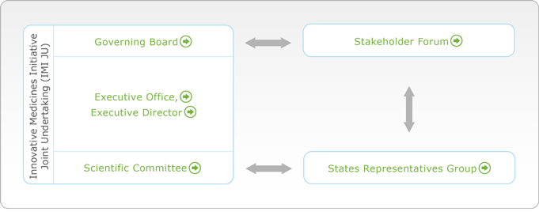

Annex 3
Summary of stakeholder consultations and list of meetings with stakeholders
- All stakeholders agreed on the relevance of the life science industry for addressing societal challenges such as the ageing population and for the European economy with 98% and 100% respectively. A variety of problems in life science research are identified, such as the difficulty in obtaining indications on treatment efficacy in early clinical testing or the challenge of addressing better diagnostic and treatment for all (‘personalised medicine’), considered by 82.1% and 88.8% of respondents as important or very important. The large majority of respondents considered that industry (91%) or Member States (65.7%) alone cannot address the challenges and that the EU needs to step in (93%). Respondents were more mixed on the extent to which a lack of qualified research personnel represents a barrier to bringing results to the market and to patients.
2. SMEs expressed most strongly the view that the challenge of incorporating new technologies in life science research and innovation for bringing innovation to patients was a very important problem (92%). According to a UK SME, “financing of SME driven research and development in Life Sciences is very difficult in Europe. PPP offer an opportunity to translate research into products and to close the gap between academic and industrial research”.
3. Member States preferred the institutionalised PPP approach over other options (57% each preferred the continuation of IMI or a renewed PPP), with the regulatory option receiving the least support (0% preferred, 71% neutral or no opinion, 29% not preferred). They also expect positive impact in the medium-term (10 years – 86%), in line with the majority of respondents (93%). A better involvement of SMEs than under the current IMI was also considered important (86% agreement).
4. Academia considered lack of funding both from the public (85%) and the private sector (87%) and lack of cooperation between publicly and privately funded research (87%) as important or very important. Overall the responses from academia were in line with the responses of all respondents combined.
Suggestions for improvements over the current model revolved around the need to simplify and render any follow up more flexible. This applied both to the ability of any follow up to respond to emerging or currently unconsidered scientific issues or domains, and to respond to the particular needs of participants (e.g. VAT as a non-eligible cost presenting a problem for NGOs, or the difficulty for non-SME non-EFPIA companies to participate).
In addition, a survey was sent to IMI project participants (550 contacts) and 235 questionnaires were submitted (42.7% response rate). According to respondents, IMI significantly contributes to strengthening the links between the different stakeholders in the health research and innovation field. Collaboration between the pharmaceutical industry, academic researchers and SMEs happens at a higher level than in traditional FP projects.
- Respondents acknowledge the considerable EU added value of IMI projects: the scale and scope achieved in projects would not be possible at the organisational or at the national/regional level.
- Access to other partners' expertise is a key asset of IMI projects: academic researchers' expertise is very highly valued by the pharmaceutical industry and vice-vice versa; SMEs acknowledge that they highly rely on other partners' expertise.
- IMI significantly contributes to leveraging extra pharmaceutical industry funding outside IMI projects: respondents acknowledge more leverage of pharmaceutical industry funding through their participation in IMI than in traditional FP projects.
- The overall level of satisfaction of respondents with IMI is very high, two thirds giving a score of 4 or 5 (on a scale of 1-5 with 5 being indicative of greatest satisfaction) and 73% indicating that they are likely or very likely to apply to participate in further IMI projects. The main sources of dissatisfaction relate to the administration, procedures and communication with the IMI office, though 70% of respondents still rated their level of satisfaction with these elements as 3, 4 or 5 (same scale).

Meetings with dedicated groups of stakeholders
A total of nine meetings were held to consult with different groups of stakeholders:
- The EFPIA Board bringing together CEOs of EFPIA companies under the leadership of the EFPIA president Sir Andrew Witty met with Commissioner Geoghegan-Quinn on 26 June 2012 to present the commitment from EFPIA to establish a renewed PPP in innovative health research under Horizon 2020 between the European biopharmaceutical industry and the European Union, represented by the Commission.
- The global heads of research of EFPIA companies met with leading regulators (including the Executive Director of EMA), leading academic investigators and representatives of the World Health Organisation on 3 September 2012 to discuss about key research priorities to be addressed under IMI2.
- A meeting with representatives of small and medium-sized enterprises (SMEs) was held on 19 September 2012. This included a number of representatives of life science industries beyond the large pharmaceutical industry.
- On 19 September 2012 a dedicated meeting was held with the umbrella organisation of the European biomedical imaging and medical information technologies industry, the ‘comité européen de coordination des industries radiologiques, électromédicales et d’information de santé’ (COCIR).
- A meeting with representatives of Member States and countries associated with FP7 (IMI States Representatives Group, SRG) as well as members of the IMI Scientific Committee (SC) took place on 24 September 2012.
- A meeting with the IMI SRG and an IMI conference took place in the context of the Cyprus presidency event ‘InnovaHealth conference’ from 11 to 13 October 2012.
- Patient representatives were consulted through a meeting on 28 September 2012.
- European regulators (EMA) and regulators from North America (US Food and Drug Administration and Health Canada) and Japan (Pharmaceutical and Medical Devices Agency) were consulted in a meeting at EMA on 7 November 2012.

Annex 4
Economic situation of the pharmaceutical industry
Figure 14: Trade balance in pharmaceutical products over time
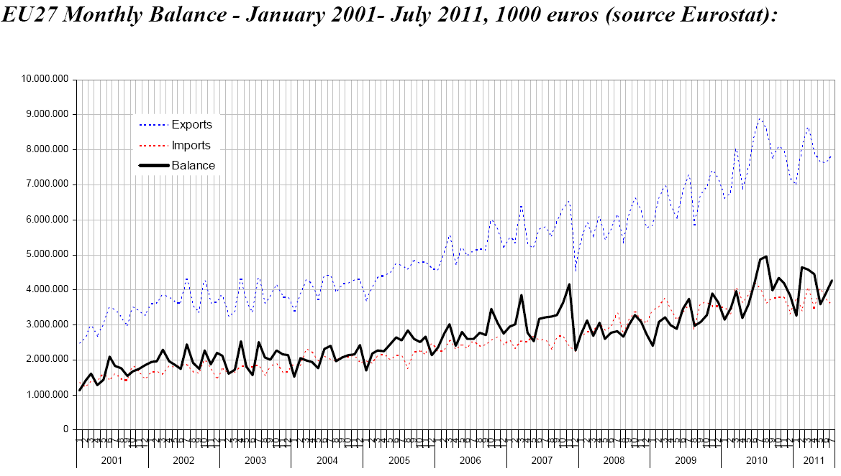
- The global pharmaceutical market has grown steadily over the last decade, increasing from $561 billion in 2003 to $875 billion in 2010. In 2010 there were 8 European companies amongst the top 20 (alongside 7 US, 1 Israeli and 4 Japanese companies) in terms of sales. Its growth is driven by worldwide demand from the increasingly ageing population (Figure 2). In particular, markets in Latin America and Asia grow at a rate of 14% per year.
2. The industry directly employs approximately 660,000 people, of which 110,000 are researchers. Each direct job leads to 3-4 indirect positions being created, such that between 2 and 2.7 million jobs in Europe depend on the biopharmaceutical industry. The jobs are underpinned by a turnover of €157 billion at wholesale prices. A particular feature of the sector is that Europe has a large trade surplus from pharmaceuticals of €47.8 billion in 2010 (European Commission, 2011)(Figure 4). The biopharmaceutical industry invests 15.2% of sales in R&D (ibid.) and is the largest investor in industrial R&D in Europe (European Commission, 2012).
The biomedical imaging and medical information technologies industries are also important for Europe. The global market in biomedical imaging and medical information technologies represents about €80 billion in sales. The European market represents 35% of the global market. There has been strong and continuous market growth of 5 to 8% on average over many years. The industry is responsible for 54,000 jobs in Europe, 8,500 of which in R&D. The industry re-invests about 8% of sales into R&D, a high amount compared with other industries.

Annex 5
Achievements of IMI
Leverage effect on industrial R&D investment
- IMI has managed to pool resources and achieve the necessary critical mass around scientific priorities in the area of bio-pharma research. Up-to-date, IMI projects have mobilised large funding (on average €12.7 million per project) and a multidisciplinary workforce (on average 100 researchers per project). This is about three times more than for an Integrated Project the largest EU instrument for funding research outside IMI. It also significantly contributes to leverage additional funding from the industry outside the PPP.
2. IMI calls have attracted European leading organisations in life sciences proving that IMI is an effective way of promoting intense competition in research, leading to higher quality and excellence. Early indicators like jobs created (twice more per million euros invested compared to traditional EU funding), the amount of top publications issued by on-going projects, and breakthrough discoveries are early signals about the success potential of the initiative. According to IMI participants' survey, almost ¾ of participants indicate they would apply again to participate in an IMI project in the future. This together with the willingness of the industrial partner to commit significantly more funding in IMI2 indicate that the open innovation ecosystems created through IMI projects work and are fully supported by the scientific community.
3. With an overall number of 1,500 jobs created, the survey of IMI project participants indicates that one position as researcher has been created in IMI projects for every €200,000 public funding invested. This figure represents double of the direct return of research positions created compared to FP7 Health research funding (1 position created per €400,000 public funding invested). The leverage effect of private sector funding goes beyond IMI. Project participants indicate twice more pharmaceutical industry funding as an extra funding source to continue or expand their work compared to participants in FP7 Health research funding.
The distribution of scientists in on-going IMI projects, while not all full time positions, is shown and EFPIA contributes with significant human resources (30%).
Figure 15: Distribution of scientists participating in IMI projects.
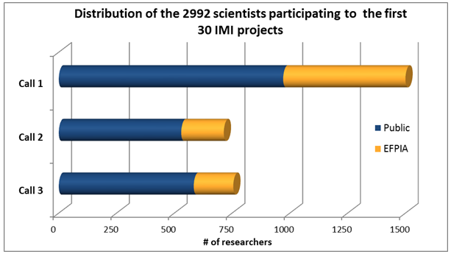
Education and training, knowledge management
European leadership in innovative biomedical research requires highly skilled, experienced researchers in different disciplines. There are currently five education and training programmes for professionals: the European Medicines Training Network (EMTRAIN), Pharmacovigilance and Pharmacoepidemiology (Eu2P), European Modular Education and Training Programme in Safety Sciences for Medicines (SafeSciMET), Pharmaceutical Medicine Training Programme (PharmaTrain) and European Patients Academy on Therapeutic Innovation (EUPATI). The aim is to substantially improve expertise in biomedical science, tools and technologies that will enable the faster and more efficient development of safe and effective drugs. Carrying out these actions at EU level through IMI provides a harmonised approach than would not be possible through national schemes. Moreover, these projects offer a considerable structuring effect throughout the EU on the organisation, performance, and quality of research training, and knowledge sharing as they involve all stakeholders in the biopharmaceutical innovation chain, from academia to EMA.
In addition to the education and training for researchers provided through projects, IMI is also funding dedicated ‘education & training’ projects. They are important because traditional academic training fails to appropriately address the need for multidisciplinary expertise that is essential for inventing and developing new treatments. These projects enable the training of patients and patient-representatives for their various roles in the drug development process. The web-platform on-course® that brings together information about training relevant for biopharmaceutical research (also beyond IMI) has been launched.
Knowledge management is a key aspect of several IMI projects, allowing the pooling of information from competitors which can lead to insights that without IMI would have been impossible to reach. IMI is particularly strong in the exploitation of existing data and bio-banks through meta-analysis leading for example to faster and cheaper trials for drug efficacy in schizophrenia (see below NEWMEDS). The EMIF project will develop a common information framework that will link up and facilitate access to diverse data sources, opening up new avenues of research for scientists. The first disease areas to be addressed are Alzheimer's disease and obesity.
Changing the way clinical trials for drug development are conducted, leading to revised regulatory guidance and cost savings
The unprecedented collaboration between industry, academia, SMEs, patient organisations and regulators made possible by IMI has led to pooling of data from different sources (especially competitor companies). For example, the NEWMEDS project has assembled the largest ever data base of clinical trial data of more than 23,000 schizophrenia patients, from 59 different clinical trials, data collected by 5 different companies and the US National Institute of Mental Health on 11 compounds, which has made it possible to improve the design of clinical trials in shortening the observation period from 6 to 4 weeks and reducing the number of patients per group from 79 to 46 patients without a negative impact on the results. Per trial costs can thereby be reduced by €2.8 million. For the trials from which the data have been pooled this would have represented a combined savings of €165 million.
The U-Biopred project has come up with a new definition of severe asthma, which facilitates performing clinical trials on this challenging illness. Also in the area of respiratory diseases, the PROactive project has developed a tool for assessing patient-centred outcomes in chronic obstructive pulmonary disease. These results will lead to a change of the regulatory guidelines for clinical trials in these areas, thus directly impacting on the way pharmaceuticals are developed in Europe. Other projects address the safety of medicines, with pivotal involvement of regulators in the projects: projects develop more effective approaches to predict adverse drug effects and late attrition, which are discussed at early stages with regulators, for example with an in silico model to predict cardiac toxicity, as well as translational biomarkers for cardiac, renal and hepatotoxicity.
Establishing robust models for drug research and novel biomarkers, leading to cost savings and offering the potential for reducing risk for drug development
IMI improves R&D productivity by eliminating poorly predictive pre-clinical models (diminishing unnecessary use of animals, time and significant cost) and establishing robust validated models for drug development. For example, the first human pancreatic β cell line has been developed by an SME participating in the IMIDIA project. This is important for diabetes research, where this cell line can be used to screen compounds in a relevant context.
The EUROPAIN project has developed translatable experimental models for several clinical aspects of pain. EUROPAIN has also discovered new imaging biomarkers of brain activation related to chronic pain, which is currently being validated in a clinical trial. In case of success this will have a large impact because it will allow the detection of the working of a molecule independent of the modulation of clinical symptoms. This project has identified a human protein called CXCL5 as novel translatable pain target.
The EU-AIMS project has developed an animal model replicating a form of autism and has demonstrated that the condition can be reversed with specific therapy. This new development is of great importance for clinical development of new treatments for autism.
Table 6: Examples scientific impact and bottlenecks in drugs R&D addressed by IMI projects
Name | Budget mill. € | Scope | Scientific impact | Bottlenecks
NEWMEDS | 22.215 | Novel methods leading to new medications in depression and schizophrenia | Assembled the largest ever data base of clinical trial data of 23000 schizophrenia patients thereby improving the design of clinical trials in shortening the observation period from 6 to 4 weeks and reducing the number of patients per group from 79 to 46 patients. | Change the way clinical trials for drug development are conducted, leading to revised regulatory guidance and immediate cost savings
U-Biopred | 20.65 | Speed up the development of better treatments for patients with severe asthma | A new stratified definition of patients with severe asthma, which facilitates performing clinical trials on this challenging illness.
EUROPAIN | 18.2 | Improve the treatment of patients with chronic pain | Developed translatable experimental models for several clinical aspects of pain; decrease the number of animal models used for pain research. Discovered new imaging biomarkers of brain activation related to chronic pain, which is currently being validated in a clinical trial. | Establishing robust models for drug research and novel biomarkers, leading to cost savings and offering the potential for reducing risk for drug development
EU-AIMS | 35.9 | Generate tools that will enhance our understanding of autism spectrum disorders | Developed an animal model replicating a form of autism and has demonstrated that the condition can be reversed with specific therapy.
Excellence of IMI projects
An increasing number of scientific articles resulting from IMI have already been published (box 5). The bibliometric analysis shows that 50% of publications come after the end of the project, 11% of which are ‘highly cited’ and 82% are in the top quartile of journals. IMI publications are above the world citation average and better than the average of European publications. Articles of several projects already have a particularly high citation record.
Furthermore 1,245 inventions were identified and associated with at least one IMI funded researcher, pointing to the involvement of 'high innovative' researchers. Around 10% of those were identified as being of high relevance to IMI, and will serve as baseline for future innovation.
Box 5: Main conclusions bibliometric analysis
- 214 publications resulting from IMI projects were published in a total of 119 journals as of August 2012. This includes 151 publications that have appeared in journals ranked in the top-quartile of journals in their respective research field.  - Publication output has increased each year since 2009 with a substantial increase between 2010/2011. | - The average citation impact for IMI project research is 1.34 for the period 2010/2011, where world and EU averages are 1.0 and 1.14, respectively.  - Despite the early state of IMI projects already three patents have been filed and 38% of the respondents of the IMI project participant survey expect that their participation will generate new intellectual property and patents.

Annex 6
Valuing drug development programmes
As is widely quoted in the literature and described in section 2.3.1., development of new pharmaceutical products is very risky. Even after all pre-clinical research and extensive testing has occurred, the overall average success rate in clinical drug development is still only around 10%. For companies to make informed investment decisions of whether to initiate the long, costly and uncertain clinical development process, they need to valuate the drug development programme they are about to start.
This is typically done by calculating a risk-adjusted net-present value (rNPV), where each inflow and outflow R_{t} occurring at time t is multiplied by the risk r that it will occur and discounted back to the present value, using the discount (interest) rate i. All values are summed up for the total number of periods N.
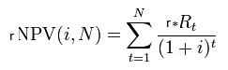
In a first step the overall programme is divided into different phases, each of which has a cost, duration and a certain probability of success. A drug development programme starts with pre-clinical R&D followed by clinical development. In the calculations below only the more expensive clinical phases are considered.
In order to make the calculations, discrete values for duration of the different phases of clinical development and for their cost have to be chosen. It needs to be emphasised however that the chosen values can only represent an illustration, because each concrete drug development programme will have its own characteristics, leading to different values.
Costs and durations of actual drug development programmes will for example differ between clinical indications, as summarised in a recent publication. The costs for developing obesity drugs ranged from $185 m to $409 m, the cost for developing a certain type of diabetes drugs ranged from $78 to $333 m, the cost for developing two cardiovascular medicines was $2983 m and $3075m and the cost of clinical development for three different medicines to treat rare diseases ranged from $4.7 to $9.3m. For the calculations costs of €20 m for Phase I, €100 m for Phase II, €375 m for Phase III and €5 m for registration for a total cost of 500m have been assumed. This is considered a reasonable cost for clinical drug development with the exception of orphan indications, where only very small clinical trials can be run at lower cost, as reported in the cited publication.
In principle the same situation applies to the duration of the different phases of clinical development, where concrete values have to be assumed for the calculations but for a specific programme these times may vary, albeit by much less than the enormous spread in the total cost of clinical development mentioned above. Average durations of 22 months for Phase I, 26 months for Phase II, 31 months for Phase III trials and 16 to 18 months for approval have been reported. These data represent trials performed in the 1990ies. Since then clinical development programmes have increased in complexity, especially the later phases. For the model calculations, durations of 12 months for Phase I, 24 months for Phase II and 48 months for phase III and 12 months for registration have been assumed.
An overall average success rate for the clinical phase of drug development of 10% is taken as a starting point. Again it needs to be emphasised that this average represents wide variations between different disease areas, companies and individual projects.
In a second step the potential sales of the product are estimated based on the disease area to be addressed, the number of patients, the number of patients one expects to be treated, the estimated therapeutic value, the competitive situation and from the last two aspects the expected market share. Then a potential price needs to be estimated. After taking into consideration access to the market issues and the expected period of patent- or data-protected sales (the latter being 10 years in Europe), potential revenue can be calculated.
In a third step the cost for producing and selling a drug needs to be estimated. Factors to be considered include cost of producing the drug (which are typically rather low for ‘classical chemical drugs’ but can be very high for biopharmaceuticals and some complicated chemical drugs), packaging and distributing it (considerations include whether the product has to be cooled, the shelf life of the product etc.), the cost for the sales force needed, the marketing cost and the general administration cost.
With these elements a risk-adjusted net present value can be calculated. Making simulations with assumptions about the cost and duration of the steps mentioned above that are in the middle of what is reported in the literature one finds in simulations that very high profits are needed in order to justify starting a drug development programme with its long period of investment before a revenue stream can be expected. Interestingly, the main driver for this is not the expected average cost of capital, which in the pharmaceutical industry is typically assumed to be 9% but the cost and duration of development until the market is finally reached. In many European markets after approval it may take about 1 year until access is given (after health technology assessment), which then leaves only 9 years of the data exclusivity period until generic competition enters the market. Once this occurs erosion of sales and profits for branded drugs is typically rapid.
With the assumption of 8 years overall duration of clinical development until registration, at a cost of €500 million for the entire programme and an overall success rate of 10.3%, 10 years exclusivity period for the product, a 9% discount rate and assuming linear build-up of sales over three years and erosion of sales to 1/5 in the first year after market exclusivity expires and to 0 thereafter, the figure 16 shows that only for a product with peak profit of €500 M one arrives at a modest positive rNPV.
Figure 16: rNPV in function of different peak sale values
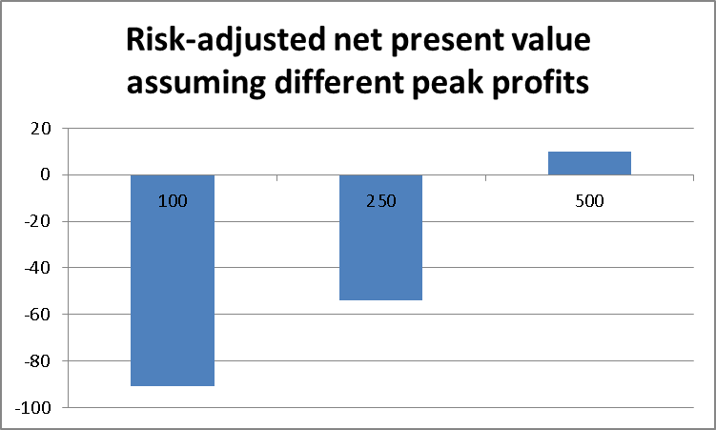
This means that with the current conditions for drug development very few projects are worth starting clinical development.
With shorter duration of the clinical development programme and increased success rates, projects become economically feasible that otherwise would not be possible.

rNPV for different combinations of success rate, peak profit and cost of capital

 | Overall success rate (%) | Peak profit  (m €) | Cost of capital (%)
 | Overall success rate (%) | Peak profit  (m €) | 5 | 7 | 9
Sales start at 8 years after start of phase 1 | 10,3 | 100 | -92 | -92 | -91
Sales start at 8 years after start of phase 1 | 10,3 | 250 | -30 | -44 | -54
Sales start at 8 years after start of phase 1 | 10,3 | 500 | 74 | 37 | 10
Sales start at 8 years after start of phase 1 | 12,4 | 100 | -96 | -97 | -96
Sales start at 8 years after start of phase 1 | 12,4 | 250 | -21 | -39 | -51
Sales start at 8 years after start of phase 1 | 12,4 | 500 | 104 | 58 | 25
Sales start at 8 years after start of phase 1 | 15,7 | 100 | -102 | -104 | -104
Sales start at 8 years after start of phase 1 | 15,7 | 250 | -7 | -30 | -46
Sales start at 8 years after start of phase 1 | 15,7 | 500 | 151 | 93 | 50

 | Overall success rate (%) | Peak profit  (m €) | Cost of capital (%)
 | Overall success rate (%) | Peak profit  (m €) | 5 | 7 | 9
Sales start at 7 years after start of phase 1 | 10,3 | 100 | -67 | -70 | -72
Sales start at 7 years after start of phase 1 | 10,3 | 250 | 6 | -13 | -27
Sales start at 7 years after start of phase 1 | 10,3 | 500 | 126 | 82 | 49
Sales start at 7 years after start of phase 1 | 12,4 | 100 | -68 | -72 | -75
Sales start at 7 years after start of phase 1 | 12,4 | 250 | 19 | -4 | -21
Sales start at 7 years after start of phase 1 | 12,4 | 500 | 80 | 110 | 164
Sales start at 7 years after start of phase 1 | 15,7 | 100 | -70 | -76 | -80
Sales start at 7 years after start of phase 1 | 15,7 | 250 | 40 | 10 | -11
Sales start at 7 years after start of phase 1 | 15,7 | 500 | 225 | 156 | 104

In figure 17 that plots rNPV for programmes with peak sales of €100, 250 or 500 million, calculating with a discount rate of 7% and different success rates in clinical development it can be seen that when the clinical development programmes becomes shorter by just 1 year (assumed shortening of phase 2 by 6 months and phase 3 by 6 months, with proportional reduction in cost), projects with €250 million in peak sales have a positive rNPV at 15.7 overall success rate and break even in rNPV at a success rate of 12.4%, when before they had clearly negative rNPV.
Figure 17: rNPV in function of different peak sales for different success rates of clinical development
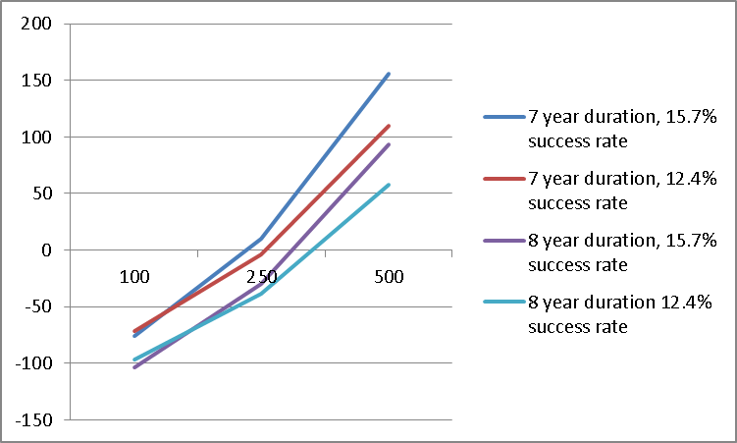
Estimation of macroeconomic effect
The reduction in the cost of individual drug development programmes and thus the increased rNPV is expected to increase the number of drug development programmes that will be undertaken. Each of them will have a higher chance of coming up with a product that reaches the market and thereby patients.
It is assumed that in 2018, when results of IMI and IMI2 programmes will have started to make an impact on the drug discovery and the business model development of the biopharmaceutical industry, more programmes will enter clinical development than otherwise would have been the case.
By 2018 five extra projects are expected, ten in 2019 and fifteen additional drug discovery projects from 2020 until 2024. With a total of 90 additional clinical development programmes started, it can be expected that from 2025 additional products will reach the market and patients that otherwise would not. A total of fifteen additional medicines can be expected. Assuming sales of €500 million each, additional peak sales of €7.5 billion can be expected, which would add 5% to the output of the European pharmaceutical industry. Based on the current ratio of jobs and sales this would mean supporting 30,000 additional jobs in Europe. Assuming a 3% yearly productivity gain in the pharmaceutical industry, by 2025 IMI2 is expected to generate 20,000 new jobs.

Annex 7
Bibliography
A call to reform the taxonomy of human disease. Kola I, Bell J., s.l. : Nat Rev Drug Discov, 2011, Vol. 10, pp. 641-642.
Archstone consulting. The biopharmaceutical sector's impact on the economy of the United States. 2010.
Adams, C.P. and Brantner, V.V. Estimating the cost of new drug development: is it really $802 million? Health affairs 25 420-428. 2006.
Battelle. Economic impact of the human genome project. 2011.
—. 2012. The biopharmaceutical research and development enterprise: growth platform for economies around the world. 2012.
Battling borderless drugs: Western and emerging-market drug firms are invading each other’s turf. The Economist. 2012.
Biotech: innovating in the New Austerity, Burrill & Company’s Report on the Life Science Industry. 2012.
Can Science Be a Business?: Lessons from Biotech. Pisano, G.P. Harvard Business Review. 2012.
Can the pharmaceutical industry reduce attrition rates? Kola, I., Landis, J., s.l. : Nat. Rev. Drug Discov., 2004, Vol. 3, pp. 711-715.
Cervantes, M. Introduction: STI Review No. 23, Public/Private Partnerships in Science and Technology. Paris : OECD, 1998.
COST. Analysis of the evolution of the costs of research – trends, drivers and impacts, Report by ETEPS Consortium to the European Commission, Directorate-General for Research and Innovation.
CXCL5 mediates UVB irradiation-induced pain. Dawes JM, Calvo M, Perkins JR, Paterson KJ, Kiesewetter H, Hobbs C, Kaan TK, Orengo C, Bennett DL, McMahon SB. 2011. 2011, Sci. Transl. Med., p. 90ra60.
Deloitte. Managing pathways to convergence in the life science industry. 2007.
Designing together the 'ideal house' for public-private partnerships in European research. JTI Sherpa's Group. 2010.
Development of HER2-specific humanized antibody Herceptin (trastuzumab). Nihira, S. 2003. 122(6), Folia Pharmacologica Japonica Nippon Yakurigaku Zasshi, pp. 504-514.
Diagnosing the decline in R&D efficiency. Scannel JW, Blanckley, A, Boldon H, and Warrington B. 2012. 3, Nat. Rev. Drug Discov., Vol. 11, pp. 191-200.
DiMasi, J.A., Grabowski, H.G. R&D Costs and Returns to New Drug Development: A Review of the Evidence. [book auth.] P.M., Nicholson, S. Danzon. The Oxford Handbook of the Economics of the Biopharmaceutical Industry. s.l. : Oxford University Press, 2012.
Di Masi JA, Feldman L, Seckler A, Wilson A. Trends in risks associated with new drug development: success rates for investigational drugs. 3, s.l. : Clin. Pharmacol. Ther., 2010, Vol. 87, pp. 272-277.
E., Ehrlich. An economic enging: NIH research, employment and the future of the medical innovation sector. s.l. : United for Medical Research, 2011.
EFPIA. The pharmaceutical industry in key figures. Key data. 2012.
Ernst&Young. Beyond Borders: Global biotechnology report. 2012.
European cardiovascular disease statistics. European Heart Network. 2012.
European Commission and OECD. Health at a glance Europe. 2012.
European Commission. EU industrial R&D investment scoreboard. 2012.
European Commission, European Competitiveness Report, Enterprise and Industry Publications, European Communities, 2004.
Communication from the Commission to the European Parliament and the Council - Action plan against the rising threats from Antimicrobial Resistance, COM (2011) 748.
—. 2011. Impact Assessment Horizon 2020.
—. 2011. Pharmaceutical industry sector fiche.
—.2012. The 2012 ageing report, economic and budgetary projections for the 27 EU Member States (2010 - 2060).
European Court of Auditors, Special Report No 2, Has the Commission ensured efficient implementation of the Seventh Framework Programme for Research?, 2013.
European parliament resolution of 14 March 2012 on addressing the EU diabetes epidemic.
Eurostat, public health data 2010.Executive Office of the President, President's Council of Advisors on Science and Technology. Report to the President on propelling innovation in drug discovery, development and evaluation. 2012.
Financial Times. Pharmas forced to put squeeze on R&D. 16. Oct. 2011.
Gvillo, F., et al.. First interim evaluation report of the Innovative Medicines Initiative Joint Undertaking panel report. European Commission. 2011.
Hay M, Roesenthal J, Thomas D, Craighead J. BioMedTrackerClinical Trial Success Rates Study. 2011.
How many drug targets are there? Overington, J.P., Bissan, A-L., Hopkins, A.L., 5, 2006, Nature Reviews Drug Discovery, pp. 993-996.
How to improve R&D productivity: the pharmaceutical industry's grand challenge. Paul, S. M., Mytelka, D. S., Dunwiddie, C. T., Persinger, C. C., Munos, B. H., Lindborg, S. R., and Schacht, A. L. 9(3), 2010, Nature Reviews Drug Discovery , pp. 203-214.
IMS. Health Market Prognosis. 2011.
Institut National du Cancer. Personalized Medicine: A nationwide initiative for an equal access to cancer treatment in France. 2011.
International Pharmaceutical fact book. CMR International. 2011.
Is there a future for prenyltransferase inhibitors in cancer therapy? Holstein, S.A., Hohl, R.J. 2012, Current Opinion in Pharmacology.
Kaplan, W., Laing, R.,. Priority Medicines for Europe and the World. World Health Organization, Department of Essential Drugs and Medicines Policy. 2004.
Khanna, I. Drug discovery in the pharmaceutical industry: productivity challenges and trends., Natural Reviews Drug Discovery, 10 pp. 428-438. 2012.
Kremer, M., Creating Markets for New Vaccines Part I: Rationale, Part II: Design issues, NBER Working Papers, 2000.
Lateral Economics. The economic value of Australia's investment in health and medical research: reinforcing the evidence for exceptional returns. 2010.
Lechevalier, S., Ikeda, Y. & Nishimura, J. The Effect of Participation in Government Consortia on the R&D Productivity of Firms, Discussion Paper Series A No.500. Tokyo : The Institute of Economic Research, Hitotsubashi University, 2008.
Lessons from 60 years of pharmaceutical innovation. Munos, B. 8, 2009, Nature Reviews Drug Discovery , pp. 959-968.
Mandl, U., Dierx, A., Ilzkovitz, F., The effectiveness and efficiency of public spending, European economy, Economic Papers 301, European Communities, 2008.
Muldur, U, Delanghe, H., A New Deal for an effective European Research Policy, Springer, 2006.
National Research Council (US) Committee on a Framework for Development a New Taxonomy of Disease. Toward Precision Medicine: Building a Knowledge Network for Biomedical Research and a New Taxonomy of Disease. Washington (DC) : National Academies Press (US), 2011.
OECD. Health data. 2012.
—. Knowledge networks and markets in the life sciences.
Outlook for the next 5 years in drug innovation. Berggren R, Moller M, Moss, R, Poda R, Smietana K.,11, 2012, Nature Reviews Drug Discovery, pp. 435-436.
Pharmaceutical industry financial performance. Goodman, M., 8, 2009, Nature Reviews Drug Discovery, pp. 927-928.
Pharmaceutical industry strategic performance. Goodman, M., 8, 2009, Nature Reviews Drug Discovery, p. 348.
R&D costs and productivity in biopharmaceuticals; faculty research working paper studies. Scherer, F.M. 2011, Harvard Kennedy School RWP.
Raman, S., Saxena, A., Chopra, M., Healthcare convergence. A myth or reality. Tata Consultancy Services Limited. 2008.
Roy, A.S.A. Stifling new cures: The true cost of lengthy clinical drug trials. Manhattan Institute, Project FDA Report, 2012.
Singh, D. How can chronic disease management programmes operate across care settings and providers? s.l. : WHO Regional Office for Europe, 2008.
Superior efficacy of new Medicines? van Luijn, J.C. Gribnau, F.W., Leufkens, H.G. 2010, 66, The European Journal of Clinical Pharmacology , pp. 445-458.
Tackling chronic disease in Europe: strategies, intervention and challenges. Busse, R. et al. 20, 2010, Observatory Studies Series. ISBN 9789289041928.
Tassey, G., Policy Issues for R&D Investment in a Knowledge-based Economy, Journal of Technology Transfer, Vol 29. 2004, pp. 153-185.
The economic cost of brain disorders in Europe. Olesen, J. 2012, Eur. J. Neuroology, Vol. 19, pp. 155-165.
The future of healthcare in Europe. A report from the Economist Intelligence Unit. The Economist Intelligence Unit Limited. 2011.
The importance of chemistry for the future of the pharma industry. Wild, H., Heimbach, D. and Huwe, C., s.l. : Angew. Chemie intl. ed., 2011, Vol. 50, pp. 7452-7453.
The importance of new companies for drug discovery: origins of a decade of new drugs. R, Kneller, 11, 2010, Nat. Rev. Drug Discov., Vol. 9, pp. 867-882.
The productivity crisis in pharmaceutical R&D. Pammolli, F., Magazzini, L., Riccaboni, M., 10(6), 2011, Nature Reviews Drug Discovery, pp. 428-438.
The Role of Public-Sector Research in the Discovery of Drugs and Vaccines. Stevens, A.J., Jensen, J.J., Wyller, K., Kilgore, P.C., Chatterjee, S., and Mark L. Rohrbaugh, M.L. 364, 2011, The New England Journal of Medicine, pp. 535-541.
Tijssen, R. J. W. Science dependence of technologies: evidence from inventions and their inventors, Research Policy, 31, pp. 509-526, 2002.
UK Medical Research Council, What's it worth? Estimating the economic benefits from medical research in the UK, 2008.

The Seventh Framework Programme (Decision No 1982/2006/EC of the European Parliament and of the Council, O.J. L 412, p.1 of 30.12.2006) provides the basis for a Community contribution to the establishment of long term PPPs in the form of JTIs. The IMI JU JTI was established by Council Regulation (EC) 73/2008 (O.J. L 30, p.38 of 4.2.2008).
COM(2011) 809 final of 30.11.2011.
Article 19 of the Horizon 2020 Regulation sets out the criteria for establishing public-private partnerships: the added value of action at Union level; the scale of impact on industrial competitiveness, sustainable growth and socio-economic issues; the long-term commitment from all partners based on a shared vision and clearly defined objectives; the scale of the resources involved and the ability to leverage additional investments in research and innovation; a clear definition of roles for each of the partners and agreed key performance indicators over the period chosen.
Designing together the 'ideal house' for public-private partnerships in European research, 2010, http://ec.europa.eu/invest-in-research/pdf/workshop/amanatidou_h2.pdf
http://ec.europa.eu/research/consultations/life_science_h2020/report_public_consultation.pdf
Questionnaire: ftp://ftp.cordis.europa.eu/pub/fp7/health/docs/imi-project-participants-questionnaire_en.pdf, report: ftp://ftp.cordis.europa.eu/pub/fp7/health/docs/outcome-imi-participants_en.pdf
Report listing members of the expert group, meetings held and sources used published at: ftp://ftp.cordis.europa.eu/pub/fp7/health/docs/expert-panel-report-2012_en.pdf
The planned PPP is significantly larger and complementary to the Ambient Assisted Living Article 185 initiative.
European Medical Research Councils White Paper II- A Stronger Biomedical Research for a Better European Future, 2011.
Singh, D. 2008. How can chronic disease management programmes operate across care settings and providers? s.l.: WHO Regional Office for Europe, 2008.
EFPIA, 2012. The pharmaceutical industry in figures. Key data 2012.
European Journal of Neurology 2012, 19: 155–162.
European cardiovascular disease statistics, 2012. European Heart Network. 2012.
Eurostat, public health data 2010.
European Parliament Resolution of 14 March 2012 on addressing the EU diabetes epidemic.
Singh, 2008.
European Commission and OECD, 2012: Health at a glance Europe 2012.
Tackling chronic disease in Europe: strategies, intervention and challenges. Busse, R. et al. 2010. 20, 2010, Observatory Studies Series, Vol. 2010. ISBN 9789289041928.
The future of healthcare in Europe. A report from the Economist Intelligence Unit. The Economist Intelligence Unit Limited. 2011.
European Commission and OECD, 2012.
See ref. 11.
UK Medical Research Council. 2008. What's it worth? Estimating the economic benefits from medical research in the UK. 2008; Lateral Economics, 2010. The economic value of Australia's investment in health and medical research: reinforcing the evidence for exceptional return; Battelle, 2011.
Ernst&Young. Beyond Borders: Global biotechnology report. 2012.
How to improve R&D productivity: the pharmaceutical industry's grand challenge. Paul, S. M., Mytelka, D. S., Dunwiddie, C. T., Persinger, C. C., Munos, B. H., Lindborg, S. R., and Schacht, 9(3), 2010, Nature Reviews Drug Discovery, pp. 203-214.
Pharmaceutical industry strategic performance. Goodman, M. 2009. 8, 2009, Nature Reviews Drug Discovery, p. 348; Pharmaceutical industry financial performance. Goodman, M. 2009. 8, 2009, Nature Reviews Drug Discovery, pp. 927-928.; International Pharmaceutical fact book. CMR International. 2011. 2011.
The importance of chemistry for the future of the pharma industry. Wild, H., Heimbach, D. and Huwe, C. 2011. s.l. : Angew. Chemie intl. ed., 2011, Vol. 50, pp. 7452-7453.
Pharmas forced to put squeeze on R&D. Financial Times, Oct 16, 2011.
Recent examples include: Pfizer (i.e.: closure of site in Sandwich in 2011, UK – 2,500 layoffs); Merck Serono (i.e.: several reorganisations in 2011/12, closure of research site in Geneva, CH, layoffs throughout the organisation; Sanofi (i.e.: reorganisation of the research organisation in France in 2012, hundreds of layoffs will occur); Bayer (i.e.: 1,700 lay-offs in pharma from 2010 to 2012 in Germany). Overall number of jobs in the industry that has constantly risen until 2010 is now stagnant or declining.
In Belgium 7 representatives of the ‘sartan’ class of blood pressure medication are available.
Van Luijn, J, Gribnau F, Leufkens H, Superior Efficacy of new medicines?, European Journal of Clinical Pharmacology, 2010 May;66(5):445-8
Battelle. Economic impact of the human genome project. 2011.
Battling borderless drugs: Western and emerging-market drug firms are invading each other’s turf. The Economist. 2012.
See ref. 24.
Can Science Be a Business?: Lessons from Biotech, Executive Office of the President, President's Council of Advisors on Science and Technology, 2012
See ref. 24..
R&D Costs and Returns to New Drug Development: A Review of the Evidence. [book auth.] P.M., Nicholson, S. Danzon. DiMasi, J.A., Grabowski, H.G. 2012. The Oxford Handbook of the Economics of the Biopharmaceutical Industry. s.l. : Oxford University Press.
Drug discovery in the pharmaceutical industry: productivity challenges and trends, 2012; Lessons from 60 years of pharmaceutical innovation. Munos, B. 2009. 8, 2009, Nature Reviews Drug Discovery , pp. 959-968.
Archstone consulting. The biopharmaceutical sector's impact on the economy of the United States. 2010.
The importance of new companies for drug discovery: origins of a decade of new drugs. R, Kneller. 2010. 11, 2010, Nat. Rev. Drug Discov., Vol. 9, pp. 867-882.
E.g. Aspirin® invented in 1897 is still a successful product for Bayer.
See ref. 11.
See ref. 27.
http://ec.europa.eu/dgs/health_consumer/docs/communication_amr_2011_748_en.pdf
A call to reform the taxonomy of human disease. Kola I, Bell J. 2011. 9, s.l. : Nat Rev Drug Discov, 2011, Vol. 10, pp. 641-642; National Research Council (US) Committee on a Framework for Development a New Taxonomy of Disease. 2011. Toward Precision Medicine: Building a Knowledge Network for Biomedical Research and a New Taxonomy of Disease. Washington (DC) : National Academies Press (US), 2011.
Current classification of diseases ICD10, http://www.who.int/classifications/icd/en/
Outlook for the next 5 years in drug innovation. Berggren R, Moller M, Moss, R, Poda R, Smietana K,. 11, 2012, Nature Reviews Drug Discovery, pp. 435-436; Trends in risks associated with new drug development: success rates for investigational drugs. DiMasi, J.A., Feldman, L., Seckler, A., Wilson, A. 87, 2010, Clinical Pharmacology & Therapeutics, pp. 272-277.
Deloitte. Managing pathways to convergence in the life science industry. 2007.
Muldur, U, Delanghe, H., A New Deal for an effective European Research Policy, Springer, 2006.
Tassey, G., Policy Issues for R&D Investment in a Knowledge-based Economy, Journal of Technology Transfer, Vol 29. 2004, pp. 153-185.
Cervantes, M. 1998. Introduction: STI Review No. 23, Public/Private Partnerships in Science and Technology. Paris: OECD, 1998.
European Commission. Impact Assessment Horizon 2020, 2011.
Kremer, M., Creating Markets for New Vaccines Part I: Rationale, Part II: Design issues, NBER Working Papers, 2000.
The importance of new companies for drug discovery: origins of a decade of new drugs. R, Kneller. 2010. 11, 2010, Nat. Rev. Drug Discov., Vol. 9, pp. 867-882.
E.g. farnesyltransferase inhibitors for the treatment of solid and haematological cancers: 70 clinical trials have been conducted with limited efficacy (Is there a future for prenyltransferase inhibitors in cancer therapy? Holstein, S.A., Hohl, R.J. 2012. 2012, Current Opinion in Pharmacology.) and no product has been approved.
Ernst & Young, "Beyond Borders, Matters of evidence", Biotechnology Industry Report 2013, p. 14.
The Role of Public-Sector Research in the Discovery of Drugs and Vaccines. Stevens, A.J., Jensen, J.J., Wyller, K., Kilgore, P.C., Chatterjee, S., and Mark L. Rohrbaugh, M.L. 2011. 364, 2011, The New England Journal of Medicine, pp. 535-541.
D. Morales, "Averting an innovation cliff", A Global Biotechnology Perspective, Scientific American World View, pp. 30-31
Development of HER2-specific humanized antibody Herceptin (trastuzumab). Nihira, S. 2003. 122(6), Folia Pharmacologica Japonica Nippon Yakurigaku Zasshi, pp. 504-514.
Raman, S., Saxena, A., Chopra, M., Healthcare convergence. A myth or realIT. Tata Consultancy Services Limited. 2008.
Lechevalier, S., Ikeda, Y. & Nishimura, J., The Effect of Participation in Government Consortia on the R&D Productivity of Firms, Discussion Paper Series A No.500. Tokyo: The Institute of Economic Research, Hitotsubashi University, 2008.
Cervantes, 1998.
Executive Office of the President, President's Council of Advisors on Science and Technology. Report to the President on propelling innovation in drug discovery, development and evaluation. 2012.
Biotech: innovating in the New Austerity, Burrill & Company’s Report on the Life Science Industry, 2012.
Article 179 TFEU, paragraph 1: “The Union shall have the objective of strengthening its scientific and technological bases by achieving a European research area in which researchers, scientific knowledge and technology circulate freely, and encouraging it to become more competitive, including in its industry, while promoting all the research activities deemed necessary by virtue of other Chapters of the Treaties”.
Institut National du Cancer. Personalized Medicine: A nationwide initiative for an equal access to cancer treatment in France. 2011.
The EFPIA leaflet on the contribution from the pharmaceutical industry to the AHA IP lists results from IMI projects PharmaCog and EUROPAIN
Proposal for a Regulation of the European Parliament and of the Council on clinical trials on medicinal products for human use, and repealing Directive 2001/20/EC, adopted 17 July 2012.
Calls are based on a strategic research agenda that has been revised in 2011; available at: http://www.imi.europa.eu/sites/default/files/uploads/documents/SRArevised2011.pdf
The conclusions of the independent interim external evaluation; a bibliometric analysis of ongoing projects; the survey carried out among participants in IMI-funded projects.
http://ec.europa.eu/dgs/health_consumer/docs/communication_amr_2011_748_en.pdf
Gvillo, F., et al., First interim evaluation report of the Innovative Medicines Initiative Joint Undertaking panel report. European Commission. 2011.
See ref. 4.
http://eca.europa.eu/portal/pls/portal/docs/1/22482779.PDF.
Kaplan, W., Laing, R.,. Priority Medicines for Europe and the World. WHO, Department of Essential Drugs and Medicines Policy. 2004 http://whqlibdoc.who.int/hq/2004/WHO_EDM_PAR_2004.7.pdf
Contractual PPPs are based on a contractual arrangement between the Union and industrial partners in a given area of research and innovation where strategic priority-setting is essential for Europe.
See ref. 70.
OECD. Knowledge networks and markets in the life sciences. 2012.
JDRF website: http://www.jdrf.org; Autism speaks website: http://www.autismspeaks.org .
http://ec.europa.eu/research/health/medical-research/rare-diseases/irdirc_en.html.
See Ref. 51.
"Cost neutral" means the cost is not higher than the revenue it generates.
http://intranet-rtd.rtd.cec.eu.int/int_com/H2020.html#JU
As shown in Annex 6, clinical development of pharmaceuticals can be associated with staggering cost. Even for companies with annual sales of several hundred million €,a drug development programme represents a huge risk. Furthermore, in other life science research programmes the cost can be very high. In the difficult financial situation since 2008 access to finance has proven very difficult for companies that do no not (anymore) full under the SME definition. However, large corporations including direct corporate members of EFPIA will continue not to be funded under the ‘Modernised JTI’ option.
Tijssen R. J. W. Science dependence of technologies: evidence from inventions and their inventors, Research Policy, 31, pp. 509-526, 2002.
Mandl U., Dierx, A., Ilzkovitz, F., The effectiveness and efficiency of public spending, European economy, Economic Papers 301, European Communities, 2008.
European Commission, European Competitiveness Report, Enterprise and Industry Publications, European Communities, 2004.
Such as biomedical imaging, medical information technologies, diagnostics or animal/human health interface.
Represented by its umbrella organisation, the European Federation of Pharmaceutical Industries and Associations (21).
Respondents were able to rate each option individually, which explains why the percentages of preferred options reach more than 100%.
'Regulatory' refers to legislation governing pharmaceutical and more general life science research.
The profile of survey respondents perfectly matches that of IMI project participants.
In this document the term ‘associated country’ refers to non-EU countries associated to FP7.
IMS. 2011. Health Market Prognosis. 2011.
See ref. 11
Personal communication form ‘comité européen de coordination des industries radiologiques, électromédicales et d’information de santé’ (COCIR)
CXCL5 mediates UVB irradiation-induced pain. Dawes JM, Calvo M, Perkins JR, Paterson KJ, Kiesewetter H, Hobbs C, Kaan TK, Orengo C, Bennett DL, McMahon SB. 2011. 2011, Sci. Transl. Med., p. 90ra60.
Roy, A.S.A. Stifling new cures: The true cost of lengthy clinical drug trials. Manhattan Institute, Project FDA Report, 2012.
Adams, C.P. and Brantner, V.V. Estimating the cost of new drug development: is it really $802 million? Health affairs 25 (2006) 420-428.
Calculations were made with the following figures: phase I of 1 year, cost of €20 million and success rate of 61%, phase II of 2 years, cost of €100 million and success rate of 34%, phase III of 4 years, cost of €375 million and success rate of 59% and registration of 1 year, cost of €5 million and success rate of 84%; the chosen success rates for the different phases of drug development are the mean of literature data: How to improve R&D productivity: the pharmaceutical industry's grand challenge, 2010; Can the pharmaceutical industry reduce attrition rates? Kola, I., Landis, J. 2004. 8, s.l. : Nat. Rev. Drug Discov., 2004, Vol. 3, pp. 711-715; Hay M, Roesenthal J, Thomas D, Craighead J. 2011. 2011BIO / BioMedTrackerClinical Trial Success Rates Study. 2011.

