1. Introduction 6
2. Procedural Issues and Consultation of Interested Parties 7
2.1. Related EU initiatives 7
2.2. Consultation of interested parties 9
2.3. Impact Assessment Steering Group and IAB 10
3. Problem Definition 11
3.1. Problem drivers 11
3.1.1. Regulatory fragmentation makes it difficult for investors to gain exposure to long-term assets 11
3.1.2. The diversity of long-term assets creates a potential for misplaced expectations from investors 12
3.2. Problems 17
3.2.1. Inefficient market for pooled investments impedes access to finance 17
3.2.2. Potential investors in long-term assets are currently deprived of an appropriate investment vehicle 18
3.2.3. Managers face barriers to activity, costs and reduced economies of scale 20
3.3. Consequences of the problems 21
3.4. How would the problem evolve without EU action? The baseline scenario 22
3.5. EU’s right to act and justification for acting 23
4. Objectives 24
5. Policy Options 25
5.1. Identification of options 25
6. Analysis of impacts 27
6.1. Analysis of options 27
6.1.1. Option 1: take no action at EU level 27
6.1.2. Option 2: Use soft law to develop an LTI fund label 28
6.1.3. Option 3: Long term assets permitted within UCITS 29
6.1.4. Option 4: LTI fund for institutional investors 30
6.1.5. Option 5: LTI fund for institutional investors and HNWI 33
6.1.6. Option 6: LTI retail fund passport with no redemptions 34
6.1.7. Option 7: LTI retail fund passport with redemptions 41
6.2. Impact summary 44
7. The retained policy option and its impact 47
7.1. The choice of instrument 47
7.2. Estimate of likely uptake 48
7.3. Substitution and distributional effects 49
7.4. Impact on EU fund legislation 51
7.5. Impact on SMEs 52
7.6. Social impact 52
7.7. Environmental impact 52
7.8. Impact on Member States 53
7.9. Impact on third countries 53
7.10. Risks 53
8. Monitoring and Evaluation 53

Executive Summary Sheet
Impact assessment on the Proposal for a regulation on Long Term Investment Funds (LTIFs)
A. Need for action
Why? What is the problem being addressed?
Investors are often too short term in perspective, reducing investments into longer term assets such as infrastructure projects. Tackling this will help stimulate the real economy by providing a further source of funding for businesses. It will also provide investors with fresh options for accessing long term assets which can generate good profits.
Currently accessing these assets can be difficult. Investment funds are a key way of investing in them, but there are no common standards among Member States (MS) so the market is fragmented, leading to higher costs and conflicting terms and definitions are used. Investor protection standards can be too low. This has discouraged or blocked investors from targeting long-term assets, such as infrastructure projects or participations in SMEs.
This proposal would create a harmonised set of product rules (for ‘Long Term Investment Funds’ or LTIFs) which would address these problems and so help stimulate growth in the real economy.
What is this initiative expected to achieve?
A LTIF brand would be created, developing a new market for these funds targeting long term assets. This would increase investment into the real economy, and provide an alternative source of capital to bank lending. Impacts would be maximised by developing harmonised product rules for LTIF. Allowing access to the widest possible range of investors will maximise the amount of capital available for firms. For this reason, the funds will be free to market cross-border to both institutional and retail investors.
The new LTIF framework will offer a secure investment environment for investors seeking exposure to long-term assets. Existing national regimes are not always sufficient to offer the kind of protection retail investors need.
What is the value added of action at the EU level?
The market for long-term assets is currently highly fragmented with Member States subjecting funds targeting them to varying rules. This is a barrier for fund managers, who have to deal with a range of legal issues depending on the Member State. Costs are raised and fund sizes constrained. The experience of UCITS shows that a strongly regulated product structure can be very successful in attracting substantial amounts of capital from both institutional and retail investors, and in building a cross-border market.
B. Solutions
What legislative and non-legislative policy options have been considered? Is there a preferred choice or not? Why?
A range of options have been considered: no action; non-legislative action; and then a range of options for creating cross-border rules with each subsequent option widening the potential audience of investors able to use them.
The preferred option is to create a LTIF open to all types of investors, including retail investors, with strong product rules and set up as a closed-ended fund.
To tackle divergences and fragmentation between Member States, a legislative measure is needed to create a consistent regulatory framework for LTIF and to ensure better cross border marketing to all types of investors.
To address possible mis-selling to retail investors, the new LTI fund would need harmonized product rules to mitigate risks. To this effect rules in the areas of diversification, derivatives, transparency, leverage, and conflict of interest are necessary. The fund would remain closed to redemptions. Strong investor protection standards create a solid basis for facilitating the marketing of LTIFs to all investors.
Who supports which option?
Stakeholders from the asset management sector are mainly supportive of this initiative. Those with experience with the UCITS market are generally more positive that a retail regime is necessary while those coming form the private equity and infrastructure background are more mixed on this issue. The few contributions received from investors suggest an appetite for investing in long-term assets but the views are however how this structure should work. Supervisors have not yet expressed strong views.
C. Impacts of the preferred option
What are the benefits of the preferred option (if any, otherwise main ones)
Permitting cross-border marketing to all investors, including retail, allows the deepest capital pools to be drawn on. Using closed-ended funds has the advantage of permitting investments in all types of long-term assets as the structure better matches the illiquidity profile of these assets. Such a solution has the merit of being transparent as to the long-term commitment that investing in such assets requires. It also is relatively simple (in that complex liquidity management is not necessary. Greatly improved and harmonized product rules may mitigate risks of mis-selling, particularly also in the context of rules already applying to distributors to act in the best interest of their clients. Institutional investors also can prefer clearly harmonised and regulated products.
Fund managers would choose whether or not to take up the preferred option, though they would be bound by it if they opted to use it. This means estimating the scale of uptake is difficult ex ante; experience in the UCITS market suggests a well-defined and understood brand can evolve into a globally dominant model.
Indirect social impacts could include better financing of social housing projects, of health infrastructure, and of green projects, which all fall within the scope of eligible assets.
What are the costs of the preferred option (if any, otherwise main ones)?
The fact that such funds would not allow redemptions during their lifecycle may limit the range of retail investors willing to invest in such funds, particularly where offered with ten year or longer time horizons. Risks remain that retail investors invest in such funds without fully grasping the risk and liquidity consequences, even where disclosures are transparent and clear. Should retail detriment arise that is not effectively mitigated through MiFID rules or the rules under the preferred option – through either active mis-selling and non-compliance, or investors failing to undertake sufficient due diligence – this could negatively impact the development of an LTIF market.
Since setting up LTIF is optional for managers, hard costs are not relevant.
How will businesses, SMEs and micro-enterprises be affected?
The creation of an LTIF would have indirect impacts for the financing of SMEs. SMEs represent one of the core assets in which the LTI funds will be able to invest. This can be achieved either by providing loans or by acquiring (direct) equity participations in the companies. The creation of pan-European LTIFs will not address all of the challenges SMEs face in accessing financing, but it can contribute to a wider range and depth of alternative sources of financing, alongside banks.
Will there be significant impacts on national budgets and administrations?
No
Will there be other significant impacts?
No other significant impact except an indirect impact on third countries. The new LTI framework may represent an added value for potential investment targets domiciled in third countries. In addition the newly created LTI fund might represent an export label as UCITS does currently for funds invested in transferable securities.
D. Follow up
When will the policy be reviewed?
The forthcoming legislation will be subject to a complete evaluation (about 4 years after its implementation deadline) in order to assess, among other things, how effective and efficient it has been in terms of achieving the objectives presented in this report and to decide whether new measures or amendments are needed.

1. Introduction
In the aftermath of the financial crisis, academics, policymakers and industry experts highlight a tendency toward short term behaviour. Investors have tended to focus on short term investment returns, strongly reflecting market fluctuations, and on assets that are capable of being readily sold. What they have not done is to focus on the return profile of assets held over the long term.
Yet taking a long term perspective and investing in asset classes which require longer term commitments from investors can have benefits for investors and for the economy more widely. For instance, investments in energy generation and distribution or transport infrastructure can reduce costs for individual firms, raise employment opportunities and provide investors with a steady rate of return. The importance of such 'knock-on' effects means that any tendency toward short term behaviours, to the detriment of long term investments, should be addressed.
The Commission Green Paper on financing long term investment in the European economy (Green Paper) examines options that might be considered in different areas for encouraging long term investments.
This impact assessment focuses specifically on asset management and options for fostering long term investments through private investment funds.
While the EU Directive on Undertakings in Collective Investment in Transferrable Securities (UCITS) creates a cross-border framework for investment into mutual funds, these funds must remain able to offer redemptions on demand. This redemption profile requires a portfolio of liquid transferable securities, such as bonds and shares. This means long term investments under UCITS can only take the form of a ‘buy and hold’ investment strategy built on liquid assets. UCITS cannot execute direct investments in unlisted entities or engage in participations in projects.
Asset classes excluded from UCITS are, however, key to long term financing. They directly contribute to the growth and financing of projects, companies and infrastructure across the EU. These assets typically share certain core features: they require long term commitments but also provide income over the long term. They are generally illiquid, so that selling an asset can be difficult, and the assets are rarely listed on secondary markets. Long-term investments can take the form of equity or debt investments covering equity or quasi-equity participations, debt or loans provided to fund infrastructure, small to medium-sized enterprises (SMEs) or property projects.
Such long term assets can also be attractive for many investors, but there is a clear lack of opportunity to buy these assets on the European market:
- Institutional investors such as pension fund operators, insurers or foundations with set liabilities (e.g. pay-outs to members on retirement by pension funds) which have a timeline that places them far in the future, for whom shorter-term liquidity of investments is not as important as matching these liabilities over this longer-term time horizon.
- Some investors specifically seek long term assets, e.g. foundations or businesses that commit to support sustainable investments, including those driven by innovation, or seek to include investments that achieve specific social or environmental impacts (e.g. green infrastructure investments).
Despite this demand, the development of cross-border investment funds targeting these assets face a number of problems:
- There is currently no EU-wide fund framework dedicated to long term assets – with a common definition of such assets -- and recognisable by any type of investor. A patchwork of national rules means funds offering targeted long term investment opportunities are not easily identifiable by smaller institutional investors and may be inaccessible to retail investors due to regulatory restrictions.
- Funds are required to comply with diverging national requirements incur legal, administrative and marketing costs.
- Regulations have not always served investor needs well enough: investors in funds that appear to target long term assets have not always properly understood the long term nature of the commitment and the specific risk profile of these assets and funds. This undermines confidence.
This report will focuses on examining these problems and options for addressing them. It identifies options for funds capable of making investments into illiquid assets not covered by UCITS.

2. Procedural Issues and Consultation of Interested Parties

2.1. Related EU initiatives
Smart, sustainable and inclusive growth is at the heart of the Europe 2020 vision. Promoting long term investment over short term investment is a clear driver for achieving these targets. Increasing levels of long term investment will contribute to all of the five targets identified in the Europe 2020 vision (employment, research and development, climate change and energy sustainability, education and fighting poverty and social exclusion).
More specifically, the Commission highlights access to a greater mix of quality finance as a key issue in the 2013 Annual Growth Survey, calling on Member States to do more on alternative sources of financing. The Commission action plan to improve access to finance for SMEs has also outlined many of the wide range of measures needed. In this respect, the equity financial instruments proposed under the Programme for the Competitiveness of Enterprises and SMEs (COSME), as well as under Horizon 2020, play a significant role as drivers of long-term financing. COSME in particular plays a key part in attracting institutional investors back to the venture capital industry by establishing cross-border, pan-European funds-of-funds.
The Commission is also committed to improve the digital infrastructure in Europe, notably with the Connecting Europe Facility (CEF).
The Single Market Act I (SMA I) underlined sustainable finance for SMEs and social entrepreneurs as key to tackling poverty and social exclusion and increasing employment. The creation of European Venture Capital Funds (EuVECA) and European Social Entrepreneurships Funds (EuSEF) illustrates the practical implementation of these measures in the area of investment funds. Raising the availability of long term investment clearly contributes directly to the pool of available patient capital.
Further steps are being taken to deepen long term financing: see for instance, the provision of financing through EU financial instruments notably under the cohesion policy, investments by the European Investment Bank, and the Europe 2020 Project Bond Initiative.
Within this broader context of multi-stranded work on long term investment, the Single Market Act II (SMA II) announced under key action 6 there will be specific work on long term investment funds: “In addition, the Commission will make proposals on possible forms of long term investment funds. Investment funds can open new sources of financing to long term projects and private companies. They can constitute an attractive offer to retail investors who seek to invest long-term, diversify risk and prefer stable and steady returns with lower volatility, as long as the necessary degree of investor protection is ensured”. This impact assessment assesses options for key action 6.
The options examined in this impact assessment are a sub-set of the broader possible measures announced in the Commission Green Paper on financing long term investment in the European economy (Green Paper). The Green Paper explores demand and supply side issues and developmental trends across the markets for long term financing, and identifies a series of measures to be explored for tackling these issues or areas in which further work might be done. This includes investors' behaviour (appetite for and adoption of long term investment perspectives); prudential rules impacting institutional investors handling of different types of assets or behaviours of fund managers (increasing focus on long term perspective when investing in short term assets). Responses to the Green Paper will inform broader actions on long term investment, but the Green Paper does not address in detail the area covered by this impact assessment, in which consultations had already commenced in July 2012, as set out under 2.2 below.
Nevertheless, the evidence collected in the course of the asset management consultation of 26 July 2012 revealed that investment funds can provide a highly regulated vehicle to channel investor's assets to a variety of asset classes. The evidence reflected in this impact assessment, therefore, suggests that a new investment fund vehicle focusing on long-term asset classes could easily be developed on the basis of certain structural elements already 'tried and tested' in the context of the successful UCITS framework. This is because the essential ingredients of a pan-European framework for asset management – a precise catalogue of assets that would be eligible for the cross-border fund vehicle, its risk diversification, exposure limits and rules to limit recourse to leverage – are already in place for the UCITS framework. This set of basic rules could be easily transposed and, if necessary adapted, to create a comparable cross-border vehicle for investment funds that do not focus on transferable securities but on less liquid long-term asset classes, such as participations in unlisted infrastructure projects, unlisted SMEs or real assets that are necessary to develop the European economies.
In light of the previous wealth of experience that exists in the design and creation of EU-level investment fund vehicles, this impact assessment concludes that the time is ripe for action at an early stage, without the need to await the outcome from the much larger consultation on long-term investing that is launched by the above mentioned Green Paper.
In addition, the high level of participation and interest in the July 2012 consultation on various topics in the field of asset management reveals that stakeholder expectations with respect to a 'second passport' for long term investment vehicles are high. The level of interest displayed and the concrete nature of many of the stakeholder responses shows that considerable thinking into the possible design of a fund passport for long-term investment funds has already taken place and that awaiting the more general and conceptual responses from the Green Paper would not deepen the Commission's knowledge pool on how to structure a fund passport for a long-term investment vehicle.
Finally, as evidenced in this impact assessment, the Commission services convened a series of targeted stakeholder roundtable to discuss specific features of a future framework covering a second passport for long-term investment vehicles. Such consultations also included extensive canvassing of possible investor interest; several representatives of the 'buy side' were also in attendance at the relevant round-tables. The consultations also provided the Commission with further insight into the possible LTI investor base and the specific safeguards necessary to ensure that the LTIF framework caters to the specific needs (in terms of yield) and vulnerabilities of these investors (in terms of the selection of assets and in terms of the absence of redemptions during the lifetime of the LTIF).
In light of the above, the conclusion is taken that the evidence gathered is of such substance that the results of a much more conceptual consultation on long-term behaviour, as launched by the Green Paper, would not add any knowledge in the very specific area of asset management.
Other external factors that might further increase the effectiveness of options explored here are also being assessed in development work linked to legislative proposals which are part of Solvency II. The European Insurance and Occupational Pensions Authority (EIOPA) has been requested to take into account longer-term financing when calibrating that work, in particular risk weightings when investing in private equity and venture capital funds.

2.2. Consultation of interested parties
Since mid-2012 the Commission has been engaged in extensive consultation with representatives from a wide range of organizations. The consultation has taken the form of bilateral and multilateral meetings, a written public consultation on asset management issues including long term investments (LTI), and a follow up questionnaire which was circulated amongst interested parties. This impact assessment draws strongly on these consultations, and where possible reflections from stakeholders are included. There is broad and strong support for action in this area across all kinds of stakeholders. The written consultation noted above was part of a broader consultation on various asset management issues published on 26 July 2012. The Commission services received 65 responses related to the LTI section. All contributions have been thoroughly examined and relevant information contained in them has been taken into account throughout the report. The follow up questionnaire led to 50 responses and further bilateral discussions with fund managers operating in the infrastructure and long term markets, fund management associations, and both retail and institutional investor representatives.

2.3. Impact Assessment Steering Group and IAB
Work on the Impact Assessment started in October 2012 with the first meeting of the Steering group on 7 November 2012, followed by 2 further meetings, the last one taking place on 18 March 2013. The following Directorates General (DGs) and Commission services participated in the meetings: Competition, Economic and Financial Affairs, Employment Social Affairs and Inclusion, Health and Consumers, Enterprise and Industry, Legal Services, Secretariat General, and Taxation Customs Union. The report and the minutes of the last steering group were sent to the Impact Assessment Board on 2 Mai 2013.
DG MARKT services met the Impact Assessment Board on 29 May 2013. The Board analysed this Impact Assessment and delivered its positive opinion on 31 May 2013. During this meeting the members of the Board provided DG MARKT services with comments to improve the content of the Impact Assessment that led to some modifications of this final draft. These are:
- The report should better explain what the real drivers of the problem are, i.e. regulatory failures or the result of LTIs particularities/investors' preferences.
- The problem definition should better describe and substantiate, with quantitative elements where possible, the magnitude and cross-border dimension of the problem.
- The reasons justifying the timing of the initiative should be clarified, given the on-going Green Paper consultation on LTI.
- Regarding the assessment of the options, the analysis should be strengthened, where possible with quantitative elements, notably with respect to the impact on administrative burden of the retained option.
- The superiority of the preferred option should be better established, for instance by demonstrating its greater effectiveness in addressing all identified problems and in attracting sufficient interest from retail investors despite its lack of redemption facilities.
- The report should clearly justify why some of the choices made deviate from the preferences expressed by stakeholders.

3. Problem Definition
Problems
Conse-quences
Untapped single market gains from long term investments
Longer-term financing constrained
Longer-term investing limited

Problem Driver
Funds deprived of a potentially important investor base
Inefficient fund market constrains access to finance
Managers face barriers to activity, costs and reduced economies of scale
Regulatory fragmentation makes it difficult for investors to gain exposure to long term assets

The diversity of long-term assets creates a potential for misplaced expectations from investors

3.1. Problem drivers

3.1.1. Regulatory fragmentation makes it difficult for investors to gain exposure to long-term assets
There is currently no effective internal market for pooled investments targeting long term assets. In the absence of a common EU fund model, national frameworks have proliferated, fragmenting the market across the EU and preventing the emergence of a deep investor base for the long term asset class. In addition, in those Member States where no national framework exists, investors are precluded from investing in a pooled vehicle that provides access to long-term investments.
In the absence of a common framework for pooled investments targeting long term assets, national frameworks have either been absent or have developed different approaches to establishing rules for investor protection for funds targeting long term assets, leading to such funds possessing very different profiles and characteristics.
For example, some structures have diversification rules whilst others permit a fund to invest into only one asset. So it is often difficult for investors to make their own risk assessment. In addition, fees can be opaque, and given their impact on the returns, if they are not well understood they can undermine confidence in the whole sector. Indications are that price competition is not effective with variations of up to 30%.
In some Member States funds make extensive use of leverage to increase exposure (and thereby their volatility and potential for gains or losses). This can change their risk and reward profile significantly, compared with funds that do not use leverage in this way. Leverage, including by means of borrowing from banks, also creates additional risks for investors.
In addition funds targeting long term assets can be particularly prone to conflicts of interest. This might occur where fund managers possess an interest or controlling influence in an investment target themselves, such that they benefit from terms that are not in the best interest of the investors in the fund. For example, a manager of a property fund may be linked to the company in charge of the entity constructing or managing the long-term asset: there is a risk that the fund pays above market price for its stake in the project.
Due to these reasons, investors in LTI funds have sometimes been misled as to expected returns and risks.
As shown in the Annexes (see Annex 2 in particular), there is a great degree of variety in national rules on pooled investment vehicles that can target long term assets, making it difficult to raise productive capital across the EU. The Alternative Investment Fund Managers Directive (AIFMD) will not remove these national frameworks in their entirety, as it focuses exclusively on managers rather than on funds.
For retail investors the market is even more fragmented. There is no framework facilitating cross-border marketing to retail investors of non-UCITS funds or funds that specialise in long-term asset classes. In consequence, each host Member State is able to individually authorize marketing to such investors and may impose additional requirements to those in the AIFMD. This has prevented the development of a single market for retail investors that wish to gain exposure to long-term investment assets.
While some Member States have created a national market for pooled investments in long term investments others have no market for this asset class at all. For example DE, FR, UK or NL have long histories of funds targeting investments in long-term assets. In some markets the investors are mostly institutional while in others retail investors – high net worth individuals, family offices or indeed mass retail – represent the biggest share. But the majority of Member States have no frameworks in pace for long-term asset classes – a fact which deprives investors in those jurisdictions from the investment opportunities that these asset classes offer. A cross-border investment vehicle will often be the only 'access gate' that will provide investors in these jurisdictions the opportunity to diversify their investment portfolio.

3.1.2. The diversity of long-term assets creates a potential for misplaced expectations from investors
Investing in long-term assets entails substantial risks when these investments are not properly managed. The first risk is that investors do not correctly understand the nature and risks of the assets they invest in due to the lack of a harmonized approach to defining these assets. Uncertainty prevails as to (1) the precise classification of assets as 'long-term' assets; (2) their risk and return profiles and (3) recommended holding periods. The second risk is linked to the characteristics of the assets, namely that they are illiquid in nature.
Sub-driver 1: No homogenous definitions of long-term assets: Long term assets include infrastructure, participations in unlisted companies and property. Box 1 identifies investment targets (long-term assets), and Box 2 the means by which investments are made in these assets (financial instruments). The duration of commitments to the assets by means of these instruments is not essential to assessing their long-term nature. Their generally non-transferable and illiquid nature distinguishes them from the mass of highly liquid assets, such as company shares and corporate bonds, which are readily bought and sold through secondary markets on a short-term basis.
Box 1: Overview of 'long term' asset classes
The definition of what constitutes a long-term asset is very broad, in general comprising all asset classes that generate steady cash returns over periods ranging from 10 to up to 50 years.
Infrastructure: This category covers different sectors such as utilities, energy generation and distribution facilities, roads, bridges, airports, telecommunications, hospitals and schools. The infrastructure category is generally characterised by public rather than purely private uses and impacts that such assets can have, reflecting the high level of positive externalities they can create. For the purpose of portfolio allocation, infrastructure projects are usually divided in two distinct categories: (1) "greenfield projects", that is new infrastructure projects and (2) "brownfield projects" which represent more mature and already operational infrastructure. To lead an infrastructure project, consortiums or special purpose entities are created for the life of the project. Investors, such as investment funds, take participations in these entities. Participation in infrastructure projects can be achieved through different ways such as acquiring a participation in the form of equity or by granting different types of loans to the project. These investments are intrinsically long term because the life cycle of an infrastructure project lasts over many years or decades. Some brownfield investments may be open-ended in duration.
Asset managers already active in this area are heavily focused on utilities and transport infrastructure. Utilities are popular on account of their government-controlled revenues and infrastructure is seen as an attractive asset when the government guarantees a certain level of income (e.g., an airport where government guarantees a minimum concession income to the operator).
Another popular asset class are PFI-PPPs where the Government promises a certain guaranteed level of return (PFI stands for public financing initiatives).
New investment commitments to infrastructure via unlisted funds, for instance, have been estimated at about $60 billion (roughly €46 billion at current exchange rates) over the period of 2004 to 2013.
SMEs and larger companies: Unlisted companies do not always have the size or structure needed to gain access to public financing, such as issuing shares on a listed market or issuing bonds. These companies often rely on private financing, provided for example through debt or equity participations, via private equity or venture capital funds or via fund-of-funds. Depending on the business cycle in which the company is operating (seed stage, start-up or more mature stage) investment characteristics change. Investment horizons are often around 10 years, reflecting the time needed for due diligence prior to investing, for launching development projects and for selling the participation at the end of the investment period, for instance by listing the company through a public offering.
Managers operating private equity or venture capital funds have considerable experience as active owners that, in addition to financial backing also exert a degree of governance and oversight as well as provide skills, management expertise and network for the underlying companies. Such managers invest either directly, or via funds-of-funds that enable larger institutional and long-term investors to access small venture capital funds backing smaller companies.
Around €500 billion has been raised between 2002 and 2011 in the private equity sector, while €45.5 billion was raised in 2012. (Source: EVCA annual yearbook). This compares to net inflows of €201 billion into UCITS funds (Source: EFAMA, Quarterly Statistical Release, No 52).
Property: This category represents investment in immovable property such as land, office buildings, private housing or social housing. These assets require high investments at the beginning which are reimbursed over an extended period of time, for instance through rental income. For this reason, they need long term investments to cope with their particular life cycle as well as with their illiquid nature.
Estimates of the size of the EU property fund market range between €120 billion and €300 billion.
Other assets: Other long term assets include the financing of certain goods, such as maritime financing and airplane financing. Due to the large amounts of capital required to buy ships or airplanes, companies often use external financing to avoid placing these assets on their balance sheets.
The size of this market is difficult to estimate due to the lack of data. Ship funds that are popular in Germany can be used as an example: they represent a size of around €50 billion. (Source: VGF Branchenzahlen 2012)

Box 2: Types of financial instruments used to gain exposure to long-term assets
Equity or quasi-equity participations: Investors acquire a share of the capital of the investment target. It can represent a share in an infrastructure project (in the consortium developing the project), a share in an unlisted company or a share in a company in charge of building properties. Shareholders are entitled to receive dividends from their equity participation. These need long term commitment because the shares are not listed on a liquid market. They can take hybrid forms that include debt elements.
Debt: Investors can provide debt facilities (bonds, project bonds or loans) to the target investments identified above. Loans are generally the instrument used for providing private debt facilities. They represent an essential part in the financing mix for companies. Usually provided by banks, loans can also be provided through other sources, such as funds. In contrast to bonds that are listed and transferable securities, loans are issued in private placements and do not benefit from liquid secondary markets. Again, investing in loans of this nature requires long term commitment, usually until the loan matures. Bonds are generally the preferred financing instruments of the companies that are large enough to have a direct access to the financial markets whereas loans are the preferred instruments of the companies that are too small, such as the SMEs, to obtain direct access to the financial markets. Bonds are subscribed by multiple buyers whereas loans are normally contracted between the borrower and the lender, being a bank or a fund, bilaterally.
Investments in long term assets can offer different risk and return profiles, depending on how the investment is structured. For example investments in infrastructure can be done indirectly, such as buying shares of investment funds or shares of companies involved in the sector, or in a direct way by acquiring a direct participation in a new or in a mature infrastructure project. Greenfield infrastructure is generally considered more risky than brownfield infrastructure (greenfield infrastructure entails constructions risk, risk of obtaining the requisite permits and changes in the regulatory environment). In general, long term assets offer access to relatively strong yields over their lifetime, following initial development phases. The yields are also backed by real assets.
The absence of a clear regulatory definition has led market participants to define various different categories for such assets, with approaches also varying across national markets. The terminology used for long term assets is complex, contradictory and fragmented. This, in turn, leads to a lack of comparability between investment propositions and a lack of transparency on essential characteristics of long-term investments, undermining investor trust and comprehension, and leading to mis-allocations of resources. The tables contained in Annex 2 reveal that each of the 9 countries that are referenced have several fund frameworks for offering access to the real estate assets or the private equity and venture capital assets. For example, only for investing in real estate assets Luxembourg has 5 different funds, France 4 and Germany 3. The proliferation of different fund frameworks make difficult for the investors to select the appropriate fund in their own Member State and almost impossible to select the appropriate fund framework across borders. This choice is even more difficult for the retail investors that lack the knowledge and resources to investigate the different legal frameworks in a language that is not necessarily customary to them.
Sub-driver 2: The liquidity profiles of long term assets are idiosyncratic: Long-term assets are mostly illiquid because they are not traded on secondary markets. The value of assets reflects the cash flows and residual capital values investors anticipate for a given holding period. Unlike liquid assets, their market values do not offer a ready and transparent short-term valuation, such that asset valuation is a key challenge for investors.
Not all forms of participation in long-term assets show the same level of illiquidity, for example equity participations in infrastructure projects tend to be the less liquid than loans provided to companies (where occasionally a secondary market might exist). Liquidity can correlate with the age of assets and transparency: assets that have clearly demonstrated a good income stream are generally more liquid than new assets with no track record.
Taking infrastructure as a case study, long term assets and the funds investing in them can be classified according to their liquidity profile (higher or lower), focus (on a few or many projects) and time lines on investments (very long term, or medium term).
 | >20 years | Between 10 and 20 years
High liquidity risk | New transport infrastructure  Motorways, tramlines, airports | New property and utility infrastructure  Hospitals, social housing, medical centres, waste treatment | Focus on a limited number of projects
Some liquidity | Operational infrastructure  Participations in existing infrastructure (transport or communications infrastructure) | Infrastructure technology  Tunnelling technologies, waste treatment | More diversification

High liquidity risk = Projects that are complex to administer, in terms of cost, cost overruns, budgets and deadlines. Some liquidity = stable returns
Source: Ernst & Young, submission on LTI

For all of these assets, even where a secondary market exists or there is some potential liquidity, it can still be difficult or impossible for an investor to divest themselves (at a price of their choice) of their commitment prior to maturity.
The illiquidity of assets forces investors to adopt a long-term investment strategy. Therefore, ‘closed-ended’ funds are the common vehicle to provide the tool for pooling investments into such assets. These funds do not buy and sell assets as investors enter or exit the fund, but are normally closed to redemptions for their entire life; they collectively manage the investments for investors and provide them with regular cash flows. Capital commitments are only reimbursed after a normally predetermined number of years. The fact that investors do not need to be given rights to redeem during the life of the fund permits the fund manager to invest in long-term assets that are illiquid.
There is a risk that investors are misinformed about the lack of redemption rights at the level of the fund, or secondary markets made available for selling investments turn out to be themselves illiquid. Spreads in the secondary market would grow very wide. There is a risk also that distributors sell investments on the basis that the distributor themselves will provide liquidity (at a price) for those wishing to leave, yet the scale of those wishing to leave (on the basis of the promises of the distributor) leaves the distributor unable to support the requests. Another problem can be that the maturity of funds might, on occasion, need to be extended without investors having the option to disinvest.
Open-ended funds, which offer regular redemption options and which normally do not have a finite life, have sometimes been used in some cases for investing into long term assets. These funds tend to be popular in the property market. But with this kind of fund, there is a risk that the liquidity of the assets will be too low to support the redemption rights offered to investors on a regular basis. An open-ended fund may therefore need to suspend redemptions. Investors are then forced to remain invested even where they formed the appropriate expectation – given the fund is open-ended -- that they would be able to redeem.

3.2. Problems

3.2.1. Inefficient market for pooled investments impedes access to finance
In the EU, banks represent the biggest provider of funding to the economy, marginally complemented by financing coming from other sources such as capital markets. According to recent data published by the Economist, US bank financing (as opposed to financing via the bond markets, and so by investment funds) represents under 30% of total financing as of 2011; for the UK and the Eurozone, the figures are about 70% and almost 90% respectively.
There are 21 million SMEs in Europe, which represent the backbone of the EU economy, and which rely heavily on bank financing which is still by far the most relevant source of financing for them. European banks hold €8 trillion of corporate debt on their balance-sheets (by comparison only €1.3 trillion of such debt is in the bond markets, which would be a conduit for investments via funds).
A variety of factors, following on from and accelerated by the crisis, have deepened the focus of private financing on shorter-term commitments. According to stakeholders, many projects have not been able to raise financing suited to their time horizons, and have instead had to resort to short term financing structures (5 to 7 years maturity), solely covering construction and initial commissioning of the projects.
For example, infrastructure operators such as Veolia underline the lack of financing instruments which take into account the construction phase and its associated operational risks. Moreover they point out that there is no financing that appears adapted to the needs of small and medium-sized projects. For such projects, for instance environmental projects that commonly fall under €100 million, project bonds are too expensive to put in place.
This is in the context of a global listed infrastructure market (e.g. shares in utilities and transport companies) estimated at about $1 trillion (approx. €770 billion), with potential to reach $5 trillion (approx. €3.8 trillion) within 5 years. Estimates of funding gaps are potentially huge; a recent UK assessment put the national ‘gap’ (for private firms) at almost £200 billion (approx. €240 billion) by 2016. The UK is a market that is already less dependent on bank financing than many markets in continental Europe.
Market participants expect a shift to other sources of funding. “The direction of travel in Europe is clear: the incremental replacement of banks by the capital markets,” says an analyst at Barclays.However, the problems identified threaten the capacity of investment funds (pooling capital market investments) to fulfill their potential.
Weaknesses in the EU market for pooled investment vehicles cannot be addressed by other capital sources. According to Macquarie Renaissance Infrastructure Fund, the key ‘added value’ of the fund model is that it allows investors to support projects indirectly that would be impossible for them directly. Without funds performing this intermediation role, capital market funding is unlikely to fulfil its potential.
Costs and burdens for those seeking to invest in long term assets therefore rise. Such costs include preparing information and data for potential investors, search costs related to finding potential investors, and structural costs in establishing corporate forms that are capable of attracting investment. The ability to perform important activities and functions are dependent on a wider range of counterparties. The under-developed nature of the LTI fund market also reduces the effectiveness of the LTI market more widely. Expertise is more dispersed or less visible, and therefore more costly. Service providers – legal, administrative, economic – are underdeveloped. Fund markets are key drivers for the development of other ancillary services, and the under-development of these has a deeper and wider effect.

3.2.2. Potential investors in long-term assets are currently deprived of an appropriate investment vehicle
Smaller institutional investors (typically smaller pension or retirement schemes, for example as may be set up by the liberal professions, certain smaller insurance undertakings, charities, foundations or municipalities) are neither able nor willing to invest in long-term asset classes directly.
Mid-size pension schemes with assets ranging from €100 million to €1.5 billion are often administered by a trustee or very small staff that lack the specific expertise to select appropriate long-term assets, assess their future revenue potential and analyse their downside in terms of risk (risk of completion, risk of change in the regulatory or public policy environment that governs the asset). On the other hand, the overall capital requirements for many long-term projects will be too great for even the largest of individual participants to bear in isolation. For mid-sized pension schemes or other investors managing investments of comparable volume the use of investment funds to pool smaller stakes and diversify investments across different projects is a precondition to investing in long term assets.
However, the absence of a single identifiable model for LTI funds across the EU undermines the visibility of such funds. This prevents the emergence of economies of scale in the LTI funding sector, and reduces their visibility in the market. In addition, costs are raised, reducing the broad attractiveness of these funds for smaller investors. National regimes can offer access to all sorts of assets, but these may have been designed for other more specific purposes, such that there are no pooling schemes dedicated to the range of long term assets as set out in this impact assessment.
For instance some institutional investors have highlighted gaps in the supply of national opportunities to invest, notably in relation to infrastructure funds. The absence of clear common criteria setting out the eligibility of investments in private equity, property or infrastructure represents an additional burden for institutional investors. In the absence of cost-effective LTI funds, institutional investors will have to arrange such investments directly. This is more costly, limiting up-take. Each investor will need to obtain in-house or buy in external expertise in the area of long term assets targeted, and undertake costly due diligence and on-going monitoring and support for these investments. Economies of scale are difficult to achieve, and benefits of diversification are either not available or entail additional costs or lower overall yields. This problem is particularly acute for pension funds and insurance companies, which are major users of investment funds. Funds backed by long term assets could be particularly attractive to such investors: long-term assets have the ability to create steady income streams backed by real economy assets that are well suited to matching the long term liabilities such investors face.
Box 3: Financial intermediaries are key in channelling investments into long-term asset classes
According to the ECB Monthly Bulletin of November 2011, the Euro area pension funds invest around 41% of their €1,420 billion of assets in investment funds whereas only 2.7% is directly invested in non-financial assets, which can be assimilated to the long term asset classes described above. Insurance undertakings invest 17.7% of their €5,664.7 billion of assets in investment funds whereas 2% is directly invested in non-financial assets. These figures show the importance of investment funds for institutional investors’ attempts to gain exposure to wider asset classes; direct investment in non-financial assets represents only a tiny proportion of their portfolios in comparison. Tackling the under-representation of long term investments within the investments funds that make up investment portfolios of institutional investors is a key lever.
Mis-selling of long-term assets could further undermine take-up of this asset class. This problem is particularly acute for retail investors who can lose confidence very rapidly, triggering runs, should investment expectations not materialize. This is despite the fact that the long-term assets can represent an interesting investment opportunity for retail investors as well. The usual low correlation of the long-term asset class with the traditional assets makes this investment attractive for diversifying the portfolio. For the retail investors seeking to invest for the long-term, they have traditionally the choice to invest in funds investing in stocks and bonds but with a long-term strategy, in long-term insurance products or simply in long-term cash deposits. Only in a few Member States do retail investors have the opportunity to gain access to long-term assets. As revealed in the box in the section 6.1.6, where the retail investors have access to funds offering exposure to long-term assets, they usually represent one of the largest investor categories. The cross-border dimension is, at this stage, not very developed. Most retail version of long-term investment funds are sold domestically under the investment laws of that specific Member State. This is mainly explained by the proliferation of fund frameworks in each Member State as described in sub-driver 1.
Even if this is difficult to assess the possible cross border retail dimension ex-ante, one could however estimate the possible cross-border dimension that could be reached by making a parallel with the UCITS framework where 20% of the assets under management result from cross-border marketing. This bulk of this cross-border flow, as with the earlier UCITS model, is expected to be constituted mostly of investors from jurisdictions that have currently no long-term investment fund framework in place. But retail investors that already benefit from national regimes might also be attracted by investment propositions linked to long-term assets of other Member States. In foreign assets, the foreign fund’s managers have a higher expertise than the domestic fund’s managers; therefore the cross-border access is essential. Contrary to stocks and bonds that tend to be highly correlated between Member States, the long-term assets are often link to local characteristics that render their return and risk profile unique. This could make foreign assets and thus foreign funds particularly attractive for diversification reasons.
For all the above reasons the long-term asset class, while seen as a valuable and important asset class, remains broadly inaccessible to smaller institutional and to retail investors. This is despite the fact that LTI funds, properly regulated and construed, may provide many advantages to investors: stable income and capital returns that have the potential together to beat inflation, and which are broadly uncorrelated with listed equity and securities traded on listed markets. For example:
- From 1990-2004 annualised real estate performance of 12.71% beat the S&P 500 (equity index) at 10.94% and the typical bond index at 7.70%.
- For long term (20 year) venture capital funds in the US, annualised returns were 16.5%, long term (20 year) private equity funds had returns of 13.3%, compared to the S&P 500 at 11.2%. In 2011, the French private equity sector achieved an annual performance of 8.5% over the last 10 years while the reference equity index achieved an annual return of 2.7%.
- Long term assets have lower volatility compared to equities: for instance, the annualised standard deviation in asset values (a measure of volatility) for real estate from 1990-2004 was 12.74%, compared to 14.65% for the S&P 500.
- In general, infrastructure investments provide a good means for achieving higher returns than the base interest rate. In average, an investor that invests in an infrastructure fund can expect a return of around 2.75%/3.00% above the base interest rate.
The positive aspects of an investment in long-term assets should also be assessed against the risks that they carry. As traditional investments in stocks and bonds, the risk to lose the entire capital is present. This is for example the case when a venture capital investment in a SME is valued at zero because that SME went bankrupt. What distinguishes the long-term assets to the other assets is their illiquidity risk. Contrary to stocks and bonds which can normally be easily sold, long-term assets do not benefit from liquid secondary markets and it often requires months or years to be able to sell such an asset.

3.2.3. Managers face barriers to activity, costs and reduced economies of scale
Differences in national rules and definitions of long term investment funds raise costs for the funds when they are marketed cross-border. AIFMD provides for a right to market to institutional investors, which will reduce costs associated with conforming to national rules for institutional funds. However, costs related to fragmentation of national markets remain. Fund managers may find it easier to access investors in different Member States by forming different funds in each target Member States, with attendant establishment costs. Funds will be smaller, and thereby proportionately more expensive to run.
Access to retail clients situated across borders requires the fund to adapt to national rules in the host member state, as there is no right to market cross-border as such (except on a reciprocal basis where a Member State permits such marketing nationally) to retail clients under the AIFMD. As there is no retail ‘fund passport’ as such there is therefore expected to be very little cross-border activity of this kind.
Box 4: Infrastructure funds in the EU operate on a small scale
A study by Preqin compares unlisted debt fundraising for infrastructure by manager location. In 2012, 22 funds raised $14.4 billion in North America while only 12 funds raised $7.7 billion in Europe. The financial crisis has amplified the gap since fundraising in Europe for long-term assets has declined to the levels last seen in 2005. This difference is also present in private equity funds: of the total number of funds currently seeking capital in the world, 23% are in Europe, 44% in the US and 32% in Asia and the rest of the world.

3.3. Consequences of the problems
Despite all the efforts that have been undertaken to create a single market in the area of asset management, the long-term asset sector will continue to be characterised by strong differences in national approach (as elaborated further in section 3.4).
UCITS funds and UCITS managers already benefit from the single market, as their funds can be marketed throughout the EU and managers can offer their services cross-border. For non-UCITS funds (28% of the sector) the AIFMD will create the same rights for the managers as those currently enjoyed by managers of UCITS. While an AIF manager will be able to market an AIF on a cross border basis from July 2013, there is however still no retail product passport for AIFs as such, and the AIFMD does not create common definitions or labels at the level of specific fund types. This directly impacts funds targeting long term assets.
In the absence of common LTI fund definition and hence a functioning single market for these funds, the contribution of the deeper pool of potential capital made available by the above mentioned investor groups across the single market would be forfeited. This would reduce funding available to LTI targets, such as schools, hospitals, transport infrastructure, but also the SME sector more widely.
Available funding is likely to remain geographically restricted or localised: bigger, more developed Member States with strong financing models will predominate; peripheral or smaller economies could suffer continued restrictions, worsened further by restrictions on bank financing as well as lack of cross-border equity either because of the small size of local markets or because asset classes are not developed or attractive enough. This also impacts on the variety and thereby the resilience of funding. Larger, more developed member states have more varied and resilient models. Problems with investments into long term investment funds mean EU-wide pools of capital are more weakly mobilised, harming growth.

3.4. How would the problem evolve without EU action? The baseline scenario
If no action is taken to create a legislative framework applicable to long term assets, it is very likely that the problems that have been identified will persist.
The application of AIFMD from July 2013 can be expected to improve the marketing of a wide range of well-known AIF categories cross-border. The AIFMD establishes a basis for a single market for AIFs directed to professional investors – by harmonising operating conditions and other measures relating to AIFMs and providing a procedure for a passport for marketing AIFs by these AIFMs. However the AIFMD does not harmonise the definition and product rules for AIFs as such, as it is focused on the rules applying to the AIFMs. As a result, the single market created by the AIFMD can be expected to benefit those AIF models that are already well understood cross-border or where detailed national regimes have not yet developed. For instance hedge funds and certain well-established private equity models (leveraged buy-out funds) might be expected to be prime beneficiaries of an AIFMD passport. Those fund models where there is already fragmentation in detailed national rules can be expected to benefit less from the AIFMD, since this fragmentation is likely to persist.
Since there is no EU-wide consistency in defining funds targeting long term investments, and no clear consistency as to the essential features of long-term asset classes, the risk and return profile that a fund vehicle specialising in such assets should be targeting, long-term fund managers encounter difficulties in practice accessing non-domestic investors. These fund managers must, as noted, determine their funds according to the variant national fund models. Domestic investors usually know and trust their own national fund regimes and it cannot be assumed that they will readily invest in fund structures regulated under foreign rules and by foreign supervisors. Given the widely differing national fund frameworks that apply across the LTI fund area, as set out in the Annex, managers may be less inclined to market such funds cross-border, and managing such funds cross-border would raise costs for managers in familiarising themselves with varying national fund rules. Fragmentation would therefore likely persist.
Other measures that are shortly to come into force will also be unlikely to transform this picture. The EuVECA Regulation will improve the functioning of the single market for Venture Capital funds. However, it is limited in scope to smaller fund managers and so is unlikely to be strong interest to those operating LTI funds that seek participations in large scale projects, such as infrastructure. In addition, the EuVECA Regulation is focused on providing risk capital (equity) to SMEs during their start-up phase, ruling out investments in other companies, real assets or projects that do not take a SME form, or support through other instruments such as loans.
Given this, even for institutional investors, current or shortly to apply rules can be expected to be insufficient to drive convergence in models and access to them. It is unlikely that the EU fund market will overcome its fragmentation in relation to LTI funds, particularly given a preference for many investors for highly-regulated (retail) funds, since non-UCITS highly-regulated funds are the most fragmented. Because of differences in national rules, costs for funds operating cross border are likely to remain significant under AIFMD.
Retail markets are likely to remain wholly national, given the discretion AIFMD provides for divergent national rules in this area, with little cross-border activity. This limits the potential for competition as LTI funds can be blocked from accessing retail investor bases in other Member States. Investors’ choice, especially retail, is also reduced with the consequence of mis-selling practices, inefficient portfolio allocations, increased risks and costs. Experience with UCITS and with the existing non-UCITS national frameworks suggests convergence between Member States to address these problems in the absence of action at the EU level would be unlikely. Given this, self-action by the industry would have little scope of success.

3.5. EU’s right to act and justification for acting
Legislative action on the policy options examined in this report is based on Article 114 of the TFEU. The legislative action to be examined would lay down uniform product rules on investment funds that are targeting long term assets. It aims at ensuring that such funds are subject to consistent rules across the EU and that they are identifiable as such by investors throughout the EU. At the same time it also aims at ensuring a level playing field between different long term investment fund managers. It aims therefore at establishing uniform conditions for the operation of such funds. This proposal therefore harmonises the operating conditions for all relevant players in the investment fund market, and for the benefit of all investors.
Different rules that vary according to the national regulation in this area create an un-level playing field, erecting additional barriers to a Single Market in financial services and products. Member States have already taken divergent and uncoordinated action to develop national fund regulation related to long term investment funds, and it is likely that this development will continue, even as the marketing and management passports contained in the AIFMD come into force. Divergences in such rules increase costs and uncertainties for fund managers, distributors, and investors, and represent an impediment to the further cross-border development of the market for long term investment funds. These divergences represent an obstacle to the establishment and smooth functioning of the Single Market. Consequently, the appropriate legal basis is Article 114 TFEU.
According to Article 4 TFEU, EU action for completing the internal market has to be appraised in the light of the subsidiarity principle set out in Article 5(3) TEU. Hence it must be assessed whether the objectives of the proposed action could not be achieved by the Member States alone in the framework of their national legal systems. The internal market for investments in long term assets by means of funds currently is fragmented due to divergent national regimes. This fragmentation raises costs, reduces economies of scale, and reduces innovation and access to investment opportunities.
Member State actions to widen funding sources and promote funds targeting long term assets have operated solely within the constraints of national markets. Different rules that vary according to the national regulation mean that funds in different national markets that target long term assets can be very divergent in their operating conditions and their permitted assets. For instance, in some national markets diversification of investments is required, while it is not in others. Or, the permitted investments can vary, between regimes designed for all kinds of assets, to those limited to certain kinds of innovative companies or infrastructure projects. These variations create an un-level playing field for fund managers depending on their location, and by fragmenting fund models along national lines erect additional barriers to a Single Market in financial services and products. Key drivers of fragmentation include the preference of investors for familiar or known investment propositions and costs associated with variations in marketing rules across different Member States.
Action by Member States alone cannot be expected to address such weaknesses in the EU market for long term assets and funds, even as the marketing and management passports contained in the AIFMD come into force. Actions by Member States alone can be expected indeed to deepen divergences, further undermining the efficiency of EU capital markets in providing long term investments.
The success of UCITS indicates the efficacy of action at the EU level in dismantling the barriers that have been erected by fragmented regulation. The launch of UCITS Directive in 1985 created a level playing field for UCITS funds and ensured effective and uniform protection for unit-holders. It shows the strongly positive impact of investor trust, rooted in the familiarity and trust that comes from uniformity of rules. The confidence that unit-holders, fund managers and investment targets derive from a single legislative framework and predictable investment conditions lay down a solid ground for a development of internal market for funds.
Consultation responses have shown a strong recognition of this factor and its possible impact by industry stakeholders. The vast majority stakeholders have endorsed the view that a market for retail investors in pan-European long term funds can be readily built on the condition that a common framework is put in place (see, e.g., Annex 6, question 1,2). By harmonizing the essential features that constitute an LTI fund the proposal aims at establishing a uniform framework in relation to the definition of such funds, clearly setting common rules on eligible investments, an area not addressed by the AIFMD which does not delimit the potential investments of AIFs.
As regards proportionality, proposals to be explored would seek to create a common product label for which there is a strong public interest and which would lay down a foundation for a common, competitive and cost efficient market for LTI funds in the EU. An appropriate combination of parameters suitable for longer horizon investments and specific investor groups can be designed by taking full account of safety and trust considerations relating to any LTI funds designation or label. Proposals would therefore not go beyond what is necessary to achieve a common legal framework for LTI funds. Action at the EU level would be more efficient than uncoordinated action at the national level. In sum, legislative action at the EU level is essential in fostering the growth of a pan-European market for the LTI funds. Definitive ptrogress cannot be achieved by the industry, nor by Member States actingalone. Therefore, it is necessary for the EU to intervene and facilitate the creation of an effective internal market for LTIFs where they can be easily marketed and accessible to all types of investors. The measures proposed to achieve that aim at complying with the principles of subsidiarity and proportionality.

4. Objectives
In light of the analysis of the risks and problems above, the general objectives are to:
General objectives
Improve the longer term financing of the European economy
Remove the barriers in the single market
Specific objective
Increase investment flows for long-term assets
Specific objective 1
Enhance economies of scale for managers of LTI funds

Specific objective 2
Increase the choice and increase the protection for investors interested in LTI funds
Operational objectives
Increase the assets under management in the long-term asset sector, including cross border
Reduce the number of mis-selling cases
(1) Improve the longer term financing of the European economy
(2) Remove the barriers in the single market
Reaching this general objective requires the attainment of the following more specific policy objectives:
(1) Enhance economies of scale for managers of LTI funds
(2) Increase the choice and protection for investors interested in LTI funds
(3) Increase investment flows into assets with long term horizons
The specific objectives listed above require the attainment of the following operational objectives:
(1) Increase the assets under management in the long-term asset sector, including cross border
(2) Reduce the number of mis-selling cases
Identified options have been selected on the basis of their capacity to address these operational objectives, and will be assessed in the light of the specific and general objectives outlined here.

5. Policy Options

5.1. Identification of options
Seven main options for addressing these objectives have been identified, from no action at EU level to the creation of a dedicated fund framework. Option 2 represents a “light touch” approach by introducing a label whereas option 3 builds on the existing framework. Options 4 to 7 entail the creation of a new European fund framework dedicated to long-term assets. Whereas options 4 and 5 consider the merits of opening the fund to professional or wealthy investors only, options 6 and 7 explore the opportunity to expand the investor base to include retail investors. The potential product rules are assessed against their general effectiveness but also against the chosen investor base, being professional only or including all investors.
Policy options | Summary of policy options
1 No action | Take no action at EU level.
2 LTI fund Label  Use soft law to develop an LTI label, no passport | Achieve greater convergence in the definition and labelling of funds targeting long term assets. Soft law instruments could seek to achieve convergence in what long term assets are and a label for funds investing in such assets, subject to self-regulation, or policy guidance to be issued by ESMA. A Recommendation, for instance, could set the criteria attached to the definition of long term assets and the funds targeting them. ESMA could be mandated to compile a list of all assets that are considered to be of a long term nature. This could enhance the coherence of the LTI market by avoiding different marketing practices around these long term assets.
3 Long term assets in UCITS  Allow UCITS some exposure to long term assets | Amend UCITS rules to allow investments into long term assets by allowing UCITS to invest up to a certain proportion of their portfolio into non-transferable securities that do not comply with the eligibility rules of the directive. This option would entail that a proportion (e.g., 10%) of a UCITS portfolio could comprise financial instruments that are not transferable or where secondary markets are illiquid. A UCITS could gain direct exposure to long term assets, such as loans, participations in infrastructure projects, building infrastructure assets or shares of unlisted companies. A precise definition of each asset class that would be eligible would be provided together with criteria to identify and circumscribe these assets.
4 LTI fund for institutional investors  Establish a common framework for LTI AIFs | Under this option, a new fund, the LTI fund, would be created with a distinct set of portfolio rules relating to the classes of long term assets that are eligible for investments by the new "LTIF AIFs".  Based on the model that exists in the UCITS Directive, the eligibility rules would cover non-transferable instruments such as participations in infrastructure projects, property or in non-listed companies. The key criterion for eligibility would be that the instruments finance long term projects as identified above (Box 1). Definitions will also be provided for identifying what are the eligible instruments for investing in SMEs and larger companies, in properties and in other long-term assets.  The target investors would be defined through the existing framework of the AIFMD, and therefore will be institutional investors. To match the long-term nature of the assets with the commitment of the fund investors, there would be no redemption rights.
5 LTI fund for institutional investors and HNWI  Establish a common framework for LTI AIFs and introduce an entry ticket | The same as option 4, but the LTI funds would be open to an additional layer of investors, the so-called "high net worth individuals" (HNWI). Through the introduction of a minimum entry ticket set at €100,000 HNWI will have direct access to the LTI fund.
6 LTI fund retail passport with no redemptions  Establish common product rules and designation for LTI, and permit marketing to retail investors with no redemption rights | The LTI funds would be open to all investors, including retail investors. This would entail stronger investor protection requirements. As compared with options 4 and 5, the retail focus would require greater use of risk mitigation techniques. To match the long-term nature of the assets, there would be no redemption rights. Transparency requirements would be enhanced to reflect the needs of retail investors, for example by introducing extensive cost disclosures..
7 LTI fund retail passport with redemptions  Establish common product rules and designation for LTI, and permit marketing to retail investors with redemption rights | The same as option 6, but including regular redemption rights, after an initial lock-in, for example for three years.
Important caveat: Compliance with all product rules set out in Options 3 to 7 would be mandatory for a fund manager seeking to market a fund under the LTIF designation.

6. Analysis of impacts
This section analyses the advantages and disadvantages of the different policy options, measured against the criteria of their effectiveness in achieving the operational objectives (developing a common label, and tackling barriers to the single market) and thereby the specific objectives identified, and their efficiency in terms of achieving these objectives for a given level of resources or at lowest cost. Impacts on relevant stakeholders and their views (see the text boxes) are also considered. The policy options to be retained should score the highest for each related specific objective while at the same time should impose the lowest costs and least adverse impacts on stakeholders.

6.1. Analysis of options

6.1.1. Option 1: take no action at EU level
Under this option, investors would benefit from funds subject to UCITS and AIFMD rules, but would not be able to easily identify long term assets or diversified LTI portfolios in these funds.
Impact on investors: The requirement that UCITS invest in transferable securities does not mean that investment objectives under UCITS cannot be orientated towards the long term. However investors in UCITS would be restricted to ‘buy and hold’ strategies, developed by means of investments into transferable securities. This would exclude investments into any of the long term asset classes set out in Box 1 of this impact assessment.
Access for investors to such asset classes could potentially be achieved by means of AIFs. As set out above, fragmentation in the market for different AIFs offering access to long term assets would mean that the identification of true long-term asset AIFs would remain difficult, and the market in them would likely continue to be bounded by national rules. Many investors would thereby not have ready access to identifiable and cost-effective AIFs targeting long term assets.
In addition, with the AIFMD, retail investors would not be able to readily make such investments across borders and the retail investors that would have the possibility to make such investments domestically would continue to face inadequate levels of protection in certain cases. The situation would actually vary depending on where an investor lives
Impact on managers: Neither UCITS nor AIFs would tap the full potential of funds targeting long term assets. Because UCITS principally invest in bonds and stocks, the long term potential of non-transferable instruments is out of their scope. The AIF market would remain fragmented with no clear fund type focused on long term assets per se.
Impact on long term financing: Fragmentation along national lines would continue to act as a barrier to the emergence of a strong single market in LTI funds. A lack of a common approach on product rules for funds (relating to such areas as redemptions, transparency, and asset valuations) would undermine confidence in funds offering long term assets on a cross-border basis. This wold prevent this vehicles form operating beneath their efficient scale and, in turn, would not alleviate the present financing gap felt by many long term projects.
In short, without action at the EU level the focus of investors will likely remain on very liquid and transferable securities. The AIF market is too fragmented or limited to allow efficient access to a diversified portfolio of non-transferable instruments that require long term commitments. The sectors of the economy that rely on that source of funding will continue to have disadvantages in comparison to the entities that can issue stocks and bonds on liquid markets. The financing of large projects will remain strongly dependent on bank funding or tax payer funding.
Some stakeholders advocate this option. They highlight that equities and bonds are very simple products that have a long history as ways of funding the long-term needs of the real economy. They are concerned that the creation of another kind of “packaged” investment product available for investors is not as efficient. They believe that options aimed at increasing the long-term engagement of shareholders are simpler and might well serve the same purpose.

6.1.2. Option 2: Use soft law to develop an LTI fund label
Impact on investors: This option would increase convergence in the definition of funds targeting long term assets but as with option 1, it would not be able to address limits on access to the funds in Member States where retail marketing is not permitted. For retail investors, this option would therefore be broadly equivalent to the situation under option 1. Institutional investors who can buy funds more easily on a cross border basis might however receive some benefits from a harmonized LTI definition. They would more easily recognize the different fund profile and could gain confidence in what they are buying. However, a lack of binding common rules could serve to undermine this confidence for some, while others might be overly confident, assuming binding common rules where this is not the case.
Impact long term financing: The effectiveness of soft-law instruments may be limited for the AIF market, since the fragmentation of this market reflects differences in national laws which a soft-law intervention would not be able to tackle unless Member States chose to change their national rules and align them with the emerging label. Experience in the fund sector has been that such changes are more patchy and difficult to coordinate if left solely to Member States, and the legal certainty and simplicity of implementation of a common approach is preferred by many Member States and fund managers.
In the absence of convergence by Member States it is unlikely that such an intervention would be able to address fragmentation effectively. This also reflects experience in the area of Venture Capital funds, where soft-law interventions have failed consistently to address market fragmentation. Should the market fragmentation persist at current levels, it is also doubtful that economies of scale would be generated to increase the financing of long term projects. The EU will continue to operate below their efficiency levels compared to their US counterparts.
Impact on managers: In principle a soft-law intervention would be relatively low in costs for participants – mostly creating administrative costs for Member State authorities and some fund managers in considering and responding to the Recommendation. However, it would allow great flexibility on whether or how far a new convergent LTI fund label would be developed, allowing for more market led developments. A likely lack of consistency in approach could however be relatively inefficient for fund managers, leaving divergences in approach between Member States in place.
This option has not been directly tested with stakeholders. However in the responses to the consultation, there is a strong preference for the use of legislative tools rather than soft law, either in the form of amendments to the existing EU law or through a new standalone rule book governing the portfolio of LTI funds.

6.1.3. Option 3: Long term assets permitted within UCITS
Impact on long term financing: This option would allow the €6.3 trillion UCITS market to contribute to funding LTI projects. For example, allowing 10% or 15% of this market to be invested in these assets represents a potential of about €600-900 billion. Because the UCITS framework has created an accepted norm allowing cross border marketing of funds, the problem of market fragmentation would not arise. These two elements would represent a major boost for the use of LTI by investors and thus for the financing of the real economy.
Impact on investors: This option would allow retail investors who have an appetite for longer-term investments to gain exposure to this asset class by investing in regulated UCITS funds that seek exposure to this asset class. Such an approach might also be attractive for institutional investors, many of whom may have a limited capacity to undertake due diligence on LTI or indeed AIFs more widely themselves, such that a well-known and well-understood framework as UCITS would naturally be preferred over other, less clear and less harmonised frameworks. This option has also the advantage of relying on the strong investor protection standards that are contained in UCITS, which would reduce the possibilities of mis-selling practices.
Impact on managers: Illiquid long term assets would conflict with the fundamental principle that UCITS are invested in transferable securities, and the requirement that investments in UCITS can be redeemed on demand by investors.
According to article 84 of the directive, “a UCITS shall repurchase or redeem its units at the request of any unit-holder”. This provision is a core element of UCITS funds because it gives investors the certainty that their investments can be redeemed on demand. Even a holding of 10% of illiquid assets could potentially put in peril this regular redemption opportunity. LTI have life cycles that often exceed ten years and it is rarely possible to dispose of these assets before their maturity. Unlike transferable securities, there is often no secondary market for investment tools used to gain access to long term assets (cf. Box 2 of this impact assessment). It is hard to conceive of a fund guaranteeing daily redemptions assuming the risk of holding assets that cannot be sold for ten years. Even a 10% limit may drastically reduce the liquidity profile of a fund. It may impede its whole investment strategy and limit its diversification opportunities.
Example
A fund has assets under management amounting to €100 million, €10 million of which (10%) are invested in illiquid non-transferable securities. An investor representing 20% of the fund wants to redeem. The fund has to sell €20 million of liquid assets as it cannot sell any of the €10 million invested in illiquid assets. The fund then has assets worth 80 million but with €10 million still invested in non-transferable assets which would then account for 12.5% of the portfolio, thus exceeding the 10% maximum. Rebalancing to the permissible 10% ratio can only be achieved if new investors subscribe as the illiquid assets cannot be sold.
As the example shows, as the assets under management in a fund decrease, the proportion of assets that are non-transferable will increase.
Making investments into long term assets and monitoring and supporting these investments also requires a different skill base and expertise than the other investments of UCITS. This could raise costs or reduce uptake of such possibilities by UCITS funds.
In addition, the marketing of UCITS invested in non-transferable securities, and sold as such, could well confuse investors, given the broad market acceptance of UCITS. Such an option would require changing the name of UCITS since Undertakings for Collective Investments in Transferable Securities would no longer be valid. There is an important risk to irreversibly damage the UCITS brand and its acceptance by investors. The UCITS brand as an export product could also suffer from this strategic change.
These concerns are strong enough that a majority of respondents – fund managers, supervisors, investor’s representatives – to the Commission consultation were against the use of UCITS as a vehicle for LTI funds. Earlier consultation on social investment funds was consistent with this; with views diverging on how far UCITS could technically be adjusted invest in assets that are not transferable securities, and whether this was sensible.
Regarding investments in non-eligible assets by a UCITS, respondents to the consultation were mainly opposed to UCITS funds being allowed to invest in EuSEF: 61% opposed this possibility, arguing that such investments by means of a bespoke LTI fund would be more suitable.

6.1.4. Option 4: LTI fund for institutional investors
Impact on long term financing: Eligibility rules would clarify that the LTI fund would have to acquire long term assets directly from the issuing entity or take direct participations in projects. This would significantly enhance the engagement of the asset manager with the operator of the investee project, and clearly target financing to those entities or projects that have not already gained access to capital markets. There are several positive benefits for long-term investing in stipulating direct investments:
- Direct financing reduces costs associated with intermediaries.
- Indirect exposure entails the risk that the LTI fund is not entirely exposed to the long term asset but to other risks, such as counterparty or market risks.
- Direct exposure requires managers to acquire sufficient knowledge of the different assets in which they are investing. This would clearly add value for investors who themselves are not able to acquire such knowledge.
Long term financing would also stand to benefit from clarity on what constitutes a long term assets and what financial instruments are eligible to gain exposure to such assets.
- Clarity on long term asset classes: The eligibility rules would also clearly set out the asset classes that are permitted, such as infrastructure (energy, transport, communications), and social infrastructure such as hospitals; and unlisted SMEs. Commodity investments would not be permitted.
- Clarity on eligible instruments to gain exposure to long-term assets: A clearly defined LTI fund would be achieved by means of precise rules concerning the investment instruments to be used by LTI funds: direct equity or quasi-equity participations, bonds and loan agreements. For example an LTI fund could hold a share in a consortium building a school, a share in a Special Purpose Vehicle in charge of a concession contract covering prisons building and maintenance, another share in an entity promoting and building apartments, with the remainder of the portfolio distributed in the form of loans to companies. Financing to the real economy could thus be improved.
Long-term financing is enhanced because a LTI fund manager would need to act as a knowledgeable intermediary capable of screening appropriate projects, undertaking risk/return analysis and due diligence, and effecting and monitoring investments in a cost effective way. Even the larger pension plans only have a staff of one or two dedicated to managing the investment portfolio, and so would be unable to undertake this work directly. On the other hand, diversification requirements along the lines of UCITS, which require a minimum of 16 assets, would appear too restrictive.
A uniform set of asset eligibility and product rules at EU level could enhance the awareness and trust of investors in these asset classes and thus increase money flows in this sector. This would help drive cross border marketing of such funds, ensuring investors across Europe would be able to find funds they have confidence in. Cross border marketing and cross border fundraising will create economies of scale that reduce the costs of investing in long term assets and at the same time increase the available money to invest.
Impact on managers: The creation of a cross border fund framework will facilitate the operations of fund managers across Europe. Greater consistency in requirements reduces costs for those operating cross border, while enhancing options for those looking to expand in this way. Economies of scale would develop as the funds increase in size or number.
In order to ensure LTI funds can offer a range of strategies and mitigate risks associated with their investments, fund managers would have the option – but not the obligation – to invest to a limited degree in assets that are not long term. Investments in transferable securities, such as stocks, bonds or short term money market instruments, would be permitted, as long as such investments do not exceed a pre-defined maximum threshold of, for example 30% (balancing flexibility with the requisite focus on long-term assets). Such shorter term investments could provide a 'bridge' for the fund whilst the manager identifies new investments. A 70/30 split between long-term assets and transferable securities would give greater confidence that the LTI fund manager can enhance its overall ability to pursue an effective strategy dedicated to funding long term projects. This could widen the range of investors the funds target.
The responses to the questionnaire highlight the need for some flexibility for acquiring short-term assets, as a portfolio management tool. Stakeholders propose different thresholds for this, mainly between 5% and 30%. Therefore the proposed threshold of 30% coincides with the expectations of market participants: it sets the upper limit at 30% to ensure the greatest degree of flexibility (fund managers are free to invest more than 70% in illiquid assets, should they decide to do so).
Impact on investors: With this option the target investor base is potentially very wide – notable both larger investors and the underdeveloped group of medium-sized institutional investors, such as smaller pension funds, insurance undertakings, foundations or municipalities.
Pension funds or insurers might particularly seek investments that enable them to match their long term liability profile, thereby focussing on the cash flow projections of any investment. However, other institutional/professional investors may be more focussed on long-term capital growth. Also, some investors will prefer the cash flow (and risk-return profile) of an initial construction phase ("greenfield") while others would express a preference for subsequent phases ("brownfield"). Indeed, one pension fund (the Tesco Pension Fund) argues that a pension plan might actively choose to exit certain investments after the construction phase.
The impact of having access to trusted long term investment funds with known investment targets could be positive for the planning horizon of pension plans, offering new options alongside, for instance, low-yielding Government bonds. This could be particularly the case for those operating defined benefit (DB) pension schemes who have the ability to allocate appropriate parts of their portfolios to assets such as LTI funds. While some managers might focus their marketing efforts on very large pension schemes, such as those prevalent in the Netherlands, other fund managers have indicated that they would offer their product to smaller pension schemes administering assets of €500 million to €1 billion. A pension scheme operator (Tesco) suggests that a uniform long-term investment scheme would also be attractive to pension plans administering assets of between £100-500 million (approx. €120-600 million).
Not all of the above mentioned institutional investors have sufficient knowledge and expertise to assess the risks of the products they are acquiring. Nevertheless, for institutional investors that are more familiar with the different long-term asset classes, an LTI fund could be designed that will go beyond the minimum allocation of 70% to long-term asset classes. Three aspects need however to be addressed in order to create investor confidence: the fund’s type, transparency and the costs of the investments.
On the other hand, this option would not create additional rights for LTI funds to market themselves to ‘high net worth individuals’ or family offices, or more importantly to retail investors. The marketing of the LTI funds to retail investors would remain subject to national rules, and thereby fragmented and subject to different investor protection standards. This option would therefore be unlikely to widen access for retail investors, or tackle barriers to the single market in funds for such investors. Institutional investors that only wish to invest in funds that are subject to the highest levels of regulation (as found in retail products) would also not gain from this option. But this option has the advantage to bring clarity as to what is a long-term asset and what is a LTI fund so that investors are not any longer misled in what they acquire.
Impact on fund structures: The illiquidity of long-term assets makes them better suited for closed-ended funds types. Under this option the fund would remain closed to redemptions until the investments (equity, quasi-equity, bonds or loans) come to maturity. The length of the fund would be decided by the manager depending on the asset classes in which he is investing and the maturity profile of the instruments employed to gain exposure to these asset classes. Institutional investors are used to commit money for long period of times without early redemption possibilities and they are also able to identify the risks associated with long holding periods. These rules would ensure consistency for LTI funds so that they take a common identifiable form, to increase recognition and understanding of these funds by investors. This has also the advantage of avoiding open-ended funds being forced to suspend redemptions for an indeterminate period where there is an excess of redemption requests and assets become too illiquid, undermining trust in the funds. In addition, transparency rules need to be established, in particular to ensure ‘look through’ in terms of the assets in which the fund invests. It is important that investors know precisely what the fund is buying.
The investment of institutional investors is mostly performed through private placement regimes where the investor is in direct contact with the fund manager. As such it is easier for the investor to identify and ratify the costs of the funds since there is no distributor involved. It is however important that the fund manager discloses in a transparent and precise manner all the costs that have been incurred when launching the fund and will likely be incurred in the future. These may include acquisition costs for assets, the costs of external consulting, legal costs and any other costs that may be incurred. This will give a better insight to the investor for making its investment decision.
Feedback from institutional investors has shown that transparency on the actual asset exposures created by a fund is vital in aiding these investors with applying new risk-based prudential and solvency rules. Ensuring regular valuation of assets and regular communication to investors of the main risks of their investments were cited as examples of possible transparency requirements.

6.1.5. Option 5: LTI fund for institutional investors and HNWI
Impact on long-term financing: This option is similar to option 4, but follows the approach in the EuVECA and EuSEF fund frameworks. These extend the range of investors the funds can be marketed to. It would include affluent ‘retail’ investors who are able to commit to a minimum investment of €100,000. This follows a similar allowance in the Prospectus Directive relating to access to some public offers, and is a common approach for allowing limited retail exposure. This approach was adopted for those two fund frameworks because the funding from so-called ‘high net worth individuals’ (HNWI) and family offices had traditionally been key to the evolution of the venture capital and social investment markets. In both markets, the motivation of individual investors can be particularly important, and so restricting access to such ‘qualified’ retail investors could have strong impacts on the viability of the regimes. Such investors do not generally require the same consumer protection measures to be in place as for mass retail investors, and can in principle be treated as professional investors. Therefore the product rules would be the same as under option 4.
But, as with the previous option, this approach would not address inconsistencies in national rules related to retail funds, and so fragmentation in the market and divergent investor protection standards would be likely to remain. This could reduce take up, if this fragmentation in the retail market has an impact on the institutional market.
Impact on LTI funds: Including HNWIs might not significantly increase the client base for an LTI fund. A €100,000 entry ticket is set high enough to restrict considerably the scope of eligible investors. The average investment in French FCPI funds amount to €8,100 and the average investment in German LTI closed-ended funds ranges from €6,000 to €60,000 depending on the asset class. In addition, many HNWI can be expected not to invest directly anyway. They often have sufficient size to be regarded as private clients and as such would be covered by private banks or by private wealth managers. These intermediaries count already as professional investors and do not need to take into account an entry ticket. The potential additional take up over option 4 might therefore be expected to be limited.
In general terms, LTI funds can be expected to be a less niche investment than investments in either EuVECA and EuSEF, so demand from HNWIs may be less critical to the development of the market. In addition, this approach does not widen access to LTI fund investments for those retail investors wanting to diversify their portfolios but who are not willing or able to commit €100,000. As with the previous option, those institutional investors reluctant to invest in non-retail funds would likely not be persuaded by an LTI fund targeted at qualified investors only.
This option would however extend access for some HNWI and others willing and able to commit more than €100,000, and so despite these caveats, can be expected to have marginally wider impact than option 4 alone.
Impact on managers: as with the option 4, managers will gain if a cross border fund framework is established. Their costs will likely fall whereas their fund volume could increase so increasing their margins and allowing them to enter markets hitherto considered too risky or costly. Operational costs might however be slightly higher than under option 4 if managers have to deal with HNWI and minimum entry tickets. The marketing of these funds would have to target investors with sufficient capital and identifying investors capable of committing €100,000 may drive incoming investment acquisition costs up.
The option to open up LTI funds to HNWI were not explicitly addressed in the consultation questions with stakeholders. Options to allow some targeted retail access emerged in some of the responses. For example Ernst&Young, while believing that retail investors should not have access to all types of funds, noted the provisions in MiFID that allow retail investors under certain preconditions to opt to be treated as professional. (The investor must satisfy two of the following: have a minimum portfolio value (€500,000), undertake an average number of transactions (10 per quarter) or have experience in the financial sector (minimum 1 year).)

6.1.6. Option 6: LTI retail fund passport with no redemptions
The option 6 will build upon the basic framework established in options 4 and 5 – adjusting this framework to make it suitable for retail participation. This implies that option 6 will contain somewhat more detailed rules on the investment policies that an LTIF is allowed to pursue.
For example, while options 4 and 5 would allow for a higher level of concentration in a fund portfolio, option 6 introduces a general requirement that the LTIF should not be exposed beyond 10%, respectively 20% of its capital to a single issuer of equity, debt or other forms of participations. Likewise, a single real asset should not constitute more than 10% of the LTIF's capital. Equally, the strict rules against leverage at fund level aims to ensure that LTIFs do not take on improper risk. A comparable set of rules would not have been strictly necessary if the LTIF would not be open to retail investors.
Option 6, when compared to options 4 and 5, also adds a series of investor protection rules. Foremost are the rules on redemptions - the absence of early redemptions will need to be clearly defined in the LTIFs rules or instruments of incorporation and this feature must also be clearly disclosed to investors. Last, but not least, the envisaged option will provide additional protection to retail investors by setting out basic rules for the trading in LTIF units or shares on secondary markets and the issuance of new shares (aimed at avoiding dilution to the detriment of existing unit- or shareholders). These rules are specific to the retail orientation of option 6 and would not have needed to be spelled out in a professional investor scheme.
Impact on long term financing: This option could support strong take up by removing barriers that effectively prevent LTI funds targeting investments by retail investors. While under AIFMD there are no hard barriers for institutional investors accessing LTI funds (barriers are rather soft, related to lack of a clear common definition or labelling of such funds), the deepest untapped capital pools for LTI funds may well sit in the areas where hard barriers exist – that is, where cross-border retail access is not possible. Because the LTI fund would not bestow redemption rights on investors, this will facilitate investments in all kind of long-term assets, even the most illiquid. In practice this means that investments in greenfield projects will be possible.
Impact on LTI funds: Permitting cross-border marketing to retail investors of the LTI fund described in Option 4 both potentially allows the deepest capital pools to be drawn on while also driving harmonisation of the fund market for LTI funds.
Option 6 would potentially allow a wider range of investors when compared to Options 4 and 5. A retail framework designed to allow for the widest range of investors would also create deeper trust amongst investors of all types, so deepening inflows. This reflects the experience in the EU with the UCITS Directive. The potential take-up of such funds is assessed in greater details in sections 7.2 and 7.3.
Consultation responses reveal that, for want of the appropriate investment vehicles, there is unmet retail investor appetite for investments into long term assets. For example, retail investments into fund vehicles across a number of national markets indicate demand; for instance, UK retail subscriptions to property funds have significantly outpaced institutional investments in recent years.
In Germany retail investors represent in 2012 70% of the money that has been raised in the LTI closed-ended fund sector. In France private investors represented 30% of the money raised in the private equity sector between 2008 and the first half of 2012. Retail investor access is contingent on national rules. In the markets where funds are opened to retail investors, they have emerged as a substantial proportion of the total investors (See Annex 4.4.2). While in some cases the investment of retail investors is often linked to specific tax regimes, in other cases the investment is uniquely driven by the long-term characteristics of the assets. The fact that in some countries no framework exists for the investment of retail investors deprive these potential investors of an entire class.
Stakeholder commentary from insurer and pension fund representatives has made clear that the creation of UCITS for retail investors has also increased the confidence of institutional investors. This also reflects the limited capacity of many institutional investors to engage in due diligence on investments, such that a well-known and well-understood framework such as UCITS would naturally be preferred over other, less clear and less harmonised frameworks.
Long term savings plans offered by banks often fall short in delivering the best returns given the long term nature of these savings objectives. A small allocation of the total portfolio of a retail investor to LTI funds could have the potential to increase the total return that the investor achieves annually, without exposing the investor to risk of short-term losses due to financial market movements, and without unduly reducing the overall liquidity of the investor’s portfolio.
Consultation respondents mostly (83%) took a view that retail access should be considered, and opposed focusing solely on institutional investors.
Bilateral discussions with selected firms operating in the closed-ended LTI market indicated that for these firms – whose investors are not in general retail investors, though they may offer some linked vehicles for this purpose – retail access might raise problems (for instance, needing to handle large numbers of investors rather than a small number of institutional investors, concerns over mis-sales to retail customers unaware of the nature of the investments). One firm noted however that retail investors could be counter-cyclical in their behaviour, remaining invested for the longer term when institutional investors disinvest due to short term targets.
On the other hand, this option could be beneficial for most institutional investors. As noted by an association representing institutional investors only, these investors are strongly focused on gaining access to new types of assets that combine high security with a higher yield than government bonds.

Impact on investors: To limit as much as possible mis-selling to retail investors, the new LTI fund would need harmonized product rules to ensure that the risks are mitigated. To this effect rules in the areas of diversification, derivatives, transparency, leverage, and conflict of interest are necessary.
Diversification is already used in most funds as a means to reduce portfolio risk. Too great an exposure to a single asset creates the risk that investors lose all their money if this asset loses value. Diversification spreads this risk among different assets, reducing individual exposures. Requiring the same diversification rules for all LTI funds will ensure that the investors face the same level of diversification risk for funds sold cross-border compared to those sold domestically. While most funds would not be impacted as they already use diversification techniques, some infrastructure funds could face difficulties reaching a sufficient level of diversification. The large average size of infrastructure projects (often above several hundred million euros) creates specific constraints as it requires significant capital commitments (sometimes above €50 million for each individual project investor) from each investor in order to be able to participate. A high diversification requirement could therefore restrict smaller funds from participating in infrastructure investments. This argument is however counterbalanced by the fact that the majority of existing infrastructure funds investing in the most illiquid "greenfield" projects are able to diversify (necessary to attract investors given the higher risks of such projects). Specifying a minimum number of issuers that need to be present in the portfolio of fund (e.g., require at least 8 different issuers) while setting a maximum proportion for a single asset that is high enough (biggest issuer capped at 20%) to allow participation in infrastructure could however address easily this issue.
A key factor in establishing the trust of investors in these funds would be their clear focus on long term asset classes without dilution by means of complex financial instruments and techniques. For this reason it is necessary to ensure the funds do not use overly complicated investment strategies or financial instruments, so that their focus on long term asset classes is clear, proven and understandable. The use of derivatives should be limited solely to hedging against certain risk inherent in the project (interest rates, duration).
Cost transparency is vital for safeguarding investor confidence in LTI funds. It is important that investors are able to assess, prior to a commitment and also during the life time of the investment, likely performance net of any fees or costs. It should not be possible for the manager to show possible returns of the fund whereby investors would not know also the fees that would be taken and the impact these have. Because sales to retail investors will mostly entail multiple layers of distribution costs, this transparency shall include all costs, including fees paid to banks and distributors. Such a requirement would not create material burdens since all managers offering products to retail investors will be required under the upcoming PRIPS Regulation (Commission proposal for a Regulation on key information documents for investment products of 3 July 2012 COM (2012) 352 final) to provide this level of information.
To match the interests of investors and the long-term profile of the fund the manager will have to develop adequate fee structures. To align the fee structure with the long-term commitment of the investors, short-term benchmarks for determining performance and fees should be avoided. The incentives of the manager should be aligned with those of their investors and those of the investment targets.
Transparency also in relation to the fund and its closed-ended nature would be vital, so that investors are clear as to the nature of the proposition on offer.
Leverage will need to be restricted to levels that do not impact the return expectation and risk profile of the investor. Under current national rules there may be no limits such that leverage of up to 4 or 5 times can be found. This creates a more complex risk-reward profile. Where the fund borrows, repaying this lending can take precedence over returns to investors in case of problems. This can undermine the interests of retail investors. On the other hand the leverage is useful to boost the investment possibilities of the fund or to allow some operational flexibility when taking up opportunities; under ideal circumstances leverage enhances the return of the investors. A right balance need to be found between the two constraints.
To prevent conflicts of interest, rules will need to be established to ensure that the managers acts in good faith and in the best interests of their investors, and avoid possible conflicts where a fund manager might be linked to investment targets.
Diversification and transparency are two characteristics that most of the respondents to the questionnaire highlighted. Different levels of diversification were proposed, ranging from one issuer (often also referred to as a counterparty') for an infrastructure fund targeting only one project to 15. However, most of the responses proposed diversification limits of between 5 and 15 counterparties.
87% of respondents to the consultation expressed strong views in favour of diversification requirements for the avoidance of excessive concentration risk and ensuring adequate liquidity requirements. Although most respondents considered diversification to be an important feature of an investment fund, several respondents argued that levels of diversification should be dependent upon the funds form. Diversification requirements were considered more pertinent for open-ended funds, whilst of less importance for closed-ended funds.
As under option 4 and 5 the fund would remain closed to redemptions. Closing the fund has the advantage of permitting investments in all types of long-term assets as the structure better matches the illiquidity profile of these assets. Such a solution has the merit of being transparent as to the long-term commitment that investing in such assets requires.
In many cases a secondary market may develop for the shares of the funds, possibly under the initiative of distributors. Investors may independently use this for selling their share of the fund to other investors that want to buy. Some funds shares are even listed on stock markets and benefit from substantial volumes in these secondary markets. The possibility to use the secondary market should not however be presented as guaranteed, as there remains (should a fund face a run) a risk that sellers are unable to find buyers. As buyers dry up spreads will grow, harming investors. Therefore the managers should make prominent statements to their investors that while it may be possible to sell one’s investment through a secondary market, there can be no guarantee of this, and investors must be ready to commit their investment for a long period of time.
Greatly improved and harmonized product rules may mitigate risks of mis-selling, particularly also in the context of rules already applying to distributors to act in the best interest of their clients (notably the conduct of business rules under MiFID). Strong investor protection standards create a solid basis for facilitating the marketing of LTI funds to all investors. This will aid institutional investors as well as retail, building confidence in long-term assets. Transparency about risks and returns as well as costs can aid investors in understanding and comparing LTI funds with competing investment opportunities. Clear and strong common rules underpin – as is the UCITS experience – greater trust in funds operating under the rules, particularly where those funds are domiciled in another Member State.
The fact that such funds would not allow redemptions during their lifecycle may however limit the range of retail investors willing to invest in such funds, particularly where offered with ten year or longer time horizons. Risks remain that retail investors invest in such funds without fully grasping the risk and liquidity consequences, even where disclosures are transparent and clear. Should retail detriment arise that is not effectively mitigated through MiFID rules or the rules under this option – through either active mis-selling and non-compliance, or investors failing to undertake sufficient due diligence – this could negatively impact the development of an LTI fund market.
Behavioural research in the retail market also shows that retail investors are often overly confident about their financial wherewithal to hold an investment to maturity. On the other hand, in many national retail markets the products with long time horizons are common. Some retail investors are clearly ready to commit money for long periods of time (as can be seen from the German closed-ended fund market). This option has also the advantage to match the investment needs of the institutional investors which prefer funds providing long-term returns instead of having regular redemption facilities.
Almost every stakeholder recognizes the need for sufficiently long holding periods on the side of investors so as to ensure the manager can invest in long term assets. The responses are split as to whether a closed-ended or open-ended form of fund makes most sense. Open-ended funds provide redemption rights by definition, whereas closed-ended funds operate without providing specific rights; investors are free to sell their fund shares in a secondary market (where this exists). Private equity and venture capital funds normally are closed-ended and offer no redemption rights. Equally, most infrastructure fund managers oppose allowing redemption rights, as they wish to find investors that adopt a “buy and hold to maturity” strategy. One fund manager explains that investors should only be permitted to get their money back through portfolio company dividends and/or exit proceeds, or through the secondary market.
Impact on managers: Greater harmonisation would reduce costs for fund managers operating cross-border once they take up the option of the new regime, as this removes differences in treatment between different markets. The impact of these differences can be strong for fund managers seeking to raise funds cross-border; in the Commission impact assessment on private placements, estimates of legal costs could reach as high as €450,000, and run to €20,000 per Member State targeted for cross-border fund raising. In the absence of harmonisation, differences in national regimes will continue, particularly in the context of retail funds, as a reflection of different market expectations and traditions. The material scale of cost reductions from harmonisation could ultimately be driven by the costs of establishment and duplication of funds across different markets.
However for fund managers, the benefits of a deeper and broader investor base need to be balanced against costs. Setting up funds with product rules on diversification or transparency might limit the investment freedom for the managers. Operational costs should be limited; this would mainly consist in costs for improving the transparency in fund marketing material. And the fact that under this option the newly created fund vehicle would not entail redemption rights, would limit the costs associated with the management of the fund.
The fact that managers can target all investors indiscriminately will be an advantage in their marketing strategy. Dealing with retail investors might however be more costly than with institutional investors as they require more explanatory disclosures and the risk of mis-selling and associated complaints is higher.
This option has the advantage of matching most existing models in the different Member States that have already LTI funds open to retail investors. The existing funds typically do not bestow redemption rights: private equity funds, infrastructure funds or some property funds are mostly of a closed nature.
According to the consultation, 83% of respondents to the Commission consultation supported moves to develop retail LTI funds. Most of the respondents that favoured this option come from the asset management sector. They believe that such an LTI fund could increase the investment opportunities for investors and market opportunities for fund managers.
The responses to the questionnaire are more split on this issue. Certain asset managers, particularly in the infrastructure fund market, believe that retail access to LTI fund might not be suitable due to the long commitments needed. Others, who believe that the LTI initiative should be the instrument to introduce property as an asset class open for cross-border funds, believe that retail access should only be foreseen for property, but that other asset classes should not be part of a retail access regime.
Impact of a closed-ended (no redemptions) structure on possible investor take-up: The preponderance of long-term investment schemes that operate at national level function as fund models (whether officially defined as 'closed' or 'open' ended in their prospectuses or marketing materials) that do not offer early redemptions (cf., Annex 2: national fund rules). For example, the entire range of French investment schemes, FCPR, FCPI or FIP are structured as 'open ended' vehicles in the sense that they can issue new shares but they do not offer existing shareholders the opportunity to redeem prior to the winding up of the funds themselves. The same is true for UK based Qualified Investor Schemes (QIS) or limited partnerships. The only exception is Germany, where real estate funds did offer regular redemptions while being invested in illiquid real estate assets. But, as described in the Annex of this IA (Section 5.4) the German model did not prove workable in practice and the legislative framework for Open Ended Real Estate Funds (OREIF) has undergone substantial reform: a minimum holding period of two years was introduced with redemption request only being accepted if they were preceded by a notice period of 12 months. In addition, the German Government, as part of the transposition of the AIFM Directive, envisages further restrictions on the opportunities to redeem investments in OREIFs.
In light of this experience, the combination of illiquid portfolio assets and regular redemptions is not a workable proposal. On balance, the reputational risk for the new LTIF scheme that would be associated with a potential redemption bottleneck outweighs the risk that the absence of regular redemptions reduces potential take-up of LTIF investments by the retail investor community. This conclusion is even more valid when considering that both the French and the UK long-term schemes have managed to attract significant retail interest without offering regular redemption opportunities.
In this context, it is noteworthy that the French investor base in long-term investment schemes, which in 2008 stood at roughly 7.5 billion, amounts to 30% of the private equity assets managed by the fund sector (Annex, Section 5.7). This comes despite the fact that French funds in the private equity space do not offer early redemptions. The popularity of retail investments into private equity is further borne out by the fact that a total of 91.000 investors have invested in such funds – clearly undeterred by the fact that these funds require investors to remain invested during the funds entire life.
Also the German Federation representing 'closed ended' funds that offer no early redemptions (Verband Geschlossener Fonds – VGF) reports that 70% of its investor base stems from the retail space. VGF funds invest in long-term assets such as infrastructure, energy, private equity and real assets (ships, aircraft). The absence of early redemptions has not deterred retail investors to contribute € 3.5 billion (70% of an overall amount of € 4.5 billion) to funds that offer no early redemptions.
In light of the above, early redemptions are not an indispensable feature to attract retail interest in such funds. But even if the absence of early redemptions would somewhat lessen the potential retail take-up of the new breed of LTIF funds, this risk is to be accepted to avoid an even bigger one: the risk that a redemption bottleneck in the early phases of the new LTIF scheme depreciates the image and the trust that the scheme needs in order to at least partly match the success of the UCITS framework. This risk that retail investors would not commit money for long periods of time has also to be accepted in light of the potential higher take up from institutional investors that such an option would create.

6.1.7. Option 7: LTI retail fund passport with redemptions
Impact on long term financing: As for option 6, one key benefit of option 7 would be that it would reduce fragmentation and remove barriers to the development of a single market. Despite the issues just noted, national regimes have developed in some Member States to permit retail access to illiquid assets, typically through open-ended or quasi-open-ended structures which permit redemptions under certain conditions. An EU framework for LTI funds along these lines would compete with these regimes, but carry the strong benefit of establishing a common approach across the Union, adding much needed depth of capital and breadth of geographic scope for the location of investors and investment targets.
On the other hand, in assessing the effectiveness of this option, the deeper potential inflows created by a mass retail regime must be balanced against the dilution of impact due to the redemption rules. This is because liquidity management may reduce the extent to which a fund would be able to concentrate solely on long term assets of an illiquid nature. Instead of having the possibility to invest up to 100% in long-term assets, the fund would need to have at least 30% of liquid assets. Returns on long term assets typically offer illiquidity premiums, attractive for investors seeking better returns that are able to lock up their investments for the long term. Introducing redemption rights could dilute these expected returns. Should the return be lower than with a traditional long-term closed-ended fund investing in the same assets, it is not granted that institutional investors would invest. Some institutional investors might prefer to invest in 'pure breed' long-term asset funds that do not permit regular redemption in order to maximize their return (See Section 3.2.3 for anticipated returns associated with long-term asset classes). This could reduce take up, and dilute impact.
As described, these rules aim to achieve a trade-off between redemption needs and long-term commitments. Some investments might nevertheless not be most efficiently realized under a 'redemption-rights' structure. For instance, a "greenfield" infrastructure project requires several years to develop and build prior to yields becoming available. Its eventual transition to a "brownfield" infrastructure asset requires a patient long-term investor base. If the fund manager cannot rely on such an investor base, he might forgo the "greenfield" investment opportunity. This initial phase can last more than 10 years in some cases, and for such time horizons the stake acquired in the project might be blocked from being exchanged in a secondary market. For these reasons it may be challenging for a manager to reconcile the need to ensure annual redemptions with a very large stake in its portfolio in an asset that cannot be sold. This would imply that funds targeting retail investors might concentrate more on those illiquid assets that entail smaller stakes, shorter commitments, or where there is some expectation for residual liquidity through a secondary market if needed.
Impact on investors: This option builds on option 6, but provides investors with redemption rights. In practice the investors would have the annual right to ask for redemption directly by the fund, following a lock-in of three years. These rights are matched with targeted liquidity management measures to ensure they can be supported. The lack of liquidity in the portfolio assets would be managed through the use of a 30% liquidity buffer as a liquidity management tool. Instead of representing a maximum for investing in liquid assets as under the options 4 to 6, the funds would be required to hold at least 30% of liquid assets in their portfolio. In order to maintain a long-term profile of the fund, the minimum investment in long-term assets would be set, e.g., at 60%.
The broad liquidity profile of different types of long term asset varies. For example, property assets can more readily accommodate redemption rights. It is common for property funds to offer daily redemption rights. On the other hand investments in companies or infrastructure projects benefit from a less developed secondary market and are therefore almost only offered via closed-ended funds. The proposed annual redemption policy represents however a compromise allowing the LTI funds to seek exposure to a mix made up of all of the above sectors. For example, a sufficiently diversified portfolio combined with deep enough liquidity buckets (at least 30%), could permit a manager to accommodate annual redemption rights even where a certain proportion of its portfolio remains invested over a fixed maturity of 10 years. Additionally managers should be permitted to use ‘gates’ so that they have the time to find new investors to replace those that are redeeming their investments. A fund could thereby maintain liquidity without reducing its size. These mechanisms could be complemented by a temporary use of borrowing facility in order to support redemption requests in extremis.
This residual liquidity could raise the attractiveness of the fund both for retail and some institutional investors. Some investors that are reluctant to invest in closed-ended funds might decide to invest in this asset class due to the redemption rights. Under this option the risks for retail investors investing in LTI without fully measuring the illiquidity consequences of closed-ended funds would be diminished.
This argument is however counterbalanced by the fact that LTI funds ensuring regular redemptions are not exempt from illiquidity risks. The assets in which the fund is investing might lose all liquidity while the fund faces strong redemption request, particularly in the context of a run on the fund whereby redemptions cannot be netted against subscriptions. In these cases even a 30% buffer of liquid assets might be insufficient to ensure the adequate levels of liquidity. Investors invest in open-ended funds on the basis that they can redeem when they decide to do so. Even where disclosures are clear that there can be extreme circumstances in which redemption are suspended, there would be significant loss of trust and confidence in the sector were such suspensions to occur. The impact of suspensions or losses might be particularly material given that access to long term savings might be crucial for retail investors precisely at the time that market distress might lead to a surge in redemption requests.
The proposed techniques that could be used for helping to create liquidity, such as gates or borrowing facilities are not without risk for the investor. For example a borrowing facility creates leverage, increasing risks for remaining investors both in relation to the borrowing and in relation to their increased exposure to the underlying (potentially distressed) assets. Remaining investors in effect have to pay for the redemption of leaving investors, raising the need to ensure rules on equitable treatment of investors in such circumstances.
Another aspect relates to the investment focus of the fund. Too much flexibility could reduce clarity for investors, particularly retail and small institutional investors who could be confused over what LTI funds offer.
Impact on managers: The manager would have the same impacts as under option 6 concerning the impacts of a retail framework and product rules. These impacts are however supplemented by the fact that the manager would need to ensure redemption rights. This will increase the running costs of the funds because the manager will need to actively manage and rebalance the portfolio on a frequent basis whereas the management of closed-ended funds do not require any specific management during the life of the fund.
Some stakeholders have proposed to introduce initial lock-up periods that would limit the redemption possibility during the first 3 years for example. Any investor that would like to redeem during this period would have to pay penalty fees. While this solution might represent an added flexibility for the manager to invest and build his fund more easily, it does not completely exclude the fact that no investor will ask for redemption.
Another risk is that some managers, especially from the infrastructure sector (according to the consultation results), might decide not to propose such LTI funds with redemption rights because it does not coincide with their usual business model or because their investments do not fit in such a structure. This would limit the take-up of such a fund.
To allow for redemptions, 70% of respondents to the consultation question were in favour of introducing minimum liquidity constraints, while 18% were of the opinion that such constraints are not necessary. Some suggested that liquidity constraints could be regular, but less frequent than the valuation/redemption cycles mandated in UCITS, these respondents were in favour of offering less frequent redemption opportunities to investors. Some respondents proposed an early redemption facility for retail investors only. According to these respondents, this would entail the formation of semi-open fund structures that enable investors to redeem their units at regular intervals, though ones far longer than those in UCITS.
A respondent representative of retail investors argued that the liquidity provided by a secondary market might be an essential feature for an efficient and safe market for retail investors.
95% of the respondents to the consultation question were of the opinion that for a fund offering redemption rights, minimum lock-up periods or other restrictions on exits should be permitted. This was due to the illiquid nature of long-term investment funds and the need to protect the interests of all investors. Several respondents argued that a balance needed to be struck between the interests of investors and those of fund managers.
Although a clear majority of the respondents favoured minimum lock-up periods and other restrictions, the options put forward by the respondents varied widely. Concern was expressed about the protection of investors remaining in a fund in order to ensure that these are not disadvantaged by redeeming investors’ use of liquidity.
One respondent favoured yearly redemption rights after a lock-up period of a few years. This could be supported by exit penalties that gradually decrease over the holding period.
As to the minimum investment period, views expressed by respondents ranged from one month to a multi-year lock-up period, with options ranging from six months to one or two years also being mentioned. One public authority argued that retail investors should never be bound for a long period of time. Respondents from both investors and the industry were of the opinion that, in the event of a regime open to retail investors, parameters should be defined to ensure retail investors can redeem in the event of unforeseeable circumstances.
Bilateral discussions with selected firms operating in the closed-ended LTI market have indicated that in their view redemption rights are necessary for retail access; attempts to achieve liquidity through listing funds on secondary markets did not, in their view, adequately address liquidity needs of retail investors. Institutional investors (AF2i) also stress the need to have a legal environment that creates solutions to prevent the illiquidity risk, for example in organizing legal ways of selling or transmitting assets.

6.2. Impact summary

Overview of the product rules for options 4 to 7
 | Option 4 | Option 5 | Option 6 | Option 7
Fund’s type | Closed-ended | Closed-ended | Closed-ended | Annual redemption after 3y lock-up
LTI portfolio | Min 70% | Min 70% | Min 70% | Max 70% / min 70% in liquid assets
Eligibility rules | Yes | Yes | Yes | Yes
Diversification rules | Flexible | Flexible | Min 10 issuers, capped at 25% | Min 10 issuers, capped at 25%
Cost transparency | Yes | Yes | Yes, including distribution fees | Yes, including distribution fees
Use of derivatives | Flexible | Flexible | Only hedging | Only hedging
Cap of leverage | No | No | Yes | Yes
Rules on conflict of interest | No | No | Yes | Yes

Option 1 cannot be retained as it would not address the problems of a lack of single market or the lack of a common LTI definition. Investors will continue to face patchy national frameworks and buy funds that may or may not be conduits for LTI without knowing how far these contain long term assets or where the funds are not fully efficient for such investments. Managers will not see barriers falling when selling their funds abroad and real economy actors will continue to lack the financial resources that would be otherwise available from the asset management space.
Option 2 would only marginally improve the current situation by encouraging some convergence in the definition of long term assets and an LTI fund label. But the identified problems would to a large extent remain unaddressed, as under option 1. Option 2 would certainly not address the issue that a suitably diversified LTI vehicle is not available for retail investors or those institutional investors that derive additional comfort in investing in a product suitable for retail.
Option 3 has the benefit of tackling barriers to LTI by retail investors, but risks to undermine the UCITS brand, confuse investors, and would still be relatively diluted in impact on LTI. It would not be effective at creating a common understanding of what constitutes an LTI funds.
Options 4 and 5 are very similar: they would be more effective than option 2 at fostering a common understanding of what constitutes an LTI fund and, by creating economies of scale in the production and marketing of LTI funds, reduce management and investor negotiation costs. However, Options 4 and 5 would not tackle barriers to retail investment in LTI funds.
Options 6 and 7 would be more effective in removing the barrier to retail investment in LTI funds, ensuring much wider access to such funds. Both would be capable of bringing greater clarity on what constitutes LTI funds and what are its eligible asset categories. Additionally both options will create strong and harmonized product rules aimed at reducing the potential of mis-selling practices.
Option 6 is chosen in preference over Option 7 because regular redemptions cannot be reconciled with the largely illiquid nature of the asset classes that are qualified as long-term assets eligible to be held in a LTIF portfolio. Participations in unlisted entities operating, e.g., infrastructure projects, motorway concessions or a network of hospitals are, by their very nature, hard to trade. The same holds true for stakes in unlisted SMEs, investments in social infrastructure or direct holdings in real assets (such as ships, aircraft or rolling stock). The lack of liquidity marking these asset classes stems from the fact that the LTIF manager, after the conduct of extensive due diligence, will have selected portfolio assets in light of their intrinsic risk and return profiles so as to match the specific expectation of its LTIF investors. Portfolio assets will thus invariably reflect the outcome of tailor-made diligence processes. In these circumstances, portfolio assets that comply with the risk and return profile of one particular LTIF cannot necessarily be traded to other investors or other specialised LTIF funds. This implies that individually selected project participations or participations in individual non-listed companies cannot be sold to other investors within the often short timeframes necessary to meet spontaneous redemption requests.
In light of the fact that most LTIF portfolio assets will reflect idiosyncratic choices by the respective LTIF managers, it is also unlikely that a highly liquid market for such assets will emerge in the foreseeable future. In light of this, preference was given to align the investment horizon of the LTIF fund with that of its investment assets and, in consequence, not to promise LTIF investors a liquidity profile that cannot be ensured. The promise of early redemptions to either all or selected investor categories was therefore held to lead to expectations that would invariably not be fulfilled and a dilution of the LTIFs orientation toward long-term assets.
The preference for Option 6 also reflects the concern that an untenable liquidity or redemption promise will also have detrimental repercussions on the image of the newly created category of LTIF funds. An early incident involving a redemption request that cannot be met with relative ease would have highly detrimental impacts on the emerging market for investments in LTIF funds. On balance, take-up of such funds might be severely limited if an early incident involving unfulfilled redemptions would 'hit the headlines' thus undermining confidence among investors.
Finally - even if a secondary market could be found for the above described long-term asset classes - spreads in these markets will be very wide. Wide spreads reflect the illiquidity of these asset classes. The risk therefore arises that redemption requests would force the LTIF managers to sell assets at large discounts. Also, early redemptions might force the manager to sell the relatively more liquid assets in preference over the even less liquid ones in a LTIF portfolio. These kind of 'fire sales' would not only severely impact the net asset value of the LTIfs portfolio (which would decline rapidly) but would also leave investors that remain in the LTIF stranded with the least liquid portfolio assets. According early redemption opportunities would thus not only diminish the returns achieved by the LTIF but would also raise complex issues around the equal treatment of LTIF investors. Not unlike the analysis contained in the impact assessment on money market funds, early redemption opportunities might foster a culture of early redemption which easily transforms into a run once it becomes clear that the LTIF is caught in a desperate effort to divest its most liquid assets on the secondary market.
In light of all of the above considerations, this impact assessment expresses a strong preference for an LTIF fund that treats all investors equally by not offering opportunities for early and potentially opportunistic redemptions.
Each option is rated between "---" (very negative), ≈ (neutral) and "+++" (very positive) based on the analysis in the previous sections. The benefits are, however, not quantified in monetary terms, as this is not possible on an ex ante basis. The costs should be understood in a broad sense, not only as compliance costs but also as all the other negative impacts on stakeholders and on the market. This is why we have assessed the options based on the respective ratio of costs to benefits in relative terms. The assessment highlights the policy option which is best placed to reach the related objectives outlined in Chapter 4 which is therefore the preferred one.
Policy options | Impact on stakeholders | Effectiveness | Efficiency
1 No action | 0 | 0 | 0
2 LTI fund Label | (+) investors will benefit from a higher harmonization of the definition of long term assets  (--) managers will continue to face national barriers to marketing their funds | (+) creation of a common definition of long term assets  (--) incapable of addressing national fund divergences | (--) low implementing costs but low results
3 Long term assets in UCITS | (+) retail investors gain limited access to long term assets  (+) managers of UCITS able to diversify offerings  (---) may undermine clarity/trustworthiness of UCITS brand for investors | (-) common definition of LTI not so clear, given UCITS focus on liquidity | (--) negative impact on UCITS brand could strongly outweigh other impacts
4 LTI fund for institutional investors | (+) common legislative definition reduces costs for fund managers  (+) institutional investor access to easily identified LTI funds widened  (-) no retail investor access, subject to national rules | (+) increased harmonisation over content of LTI funds  (-) take up likely to be lower if limited to institutional investors  (≈) single market established for institutional investors | (+) the fund regime would not reach its optimal situation with only institutional
5 LTI fund for institutional investors and HNWI | (+) common legislative definition reduces costs for fund managers  (+) institutional and qualified investor access to easily identified LTI funds widened  (-) no retail investor access, subject to national rules | (+) increased harmonisation over content of LTI funds  (-) take up likely to be low if limited to institutional / qualified investors  (≈) single market established for institutional / qualified investors | (+) the fund regime would benefit from a solid client base but not sufficient to ensure its prosperity
6 LTI fund retail passport with no redemptions | (+) common legislative definition reduces costs for fund managers  (+) access granted for all investors  (-) possible retail detriment if risks / lack of redemption rights not understood  (-) lack of redemption rights may limit attractiveness for mass retail market | (++) increased harmonisation over content of LTI funds  (++) higher take up across institutional markets  (+) opens take up across retail markets  (++) single market established for all investors | (++) fund regime would have deeper capital basis by targeting all investors, but lack of redemption rights may reduce take up for retail
7 LTI fund retail passport with redemptions | (+) common legislative definition reduces costs for fund managers  (+) access granted for all investors  (--) possible retail detriment if risks / lock-in profile not understood  (+) redemption rights may increase attractiveness for mass retail market  (--) possible retail detriment where redemptions are suspended | (++) increased harmonisation over content of LTI funds  (++) higher take up across retail markets  (-) less take up across institutional investors  (++) single market established for all investors  (--) redemption rights dilute focus of funds purely on LTI investments | (+) fund regime would achieve its optimum in targeting all investors, but liquidity mismatch due to need to meet redemption undermines efficiency and raises risks of liquidity crunch

7. The retained policy option and its impact
Based on the analysis above, the most efficient and effective policy option is option 6, which is therefore retained.
New product rules would be established for LTI funds which would be open to all investors across the EU (retail fund passport). Product rules would address diversification, maximum exposure to a single issuer (project), transparency, use of leverage and derivatives, conflicts of interests. The fund rules will not provide any redemption rights.
Transparency requirements would warn investors as to the need to hold investments into the funds to maturity, but outline the limited redemption rights that may be provided.

7.1. The choice of instrument
The proposed legislative measure aims at ensuring harmonization of the single market in relation to managers’ activities involving a specific type of fund (LTI fund), setting up rules on the specific characteristics of such LTI funds.
In pursuit of this objective the proposed legislative measure will create a regulatory framework for LTI funds in order to ensure better cross border marketing of LTI funds. The provisions envisaged will deal, among others, with the scope of eligible assets, with diversification rules, rules on transparency about the product and rules related to liquidity management. These are product rules that aim at making the European LTI fund market more harmonized and efficient so as to ensure a proper functioning of the single market.
Currently there are no specific rules for LTI funds laid down in EU law. This results in large divergences and legal uncertainty as to what constitutes an LTI fund investment. This creates an un-level playing field, impeding the smooth functioning internal market.
Defining LTI funds at the EU level would reinforce the envisaged designation of an LTI fund by ensuring it was more dependable and consistent across the EU, and would reduce possible impacts of regulatory arbitrage between Member States. This consideration is further compounded by the need to ensure investor’s safety, which is better attended by having a uniform set of rules determining essential characteristics of an LTI fund.
Fund managers would be subject to relevant management rules (as set out separately in UCITS and AIFMD), reflecting the nature of the assets under their management, and reflecting also the types of investor they are targeting..
In view of the objectives of the current proposal, a directive may not be the most efficient choice of instrument because a proposal regulating the essential features of an LTI fund requires that the legislative framework is applied throughout the EU with exactly the same scope, without any gold-plating and without national legislators adopting divergent rules so as to continue to fragment the single market for LTI funds. The objectives of developing a common definition of long term assets and the funds that invest in them, and removing barriers to a single market for such funds, require uniformity and legal certainty as to the scope of application, the conditions of application, and the content of measures throughout the EU, without exceptions or diverging implementations by national authorities and jurisdictions.
In addition, the measures considered in this report relate, in the most part, to the establishment of a uniform definition of LTI funds. They do not address other rights or obligations of investment fund managers, where a directive might be the appropriate legal form.

7.2. Estimate of likely uptake
Given the retained option would be an elective approach – fund managers would choose whether or not to take up the new options – estimating the scale of uptake is difficult ex ante.
Uptake depends in the first instance on fund managers deciding to take up the new options. This decision is directly linked to the perceptions of fund managers of interest from both institutional and retail investors. Ultimately uptake over the longer term will be determined by sustainable demand from investors. This will also reflect the difficulty of estimating macro-economic developments that impact investor flows between asset classes.
As set out in the summary table under section 6.2, tackling barriers to access for retail investors in principle opens up the deepest capital pools. This is due to both direct and indirect impacts. Directly, retail investors add a new capital source that is currently hindered by the lack of a single market for such investors. Indirectly, the success of UCITS as a vehicle in institutional markets reflects, amongst other factors, the high density of product rules contained in the UCITS Directive.
Estimates of the scale of new activity by the fund managers and interest from investors vary strongly depending on what proxies are used. For instance, if infrastructure is taken as a proxy, and the volume of assets under management in the EU evolved so as to be similar to that in the US, this would see a doubling of the current market. Even in the developed real estate market, the European Public Real Estate Association (EPRA) estimate that the EU Real Estate Investment Trust (REIT) market of €300 billion assets under management perhaps has room to double in size in upcoming years.
Another possible proxy would be to see how the market might grow if cross-border business approximated that of UCITS, where 20% of fund activity is cross-border. The Commission Impact Assessment on the Venture Capital market estimated growth of 8% might be possible from tackling these barriers, compared with existing levels of cross-border business, amounting to €4.2 billion additional funding for Venture Capital. The EU private equity and venture capital markets overall amount to €539 billion assets under management, of which Venture Capital represents €65 billion.
However, any estimates are subject to uncertainty. In this case, arguably, take up might be stronger than anticipated from normal market developments. Experience with the UCITS framework shows that if a framework can establish the trust of the markets and recognition for its strength and relevance for investors, then it can rapidly develop. It can become a focal point for investors, and also a focal point for other regulatory activities, including national measures on tax, that may further deepen impacts. On the other hand, if the framework does not meet the needs of investors and fund managers, then take up could be very low.
On balance, offering a LTIF with no redemption opportunities is deemed to best reflect the required long-term commitment – often referred to as the need to attract 'patient capital'. This is the reason why a two tier approach, while attractive as a theoretical model, was not deemed to be workable in practice. A two-tier approach – by promising retail investors regular redemption opportunities while not providing this promise to professional investors – would invariably oblige the LTIF manager to, in permanence, manage the unpredictable redemption desires of its retail investor base and adjust the liquidity of the LTIF investment portfolio in line spikes in redemption requests among the retail segment of its investors. The fact that redemption desires by retail investors are more often than not influenced not by the economic cycle but rather by personal circumstances makes their potential redemption behaviour even harder to predict and to manage. In essence, a two tier approach would introduce one of the most complex and intractable versions of what is commonly known as a 'know-your-customers' policy.
Apart from being an extremely burdensome form of LTIF management – as it requires continuous monitoring of possible redemption patterns among retail investor base – the two-tier approach would, in essence, reduce the LTIF managers' discretion to focus on long-term asset classes. This is because the two tier approach would introduce a bias toward more liquid portfolio assets that are chosen because of their greater trading potential in preference over their long-term potential to appreciate in value or their long-term potential of producing regular and predictable yield during the lifetime of the investment. It is thus held that a two tier approach would have a detrimental impact on the return profile of the LTIF – a consequence that appears incompatible with the desired focus on maximising returns; a focus that can often only be achieved at the cost of very long holding periods that are rarely shorter than 10 years. This IA therefore concludes that the two tier approach is fundamentally incompatible with the type of long-term holding periods that are necessary to maximise the potential of achieving the extra yield associated with illiquid investments (cf. the performance data provided in Section 3.2.3 of this IA).

7.3. Substitution and distributional effects
Where there is a successful take up of LTI funds, substitution effects (where do investment inflows come from?) and distributional effects (which fund managers or jurisdictions will benefit the most, and who might be impacted negatively?) might arise.
Substitution effects
A new LTI fund regime would draw investments from those currently investing in UCITS funds and from those currently investing in other existing LTI instruments including national funds. It would also, as a new fund opportunity for investors unable currently to target LTI funds, generate additional investments.
It is difficult to assess the balance between these different elements. Substitution for UCITS investments by retail investors is not likely to be great, as the investment profile of LTI funds would be significantly different to UCITS, and the proportion of individual portfolios suited to long term commitments might be relatively small given the need for households to retain liquidity in their overall investment portfolios. For those investors already making investments into alternative asset classes, including retail, mass affluent and HNWI investors, and institutional investors, LTI funds might substitute for some of these other vehicles – e.g. structured instruments, or AIFs. Given that LTI funds would channel investments to long term assets, and these other vehicles are rather more diffuse and varied in their asset allocations, increased allocations to LTI funds would of course be expected to increase overall funding available to long term assets.
For institutional investors currently not holding long term assets or where such assets are under-represented on their portfolios, a flourishing LTI fund market would make such investments easier, more transparent and cheaper. Asymmetries of information would be reduced. The availability of transparent vehicles targeting LTI that are known to be well regulated can therefore be expected to increase institutional allocations to long term assets. This might see a minor redistribution move away from shorter-term liquid assets (short term bonds, and to a lesser extent equities), towards longer-term assets. Even small shifts in institutional portfolio allocations could have strong impacts on LTI markets given the scale of these portfolios.
Distributional effects (between different fund markets)
A new LTI fund regime could be expected to increase capital available to peripheral markets in the EU and investment opportunities for investors in those markets. From the perspective of the investment target, deeper capital pools (taken from across the EU), could likely permit further specialisation and differentiation in fund offerings, including vehicles targeting markets so far underdeveloped due to the collective impact of market fragmentation. From the perspective of the investor, an LTI fund framework with passporting rights could make such investments available to all investors across the EU. This could replace a situation in which options for such investments are only available in certain markets for certain investors.
Benefits for the core markets in the EU might be expected to be less marked, to the extent that these markets already have access to national fund regimes. However fragmentation in these regimes and patchy focus on LTI means that even in these core markets, increased capital flows to LTI funds would be expected to increase funding for long term assets compared to existing national funds. A deeper capital pool for LTI funds would, as noted, permit deeper differentiation and specialisation in that fund market, thereby permitting investment types that are currently most constrained to develop further. This may be particularly the case in relation to more risky greenfield investments.
New economies of scale and benefits for existing players, driven by new market opportunities, could benefit dominant EU fund domiciliation jurisdictions (Luxembourg, Ireland, France, UK, Germany). However, the regime might also be expected to permit new entrants to the market, increasing competition.

7.4. Impact on EU fund legislation
The choice to create a single investment vehicle that can accommodate a variety of investment strategies is the default choice in EU fund legislation. For example, the hugely popular UCITS framework creates a single set of rules covering investment policies (diversification, risk exposure) or safekeeping that can accommodate investment strategies involving shares, bonds, money market instruments or strategies based on tracking diversified and widely recognised indices. Likewise, the UCITS framework can also accommodate so-called 'mixed' funds which engage in a mixture of the above mentioned investment strategies. The drafters of the UCITS framework have rightly refrained from creating sector specific rules for share funds vs. bond funds. They have also refrained from creating a special fund category for 'mixed' funds. This is because the general UCITS framework creates a single set of rules, e.g., on diversification or exposure limits, which are valid for all investment strategies.
Equally, the more recent AIFM Directive establishes a uniform framework that comprises managers of a variety of alternative investment funds, ranging from hedge funds, private equity operators, real estate funds, funds investing in distressed securities and those that specialise in commodities. While the AIFM Directive comprises a large variety of alternative asset classes, the single approach is justified because the AIFM Directive essentially limits itself to regulating those features of the above mentioned alternative fund managers have in common – e.g., the difficulty to reliably value non-listed asset classes, the need to establish an independent valuation, the need to evaluate the recourse to leverage at fund level, the need to eventually cap leverage if it becomes systemically relevant.
The envisaged LTIF model follows this inclusive approach. The chosen approach is to create a single vehicle that contains generic rules on the investment policies of all ELTIFs, regardless of whether these LTIFs specialise in infrastructure investment, investments in unlisted SMEs or in airplane or marine financing. For example, the envisaged rules on investment policies (portfolio composition and diversification, concentration limits, limits on cash borrowing) or the envisaged rules on redemption policies are designed to apply to all categories of LTIF, whether they specialise in providing equity participations for infrastructure or whether they invest in real assets directly (airplane or ship finance). This approach also makes eminent sense: risk spreading is necessary in the case of providing equity to a variety of project companies as well as when investing in real assets. Equally, rules against leverage at the fund level appear necessary for all types of LTI strategies that an LTIF may wish to pursue.

In addition, certain overriding commonalities displayed by all long-term asset classes militate in favour of a single vehicle. As set out in this report (notably Box 1 'overview of long-term asset classes'), the overriding feature that unites long-term assets is their lack of liquidity and the difficulty to divest these assets at short notice by finding a trade buyer on so-called 'secondary markets'. Their second common feature is that uncorrelated and supra-competitive yield (when compared to shares and bonds) can only be achieved when these assets are held for comparatively long periods (usually not shorter than a decade). It therefore appears eminently suitable to provide for common rules on redemption policies, alignment of the LTIs lifecycle with that of its underlying investments, trading of LTIF shares on secondary markets and the orderly disposal of portfolio assets prior to the winding up of the LTIF fund. These sets of rules must, by necessity, apply irrespective of the long-term asset class that any given LTIF has chosen to invest in.
In light of the above, this report aims to continue with the well-established policy of creating a single fund vehicle for a comparable set of asset classes.

7.5. Impact on SMEs
The creation of an LTI fund would have indirect impacts for the financing of SMEs. SMEs represent one of the core assets in which the LTI funds will be able to invest. This can be achieved either by providing loans or by acquiring equity participations in the companies. SME financing varies by phase of development. Typically these companies rely on private financing for driving growth and expansion, given the costs or barriers to public financing. Banks are a main source of such financing, but as set out also in the VC impact assessment, investment funds have a key potential role to play. The cost of funding for a SME is fundamental for undertaking new development projects. Should the cost of funding decrease, SMEs will be able to undertake new projects and more readily grow. The creation of pan-European LTI funds will not address all of the challenges SMEs face in accessing financing, but it can contribute to a wider range and depth of alternative sources of financing, alongside banks. As described in the previous sections, a common LTI fund framework has the potential to create economies of scale and increase the money going into long-term assets. Should the money invested in LTI funds increase, it is likely that SMEs would benefit from cheaper financing possibilities. This is particularly the case given that investments into SMEs would be eligible investments for these funds.

7.6. Social impact
Nothing would suggest that the proposed policy will have any direct impacts on social issues. An indirect impact might however relate to the financing of social housing projects. Social housing will be included in the scope of eligible assets as part of the real estate category. Investment funds can provide financing to social housing projects or associations responsible of managing social housing properties. As underlined in a UK example, investment funds can replace banks for providing loans to housing associations. Just in the UK the social housing needs are estimated at £20 billion over the next five years. Investment funds are best placed to offer solutions that substitute for bank financing. Another indirect impact might be on the employment in the companies that attract investment from LTI funds. By providing financing to these companies, they could secure existing jobs or create new job opportunities.

7.7. Environmental impact
By increasing funding options for long term projects, it can be expected that a successful LTI fund regime would aid the development of environmental projects and sustainable growth. A wider range of financing may benefit marginal (more risky from a pure financial perspective) projects more than core (less risky from a pure financial perspective) projects, though this would be a secondary impact depending on the nature of the projects targeted by LTI funds. It is difficult to measure the exact impact that LTI funds could have but as an example the LTI funds could represent an added value for helping to finance environmental projects where the issuance of bonds is too costly, as explained by the stakeholder Veolia in its response to the questionnaire.

7.8. Impact on Member States
The creation of a new fund framework will require the introduction of an authorization procedure to be checked by the competent authorities of the Member States. This could raise additional burdens for the Member States that do not already have such authorization procedures in place. In addition these LTI funds will require continuous monitoring but this should be not be more important than the current supervision that already occurs under the current national law.
Some additional burdens might impact ESMA that could be require to keep a central register of all authorized LTI funds. ESMA will also have to be involved in the usual complaint resolution that arises in the application of single market law.
Regarding the opinion of Member States on possible issues on compliance with any new requirement, no specific views have yet been expressed.

7.9. Impact on third countries
The new LTI framework may represent an added value for potential investment targets domiciled in third countries. Should the focus on long term assets increase, it is to be expected that long term assets domiciled in third countries may also benefit from an increased demand.
Finally the newly created LTI fund could represent an export label as UCITS does currently for funds invested in transferable securities. For example Asia and Latin America are important export markets for UCITS. LTI funds could become a new international standard for the investment in non-transferable securities. As such investors outside the Union might as European investors benefit from this new framework.

7.10. Risks
Given the need for retail investors to accept not to withdraw their money for a possible long-period of time, transparency and warnings related to the lack of liquidity of these funds are vital.
Any mis-selling of LTI funds to retail investors who do not understand this lack of liquidity, or events that would lead to strong needs for redemptions by retail investors, could undermine the development of the LTI fund market. Investor confusion as to the differences between LTI funds and UCITS could also lead to mis-purchasing of LTI funds.
Should a fund be in the impossibility to redeem their investor at the agreed end of fund’s life due to the illiquidity of the assets contained in the portfolio, the investors would have to wait till these assets can be sold. This type of event is probable if the managers do not start to dispose of their assets early enough for ensuring redemption on time. Orderly disposal plans at the level of the manager will be needed to minimize the occurrence of these situations.
The other risk is that the fund rules are too restrictive for fund managers, such that take up is weak and the new fund structure thereby does not reach a large enough size to outweigh the sunk costs for active participants associated with putting it into place. This risk should however be counterbalanced by the fact that the manager will have the opportunity to market its funds to all investors across borders, potentially outweighing the constraints attached to product rules.

8. Monitoring and Evaluation
Ex-post evaluation of all new legislative measures is a priority for the Commission. Evaluations are planned about 4 years after the implementation deadline of each measure. The forthcoming Regulation will also be subject to a complete evaluation in order to assess, among other things, how effective and efficient it has been in terms of achieving the objectives presented in this report and to decide whether new measures or amendments are needed.
In terms of indicators and sources of information that could be used during the evaluation, the data provided from the national competent authorities will be used. They are responsible for granting authorization to funds and as such they are able to know how many LTI funds are domiciled and marketed in their territory. Data from trade associations are another important source of information that can be used since associations such as EFAMA and EVCA collect European wide data on the asset management sectors they represent. Data providers such as Preqin will represent an additional source of information, especially for the infrastructure sector.
The most important indicator will be the number of funds that have adopted the LTI fund rules. With this number it is possible to estimate the number of funds that operate cross border. Another indicator will be the average size of the LTI funds: should this average size have increased this would mean that the LTI regulation has potentially created economies of scale. Inputs from investors will be necessary to evaluate whether the new LTI framework has created interesting investment opportunities for them. Finally it will be important to measure the proportion of funding that comes from investment funds in projects such as infrastructure, real estate and companies. If the proportion of funding coming from investment fund increases this would be an indicator that LTI funds have achieved their aim. Progress towards the objective to reduce the number of mis-selling cases will be assessed through the number of complaints and redress cases raised by investors. The competent authorities will play a role in monitoring these complaints.

ANNEXES

ANNEXES 53
1. Glossary 54
2. Annex: National Fund Rules 58
3. Annex: Examples of Problems for Retail Investors 65
3.1. Germany 65
3.2. UK 67
3.3. Costs of investing in funds 67
4. Annex: Asset Classes 68
4.1. Infrastructure projects 68
4.1.1. Description and market Size 68
4.1.2. Market players 70
4.1.3. Relevance for LTI 72
4.2. Property 73
4.2.1. Description and market size 73
4.2.2. Relevance for LTI 74
4.3. Aircraft and maritime financing 75
4.3.1. Description and market size 75
4.3.2. Description and market size 76
4.4. SMEs and larger companies 76
4.4.1. Description and market size of the private equity 76
4.4.2. Market participants in the private equity sector 77
4.4.3. Debt participation 78
4.4.4. Relevance for the LTI 79
5. Annex: Market Overview of Existing National Fund Regimes for Illiquid Assets 80
5.1. Luxembourg 80
5.2. United Kingdom 81
5.3. Ireland 82
5.4. Germany 83
5.5. The Netherlands 84
5.6. Italy - Real estate funds 85
5.7. France 86
6. Annex: Feedback Statement from The Public Consultation 87
7. Annex: Feedback Statement from The Informal Questionnaire 103

1. Glossary
2013 Annual Growth Survey | The Annual Growth Survey is intended to foster European economic policy coordination and to ensure that Member States align their budgetary and economic policies with the Stability and Growth Pact and the Europe 2020 strategy. It forms the basis for building a common understanding about the priorities for action at the national and EU level as the EU seeks to foster sustainable growth and job creation. The Annual Growth Survey feeds into national economic and budgetary decisions.
Action Plan to improve access to finance for SMEs | A plan containing the various policies the Commission is pursuing to make access to finance easier for SMEs and to contribute to the growth of SMEs in Europe.
Alternative Investment Fund (AIF) | A legal structure to pool assets and hold investments under the AIFMD. The AIFMD defines ‘AIFs’ as being collective investment undertakings, including investment compartments thereof, which (i) raise capital from a number of investors, with a view to investing it in accordance with a defined investment policy for the benefit of those investors; and (ii) do not require authorisation pursuant to Article 5 of the UCITS Directive (Directive 2009/65/EC).  An AIF usually has no economic life on its own; the key decisions in relation to the management and marketing of AIF are taken by the AIFM. AIF span a wide range of legal structures, including closed and open-end funds.
Alternative Investment Fund Manager (AIFM) | The legal persons whose regular business is managing one or more AIFs under the AIFMD. Typical tasks include, for example, the provision of internal governance structures, risk management, the delegation of functions to third parties and relations with investors.
Alternative Investment Fund Managers Directive (AIFMD) | Directive 2011/61/EC of the European Parliament and of the Council of 8 June 2011 on Alternative Investment Fund Managers and amending Directives 2003/41/EC and 2009/65/EC and Regulations (EC) No 1060/2009 and (EU) No 1095/2010. The AIFMD lays down a prudential and supervisory framework applicable to managers of AIFs.
Asset allocation | A fund manager’s allocation of investment portfolios into various asset classes (e.g. stocks, bonds, private equity).
Asset class | A category of investment which is defined by the main characteristics of risk, liquidity and return.
Assets under management (AuM) | The value of assets that an investment company manages on behalf of investors.
Brownfield infrastructure | Unlike Greenfield infrastructure, Brownfield infrastructure describes an investment in an already existing or operating infrastructure project, such as the financing of an expansion to a wind farm.
Closed-ended fund | A collective investment undertaking with a fixed number issued shares. Once the fund is launched new shares are rarely issued. Redemption of shares held by investors in the fund are not permitted, but shares are normally exchanged on a secondary market directly between investors. Selling shares in some types of closed-ended fund, like private equity, often requires consent of the fund manager.
Collateral | An asset or third party commitment used by the collateral provider to secure an obligation to the collateral taker. Collateral arrangements may take different legal forms such as by title transfer or pledge.
Competent authority | Any organisation that has the legally delegated or invested authority, capacity, or power to perform a designated function.
Connecting Europe Facility (CEF) | A plan by the European Commission that fund €50 billion worth of investment to improve Europe’s transport, energy and digital networks. Such investments will focus on key infrastructure projects that are intended to create jobs and improve Europe’s competitiveness.
Derivative | A type of financial instrument whose value is based on the change in value of an underlying asset.
Directive | A legislative act of the European Union, which requires Member States to achieve a particular result without dictating the means of achieving that result. A Directive therefore needs to be transposed into national law contrary to regulation that have direct applicability.
Diversification | A risk management technique that aims to reduce risk by spreading investments in a variety of assets or counterparties.
Europe 2020 | The EU's growth strategy for the coming decade. In addition to overcoming the crisis, Europe 2020 is intended to address the shortcomings of the growth model in the EU and stimulate growth that is smarter, more sustainable and inclusive. The EU has set five key objectives covering the sectors of employment, innovation, education, social inclusion and climate/energy, to be reached by 2020. Each Member State has adopted its own national targets in each of these areas. Concrete actions at EU and national levels underpin the strategy.
European Securities and Markets Authority (ESMA) | The European Securities and Markets Authority is the successor body to CESR, continuing work in the securities and markets area as an independent agency and also with the other two former level three committees.
European Fund and Asset Management Association (EFAMA) | A private body that represents the interests of the European investment management industry.
European Social Entrepreneurship Funds (EuSEF) | The fund label in the Commission Proposal for a Regulation of the European Parliament and of the Council on European Social Entrepreneurship Funds, (COM (2011) 0418) creating a common framework for Social Entrepreneurship funds in the EU.
European Venture Capital Funds (EuVECA) | The fund label in the Commission Proposal for a Regulation of the European Parliament and of the Council on European Venture Capital Funds, (COM (2011) 860) creating a common framework for Venture Capital funds in the EU.
Green Paper on financing long term investment in the European economy | A Commission paper that explores demand and supply side issues and developmental trends across the financial markets for long term financing, and identifies a series of measures to be explored for tackling these issues or areas in which further work might be done.
Greenfield infrastructure | An investment in an infrastructure project that is to be commenced from scratch.
Hedging arrangement | Combinations of trades on derivative instruments and/or security positions which do not necessarily refer to the same underlying asset and where those trades on derivative instruments and/or security positions are concluded with the sole aim of offsetting risks linked to positions taken through the other derivative instruments and/or security positions.
High-Net-Worth-Individuals (HNWI) | A classification of individuals that earn a high net worth income. This status denotes that such investors may be treated as sophisticated investors alongside professional and institutional investors.
Index funds | An index fund matches the shareholdings of a target index, such as the Standard & Poor's 500 Composite Stock Price Index (S&P 500). Index funds are distinct from actively managed funds in that they do not involve any stock picking by supposedly skilled professionals. Rather, they simply seek to replicate the returns of the specific index.
Institutional investors | Professional investors that invest large sums of capital, such as banks, insurance companies, and pension funds.
Leverage | The use of various financial instruments or borrowed capital to increase the potential return of an investment. A general term used for any technique to multiply gains and losses. Leverage can be generated by borrowed money that a fund employs to increase buying or selling power and increase its exposure to an investment or by using derivative instruments that embed already leverage. It is expressed as a ratio between the exposure of the fund and its Net Asset Value
Limited Partnership | The legal structure used by most venture and private equity funds. The partnership is usually a fixed-life investment vehicle, and consists of a general partner (the management firm, which has unlimited liability) and limited partners (the investors, who have limited liability and are not involved with the day-to-day operations).
Liquidity | A complex concept that is used to qualify market and instruments traded on these markets. It aims at reflecting how easy or difficult it is to buy or sell an asset, usually without affecting the price significantly. Liquidity is a function of both volume and volatility. Liquidity is positively correlated to volume and negatively correlated to volatility. A stock is said to be liquid if an investor can move a high volume in or out of the market without materially moving the price of that stock. If the stock price moves in response to investment or disinvestments, the stock becomes more volatile.
Locked-in capital | Capital that is invested subject to the condition that it cannot be withdrawn for a definite period of time.
Lock-up period | A period of time during which an investor is unable to withdraw the capital invested or redeem units or shares held in an investment fund.
Long-term Assets | Assets that are not Transferable Securities and are investments that fall within the following categories: Infrastructure projects, Property, Aircraft and maritime financing, and SMEs and larger unlisted companies.
Long-term Investments | Investments in long term assets, or investments made with a long time horizon.
Markets in Financial Instruments Directive  (MiFID) | Directive 2004/39/EC that lays down rules for the authorisation and organisation of investment firms, the structure of markets and trading venues, and the investor protection regarding financial securities.
Net Asset Value (NAV) | The value of a single unit/share of a fund, based on the value of the underlying assets minus the fund’s liabilities over the number of units/shares outstanding. It is usually calculated at the end of each business day. The NAV per share is used to determine prices available to investors for redemptions and subscriptions.
Non-listed company | A company whose shares are not on the official list of shares traded on a particular stock market.
Non-transferable Securities | All securities or instruments that are not Transferable Securities. Non-transferable securities include Long-term Assets.
Open-ended fund | A collective investment undertaking that can issue and redeem shares at any time. Investors can buy or sell shares directly from the fund.
Patient capital | Capital that is provided by investors for the long-term and with the expectation that higher-returns will be achieved from holding such investment for a long period of time as a result of the long-term nature of the underlying investment.
Principle of proportionality | Similarly to the principle of subsidiarity, the principle of proportionality regulates the exercise of powers by the European Union. It seeks to set actions taken by the institutions of the Union within specified bounds. Under this rule, the involvement of the institutions must be limited to what is necessary to achieve the objectives of the Treaties. In other words, the content and form of the action must be in keeping with the aim pursued. The principle of proportionality is laid down in Article 5 of the Treaty on European Union. The criteria for applying it is set out in the Protocol (No. 2) on the application of the principles of subsidiarity and proportionality annexed to the Treaties.
Private equity | Provides equity capital to enterprises not quoted on a stock market. It includes the following investment stages: venture capital, growth capital, replacement capital, rescue/turnaround and buyouts. Private equity funds are pools of capital managed in general as closed-end, fixed-life funds doing primarily equity capital investments into enterprises not quoted on stock market. The majority of private equity consists of institutional investors and accredited investors who can commit large sums of money for long periods of time
Private placement | The means of marketing investment funds under national rules in individual Member States.
Project Bond Initiative / Europe 2020 Project Bond Initiative | The Project Bond Initiative is the result of a Cooperation Agreement between the European Commission and the European Investment Bank and aims to improve the capital market financing of infrastructure in Europe. The Project Bond Initiative is designed to stimulate capital market financing for infrastructure delivered under ‘project finance’ structures, including Public Private Partnerships (PPPs). It will seek to enhance the credit rating of bonds issued by project companies to a rating level that is attractive for investors, and to lower the project’s overall financing costs.
Project finance | Project finance is a method of financing long-term infrastructure and industrial projects on the basis of the revenues generated by such projects that serve both as the source of repayment and security for the completion of the projects. The capital structure of project financing combines both equity and debt as financing sources for funding the project.
Prospectus Directive | Directive 2003/71/EC of the European parliament and of the Council, which lays down rules for information to be made publicly available when offering financial instruments to the public.
Public Private Partnerships (PPP) | A joint venture between a public sector authority, such as a local government authority, and companies from the private sector for the provision of a public service or other business venture, such as the completion and operation of an infrastructure project, aimed at the public benefit.
Quasi-open-ended fund | An investment fund that incorporates features of both an Open-ended and Closed-ended fund.
Redemption rights | The right of redemption is the right held by investors in a fund to require the fund to repurchase the shares or units they hold in such fund.
Regulation | A form of EU legislation that has direct legal effect on being passed in the Union.
Retail investors | Investors that are not High-Net-Worth Individuals and Institutional Investors.
Shares or units | Shares or units are instruments that represent the ownership interest of investors in an investment fund or in such other legal entity that may issue shares or units.
Single Market Act (SMA I and II) | The Single Market Act presented by the Commission in April 2011 sets out twelve levers to boost growth and strengthen confidence in the single market. In October 2012 the Commission proposed a second set of actions (Single Market Act II) to further develop the Single Market and exploit its untapped potential as an engine for growth.
Spread | The difference between the bid and the ask price of a security or asset.
Stability and Growth Pact (SGP) | A rule-based framework for the coordination of national fiscal policies in the European Union. It was established to safeguard sound public finances, based on the principle that economic policies are a matter of shared concern for all Member States.
Syndication | A process through which a group of banks are providing a loan to a debtor, usually with the division of risk and financing across the different banks which are part of the process (syndicate).
Transferable Securities | Transferable Securities as defined in the UCITS Directive, that is: (i) shares in companies and other securities equivalent to shares in companies (shares); (ii) bonds and other forms of securitised debt (debt securities); or (iii) any other negotiable securities which carry the right to acquire any such transferable securities by subscription or exchange.
Underlying asset | A term used in derivatives trading, such as with options. A derivative is a financial instrument whose price is based (derived) from a different asset. The underlying asset is the financial instrument (e.g., stock, futures, commodity, currency or index) on which a derivative's price is based.  The term underlying may also be used to refer to the underlying investments of an investment fund, such as: real estate, infrastructure projects, loans etc.
Undertakings for Collective Investment in Transferable Securities (UCITS) Directive | Directive 2009/65/EC of the European Parliament and of the Council of 13 July 2009 on the coordination of laws, regulations and administrative provisions relating to undertakings for collective investment in transferable securities (UCITS).  UCITS is a European legislative framework that creates common rules for the authorisation, supervision, structure and activities of UCITS compliant collective investment schemes in view of ensuring a strong protection of investors in UCITS.
Underwriting | The process of checks that a lender carries out before granting a loan, or issuing an insurance policy. It can also refer to the process of taking responsibility for selling an allotment of a public offering.
Venture capital | A subset of private equity and refers to equity investments made for the launch, early development or expansion of a business.
Volatility | The change in value of an instrument in a period of time. This includes rises and falls in value, and shows how far away from the current price the value could change, usually expressed as a percentage.

2. Annex: National Fund Rules
The table here below lists fund frameworks that exist in the different Member States and allow exposure to illiquid assets. The main characteristics of each fund are summarized to give an overview of the different product rules that may exist.

Member State,  Fund regimes | Types of eligible assets, AuM | Fund type | Investor type | Liquidity requirements | Redemption requirements/ Holding periods | Other requirements
FR,  FCPR  (Wide distribution) | At least 50% in non-listed companies  Up to 15% in current account advance when funds are holding at least 5% of the capital;  €27 bn | Open-ended | Include retail investors | Depending on the contract | Up to 10 years | Retails FCPR must provide a KIID.  Holding shares or voting rights of a target company does not exceed 35 %  Holding of shares or units of a CIS does not exceed 10%  Holding securities of a specific company does not exceed 10%  Holding shares or units of CIS does not exceed 35%
FCPR déclaré (registred FCPR) | At least 50% in non-listed companies  A maximum of 15% invested in current account advance when funds are holding at least 5% of the capital | Open-ended | Retail Investors subject to minimum subscription requirement of 500 000€ | Depending on the contract | Up to 10 years
FCPR conctractuel (specialised) | Any | Open-ended | Retail Investors subject to minimum subscription requirement of 250 000 | Depending on the contract | Depending on the contract | Depending on the contract
FCPI  (Innovation funds) | At least 60% in unlisted innovative companies.  Unlisted companies localised in EU  Securities with a right on the capital of a SARL (limited company)  Listed company securities < 20%  A maximum of 15% invested in current account advance when funds are holding at least 5% of the capital,  € 4,4bn raised in 1997-2007 | Open-ended | Include retail investors (subject to | Depending on the contract | Up to 10 years | The funds must provide a KIID  Holding of shares or voting rights of a target company does not exceed 35 %  Holding of shares or units of a CIS does not exceed 10%  Holding of securities on a specific company does not exceed 10%  Holding of shares or units of CIS does not exceed 35%
FIP  (Regional funds) | At least 60% invested in unlisted companies localised in one, two, three or four neighbouring region.  Unlisted companies localised in EU.  Listed company securities < 20%  A maximum of 15% invested in current account advance when funds are holding at least 5% of the capital,  € 196m raised in 2011; € 142,3m raised in 2012 | Open-ended | Include retail | Depending on the contract | Up to 10 years | The funds must provide a KIID.  The FIP cannot be a feeder funds.  Holding of shares or voting rights of a target company does not exceed 35 %  Holding of shares or units of a CIS does not exceed 10%  Holding of securities on a specific company does not exceed 10%  Holding of shares or units of CIS does not exceed 35%
FCT (securitisation vehicle) | Credit and debt instruments | Open and closed ended | Qualified investors | Depending on the contract | Depending on the contract | Depending on the contract
SICAF | Financial instruments | Closed-ended | Retail Investors subject to minimum subscription requirement of 10 000€ | Depending on the contract | Depending on the contract | Depending on the contract
IRL,  QIF  (Qualifying Investor Fund) | Any,  €150 bn | Open-ended or closed ended | Include Qualifying investor (+ subject to minimum subscription requirement) | No requirement | Redemption varies depending on a type of fund from quarterly to yearly (open-ended) to lock in to maturity (closed-ended). | A general risk spreading requirement
DE,  Spezial-Sondervermögen or Spezialfond | Only 20% of the fund’s value may be invested in unlisted companies.  €876 bn | Open-ended | Institutional only | No requirement | Depending on the contract | Depending on the contract
Infrastruktur-Sondervermögen | The investment in PPPs must at least amount to 60%, but may not exceed 80% of the NAV and no more than 10 % of NAV can be invested in a single PPP project company.  No more than 20 % of an infrastructure fund's assets are invested in listed securities.  No more than 30 % of an infrastructure fund's assets are invested in real estate and rights of this kind. | Open –ended (possibly can change to allow only closed-ended) | Include retail investors | Depending on the contract | No more than once every six months, but at least once a year.  Investors can only request the disbursement of their units in an infrastructure fund on a particular redemption date if, on the date their notice of redemption is received, the value of the redeemed units does not exceed EUR 1 million. | Depending on the contract
Limited partnership  (e.g. GmbH&Co KAG) | Any | Closed- ended | Private placement | Depending on the contract | Typically established for a term of 10+1 | Management team capital commitment to the fund of at least 1% of the aggregated capital commitment is customary.
UK,  NURS | All UCITS + direct property, other funds | Open-ended | Include retail investors | Depending on the contract | By close of play on the fourth business day following the instruction to redeem.  Where investments are made in real estate at least once every six months. | Limits on permitted investments, diversification limits, concentration limits, counterparty exposure, limited temporary borrowing
QIS | All UCITS + direct property, Loans, other funds and etc. | Open-ended | Include qualified investors | Depending on the contract | Depending on the contract | No restrictions, borrowing is permitted up to 100% of the net value of the scheme property
Limited partnerships | Any | Closed-ended | Institutional investors or private placement | Illiquid, expected commitment for the total life time of the fund | Typically established for a term of 10, a common holding period is 3-5 years. | A cap exists for certain pensions funds investing in LPs
NL,  Fund for join account (FGR) | Any | Closed-ended or (semi) open-ended | Include retail investors | No restrictions | No restrictions | Restrictions depending on the tax structure
Limited partnership (CV) | Any | Closed- ended | Professional investors only, except for the cases of small investment institutions | No restrictions | No restrictions | No restrictions
Limited liability company (NV or BV) | Any | Open-ended or closed- ended | Include retail investors provided a number of requirement are met | No restrictions | If approved by shareholders | Restrictions depending on the tax structure
IT,  Fondo Chiuso | Any,  €5,8bn | Closed-ended | Include retail investors | No restrictions | The life of the fund cannot exceed 30 years + 3 years extension | No restrictions
LUX,  Specialised Investment Fund (SIF) | Any | Open –ended or closed-ended | Sophisticated investors only (Institutional investors, Professional investors, Well-informed investors). | No restrictions | A SIF with variable share capital is not subject to any restrictions other than those set out in its articles of incorporation.  Although redemptions are possible, certain restrictions apply to a SIF with fixed share capital depending on the legal form of the SIF. | Risk-spreading rules apply. The rule is applied on a case-by-case basis, but in general, a SIF must target several entities.
UCI Part II | Any | Open –ended or closed-ended | No restriction (May be offered also to retail investors) | No restriction | A UCI Part II with variable share capital is not subject to any restrictions other than those set out in its articles of incorporation.  Although redemptions are possible, certain restrictions apply to a UCI Part II with fixed share capital, depending on the legal form of the SIF. | Risk-spreading rules apply. The rule is applied on a case-by-case basis, but in general, a UCI Part II must target several entities.

Table [-] Available legal vehicles for non-harmonised investment funds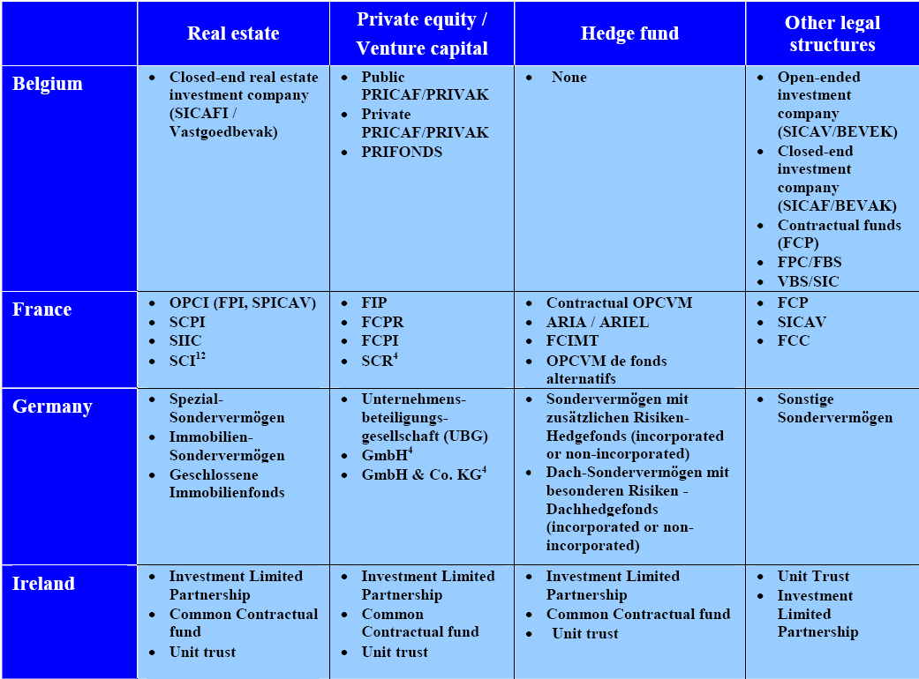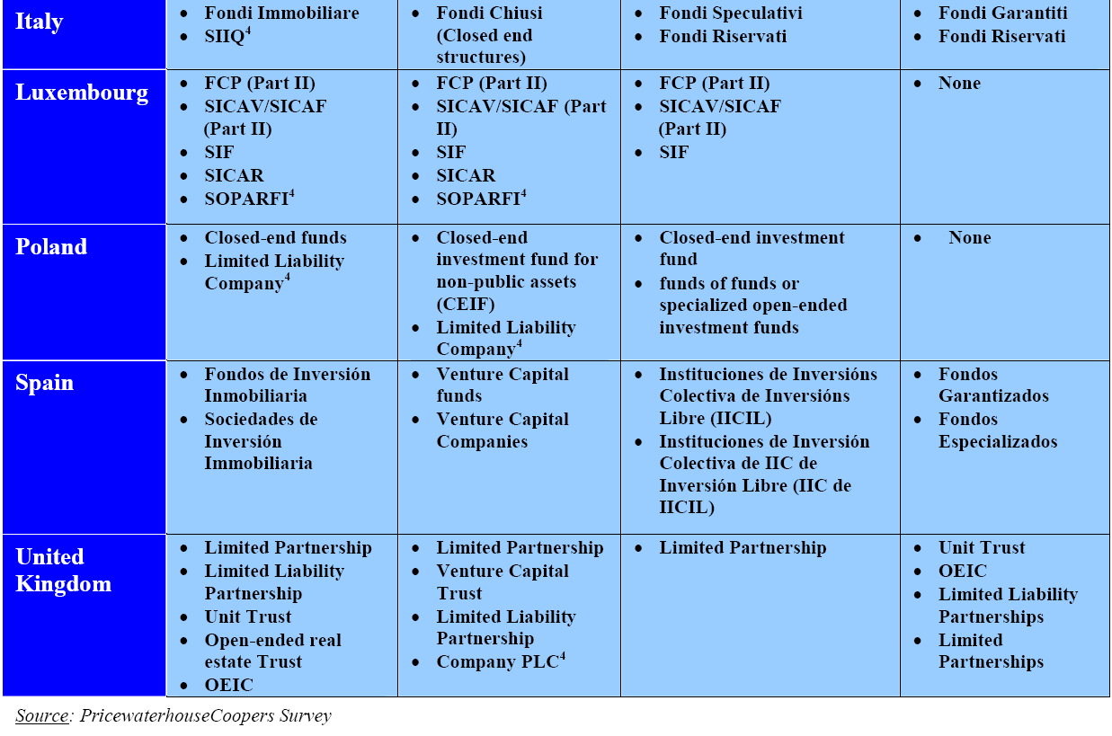
“The analysis of PWC indicates that there are more than 50 different legal structures used across the nine selected jurisdictions to establish and operate non-harmonised investment funds covering the key investment strategies or policies. Some jurisdictions permit a number of different legal structures that could be used to establish and distribute non-harmonised funds.
Other jurisdictions (e.g. Italy) offer a comparatively limited choice of legal structures to choose from. The legal structures vary between different types of corporate vehicles, structures without legal personality, tax transparent structures and common ownership vehicles. To an extent, especially with regards the local taxation frameworks, the multitude of different legal structures that must or can be used across the four key investment objectives makes jurisdictional comparative analysis more complex than would otherwise be the case.
The analysis indicates that regulatory impediments or barriers exist in all nine jurisdictions to the public distribution of non-harmonised funds, including funds distributed domestically and those distributed on a cross-border basis. Findings from the market survey support the existence of these barriers to retail distribution. Many respondents commented on the existence and strength of such regulatory barriers.
In summary, the following regulatory impediments to retail distribution of non-harmonised funds have been identified within the jurisdictions in scope:
- A lack of specific regulatory regime or structure for non-harmonised funds in some jurisdictions, (e.g. Poland for all non-harmonised funds and Belgium for HF);
- In some jurisdictions a complete prohibition on the direct public distribution of certain fund types, (both domestic and foreign funds);
- The imposition of minimum initial subscription amount (often significantly higher than that established for this study) blocking distribution to retail investors;
- None of the jurisdictions operate reciprocal distribution arrangements for foreign funds,
- All jurisdictions require foreign non-harmonised funds to be “authorised” to publicly distribute, adding to the administrative burden, cost and time-to-market;
- Local regulatory regimes require foreign domiciled non-harmonised funds to conform to and to satisfy local regulations for the equivalent local product;
- Three jurisdictions impose additional requirements on foreign products.”

3. Annex: Examples of Problems for Retail Investors
Investments in illiquid and long-term assets for retail investors have been permitted in some Member States. However, investor protection and fund operating rules have not been able to eliminate problems for retail distribution of funds exposed to such assets. Situations have arisen where retail investors had invested a substantial proportion of their savings in only one fund that suffered heavy losses during the last financial crisis, indicating amongst other issues possible problems with the distribution of such funds. This section gives some examples of the problems arising following the recent liquidity and market shocks.

3.1. Germany
In Germany the investments in long-term assets such as property, energy, ships or companies is possible for retail investors through closed-ended funds. The retail investors have always represented the big bulk of this asset class in Germany. According to the data compiled by VGF (Verbank Geschlossene Fonds), private investors represented 82% in 2011 and 70% in 2012 of the total money (€5.85 billion in 2011 and €4.50 billion in 2012) raised by these funds. Some of these funds never achieved the promised return and in some situations these funds lost substantial amount of their portfolio. Retail investors were severely hit.
Return: according to a study of the rating agency Scope realized on property funds between 2001 and 2006, only 58% of the funds matched the dividend and redemption plan. (Source: “Geschlossene Fonds in Not”, Die Welt, 24.01.2013) One of the reasons is that funds are too heavily concentrated in one sector which impacts too much the return target when the sector faces problem. Another reason is the too long maturity of some funds. For funds with 15 or 20 years maturity, the risk cannot be hedged for a so long period. It means that the return will be impacted by inflation or changes in interest rates.
Costs: according to a study made by the agencies Scope and Feri, the costs (all inclusive) reached abnormal levels: from an average of 17% for foreign property funds to an average of 21% for energy funds. Some funds reached cost levels above 30%. The distributors are gaining the most from these costs: banks, regional banks or other product distributors. (Source: “Die schlechteste Geldanlage der Welt”, Handelsblatt, 15.04.2011). For comparison purposes, normal levels of costs for closed-ended funds investing in such long-term assets are between 10% and 15%. One of the reasons of such high costs is the fact that managers often commit to acquire the assets before having the corresponding subscriptions. Because they are confronted to the risk to have to pay for assets without having the money, they pay high commissions to distributors for finding as quick as possible the investors. The payment of these high commissions can represent a huge cost for the investor.
Conflict of interest: investments in long-term assets involve higher risk of conflict of interest than investments in listed shares and bonds. The transactions are mainly processed through private placements which increase the risk of collusion between the fund manager and the target investment. For example a manager of a property fund may be linked to the company in charge of building the property in which the fund is investing: there is a risk that the fund is pays a higher than normal price for that property. Another example might be that a manager of a private equity fund is linked with the bank that has lent money to a company in which the fund is buying equity participation: the investment might be dictated by the fact that the bank wanted to be sure to be reimbursed. One example is the investment in Hotel Adlon in Berlin through a fund managed by Jagdfeld that has also renovated the hotel (Source: “Die schlechteste Geldanlage der Welt”, Handelsblatt, 15.04.2011)
Leverage: closed-ended funds make an extensive use of leverage for increasing the size of the fund. Fund managers enter into borrowing agreements with banks to obtain additional funding. When the fund faces problems, the banks are the first to get reimbursed, before the investors. Often investors are also forced to stand with their own money for the losses of the banks. This risk is even higher when the fund borrows money in a foreign currency: several funds borrowed money in Swiss francs which causes several problems when the Swiss franc appreciated in value. This is often associated with specific clauses for banks that allow them to stop dividend payments or redemptions to investors when the value of the fund deviates too much from the value of the borrowing. (Source: “Neues Jahr – Alte Probleme: Geschlossene Fonds in Nöten”, Anlegerschutz Anwälte, 24.01.2013)
 | Own capital (in € bn) | Total size (in € bn) | Leverage
Property funds DE | 23.3 | 46.3 | 199%
Ship funds | 20.7 | 50.3 | 243%
Foreign property funds | 13.5 | 25.8 | 191%
Leasing funds | 11.6 | 27.7 | 239%
Private equity funds | 7.1 | 7.2 | 101%
Aircraft funds | 5.6 | 14.5 | 259%
Life insurance funds | 5.3 | 7.8 | 147%
Energy funds | 3.7 | 8.8 | 238%
Speciality funds | 3.2 | 3.3 | 103%
Infrastructure funds | 1.8 | 2.3 | 128%
Portfolio funds | 0.9 | 0.9 | 100%
Source VGF Branchenzahlen 2012
According to the agency Feri, €200 billion have been invested during the last 30 years in closed-ended funds and at the same time €204 billion of credit have been taken by these funds.

3.2. UK
During the financial crisis some UK property funds offered to retail customers invoked contractual clauses allowing them to defer redemptions, usually for up to six months. They did this for two main reasons.
First, the high volume of surrender requests coming from retail customers meant that funds needed to dispose of some of their property holdings to meet those requests. Firms running funds affected by this were concerned that they might be forced into a 'fire sale' of assets: selling property below its real value to meet these requests within a short time frame. This raised the concern that selling property below its true market price would disadvantage investors who did not want to redeem their money but instead ride out the market falls. A significant number of firms invoked clauses in their terms allowing them to defer non-contractual redemptions.
The second issue related more narrowly to property funds used to back unit-linked life and pension contracts. Such property funds are allowed to hold up to 20% of property assets indirectly, usually via unregulated collective investment schemes. They are also allowed to be geared, but only up to 10% of the aggregate value of the fund. In practice a number of funds held property highly geared unregulated collective investment schemes, but had no gearing on direct property holdings in order to comply with the overall 10% limit. This made disposing of such assets in response to high volumes of redemption requests particularly challenging. In some cases such unregulated collective schemes held one single very large property, for example a shopping centre, and had a very small number of unit-holders. In some cases the only way to dispose of the holding was to secure permission from the other unit-holders to wind up the fund, but they were often unwilling to do so.
The firms deferring redemptions were contractually allowed to do so and this information had as a rule been included in disclosure documents provided to investors. As a result this might not be considered an instance of mis-selling but rather an example of the challenges for market efficiency in the face of what might not be rational investor behaviour. It points to the challenges any funds which invest in illiquid assets may face under stressed market conditions.

3.3. Costs of investing in funds
Managers of closed-ended funds face implementation costs that managers of open-ended funds generally do not have to incur. The investment in long-term assets is not as easy as investing in listed shares or bonds and therefore requires additional costs. These costs include:
- Acquisition costs such as conception costs, legal costs, consulting costs, due diligence costs or tax advisory costs
- Financing costs: setting up the financing structure
- Fund costs: fund administration and related tasks
In average these one-off costs might range between 10% and 15% of the fund’s money. The annual running costs then will amount to around 0.50%.
This has to be compared with the costs of open-ended funds. These funds have generally less implementation costs but higher running costs. Assuming no implementation costs at all and 2% annual running costs (usual level observed in the market), the level of fees is very similar for an investment of 10 years.
 | Open-ended fund: 2% annual cost |  |  | Closed-ended fund: 15% upfront and 0.50% annual cost
Year | Total no fees | Total with fees | Total fees | Total no fees | Total with fees | Total fees
 | €1,000 | €1,000 |  | €1,000 | €850
1 | €1,050 | €1,029 | €21 | €1,050 | €888 | €162
2 | €1,103 | €1,059 | €44 | €1,103 | €928 | €175
3 | €1,158 | €1,090 | €68 | €1,158 | €969 | €188
4 | €1,216 | €1,121 | €94 | €1,216 | €1,013 | €203
5 | €1,276 | €1,154 | €123 | €1,276 | €1,058 | €218
6 | €1,340 | €1,187 | €153 | €1,340 | €1,105 | €235
7 | €1,407 | €1,222 | €186 | €1,407 | €1,155 | €252
8 | €1,477 | €1,257 | €220 | €1,477 | €1,206 | €271
9 | €1,551 | €1,293 | €258 | €1,551 | €1,260 | €291
10 | €1,629 | €1,331 | €298 | €1,629 | €1,317 | €312
These calculations assume a 5% annual growth, no inflation and payment of the fees at the end of the year.
This stable shows that after an investment of 10 years, the cost level is mostly comparable: 29.8% for the open-ended fund and 31.2% for the closed-ended fund.
When the fund is marketed through distribution channels, the investor might face in addition distribution costs that are not taken into account in this section.

4. Annex: Asset Classes

4.1. Infrastructure projects

4.1.1. Description and market Size
Industry now views infrastructure as a separate asset class. Distinction is sometimes made between investing in core infrastructure, such as roads, airports and ports, utilities, telecommunications infrastructure, social infrastructure and tangential assets, where the latter means an essential service business inextricably linked to traditional infrastructure assets.
Others make a categorisation within this asset class according to an overall risk profile distinguishing between core, value-added and opportunistic investments. Core assets are recognised to have bond-like features with a correspondingly more modest return profile. Value-added and opportunistic investments in infrastructure are viewed as being closer to equity participations entailing higher risk and a better return potential. The latter investments require more active asset management, operational expertise and ability to cope with a wide range of risks. Depending on a project the fund manager’s experience may be valuable for completing an acquisition of infrastructure assets.
Infrastructure investments are often divided into two categories. So-called brownfield infrastructure projects correspond to the completed infrastructure projects. They are more susceptible to direct acquisitions given their lower risk profile and due to the fact that they require less intensive management. So-called greenfield infrastructure projects correspond to the launching phase of an infrastructure project. They fall within the riskier group of investments and often require a more active management in order to extract value from yet undeveloped projects, which can be rewarded with a higher return. Therefore, investments in the latter are likely to be handled with the help of fund managers also in the future as confirmed by some investors
Direct Investment vs Commitment to Funds 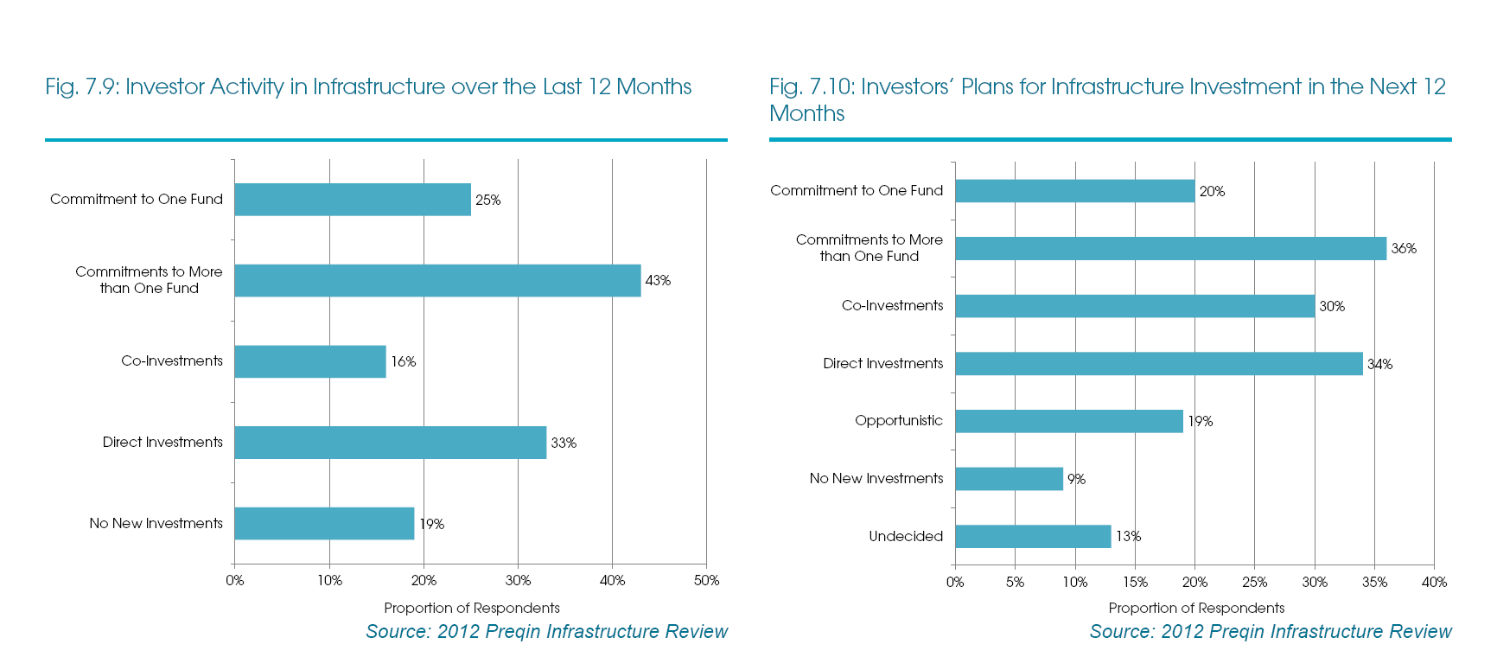
This graph taken out the Preqin Infrastructure Review reveals that investors have a clear bias toward the investment in funds instead of investing directly in infrastructure assets. The first two categories, commitment to one or more than one fund, account for 68% of the investor activity in infrastructure.
In 2011, more than 350 projects reached financial close in Europe worth approximately €110 billion. According to the Infrastructure Journal, the transaction volume is between €100 and €150 billion every year since 2007. This shows a relative stability in the launching of new infrastructure projects.
Different sources provide different estimation as to the amount of financing that the EU will need to fund its infrastructure over the upcoming years. Some sources estimate that the EU would need €1 trillion for the period up to 2020 to finance overall investment in transport, energy and telecom infrastructures networks. Other sources’ infrastructure needs for investment are estimated to be even higher (cf. table below).
According to Dealogic, the infrastructure needs in Europe till 2020 are estimated between €1’500 and €2’000 billion. The project financing needs are split among the following categories:
Energy | 34%
Infrastructures | 31%
Oil and Gas | 18%
Mines | 6%
Industrial projects | 5%
Petrochemie | 4%
Telecom | 2%
Investment needs in R&D, new technologies and innovation are calculated to amount to €24 trillion over the same period.
OECD’s Survey on Pension Funds Investment in Infrastructure 2011 breaks down the figures by specific projects. It reads:
“From now until 2020, €500 billion is estimated to be needed for the implementation of the Trans- European Transport Network (TEN-T) programme. In the energy sector, public and private entities in the Member States will need to spend around €400 billion on distribution networks and smart grids, another €200 billion on transmission networks and storage as well as €500 billion to upgrade and build new generation capacity between now and 2020. Last, but not least, between €38-58 billion and €181-268 billion capital investment is required to achieve the Commission's broadband targets.”
A separate section in the OECD Survey overviews the UK’s situation by referring to the National Infrastructure Plan 2010. GBP 200 billion was identified as infrastructure financing needs over the upcoming 5 years. In the Spending Review the Government was ready to commit over 40 billion to fund infrastructure projects.
PFG Report Investing in Infrastructure Funds of September 2007 stated that in 2007 Germany needed €90 billion for infrastructure investments.

4.1.2. Market players
Typically a company or more often a consortium of companies designs, finances and builds a new infrastructure project. They create a special purpose entity where the project owners and equity investors contribute to its capital and loan providers ensure additional financing. More complex projects may involve corporate finance, securitization or use of derivatives. Normally only professional investors are able to directly participate in such projects due to a significant size of an investment ticket (that is, a minimal amount one has to invest in a company to be accepted as a shareholder). In this way project owners have to interact with a fewer shareholders thus minimizing the burden of dealing with too many shareholders and avoiding various risks, including those associated with the retail consumers. As mentioned before, professional investors can make these investments directly or via funds.
Examples of infrastructure funds
- greenfield infrastructure funds : FIDEPPP (200M€) and FIDEPPP 2 (180M€ targeted)
- greenfield renewable energy funds : FIDEME (40M€) - EUROFIDEME 2 (95M€)
- Meridiam Infrastructure SICAR: €750m of AUM
- Meridiam Infrastructure Europe II SICAR: €935m of AUM
- Meridiam Infrastructure North America II: USD1100m
Detailed example of FIDEPPP
FIDEPPP (Fonds d’Investissement et de Développement des Partenariats Public-Privé) is a French FCPR that invests in greenfield projects. Created in 2005, the fund is invested in 15 projects. It typically buys a share in the SPV that have been created for managing the projects. Examples of the 15 projects in which the fund is invested are:
- 26% participation in the company ALIS: concession contract for the A28 motorway in France
- 23.3% participation in Arema: partnership contract with the City of Marseille concerning the Stade Velodrome
- 24% in Guyane SAS: conception, financing and construction of three schools in French Guyana
- 8.5% in Mars: concession contract for the conception, financing and realisation of a tramway in Reims
- 33.5% in Helios: partnership contract for the conception, building and maintenance of prisons in France
The fund invests in projects with a minimum value of €50 million and commits a least €1.5 million of its money in each project. One single project cannot account for more than 20% of the portfolio of the fund.

In the UK, some closed-ended infrastructure funds are listed in order to provide greater facilities for the exchange of shares in the secondary market. These funds are listed on the FTSE 250 as a normal share. As such they are accessible for every investor, including the retail ones.
- John Laing Infrastructure Fund: value of around £500 million invested in 38 projects
- HICL Infrastructure Company Limited: value of around £1.1 billion invested in 79 projects
- GCP Infrastructure Investments Ltd: value of around £270 million invested in infrastructure debt
Focus on John Laing Infrastructure Fund
The fund invests in equity and subordinated debt issued by infrastructure PPP projects that are mostly in their operational phase when the construction phase is finished. Each project cannot account for more than 25% of the fund’s portfolio. The fund does not invest more than 15% of its assets in projects that are under construction. The key determinant in their investment policy is that the projects in which they invest must generate revenue that is backed by public sector or government. They only invest in countries that are regarded as fiscally strong. The breakdown between sectors is as follows:
Sector | Weight
Roads and transport | 23.8%
Street Lighting | 1.9%
Schools | 7.8%
Regeneration | 11.4%
Justice and emergency services | 4.5%
Defence | 12.5%
Health | 38.0%
The investments consist of acquiring a stake in concessions. These concessions pay regular revenues over their entire length. In this precise example, the remaining length ranges from below 10 years to more than 30 years.

4.1.3. Relevance for LTI
Participations in the infrastructure projects can be done directly or through an intermediary. Unless the project company goes public, retail investors do not have access to these assets. Professional investors may do it directly, but as it appears from the surveys, majority prefers to invest through the funds as certain projects require particular expertise and skill to drive the venture to a successful closure. Fund managers are able to tailor the investment strategies and investment formats to the needs to every investor. They are able to pool the investments together on the transactions to increase origination power and improve investment terms. This can include through public private partnership arrangements.
For investors, infrastructure debt reduces reliance on duration-driven returns and adds skill-based, difficult to access beta. The asset class complements fixed income with its investment grade performance, stable cash yields, attractive liquidity premiums and low correlation with other assets. In addition, participating in the infrastructure projects through the funds provides a diversification benefit where a portfolio includes different assets by their type and geography and they are issued by a number of different issuers.
Investment funds may represent a useful vehicle for matching the financing needs of infrastructure projects. They could contribute at reducing the burden placed on governments for financing large infrastructure projects. In a general decline in public spending, many infrastructure projects may be threatened or postponed in the future which will inevitably affect the growth potential of the European economy. Based on the example of the UK government that seeks private funding for major infrastructure projects, the creation of this new asset class could well serve this purpose.
Risks of relying on investment funds for financing infrastructure projects cannot be ruled out. The cost of private money might be higher than the cost of public money: the return on investment or yield demanded by private investment sources such as funds could likely be higher than the comparable cost of funding for governments. It is then to be expected that the funding costs of these projects might rise, thus increasing the future costs for the users of the infrastructure (car drivers, patients or students). In addition there is a risk that the introduction of financial activities in the real economy space, namely infrastructure financing, creates uncertainty when predictability is necessary. It cannot be excluded that financial market turbulences will not affect to a certain degree the viability of these projects.
The risks mentioned here above have not yet materialized. The economic concept of the involvement of investment funds has proven to be valid since numerous investment funds are already active in this sector. The possible instability of introducing capital markets in such projects is counterbalanced by the fact that the investment fund must commit the money over a long period of time with very limited possibilities to withdraw the money earlier.
The definition of infrastructure as an asset class will need to be precise enough to avoid any misconception. What is important to target is the direct investment in infrastructure projects, the type of investment that is entirely correlated to infrastructure characteristics. Buying stakes of infrastructure companies does not offer the same exposure because only a small proportion of their business may be related to infrastructure. Furthermore these companies may be totally absent from the financing of new infrastructure projects but entirely focused on the maintenance of existing ones (e.g. toll roads).

4.2. Property

4.2.1. Description and market size
The investment in property assets is broad in nature and may cover different stages in a property cycle. Usually the investments are categorized among the following sectors:
Investment | Characteristics
Raw land | Illiquid, return from value appreciation only
Apartments | Medium liquidity, return from income and appreciation
Office buildings | Medium liquidity, return from income and appreciation
Warehouses | Medium liquidity, return mostly from periodic income
Shopping centers | Low liquidity, return from income and appreciation
Hotels | Medium / low liquidity, return from income and appreciation
Source: CFA Institute, 2011
The property market is a clear and distinct asset class in the asset management universe. The fund industry offers different types of strategies permitting investors to gain exposure to different classes of real estate assets. Here below are the lists of the 10 biggest funds, from the open-end and closed-end nature.

List of the 10 biggest EU open-end property funds (according to Morningstar)
Name | Domicile | Firm Name | Fund Size EUR
Deka-ImmobilienEuropa | DE | Deka Immobilien Investment GmbH | 12,181,745,560
hausInvest | DE | Commerz Real Investment GmbH | 9,294,545,470
UniImmo: Deutschland | DE | Union Investment Real Estate GmbH | 8,823,403,332
UniImmo: Europa | DE | Union Investment Real Estate GmbH | 8,269,247,184
WestInvest InterSelect | DE | WestInvest mbH | 5,023,756,068
CS EUROREAL A EUR | DE | Credit Suisse Asset Management KAG mbH | 4,873,311,608
SEB ImmoInvest I | DE | SEB Investment GmbH | 4,639,878,559
Grundbesitz Europa | DE | RREEF Investment GmbH | 3,685,000,000
KanAm grundinvest Fonds | DE | KanAm Grund KAG mbH | 3,341,928,225
Deka-ImmobilienGlobal | DE | Deka Immobilien Investment GmbH | 3,233,408,629
The open-end real estate fund structure is particularly popular in Germany. Out of the €113 billion of such funds in the EU, €85 billion is domiciled in Germany.

List of the 10 biggest EU closed-end property funds (according to Morningstar)
Name | Domicile | Firm Name | Fund Size EUR
AFI Development 'B' Ord | Cyprus | Australian Foundation Investment Co Ltd | 719,115,166
AFI Development 'A' DR | Cyprus | Australian Foundation Investment Co Ltd | 680,090,284
XXI Century Investments Ord | Cyprus | XXI Century Investments | 245,646,307
Mirland Development Corp Ord | Cyprus | MirLand Development Corporation PLC | 241,761,753
Interfundo Renda Predial | Portugal | Interfundos - Gestão de FII | 200,179,578
Interfundo Imosotto - Acumu. | Portugal | Interfundos - Gestão de FII | 189,447,388
Interfundo Imorenda | Portugal | Interfundos - Gestão de FII | 187,952,129
Conygar Investment Ord | UK | Conygar Investment Company Plc | 171,370,697
Santander LusImovest | Portugal | Santander Asset Management | 147,510,213
Banif Renda Habitação - FIIAH | Portugal | Banif Gestão de Activos - SGFIM S.A. | 146,975,106
The total of closed-end funds is €6.1 billion in the EU. This table should be taken with caution since the German closed-ended funds are not included.
The sum of open-end and closed-end funds in the EU is, according to Morningstar about €120 billion. The data collected by industry associations give another picture. For instance EPRA has estimated a €300 billion market capitalization for European listed property “that under a ‘best-case’ scenario … has the potential to double”. EFAMA, in its statistical release of March 2013, estimates at €258 billion the size of the EU property funds market. It is however not clear if these data cover the EU only or the whole continent: numerous funds are domiciled in European third jurisdictions such as the Channel Islands.
Example of a fund
The biggest EU fund, Deka-Immobilien Europa, is invested as such:
- 72.3% in direct investments (€7.9 billion for 125 projects): for example in Le Centorial, Paris; Moor House, London; Leo, Francfort or Schloss Arkaden, Braunschweig
- 27.7% in indirect investments, through real estate companies (33 companies)
- Mostly invested in office buildings (60.1%)
- 19.9% of the investments are less than 5 years old and 44.5% are between 5 and 10 years

4.2.2. Relevance for LTI
The property market is characterized by its lack of liquidity, by the large amounts required to invest, the non-transferability of the assets (assets are immobile) and low transparency about the factors that affect the risk and return profile of the investments. The market essentially operates with bilateral transactions, without any centralized exchange. This creates difficulties to appraise the value of the assets on a regular and accurate basis. Furthermore the market is driven by factors that are often opaque for the non-initiated investors: the supply / demand for property assets is linked to the location characteristics, to population factors or to design aspects.
For these reasons, indirect investment is often the unique opportunity for an investor to gain access to this market. Fund investment, through their pooling of capital, can provide the necessary money for investing and can face the illiquidity problem through diversification. Nevertheless the property illiquidity nature requires long term commitments from investors. The risk of the property assets depends from the cycle of the asset: an investment in the construction phase will be more risky than an investment in the period when rental income is generated.
Property assets already benefit from a high penetration in investor’s portfolios; they represent a large part of the AIFs in Europe. But their share and market presence have a potential to increase which would be beneficial for the economy. The property sector is core to the real economy where it provides a fundamental source of employment and economic growth According to AREF, the commercial real estate sector contributed €285 billion to the European economy in 2011 and directly employs over 4 million people. A substantial part (around 50%) of the real estate assets are held as an investment and leased to businesses reluctant to commit the capital and management resources required of owner occupation. Therefore investment funds represent a useful link to provide real estate infrastructure needed for entrepreneurship. Another area that is less developed than the commercial real estate market is the sector of social housing. The building of real estate for a social occupation requires massive amount of money that investment funds could help to contribute.

4.3. Aircraft and maritime financing

4.3.1. Description and market size
The importance of the money required to buy aircraft (often hundreds of millions of Euros) leads companies to search for alternative sources of funding. Banks have originally been the key providers of loans to airline companies for the financing of new aircrafts. But, as in other long-term sectors, the banks are retreating from this business. According to Addy Pieniazek, global head of consultancy at Ascend, an aerospace specialist, the “volume of aircraft loans being made by banks had fallen 20% last year [2011]”.
In the same article, William Glaister, a partner at Clifford Chance, makes the following statement: “Aircraft financing is attractive for asset management firms. Whether loans or leases, they are long-term investments and fixed-rate dollar assets, which is attractive for dollar investors. They are also secured – which is what people want in the current environment.”
From the investor side, Michael Weiss, head of Investec’s aircraft finance business, makes the following statement: “Pension funds like this stuff, as they view it as a long-term, fairly defensive asset. If you want 5% of your fund in alternatives, it makes sense for a slice of that to be in aircraft financing.”
The investment funds will certainly not be able to replace banks for providing loans but they will have an increased role in the financing mix of new aircrafts. The needs of the industry for financing sources are increasing: according to a study realized by PwC, the value of aircraft that have been ordered but not yet delivered amounts to around $700 billion worldwide.
The maritime sector is confronted to the same problems: large amount of money are required to develop new ships. As such investment funds can play a role in providing the necessary resources.
An example of such fund is the Danish Maritime Fund:
“Through ownership of Danish Ship Finance, the fund operates to ensure that ship financing operations will continue to be undertaken under the auspices of Danish Ship Finance to the benefit of Danish ship owners and/or shipyards.
The objective of the fund is to provide financial support for initiatives and measures to develop and promote Danish shipping and/or the Danish shipbuilding industry. This is achieved through financial support for research, technological advances and product innovation, training, recruitment and other initiatives with a maritime focus.”

4.3.2. Description and market size
The financing of such activities is not as developed as other long-term investments. Nevertheless they are associated with strong productive and long-term aspects and their share in fund’s portfolios is expected to rise over the next years.

4.4. SMEs and larger companies
There are two possible instruments for gaining exposure to companies: equity participation or loan. This section discusses both approaches separately since they represent two different business models.

4.4.1. Description and market size of the private equity
Private companies’ capital is raised through offering securities via a private placement as opposed to public offering. Companies in need of capital may approach potential investors directly, through private equity funds or fund-of-funds (indirectly). Fund-of-funds can enable larger or institutional investors to access small venture capital funds, which in particular provide alternative finance for innovative firms that have limited access to more traditional bank finance. Depending on the development stage of the target company, the investment funds are called venture capital funds or private equity funds. They pool the funds from a number of sophisticated investors and make allocations to highly illiquid and thus long term investments. These are highly illiquid investments (a secondary market for these assets is small) and require a long-term capital commitment. Typically equity funds are established for a period of 10 years and are closed-ended, offering no redemption rights, with a possible extension. Withdrawing investments from these funds can be difficult. The limited partnership model provides a framework that has allowed funds to develop that reduce market volatility and provides diversification benefits for investors – sophisticated and long-term investors. The disinvestment or liquidation of the investment occurs by a merger with another company, an acquisition by another company (including another fund) or an Initial Public Offering (IPO), the process for becoming public.
After a sharp dip provoked by the financial crisis private equity market is recovering and demonstrates a noticeable pick-up in equity value of investments and a number of companies invested in. According to the EVCA Yearbook 2012, €45.5 billion were invested in the sector. The sector is recovering from the last financial crisis but it is still far from the level reached in 2007 with €72.2 billion.
In terms of portfolio companies’ location and in terms of fund location, the private equity market is mostly developed in France, Benelux, UK and Ireland. These regions represent 55% of the EU market in terms of location of the portfolio company and 70% in terms of location of the private equity firm.
A breakdown by industry shows a great variety of sectors where the EU private equity market is active. All these investments, as mentioned, are made with a longer term horizon.

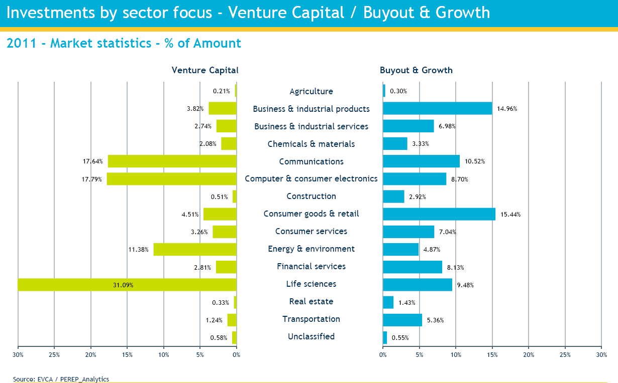
Source: EVCA Yearbook 2012

4.4.2. Market participants in the private equity sector
Institutional investors such as pension funds, fund of funds, insurance companies or banks as well as private individuals are normally on the investor side of a private equity market. There is a tendency of seeing banks limiting their exposure to the private equity sector as a result of incoming EU rules implementing Basel III.
Sources of funds (2007-2011) | Proportion
Pension funds | 25.60%
Fund of funds | 15.50%
Banks | 13.80%
Insurance companies | 8.10%
Private individuals | 6.30%
Government agencies | 5.60%
Other asset managers | 5.50%
Family offices | 5.40%
Sovereign wealth funds | 5.20%
Endowments and foundations | 3.40%
Corporate investors | 3.10%
Capital markets | 2.10%
Academic institutions | 0.30%
Source: EVCA
The investors do not target equally all types of private equity funds. For instance private investors have a tendency to focus on funds targeting early stage companies, from the seed stage to the development stage. This is illustrated by the larger proportion in venture capital funds. To the contrary institutional investors have a tendency to invest in mature companies (buyout funds) whose strategy is to acquire other businesses. Their proportion in the total amount of capital raised for all types of funds is the highest due to the over representation of buyout funds.
For the year 2011 | Venture Funds | Buyout funds | Generalist funds
Pension funds | 8% | 22% | 3%
Fund of funds | 9% | 17% | 4%
Banks | 10% | 18% | 11%
Insurance companies | 3% | 7% | 1%
Private individuals | 15% | 5% | 26%
Government agencies | 34% | 5% | 13%
Other asset managers | 1% | 4% | 0%
Family offices | 2% | 4% | 34%
Sovereign wealth funds | 0% | 13% | 0%
Endowments and foundations | 1% | 3% | 5%
Corporate investors | 12% | 2% | 1%
Capital markets | 5% | 0% | 3%
Academic institutions | 0% | 0% | 1%
Total amount raised | €4.8 billion | €33.2 billion | 1.7 billion
Source: EVCA
Private investors are not evenly spread across the EU. Private investors in western countries have a clear tendency to invest more in private equity funds than private investors in Central and Eastern European countries. Private investors and family offices in France and Benelux represent the highest category, all types of funds and investors included.
For the year 2011 | Proportion of private individuals and family offices
UK & Ireland | 8.60%
Germany, Austria, Switzerland | 13.70%
Denmark, Finland, Norway, Sweden | 9.50%
France & Benelux | 22.20%
Greece, Italy, Portugal, Spain | 13.10%
Central Eastern Europe | 1.20%
Source: EVCA

4.4.3. Debt participation
Purchasing equity shares is not the only possibility to participate in companies via unlisted means. Alongside their borrowing from banks and their issuance of bonds, companies have recourse to private loans. Loans can be used to finance different purposes, such as the acquisition of a new business or the development of the company. They are mostly used by companies that are too small or because they are not rated by a credit rating agency for having a direct access to the bond’s market. Loans represent a useful complement to bank financing in the sense that it diversifies the sources of funding for the companies. Typically the money is raised in private placements; a company is in need of money and seeks investors ready to lend this money. The companies are usually non-investment grade, meaning that they have a credit rating below BBB. According to the Loan Market Association (LMA), the size of these types of loans in Western Europe amounted to €415 billion as of 30 June 2012, to be compared with the €187 billion of their counterpart in the high yield bond market. The investment funds are far from being the only holders of such debt; many other institutions are present in this market.
The loans provide different characteristics than equity participations: loans have a pre-defined and fixed maturity and they offer regular and pre-defined yields. The risk attached to this investment is linked to the credit quality of the company issuing the loan because the fund is directly exposed to the counterparty risk, the risk of default of the company.
Examples of companies that have recourse to loans include the following:
Company | Country | Company | Country
TDC | Denmark | Ruhrgas | Germany
Legrand | France | Telenet | Holland
Numericable | France | Avio | Italy
Picard | France | Wind | Italy
Orangina | France | Sanidad | Spain
KBW | Germany | Dorna | Spain
Kion | Germany | Smurfit | UK/Ireland
Prosieben | Germany | Weetabix | UK/Ireland
Source: LMA

4.4.4. Relevance for the LTI
There is a widely accepted belief that these investments often need experienced and active managers who are able to identify and be ready to deal with the variety of risks and issues.
Generally investing in private equity funds are limited to institutional investors and are closed for a retail population. The latter could get such exposure by participating in the listed funds.
Venture capital and private equity share the same characteristics in the sense that both are highly illiquid investments that require long commitments from the investors. Investment funds play a key role in this asset class as they represent the main providers of financing. Venture capital funds and private equity funds represent a clearly distinct fund category in the space of alternative funds. These funds are mostly set up as closed-ended funds, which permit the investors to sell their units on the secondary market. But as for every closed-end fund, the liquidity in the secondary market is not guaranteed, thus possibly requiring the investor to hold its investment till the end of the commitment (usually several years).
Venture capital funds will benefit from an increased visibility with the creation of a European label for venture capital funds. These funds will have to respect harmonized product rules in order to earn the label. Units or shares of these recognized funds could be introduced as well in the eligible assets to increase the potential that the venture capital can attract.
The loan funds are less developed than the private equity or venture capital funds, even if there is a general trend to have more of such funds. They generally benefit from a more liquid secondary market than equity participations but their liquidity is far from being sufficient for funds offering regular redemptions. Because the secondary market does not offer constant liquidity, loans require long-term commitments.

5. Annex: Market Overview of Existing National Fund Regimes for Illiquid Assets
According to EFAMA, by the end of the second quarter of 2012, there were 18’411 non-UCITS funds in Europe, managing EUR 2’486 billion of assets. The Luxembourg, Ireland, UK, Germany, France, Italy and the Netherlands are major players in the European market for investment funds, and have substantial domestic markets for non-UCITS funds available for investors.

5.1. Luxembourg
Luxembourg does not have a specific regime for real estate or infrastructure funds but offers the possibility to set up both regulated and unregulated vehicles that lend themselves to investments in real estate. The regulated vehicles are supervised by the Commission de Surveillance du Secteur Financier (CSSF) and include the SIF , the SICAR and the UCI Part II regimes. The SOPARFI is the non-supervised regime. A number of corporate forms may be used to structure real-estate funds in Luxembourg under both the supervised and non-supervised regimes.
Since its introduction, the Law of 13 February 2007 (the ‘SIF Law’) on Specialised Investment Funds (SIF) has become the predominant regime for establishing alternative investment funds in Luxembourg. The SIF is also the most widely used regime for Luxembourg real-estate investment funds. Although an institutional investor fund regime existed since 1991, in 2007 it was replaced by the SIF Law of 13 February 2007. SIF real estate funds have grown exponentially since the introduction of the SIF law in 2007. A growth of 350% in SIF real-estate funds has been recorded in July 2012 when compared to the number of real-estate funds under the SIF predecessor in 2006. The SIF Law is not specifically designed for real-estate or infrastructure funds and real-estate amounts to 8.2% of the total assets under management by SIFs as at 31 December 2010.
As at 31 December 2011, Luxembourg recorded 1,374 SIF vehicles, comprising approximately 2,800 funds (single funds and sub-funds of umbrella SIFs), with net assets of nearly €240 billion. The assets under management have also increased in significant proportions together with the number of SIF vehicles. According to EFAMA, as at September 2012 the net assets of non-UCITS funds in Luxembourg amounted to €373 billion. This means that approximately 64% of non-UCITS funds in Luxembourg are SIFs.
In legal terms, SIFs are undertakings for collective investment whose objectives are limited to fulfilling three purposes:
1) the collective investment of its funds in assets in order to spread the investment risks and to ensure for the investors the benefit of the results of the management of their assets;
2) the securities of the SIF are reserved to investments by one or several well-informed investors; and
3) the constitutive documents or offering documents of the SIF provide that they are subject to the SIF law.
Although natural persons can invest in a SIF, a SIF cannot be sold to the mass retail public but only to “sophisticated natural persons”. Only “well-informed investors” may invest in a SIF. The concept of “well-informed investor” is defined in the SIF Law by reference to three groups of investors: (1) institutional; (2) professional; and (3) a third category of investors that meet a set of defined criteria. The criteria for the third category of eligible investors are that the investor:
a) confirms in writing that he adheres to the status of well-informed investor, and
b) either: (i) invests a minimum of € 125,000; or (ii) has been subjected to an assessment made by a credit institution, an investment firm, or by a management company certifying the investor’s expertise, experience and knowledge in adequately apprising an investment in a SIF.
The objective of spreading investment risk by a SIF is interpreted by the CSSF in a flexible manner due to the sophisticated nature of the eligible investors in a SIF. In principle, a SIF would be required to invest not more than 30% of its assets or commitments in securities of the same type issued by the same issuer. The CSSF may grant an exemption from the 30% threshold upon appropriate justification or apply additional restrictions.
The SIF Law requires that the offering document of a SIF include sufficient information for investors to be in a position to make a well-informed judgment on the investment proposition. In this regard, the CSSF would require “quantifiable restrictions” that give evidence to the fulfilment of the principle of risk spreading.
Given that there are no investment restrictions imposed on a SIF by the SIF Law, a SIF lends itself to investing in various asset classes and to undertaking various types of investment strategies. The success of the SIF is attributed to the great deal of flexibility permitted by the SIF Law. A SIF may also take various corporate legal forms such as a company, partnership or contractual form.
Another attractive feature of the SIF is that it may be established with multiple investment compartments, with each compartment having distinct assets and liabilities. In this way, the rights of investors and of creditors concerning a compartment are limited to the assets of that compartment, unless provided otherwise.
The SIF Law does not impose any restrictions on redemptions by investors in the fund and redemption rights are subject to the rules contained in the constitutional documents of the SIF.
A SIF must ensure there are appropriate risk management systems and that conflicts of interest are minimised. The SIF also benefits from lighter publication requirements.
The UCI Part II regime is another important framework for structuring non-UCITS strategies in Luxembourg. However, unlike the SIF, UCI Part II funds are open to both retail and institutional investors. The primary features of the UCI Part II framework is that it enables fund managers to sell alternative strategies to retail investors. UCI Part II funds are not subject to any investment restrictions in relation to the asset classes in which they may invest. This flexibility permits them to combine various investment strategies, including real estate. Like SIFs, UCI Part II funds are also required to comply with the principle of risk spreading and must therefore spread their investments across several entities.

5.2. United Kingdom
The UK currently maintains a domestic-authorised investment fund regime for sale to retail investors, the so called Non-UCITS Investment Schemes (NURS) which operates alongside the UCITS regime. NURS are UK funds that do not comply with all the UCITS rules and, therefore, cannot be promoted across the EU. They can, however, be sold to UK retail investors. NURS can invest in a wider range of eligible investments than UCITS. NURS can invest in the same range of assets as UCITS, but they can also invest in real estate, gold and units of unregulated funds. Up to 20% of the fund's value can be invested in unapproved securities. Property funds can borrow up to 20% on a long-term basis.
In the UK, there are both nationally-regulated open-ended funds and listed, closed-ended investment companies (such as real estate investment trusts or venture capital trusts) that allow retail investors access to asset classes such as real estate, commodities, precious metals and private equity, and access to funds of funds where the underlying funds are not UCITS. These types of vehicles are invested in generally, but not exclusively, by “mass affluent” and “high net worth” retail investors.
UK authorised funds under management at the end of December 2011 totalled to £595 billion, of which property funds represented 2.2%.
Regarding private equity funds, the British Private Equity & Venture Capital Association (BCVA) provides figures in their annual report. At the end of 2011 the members of BVCA had a total amount invested of £18 billion covering investments in 1,048 companies.
The split among the sources of raised money is as follows:
Investor's type | 2011 | 2010
Fund of funds | 25% | 11%
Pension funds | 24% | 25%
Private investors | 7% | 5%
Credit institutions | 4% | 2%
Insurance | 8% | 2%
Government agencies | 9% | 6%
Source: BVCA
The institutional investors dominate the sector. Private investors represent nevertheless the fourth category of investors. In terms of money raised, the figures are as follows:
 | 2009 | 2010 | 2011
Investments (in £ Mio) | 2,987 | 6,594 | 4,543
Source: BVCA

5.3. Ireland
Qualified Investor Fund (QIF) is a non-UCITS fund vehicle, which may be used for gaining exposure to illiquid assets. Whilst QIFs are subject to rules on supervision, disclosure and safe-keeping of assets, investment and borrowing are not regulated by law. Fund managers must only ensure that diversification requirement and leverage limits, as stated in the prospectus, are respected. Investing in QIFs is restricted to qualifying investors with a minimum subscription requirement of €100,000. QIF can be formed as a company, unit trust, investment limited partnership, or common contractual fund.
The QIF regime does not specifically target real-estate or infrastructure but because of its flexibility it is used for investing in this asset class. QIFs can invest directly in underlying assets or through special purpose vehicles. Investing through the separate entities allows ring-fencing liability concerns relating to each project with ensuing benefits and risks.
According to figures from the Central Bank of Ireland there are 1664 QIFs registered in Ireland. In 2010 the total assets managed by Irish-domiciled QIFs increased by 35% to €152.8bn, in 2011 - to €182bn and in December 2012 it was at € 204bn. More than 100% increase in the QIFs assets is calculated between the period of 2009 and the end of 2012.
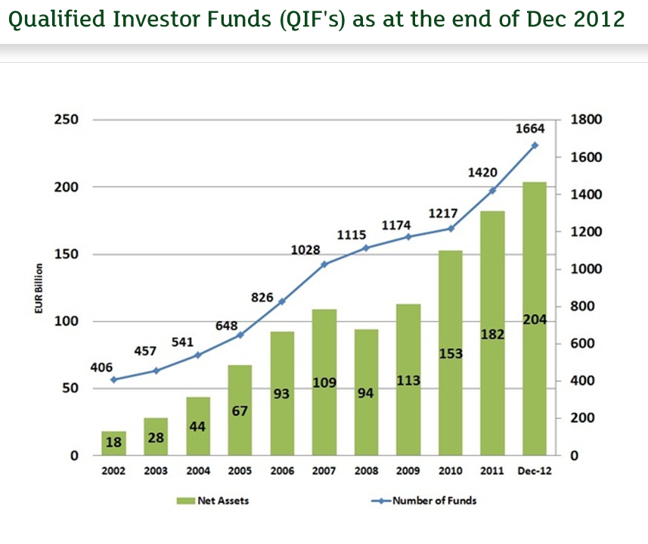
Source: Ifia
With particular regard to real estate and infrastructure, at the end of 2009 all Ireland-based funds had invested €15,3bn in non-financial assets. The ‘Other funds’, which are distinguished from equity and bond funds and comprise mixed, real estate and other funds, had €5,1bn invested in non-financial assets.

5.4. Germany
In Germany, long-term investment opportunities can currently be offered by open-ended funds or by closed-ended funds. Different sources exist for having access to the relevant data. The data are mostly compiled by associations representing managers in their respective sector. Therefore the data might diverge according to the population that is covered by the analysis.
Open-ended funds are generally only investing in properties. The so-called Open Ended Real Estate Funds (OEREFs) are set up as retail vehicles eligible for public marketing. OEREFs offer retail investors the possibility to participate in long-term property projects, even by investing in small amounts, through fund units. German OEREFs have recently undergone a major regulatory reform as a result of liquidity problems experienced by some of these products. Under the new rules, units in OEREFs can be redeemed only after an initial lock-up period of two years and following a notice period of twelve months. Redemptions not exceeding €30’000 in a calendar year are exempted from these provisions. German OEREFs are very popular among German investors and comprise roughly €83 billion assets under management. The net sales of OEREFs amounted to approximately €2 billion by the end of the second quarter 2012.
Closed-ended funds present another option of investing in long-term assets available to German retail investors. These funds invest in a vast array of long-term assets, ranging from properties, ships, private equity to infrastructure and energy. According to the association VGF, they manage around €200 billion of assets. VGF closed-ended funds have the characteristics to be dominated by retail investors since they represent 70% of the €4.5 billion raised by the VGF members in 2012.
The fund size of the VGF closed-ended funds is split as follows:
 | Total size (in € bn)
Property funds DE | 46.3
Ship funds | 50.3
Foreign property funds | 25.8
Leasing funds | 27.7
Private equity funds | 7.2
Aircraft funds | 14.5
Life insurance funds | 7.8
Energy funds | 8.8
Speciality funds | 3.3
Infrastructure funds | 2.3
Portfolio funds | 0.9
Source: VGF
Germany has also a well-developed private equity fund market. According to statistics realized by the Bundesverband Deutscher Kapitalbeteiligungsgesellschaften (BVK), the volume of German managed private equity funds amount to €35.88 billion. The fundraising activity varies significantly according to the years:
 | 2007 | 2008 | 2009 | 2010 | 2011 | 2012
Investments (in € Mio) | 5,662 | 2,692 | 1,071 | 1,198 | 3,303 | 1,820
Source: BVK
The money is invested mainly in Germany: from a total of 1,227 companies benefiting from investments, 1,172 are domiciled in Germany.
The source of the money comes mainly from institutional investors:
Investor's type | 2011 | 2012
Fund of funds | 20.9% | 14.9%
Pension funds | 7% | 14.8%
Private investors | 6.5% | 1.9%
Credit institutions | 17.2% | 5.6%
Insurance | 6.3% | 7.3%
Source: BVK
In 2011 private investors represented a non-negligible proportion of the money collected whereas in 2012 their proportion shrunk considerably.

5.5. The Netherlands
In the Netherlands there are adequate supervision funds (established in a jurisdiction that has been designated by the Dutch Ministry of Finance as having adequate supervision), non-UCITS retail funds and exempt funds (marketed only to qualified investors or satisfying other conditions set in the Dutch law) regimes operating alongside the UCITS regime. Both open-ended and closed-ended real estate funds are available for retail investors in the Netherlands.
Total assets under management of real estate funds in the Netherlands amounted to EUR 77.7 billion in 2011, while the assets under management in other types of funds, including commodity funds, infrastructure funds, funds investing in derivatives, private loans, ‘green’ ventures, was EUR 31.2 billion. Fig. 6 shows the assets under management of the Dutch real estate fund market compared to the assets under management in other types funds for the period of 2008 to 2011.

Assets under management of Dutch real estate and other fund types for 2008-2011 (in millions of EUR):

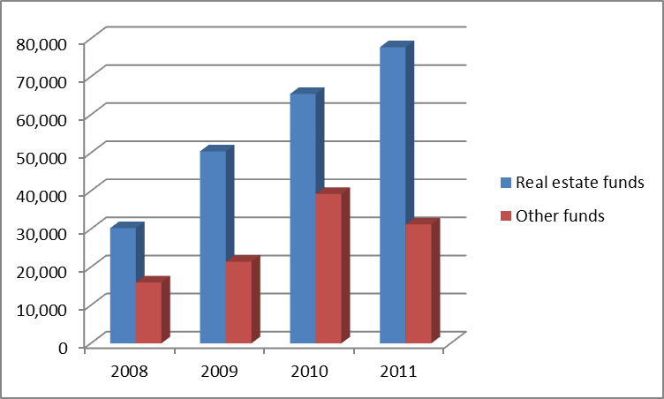
(Source: Statistics of De Nederlandsche Bank)

5.6. Italy - Real estate funds
The real estate investment funds allow one making real estate investments without buying the property directly. These funds are set up and managed by management companies (SGR) authorized by the Bank of Italy, after consulting the national regulator Consob. Their characteristics and operation regime, such as commissions or the minimum investment thresholds, are set out in the Management Regulations, which was also approved by the Bank of Italy.
The portfolio of funds, separate from that of the SGR, is funded through the placement of shares with investors. The latter receive income through the distribution of dividends or as a result of redemption of units at the end of lifetime of the fund, which can be up to 30 years.
In June 2009, net asset value (NAV) of the Italian real estate funds amounted to 24.6 billion euro, accounting for 10.4 % of the total assets of mutual investment funds (securities and real estate) under Italian law. By size of net assets under management, Italy is the fourth largest market in Europe, after Germany, the Netherlands and Great Britain. In the past years growth of the NAV of the funds Italians was very rapid (about € 20 billion in December 2003 to June), reflecting mainly the entry of new funds.

5.7. France
France is one the largest domicile for private equity funds in Europe. There is a developed activity from the investor side but as well from the investee side. The precise size of the market can be approximated by the amount provided in a study realized for the account of the Association Française des Investisseurs pour la Croissance (APIC): 147 asset managers responded which corresponds to 887 investment funds for a volume of €54.2 billion at the end of 2011.
Here below is a table representing the annual inflows in the private equity sector in France as well as the number of companies benefiting from investments. As shown, the amounts invested every year vary significantly.
 | 2007 | 2008 | 2009 | 2010 | 2011 | 1st Semester 2012
Investments (in € Mio) | 12,554 | 10,009 | 4,100 | 6,598 | 9,738 | 2,279
Invested companies | 1,558 | 1,595 | 1,469 | 1,685 | 1,694 | 834
Source: www.afic-data.com / Grant Thornton
The companies receiving financing from private equity funds are mostly of a small size: 97% of the investments concern operations of less than €15 million. The French funds invest mainly in French targets: 86% of the investments are realized domestically.
In terms of raised capital, the evolution is as follows:
 | 2007 | 2008 | 2009 | 2010 | 2011 | 1st Semester 2012
Investments (in € Mio) | 9,995 | 12,730 | 3,672 | 5,043 | 6,456 | 1,794
Source: www.afic-data.com / Grant Thornton
The structure that attracts the most of the raised capital is the FCPR (around 83%) followed by the FCPI and FIP.
Historically retail investors and family offices represent the biggest share of investor. While their investment diminished over the last years, they still represent the highest share (30%):
Investor's type | 2008 - S1 2012, in € Mio
Private investors / Family offices | 7,505
Banks | 5,223
Insurances | 4,199
Funds of funds | 4,020
Public sector | 3,331
Corporate investors | 637
Source: www.afic-data.com / Grant Thornton. The proportion of private investors in the first category is 74% for the data concerning the first semester of 2012.
Private investors invest in all 3 available structures: FCPR; FCPI and FIP. When investing in FCPI and FIP private investors may benefit from tax deductions (from income tax and wealth tax) which may explain the high number of subscribers (91’000 investors in 2011) in these funds and the low average subscribed amount (€8’100). In total the FCPI and FIP collected €835 in 2011, about 13% of the total amount raised this year.

6. Annex: Feedback Statement from The Public Consultation
A Consultation Document was published by the European Commission on 26th July 2012 seeking the views of stakeholders on reforming the Undertakings for Collective Investment in Transferable Securities (UCITS) Directive in relation to Product Rules, Liquidity Management, Depositary, Money Market Funds, Long-term Investments consultation on UCITS. A total of 65 respondents replied to section of the consultation on long-term investments. The majority (43%) of the replies were provided by the respondents representing the asset management industry. This Annex analyses the responses and the possible options put forward by the respondents to the Consultation Document.
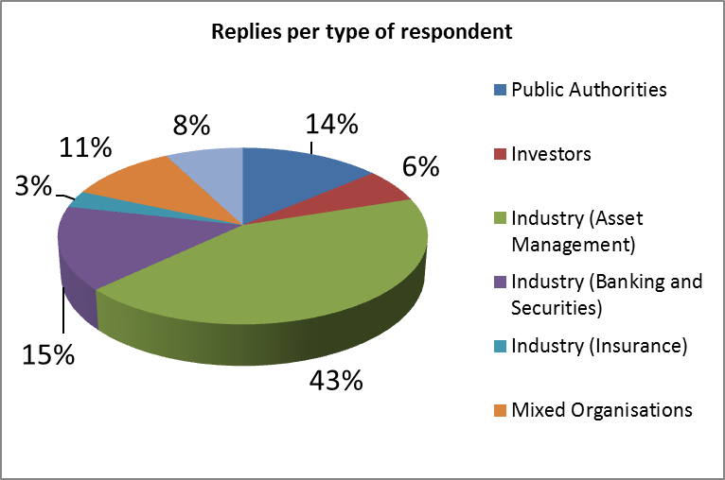

DETAILED ANALYSIS OF THE RESPONSES

1. What options do retail investors currently have when wishing to invest in long-term assets? Do retail investors have an appetite for long-term investments? Do fund managers have an appetite for developing funds that enable retail investors to make long-term investments?

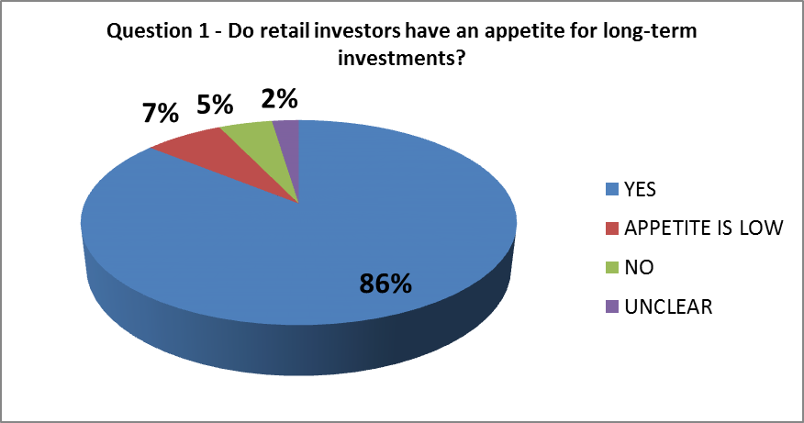
86% of respondents to this consultation question expressed positive views about the appetite of retail investors for long-term investment opportunities. Only 5% of the respondents to this question expressed negative views, while 7% were of the opinion that appetite is currently low.
Most respondents to this consultation question agreed that the options available to retail investors to invest in long-term assets were limited. Long-term investment opportunities were in most cases limited to participations in non-fund products (pension plans, life insurance plans or other retail structured products) or fund products outside the UCITS framework.
Respondents from some of the large EU Member States such as Germany and the United Kingdom explained that retail investors have a number of investment opportunities available for them to invest in long-term assets. Retail investors may mostly get access to long-term investment via listed closed-ended funds or for certain assets classes such as real estate – via nationally regulated open-ended funds that are available to them. Some respondents mentioned indirect access to the financing of long-term infrastructure projects through funds, such as UCITS, investing a minor portion of their assets in debt or other instruments issued by national and supranational governments and institutions. Others mentioned direct investments into listed and unlisted companies and investments into real estate.
Respondents from the UK stated that retail investors in the UK had a broad range of investment opportunities to invest directly or indirectly in long-term assets. These include, structured products, holdings of equities of companies involved in infrastructure or property (directly or through funds), corporate bonds or social sector organisations, real estate investment trusts, shares of unlisted companies which hold renewable assets or shares in industrial and provident societies. These respondents referred to nationally-regulated open-ended funds and listed closed-ended investment companies that give retail investors access to real estate, commodities, precious metals and private equity, and access to fund of funds whose underlying are not UCITS. These types of vehicles are invested in generally, but not exclusively, by mass affluent and high net worth retail investors. According to these respondents, long-term investment products are popular among retail investors in the UK.
Respondents from Germany explained that investment opportunities in long-term investment funds are currently offered by open-ended real estate funds (OEREFs) which can be launched as retail vehicles eligible for public marketing. German OEREFs are very popular among German investors and comprise roughly EUR 83 billion of assets under management. According to one respondent, closed-ended funds present another option of investing in “real assets” available to German retail investors. These investment vehicles are currently lacking product regulation, but will be subjected to product-related rules in the course of AIFMD implementation in Germany.
A French asset manager confirmed the appetite of retail investors for long-term investments by reference to the popularity of open-ended real estate funds. This asset manager mentioned that the average length of investment in retail funds is often superior to 7 or 8 years.
Most of the respondents (86%) to the consultation document concluded that the appetite of retail investors for long term investments exits.
A respondent representing the views of retail investors mentioned that retail investors would certainly need an investment proposition that provides them with the potential for sustainable and long-term investment returns. This respondent pointed out that, although investors currently have some options available for making long-term investments, the existing options are very limited and their benefits for investors are increasingly unclear. This respondent also complained that the investment sector lacked innovation and was driven by supply rather than demand. Respondent representative of the asset management industry confirmed the appetite of retail investors for long-term investments. On the other hand, a respondent representing the interests of institutional investors explained that retail investors are not willing to invest in long-term investments except for real-estate. This respondent, however, pointed out that long term investments would remain a core business of institutional investors.
Some respondents from the industry explained that there was a greater appetite for long-term investments coming from institutional investors. These respondents predicted that institutional investors' appetite is expected to grow at a faster pace than that of retail investors. A respondent representing the interests of the asset management industry observed that, during the current turbulent market conditions, wealthier or sophisticated retail investors were seeking to diversify their portfolio by investing in new asset classes, such as real-estate and commodities, as these were less correlated to the financial markets. This refuge by retail investors into less liquid and longer-term assets was also confirmed by asset managers.

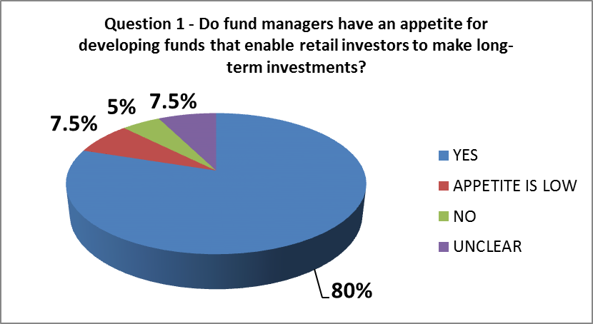

80% of respondents to this consultation question expressed positive views about the appetite of asset managers for offering or developing long-term investment opportunities. Only 7.5% of the respondents to this question expressed negative views, while 5% were of the opinion that appetite is currently low.
Most respondents, including the asset managers themselves, agreed that fund managers are willing to develop long-term investment funds for retail investors. A respondent representing the interests of retail investors explained that following the financial crisis the appetite of asset managers to offer long-term investment funds is not yet clear. This respondent argued that, typically, asset managers only design products if it benefits them to do so.
Some replies received from supervisory authorities stated that there was currently no demand by retail investors for long-term investments or that demand was very low due to a greater preference for liquidity. These public authorities explained that asset managers were not very keen to offer long-term investments in illiquid assets to retail investors. Another supervisory authority believed retail investors do have an appetite for long-term investments and argued that it could be reasonably assumed that asset managers would seek opportunities to develop products in this area.

2. Do you see a need to create a common framework dedicated to long-term investments for retail investors? Would targeted modifications of UCITS rules or a stand-alone initiative be more appropriate?

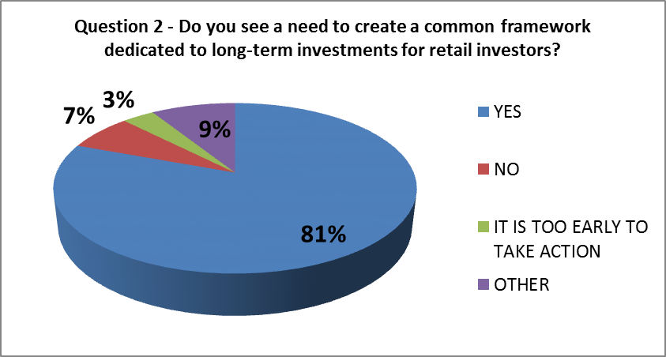

81% of respondents to this consultation question expressed favourable views about the need to create a common framework dedicated to long-term investments for retail investors. Only 7% of the respondents to this question expressed negative views, while 9% gave mixed views.
Most respondents agreed that there was a need to create a common framework for long-term investments for retail investors. However, some of the replies indicated that it was too early to take action in this respect and that it was better to wait for further developments in national rules resulting from the implementation of the AIFMD or to consider long-term investment as a part of UCITS regime.
A respondent representative of the interests of retail investors argued that they saw real merit in developing a regime that provided alternative sources to bank lending for small and medium size companies. This respondent pointed out that a modified UCITS regime should enable retail investors and their advisers to fully understand the risk / reward trade-off. A respondent representative of the asset management industry confirmed the need to create a common European framework dedicated to investment funds investing in less liquid assets with the inclusion of a European passport. An asset manager argued that developing a framework for long-term investments would provide new solutions for financing the economy and would serve to benefit Member States, enterprises and investors in these challenging times.
Only few of the respondents were of the opinion that there was no need for a common framework specifically designed for retail investors as the appetite of retail investors for such funds was low.
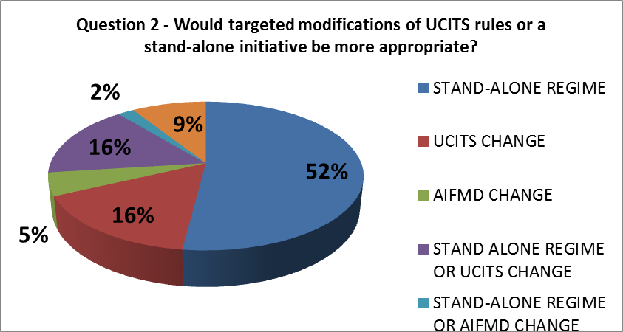

52% of the respondents to this consultation question expressed preference for a stand-alone regime, that is, a regime dedicated to long-term investment funds that is independent of UCITS Directive and the AIFMD. On the other hand, 16% of the respondents to this consultation question were of the opinion that a long-term investment fund regime should be incorporated into the existing UCITS framework, while another 16% of the respondents did not express a clear preference between a stand-alone regime and targeted modifications to the UCITS rules. Only very few respondents were of the opinion that a regime dedicated to long-term investments should be placed within the AIFMD.
The majority of the respondents favoured a stand-alone regime based on the UCITS framework so as not to create confusion and to harm the well-established UCITS brand. The views expressed by some asset managers showed preference towards the creation of a distinct chapter for long-term investments within the UCITS Directive and cautioned against the creation of an overload of European regulation Other respondents agreed with both of the options, that is, the creation of a distinct chapter within the UCITS Directive and a stand-alone regime. Few of the respondents also suggested developing retail alternative investment funds (AIFs), that is, a fund regime within the AIFMD instead of modifying the UCITS regime.
A respondent representing the interests of the asset management industry explained that long-term investments by retail investors have no place within the AIFMD framework because the AIFMD was designed for a professional investor base. This respondent also emphasised the inadequacy of the AIFMD as it does not take into account product regulation and does not provide a European passport for retail investors. Asset managers also confirmed the inadequacy of the AIFMD covering long-term investments for retail investors and expressed preference for a new type of UCITS-like fund regime.

3. Do you agree with the above list of possible eligible assets? What other type of asset should be included? Please provide definitions and characteristics for each type of asset.
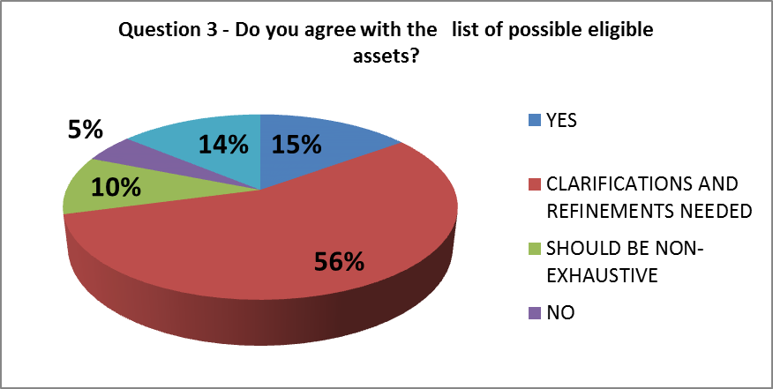
52% of respondents to this consultation question expressed the need for further clarification about the list of potential eligible assets mentioned in the consultation question. Most requests for clarifications were primarily related to the inclusion or exclusion of particular assets from the broad types of assets mentioned in the consultation paper. A respondent representative of the asset management industry expressed preference for broad categories of eligible assets that would subsequently be further defined through technical standards to be developed by ESMA.
Most respondents agreed in principle with the list of possible eligible assets mentioned in the consultation document, but were of the opinion that such list should not be exhaustive and open to additional asset classes in accordance with future market developments. The majority of the respondents highlighted the need for flexibility in the determination of the eligible assets. Some of the asset classes or instruments mentioned by respondents included: bonds and shares (listed and unlisted), loans, direct commodity investments, direct and indirect real estate, utilities and telecommunications, energy networks and storage, energy generation plants, etc. A number of respondents explained that investment in liquid assets should also be permitted as these are important for the purposes of proper liquidity management.

4. Should a secondary market for the assets be ensured? Should minimum liquidity constraints be introduced? Please give details.
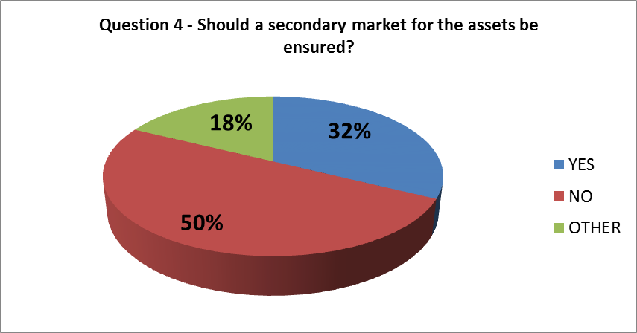

The views of the respondents to this consultation question were split as 50% of the respondents to this question were of the opinion that a secondary market for assets need not be ensured while the remaining were in favour (32%) or offered mixed views (18%).
Some respondents viewed secondary markets as an advantageous additional solution, provided it were feasible to ensure. However, according to these respondents, the secondary market should not be compulsory for all eligible assets as they were of the opinion that it is usually difficult to ensure.
Respondents to this question distinguished between ensuring a secondary market for the assets in the fund from ensuring a secondary market for the shares or units in the fund held by investors. Respondents that interpreted the consultation question as referring to a secondary market for the shares or units held by retail investors in the fund argued in favour of ensuring a secondary market for retail investors. These respondents believed that since the personal or financial situation of such investors may change over time, it was important to ensure an early redemption facility would be available.
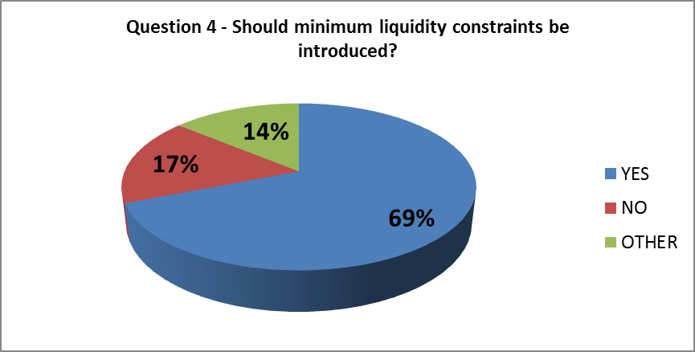
69% of respondents to this consultation question were in favour of introducing minimum liquidity constraints, while 17% were of the opinion that such constraints need not be introduced.
Although the majority of the respondents to this consultation question were of the opinion that minimum liquidity constraints should be introduced, various options were voiced by the respondents. Some suggested that liquidity constraints could be similar to those under the UCITS regime, such as by granting a right to investors to request redemptions on demand, but adapted to the long-term character of the investments. In other words, these respondents were in favour of offering less frequent redemption opportunities to investors. Some respondents proposed building an extraordinary early redemption facility for retail investors in some form. According to these respondents, this option would work by creating semi-open fund structures that enabled investors to redeem their units at regular, but longer, intervals. A respondent representative of retail investors argued that liquidity provided by a secondary market in some form is an essential feature for an efficient and safe market for retail investors.

5. What proportion of a fund's portfolio do you think should be dedicated to such assets? What would be the possible impacts?

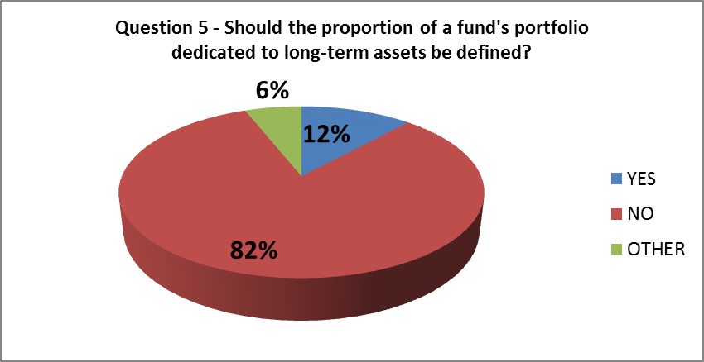
82% of respondents to this consultation question expressed their views against having a predetermined proportion of an investment portfolio dedicated to long-term assets.
The majority of the respondents favoured flexibility and indicated that the exact proportion of a fund's portfolio should largely depend on the investment strategy and liquidity profile of the fund, and should be disclosed in its subscription documents.
A number of respondents were of the opinion that it should be possible for closed-ended funds to be invested entirely in illiquid assets. Semi-open ended funds, on the other hand, would require a certain proportion of liquid assets. Others suggested that a maximum threshold of 80% of the fund's assets be reserved to long-term assets.
A respondent representative of retail investors argued that the optimal investment allocation could vary depending on the risk and reward characteristics of the type of asset in question. This respondent also explained that the ability of investors and their advisers to understand such risk and reward profile was equally important. A respondent representing the views of the asset management industry was also of the opinion that it was not possible to provide a clear-cut answer in such cases and that the composition of the portfolio varied depending on the investment objective of the fund and the level of liquidity promised to retail investors.

6. What kind of diversification rules might be needed to avoid excessive concentration risks and ensure adequate liquidity? Please give indicative figures with possible impacts.

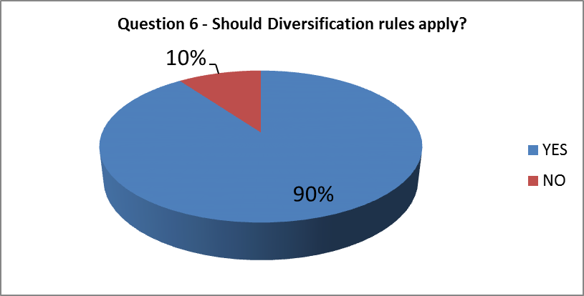
90% of respondents to this consultation question expressed strong views in favour of diversification requirements for the avoidance of excessive concentration risk and ensuring adequate liquidity requirements.
Although asset managers expressed views in favour of risk diversification, a respondent representative of institutional investors argued against mandatory concentration limits. According to this respondent, asset managers should enjoy the freedom to make investment allocations as they deemed appropriate, provided this was in line with the long-term objective of the fund and was clearly disclosed to investors prior to them investing in the fund.
More than half of the respondents (47%) noted that diversification is an essential feature of an investment fund. Although most respondents considered diversification to be an important feature of an investment fund, several respondents were also of the opinion that the level of diversification was dependent upon the typology of the fund. Diversification requirements were considered more pertinent for open-ended funds, whilst this was of less importance for closed-ended funds according to the views expressed by the respondents.
A number of respondents also argued that, given the nature of longer-term investments, there should be the possibility for single-asset investments, such as in the case of specific infrastructure or energy projects that require significant financing needs. At the same time it was suggested that in such cases, additional safeguards should be applied for investor protection at the distribution level, especially if funds are intended for the retail market. A number of respondents (16%) mentioned UCITS standards may serve as a good basis for determining which principles should govern risk spreading in the fund. Other stakeholders were of the opinion that applying UCITS standards in this space would not serve the right purpose as the concentration of risks in an LTI fund maybe different to those of UCITS funds.

7. Should the use of leverage or financial derivative instruments be banned? If not, what specific constraints on their use might be considered?

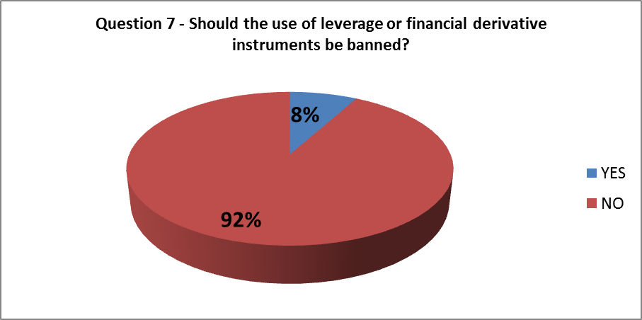
92% of the respondents to this consultation question were of the opinion that leverage or derivative instruments should not be banned.
The majority of the respondents (68%) to this consultation question were of the opinion that derivative instruments were an important risk mitigation technique and that the mitigation of such risks via derivatives may be even more important for funds structured as having a long-term time horizon as opposed to other types of funds. Currency, inflation and interest rate risks were mentioned as requiring hedging in the best interest of investors. Some replies pointed out that the use of derivatives is already permitted by the current UCITS rules and a new regime for long-term investments should not attempt to be stricter than the UCITS framework. 22% of the respondents suggested that derivative instruments should be allowed as part of efficient portfolio management and could possibly follow the principles applicable to the risk spreading of UCITS.
Respondents representing the interests of institutional and retail investors were against the use of derivatives for speculative or investment purposes and argued that these should be banned from the list of eligible assets. One think-thank was also very critical of the use of derivatives, however, showed some leniency toward leverage.
More than half of the respondents (51%) were of the opinion that borrowing should be permitted but subject to certain constrains. Leverage through borrowing is considered beneficial and in certain cases, essential, for long-term asset classes such as infrastructure. Given that infrastructure projects require a high degree of funding needs, respondents argues that leverage may be an indispensable instrument for the completion of infrastructure projects. One respondent argued in favour of limiting borrowing to a proportion of the fund’s assets.
A number of respondents suggested that long-term investment funds should be allowed to borrow on a permanent basis as opposed to borrowing of a temporary nature as currently permitted under the UCITS framework.
Several respondents also agreed that retail investor protection demanded that the use of leverage or financial derivative instruments, although permitted, be subject to certain limitations.

8. Should a minimum lock-up period or other restrictions on exits be allowed? How might such measures be practically implemented?

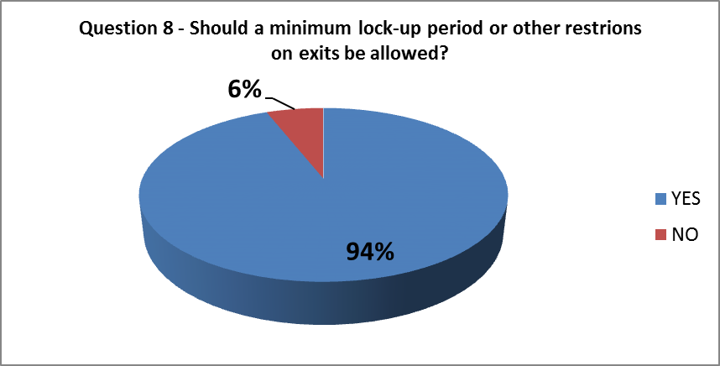
94% of the respondents to this consultation question were of the opinion that minimum lock-up periods or other restrictions on exits by investors in the fund should be permitted.
The responses received from the industry and public authorities were largely in agreement on the need to permit minimum lock-up periods or other restrictions. Of a different opinion was a respondent representative of retail investors that expressed preference for incentives to retail investors to hold on to their investments as in their opinion any restrictions on capital withdrawal would reduce the attractiveness and the trust of retail investors in a new investment proposition. A respondent representative of institutional investors expressed preference for permitting temporary lock-ups in the event of an emergency and to be exercised under the control of local competent authorities.
Considerations on the illiquid nature of long-term investment funds and the protection of the interests of all shareholders in the fund, led the vast majority of the respondents to favour the inclusion of mandatory minimum lock-up periods or other similar restrictions. Several respondents were of the opinion that redemptions in the investment fund should be limited and that a balance should be struck between the interests of the investors and those of the fund manager.
Although a clear majority of the respondents favoured minimum lock-up periods and other restrictions, the options put forward by the respondents varied broadly. Concern was expressed about the protection of the remaining investors in the fund in order to ensure that these are not disadvantaged by the provision of liquidity to the redeeming investors. Respondents explained that maintaining a degree of liquidity in the fund to meet redemption requests involved diversification of investments in the fund. In this regard, respondents also cautioned that such diversification would require investment in liquid assets and that this may defeat the scope of the investment of objective of an LTI fund, that is, investment in long-term illiquid assets.
As to the minimum investment period, the views expressed by the respondents ranged from one month to a multi-year lock-up period, with options ranging from six months to one or two years also being mentioned. A public authority opined that retail investors should not be irrevocably and unreasonably bound to an investment in the fund for a long period of time. Respondents from both investors and the industry were of the opinion that, in the event of a regime open to retail investors, parameters should be defined which ensured retail investors would be able to redeem their interests in the fund in the event of unforeseeable circumstances. Others considered that no conditions should be imposed upon redemption requests made by retail investors for a prescribed and predetermined set of circumstances.
One respondent suggested that a formula or calculation should be devised that permitted investors to redeem proportionately to the duration or the amount of the commitment made to the fund. Another respondent argued that early withdrawal may be permitted except if the lock-up period is inferior or equal to the recommended holding period for that particular product. Decreasing tax rates for longer holding periods was a solution already implemented for certain saving products in some Member States, argued a respondent representative of the interests of retails investors.
Many emphasised that, regardless of the restrictions imposed upon investors in the fund, the focus should be on transparency and appropriate disclosures to investors.

9. To ensure high standards of investor protection, should parts of the UCITS framework be used, e.g. management company rules or depositary requirements? What other parts of the UCITS framework are deemed necessary?

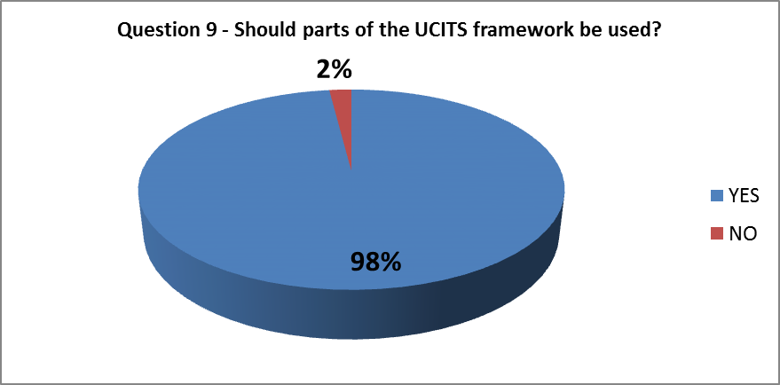
98% of the respondents to this consultation question expressed their preference towards using the UCITS framework as a model for ensuring a high standard of investor protection.
The views expressed on the robustness of the UCITS framework for achieving a high standard of investor protection by public authorities, investors and the industry were largely in alignment.
Nearly half of respondents to this consultation question (49%) were of the opinion that disclosure requirements under the UCITS framework are key to ensuring a high standard of investor protection. Clear preferences were also expressed in favour of incorporating the organisational rules (46%), the rules on risk management (40%), depositary rules (35%), and reporting requirements (32%). 38% of respondents were of the opinion that the rules applicable to management companies under the UCITS framework should be borrowed by the regime dedicated to long-term investments.
The vast majority of respondents to this consultation question favoured an investor protection framework similar to that offered by the UCITS Directive but that it should take into account the features of long-term investments.
Nearly half of respondents (49%) to this consultation question mentioned that the eligibility of assets requirements under the UCITS Directive would not allow them to invest in the assets contemplated by this initiative. It was therefore suggested that the UCITS eligibility requirements not be reproduced in an eventual proposal or be broadened to include the possibility of direct investments in illiquid assets or the inclusion of other asset classes, such as loans.
The parts of the UCITS framework that respondents believed should be used as a model for an LTI regime included the organisational requirements, the rules on risk management, reporting requirements, the provisions on the management company passport and the fund or product passport.

10. Regarding social investments only, would you support the possibility for UCITS funds to invest in units of EuSEF? If so, under what conditions and limits?

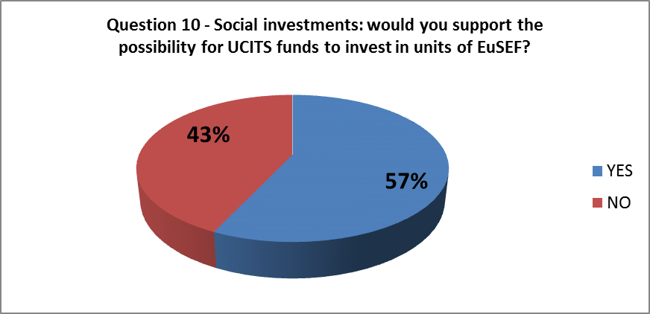
43% of the respondents were not in favour of broadening the UCITS eligible asset classes to include direct investments in EuSEFs.
Although a majority of the respondents to this consultation question were in favour of permitting investments in EuSEFs, they were primarily only in favour of permitting such investments under a new LTI regime. Although the views of asset managers were split on this issue, investors and public authorities were willing to permit retail access to EuSEFs via the UCITS brand. Few respondents believed UCITS should be permitted to invest in EuSEFs provided this was clearly disclosed to investors.
While one respondent representing the interests of institutional investors argued that investments in EuSEFs were already permitted under the UCITS framework, another respondent representing the interests of retail investors took a more cautious approach and expressed that, although there was merit in permitting access to this asset class by retail investors, the further development of the framework would need to be assessed. This respondent also argued that the priority for developing a regime that gave retail investors access to such asset classes should be to ensure there was clear labelling of funds and adequate disclosure to enable investors to identify the funds that are best suited to their needs.

7. Annex: Feedback Statement from The Informal Questionnaire
It emerged from the above-mentioned consultation that a strong majority of respondents favoured a stand-alone regime dedicated to the long-term investments separate from the UCITS. The Commission services took note of this and started exploring the options for a possible new legal framework which would permit investments in certain alternative assets. Seeking to gather views from a broader range of stakeholders on the features that would make LTIFs attractive for the investors and useful for the investment targets, on 15 of January 2013 the Commission services circulated an informal Questionnaire. This Annex sums up the responses to the Questionnaire and records the expressed preferences on a new fund regime for the long term investments.

General remarks and posed questions
The Questionnaire posed five groups of questions. The first four groups were aimed at establishing the profiles of respondents. It was asked to identify what type of entity the respondent was, what activities it was engaged in, in which field it was active et etc. Investors and fund managers were asked about their business practices, in particular about their investment targets, financial instruments they use for long-term investing and factors that they take into account when making investment decisions. Sections i) – iii) sum up those responses.
The fifth group of questions was addressed to all respondents enquiring about their preferences on a possible design of the LTIF framework. In some cases the Questionnaire posed multiple choice questions. Often respondents would mark all or some of the presented options or would omit answering a particular question altogether. Some of the expressed preferences were explained in detail and other remained unelaborated. Some respondents replied to the questions, which were not meant to be addressed to them and this was taken into account when summarising results of this consultation. One can conclude on the basis of the received replies that there are diverging views on most of the aspects of the envisaged fund regime. Consequently, the results of this consultation must be read in this context.

I. Respondent profiles
As in the previous consultation, the majority of the received 55 responses came from the asset management industry (53%) (Fig. 1). Institutional investors (16%), infrastructure providers (7%), mixed entities (11%) and retail investor representatives (4%) provided views based on their experience (Fig. 1).
Figure 1:
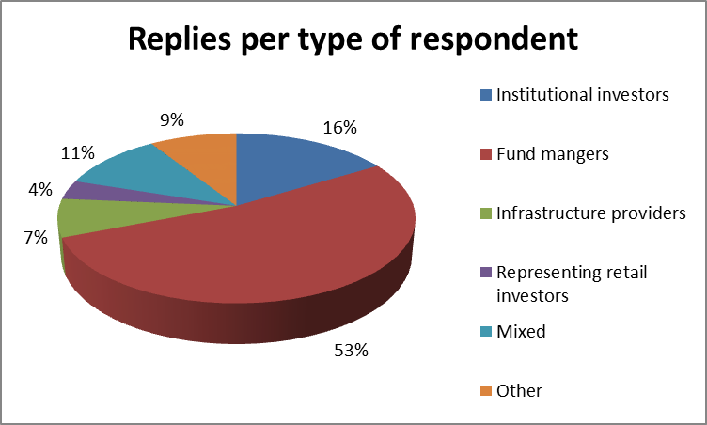
The breakdown of respondents by country demonstrates a wide geographic coverage (Fig. 2). Many participants of this consultation are based in France, UK, Belgium and a fewer of them are established in other Member States or in the third countries.
Figure 2:
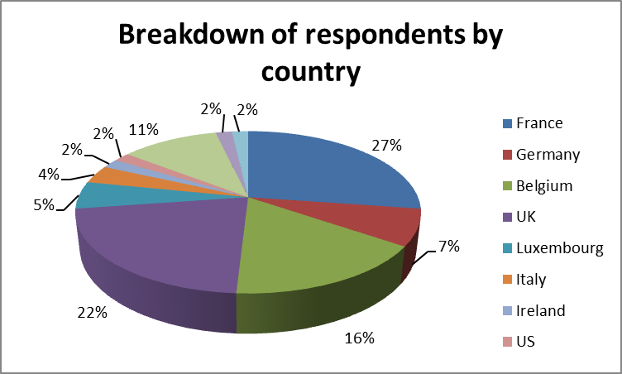
69% of respondents confirmed that they operate ‘cross-border’, 4% admitted working confined to the Member State of establishment and the remainder skipped this question.

i) Investors
The questions addressed to investors were answered not only by institutional investors but also by some fund managers or their associations. Thus instead of deriving inaccurate percentages, the results are presented by a number of responses.
27 respondents stated that they are making direct investments in infrastructure. 22 replied that they take an equity stake when participating in long-term projects, 18 provide debt financing and 16 prefer investing via funds (Fig. 3). Some respondents mentioned that guidelines of some institutional investors do not allow direct investments into projects and debt financing thus making them turn to investment funds when seeking exposure to illiquid assets. Combined public and private financing, loans, joint ventures and mezzanine instruments were listed as other forms of participation.
Figure 3:
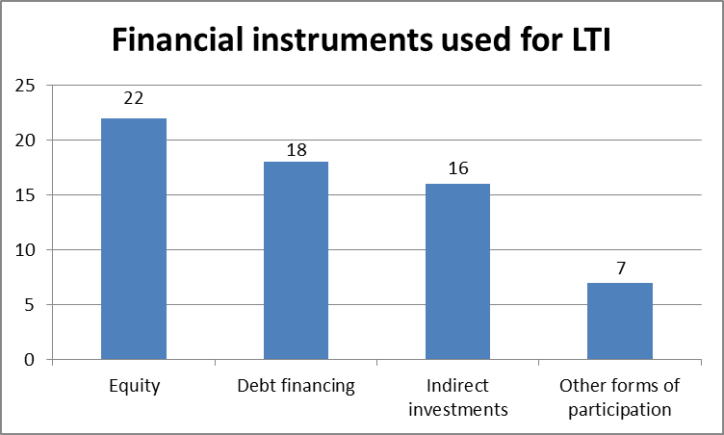
Many investors (19) target infrastructure and make specific reference to energy (11), transport (10) and social projects (10) as being of their particular interest (Fig. 4). Given that a number of real estate funds and their associations participated in this consultation, investments in housing (12) and other real estate, such as commercial property or land (8), were mentioned as separate groups of investment targets.
Figure 4:
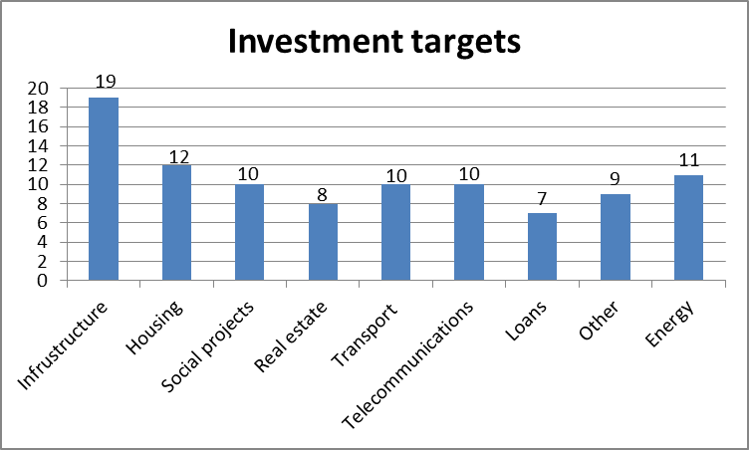
When making investment decisions the respondents said taking into account a lot of different factors, including regulatory safety, a return profile, various risks, such as volume, manager or political risk (Fig. 5). Although 15 replies mentioned that liquidity is an important element, it was often considered to be of a lesser relevance than the risk evaluation and the prospect of a return. Cash flow stability, financial robustness of the project, capital charge, valuation method, ESG and a number of other aspects were occasionally mentioned by individual participants as relevant for making allocations.
Figure 5:
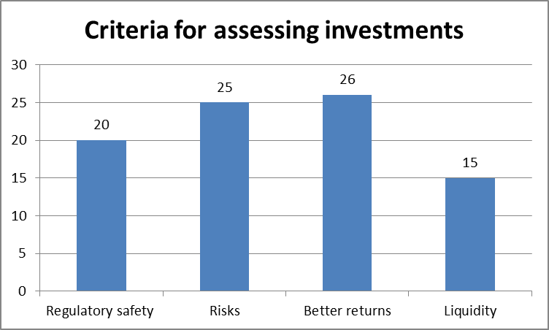
Responses were not unfavourable to investing through the funds. One (1) respondent considered costs as an obstacle for investing via funds, four (4) mentioned that it is difficult to find the right funds with the desired longer investment time horizon. Lack of transparency and poor reporting by the funds were identified as discouraging factors for investing indirectly.
ii) Investment managers and intermediaries
74% of respondents to this group of questions stated that they manage long-term investment funds with 6% saying that they do not. 15% of fund managers informed that they are managing only open-ended funds, 26% - only closed ended funds and 29% confirmed that they have both types of funds under their management. The remainder did not provide specific information in this respect.
38% mentioned that they are directly investing in real estate assets. 35% respondents targeting infrastructure investments took a stake in equity of, for example project companies, invested in debt 20% or loans 9% (Fig. 6).
Figure 6:
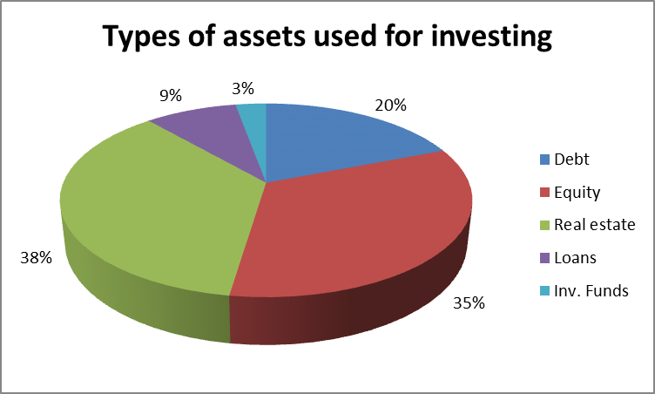
Majority of asset managers (68%) stated that their funds are serving only institutional investors, and 24% are managing funds accessible to the retail population, 9% of which are focusing on investments in real estate and others – on renewable energy projects, venture capital, social and other investments.
Ten (10) respondents stated that open-ended funds that they manage do operate redemption facility ranging from daily to annual frequency depending on the fund. 17 respondents noted that their closed-ended funds do not offer direct redemption opportunities before the maturity of the fund. Secondary transaction within the fund is often mentioned as an option for those willing to disinvest.

iii) Investment beneficiaries
Four infrastructure providers participated in this consultation sharing valuable views of the receiving end of the financing. Three (3) of them informed that they are active in realising energy and transport projects (energy performance contracting, electricity transmission, renewable energy, tunnels, roads, bridges, seafront, high speed trains, metro et etc.), one (1) is building social infrastructure (schools, hospitals, universities et etc.) and two (2) identified other activities which do not fall within the latter categories.
Three (3) respondents agreed that their projects last a rather long period of time and pointed to a 16-21 year period, which sometimes stretches to 30, as a normal time horizon for the financing of projects in their field of activity. One infrastructure provider, whilst agreeing with the majority that some projects may last up to 20 years, noted that ultimately this depends on the project, which may take, for example, 5 years to complete.
According to all four (4) respondents, investors take stake in their projects though equity participations. According to three (3) of them bank loans and market debt are also frequently used to finance their works. Two (2) respondents mentioned investment funds or public financing as other sources of funding.
When asked what the reasons for having failed to secure funding from investment funds could have been, two (2) participants mentioned unattractive risk/return profile and unstable regulatory system as the factors, which might have contributed to such impediment. One (1) opinion referred to new technology and long construction periods as potential deterrents. One (1) respondent observed that many banks have withdrawn from financing such projects and this prompts looking for other sources of funding.

II. Views on the possible LTIF framework
The above-described stakeholder pool was invited to express views on a possible calibration of the LTIF framework. Sections below summarise the communicated preferences.

1. What type of investors should be eligible to invest in the fund?
i) Institutional investors ii) High-net-worth investors iii) Retail investors
38% of respondents to the Questionnaire were in favour of allowing access to LTI funds to all investor groups, including retail investors, as opposed 51% who considered that such funds would be suitable only to institutional and high-net-worth investors, given illiquidity of the underlying and other risks arising from this type of assets (Table 1). Infrastructure providers’ choice was explained by the ease in dealing with professional investors.
It should be observed that a representative of retail investors (1) was in favour of opening up the market to this investor group. This aligns with the opinion of many fund managers who feel that retail population is increasingly seeking to deploy capital for longer-term and are not necessary willing to bear the costs of liquidity. This group is said to have not much choice in this respect.
A few drew attention to the distinction between investment targets noting that real estate and infrastructure projects may have different time horizons and thus would require different level of capital commitment. The retail demand, in their opinion, would depend on the underlying and on the liquidity profile of the fund.
Table 1:

2 .What type of assets should be permitted in the LTIFs?
i) Debt financing ii) Equity financing iii) Indirect investments iv) Other forms of participation
Respondents (53%) were most positive about equity participations as assets permitted in the LTIFs (Fig. 7). A good support was lent to debt financing as well as indirect investments in other funds (33% for both), although there were a few negative opinions expressed against permitting ‘funds of funds’ in the LTIF framework, one of them pointing out to the resulting several layers of managements fees.
21% considered that any assets should be considered as eligible assets and that no restriction was necessary to this effect. The fund manager should be left to decide this in accordance with the Fund’s prospectus and project needs. A few respondents mentioned mezzanine and mortgage loans (9%), unleveraged acquisition of assets, real assets, shares of unlisted companies and participation notes as items which should be allowed in the portfolio.
A few reservations were expressed regarding securitisation and long-term infrastructure financing in general as being not suitable for the funds accessible to individual investors.
Figure 7:
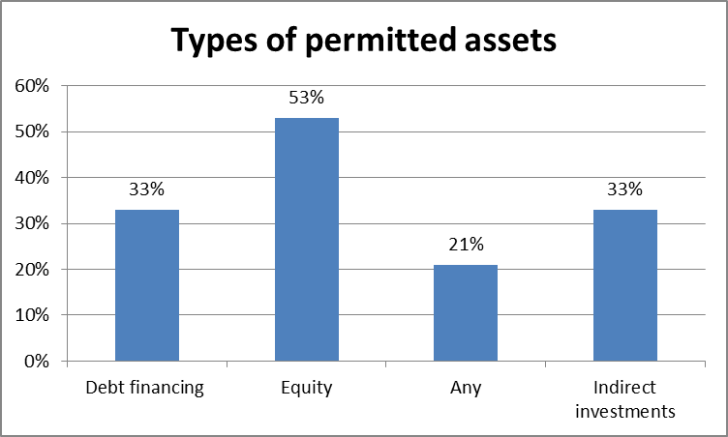

3. What types of investment targets should be permitted?
i) Infrastructure investments ii) Any investments with longer maturities iii) Other

Almost half of respondents agreed that LTIFs should be allowed to target infrastructure and/or any investments with longer-term maturities (Fig. 8). The point was made in some replies that the “infrastructure” concept has multiple facets and might include a wide range of greenfield and brownfield projects, infrastructure technology and possibly other specific segments such as environmental, energy, transport, telecommunications and social projects, which would make it difficult to define eligible assets for the regulatory purposes.
18% of answers supported inclusion of real estate in the LTIF’s portfolio owning to the experience of a number of respondents who are already active on this market. One (1) respondent noted that investments funding real economy should be the primary focus of the LTIFs.
Figure 8:
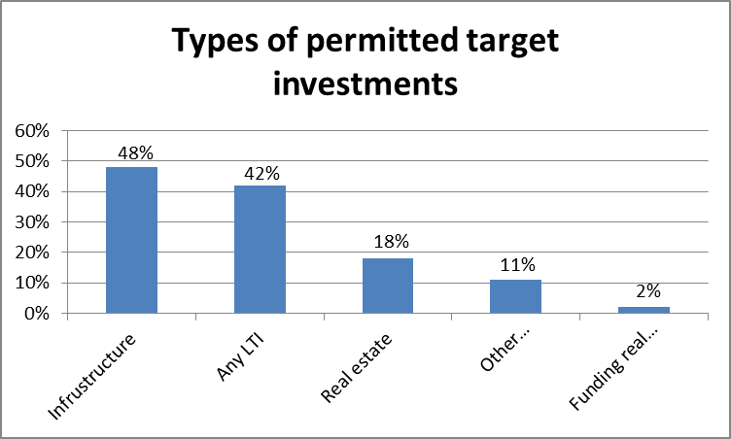

4. If longer-term investments were to be limited only to those with certain maturities, what threshold might be appropriate?
i) Only investments with a maturity +10 years ii) Only investments with a maturity + 20 years iii) Other possible maturity?

The views on this issue were again divided (Table 2). Half of respondents (50%) would agree with applying on LTIFs restricting maturities ranging from 5 to 20 years. Some argue that this is important in order to clearly distinguish LTIFs from other funds. Such a requirement could also send a clear message about the fund’s limited liquidity profile.
25%, including representatives of retail investors, however, would advocate against regulating this aspect reasoning that different projects have different maturities and acquiring an interest in a longer term asset does not mean that under certain conditions it cannot be sold. Attention was drawn to different holding expectations for infrastructure and real estate investments the latter’s falling within a 5-10 years span. In the opinion of some respondents, it would be enough to require that acquired assets have longer maturities and that they are not publicly listed or to allow longer lock-up periods. These could be the features pertaining to the LTIFs brand.
Table 2:

5. Should shorter-term investments be allowed in the LTIFs’ portfolio?
Views varied on the issue whether shorter term investments should be permitted in the LTIFs’ portfolio (Table 3). A few did not find it a relevant aspect; 22% expressly suggested different degrees of limitation (from 10% to 50%) in order to ensure that a bespoke LTIF predominantly contains assets with longer-term maturities. 17% (15% +2%) suggested that the exact proportion of the permitted shorter-term investments should depend on the precise composition of the fund, in particular whether it is a closed-ended or open-ended fund, and on its redemption policy. 13% was clearly against any imposed limitation in this respect.
Table 3:

6. Should diversification of investments be required?
A bit more than a half of respondents (51%) were of the opinion that diversification should be prescribed by the fund rules (Fig. 9). A few replies (9%) were negative in this respect some of them noting that single investments should be permitted due to the scale of funding required by certain projects. A large part of responses (40%) was not explicit on this question providing elusive reflections or skipped the question altogether.
Figure 9:
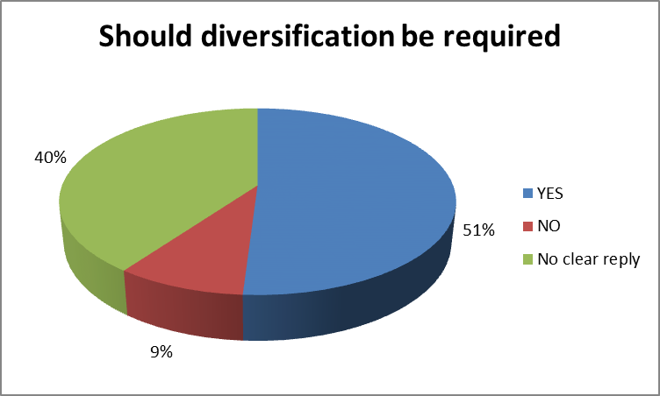
Table 4 below records expressed diversification preferences. 24% (11% + 13%) would approve of diversification ranging from 3 to 15 counterparties. Some respondents (9%) (5% + 4%) suggested specific concentration limits in the range from 15% to 25% of the portfolio.
13% considered that no regulatory requirement should be imposed in this respect. 4% stood clearly against diversification being required from the funds that are open only to institutional investors with 13% acknowledging that this is only relevant for the funds suitable for individual investors. 16% of respondents considered that ultimately the extent of diversification will depend on the bespoke fund and the underlying assets. It was suggested to calibrate this aspect in the light of the fact that the pool of available target investments is smaller than in the case of traditional assets. A sufficient ramp-up period was said to be necessary in certain cases if diversification was made mandatory. An idea was expressed that there should be no mix of debt and equity in the same fund in order to avoid conflict of interests.
Table 4:

7. Should investors have redemption rights?
i) Periods less than a year ii) Yearly iii) Some longer set period iv) No rights from the fund manager v) Other approaches (e.g. relying on or requiring secondary trading of units in the fund)

14% (9% + 5%) of respondents sided with the idea that a longer or shorter period of redemption facility falling within one year’s span should be provided by the fund managers with 7% viewing this as a feature pertaining only to open-ended funds. Respondents mentioning periods around one year had a particular concern for retail investor population. Some (9%) stated that different redemption periods for retail and professional investors could be justified. Other respondents considered that redemption policy should be decided in view of the underlying assets and it is difficult to prescribe one in abstract.
Questionnaire responses show differences over whether redemptions should be permitted., Only 38% of respondents explicitly supported yearly or longer redemption. By contrast, 48% of responses explicitly supported a closed-ended model. 35% pointed to secondary trading as a way of satisfying disinvestment calls. A number of replies (15%) mentioned liquidity buffer as a way of allowing redemptions, but it was criticized by other participants of this consultation (7%) as being liable to reduce actual exposure of the fund to the long term assets, diluting performance and resulting in liquidity costs that all investors would be forced to accept. A few mentioned gates or queuing, borrowing or extraordinary early redemption facility for retail investors as possible means of providing some liquidity.
Table 5:

8. Should transparency requirements (e.g. look-through) apply?
Many respondents (45%) considered transparency to be an important aspect of the fund framework (Fig. 10). Some identified different needs of different investor groups, but in principle there was an agreement that investors can only benefit from a proper reporting and disclosure. Negative opinion on this matter referred to the currently applicable disclosure rules being sufficient and hence there was no need for additional regulation in this respect. Half of respondents considered this question to be not sufficiently clear or omitted replying to it for other reasons.
Figure 10:
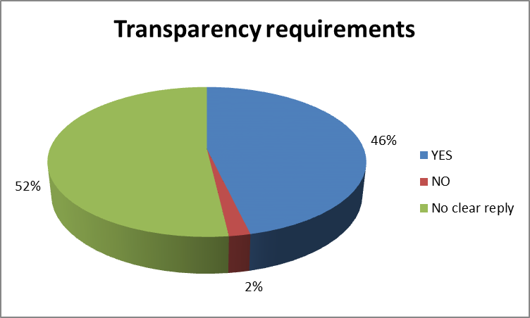

9. Which fund features should be regulated and which should be left to contractual arrangements?
A wide range of suggestions was received on various aspects that stakeholders would like to see harmonised by the LTIFs framework. A number of respondents (17%) considered that the LTIF’s product rules should sit within the AIMFD framework (Fig. 11). A few (9%) suggested benefiting from certain UCITS rules that would be appropriate if LTIFs were calibrated to suit retail investors. Transparency and disclosure requirements, defining eligible assets, risk management, diversification requirements, borrowing restrictions, redemption, liquidity and governance were mentioned by one (1) to three (3) respondents as the features, which should be defined by legislation, often considering protection of individual investors. It was also suggested to qualify LTIFs as complex products under MIFID. Most of the respondents generally advocated leaving sufficient freedom for contractual arrangement between managers and investors.
The largest number of respondents called for adapting prudential requirements (17%) and aligning tax regimes throughout the EU (15%) in order to make LTIFs interesting to invest in.
Figure 11:
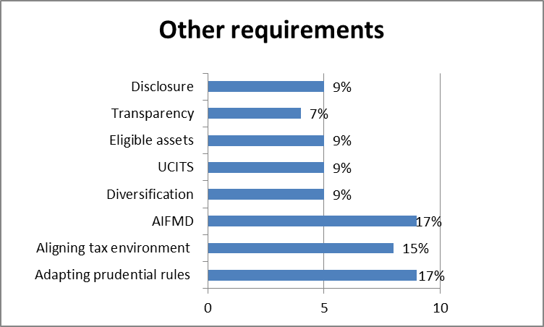

http://ec.europa.eu/internal_market/finances/financing-growth/long-term/index_en.htm. See also The Kay review of UK equity markets and long-term decision making, Final report, July 2012
Such funds have amassed around €6,350 billion in assets under management (AuM), which equates to about 72% of AuM in the EU. EFAMA Investment Fund Factsheet, December 2012
See Annex 3 for examples of mis-selling examples
http://ec.europa.eu/europe2020/europe-2020-in-a-nutshell/index_en.htm.
See http://ec.europa.eu/europe2020/making-it-happen/annual-growth-surveys/index_en.htm.
http://eur-lex.europa.eu/LexUriServ/LexUriServ.do?uri=COM:2011:0870:FIN:EN:PDF.
http://ec.europa.eu/cip/cosme/index_en.htm.
http://ec.europa.eu/cip/cosme/index_en.htm
See http://ec.europa.eu/economy_finance/financial_operations/investment/europe_2020/index_en.htm.
See for SMA I http://eur-lex.europa.eu/LexUriServ/LexUriServ.do?uri=COM:2011:0206:FIN:EN:PDF, e.g. Levers 1 and 8. For SMA II http://ec.europa.eu/internal_market/smact/docs/single-market-act2_en.pdf, p. 10.
http://ec.europa.eu/internal_market/finances/financing-growth/long-term/index_en.htm
See http://europa.eu/rapid/press-release_IP-12-853_en.htm?locale=en
See http://ec.europa.eu/internal_market/consultations/docs/2012/ucits/ucits_consultation_en.pdf
See http://europa.eu/rapid/press-release_IP-12-853_en.htm?locale=en
A detailed summary of the responses can be found in Annex 6.
Closed-ended funds that invest in long-term assets have generally high implementation costs due to the acquisition costs of the assets. This is balanced by the fact that annual running costs are low. See Annex 3.3 for further details comparing cost structures.
This is despite the rights accorded by AIFMD on fund managers to market cross-border the funds they establish under particular national fund rules: as set out below the fragmentation of fund rules along national lines will not be overcome by AIFMD.
Proposed mutual recognition to remove obstacles to cross-border investments by VC funds as proposed by the Commission and endorsed by the MS in 2008 has not resulted in any reduction of barriers. See: http://ec.europa.eu/enterprise/policies/finance/risk-capital/venture-capital/index_en.htm http://ec.europa.eu/enterprise/newsroom/cf/itemdetail.cfm?item_id=2033 http://www.consilium.europa.eu/ueDocs/cms_Data/docs/pressData/en/intm/100715.pdf
Please see Annex 2 for further details on each national market.
See Annex 4 for details on each asset class, concrete examples and precise figures.
FTfm 11 Feb, 2013, p. 12. Brookfield Investment Management estimates of listed infrastructure market. See Annex 3.
There are also strong differences between types of greenfield infrastructure. As one stakeholder put it, power stations are more risky than social infrastructure, such as schools or hospitals. See Annex 3 for more detail.
For example, real estate funds in Germany include categories such as residential real estate, commercial real estate, un-developed real property whereas in France the real estate funds define the eligible properties as the ones that are acquired for the purpose of leasing them.
On the other hand, units or shares in a closed-ended fund may benefit from a secondary market, meaning that investors may exchange the units of the fund between themselves. This form of trading does not, however, guarantee daily liquidity because when the fund performs badly or during stressed market situations, the secondary market has a tendency to freeze, forcing the investors to remain invested.
See Annex 3.2 for a concrete example
http://www.economist.com/news/briefing/21568365-europes-banks-are-shrinking-what-will-take-their-place-filling-bank-shaped-hole
SMEs are currently struggling to access bank financing. According to the latest ECB bank lending survey published in January 2013, the tightening of credit standards by euro area banks for loans to enterprises has been broadly stable in the fourth quarter 2012 and banks expect a similar degree of net tightening for first quarter of 2013 http://www.ecb.int/stats/money/surveys/lend/html/index.en.html.
http://www.economist.com/news/briefing/21568365-europes-banks-are-shrinking-what-will-take-their-place-filling-bank-shaped-hole
UK report: FTfm Nov 5, 2012, p. 22.
http://www.economist.com/news/briefing/21568365-europes-banks-are-shrinking-what-will-take-their-place-filling-bank-shaped-hole
http://www.gfmag.com/archives/146-january-2012/11566-special-report-infrastructure-finance.html#axzz2LXvBrN7n
Source: CISDM (2005), via CFA.
Source: NVCA and Thomson Venture Economics 4 Feb 2004, news release, via CFA.
« Performance nette des acteurs français du capital investissement à fin 2011 », Ernst & Young
Source: CISDM (2005), via CFA.
Source: “The role of infrastructure within a long term investment portfolio”, BlackRock
The 2013 Preqin Global Infrastructure Report, p. 23. [In the public domain, see, http://www.preqin.com/docs/samples/The_2013_Preqin_Global_Infrastructure_Report_Sample_Pages.pdf?rnd=1]
http://mediacommun.ca-cib.com/sitegenic/medias/DOC/15951/2012-01-26-agefi-detteinfra.pdf
“Preqin Special Report: European Private Equity”, March 2012
See section 7.5 below.
See REGULATION (EU) No 345/2013 OF THE EUROPEAN PARLIAMENT AND OF THE COUNCIL of 17 April 2013 on European venture capital funds.
Article 50(2)(a) of directive 2009/65/EC
For a precise analysis of each long term asset class, please refer to Annex 4. This annex analyses the rationale for including the assets in the scope of the eligible assets or not. This analysis is valid for all options of this report aimed at introducing a new set of eligible assets.
The European Federation of Financial Services Users : response to the questionnaire on LTI funds (Annex 7)
http://ec.europa.eu/internal_market/investment/docs/venture_capital/111207-impact-assessment_en.pdf.
See Annex 6.
See http://ec.europa.eu/internal_market/investment/docs/social_investment/20111207ia_en.pdf p. 78.
The attribution of loans necessitate in some Member States to have a banking license. This proposal for LTI fund will not cover this aspect of the regulation.
In 2012, net retail sales were £373 million; net institutional sales were negative (£183 million). IMA.
Please see Annex 5 for details.
Marguerite Adviser SA, investment adviser of the 2020 European Fund for Energy, Climate Change and Infrastructure (the Marguerite Fund): response to the questionnaire
This data predates AIFMD, which will have some impact on costs of operating cross border by creating consistent management rules. AIFMD does not however harmonise product rules. See http://ec.europa.eu/internal_market/investment/docs/legal_texts/ia_private-placement_en.pdf, p. 13.
See Annex 2
See Annex 3.2
See above p. 12.
Impact Assessment on Venture Capital Funds, p. 60.
EVCA Yearbook 2012 p. 63 for estimate of base market size.
http://ec.europa.eu/internal_market/investment/docs/venture_capital/111207-impact-assessment_en.pdf
“L&G offers social housing loans”, Financial Times, 01 July 2012
Exempt Investment Institution (VBI) for tax purposes. VBI should apply risk diversification Investments restricted to categories of securities listed in regulatory law.
Commanditaire vennootschap (CV).
Participation is limited to maximum of 25 natural persons, investment is limited to a maximum of €9,076,60 per investor and etc.
Naamloze vennootschap (NV) or Besloten vennootschap met beperkte aansprakelijkheid (BV).
A prospectus must be issued meeting a number of requirements.
VBI should apply risk diversification Investments restricted to categories of securities listed in regulatory law.
Fondo Comune d’investimento Mobiliare di Tipo Chiuso.
Undertaking of Collective Investment.
PriceWaterHouseCoopers, The retailisation of non-harmonised investment funds in the European Union ETD/2007/IM/G4/95); Prepared for European Commission DG Internal Market and Services; October 2008; p.40.
For further details see the UK FSA's consultation paper CP11/23 Solvency II and linked long term insurance business. November 2011. See pages 14 and 15.
« Trotz Pleiten sehr beliebt », Finanztest, 12/2012
See Deloitte, The fork in the road ahead An in-depth analysis of the current infrastructure funds market, 2011.
Inside the Infrastructure Fund Investor: a compendium of institutional investor attitudes to the unlisted infrastructure asset class, PEI [2012], p.91.
‘Regulatory re-pricing, asset obsolesce and bypass risk, emergence of new technologies and suboptimal refinancing resulting in yield lock-up’, Deloitte, The fork in the road ahead An in-depth analysis of the current infrastructure funds market, 2011. Inside the Infrastructure Fund Investor: a compendium of institutional investor attitudes to the unlisted infrastructure asset class, PEI [2012], p.91.
The 2013 Preqin Global Infrastructure Report, p. 23. [ http://www.preqin.com/docs/samples/The_2013_Preqin_Global_Infrastructure_Report_Sample_Pages.pdf?rnd=1]
http://cbr.edmond-de-rothschild.ch/presentation/publications/seminaires-annuels/seminaire-2012/structuring-debt-financing-for-infrastructure-projects.aspx.
Connecting Europe Facility: About EUR 500 billion in transport, EUR 200 billion in energy and EUR 270 billion for fast broadband infrastructures
http://mediacommun.ca-cib.com/sitegenic/medias/DOC/15951/2012-01-26-agefi-detteinfra.pdf.
The total need was estimated for the EU27, using 2011 GDP data at current prices, constant investment rate at 19.8% and assuming the GDP deflator of 1.6 and an average increase of real GDP of 1% until 2020.
http://www.oecd.org/sti/futures/infrastructureto2030/48634596.pdf.
COM own analysis (see Annex 2); European Public Real Estate association (EPRA), http://www.epra.com/main-news-tree/pr-template5/.
« Buyside takes off in aircraft financing », Financial News, 06.02.2012
« Aviation finance : Fasten your seatbelts », PwC, January 2013
2013 Preqin Global Private Equity Report
‘Regulatory re-pricing, asset obsolesce and bypass risk, emergence of new technologies and suboptimal refinancing resulting in yield lock-up’, Deloitte, The fork in the road ahead An in-depth analysis of the current infrastructure funds market, 2011.
“BCVA Private Equity and Venture Capital Report on Investment Activity 2011”, BVCA
http://www.centralbank.ie/regulation/industry-sectors/funds/non-ucits/Pages/Authorisation.aspx.
http://download.pwc.com/ie/pubs/2011_keeping_you_up_to_date_the_irish_qualifying_investor_fund_qif_flyer_14feb.pdfSee http://www.pwc.com/en_GX/gx/banking-capital-markets/publications/assets/pdf/next-chapter-creating-understanding-of-spvs.pdf.
http://www.irishfunds.ie/fs/doc/statistics/stats-factsheet-additional-dec-2012.pdf
http://www.professionalpensions.com/global-pensions/news/2024941/irish-qifs-totalled-eur153bn.
http://www.esma.europa.eu/system/files/ifia_response_to_esma_discussion_paper_re_aifmd_key_concepts___types_of_aifm_-_23_march_2012.pdf
http://www.centralbank.ie/polstats/stats/investfunds/Documents/The%20Investment%20Funds%20Industry%20in%20Ireland%20-%20A%20Statistical%20Overview.pdf
« BVK-Statistik, Der Jahr in Zahlen 2012 », BVK
« Performance nette des acteurs français du Capital Investissement à fin 2011 », Ernst & Young
The Consultation Document is available at: http://ec.europa.eu/internal_market/consultations/docs/2012/ucits/ucits_consultation_en.pdf
The Consultation Document is available at: http://ec.europa.eu/internal_market/consultations/docs/2012/ucits/ucits_consultation_en.pdf
Five (5) out of six (6) mixed entities identified themselves as fund managers and investors and one (1) - as an investor and an infrastructure provider.
In this IA ‘retail investor’ has the same meaning as ‘individual investor’.
Representatives of retail investors have not replied to the questions of this section.
29 respondents identified themselves as operators or managers of an investment fund or company or representing this side of the market and five (5) more mentioned asset management as being a part of the group’s business. Consequently, the results of this section are calculated in relation to the total of 34 replies.

