 | 
COUNCIL OF  THE EUROPEAN UNION |  |  | Brussels, 5 August 2013
 | Interinstitutional File:  2013/0072 (COD) |  | 12955/13
AVIATION 133
CONSOM 153
CODEC 1886
INST 451
PARLNAT 209

COVER NOTE
from: | Assembleia da República
date of receipt: | 15 May 2013
to: | General Secretariat of the Council of the European Union
Subject: | Proposal for a Regulation of the European Parliament and of the Council amending Regulation (EC) No 261/2004 establishing common rules on compensation and assistance to passengers in the event of denied boarding and of cancellation or long delay of flights and Regulation (EC) No 2027/97 on air carrier liability in respect of the carriage of passengers and their baggage by air  - Opinion on the application of the Principles of Subsidiarity and Proportionality  doc. 7615/13 AVIATION 47 CONSOM 47 CODEC 616  COM(2013) 130 final

Delegations will find annexed a copy of the above-mentioned letter.

________________________

ANNEX
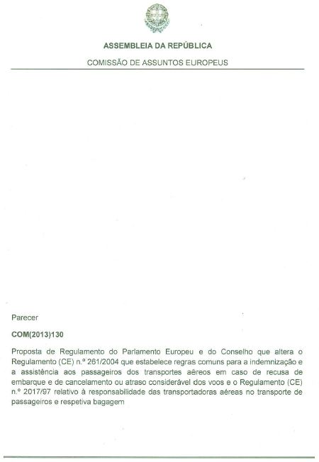
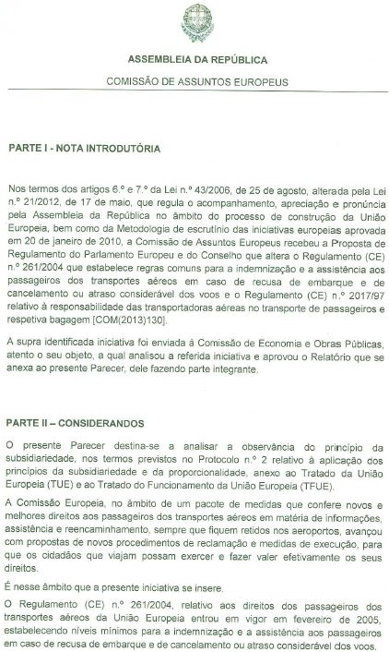
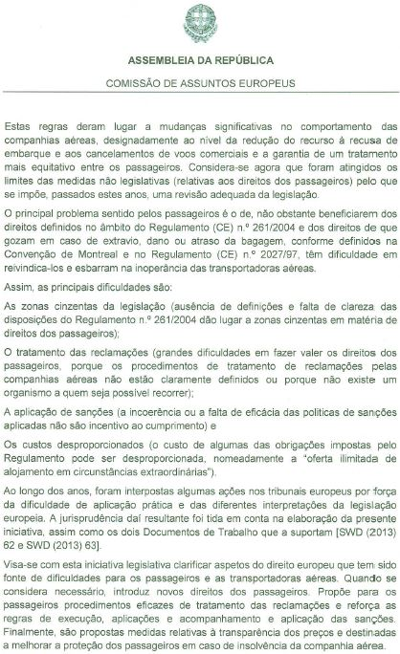
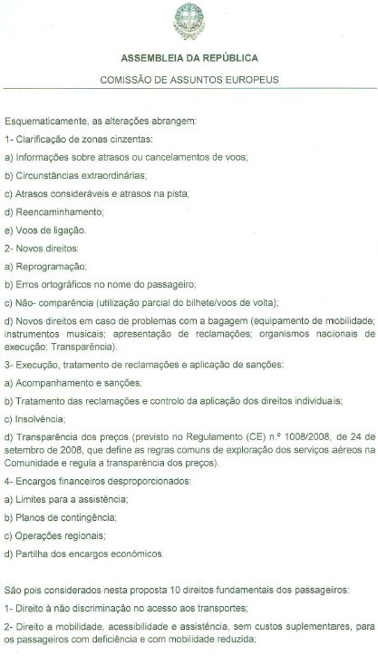
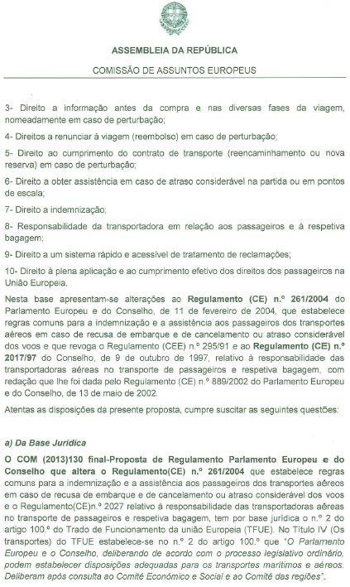
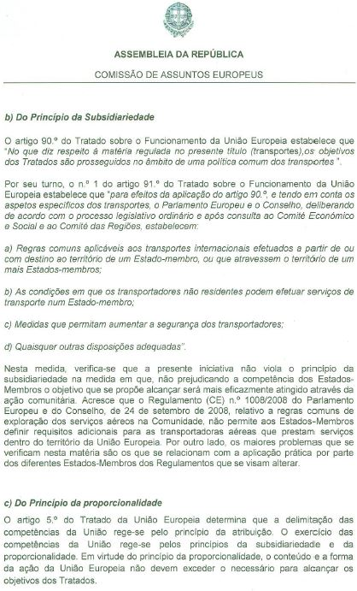
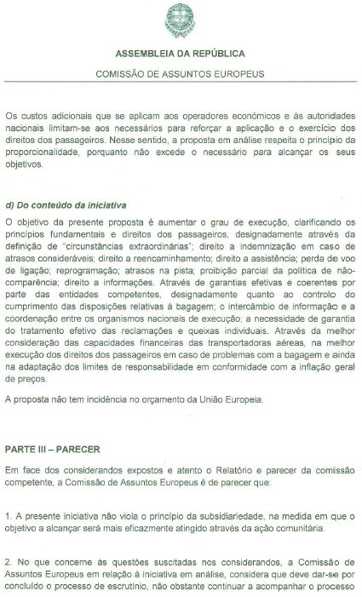
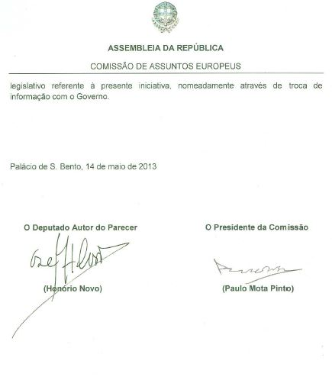
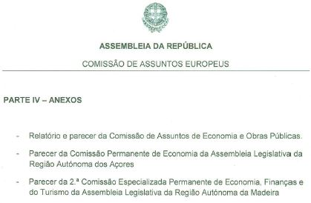
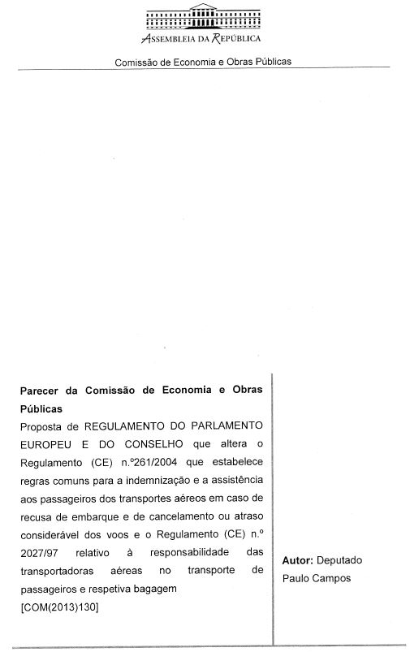
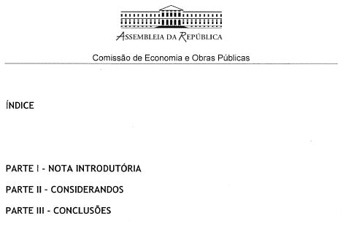
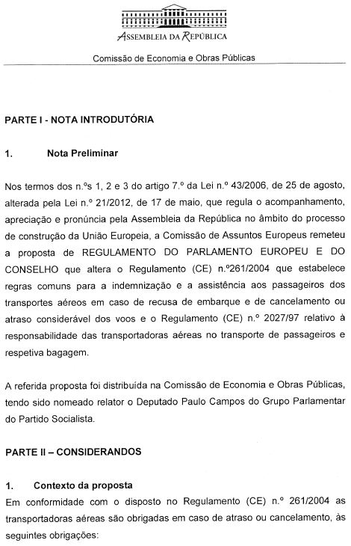
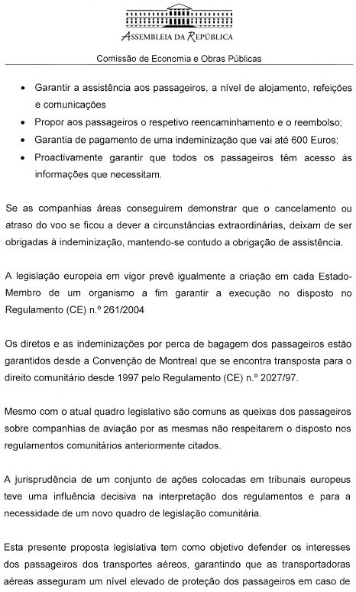
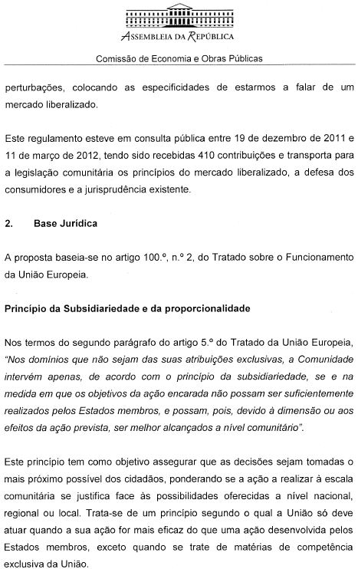
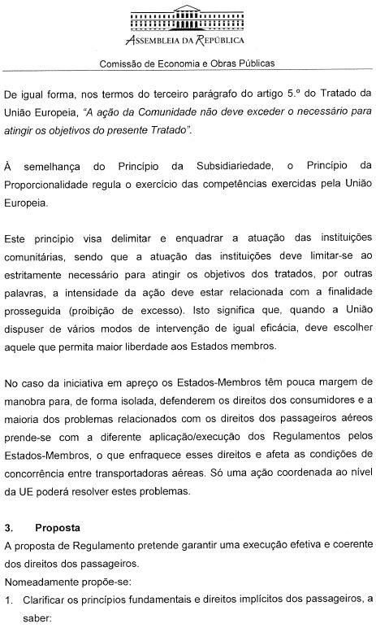
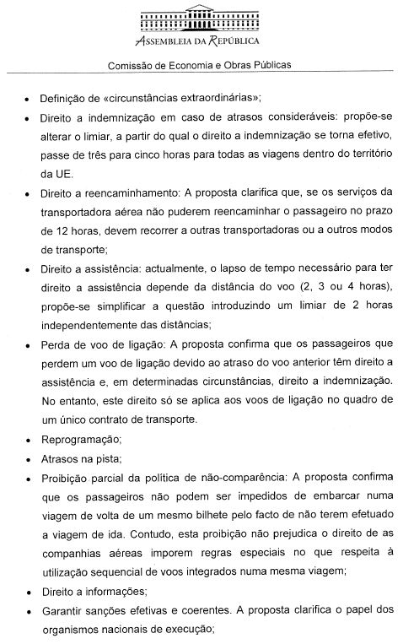
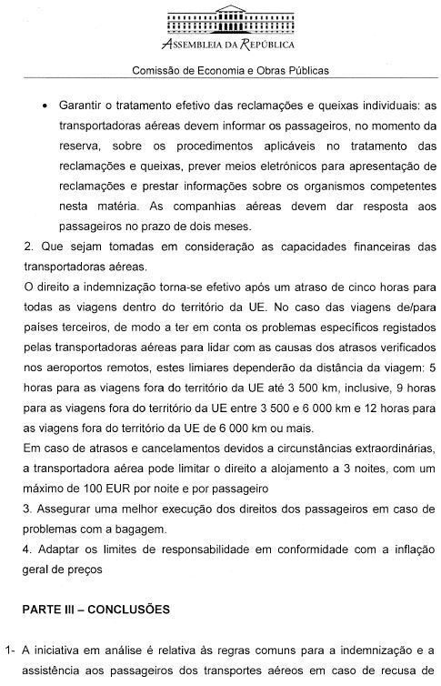
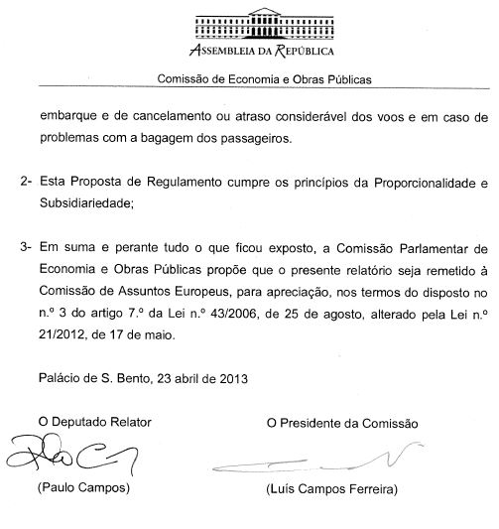
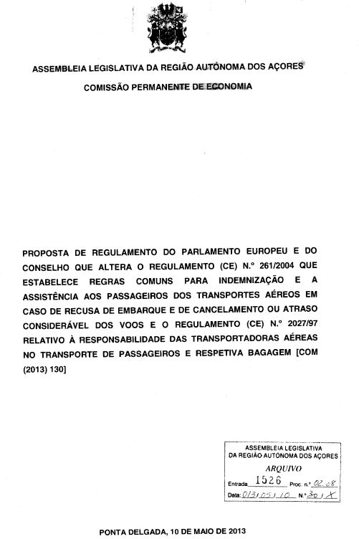
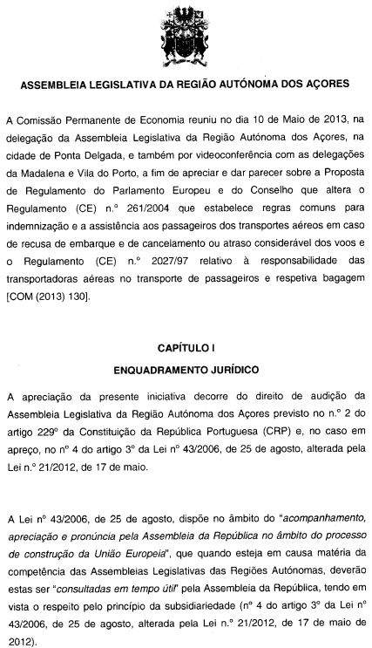
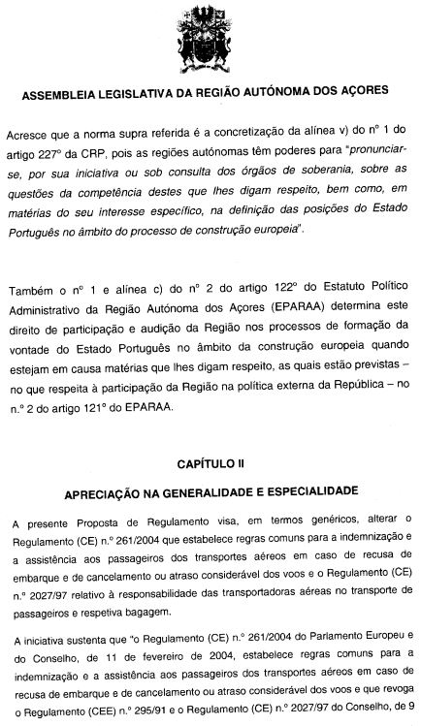
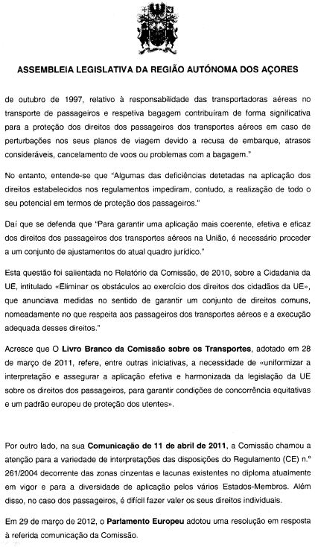
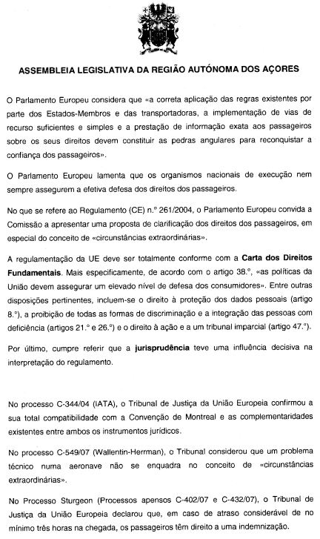
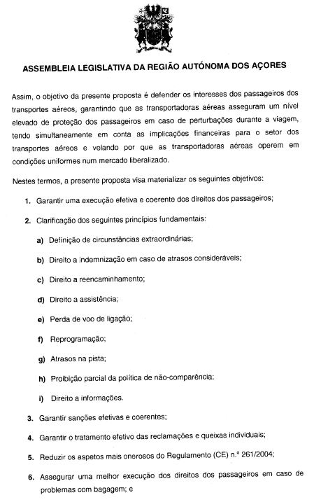
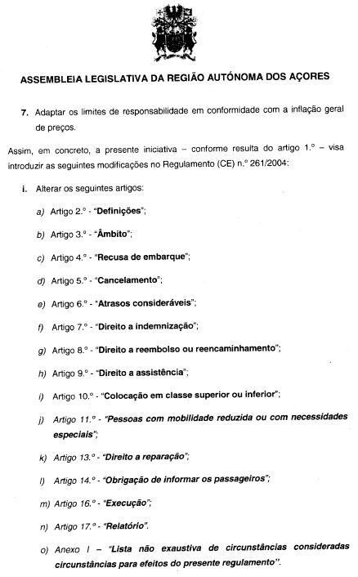
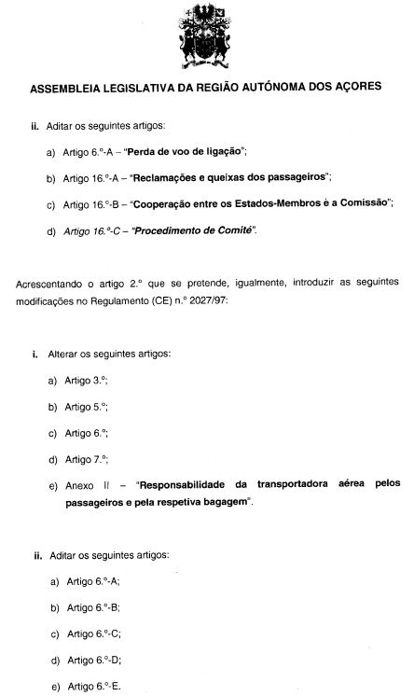
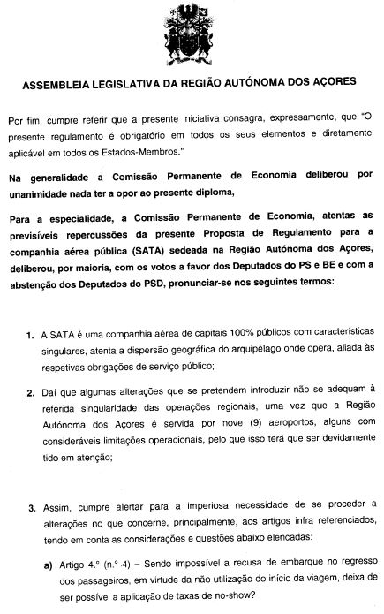
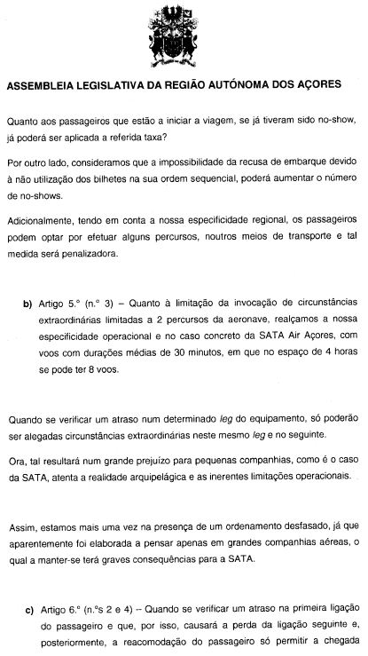
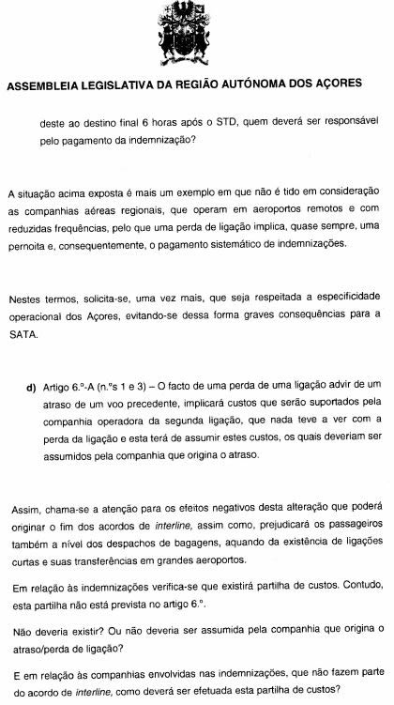
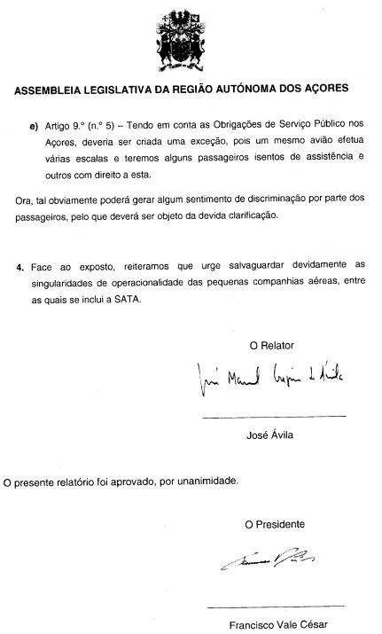
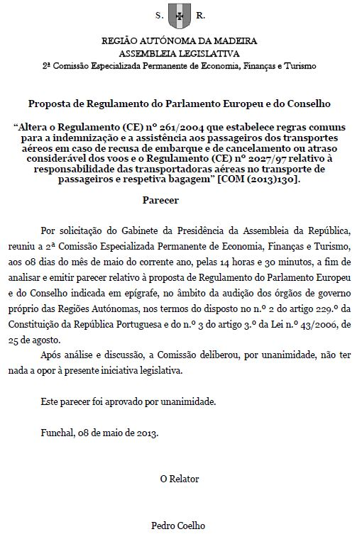
______________

Translation(s) of the opinion may be available in English on the Interparliamentary EU information exchange Internet site (IPEX) at the following address: http://www.ipex.eu/IPEXL-WEB/search.do

