 | 
COUNCIL OF  THE EUROPEAN UNION |  |  | Brussels, 30 July 2013
 | Interinstitutional File:  2013/0014 (COD)  2013/0015 (COD)  2013/0016 (COD)  2013/0028 (COD)  2013/0029 (COD) |  | 8626/13
TRANS 171
CODEC 856
INST 188
PARLNAT 94

COVER NOTE
from: | the Portuguese Parliament
date of receipt: | 28 March 2013
to: | General Secretariat of the Council of the European Union
Subject: | Proposal for a REGULATION OF THE EUROPEAN PARLIAMENT AND OF THE COUNCIL on the European Union Agency for Railways and repealing Regulation (EC) No 881/2004  [Council ST 6012/13 - COM (2013) 27 final]  Proposal for a REGULATION OF THE EUROPEAN PARLIAMENT AND OF THE COUNCIL amending Regulation (EC) No 1370/2007 concerning the opening of the market for domestic passenger transport services by rail  [Council ST 5960/13 - COM (2013) 28 final]  Proposal for a DIRECTIVE OF THE EUROPEAN PARLIAMENT AND OF THE COUNCIL amending Directive 2012/34/EU of the European Parliament and of the Council of 21 November 2012 establishing a single European railway area, as regards the opening of the market for domestic passenger transport services by rail and the governance of the railway infrastructure  [Council ST 5985/13 - COM (2013) 29 final]  Proposal for a DIRECTIVE OF THE EUROPEAN PARLIAMENT AND OF THE COUNCIL on the interoperability of the rail system within the European Union (Recast).  [Council ST 6013/13 - COM (2013) 30 final]  Proposal for a DIRECTIVE OF THE EUROPEAN PARLIAMENT AND OF THE COUNCIL on railway safety (Recast).  [Council ST 6014/13 - COM (2013) 31 final]  - Opinion on the application of the Principles of Subsidiarity and Proportionality

________________________
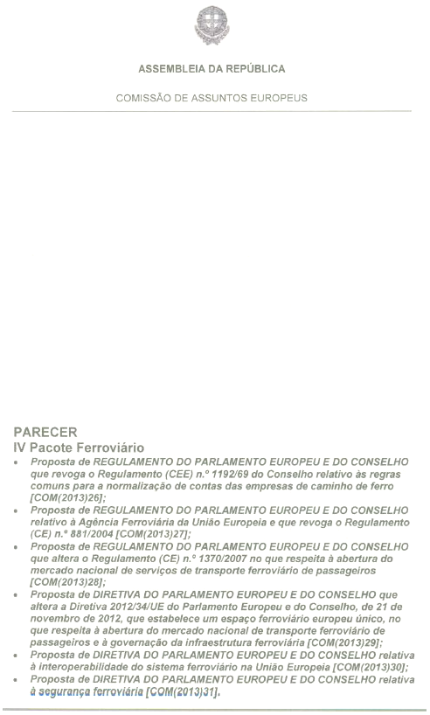

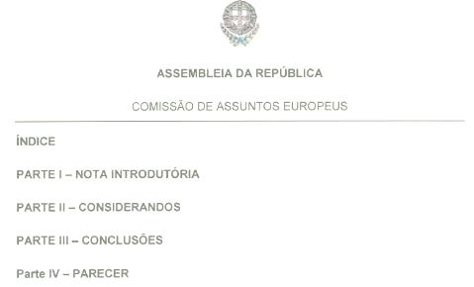
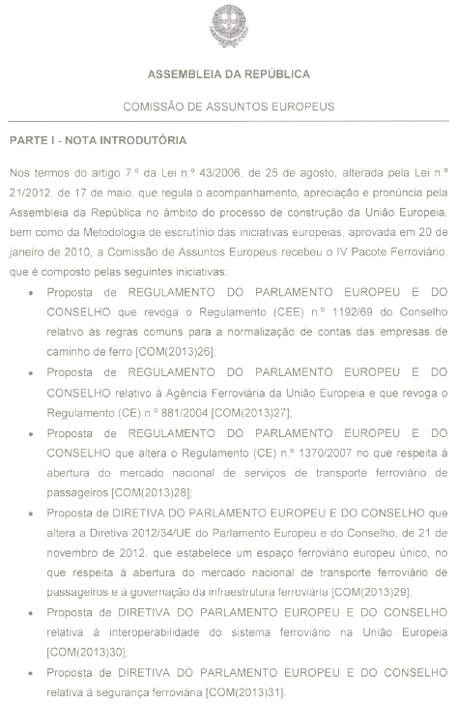
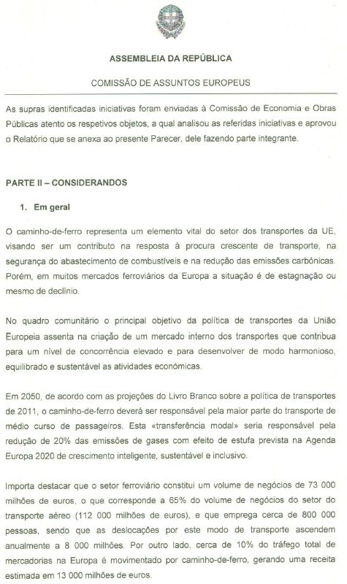
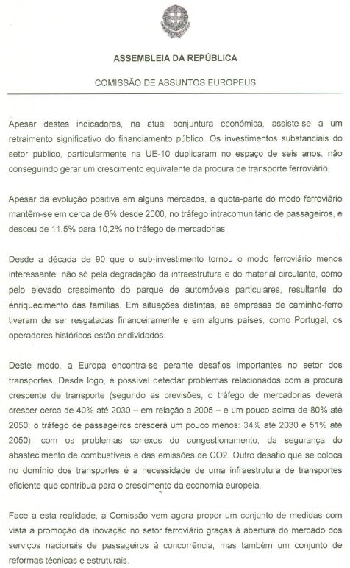
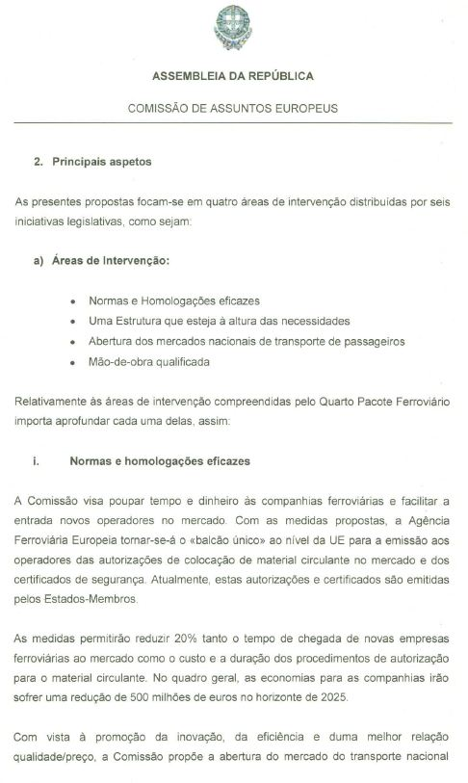
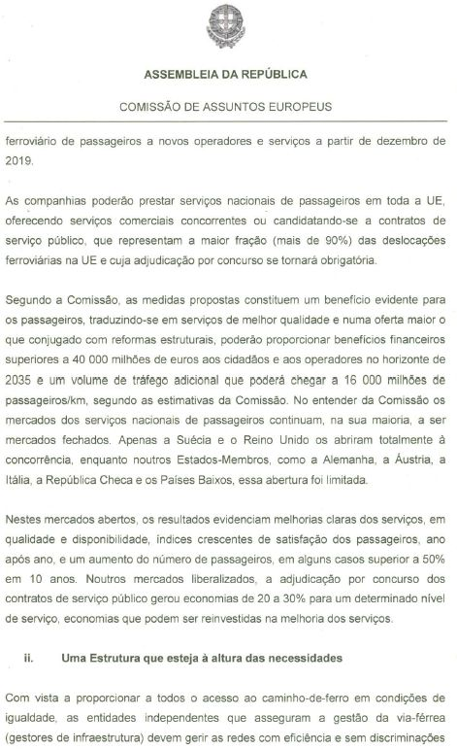
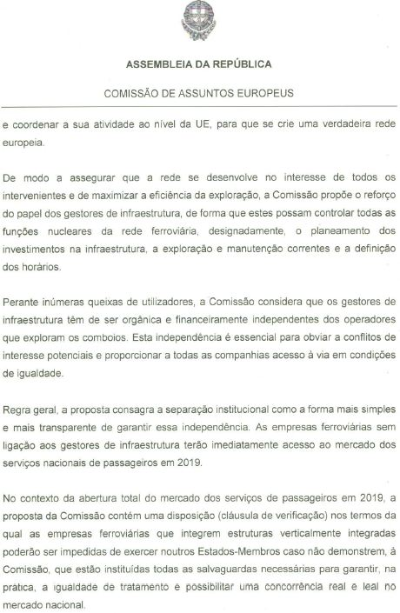

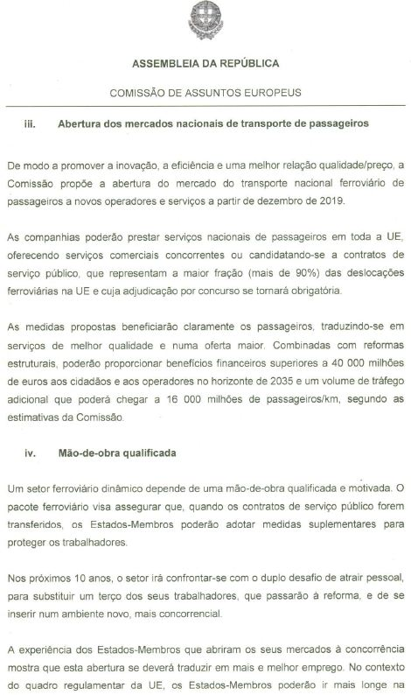
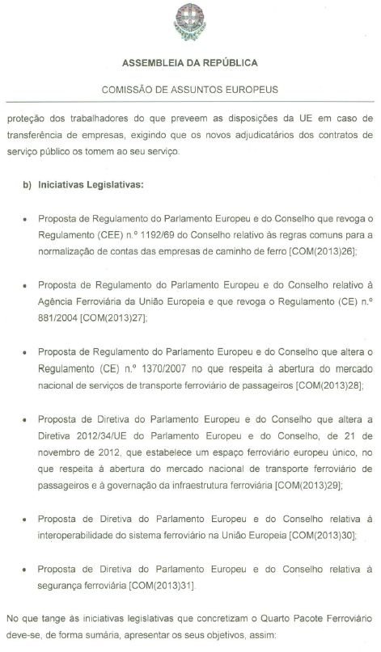
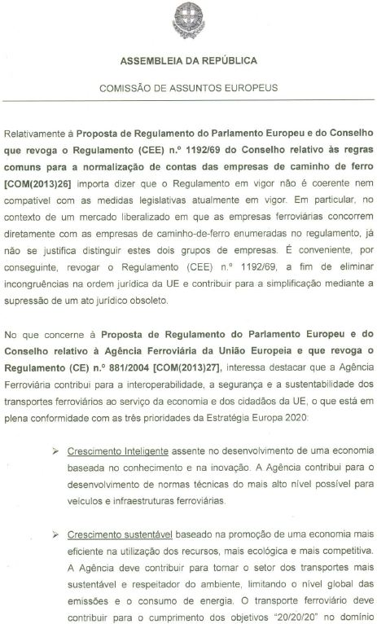
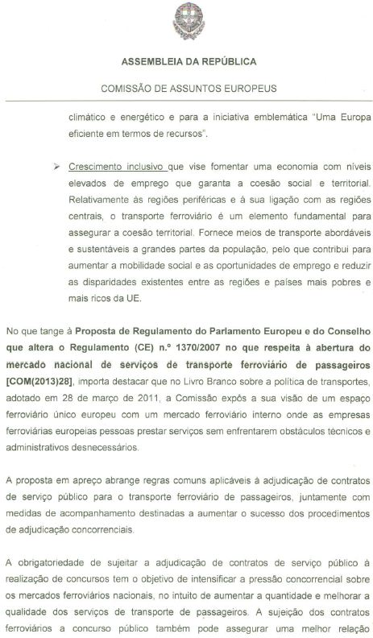
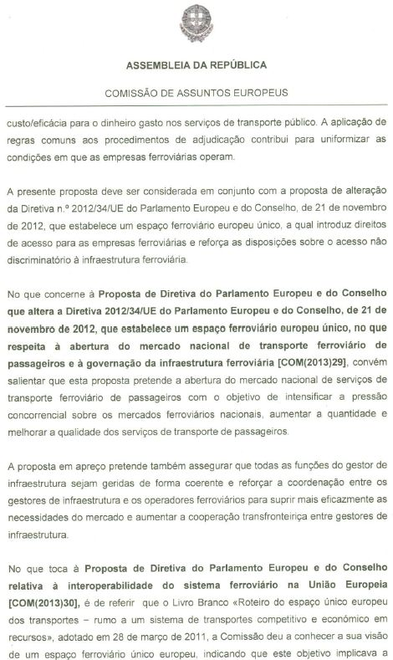
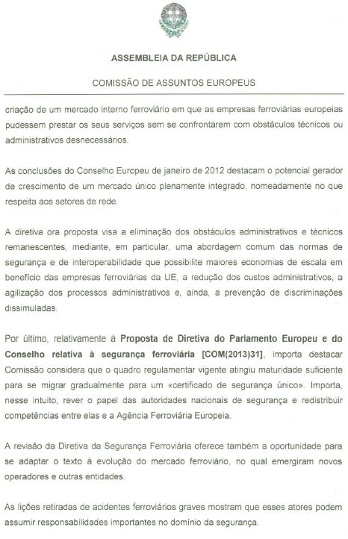
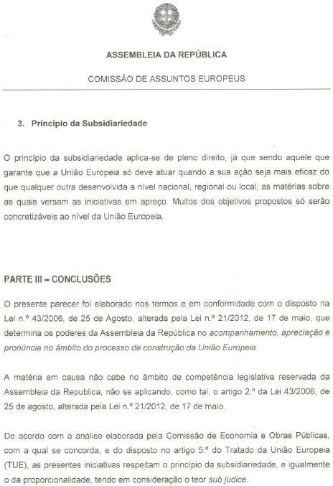
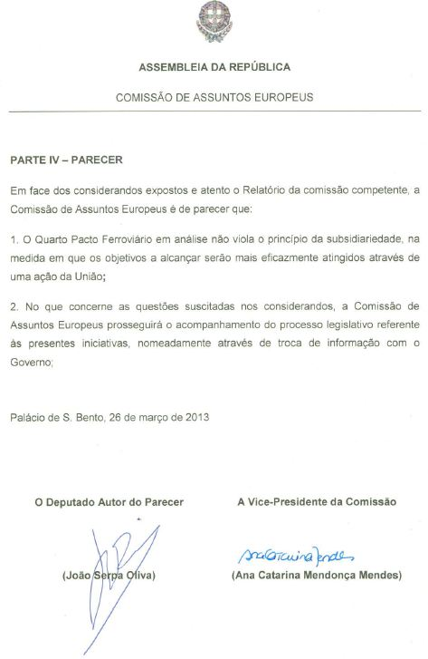
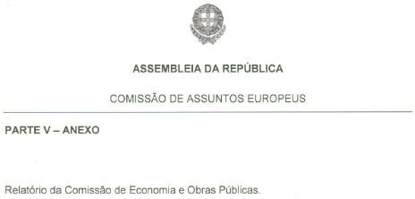
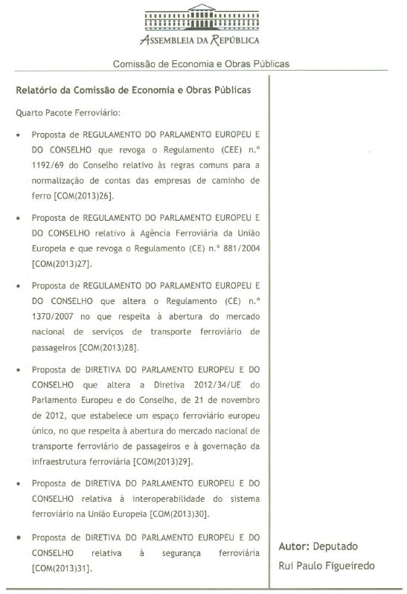
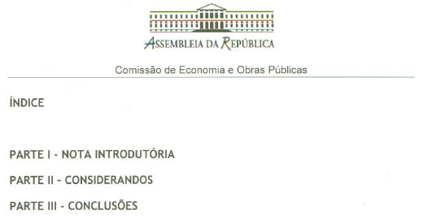
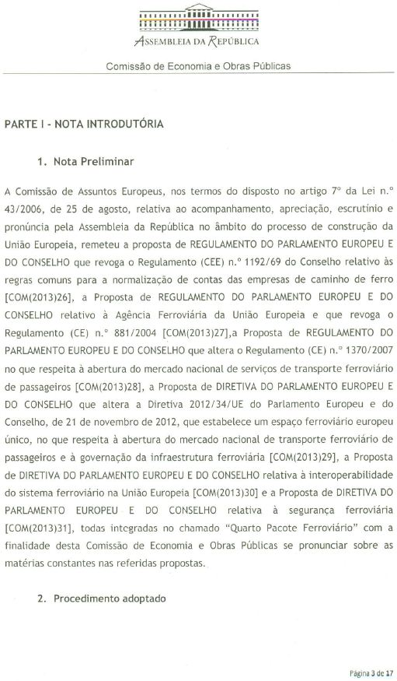
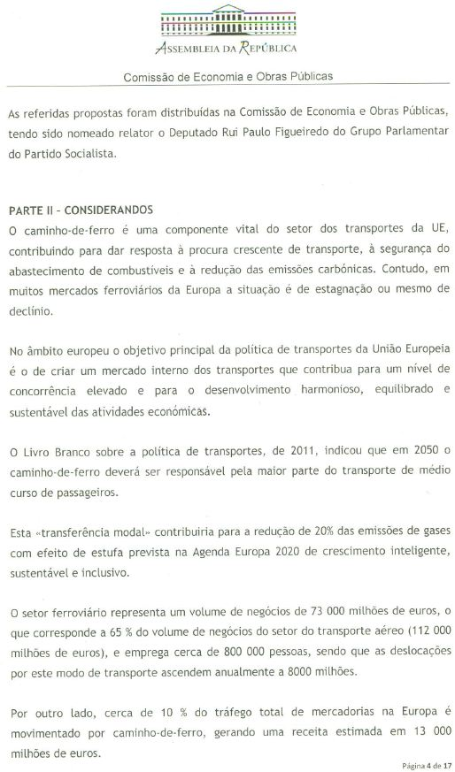
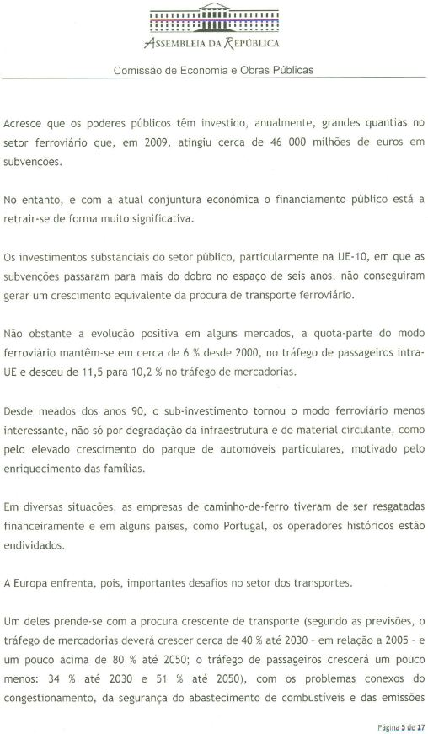
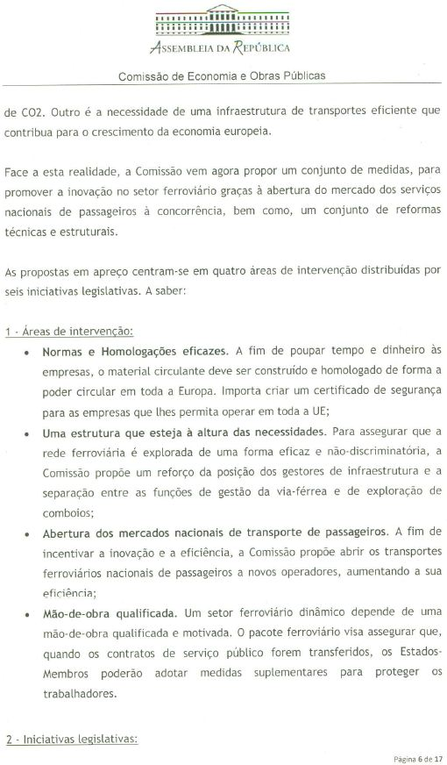
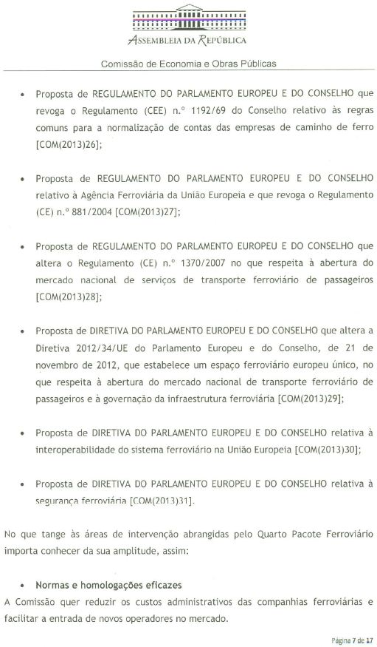
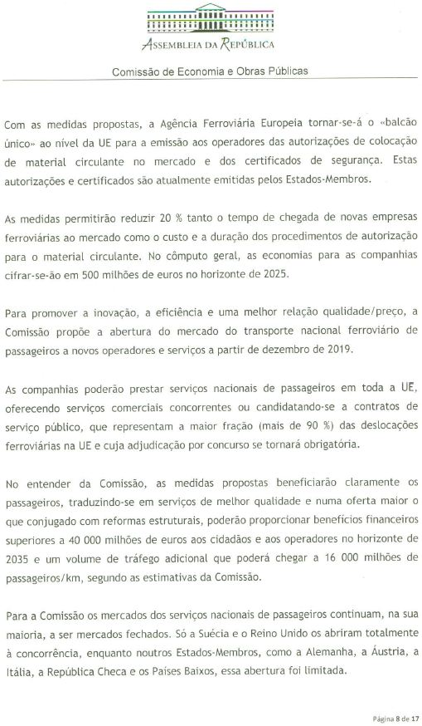
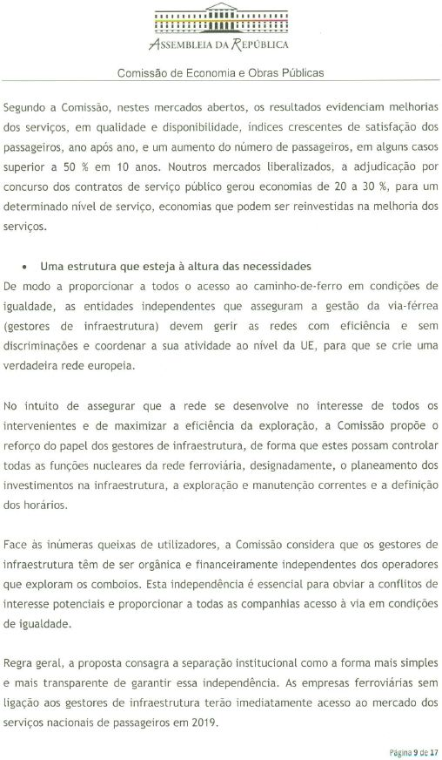
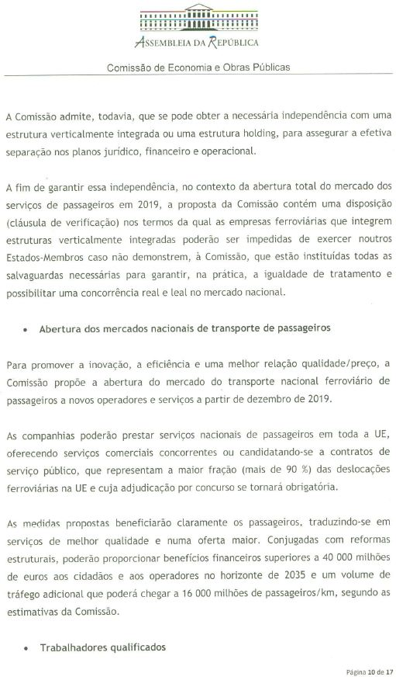
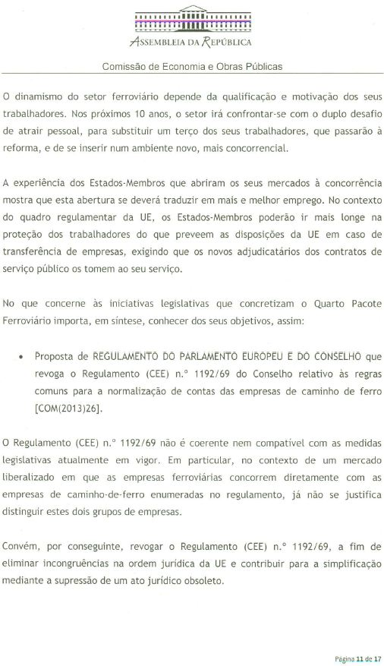
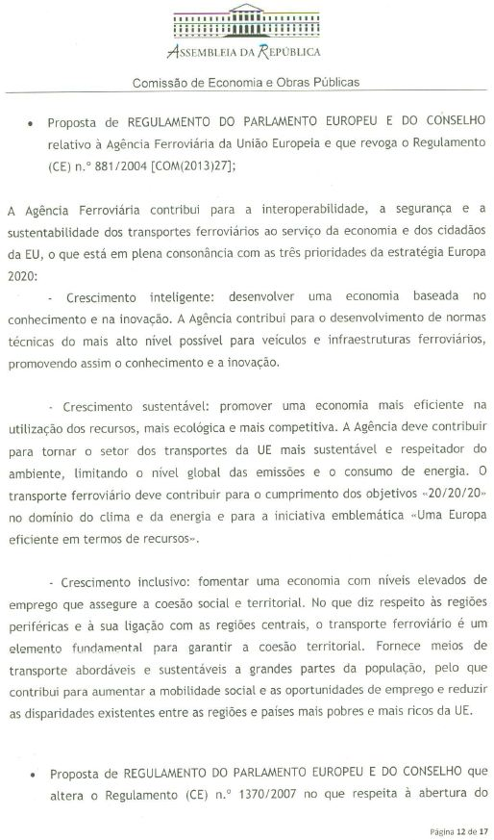
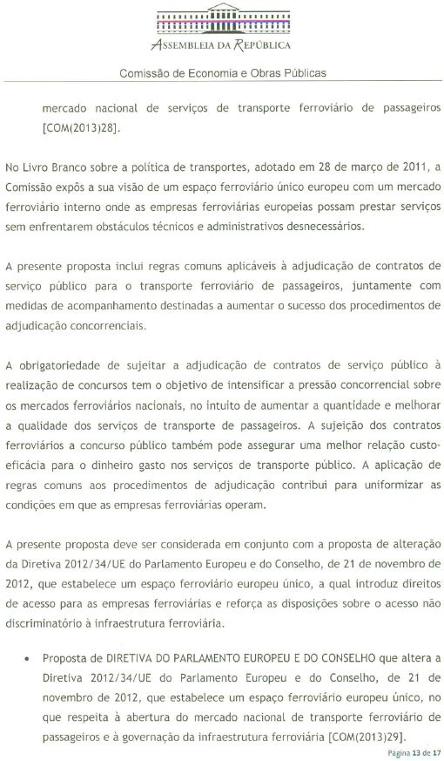
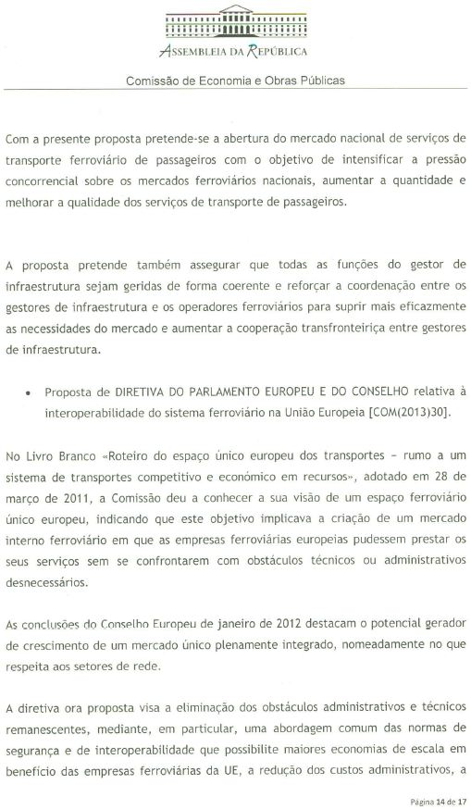
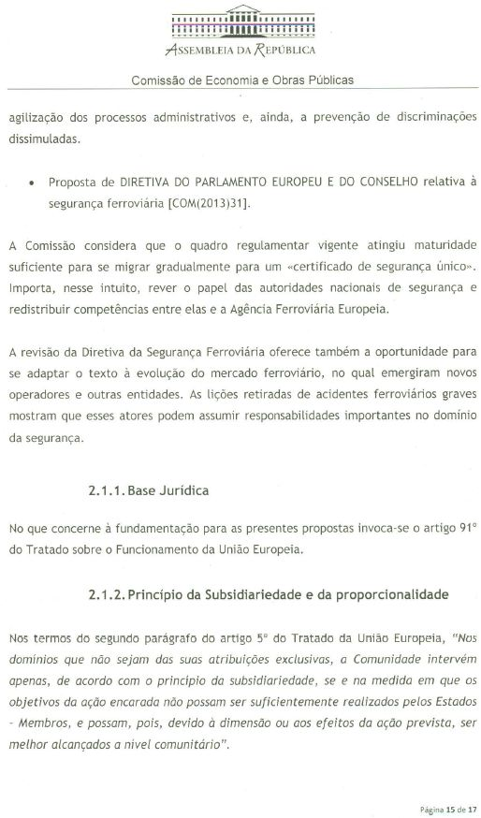
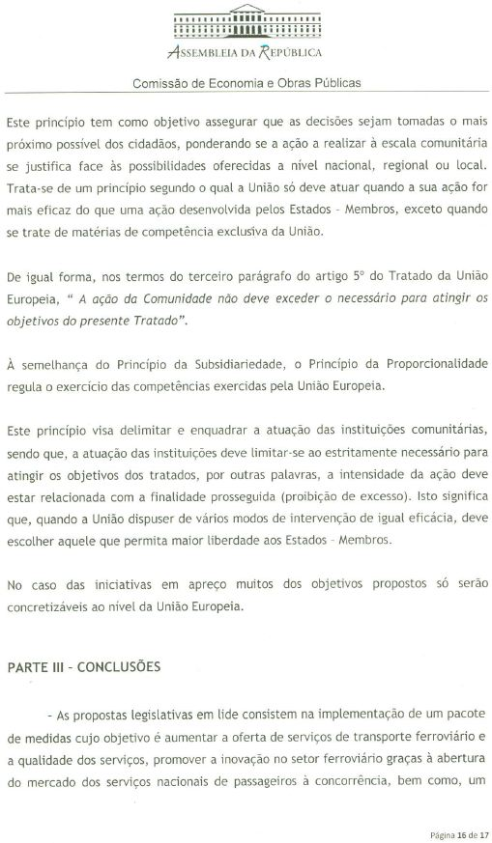
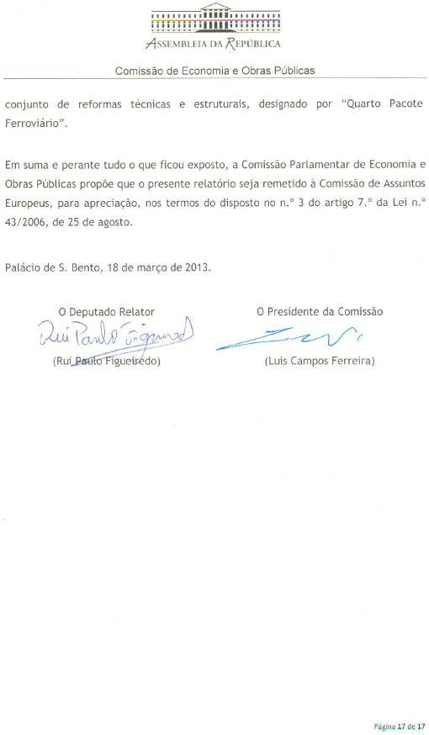
____________________

Translation(s) of the opinion may be available at the Interparliamentary EU information exchange site IPEX at the following address: http://www.ipex.eu/IPEXL-WEB/search.do

