 | 
COUNCIL OF  THE EUROPEAN UNION |  |  | Brussels, 5 September 2013
 | Interinstitutional File:  2013/0162(COD) |  | 13322/13
CULT 95
MI 725
ENFOPOL 280
ENFOCUSTOM 132
UD 220
CODEC 1950
INST 465
PARLNAT 219

OPINION
from: | The Senate of the Republic of Italy
date of receipt: | 31 July 2013
to: | Council
Subject: | Proposal for a Directive of the European Parliament and of the Council on the return of cultural objects unlawfully removed from the territory of a Member State  [doc. 10471/13 CULT 70 MI 501 ENFOPOL 172 ENFOCUSTOM 103 UD 121 CODEC 1323 - COM(2013) 311 final]  - Opinionon the application of the Principles of Subsidiarity and Proportionality

Delegations will find attached the above mentioned opinion.

____________

Encl.

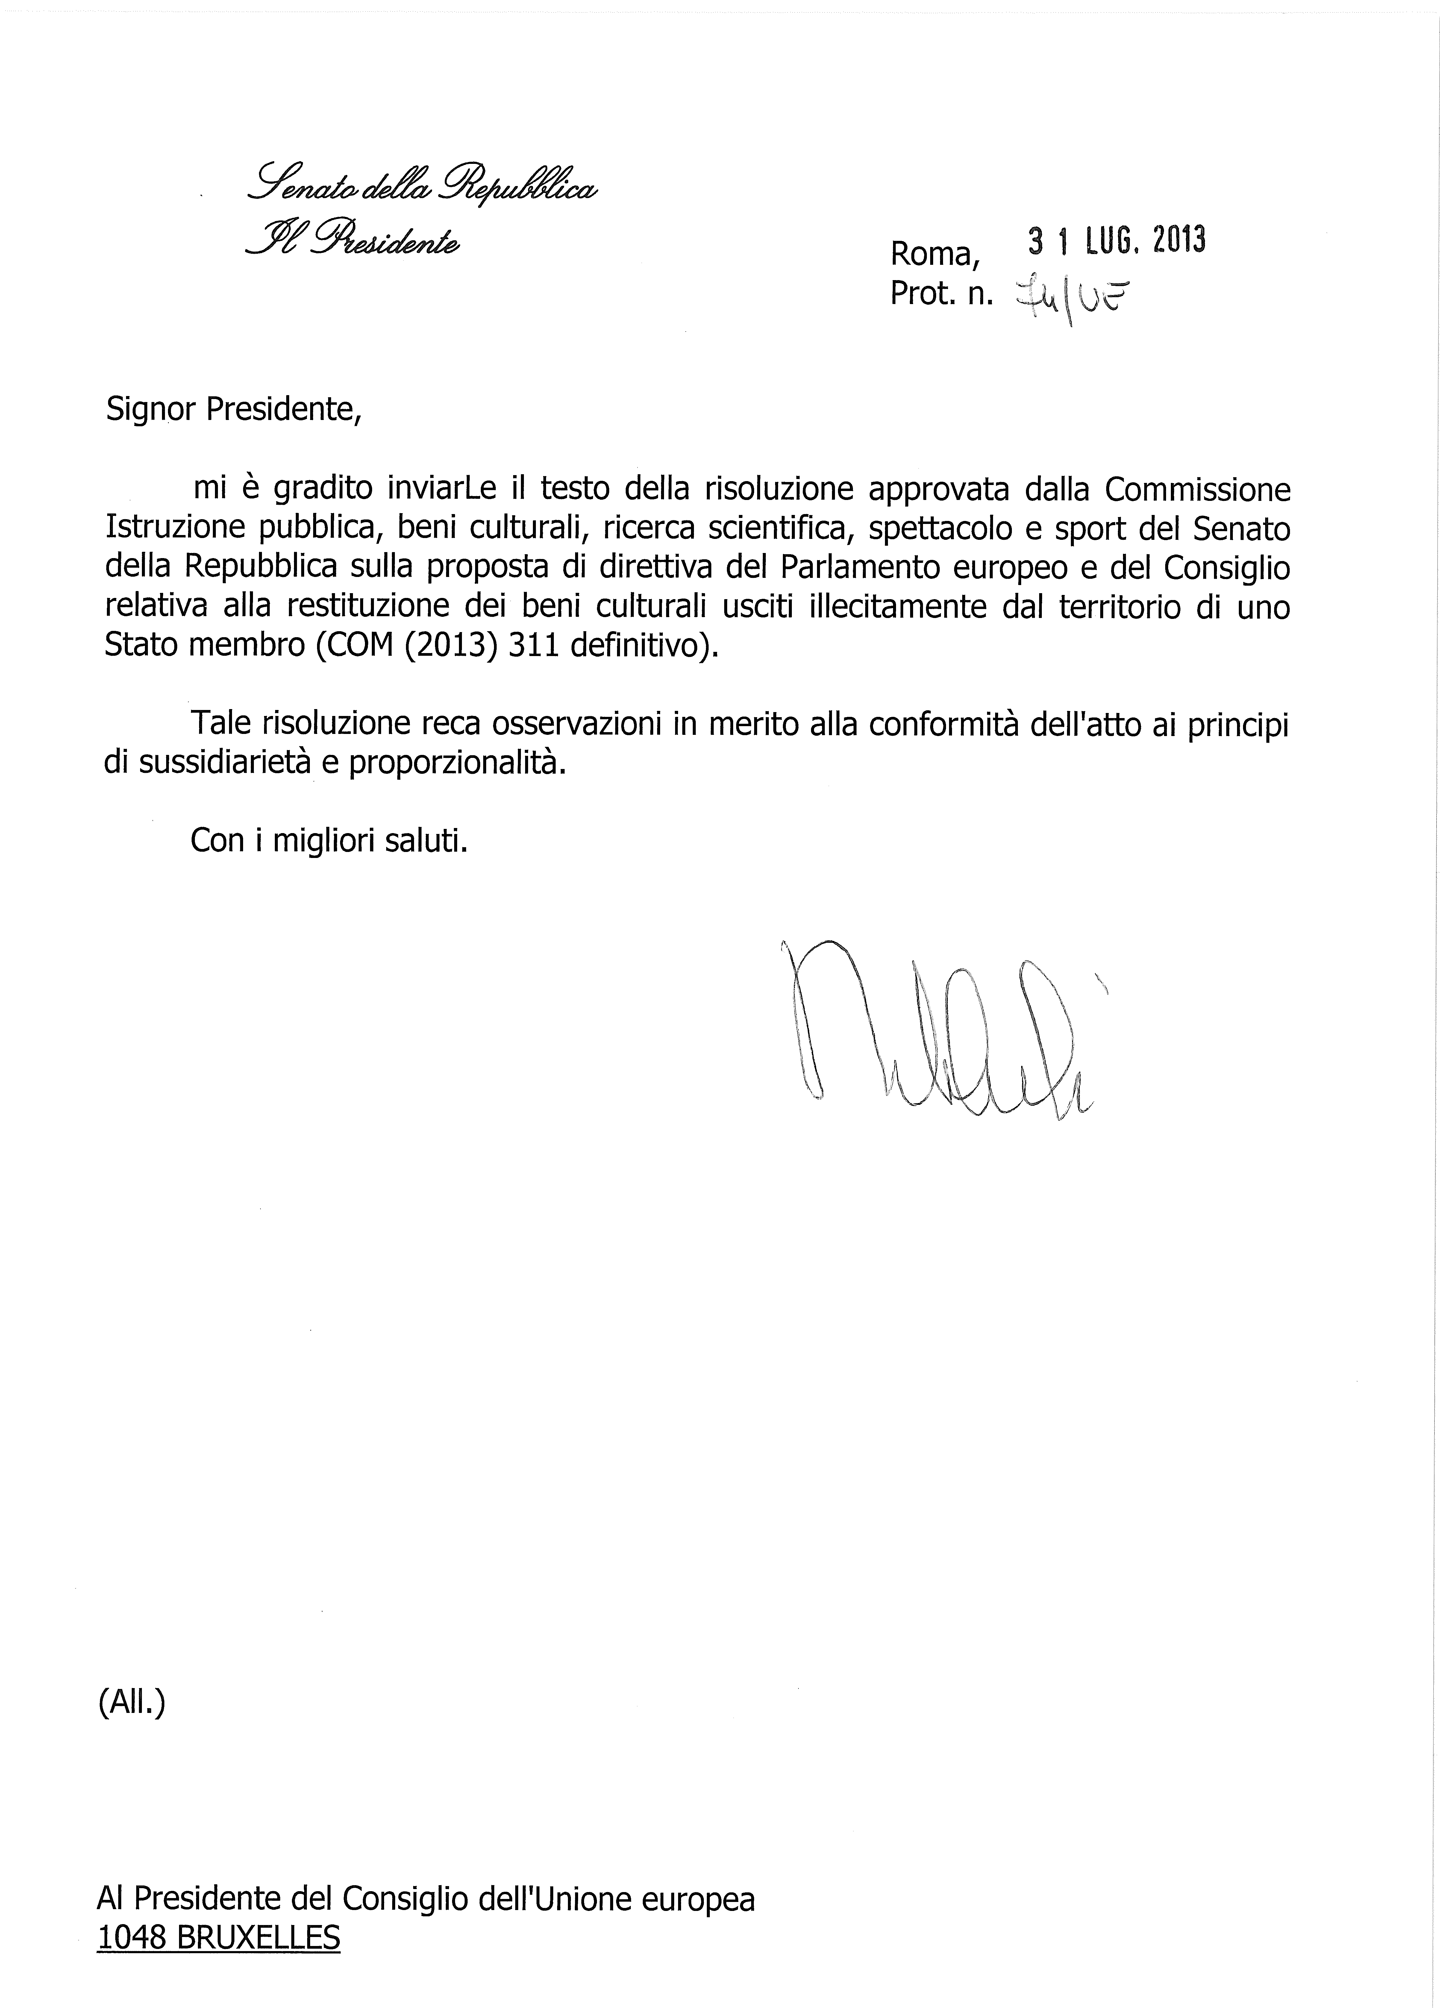

_______________

The translation of the following opinion may be available at the Interparliamentary EU information exchange site IPEX at the following address: http://www.ipex.eu/IPEXL-WEB/search.do

