 | 
COUNCIL OF  THE EUROPEAN UNION |  |  | Brussels, 12 July 2013
 | Interinstitutional File:  2013/0140 (COD) |  | 12150/13
AGRI 468
VETER 65
AGRILEG 95
ANIMAUX 11
SAN 262
DENLEG 74
PHYTOSAN 25
SEMENCES 13
CODEC 1712
INST 389
PARLNAT 170

COVER NOTE
from: | The Chamber of Deputies of the Grand Duchy of Luxembourg
date of receipt: | 5 July 2013
to: | President of the Council of the European Union
Subject: | Proposal for a Regulation of the European Parliament and of the Council on official controls and other official activities performed to ensure the application of food and feed law, rules on animal health and welfare, plant health, plant reproductive material, plant protection products and amending Regulations (EC) No 999/2001, 1829/2003, 1831/2003, 1/2005, 396/2005, 834/2007, 1099/2009, 1069/2009, 1107/2009, Regulations (EU) No 1151/2012, [….]/2013 [Office of Publications, please insert number of Regulation laying down provisions for the management of expenditure relating to the food chain, animal health and animal welfare, and relating to plant health and plant reproductive material], and Directives 98/58/EC, 1999/74/EC, 2007/43/EC, 2008/119/EC, 2008/120/EC and 2009/128/EC (Official controls Regulation)  [doc. 9464/13 AGRI 295 VETER 36 AGRILEG 61 ANIMAUX 2 SAN 159 DENLEG 41 PHYTOSAN 11 SEMENCES 4 CODEC 1045 - COM(2013) 265 final]  - Opinion on the application of the Principles of Subsidiarity and Proportionality

Delegations will find attached a copy of the abovementioned opinion.
________________________

ANNEX
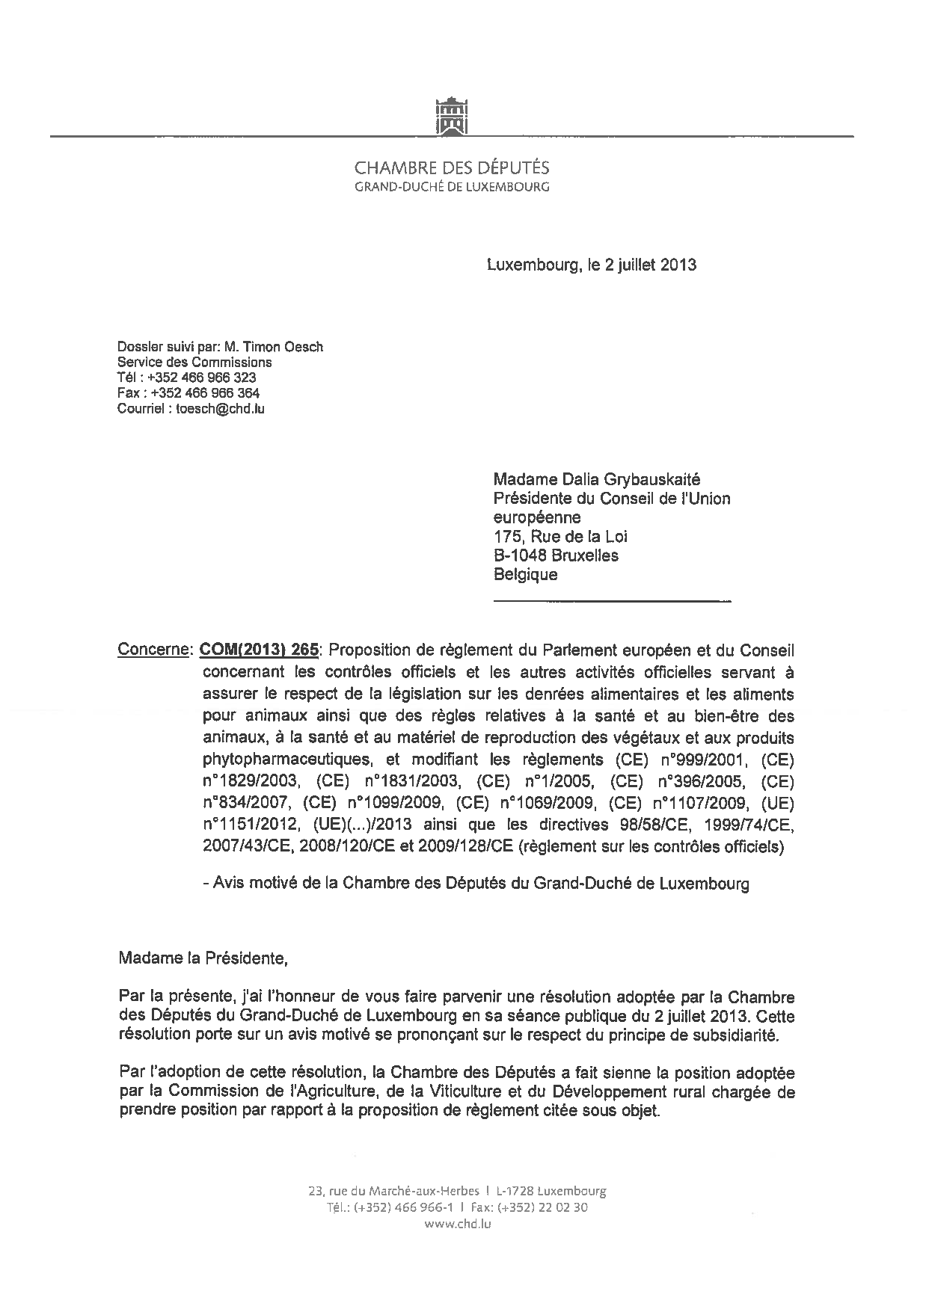

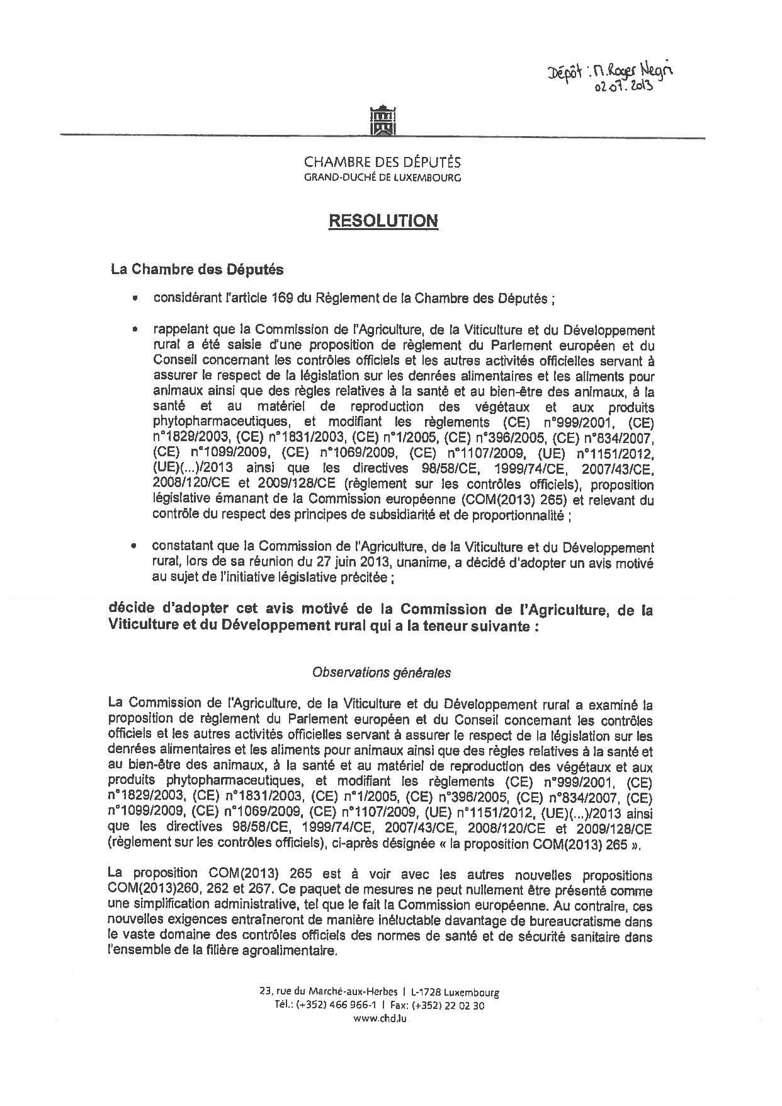
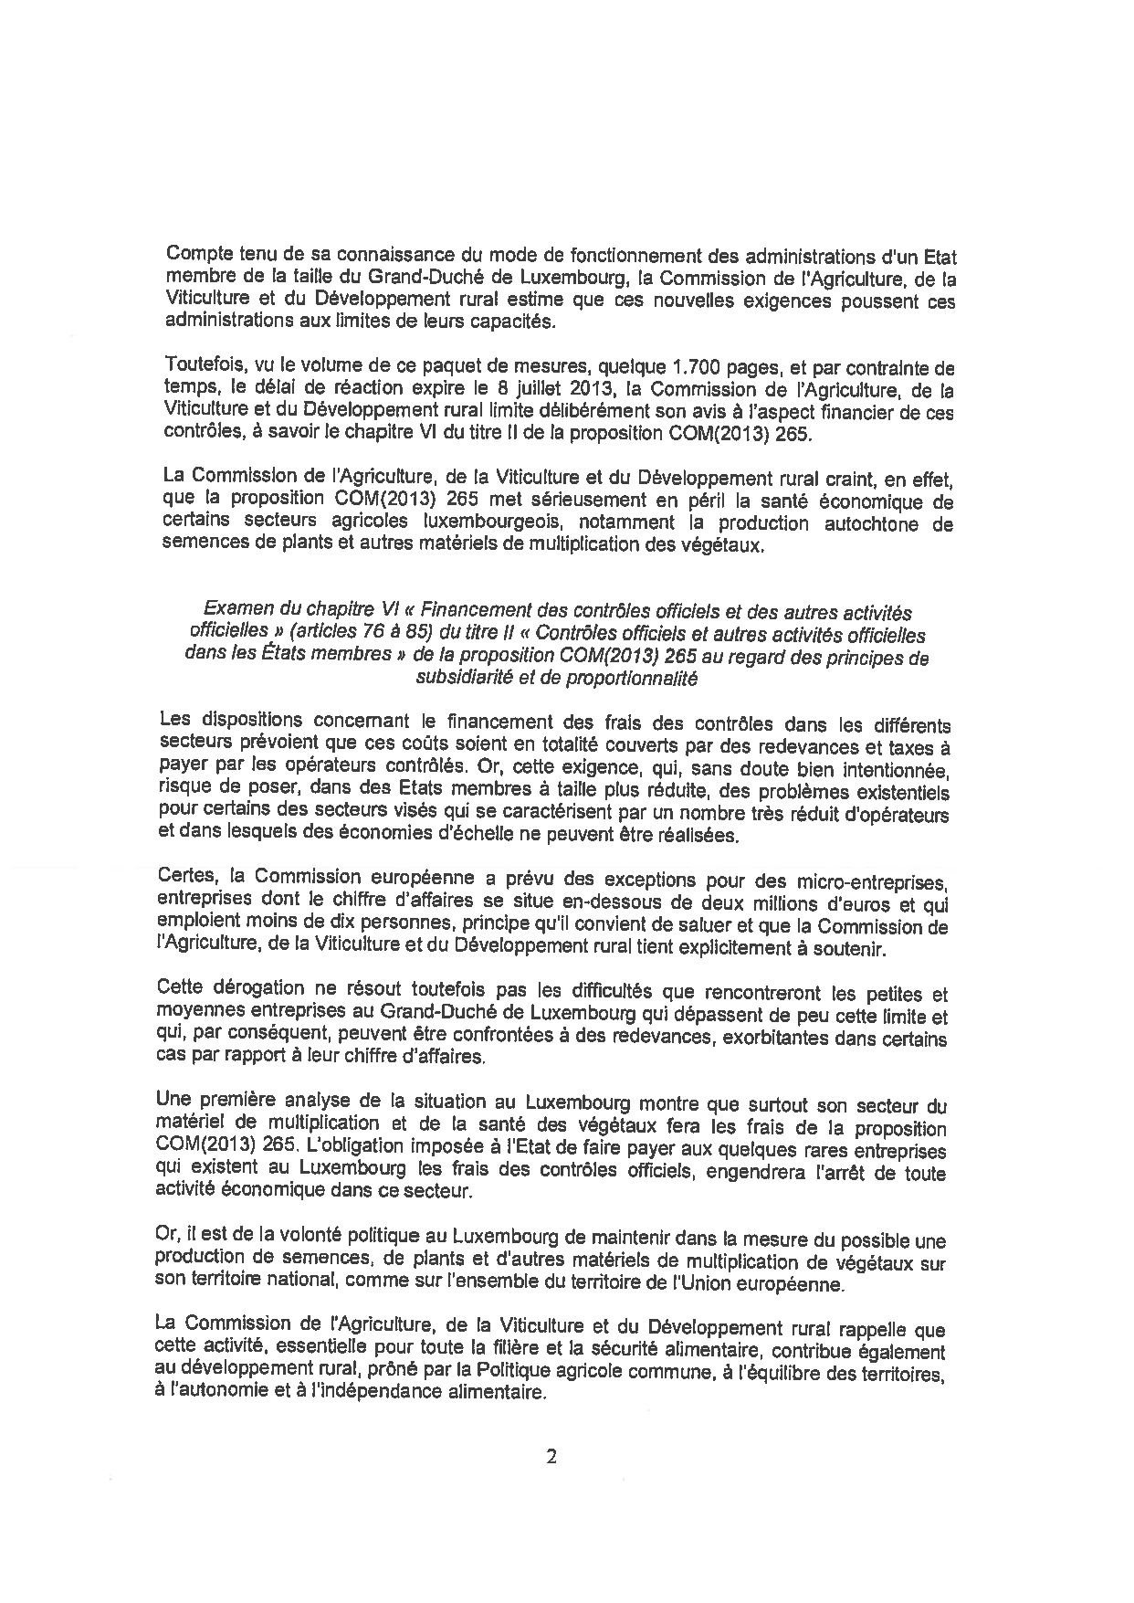
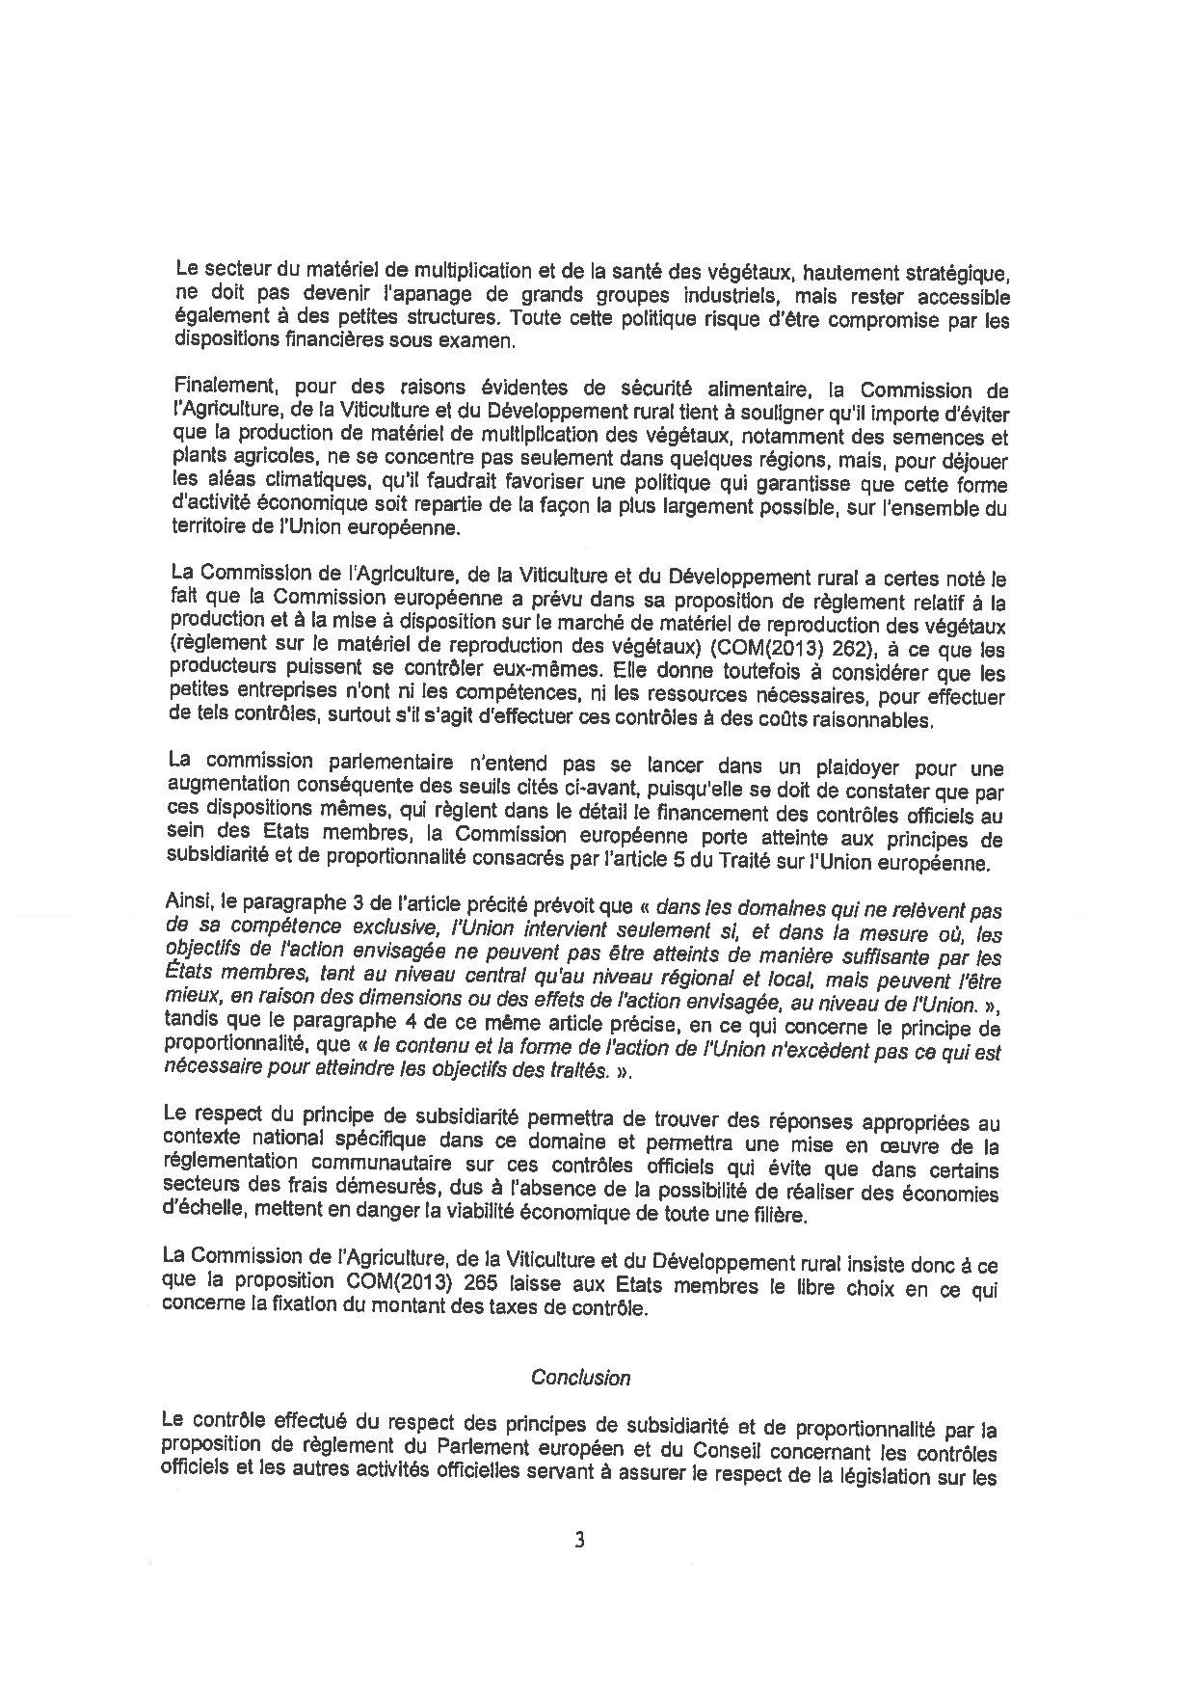
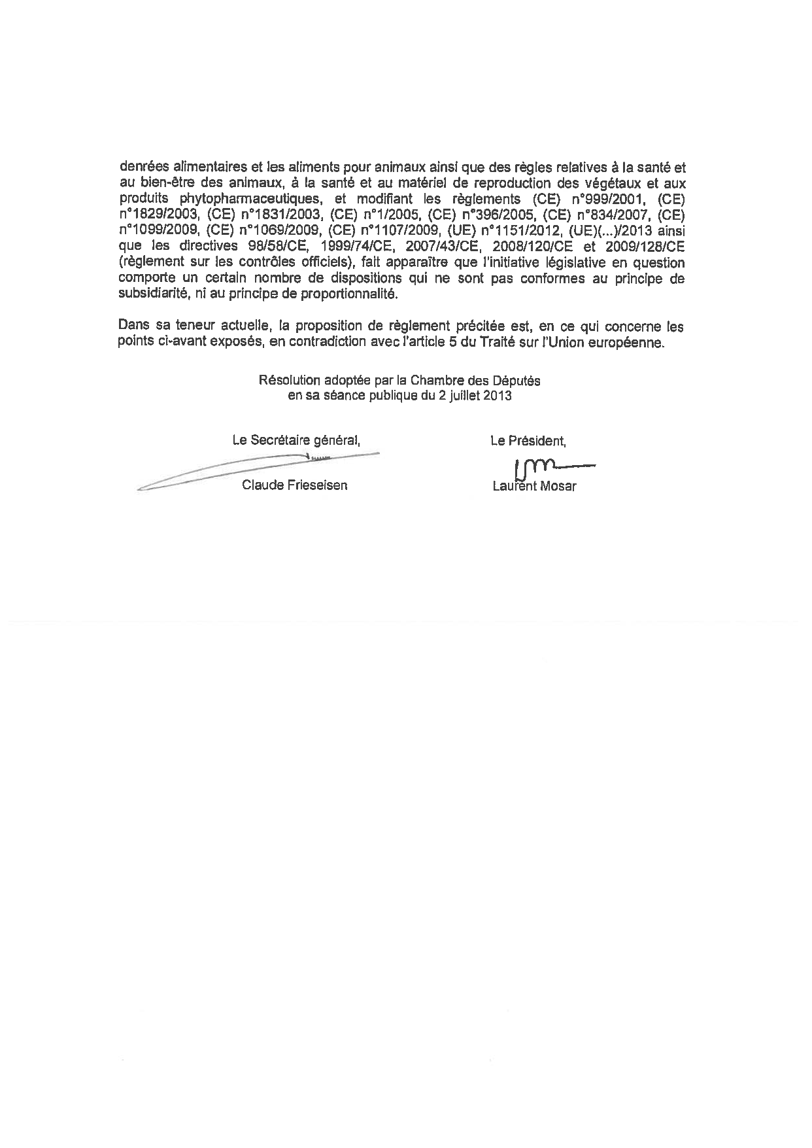

The translation can be found at the Interparliamentary EU information exchange Internet site (IPEX) at the following address: http://www.ipex.eu/ipex/cms/home/Documents/pid/10.

