 | 
COUNCIL OF  THE EUROPEAN UNION |  |  | Brussels, 10 July 2013
 | Interinstitutional File:  2013/0119 (COD) |  | 12142/13
JUSTCIV 164
FREMP 103
CODEC 1711
INST 386
PARLNAT 169

COVER NOTE
from: | the Italian Senate
Date of receipt: | 4 July 2013
to: | Algirdas Butkevičius, President of the Council of the European Union
Subject: | Proposal for a Regulation of the European Parliament and of the Council on promoting the free movement of citizens and businesses by simplifying the acceptance of certain public documents in the European Union and amending Regulation (EU) No 1024/2012  [doc. 9037/13 JUSTCIV 108 FREMP 70 CODEC 952 - COM(2013) 228 final]  - Opinion on the application of the Principles of Subsidiarity and Proportionality

Delegations will find attached a copy of the above mentioned opinion.

_______________________

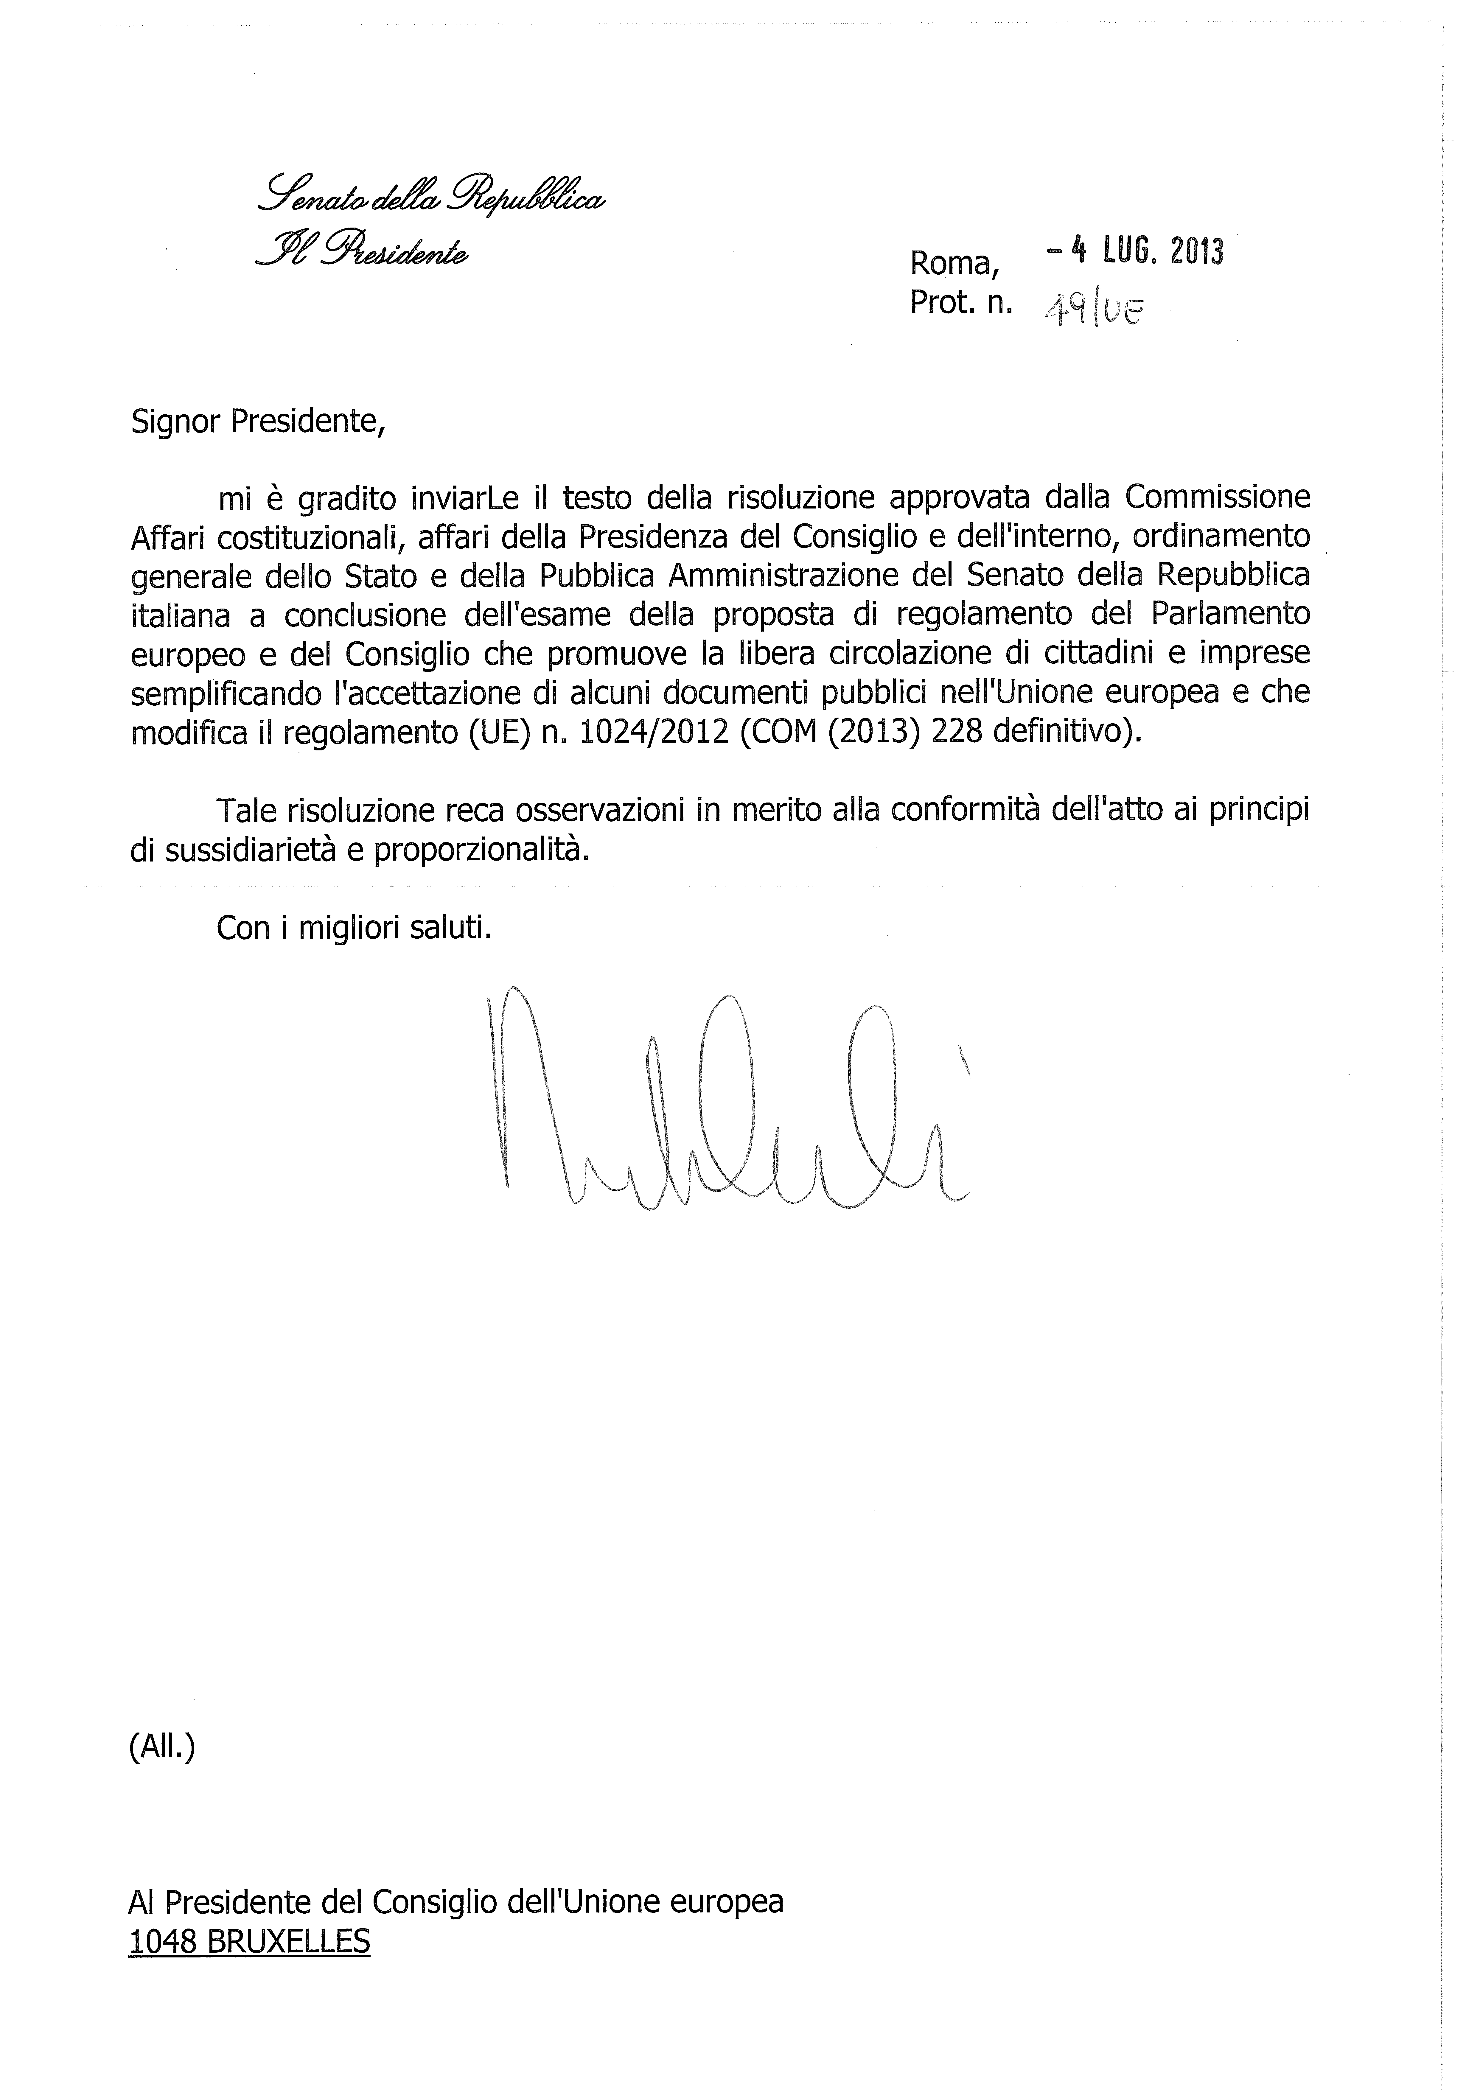
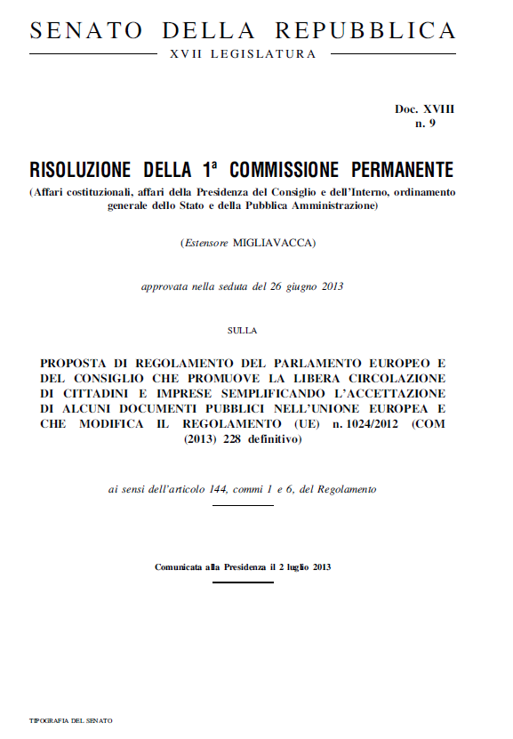
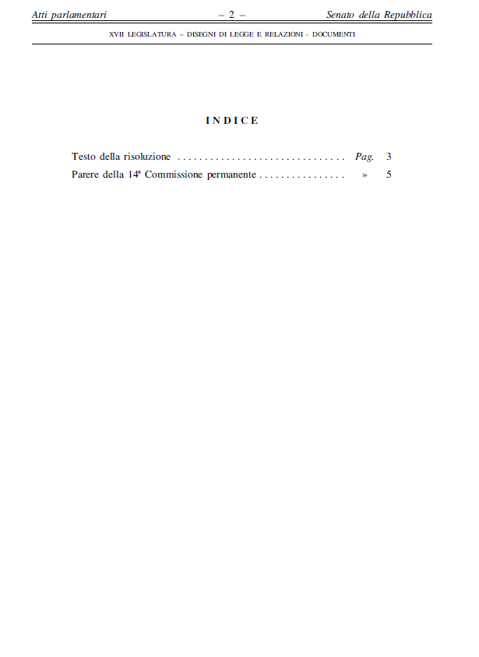
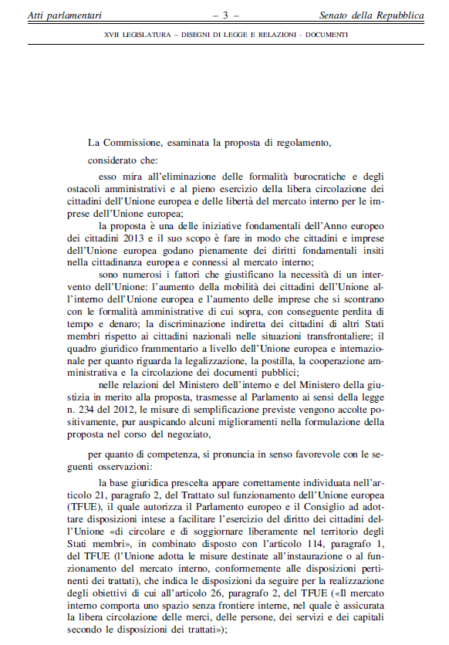
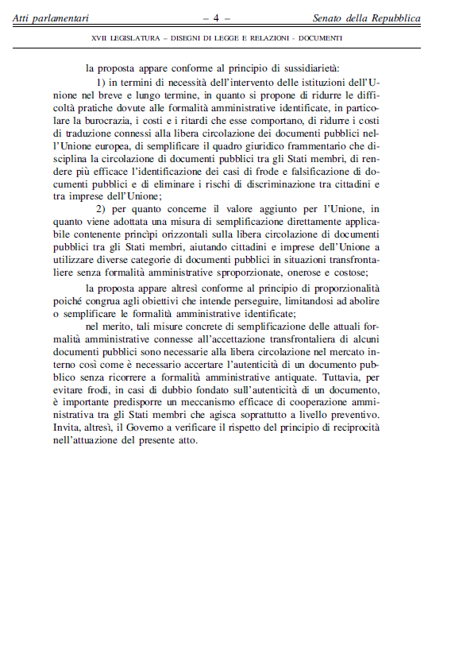
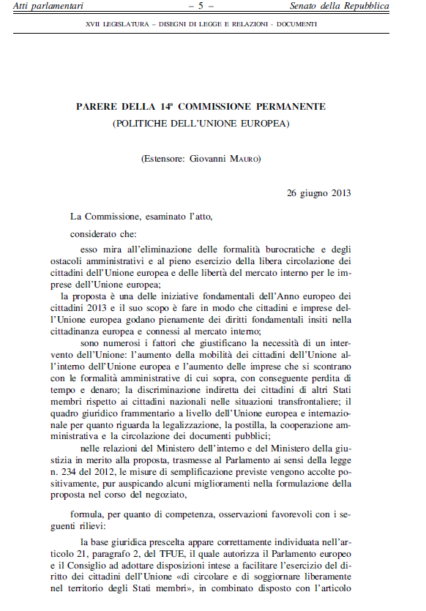
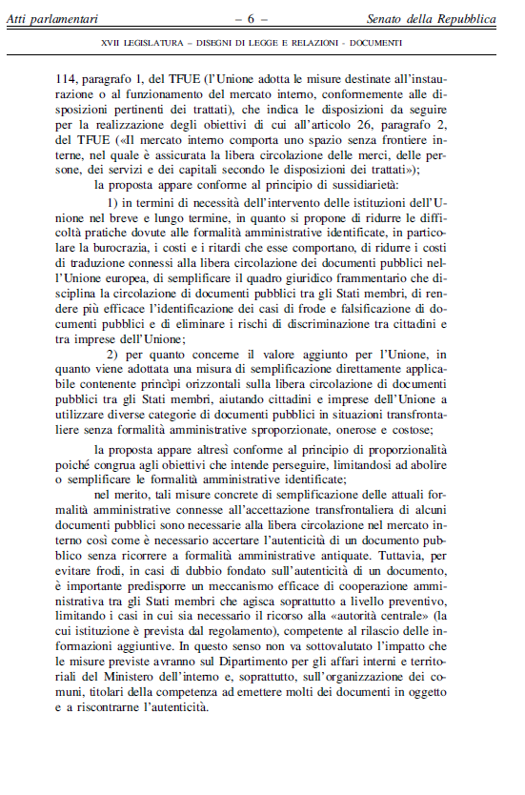

_______________

For other available language versions of the opinion, reference is made to the Interparliamentary EU information exchange Internet site (IPEX) at the following address: http://www.ipex.eu/IPEXL-WEB/search.do

