 | 
COUNCIL OF  THE EUROPEAN UNION |  |  | Brussels, 2 July 2013
 | Interinstitutional File:  2013/0141 (COD) |  | 11870/13
AGRI 448
AGRILEG 93
CODEC 1664
PHYTOSAN 24
INST 362
PARLNAT 165

COVER NOTE
from: | President of the Bundesrat of the Republic of Austria
date of receipt: | 2 July 2013
to: | President of the Council of the European Union
Subject: | Proposal for a Regulation of the European Parliament and of the Council on protective measures against pests of plants  [doc. 9574/13 AGRI 309 AGRILEG 64 CODEC 1085 PHYTOSAN 13 - COM(2013) 267 final]  - Opinion on the application of the Principles of Subsidiarity and Proportionality

Delegations will find attached the above-mentioned opinion.

________________________

ANNEX

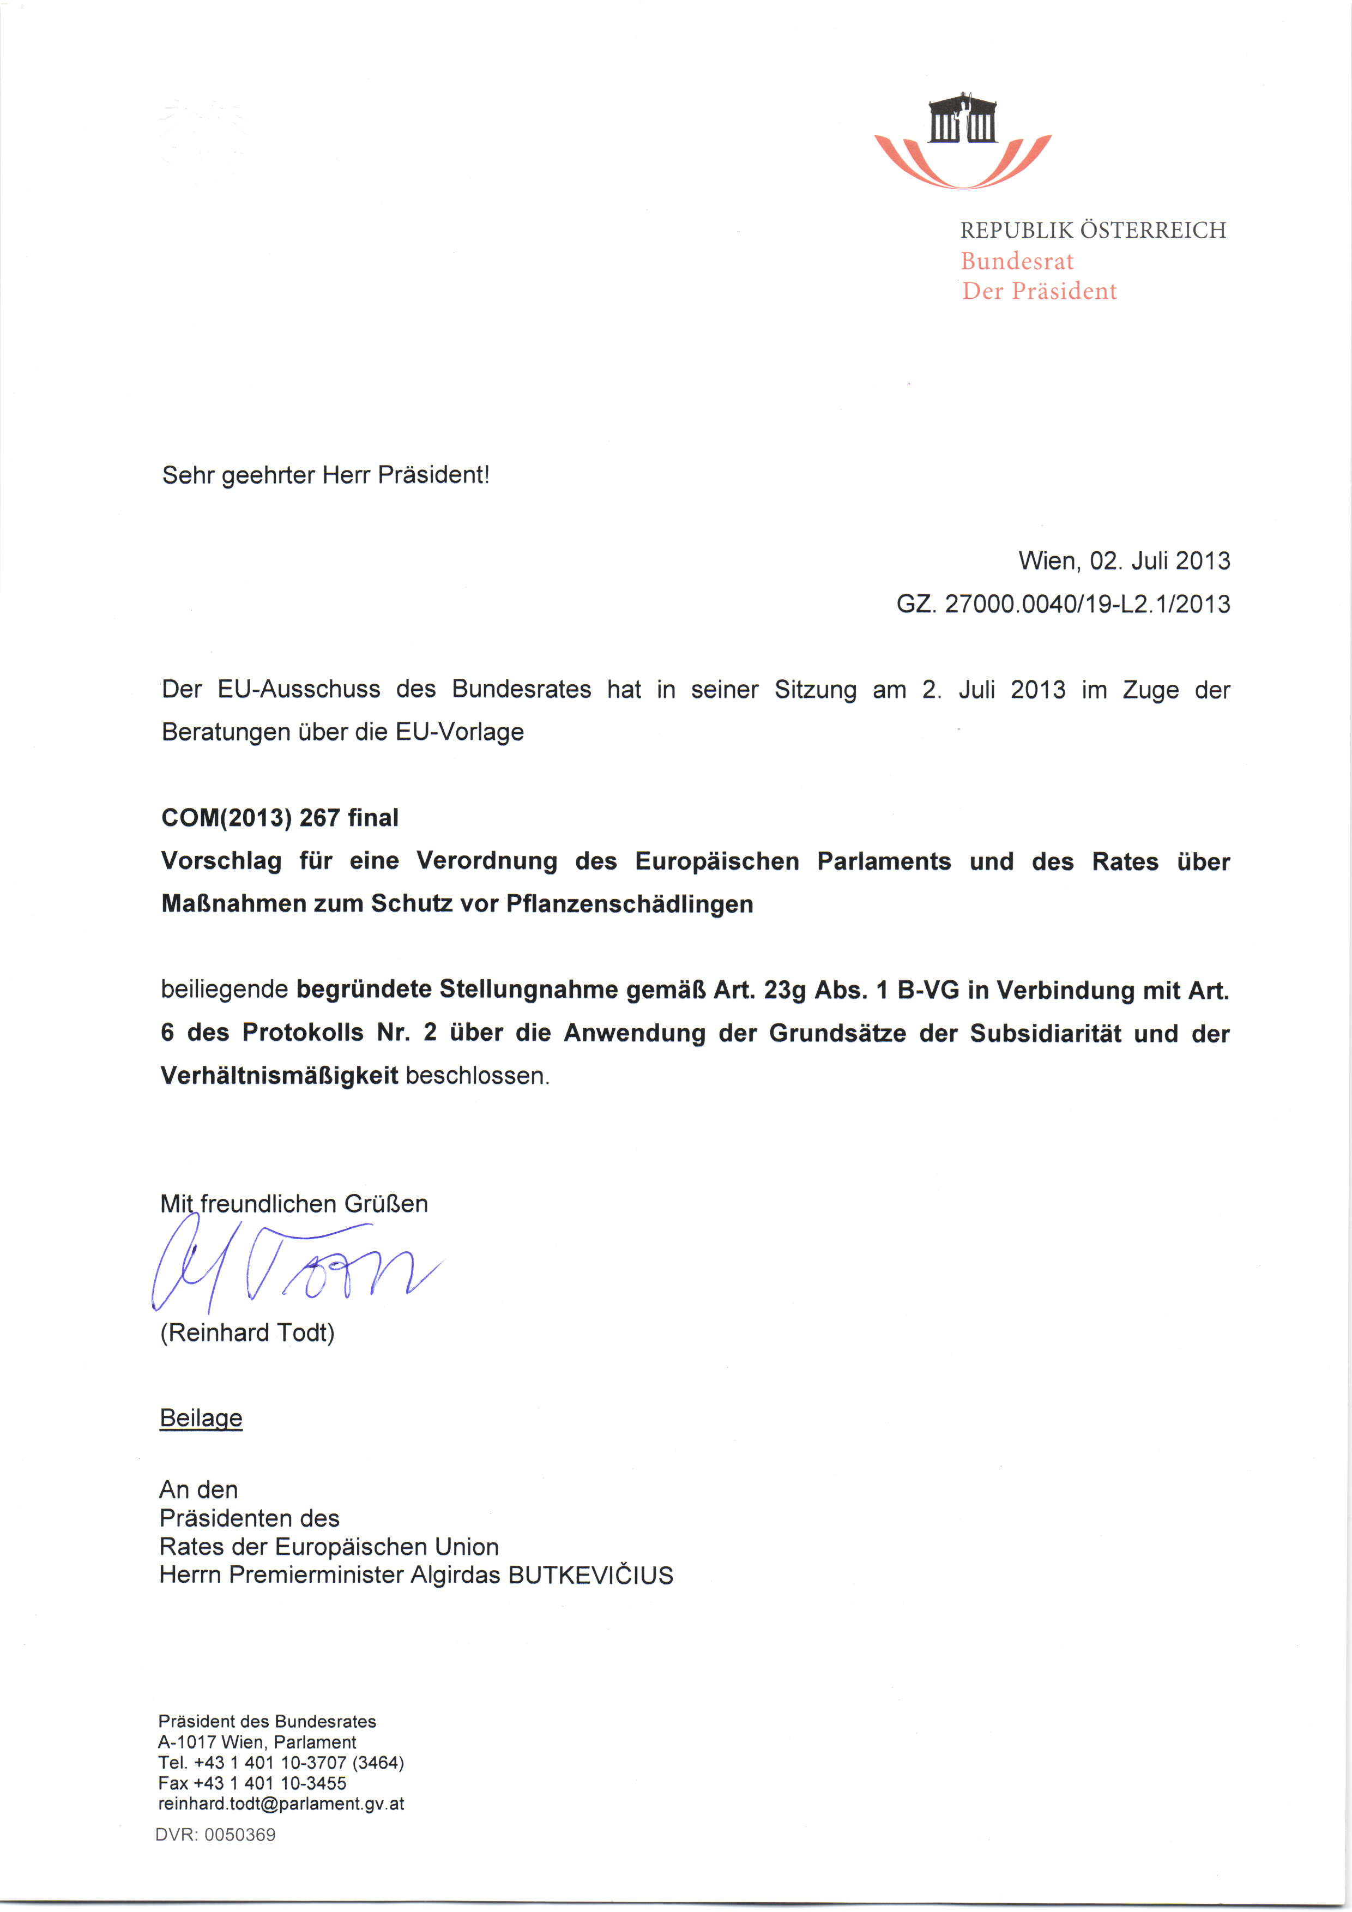
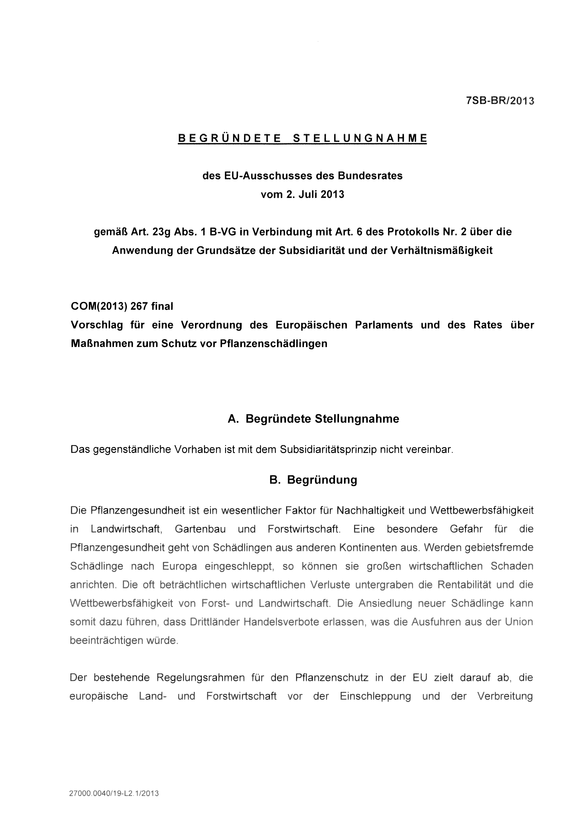
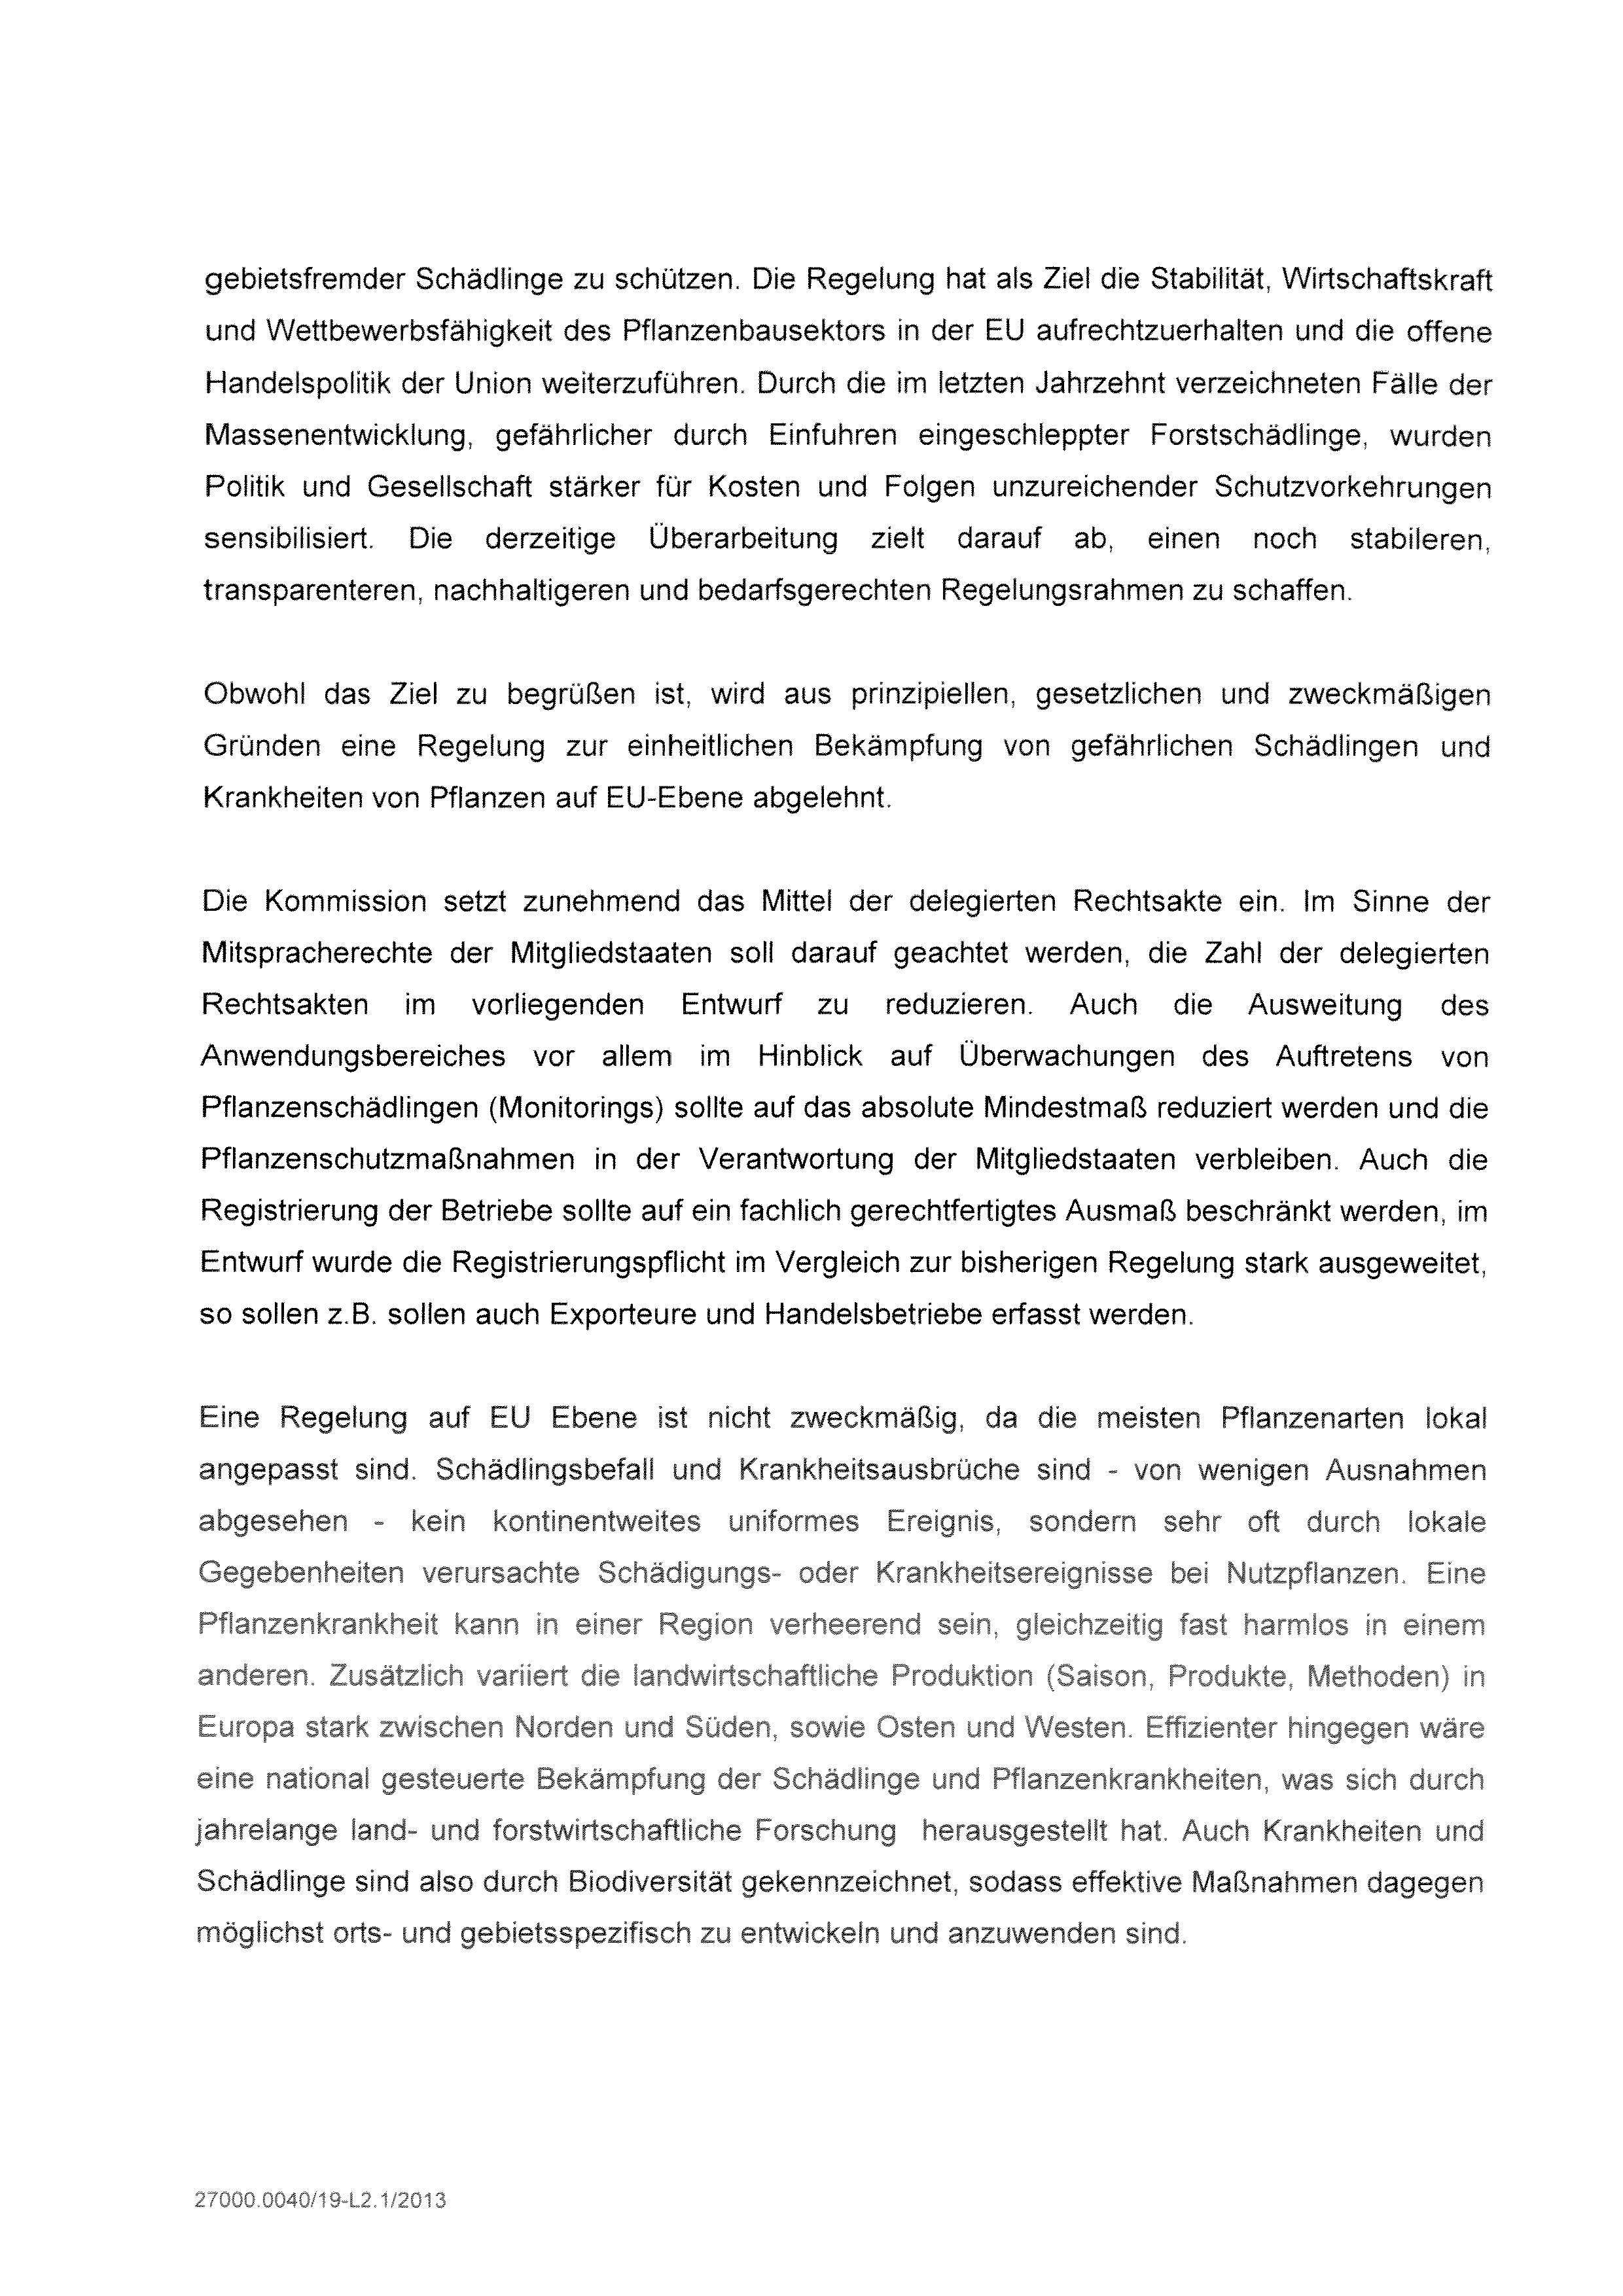

Translation(s) of the opinion may be available at the Interparliamentary EU information exchange site IPEX at the following address: http://www.ipex.eu/IPEXL-WEB/search.do

