 | 
COUNCIL OF  THE EUROPEAN UNION |  |  | Brussels, 2 July 2013
 | Interinstitutional File:  2013/0117 (COD) |  | 11413/13
AGRI 416
AGRIFIN 107
AGRISTR 75
AGRIORG 92
CODEC 1570
INST 336
PARLNAT 155

COVER NOTE
from: | Portuguese Parliament
date of receipt: | 19 June 2013
to: | President of the Council of the European Union
Subject: | Proposal for a regulation of the European Parliament and of the Council laying down certain transitional provisions on support for rural development by the European Agricultural Fund for Rural Development (EAFRD) and amending Regulation (EU) No [RD] as regards resources and their distribution in respect of the year 2014 and amending Council Regulation (EC) No 73/2009 and Regulations (EU) No [DP], (EU) No [HZ] and (EU) No [sCMO] as regards their application in the year 2014  [8340/13 (AGRI 234 AGRIFIN 76 AGRISTR 47 AGRIORG 59 CODEC 847) - COM (2013) 226 final]  - Opinion on the application of the Principles of Subsidiarity and Proportionality

Delegations will find attached the opinion of the Portuguese Parliament.

_______________

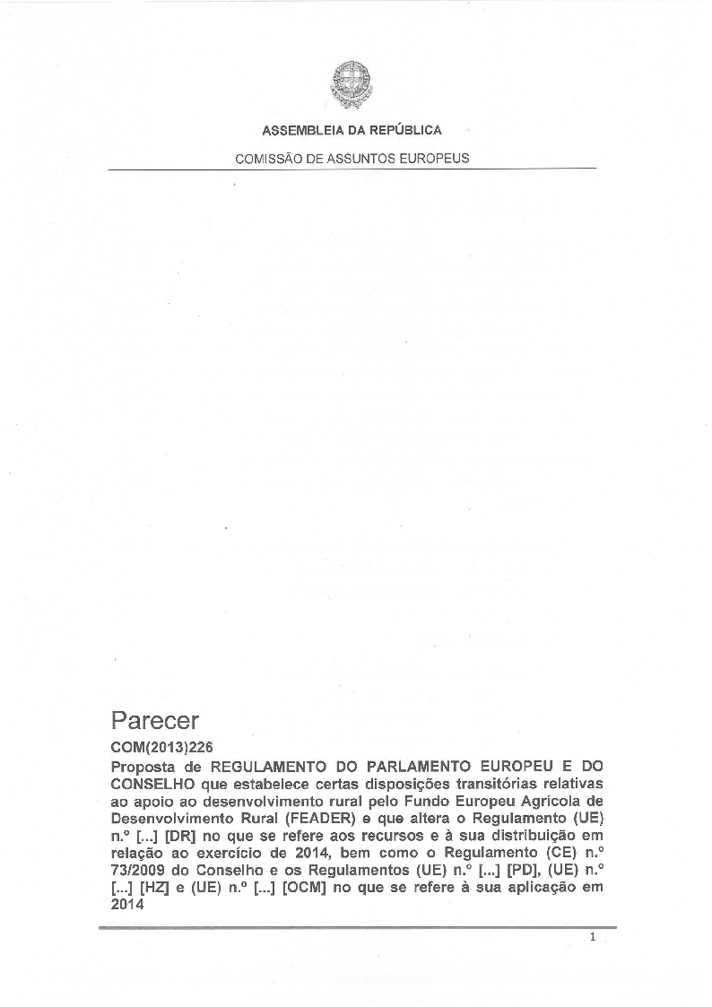

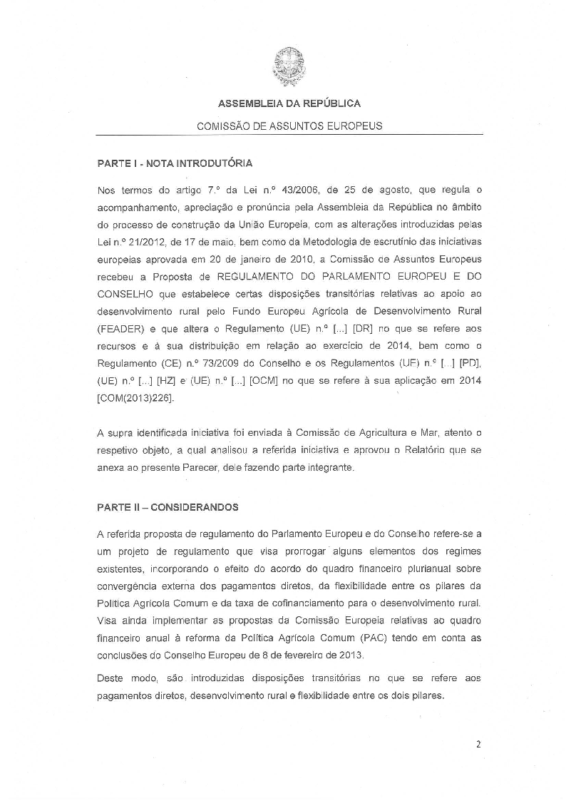
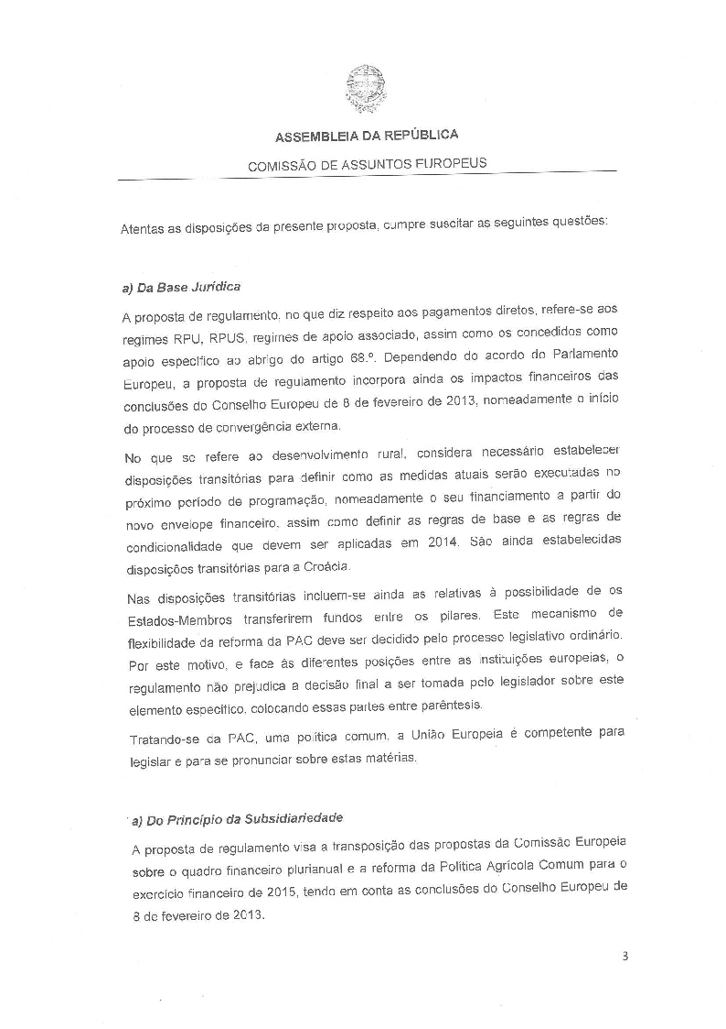
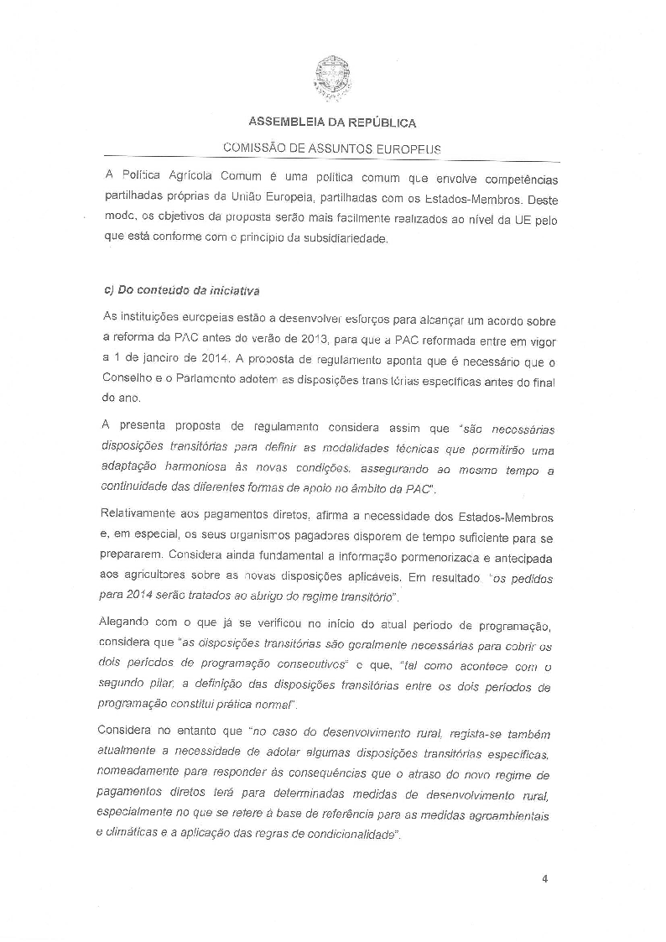
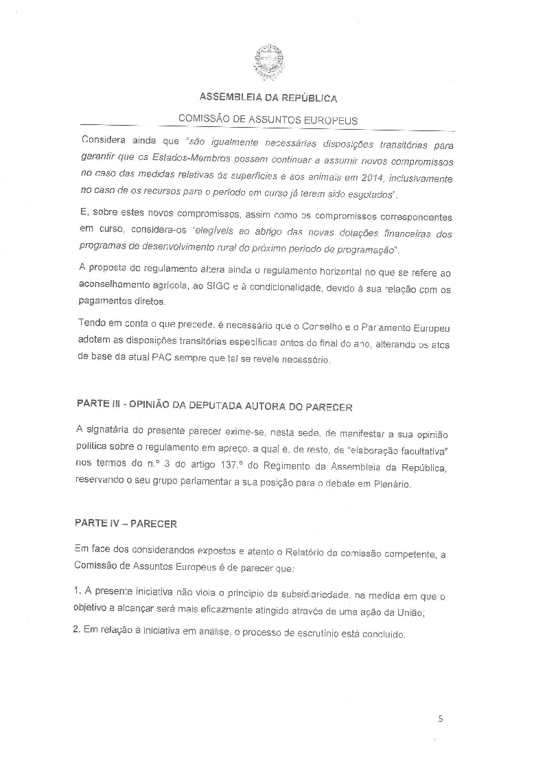


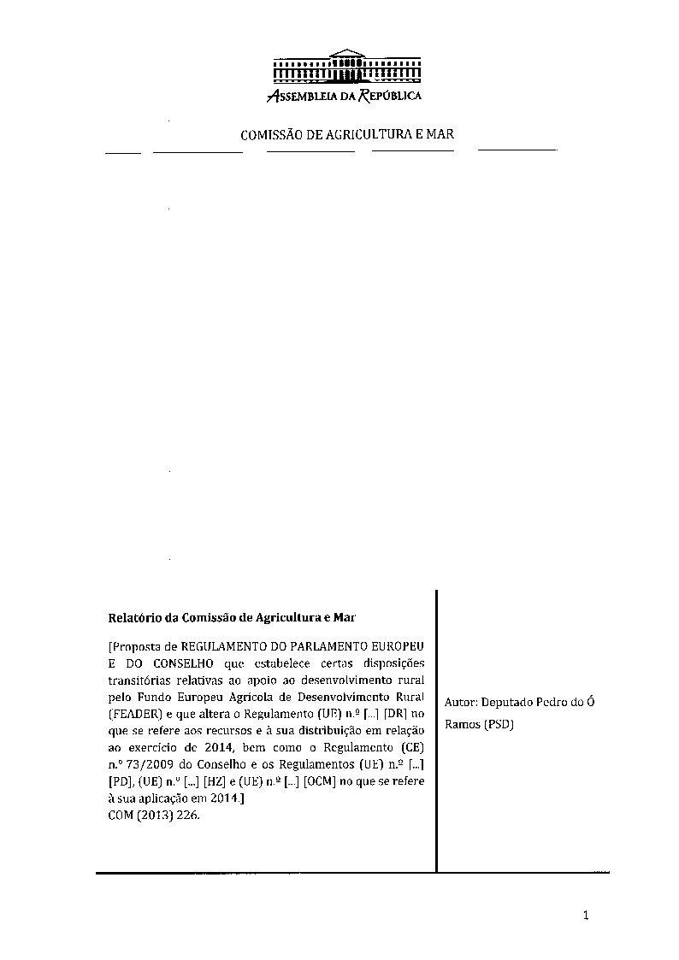
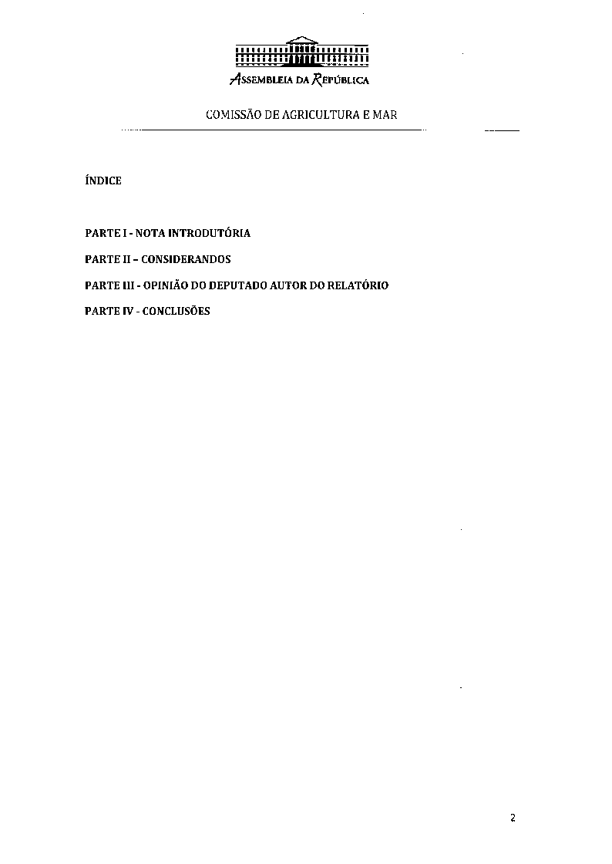
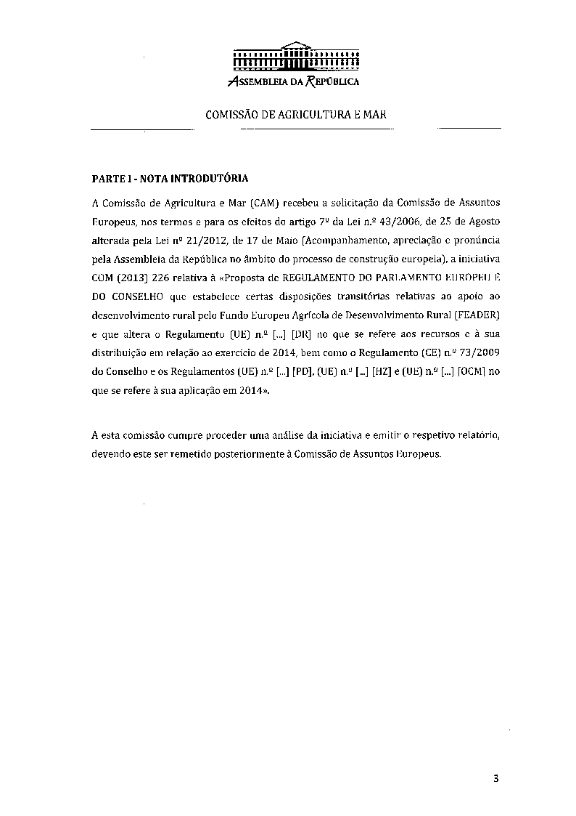
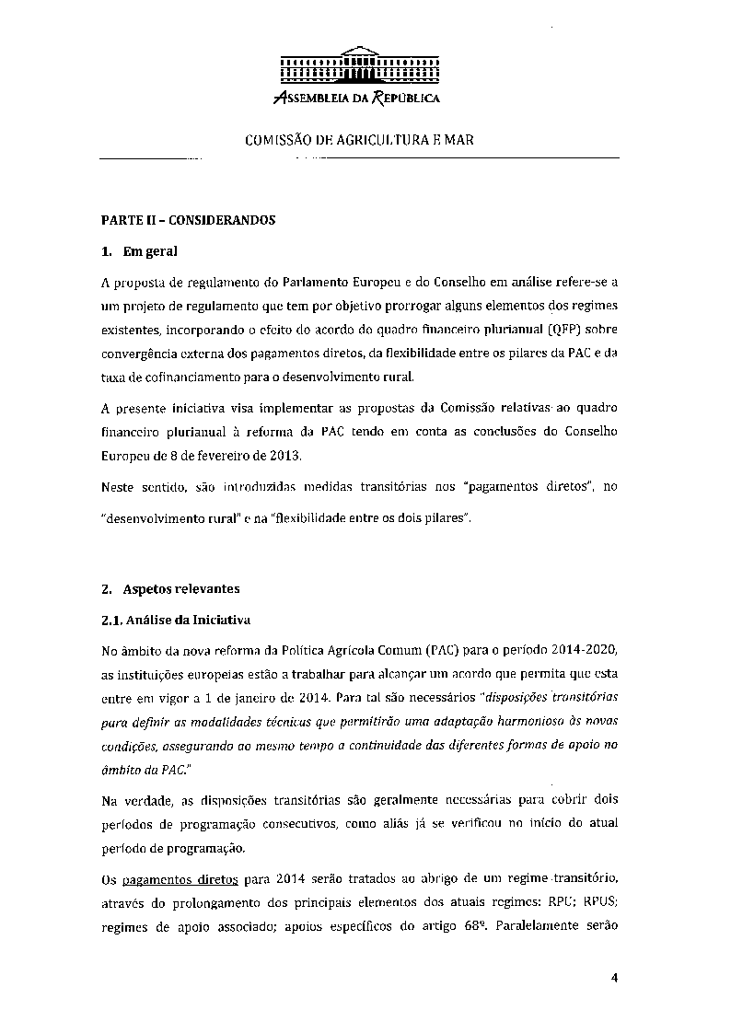
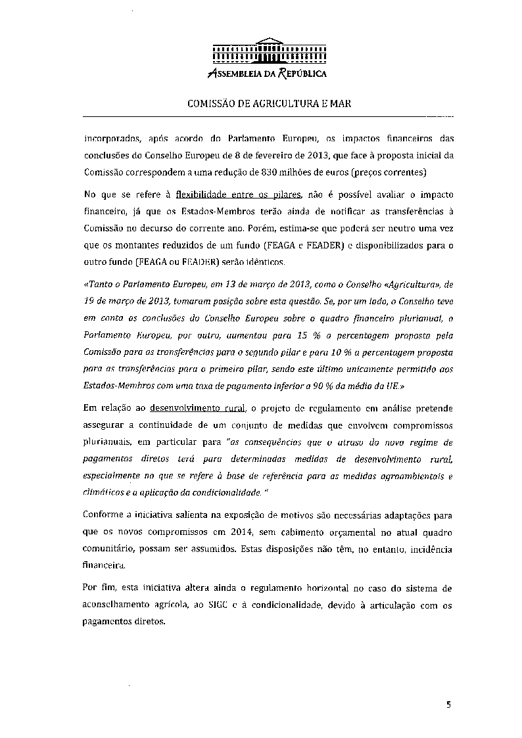
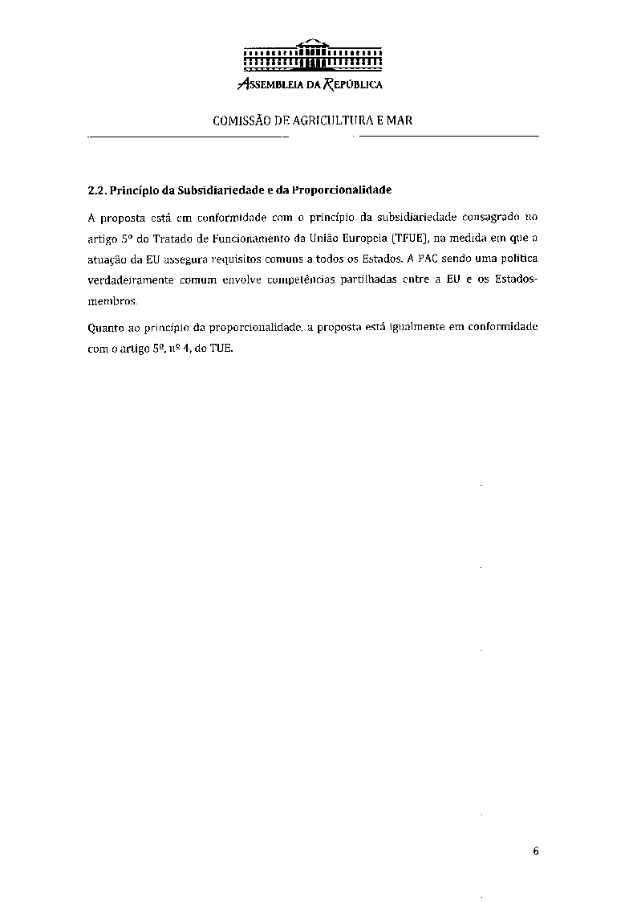
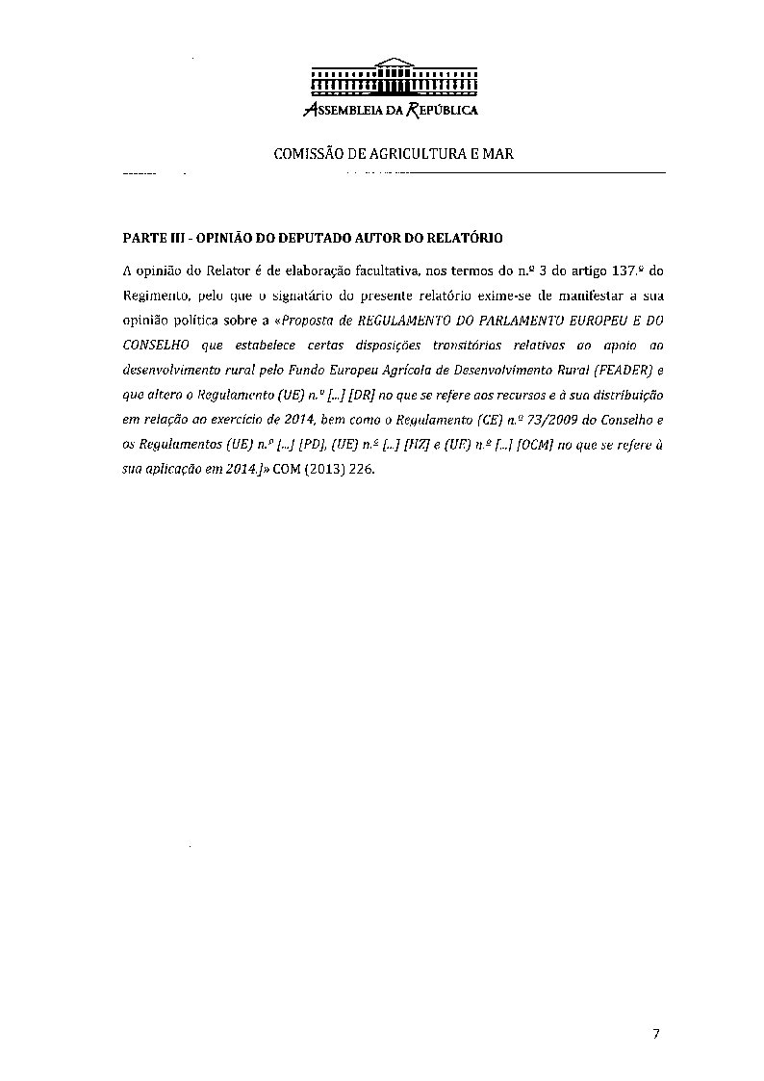
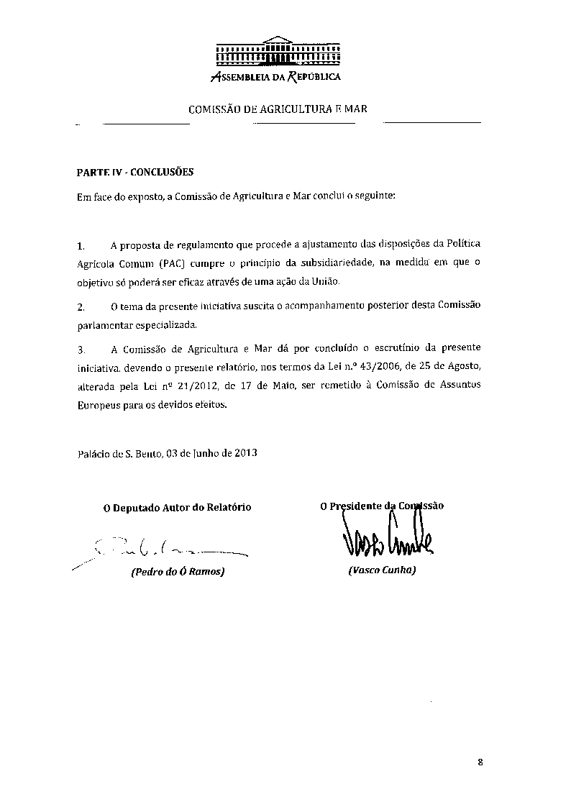
_______________

The translation can be found at the Interparliamentary EU information exchange site IPEX at the following address: http://www.ipex.eu/IPEXL-WEB/search.do

