 | 
COUNCIL OF  THE EUROPEAN UNION |  |  | Brussels, 27 June 2013
 | Interinstitutional File:  2013/0119 (COD) |  | 11611/13
JUSTCIV 151
FREMP 94
CODEC 1611
INST 349
PARLNAT 157

COVER NOTE
from: | the Romanian Senate
Date of receipt: | 15 June 2013
to: | Enda Kenny, President of the Council of the European Union
Subject: | Proposal for a Regulation of the European Parliament and of the Council on promoting the free movement of citizens and businesses by simplifying the acceptance of certain public documents in the European Union and amending Regulation (EU) No 1024/2012  [doc. 9037/13 JUSTCIV 108 FREMP 70 CODEC 952 - COM(2013) 228 final]  - Reasoned Opinion on the application of the Principles of Subsidiarity and Proportionality

Delegations will find attached a copy of the above mentioned opinion.

_______________________

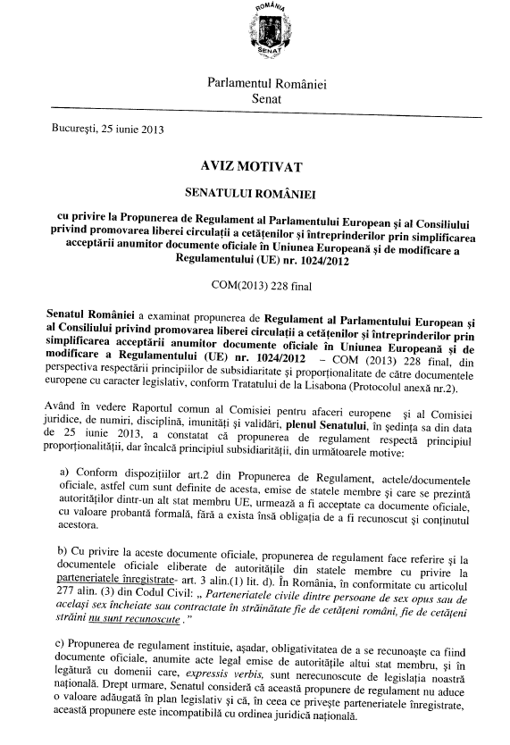
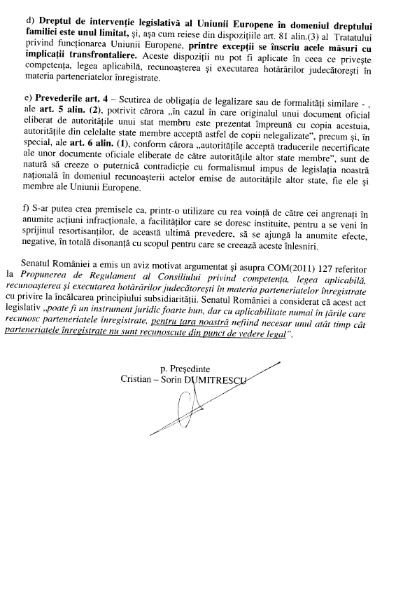
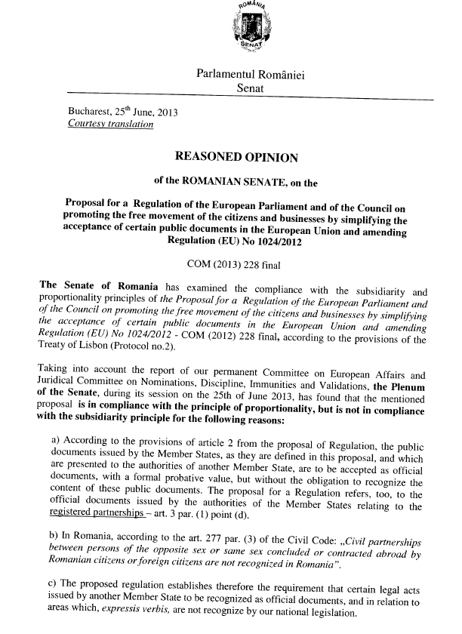
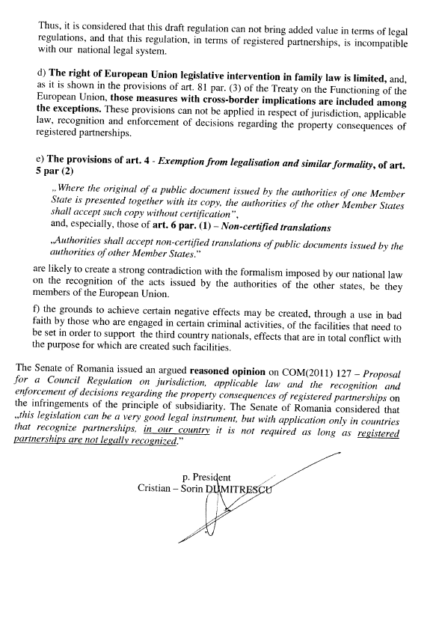
_______________

For other available language versions of the opinion, reference is made to the Interparliamentary EU information exchange Internet site (IPEX) at the following address: http://www.ipex.eu/IPEXL-WEB/search.do

