 | 
COUNCIL OF  THE EUROPEAN UNION |  |  | Brussels, 24 June 2013
 | Interinstitutional File:  2013/0110 (COD) |  | 11529/13
DRS 127
COMPET 526
ECOFIN 638
SOC 542
CODEC 1598
INST 343
PARLNAT 156

COVER NOTE
from: | Portuguese Parliament
date of receipt: | 18 June 2013
No Cion doc.: | 8638/13 DRS 75 COMPET 226 ECOFIN 282 SOC 259 CODEC 859  - COM(2013) 207 final
Subject: | Proposal for a DIRECTIVE OF THE EUROPEAN PARLIAMENT AND OF THE COUNCIL amending Council Directives 78/660/EEC and 83/349/EEC as regards disclosure of non-financial and diversity information by certain large companies and groups  - Opinion on the application of the Principles of Subsidiarity and Proportionality

Delegations will find attached the Opinion of the Portuguese Parliament on the above proposal.

________________________

Encl.:

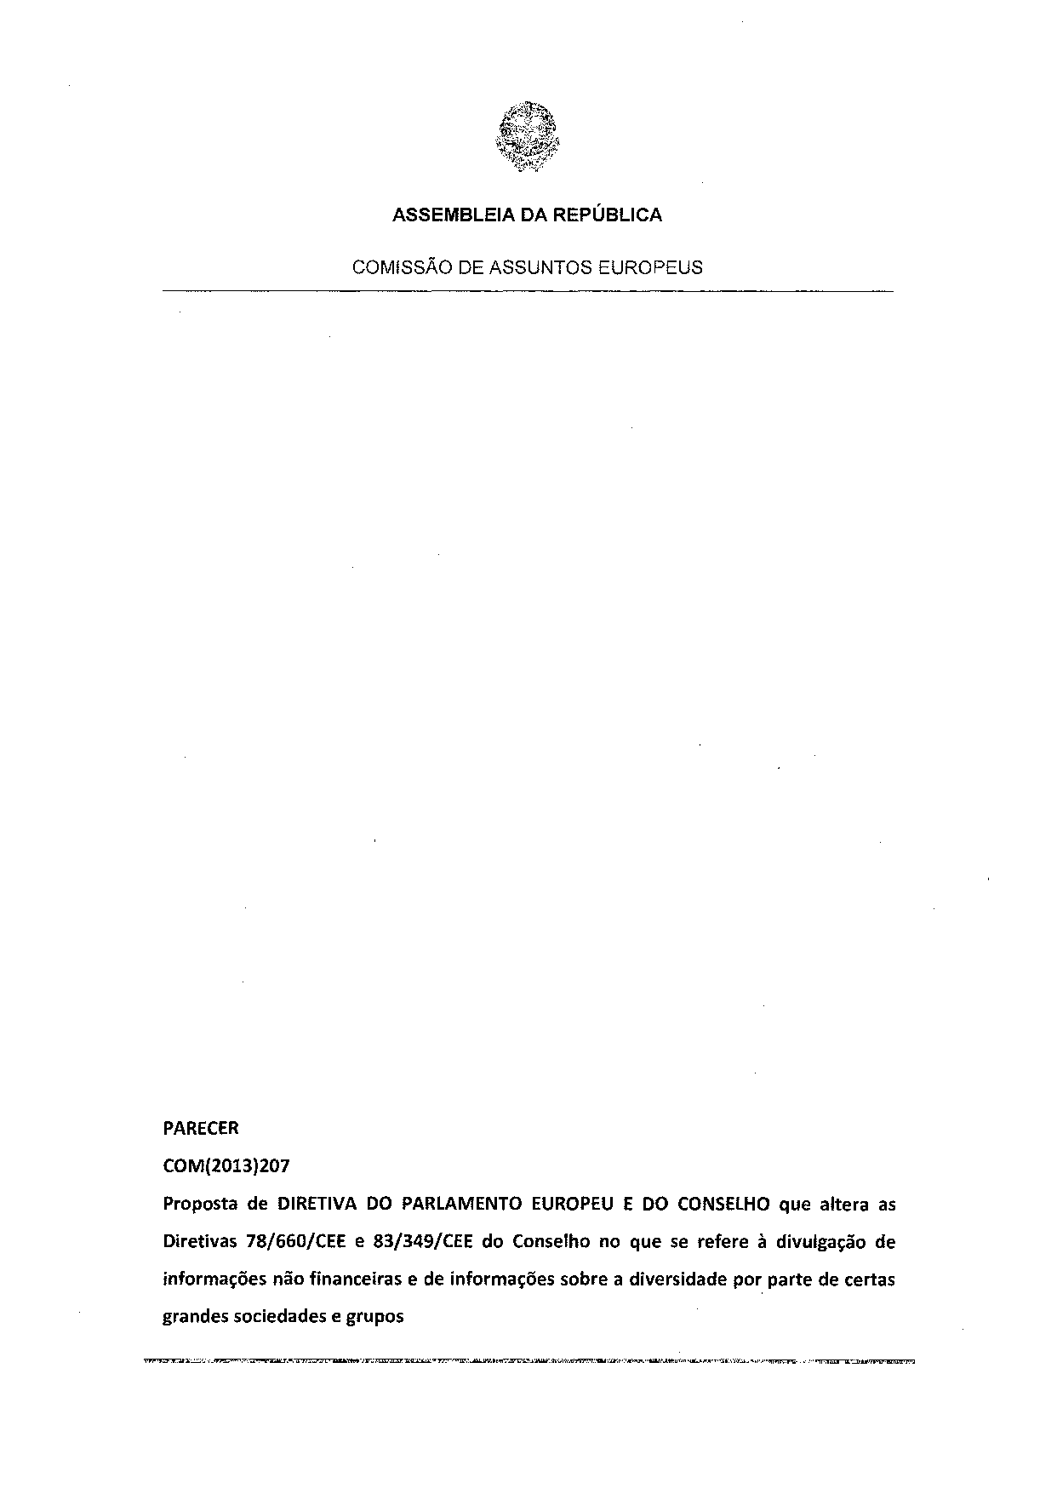
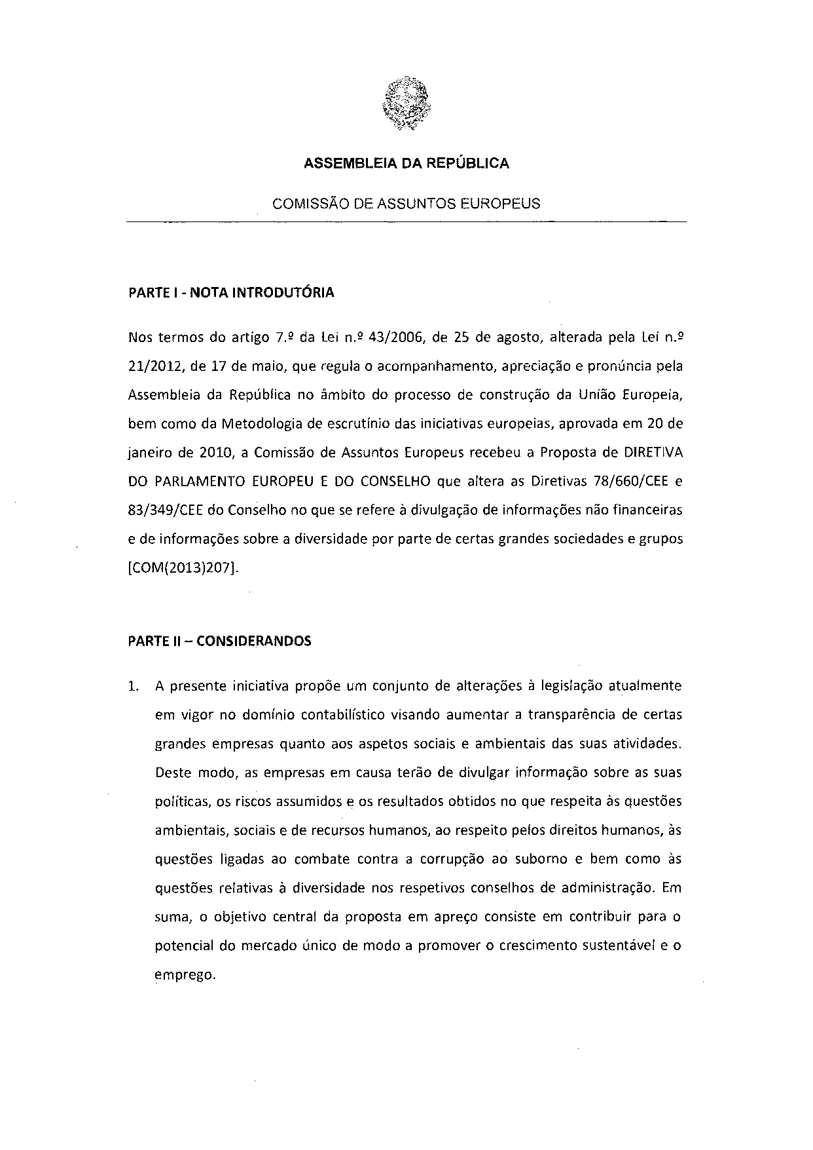
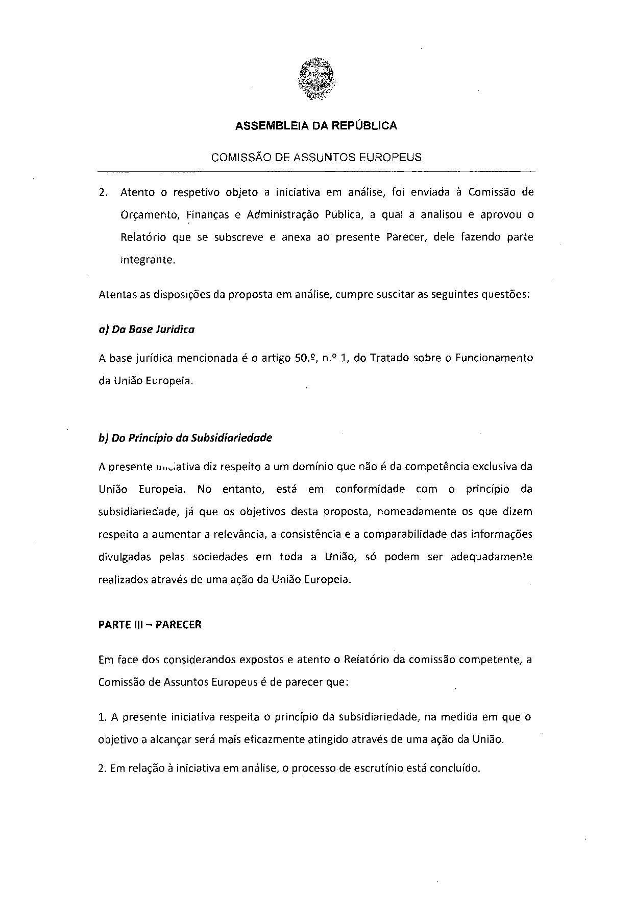
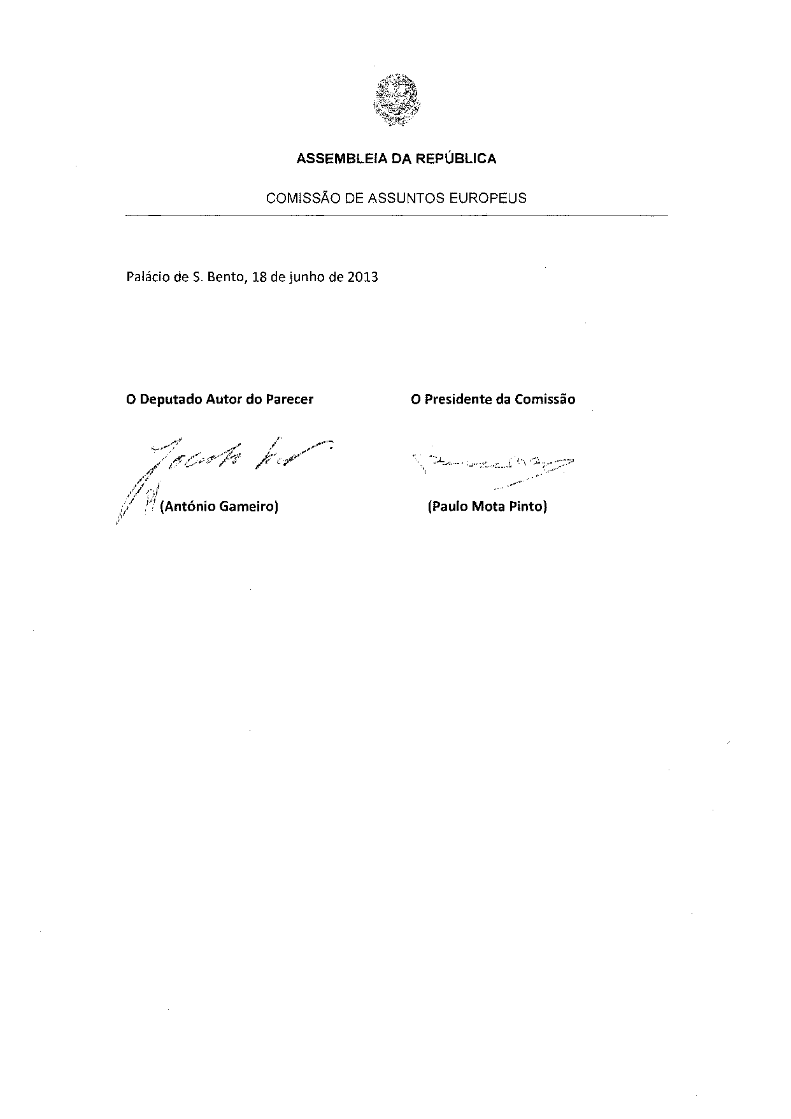


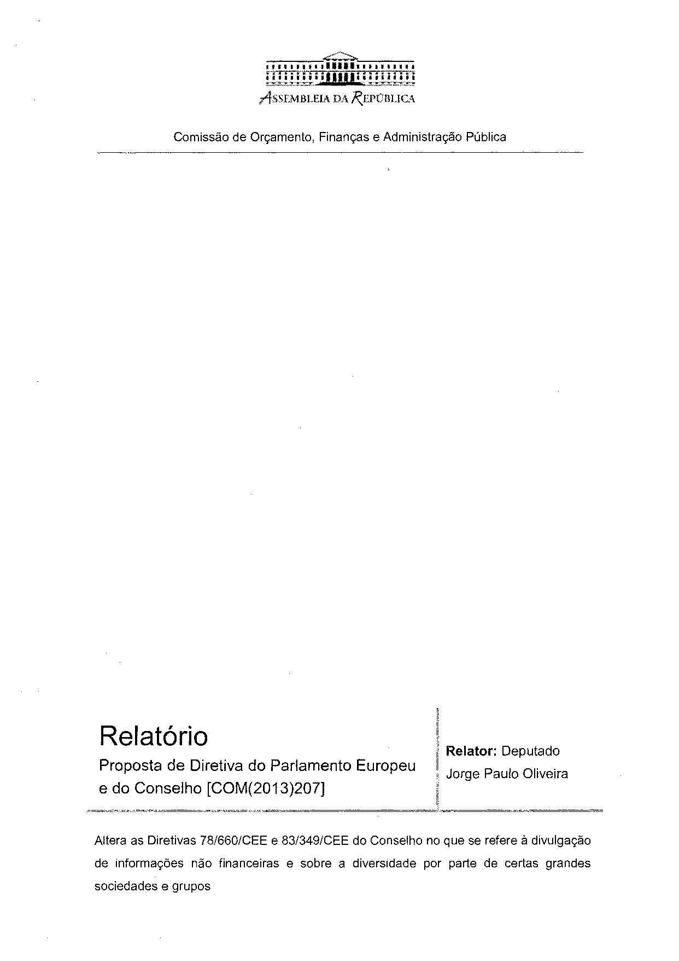
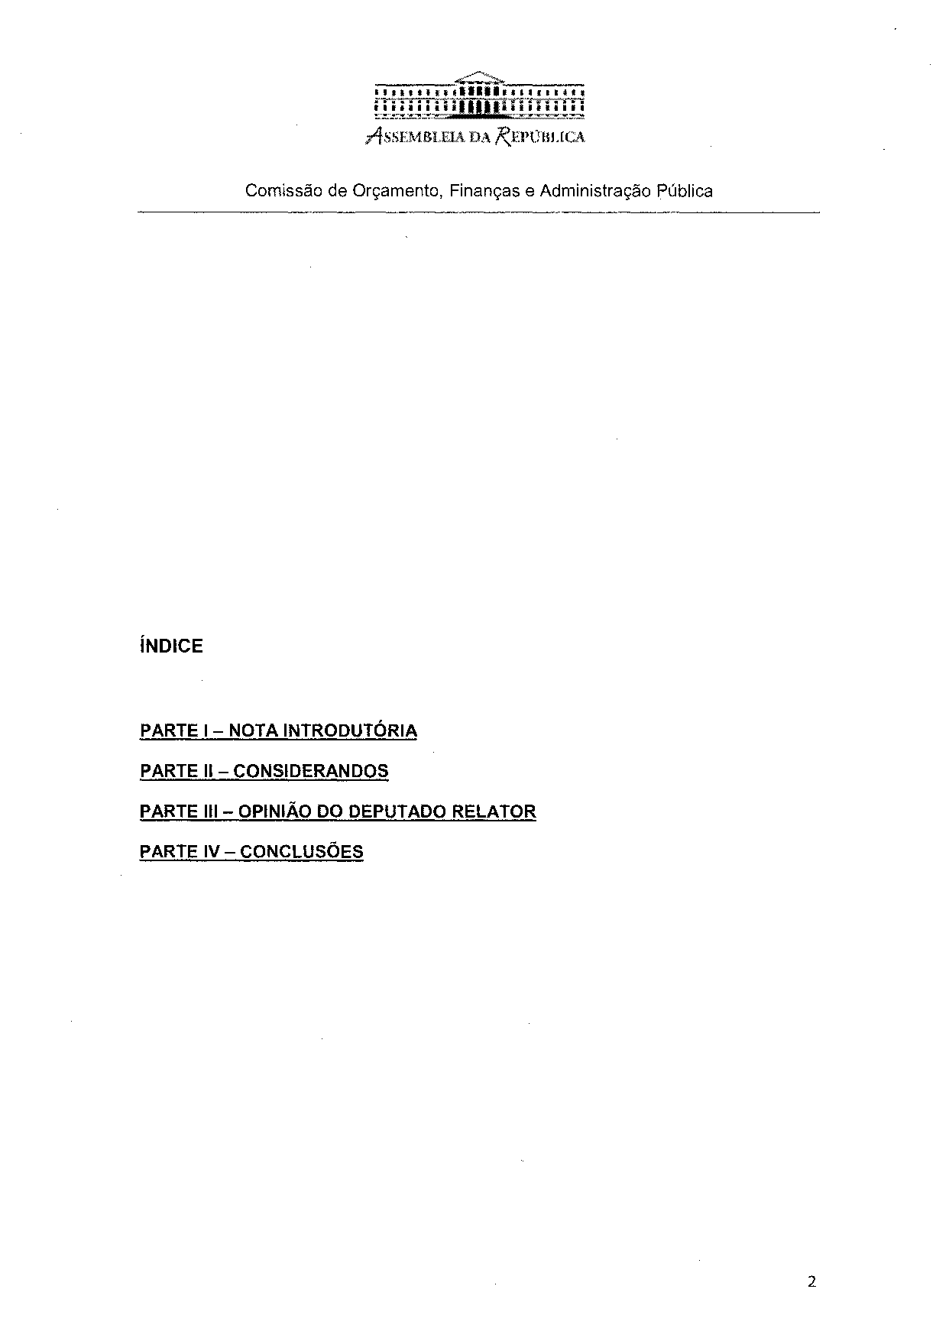
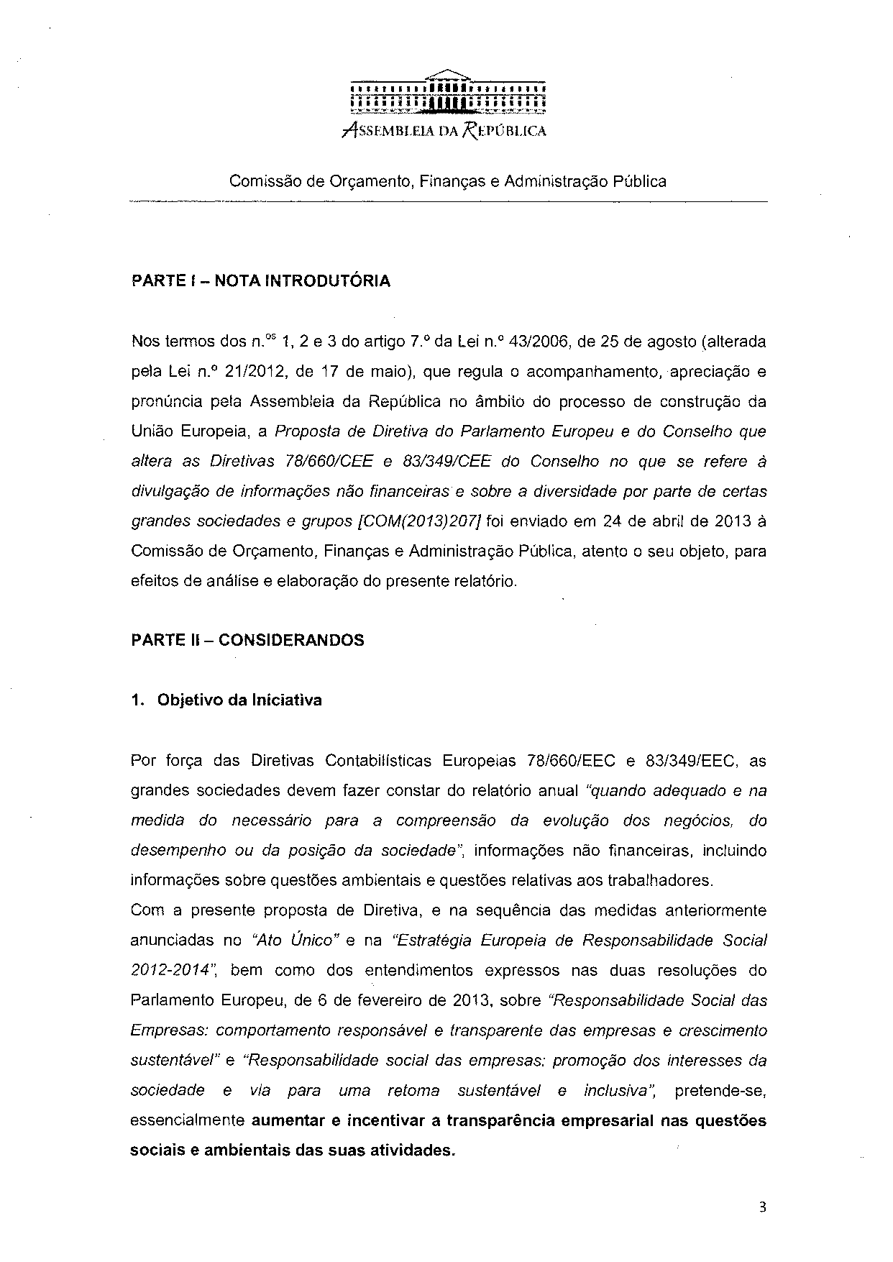
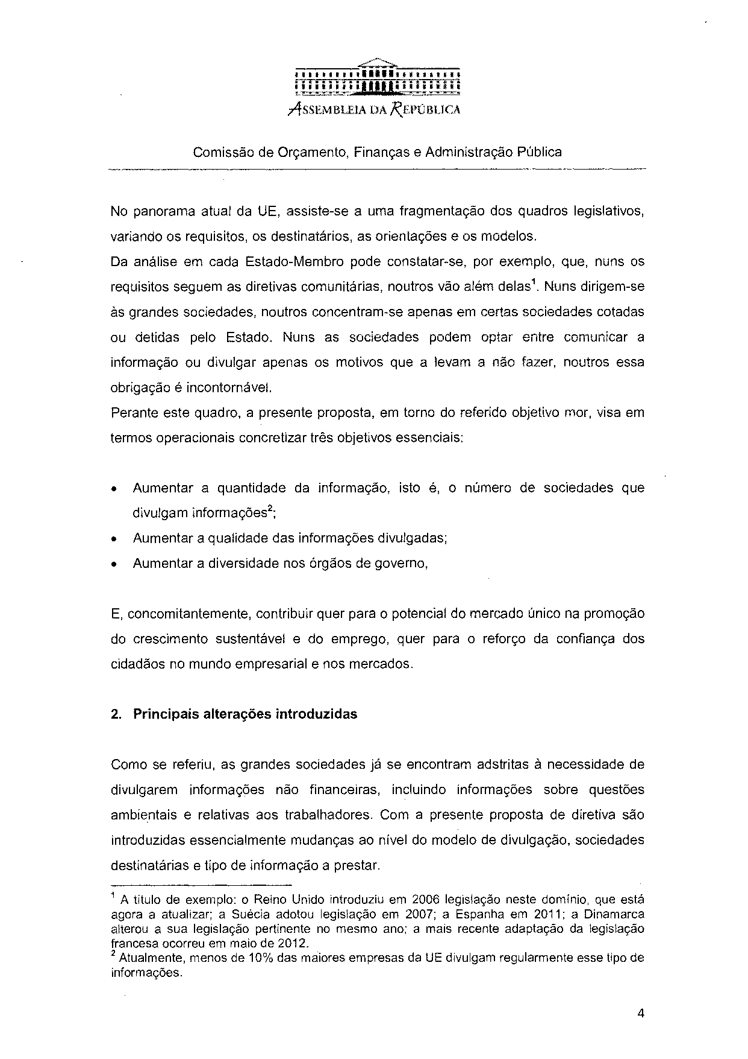
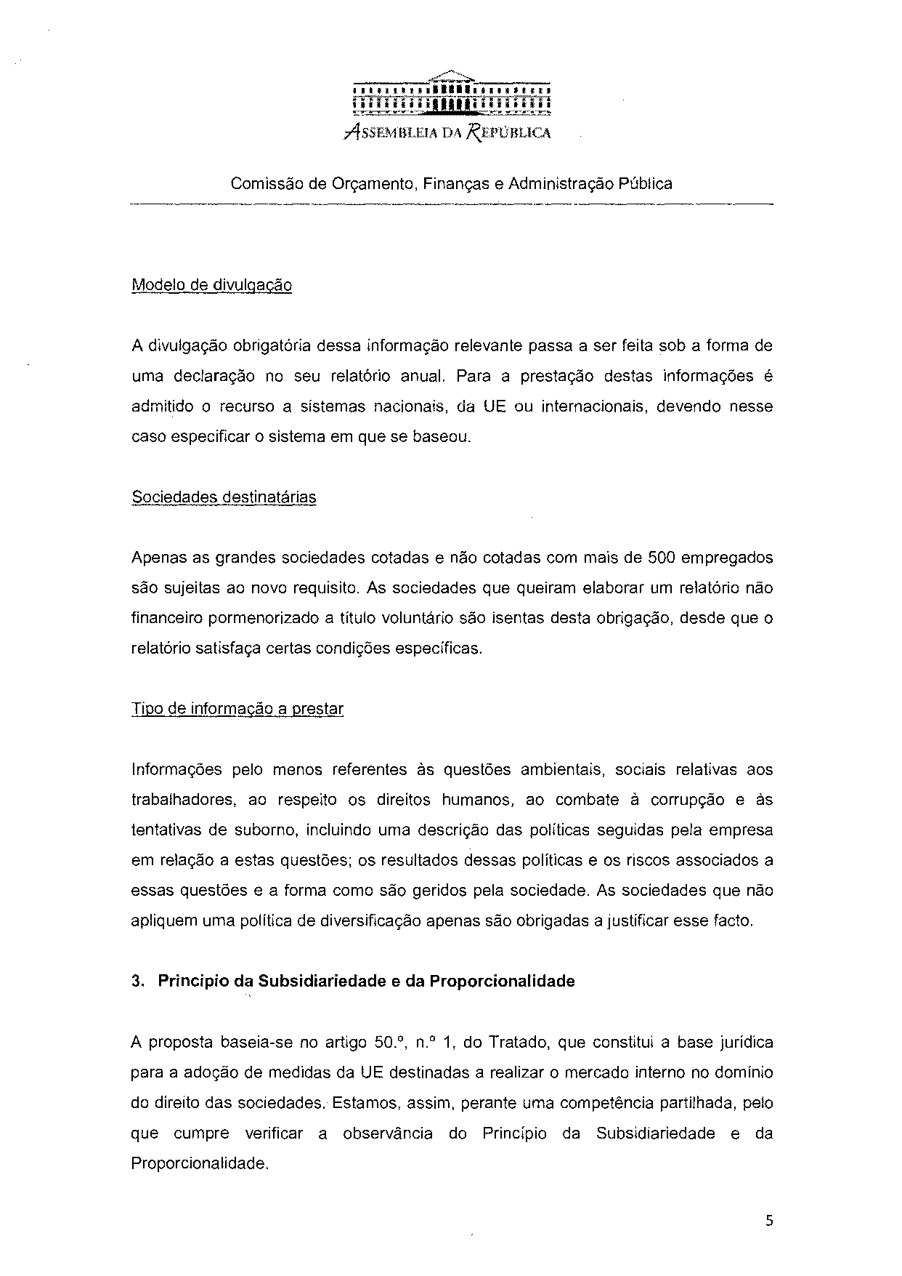
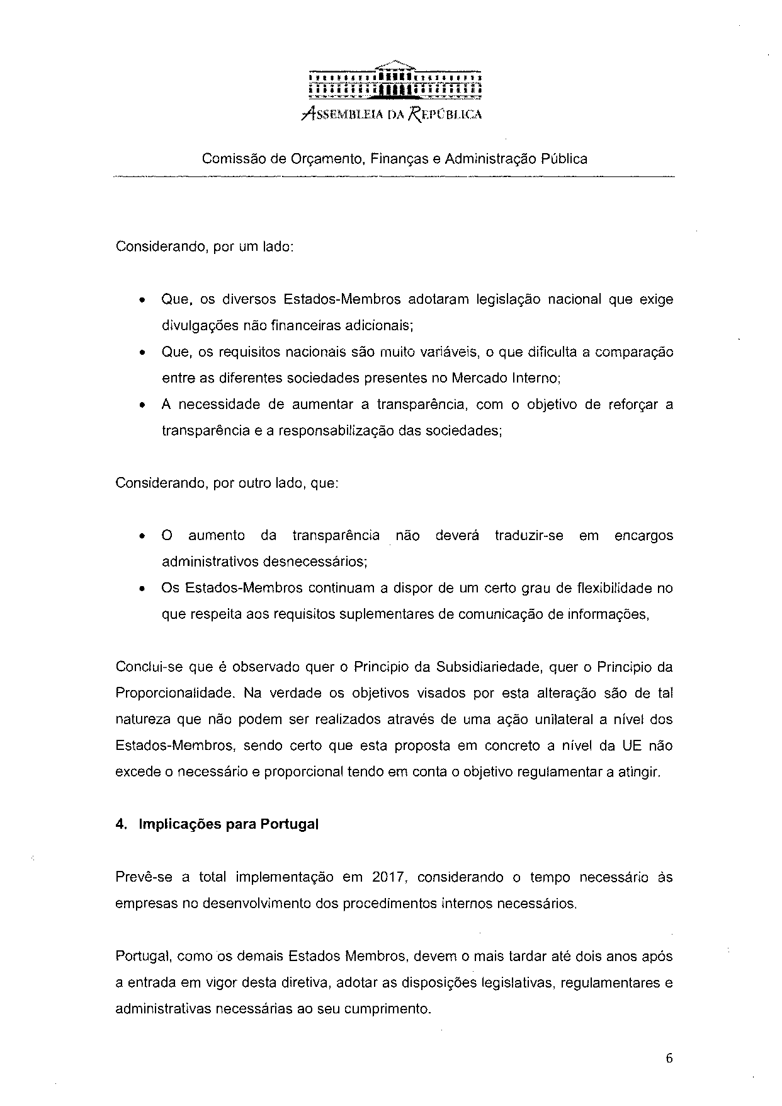
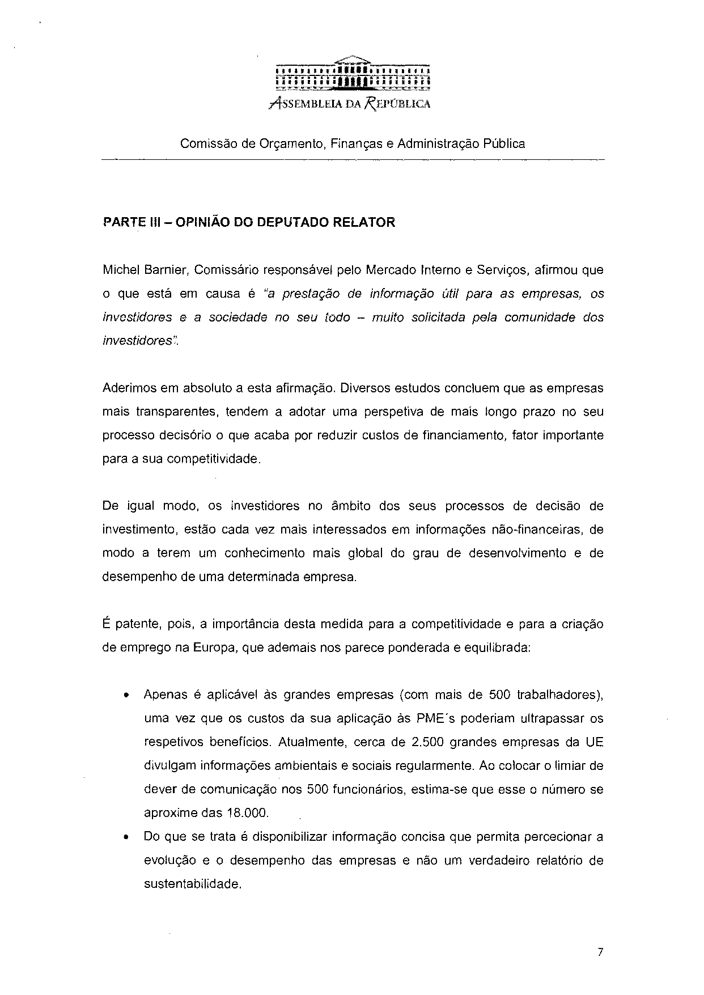
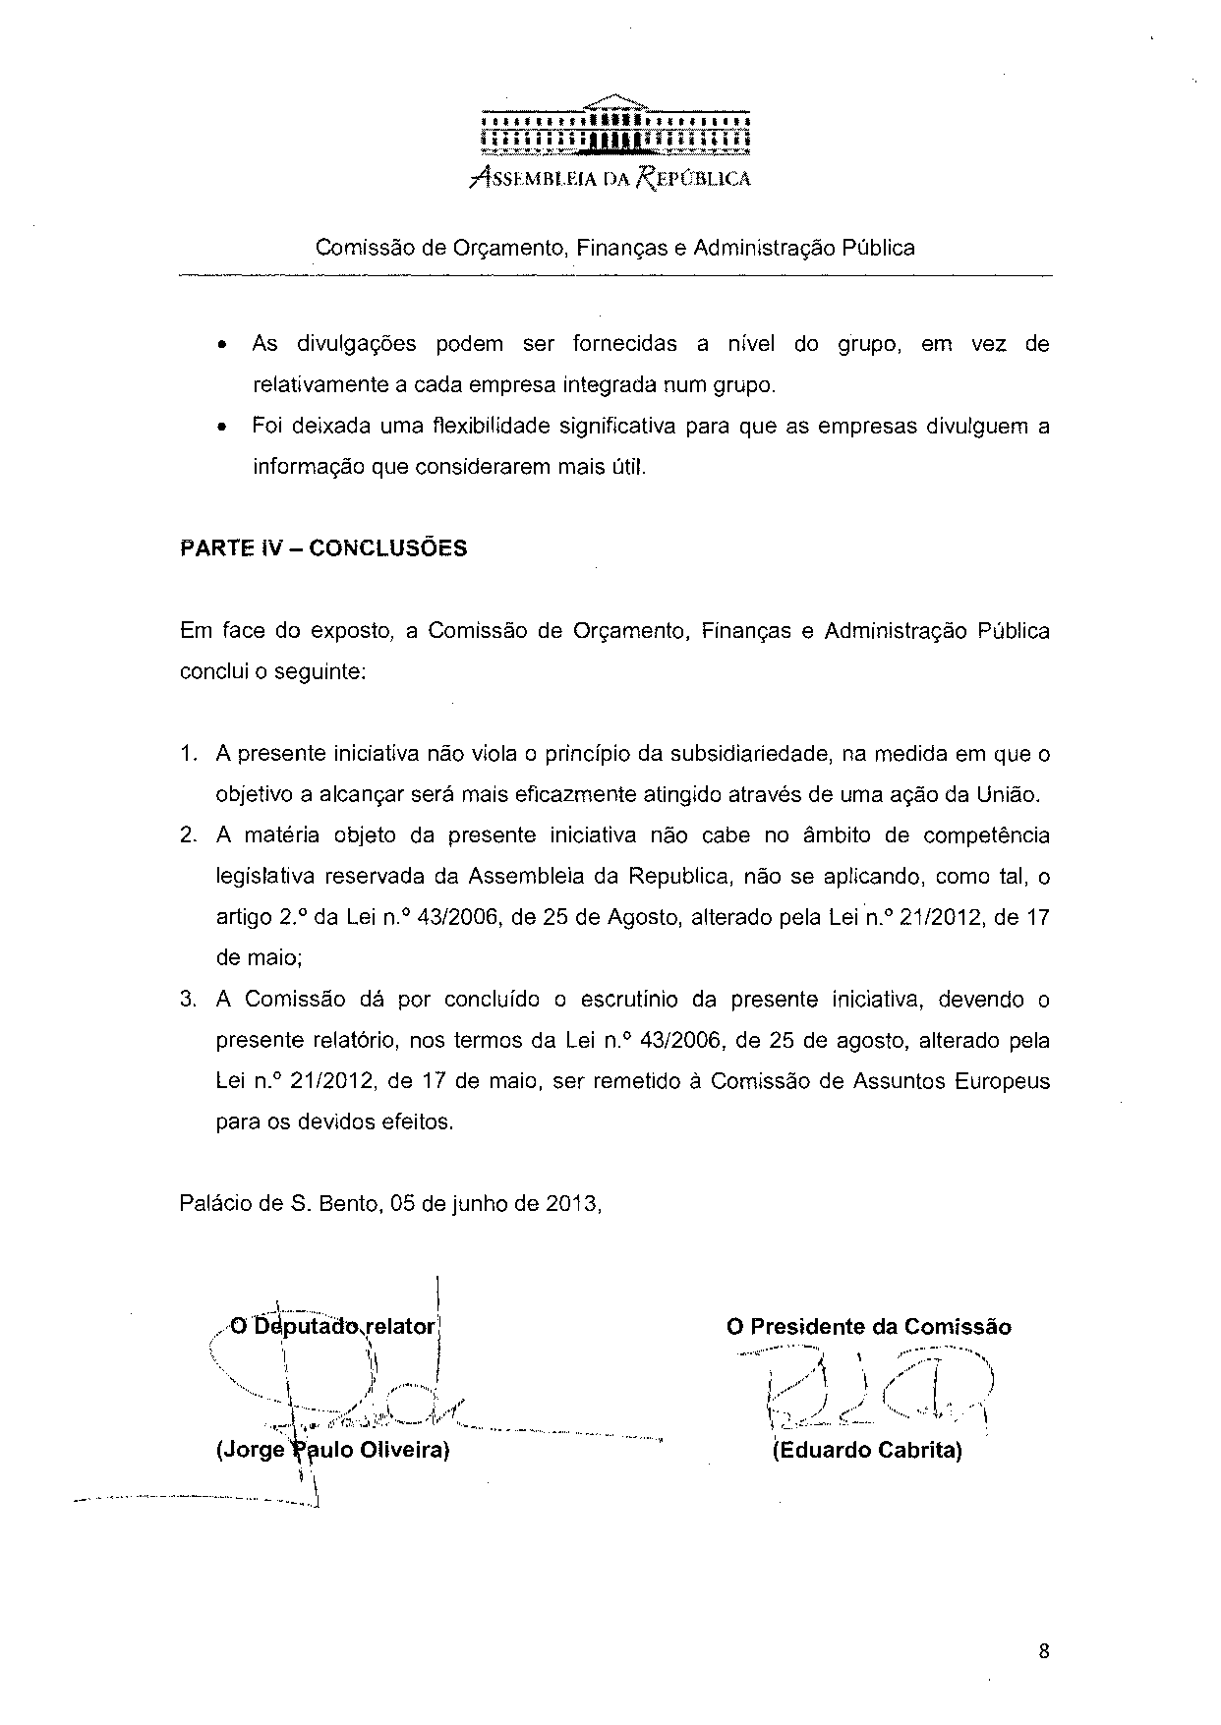

Translation may be available at the Interparliamentary EU information exchange site IPEX at the following address: http://www.ipex.eu/IPEXL-WEB/search.do

