 | 
COUNCIL OF  THE EUROPEAN UNION |  |  | Brussels, 20 June 2013
 | Interinstitutional File:  2011/0380 (COD) |  | 11308/13
PECHE 273
CODEC 1546
CADREFIN 156
FC 31
INST 325
PARLNAT 147

COVER NOTE
from: | Ms Assunção ESTEVES, President of the Assembly of the Republic of Portugal
date of receipt: | 18 June 2013
to: | Mr Eamon GILMORE, President of the Council of the European Union
Subject: | Amended proposal for a Regulation of the European Parliament and of the Council on the European Maritime and Fisheries Fund [repealing Council Regulation (EC) No 1198/2006 and Council Regulation (EC) No 861/2006 and Council Regulation No XXX/2011 on integrated maritime policy]  [doc. 8883/13 PECHE 234 CODEC 1284 CADREFIN 128 FC 26 -  COM (2013) 245 final]  - Opinion on the application of the Principles of Subsidiarity and Proportionality

Delegations will find attached an opinion of the Portuguese Parliament on the above-mentioned subject.

________________________
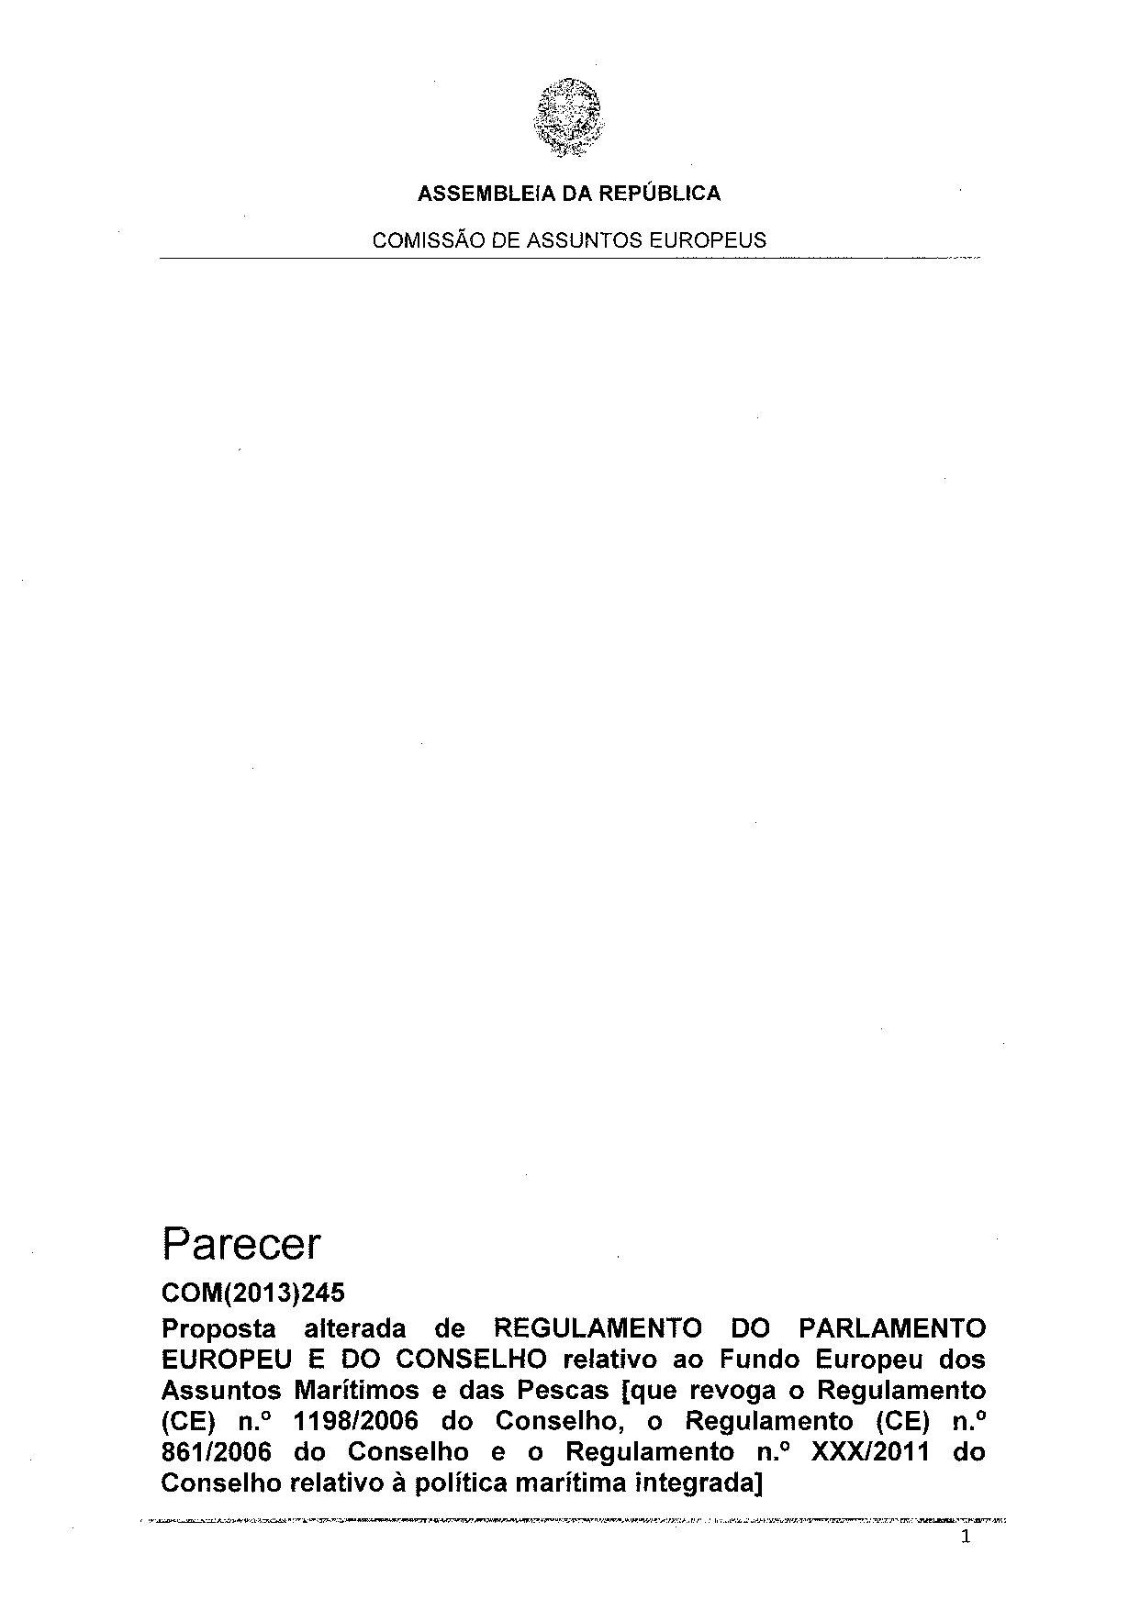
ANNEX

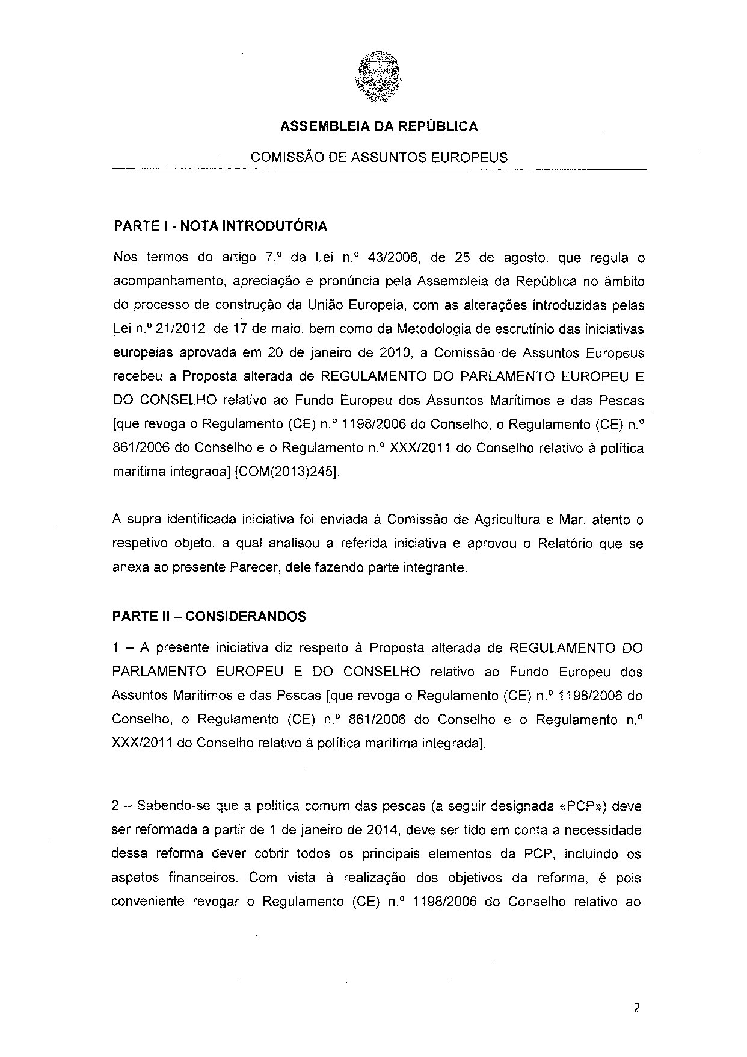
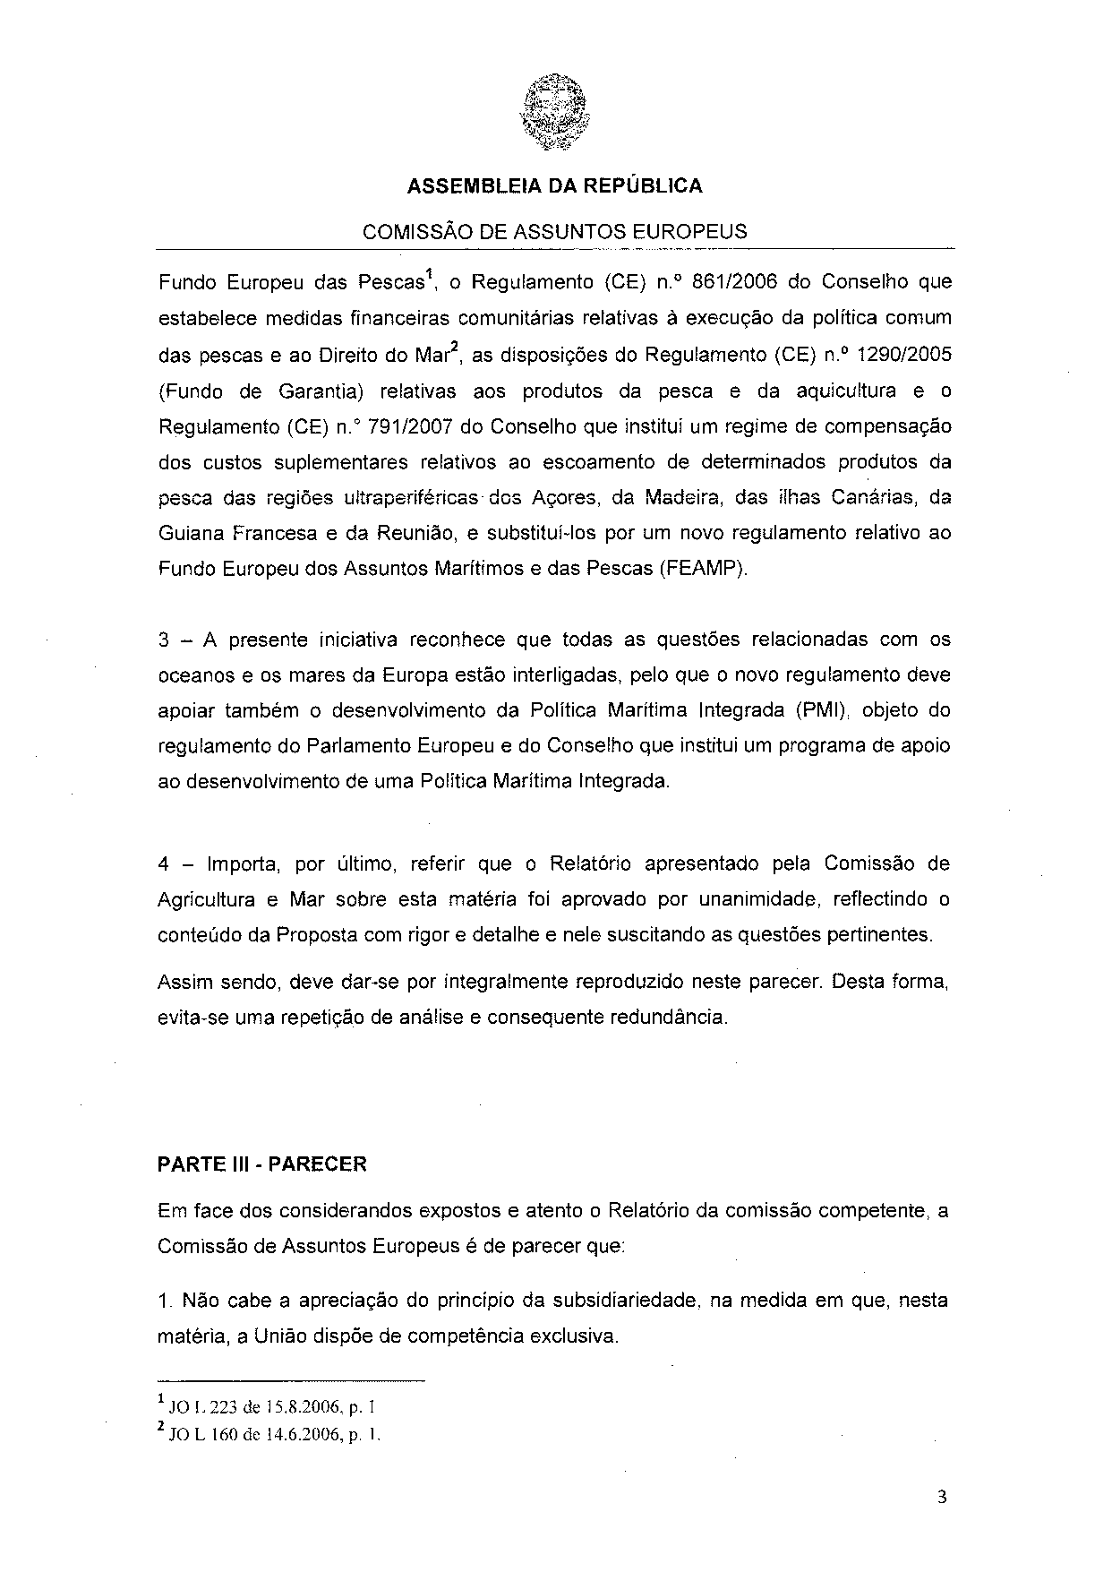
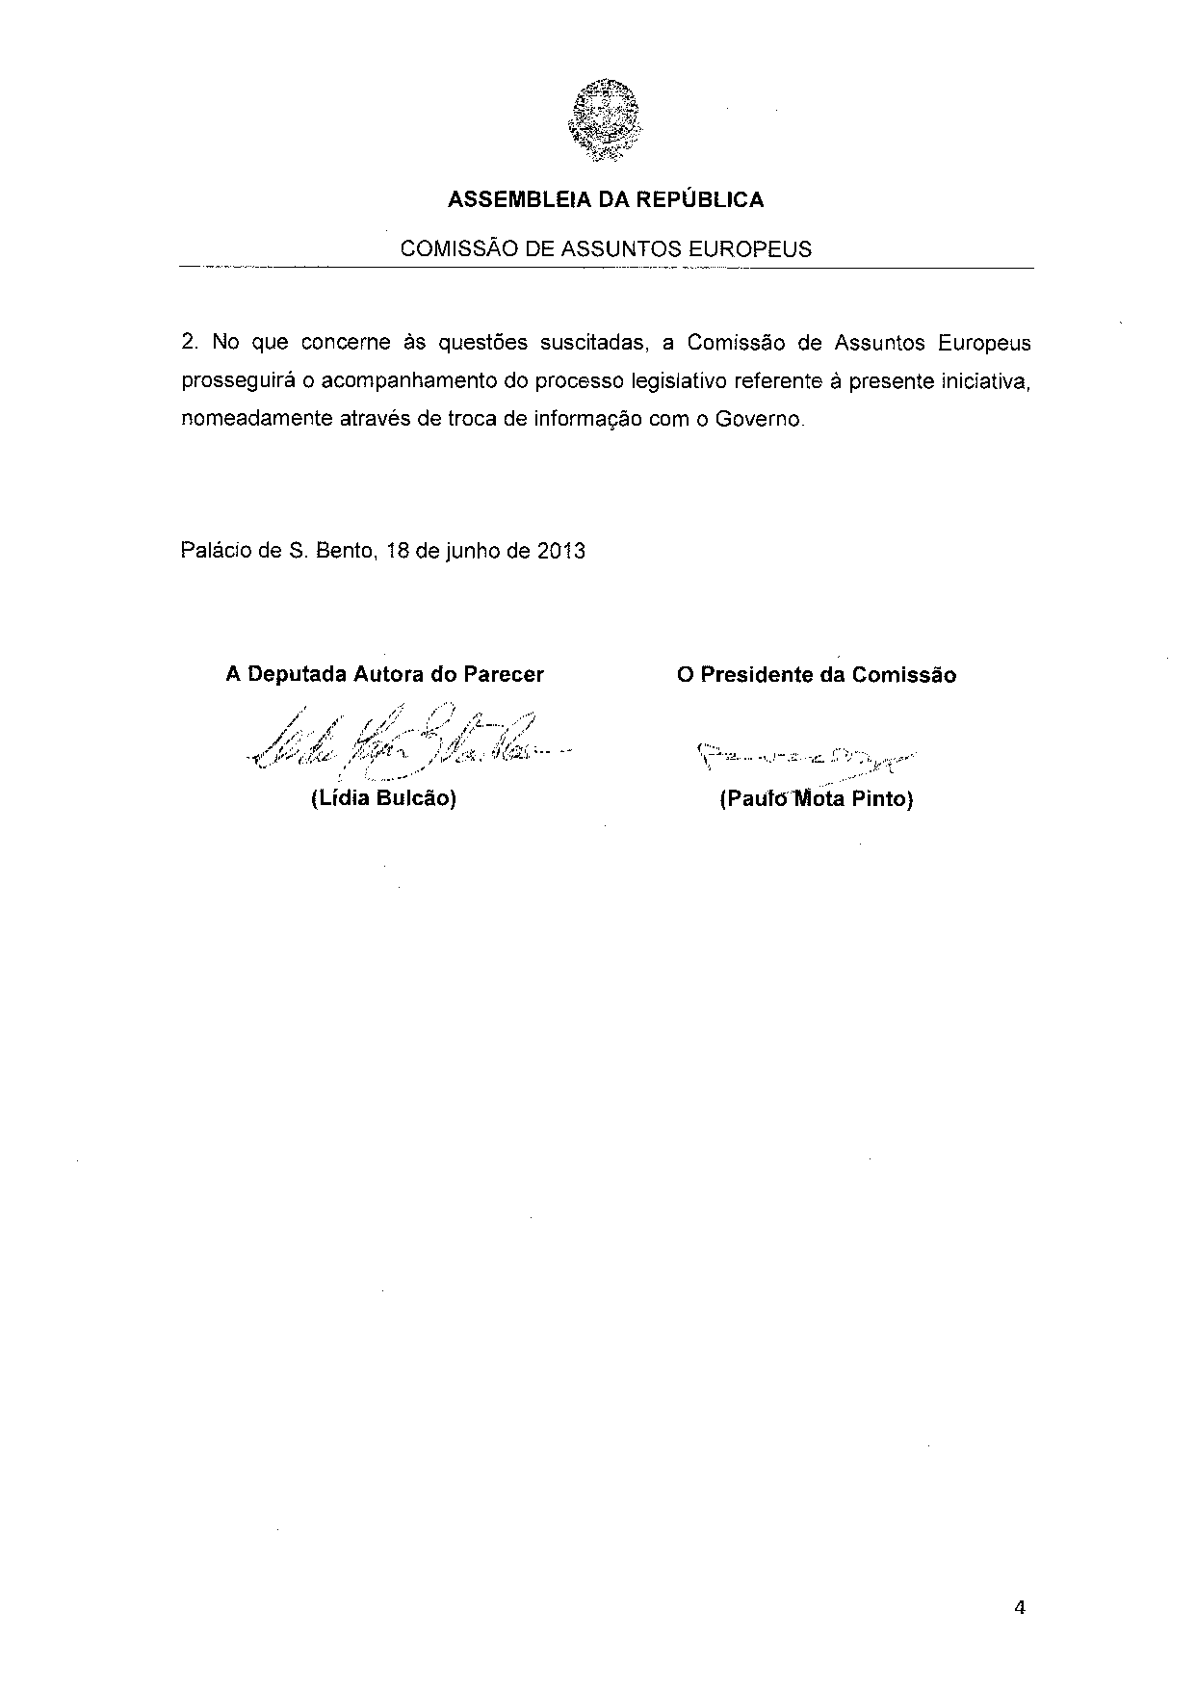
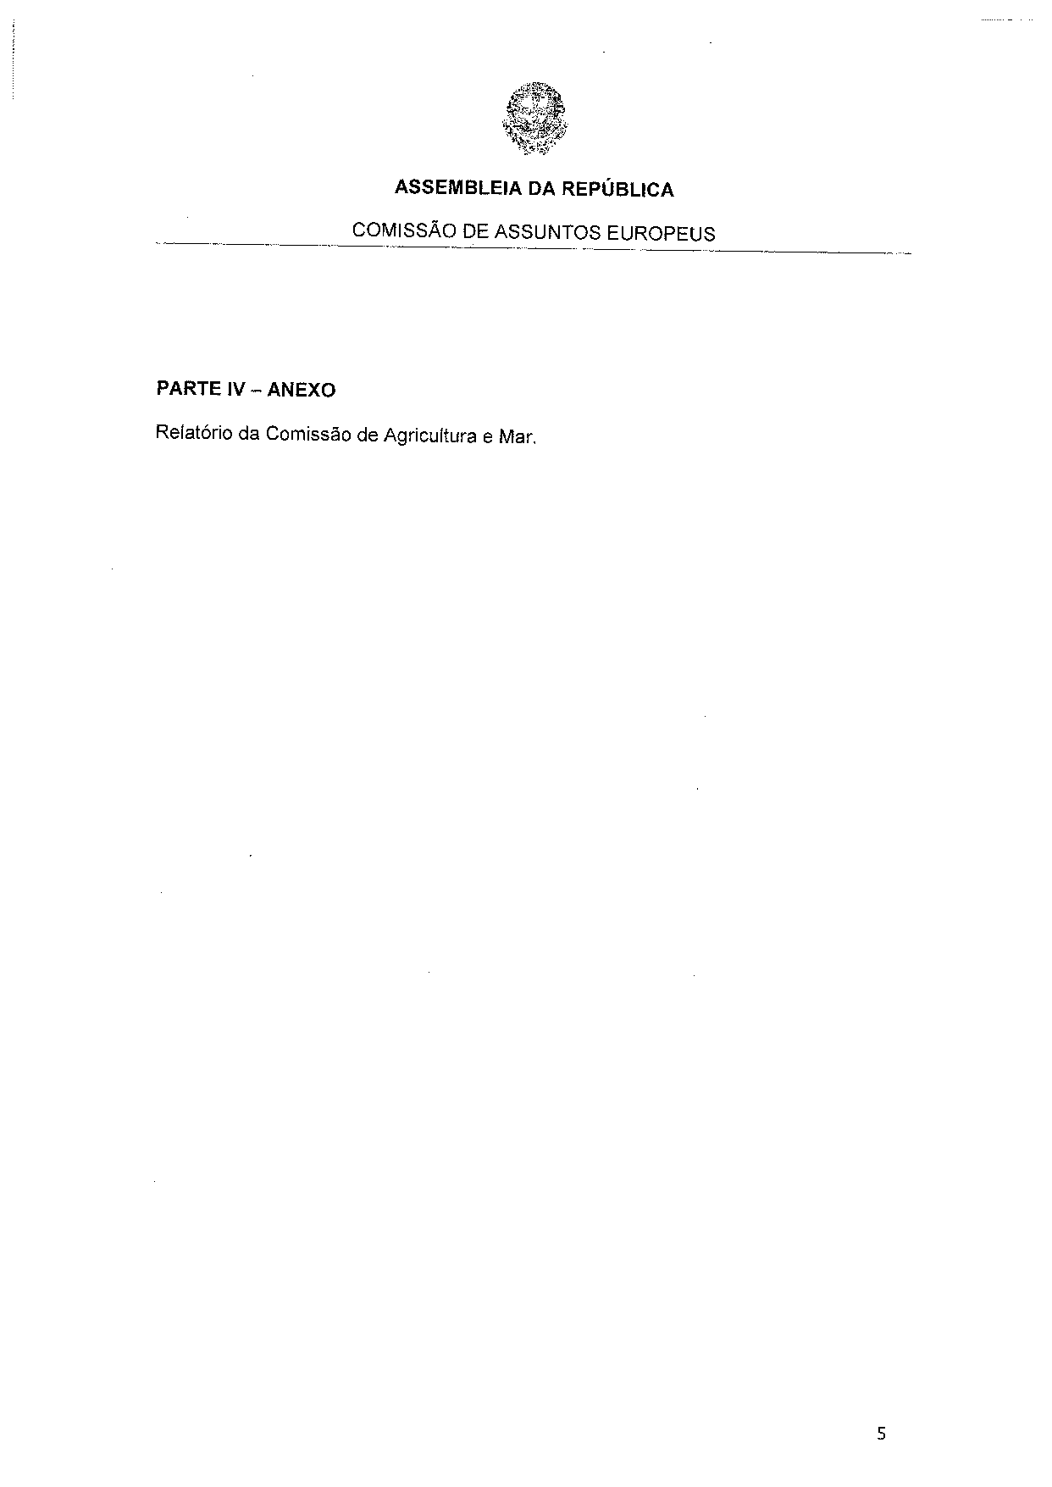
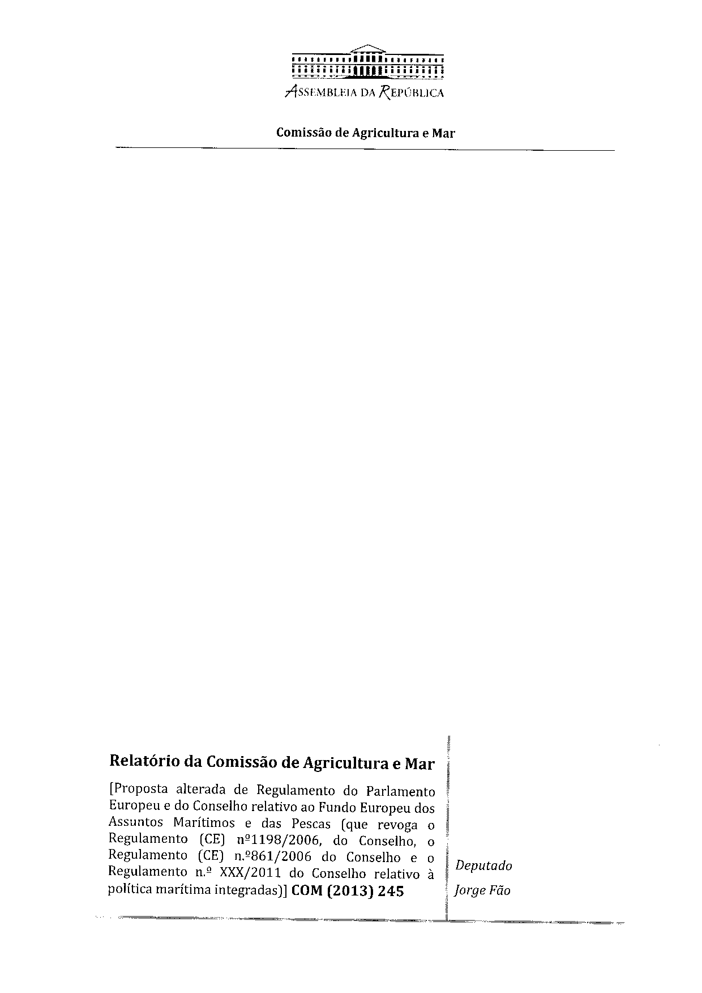
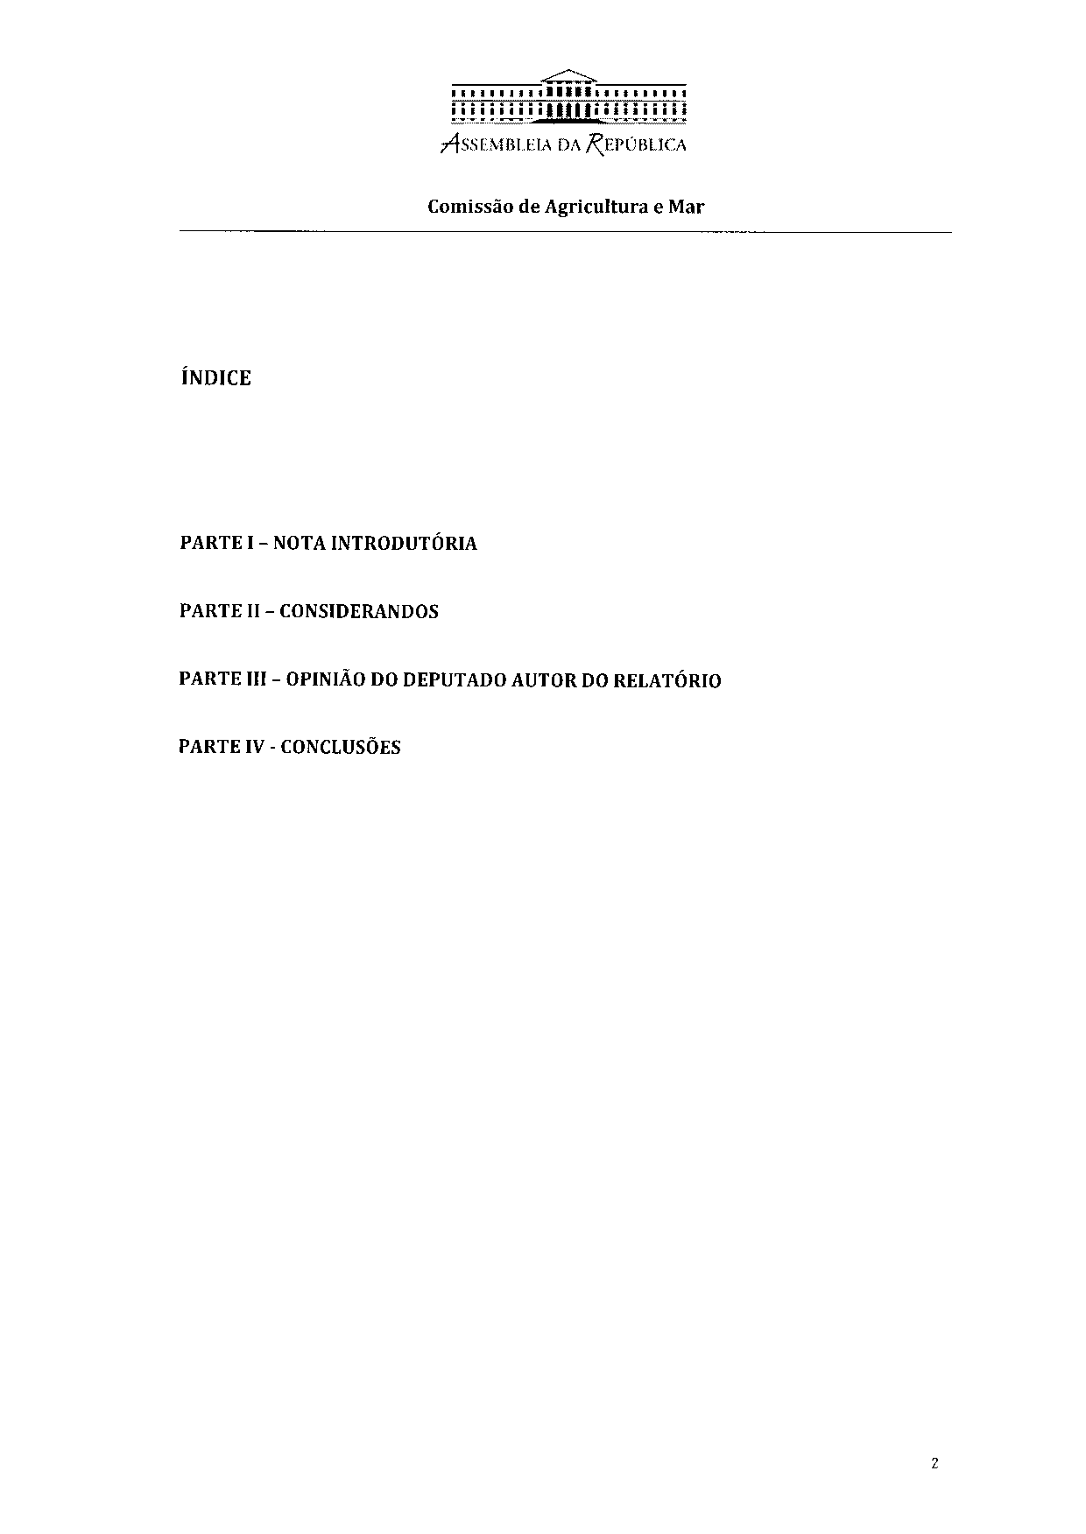
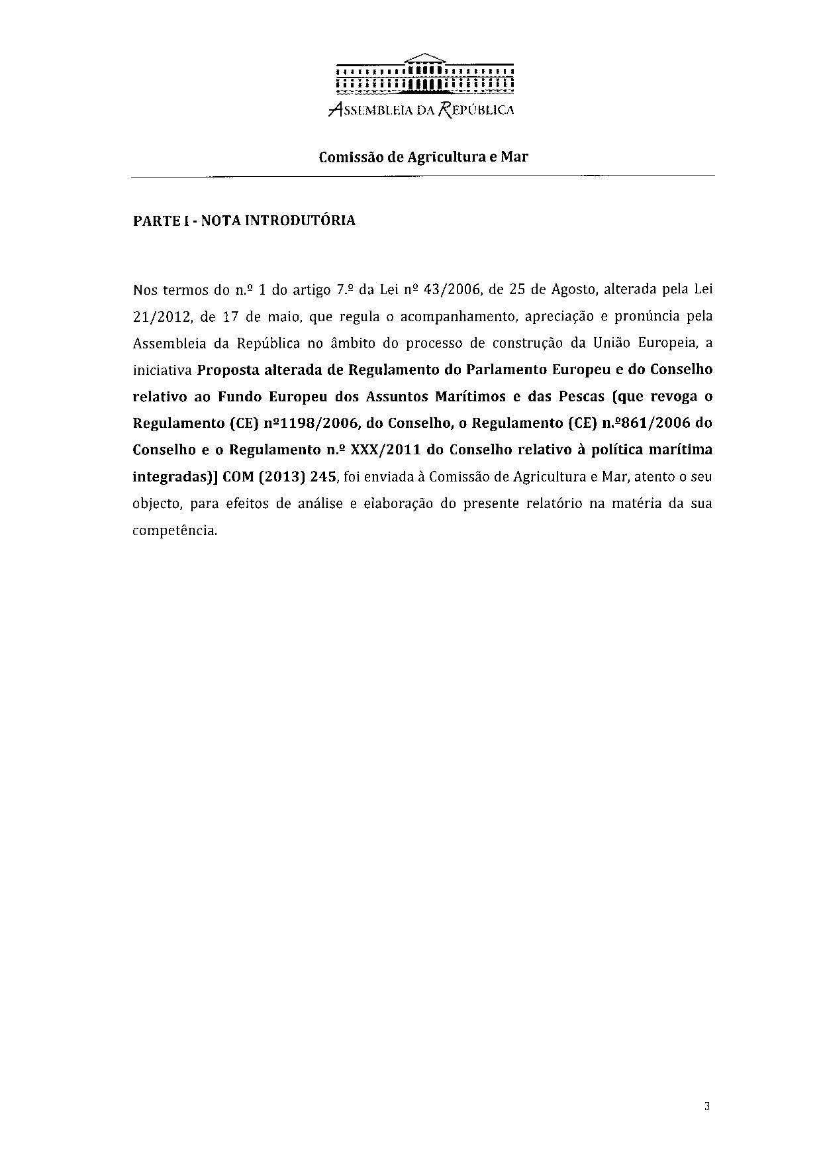
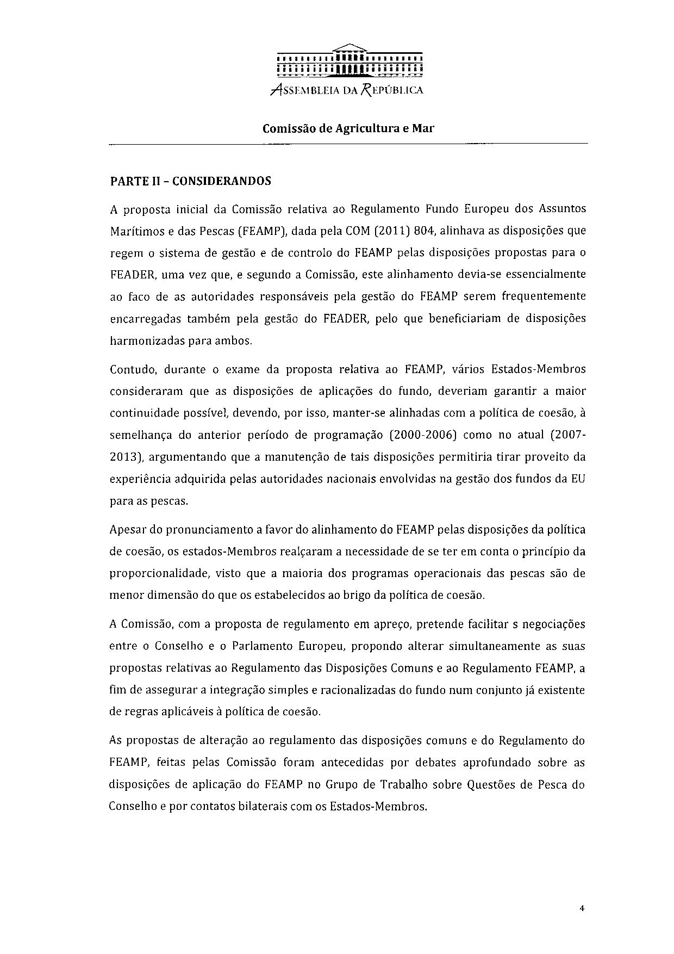
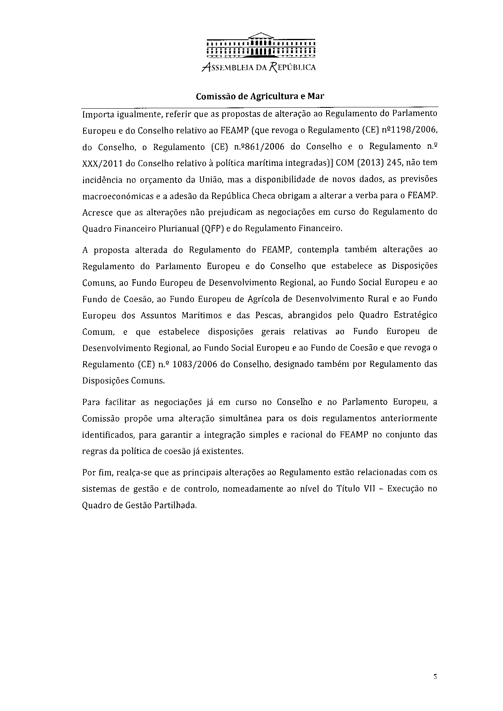
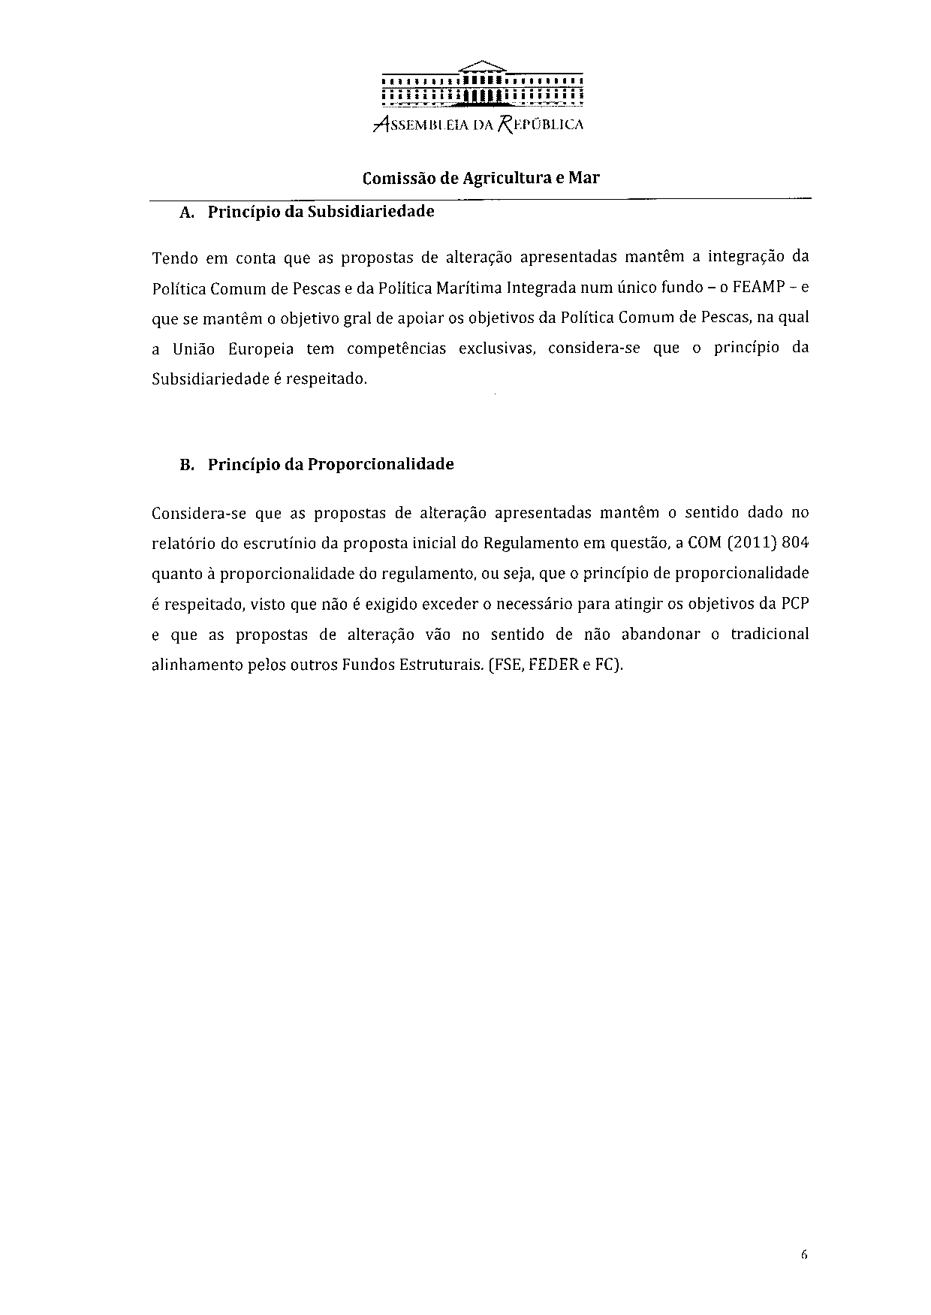
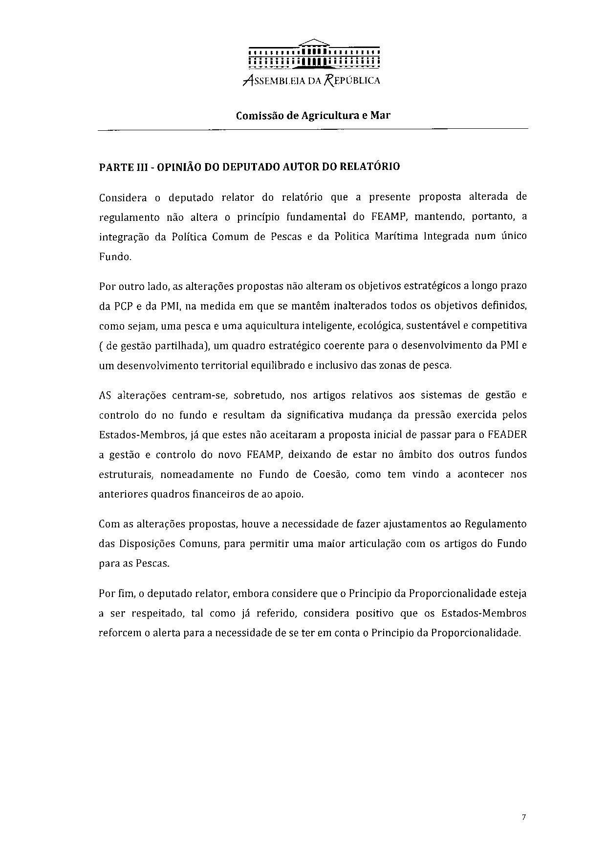
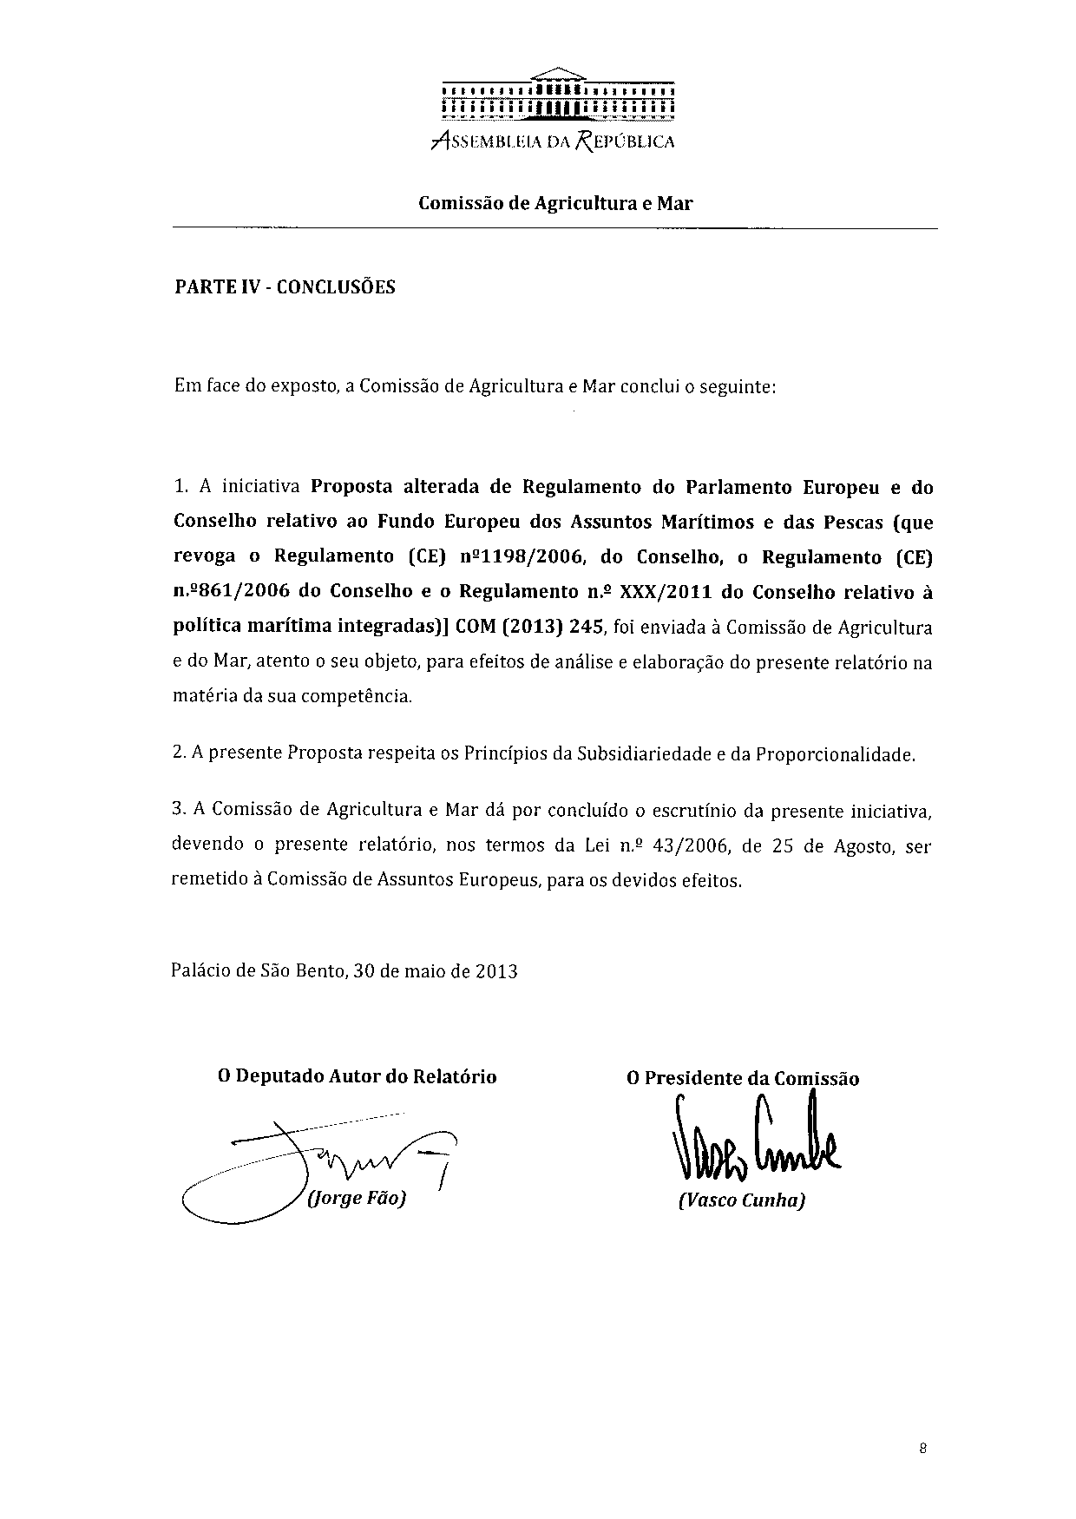

Translation(s) of the opinion may be available on the Interparliamentary EU Information Exchange site IPEX at the following address: http://www.ipex.eu/IPEXL-WEB/search.do

