 | 
COUNCIL OF  THE EUROPEAN UNION |  |  | Brussels, 20 June 2013
 | Interinstitutional File:  2013/0119 (COD) |  | 11332/13
JUSTCIV 148
FREMP 87
CODEC 1549
INST 328
PARLNAT 148

COVER NOTE
from: | the Portuguese Parliament
Date of receipt: | 19 June 2013
to: | Enda Kenny, President of the Council of the European Union
Subject: | Proposal for a Regulation of the European Parliament and of the Council on promoting the free movement of citizens and businesses by simplifying the acceptance of certain public documents in the European Union and amending Regulation (EU) No 1024/2012  [doc. 9037/13 JUSTCIV 108 FREMP 70 CODEC 952 - COM(2013) 228 final]  - Opinion on the application of the Principles of Subsidiarity and Proportionality

Delegations will find attached a copy of the above mentioned opinion.

_______________________

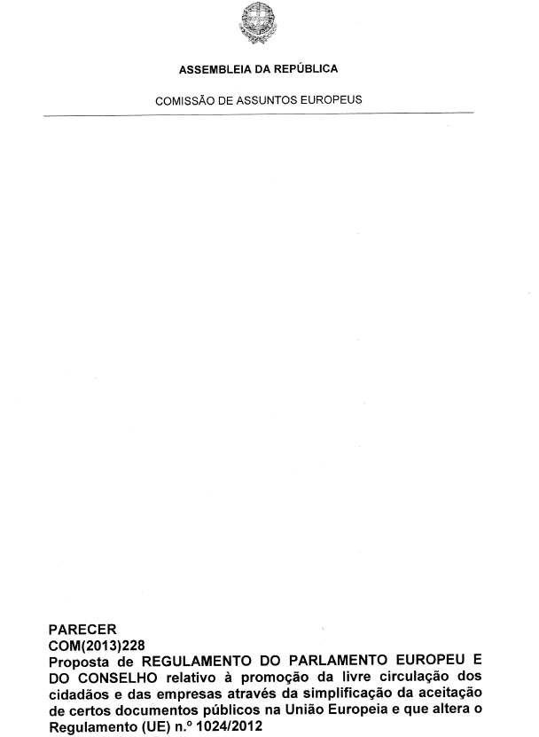
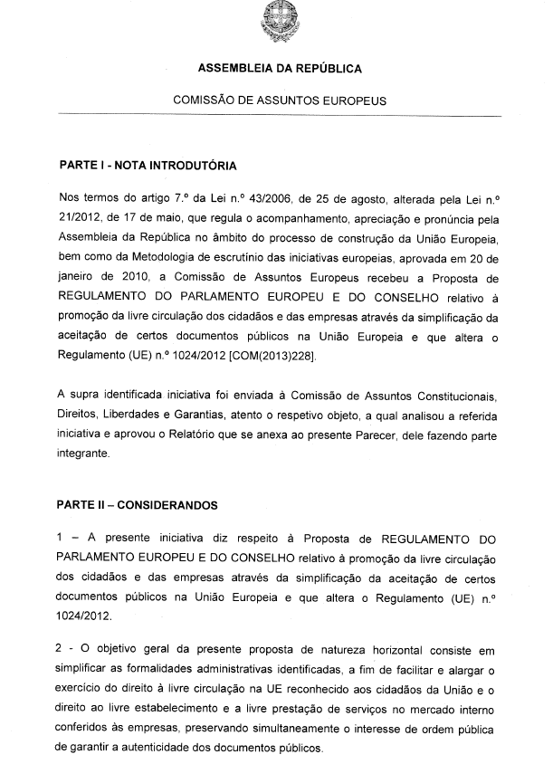
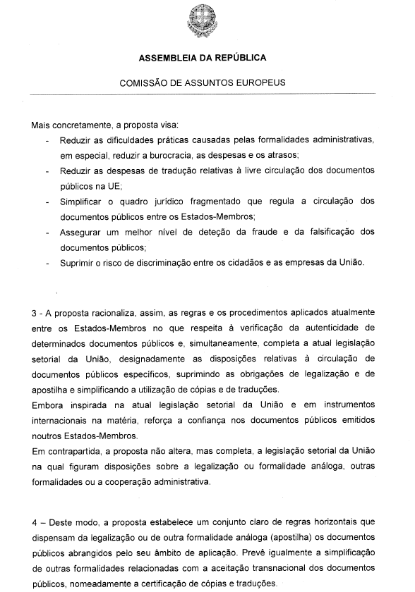
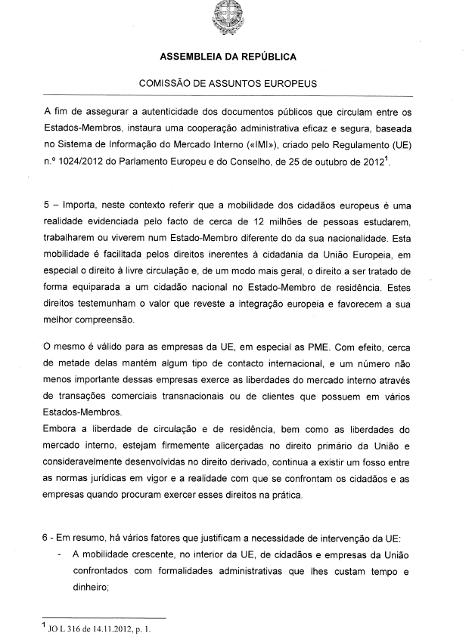
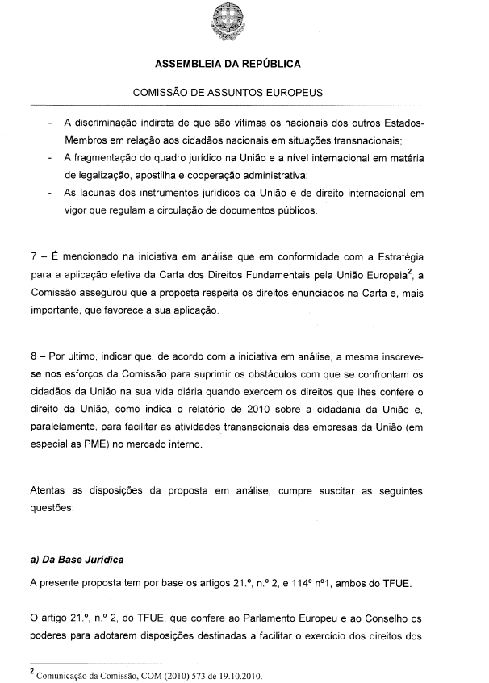

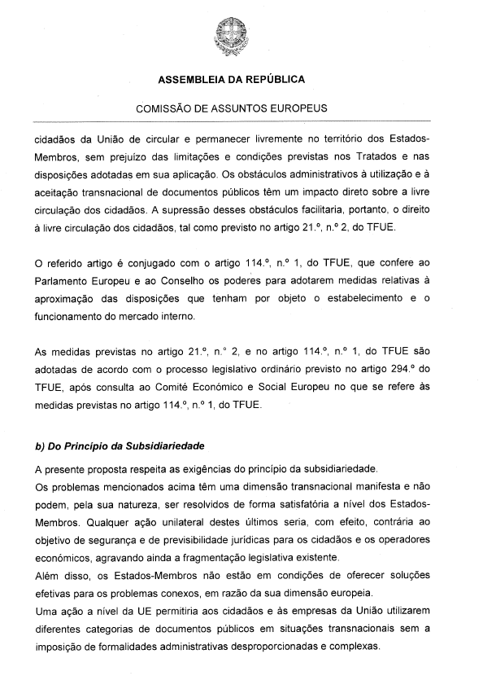

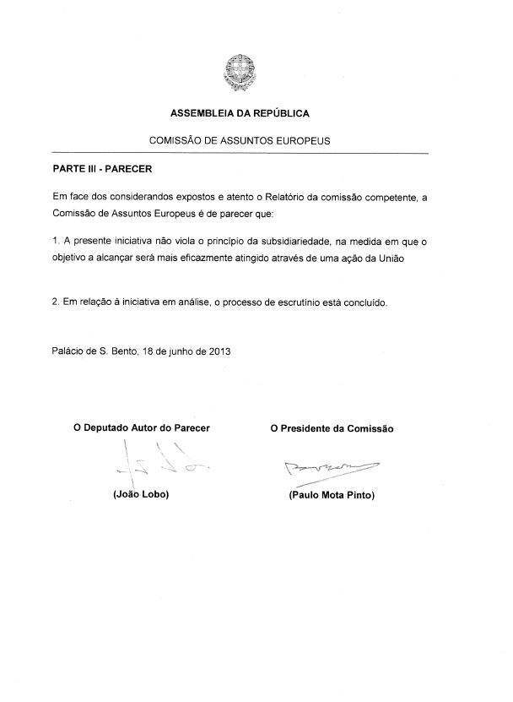
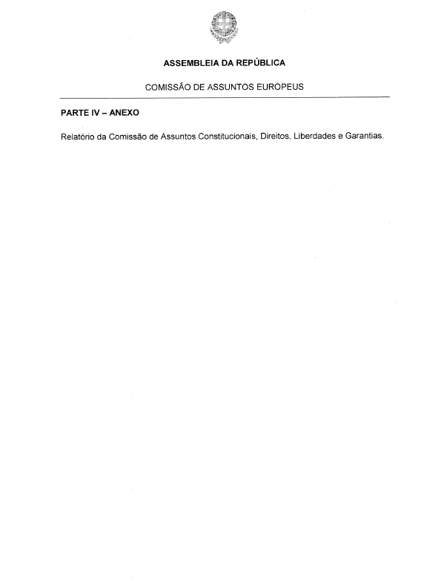
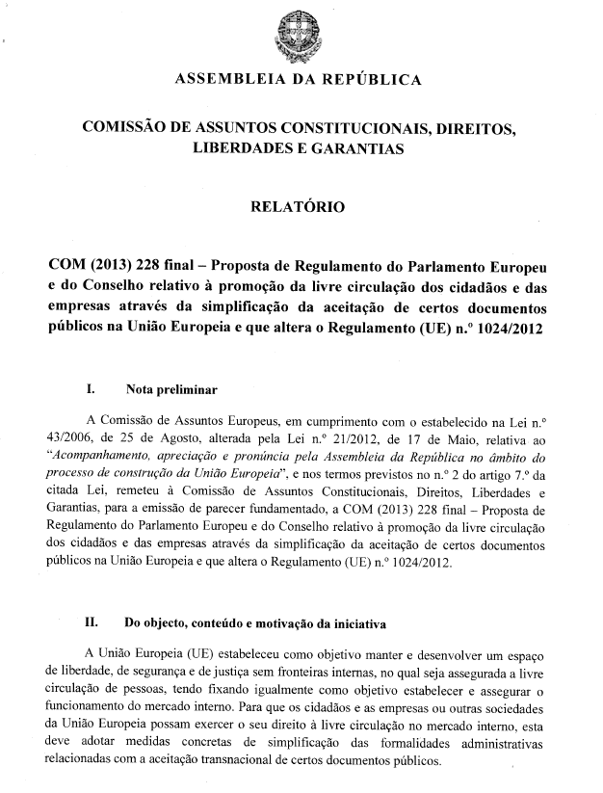
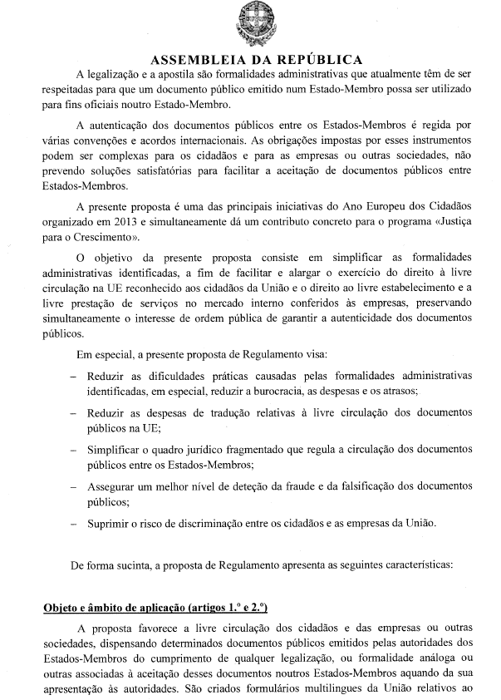
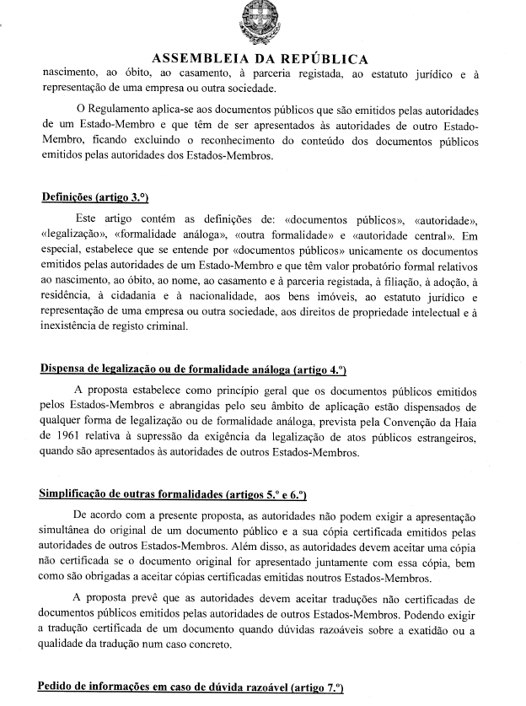
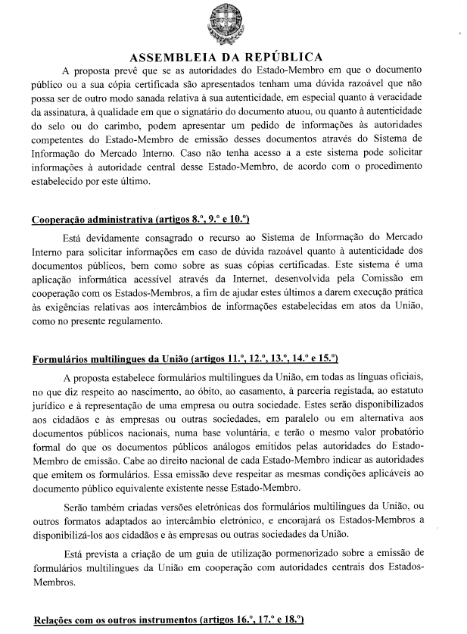
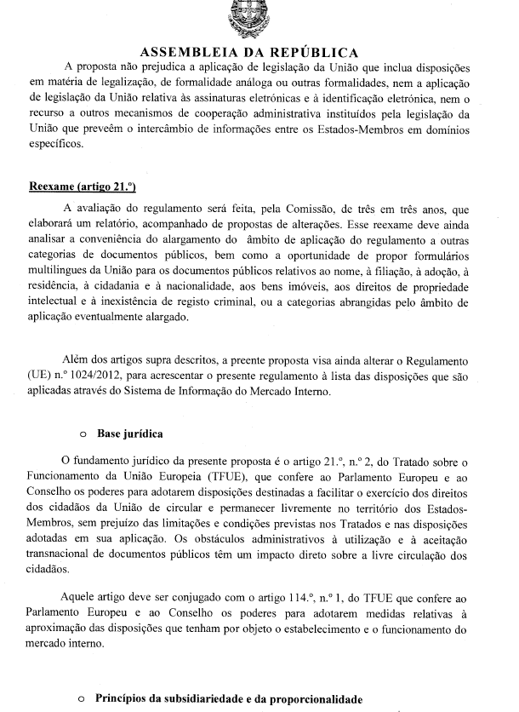
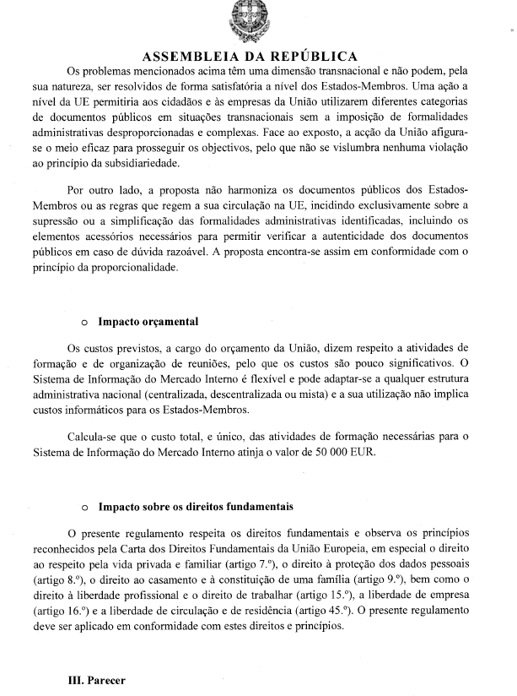
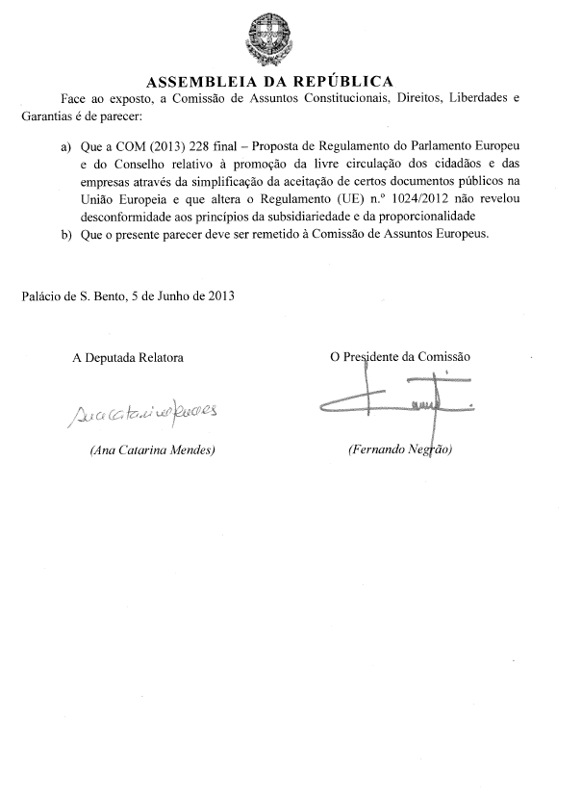
_______________

For other available language versions of the opinion, reference is made to the Interparliamentary EU information exchange Internet site (IPEX) at the following address: http://www.ipex.eu/IPEXL-WEB/search.do

