TABLE OF CONTENTS
1. Context and overview 4
2. Implementation of the Community's priorities 7
3. Outlook 13
REPORT FROM THE COMMISSION TO THE EUROPEAN PARLIAMENT, THE COUNCIL, THE EUROPEAN ECONOMIC AND SOCIAL COMMITTEE AND THE COMMITTEE OF THE REGIONS
Second Report on the implementation of the national strategy plans and the Community strategic guidelines for rural development (2007-2013)
This report is the second report from the Commission to the European Parliament, the Council, the European Economic and Social Committee and the Committee of the Regions on the implementation of the National Strategy Plans (NSP) and the Community strategic guidelines for rural development (2007-2013).
This Commission report is based on the analysis and appraisal of the summary reports submitted by Member States (MS) in 2012 as well as from other available information, notably the financial and physical common monitoring indicators and some outcomes from the European Network for Rural Development.
It provides a summary of the main current developments, trends and challenges relating to the implementation of the national strategy plans and the Community strategic guidelines.
It is important to note that the data used in the 2012 summary reports by MS are aggregates from the beginning of the programming period in 2007 to the end of 2011. The adjustments of the NSP and the related Rural Development Programmes (RDP) which followed the CAP-Health Check (HC) and the European Economic Recovery Plan (EERP) finalised in 2010 are taken into consideration in this current report.

1. Context and overview

1.1 The Community's priorities for rural development for the period 2007-2013
On February 2006 the Council of the European Union adopted Strategic Guidelines for rural development for the period 2007-2013², providing three core thematic priorities:
Improving the competitiveness of the agricultural and forestry sector. The European Agricultural Fund for Rural Development (EAFRD) should contribute to a strong and dynamic European agrifood sector by focusing on the priorities of knowledge transfer, modernisation, innovation and quality in the food chain, and on priority sectors for investment in physical and human capital. The measures grouped in 'axis 1' shall contribute mostly to the competitiveness objective of the RDPs.
Improving the environment and the countryside. To protect and enhance the EU’s natural resources and landscapes in rural areas, the resources devoted to this priority should contribute to three EU-level priority areas: biodiversity and the preservation and development of high nature value farming and forestry systems and traditional agricultural landscapes; water; and climate change. The measures grouped in 'axis 2' of the RDPs shall contribute mostly to the environment objective.
Improving the quality of life in rural areas and encouraging diversification of the rural economy. The resources devoted to these fields should contribute to the overarching priority of the creation of employment opportunities and conditions for growth. Interventions should in particular be used to promote capacity building, skills acquisition and organisation for local strategy development and also help to ensure that rural areas remain attractive for future generations. In promoting training, information and entrepreneurship, the particular needs of women, young people and older workers should be considered. The measures grouped in 'axis 3' of the RDPs shall contribute mostly to the wider rural development objectives together with axis 4.
Beyond the thematic priorities, the Strategic Guidelines also highlighted the need for:
- Building local capacity for employment and diversification - while contributing to the thematic priorities. This horizontal axis, also called "Leader Axis" (Axis 4) should play an important role in improving governance and mobilising the endogenous development potential of rural areas, through Local Development Strategies.
- Ensuring consistency in programming. Synergies between and within the axes should be maximised. Where appropriate, other EU-level strategies should be taken into account. Means to improve governance and policy delivery should be mobilised. In particular, European and national networks for rural development should be set up as a platform for exchange of best practice and expertise on all aspects of policy design, management and implementation between stakeholders.
- Complementarity between Community instruments. In order to foster synergy between structural, employment and rural development policies, MS should ensure complementarity and coherence between actions to be financed by different EU funds.
These Strategic Guidelines provided the framework on the basis of which MS prepared their NSP, which translate the EU priorities into national priorities, and serve as a reference for the RDPs. These implement the priorities through sets of selected measures grouped by axis (see table 1 with the list of measures per axis). The programmes can be national or regional and were approved by the Commission in 2007 and 2008. Their implementation is monitored and evaluated on the basis of the Common Monitoring and Evaluation Framework (CMEF).
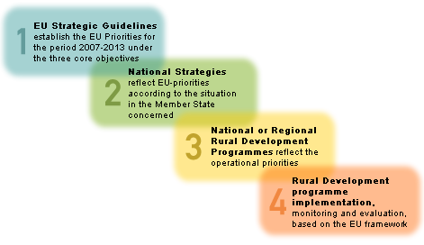

1.2 Overview of the budget and operational targets
The overall EAFRD budget amounted to EUR 96.2 billion for the whole programming period 2007-2013 after the addition of 4.95 billion from the CAP- HC and the EERP. To ensure a balanced strategy the EAFRD has minimum spending levels for each thematic axis to be applied in each RDP (10%, 25% and 10% respectively for axis 1, 2 and 3). For the Leader axis a minimum of 5% (2.5% for the new MS) of the EU funding for each programme is reserved. Being used under shared management, the EAFRD is complemented by national public funding.
Once the programming was made at MS level, the financial breakdown between the different axes, as well as the definition of the main targets for 2013, resulted in the following, as at-December 2011:
- Axis 1 'improvement of the competitiveness of the agricultural and forestry sector' accounts for 35% of the total EAFRD. This axis is expected, by 2013, to contribute to 600,000 investment projects for the modernisation of agricultural holdings, to support 35,000 enterprises for adding value to agricultural and forestry products, and to result in 2.8 million participants successfully completing a training activity related to agriculture and/or forestry.
- Axis 2 'improving the environment and the countryside' is predominant with 47% of the total EAFRD. The planned result is to have 47 million Ha of agricultural land under agri-environment management, 55 million Ha of agricultural land in less favoured and mountainous areas compensated for their handicaps, 573,000 Ha of new afforested land and 1.3 million Ha of agricultural land supported to meet NATURA 2000 requirements.
- Axis 3 'quality of life in rural areas and diversification of the rural economy' has a lesser share with 18% of the total EAFRD. By 2013, it is expected to contribute to providing improved services to 88 million inhabitants of rural areas and to supporting 28,000 village renel projects.
The share of the Leader axis is 6% of total EAFRD funding. The largest share of support for implementing local development strategies is planned to contribute to diversification and quality of life (axis 3 type projects).
At measure level, the main measure remains support for agri-environment payments (214) which accounts for EUR 23 billion for the whole period. The next most important measures in terms of budget are the less favoured area supports (211+212) with 13.4 billion EUR, and the modernisation of agricultural holdings measure (121) accounting for 11 billion EUR
Figure 1: EAFRD allocation (2007-2013) programmed by measure (situation end 2011) (billion EUR)
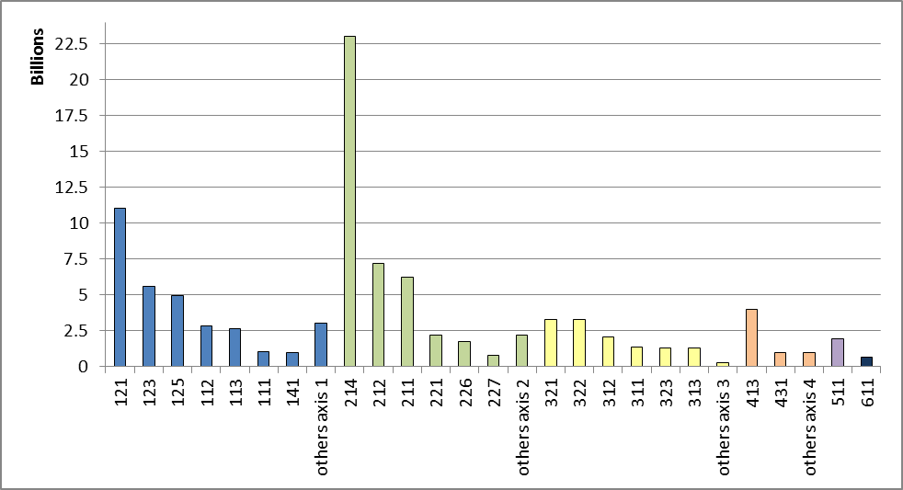
To zoom in to the specific programing of the HC and EERP finalized in 2010, figure 2 shows the breakdown of the additional HC and EERP budget by the different priorities. The majority of the funds are concentrated in the areas of bio-diversity (31% of all funds, EUR 1.5 billion) and water management (27%, EUR 1.3 billion). Dairy restructuring received 15% of the additional budget (EUR 0.7 billion), climate change measures account for 14% (EUR 0.7 billion) and renewable energy for 6% (EUR 0.3 billion). The development of broadband infrastructure remains an important policy issue for rural areas. Member States have thus decided to invest 35% of the European Economic Recovery Package funds for broadband, which equates to EUR 360.4 million of the available EUR 1 billion.
Figure 2: Breakdown of CAP Health-Check and EERP funds across new challenges (%)
Source: Table 2 from the accompanying Commission Staff Working Paper
The new funds directed to the Rural Development Programmes (RDPs) released by the HC and EERP are an addition to the overall EAFRD to increase the overall budget addressing the specific challenges identified. In many cases, relevant operations were already part of the initial programmes and, their funding has been increased through HC and EERP.

2. Implementation of the Community's priorities

2.1 Overview of results, difficulties and solutions
The total EAFRD expenditure realized by the EU27 MS at the end of 2011 amounted to EUR 44.5 billion, representing 46% of the overall 2007-2013 budget of EUR 96.2 billion. Given that the timeframe under consideration represents 56% of the payment period (5 years out of 9), annual expenditure has been accelerating after an initial slow start during the first years of the programming period 2007-2013.
The picture is far from homogeneous among the MS (Fig 2.): two MS had spending levels around 70%, while four MS have spent less than 40%. It must be noted that payments made for commitments of the previous programming period 2000-2006 as foreseen in the transitional rules had mostly run out.
Figure 3: Overall execution of the EAFRD budget by the end of 2011 compared to the overall 2007-2013 allocation
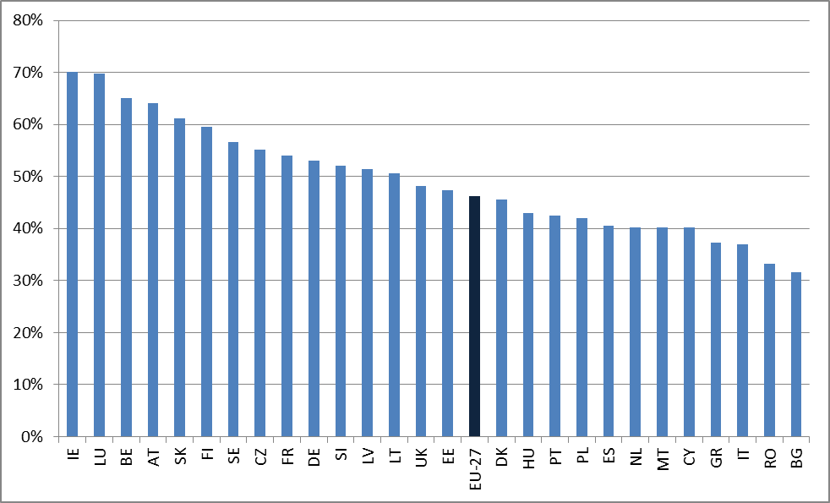
Axis 2 expenditure has reached cruising speed, mostly due to the multiannual nature of key measures (agri-environment, less favoured areas) with returning annual payments. Axes 1 implementation is also globally on track. On the other hand, axis 3 uptake remains low, possibly due to financial difficulties of potential beneficiaries to obtain the necessary match funding. As regards axis 4, a typically slow start has been observed which is explained by the need to first establish the local strategies and the Local Action groups prior to any project implementation (see table 4).
Figure 4: Overall rural development budget (EAFRD, billion EUR) and share of the uptake by end 2011
If focus is specifically on the implementration rate of the HC and EERP, EUR 1.27 billion was spent by the end of 2011 out of the overall EUR 4.95 billion programmed. It represents 26% of the total but the very significant increase between 2010 and 2011 (+ 235%) shows a positive trend after an expected modest start in 2010.
If one looks at the uptake by challenges, it shows that climate change and biodiversity challenges have higher uptake compared to the average with respectively 52% and 32% whereas broadband, water management and renewable energy are lagging behind with uptakes around 10%. The higher uptake of the biodiversity and climate change challenges is explained by the fact that these challenges have been predominantly tackled via axis 2 measures which to a certain extent were already in place.
Figure 5: Overall HC and EERP rural development budget (EAFRD, billion EUR) and indicative share of the uptake by end 2011
The level of output as measured by output indicators, against the overall targets for 2013 established by the MS in their programmes is globally in line with the financial level of implementation. The complete set of output indicators is presented in table 3.
General implementation difficulties, solutions found
The most frequent issue raised by MS is the economic crisis. This led to difficulties in the uptake of investment measures due to beneficiaries' lack of own resources, difficulties in obtaining loans by the applicants and to budgetary constraints restricting public initiatives. The private sector has been in general less keen on taking risks, and some investments may have been shifted to less ambitious projects, or simply postponed. Situations have not been similar across EU-27, some MS are still facing adverse situations while others have experienced some recovery since 2008. This issue has influenced axis 1 but is most significantly observed in axis 3 supporting projects such as infrastructure which require more time to finance and implement.
For some RDPs the implementing bodies (Management Authorities, Paying Agencies) have still faced administrative and capacity problems to deal with all applications.
Lack of awareness and experience by potential beneficiaries can also undermine the implementation notably in some EU-12 MS (i.e. slow progress on human capital measures; inadequate applications), or in the overall EU-27 when new measures are introduced. Some MS put in place a sufficiently critical mass of training/farm advisory services activities to overcome these issues but it takes time.
Solutions have been found and are substantially introduced in the programmes through modifications, notably following the Mid Term Evaluation (MTE) recommendations. In the face of the financial crisis, MS introduced different programme adaptations such as: change in the state aid coverage, the level of grants, the intervention rates for less attractive measures, adjustment of selection procedures and demarcation, increase in the EU co-financing rate, financial engineering tools such as guarantee funds or mechanisms providing interest-free loans and/or reallocation of the funds.
At this stage, mechanisms ensuring complementarity between EAFRD and EU Structural Funds are settled and are running. They take the form of establishing demarcation lines and co-ordination mechanisms (inter-ministerial body…).

2.2. Improving the competitiveness of the agricultural and forestry sector
The total EAFRD axis 1 expenditure registered for the 2007-2011 period amounts to 42% of its 2007-2013 overall allocation (EU27 average).
The main results for this objective, at the end of 2011, are:
- Number of participants who successfully completed a training related to agriculture and/or forestry: 1,353,000 (49% of the 2013 estimated target).
- Number of holdings introducing new products or new techniques: 73,600 (29% of the 2013 estimated target).
Implementation of measures
Measure 121 (Modernisation of agricultural holdings) is the biggest axis 1 measure in terms of budget allocation (EUR 11 billion). The payment uptake of this measure is 51% of its total budget with 220,000 modernisation projects already completed (37% of the 2013 target) including more than 3,000 projects and 765 million of total investment (private + public) aiming at restructuring the dairy sector through the HC. Its positive uptake demonstrates the high interest of farmers for investments. Where implementation rates were below the targets the main justification given by MS was the economic crisis which had a negative influence on the investment capability of the holdings.
Measures 123 (Adding value to agricultural and forestry products) which is the second biggest axis 1 measure in terms of allocation, has an uptake of 35% and 15,770 holdings supported (out of 35,250 as the target for 2013). Other axis 1 measures present the following uptake levels: 112 (Setting up of young farmers, 50% with 100,000 young farmers supported) and 141 (Semi-subsistence farming, 51% and 40,000 semi-subsistence farm holdings supported).

2.3. Improving the environment and the countryside
The total EAFRD axis 2 expenditure for the period 2007-2011 represents 58% of its overall allocation.
The main results achieved for this objective at the end of 2011 are notably:
- 50 million Ha under successful land management contributing to biodiversity;
- 32 million Ha to improve water quality or
- 40 million Ha to improve soil quality.
Implementation of measures
The three biggest measures in terms of budget allocation are also those with the highest uptake among axis 2 measures: 211 (Natural handicap payments to farmers in mountain areas, with an uptake of 74%), 212 (Payments to farmers in areas with handicaps, other than mountain areas, with an uptake of 67%) and 214 (Agri-environment payments, with an uptake of 58%).
Measures 211 and 212 together support 52.8 million Ha, and agri-environment is supporting 41 million Ha including 4 and 5.2 million to adress respectively climate change and biodiversity challenges through the HC.
These measures are followed in terms of financial uptake by measures 215 (Animal welfare, with a financial uptake of 50% and 144,650 contracts supported so far), and 221 (First afforestation of agricultural land with a financial uptake of 41% and 165,600 Ha afforested so far).

2.4. Improving the quality of life in rural areas and encouraging diversification of the rural economy
The total EAFRD axis 3 expenditure for the period 2007-2011 represents 31% of its overall allocation 2007-2013 with significant differences between MS (see table 4). According to MS, the main elements explaining this slow uptake are the financial crisis (scarcity of private and national/local funds) and some administrative requirements (control obligations, long procedures for applications and selections). Furthermore, in some MS, implementation of axis 3 is made exclusively via Leader, and therefore the delays in Leader implementation have also impacted on axis 3 uptake.
The main results achieved for this objective at the end of 2011 are:
- Axis 3 contributed to creating jobs (more than 20,000) in a context of growing unemployment in rural areas
- Population in rural areas benefiting from improved services supported by EAFRD: 62 million people
- An additional 3.5 million households in rural areas have potential access to internet.
Implementation of measures
The biggest measures of axis 3 in terms of total allocations are 321 (Basic services for the economy and rural population, financial uptake of 31% and 35,400 projects completed including 550 project to increase broadband infrastructure in rural areas supported through the EERP) and 322 (Village renewal and development, financial uptake of 42% and 27,700 villages where renewal activities took place).
Among the highest uptake in axis 3 measures, we can quote 341 (Skills acquisition, animation and implementation of local development strategies) with 41% and 5,600 projects completed and the measure 323 (Conservation and upgrading of rural heritage) with an uptake of 30% and 48,400 projects completed so far.

2.5. Building local capacity for employment and diversification
At the end of 2011 the selection of Local Action Groups (LAGs) was completed in 25 MS. The total number of LAGs is now 2323 LAGs. This number has doubled in comparison to Leader+ and half the territories are implementing the Leader approach for the first time.
Due to the fact that the LAG selection process was completed relatively late, many of the selected LAGs have only started to implement projects linked to their local development strategy. This explains the low EAFRD axis 4 financial uptake which represents 18% of the overall allocation for this axis for the programming period but a substantial increase in the latest quaterly expenditure has been taking place.
Specific difficulties have been pointed out by some MS. The mainstreaming of Leader has notably modified the approach impliying important administrative adaptations (administrative reorganization, training of staff).

3. Outlook
For many programmes implementation only really started in 2008. Figures for the following years showed an acceleration and by the end of 2011, overall financial uptake was nearly on track, despite some unfavourable conditions such as the economic situation. Most RDPs will be able to fully spend their EAFRD budget.
For the individual programmes, most implementation issues are now solved. Many RDP modifications have been made to correct difficulties encountered in the first years of implementation, take on board recommendations from the mid-term evaluations and incorporate additional funds addressing new challenges (Health Check) and the economic crisis (European Economy Recovery Package). Some shifts between axes are still expected to maximise uptake, but in respect of the minimum spending rate for each axis. However, a few RDPs especially in EU-12 might have difficulties to fulfill the minimum spending rate for axis 4 due to a late implementation of Leader.
In terms of policy objectives, with four years of implementation left, targets set in the programmes are globally well on track for axis 1 and axis 2 while realization is still slightly lagging behind for axis 3 and 4 but the trends are globally positive.
More specifically, in axis 1, 220,000 modernisation projects have been already completed (37% of the 2013 target) and, as a result of the different measures supporting investment, 73,600 holdings have introduced new products or new techniques (29% of the 2013 estimated target). In axis 2, measures targeting environmental issues have been implemented on 41 million hectares so far (87% of the 2013 target). In axis 3, 35,400 projects of basic services for the economy and rural population are completed (40% of the 2013 target) and 19,000 micro-entreprises have been supported or created (25% of the 2013 target). Finally, 55,000 LEADER projects (axis 4) have been supported so far (25% of the 2013 target).
The Common Monitoring and Evaluation framework has provided useful information for reporting and for following the progress in programme implementation and achievement on an ongoing basis. Preliminary figures for 2012 indicate that a majority of programmes are also catching up for axis 3 and 4, where slow uptake was still encountered until the end of 2011.

See Title II, Chapter II of Council Regulation (EC) No 1698/2005 of 20 September 2005 on support for rural development by the European Agricultural Fund for Rural Development (EAFRD).
Council decision of 20 February 2006 on Community strategic guidelines for rural development (programming period 2007 to 2013) (2006/144/EC).
See Article 14 "Commission report" of Council Regulation (EC) No 1698/2005 of 20 September 2005.
See Article 13 of Council Regulation (EC) No 1698/2005 of 20 September 2005. These summary reports set out the progress made in implementing the national strategy plans and objectives, and the contribution to the achievement of the Community strategic guidelines.
See http://ec.europa.eu/agriculture/healthcheck/index_fr.htm for information on the CAP Health check and the European Economic Recovery Plan, and for access to the related legislation adopted in 2009.
Council Regulation (EC) No 1698/2005 of 20 September 2005 on support for rural development by the European Agricultural Fund for Rural Development (EAFRD).
All the tables are presented in the Commission Staff Working Paper
Since 2007, the EAFRD budget for the 2007-2013 programming period has been increased (notably by the HC and the EERP) to EUR 96.2 billion.
All financial data in the report relate to EAFRD only.
Part of the funds allocated to LEADER, technical assistance and direct payments have been attributed proportionally to the three main axes in the figures and table below.
see legend of measures in table 1 of the Commission Staff Working Paper
Amounts planned for innovation have been redistributed between the other challenges
Payments to MS related to 2007, 2008, 2009, 2010 and 2011 calendar year. It cannot be compared to the 5th Financial Report of the Commission to the European Parliament and the Council on the implementation of EAFRD which is based on financial year.
Payments can be made 2 years after the last commitment (2013), thus until the end of 2015.
Based on monitoring data from CMEF 2011.
See table 4 for the break down by gender and age as foreseen under the art.81(§3) of the reg. 1698/2005
Result indicator from the CMEF, a same area could contribute to several challenges.
Commitments from 2007 onwards only
Depending on the nature of the land management practices defined in the programme, complementary practices could be practised on the same hectare
Unemployment globally increased from 7.1% in 2007 to 10.1% in 2011 in the thinly populated rural areas and from 7% in 2007 to 8.5% in 2011 in intermediate areas (source: Eurostat)
This includes potential population benefiting from the services
See table 4 for the break down by sex and age as foreseen under the art.81(§3) of the reg. 1698/2005
After completion of the RO and BG LAG selection procedures in 2012

