Table 1: EAFRD expenditure realized 2007-2011, EAFRD total allocation 2007-2013
and uptake level
Measures code | Measures | Number of RDP implementing the measures (max 88) | EAFRD 2007-2011 | Total allocation 2007-2013 | uptake level
111 | Vocational training and information actions | 68 | 298 617 798 | 999 056 425 | 30%
112 | Setting-up of young farmers | 69 | 1 412 405 220 | 2 798 849 247 | 50%
113 | Early retirement | 49 | 1 438 388 559 | 2 604 494 367 | 55%
114 | Use of advisory services | 38 | 45 237 312 | 340 902 584 | 13%
115 | Setting up of farm management, relief and advisory services | 23 | 13 734 976 | 86 466 959 | 16%
121 | Modernisation of agricultural holdings | 87 | 5 582 343 255 | 11 034 896 061 | 51%
122 | Improvement of the economic value of forests | 43 | 138 778 254 | 591 708 043 | 23%
123 | Adding value to agricultural and forestry products | 84 | 1 929 723 380 | 5 557 735 472 | 35%
124 | Cooperation for development of new products, processes and technologies | 33 | 48 427 562 | 334 315 129 | 14%
125 | Infrastructure related to the development and adaptation of agriculture and forestry | 74 | 1 392 533 471 | 4 903 234 347 | 28%
126 | Restoring agricultural production potential damaged by natural disasters and introducing appropriate prevention actions | 17 | 217 561 916 | 502 441 164 | 43%
131 | Meeting standards based on Community legislation | 16 | 52 069 512 | 80 520 102 | 65%
132 | Participation of farmers in food quality schemes | 37 | 37 548 151 | 209 187 923 | 18%
133 | Information and promotion activities | 27 | 31 274 777 | 197 345 474 | 16%
141 | Semi-subsistence farming | 8 | 487 185 979 | 951 110 453 | 51%
142 | Producer groups | 11 | 89 750 229 | 328 049 108 | 27%
143 | Providing farm advisory and extension services | 1 | 2 453 863 | 131 773 438 | 2%
144 | Restructuring due to reform of common market organization | 2 | 69 059 681 | 186 497 835 | 37%
Total Axis 1 |  |  | 13 287 093 895 | 31 838 584 131 | 42%
211 | Payments to farmers in areas with handicaps (Article 36 (a) (i) of Reg. (EC) No 1698/2005) | 60 | 4 594 389 313 | 6 246 772 115 | 74%
212 | Payments to farmers in areas with handicaps in mountain areas (Article 36 (a) (ii) of Reg. (EC) No 1698/2005) | 75 | 4 841 186 389 | 7 200 409 826 | 67%
213 | Natura 2000 payments and payments linked to Directive 2000/60/EC (WFD) | 22 | 107 971 239 | 451 776 171 | 24%
214 | Agri-environment commitments | 88 | 13 357 072 296 | 23 005 385 161 | 58%
215 | Animal welfare payments | 23 | 260 089 426 | 519 687 754 | 50%
216 | Non-productive investments | 39 | 146 813 651 | 571 183 820 | 26%
221 | First afforestation of non-agricultural land | 63 | 892 426 729 | 2 192 630 309 | 41%
222 | First establishment of agroforestry systems on agricultural land | 2 | 186 729 | 18 736 199 | 1%
223 | First afforestation of non-agricultural land | 26 | 74 020 161 | 327 100 024 | 23%
224 | Natura 2000 payments | 11 | 12 937 018 | 92 479 889 | 14%
225 | Forest-environment payments | 25 | 25 439 630 | 218 162 448 | 12%
226 | Restoring forestry potential and introducing prevention actions | 52 | 664 068 088 | 1 700 526 186 | 39%
227 | Non-productive investments | 61 | 214 660 860 | 746 932 381 | 29%
Total Axis 2 |  |  | 25 191 261 530 | 43 291 782 283 | 58%
311 | Diversification into non-agricultural activities | 61 | 390 814 424 | 1 327 371 823 | 29%
312 | Business creation and development | 36 | 442 017 928 | 2 029 433 548 | 22%
313 | Encouragement of tourism activities | 53 | 261 489 658 | 1 262 328 360 | 21%
321 | Basic services for the economy and rural population | 58 | 1 002 898 171 | 3 266 178 302 | 31%
322 | Village renewal and development | 44 | 1 367 247 678 | 3 251 866 027 | 42%
323 | Conservation and upgrading of the rural heritage | 58 | 392 731 769 | 1 293 498 677 | 30%
331 | Training and information for economic actors operating in the fields covered by Axis 3 | 24 | 33 486 118 | 131 604 782 | 25%
341 | Skills acquisition, animation and implementation | 27 | 55 788 398 | 137 213 139 | 41%
Total Axis 3 |  |  | 3 946 474 145 | 12 699 494 658 | 31%
411 | Implementing local development strategies - axis 1 | 43 | 60 014 662 | 499 862 233 | 12%
412 | Implementing local development strategies - axis 2 | 22 | 7 028 810 | 163 952 486 | 4%
413 | Implementing local development strategies - axis 3 | 70 | 693 901 763 | 3 948 029 004 | 18%
421 | Implementing cooperation projects | 37 | 16 842 100 | 281 635 728 | 6%
431 | Running the local action group, acquiring skills and animating the territory | 85 | 302 251 571 | 982 080 048 | 31%
Total Axis 4 |  |  | 1 080 038 906 | 5 875 559 499 | 18%
511 | Technical assistance |  | 522 004 590 | 1 891 553 191 | 28%
611 | Direct Payments (RO and BG) |  | 437 324 358 | 645 581 697 | 68%
Grand Total |  |  | 44 464 197 424 | 96 242 555 459 | 46%

Table 2: HC/EERP EAFRD expenditure realized 2007-2011, HC and EERP allocation 2007-2013
and uptake level (million €)

HC and EERP challenges | EAFRD Expenditure (2010-2011) | Allocation (2010-2013) | Uptake level
Climate change | 369.2 | 704.2 | 52%
Renewable energy | 22.7 | 275.4 | 8%
Water management | 163.9 | 1 332.2 | 12%
Biodiversity | 498.5 | 1 542.0 | 32%
Restructuring dairy sector | 172.9 | 715.6 | 24%
Innovative approaches (new challenges) | 1.4 | 15.8 | 9%
Broadband infrastructure | 43.1 | 360.4 | 12%
Total | 1 271.7 | 4 945.6 | 26%

Table 3(a): Monitoring output indicators 2007-2011, and targets 2007-2013
(including HC as at end 2011)
Code | Measure | Output | Unit | Value (2007-2011) | Targets 2007-2013 | % target
111 | Vocational training and information actions | Number of participants in training | N. | 2 420 490 | 3 478 471 | 70%
112 | Setting up of young farmers | Number of assisted young farmers | N. | 99 930 | 185 014 | 54%
113 | Early retirement | Number of beneficiaries | N. | 27 032 | 41 780 | 65%
113 | Early retirement | Number of hectares released | Ha | 445 037 | 606 556 | 73%
114 | Use of advisory services | Number of farmers supported | N. | 90 052 | 554 549 | 16%
114 | Use of advisory services | Number of forest holders supported | N. | 1 619 | 40 251 | 4%
115 | Setting up of management, relief and advisory services | Number of newly set up management, relief or advisory services | N. | 556 | 775 | 72%
121 | Modernisation of agricultural holdings | Number of farm holdings that received investment support | N. | 219 649 | 598 139 | 37%
122 | Improvement of the economic value of forests | Number of forest holdings that received investment support | N. | 12 601 | 59 459 | 21%
123 | Adding value to agricultural and forestry products | Number of enterprises supported | N. | 15 768 | 35 242 | 45%
124 | Cooperation for development of new products, processes and technologies | Number of cooperation initiatives supported | N. | 1 416 | 5 712 | 25%
125 | Infrastructure related to the development and adaptation of agriculture and forestry | Number of operations supported | N. | 28 196 | 46 780 | 60%
126 | Restoring agricultural production potential damaged by natural disasters and prevention actions | Supported area of damaged agricultural land | Ha | 351 866 | 1 412 591 | 25%
131 | Meeting standards based on Community legislation | Number of beneficiaries | N. | 16 344 | 66 311 | 25%
132 | Participation of farmers in food quality schemes | Number of supported farm holdings participating in a quality scheme | N. | 224 134 | 284 384 | 79%
133 | Information and promotion activities | Number of supported actions | N. | 4 534 | 6 008 | 75%
141 | Semi-subsistence farming | Number of semi-subsistence farm holdings supported | N. | 39 299 | 105 422 | 37%
142 | Producer groups | Number of supported producer groups | N. | 888 | 2 132 | 42%
LFA | Support to Less Favoured Areas | Number of supported holdings in LFAs | N. | 2 800 00 | 3 000 000 | 93%
LFA | Support to Less Favoured Areas | Supported agricultural land in LFAs | Ha | 52 800 000 | 55 000 000 | 96%
213 | Natura 2000 payments and payments linked to Directive 2000/60/EC (WFD) | Number of supported holdings in Natura 2000 areas/under WFD | N. | 51 065 | 63 123 | 81%
213 |  | Supported agricultural land under Natura 2000/under WFD | Ha | 898 289 | 1 332 965 | 67%
214 | Agri-environment payments | Number of farm holdings | N. | 2 515 434 | 3 154 024 | 80%
214 | Agri-environment payments | Physical area under agri-environmental support | Ha | 41 000 000 | 47 000 000 | 87%
215 | Animal welfare payments | Number of animal welfare contracts | N. | 144 653 | 169 383 | 85%
216 | Non-productive investments | Number of farm holdings | N. | 16 864 | 107 918 | 16%
221 | First afforestation of agricultural land | Number of beneficiaries receiving support | N. | 29 655 | 111 921 | 26%
221 | First afforestation of agricultural land | Number of ha afforested land | Ha | 165 634 | 573 440 | 29%
222 | First establishment of agroforestry systems on agricultural land | Number of beneficiaries | N. | 64 | 3 422 | 2%
222 |  | Number of ha under new agroforestry systems | Ha | 637 | 41 236 | 2%
223 | First afforestation of non-agricultural land | Number of beneficiaries receiving support | N. | 5 368 | 27 652 | 19%
223 | First afforestation of non-agricultural land | Number of ha of afforested land | Ha | 48 348 | 190 792 | 25%
224 | Natura 2000 payments | Number of forest holdings receiving aid in Natura 2000 area | N. | 7 328 | 35 449 | 21%
224 | Natura 2000 payments | Supported forest land (ha) in Natura 2000 area | Ha | 117 580 | 303 161 | 39%
225 | Forest-environment payments | Number of forest holdings receiving support | N. | 6 903 | 71 219 | 10%
225 | Forest-environment payments | Physical forest area under forest environment support | Ha | 246 938 | 898 015 | 27%
226 | Restoring forestry potential and introducing prevention actions | Number of prevention/restoration actions | N. | 43 303 | 128 575 | 34%
227 | Non-productive investments | Number of supported forest holders | N. | 61 786 | 118 775 | 52%
311 | Diversification into non-agricultural activities | Number of beneficiaries | N. | 18 961 | 62 117 | 31%
312 | Business creation and development | Number of micro-enterprises supported/created | N. | 19 139 | 77 397 | 25%
313 | Encouragement of tourism activities | Number of new tourism actions supported | N. | 10 539 | 34 656 | 30%
321 | Basic services for the economy and rural | Number of supported actions | N. | 35 372 | 87 473 | 40%
322 | Village renewal and development | Number of villages where actions took place | N. | 27 697 | 27 619 | 100%
323 | Conservation and upgrading of the rural heritage | Number of rural heritage actions supported | N. | 48 399 | 71 342 | 68%
331 | Training and information | Number of economic actors participating | N. | 364166 | 758 664 | 48%
341 | Skills acquisition, animation and implementation | Number of actions supported | N. | 5 583 | 5 225 | 107%
414 412 413 | Implementing local development strategies | Number of projects financed by LAGs | N. | 54 810 | 220 222 | 25%
421 | Implementing cooperation projects | Number of cooperation projects | N. | 1 327 | 4 606 | 29%
431 | Running the local action group, acquiring skills and animating the territory | Number of actions supported | N. | 84 260 | 89 895 | 94%
Table 3(b) Selection of main relevant target indicators (outputs) per priority for the HC/EERP budget defined in the Rural Development Programmes and realization by the end of 2011
Priority/indicators | Unit of measure | Targets | Values (2011) | %
Climate Change
Improvement of energy efficiency | total volume of investments (million EUR) | 243 | 103 | 30%
Improve efficiency of nitrogen fertiliser use | total volume of investments (million EUR) | 104 | 103 | 30%
Soil management practices (measure 214) | N of ha supported (million ha) | 1.4 | 0.5 | 36%
Extensive livestock (measure 214) | N of ha supported (million ha) | 2.6 | 2 | 77%
Afforestation and the establishment of agro-forestry system | N of ha supported (ha) | 10,000 | 1263 | 13%
Renewable energy
Installations/infrastructure for renewable energy using biomass and other renewable energy sources (solar and wind power, geothermal) | total volume of investments (million EUR) | 248 | 129 | 26%
Processing of agricultural/forest biomass for renewable energy | total volume of investments (million EUR) | 197 | 129 | 26%
Biogas production using organic waste (on farm and local production) | total volume of investments (million EUR) | 62 | 129 | 26%
Water management
Water storage (including water overflow areas) – Axis 1 | total volume of investments (million EUR) | 184 | 186 | 25%
Water savings technologies (e.g. efficient irrigation systems) – Axis 1 | total volume of investments (million EUR) | 568 | 186 | 25%
Westland restoration (measure 216) | total volume of investments (million EUR) | 119 | 12.3 | 10%
Meandering rivers (measure 323) | total volume of investments (million EUR) | 71 | 13.4 | 19%
Biodiversity
Extensive forms of livestock management (measure 214) | N of ha supported (million ha) | 3.60 | 2.7 | 75%
Integrated and organic production (measure 214) | N of ha supported (million ha) | 1.58 | 0.77 | 49%
Land use change (extensive grassland management) (measures 216 and 323 ) | total volume of investments (million EUR) | 76 | 29 | 38%
Restructuring of diary sector
Investments related to dairy production (measure 121) | total volume of investments (million EUR) | 1,116 | 724 | 65%
Improvements in processing and marketing related to dairy sector (measure 123) | total volume of investments (million EUR) | 270 | 41 | 15%
Broadband infrastructure
Creation and enabling of access to broadband infrastructure | total volume of investments (million EUR) | 383 | 94 | 25%
Upgrade of existing broadband infrastructure | total volume of investments (million EUR) | 175 | 2 | 1%
Laying down passive broadband infrastructure | total volume of investments (million EUR) | 129 | 15 | 12%

Table 3(c): Monitoring result indicators 2007-2011, and targets 2007-2013
 | result indicators |  | 2007-2011 values | Targets
AXIS 1 | Number of participants that successfully ended a training activity related to agriculture and/or forestry |  | 1 353 000 (49%) | 2 774 000
AXIS 1 | Increase in GVA in supported holdings/enterprises ('000 EUR) |  | 7 252 000 (29%) | 25 000 000
AXIS 1 | Number of holdings / enterprises introducing new products and/or new techniques |  | 73 600 (29%) | 252 000
AXIS 1 | Number of farms entering the market |  | 2 679 (3%) | 82 000
AXIS 1 | Value of agricultural production under recognized quality label/standards (millions of euros) |  | 13 200 (45%) | 29 200
Axis 2 | Agricultural and forestry areas under successful land management contributing to (ha) | Biodiversity | 50 300 000 (>100%) | 49 800 000
Axis 2 |  | Water quality | 31 600 000 (91%) | 34 600 000
Axis 2 |  | Climate change | 31 800 000 (>100%) | 23 400 000
Axis 2 |  | Soil quality | 39 500 000 (>100%) | 32 000 000
Axis 2 |  | Avoidance marginalisation | 47 700 000 (92%) | 52 000 000
Axis3 | Increase in Non-agricultural gross value added in supported business ('000 EUR) |  | 1 147 000 (28%) | 4 000 000
Axis3 | Gross number of jobs created |  | 20 162 (8%) | 241 000
Axis3 | Additional number of tourist visits | Number of day visitors | 4 121 911 (43%) | 9 500 000
Axis3 | Additional number of tourist visits | Number of overnight stays | 1 722 051 (20%) | 8 300 000
Axis3 | Population in rural areas benefiting from improved services |  | 62 000 000 (70%) | 88 000 000
Axis3 | Increase in internet penetration in rural areas ( nbr of persons) |  | 3 491 911 (37%) | 9 300 000
Axis3 | Number of participants that successfully ended a training activity in the field of axis 3 |  | 244 007 (57%) | 425 000

Table 4: Overall execution of the EAFRD budget by the end of 2011 compared to the overall 2007-2013 allocation, axis per axis

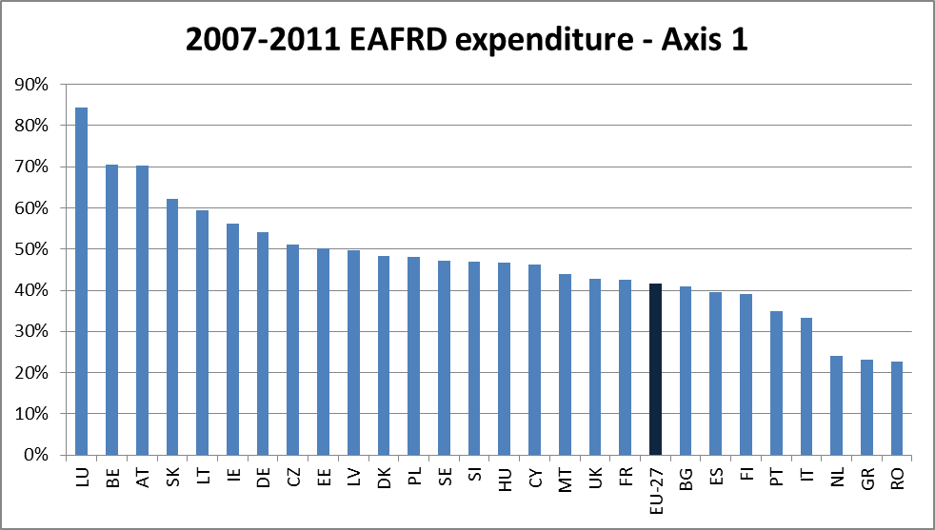
EU-27 average: 42%

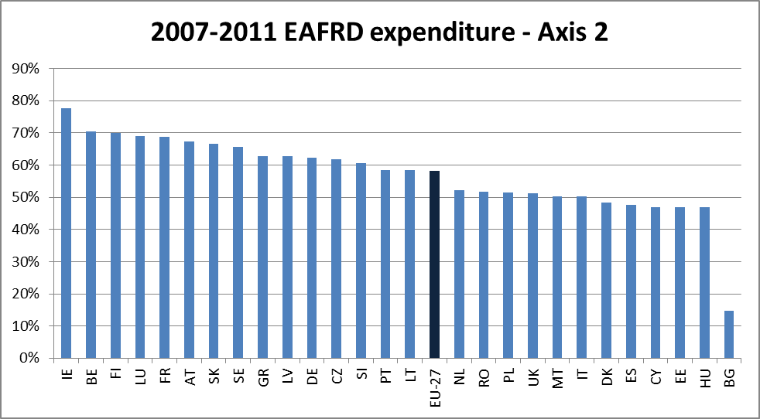
EU-27 average: 58%

EU-27 average: 31%

EU-27 average: 18%
Table 5: axis 1 and axis 3 implementation break down according gender and age as laid down in the Art. 81 of the Reg. (EC) No 1698/2005
Share of the beneficiaries under 40 years for the measures training (111) and modernisation (121) compared to the EU27 share of young holders

Share of women beneficiaries for the measures training (111) and modernisation (121) compared to the EU-25 share of women holders for the whole sector

Share of women beneficiaries for the measure young farmer (112) compared to the EU-25 share of young women holders for the whole sector

Share of women beneficiaries for the measures diversification (311) and micro enterprises support (312)

Source: DG AGRI, allocation as at end 2011. The calendar year expenditure cannot be compared to the 5th Financial Report of the Commission to the European Parliament and the Council on the implementation of EAFRD which is based on financial year.
Total allocation do not include 75€ million not programmed by PT (as at end of 2011)
Source: DG AGRI, allocation as at 2010. Indicative expenditure based on CMEF monitoring data 2011
Source: RDIS IDIM 2011, outputs indicators for commitments made from 2007 onwards
FR not included
As at beginning of 2010
Total amount (= the sum of all public and private expenditure) of all the tangible and/or intangible investments related to the supported operations.
Source: AGRI, outputs indicators for commitments made from 2007 onwards (including HC as at end 2012)
BG and ES CYL non included
EL, HU and PT non included
ES CAT RDP not included
LT, UK, IE, ES, PL, SK: data from 2010 APR
Sources: DG AGRI
Source: RDIS IDIM 2011, outputs indicators for commitments made from 2007 onwards
Eurostat
Eurostat

