EXPLANATORY MEMORANDUM
Point 28 of the Interinstitutional Agreement of 17 May 2006 between the European Parliament, the Council and the Commission on budgetary discipline and sound financial management allows for the mobilisation of the European Globalisation Adjustment Fund (EGF) through a flexibility mechanism, within the annual ceiling of EUR 500 million over and above the relevant headings of the financial framework.
The rules applicable to the contributions from the EGF are laid down in Regulation (EC) No 1927/2006 of the European Parliament and of the Council of 20 December 2006 on establishing the European Globalisation Adjustment Fund.
On 22 May 2013, Spain submitted application EGF/2013/004 ES/Comunidad Valenciana building materials for a financial contribution from the EGF, following redundancies in 140 enterprises operating in the NACE Revision 2Division 23 (Manufacture of other non-metallic mineral products) in the NUTS II region of Comunidad Valenciana (ES52) in Spain.
After a thorough examination of this application, the Commission has concluded in accordance with Article 10 of Regulation (EC) No 1927/2006 that the conditions for a financial contribution under this Regulation are met.
SUMMARY OF THE APPLICATION AND ANALYSIS
Key data:
EGF Reference no. | EGF/2013/004
Member State | Spain
Article 2 | (b)
Enterprises concerned | 140
NUTS II region | Comunidad Valenciana (ES52)
NACE Revision 2 Division | 23 (Manufacture of other non-metallic mineral products)
Reference period | 14.6.2012 – 14.3.2013
Starting date for the personalised services | 22.8.2013
Application date | 22.5.2013
Redundancies during the reference period | 630
Redundant workers expected to participate in the measures | 300
Expenditure for personalised services (EUR) | 1 600 000
Expenditure for implementing EGF (EUR) | 80 000
Expenditure for implementing EGF (%) | 4,76
Total budget (EUR) | 1 680 000
EGF contribution (50 %) (EUR) | 840 000
1. The application was presented to the Commission on 22 May 2013 and supplemented by additional information up to 17 July 2013.
2. The application meets the conditions for deploying the EGF as set out in Article 2(b) of Regulation (EC) No 1927/2006, and was submitted within the deadline of 10 weeks referred to in Article 5 of that Regulation.
Link between the redundancies and major structural changes in world trade patterns due to globalisation
3. In order to establish the link between the redundancies and major structural changes in world trade patterns due to globalisation, Spain argues that at worldwide level, production of other non-metallic mineral products in 2011 (3 055,6 million tonnes) doubled since 2001. In 2001, China was the largest producer (661 million tonnes) and the EU the second largest (329 million tonnes). Ten years later both positions were unchanged. However, whereas Chinese production increased by 312 % during the decade, EU production fell by 12 %. This broadened the gap between both productions levels. Whereas, in 2001 China produced twice as much other non-metallic mineral products than the EU, in 2011 Chinese production was seven times the EU production. The production of India, the third largest producer of other non-metallic mineral products worldwide, increased by 217,2 % over the period 2001-2011.
Production of other non-metallic mineral products.
(million tonnes)
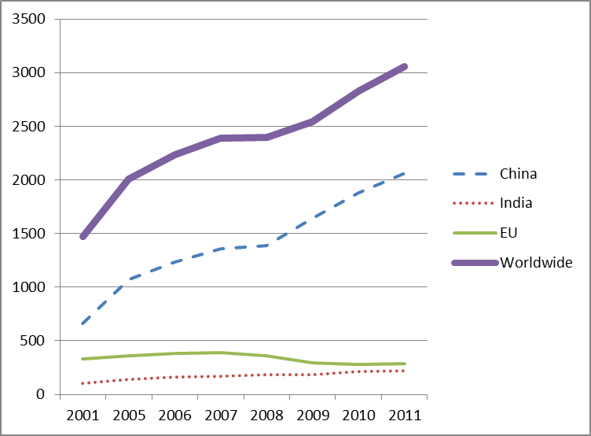
 | 2001 | 2005 | 2006 | 2007 | 2008 | 2009 | 2010 | 2011
China | 661 | 1 068,8 | 1 236,8 | 1 361,2 | 1 388,4 | 1 644 | 1 881,9 | 2 063,2
India | 102,9 | 142,7 | 159 | 170,5 | 183,3 | 186,9 | 213,9 | 223,5
EU | 328,8 | 357,9 | 380,3 | 386,5 | 360,1 | 293,7 | 281,1 | 289,6
Worldwide | 1 470,3 | 2 005,9 | 2 232 | 2 386,3 | 2 398,3 | 2 546,1 | 2 830 | 3 055,6
Source: World Bank, Global Economic Prospects, January 2012
4. The decline in the production of other non-metallic mineral products in the EU has been accompanied by a loss of worldwide market share.
Market share
(%)
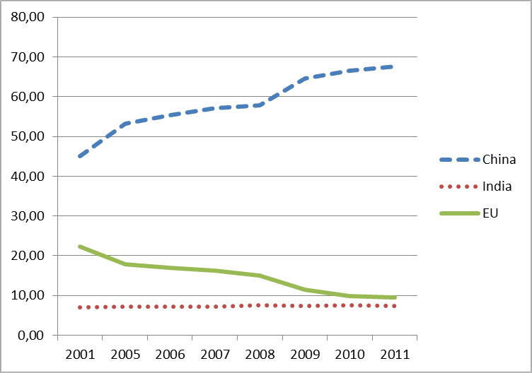
 | 2001 | 2005 | 2006 | 2007 | 2008 | 2009 | 2010 | 2011
China | 44,96 | 53,28 | 55,41 | 57,04 | 57,89 | 64,57 | 66,50 | 67,52
India | 7,00 | 7,11 | 7,12 | 7,14 | 7,64 | 7,34 | 7,56 | 7,31
EU | 22,36 | 17,84 | 17,04 | 16,20 | 15,01 | 11,54 | 9,93 | 9,48
Source: Compiled by the applicant from data production from World Bank, Global Economic Prospects, January 2012
5. These figures show that growth in the manufacture of other non-metallic mineral products in the EU was lower than in its major competitors, thus leading to a loss of market share in the sector. The EU-27's market share of world production of other non-metallic mineral products fell from 22,36 % in 2001 to 9,48 % in 2011, while China's market share grew from 45 % to 67,5 % and India's market share remained stable at around 7 %.
6. The manufacture of other non-metallic mineral products in Spain followed the same negative trend as shown for the EU. However, the decline in production in Spain has become steeper since 2008.
Manufacture of other non-metallic mineral products
Volume of production
(% change compared with previous year)
 | 2006 | 2007 | 2008 | 2009 | 2010 | 2011
Spain | 2,37 | -4,62 | -23,64 | -23,81 | -10,42 | -10,47
EU | 6,26 | 1,63 | -6,83 | -18,44 | -4,29 | 3,02
Worldwide | 11,27 | 6,91 | 0,50 | 6,16 | 11,15 | 7,97
Source: Eurostat. Volume of production 2011
7. EUROSTAT trade statistics for the EU-27 show a substantial increase in imports of other non-metallic mineral products into the EU over the period 2001-2011. In 2010 imports had tripled compared to 2001, despite a decrease in imports experienced in 2008 and 2009 due to the impact of the financial and economic crisis on the construction sector.
Imports of other non-metallic mineral products in EU
(EUR million)
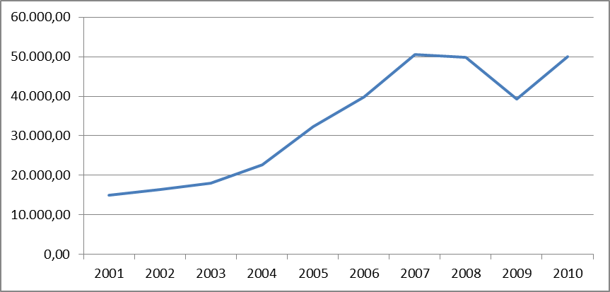
Furthermore, according to the ICEX, during the period January to November 2012, 85 % of all imports of other non-metallic mineral products worldwide were imports into the EU.
8. In conclusion, the Commission considers that the redundancies in the 140 enterprises involved in manufacturing activities in NACE 2 rev 2 Division 23 ('manufacture of other non-metallic mineral products') in the NUTS II region of Comunidad Valenciana (ES52) can be linked, as required by Article 2 of Regulation (EC) No 1927/2006, to major structural changes in world trade patterns, which have led to an increase in imports into the EU of other non-metallic mineral products and to a reduction in the EU share of production of other non-metallic mineral products at worldwide level.
9. To date, the sector covering the manufacture of other non-metallic mineral products has been the subject of four EGF applications, three of which were submitted by Spain following redundancies in the NUTS II region of Comunidad Valenciana.
Demonstration of the number of redundancies and compliance with the criteria of Article 2(b)
10. Spain has submitted this application under the intervention criteria of Article 2(b) of Regulation (EC) No 1927/2006, which requires at least 500 redundancies over a nine-month period in enterprises operating in the same NACE Revision 2 Division in one region or two contiguous regions at NUTS II level in a Member State.
11. The application cites 630 redundancies in 140 enterprises operating in the NACE Revision 2 Division 23 (Manufacture of other non-metallic mineral products) in the NUTS II region of Comunidad Valenciana (ES52) during the nine-month reference period 14 June 2012 to 14 March 2013. All of these redundancies were calculated in accordance with the second indent of the second paragraph of Article 2 of Regulation (EC) No 1927/2006.
Explanation of the unforeseen nature of those redundancies
12. The Spanish authorities argue that the financial and economic crisis led to a sudden collapse of the economy with an enormous impact on many sectors and in particular on demand for building construction. In countries like Spain, where the annual growth rate of construction activity was higher than the European average, a slowdown in construction activity was already anticipated for the medium term. However, the manufacturers of building materials could not anticipate the combination of rising imports of construction materials, which tripled in the last 10 years, and the sudden and substantial slowdown of construction activity as a consequence of the financial and economic crisis.
Identification of the dismissing enterprises and workers targeted for assistance
13. The application relates to 630 redundancies in the following 140 enterprises.
Enterprises and number of dismissals
ACTIA INICIATIVAS S.L. |  | 1 | HORMIGONES PRETENSADOS SETABENSES S.L. |  | 1
AGC FLAT GLASSS IBERICVA S.A. |  | 1 | IBERO ALCORENSE S.L. |  | 4
ALFARBEN SA |  | 1 | INDUSTRIAS SEYFE SA |  | 1
ALFREDO FENOLLAR, S.A. |  | 1 | INDUSTRIAS ALCORENSES CONFEDERADAS S.A. |  | 1
ANDRES DOMINGO IBORRA, S.L. |  | 4 | INGENIERIA DE COMPUESTOS, S.L. |  | 13
ARCANA CERAMICA, S.A. |  | 1 | INSTITUTO VALENCIANO DE LA VIVIENDA |  | 1
ARCILLA BLANCA, S.A. |  | 2 | JOSE MONSERRAT SL |  | 1
ARTE Y DISEÑO CERAMICO SA |  | 1 | JOSECER SL |  | 1
AZTECA PRODUCTS & SERVICES SL |  | 1 | KADENA HOME DESIGN SL |  | 1
AZULEJERA ALCORENSE 1, S.L. |  | 1 | KERABEN GRUPO SA |  | 1
AZULEJO ESPAÑOL S.L. |  | 1 | KERABEN SA |  | 1
BALDOCER SA |  | 1 | KERAKOLL IBERICA, S.A. |  | 2
BENESOL, S.L. |  | 15 | KERAMEX SA |  | 1
BLENDCUT SL |  | 1 | LABORATORIOS DOCTA, S.L. |  | 1
CALES DE LA PLANA S.A. |  | 2 | LEBARA LIMITED  SUCURSAL EN ESPAÑA |  | 1
CANTERAS ALICANTINAS SL |  | 1 | LEVITILE SA |  | 1
CEMENTOS LA UNIÓN, S.A. |  | 18 | MANILUZ S.L |  | 1
CEMENTVAL MATERIALES DE CONSTRUCCION S.L. |  | 1 | MARAZZI IBERIA SAU |  | 6
CEMEX ESPAÑA S.A. |  | 54 | MARMOLES NOVELDA SA |  | 2
CERACASA, S.A. |  | 3 | MARMOLES PAREDES, S.L. |  | 1
CERAMICA EUROPEA DE FIGUEROLES SL |  | 1 | MARMOLES TARRAGONA SA |  | 1
CERAMICA LA ESCANDELLA SA |  | 1 | MARSEMOL,S.L. |  | 1
CERAMICA LATINA SL |  | 1 | MAVIDRE S.L. |  | 1
CERAMICA NULENSE S.A. |  | 3 | MAYOLICA AZULEJOS, SL |  | 2
CERAMICAS AZAHAR, SAU |  | 2 | MERCURY CERAMICA, S.L. |  | 2
CERAMICAS BELCAIRE SA |  | 1 | MOSAVIT ALCALATEN SL |  | 1
CERAMICAS IBEROALCORENSE, S.L. |  | 2 | NATUCER S.L. |  | 1
CERLAT S.A. |  | 20 | NAVARTI GRUPO, SA |  | 1
CICOGRES SA |  | 1 | NOVOGRES, S.A. |  | 1
CIFRE CERAMICA S.L. |  | 1 | NUEVAS AUTOMATIZADAS, S.L.U. |  | 5
COLOR ESMALT, S.A. |  | 1 | PERONDA CERAMICAS, S.A. |  | 1
COLORKER SA |  | 1 | PORCELANITE, S.L. |  | 1
COMERCIAL E INDUSTRIAL DEL MÁRMOL S.L. |  | 1 | PORCELANOSA GRUPO A.I.E |  | 3
COMPACGLAS, S.L. |  | 1 | PORCELANOSA, S.A. |  | 5
COMPONENTES ELECTRICOS INDUSTRIALES,S.E.I. , S..L. |  | 1 | PRANE PROYECTOS E INVERSION S.L. |  | 1
CORINGLE, SL |  | 2 | PREINDUSTRIALIZADOS PRETENSADOS DE LEVANTE, S.A. |  | 38
CORTE CERAMICO LA VALL, S.L. |  | 1 | PROSART RESINAS, S.L. |  | 1
CRIARESA, S.L. |  | 1 | QUIMICER SA |  | 1
CRISTAL CERAMICAS SA |  | 1 | REAL CERAMICA S.A.U. |  | 1
CRISTALERIA BERCA SL |  | 1 | RECICLADOS VICENTE MALLEN, S.L. |  | 1
CRISTALERÍA FORCADELL |  | 21 | REY-GRES, SL |  | 1
CRISTALERIA JUANVI Y HERMANOS, S.L. |  | 3 | RIBERA SALUD II UTE LEY 18/82 |  | 1
CRISTALERIA MOIXENT S.L |  | 1 | ROIG CERAMICA SA (ROCERSA CERAMICA) |  | 2
CRISTALES Y ARTICULOS DE REGALO, S.A. |  | 1 | ROSA GRES S.L.U. |  | 1
CRITALGLASS VALENCIA S.L.U. |  | 1 | SAINT GOBAIN PLACO IBERICA, S.A. |  | 1
DUNE CERAMICA S.L. |  | 2 | SAS PREFABRICADOS DE HORMIGON, S.A. |  | 1
EMIGRES SL |  | 1 | SERRAGLASS S.L |  | 1
EMPORIO CERAMICO S.L. |  | 1 | SPANISH TILE FROM NULES, S.A. |  | 1
ENDEKA CERAMICS S.A. |  | 1 | STYLGRAPH HISPANIA SL |  | 1
ENMALLADO PRODUCTOS CERAMICOS JMEL S.L. |  | 2 | SYSTEM POOL SA |  | 1
EQUIPCERAM S.L. |  | 1 | TAULELL SL |  | 1
ESMALGLASS S.A. UNIPERSONAL |  | 2 | TERREAL ESPAÑA DE CERAMICAS, S.A.U. |  | 33
ESTUDIO CERAMICO, SL |  | 1 | THE SIZE SINTERED CERAMICS, S.A. |  | 1
EUROATOMIZADO S.A. |  | 3 | TIERRA ATOMIZADA, S.A. |  | 15
EXCLUSIVAS QUIM SL |  | 1 | TODAGRÉS, S.A. |  | 43
FERRAES CERAMICA S.A. |  | 1 | TORRECID, SL |  | 1
FERRO SPAIN, S.A. |  | 5 | TURGAL CERAMICAS S.L. |  | 1
FORTE |  | 35 | UNDEFA 1, S.L. |  | 41
FRANCISCO STRUCH, S.L. |  | 11 | UNDEFASA SA |  | 1
GAMA-DECOR, SA |  | 1 | UNION VIDRIERA LEVANTE SL |  | 1
GEOTECNIA Y CIMIENTOS,S.A. |  | 1 | UNIVERSAL CERAMICA SL |  | 1
GRES CID SL |  | 6 | UNIXAN XXI, S.A. |  | 15
GRESPANIA S.A. |  | 4 | UNVISA VALENCIA SA |  | 1
HALCON CERAMICAS S.A. |  | 2 | VENIS, S.A. |  | 2
HATZ SPAIN S.A. |  | 1 | VERNI-PRENS S.A. |  | 1
HISPANO DE MARMOLES, S.A.L. |  | 2 | VIDRIOS SAN MIGUEL COOP. V. |  | 1
HORMICEMEX S.A |  | 21 | VIGUETAS CASES, S.L. |  | 8
HORMIGONES BUÑOL SL |  | 3 | VIGUETAS EL SARDINERO, S.L. |  | 34
HORMIGONES DEL MAESTRAZGO SAU |  | 2 | VITROBEN,S.L |  | 1
HORMIGONES DEL VINALOPO, S.A. |  | 13 | VIVES AZULEJOS Y GRES, S.A. |  | 1
Total enterprises: 140 | Total dismissals: 630
14. All the redundant workers will be offered the possibility of participating in the measures. However, the Spanish authorities, based on their previous experience in managing EGF cases, estimate that about 300 workers will opt to participate in the EGF measures.
15. The breakdown of the workers expected to participate in the measures is as follows:
Category | Number | Percent
Men | 267 | 89,0
Women | 33 | 11,0
EU citizens | 290 | 96,7
Non EU citizens | 10 | 3,3
15-24 years old | 2 | 0,7
25-54 years old | 243 | 81,0
55-64 years old | 55 | 18,3
> 64 years old | 0 | 0
16. In terms of occupational categories, the breakdown is as follows:
Category | Number | Percent
Managers | 13 | 4,3
Technicians | 47 | 15,7
Clerks | 2 | 0,7
Service workers | 2 | 0,7
Plant and machine operators | 199 | 66,3
Elementary occupations | 36 | 12,0
Apprentices | 1 | 0,3
17. In terms of educational level , the breakdown is as follows.
Educational level | Number | Percent
Basic education (to end of compulsory education) | 223 | 74,4
Upper secondary education | 30 | 10,0
Tertiary education | 39 | 13,0
Others (non-formal education) | 1 | 0,3
Uneducated or early school leavers | 7 | 2,3
18. In accordance with Article 7 of Regulation (EC) No 1927/2006, Spain has confirmed that a policy of equality between women and men as well as non-discrimination has been applied, and will continue to apply, during the various stages of the implementation of, and in particular in access to, the EGF.
Description of the territory concerned and its authorities and stakeholders
19. The territory concerned by the redundancies is the NUTS II region of Comunidad Valenciana. Of all Spanish enterprises 11,5 % are based in this region. The manufacturing sector represents 26 % of total employment here, while the service sector represents 60 %, construction 10 % and the primary sector 4 %. The business model in Comunidad Valenciana is characterised by a high percentage of small and medium-sized enterprises specialised mainly in the manufacture of furniture, shoes, textiles, ceramics and toys. These industries are concentrated in districts around a limited number of municipalities.
20. The main stakeholders are the Generalitat Valenciana (the autonomous government of Comunidad Valenciana) and in particular the SERVEF (public labour offices of the autonomous government); the trade unions UGT-PV, and CCOO-PV; the employers association FEDCAM (Federation of Manufacturers of Cement and Building Materials) and the non-profit association FESMAC (Foro Económico y Social de Materiales de Construcción).
Expected impact of the redundancies as regards local, regional or national employment
21. Employment in Comunidad Valenciana has been severely affected by the crisis. The unemployment rate in the region increased rapidly, rising from 9,61 % (Q1 2008) to 29,19 % (Q1 2013). The employment situation in the affected region seems particularly fragile, given the impact of the crisis on traditional sectors such as textiles, footwear and construction, which are very important for the region's economy.
Unemployment rate in Comunidad Valenciana
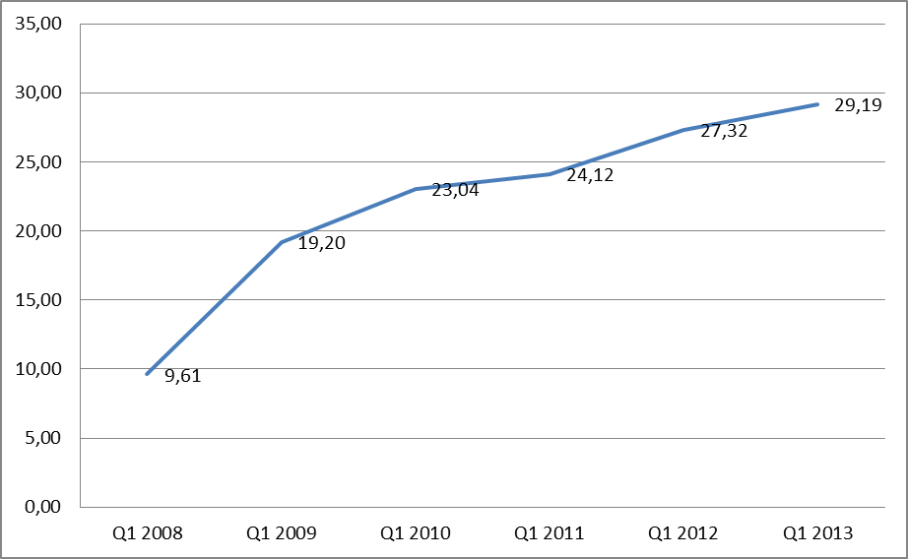
Source: Encuesta de Población Activa (EPA)
22. The Spanish authorities argue that the redundancies in NACE Revision 2 Division 23 in Comunidad Valenciana will further aggravate the unemployment situation, since the region and in particular the province of Castellón are highly dependent on this sector. The coefficient of regional specialisation of economic activity in Comunidad Valenciana regarding the NACE Revision 2 Division 23 is 2,074.
23. Furthermore, the jobs available in NACE Revision 2 Division 23 in Comunidad Valenciana decreased by almost 40 % from 2008 to 2011.
Occupancy in enterprises operating in the NACE Revision 2 Division 23
in Comunidad Valenciana
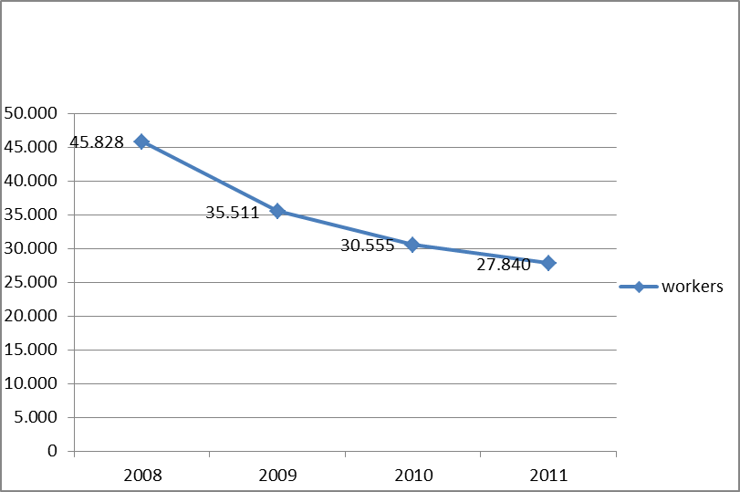
Source: Compiled from INE data. Encuesta industrial empresas 2011.
24. Following redundancies in the Comunidad Valenciana in sectors other than NACE Revision 2 Division 23, Spain submitted applications for financial contributions from the EGF in March 2010 (textiles) and July and December 2011 (construction and footwear, respectively). Moreover, this is the third application submitted by Spain concerning redundancies in the NACE Revision 2 Division 23 in Comunidad Valenciana.
Co-ordinated package of personalised services to be funded and breakdown of its estimated costs, including its complementarity with actions funded by the Structural Funds
25. All the following measures combine to form a coordinated package of personalised services aimed at reintegrating the redundant workers into employment:
- Welcome and information sessions: This is the first measure to be offered to all redundant workers and includes: (1) general information sessions and individual information sessions on skills and training requirements; on available counselling and training programmes; and on allowances and incentives; (2) enrolment procedure.
- Profiling, occupational guidance and counselling: This involves the profiling of the participant workers and the design of the customised reintegration pathway (phase I), workshops on job-search techniques (phase II) and counselling and follow-up of the personalised support throughout the implementation period.
- Training. The training measure will include a variety of training courses: (1) Vocational training and upskilling. The vocational training will focus on sectors where opportunities exist or will arise, such as for nursing assistants in geriatrics and passenger transport CPC, while upskilling (i.e. vocational training within the same sector) aims to improve the existing skills of the participants. The upskilling will be designed to cater for the future needs of manufacturers of other non-metallic mineral products (e.g. ISO 14001 environmental management/concrete; pathologies of precast concrete; design of one way slabs according to EHE-08, etc.). Around 120 workers are expected to participate in this training.
- (2) On-the-job training. This vocational training activity will be designed to cater for the identified needs of local enterprises. The distinguishing feature of this training activity is that the class-room training will be complemented by on-the-job training. It is estimated that 60 workers will participate in this training. (3) Promotion of entrepreneurship. Specific training activities will be provided for workers who wish to establish an enterprise. It is estimated that 50 workers will participate in this training. (4) Training in transversal skills. The training offer will include training in personal skills (such as emotional intelligence, managing change, leadership, etc.), in information and communication technologies (ICT), and in foreign languages. It is estimated that 170 workers will participate in this training activity.
- Intensive job-search assistance: This will involve an intensive employment search, including search for local and regional employment opportunities and job-matching. A website will be created to provide the workers with online tools which can help them with their individual job searches. Tutors will accompany the workers throughout the selection processes. Individual tutoring sessions will follow to help the workers reintegrated into employment to settle into their new jobs.
- Support towards entrepreneurship: This measure seeks to assist dismissed workers who envisage creating their own businesses. The support is organised in three phases: (1) Counselling on projects and initiatives. This aims to develop, produce and guide viable business or self-employment projects. The tutors will also try to find openings for self-employment within and outside the workers place of residence and propose them to the participants in the measure. (2) Accompaniment towards business creation. This will consist of personalised tutoring during the whole process of starting the business (development of a business idea, feasibility analysis, and assistance with preparing a business plan) and support regarding administrative requirements. (3) Logistic and financial support. This relates to fund-raising and support on administrative requirements to successfully apply for incentives to set up a business. It is estimated that 90 workers will participate in the first phase, 50 workers in the second phase and 25 workers in the third phase.
- Incentives. There will be four types of incentives: (1) Job-search incentive. The workers will be granted a lump sum of EUR 300 for carrying out their own personalised package of measures completely. It is estimated that all participants will receive this incentive. (2) Contribution to commuting expenses. Due to the lack of suitable public transport between the localities in the region, the participants will have to use their own vehicles to commute from their places of residence to the location where the measures will take place. The workers participating in the measures will receive up to EUR 400 as a contribution to their commuting expenses. It is estimated that 90 workers will receive this incentive. (3) Outplacement incentives. The workers who return to employment as employees or self-employed workers will receive up to EUR 700. It is estimated that 125 workers will receive this incentive. (4) Support for setting up a business. The workers who start their own businesses will receive up to EUR 3 000 to cover setting-up costs. It is estimated that 25 workers will receive this incentive.
26. The expenditure for implementing the EGF, which is included in the application in accordance with Article 3 of Regulation (EC) No 1927/2006, covers management and control activities as well as information and publicity.
27. The personalised services presented by the Spanish authorities are active labour market measures within the eligible actions defined by Article 3 of Regulation (EC) No 1927/2006. The Spanish authorities estimate the total costs at EUR 1 680 000, of which the expenditure for personalised services at EUR 1 600 000 and the expenditure for implementing the EGF at EUR 80 000 (4,76 % of the total amount). The total contribution requested from the EGF is EUR 840 000 (50 % of the total costs).
Actions | Estimated number of workers targeted |  | Estimated cost per worker targeted  (EUR)  (*) | Total costs (EGF and national cofinancing) (EUR)  (**)
Personalised services (first paragraph of Article 3 of Regulation (EC) No 1927/2006)
Welcome and information sessions  (Acogida) |  | 300 | 200 | 60 000
Profiling, occupational guidance and counselling  (Orientación) |  | 300 | 683 | 205 000
Training  (Formación) |  | 3 00 | 2 233 | 670 000
Intensive job-search assistance  (Servicios de inserción) |  | 250 | 990 | 247 500
Support towards entrepreneurship  (Servicios de emprendedurismo) |  | 90 | 1 433 | 129 000
Incentives  (Incentivos) |  | 300 | 961 | 288 500
Sub total personalised services |  |  |  | 1 600 000
Expenditure for implementing EGF (third paragraph of Article 3 of Regulation (EC) No 1927/2006)
Preparatory activities |  |  |  | 0
Management |  |  |  | 70 000
Information and publicity |  |  |  | 5 000
Control activities |  |  |  | 5 000
Sub total expenditure for implementing EGF |  |  |  | 80 000
Total estimated costs |  |  |  | 1 680 000
EGF contribution (50 % of total costs) |  |  |  | 840 000
(*) To avoid decimals, the estimated costs per worker have been rounded. However the rounding has no impact on the total cost of each measure, which remains as in the application submitted by Spain.
(**) Totals do not tally due to roundings.
28. Spain confirms that the measures described above are complementary with actions funded by the Structural Funds and that all double financing will be prevented.
29. The main objectives of the 2007-13 ESF operational programmes for the Comunidad Valenciana are promoting workers' lifelong learning and decreasing the risk of early school-leaving, focusing in particular on the most vulnerable people or people at risk of social exclusion, mainly young workers, or those over 45 years old, women and disabled people, while the EGF measures will focus on former workers of manufacturers of other non-metallic mineral products without applying any restriction related to age, education, etc.
30. Continuous follow-up of ESF and EGF actions with similar aims and the workers concerned will avoid any overlap between ESF and EGF measures.
Date(s) on which the personalised services to the affected workers were started or are planned to start
31. Spain started the personalised services to the affected workers included in the co-ordinated package proposed for co-financing to the EGF on 22 August 2013. This date therefore represents the beginning of the period of eligibility for any assistance that might be awarded from the EGF.
Procedures for consulting the social partners
32. The proposed application was discussed at several meetings with the social partners referred to under point 20 above. During the meetings held on 18 January, 7 March and 15 April 2013 the social partners were consulted on issues such as the substance of the integrated package of measures; the allocation of roles and distribution of tasks; and the scheduling of actions.
33. The Spanish authorities confirmed that the requirements laid down in national and EU legislation concerning collective redundancies have been complied with.
Information on actions that are mandatory by virtue of national law or pursuant to collective agreements
34. As regards the criteria contained in Article 6 of Regulation (EC) No 1927/2006, the Spanish authorities in their application:
- confirmed that the financial contribution from the EGF does not replace measures which are the responsibility of companies by virtue of national law or collective agreements;
- demonstrated that the actions provide support for individual workers and are not to be used for restructuring companies or sectors;
- confirmed that the eligible actions referred to above do not receive assistance from other EU financial instruments.
Management and control systems
35. Spain has notified the Commission that the financial contribution will be managed and controlled by the same bodies that manage and control the ESF. The Directorate-General for European Projects and Funds of the Regional Ministry of Finance and Government of the Comunidad Valenciana will be the intermediate body for the managing authority.
Financing
36. On the basis of the application from Spain, the proposed contribution from the EGF to the coordinated package of personalised services (including expenditure to implement the EGF) is EUR 840 000, representing 50 % of the total cost. The Commission's proposed allocation under the Fund is based on the information made available by Spain.
37. Considering the maximum possible amount of a financial contribution from the EGF under Article 10(1) of Regulation (EC) No 1927/2006, as well as the scope for reallocating appropriations, the Commission proposes to mobilise the EGF for the total amount referred to above, to be allocated under heading 1a of the financial framework.
38. The proposed amount of financial contribution will leave more than 25 % of the maximum annual amount earmarked for the EGF available for allocations during the last four months of the year, as required by Article 12(6) of Regulation (EC) No 1927/2006.
39. By presenting this proposal to mobilise the EGF, the Commission initiates the simplified trialogue procedure, as required by Point 28 of the Interinstitutional Agreement of 17 May 2006, with a view to securing the agreement of the two arms of the budgetary authority on the need to use the EGF and the amount required. The Commission invites the first of the two arms of the budgetary authority that reaches agreement on the draft mobilisation proposal, at appropriate political level, to inform the other arm and the Commission of its intentions. In case of disagreement by either of the two arms of the budgetary authority, a formal trialogue meeting will be convened.
40. The Commission presents separately a transfer request in order to enter in the 2013 budget specific commitment appropriations,, as required in Point 28 of the Interinstitutional Agreement of 17 May 2006.
Source of payment appropriations
41. Appropriations allocated to the EGF budget line in the 2013 budget will be used to cover the amount of EUR 840 000 needed for the present application.
Proposal for a
DECISION OF THE EUROPEAN PARLIAMENT AND OF THE COUNCIL
on the mobilisation of the European Globalisation Adjustment Fund in accordance with point 28 of the Interinstitutional Agreement of 17 May 2006 between the European Parliament, the Council and the Commission on budgetary discipline and sound financial management (application EGF/2013/004 ES/Comunidad Valenciana building materials from Spain)
THE EUROPEAN PARLIAMENT AND THE COUNCIL OF THE EUROPEAN UNION,
Having regard to the Treaty on the Functioning of the European Union,
Having regard to the Interinstitutional Agreement of 17 May 2006 between the European Parliament, the Council and the Commission on budgetary discipline and sound financial management, and in particular point 28 thereof,
Having regard to Regulation (EC) No 1927/2006 of the European Parliament and of the Council of 20 December 2006 establishing the European Globalisation Adjustment Fund, and in particular Article 12(3) thereof,
Having regard to the proposal from the European Commission,
Whereas:
(1) The European Globalisation Adjustment Fund (EGF) was established to provide additional support for workers made redundant as a result of major structural changes in world trade patterns due to globalisation and to assist them with their reintegration into the labour market.
(2) The Interinstitutional Agreement of 17 May 2006 allows the mobilisation of the EGF within the annual ceiling of EUR 500 million.
(3) Spain submitted an application to mobilise the EGF, in respect of redundancies in 140 enterprises operating in the NACE Revision 2 Division 23 (Manufacture of other non-metallic mineral products) in the NUTS II region of Comunidad Valenciana (ES52), on 22 May 2013 and supplemented it by additional information up to 17 July 2013. This application complies with the requirements for determining the financial contributions as laid down in Article 10 of Regulation (EC) No 1927/2006. The Commission, therefore, proposes to mobilise an amount of EUR 840 000.
(4) The EGF should, therefore, be mobilised in order to provide a financial contribution for the application submitted by Spain,
HAVE ADOPTED THIS DECISION:
Article 1
For the general budget of the European Union for the financial year 2013, the European Globalisation Adjustment Fund (EGF) shall be mobilised to provide the sum of EUR 840 000 in commitment and payment appropriations.
Article 2
This Decision shall be published in the Official Journal of the European Union.
Done at Brussels,
For the European Parliament For the Council
The President The President

OJ C 139, 14.6.2006, p. 1.
OJ L 406, 30.12.2006, p. 1.
Regulation (EC) No 1893/2006 of the European Parliament and of the Council of 20 December 2006 establishing the statistical classification of economic activities NACE Revision 2 and amending Council Regulation (EEC) No 3037/90 as well as certain EC regulations on specific statistical domains (OJ L 393, 30.12.2006, p. 1).
NACE Revision 2 Division 23 'Manufacture of other non-metallic mineral products' includes: manufacture of glass and glass products, manufacture of refractory products, manufacture of clay building materials, manufacture of other porcelain and ceramic products, manufacture of cement, lime and plaster, manufacture of articles of concrete, cement and plaster, cutting, shaping and finishing of stone and manufacture of abrasive products and non-metallic mineral products n.e.c.
In accordance with the third paragraph of Article 3 of Regulation (EC) No 1927/2006.
EUROSTAT. EU27 Trade since 1988 by SITC [DS-018995].
Instituto Español de Comercio Exterior – ICEX (Spanish Institute for Foreign Trade) www.icex.es.
EGF/2013/004 Comunidad Valenciana building materials (the current case); EGF/2009/012 Waterford Crystal, COM(2010) 196; EGF/2009/014 Comunidad Valenciana ceramics, COM(2010) 216; EGF/2010/005 Comunidad Valenciana natural stone COM(2010) 617.
Categories based on the International Standard Classification of Education (ISCED-97).
EPA (Labour Force Survey) http://www.datosmacro.com/paro-epa/ccaa/valencia?sector=Tasa-de-paro&sc=EPA-.
INE, Spanish national institute of statistics.
EGF/2010/009 ES Comunidad Valenciana textiles. COM(2010) 613.
EGF/2011/006 ES Comunidad Valenciana construction. COM(2012) 053.
EGF/2011/020 ES Comunidad Valenciana footwear. COM(2012) 204.
EGF/2013/004 ES Comunidad Valenciana building materials (the current case); EGF/2009/014 ES Castellón ceramics. COM(2010) 216; EGF/2010/005 ES Comunidad Valenciana natural stone. COM(2010) 617.
Certificate of Professional Competence (CPC) is the certificate attesting that certain professional drivers have passed the courses and tests required by Directive 2003/59/EC.
EHE is the abbreviation of the name given to the Spanish legislation on safety and design of concrete structures.
Dirección General de Proyectos y Fondos Europeos de la Consellería de Hacienda y Administraciones Públicas de la Generalitat Valenciana.
OJ C 139, 14.6.2006, p. 1.
OJ L 406, 30.12.2006, p. 1.
OJ C […], […], p. […].

