Introduction

When disaster strikes, relief is needed fast. Timely intervention by the international community can make the difference between life and death. The European Union (EU) and its Member States collectively provide more than half the funding required for emergency relief to victims of man-made and natural disasters throughout the world and actively promote respect for international humanitarian law.

This Annual Report outlines the main policy achievements and activities of the European Commission in the field of humanitarian aid, carried out principally through its Directorate-General for Humanitarian Aid and Civil Protection (ECHO) during 2012. While it does not describe in detail all the work and actions undertaken, it does present the ‘headline’ activities and developments of general interest.

Since 2010 ECHO’s mandate has encompassed both humanitarian assistance and civil protection. These are the two main mechanisms through which the European Union can ensure rapid and effective delivery of relief assistance to people faced with the immediate consequences of disasters.

EU humanitarian aid provides relief assistance to people in need outside the EU. It often throws a lifeline to those who are faced with the immediate consequences of disasters. The EU’s mandate under the Humanitarian Aid Regulation is to save and preserve life. Its role is also to prevent or reduce suffering and safeguard the integrity and dignity of individuals by providing relief and protection at times of humanitarian crises. The Commission also facilitates coordination with and among the EU Member States on humanitarian action and policy.

The overall priority is to ensure that the aid is managed in the most efficient way possible, thus guaranteeing that the assistance the EU delivers to people in need has the maximum effect and respects the principles of international law. The EU upholds at all times the humanitarian principles of impartiality, neutrality, humanity and independence.

The EU’s other main tool for providing help is civil protection. The Commission, through ECHO, strives to encourage and facilitate cooperation between the 32 states participating in the Civil Protection Mechanism in order to improve the prevention of and protection against natural, technological or man-made disasters, both inside and outside Europe.

Through these instruments, the EU provided substantial needs-based assistance in 2012, with total funding of EUR 1 344 million in commitments, including:

- Humanitarian aid actions helping approximately 122 million victims of natural disasters, man-made or protracted crises. Aid was provided in more than 90 non-EU countries.
- 38 activations of the Civil Protection Mechanism in 2012 (the figure includes requests for assistance, pre-alerts, and monitoring).

The global context

The year 2012 was marked by a very high number of humanitarian crises and disasters, and great vulnerability. Needs are now beginning to outstrip available resources. The delivery of humanitarian aid and civil protection is also becoming increasingly complex. Due to the frequency and intensity of natural disasters with major consequences, humanitarian crises are occurring with less warning.

In the course of 2012, statistics published by the Centre for Research on the Epidemiology of Disasters (CRED) and the UN Office for Disaster Risk Reduction (UNISDR) show that there were 310 natural disasters of variable magnitude. These disasters killed almost 10 000 people and affected 106 million people worldwide. At global level, Asia was the continent most affected by natural disasters. This was reflected in terms of both the number of disasters (42 % of worldwide disasters) and the number of victims (64 %). The impact of disasters on less-developed economies is particularly significant: for example, the damage caused by Typhoon Bopha in the Philippines, and floods in Pakistan. Africa was severely affected both by drought and by floods. The consequences of major disasters are devastating and varied: lives are lost, and housing, crops and livelihoods are destroyed.

Global Disaster Risk Map
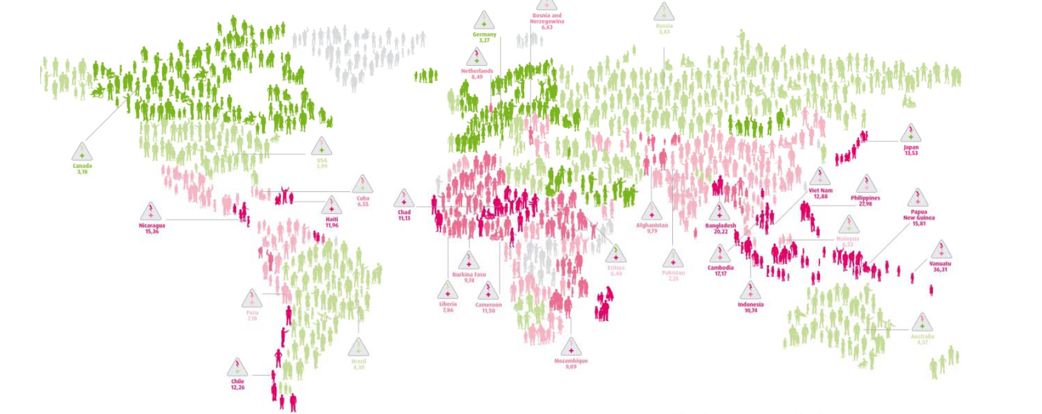
Internal armed conflicts remain the major cause of man-made humanitarian disasters, with civilian populations being increasingly exposed to violence and suffering. Conflicts of this type are often marked by the disregard of the perpetrators for international humanitarian law (IHL) and its principles. As a result, there has been a shrinking of the ‘humanitarian space’, i.e. the areas in which humanitarian relief can be provided neutrally and impartially without impediment. In this context, humanitarian access to people in need and the safety and protection of civilian populations and humanitarian workers have become more and more problematic. The overall situation and working environment has deteriorated in all these respects, particularly in Syria, Niger, Mali and the Central African Republic (CAR). In other countries, no improvement in security has been observed since last year, in particular in Somalia, the Democratic Republic of the Congo (DRC) and Afghanistan.
Although only a few have been mentioned by name, the impact of these disasters has greatly stretched the response capacity of the international humanitarian community. In 2012, the United Nations launched a consolidated funding appeal for USD 8.9 billion and received funding amounting to USD 5.6 billion for humanitarian needs in 21 countries. There is an increasing mismatch between rising global humanitarian needs, on the one hand, and the increasingly scarce financial resources available to respond to these needs, on the other. This is especially the case in the light of the economic and financial crisis that has hit many western donor countries. The chronic vulnerability seen in many parts of the world is compounded by the global economic crisis.

It also means that donors have to step up their efforts to respond to disasters in a more efficient manner, by making even better use of their limited resources. For the Commission, this translates into identifying efficiency gains when working with its partners. In this vein ECHO launched the ‘process review’ – an internal initiative, aimed at transforming the business processes and support systems to achieve both efficiency gains and higher quality/effectiveness. The aim should be to enable them to cope better with disasters, thereby reducing the devastating impact on affected populations and their livelihoods. The EU — as part of the overall international humanitarian system — also plays a key role in encouraging other countries and regions to increase their participation in humanitarian preparedness and response in order to mobilise more effectively the growing resources of emerging economies for humanitarian action and disaster response. At the same time, further synergies between humanitarian aid and civil protection are being developed. Preparations continued in 2012 for the opening in 2013 of the Emergency Response Centre (ERC) with the aim of enhancing the Commission civil protection 'hub' capacity and better coordinating civil protection and humanitarian aid responses to disasters.
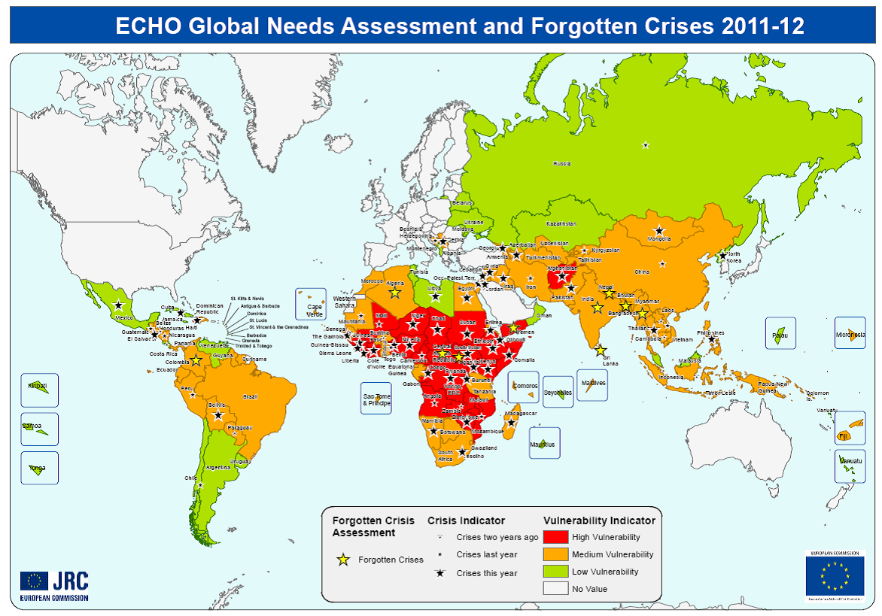
The importance of building up preparedness and resilience of vulnerable communities is demonstrated by the long-term impact on lives and livelihoods in the aftermath of major crises, such as the 2010 earthquake in Haiti and recurrent drought in the Horn of Africa and the Sahel. These disasters demonstrate how crucial it is to appropriately address longer-term rehabilitation and development needs at the very earliest stages of a humanitarian response. Only if humanitarians and development actors work hand in hand will they have a chance to reduce the devastating impact of recurring disasters and genuinely improve the prospects for sustainable development. That is why the Commission is developing an action plan and guidelines on resilience and Linking between relief, rehabilitation and development (LRRD). The Commission is actively working towards improving LRRD and developing stronger cooperation with other Commission services and other donors.
The year also saw humanitarian organisations being faced with increasing problems in gaining access to people that need help. Governments and militia or armed groups often shrink the humanitarian space and sometimes disregard the most basic protection guaranteed under IHL. Access restrictions faced by humanitarian organisations were most prevalent in areas of conflict and/or where there was a marked absence of the rule of law due to political obstacles (e.g. Syria, Mali, Somalia or Sudan/South Sudan). In many conflict zones (e.g. the DRC, Somalia, Sudan) humanitarian workers witnessed particularly brutal methods of warfare. These included the targeting of civilians and the use of sexual violence as a weapon of war.

The incidence of attacks on humanitarian aid workers, including kidnappings, expulsions and killings, was on the rise in 2012. Donors have had to manage and mitigate risks to the safety of humanitarian staff, and the funding and to the infrastructure that they provide. Some governments have been expropriating or ‘borrowing’ funds and properties financed by donors, and have expelled some humanitarian aid organisations once they have been stripped of their assets. This is a worrying trend.

Humanitarian aid interventions

Natural disasters continued to cause human suffering and severe damage throughout the world in 2012. In dealing with this type of disaster, the Commission has adopted a two-pronged strategy:

- Rapid response, by providing humanitarian aid and by facilitating and coordinating civil protection assistance. The latter is provided on a voluntary basis by EU Member States to other countries (within or outside the EU) participating in the Civil Protection Mechanism;
- Disaster preparedness, by identifying those geographical areas and populations which are most vulnerable to natural disasters and for which specific disaster preparedness programmes are established. In 2012, the EU continued its support to DIPECHO programmes in Southern Africa, the Caucasus, Central Asia, South-East Asia and Central America.

During the year, the EU provided humanitarian assistance to cope with the consequences of the following disasters:

- earthquakes in Costa Rica, Guatemala and the Philippines;
- droughts in West Africa (Burkina Faso, Mauritania, Mali, Niger, Chad), in the Horn of Africa (Djibouti, Ethiopia, Kenya, Somalia) and in Afghanistan;
- floods in Pakistan, Bangladesh, India, Sri Lanka, the Philippines, Myanmar, Fiji, Peru, Ecuador, Paraguay, Bolivia, Costa Rica, Panama, Nigeria, Niger, Senegal, Benin, Gambia, and Southern Africa;
- cyclones/hurricanes/tropical storms in India, South-East Asia (Cambodia, Laos, the Philippines, Thailand, Vietnam), the Caribbean (Haiti, Cuba, the Dominican Republic) and the Indian Ocean (Madagascar, Mozambique);
- epidemics, mainly in West Africa, the DRC, Sudan, South Sudan, Côte d’Ivoire, Haiti, El Salvador, Laos and Pakistan.

In terms of ‘man-made crises’, the far-reaching conflict and civil war in Syria, with a big exodus of Syrian refugees to neighbouring countries, including Turkey, Jordan, and Lebanon, clearly required a very significant humanitarian response from the EU. By the end of 2012, EU humanitarian funding for Syria totalled EUR 149.3 million, providing life-saving assistance both inside Syria and to those who had been forced to flee the violence in the country. This humanitarian assistance covered:
- In Syria — for Syrian internally displaced persons (IDPs) and host communities: inter alia, medical emergency relief, protection, food and nutritional items, water, sanitation, shelter, winter preparation and psychosocial support. It also covered the needs of the most vulnerable Palestinian refugees.

- Outside Syria — for people who fled their homes to seek protection in neighbouring countries and host communities: inter alia, shelter, winter preparation, food, water & sanitation, emergency medical rehabilitation to prevent further disabilities among the wounded, and legal assistance.

Many coordination meetings were held between the different services of the Commission to avoid duplication of effort and double funding, and to ensure that the activities complemented each other.

Another example of man-made crisis is the case of Colombia. Although it is going through a crucial peace process, the humanitarian consequences are still present: violation of human rights, impunity, displacement and massacres of civilians, and citizens ‘trapped’ in the conflict. Colombia has the second highest IDP rate after Syria, with a total, annual (increasing) figure of between 200 000 and 300 000. The accumulated total of displaced persons is 5 million according to NGOs, and 3.5 million according to the Colombian Government.

The EU also called for additional funding from other donors, and sought to ensure that additional assistance would address the needs of displaced populations throughout Syria and not just in the ‘hotspots’. The EU also pushed to increase the number of humanitarian organisations authorised to provide assistance inside Syria to cope with increasing needs, requiring that civilians (including humanitarian workers and medical personnel) and facilities be properly protected, and that unfettered access be given to conflict zones throughout the country.

The post-electoral crisis in Côte d’Ivoire continued, affecting neighbouring countries, particularly Liberia and Ghana, due to the continued presence of refugees. In Mali, the war, together with the food and nutrition crisis, increased the vulnerability of the population. In both countries, ECHO actively supported refugees, by restoring access to healthcare, focusing on nutrition and food assistance and providing protection assistance.

In India, inter-communal violence broke out in Assam, resulting in the displacement of hundreds of thousands of people, and inter-communal violence also occurred in Rakhine State. The EU provided basic services such as safe drinking water, sanitation, shelter, non-food items (NFIs), protection, nutrition and medical care. 126 000 people were displaced in Myanmar and the country saw many aid agencies suspending their operations and evacuating staff due to strong anti-UN/NGO sentiment. In some instances this resulted in the arrest of humanitarian staff. In Kachin State, the internal conflict continued with significant humanitarian impact on the civilian population (75 000 people displaced). IDPs received food assistance, WASH, shelter/NFIs, health and protection. As access was seriously constrained, close to 40 000 IDPs could not be reached by aid agencies.

The Commission responded to several protracted and complex emergencies, including in the following instances:

- Sudan and South Sudan: since the separation of Sudan into two countries in July 2011, there has been continuous conflict in the Sudanese border states of South Kordofan and Blue Nile. This has resulted in 173 000 refugees fleeing to South Sudan and 35 000 to Ethiopia. Conditions in the refugee camps near the border were very difficult in 2012. By year-end substantial assistance was still needed by the 1.7 million IDPs in Darfur, Sudan. Periodic outbreaks of inter-ethnic conflict in South Sudan led to 183 000 people being displaced from their homes. The Commission has intervened by mainly providing access to food, safe water, sanitation, nutrition and health services. Prevention/preparedness activities and a vaccination campaign have also been implemented.

- In Palestine the population continued to experience severe hardship and social distress. A protracted socio-economic crisis, characterised by severe restrictions on movement and the recurrent destruction of physical assets, led to continued high levels of poverty and unemployment. In the West Bank, Israeli settlement growth, settlers’ violence against Palestinians, demolitions, evictions, and land and asset confiscations — leading to forced population transfers — increased and continued to affect everyday life. Strict controls remained in place on Palestinians’ entry to Israel and East Jerusalem, and farmers had increasing difficulty accessing their land near the security barrier and settlements. In addition, the eight-day conflict in Gaza in November added another layer to the vulnerability of the population in Gaza. The Commission is still providing direct assistance in the water and sanitation, food assistance and health sectors. It is also continuing its strategic shift from a classical humanitarian programme to an increasing focus on protection and advocacy.

- In the Democratic Republic of Congo, with 2.5 million displaced people out of a total population of approx. 60 million, the humanitarian situation remained precarious. This is especially so in the east of the country, where numerous armed groups and the Congolese army were fighting to control territory and the rich resources of the region. The redeployment of Congolese army battalions to North Kivu to fight M23 rebels led to security vacuums in North and South Kivu. As a result of this insecurity tens of thousands of Congolese sought refuge in Uganda, Rwanda and Burundi in 2012. The Commission continued providing direct assistance to IDPs and refugees while also advocating better preparedness and improved access to vulnerable groups.

- In the Central African Republic, a crisis blew up at the end of the year when the rebel Seleka coalition began to march on Bangui, the capital, meeting little resistance along the way and taking control of town after town. Tens of thousands of people had to flee their homes. Humanitarian workers had to be evacuated, and some humanitarian bases were pillaged before an uneasy truce and negotiations led to a return to something like normality. This is a forgotten crisis, where the EU was one of the few humanitarian donors present. The Commission provided support in several areas including protection and access to healthcare, as well as provision of basic household items, clean drinking water, sanitation, nutrition and food assistance.

Overall, the EU’s comprehensive response to crises remained driven by needs, varied and multi-sectorial. It included components such as health (including psychological support, financing of clinics), protection (including activities addressing sexual violence), food and non-food items, shelter, water/sanitation, reconstruction and rehabilitation. The table below shows the distribution of aid per sector of intervention in 2012:

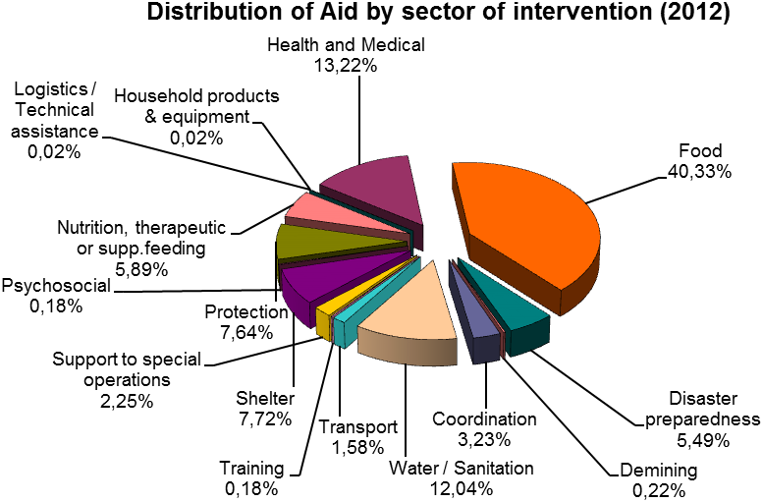

Civil protection operations

The civil protection mechanism was activated 38 times during the year. 31 of these instances related to natural disasters (snowstorms, severe cold weather, floods, earthquakes, tsunamis, avalanches, storms, forest fires), and seven involved man-made disasters (explosions, setting up of refugee settlement camps, marine pollution). 16 activations concerned countries that operate within the EU Civil Protection Mechanism (EUCPM) and 22 concerned countries elsewhere. As regards natural disasters, the Mechanism was activated in respect of forest fires in Spain, Portugal, Greece, Italy, Slovenia, Croatia, Bulgaria, Romania, and countries in the Western Balkans; floods in Bulgaria, the Comoros Islands, Chad and Nigeria; and severe weather conditions in Central and Eastern Europe. The EUCPM also responded to tropical cyclones in France (New Caledonia), the United States, the Philippines, Fiji and Haiti, and earthquakes in Italy, Mexico, Guatemala and Indonesia.

Countries participating in the EUCPM offered assistance to Turkey and Jordan to support the efforts of national governments in building refugee camps following the Syria crisis. Complementarity between humanitarian and civil protection assistance was ensured with, for example, additional NFI support for refugees in Zaatari camp in Jordan. The mechanism was also activated for explosions in Bulgaria and the Republic of the Congo, and for marine pollution in Italy. ECHO’s Monitoring and Information Centre (MIC) monitors all these disasters. It also acts as an information hub and entry point for requests for assistance, and coordinates assistance provided by countries participating in the EUCPM. Preparations continued in 2012 to upgrade the MIC and transform it into the new Emergency Response Center (ERC), with enhanced capacity to coordinate civil protection response to disasters and also to serve as a coordination platform for disaster response for civil protection and humanitarian aid within ECHO. The ERC will, as from 2013, also play an important role in promoting awareness of situations requiring a disaster response within the Commission, other institutions and Member States, having the capacity to deal with several simultaneous emergencies in different time zones, collecting and analysing real-time information on disasters, monitoring hazards, preparing plans for the deployment of experts, teams and equipment, and working with Member States to map available assets and coordinate the EU’s disaster response efforts by matching offers of assistance to the needs of the disaster-stricken country.

As part of civil protection policy, and in cooperation with Member States, the Commission also supports disaster preparedness and prevention activities within the EU. This covers inter alia the training of civil protection personnel and large-scale simulation exercises, exchange of experts, and cooperation projects on prevention and preparedness, involving actors from two or more Member States.

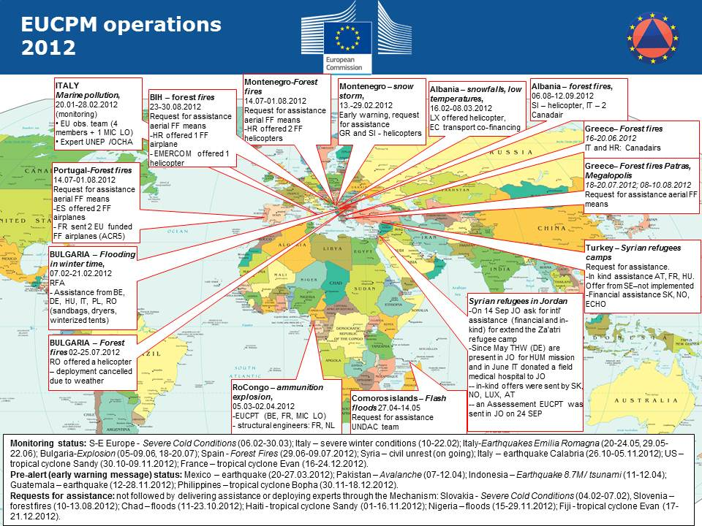

In 2012, in support of field operations, the Commission provided EU Member States and associated users with satellite imagery using the GIO-EMS service (GMES Initial Operations-Emergency Management Service). This became operational as of 1 April 2012, by having the MIC in ECHO as the single entry point for activation. By the end of 2012, the service had been activated 23 times and more than 170 satellite maps were produced for various types of disasters or crises.

Financial and human resources
The initial EU budget of EUR 874 million for humanitarian aid was increased several times in order to respond to new crises and natural disasters occurring during the year. Examples of this include the outbreak of conflict in Syria, the conflicts in Mali, the deepened drought in the Sahel, increased conflict and refugee flows in Sudan and South Sudan, the upsurge of conflict in the east of the DRC, the outbreak of inter-communal violence in Myanmar, and hurricane Sandy.

Extra money was mainly obtained by transferring funds from the Emergency Aid Reserve and some additional transfers from the 10th European Development Fund, part of which is reserved for humanitarian aid in African, Caribbean and Pacific countries. It was also supplemented by EFTA contributions and by transfers from other budget lines within the EU budget’s Heading 4 for external aid, adding up to a final 2012 budget of EUR 1 344 million in commitment appropriations, which represents a record annual budget for EU humanitarian aid and civil protection.

This funding was provided to the following regions (rounded figures, in EUR millions of commitment appropriations):

Region/country |  | Amount |  | %
Africa |  | 681 |  | 51%
Sudan & Chad |  | 207
Central Africa |  | 92
Horn of Africa |  | 162
Southern Africa, Indian Ocean |  | 32
West Africa |  | 188
Middle East, Mediterranean |  | 265 |  | 20%
Middle East |  | 255
Mediterranean |  | 10
Asia, Pacific |  | 198 |  | 15%
Central and South West Asia |  | 110
Central South Asia |  | 32
South East Asia and Pacific |  | 56
Latin America, Caribbean |  | 68 |  | 5%
Latin America |  | 30
Caribbean |  | 38
Worldwide disasters |  | 19 |  | 1%
Civil protection |  | 27 |  | 2%
Inside the EU |  | 21
Outside the EU |  | 6
Worldwide assistance and support |  | 86 |  | 6%
TOTAL |  | 1 344 |  | 100 %

The bulk of EU funding in 2012 was, as in previous years, allocated to Africa (51 %). Substantial assistance was also provided in the Middle East (Syria and neighbouring countries), for the Myanmar/Burma crisis, and for the natural disasters in South-East Asia and the Caribbean.

In 2012 the Commission had 302 staff members working at its ECHO headquarters in Brussels. To be able to respond to disasters in non-EU countries, the Commission has maintained its unique network of ECHO field experts available throughout the world, employing 145 field experts and 293 local staff, making a total of 438 people working in the Commission’s ECHO field offices as of 31 December 2012. These were located in 38 countries. Immediately following a disaster, humanitarian experts are deployed on the spot to carry out needs assessments and they are also responsible for monitoring the implementation of the EU-funded humanitarian projects.

The Commission does not implement assistance programmes itself. As a humanitarian aid donor, it fulfils its mission by funding EU humanitarian actions through partner organisations which have signed ECHO’s Framework Partnership Agreement (FPA). The Commission’s partners include a wide range of professional bodies — European NGOs and international organisations such as the Red Cross and the various agencies of the United Nations with which the Commission has signed a Financial and Administrative Framework Agreement (FAFA). The specialised agencies of Member States are also considered as partners.

This wide range of implementing partners enables the EU to cover a growing list of needs in different parts of the world, often in increasingly complex situations. Commission-managed grants and contributions are made by selecting the best proposals received. The 2012 breakdown for Humanitarian Agreements signed was: 47 % of actions carried out by NGOs (118 partners), 44 % by UN agencies (15 partners) and 9 % by international organisations (3 partners).

From the security point of view, the Commission took further steps to strengthen its own security management system. This was accomplished both at headquarters and in the field through improved coordination and collaboration with humanitarian partners, by monitoring and visiting projects, and by carrying out ex-ante controls, audits and evaluations.

Humanitarian and civil protection assistance policy
At policy level, the Commission invested time and effort in several initiatives of strategic importance:

- The Commission continued negotiations with the Council and the European Parliament on the new EU Civil Protection Mechanism legislation, aiming to support, coordinate and supplement the actions of Member States in the field of civil protection to improve the effectiveness of systems for preventing, preparing for and responding to natural and man-made disasters. In this connection, the Commission proposed a series of innovative initiatives, the most important of which were:
  - the creation of a voluntary pool of pre-committed response capacities (ranging from search and rescue teams to field hospitals and relief supplies). These resources would be made available by the Member States concerned for EU civil protection missions, and quality criteria and a certification process would be developed;
  - a gap identification process with the possibility of funding specific types of response capacities at EU level;
  - a training network;
  - a new approach to support Member States in the field of disaster risk management.
- Preparatory work on the creation of a voluntary corps. Preparations for launching the EU Aid Volunteers legislative initiative advanced significantly in 2012 and the proposal to establish the programme was adopted in September. The proposal provided for financial support to train and deploy volunteers to complement humanitarian aid actions in non-EU countries, and to build capacity for volunteering in non-EU countries. In parallel the Commission continued the preparatory work started in 2011 and 2012. Financial support, focusing on building up resilience and civil protection capacity, was agreed for an additional five pilot projects involving approximately 150 volunteers.
The Commission continued to put emphasis on the commitments stemming from the ‘European Consensus on Humanitarian Aid’ and selected horizontal policy priorities. The year 2012 saw continued progress in the implementation of the European Consensus on Humanitarian Aid. EU Member States and the Commission maintained their efforts to put in place the key elements of the Consensus Action Plan using both internal and external initiatives. As a follow-up to the Council conclusions, the Commission prepared the first Annual Report on the implementation of the Consensus in the previous year, which provided an overview of actions undertaken by the EU, including on a coordinated and joined-up approach of EU Member States and the Commission.

Enhancing coherence and coordination between the EU and its Member States in response to a disaster or protracted crisis is a key issue for improving the efficiency of the overall EU aid contribution. Since 2009 coordination with Member States has mainly taken place in the Council Working Party on Humanitarian Aid and Food Aid (COHAFA).

On a strategic level, COHAFA has allowed the EU to increase the coherence and complementarity of the Commission’s and Member States’ humanitarian aid activities: there is an annual exchange on policies/strategies, information and analysis produced by the Commission are used by Member States, and individual EU donor activities in specific crises are better coordinated. The Commission also increased its efforts to follow and contribute to the work of EP committees. The European Parliament was briefed about policy initiatives and priorities, as well as about the Commission’s response to specific crises.

Building up the resilience of affected populations to future crises continued to be a key priority throughout the year. A Commission Communication sought to step up the resilience-building effort in EU external action. The lessons learnt from the recent Horn of Africa and Sahel food crises provided input into the policy framework. The Communication underlined the EU’s commitment to stronger links between humanitarian and development aspects, in order to address both the symptoms and the underlying causes of crises. The preparation of a joint action plan was launched to kick-start the initiative.

The Commission launched a public consultation to gather stakeholders’ views on the challenges, objectives and options for further enhancing the effectiveness and impact of EU humanitarian aid. It took into account the changing global context at the outset of the 21st century. The results of the consultation, entitled ‘The Union’s humanitarian aid: Fit for purpose’, will feed into the Commission’s future initiatives in 2013 and 2014 to further increase the impact of EU humanitarian aid.

Throughout the year, the Commission also maintained regular contact with relevant international organisations, in particular the UN and the Red Cross Movement, on policy development and operational issues. Regular meetings were held with key partners. Special emphasis was placed on close cooperation with the UN Emergency Relief Coordinator, in particular on efforts to obtain a more inclusive humanitarian system through outreach to new partners, and the Transformative Agenda which the IASC agreed in 2011. The Transformative Agenda seeks to strengthen the international humanitarian system in the areas of leadership (especially the role of Humanitarian Coordinators), coordination (more efficient cluster systems) and accountability (including more coordinated needs assessments).

The Commission remained actively involved in the negotiations for a new Food Assistance Convention on behalf of the EU, which was ratified in November 2012. The Food Assistance Convention is an international instrument which reaffirms the commitment of donors to addressing the food and nutrition needs of the most vulnerable.

The roll-out of the humanitarian food assistance policy was also pursued. Preparations were made jointly with DG Development and Cooperation - EuropeAid for a Communication to enhance maternal and child nutrition. Work was also started on a Staff Working Document ‘Addressing Under-nutrition in Emergencies’ to accompany the Communication and translate it into operational guidance.

The Commission prepared a Staff Working Document on Humanitarian Water, Sanitation and Hygiene, capturing best practice in this important humanitarian sector and providing operational guidance.

The Commission also remained committed to supporting the development and strengthening of the collective global humanitarian preparedness and response capacity. In 2012, EUR 23 million was made available for enhanced humanitarian response capacity programmes. These were undertaken within UN agencies, NGOs and the International Federation of Red Cross and Red Crescent Societies. The programmes focus on:

- increasing the effectiveness and reinforcing the capacity of international humanitarian organisations and non-governmental organisations. This includes the ability to assess, analyse, prepare for and respond to humanitarian needs, during man-made and/or natural disasters and in their immediate aftermath, in a coordinated and inclusive manner; and
- reinforcing the capacity of international humanitarian organisations and non-governmental organisations to deliver more varied and appropriate forms of food assistance, during emergencies and in their immediate aftermath.
During 2012, the EU provided funding for a project to identify how humanitarian principles are applied in practice, with a view to strengthening their implementation, and further support to provide training in IHL and related humanitarian norms to armed non-state actors. Assistance was also given to increase awareness of IHL and humanitarian principles among European humanitarian organisations and their implementing partners working in conflict-prone or post-conflict countries.

Conclusion
The Commission responded effectively in 2012 to the ever increasing need for emergency response and relief aid worldwide. Though more assistance was given in 2012 than in previous years, the EU was unable to fully meet the needs of all victims due to the increase in the number of disasters globally. With global warming already a reality, this trend is set to continue. Within the context of the financial crisis an even more concerted effort has been made to make every euro count. This has not only meant ensuring that the right aid reaches those most in need at the right time, but also finding ways of doing more with less. In 2012, significant emphasis was placed on increasing speed and efficiency and cutting out duplication of processes and actions. In addition, progress was made on major new initiatives, including working towards opening the Emergency Response Centre, which will greatly enhance our ability to carry forward the work done by the Commission into 2013 and beyond.

Financial information on the Commission’s 2012 performance on humanitarian aid and civil protection can be found at the following address:
http://ec.europa.eu/echo/funding/key_figures/echo_en.htm
Operational information can be found at the following address:
http://ec.europa.eu/echo/about/annual_reports_en.htm

According to the most recent (2012) data available (Global Humanitarian Assistance: http://www.globalhumanitarianassistance.org).
Council Regulation (EC) No 1257/96 of 20 June 1996 concerning humanitarian aid.
The EU Civil Protection Mechanism (CPM) is made up of 32 states (27 EU Member States plus Croatia, former Yugoslav Republic of Macedonia, Iceland, Liechtenstein and Norway) which cooperate in the field of civil protection. The assistance can take the form of in-kind assistance, equipment and teams, or involve sending experts to carry out assessments. It relies on government resources and, if assistance is required in third countries, usually works in parallel with or hands over to humanitarian aid. The operational heart of CPM is the European Emergency Response Centre (ERC — formerly MIC — Monitoring and Information Centre) accessible 24 hours a day, seven days a week. Any country inside or outside the EU affected by a disaster and overwhelmed by its magnitude can make an appeal for assistance through the MIC/ERC.
€ 1317 million for humanitarian aid and € 27 million for civil protection.
Of which 108 million people were helped through humanitarian aid and food assistance and 14 million people through disaster preparedness programmes.
As detailed in paragraph 2.2, a total of 16 activations concerned countries within the EU Civil Protection Mechanism (EUCPM) and 22 concerned countries outside the Mechanism.
www.cred.be.
www.unisdr.org.
DIPECHO (Disaster Preparedness ECHO) is a specific programme dedicated to disaster preparedness. It targets highly vulnerable communities living in some of the most disaster-prone regions of the world.
Humanitarian Aid and Civil Protection (ECHO), Development and Cooperation – EuropAid (DEVCO), Service for Foreign Policy Instruments (FPI), European External Action Service (EEAS), Home Affairs (HOME), Enlargement (ELARG), Economic and Financial Affairs (ECFIN), Budget (BUDG)
This breakdown is simplified in that it associates projects to one single sector. In practice, most projects are linked to more than one sector. For instance, the figure for disaster preparedness (5.49 %) refers to those projects financed by the EU primarily linked to disaster preparedness. Nevertheless, if we take into account all the contracts including significant disaster preparedness components but for which the main sector of intervention is not DP, we reach a total of 15 %.
EUR 1 109 million in payment appropriations (82 % of commitment appropriations).
For civil protection the figures in the table are not broken down by country/region.
One operation is delivered directly, namely the ECHO Flight programme in DRC and Kenya to provide logistical support in a region prone to access problems.
(COM(2011) 934 final).
Article 214(5) of the Lisbon Treaty on the Functioning of the European Union (TFEU).
Inter-Agency Standing Committee Task Force.

