REPORT FROM THE COMMISSION TO THE EUROPEAN PARLIAMENT AND THE COUNCIL
on the implementation of Council Regulation (EC) No 814/2000 on information measures relating to the common agricultural policy

I. Introduction
This report concerns the implementation of Council Regulation (EC) 814/2000 (hereinafter "the Regulation") for the years 2011 and 2012.
The objectives of the information measures as defined in the Regulation are
- helping to explain the CAP as well as to implement and develop it
- promoting the European Model of agriculture and helping people to understand it
- providing information for farmers and others living in rural areas
- raising public awareness of the issues and objectives of the CAP
Actions fall into two main categories:
- Those submitted by third party organisations for co-financing under the EAGF (grants)
- Those at the initiative of the Commission and financed at a rate of 100% under the EAGF (direct actions)
It was decided by the Council (under Article 8 of Council Reg 814/2000) that a report on the implementation of the regulation should be presented to the European Parliament and the Council every two years. This is the fifth such report.
The annexes mentioned in the text are to be found in the accompanying Commission Staff Working Document.

II. BUDGET
The budget made available for information measures under budget line 05 08 06 was €8 million in 2011 and €8 million in 2012. The provisional breakdown between actions to be taken at the initiative of the Commission and actions to be co-financed (grants) was as follows:
2011: direct actions (€4.5 million) (56%) – Grants (€3.5 million) (44%)
2012: direct actions (€5.8 million ) (72%) – Grants (€2.2 million ) (28%)
Execution of the budget reached 100% for 2011 and 99% for 2012, in terms of commitments, and 80% in terms of payments for 2011. The final figures of the execution in terms of payments for 2012 cannot be reported yet as payments relating to the 2012 budget are to be made until 31 December 2013.

III. BREAKDOWN OF ACTIONS FINANCED
The common agricultural policy is due to be reformed after 2013. After a wide-ranging public debate, the Commission presented on 18 November 2010 a communication on "The CAP towards 2020", which outlines options for the future CAP and launched the debate with the other institutions and with stakeholders. On 12 October 2011, the Commission presented a set of legal proposals designed to make the CAP a more effective policy for a more competitive and sustainable agriculture and vibrant rural areas. Hence, there was a strong focus in the reporting period on information actions which aimed to raise public understanding of the Commission proposals to reform the common agricultural policy, and their contribution to meeting the challenges identified in the Commission's Europe 2020 strategy. This was the main element of the communication strategy defined by the Commission under the Regulation which is implemented through annual action plans. This priority reflects the findings of a number of Eurobarometer surveys on agriculture and the CAP in recent years: the guiding principles and aims of the Common Agricultural Policy (CAP) are supported by a majority of people but many are unaware of the policy itself. Therefore the communication strategy aims to raise awareness of the CAP and show that it addresses citizens' concerns.
In addition, the fiftieth anniversary of the entry into force of the common agricultural policy, and its role as a pillar of European integration, was highlighted in both direct and indirect actions in 2012. This anniversary was seen as an opportunity to raise public awareness of the CAP, in relation both to its achievements and its scope for future development through the proposed reform.
Planning of information measures focussed on meeting the needs of specific target groups, better defining appropriate messages, and dissemination strategies in line with the Regulation, as well as evaluation and feedback. Efforts were intensified to further develop synergies with the different actors in the field of communication on agriculture, including stakeholders, and the national authorities. Cooperation was deepened with the other EU institutions, as well as networks such as the Europe Direct Information Centres and European Network for Rural Development.

1. Grants (communication actions taken at the initiative of third party organisations)
The Regulation envisages two kinds of measures to be funded through grants, specific information measures and annual work programmes. A specific information measure means information events limited in time and space and implemented on the basis of a single budget. An annual work programme means sets of two to five specific information measures. For 2011 and 2012, it was decided (as in the three previous years) to retain only specific information measures for co-financing, with the aim of simplifying the grants scheme and ensuring coherence between the different communication actions. Efforts were reinforced to deepen dialogue with grants beneficiaries so as to further improve effectiveness and synergy between the co-financed actions carried out by third parties, and measures carried out at the initiative of the Commission (direct actions). More specifically, calls for proposals for co-financed actions in 2011 and 2012 encouraged information measures to raise public awareness of the Commission's proposals for reform of the CAP.
The maximum financing rate for the measures referred to above is 50% of eligible costs. However, the rate may be increased up to 75% in exceptional cases, as specified in the implementing Regulation and defined in the call for proposals. For 2011, it was decided to retain 50% as the maximum financing rate for the co-financed actions. For 2012, the call for proposals provided for the maximum rate of 75% for information measures of exceptional interest. However, as no proposal met the criteria laid down for such exceptional measures, no action was awarded a financing rate of 75% for 2012.
Under the 2011 call for proposals, 44 specific actions were co-financed (two more actions were selected by the Commission but abandoned during the implementation phase by the grant beneficiaries). The amount of grants to be requested from the Commission was between €20,000 and €300,000.
Under the 2012 call for proposals, 11specific actions were co-financed (one more action was selected but abandoned during the year). It is to be noted that the call for proposals for 2012 was designed to give priority to innovative and creative measures likely to have a major impact across several countries. Thus, for 2012, applicants were invited to apply for grants between €100,000 and €500,000; consequently, a smaller number of bigger actions were co-financed for that year.
Overall therefore, in the reporting period, a total of 55 actions were co-financed. Grants were awarded mainly for information campaigns, audio-visual productions, conferences, seminars, and a number of projects aimed at informing schoolchildren about the CAP. In the reporting period, the important number of information campaigns reflected the continuous emphasis in the calls for proposals on encouraging co-financed actions using a mix of communication tools with the aim of achieving maximum impact and reaching the widest possible audience. As mentioned previously, the fiftieth anniversary of the CAP was highlighted in the calls for proposals as a means of informing citizens about the contribution of the policy to EU integration and its role in meeting further challenges.
The types of grants beneficiaries were principally as follows: professional farm organisations, other non-governmental organisations/associations, public administrations (local, regional, and national authorities), and media organisations.
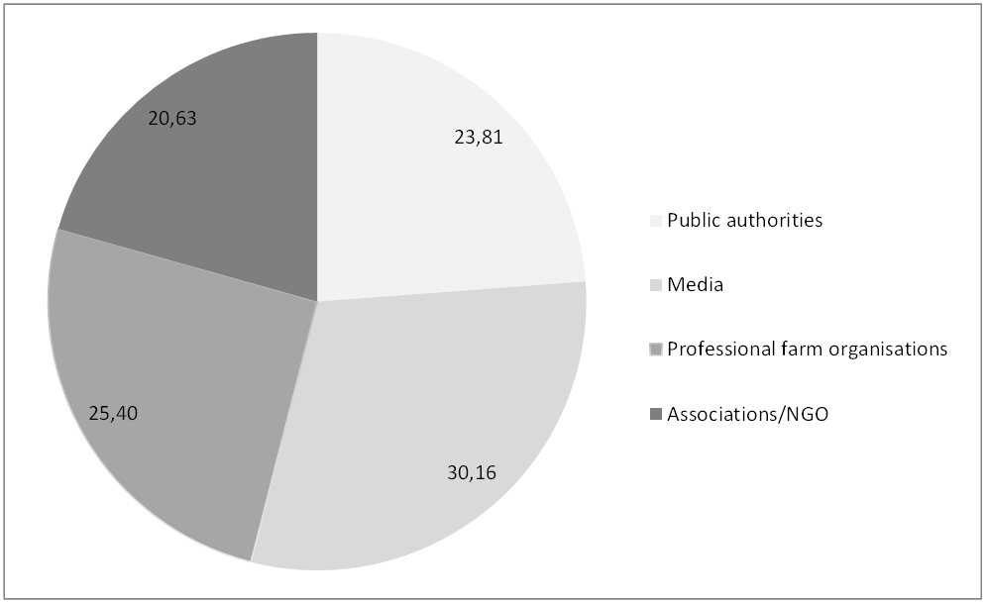
As in the past, socio-professional organisations active in agriculture and rural development at national level (often members of EU level bodies) figured prominently among the lists of beneficiaries. In addition, inter alia, media organisations –especially the audio-visual sector– increased their participation. In several co-financed actions, beneficiaries made use of the possibility to involve further organisations as partners in the execution of the projects, for example, in the actions implemented by media organisations, frequently farm organisations or other types of associations/NGO were partners or co-organisers.
Annex 1 gives an overview of grants in the reporting period. Details on individual grants are to be found on the Europa website:
http://ec.europa.eu/agriculture/grants-for-information-measures/index_en.htm
Applications were assessed in the light of rigorous eligibility, exclusion, selection and award criteria as laid down in the call for proposals. This was in line with the Regulation and reflected the Commission's aim to achieve equal treatment and fair competition between applicants.
In the reporting period, the number of successful grant applications from the EU12 Member States continued to increase; 37, 3% of the total number of grants awarded in 2011 and 2012 were allocated to organisations in those MS. There continued as in the past to be a strong level of interest from the southern part of the EU.
The table below indicates the number of received and awarded applications by Member State, in the reporting period.
Table I
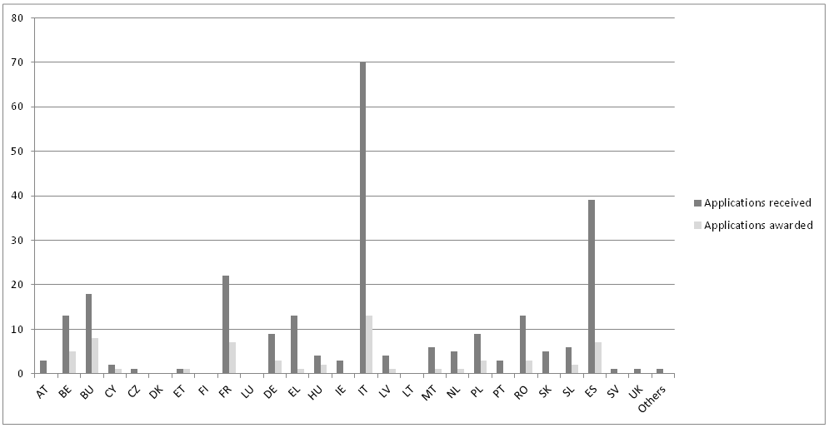
It is important to emphasise that, as in the past, a considerable number of co-financed actions reached a wider audience beyond the immediate participants, thanks to the multiplier effect of the specialised press and audio-visual media, as well as increased use of the internet and social networks as dissemination tools.

2. Communication actions taken at the initiative of the Commission
In the reporting period, as in previous years, an important number of communication actions were carried out at the initiative of the Commission. These were often implemented with external technical assistance. Some 64% of the budget was allocated for these measures in the 2011-2012 period.
Annex II provides detail on the Commission initiatives in this period, including the respective costs.
Participation at fairs
The Commission's emphasis on "going local" and improving the awareness of citizens about the CAP and the EU in general was central to the organisation of the Commission's stands in fairs in 2011-2012. Activity at fairs continued to target the general public and stakeholders, and the fiftieth anniversary campaign was used inter alia to communicate to the general public that the CAP and rural development are of relevance to the whole of society. Participation at fairs continued to provide a forum for dialogue with farmers, stakeholders and the general public on policy issues. Actions highlighted successful rural development projects, the EU's quality policy, as well as organising informative and educational activities designed to appeal to young audiences, and the general public.
Conferences
During this period, conferences provided an important forum for dialogue and consultation with stakeholders on aspects of the reform of the common agricultural policy. For example, the July 2012 conference "The CAP towards 2020-taking stock with civil society" was organised as a follow-up to the broad consultation on the challenges faced by European agriculture which was launched in 2010; it provided an opportunity for the non-governmental sector, representatives of the Member States and the EU institutions to debate and discuss the CAP reform legislative proposals for post-2013, adopted by the Commission on 12 October 2011. A number of events were designed also to highlight the priority given to enhancing innovation and the delivery of research in European agriculture. This included a conference-debate organised in cooperation with the Presidency of the EU and the European Parliament in December 2011; and a further high level conference in March 2012. In another conference on 20 April 2012, some four hundred stakeholders explored ways and means to mobilise and develop the potential of local agriculture and short supply chains to promote jobs and growth in rural areas.
These events contributed to the process of communicating, implementing and developing the agricultural policy, in line with the Regulation. The use of web-streaming technology ensured broad dissemination of conference proceedings.
Publications
In the reporting period, publications continued to reflect the legislative programme. This included texts concerning the CAP reform proposals and the quality policy. To coincide with the CAP 50th anniversary campaign, a number of attractive pedagogical publications were produced in 2012 to appeal to schoolchildren and the general public. These were widely distributed in the Member States and in this way, the anniversary campaign helped to raise awareness of the common agricultural policy and rural development.
Website
The "Agriculture and Rural Development" website continued to develop in the reporting period, notably as an important source of specialist information on the CAP and rural development. It also played a significant role in the process of consulting stakeholders and the general public as to the future direction of agricultural policy. Two on-line consultations were undertaken (one on information and promotion for EU agricultural products, one on the review of the EU fruit and vegetable regime). The views expressed have been or are being taken into consideration in the development of the respective policy. Subscriptions to the "Monitoring Agri-Trade Policy (MAP)" newsletter and briefs have risen to 5150, the "Agricultural commodity price dashboard" updates have now 1320, and the "Agricultural Policy Perspectives" briefs 1180 subscribers. The migration to a completely new version of the website (new corporate design, web content management technology, streamlined and updated content, in line with the Commission's web rationalisation and optimisation initiative) is nearing completion.
Opinion polls
In May 2011, a special Eurobarometer survey was carried out on a limited number of issues in the context of the preparation of the CAP reform legislative proposals, including the issue of transparency concerning the beneficiaries of CAP payments. In March 2012, a further survey was carried out on citizens' attitudes towards food security, food quality and perceptions of the link between agriculture and the preservation of nature and the countryside.
Visits
In the 2011-2012 period, groups of visitors, comprising principally farmers, farmers' representatives, students, regional and local representatives, journalists and academics were received. The purpose of the visits was to explain and deepen understanding of the common agricultural policy, including rural development, and the rationale for its reform.
Media actions
There was a strong focus in the reporting period on further developing and deepening links with the media, due to its importance as a multiplier in the field of communication. The setting up in September 2011 of an electronic platform ("Ag-press.eu") provides for daily interaction between relevant Commission services and journalists interested in agriculture across the EU.
This European Ag-Press network for agricultural journalists now has some 800 journalist members. The e-platform, updated on a daily basis, facilitates access to news and information on farming matters, mainly from the European Commission, but also from the other institutions. It also enables the exchange of experience between the journalists themselves. Through actions such as field trips and farm visits for journalists, seminars and study trips in Brussels and in the Member States, representatives of the media are informed about the CAP, and the diversity of EU agriculture.
In this period also, activity concerning agriculture and rural development on social media has been stepped up.

IV. COMMUNICATION CAMPAIGNS ON MAJOR ISSUES
Reference has been made in earlier reports to the broad public debate on the future of EU farm policy and subsequent communication actions in order to generate an open dialogue where the CAP was explained and discussed with the general public, stakeholders, and others. In the period under review, efforts were continued to improve understanding of the common agricultural policy and rural development by the stakeholders and the general public, through specific communication campaigns.
For example, the adoption by the Commission of the legislative proposals on the reform of the CAP in October 2011 was accompanied by press and stakeholder briefings in all EU 27 Members States. These briefings attracted over 2,500 representatives of the media (specialised and regional media, national TV and radio) and stakeholders (civil society bodies, regional and national administrations). They generated considerable media coverage (including over 500 press articles in the 24 hour period following the event). This represented a major effort in communication at local level, with all interested parties including the general public.
Another important action was the media campaign organised in the aftermath of the e-coli crisis in 2011 so as to demonstrate the Commission's support for producers' efforts in resuming consumer confidence in, and consumption of, fruit and vegetables. The EU wide press and TV campaign, consisting of press advertisements in one publication in each Member State, and a video news package for TV, is estimated to have reached some 37 million people.
As mentioned above, the theme of the fiftieth anniversary of the entry into force of the common agricultural policy figured prominently in information actions in 2012. In the reporting period, the preparation and implementation of the CAP@50 communication campaign was marked by a substantial degree of cooperation between the Commission, other EU institutions, the Member States and stakeholders. This campaign was a significant catalyst for information actions on CAP throughout the EU; some 150 related events in the Member States took place throughout the year, organised by national and regional authorities and civil society organisations, thanks to the creation of a dedicated website and interactive platform which included inter alia audio-visual and archival material, and publications and promotional material on the historical contribution of the CAP to the building of Europe, and its role in meeting current and future challenges.
An important highlight of the anniversary events was the EU-wide road show of a highly interactive exhibition targeting the general public – the CAP Past Present and Future – which toured some 20 Member States, as well as other EU institutions between April and December 2012, attracting more than 60,000 visitors over 24 stops.
Other related CAP@50 actions included participation in popular events such as A farm in the City organised in Brussels in September 2012. 5000 people visited the Commission's pavilion and 20,000 were exposed to the main messages of the event (via media promotion). In 2012, the first edition of the CAP Communication Awards for best practice examples in communicating the CAP was launched; the aim was to identify particularly effective information measures and to foster exchange of best practice among the different multipliers and networking partners.

V. THE PROPORTION OF SPENDING (COMMITMENTS AND PAYMENTS) BETWEEN CO-FINANCED ACTIONS AT THE INITIATIVE OF THIRD PARTIES (GRANTS) AND INFORMATION ACTIONS AT THE INITIATIVE OF THE COMMISSION
 |  | 2011 |  |  |  | 2012
 |  | Grants |  | Direct actions | Total | Grants | Direct actions | Total
Provisional split of budget |  | 3.500.000 |  | 4.500.000 | 8.000.000 | 2.200.000 | 5.800.000 | 8.000.000
Commitments in EUR |  | 3.507.228 |  | 4.480.063 | 7.987.291 | 2.197.904 | 5.707.754 | 7.905.658
% of commitment |  | 100% |  | 100% | 100% | 100% | 98% | 99%
Payments (**) in EUR |  | 2.440.123 |  | 3.939.636 | 6.379.759 | (*) | (*) | (*)
% of disbursement vs commitment |  | 70% |  | 88% | 80% | (*) | (*) | (*)
(*) Figures not yet available – most of the actions have not been paid yet
(**) The payments mentioned in the table do not represent the execution of the year N only but regroup the payments made in years N and N+1on the commitments of year N.
It is to be noted that there is an improvement of the commitment and disbursement rates compared to the previous reporting period where the average rate of commitment over the three years reached 85% for the grants and 96% for the direct actions and the average rate of payment respectively 65% and 86% for grants and direct actions. Payments are always lower than the amounts originally committed. In the case of grants, this can be explained by the fact that firstly, in many cases, final costs of the actions are lower than initially foreseen by the beneficiary, and secondly, because not all expenses declared by the beneficiaries can be considered as eligible. In the case of actions taken at the initiative of the Commission, the differences are smaller and due to the commitments, which take into account all possible foreseeable expenditure and which are sometimes finally lower than initially foreseen, as savings are being made and most cost-effective measures taken during the projects' implementation.

VI. CONCLUSION
The communication actions relating to the CAP in the reporting period aimed to inform and create awareness among the general public and stakeholders concerning the achievements of the common agricultural policy in delivering a modern, sustainable and efficient agricultural sector in Europe; they emphasised also the importance of the reform of the CAP in continuing this process to secure a fairer and greener farm policy equipped to contribute actively to achieving the goals of the Europe 2020 strategy. In carrying out these information actions, efforts were reinforced to promote stronger synergies between the communication actions of the Commission, other EU institutions, civil society, and Member States.

COM (2003)235 final of 8.5.2003; COM (2007)324 final of 13.6.2007; COM (2009)237 final of 20.5.2009; (COM (2011) 294 final of 25.5.2011.
OJ C 231/8, 27.8.2010; OJ C 212/22, 19.7.2011.
Commission Regulation (EC) No 2208/2002 of 12 December 2002 laying down detailed rules for applying Council Regulation (EC) No 814/2000 on information measures relating to the common agricultural policy (OJ L 337/21, 13.12.2002)

