Table of Contents
1. Introduction 3
2. Statement of financial performance 3
2.1. Development of the Fund in 2012 3
2.2. Situation of the Fund 4
2.2.1. Contributions as at 31 December 2012 4
2.2.2. The Fund’s holdings net of accrued interest at 31 December 2012 5
2.3. General and segmental analysis of the Fund 5
2.3.1. Liquidity analysis 5
2.3.2. General analysis of the results of the Fund 5
2.3.3. Analysis by segment 6
2.4. Benchmarking, performance and interest rate risk analysis 11
2.4.1. Benchmarking 11
2.4.2. Performance 13
2.4.3. Interest rate risk 14
3. Statement of Financial Position of the Fund as at 31 December 2012 14
3.1. Economic Outturn Account for the year ended 31 December 2012 16
3.2. Balance Sheet as at 31 December 2012 17
3.3. Statement of changes in contributors’ resources for the year ended 31 December 2012 (in EUR) 19
3.4. Cash Flow statement for the year ended 31 December 2012 20
3.5. Notes to the financial statements 21
3.5.1. General disclosures 21
3.5.2. Significant accounting policies 21
3.5.3. Financial Risk Management 25
3.5.4. Short-term Investments – Available For Sale portfolio 33
3.5.5. Other short term receivables 34
3.5.6. Cash and Cash Equivalents 34
3.5.7. Contributions 34
3.5.8. Current Liabilities 35
3.5.9. Financial operations revenues 35
3.5.10. Financial operations expenses 35
3.5.11. Subsequent events 36

1. Introduction
According to the Article 7 of the guarantee fund regulation, the assets of the Guarantee Fund are managed by the EIB. The agreement signed between the Commission and the EIB defines the principles governing the management of assets.
Under Article 8(2) of the Agreement, by 1 March of each year the EIB has to send the Commission an annual status report on the Fund and the management thereof (‘Statement of financial performance’) and a financial statement for the Fund for the preceding year (‘Statement of financial position of the Fund’).
The 'Statement of financial performance' prepared by the EIB has been attached in the section 2 of the Commission staff working document. The ‘Statement of financial position of the Fund’ audited by an external auditor is included in section 3.

2. Statement of financial performance

2.1. Development of the Fund in 2012
As at 31 December 2012, the total assets (excluding accrued interest) of the Guarantee Fund (the “Fund”) amounted to EUR 2,002.9 million against EUR 1,734.7 million as at 31 December 2011, an increase of EUR 268.2 million.
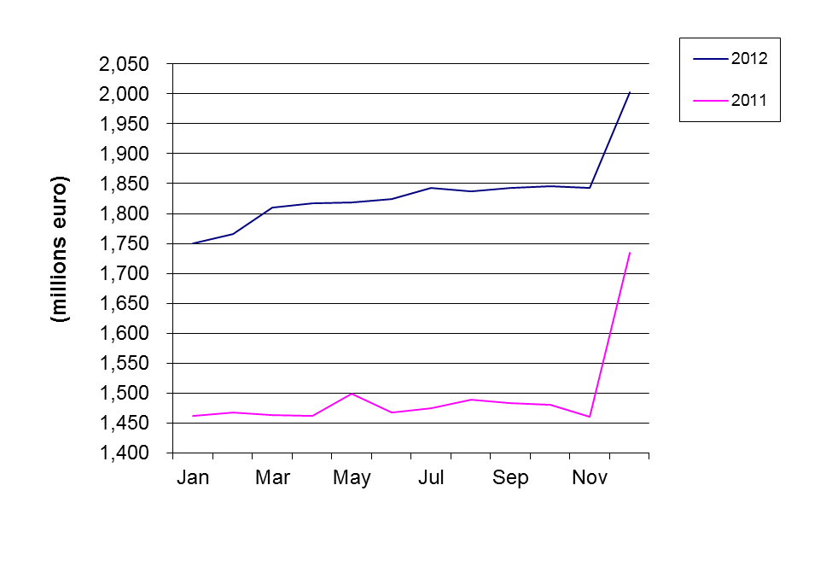
Fig.1: Development of total assets in 2012 and 2011

The net operating result amounted to EUR 43.99 million at 31 December 2012 compared with EUR 42.15 million at 31 December 2011 representing an increase of 4.4%.

2.2. Situation of the Fund

2.2.1. Contributions as at 31 December 2012

2.2.1.1. Contributions paid in as at 31 December 2012
The net contributions paid into the Fund by the European Union budget increased by EUR 238.3 million, or 32.8% from EUR 727.1 million at 31 December 2011 to EUR 965.4 million at 31 December 2012.
This is explained by the movements shown in the following table:
Contributions paid in (in EUR) | Situation at | Movements | Situation at
Contributions paid in (in EUR) | 31/12/2011 | in 2012 | 31/12/2012
Provisioning | 3,129,655,163 | 260,170,000 | 3,389,825,163
Repayment of surplus | -1,775,870,000 | 0 | -1,775,870,000
Activation of guarantee calls | -477,860,856 | -24,022,973 | -501,883,829
Recovery of historic called amounts | 576,705,008 | 2,149,346 | 578,854,354
Repayment of Funds (9%) | -725,521,527 | 0 | -725,521,527
Balance | 727,107,788 | 238,296,373 | 965,404,161

2.2.1.2. Contributions payable and receivable as at 31 December 2012
As at 31 December 2012 the Fund has recorded EUR 18.0 million (2011: EUR nil million) as contribution payable representing the provisioning for two guarantee calls made by the European Investment Bank in 2012 with regard to Syrian loan defaults. In addition, as at 31 December 2012 the Fund has recorded EUR 155.7 million (2011: EUR 260.2 million) as contributions to be paid in by the European Union.

2.2.2. The Fund’s holdings net of accrued interest at 31 December 2012
The Fund’s holdings at 31 December 2012 excluding accrued interest and contributions receivable totalled EUR 1,846.7 million as detailed below:
- EUR 242.0 million in the monetary portfolio (nominal value of interbank term deposits);
- EUR 8.1 million in the current accounts;
- EUR 1,596.6 million in the Available For Sale (AFS) (portfolio market value of fixed rate bonds, floating rate bonds and inflation linked bonds, excluding accrued interest).
The Fund operates in one currency only, the Euro.

2.3. General and segmental analysis of the Fund

2.3.1. Liquidity analysis
The liquidity position of the Fund at 31 December 2012 is outlined in the table below. The liabilities shown in the column "maturity undefined" represent the Contributor's (i.e. European Union's) resources.
Liquidity position as at 31 December 2012 (in EUR million):

Maturity | less than 3 months | 3 months to 1 year | 1 to 10 years | maturity undefined | Total
Total Assets | 517 | 157 | 1,348 | 0 | 2,022
Contributors resources and Liabilities (in EUR million)
Total contributors’ resources | 0 | 0 | 0 | 2,003 | 2,003
Total Liabilities | 19 | 0 | 0 | 0 | 19

2.3.2. General analysis of the results of the Fund
Overall, during the reporting period 1 January 2012 to 31 December 2012, the Fund achieved EUR 43.99 million in net revenue. The following table outlines the net revenue earned in 2012 and compares it with 2011:
In EUR million | From 1 January to  31 December 2012 |  | From 1 January to  31 December 2011
Interest income on cash & cash equivalents | 2.15 | 4.9% | 4.12 | 9.8%
Interest income on AFS assets | 36.87 | 83.9% | 40.77 | 96.7%
Realised gain on sale of AFS assets | 8.60 | 19.5% | 0.00 | 0.0%
Income from securities lending activity | 0.10 | 0.2% | 0.09 | 0.2%
Realised loss on sale of AFS assets | -2.78 | -6.3% | -1.94 | -4.6%
Commission and other charges | -0.95 | -2.2% | -0.89 | -2.1%
Total | 43.99 | 100.0% | 42.15 | 100.0%

2.3.3. Analysis by segment

2.3.3.1. Analysis of money market operations
Money-market investments (excluding accrued interest) amount to EUR 250.1 million at 31 December 2012, as compared to EUR 300.9 million the year before.
- Evolution of money-market rates in 2012
In light of sluggish growth in the Euro area and prospects of slow recovery ahead, the European Central Bank (ECB) decided to lower the reference rate in July 2012 from 1.00% to 0.75%. Market sentiment in 2012 was still affected by the problems of Euro-area peripheral countries, with particular attention to the details of the restructuring of the Greek sovereign debt and to the IMF reports on the updated situation in Ireland and Portugal. The whole year 2012 was still characterized by excess liquidity in the system which kept rates at low level. From the chart below, the decreasing path of the short term rates during the year can be noted, with evidence of reaching new lows right after the ECB decision of cutting further the main reference rate in July 2012.
Figure 2 shows the evolution of the one- and three-month Euribor during 2012.
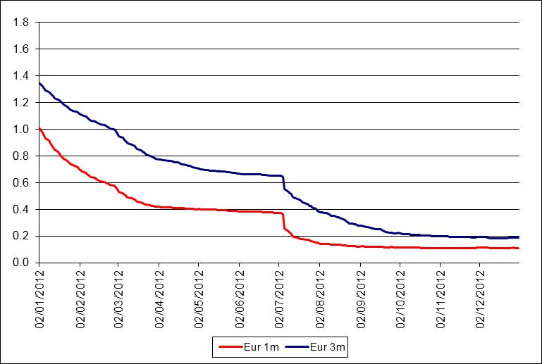
Fig. 2: Evolution of Money Market rates during 2012 (source Bloomberg)

- Profile of counterparties
In accordance with the agreement between the European Union and the EIB on the management of the Fund, all banks with which deposits are placed should have a minimum short-term credit rating of P-1 (Moody's or equivalent). The breakdown, including accrued interest, is as follows:

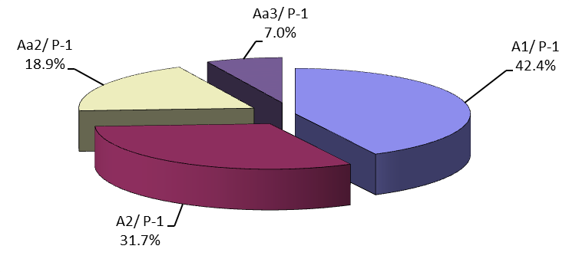

Fig. 3: Short term interbank investments by profile of counterparty at 31 December 2012

- Geographical breakdown
The EIB has diversified short term deposits amongst a number of banks located in the main EU financial centres.

2.3.3.2. Analysis of bond portfolio results
The global (modified) duration of the bond portfolio decreased over 2012 to reach 1.64 years at the end of the year. As of 31 December 2012, the clean market value of the investment bond portfolio came to EUR 1,596.6 million (2011: EUR 1,173.6 million) compared with a book value (including premiums/discounts) of EUR 1,542.9 million (2011: EUR 1,207.8 million), which gives an unrealised fair value result of EUR +53.7 million (2011: EUR -34.2 million).

During 2012 the German sovereign yields above 1 year declined across the curve as shown in figure 4.

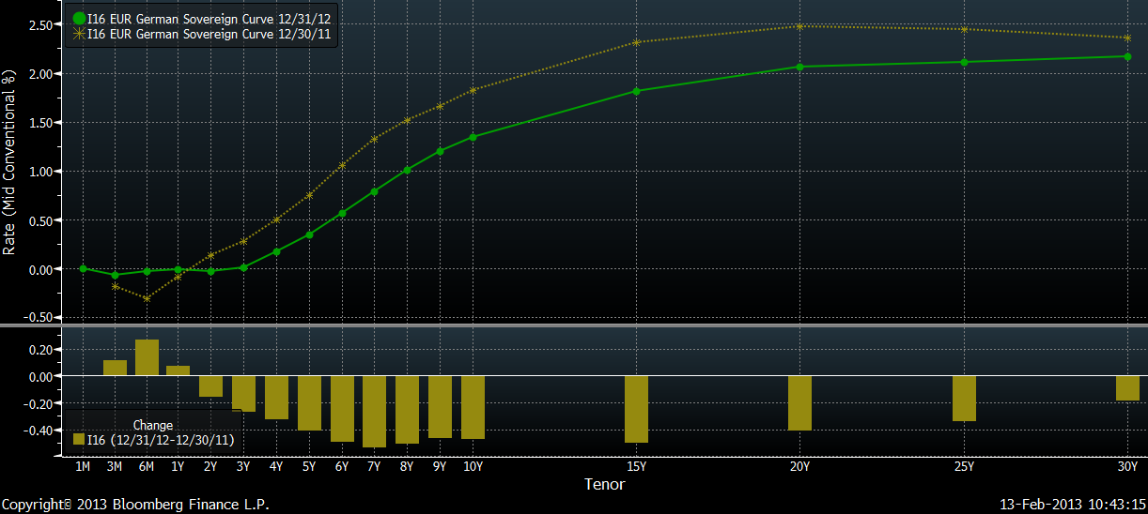

Fig. 4: Euro sovereign yield declined during 2012 (Source Bloomberg)
The on-going portfolio management throughout 2012 centred around the following topics: increase of the covered bond holdings of the portfolio, further accumulation of the floating rate format securities, disinvestment out of near-zero yielding positions and reduction of peripheral holdings and increase of exposure towards inflation linked bonds.
In accordance with the 2011 and 2012 approved investment strategy and in compliance with the guidelines, a total nominal amount of EUR 731.2 million (excluding coupon payments) was invested in fixed and floating rate SSA (56%) and sovereign (1%) securities, covered bonds (38%), inflation-linked bonds (3%) and corporate bonds (2%) within allowed maturities either on an outright or switch basis in the primary and secondary markets. All of the transactions were done with the objective of maximising the total return within the guidelines by taking into account the general macroeconomic environment and maintaining relatively conservative risk profile with respect to the relative country allocation versus the corresponding benchmark. The charts below outline the total 2012 investments as well as the country diversification of the portfolio investments added during 2012.
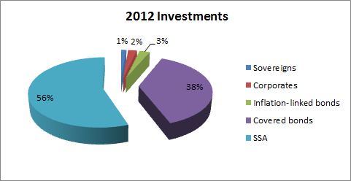
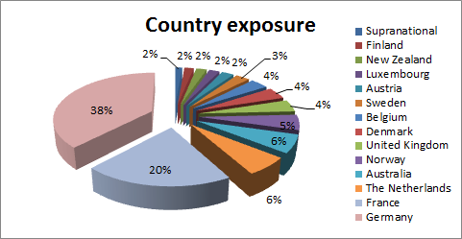
As of 1 January 2012, a total nominal amount of EUR 219.75 million of redemptions on the long-term portfolio was scheduled for the year with EUR 174.75 million of fixed rate bonds and EUR 45 million of Floating Rate Notes.
The covered bond purchases amounted to a total sum of EUR 278.2 million, spread with a view of diversifying investments among a variety of jurisdictions: Austria, Australia, Denmark, Germany, Finland, France, New Zealand, Netherland, United Kingdom, Sweden and Norway. Particular emphasis has been put on pursuing investment opportunities out of Eurozone (Australian Westpac Corporation, Norwegian Bolligkredit or New Zealand ASB Finance Ltd.) and – in case of Eurozone issuers – on staying within the safest Pfandbrief and in general northern universe, avoiding more volatile issuers in current market environment. The few purchases of French covered bonds have been made on opportunistic basis due to an attractive yield offered by respective papers.
The floating rate instrument spectrum remained a very conservative investment for the scenario of rates rising in the medium-term future which cannot be totally excluded. The 2012 purchases of FRNs amounted to EUR 387.5 million in total or 53% versus EUR 343.7 million or 47% in fixed rate bonds, spread among different asset classes as depicted in the above chart. As regards the country diversification, Germany was favoured with EUR 277.5 million or 38% compared to 62% of the remaining position (France 20%, The Netherlands and Australia 6%, Norway 5%, the UK, Denmark and Belgium 4% respectively, Sweden 3% and Austria, Luxembourg, New Zealand and Finland 2%).
In line with the general idea of increasing inflation exposure, as already outlined in the 2011 strategy, one inflation linked security (FRTR 0.25% 25/07/2018) has been purchased.
The credit ratings continued to remain under pressure during 2012, so as for covered bonds resulting in a sale of 5 bonds from different jurisdictions detailed as follows:
In anticipation of a downgrade by Moody’s of the rating of Banco Bilbao Vizcaya Argentaria, a EUR 5 million position of BBVASM 4.25 % 01/17 held in the GF portfolio, has been sold on 15 February.
In April, Moody's announced that it would complete its rating review of European banks by the end of June. While the German banks have been under scrutiny, with the exception of Deutsche Bank, Moody's downgraded the rating of Deutsche Hypothekenbank from AAA to Aa2. As a consequence, the EUR 10 million covered bond position held in the portfolio was no longer eligible according to article 3.2.2.3 (2) of the relevant guidelines and has been sold.
In addition, following the Fitch downgrade of two Depfa ACS Bank covered bonds (EUR 25.5 million holdings) on 29 June, the minimum rating of the securities changed to Aa3 and consequently the papers have been sold on 2nd July.
The same occurred to a Dutch SNS covered bond downgraded by Fitch from AAA to AA+ on 12 October 2012. The total exposure of EUR 5 million has been sold on 15 October as a consequence of the downgrade and following article 2.9 of the AM guidelines.
In order to improve the average yield carry of the portfolio, a few German and French government papers of relatively short maturities, whose yield approached the 0% yield level, have been sold.
Further reduction of peripheral exposure has been achieved either by outright sales or by redemptions. At the end of 2012, the remaining exposure (based on nominal values and by issuer country name) to Greece amounted to EUR 17 million, Ireland and Portugal totalled EUR 84 million (EUR 68 million (IE) and EUR 16 million (PT) respectively), whereas the less exposed countries like Spain and Italy amounted to EUR 72.5 million (IT) and EUR 37.5 million (ES) respectively.

- Breakdown of the investment portfolio between fixed rate and variable rate securities (nominal value)
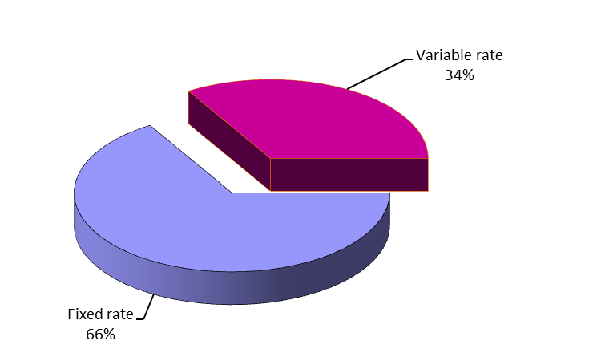
Fig. 6: Investment portfolio breakdown between fixed and variable rate securities at 31 December 2012
- Redemption profile of investment portfolio (nominal value)
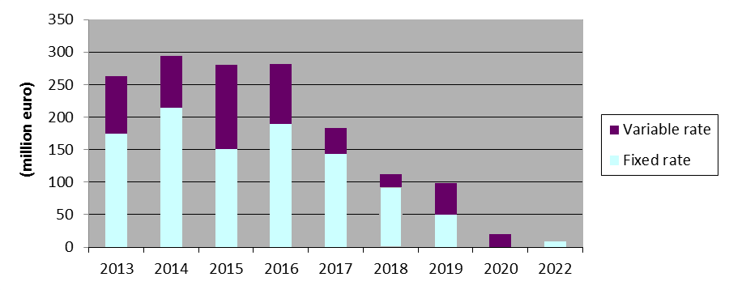
Fig.7: Investment portfolio: Redemption profile at 31 December 2012
The latest final maturity date for fixed rate securities is 12 September 2022.
- Profile of issuers
All the securities held in the portfolio are in line with the management guidelines and meet the following criteria for:
- Securities issued by Member States: minimum rating Baa3
- Securities issued by a Supranational, other States or Public Company: minimum rating Aa2
- Covered Bonds: rating Aaa
- Securities issued by Banks and Corporates: minimum rating Aa2
The profile of issuers of the investment portfolio (nominal amount) at 31 December 2012 is as follows:
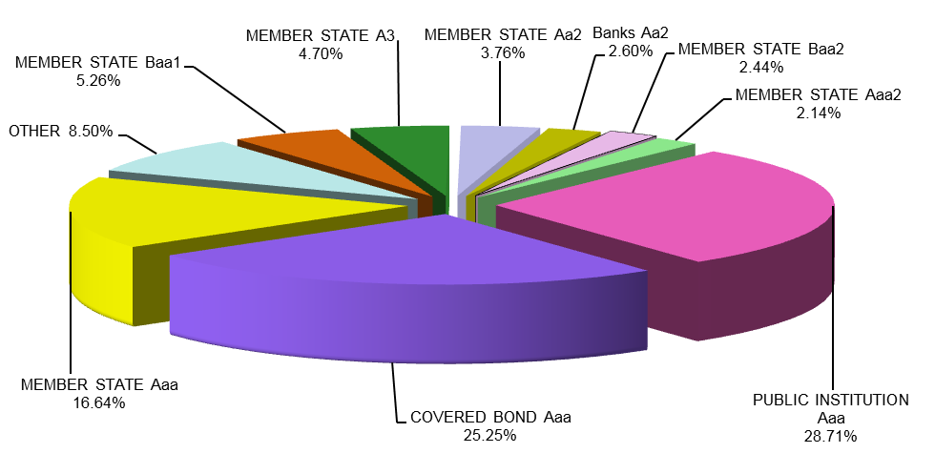
Fig. 8: Investment portfolio: Profile of issuers at 31 December 2012

2.4. Benchmarking, performance and interest rate risk analysis

2.4.1. Benchmarking
The performance of the Fund is monitored on a marked-to-market (MTM) basis against a composite index. This index is the result of the combination of the following sub-indices:
- Euribid 1M for money-market operations
- Euribid 3M for floating rate notes and fixed rate bond with less than one year to maturity
- IBOXX EUR Sovereign indices for fixed rate bonds issued by sovereign (or similar) issuers, split by maturity buckets
- IBOXX EUR Collateralized Covered indices for fixed rate bonds issued by corporate (or similar) issuers, split by maturity buckets
Index weightings are based on portfolio composition and are reviewed:
- at each end-month day: the dates which define the time buckets (up to 1y, from 1y to 3y, from 3y to 5y, from 5y to 7y and from 7y to 10y) are updated. As a consequence, the shifts between buckets due to the aging of existing positions are accounted only once per month at end-month, following the same procedure underlying the managing of the IBOXX’s indexes;
- during the month, whenever a change higher then ±5% in one of the asset-classes (respect to the last benchmark’s adjustment) is observed. This change can be the result of:
- the impact of a contribution from the European Commission to the portfolio (external cash flows from the European Commission);
- the impact of a withdrawal from the portfolio to the European Commission (external cash flows to the European Commission);
- the impact of a transaction settled (sales and purchases);
- the impact of a redemption;
- the sum of the impacts of previous events accumulated from the last benchmark’s adjustment, taking also into consideration the changes in the clean values of the positions.

Bucket (years) | Performance Benchmark Sector |  | Instrument |  | Average Clean Market Value Composition of 2012
0-1 |  | 1 m |  | Money Market |  | 21.40%
 |  | 3 m |  | FRN and Fixed Rate Bonds |  | 29.10%
1-3 |  | sovereign |  |  |  | 3.90%
 |  | covered bonds |  |  |  | 5.40%
3-5 |  | sovereign |  | Fixed |  | 1.10%
 |  | covered bonds |  | Rate |  | 0.10%
5-7 |  | sovereign |  | Bonds |  | 17.70%
 |  | covered bonds |  |  |  | 14.50%
7-10 |  | sovereign |  |  |  | 6.80%
 |  | covered bonds |  |  |  | 0.00%
Total |  |  |  |  |  | 100%

2.4.2. Performance
The performance of the Fund portfolio was monitored on a marked-to-market basis. During 2012, the portfolio delivered a 7.796% MTM yearly return, over performing its benchmark by 394.41 bps. The evolution of the portfolio return and excess return vis-à-vis its benchmark is presented in the following table:
 | Portfolio |  |  |  | Out-performance
 | Market Value (including accrued interest) | Monthly return (absolute return in %) | YTD return (absolute return in %) |  | Monthly  Excess Return compared to benchmark (in%) | YTD  Excess Return (in%)
31/01/2012 | 1,511,655,709 | 1.0136 | 1.0136 |  | 0.0562 | 0.0562
29/02/2012 | 1,785,732,118 | 0.8862 | 1.9087 |  | 0.2860 | 0.3455
31/03/2012 | 1,829,964,468 | 2.4770 | 4.4330 |  | 2.3910 | 2.7825
30/04/2012 | 1,834,529,052 | 0.2494 | 4.6935 |  | 0.2413 | 3.0347
31/05/2012 | 1,837,118,746 | 0.1412 | 4.8413 |  | 0.2393 | 3.2822
30/06/2012 | 1,841,473,523 | 0.2370 | 5.0898 |  | 0.1324 | 3.4244
31/07/2012 | 1,856,403,855 | 0.8108 | 5.9418 |  | 0.3959 | 3.8547
31/08/2012 | 1,853,167,853 | 0.5459 | 6.5202 |  | 0.0954 | 3.9731
30/09/2012 | 1,858,732,045 | 0.3003 | 6.8400 |  | -0.0860 | 3.8968
31/10/2012 | 1,862,281,206 | 0.2308 | 7.0866 |  | -0.0593 | 3.8448
30/11/2012 | 1,860,830,902 | 0.3827 | 7.4964 |  | 0.0218 | 3.8820
31/12/2012 | 1,866,022,096 | 0.2790 | 7.7963 |  | 0.0495 | 3.9441

- Following the exchange of debt by Greece the valuation of bonds issued or guaranteed by Greece has been changed from a mark-to-market to a model based approach.

2.4.3. Interest rate risk
The interest rate risk sensitivity of the MTM value of the portfolio mainly stems from its fixed rate exposure. A 1 basis point (bp) increase of interest rates reduces the value of the portfolio by EUR 305,731, of which EUR 294,311 is related to the fixed rate bond exposure. The global modified duration of the fund decreased during 2012 and stood at 1.64 years as of 31 December 2012, compared to 1.81 years as of 31 December 2011.

GF Sub- Portfolios | Market Value (excluding accrued interest) | Modified Duration (Years) | Interest Rate Exposure (+/-1bp)
Floating Rate Notes | 241,996,417 | 0.11 | -/+ 2,860
Fixed Rate Bonds | 520,334,248 | 0.16 | -/+ 8,560
Money Market Instruments | 1,076,262,090 | 2.69 | /+ 294,311
Cash account | 8,072,731 ⁽⁾
Total GF | 1,846,665,485 | 1.64 | -/+ 305,731

3. Statement of Financial Position of the Fund as at 31 December 2012
The financial statements for the Fund have been prepared by the EIB in accordance with International Financial Reporting Standards (IFRS) and the accounting rules adopted by the European Commission, in particular ‘Accounting rule 11 — Financial assets and liabilities’, dated December 2004 and updated in October 2006, December 2009 and December 2011. These financial statements are presented in euro. This is the financial statement for the Fund’s assets managed by the EIB. The annual accounts of the Guarantee Fund for the year ending on 31 December 2012 have been audited and certified by an independent auditor.
It should be noted that these financial statement do not reflect the decision of the Accounting Officer of the Commission (AO) on 31 January 2013, effective as from financial periods beginning on or after 1 January 2012, to show the available-for-sale financial assets of the European Institutions as current/non-current according to their remaining maturity and not longer as current. The decision was effectively adopted too late to be incorporated in the accounts of the Guarantee Fund for External Action as provided by the EIB. However, the distinction between current/non current has been reflected in the pre-consolidated accounts showed in the attached document "Report from the Commission on the Guarantee Fund and its management in 2012".

3.1. Economic Outturn Account for the year ended 31 December 2012

 | Notes | From  01.01.2012  to 31.12.2012  EUR | From  01.01.2011  to 31.12.2011  EUR
Financial operations revenues | 9
Interest income |  | 39,022,011.60 | 44,890,043.09
Interest income on cash and cash equivalents |  | 2,152,817.58 | 4,118,369.38
Interest income on Available For Sale Portfolio |  | 36,869,194.02 | 40,771,673.71
Realised gain on sale of Available For Sale Portfolio |  | 8,596,018.53 | 0.00
Income from securities lending activity |  | 104,765.51 | 86,225.62
Financial operations expenses | 10
Realised loss on sale of Available For Sale Portfolio |  | (2,781,347.56) | (1,940,019.61)
Other financial charges |  | (951,832.57) | (883,448.14)
Thereof: Management fees |  | (805,306.70) | (739,809.98)
ECONOMIC RESULT OF THE YEAR |  | 43,989,615.51 | 42,152,800.96
Items directly recognised in contributors’ resources
Net change in fair value of Available For Sale Portfolio |  | 91,322,572.14 | (34,522,512.96)
Net amount transferred to profit or loss |  | (3,443,811.19) | 2,170,190.49
NET RESULT RECOGNISED IN CONTRIBUTORS’ RESOURCES |  | 87,878,760.95 | (32,352,322.47)

The accompanying notes form an integral part of these financial statements.

3.2. Balance Sheet as at 31 December 2012
ASSETS | Notes | 31.12.2012 | 31.12.2011
 |  | EUR | EUR
CURRENT ASSETS
Short-term Investments | 4
Available For Sale Portfolio – cost |  | 1,543,373,344.18 | 1,206,885,759.50
Available For Sale Portfolio – actuarial difference |  | (446,413.80) | 913,066.98
Available For Sale Portfolio – adjustment to fair value |  | 53,669,406.98 | (34,189,857.13)
Available For Sale Portfolio – accrued interest |  | 18,974,631.18 | 20,943,684.79
Total Short-term Investments |  | 1,615,570,968.54 | 1,194,552,654.14
Short-term receivables
Contributions receivable |  | 155,660,000.00 | 260,170,000.00
Other short term receivables | 5 | 601,389.32 | 0.00
Total Short-term receivables |  | 156,261,389.32 | 260,170,000.00
Cash and Cash Equivalents | 6
Current accounts |  | 8,074,235.40 | 1,340,446.23
Short-term deposits – nominal |  | 242,000,000.00 | 299,600,000.00
Accrued interest on short-term deposits |  | 19,608.74 | 542,055.69
Total Cash and Cash equivalents |  | 250,093,844.14 | 301,482,501.92
Total Current Assets |  | 2,021,926,202.00 | 1,756,205,156.06
TOTAL ASSETS |  | 2,021,926,202.00 | 1,756,205,156.06

The accompanying notes form an integral part of these financial statements.

CONTRIBUTORS’ RESOURCES AND LIABILITIES | Notes |  | 31.12.2012 |  | 31.12.2011
 |  |  | EUR |  | EUR
A. CONTRIBUTORS’ RESOURCES
Contributions | 7
Net contributions paid in |  |  | 965,404,160.88 |  | 727,107,788.12
Contributions payable as guarantee call |  |  | (17,982,385.53) |  | 0.00
Contributions allocated but not yet paid in |  |  | 155,660,000.00 |  | 260,170,000.00
Reserves
Available for Sale reserve - First Time Application |  |  | 11,865.89 |  | (7,630.95)
Available for Sale reserve |  |  | 53,669,406.98 |  | (34,189,857.13)
Accumulated surplus
Results brought forward |  |  | 802,354,046.04 |  | 760,201,245.08
Economic result of the year |  |  | 43,989,615.51 |  | 42,152,800.96
Total Contributors’ resources |  |  | 2,003,106,709.77 |  | 1,755,434,346.08
B. CURRENT LIABILITIES | 8
Accounts Payable
Guarantee call payable | 7 |  | 17,982,385.53 |  | 0.00
Others |  |  | 837,106.70 |  | 770,809.98
Total Current Liabilities |  |  | 18,819,492.23 |  | 770,809.98
TOTAL CONTRIBUTORS’ RESOURCES AND LIABILITIES |  |  | 2,021,926,202.00 |  | 1,756,205,156.06

The accompanying notes form an integral part of these financial statements

3.3. Statement of changes in contributors’ resources for the year ended 31 December 2012 (in EUR)
 | Notes | Contributions | Reserves |  | Accumulated Surplus | Economic Result of the year | Total contributors’ resources
 | Notes | Contributions | First Time Application - Available For Sale reserve | Available For Sale reserve | Accumulated Surplus | Economic Result of the year | Total contributors’ resources
Balance as at 01.01.2011 |  | 727,107,788.12 | 42,963.53 | (1,888,129.14) | 717,683,872.56 | 42,517,372.52 | 1,485,463,867.59
Contributions from the European Commission allocated but not yet paid | 3.7 | 260,170,000.00 | 0.00 | 0.00 | 0.00 | 0.00 | 260,170,000.00
Change of First Time Application - Available For Sale reserve |  | 0.00 | (50,594.48) | 0.00 | 0.00 | 0.00 | (50,594.48)
Change of Available For Sale reserve | 3.4 | 0.00 | 0.00 | (32,301,727.99) | 0.00 | 0.00 | (32,301,727.99)
Allocation of the Economic result of the year 2010 |  | 0.00 | 0.00 | 0.00 | 42,517,372.52 | (42,517,372.52) | 0.00
Economic result of the year 2011 |  | 0.00 | 0.00 | 0.00 | 0.00 | 42,152,800.96 | 42,152,800.96
Balance as at 31.12.2011 |  | 987,277,788.12 | (7,630.95) | (34,189,857.13) | 760,201,245.08 | 42,152,800.96 | 1,755,434,346.08
Contributions from the European Commission allocated but not yet paid | 3.7 | 155,660,000.00 | 0.00 | 0.00 | 0.00 | 0.00 | 155,660,000.00
Contributions paid to the EIB as guarantee call net of recovered amounts | 3.7 | (21,873,627.24) | 0.00 | 0.00 | 0.00 | 0.00 | (21,873,627.24)
Contributions payable as guarantee call | 3.7 | (17,982,385.53) | 0.00 | 0.00 | 0.00 | 0.00 | (17,982,385.53)
Change of First Time Application - Available For Sale reserve |  | 0.00 | 19,496.84 | 0.00 | 0.00 | 0.00 | 19,496.84
Change of Available For Sale reserve | 3.4 | 0.00 | 0.00 | 87,859,264.11 | 0.00 | 0.00 | 87,859,264.11
Allocation of the Economic result of the year 2011 |  | 0.00 | 0.00 | 0.00 | 42,152,800.96 | (42,152,800.96) | 0.00
Economic result of the year 2012 |  | 0.00 | 0.00 | 0.00 | 0.00 | 43,989,615.51 | 43,989,615.51
Balance as at 31.12.2012 |  | 1,103,081,775.35 | 11,865.89 | 53,669,406.98 | 802,354,046.04 | 43,989,615.51 | 2,003,106,709.77
The accompanying notes form an integral part of these financial statements.

3.4. Cash Flow statement for the year ended 31 December 2012
 |  | From 01.01.2012 to 31.12.2012 | From 01.01.2011 to 31.12.2011
 |  | EUR | EUR
Investing activities
 | Interest received on cash and cash equivalents | 2,675,264.53 | 3,815,079.42
 | Management fee paid during the year | (739,809.98) | (715,037.50)
 | Bank charges / audit fees paid during the year | (145,725.87) | (143,947.54)
 | Purchase of investments - Available For Sale Portfolio | (736,980,629.68) | (278,687,734.50)
 | Proceeds of investments - Available For Sale Portfolio | 407,099,445.00 | 202,080,739.78
 | Interest received - Available For Sale Portfolio | 38,824,106.90 | 41,853,323.85
 | Income from securities lending activity | 104,765.51 | 86,225.62
Net Cash Flows from investing activities |  | (289,162,583.59) | (31,711,350.87)
Financing activities
 | Contributions received from the European Commission | 260,170,000.00 | 138,880,000.00
 | Contributions paid as guarantee call | (24,022,972.83) | 0.00
 | Recovered amounts on guarantee call | 2,149,345.59 | 0.00
Net Cash Flows from financing activities |  | 238,296,372.76 | 138,880,000.00
Net increase in cash and cash equivalents |  | (50,866,210.83) | 107,168,649.13
Cash and cash equivalents at beginning of financial year |  | 300,940,446.23 | 193,771,797.10
Cash and cash equivalents at the end of financial year |  | 250,074,235.40 | 300,940,446.23
Cash and cash equivalents are composed of
(excluding accrued interest):
Current accounts |  | 8,074,235.40 | 1,340,446.23
Short-term deposits |  | 242,000,000.00 | 299,600,000.00
Total cash and cash equivalents |  | 250,074,235.40 | 300,940,446.23

The accompanying notes form an integral part of these financial statements.

3.5. Notes to the financial statements

3.5.1. General disclosures
The rules and principles for the management of the Guarantee Fund (the “Fund”) are laid out in the Convention between the European Commission (the “Commission”) and the European Investment Bank (the “EIB”) dated 25 November 1994 and the subsequent amendments dated 17/23 September 1996, 8 May 2002, 25 February 2008, 20 October 2010 and 9 November 2010.
The main principles of the Fund, as extracted directly from the Convention, are as follows:
- The Fund will operate in one single currency being Euro (EUR). It will exclusively invest in this currency in order to avoid any exchange rate risk.
- The management of the Fund will be based upon the traditional rules of prudence adhered to for financial activities. It will have to pay particular attention to reducing the risks and to ensuring that the managed assets have a sufficient degree of liquidity and transferability, taking into account the commitments to which the Fund will have.
The present financial statements cover the period from 1 January 2012 to 31 December 2012.
EIB’s management has authorized the financial statements for issue on 27 March 2013.

3.5.2. Significant accounting policies

3.5.2.1. Basis of preparation
The Fund’s financial statements have been prepared in accordance with the accounting rules adopted by the Accounting Officer of the European Commission, in particular “Accounting rule 11 – Financial assets and liabilities” dated December 2004 and updated in October 2006, December 2009 and December 2011. The updated rule is effective for periods beginning on or after 1 January 2012 with the exception of the rules on disclosures, which shall become effective for periods beginning on or after 1 January 2013. The changes in the accounting rule 11 have no impact on the accounting policies applicable and therefore there is no change for the comparatives.

3.5.2.2. Significant accounting and judgments and estimates
The preparation of financial statements in conformity with the accounting rules adopted by the Accounting Officer of the European Commission requires the use of certain critical accounting estimates. It also requires the EIB Management to exercise its judgment in the process of applying the Fund’s accounting policies. The areas involving a higher degree of judgment or complexity, or areas where assumptions and estimates are significant to the financial statements are disclosed hereafter.
The most significant use of judgments and estimates are as follows:
Fair value of financial instruments
Where the fair values of financial assets and financial liabilities recorded on the balance sheet cannot be derived from active markets, they are determined using a variety of valuation techniques that include the use of mathematical models. The input to these models is taken from observable markets where possible, but where this is not feasible, a degree of judgement is required in establishing fair values. The judgments include considerations of liquidity and model inputs such as correlation and volatility for longer dated derivatives.
Impairment losses on financial instruments
The Fund reviews its financial instruments at each reporting date to assess whether an allowance for impairment should be recorded in the economic outturn account. In particular, judgment by EIB Management is required in the estimation of the amount and timing of future cash flows when determining the level of allowance required.

3.5.2.3. Summary of significant accounting policies

(a) Foreign currency translation
The Fund uses the Euro (EUR) for presenting its financial statements, which is also the functional currency.
Foreign currency transactions are translated at the exchange rate prevailing on the date of the transaction.
Monetary assets and liabilities denominated in currencies other than Euro are translated into Euro at the exchange rate prevailing at the balance sheet date. The gain or loss arising from such translation is recorded in the economic outturn account.
Non-monetary items that are measured in terms of historical cost in a foreign currency are translated using the exchange rates at the dates of the initial transactions. Non-monetary items measured at fair value in a foreign currency are translated using the exchange rates at the date when the fair value was determined.
Exchange differences on non-monetary assets are a component of the change in their fair value. Depending on the classification of a non-monetary financial asset, exchange differences are either recognised in the economic outturn account or within the reserves.
Exchange differences arising on the settlement of transactions at rates different from those at the date of the transaction, and unrealised foreign exchange differences on unsettled foreign currency monetary assets and liabilities, are recognised in the economic outturn account.
The elements of the economic outturn account are translated into Euro on the basis of the exchange rates prevailing at the end of each month.

(b) Cash and cash equivalents
The Fund defines cash and cash equivalents as current accounts and short-term deposits with original maturities of three months or less.

(c) Short-term investments
The bond portfolio is composed of Euro-denominated securities.
These securities are classified as Available For Sale (AFS) according to the accounting rules adopted by the Accounting Officer of the European Commission and consequently, are carried out at their fair value through contributors’ resources. Unrealised gains or losses are reported in reserves until such security is sold, collected or otherwise disposed of, or until such security is determined to be impaired. Impairment losses identified are recognised in the economic outturn account for the year.
On disposal of an Available For Sale security, the accumulated unrealised gain or loss included in contributors’ resources is transferred to the economic outturn account for the year. Interest income on Available For Sale securities is included in “interest income”. The determination of fair values of Available For Sale investments is generally based on quoted market rates in active markets.
These securities are initially measured at their acquisition cost, being their fair value at this moment. The difference between the entry price and the redemption value, i.e. the premium/discount spread, is amortised over the remaining life of each of the securities using the effective interest rate method as specified under Accounting Rule 11.
Securities are considered impaired if there is objective evidence of impairment as a result of one or more events that occurred after the initial recognition of the security (a “loss event”) and that loss event has an impact on the estimated future cash flows of the security that can be reliably estimated.
Evidence of impairment is mainly about significant financial difficulties of the issuer, a breach of contract, a restructuring of the debt of the issuer, a high probability of bankruptcy, etc. It is important to stress that the disappearance of an active market because the entity’s financial instruments are no longer publicly traded is not evidence of impairment. A downgrade of an entity’s credit rating is not, in itself, evidence of impairment, although it may be evidence of impairment when considered with other available information. A decline in the fair value of a financial asset below its cost or amortised cost is not necessarily evidence of impairment.
If in a subsequent period, the fair value of a debt instrument classified as Available For Sale increases and the increase can be objectively related to an event occurring after the impairment loss was recognised in the economic outturn account, the impairment loss shall be reversed, with the amount of the reversal recognised in the economic outturn account.

(d) Contributions
Contributions are increased by:
- Payment allocations made to the Fund by the general budget of the European Union;
- Guarantee recoveries received from EIB.
Contributions are decreased by:
- Payment allocations to be made from the Fund to the general budget of the European Union;
- Guarantee calls made by the EIB.
Contributions to be received from the general budget of the European Union, or to be paid back to the general budget of the European Union are recognized in the balance sheet on the date when they become due or owed according to articles 3, 4, 5 and 6 of the Council Regulation (EC, Euratom) No 480/2009 of 25 May 2009 establishing a Guarantee Fund for external actions (codified version). When it relates to articles 5 and 6 the contributions to be paid or received, based on the year end n-1 difference between the target amount and the value of the Fund’s net assets, are calculated and recorded at the beginning of the year n. When article 4 applies, the contribution to be paid back is calculated and recorded at the date of accession of the new Member State to the European Union.
Contributions to be paid to the EIB in the context of guarantee calls in line with the Guarantee Agreement between the European Union and the EIB in respect of loans and loan guarantees granted by the EIB for projects outside the European Union signed on 22 November 2011 (“Guarantee Agreement”) are derecognised from the balance sheet on the date when the guarantee call becomes due.
Guarantee recoveries paid from the EIB to the Fund in line with the Guarantee Agreement are recognised in the balance sheet as contributions on the date when the guarantee recovery becomes due.

(e) Securities Lending Activity
In April 2008 the Fund entered into an automatic securities lending program with Euroclear Bank SA/NV to lend assets from its Available for Sale bond Portfolio. Within this securities lending program all bonds from the Available for Sale Portfolio are eligible to be lent out.
Securities lent within the automatic securities lending program are not derecognized from the Fund’s balance sheet as the control of the contractual rights that comprises these securities is still held by the Fund itself.
Income from securities lending activity is recorded in the economic outturn account on an accrual basis.

(f) Taxation
The Protocol on the Privileges and Immunities of the European Communities, appended to the treaty on the European Union and the treaty of the functioning of the European Union, stipulates that the assets, revenues and other property of the Institutions of the Union are exempt from all direct taxes.

3.5.3. Financial Risk Management
The Risk Management function of EIB ensures that the portfolio is managed in line with the agreed asset management guidelines, especially in respect of the eligible investments in the Fund’s portfolio, the average maturity, the interest rate risk and the credit risk exposure of the Fund’s portfolio. In this respect quarterly reporting is also delivered to EC concerning the risk and the performance of the Fund’s portfolio. The reporting makes reference to breaches, if any, of the limits set out in the guarantee fund agreement and includes a comparison of the valuations of the portfolio to a performance index taken as benchmark.

3.5.3.1. Interest Rate and Liquidity Risks
Interest rate risk position (in EUR’000)
The following table shows the sensitivity of the three GF sub-portfolios to interest rate variations. The GF sub-portfolios are as follows:
- GF – Short term (Short term deposits, discount papers, zero coupon bonds),
- GF – FRN (AFS Bond portfolio variable interest),
- And GF- Long Term (AFS Bond portfolio fixed interest).
31 December 2012
GF subportfolios | Nominal value  in  EUR'000 | Clean market value  in  EUR'000 | Modified Duration (Years) | IR Exposure (+/-1bp)  in  EUR'000 | IR Exposure (100bp)  in  EUR'000 | IR Exposure  (-100bp) in  EUR'000
GF - Short term | 242,000 | 241,996 | 0.11 | -/+ 2.860 | - 284 | + 288
GF - FRN | 519,500 | 520,334 | 0.16 | -/+ 8.560 | - 853 | + 860
GF - Long term | 1,021,700 | 1,076,262 | 2.69 | -/+ 294.311 | - 28,728 | + 30,165
TOTAL GF | 1,783,200 | 1,838,592 | 1.64 | -/+ 305.731 | - 29,865 | + 31,313

31 December 2011
GF subportfolios | Nominal value  in  EUR'000 | Clean market value  in  EUR'000 | Modified Duration (Years) | IR Exposure (+/-1bp)  in  EUR'000 | IR Exposure (100bp)  in  EUR'000 | IR Exposure  (-100bp) in  EUR'000
GF - Short term | 299,600 | 299,655 | 0.09 | -/+ 2.782 | - 277 | + 280
GF - FRN | 208,000 | 203,464 | 0.17 | -/+ 3.654 | - 364 | + 366
GF - Long term | 1,004,250 | 970,145 | 2.67 | -/+ 266.275 | - 26,003 | +27,279
TOTAL GF | 1,511,850 | 1,473,264 | 1.81 | -/+ 272.711 | - 26,644 | + 27,925

The clean market value of the GF-Short term sub-portfolio as reported above represents the sum of clean market values calculated for short term deposits and zero coupon bonds. Those clean market values are determined as follows:
- Short term deposits: the sum of the nominal value and total interest at maturity for each position is discounted from the maturity date to the spot date, whereas the spot date equals the valuation date plus two business days. Finally, accrued interest at spot date is subtracted from the calculated market value of the position.
- Zero coupon bonds: the nominal value of each position is multiplied with the observed Spot-Quote/Price
The clean market values of the GF-Long term sub-portfolios as reported above represents the sum of clean market values calculated for inflation linked, fixed and floating rate bonds. Those clean market values are determined as follows:
- Fixed rate bonds: the nominal value of each position is multiplied by its market quote as observed at valuation date.
- Floating rate bonds (FRNs): the nominal value of each position is multiplied by its market quote as observed at valuation date.
- Inflation linked bonds: the nominal value of each position is multiplied by its market quote as observed at valuation date multiplied by the Inflation Index Ratio.
- Greek bonds: a model based valuation methodology is applied at valuation date (ad-hoc market driven discounting methodology).

Liquidity position
The table below provides an analysis of assets, liabilities and contributors’ resources into relevant maturity groupings based on the remaining period from the balance sheet date to the contractual maturity date. It is presented under the most prudent consideration of maturity dates. Therefore, in the case of liabilities the earliest possible repayment date is shown, while for assets it is the latest possible repayment date.
Those assets and liabilities that do not have a contractual maturity date are grouped together in the “Maturity undefined” category.
The liquidity position as at 31 December 2012 is as follows:

Maturity | less than 3 months | 3 months to 1 year | 1 to 10 years | maturity  undefined | TOTAL
Assets in EUR

Short-term receivables | 156,261,389.32 | 0.00 | 0.00 | 0.00 | 156,261,389.32
Current accounts | 8,074,235.40 | 0.00 | 0.00 | 0.00 | 8,074,235.40
Short term deposits | 242,019,608.74 | 0.00 | 0.00 | 0.00 | 242,019,608.74
of which:  accrued interest | 19,608.74 | 0.00 | 0.00 | 0.00 | 19,608.74
Short-term Investments | 111,056,499.10 | 157,011,267.89 | 1,347,503,201.55 | 0.00 | 1,615,570,968.54
of which:  accrued interest | 1,817,324.10 | 1,177,209.31 | 15,980,097.77 | 0.00 | 18,974,631.18
Total | 517,411,732.56 | 157,011,267.89 | 1,347,503,201.55 | 0.00 | 2,021,926,202.00
Contributors’ resources and Liabilities in EUR
Contributors’ resources | 0.00 | 0.00 | 0.00 | 2,003,106,709.77 | 2,003,106,709.77
Accounts Payable | 18,819,492.23 | 0.00 | 0.00 | 0.00 | 18,819,492.23
Total | 18,819,492.23 | 0.00 | 0.00 | 2,003,106,709.77 | 2,021,926,202.00

The liquidity position as at 31 December 2011 is as follows:

Maturity | less than 3 months | 3 months to 1 year | 1 to 10 years | maturity  undefined | TOTAL
Assets in EUR

Short-term receivables | 0.00 | 260,170,000.00 | 0.00 | 0.00 | 260,170,000.00
Current accounts | 1,340,446.23 | 0.00 | 0.00 | 0.00 | 1,340,446.23
Short term deposits | 300,142,055.69 | 0.00 | 0.00 | 0.00 | 300,142,055.69
of which:  accrued interest | 542,055.69 | 0.00 | 0.00 | 0.00 | 542,055.69
Short-term Investments | 60,164,175.38 | 140,241,460.76 | 994,147,018.00 | 0.00 | 1,194,552,654.14
of which:  accrued interest | 1,480,925.38 | 2,340,296.26 | 17,122,463.15 | 0.00 | 20,943,684.79
Total | 361,646,677.30 | 400,411,460.76 | 994,147,018.00 | 0.00 | 1,756,205,156.06
Contributors’ resources and Liabilities in EUR
Contributors’ resources | 0.00 | 0.00 | 0.00 | 1,755,434,346.08 | 1,755,434,346.08
Accounts Payable | 770,809.98 | 0.00 | 0.00 | 0.00 | 770,809.98
Total | 770,809.98 | 0.00 | 0.00 | 1,755,434,346.08 | 1,756,205,156.06

3.5.3.2. Credit Risk
Fixed Term Deposits - Profile of counterparties
In accordance with the agreement between the Commission and the EIB on the management of the Fund, all interbank investments should have a minimum issuer short term rating from Moody's or equivalent of P-1. The following table shows the ratings of the interbank investments as at 31 December 2012 and as at 31 December 2011 (including accrued interest).

Long term rating | Short term rating | 31.12.2012 |  | 31.12.2011
Long term rating | Short term rating | EUR |  | EUR
Aa2 | P-1 | 45,701,510.64 | 18.88% | 0.00 | 0.00%
Aa3 | P-1 | 17,001,728.34 | 7.02% | 105,301,708.66 | 35.08%
A1 | P-1 | 102,706,224.45 | 42.44% | 104,714,444.50 | 34.89%
A2 | P-1 | 76,610,145.31 | 31.66% | 90,125,902.53 | 30.03%
Total |  | 242,019,608.74 | 100.00% | 300,142,055.69 | 100.00%

Available For Sale Portfolio - Profile of issuers
All the securities held in the portfolio are in line with the revised management guidelines and meet the following criteria for:
- Securities issued or guaranteed by Member States: minimum rating Baa3;
- Securities issued by a Supranational, other States or Public Company: minimum rating Aa2;
- Covered Bonds or other legal bodies (including structured products): minimum rating Aaa;
- Securities issued by Banks and Corporates: minimum rating Aa2.

As at 31 December 2012 and 31 December 2011 the profile of the Available For Sale Portfolio by issuers and the market value (excluding accrued interest) are as follows:

Issuer | 31.12.2012 |  | 31.12.2011
 | EUR |  | EUR
BANKS Aaa | 0.00 | 0.00% | 18,426,955.90 | 1.57%
BANKS Aa2 | 40,723,849.10 | 2.55% | 4,914,850.00 | 0.42%
EUROPEAN UNION Aaa | 22,032,900.75 | 1.38% | 21,041,064.90 | 1.79%
MEMBER STATE Aaa | 275,538,052.25 | 17.26% | 277,327,355.10 | 23.63%
MEMBER STATE Aa1 | 0.00 | 0.00% | 15,412,783.50 | 1.31%
MEMBER STATE Aa2 | 60,795,547.30 | 3.81% | 0.00 | 0.00%
MEMBER STATE Aa3 | 10,614,981.00 | 0.66% | 82,648,318.75 | 7.04%
MEMBER STATE A1 | 17,833,500.00 | 1.12% | 93,757,402.70 | 7.99%
MEMBER STATE A2 | 15,119,290.00 | 0.95% | 3,980,600.00 | 0.34%
MEMBER STATE A3 | 74,463,489.20 | 4.66% | 0.00 | 0.00%
MEMBER STATE B3 | 16,486,020.63 | 1.03% | 0.00 | 0.00%
MEMBER STATE Ba2 | 15,711,641.60 | 0.98% | 0.00 | 0.00%
MEMBER STATE Baa1 | 82,413,049.50 | 5.16% | 94,041,144.00 | 8.01%
MEMBER STATE Baa2 | 37,556,767.25 | 2.35% | 0.00 | 0.00%
MEMBER STATE Baa3 | 0.00 | 0.00% | 38,942,757.20 | 3.32%
MEMBER STATE Caa2 | 0.00 | 0.00% | 15,259,823.10 | 1.30%
PUBLIC INSTITUTION Aa1 | 10,588,000.00 | 0.67% | 0.00 | 0.00%
PUBLIC INSTITUTION Aa2 | 34,777,887.00 | 2.18% | 0.00 | 0.00%
PUBLIC INSTITUTION Aaa | 452,279,794.95 | 28.33% | 289,912,245.90 | 24.70%
COVERED BOND Aaa | 401,665,202.43 | 25.16% | 176,942,999.50 | 15.08%
COVERED BOND Aa1 | 4,989,000.00 | 0.31% | 0.00 | 0.00%
COVERED BOND Aa2 *) | 0.00 | 0.00% | 22,527,620.00 | 1.92%
COVERED BOND A2 *) | 0.00 | 0.00% | 6,411,070.40 | 0.55%
SUPRANATIONAL Aaa | 23,007,364.40 | 1.44% | 12,061,978.40 | 1.03%
Total | 1,596,596,337.36 | 100.00% | 1,173,608,969.35 | 100.00%

*) The covered bonds rated Aa2 and A2 as at 31 December 2011 had the external rating Aaa at acquisition, in line with the revised management guidelines. They were subsequently downgraded in 2011 to Aa2 and A2 respectively and finally sold in January and February 2012.
The following table shows the exposure to EU sovereign risk per underlying country for 2012:
At 31.12.2012 |  | Purchase price | Value at final maturity |  | Book Value*)
EU sovereigns
Austria |  | 35,981,115.00 | 35,500,000.00 |  | 36,534,638.70
Belgium |  | 107,092,340.00 | 106,500,000.00 |  | 113,042,403.05
Czech Republic |  | 10,420,000.00 | 10,000,000.00 |  | 10,614,981.00
Denmark |  | 39,884,236.00 | 39,900,000.00 |  | 40,332,182.76
France |  | 295,164,533.68 | 294,500,000.00 |  | 312,874,634.50
Germany |  | 419,470,009.50 | 421,000,000.00 |  | 430,957,454.85
Greece |  | 17,661,350.00 | 17,000,000.00 |  | 16,486,020.63
Ireland |  | 62,552,280.00 | 63,000,000.00 |  | 63,537,017.00
Italy |  | 102,320,515.00 | 103,300,000.00 |  | 105,932,143.52
Luxembourg |  | 10,025,500.00 | 10,000,000.00 |  | 9,957,500.00
Lithuania |  | 17,622,600.00 | 18,000,000.00 |  | 18,876,032.50
Netherlands |  | 121,000,850.00 | 120,000,000.00 |  | 124,545,392.25
Norway |  | 47,976,180.00 | 48,000,000.00 |  | 49,729,420.00
Poland |  | 3,716,000.00 | 4,000,000.00 |  | 4,339,440.00
Portugal |  | 16,032,480.00 | 16,000,000.00 |  | 15,711,641.60
Slovakia |  | 26,617,750.00 | 26,500,000.00 |  | 28,613,350.00
Spain |  | 47,506,625.00 | 47,500,000.00 |  | 47,598,067.25
Sweden |  | 30,285,200.00 | 30,000,000.00 |  | 30,536,922.00
Switzerland |  | 14,882,450.00 | 15,000,000.00 |  | 15,196,542.00
United Kingdom |  | 33,877,440.00 | 33,500,000.00 |  | 34,810,463.85
EU Supranational |  | 12,778,040.00 | 12,000,000.00 |  | 12,982,264.40
Total EU sovereigns |  | 1,472,867,494.18 | 1,471,200,000.00 |  | 1,523,208,511.86
Other sovereign or corporate bonds |  | 70,505,850.00 | 70,000,000.00 |  | 73,387,825.50
TOTAL |  | 1,543,373,344.18 | 1,541,200,000.00 |  | 1,596,596,337.36
*) The book value represents the clean market value of the assets excluding accrued interest.
The following table shows the exposure to EU sovereign risk per underlying country for 2011:
At 31.12.2011 |  | Purchase price | Value at final maturity | Book Value*)
EU sovereigns
Austria |  | 60,390,220.00 | 59,100,000.00 | 60,680,137.40
Belgium |  | 35,146,520.00 | 35,500,000.00 | 36,453,848.40
Czech Republic |  | 10,420,000.00 | 10,000,000.00 | 10,447,342.00
Denmark |  | 6,497,790.00 | 6,500,000.00 | 6,568,025.10
France |  | 217,308,690.00 | 219,000,000.00 | 227,077,017.80
Germany |  | 181,716,564.50 | 184,000,000.00 | 196,111,663.30
Greece |  | 51,285,415.00 | 50,700,000.00 | 15,259,823.10
Ireland |  | 87,368,380.00 | 88,000,000.00 | 76,736,970.00
Italy |  | 71,146,535.00 | 72,500,000.00 | 67,146,952.70
Lithuania |  | 17,622,600.00 | 18,000,000.00 | 17,304,174.00
Netherlands |  | 70,812,080.00 | 70,000,000.00 | 71,793,257.40
Poland |  | 3,716,000.00 | 4,000,000.00 | 3,980,600.00
Portugal |  | 45,573,480.00 | 46,000,000.00 | 38,942,757.20
Slovakia |  | 26,617,750.00 | 26,500,000.00 | 26,610,450.00
Spain |  | 73,033,590.00 | 72,950,000.00 | 72,200,976.75
Sweden |  | 4,996,050.00 | 5,000,000.00 | 5,009,500.00
EU Supranational |  | 1,986,040.00 | 2,000,000.00 | 2,057,078.40
Total EU sovereigns |  | 965,637,704.50 | 969,750,000.00 | 934,380,573.55
Other sovereign or corporate bonds |  | 241,248,055.00 | 242,500,000.00 | 239,228,395.80
TOTAL |  | 1,206,885,759.50 | 1,212,250,000.00 | 1,173,608,969.35
*) The book value represents the clean market value of the assets excluding accrued interest.

3.5.4. Short-term Investments – Available For Sale portfolio
The following tables show the movements of the Available For Sale Portfolio:

 | EUR
Balance as at 1 January 2011 | 1,153,319,651.66
Acquisitions | 278,687,734.50
Disposals and withdrawals (original acquisition cost) | (206,770,701.10)
Change in carrying amount - actuarial difference | 2,268,426.94
Change in accrued interest | (650,729.87)
Change in fair value | (32,301,727.99)
Balance as amount at 31 December 2011 | 1,194,552,654.14

 | EUR
Balance as at 1 January 2012 | 1,194,552,654.14
Acquisitions | 736,980,629.68
Disposals and withdrawals (original acquisition cost) | (400,493,045.00)
Change in carrying amount - actuarial difference | (1,359,480.78)
Change in accrued interest | (1,969,053.61)
Change in fair value | 87,859,264.11
Balance as at 31 December 2012 | 1,615,570,968.54

At 31 December 2012, the nominal value of the investment portfolio was EUR 1,541.2 million (2011: EUR 1,212.3 million), against a market value of EUR 1,596.6 million (2011: EUR 1,173.6 million), excluding accrued interest.
Accrued interest at 31 December 2012 amounting to EUR 18,974,631.18 (2011: EUR 20,943,684.79) is split between:
- Fixed rate notes EUR 18,653,314.71 (2011 EUR: 20,548,372.11)
- Floating rate notes EUR 321,316.47 (2011: EUR: 395,312.68)

As at 31 December 2012 the market value of securities lent within the automatic security lending agreement with Euroclear (excluding accrued interest) amounts to EUR 39,086,160.80 (2011: EUR 21,801,851.66).

3.5.5. Other short term receivables
Other short term receivables represent coupons due but unpaid at balance sheet date.

3.5.6. Cash and Cash Equivalents
The following table shows the split of cash and cash equivalents (including accrued interest):
Description | 31.12.2012  EUR | 31.12.2011  EUR
Current accounts | 8,074,235.40 | 1,340,446.23
Short term deposits | 242,019,608.74 | 300,142,055.69
Total | 250,093,844.14 | 301,482,501.92

3.5.7. Contributions
Contributions are increased by contributions from the general budget of the European Union and by the recovery of previous interventions made by the Fund with regard to defaulted guaranteed loans. Contributions are either decreased by repayments to the general budget of the European Union or by interventions the Fund is paying with regard to defaulted guaranteed loans. Contributions to/from the budget of the European Union are recognised in the balance sheet on the date when they become due or owed according to articles 3, 4, 5 and 6 of the Council Regulation (EC, Euratom) No 480/2009 of 25 May 2009 establishing a Guarantee Fund for external actions.
The contribution allocated but not yet paid in as at 31 December 2011 amounting to EUR 260,170,000.00 was paid in cash during the reporting period. In 2012, the Fund has been allocated an additional contribution amount of EUR 155,660,000.00 which has not been paid as at 31 December 2012.
The following table shows the movements of the contributions during the reporting period:
 | EUR
Balance as at 1 January 2011 | 727,107,788.12
Contributions from the European Commission allocated but not paid in | 260,170,000.00
Contributions paid to the EIB as guarantee call | 0.00
Recovery of historic called amount | 0.00
Balance as amount at 31 December 2011 | 987,277,788.12

 | EUR
Balance as at 1 January 2012 | 987,277,788.12
Contributions from the European Commission allocated but not paid in | 155,660,000.00
Contributions payable as guarantee call | (17,982,385.53)
Contributions paid to the EIB as guarantee call | (24,022,972.83)
Recovery of historic called amount | 2,149,345.59
Balance as at 31 December 2012 | 1,103,081,775.35

3.5.8. Current Liabilities
Description | 31.12.2012  EUR | 31.12.2011  EUR
Accounts Payable
Guarantee call payable | 17,982,385.53 | 0.00
Management Fees | 805,306.70 | 739,809.98
Audit Fees | 31,800.00 | 31,000.00
Total | 18,819,492.23 | 770,809.98

Management fees are payable to the EIB on an annual basis. The management fees are calculated as a percentage per annum of the average of the Fund’s assets. This percentage is based upon a declining rate dependent on the Fund’s assets.

3.5.9. Financial operations revenues
Description | From 01.01.2012  to 31.12.2012 | From 01.01.2011  to 31.12.2011
Description | EUR | EUR
Total amount, thereof: | 47,722,795.64 | 44,976,268.71
Interest income, thereof: | 39,022,011.60 | 44,890,043.09
Interest income on cash and cash equivalents | 2,152,817.58 | 4,118,369.38
Interest income on Available For Sale Portfolio | 36,869,194.02 | 40,771,673.71
Other financial income, thereof: | 8,700,784.04 | 86,225.62
Realised gain on sale of Available For Sale Portfolio | 8,596,018.53 | 0.00
Income from securities lending activity | 104,765.51 | 86,225.62

3.5.10. Financial operations expenses
Description | From 01.01.2012  to 31.12.2012 | From 01.01.2011 to 31.12.2011
Description | EUR | EUR
Total amount, thereof: | (3,733,180.13) | (2,823,467.75)
Realised loss on sale of Available For Sale Portfolio | (2,781,347.56) | (1,940,019.61)
Management fees | (805,306.70) | (739,809.98)
Bank fees | (114,725.87) | (111,527.16)
Audit fees | (31,800.00) | (32,111.00)

3.5.11. Subsequent events
There have been no material post-balance sheet events, which would require disclosure or adjustment to the 31 December 2012 financial statements.

The balance of total assets includes a contribution receivable of EUR 155.7 million which is due to be paid in 2013 (2012: EUR 260.2 million). In the chart presented in figure 1 contributions receivable are recognized as assets in December of the corresponding years.
Supranational, sub-sovereigns and agencies
The positions issued or guaranteed by Ireland, Spain, Portugal and Greece have been kept in the GF-portfolio after the downgrade below the eligibility level in line with article 2.9 of the asset management guidelines.
After the downgrade of Covered Bonds issued by Hypothekenbank Frankfurt by S&P on 28/12/2012 from AAA to A-, the maximum rating changed from Aaa to Aa1 and as a consequence the limits have been cut. The position has been sold on 03/01/2013 with value date 08/01/2013.
The “Other” category presented in figure 8 includes: Supranational Institutions-Aaa (1.4%), European Communities-Aaa (1.3%), Member States-A1 (1.1%), Member States-B3 (1.1%), Member States-Ba2 (1%), Member States-A2 (0.9%), Member States-Aa3 (0.7%), Public Institutions -Aa1 (0.7%), Covered Bonds-Aa1 (0.3%).
The EUR 8.073 million “cash account” balance reported in this table does not include any payments relating to commissions, fees and other payments not strictly depending on the positions in the portfolio. This explains why it does not match the EUR 8.074 million total balance of the “current account” balance reported in section 1.2. The “cash account” balance is however reset at the beginning of each year to match the total balance of the current accounts.
This is based on the revised standards IAS 32 and 39 as issued by the IASB on 18 December 2003 and consequently, does not integrate the carved out provisions as set out in the version of IAS 39 endorsed by the European Commission on 19 November 2004.
This accounting rule is based on the following IPSAS standard: IPSAS 28 “Financial Instruments: Presentation”, IPSAS 29 “Financial Instruments: Recognition and Measurement” and IPSAS 30 “Disclosures”.
This is based on the revised standards IAS 32 and 39 as issued by the IASB on 18 December 2003 and consequently, does not integrate the carved out provisions as set out in the version of IAS 39 endorsed by the European Commission on 19 November 2004.
This accounting rule is based on the following IPSAS standard: IPSAS 28 “Financial Instruments: Presentation”, IPSAS 29 “Financial Instruments: Recognition and Measurement” and IPSAS 30 “Disclosures”.
The interinstitutional Agreement between the European Parliament, the Council and the Commission on budgetary discipline and sound financial management adopted on 17 May 2006 sets the multiannual financial framework of the European Union for the period 2007 to 2013.
Member States securities (including securities guaranteed by Member States) may be kept in an event of downgrade below the minimum requirements. This applies also to cases where the rating downgrade would trigger a lower limit.
See in the attached document "Report from the Commission on the Guarantee Fund and its management in 2012", point 2.4.2 : the decision of the Accounting Officer of the Commission (AO) adopted on 31 January 2013 and effective as from financial periods beginning on or after 1 January 2012, to show the available-for-sale financial assets of the European Institutions as current/non-current according to their remaining maturity and no longer as current, is not reflected in the balance sheet presented by the EIB due to late adoption. However, this distinction between current/non current has been reflected in the pre-consolidated accounts showed in the attached document "Report from the Commission on the Guarantee Fund and its management in 2012".
This contains redemptions of Greek government bonds with a nominal value of EUR 33.7 million at par.

