Table of Contents
1. INTRODUCTION 4
1.1. Background 4
1.2. Objective and scope of this document 5
1.3. Conclusion 6
2. OVERVIEW OF ACTIONS ENSURING THE PROTECTION OF THE EU BUDGET 7
2.1. Legislation 7
2.2. Methods of implementing and controlling the EU budget 8
2.3. Overview of financial corrections and recoveries implemented 11
2.4. Impact of financial corrections and recoveries on the EU Budget 15
2.5. Impact of financial corrections and recoveries on national budgets 16
2.6. Role of financial corrections and recoveries if error rates are persistently high 17
3. FINANCIAL CORRECTIONS AND RECOVERIES UNDER AGRICULTURE (EAGF AND RURAL DEVELOPMENT) 18
3.1. Preventive actions under Agriculture (EAGF and Rural Development) 18
3.2. Corrective mechanisms under Agriculture (EAGF and Rural Development) 20
3.3. Financial corrections in progress as at end 2012 24
3.4. Financial corrections decided/confirmed in 2012 25
3.5. Financial corrections implemented in 2012 26
3.6. Financial corrections – cumulative figures to end 2012 28
3.7. Recoveries under Agriculture (EAGF & Rural Development) 31
4. FINANCIAL CORRECTIONS AND RECOVERIES UNDER COHESION POLICY 32
4.1. Preventive actions under Cohesion Policy 33
4.2. Corrective mechanisms under Cohesion Policy 36
4.3. Financial corrections in progress as at end 2012 38
4.4. Financial corrections decided/confirmed in 2012 39
4.5. Financial corrections implemented in 2012 40
4.6. Financial corrections: cumulative figures & implementation rates to end 2012 43
4.7. Recoveries under Cohesion Policy 49
5. INTERNAL & EXTERNAL POLICIES AND ADMINISTRATIVE EXPENDITURE 50
5.1. Preventive actions 50
5.2. Corrective mechanisms 51
5.3. Financial Corrections 51
5.4. Recoveries 52
6. CORRECTIVE ACTIONS MADE BY MEMBER STATES UNDER COHESION POLICY ON THEIR OWN INITITATIVE 54
6.1. Background 54
6.2. Corrections reported by Member States 54
7. RECOVERY OF PRE-FINANCING AMOUNTS 56
8. RECOVERIES RELATING TO OWN RESOURCE REVENUES 57
9. GLOSSARY 58
Annex 1: Cumulative financial corrections confirmed under Cohesion Policy - Breakdown by Member State 62
Annex 2: Cumulative financial corrections implemented under Cohesion Policy - Breakdown by Member State 64

INTRODUCTION

Background
According to Article 317 of the Treaty on the Functioning of the European Union (TFEU):
Article 317:

The Commission shall implement the budget in cooperation with the Member States in accordance with the provisions of the regulations made pursuant to Article 322, on its own responsibility and within the limits of the appropriations, having regard to the principles of sound financial management. Member States shall cooperate with the Commission to ensure that appropriations are used in accordance with the principles of sound financial management.
The regulations shall lay down the control and audit obligations of the Member States in the implementation of the budget and the resulting responsibilities. They shall also lay down the responsibilities and detailed rules for each Institution concerning its part in effecting its own expenditure.
…
Article 322 of the TFEU states that:
Article 322:

The European Parliament and the Council, acting in accordance with the ordinary legislative procedure, and after consulting the Court of Auditors, shall adopt by means of regulations:
(a) the financial rules which determine in particular the procedure to be adopted for establishing and implementing the budget and for presenting and auditing accounts;
(b) rules providing for checks on the responsibility of financial actors, in particular authorising officers.
…
According to the Financial Regulation, its rules of application and various sector-specific regulations, the Commission protects the EU budget, i.e. EU spending, from undue or irregular expenditure via two main methods:
- preventive actions; and
- correction mechanisms.
Apart from the simplification and fraud proofing of regulations, preventive actions include ex-ante checks made by the responsible services on eligibility of expenditure being claimed by beneficiaries (including Member States). Under shared management expenditure, Member States' responsible authorities are in the first instance responsible for such ex-ante checks. Furthermore, preventive actions under Cohesion Policy also include interruption of the payment deadlines and suspending payments for given programmes until the appropriate corrective actions have been implemented by the Member State.
Ex-post controls and audits are made by the Commission services, the European Court of Auditors (ECA), the European Anti-Fraud Office (OLAF) and, in the case of shared management, by Member States throughout the life cycle (including also closures) of programmes and projects so as to ensure that expenditure paid out from the EU budget is legal and regular. The result of these ex-post checks can be, in the case of irregularities, the application of corrective mechanisms. They take the form, primarily, of financial corrections under shared management and recovery activities across all policy areas.
It is stressed that the primary objective of financial corrections is to ensure that EU funds are used correctly and for the purposes for which they were given. This is why, for example, under the legislation in force for Cohesion Policy, detected irregular expenditure must always be excluded, often by being replaced by regular spending at Member State level. However, recoveries (and financial corrections related to the Common Agricultural Policy ("CAP")) result in the return of previously paid irregular amounts to the EU Budget. See sections 3 and 4 for more details.

Objective and scope of this document
This Commission Staff Working Document, hereafter referred to as the "SWD", is linked to the Communication of the Commission on the protection of the European Union Budget, which has been requested by the European Parliament in the context of the 2011 discharge procedure. It is also communicated to the Council and the ECA. It provides more details on figures that are disclosed in Note 6 of the 2012 consolidated annual accounts of the EU.
The objective of this report is to provide:
- an overview of the mechanisms foreseen in the legislation which define the process of identifying and then dealing with administrative errors, irregularities and suspected fraud detected by EU bodies and by Member States; and
- a best estimate of the total amounts concerned for 2012 and cumulative so as to illustrate in real terms how:
  - the EU budget is protected from expenditure incurred in breach of law,
  - the Member States are involved and impacted.
In addition to the above, information is also provided on amounts recovered relating to advances (pre-financing) paid out that have not been used by the beneficiary as this ensures that no excess money is kept without proper expense justification, thus equally contributing to the protection of the EU budget.
Furthermore, information is not only presented concerning actions made at the EU level, but is also given on the additional corrections reported as effected by Member States. For Agriculture, this concerns amounts reimbursed to the EU budget relating to irregularities declared by the Member States. For Cohesion Policy this concerns amounts recovered by Member States following their own controls and audits, in particular for the programming period 2007-2013, since for previous programming periods, there was no legal requirement for reporting this information to the Commission. Thus data was presented by Member States in a non-structured way and was thus incomplete and/or unreliable. These corrections are not recorded in the Commission's accounting system because Member States can reuse, in most cases, amounts released in this way for other eligible expenditure.

Conclusion
The importance of financial corrections and recoveries is particularly highlighted when considering multi-annual residual error rates. This is because these rates take into account both detected error rates and financial corrections and recoveries over the entire life cycle of programmes and projects. Therefore, they indicate the real impact of irregular expenditure and represent key indicators for assessing how supervisory and control systems manage the risks relating to the legality and regularity of operations financed by the EU budget.

The figures presented in this SWD demonstrate that the result of the multi-annual preventive and corrective activities undertaken by the Commission is that the EU budget is adequately protected from expenditure incurred in breach of applicable law.

OVERVIEW OF ACTIONS ENSURING THE PROTECTION OF THE EU BUDGET

Legislation
The obligation of both the Commission and the Member States to manage adequately the risks relating to the legality and regularity of operations financed by the EU Budget is laid down in the legislation. Where preventive measures fail, there is a clear requirement to ensure that corrective actions are pursued.
In accordance with Article 32 of the Financial Regulation, covering the internal control on budget implementation, the Commission, and Member States for shared management (see section 2.2.1), have an obligation to ensure:
Article 32 – Internal control on budget implementation
1. The budget shall be implemented in compliance with effective and efficient internal control as appropriate in each method of implementation, and in accordance with the relevant sector-specific rules.
2. For the purposes of the implementation of the budget, internal control is defined as a process applicable at all levels of management and designed to provide reasonable assurance of achieving the following objectives:
(a) effectiveness, efficiency and economy of operations;
(b) reliability of reporting;
(c) safeguarding of assets and information;
(d) prevention, detection, correction and follow-up of fraud and irregularities;
(e) adequate management of the risks relating to the legality and regularity of the underlying transactions, taking into account the multiannual character of programmes as well as the nature of the payments concerned.
…
Article 80 of the same regulation goes on to say:
Article 80 – Rules on recovery
…
3. The Member States shall in the first instance be responsible for carrying out controls and audits and for recovering amounts unduly spent, as provided for in the sector-specific rules. To the extent that Member States detect and correct irregularities on their own account, they shall be exempt from financial corrections by the Commission concerning those irregularities.
4. The Commission shall make financial corrections on Member States in order to exclude from Union financing expenditure incurred in breach of applicable law. The Commission shall base its financial corrections on the identification of amounts unduly spent, and the financial implications for the budget. Where such amounts cannot be identified precisely, the Commission may apply extrapolated or flat-rate corrections in accordance with the sector-specific rules.
The Commission shall, when deciding on the amount of a financial correction, take account of the nature and gravity of the breach of applicable law and the financial implications for the budget, including the case of deficiencies in management and control systems.
The criteria for establishing financial corrections and the procedure to be applied may be laid down in the sector-specific rules.
5. The methodology for applying extrapolated or flat-rate corrections shall be laid down in accordance with the sector specific rules with a view to enabling the Commission to protect the financial interests of the Union.

It is also important to underline that for a significant portion of EU expenditure, e.g. Cohesion and Research policies, the programmes concerned are of a multi-annual nature and, as highlighted above in Article 32 (e) of the Financial Regulation, this must be taken into account when designing and implementing preventive and corrective measures, as well as when assessing the results of these actions.

In general the life-cycle of an EU funded project/programme could be viewed as follows:
Financial corrections and recoveries can be made at any stage once expenditure has been incurred and/or a payment has been made. Nonetheless the majority of corrections tend to occur at the closure of the project/programme, which can be years after the first expenditure has been incurred and/or first payment was made.

Methods of implementing and controlling the EU budget
Preventive actions and responsibilities depend on the method of implementation of the EU budget. This also impacts how and when corrective actions are implemented. Furthermore, when setting up such procedures and controls, the Commission is bound by Article 32 (4g) of the Financial Regulation to take into consideration efficiency and, in particular, "improving the cost-benefit ratio of controls".

In summary, the 2012 EU budget was implemented via the following methods:
2.2.1 Shared Management
Under shared management (i.e. Agriculture and Cohesion policy expenditure), which accounts for around 80% of the annual EU Budget, the Commission relies on Member States for the implementation of EU programmes i.e. the EU contribution is paid, following receipt of payment applications, to national certifying and management authorities or payment agencies, who are then responsible for the payments made to final beneficiaries. As a result, Member States are primarily responsible for the prevention, detection and correction of errors and irregularities committed by the beneficiaries, while the European Commission ensures an overall supervisory role (i.e. verifying the effective functioning of Member States' management and control systems and applying financial corrections where necessary) – see Article 59 of the Financial Regulation below:
Article 59 - Shared management with Member States
1. Where the Commission implements the budget under shared management, implementation tasks shall be delegated to Member States. The Commission and the Member States shall respect the principles of sound financial management, transparency and non-discrimination and shall ensure the visibility of Union action when they manage Union funds. To this end, the Commission and the Member States shall fulfil their respective control and audit obligations and assume the resulting responsibilities laid down in this Regulation. Complementary provisions shall be laid down in sector-specific rules.
2. When executing tasks relating to the implementation of the budget, Member States shall take all the necessary measures, including legislative, regulatory and administrative measures, to protect the Union's financial interests, namely by:
(a) ensuring that actions financed from the budget are implemented correctly and effectively and in accordance with the applicable sector-specific rules and, for that purpose, designating in accordance with paragraph 3, and supervising bodies responsible for the management and control of Union funds;
(b) preventing, detecting and correcting irregularities and fraud.
In order to protect the Union's financial interests, Member States shall, respecting the principle of proportionality, and in compliance with this Article, and the relevant sector specific rules, carry out ex-ante and ex-post controls including, where appropriate, on-the-spot checks on representative and/or risk-based samples of transactions. They shall also recover funds unduly paid and bring legal proceedings where necessary in this regard.
…

Under shared management, preventive measures used vary; for example, Member States have the legal obligation to set up management and control systems. Another example, for Cohesion spending and in the future for CAP, is where serious failings in the management and control systems have led or could lead to individual or systemic irregularities, the Commission can interrupt or suspend payments. Other measures include guidance and training to support Member States. The processes are explained in more detail in sections 3 and 4 below.
Regarding corrective measures, errors, irregularities and fraud are addressed by the Commission itself almost exclusively by means of what is known as a financial correction procedure, with recoveries used in limited cases. The results of these Commission corrective actions are summarised below (see 2.3), with more details given in sections 3 and 4.
It must be highlighted that the primary responsibility of the Commission in implementing the EU budget is to protect the Union's financial interests, or in other words, to protect the EU budget from irregular expenditure. In the context of shared management, this has two important consequences:

- While the Commission applies financial corrections (as well as interruptions and suspensions) linked to Member States' system weaknesses, it remains the Member States' responsibility to react to these measures and make improvements in their systems; and
- The protection of the national budgets, in particular by recovering amounts from final beneficiaries, remains the responsibility of the Member States. It is, however, underlined that financial corrections do not relieve the Member States from the obligation to recover the undue payments from the beneficiaries whenever it is feasible and cost-effective.

Even if the Member States do not recover irregular expenditure from the final beneficiary, the effective deduction of the irregular expenditure either by the Member States or by the Commission ensures that EU budget is protected. As a result, expenditure incurred in breach of law is no longer funded by the EU budget.

2.2.2 Other methods of budget implementation
The European Commission also implements policies under other management modes, as shown above. In these areas, representing approximately 20% of the annual EU budget, the key preventive actions to highlight include the Commission’s internal control system, as well as support and guidance to beneficiaries, staff training and eligibility assessments. The processes are explained in more detail in section 5.
Corrective actions are made via the actual recovery of unduly paid amounts, executed by recovery order or offsetting with a subsequent payment to the beneficiary – see Articles 78 and 80 of the Financial Regulation, as well as section 5.
Article 78 – Establishment of amounts receivable
1. The establishment of an amount receivable is the act by which the authorising officer responsible:
(a) verifies that the debt exists;
(b) determines or verifies the reality and the amount of the debt;
(c) verifies the conditions according to which the debt is due.
2. …
3. Amounts wrongly paid shall be recovered.
…

Article 80 – Rules on recovery
1. The accounting officer shall act on recovery orders for amounts receivable duly established by the authorising officer responsible. The accounting officer shall exercise due diligence to ensure that the Union receives its revenue and shall ensure that the Union's rights are safeguarded.
The accounting officer shall recover amounts by offsetting them against equivalent claims that the Union has on any debtor who in turn has a claim on the Union. Such claims shall be certain, of a fixed amount and due.
…

Overview of financial corrections and recoveries implemented
2.3.1 Financial corrections and recoveries implemented in 2012
Financial corrections and recoveries are primarily dependent on the level of irregularities of previous years, i.e. if weaknesses/ deficiencies observed increase, it is the Commission's obligation to ensure that the corresponding financial corrections and recoveries are made. But given the multi-annual character of the control framework and the complexity of the corrective mechanisms and procedures, this can only happen over time. Sections 3.6 and 4.6 give an idea of the impact of the corrective measures over a longer period: for Agriculture (EAGF) (1.5% of all payments for the period 1999-2012 covering all clearance of accounts decisions) and for ERDF and ESF (4% of all payments for the programming period 2000-2006 which is in the closure stage).
However, looking exclusively at 2012, and in order to give an idea of the amplitude of the financial corrections and recoveries implemented in that year, it is noted that the amounts, while mostly relating to irregularities of past years, represent in financial terms 3.2% of all 2012 budget payments.
Table 2.3.1.1: Financial corrections and recoveries implemented in 2012
EUR millions
 | 2012 EU budget payments | Financial Corrections | Recoveries | 2012  Total | % of payments of the EU budget
Agriculture:
EAGF | 44 551 | 610 | 161 | 771 | 1.7%
Rural Development | 13 123 | 59 | 166 | 225 | 1.7%
Cohesion Policy*:
ERDF | 27 457 | 2 416 | N/A | 2 416 | 8.8%
Cohesion Fund | 9 626 | 207 | N/A | 207 | 2.2%
ESF | 11 295 | 430 | N/A | 430 | 3.8%
FIFG/EFF** | 481 | 1 | N/A | 1 | 0.2%
EAGGF Guidance** | 138 | 17 | 3 | 20 | 14.5%
Other | 106 | N/A | 11 | 11 | 10.4%
Sub-total | 106 777 | 3 741 | 341 | 4 081 | 3.8%
Internal policy areas | 16 278 | 1 | 229 | 230 | 1.4%
External policy areas | 7 064 | N/A | 99 | 99 | 1.4%
Administration | 8 564 | N/A | 9 | 9 | 0.1%
Total | 138 683 | 3 742 | 678 | 4 419 | 3.2%
* Implemented financial corrections under Cohesion policy also include recovery orders issued by the Commission.
** FIFG/EFF and EAGGF Guidance belong to Cohesion policy only for the programming period 2000-2006 and before.

A breakdown of the financial corrections implemented in 2012 by Member State for the different shared management areas is shown in the table below:

Table 2.3.1.2: Shared management financial corrections implemented per Member State in 2012
 |  |  |  |  |  |  |  |  |  | EUR millions
Member State | Payments received from the EU budget | Financial corrections
Member State | Payments received from the EU budget | EAGF | Rural Development | ERDF | Cohesion Fund | ESF | Other | Total 2012 | % as compared to payments received from the EU budget |  | % as compared to the total amount of financial corrections
Belgium | 1 114 | 0 | 3 | 0 | - | 11 | 0 | 14 | 1.3% |  | 0.4%
Bulgaria | 1 590 | 15 | 7 | 0 | 6 | 1 | - | 30 | 1.9% |  | 0.8%
Czech Republic | 4 433 | 0 | - | 116 | 8 | - | 0 | 125 | 2.8% |  | 3.3%
Denmark | 1 101 | 22 | - | 0 | - | - | - | 22 | 2.0% |  | 0.6%
Germany | 10 358 | (16) | 3 | 23 | - | 0 | 0 | 10 | 0.1% |  | 0.3%
Estonia | 915 | 0 | 1 | 0 | 0 | 0 | - | 1 | 0.1% |  | 0.0%
Ireland | 1 750 | (1) | 10 | - | - | - | - | 9 | 0.5% |  | 0.2%
Greece | 6 022 | 85 | 5 | 0 | 13 | 159 | 0 | 262 | 4.4% |  | 7.0%
Spain | 12 967 | 47 | 2 | 1 952 | 81 | 84 | 7 | 2 172 | 16.8% |  | 58.0%
France | 10 868 | 64 | 1 | 20 | - | 37 | 2 | 123 | 1.1% |  | 3.3%
Italy | 8 835 | 209 | 0 | 57 | - | 3 | 7 | 275 | 3.1% |  | 7.3%
Cyprus | 111 | 8 | 0 | - | - | - | 0 | 8 | 7.2% |  | 0.2%
Latvia | 1 128 | - | - | 1 | 1 | 9 | 0 | 12 | 1.1% |  | 0.3%
Lithuania | 1 644 | 3 | 4 | 3 | 1 | 0 | 0 | 10 | 0.6% |  | 0.3%
Luxembourg | 52 | 0 | - | 0 | - | - | - | 0 | 0.0% |  | 0.0%
Hungary | 3 973 | 6 | 0 | 0 | - | - | 0 | 6 | 0.2% |  | 0.2%
Malta | 101 | 0 | - | - | - | - | - | 0 | 0.0% |  | 0.0%
Netherlands | 1 247 | 17 | 2 | 0 | - | - | 0 | 20 | 1.6% |  | 0.5%
Austria | 1 513 | 1 | - | - | - | - | 0 | 1 | 0.1% |  | 0.0%
Poland | 15 417 | 12 | 2 | 45 | 79 | 23 | 0 | 162 | 1.1% |  | 4.3%
Portugal | 6 526 | 15 | 1 | 117 | 0 | - | 0 | 134 | 2.1% |  | 3.6%
Romania | 3 290 | 24 | 12 | 22 | - | 81 | - | 139 | 4.2% |  | 3.7%
Slovenia | 836 | 0 | 0 | - | - | - | 0 | 0 | 0.0% |  | 0.0%
Slovakia | 2 190 | 0 | - | 29 | 17 | 11 | - | 57 | 2.6% |  | 1.5%
Finland | 1 107 | 1 | 0 | 0 | - | - | 0 | 1 | 0.1% |  | 0.0%
Sweden | 1 166 | 72 | 2 | 0 | - | 0 | - | 74 | 6.3% |  | 2.0%
United Kingdom | 5 384 | 27 | 4 | 4 | - | 12 | 2 | 50 | 0.9% |  | 1.3%
Non-split | 1 140 | - | - | 24 | - | - | - | 24 | - |  | -
TOTAL | 106 777 | 610 | 59 | 2 416 | 207 | 430 | 19 | 3 742 | 3.5% |  | 100%

The graph below takes into account both the absolute “contribution” of each Member State to the total financial corrections and the relative weight of financial corrections for each Member State compared to the payments received from the EU budget.
In 2012, 11 Member States present overall percentages below 1% and a further 11 Member States between 1% and the average of 3.5% - in total these 22 contribute to 29% of the total corrections. Finally, 5 Member States present percentages higher than the average, over 4.2% in all cases, and contribute to 71% of the amount of financial corrections implemented in 2012. Spain, with a percentage of 16.8%, is clearly the most significant due to specific and complex corrections that were implemented in 2012 in the context of the closure of 2000-2006 programming period.
Graph 2.3.1: Share of Member States’ financial corrections implemented as compared to payments received from the EU budget in 2012*
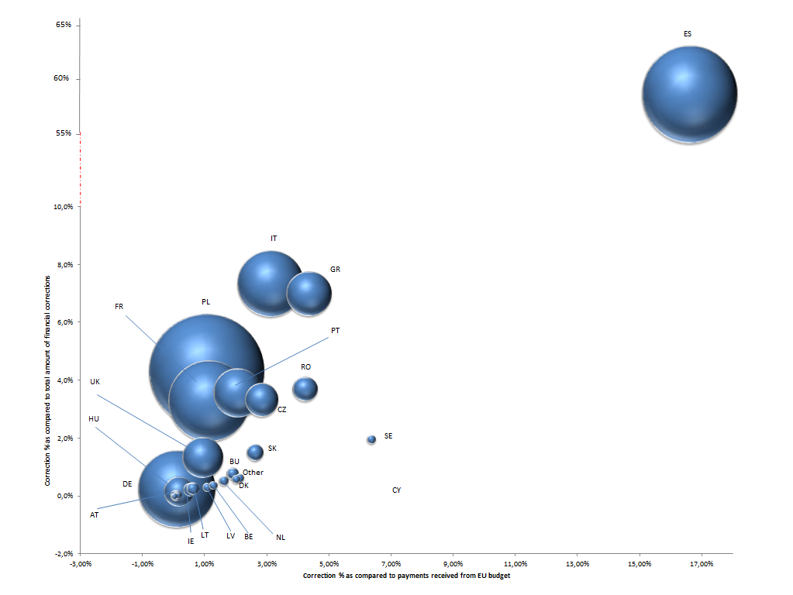
* The size of the "bubble" is proportionate to the EU Funds received.
Attention is drawn to the fact that the above data relates to one year only, 2012. The level of both the global corrections amount and the split by Member State can change significantly depending on the year.

Therefore, a meaningful assessment of the corrective capacity of supervisory and control systems has to be based on a multi-annual perspective. For this reason, information on the cumulative financial corrections at end 2012 is presented below.

2.3.2 Cumulative financial corrections and recoveries to end 2012
The graph below shows the evolution of financial corrections and recoveries implemented during the last 4 years:
Graph 2.3.2: Financial corrections and recoveries 2009-2012

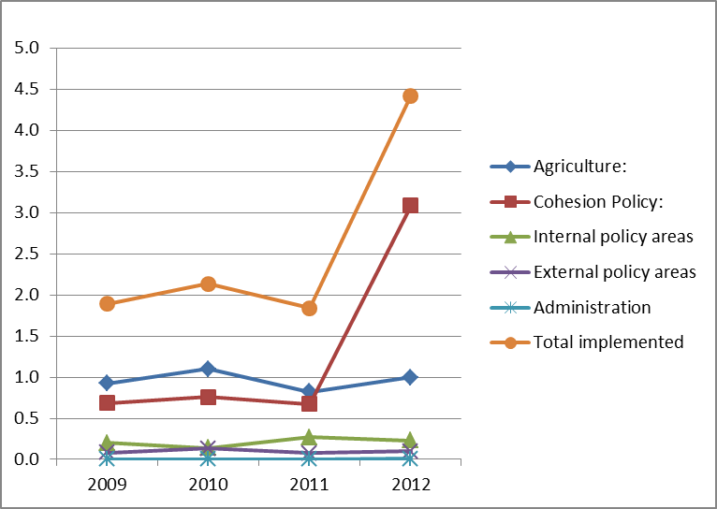
Euro billions

The average amount of financial corrections and recoveries implemented per year by the Commission during the period 2009 to 2012 was EUR 2.6 billion or 2% of the average amount of payments from the EU budget of EUR 127.2 billion (shared management: EUR 2.3 billion or 2.3% of the average amount of payments (EUR 97.2 billion)). 2012 amounts were significantly higher due to cohesion corrections relating to the closure of the 2000-2006 programmes for one Member State, Spain, and a quicker implementation of financial corrections for current programmes.

In 2012, in its Synthesis report, the Commission estimated amounts at risk to be between EUR 2.6 billion and EUR 3.5 billion. This corresponds to 1.9% and 2.6% of all executed payments in the Commission budget. For internal and external policy areas, these amounts at risk do include recoveries (average amount implemented per year for the period 2009 to 2012: EUR 288 million) which corrected irregular payments of current or previous periods.

With regard to the two largest spending areas (agriculture, natural resources and health, and cohesion) these amounts at risk do not take into account future financial corrections and recoveries which exclude expenditure incurred in breach of law from Union financing. Noting the average amount of financial corrections and recoveries implemented for the period 2009 to 2012 under shared management (EUR 2.3 billion), and assuming that similar levels continue to apply, then it can be seen that financial corrections and recoveries protect adequately the EU budget (as a whole, as well as most of the different policy areas).
The table below shows the cumulative financial corrections implemented to end 2012:

Table 2.3.2.1: Cumulative financial corrections implemented to end 2012
 |  |  | EUR millions
 |  | Implemented to end 2012 |  |  |  |  |  | Total decided at end 2012 | % Implemented
 |  | Programming Period |  |  |  | Cumulated annual amounts | Total | Total decided at end 2012 | % Implemented
 |  | 1994-1999 Period |  | 2000-2006 Period | 2007-2013 Period
Agriculture: |  | - |  | 93 | 81 | 7 728 | 7 902 | 8 525 | 92.7%
EAGF |  | - |  | - | - | 7 728 | 7 728 | 8 286 | 93.3%
Rural Development |  | - |  | 93 | 81 | - | 174 | 239 | 72.8%
Cohesion Policy: |  | 2 535 |  | 6 359 | 779 | - | 9 673 | 10 787 | 89.7%
ERDF |  | 1 764 |  | 4 626 | 154 | - | 6 544 | 7 305 | 89.6%
Cohesion Fund |  | 264 |  | 464 | 87 | - | 815 | 984 | 82.8%
ESF |  | 407 |  | 1 206 | 538 | - | 2 150 | 2 224 | 96.7%
FIFG/EFF |  | 100 |  | 5 | 0 | - | 105 | 201 | 52.2%
EAGGF Guidance |  | 0 |  | 58 | - | - | 58 | 72 | 80.6%
Other |  | - |  | - | - | 2 | 2 | 2 | 100%
Total |  | 2 535 |  | 6 452 | 861 | 7 730 | 17 577 | 19 313 | 91.0%

Details on cumulative financial corrections per Member States are given in section 3 for Agriculture (EAGF) for all decisions taken up to 2012, and in section 4 for Cohesion Policy for each programming period.

The information below shows the breakdown of recoveries per year for the period 2009-2012 – information is taken from a technical field (recovery context) specifically introduced in the Commission's accounting system in 2008:

Table 2.3.2.2: Recoveries implemented 2009 to 2012
EUR millions
 |  |  |  |  | Total as at end 2012 | Still to be recovered
Recoveries | Years |  |  |  | Total as at end 2012 | Still to be recovered
 | 2009 | 2010 | 2011 | 2012 | Total as at end 2012 | Still to be recovered
Agriculture:
EAGF | 148 | 172 | 178 | 161 | 659 | 50
Rural Development | 25 | 114 | 161 | 166 | 466 | 0
Cohesion | 102 | 25 | 48 | 14 | 189 | 9
Internal policy areas | 100 | 162 | 268 | 229 | 759 | 50
External policy areas | 81 | 136 | 77 | 99 | 393 | 38
Administration | 9 | 5 | 2 | 9 | 25 | 4
Total | 464 | 614 | 734 | 678 | 2 491 | 151

Impact of financial corrections and recoveries on the EU Budget
The budget implementation type and the policy area influence how the EU budget is impacted by the different correction mechanisms, but in all cases, the correction mechanisms ensure that the EU budget funds only regular and eligible expenditure. In some cases, notably under the CAP, the corrective action leads to the return or recovery of previously paid amounts to the EU budget. However, for other policy areas, many financial corrections do not result in reimbursements to the EU budget because, in line with the legal framework, the corrected amounts can be re-used to fund other eligible projects. For more details, see table 2.4 and information provided in the sections below.
Table 2.4: Impact of financial corrections & recoveries on the EU Budget

Policy domain | Total amount implemented in 2012 (in EUR millions) | Exclusion of expenditure incurred in breach of law (Yes/No) | Reimbursement to EU budget (Yes/No) | Impact* on Budget | Main budget chapters concerned
Agriculture:
EAGF financial corrections | 610 | Y | Y | Assigned revenue | 05 02  05 03
EAGF recoveries | 161 | Y | Y | Assigned revenue | 05 02  05 03
Rural development financial corrections | 59 | Y | Y | Assigned revenue | 05 04
Rural development recoveries | 166 | Y | N** | - | -
Cohesion Policy
Financial corrections implemented by withdrawals | 738 | Y | N | - | -
Financial corrections implemented by recoveries | 49 | Y | Y | Assigned revenue | 13 03  13 04  04 02  11 06
Financial corrections implemented by decommitment/ deduction at closure | 2 284 | Y | N** | - | -
Recoveries | 14 | Y | Y | Assigned revenue | 13 03  13 04  04 02  11 06
Other policy areas
Financial corrections implemented by decommitment/ deduction at closure | 1 | Y | N** | - | -
Financial corrections implemented by recoveries | 0 | Y | Y | Assigned revenue | 18 03
Recoveries | 337 | Y | Y | Assigned revenue | Various
TOTAL | 4 419
* Assigned revenue goes back on the expense line or Fund from which the expenditure was originally paid and may be spent again.
** Under the current legal framework, financial corrections can lead to reduction in expenses/envelope only:
- If Member States are unable to present sufficient eligible expenditure;
- After the closure of programmes where replacement of expenditure is no longer possible;
- In case of disagreement with the Commission.

Impact of financial corrections and recoveries on national budgets
Under shared management, all financial corrections and recoveries have an impact on national budgets regardless of their method of implementation. It has to be underlined that even if no reimbursement to the EU budget is made, the impact of financial corrections is always negative at Member State’s level. In order not to lose EU funding, the Member State must replace ineligible expenditure by eligible operations. That means that the Member State bears with own resources (from the national budget) the financial consequences of the loss of EU co-financing of the expenditure considered ineligible, unless it recovers the amounts from individual beneficiaries. This is not always possible, for example in the case of flat-rate corrections at programme level (due to deficiencies in the national administration managing the programme) which are not linked to individual irregularities at project level. However, those flat rate corrections do protect adequately the EU Budget.

Role of financial corrections and recoveries if error rates are persistently high
The European Parliament resolution on the integrated internal control framework adopted on 3rd July 2013 requested a strict application of the Article 32 (5) of the Financial Regulation which states:
Article 32 – Internal control on budget implementation
…
5. If, during implementation, the level of error is persistently high, the Commission shall identify the weaknesses in the control systems, analyse the costs and benefits of possible corrective measures and take or propose appropriate action, such as simplification of the applicable provisions, improvement of the control systems and re-design of the programme or delivery system.
The Commission is required to implement this provision of the Financial Regulation in the most economical way, taking into account the resources available, in particular during a period of staff reduction.
However, difficulties have arisen in the legislative procedure for the period 2014-2020 which could affect the proposed simplification and the objective of cost-effective controls. The remaining risks caused by overly complex rules complicate the prevention of errors and therefore lead to a high cost of control. This is why the Commission considers that especially in the area of shared management the implementation of this new requirement foreseen in Article 32(5) cannot be limited to actions which only focus on identifying and correcting errors at the level of final recipients.
Financial corrections and recoveries at the level of the Member States, which are implemented during the lifetime of multi-annual programmes, will always be an important factor to be taken into consideration, as well as the continued efforts to simplify rules, redesign and strengthen systems.

FINANCIAL CORRECTIONS AND RECOVERIES UNDER AGRICULTURE (EAGF AND RURAL DEVELOPMENT)
The graph below shows the financial corrections and recoveries in the area of Agriculture (EAGF and Rural Development) for the period 2009-2012.
Graph 3: Financial corrections and recoveries implemented in the area of Agriculture and Rural Development for the period 2009-2012 (in millions of Euro):
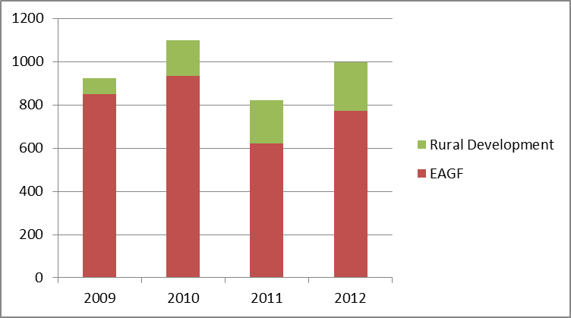

Preventive actions under Agriculture (EAGF and Rural Development)
3.1.1 Compulsory administrative structure at the level of Member States

Management and control of the expenditure is entrusted to dedicated paying agencies, which prior to their operation must be accredited by the Member States on the basis of a comprehensive set of criteria laid down in EU law. The paying agencies' compliance with these accreditation criteria is subject to a detailed review by an external audit body as well as to constant supervision by the competent national authority, and clear procedures exist as to how to address and remedy any problems. Moreover, the heads of the paying agencies are required to provide an annual statement of assurance which covers the completeness, accuracy and veracity of the accounts as well as a declaration that a system is in place which provides reasonable assurance on the legality and regularity of the underlying transactions. These statements of assurance are verified by independent certification bodies, which are required to provide an opinion thereon. These statements of assurance, together with the documents of the certification body, constitute by definition the annual summary referred to in Article 59 of the Financial Regulation. They accompany the yearly accounting declaration on which the Commission applies a yearly financial clearance procedure – see below.

3.1.2 Detailed systems put in place for ex-ante controls and dissuasive sanctions

For each aid support scheme financed by the European Agricultural Guarantee Fund (EAGF) or European Agricultural Fund for Rural Development (EAFRD), there is a system of ex-ante administrative and on-the-spot checks and dissuasive sanctions in case of non-compliance by the beneficiary. These systems are to be applied by the paying agencies (i.e. the Member States) and contain some common features and special rules tailored to the specificities of each aid regime. The systems provide for exhaustive ex-ante administrative controls of 100% of the aid applications, cross-checks with other databases where this is considered appropriate as well as pre-payment on-the-spot checks of a sample of transactions ranging between 5% and 100%, depending on the risk associated with the regime in question. All these checks are carried out prior to any payment to the beneficiaries; the resulting corrections are in most cases executed via a reduction of the payment. If the on-the-spot checks reveal a high number of irregularities, additional controls must be carried out, which in extreme cases cover the entire population.

Amounts erroneously claimed by beneficiaries and corrected by the Member States do not appear in the expenditure declared by the Member States because the Member States may only declare amounts paid to the beneficiaries. According to information provided by Member States, the aggregated amount of erroneous payment claims detected and corrected via their own administrative and on-the-spot controls made in 2012, totalled EUR 161 million for EAGF and EUR 116 million for EAFRD.

By far the most important system is the IACS (Integrated Administration and Control System), which in financial year 2012 covered 91.4% of EAGF expenditure. To the extent possible, the IACS is also used to manage and control rural development measures relating to parcels or livestock, which in 2012 accounted for 43.0% of payments under the EAFRD. For both Funds together, the IACS covered 80.4% of total expenditure.

A detailed reporting from the Member States to the Commission on the checks carried out by them and on the sanctions applied is foreseen in the legislation. The reporting system enables a calculation, for the main aid schemes, of the extent of error found by the Member States at the level of the final beneficiaries. The accuracy of the statistical information reported and the quality of the underlying on-the-spot checks is also verified and validated by the certification bodies for direct aids and rural development measures. These statistics are also used by DG AGRI in order to estimate amounts at risk.

3.1.3 Provision of advice and guidance to Member States

DG AGRI liaises closely with Member States, its partners in shared management, to provide them with guidance and advice and share best practices for the continuous improvement of the Common Agricultural Policy ("CAP") management and control systems:
- Monthly meetings of the Agricultural Funds Committee, as well as regular meetings of the Committee for the market measures, the Committee for direct payments and the Committee for rural development, allow Member States to raise any issues of concern and the Commission to give information and guidance as appropriate.
- Three conferences for the Directors of the Paying agencies and Co-ordination bodies are organised each year - two by the Presidency of the Council and one by DG AGRI. Two conferences for IT experts ("Panta Rhei") are also organised each year by Member States. Representatives of the audit directorate and, where relevant, of the operational directorates in DG AGRI participate both in plenary sessions and workshops. The Learning Network of Directors of Paying Agencies and Co-ordinating bodies regularly makes presentations on the outcome of their work.
- In addition, in the rural development policy area, the Commission participates in Monitoring Committees for rural development programmes and in annual meetings with Managing Authorities.
- DG AGRI also manages the European Network for Rural Development, which aims to contribute to the efficient implementation of rural development programmes, and the Evaluation Expert Network, which aims to increase the usefulness of evaluation as a tool for improving the formulation and implementation of rural development policies.

Corrective mechanisms under Agriculture (EAGF and Rural Development)
3.2.1 Clearance of accounts system
The clearance of accounts system consists of both an annual financial clearance and a multi-annual conformity clearance.
Description of the current clearance of accounts procedure

The process of the current clearance of accounts procedure is as follows:
(a) farmers present claims to an accredited Paying Agency ("PA") in their Member States;
(b) the PA checks these claims and pays the claimant. It then reports expenditure made to the Commission, which reimburses the PA;
(c) the accounts and payments of the PA are examined by an independent body (the Certifying Body ("CB")) which reports to the Commission in February of the following year;
(d) by 30 April of that year, the Commission must decide on whether to accept the accounts (financial clearance decision) or to ask for more work to be performed or for additional information;
(e) the Commission can then still examine the payments made by the PA. For this purpose, a specific directorate within the Commission’s Directorate-General for Agriculture and Rural Development carries out audits selected on the basis of an annual risk analysis which aims to verify that Member States have strictly applied Union rules for checking the legality and regularity of the expenditure (conformity audits);
(f ) where these conformity audits reveal that expenditure has not been effected in compliance with Union rules or that Member States have not satisfactorily checked the expenditure in question and that this has resulted in a financial loss to the EU budget, the Commission can impose a correction, which in effect is a refusal to reimburse the Member State for payments it has made. Any such correction proposed by the Commission must be notified to the Member States, who have the right to invoke a conciliation procedure. Only when this procedure has run its course is the Commission in a position to include a financial correction in a conformity decision.

The financial clearance covers the completeness, accuracy and veracity of the paying agencies' accounts. Moreover, it includes a mechanism under which 50% of any undue payments which the Member States have not recovered from the beneficiaries within 4 or, in the case of legal proceedings, 8 years will be charged to their respective national budgets (50/50 rule). If the undue payments are the result of administrative errors committed by the national authorities, the entire amount involved is deducted from the annual accounts and, thus, excluded from EU financing. Even after the application of the 50/50 rule, Member States are, however, obliged to pursue their recovery procedures and, if they fail to do so with the necessary diligence, the Commission may decide to charge the entire outstanding amounts to the Member State concerned.

The conformity clearance, for its part, relates to the legality and regularity of the underlying transactions. It is designed to exclude expenditure from EU financing which has not been executed in conformity with EU rules, thus shielding the EU budget, by means of financial corrections, from expenditure that should not be charged to it. It is not, however, a mechanism by which irregular payments to beneficiaries are recovered; according to the principle of shared management this is the sole responsibility of Member States. Instead, it results in a reduction of funding for the Member State concerned. The monies return to the Commission as assigned revenue which can be re-used in the future.
Where undue payments are or can be identified as a result of the conformity clearance procedures, Member States are required to follow them up by recovery actions against the final beneficiaries. However, even where this is not possible because the financial corrections only relate to deficiencies in the Member States' management and control systems, financial corrections are an important means to improve these systems and, thus, to ensure that they prevent or detect and recover irregular payments to final beneficiaries. The conformity clearance thereby contributes to the legality and regularity of the transactions at the level of the final beneficiaries.
3.2.2 Financial Corrections
Financial corrections are the main corrective tool used under Agriculture (EAGF) and Rural Development. The objective of financial corrections is to exclude from EU funding expenditure that is not in accordance with applicable rules and regulations, i.e. ensure that all expenditure declared by the Member State (and paid by the EU) is legal and regular. Financial corrections may also be applied where the Member States have failed to take corrective measures following the detection of serious deficiencies in the management and control systems of their national bodies which led or could lead to systemic irregularities.
As already mentioned above, under shared management, the primary responsibility for controlling expenditure and recovering monies from final beneficiaries lies with the Member States. It is thus in accordance with the underlying legislation, that financial corrections imposed by Commission do not always result in repayments from the farmers or other final beneficiaries. Where undue payments are or can be identified as a result of the conformity clearance procedures, Member States are required to follow them up by recovery actions against the final beneficiaries.

Commission's methods for the calculation of financial corrections

The Commission uses three calculation methods:
(a) When the error revealed by the audit is based on a specific case (or a few cases), the correction is equal to the value of the erroneous transactions.
(b) When errors are revealed by the examination of a representative sample of transactions, the correction is then based on the extrapolation of these results.
(c) When it is not possible to use one of the two methods mentioned above, flat-rate corrections are applied to the amount of expenditure placed at risk.

The level of the flat-rate correction applied (2 %, 5 %, 10 %, 25 % or higher) depends on the seriousness of the weaknesses found, whether they are related to key or ancillary controls and whether they are recurrent or not.

- Use of a 2 % flat-rate: Key controls are satisfactory, but one or more ancillary controls failed to operate.
- Use of a 5 % flat-rate: Not all the key controls are executed in the number, frequency or depth required by the regulations. Therefore, the risk of loss for the fund is significant.
- Use of a 10 % flat-rate: One or more key controls are not applied or applied so poorly or so infrequently that they are completely ineffective in determining the eligibility of the claim or preventing irregularity. Therefore, there is a high risk of widespread loss to the fund.
- Use of a 25 % flat-rate: When a control system is absent or gravely deficient and there is evidence of widespread irregularity and negligence in countering irregular or fraudulent practices. Therefore, there is a risk of exceptionally high losses to the fund.
- Use of higher flat-rates: Deficiencies are so serious as to constitute a complete failure to comply with Union rules, so rendering all payments irregular.

Since the system was modified to take its present form, a total of 39 decisions have been adopted to end 2012, (the first in 1999). They have excluded from EU financing a sum of EUR 8.3 billion. The average correction rate per financial year for the period 1999-2012 has been 1.5% (see table 3.6.2).

Financial corrections made under EAGF and EAFRD follow these general steps, which are common to other policy areas under shared management:

As can be seen above, the first step is an audit/control one. DG AGRI, and also the ECA, make on the spot audits throughout the year and in addition Member State bodies perform their own controls. Moreover, there are specific mechanisms set-up to control and correct irregular expenditure:
In addition to the ex-ante controls, all aid measures, other than direct payments covered by the IACS, are subject to ex-post controls under either Regulation (EC) No. 485/2008:

Article 2
1. Member States shall carry out systematic scrutiny of the commercial documents of undertakings taking account of the nature of the transactions to be scrutinised. Member States shall ensure that the selection of undertakings for scrutiny gives the best possible assurance of the effectiveness of the measures for preventing and detecting irregularities under the system of financing by the EAGF, inter alia, the selection shall take account of the financial importance of the undertakings in that system and other risk factors.

And for rural development measures, Regulation (EU) No. 65/2011:

Article 10
General principles
1. Member States shall make use of the integrated administration and control system provided for in Chapter 4 of Title II of Regulation (EC) No 73/2009 (hereinafter referred to as IACS).
2. Verification of compliance with the eligibility criteria shall consist of administrative and on-the-spot checks.
3. Observance of cross-compliance requirements shall be verified through on-the-spot checks and, where appropriate, through administrative checks.

Moreover, the paying agencies' annual accounts and the functioning of their internal control procedures are verified and certified on an ex-post basis by the certification bodies. Both types of ex-post controls are carried out in accordance with an annual audit plan established on the basis of a pre-determined audit strategy.

DG AGRI carries out over 100 audits every year in the Member States in order to examine the effectiveness of management and control systems. Where deficiencies are found in those systems, conformity clearance procedures are launched involving a "contradictory" procedure with the Member State which enables both the latter and the Commission to clarify their positions and to establish the extent of the risk to the EU budget. The financial corrections shield the EU budget from expenditure which should not be charged to it. DG AGRI regularly informs Member States of its most common audit findings.

The processing of financial corrections, after this initial audit or control, then follows the three key steps ("in progress", "decided/confirmed" and "implemented") which are detailed separately below.

The final step is reporting where every year the Commission provides the results of its recovery actions to the Discharge Authority and the ECA via reports such as this, as well as in the EU consolidated annual accounts, and the DG's Annual Activity Report.
3.2.3 Recoveries

In the area of Agriculture (EAGF) & Rural Development, the legislation obliges Member States to identify and report errors and irregularities and to recover from beneficiaries amounts unduly paid in accordance with national rules and procedures. For the EAGF, amounts recovered from the beneficiaries are credited to the EU budget, after deduction applied by Member States of 20% (to cover collection costs). For EAFRD, the full amount of the recoveries made by the Member State are deducted by the Member State from the next payment claim before it is sent to the Commission. This generally doesn’t lead to a net correction because the Commission will continue to reimburse eligible expenditure until the agreed budget is consumed.
Furthermore, if a Member State does not pursue the recovery or is not diligent in its actions, the Commission may decide to intervene and to impose a financial correction on the Member State concerned, or to initiate an infringement procedure under Article 258 of the TFEU. See section 3.7 below for the results of these actions.
Where the Commission considers that the time taken for a Member State to recover amounts from a final beneficiary is too long, it can launch procedures against the Member State involved. This of course is in addition to the fact that the EU Budget may already be protected via the original financial correction.
In addition, as indicated under 3.2.1, 50% of the irregular payments not recovered from the beneficiaries within 4 years (8 years in case of judicial procedure) are charged to the national budgets concerned. If the undue payments are the result of administrative errors committed by the national authorities, the entire amount involved is borne by to the Member State.
Infringement procedure following financial corrections
In 2013, the European Commission, via a letter of formal notice, called on Italy to take action to address deficiencies in the implementation of EU legislation concerning imposition of surplus levy on milk and other milk products among milk producers who have contributed to the overruns of the national quotas, and specifically to effectively recover levy due from such liable producers.
The failure to ensure the effective recovery undermines the possibility for that system to achieve its objectives of stabilisation of the market and also creates distortions of competition with other European and Italian producers having abided to the system of production limitation or having regularly paid the surplus levies due in case of overrun. The total of levy still not recovered amounts to at least EUR 1.4 billion and it is due to the Italian budget.
The Commission has already imposed financial corrections amounting to EUR 750 million linked to this problem. Furthermore, it raised the issue of Italy's inability to comply with the obligation of taking all measures necessary to ensure the timely payment of surplus levy by the concerned producers in its numerous correspondences with the Italian authorities. Italy manifestly did not take the appropriate measures to effectively recover the levy due from such liable producers, despite the repeated requests coming from the Commission. The Commission has accordingly decided to initiate the infringement procedure under Article 258 of the TFEU.

Financial corrections in progress as at end 2012
Following the evidence produced by an audit or other control, the next step in the financial correction process is the preliminary stage where the amounts are still only estimates and subject to change since they are not yet finalised for various reasons: for example in the case of an audit which is not yet completed, the potential amount of correction thus evolves with the audit findings as the Commission is still in the contradictory phase with the Member State concerned and new evidence or arguments may be introduced.
Under Agriculture (EAGF) and Rural Development, the amount of financial corrections in progress is based on an estimate of the amount of expenditure which is likely to be excluded from EU financing by future conformity decisions. Since EAGF corrections are decided per financial year of expense, it is possible to calculate the average of financial corrections per financial year closed, and to extrapolate this percentage to more recent financial years for which controls are still on-going. The reliability of the method of estimation is continuously assessed by comparing the estimate amount with the results of the conformity audits completed in the years concerned.

Table 3.3: Financial corrections in progress for Agriculture (EAGF & Rural Development) as at end 2012
EUR millions
 |  |  |  |  | Financial corrections in progress as at 31.12.2012
EAGF:
EAGF - future conformity and financial decisions |  |  |  |  | 2 647
Rural Development:
TRDI 2000-2006 |  |  |  |  | 36
SAPARD 2000-2006 |  |  |  |  | 82
EAFRD 2007-2013 |  |  |  |  | 626
Total |  |  |  |  | 3 391

The amount of EAGF financial corrections in progress at end 2012 shows the consolidation of the estimation method for future conformity decisions.
SAPARD and TRDI programmes are in the closure phase which explains the low amounts of financial corrections in progress.
Concerning EAFRD, the amounts are higher than in previous years due mainly to a change in the estimation method. Until 2010, the extrapolation method used was based on historical data, i.e. real cases opened for EAGGF 2000-06. This estimation was then compared to the level of real cases opened for the first years of the EAFRD programmes. However, two years ago this method proved to give lower amounts than those actually constituted by cases opened. Therefore the extrapolation method has been adapted and aligned to that of EAGF since both funds actually share the same clearance process. The amounts reported in progress give now a more realistic view on future financial corrections.

Financial corrections decided/confirmed in 2012
Following this step of the process, the amounts are final, meaning that they have been subject to Commission decision. Member States can make an appeal to the Court of Justice against a financial correction decision.
Table 3.4: Financial corrections decided/confirmed for Agriculture (EAGF & Rural Development) as at end 2012
 | EUR millions
 |  | 2012
EAGF:
Financial clearance |  | (28)
Conformity clearance |  | 503
Rural Development:
TRDI 2000-2006 |  | 4
SAPARD 2000-2006 |  | 5
EAFRD 2007-2013 |  | 67
Total |  | 551

The amount effectively implemented is different from the amount decided due to a short delay in cashing. The negative financial clearance amount results from payments to certain Member States (mainly Germany, Italy, the United Kingdom, Lithuania and Ireland) that exceeded amounts to be recovered for the year.

Financial corrections implemented in 2012
This is the most important step of the process whereby the observed situation of undue expenditure is definitively corrected. In the case of the EAGF, financial corrections are always implemented by deduction in the monthly declarations (two months later) and a recording of corrections on specific income accounts. There is thus a direct impact on the EU budget which pays out less money to the Member State in question.
For Rural Development financial corrections are implemented by the issue of recovery orders, which are treated as assigned revenue for the EU Budget.
Table 3.5.1: Financial corrections implemented for Agriculture (EAGF & Rural Development) in 2012
 | EUR millions
2012
Total
EAGF:
Financial clearance |  | (28)
Conformity clearance |  | 638
Rural Development:
TRDI 2000-2006 |  | 4
SAPARD 2000-2006 |  | 5
EAFRD 2007-2013 |  | 50
Total |  | 669
As declarations of corrections are made two months after the decision is taken, and the financial year of EAGF finishes on 15 October, decisions which are taken from 1 September will not be implemented in the same financial year. Moreover, due to the financial crisis, under exceptional circumstances, Member States which are particularly exposed can obtain an extension of up to 3 years for the reimbursement of the full correction amount. This explains the difference between decided and implemented amounts (see section 3.6 below).
A breakdown of the financial corrections implemented in 2012 per Member State for Agriculture (EAGF) – including irregularities declared by Member States and repaid to the EU budget – is shown in table 3.5.2 below:

Table 3.5.2: Total financial corrections and repayment due to irregularities implemented in 2012 for EAGF - Breakdown by Member State
EUR millions
Member State | Payments received from the EU budget | Financial corrections and repayment due to irregularities
Member State | Payments received from the EU budget | Financial clearance and non-respected payment deadlines | Conformity clearance | Irregularities declared by Member States (repaid to EU) | Total 2012 | % as compared to payments received from the EU budget | % as compared to total amount of financial corrections and repayment due to irregularities
Belgium | 618 | 0 | - | 2 | 2 | 0.3% | 0.3%
Bulgaria | 426 | 3 | 12 | 3 | 18 | 4.2% | 2.3%
Czech Republic | 769 | 0 | - | 0 | 0 | 0% | 0%
Denmark | 954 | 0 | 22 | 4 | 26 | 2.7% | 3.4%
Germany | 5 446 | (18) | 2 | 10 | (6) | -0.1% | -0.8%
Estonia | 92 | 0 | - | 0 | 0 | 0% | 0%
Ireland | 1 290 | (1) | 0 | 9 | 8 | 0.6% | 1.0%
Greece | 2 409 | 0 | 84 | 6 | 91 | 3.8% | 11.8%
Spain | 5 545 | 0 | 47 | 37 | 83 | 1.5% | 10.8%
France | 8 353 | 1 | 63 | 19 | 82 | 1.0% | 10.6%
Italy | 4 660 | (2) | 211 | 20 | 229 | 4.9% | 29.7%
Cyprus | 46 | 0 | 8 | 0 | 8 | 17.4% | 1.0%
Latvia | 127 | - | - | 1 | 1 | 0.8% | 0.1%
Lithuania | 331 | (2) | 5 | 1 | 4 | 1.2% | 0.5%
Luxembourg | 21 | 0 | - | 0 | 0 | 0% | 0%
Hungary | 1 146 | 0 | 5 | 4 | 10 | 0.9% | 1.3%
Malta | 6 | - | 0 | 0 | 0 | 0% | 0%
Netherlands | 911 | (1) | 18 | 3 | 20 | 2.2% | 2.6%
Austria | 744 | - | 1 | 6 | 7 | 0.9% | 0.9%
Poland | 2 840 | 0 | 12 | 4 | 16 | 0.6% | 2.1%
Portugal | 773 | (1) | 16 | 9 | 24 | 3.1% | 3.1%
Romania | 1 024 | 0 | 24 | 5 | 29 | 2.8% | 3.8%
Slovenia | 124 | - | 0 | 1 | 1 | 0.8% | 0.1%
Slovakia | 333 | 0 | - | 1 | 1 | 0.3% | 0.1%
Finland | 551 | 0 | 1 | 1 | 2 | 0.4% | 0.3%
Sweden | 710 | 0 | 72 | 4 | 76 | 10.7% | 9.9%
United Kingdom | 3 341 | (7) | 34 | 9 | 37 | 1.1% | 4.8%
Earmarked | 961 | - | - | - | - | - | -
Total implemented | 44 551 | (28) | 638 | 161 | 771 | 1.7% | 100%
The following graph takes into account both the absolute “contribution” of each Member State to the total financial corrections and repayments due to irregularities, and the relative weight of these financial corrections and repayments for each Member State compared to the payments received from the EU budget.
15 Member States present rates below 1% and 3 Member States between 1% and 2%. Corrections for these 18 Member States contribute to a 32% of the total corrections. Another 7 Member States present a rate between 2% and 5% and contribute to 57% to the total amounts of corrections. Finally, 2 Member States present rates considerably higher than the average, being 10.7% and 17.4%, and contribute EUR 84 million or 11% to the amount of financial corrections implemented in 2012.
This reflects the deficiencies raised for these Member States by EU and national audits and controls.
Graph 3.5: Share of Member States’ financial corrections and repayments due to irregularities declared as compared to payments received from the EU budget in 2012 for Agriculture (EAGF)*
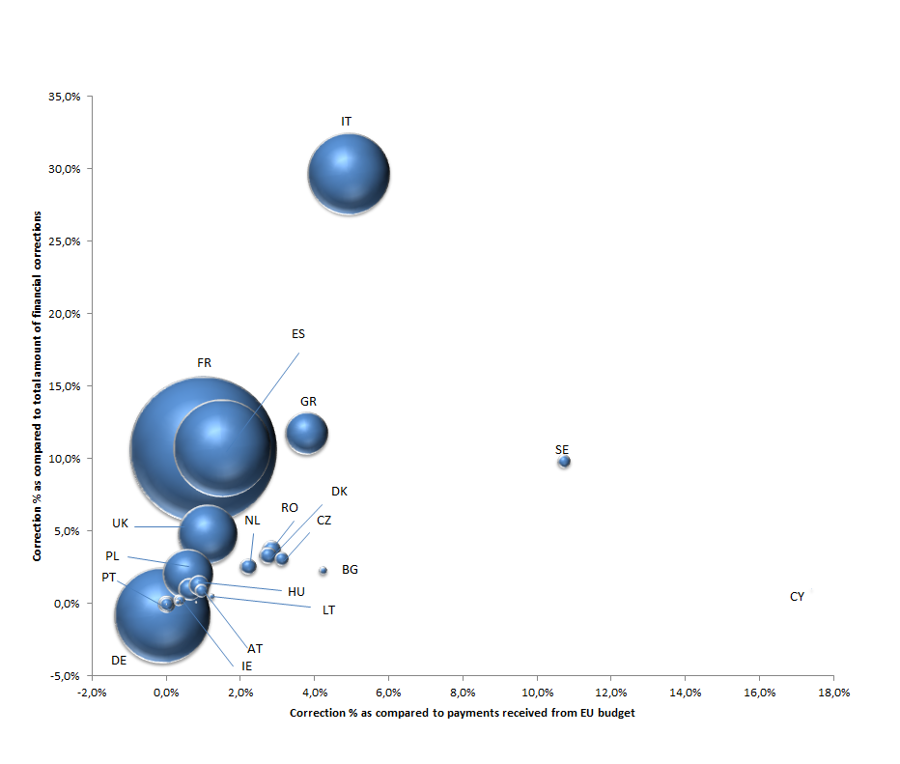* The size of the "bubble" is proportionate to the EU Funds received.

Financial corrections – cumulative figures to end 2012
3.6.1 Overview of financial corrections - cumulative figures to end 2012

Concerning Agriculture (EAGF), the cumulated amount decided of EUR 8 286 million covers all corrections made as from when the first decision was made in 1999. Concerning Rural Development, the cumulated amount decided of EUR 239 million covers all corrections and recovery of irregularities as from 2007. It is to be noted that in some cases the date of implementation was deferred by 18 months, and some decisions are also reimbursed in 3 deferred annual instalments. This is notably the case for Member States subject to financial assistance in accordance with the European Financial Stability Framework Agreement signed on 7 June 2010. As a consequence, there is an increasing discrepancy between the cumulative amounts decided and implemented.

Table 3.6.1: Agriculture (EAGF & Rural Development) financial corrections – cumulative to end 2012
 |  |  | EUR millions
 | Decided/  confirmed at end 2012 | Implemented at end 2012 | % Implemented
Agriculture (EAGF):
Clearance of accounts procedure | 8 286 | 7 728 | 93.3%
Rural Development:
TRDI 2000-2006 | 68 | 68 | 100%
SAPARD 2000-2006 | 25 | 25 | 100%
EAFRD 2007-2013 | 146 | 81 | 55.5%
 | 239 | 174 | 72.8%
Total | 8 525 | 7 902 | 92.7%
It should be noted that all clearance decisions are formally taken by means of a Commission decision, noting that conformity clearance decisions usually take longer than financial clearance decisions to proceed and will impact the coming years.
The evolution of the overall Agriculture (EAGF) financial corrections decided per year since 1999 is shown in the graph below. Year on year, the total amounts of financial corrections remain relatively stable and even show a positive trend over the period, in absolute amounts and also in terms of percentage of expenditure.

Graph 3.6.1: Cumulative financial corrections decided under EAGF clearance of accounts from the first decision in 1999 to end 2012 as compared to payments received from the EU Budget
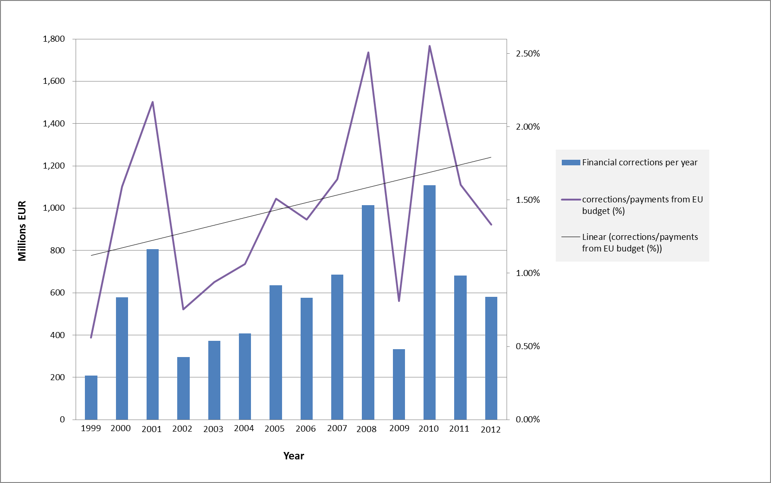
The table below provides a breakdown by Member State of the cumulative financial corrections decided under EAGF clearance of accounts from the first decision in 1999 to end 2012.

Table 3.6.2: Cumulative financial corrections decided under EAGF clearance of accounts from the first decision in 1999 to end 2012: Breakdown by Member State
EUR millions
Member State | Payments received from EU budget | Cumulated financial corrections at end 2012 | % as compared to payments received from EU budget | % as compared to total amount of financial corrections
Belgium | 11 018 | 34 | 0.3% | 0.4%
Bulgaria | 1 441 | 37 | 2.6% | 0.4%
Czech Republic | 3 904 | 1 | 0.0% | 0.0%
Denmark | 15 414 | 173 | 1.1% | 2.1%
Germany | 76 997 | 178 | 0.2% | 2.1%
Estonia | 428 | 0 | 0.0% | 0.0%
Ireland | 18 225 | 42 | 0.2% | 0.5%
Greece | 35 793 | 2 102 | 5.9% | 25.4%
Spain | 79 733 | 1 366 | 1.7% | 16.5%
France | 124 663 | 1 115 | 0.9% | 13.5%
Italy | 64 791 | 1 672 | 2.6% | 20.2%
Cyprus | 287 | 10 | 3.5% | 0.1%
Latvia | 601 | 0 | 0.0% | 0.0%
Lithuania | 1 732 | 7 | 0.4% | 0.1%
Luxembourg | 399 | 5 | 1.3% | 0.1%
Hungary | 6 007 | 31 | 0.5% | 0.4%
Malta | 22 | 0 | 0.0% | 0.0%
Netherlands | 15 549 | 179 | 1.2% | 2.2%
Austria | 9 731 | 9 | 0.1% | 0.1%
Poland | 13 569 | 67 | 0.5% | 0.8%
Portugal | 9 511 | 193 | 2.0% | 2.3%
Romania | 3 573 | 97 | 2.7% | 1.2%
Slovenia | 568 | 5 | 0.9% | 0.1%
Slovakia | 1 714 | 0 | 0.0% | 0.0%
Finland | 7 376 | 21 | 0.3% | 0.3%
Sweden | 9 847 | 116 | 1.2% | 1.4%
United Kingdom | 51 953 | 826 | 1.6% | 10.0%
Total | 564 847 | 8 286 | 1.5% | 100%

The following graph takes into account both the absolute “contribution” of each Member State to the total financial corrections and the relative weight of the financial corrections for each Member State compared to the payments received from the EU budget.
15 Member States present overall rates below 1% - corrections for these 15 Member States contribute to 18% of the total corrections. A further 4 Member States present rates between 1% and the average rate of 1.5% and represent 6% of the total corrections. Finally, 8 Member States present a rate above the average of 1.5% and contribute to 76% of the total amount of corrections.

Graph 3.6.2: Share of Member States' cumulative financial corrections under EAGF clearance of accounts from the first decision in 1999 to end 2012 as compared to payments received from the EU Budget*
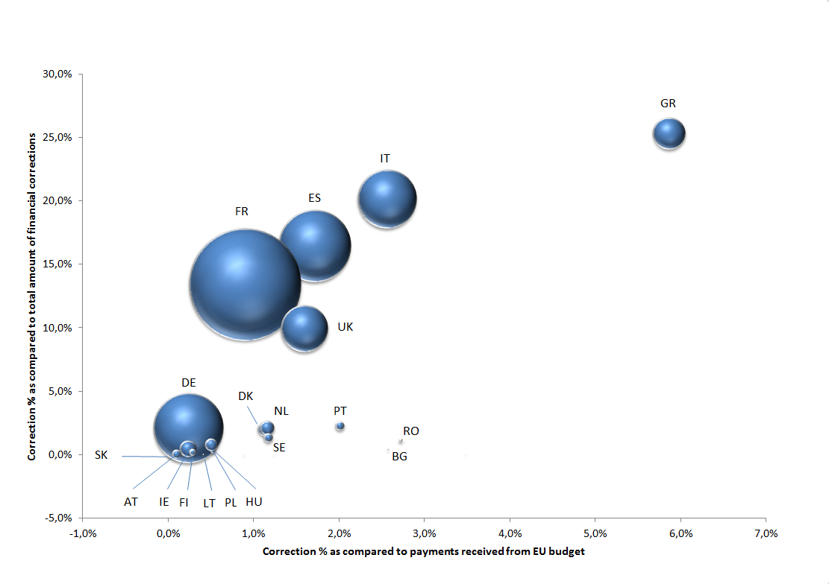
* The size of the "bubble" is proportionate to the EU Funds received.

Recoveries under Agriculture (EAGF & Rural Development)
An explanation of the recovery process in the area of Agriculture & Rural Development is given under 3.2.3 above.
Table 3.7: Agriculture (EAGF & Rural Development) recoveries in 2012
 | EUR millions
 |  | 2012  Recoveries  Decided | 2012  Recoveries  Implemented | %  Implemented
Agriculture (EAGF):
EAGF irregularities |  | 162 | 161 | 99.4%
Rural Development:
TRDI 2000-2006 |  | 5 | 5 | 100.0%
SAPARD 2000-2006 |  | 26 | 34 | 130.8%
EAFRD 2007-2013 |  | 114 | 127 | 111.4%
 |  | 145 | 166 | 114.5%
Total |  | 307 | 327 | 106.5%

Decisions taken at year-end will be implemented in the next financial year. As a consequence, amounts implemented in a given year can be higher than amounts decided.

FINANCIAL CORRECTIONS AND RECOVERIES UNDER COHESION POLICY
The graph below shows the financial corrections and recoveries under Cohesion policy for the period 2009-2012.
Graph 4: Financial corrections and recoveries implemented in the area of Cohesion Policy for the period 2009-2012 (in millions of Euro):
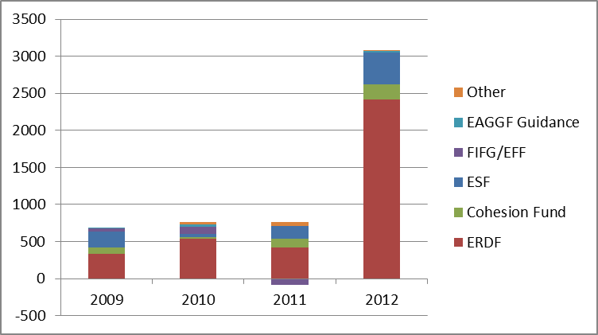
Article 59 of the Financial Regulation defines the responsibilities of the Commission:
Article 59 – Shared Management with Member States
…
6. In order to ensure that Union funds are used in accordance with the applicable rules, the Commission shall:
(a) apply procedures for the examination and acceptance of the accounts of the designated bodies, ensuring that the accounts are complete, accurate and true;
(b) exclude from Union financing expenditure for which disbursements have been made in breach of applicable law;
(c) interrupt payment deadlines or suspend payments where provided for in the sector-specific rules.
Council Regulation (EC) No. 1083/2006 of 11 July 2006 laying down general provisions on the European Regional Development Fund, the European Social Fund and the Cohesion Fund defines the responsibilities of Member States:
Article 98 – Financial corrections by Member States
1. The Member States shall in the first instance bear the responsibility for investigating irregularities, acting upon evidence of any major change affecting the nature or the conditions for the implementation or control of operations or operational programmes and making the financial corrections required.
2. The Member State shall make the financial corrections required in connection with the individual or systemic irregularities detected in operations or operational programmes. The corrections made by a Member State shall consist of cancelling all or part of the public contribution to the operational programme. The Member State shall take into account the nature and gravity of the irregularities and the financial loss to the Funds. The resources from the Funds released in this way may be reused by the Member State until 31 December 2015 for the operational programme concerned in accordance with the provisions referred to in paragraph 3.
3. The contribution cancelled in accordance with paragraph 2 may not be reused for the operation or operations that were the subject of the correction, nor, where a financial correction is made for a systemic irregularity, for existing operations within the whole or part of the priority axis where the systemic irregularity occurred.

Preventive actions under Cohesion Policy
In accordance with Articles 91 and 92 respectively of Regulation 1083/2006, under Cohesion Policy, and in addition to making financial corrections and recoveries, the Commission may:

- interrupt the payment deadline for a maximum period of 6 months for 2007-13 programmes if:
(a) There is evidence to suggest a significant deficiency in the functioning of the management and control systems of the Member State concerned;
(b) The Commission services have to carry out additional verifications following information that expenditure in a certified statement of expenditure is linked to a serious irregularity which has not been corrected.

- suspend all or part of an interim payment to a Member State for 2007-13 programmes in the following three cases:
(a) There is evidence of serious deficiency in the management and control system of the programme and the Member State has not taken the necessary corrective measures; or
(b) Expenditure in a certified statement of expenditure is linked to a serious irregularity which has not been corrected; or
(c) Serious breach by a Member State of its management and control obligations.
Where the required measures are not taken by the Member State, the Commission may impose a financial correction.
The tables below present for the ERDF, the Cohesion Fund, the ESF and the EFF, a view on the evolution of the interruption cases both in number and in amount. The opening balance includes all the cases still open at end 2011, irrespective of the year when the interruption was notified to the Member State (for this reason certain figures are not directly comparable with those disclosed in the 2011 annual accounts). The new cases only refer to the interruptions notified in the year 2012. The closed cases represent the cases for which the payment of cost claims resumed in 2012, irrespective of the year when the interruption started. The cases still open at end 2012 represent the interruptions that remain active at 31 December 2012, i.e. the payment of cost claims is still interrupted pending corrective measures to be taken by the Member State concerned.

Table 4.1.1: Interruptions for ERDF and Cohesion Fund 2007-2013

EUR millions
 | ERDF / Cohesion Fund 2007-2013
Member State | Total open cases at 31.12.2011 |  | New cases 2012 |  | Closed cases during 2012 |  | Total open cases at 31.12.2012
 | No. of cases | Amount | No. of cases | Amount | No. of cases | Amount | No. of cases | Amount
Germany | 3 | 17 | 2 | 163 | - | - | 5 | 180
Spain | - | - | 49 | 1 495 | 41 | 1 319 | 8 | 176
France | - | - | 6 | 51 | 5 | 24 | 1 | 27
Italy | 10 | 265 | 20 | 1 122 | 19 | 860 | 11 | 526
Latvia | - | - | 5 | 94 | 5 | 94 | 0 | 0
Lithuania | - | - | 4 | 164 | 4 | 164 | 0 | 0
Hungary | - | - | 3 | 55 | - | - | 3 | 55
Poland | - | - | 5 | 605 | - | - | 5 | 605
Romania | - | - | 1 | 41 | - | - | 1 | 41
Slovenia | - | - | 1 | 6 | 1 | 6 | 0 | 0
Slovakia | 2 | 71 | - | - | 2 | 71 | 0 | 0
United Kingdom | - | - | 1 | 22 | - | - | 1 | 22
Cross-border | - | - | 11 | 59 | 8 | 52 | 3 | 6
Total | 15 | 353 | 108 | 3 878 | 85 | 2 592 | 38 | 1 639

In addition to these interruption procedures, 119 warning letters (in cases where no payment claim was pending) have been sent in 2012 for ERDF, contributing to the further prevention of irregular amounts.
Table 4.1.2: Interruptions for ESF 2007-2013
EUR millions
 | ESF 2007-2013
Member State | Total open cases at 31.12.2011 |  | New cases 2012 |  | Closed cases during 2012 |  | Total open cases at 31.12.2012
 | No. of cases | Amount | No. of cases | Amount | No. of cases | Amount | No. of cases | Amount
Czech Republic | - | - | 1 | 47 | - | - | 1 | 47
Germany | - | - | 5 | 165 | 4 | 145 | 1 | 19
Spain | 2 | 10 | 8 | 159 | 9 | 160 | 1 | 9
France | 2 | 25 | 9 | 142 | 4 | 91 | 7 | 76
Italy | 4 | 53 | 7 | 207 | 6 | 231 | 5 | 30
Latvia | - | - | 2 | 26 | 2 | 26 | 0 | 0
Lithuania | - | - | 1 | 1 | 1 | 1 | 0 | 0
Romania | - | - | 1 | 21 | 1 | 21 | 0 | 0
Slovakia | - | - | 1 | 45 | 1 | 45 | 0 | 0
United Kingdom | 2 | 234 | 2 | 69 | 4 | 303 | 0 | 0
Total | 10 | 323 | 37 | 881 | 32 | 1 023 | 15 | 181

Table 4.1.3: Interruptions for EFF 2007-2013

EUR millions
 | EFF 2007-2013
Member State | Total open cases at 31.12.2011 |  | New cases 2012 |  | Closed cases during 2012 |  | Total open cases at 31.12.2012
 | No. of cases | Amount | No. of cases | Amount | No. of cases | Amount | No. of cases | Amount
Czech Republic | - | - | 1 | 1 | 1 | 1 | 0 | 0
Denmark | 1 | 0 | - | - | 1 | 0 | 0 | 0
Germany | 2 | 1 | - | - | - | - | 2 | 1
Estonia | 1 | 0 | 3 | 0 | - | - | 4 | 0
Spain | 1 | 62 | 2 | 32 | 2 | 84 | 1 | 9
France | 2 | 3 | - | - | - | - | 2 | 3
Italy | - | - | 6 | 38 | - | - | 6 | 38
Latvia | - | - | 1 | 0 | - | - | 1 | 0
Netherlands | - | - | 3 | 8 | 3 | 8 | 0 | 0
Poland | - | - | 1 | 2 | 1 | 2 | 0 | 0
Portugal | - | - | 3 | 16 | 2 | 12 | 1 | 4
Romania | - | - | 5 | 35 | - | - | 5 | 35
Slovakia | - | - | 2 | 2 | - | - | 2 | 2
Finland | 2 | 0 | 3 | 0 | 5 | 1 | 0 | 0
Sweden | 1 | 0 | 2 | 6 | - | - | 3 | 6
United Kingdom | 1 | 34 | 4 | 7 | 2 | 33 | 3 | 8
Total | 11 | 100 | 36 | 149 | 17 | 141 | 30 | 108

Suspensions:
Concerning ERDF and the Cohesion Fund, suspension decisions were taken for 2 programmes in Germany and in Italy. Both suspensions were still effective after 31 December 2012. Concerning ESF, 2 suspension decisions were adopted in 2012 and concerned the Czech Republic and Slovakia. Suspension was still on-going for Czech Republic after 31 December 2012. There were no suspension decisions taken in 2012 for EFF.
Additionally, following the preparation of the DGs' 2012 Annual Activity Reports and the identification of programmes under reservation, immediate targeted action plans were launched to protect the EU's financial interests. DG’s will strictly follow up the remedial actions requested from Member States. The objective of the operational and/or audit actions, to be carried out by the Member States, is to address systemic weaknesses and to correct irregular expenditure. Once evidence is available that this is done, interruptions may be lifted.
The Commission calculates the error rates in the programmes that it funds. These error rates, reflecting the effective functioning of management and controls systems, together with the cumulative residual risk, constitute the cornerstone of the assurance process of the consolidated methodology to estimate the amount at risk. Other sources include: (i) the results of the Commission's own audit work, in particular the review of the work of the audit authorities and the audit of specific risk programmes or areas such as management verifications and public procurement; (ii) other EU audit results; (iii) national system audit reports received throughout the year; (iv) annual summaries of controls and national declarations; (v) the opinions of the Directors as Authorising Officers by Sub-Delegation for the programmes and (vi) experience from previous years.
The Commission also assesses the reliability and correctness of the total projected error rates reported by the audit authorities, based on data and detailed information provided or subsequently requested from audit authorities. In cases where serious inconsistencies/doubts or lack of information were identified, on-the-spot fact finding missions are carried out.
This methodology to assess the cumulative residual risk therefore reinforces the annual assessment and Commission's supervision for operational programmes in the context of shared management under a multiannual control framework. It also requires a more proactive role by managing and certifying authorities to quickly correct irregular expenditure across the whole programme or concerned population of operations, based on the results and analysis of the audit authorities’ work and statistical sampling and thus increasing the assurance process for the year. As an example, on average for all ERDF and Cohesion Fund programmes, the cumulative residual risk at end 2012 is 1.3% compared to around 2% at end 2011, which shows improvements in the corrective actions taken by Member States in 2012.

Corrective mechanisms under Cohesion Policy
4.2.1 Financial Corrections
Financial corrections are the main tool used under Cohesion Policy for addressing errors and irregularities. As with Agriculture, the objective of financial corrections is to exclude from EU funding expenditure that is not in accordance with applicable rules and regulations, i.e. ensure that all expenditure declared by the Member State (and reimbursed by the EU) is legal and regular – however the legal framework does not foresee a sanction mechanism against Member States. This means that the recovery of monies stricto sensu (i.e. the return of cash to the EU budget by the issuance of a recovery order by the Commission requesting reimbursement of amounts unduly paid) is not the main objective of a financial correction procedure; it is however one of the different means to implement financial corrections (see 4.5 below).
In this context, it should be noted that the Commission's proposal for the Common Provisions on Regulations covering the Structural Funds for the period 2014-2020, provides for the possibility of financial corrections reducing the budgetary allocation to the particular Member State, thus having a net reduction effect. This would be foreseen for cases of irregularities that demonstrate serious deficiencies in the effective functioning of the management and control systems, and which were detected by the Commission or the ECA after the submission of the annual accounts by the Member State. This should set better incentives for Member States to operate effective supervisory and control systems. The result of the controls and corrections made by Member States under Cohesion policy are presented in section 6 below.

Financial corrections may also be applied by the Commission where the Member States have failed to take corrective measures following the detection of serious deficiencies in the management and control systems of their national bodies which led or could lead to systemic irregularities.
The Commission bases its financial corrections on individual cases of irregularity identified. However, where it is not possible or cost effective to quantify the amount of irregular expenditure precisely, the Commission has the possibility to apply extrapolated or flat-rate corrections. Extrapolation is used when there are results of a representative sample available in relation to a systemic irregularity. Flat-rate corrections are calculated on the basis of standard scales of corrections decided by the Commission for each programming period and applied in the case of individual breaches or systemic irregularities where the financial impact is not precisely quantifiable and it would be too costly to audit each project potentially affected.
Commission's methods for the calculation of flat rate financial corrections

When it is not possible to use individual or extrapolated corrections, flat-rate corrections are applied to the amount of expenditure placed at risk. The level of the flat-rate correction applied (2 %, 5 %, 10 %, 25 % or 100%) depends on the seriousness of the weaknesses found, whether they are related to key or ancillary controls and whether they are recurrent or not*.

- Use of a 2 % flat-rate: Key controls are satisfactory, but one or more ancillary controls failed to operate.
- Use of a 5 % flat-rate: Not all the key controls are executed in the number, frequency or depth required by the regulations. Therefore, the risk of loss for the fund is significant.
- Use of a 10 % flat-rate: One or more key controls are not applied or applied so poorly or so infrequently that they are completely ineffective in determining the eligibility of the claim or preventing irregularity. Therefore, there is a high risk of widespread loss to the fund.
- Use of a 25 % flat-rate: When a control system is absent or gravely deficient and there is evidence of widespread irregularity and negligence in countering irregular or fraudulent practices. Therefore, there is a risk of exceptionally high losses to the fund.
- Use of 100% flate-rate: Deficiencies are so serious as to constitute a complete failure to comply with Union rules, so rendering all payments irregular.
* See Commission Decision C(2011) 7321 final of 19.10.2011

The general process is outlined below:

The first action is generally an audit/control by the Commission services, by the ECA or the Member State itself, or an anti-fraud investigation conducted by OLAF. This audit/control may provide evidence of irregular expenditure or weaknesses in control systems and should also provide an estimate of the amounts concerned.
Cohesion policy is built on a multiannual and multilevel control system whereby one level of control may rely on the work of previous controls performed by other bodies (single audit concept). Section 6 provides details on the impact of the actions of the Member States.

Throughout the implementation period the Commission services hold regular meetings with Member States authorities to ensure the correct monitoring of implementation of all programmes and audit/control activities. The Commission has an audit strategy in place covering all structural fund instruments, which is updated annually.

During programme implementation the audit work by the Commission consists of a combination of desk reviews of the work of the national audit authorities and on-the-spot audit missions. At the end of the programming period, the audit authority gives its opinion on the legality and regularity of expenditure declared for each programme, based on the examination of the audit results, the expenditure and irregularities declared and withdrawals and recoveries made by the certifying authority. The Commission scrutinises all closure documents (desk review) and may perform ex-post closure audits using a risk based approach so as to obtain additional assurance that the submitted closure documents are reliable.
The processing of financial corrections, after these initial audits or controls, then follows the three key steps ("in progress", "decided/confirmed" and "implemented") which are detailed separately below.

The final step is reporting where every year the Commission provides the results of its corrective actions to the Discharge Authority and the ECA via reports such as this, as well as in the EU consolidated annual accounts and in the relevant DGs' Annual Activity Reports and other ad-hoc reports. Quarterly reports on the status of financial corrections are also sent to the Discharge Authority.
4.2.2 Recoveries
In the area of Cohesion Policy, Member States (and not the Commission) are primarily responsible for recovering amounts unduly paid from the final beneficiaries, increased where applicable by late payment interest. In most cases, corrections initiated at the Commission's request lead to withdrawals by the Member State in a payment claim (see below). For this reason, recoveries by the Commission from Member States are generally a residual way of implementing financial corrections.

Financial corrections in progress as at end 2012
Under Cohesion Policy, the estimate of the amount of financial corrections in progress is based on audit findings of the Commission, the ECA or OLAF, all of which are followed up by the relevant Directorate General through on-going contradictory procedures with the concerned Member States. A best and prudent estimate is made, which takes into account the state of play of the follow up of the audits and the issuance of final position letters or pre-suspension letters at 31 December 2012. This amount may be subject to change following the contradictory procedures, under which Member States are given the opportunity to present further evidence.
Table 4.3: Financial corrections in progress as at end 2012
EUR millions
 |  |  |  |  | Financial corrections in progress as at 31.12.2012
ERDF |  |  |  |  | 1 350
Cohesion Fund |  |  |  |  | 114
ESF |  |  |  |  | 590
FIFG/EFF |  |  |  |  | 7
EAGGF Guidance |  |  |  |  | 102
Total |  |  |  |  | 2 163
ERDF and Cohesion Fund: At the end of 2012, correction procedures were in progress at Commission level for an estimated total of EUR 1 464 million. The decrease in amounts compared to previous years reflects the phasing out of financial corrections previously reported as "in progress" for the 2000-06 programmes.
ESF: At the end of 2012, correction procedures were in progress at Commission level for an estimated total amount of EUR 590 million. The increase in the estimated amounts in progress from prior years is mainly due to the closure of a significant amount of programmes under 2000-2006 programming period for which the closure proposal with financial corrections has been communicated to the Member State or a suspension has been merged with closure process. When the amount of a financial correction is not yet known, e.g. the contradictory procedure is on-going, then the case is reported at EUR 1 value for prudence reasons. This is the case for the current financial corrections in progress in relation to the 2007-13 period.

Financial corrections decided/confirmed in 2012
These amounts are final, meaning that they have been either agreed by the Member State concerned or decided by the Commission. In the area of Cohesion Policy, financial corrections decided/confirmed are the result of EU controls and audits by the Commission, the ECA or OLAF.
Table 4.4: Financial corrections decided/confirmed under Cohesion Policy by programming period in 2012
EUR millions
Cohesion Policy | 1994-1999 Period | 2000-2006 Period | 2007-2013 Period | Total as at end 2012
ERDF | (2) | 428 | 531 | 958
Cohesion Fund | (2) | 106 | 99 | 203
ESF | 11 | 41 | 374 | 425
FIFG/EFF | - | 2 | 1 | 2
EAGGF Guidance | 0 | 31 | - | 31
Total | 7 | 608 | 1 005 | 1 619
A breakdown of these amounts per Member State is disclosed in Annex 1.
ERDF and the Cohesion Fund: Amounts both confirmed/decided have significantly increased compared to last year:
- Period 2007-2013: Due to stricter supervision by the Commission (e.g. more audits completed) leading to more timely procedures for financial corrections, a significant amount (EUR 631 million) of financial corrections were confirmed. These mainly concern Spain (EUR 267 million), the Czech Republic (EUR 111 million), Greece (EUR 82 million) and Poland (EUR 77 million).
- Period 2000-2006: EUR 534 million covers corrections related to the on-going closure process of the programming period 2000-2006. The corrections at closure result from the analysis of winding-up declarations, or the extrapolation of the residual error rate. The main corrections concern Spain (EUR 316 million), Italy (EUR 65 million) and Portugal (EUR 53 million). These corrections should continue in 2013 as the result of the finalisation of the closure exercise, with lower amounts though.

ESF:
- Period 2000-2006: most of the financial corrections reported relate to either the extrapolation of the residual error rate at closure (following the analysis of the winding-up declarations), or net corrections at closure. Closure audits are on-going.
- Period 2007-2013: the amounts reported relate to irregular amounts deducted from interim payment claims submitted by Member States during the life cycle of the programme. The increase in the amounts reported compared to previous years comes from the joint audit strategy developed for this programming period.

Financial corrections implemented in 2012
These amounts are linked to the final step of the process whereby the observed situation of undue expenditure is definitively corrected in order to protect the EU budget. They are implemented as follows:
- if the correction is accepted, as it is in the vast majority of cases, the Member State either deducts (withdraws) this amount from a subsequent payment claim to the Commission before recovery proceedings are completed at national level, or it first recovers the amount from the beneficiary and then deducts it from a subsequent payment claim (recovery at national level). In both cases the replacement of irregular expenditure by other eligible operations is allowed by the applicable regulations. In these cases there is no impact in the Commission's accounts, as the level of EU funding to a specific programme is not reduced since the funds were re-used for eligible actions. The validation of the payment request by the authorising officer in the accounting system is a necessary step to establish the implementation of financial corrections.
- if the Member State disagrees with the correction proposed by the Commission, following a formal contradictory procedure with the Member State (that may include the suspension of payments to the programme), the Commission will adopt a formal financial correction decision and issue a recovery order to obtain repayment from the Member State. Therefore, there is no possibility for the Member State to re-use the corrected amount for other eligible operations and there is a net reduction in EU funding with a return of monies to the EU budget. It should be noted that this situation arises in only a very small number of cases (e.g. only 1% of the corrections in 2012.) The issuance of the recovery order is of course recorded in the Commission's accounting system.
- At programme closure when no further re-use of the funds is possible by the Member State, the amount of the irregular expenditure is deducted from the final cost claim either by the Member State or by the Commission services within the closure process of the programme.
A summary of the possibilities for implementation under Cohesion Policy are given below:

Financial correction decided
Deduction from final cost claim (i.e. withdrawal)

Programme is closed
Issuance of a recovery order
Yes
or

or
Decommitted
No

MS withdraws in next claim before recovering from beneficiary
Member State agrees
Yes
or
MS recovers from beneficiary and then withdraws in subsequent claim

No

Commission Decision and recovery order issued

Member State disagrees
Yes

Table 4.5.1: Financial corrections implemented under Cohesion Policy in 2012 (split by decided/confirmed in 2012 and in previous years)
EUR millions
 |  | ERDF | CF | ESF | FIFG/ EFF | EAGGF  Guidance | Total 2012
Financial Corrections 1994-1999 period:
Confirmed in 2012 |  | (2) | (2) | - | - | 0 | (4)
Confirmed previous years |  | - | - | 11 | - | - | 11
Subtotal 1994-1999 period |  | (2) | (2) | 11 | - | 0 | 7
Financial Corrections 2000-2006:
Confirmed in 2012 |  | 395 | 85 | 35 | 0 | 17 | 532
Confirmed previous years |  | 1 871 | 37 | 6 | - | - | 1 914
Subtotal 2000-2006 period |  | 2 267 | 122 | 41 | 0 | 17 | 2 447
Financial Corrections 2007-2013:
Confirmed in 2012 |  | 151 | 87 | 377 | 0 | - | 615
Confirmed previous years |  | 0 | - | 2 | - | - | 2
Subtotal 2007-2013 period |  | 151 | 87 | 379 | 0 | - | 617
Total financial corrections implemented in 2012 |  | 2 416 | 207 | 430 | 1 | 17 | 3 071
 | A breakdown of these amounts per Member State is disclosed in Annex 2.

These corrections concern primarily the 2000-2006 period and financial corrections that were decided/accepted in previous years. It includes a major correction for Spain (EUR 1.8 billion) that has been reported as implemented following the completion of the verification of all closure documents, the full validation of the cost claims submitted by the national authorities from which the corrections were deducted, as well as the processing of the partial payment of the remaining balance to this Member State.
Table 4.5.2: Financial corrections implemented under Cohesion Policy in 2012 (by implementation type)
EUR millions
 | ERDF | CF | ESF | FIFG/EFF | EAGGF  Guidance | TOTAL
Financial Corrections 1994-99:
- By decommitment/deduction at closure | (2) | (2) | 11 | - | - | 7
- By recovery order | 0 | 0 | - | - | 0 | 0
Subtotal 1994-1999 period | (2) | (2) | 11 | - | 0 | 7
Financial Corrections 2000-2006:
- By decommitment/deduction at closure | 2 163 | 115 | 29 | 0 | 15 | 2 323
- By Member States | 70 | 4 | 2 | - | - | 76
- By recovery order | 34 | 4 | 9 | 0 | 2 | 48
Subtotal 2000-2006 period | 2 267 | 122 | 41 | 0 | 17 | 2 447
Financial Corrections 2007-2013:
- By decommitment/deduction at closure | - | - | - | 0 | - | 0
- By Member States | 151 | 87 | 379 | - | - | 617
- By recovery order | - | - | - | - | - | -
Subtotal 2007-2013 period | 151 | 87 | 379 | 0 | - | 617
Total financial corrections implemented in 2012 | 2 416 | 207 | 430 | 1 | 17 | 3 071

Financial corrections: cumulative figures & implementation rates to end 2012
4.6.1 Overview
The graph below shows the cumulative financial corrections under Cohesion policy for the different programming periods:
Graph 4.6.1: Financial corrections implemented under Cohesion Policy– cumulative figures (in EUR millions)
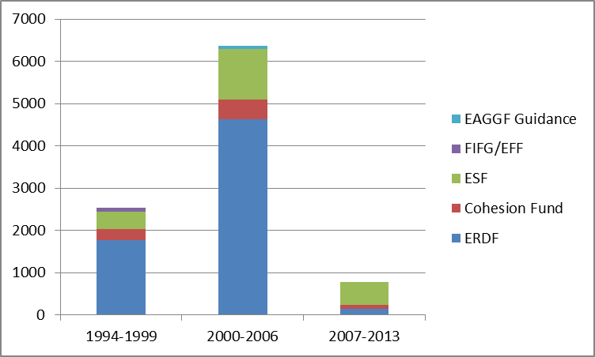

Table 4.6.1: Financial corrections decided/confirmed under Cohesion Policy and implementation rates as at 31 December 2012 (cumulative figures)
EUR millions
 | ERDF | CF | ESF | FIFG/EFF | EAGGF  Guidance | Total 2012
1994-1999 programmes
Confirmed/decided | 1 767 | 271 | 407 | 100 | - | 2 545
Implemented | 1 764 | 264 | 407 | 100 | - | 2 535
Confirmed/decided but not yet implemented | 3 | 7 | - | - | - | 10
Rate of implementation | 99.9% | 97.2% | 100% | 100% | - | 99.6%
2000-2006 programmes
Confirmed/decided | 5 004 | 614 | 1 225 | 100 | 72 | 7 015
Implemented | 4 626 | 464 | 1 206 | 5 | 58 | 6 359
Confirmed/decided but not yet implemented | 378 | 150 | 19 | 95 | 14 | 654
Rate of implementation | 92.5% | 75.7% | 98.6% | 4.8% | 80.9% | 90.7%
2007-2013 programmes
Confirmed/decided | 535 | 99 | 592 | 1 | - | 1 227
Implemented | 154 | 87 | 538 | 0 | - | 779
Confirmed/decided but not yet implemented | 381 | 12 | 54 | 0 | - | 448
Rate of implementation | 28.8% | 87.4% | 90.9% | 60.9% | - | 63.5%
Total financial corrections
Confirmed/decided | 7 305 | 984 | 2 224 | 201 | 72 | 10 787
Implemented | 6 544 | 815 | 2 150 | 105 | 58 | 9 673
Confirmed/decided but not yet implemented | 761 | 169 | 74 | 96 | 14 | 1 112
Rate of implementation | 89.6% | 82.8% | 96.7% | 52.2% | 80.6% | 89.7%

As would be expected for the 1994-1999 period, which has been closed for some time, there is a very high level of implementation (99.6%). For the following period, 2000-2006, the closure is advancing. This can be seen by the increased implementation rate for ERDF for the programming period 2000-2006 in 2012 (from 52% in 2011 to 92% in 2012) which is explained by the sending to Member States of all but seven ERDF closure letters covering operational programmes by end 2012, followed by the authorisation of partial ERDF 2000-2006 final payment claims (within the limits of available credits). This high implementation rate at end 2012 applies to ESF as well. For FIFG, closure documents and final payment claims are still being processed by the Commission services, which explain the low implementation rate for this programming period.

For the period 2007-2013, the cumulative amount of corrections decided/ confirmed or implemented by end 2012 increased, compared to previous year, as a result of stricter supervision by the Commission and growing number of audits completed at this stage of execution of the programmes. The corrections confirmed/decided or implemented will continue to increase in the coming years, as a result of the Commission supervisory role and EU audits.

4.6.2 Closure of the 2000-2006 programming period – the impact of financial corrections imposed by the Commission

As the closure of the period 2000-2006 is in the completion stage, the overall results of the corrective actions and the total monies spent can be compared and a more complete view of the impact of corrective mechanisms is possible, as indicated in a recent report of the Commission services. For the ERDF and ESF funds at the end of 2012 the rates of financial correction, based on Commission supervision only, were 4.9% for the ERDF and 2.4% for the ESF of the decided allocations (EUR 129.6 billion and EUR 67.3 billion respectively). This corresponds to EUR 6.3 billion for the ERDF and EUR 1.6 billion for the ESF of financial corrections.

The closure process has been essential in ensuring that residual risks are appropriately covered for both Funds since financial corrections imposed at the closure stage by the Commission represent roughly one third of the total financial corrections imposed by the Commission (EUR 5 billion for the ERDF and EUR 1.2 billion for the ESF, corresponding to 3.9% and 1.8% of allocations respectively). They were implemented through deduction from expenditure reimbursed by the Commission for 92% (ERDF) and 98% (ESF).

This includes amounts of corrections in progress at end 2012 corresponding to 1% for the ERDF and 0.6% for the ESF of allocations (EUR 1.3 billion and EUR 0.4 billion respectively). Such amounts are included in closure letters formally communicated to Member States authorities but not yet accepted by Member States. These estimated rates of financial correction do not include additional potential ERDF corrections linked to unfinished projects nor additional corrections that may result from the completion of the closure process.

Table 4.6.2.1: ERDF – Programming period 2000-2006: Financial corrections decided/confirmed and in progress (at 31/12/2012) – Breakdown by Member State
EUR millions
Member State | ERDF contribution Amount | Financial corrections decided/ confirmed | Financial corrections in progress (closure letters sent) | Total Financial corrections imposed for 2000-2006 | Financial corrections imposed as compared to ERDF contribution | Share of Financial corrections imposed compared to total financial corrections
Belgium | 865 | 7 | - | 7 | 0.8% | 0.1%
Czech Republic | 986 | 5 | 10 | 15 | 1.5% | 0.2%
Denmark | 147 | 0 | - | 0 | 0.3% | 0.0%
Germany | 15 575 | 23 | 88 | 112 | 0.7% | 1.8%
Estonia | 233 | 1 | - | 1 | 0.4% | 0.0%
Ireland | 1 952 | 18 | 160 | 178 | 9.1% | 2.8%
Greece | 15 177 | 1 135 | 81 | 1 216 | 8.0% | 19.2%
Spain | 28 019 | 2 446 | 254 | 2 700 | 9.6% | 42.7%
France | 8 270 | 111 | 26 | 137 | 1.7% | 2.2%
Italy | 18 753 | 739 | 459 | 1 197 | 6.4% | 18.9%
Cyprus | 28 | - | - | - | 0.0% | 0.0%
Latvia | 382 | 1 | - | 1 | 0.2% | 0.0%
Lithuania | 584 | 3 | - | 3 | 0.5% | 0.0%
Luxembourg | 44 | 0 | - | 0 | 0.1% | 0.0%
Hungary | 1 239 | 4 | - | 4 | 0.3% | 0.1%
Malta | 47 | - | - | - | 0.0% | 0.0%
Netherlands | 971 | 0 | - | 0 | 0.0% | 0.0%
Austria | 894 | 0 | - | 0 | 0.0% | 0.0%
Poland | 4 973 | 129 | - | 129 | 2.6% | 2.0%
Portugal | 13 249 | 181 | 3 | 184 | 1.4% | 2.9%
Slovenia | 137 | - | - | - | 0.0% | 0.0%
Slovakia | 881 | 42 | - | 42 | 4.8% | 0.7%
Finland | 916 | 0 | - | 0 | 0.0% | 0.0%
Sweden | 611 | 0 | 0 | 0 | 0.0% | 0.0%
United Kingdom | 8 991 | 132 | 40 | 172 | 1.9% | 2.7%
Interreg | 5 645 | 25 | 202 | 227 | 4.0% | 3.6%
Total | 129 566 | 5 004 | 1 322 | 6 325 | 4.9% | 100%

The graph below takes into account both the absolute “contribution” of each Member State to the total financial corrections and the relative weight of the financial corrections for each Member State compared to the payments received from the EU budget.
15 Member States present overall rates below 1% - corrections for these 15 Member States contribute to 2% of the total corrections. A further 6 Member States plus INTERREG present rates between 1% and the average rate of 4.9% and represent 14% of the total corrections. Finally, 4 Member States present rates above the average of 4.9% and contribute to 84% of the total corrections.

Graph 4.6.2.1 Share of Member States' cumulative financial corrections decided/confirmed and in progress (at 31/12/2012) for ERDF programming period 2000-2006*
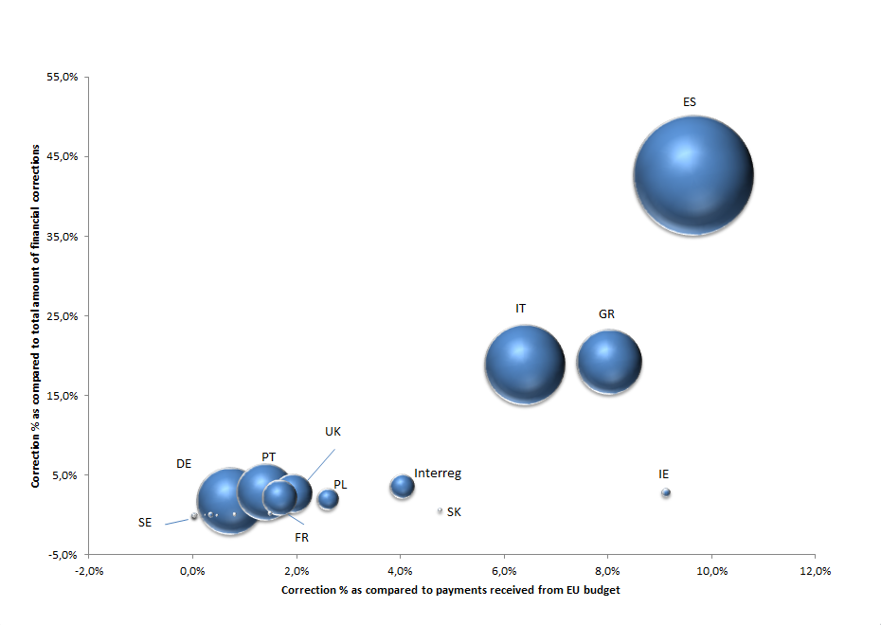
* The size of the "bubble" is proportionate to the EU Funds received.

Table 4.6.2.2: ESF – Programming period 2000-2006: Financial corrections decided/confirmed and in progress (at 31/12/2012) – Breakdown per Member State

EUR millions
Member State | ESF contribution Amount | Financial corrections decided/ confirmed | Financial corrections in progress (closure letters sent) | Total Financial corrections imposed for 2000-2006 | Financial corrections imposed as compared to ESF contribution | Share of Financial corrections imposed compared to total financial corrections
Belgium | 1 080 | 5 | 2 | 7 | 0.6% | 0.4%
Czech Republic | 470 | - | - | - | 0.0% | 0.0%
Denmark | 423 | 0 | - | 0 | 0.0% | 0.0%
Germany | 11 385 | 13 | 0 | 13 | 0.1% | 0.8%
Estonia | 73 | 0 | - | 0 | 0.3% | 0.0%
Ireland | 1 115 | 3 | - | 3 | 0.3% | 0.2%
Greece | 5 034 | 19 | - | 19 | 0.4% | 1.1%
Spain | 12 667 | 474 | 114 | 589 | 4.6% | 36.1%
France | 6 555 | 198 | 7 | 205 | 3.1% | 12.6%
Italy | 8 748 | 273 | 281 | 554 | 6.3% | 34.0%
Cyprus | 25 | - | - | - | 0.0% | 0.0%
Latvia | 136 | 3 | - | 3 | 2.3% | 0.2%
Lithuania | 189 | 0 | - | 0 | 0.0% | 0.0%
Luxembourg | 27 | 2 | - | 2 | 6.7% | 0.1%
Hungary | 455 | 8 | - | 8 | 1.8% | 0.5%
Malta | 11 | - | - | - | 0.0% | 0.0%
Netherlands | 1 731 | 0 | - | 0 | 0.0% | 0.0%
Austria | 753 | - | - | - | 0.0% | 0.0%
Poland | 2 059 | 51 | - | 51 | 2.5% | 3.1%
Portugal | 4 928 | 0 | - | 0 | 0.0% | 0.0%
Slovenia | 79 | 2 | - | 2 | 2.4% | 0.1%
Slovakia | 365 | 1 | - | 1 | 0.3% | 0.1%
Finland | 873 | - | - | - | 0.0% | 0.0%
Sweden | 1 023 | 11 | - | 11 | 1.1% | 0.7%
United Kingdom | 7 139 | 161 | - | 161 | 2.3% | 9.9%
Total | 67 344 | 1 225 | 404 | 1 629 | 2.4% | 100%

In the context of the ESF, at the end of 2012, there were still 61 programmes to be closed where potential financial corrections might be identified.

The graph below takes into account both the absolute “contribution” of each Member State to the total financial corrections and the relative weight of the financial corrections for each Member State compared to the payments received from the EU budget.
15 Member States present overall rates below 1% - corrections for these 15 Member States contribute to 3% of the total corrections. A further 5 Member States present rates between 1% and the average rate of 2.4% and represent 11% of the total corrections. Finally, 5 Member States present rates above the average of 2.4% and contribute to 86% of the total corrections.
Graph 4.6.2.2 Share of Member States' cumulative financial corrections – decided/confirmed and in progress (at 31/12/2012) for ESF programming period 2000-2006*
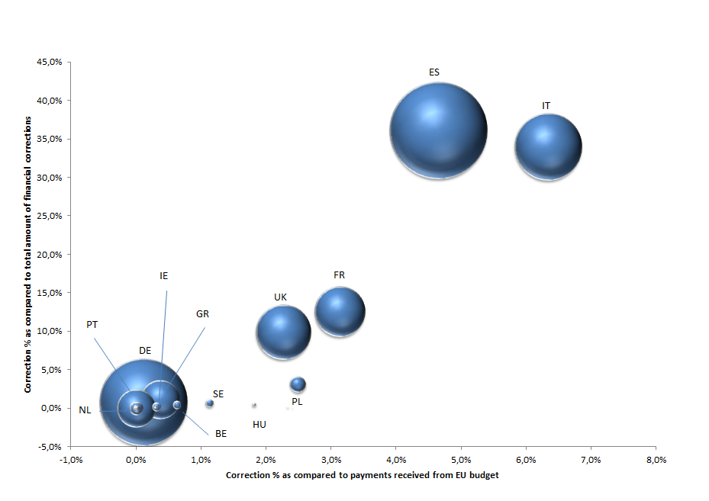
LU
* The size of the "bubble" is proportionate to the EU Funds received.
4.6.3 Preventive effect of financial corrections

It is underlined that the reported amounts in the sections above do not reflect the totality of the amount of financial corrections accepted by Member States as a result of the supervisory role of the Commission. Remedial action plans may have a preventive impact on expenditure already incurred by beneficiaries and registered at national level in the certifying authority's accounts but not yet declared to the Commission. For such expenditure, the certifying authority (under Cohesion policy) applies the financial correction requested by the Commission prior to declaring expenditure. Particularly in the case of extrapolated or flat rate corrections, where there are weaknesses in management and control systems covering a large population of projects, the amounts concerned can be significant.

Preventive effect of financial corrections under Cohesion policy
As a result of the Commission action plan and interruptions, at the end of 2012, the Czech Republic accepted a Commission request for a correction of about EUR 450 million covering two ERDF programmes. The Commission could formally report only EUR 108 million as withdrawals from previously certified expenditure; the remaining corrections do not appear in the official Commission reporting, as an amount of EUR 151.4 million was not included in the certification of October 2012 and a further amount of approximately EUR 189 million will be deducted by the certifying authority before certifying future claims to the Commission in 2013. A similar preventive effect, not reflected in the official reporting of financial corrections, concerns an ERDF/CF Slovak programme where a 7.3% deduction of all expenditure certified and to be certified in the future for hundreds of contracts was deemed necessary by the Commission in order to adequately protect the EU budget and it is now implemented by the Member State.

Another case concerns an ESF flat-rate correction for Romania: The Commission identified serious problems in a Romanian operational programme during 2012. The Commission and Romanian authorities agreed on a 25% flat-rate correction covering all expenditure incurred as at end 2012, plus further claims affected by the same irregularities identified by the Commission. As a result Romania made a further declaration of expenditure (exceeding 25 % of all expenditure declared previously), on the basis of which the Commission paid a very small amount to Romania in December 2012 after offsetting the agreed financial correction. The impact of the financial correction is that expenditure incurred, which was in breach of law, is excluded from Union expenditure.

This preventive effect of the Commission supervisory role is not reflected in the official reporting even though it leads to an increased protection of the EU budget. Warning letters sent out by the Directorates-General when system deficiencies are identified before a payment claim is submitted to the Commission may have the same preventive effect on the protection of the EU budget, but in this case no financial correction is reported by the European Commission/ Member States either.

Recoveries under Cohesion Policy
Due to the reasons described in the sections above, recoveries by the Commission are generally a residual way of implementing financial corrections under Cohesion Policy. Amounts concerned are therefore not significant.
Table 4.7: Recoveries under Cohesion Policy in 2012
EUR millions
 | Confirmed | Implemented
Cohesion Policy | 22 | 14

The amounts recovered by the Member States, based on their own initiative, are also disclosed in this report (see section 6), noting that these cover only the 2007-2013 period, where Member States are legally required to provide the Commission with clear and structured data on amounts withdrawn from co-financing before the national recovery process is finalised and the amounts deducted from payment claim after having been effectively recovered from beneficiaries at national level. These recoveries are not recorded the Commission's accounting system. Figures available for prior programming periods are not considered complete and/or reliable and present potential overlaps with Commission's figures and so are not reported.

INTERNAL & EXTERNAL POLICIES AND ADMINISTRATIVE EXPENDITURE
This heading concerns the preventive and corrective actions for the remaining parts of the budget which are not executed under shared management, essentially external and internal policy areas as well as administrative expenditure. Centralised-direct management means that the Commission, at Headquarters or in Delegations, undertakes the contract award procedures and payments to final beneficiaries. Centralised-indirect management means that implementation tasks are given to EU or other bodies. Decentralised management implies that implementation tasks are entrusted (partially, substantially or fully) to a third country. Joint management means that implementation tasks are entrusted to an international organisation. In total these areas cover about 15% of the annual EU budget.
Graph 5: Financial corrections and recoveries implemented for internal and external policy areas 2009-2012 (in EUR millions):
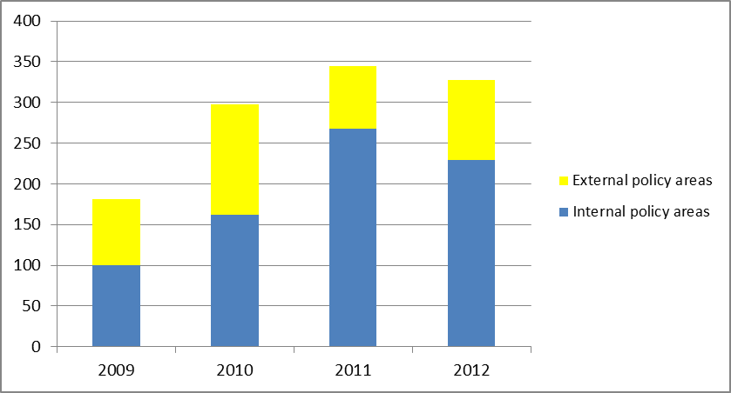

Preventive actions
Across the DGs implementing the non-shared management expenditure, there are of course varying measures applied. Examples of the main types are given below.

5.1.1 Support and guidance of operations

DGs provide guidance via internet and other sources and support (by email, telephone, field visits), particularly on contractual issues, with the aim of ensuring a sound and efficient management of funding and therefore a lower risk of irregularities. Comprehensive and up to date guidance is used to mitigate the risks associated with what can often be a complex financial management environment.

5.1.2 Core training

DGs invest time and resources in training their staff so as to ensure that they are competent to manage the underlying expenditure and make the necessary checks. Horizontal courses are also available to staff in the areas of finance and contracts.

5.1.3 Eligibility assessments

Depending on the management type, the underlying legislation and the contractual conditions, varying eligibility criteria will be defined for a given expenditure. The Authorising Officer services have to demonstrate that the eligibility criteria are met both prior to and throughout the subsequent life of a project. The continuous assessment of the eligibility criteria enables the Commission to ensure the legality of the programmes, through commitments to payments.

5.1.4 Fraud prevention

Anti-fraud measures and actions are embedded in various ex-ante controls for prevention purposes. External audits ensure the follow-up of fraud cases and fraud suspicions including coordination with OLAF. In line with the relevant Commission decision and recent developments, DGs are required to have an Anti-Fraud Strategy, which should enhance the functioning of the fraud risk related controls.

5.1.5 Ex-ante transactional checks performed by the Commission

Depending on their underlying business and risk assessments, some DGs focus more on ex-ante controls, while others have found it more efficient and effective to rely more on ex-post controls (see section 5.2). Comprehensive and rigorous ex-ante transactional controls performed by Commission staff are key financial controls on contracts and payments. Before any operation is authorised, the operational and financial aspects are initiated and verified by two different (operational/financial) entities. This is the "four eyes" principle of the Financial Regulation, which can be reinforced further if a DG wishes (e.g. by requiring controls by two separate agents for each of these two stages). Ex-ante checks are made, for example, on cost claims and audit certificates on cost statements established by external auditors. Staff will check, for example, the eligibility of costs and key documents such as valid financial guarantees (tender guarantee, pre-financing guarantee, performance guarantee) and certificates of acceptance issued by the project managers or supervisors. These controls are regularly reviewed and updated to respond to feedback from controls and subsequent risk analysis.

Corrective mechanisms
Ex-post audits and on-the-spot verifications are made based on mandatory requirements and/or risk based audits and verifications, often using external auditors contracted (either by the Commission or by third parties e.g. beneficiaries). For many DGs, at the moment the payment is authorised, the Commission is not able to ensure fully that the amount paid is accurate and in compliance with the applicable legal and contractual provisions. This can generally only be achieved through checks carried out at the beneficiaries' premises after costs have been incurred and declared. The result of these checks is primarily recoveries to the Commission (see section 5.4), although the use of financial corrections is growing.

Financial Corrections
While financial corrections are primarily a method used under Agriculture and Cohesion policies, it is a mechanism that is beginning to be applied in the policy of Home Affairs. The amount of financial corrections decided and implemented in 2012 is EUR 1 million (2011: EUR 0.4 million) and is expected to increase in the coming years.

Recoveries
5.4.1 Recovery procedure under indirect centralised, decentralised and joint management

As with shared management, the recovery of amounts unduly paid under decentralised and indirect centralised management modes is the primary responsibility of Member States, third countries or agencies. The joint management mode applies also corrective tools that are defined in the agreements concluded with international organisations. But the Commission also issues recoveries in all these areas.

Recoveries at the level of the Commission are made so as to ensure that expenditure that is not in accordance with applicable rules and regulations is excluded from EU financing. Amounts concerned can either be the subject of a recovery order established by the Commission or deducted from the subsequent request for payment. It should be noted that some DGs may have a low rate of recovery for undue payments from funds' recipients because the deduction is directly made by the beneficiary in the request for payment. Therefore, the information cannot be registered in the Commission's accounting system.

In accordance with the Financial Regulation, recovery orders should be established by the Authorising Officer. Recoveries are then implemented by direct bank transfer from the debtor or by offsetting from other amounts that the Commission owes to the debtor. The Financial Regulation foresees additional procedures to ensure the collection of recovery orders overdue, which are the object of a specific follow up by the Accounting Officer of the Commission.
5.4.2 Recovery procedure in direct centralised management
When the Commission implements the budget directly, financial operations are performed by its departments under the principle of segregation of duties between the Authorising Officers and the Accounting Officer. The powers of Authorising Officer are delegated by the College to each Director General and head of service of the Commission who can sub-delegate these powers to their staff (Article 65 of the Financial Regulation).

The responsibility to establish an amount receivable lies with the Authorising Officer, who verifies that the debt is certain, of a fixed amount and due (Article 78 of the Financial Regulation). The authorisation of recovery is the act by which the Authorising Officer responsible instructs the Accounting Officer, by issuing a recovery order, to recover an amount receivable that the Authorising Officer has established (Article 79 of the Financial Regulation).

If the full amount has not been recovered by the deadline set by the Authorising Officer, the Accounting Officer launches the procedure for effecting recovery by any means offered under the law. This implies that the Accounting Officer sends reminders and letters of formal notice and negotiates, when appropriate, additional time for payment under the stringent conditions laid down in the rules of application of the Financial Regulation (Article 89 of the Rules of Application, "RAP"). In addition, the Accounting Officer must call any guarantee lodged in advance by the debtor per Article 88 (1) of the RAP and offset the amounts to recover with equivalent claims that the debtor has on the Union. The claim of the Union and the claim of the debtor must be certain, of a fixed amount and due. In exceptional circumstances, where it is necessary to safeguard the financial interests of the Union, when the Accounting Officer has justified grounds to believe that the amount due to the Union would be lost, the Accounting Officer shall recover by offsetting the amount due to the Commission against a payment to be made to the same beneficiary before the deadline set by the Authorising Officer. In 2012, 688 offsettings were made for a total amount of EUR 106 million.

Failing voluntary payment or offsetting, the Accounting Officer shall launch a forced recovery either; (a) by enforcing a recovery decision adopted by the Commission under Article 299 of the TFEU, (b) by legal action before the national competent Court or, (c) in case of compromissory clause, before the Court of Justice of the European Union.

Recovered amounts are booked as assigned revenues (in the cases listed under Article 21 of the Financial Regulation, e.g. recovery of undue payments) or as miscellaneous revenues for other cases. Revenue pertaining to competitions fines are booked when all legal remedies have been exhausted (Article 83 Financial Regulation).
5.4.3 Recoveries implemented
Due to the multi-annual nature of a large portion of EU spending, recoveries should be viewed over a period of time rather than on a one year basis alone. Table 5.4.3 below shows the recoveries made per year from 2009 to 2012, excluding shared management. The table indicates an average correction rate of 1% (compared to budget payments received) over this four year period. Excluding Administration expenditure, the average would be 1.3%.
Table 5.4.3: Recoveries implemented for internal and external policy areas and administration 2009-2012
EUR millions
Expenditure type | 2009 | 2010 | 2011 | 2012 | Total Recoveries | Total budget payments 2009-12 | % of recoveries compared to payments of the EU budget
Internal policies | 100 | 162 | 268 | 229 | 759 | 57 436 | 1.3%
External policies | 81 | 136 | 77 | 99 | 393 | 29 636 | 1.3%
Administration | 9 | 5 | 2 | 9 | 25 | 32 644 | 0.1%
Total | 190 | 303 | 347 | 337 | 1 177 | 119 716 | 1.0%

CORRECTIVE ACTIONS MADE BY MEMBER STATES UNDER COHESION POLICY ON THEIR OWN INITITATIVE

Background
Under shared management, Member States have the primary obligation to prevent and detect irregularities, and thus to make financial corrections and recover undue amounts from beneficiaries. Thus, they perform management verifications, controls and audits in the first instance, these being in addition to those of the Commission detailed above. Under the regulations for the current programming period, Member States have to report annually the corrections stemming from all controls performed. Such a requirement was only introduced for 2007-2013 and the Commission is performing risk-based audits to test the reliability of these figures for the purpose of its assurance process.

Throughout the implementation period for Cohesion Policy, the managing authority (and its intermediate bodies) performs management verifications, i.e. desk checks on all payment claims and on-the-spot checks on sampled operations. The certifying authority takes steps to ensure that adequate verifications have been made by the managing authority before certifying the legality and regularity of expenditure declared to the Commission, including carrying out its own checks when necessary. The audit authority is responsible for setting an audit strategy to perform system audits on the management and control systems and audits on representative samples of operations. It reports the results annually to the Commission in an annual control report, which includes an annual audit opinion on the functioning of the systems and the total projected error rate resulting from audits on operations. Audits carried out by the national audit authorities are carried out ex-post after certification of expenditure to the Commission.

Graph 6.1: Cohesion Policy:
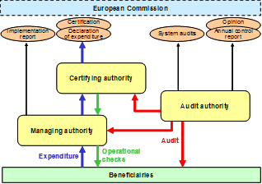

Corrections reported by Member States
The cumulative corrections implemented to end 2012, following the controls made by the Member States for Cohesion Policy programming period 2007-2013, are given below. These amounts are in addition to, and after deduction of, the corrections reported cumulatively by the Commission above.

Table 6.2: Cumulative corrections reported by Member States for Cohesion Policy period 2007-2013
EUR millions
Member State | ERDF/CF | ESF | EFF | Total 2012
Belgium | 3 | 11 | - | 14
Bulgaria | 13 | 2 | 0 | 15
Czech Republic | 191 | 37 | - | 228
Denmark | 0 | 0 | 0 | 0
Germany | 290 | 49 | 1 | 340
Estonia | 4 | 0 | 0 | 4
Ireland | 0 | 5 | 0 | 5
Greece | 63 | - | 0 | 63
Spain | 204 | 39 | 9 | 252
France | 42 | 37 | 0 | 79
Italy | 141 | 27 | 0 | 168
Cyprus | 0 | 0 | 0 | 1
Latvia | 10 | - | 0 | 10
Lithuania | 6 | 0 | 0 | 6
Luxembourg | - | 0 | - | 0
Hungary | 26 | - | 0 | 26
Malta | 1 | 0 | - | 1
Netherlands | 1 | 2 | 0 | 3
Austria | 4 | 1 | 0 | 5
Poland | 204 | - | 0 | 204
Portugal | 46 | 28 | 1 | 75
Romania | 43 | - | 0 | 43
Slovenia | 5 | 5 | - | 10
Slovakia | 33 | 4 | 0 | 37
Finland | 1 | 0 | 0 | 1
Sweden | 2 | 1 | 1 | 4
United Kingdom | 38 | 13 | 1 | 52
Cross-border | 8 | - | - | 8
TOTAL IMPLEMENTED | 1 377 | 261 | 14 | 1 652

The table above shows the cumulative financial corrections reported by each Member State since the beginning of the 2007-2013 programming period to end 2012. These are in addition to the corrections reported cumulatively by the Commission above. Complete and/or reliable figures are not available for previous programming periods since the requirement to report such corrections to the Commission had not been included in the underlying legislation.

So as to gain additional assurance as to the completeness and reliability of the Member States’ reporting on recoveries and withdrawals, the Commission started an audit of structural actions (ERDF, CF, ESF, EFF) in 2011. Based on a risk analysis, a sample of 12 certifying authorities in 10 Member States was selected (the conclusions of this audit, based on the final reports and follow-up implemented by the concerned Member States, were communicated to the Discharge Authority). During 2012, the Commission services obtained reasonable assurance that 11 of the 12 audited certifying authorities have satisfactory arrangements in place for keeping an account of amounts concerning for the recovery and withdrawal of undue payments and for the reporting of them to the Commission. The Commission will continue this audit in 2013 and beyond in other Member States, following analysis of the annual statements from Member States on withdrawals and recoveries.

RECOVERY OF PRE-FINANCING AMOUNTS
Another important protective control of the Commission, which is not covered by any of the above mechanisms, is the recovery of unused (i.e. unspent) pre-financing amounts. In almost all areas, the EU makes pre-financing, or advance payments to beneficiaries. These are payments intended to provide the beneficiary with a cash advance or float. When a beneficiary has not used (spent) the pre-financing amount received from the EU on eligible expenditure, the Commission services issue a recovery order to return the monies to the EU budget. This procedure represents an important step in the control system of the EU to ensure that no excess money is kept by the beneficiary without proper expense justification, thus contributing to the protection of the EU budget.
Table 7: Recovery of Pre-financing amounts in 2012
EUR millions
 |  |  | 2012
Agriculture:
EAGF |  |  | 0
Rural Development |  |  | 0
Cohesion Policy:
ERDF |  |  | 38
Cohesion Fund |  |  | 5
ESF |  |  | 214
FIFG/EFF |  |  | 0
EAGGF Guidance |  |  | 5
Internal policy areas |  |  | 207
External policy areas |  |  | 104
Administration |  |  | 2
Total recovered Pre-Financing |  |  | 575

The above amounts are all the result of the issuance of a recovery order by the Commission, and are recorded in the accounting system as such. The diagram below shows how the process works:

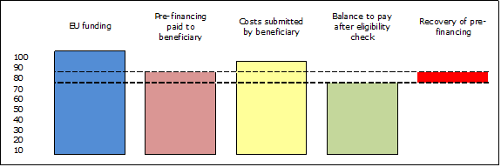
The above recovery of unused pre-financing amounts should not be confused with irregular expenditure recovered. Where Commission services identify and recover such expenditure in relation to pre-financing amounts paid out, these are included in the normal financial correction or recovery processes described above.

RECOVERIES RELATING TO OWN RESOURCE REVENUES
So as to provide a complete picture of all the tools used by the Commission to protect the EU budget, it is also necessary to consider the recoveries made in the area of own resource revenue. Own resource revenue is the primary element of the EU’s operating revenue and therefore the bulk of expenditure is financed by it. There are three categories of own resources: traditional own resources, the VAT-based resource and the GNI-based resource. Traditional own resources comprise sugar levies and customs duties. Member States retain, by way of collection costs, 25% of traditional own resources, and the above amounts are shown net of this deduction.

The Commission makes on-the-spot inspections so as to verify that the correct amounts are being supplied to the EU budget. Amounts can also be audited as part of the ECA’s annual audit process. Recoveries of amounts due to the budget are made following: European Commission's inspection reports, ECA's audits, financial responsibility cases resulting from Member States' administrative errors or lack of diligence in their recovery action, infringement proceedings, European Court of Justice's rulings and also amounts resulting from spontaneous payments from Member States and interest on late payments related to own resources.

In 2012, the amounts recovered were as follows:

Table 8: Recoveries relating to Own Resources revenue in 2012

 | EUR millions
 |  |  |  | 2012
Amounts recovered:  - Principal  - Interest |  |  |  | 133  160
Total recovered |  |  |  | 293

GLOSSARY
AAR Annual Activity Reports: Since the 2001 budget exercise for the Commission, and since 2003 for all Union institutions, the authorising officer by delegation must report to his/her institution on the performance of his/her duties in the form of an annual activity report together with financial and management information. This report indicates the results of the operations by reference to the objectives set, the risks associated with these operations and the way the internal control functions.
Administrative error A case of non-compliance with Commission instructions or procedures but which does not imply lack of compliance with regulatory or contractual provisions.
Annex III and Annex IIIA The overview of amounts to be recovered from final beneficiaries provided by the paying agency to the Commission as part of its annual accounts (under Agriculture).
Assigned revenue Amounts recovered (cashed) are assigned to a specific budget line which triggers payment appropriations for the programme concerned. The amount is available again for expenditure.
Authorising Officer Is responsible in each institution for implementing revenue and expenditure in accordance with the principles of sound financial management and for ensuring that the requirements of legality and regularity are complied with.
Budget Annual financial plan, drawn up according to budgetary principles, that provides forecasts and authorises, for each financial year, an estimate of future costs and revenue and expenditures and their detailed description and justification, the latter included in budgetary remarks.
CAP The Common Agricultural Policy
Certifying Body Public or private legal entity designated by the Member State with a view to certifying the truthfulness, completeness and accuracy of the accounts of the accredited paying agency.
Clearance of accounts The procedure (under Agriculture) by which the Commission accepts the accounts of the Member States and thereby the expenditure made by the paying agencies to farmers and beneficiaries. Firstly the accounts of paying agencies are checked for accuracy by certification bodies in the Member States and are then subject to an annual financial clearance decision by the Commission. Secondly the Commission itself then carries out the conformity clearance procedure based on audits which permit it to identify and exclude (in later years) payments not complying with the rules.
Cost claim A statement of costs incurred often linked to a request for further funds (in line with the underlying contract).
EAFRD European Agricultural Fund for Rural Development
EAGF European Agricultural Guarantee Fund
EAGGF European Agricultural Guarantee & Guidance Fund
ERDF European Regional Development Fund
ESF European Social Fund
Error A non-deliberate clerical or technical error committed by the beneficiary, i.e. arithmetical or transmission errors.
Financial corrections The Commission shall make financial corrections on Member States in order to exclude from Union financing expenditure incurred in breach of applicable law. The Commission shall base its financial corrections on the identification of amounts unduly spent, and the financial implications for the budget. Where such amounts cannot be identified precisely, the Commission may apply extrapolated or flat-rate corrections in accordance with the sector-specific rules.
The Commission shall, when deciding on the amount of a financial correction, take account of the nature and gravity of the breach of applicable law and the financial implications for the budget, including the case of deficiencies in management and control systems.
The criteria for establishing financial corrections and the procedure to be applied may be laid down in the sector-specific rules.
Financial Regulation Sets out the operating principles and basic rules governing the EU budget. Deals thoroughly with budget implementation and control issues, which are not fully covered in the EU treaties.
Fraud Fraud covers a range of irregularities and illegal acts characterized by intentional deception or misrepresentation, damaging interests of the EU.
Irregularities Irregularities mean any infringement of a provision of Union law resulting from an act or omission by an economic operator, which has, or would have, the effect of prejudicing the general budget of the Union or budgets managed by them, either by reducing or losing revenue accruing from own resources collected directly on behalf of the Union, or by an unjustified item of expenditure.
Legal basis Legal base or basis is, as a general rule, a law based on an article in the Treaty giving competence to the Union for a specific policy area and setting out the conditions for fulfilling that competence including budget implementation. Certain Treaty articles authorise the Commission to undertake certain actions, which imply spending, without there being a further legal act.
OLAF European Anti-Fraud Office
Paying Agency A paying agency is the organisation responsible within a Member State for the proper assessment, calculation, inspection and payment of subsidies. Part of the work of the paying agency may be done by delegated bodies.
Pre-debtor Under Agriculture, the ‘pre-debtors’ fulfil the criteria of the Commission to be included in the accounts (Annex III/IIIA tables) and are the result of a pre-notification where the debtor has been informed by the PA of a potential debt which may end up in a recovery notification. The time elapsing between informing of a potential debt and the recovery notification can take several months or even years.
Recoveries Entitlements vis-à-vis the Union's debtors. Authorising Officers establish third parties' debts towards the Union and instruct the accounting officer to recover money due. Actual recovery of amounts due to the Union may take different forms: voluntary payment by the debtor, offsetting of mutual debts, resort to a financial guarantee or enforcement action (either directly through a Union decision in accordance with Art 256 ECT or following an enforcement title obtained before the competent jurisdiction).
Recovery order The recovery order is the document issued by which the Authorising officer (AO) registers an entitlement by the Commission in order to retrieve the amount which is due to the Commission. The entitlement is the right that the Commission has to claim the sum which is due by a debtor, usually a beneficiary.
Residual error rate The residual error rate is the estimate of the remaining level of error in an audited population after corrective measures have been taken. It is used to assess whether corrective measures have adequately mitigated the risks of irregularities.
Rules of Application Lay down detailed rules for the application of the Financial Regulation. They are set out in a Commission Regulation adopted after consulting all institutions and cannot alter the Financial Regulation upon which they depend.
Structural Funds The Structural Funds and the Cohesion Fund are funds allocated by the European Union as part of its regional policy. The purpose of the Structural Funds is to strengthen the economic and social cohesion of the enlarged European Union in order to promote the harmonious, balanced and sustainable development of the Community (Article 3 of Regulation (EC) No. 1083/2006).
Systemic irregularity A systemic irregularity is a recurrent error due to serious failings in management and control systems designed to ensure correct accounting and compliance with rules and regulations.

Annex 1: Cumulative financial corrections confirmed under Cohesion Policy - Breakdown by Member State

EUR millions
Member State | Cumulative end 2011 | Financial corrections confirmed in 2012 |  |  |  |  |  | Cumulative end 2012
Member State | Cumulative end 2011 | ERDF | CF | ESF | FIFG/  EFF | EAGGF Guidance | Total 2012 | Cumulative end 2012
1994-1999 | 2 539 | (2) | (2) | 11 | 0 | 0 | 7 | 2 545
Belgium | 3 | 0 | - | 11 | - | - | 10 | 13
Denmark | 3 | 0 | - | - | - | - | 0 | 3
Germany | 327 | 1 | - | - | - | - | 1 | 328
Ireland | 41 | - | - | - | - | - | 0 | 41
Greece | 520 | 0 | 0 | - | - | - | 1 | 521
Spain | 655 | - | - | - | - | - | 0 | 655
France | 85 | - | - | - | - | - | 0 | 85
Italy | 476 | (2) | - | - | - | 0 | (2) | 474
Luxembourg | 5 | - | - | - | - | 0 | 0 | 5
Netherlands | 178 | - | - | - | - | - | 0 | 178
Austria | 2 | - | - | - | - | - | 0 | 2
Portugal | 97 | (1) | (2) | - | - | - | (4) | 94
Finland | 1 | - | - | - | - | - | 0 | 1
Sweden | 1 | - | - | - | - | - | 0 | 1
United Kingdom | 135 | 0 | - | - | - | - | 0 | 135
INTERREG | 10 | - | - | - | - | - | 0 | 10
2000-2006 | 6 405 | 428 | 106 | 41 | 2 | 31 | 608 | 7 015
Belgium | 11 | 2 | - | 0 | - | - | 2 | 13
Bulgaria | 22 | - | - | - | - | - | 0 | 22
Czech Republic | 19 | 1 | 4 | - | - | - | 5 | 24
Denmark | 0 | 0 | - | - | - | - | 0 | 0
Germany | 13 | 22 | - | 0 | 0 | - | 22 | 35
Estonia | 0 | 1 | - | - | - | - | 1 | 1
Ireland | 44 | - | - | - | - | - | 0 | 44
Greece | 1 183 | - | 8 | - | - | - | 8 | 1 191
Spain | 2 963 | 228 | 88 | 19 | - | 18 | 353 | 3 316
France | 288 | 13 | - | 19 | - | 2 | 33 | 321
Italy | 954 | 65 | - | 0 | 1 | 8 | 75 | 1 029
Cyprus | 0 | - | - | - | - | - | 0 | 0
Latvia | 4 | - | 1 | - | 0 | - | 2 | 6
Lithuania | 2 | 3 | 1 | - | - | - | 3 | 5
Luxembourg | 2 | 0 | - | - | - | - | 0 | 2
Hungary | 55 | - | - | 1 | - | - | 1 | 56
Malta | 0 | - | - | - | - | - | 0 | 0
Netherlands | 2 | - | - | - | 0 | - | 0 | 2
Austria | 0 | - | - | - | - | - | 0 | 0
Poland | 274 | 22 | 1 | 0 | - | - | 23 | 297
Portugal | 201 | 50 | 3 | - | - | - | 53 | 254
Romania | 12 | - | - | - | - | - | 0 | 12
Slovenia | 2 | - | - | - | - | - | 0 | 2
Slovakia | 45 | - | 0 | - | - | - | 0 | 45
Finland | 1 | 0 | - | - | - | - | 0 | 1
Sweden | 11 | - | - | 0 | - | - | 0 | 11
United Kingdom | 289 | 4 | - | 2 | - | 2 | 8 | 297
INTERREG | 8 | 18 | - | - | - | - | 18 | 26

Member State | Cumulative end 2011 | Financial corrections confirmed in 2012 |  |  |  |  |  | Cumulative end 2012
Member State | Cumulative end 2011 | ERDF | CF | ESF | FIFG/EFF | EAGGF Guidance | Total 2012 | Cumulative end 2012
2007-2013 | 221 | 531 | 99 | 374 | 1 | 0 | 1 005 | 1 227
Belgium | 0 | - | - | 3 | - | - | 3 | 3
Bulgaria | 2 | 0 | - | 1 | - | - | 1 | 3
Czech Republic | 0 | 111 | - | 36 | - | - | 147 | 147
Denmark | 0 | - | - | - | - | - | 0 | 0
Germany | 3 | 0 | - | 6 | 0 | - | 6 | 9
Estonia | 0 | 10 | 0 | - | - | - | 10 | 10
Ireland | 2 | - | - | - | - | - | 0 | 2
Greece | 0 | 82 | - | 159 | - | - | 241 | 241
Spain | 85 | 267 | - | 23 | - | - | 291 | 376
France | 0 | 2 | - | 19 | - | - | 21 | 21
Italy | 1 | 18 | - | 2 | 0 | - | 20 | 21
Cyprus | 0 | - | - | - | 0 | - | 0 | 0
Latvia | 0 | - | - | 9 | - | - | 9 | 9
Lithuania | 0 | - | - | - | - | - | 0 | 0
Luxembourg | 0 | - | - | - | - | - | 0 | 0
Hungary | 27 | 1 | 4 | - | - | - | 6 | 33
Malta | 0 | - | - | - | - | - | 0 | 0
Netherlands | 0 | - | - | - | 0 | - | 0 | 0
Austria | 0 | 2 | - | - | - | - | 2 | 2
Poland | 92 | 6 | 71 | 19 | 0 | - | 95 | 187
Portugal | 1 | 1 | - | 0 | - | - | 1 | 2
Romania | 0 | 22 | - | 81 | - | - | 103 | 103
Slovenia | 0 | - | - | - | - | - | 0 | 0
Slovakia | 0 | 8 | 25 | 11 | - | - | 43 | 43
Finland | 0 | - | - | - | 0 | - | 0 | 0
Sweden | 0 | - | - | 0 | - | - | 0 | 0
United Kingdom | 6 | - | - | 5 | - | - | 5 | 11
INTERREG | 0 | 0 | - | - | - | - | 0 | 0
Total | 9 166 | 958 | 203 | 425 | 2 | 31 | 1 619 | 10 787

Annex 2: Cumulative financial corrections implemented under Cohesion Policy - Breakdown by Member State

EUR millions
Member State | Cumulative end 2011 | Financial corrections implemented in 2012 |  |  |  |  |  | Cumulative end 2012
Member State | Cumulative end 2011 | ERDF | CF | ESF | FIFG/  EFF | EAGGF Guidance | Total 2012 | Cumulative end 2012
1994-1999 | 2 528 | (2) | (2) | 11 | 0 | 0 | 7 | 2 535
Belgium | 4 | 0 | - | 11 | - | - | 11 | 15
Denmark | 3 | 0 | - | - | - | - | 0 | 3
Germany | 326 | 1 | - | - | - | - | 1 | 327
Ireland | 38 | - | - | - | - | - | 0 | 38
Greece | 517 | 0 | 0 | - | - | - | 1 | 518
Spain | 648 | - | - | - | - | - | 0 | 648
France | 87 | - | - | - | - | - | 0 | 87
Italy | 474 | (2) | - | - | - | 0 | (2) | 472
Luxembourg | 4 | - | - | - | - | - | 0 | 4
Netherlands | 178 | - | - | - | - | - | 0 | 178
Austria | 2 | - | - | - | - | - | 0 | 2
Portugal | 97 | (1) | (2) | - | - | 0 | (4) | 93
Finland | 1 | - | - | - | - | - | 0 | 1
Sweden | 1 | - | - | - | - | - | 0 | 1
United Kingdom | 139 | 0 | - | - | - | - | 0 | 139
INTERREG | 9 | - | - | - | - | - | 0 | 9
2000-2006 | 3 912 | 2 267 | 122 | 41 | 0 | 17 | 2 447 | 6 359
Belgium | 8 | 0 | - | 0 | - | - | 1 | 8
Bulgaria | 12 | - | 6 | - | - | - | 6 | 18
Czech Republic | 5 | 5 | 8 | - | - | - | 13 | 19
Denmark | 0 | 0 | - | - | - | - | 0 | 0
Germany | 11 | 22 | - | 0 | 0 | - | 22 | 33
Estonia | 0 | 0 | - | 0 | - | - | 1 | 1
Ireland | 26 | - | - | - | - | - | 0 | 26
Greece | 1 149 | - | 12 | - | - | - | 12 | 1 162
Spain | 1 051 | 1 952 | 81 | 19 | - | 6 | 2 058 | 3 109
France | 250 | 20 | - | 18 | - | 2 | 40 | 290
Italy | 833 | 55 | - | 0 | - | 7 | 62 | 895
Cyprus | 0 | - | - | - | - | - | 0 | 0
Latvia | 4 | 1 | 1 | - | 0 | - | 3 | 6
Lithuania | 1 | 3 | 1 | 0 | - | - | 3 | 4
Luxembourg | 2 | 0 | - | - | - | - | 0 | 2
Hungary | 55 | - | - | - | - | - | 0 | 55
Malta | 0 | - | - | - | - | - | 0 | 0
Netherlands | 1 | 0 | - | - | - | - | 0 | 1
Austria | 0 | - | - | - | - | - | 0 | 0
Poland | 151 | 39 | 9 | 1 | - | - | 49 | 200
Portugal | 121 | 118 | 3 | - | - | - | 121 | 242
Romania | 11 | - | - | - | - | - | 0 | 11
Slovenia | 2 | - | - | - | - | - | 0 | 2
Slovakia | 6 | 24 | 0 | - | - | - | 24 | 30
Finland | 0 | 0 | - | - | - | - | 0 | 0
Sweden | 11 | - | - | - | - | - | 0 | 11
United Kingdom | 201 | 4 | - | 2 | - | 2 | 8 | 208
INTERREG | 1 | 24 | - | - | - | - | 24 | 25

Member State | Cumulative end 2011 | Financial corrections implemented in 2012 |  |  |  |  |  | Cumulative end 2012
Member State | Cumulative end 2011 | ERDF | CF | ESF | FIFG/ EFF | EAGGF Guidance | Total 2012 | Cumulative end 2012
2007-2013 | 162 | 151 | 87 | 379 | 0 | 0 | 617 | 779
Belgium | 0 | - | - | 0 | - | - | 0 | 1
Bulgaria | 1 | 0 | - | 1 | - | - | 1 | 2
Czech Republic | 0 | 111 | - | 0 | - | - | 111 | 111
Denmark | 0 | - | - | - | - | - | 0 | 0
Germany | 3 | - | - | - | - | - | 0 | 3
Estonia | 0 | - | 0 | 0 | - | - | 0 | 0
Ireland | 2 | - | - | - | - | - | 0 | 2
Greece | 0 | - | - | 159 | - | - | 159 | 159
Spain | 41 | 0 | - | 65 | - | - | 65 | 106
France | 0 | - | - | 19 | - | - | 19 | 19
Italy | 0 | 4 | - | 3 | - | - | 6 | 6
Cyprus | 0 | - | - | - | 0 | - | 0 | 0
Latvia | 0 | - | - | 9 | - | - | 9 | 9
Lithuania | 0 | - | - | - | - | - | 0 | 0
Luxembourg | 0 | - | - | - | - | - | 0 | 0
Hungary | 28 | 0 | - | - | - | - | 0 | 28
Malta | 0 | - | - | - | - | - | 0 | 0
Netherlands | 0 | - | - | - | 0 | - | 0 | 0
Austria | 0 | - | - | - | - | - | 0 | 0
Poland | 86 | 6 | 71 | 22 | 0 | - | 98 | 184
Portugal | 1 | 1 | - | 0 | - | - | 1 | 1
Romania | 0 | 22 | - | 81 | - | - | 103 | 103
Slovenia | 0 | - | - | - | - | - | 0 | 0
Slovakia | 0 | 6 | 16 | 11 | - | - | 33 | 33
Finland | 0 | - | - | - | 0 | - | 0 | 0
Sweden | 0 | 0 | - | 0 | - | - | 0 | 0
United Kingdom | 0 | - | - | 11 | - | - | 11 | 11
INTERREG | 0 | 0 | - | - | - | - | 0 | 0
Total | 6 601 | 2 416 | 207 | 430 | 1 | 17 | 3 071 | 9 673

See Official Journal C 115 of 9 May 2008.
See also Article 325 of the TFEU, which states that: "1. The Union and the Member States shall counter fraud and any other illegal activities affecting the financial interests of the Union through measures to be taken in accordance with this Article, which shall act as a deterrent and be such as to afford effective protection in the Member States, and in all the Union's institutions, bodies, offices and agencies. 2. Member States shall take the same measures to counter fraud affecting the financial interests of the Union as they take to counter fraud affecting their own financial interests. … 5. The Commission, in cooperation with Member States, shall each year submit to the European Parliament and to the Council a report on the measures taken for the implementation of this Article."
Regulation (EU, Euratom) No 966/2012 of the European Parliament and of the Council of 25 October 2012 (Official Journal L 298, 26 October 2012).
Commission Delegated Regulation (EU) No 1268/2012 of 29 October 2012 (Official Journal L 362, 31 December 2012).
See sections 3 & 4 of this document.
European Parliament resolution of 17 April 2013 with observations forming an integral part of its Decisions on discharge in respect of the implementation of the general budget of the European Union for the financial year 2011, Section III – Commission and executive agencies (COM(2012)0436 – C7-0224/2012 – 2012/2167(DEC)) – Priority Action 1.
See also the 2012 Annual Report on the Protection of the European Union's financial interests — Fight against fraud which has been adopted on 24 July 2013.
Due to the rounding of figures into millions of Euros, amounts in some tables may appear not to add up.
It is noted that the Commission's Anti-Fraud Strategy adopted in June 2011 led, with OLAF's involvement and support, to important progress in the field of fraud prevention and detection.
The methods of implementing the EU budget have been adapted following the adoption of the new Financial Regulation and the new methods will come into force in 2014.
The clear responsibility for Member States to make controls and to recover monies from beneficiaries is also laid down in Article 80 of the Financial Regulation, as quoted earlier.
As explained in more detail later in this SWD, implementation is the last step in the financial correction or recovery process. Implementation means that for a financial correction or recovery that has been previously detected and then decided/agreed upon, the observed situation of undue expenditure is definitively corrected.
EAGF amounts executed under shared management total EUR 44 495 million.
For example, for the implementation mechanism of financial corrections for cohesion policy see explanations provided in the section 4.2.1.
Ref. P7_TA(2013)0319
It should be noted that in the area of Agriculture and Rural Development for the 2007-2013 period, the European Agricultural Guarantee Fund ("EAGF") and the European Agricultural Fund for Rural Development ("EAFRD") have replaced the European Agricultural Guidance and Guarantee Fund ("EAGGF") 2000-2006.
Council regulation (EC) No 485/2008 of 26 May 2008 (Official Journal L 143, 3 June 2008).
Commission Regulation (EU) No 65/2011 of 27 January 2011 (Official Journal L25, 28 January 2011).
EAGF amounts executed under shared management total EUR 44 495 million.
Official Journal L210, 31 July 2006.
COM(2011)615 final of 6.10.2011
For example, "Report on financial corrections carried out for ERDF and ESF on 2000-2006 programmes" sent to the EP/CONT Committee on 12/04/2013, Ares (2013)689652.
Please note that the negative amount of EUR 4 million reported under 1994-99 programming period is the result of a reclassification of a financial correction, previously reported under 1994-1999, but actually pertaining to the 2000-2006 period.
Due to the lack of payment appropriations in the 2012 budget, at the end of the year (following the rejection by the budget authority of the proposal for an amending budget with higher payment appropriations), the Commission services could not make a full payment of the balance due.
“Report on financial corrections carried out for ERDF and ESF on 2000-2006 programmes”, reference note ARES(2013)689652 of 12/04/2013, sent to CONT and note ARES(2013)1041808 of 14/05/2013 sent to the ECA.
These estimated rates of financial correction do not include additional potential ERDF corrections linked to unfinished projects nor additional corrections that may result from the completion of the closure process. In the context of the ESF, at the end of 2012, there were still 61 programmes to be closed where potential financial corrections might be identified.
A prudent estimate of the Commission services of additional corrections carried out by Member States themselves and reported to the Commission until March 2010 is EUR 0.96 billion for the ERDF and 0.32 billion for the ESF, representing at least 0.7% and 0.5% of allocations respectively. This means that by end 2012 the overall rate of correction for the 2000-2006 period is at least 5.6% for the ERDF decided allocations and 2.9% for the ESF (for details, see Report on Financial corrections carried out for ERDF and ESF on 2000-2006 programmes sent to EP CONT Commitment on 12/04/2013 ARES(2013)689652 pages 12 to 18).
In 2012, some 16,000 recovery orders (with a value of roughly EUR 140 billion) have been issued by the Authorising Officers of the Commission relating to the implementation of the EU budget. Of course, the bulk of the total (approximately EUR 130 billion) relates to own resource revenues received from the Member States.

