Foreword
In May 2011 the High Representative of the Union for Foreign Affairs and Security Policy and the European Commission put forward a new policy response to a changing EU neighbourhood.
The renewed neighbourhood policy put additional emphasis on shared commitment to the universal values of human rights, democracy and the rule of law and involving a much higher level of differentiation. It also introduces the concept of “deep and sustainable democracy” encompassing the following elements: free and fair elections; freedom of association, expression and assembly and a free press and media; the rule of law administered by an independent judiciary and right to a fair trial; fighting against corruption; security and law enforcement sector reform (including the police) and the establishment of democratic control over armed and security forces.
This year Country Progress Reports reflect the new approach and pay additional attention to progress towards deep and sustainable democracy and the respect of human rights in general. They are accompanied, for the first time by a Statistical Annex which builds and expand on the basic statistical information provided until 2011 in the Annex to the Sector Report and complements the narrative information included in the Country Progress reports.
Besides the “classical” economic, trade and social data, this Annex also collates information and indicators related to advancements in deep and sustainable democracy and in the respect of human rights. Such information and indicators come from a variety of sources, notably: the Freedom House, Transparency International, the Economist Intelligence Unit, the Word Bank, Ilga International. A close cooperation with civil societies and NGOs has brought to include indicators on freedom of the press, on the respect of LGBTI rights, on the fights against cruel and inhuman treatments and against death penalty.
The Statistical Annex also provides more detailed fact and figures on the EU assistance in a new set of Country fiches.
The present document provides, as a background to the European Neighbourhood Policy (ENP) Joint Communication, selected political, economic, mobility and assistance related indicators, statistics and graphs.
Overview

Section I: Democracy, Good Governance and Human rights 5
1. State of ratification/signature of selected human rights conventions 5
2. Deep Democracy Indicators 8
Transparency International Corruption Perception Index (2012) 8
Freedom house assessment (2012) 9
3. Other Human Rights indicators 10
Death Penalty (2012) 10
LGBT (Lesbian, Gay, Bisexual and Transgender) rights (2012) 11
4. Other indicators 12
UNDP Human Development Index (2012) 12
World Bank’s “Doing Business” Ranking (2012) 13
Ratification of core labour standards (2012) 14
Section II: Macroeconomic indicators 14
BASIC DATA 14
Real GDP growth 15
Inflation rate 16
GDP per capita 17
Unemployment rate 18
EMPLOYMENT RATE 19
Government debt and Current Account Balance 20
Trade Balance 21
Section III: the EU and the partners 22
1. Main agreements in force with partnerS 22
2. Trade flows 25
EU Share of Partners' Imports and Exports (2012) 27
EU trade with the world (2012) 28
Breakdown of Southern ENP partners' trade with the EU (2012) 29
Breakdown of Eastern ENP partners' trade with the EU (2012) 30
3. Schengen Visas issued by Partner in 2012 31
4. European Integration Index for Eastern Partnership Countries – Open Societies Foundations / Renaissance foundation 32
Section IV: EU assistance to partners 33
1. Tables on commitments and programmed amounts under ENPI 33
2. ENPI-Cross Border Cooperation - Allocations 2007 – 2013 34
3. Fiches covering EU assistance for each partner (2007-2013) 36
Algeria 36
Armenia 38
Azerbaijan 41
Belarus 43
Egypt 45
Georgia 47
Israel 50
Jordan 52
Lebanon 54
Libya 56
Republic of Moldova 58
Morocco 61
Palestine 63
Syria 65
Tunisia 67
Ukraine 70
4. ENPI Regional East - Allocations 2007 – 2013 72
5. ENPI Regional south - Allocations 2007 – 2013 73
6. ENPI Interregional - Allocations 2007 – 2013 75
7. Mobility of students and researchers 76
Participation of ENP partners in FP7 Marie Curie Actions (People Programme) 2012 76
Youth in Action mobility figures 2011-2012 77
Mobility under Erasmus Mundus, Action 1 and Action 2, 2012 78
Tempus IV- number of projects per partner accepted in 2012 79
8. TAIEX events, SIGMA operations and twinning projects with ENP partners 80
Breakdown of TAIEX requests from ENP partner countries and the Russian Federation 80
Single ENP Partner Events 2007 82
Number of participants (single and multi-ENP partner events) 83
Sector coverage – TAIEX ENPI (2006 to December 2012) 84
Type of assistance requested 2007 – December 2012 85
SIGMA 86
Twinning projects 88
Twinning projects ENP 2005- December 2012 (per sector) 89
Twinning projects by sector 90
Number of Twinning proposals by Member States 2005-2012 91
Member States selected in Twinning projects 2005-2012 92
9. Neighbourhood Investment Facility projects in 2012 93
Projects in the ENP East region 93
Projects in the ENP South region 94
Distribution of NIF Contribution by sector in 2012 95
Distribution of NIF contributions by objectives in 2012 96
Neighbourhood Investment Facility (NIF): Contributions pledged by Member States 2008-2012 (as of 31/12/2012) 97

Section I: Democracy, Good Governance and Human rights

1. State of ratification/signature of selected human rights conventions

State of ratification/ signature of major HR conventions * | ICCPR  International Covenant on Civil and Political Rights OP1*  OP2 | ICESCR  International Covenant on Economic, Social and Cultural Rights  OP | CEDAW  Convention on the Elimination of All Forms of Discrimination against Women  OP | CAT  Convention against Torture  OP  Right to Individual Complaint (Art.22) | CRC  Convention on the Rights of the Child  OP AC  OP SC
ALGERIA | 12/09/1989  OP1 - 12/09/1989  OP2 - NO | 12/09/1989  OP - NO | 22/05/1996 -R  OP - NO | CAT 12/09/1989  OP - NO  Art. 22 11/05/1994 | CRC 16/04/1993  OP-AC – 06/05/2009  OP-SC - 27/12/2006
ARMENIA | 23/06/1993  OP1 - 23/06/1993  OP2 - NO | 13/09/1993  OP – 29/09/2009 | 13/09/1993  OP - 14/09/2006 | CAT 13/09/1993  OP 14/09/2006 Art. 22 - NO | CRC 23/06/1993  OP-AC - 30/09/2005  OP-SC - 30/06/2005
AZERBAIJAN | 13/08/1992  OP1 - 27/11/2001  OP2 - 22/01/1999 | 13/08/1992  OP-25/09/2009 | 10/07/1995  OP - 1/06/2001 | CAT 16/08/1996  OP 28/01/2009  Art. 22  4/02/2002 | CRC 13/08/1992  OP-AC - 3/07/2002  OP-SC - 3/07/2002
BELARUS | 12/11/1973  OP1 - 30/09/1992  OP2 - NO | 12/11/1973  OP - NO | 04/02/1981  OP - 3/02/2004 | CAT 13/03/1987  OP – NO  Art. 22 - NO | CRC 1/10/1990  OP-AC - 25/01/2006  OP-SC - 23/01/2002
EGYPT | 14/01/1982  OP1 - NO  OP2 - NO | 14/01/1982  OP - NO | 18/09/1981 R  OP - NO | CAT 25/06/1986  OP - NO  Art. 22 - NO | CRC 6/07/1990 R  OP-AC - 6/02/2007  OP-SC - 12/07/2002
GEORGIA | OP1 - 3/05/1994  OP2 - 22/03/1999 | 3/05/1994  OP - NO | CEDAW 26/10/1994  OP – 01/08/2002 | CAT 26/10/1994  OP - 9/08/2005  Art. 22 30/06/2005 | CRC 2/06/1994  OP-AC – 03/08/2010  OP-SC - 28/06/2005
ISRAEL | 3/10/1991  OP1 - NO  OP2 - NO | 3/10/1991  OP - NO | 3/10/1991 R  OP - NO | CAT 3/10/1991 R  OP - NO  Art. 22 - NO | CRC 3/10/1991  OP-AC - 18/07/2005  OP-SC - 23/07/2008
JORDAN | 28/05/1975  OP1 - NO  OP2 - NO | 28/05/1975  OP - NO | 1/07/1992 R  OP - NO | CAT 13/11/1991  OP – NO  Art. 22 - NO | CRC 24/05/1991 R  OP-AC - 23/05/2007  OP-SC - 4/12/2006
LEBANON | 3/11/1972  OP1 - NO  OP2 - NO | 3/11/1972  OP - NO | 16/04/1997 R  OP - NO | CAT 5/10/2000  OP – 22/12//2008  Art. 22 - NO | CRC 14/05/1991  OP-AC - 11/02/2002  OP-SC - 8/11/2004
LIBYA | 15/05/1970  OP1 - 16/05/1989  OP2 - NO | 15/05/1970  OP - NO | CEDAW  4/02/1981 – R  OP - 18/06/2004 | CAT 16/05/1989  OP – NO  Art. 22 - NO | CRC 15/04/1993  OP-AC - 29/10/2004  OP-SC - 18/06/2004
MOROCCO | 3/05/1979  OP1 - NO  OP2 - NO | 3/05/1979  OP - NO | 21/06/1993 R  OP - NO | CAT 21/06/1993 R  OP - NO  Art. 22 19/10/2006 | CRC 21/06/1993 R  OP-AC - 22/05/2002  OP-SC - 2/10/2001
REPUBLIC OF MOLDOVA | 26/01/1993  OP1 - 23/01/2008  OP2 - 20/09/2006 | 26/01/1993  OP - NO | 1/07/1994  OP - 28/02/2006 | CAT 28/11/1995  OP 24/07/2006  Art. 22 - NO | CRC 26/01/1993  OP-AC - 7/04/2004  OP-SC - 12/04/2007
SYRIA | 21/04/1969  OP1 - NO  OP2 - NO | 21/04/1969  OP - NO | 28/03/2003  OP - NO | CAT 19/08/2004  OP - NO  Art. 22 - NO | CRC 15/07/1993  OP-AC - 17/10/2003  OP-SC - 15/05/2003
TUNISIA | 18/03/1969  OP1 – 29/06/11  OP2 - NO | 18/03/1969  OP - NO | CEDAW 20/09/1985 R  OP - 23/09/2008 | CAT 23/09/1988 R  OP – 29/06/2011  Art. 22 22/09/1988 | CRC 30/01/1992  OP-AC - 2/01/2003  OP-SC - 13/09/2002
UKRAINE | 12/11/1973  OP1 - 25/07/1991  OP2 - 25/07/2007 | 12/11/1973  OP – 24/09/09 | 12/03/1981  OP - 26/09/2003 | CAT 24/02/1987  OP - 19/09/2006  Art. 22 12/09/2003 | CRC 28/08/1991  OP-AC - 11/07/2005  OP-SC - 3/07/2003

* OP: Optional Protocol
* date of signature in bold; date of ratification in standard. Also in bold where an instrument has been neither signed nor ratified (“NO”).
* R: text adopted with reservations

Source: http://treaties.un.org/

2. Deep Democracy Indicators

Transparency International Corruption Perception Index (2012)
The Corruption Perceptions Index ranks countries/territories based on how corrupt their public sector is perceived to be. A country/territory’s score indicates the perceived level of public sector corruption on a scale of 0 – 10 for 2011 and 0 – 100 for 2012, where 0 means that a country is perceived as highly corrupt and 10 for 2011 and 100 for 2012 means that a country is perceived as very clean. A country's rank indicates its position relative to the other countries/territories included in the index.

 | 2011 |  | 2012
 | Rank  (1-183) | Score | Rank  (1-176) | Score
Algeria | 112 | 2.9 | 105 | 34
Armenia | 129 | 2.6 | 105 | 34
Azerbaijan | 143 | 2.4 | 139 | 27
Belarus | 143 | 2.4 | 123 | 31
Egypt | 112 | 2.9 | 118 | 32
Georgia | 64 | 4.1 | 51 | 52
Israel | 36 | 5.8 | 39 | 60
Jordan | 56 | 4.5 | 58 | 48
Libya | 168 | 2.0 | 160 | 21
Lebanon | 134 | 2.5 | 128 | 30
Republic of Moldova | 112 | 2.9 | 94 | 36
Morocco | 80 | 3.4 | 88 | 37
Syria | 129 | 2.6 | 144 | 26
Tunisia | 73 | 3.8 | 75 | 41
Ukraine | 152 | 2.3 | 144 | 26

Source:
2011 report: http://cpi.transparency.org/cpi2011/
2012 report: http://cpi.transparency.org/cpi2012/results/

Freedom house assessment (2012)
Human Rights and Fundamental Freedom in 2012: Freedom score is graded using a scale from 1 to 10, where 1 represents the maximum freedom.
 | Political rights rating | Civil rights rating | Freedom rating | Freedom Status
Algeria | 6 | 5 | 5.5 | Not free
Armenia | 6 | 4 | 5 | Partly Free
Azerbaijan | 6 | 5 | 5.5 | Not Free
Belarus | 7 | 6 | 6.5 | Not Free
Egypt | 5 | 5 | 5 | Partly Free
Georgia | 4 | 3 | 3.5 | Partly Free
Israel | 1 | 2 | 1.5 | Free
Jordan | 6 | 5 | 5.5 | Not Free
Lebanon | 5 | 4 | 4.5 | Partly Free
Libya | 4 | 5 | 4.5 | Partly Free
Republic of Moldova | 3 | 3 | 3 | Partly Free
Morocco | 5 | 4 | 4.5 | Partly Free
Syria | 7 | 7 | 7 | Not Free
Tunisia | 3 | 4 | 3.5 | Partly Free
Ukraine | 4 | 3 | 3.50 | Partly Free
Source: http://www.freedomhouse.org/report-types/freedom-world

3. Other Human Rights indicators

Death Penalty (2012)
Is death Penalty applied?

 | Death Penalty | UN resolution in favour of a universal moratorium on the Death Penalty  (Dec 2010)
Algeria | Observing a Moratorium | In favour
Armenia | Abolished by Constitution | In favour
Azerbaijan | Abolished by Constitution | In favour
Belarus | Applied | Abstained
Egypt | Applied | Against
Georgia | Abolished by Constitution | In favour
Israel | Abolished by Constitution | In favour
Jordan | Applied / no execution carried out since 2006 | Abstained
Lebanon | Applied | Abstained
Libya | Applied | Against
Republic of Moldova | Abolished by Constitution | In favour
Morocco | Not applied | Abstained
Syria | Applied | Against
Tunisia | Not applied | Moratorium applied
Ukraine | Abolished by Constitution | In favour
Source: http://www.handsoffcain.info/bancadati/index.php?tipotema=arg&idtema=16000641

LGBT (Lesbian, Gay, Bisexual and Transgender) rights (2012)
Is homosexuality legal?
 | Legal / illegal
Algeria | Illegal
Armenia | Legal
Azerbaijan | Legal
Belarus | Legal
Egypt | Illegal
Georgia | Legal
Israel | Legal
Jordan | Legal
Lebanon | Illegal
Libya | Illegal
Republic of Moldova | Legal
Palestine | Illegal for male to male relationships / Legal for female to female relationships
Morocco | Illegal
Syria | Illegal
Tunisia | Illegal
Ukraine | Legal

Source: http://ilga.org/

4. Other indicators

UNDP Human Development Index (2012)
The HDI is a summary measure for assessing long-term progress in three basic dimensions of human development: a long and healthy life, access to knowledge and a decent standard of living. It ranges from 0 to 1, with the higher-scoring countries being "developed" and the lower ones being "developing" or "undeveloped".
 | Ranking  (1-187) | HDI | Human development category
Algeria | 96 | 0.698 | Medium
Armenia | 86 | 0.716 | High
Azerbaijan | 76 | 0.731 | High
Belarus | 65 | 0.756 | High
Egypt | 113 | 0.644 | Medium
Georgia | 75 | 0.733 | High
Israel | 17 | 0.888 | Very High
Jordan | 95 | 0.698 | Medium
Lebanon | 71 | 0.739 | High
Libya | 64 | 0.760 | High
Republic of Moldova | 111 | 0.649 | Medium
Morocco | 130 | 0.582 | Medium
Palestine | 114 | 0.641 | medium
Syria | 119 | 0.632 | Medium
Tunisia | 94 | 0.698 | High
Ukraine | 76 | 0.729 | High

Source: UNDP, http://hdr.undp.org/en/reports/

World Bank’s “Doing Business 2013” Ranking (2012)
Economies are ranked on their ease of doing business, from 1 – 185. A high ranking on the ease of doing business index means the regulatory environment is more conducive to the starting and operation of a local firm. This index averages the country's percentile rankings on 10 topics, made up of a variety of indicators, giving equal weight to each topic. The rankings for all economies are benchmarked to June 2012

 | Rank 2012 | Rank 2011 | Change in rating
Algeria | 152 | 150 | -2
Armenia | 32 | 50 | 18
Azerbaijan | 67 | 66 | -1
Belarus | 58 | 60 | 2
Egypt | 109 | 110 | 1
Georgia | 9 | 12 | 3
Israel | 38 | 36 | -2
Jordan | 106 | 105 | -1
Lebanon | 115 | 112 | -3
Libya | - | - | -
Republic of Moldova | 83 | 86 | 3
Morocco | 97 | 93 | -4
Palestine | 135 | 135 | 0
Syria | 144 | 137 | -7
Tunisia | 50 | 45 | -5
Ukraine | 137 | 152 | 15

Source http://www.doingbusiness.org/rankings

Ratification of core labour standards (2012)
The core labour standards are fundamental principles that protect basic human rights in the workforce. As stated in the ILO Declaration on Fundamental Principles and Rights at Work (1998) the core labour standards aim to: (1) eliminate all forms of forced or compulsory labour; (2) effectively abolish child labour; (3) eliminate discrimination in respect of employment and occupation; and (4) ensure the freedom of association and the right to collective bargaining.
Ratification | Elimination of forced and compulsory labour |  | Abolition of child labour |  | Elimination of discrimination in respect of employment and occupation |  | Freedom of association and collective bargaining
Convention | 29 | 105 | 138 | 182 | 100 | 111 | 87 | 98
Algeria | X | X | X | X | X | X | X | X
Armenia | X | X | X | X | X | X | X | X
Azerbaijan | X | X | X | X | X | X | X | X
Belarus | X | X | X | X | X | X | X | X
Egypt | X | X | X | X | X | X | X | X
Georgia | X | X | X | X | X | X | X | X
Israel | X | X | X | X | X | X | X | X
Jordan | X | X | X | X | X | X |  | X
Lebanon | X | X | X | X | X | X |  | X
Libya | X | X | X | X | X | X | X | X
Republic of Moldova | X | X | X | X | X | X | X | X
Morocco | X | X | X | X | X | X |  | X
Palestine | - | - | - | - | - | - | - | -
Syria | X | X | X | X | X | X | X | X
Tunisia | X | X | X | X | X | X | X | X
Ukraine | X | X | X | X | X | X | X | X
Source: ILOLEX, http://www.ilo.org/ilolex/english/newratframeE.htm

Section II: Macroeconomic indicators

Basic Data
 | Population (1000) |  | Population under 15 (% of total population) |  | Population over 65 (% of total population) |  | Population, annual average growth rates  2000 to 2011 (%)
 | 2000 (1) | 2011 (2) | 2000 (1) | 2011 (2) | 2000 (1) | 2011 (2)
Algeria | 30 183 | 36 717 | 34,1 | 27,7 | 4,6 | 5,4 | 1,8
Armenia | 3 227 | 3 263 | 24,7 | 19,4 | 9,0 | 9,8 | 0,1
Azerbaijan | 8 114 | 9 235 | 30,6 | 22,3e | 5,5e | 5,8e | 1,2
Belarus | 10 003 | 9 481 | 19,0 | 14,9 | 13,3 | 13,8 | -0,5
Egypt | 63 255 | 79603 | 35,4 | 31,1 | 3,6 | 4,2 | 2,1
Georgia | 4 435 | 4 469 | 21,3 | 17,0 | 12,4 | 13,8 | 0,1
Israel | 6 369 | 7 695 | 28,7 | 28,0 | 9,8 | 9,9 | 1,8
Jordan | 4 738 | 6 249 | 41,4 | 37,3 | 2,6 | 3,2 | 2,5
Lebanon | 3 755 | 3 786 | 27,2 | 24,8 | 7,5 | 7,5 | 0,2
Republic of Moldova | 3 644 | 3 560 | 25,7 | 16,5 | : | 10,0 | -0,2
Morocco | 28 275 | 32 245 | 31,0 | 27,0 | 5,5 | 5,9 | 1,2
Palestine | 3 053 | 4 108 | 47,0 | 41,1 | 3,5 | 3,0 | 2,8
Syria | 16 526 | 21 124 | 40,5 | 37,1 | 3,1 | 4,1 | 2,8
Tunisia | 9 619 | : | 29,3 | : | 6,4 | : | :
Ukraine | 49 115 | 45 598 | 17,9 | 14,2 | 13,9 | 15,3 | -0,7
Sources: Eurostat, based on data supplied by the national statistical offices of the countries.
(1)Israel, Syria and Tunisia, 2001; Lebanon, 2004.
(2)Lebanon, 2009.
: = not available

Real GDP growth

(% change ) | 2008 | 2009 | 2010 | 2011 | 2012*
Algeria | 2,4 | 2,4 | 3,3 | 2,4: | 2,6
Armenia (1) | 6,9 | -14,1 | 2,2 | 4,7 | 7,2
Azerbaijan | 10,8 | 9,3 | 5p | 0,1 | 2,2
Belarus | 10,2 | 0,2 | 7,7 | 5,3 | 1,5
Egypt | 7,2 | 4,7 | 5,1 | 1,9 | 2,2
Georgia | 2,3 | -3,8 | 6,3 | 7,0* | 6,1
Israel | 4,1 | 1,1 | 5,0 | 4,6 | 3,3
Jordan | 7,2 | 5,5 | 2,3 | 2,6 | 3,0
Lebanon | 9,3 | 8,5 | 7,0 | 1,5 | 2,0
Republic of Moldova | 7,8 | -6,0 | 7,1 | 6,4p | -0,1
Morocco | 5,6 | 4,9 | 3,6 | 5,0 | 3,2
Palestine | 7,1 | 7,4 | 9,8 | 9,9 | 6,2
Syria | 4,5 | 5,9 | 3,4 | : | :
Tunisia | 4,7 | 3,2 | 3,2 | -1,0 | 3,5
Ukraine | 2,3 | -14,8 | 4,1 | 5,2 | 0,2
Source: Eurostat, based on data supplied by the national statistical offices of the countries.
DATA in Italics are data from the national authorities, the IMF and the European Commission services;.- 2012 estimated by European Commission services and preliminary figures from national authorities
(1): In constant 2005 prices
p = provisional date
* = estimate
: = not available

Inflation rate, average in %

 | (period average)
 | 2008 | 2009 | 2010 | 2011 | 2012
Algeria | 4,9 | 5,7 | 3,9 | 4,5 | 8,9
Armenia | 9,0 | 3,4 | 8,2 | 7,7 | 2,6
Azerbaijan | 20,8 | 1,5 | 5,7 | 7.9 | 1,1
Belarus | 14,8 | 13 | 7,8 | 53,2 | 59,2
Egypt | 18,3 | 11,8 | 11,1 | 10,1 | 4,7
Georgia | 10 | 1,7 | 7,1 | 8,5 | -0,9
Israel | 4,6 | 3,3 | 2,7 | 3,5 | 1,7
Jordan | 13,9 | -0,7 | 6,3 | 4,2 | 4,8
Lebanon | 5,5 | 3,4 | 4,6 | 3,1 | 6.6
Republic of Moldova | 12,7 | 0,0 | 7,4 | 7,6 | 4,6
Morocco | 3,7 | 1,0 | 0,9 | 1,3 | 1,3
Palestine | 9,9 | 2,8 | 3,8 | 2,9 | 2,8
Syria | 15,1 | 2,8 | 4,4 | : | :
Tunisia | 4,9 | 3,5 | 4,4 | 3,5 | 5,6
Ukraine | 25,2 | 15,9 | 9,4 | 8,0 | 0,6

Source: Eurostat, based on data supplied by the national statistical offices of the countries; National authorities; IMF; * - 2012 estimated by European Commission services.
DATA in Italic are IMF data
: = not available
* = estimated by Commission services

GDP per capita

 | (in EUR)
 | 2008 | 2009 | 2010 | 2011 | 2012
Algeria | 3 380 | 2 811 | 3 378 | 3 953 | 4 405
Armenia (1) | 2 454 | 1 912 | 2 147 | 2 231 | 2 364
Azerbaijan | 3 728 | 3 533 | 4 397* | 5 039* | 5 820
Belarus | 4 339 | 3 718 | 4 383 | 4 498 | 5 204
Egypt | 1 497 | 1 803 | 2 085 | 2 106 | 2 360
Georgia | 1 989 | 1 760 | 1 978 | 2 310p | 2 700
Israel | 18 638 | 18 749 | 21 410 | 22 516 | 24 969
Jordan | 2 554 | 2 858 | 3 263 | 3 318 | 3 815
Lebanon | : | 6 643 | : | 7 085 | 8 110
Republic of Moldova (2) | 1 152 | 1 091 | 1 230 | 1 413p | 1 662
Morocco | 1 947 | 2 066 | 2 152 | 2 209 | 2 380
Palestine | 1 180 | 1 302 | 1 649 | 1 825* | 1 890
Syria | 1 737 | 1 833 | 2 114 | : | :
Tunisia | 2 963 | 2 990 | 3 167 | 3 103 | 3 334
Ukraine | 2 663 | 1 828 | 2 245 | 2 603 | 2 935

Source: Eurostat, based on data supplied by the national statistical offices of the countries.
DATA in Italic are IMF data and European Commission services data; *.- 2012 estimated by European Commission services
(1) 2008 - 2009] - Estimated using the GDP in euro and average annual population data.
(2) 2008, estimated using the GDP in euro and the average population without Transnistria.
p = provisional date
* = estimate
: = not available

Unemployment rate (%)

Unemployment rate (1) |  |  |  |  |  | Unemployment rate – 2011 (2)
 | 2008 (3) | 2009 | 2010 | 2011 | 2012* | male | female | youth
Algeria | 11,3 | 10,2 | 10,0 | 10,0 | 9,7 | 8,1 | 19,1 | 21,5
Armenia | 16,4 | 18,7 | 19,0 | 18,4 | 15,0 | 17,3 | 0,7 | 39,2
Azerbaijan | 5,9 | 5,7 | 5,6 | 5,4 | 5,3 | 4,4 | 6,4 | 14,7
Belarus | 0,9 | 0,9 | 0,8 | 0,7 | 0,6 | 0,7 | 0,7 | :
Egypt | 8,7 | 9,2 | 9,0 | 12,0 | 12,7 | 8,9 | 22,7 | 29,7
Georgia | 16,5 | 16,9 | 16,3 | 15,1 | 14,4 | 16,7 | 13,1 | 35,6
Israel | 6,2 | 7,7 | 6,7 | 6,8 | 6,5 | 5,6 | 5,36 | 10,9
Jordan | 13,1 | 12,9 | 12,5 | 12,9 | 12,2 | 10,3 | 25,6 | 34,7
Lebanon | 9.2 | 6,4 | : | : | : | 5,0 | 10,4 | 16,8
Republic of Moldova | 4,0 | 6,4 | 7,4 | 6,7 | 5,6 | 7,7 | 5,6 | 14,9
Morocco | 9,6 | 9,1 | 9,1 | 8,9 | 9,4 | 8,4 | 10,2 | 17,9
Palestine | 26,6 | 24,5 | 23,7 | 20,9 | 22,0 | 19,2 | 28,4 | 35,7
Syria | 8,1 | 8,1 | 8,6 | : | : | : | : | :
Tunisia | 14,2 | 13,3 | 13,0 | 18,9 | 17,6 | 12,6 | 18,6 | 31,6
Ukraine | 6,4 | 8,8 | 8,1 | 7,9 | 7,5 | 8,8 | 6,8 | 18,6

Sources: Eurostat, based on data supplied by the national statistical offices of the countries.
DATA in Italic are IMF data and European Commission services data; *.- 2012 estimated by European Commission services.

(1) Armenia: Data are related to the persons aged 15-75. The ILO standard definition of unemployment is used from 2008.
Belarus: 2008 - 2010, registered unemployment, annual average; Ukraine: Unemployment rates of the population aged 15-70.
(2) Algeria (2010); Lebanon (2009); Tunisia (2008); Jordan (2007); Syria (2006)
(3) Jordan, 2007; Syria, 2006.
: = not available

Employment rate (%)

 | 2008 | 2009 | 2010 | 2011
Algeria | 39,9 | 40,2 | 40,6 | :
Armenia | 51,7 | 49,6 | 51,4 | 53,3
Azerbaijan | 66,2 | 66,0 | 65,6 | :
Belarus | : | : | : | :
Egypt | 46,0 | 46,0 | 47,8 | 45,9
Georgia | 55,3 | 56,2 | 57,4 | 59,3
Israel | 61,5 | 61,0 | 62,1 | :
Jordan | 30,9 | : | : | :
Lebanon | 29,7 | : | : | :
Republic of Moldova | 47,0 | 44,6 | 43,0 | 43,8
Morocco | 49,8 | 49,3 | 49,1 | 49,0
Palestine | 31,4 | 32,6 | 32,6 | :
Syria | : | : | : | :
Tunisia | 44,5 | : | : | :
Ukraine | 63,4 | 61,0 | 61,5 | 61,9

Sources: Eurostat, based on data supplied by the national statistical offices of the countries.
: = not available

Government Debt and Current Account Balance

 | General government debt relative to GDP (%) |  | Current Account Balance (% of GDP)
 | 2010 | 2011 | 2008 | 2009 | 2010 | 2011 | 213  2012
Algeria | : | : | 25.4 | 0.3 | 7.5 | 10.0 | 6.2
Armenia | 39,9 | 42,2 | -11.8 | -15.8 | -14.8 | -10.9 | -10.4
Azerbaijan | 7,3p | 9,0 | 33.7 | 22.9 | 28.3 | 26.5 | 22.0
Belarus | 36,9 | 25,3 | -8.2 | -12.5 | -15.0 | -9.7 | -2.2
Egypt | : | : | 0.6 | 2.5 | -2.0 | -2.6 | -3.1
Georgia | 33,8 | 32,4p | -22.0 | -10.5 | -10.2 | -12.4 | -11.8
Israel | 74,5 | 72,6 | 1.0 | 3.9 | 2.9 | 0.8 | -0.6
Jordan | : | : | -9.3 | -4.9 | -7.1 | -12.0 | -17
Lebanon | 121,3 | : | -9.2 | -9.8 | -9.6 | -14.0 | -16.2
Republic of Moldova | 26,8 | 25,6p | -16.2 | -8.6 | -7.9 | -11.5 | -7.4
Morocco | : | : | -5.2 | -5.4 | -4.5 | -8.4 | -8.9
Palestine | : | : | 12.2 | -11.0 | -8.6 | -27.3 | -19.7
Syria | : | : | -1.3 | -3.6 | -3.3 | n.a. | n.a.
Tunisia | : | : | -3.8 | -2.8 | -4.8 | -7.3 | -8.2
Ukraine | 39,9 | 35,9 | -7.1 | -1.5 | -2.2 | -6.2 | -8.3

Source: Eurostat based on data supplied by the national statistical offices; IMF; Commission Staff estimates;
* - figures for 2012 are estimates; Note that Egypt’s fiscal year runs from July to June
: = not available
p = provisional date

Trade Balance

 | (% of GDP)
 | 2007 | 2008 | 2009 | 2010 | 2011
Algeria | 25,3 | 23,7 | 5,6 | 6,5 | 14,8
Armenia | -17,3 | -22,8 | -24,4 | -21,7 | -21,0
Azerbaijan | 46,1 | 47,1 | 33,9 | 40,9 | 43,0
Belarus | -8,9 | -10,3 | -14,2 | -16,7 | -16,0
Egypt | -12,5 | -14,4 | -13,4 | -12,0 | -10,7
Georgia | -26,8 | -29,8 | -22,3 | -22,9 | -28,7
Israel | -1,7 | -1,3 | 0,0 | -0,9 | -3,3
Jordan | -37,9 | -34,4 | -29,2 | -22,4 | 25,6
Lebanon | -18,2 | -18,7 | -16,2 | -15,9 | -18,9
Libya | 38,5 | 42,0 | 21,8 | 29,8 | 0,0
Republic of Moldova | -52,2 | -53,2 | -36,0 | -39,3 | -42,8
Morocco | -18,8 | -21,9 | -17,9 | -21,6 | -18,3
Palestine | -61,0 | -57,2 | -58,6 | -69,6 | na
Syria | -1,3 | 3,9 | 3,9 | -1,8 | -2,1
Tunisia | -11,0 | -8,9 | -8,5 | -4,7 | -5,9
Ukraine | -7,4 | -8,9 | -3,7 | -6,1 | -8,1

Sources: Eurostat, national authorities, IMF, Commission staff estimates, EIU

Section III: the EU and the partners

1. Main agreements in force with partners
 | Association Agreements | Partnership and Co-operation Agreements | Action Plans or equivalent documents | Comments/Plans for the future
Algeria | 2005 |  |  | There is no agreed ENP Action Plan or an equivalent document. A more succinct ‘feuille de route’ for the implementation of the Association Agreement is in place since 2008. In 2012 the EU and Algeria have started discussions on and ENP Action Plan.
Armenia | Currently being negotiated. | 1999 | Adoption date: 2006 | The future Association Agreement should contain a Deep and Comprehensive Free Trade Area as its integral part.
Armenia | Currently being negotiated. | 1999 | Expiry date: The ENP Action Plan was rolled over in 2011.
Azerbaijan |  | 1999 | Adoption date: 2006
Azerbaijan |  | 1999 | Expiry date:
Egypt | 2004 |  | Adoption date: 2007 | Negotiations on a new Action plan are due to start when the new government is in place.
Egypt | 2004 |  | Expiry date: 06.03.2012 (extended until 06.03.2013)
Georgia |  | 1999 | Adoption date: 2006
Georgia |  | 1999 | Expiry date
Israel | 2000 |  | Adoption date: 2005
Israel | 2000 |  | Expiry date: 2008 (extended until 30 June 2012)
Jordan | 2002 |  | Adoption date: 23.03.2012 | This replaces the previous action plan adopted in 2005.
Lebanon | 2006 |  | Adoption date: 2007 | Negotiations on new Action Plan launched at Ass Committee in December 2011 with a view to adoption at Ass Council possibly in September 2012.
Lebanon | 2006 |  | Expiry date: January 2012
Libya
Republic of Moldova |  | 1998 | Adoption date: 2005 | The future Association Agreement should contain a Deep and Comprehensive Free Trade Area as its integral part
Republic of Moldova |  | 1998 | Expiry date:
Morocco | 2000 |  | Adoption date: 2005 | Action Plan extended. Negotiations on a new draft Action Plan in the framework of the ‘advanced status’ currently ongoing with the Moroccan authorities in view of possible endorsement by Association Council end of April.
Morocco | 2000 |  | Expiry date: 24.10.2010
Palestine | 1997 (The Palestinian Authority and the EU concluded an Interim Association Agreement on trade and cooperation) |  | Adoption date: 2005 | Current Action Plan extended. Work on new Action Plan in an initial phase.
Palestine |  |  | Expiry date: 31.12.2011
Syria |  |  |  | Negotiations on an Association Agreement were completed in October 2004 but the agreement was never formally signed.
Tunisia | 1998 |  | Adoption date: 2005 | Action Plan extended. A new draft Action Plan will be developed and discussed with the Tunisian side towards the end of the year in the light of the launch of negotiations on the new “Privileged Partnership” which took place in Tunisia 27 September 2011.
Tunisia | 1998 |  | Expiry date: 04.07.2010
Ukraine | Association Agreement was negotiated since March 2007. Its DCFTA part since February 2008.  Negotiations on the Association Agreement finalised in December 2011.  Initialling of the Association Agreement took place on 30 March 2012. | 1998 | Adoption date: EU-Ukraine Association Agenda, which prepares for and facilitates the entry into force of the Association Agreement, was endorsed in November 2009. | No date set for signature, ratification and conclusion of the Association Agreement, including its DCFTA part.
Ukraine |  | 1998 | Expiry date: no date.

For a detailed list of the agreements between the UE and the partners on sector policies consult the agreements database of the European Council:
http://www.consilium.europa.eu/policies/agreements/search-the-agreements-database?command=party&letter=U&doclang=EN&lang=en

Source: European Commission

2. Trade flows

EU trade with partners (million EUR (2012) (1)
 | 2009 |  | 2010 |  | 2011 |  | 2012 (Jan-Nov) |  | 2012 (Jan-Nov)
 | EU Imports | EU Exports | EU Imports | EU Exports | EU Imports | EU Exports | EU  Imports | EU  Exports | Trade balance
Algeria | 17 410,7 | 14 776,5 | 21 068,6 | 15 545,6 | 27 842.6 | 17 265.0 | 29 175,3 | 18 849,4 | -10 326
Armenia | 160,6 | 535,0 | 258,9 | 554,5 | 321.1 | 643.0 | 252,7 | 621,5 | 369
Azerbaijan | 7 353,8 | 1 602,0 | 9 712,8 | 2 346,4 | 14 902.8 | 2 879.5 | 12 614,.0 | 2 733,8 | -9 880
Belarus | 2 585,0 | 4 981,9 | 2 639,7 | 6 620,4 | 4 308.9 | 7 214.6 | 4284,9 | 7114,6 | 2 830
Egypt | 6 170,8 | 12 647,5 | 7 232,3 | 14 854,6 | 9 590.8 | 14 012.4 | 7 805,0 | 13 973,8 | 6 169
Georgia | 517,4 | 877,9 | 567,2 | 1 153,0 | 6 14.1 | 1 596.6 | 557,8 | 1847,8 | 1 290
Israel | 8 891,5 | 11 419,3 | 11 090,2 | 14 404,6 | 12 724.6 | 16 866.7 | 11 723,7 | 15 567,5 | 3 844
Jordan | 178,9 | 2 591,4 | 249,1 | 2 785,2 | 3 14.0 | 3 263.0 | 323,2 | 3 105,1 | 2 782
Lebanon | 255,7 | 4 196,2 | 330,2 | 4 717,5 | 410.9 | 5 277.7 | 350,2 | 6 003,2 | 5 653
Republic of Moldova | 515,5 | 1 227,3 | 582,6 | 1 527,6 | 842.8 | 1 859.4 | 857,8 | 1 871,0 | 1 013
Morocco | 6 561,1 | 11 932,6 | 7 737,7 | 13 680,6 | 8 847.7 | 15 393.7 | 8 336,6 | 15 584,0 | 7 247
Palestine | 6,5 | 51,0 | 34,7 | 79,8 | 12.4 | 87.6 | 13,9 | 92,0 | 78
Syria | 2 319,8 | 3 079,1 | 3 599,2 | 3 653,1 | 3 213.4 | 3 032.3 | 255,9 | 1 142,6 | 887
Tunisia | 8 048,0 | 9 020,8 | 9 534,1 | 11 097,3 | 9894.2 | 10968.6 | 8 788,8 | 10 269,5 | 1 481
Ukraine | 7 908,5 | 13 959,2 | 11 480,5 | 17 352,2 | 15093.2 | 21243.9 | 13 328,4 | 21 885,8 | 8 557
EU trade with ENP partners | 68 884 | 92 898 | 86 118 | 110 372 | 108 934 | 121604 | 98 668 | 120 662 | 21 994
Sources: Eurostat, (COMEXT database).
(1) Based on data reported by EU 27 countries. Trade balance = Exports minus Imports
Share of EU in ENP trade

 | EU share of total Partner imports (%) |  |  |  | EU share of total Partner exports (%)
 | 2009 | 2010 | 2011 | 2012 | 2009 | 2010 | 2011 | 2012
Algeria | 53,0 | 51,1 | : |  | 51,7 | 49,1 | :
Armenia | 26,4 | 25,4 | 26,0 |  | 45,2 | 49,5 | 46,0
Azerbaijan | 26,7 | 25,3 | 32,3 |  | 43,7 | 47,5 | 59,6
Belarus | 22,9 | 21,5 | 18,9 |  | 43,7 | 30,0 | 38,9
Egypt | 32,8 | 32,3 | : |  | 28,2 | 30,0 | :
Georgia | 28,3 | 28,2 | : |  | 20,6 | 18,5 | :
Israel | 36,6 | 48,6 | : |  | 25,4 | 30,5 | :
Jordan | 21,0 | 20,6 | : |  | 2,7 | 3,7 | :
Lebanon | 38,3 | 35,8 | : |  | 13,0 | 18,1 | :
Republic of Moldova | 43,4 | 44,2 | 43,5 |  | 52,0 | 47,3 | 48,9
Morocco | 52,3 | 49,2 | :: |  | 66,0 | 59,7 | :
Palestine | 9,6 | 9,2 | 10,4 |  | 0,9 | 1,7 | 2,0
Syria | 17,8 | 25,3 | : |  | 32,8 | 40,5 | :
Tunisia | 62,7 | 61,2 | : |  | 73,8 | 73,2 | :
Ukraine | 33,9 | 31,5 | 31,2 |  | 23,9 | 25,4 | 26,3
Sources: Eurostat, based on data supplied by the national statistical offices of the ENP partners

Source: Eurostat (COMEXT database)
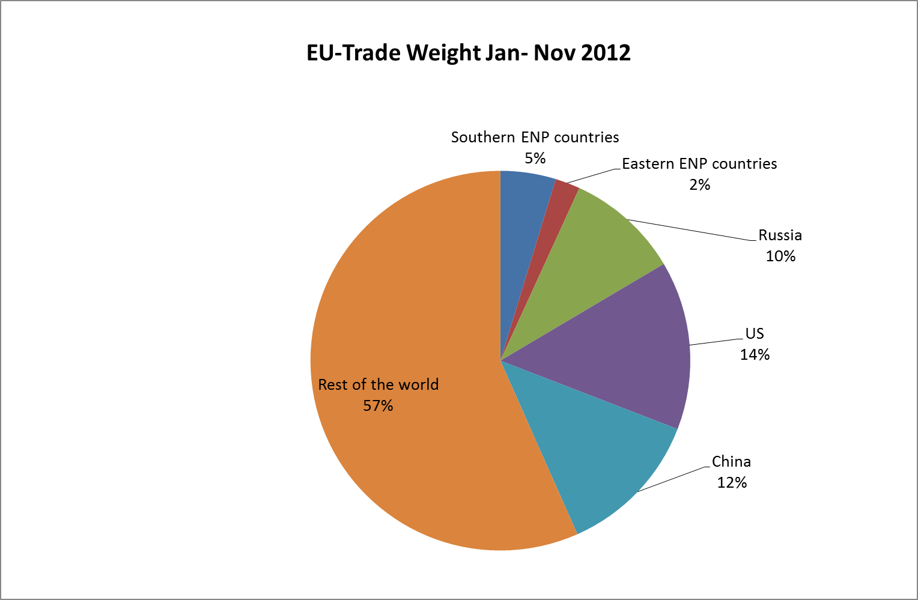

EU trade with the world (2012 Jan-Nov) | Note | Southern ENP countries | Eastern ENP countries | China | US | Russia | Rest of the world
Trade Weight (million EUR) (10) |  | 151,360 | 67,970 | 400,919 | 461,648 | 310,237 | 1,819,001
% of total EU trade |  | 4.7 | 2.1 | 12.5 | 14.4 | 9.7 | 56.6
Sources: Eurostat (COMEXT database)

(10)Trade weight is the sum of import and exports.
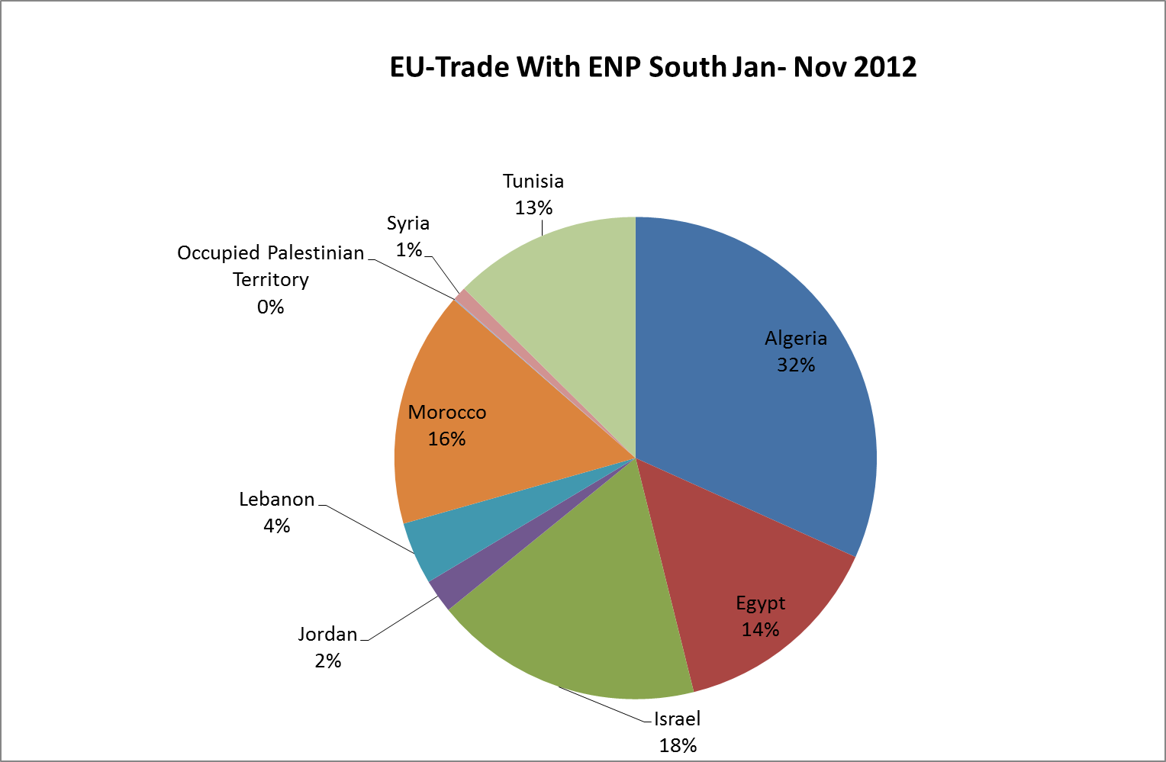

Southern ENP partners' trade with the EU (2012 Jan-Nov) | Note | Algeria | Egypt | Israel | Jordan | Lebanon | Morocco | Palestine | Syria | Tunisia
Trade Weight (million EUR) |  | 48025 | 21779 | 27291 | 3428 | 6353 | 23921 | 106 | 1398 | 19058
ENP-South trade with EU as % of total trade |  | 31.7 | 14.4 | 18.0 | 2.3 | 4.2 | 15.8 | 0.1 | 1.0 | 12.6
Sources: Eurostat (COMEXT database)

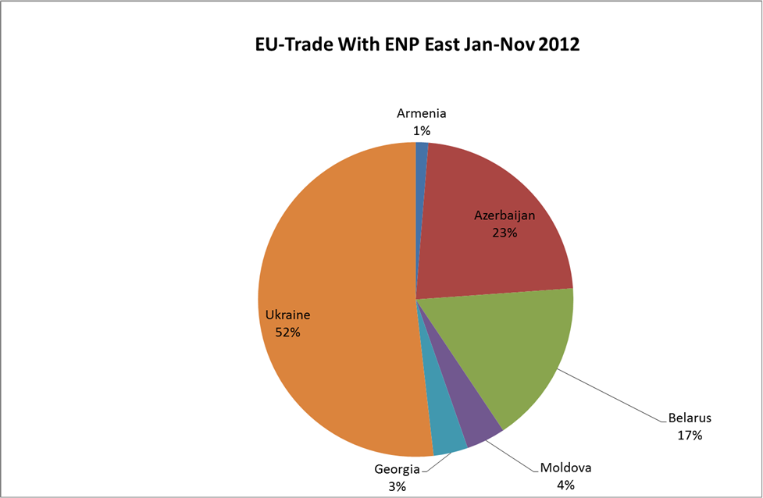

Eastern ENP partners' trade with the EU (Jan – Nov 2012) | Note | Armenia | Azerbaijan | Belarus | Georgia | Republic of Moldova | Ukraine
Trade Weight (million EUR) |  | 874 | 15348 | 11399 | 2406 | 2729 | 35214
ENP-East trade with EU as % of total trade |  | 1.3 | 22.6 | 16.8 | 3.5 | 4 | 51.8
Source: Eurostat (COMEXT database)

3. Schengen Visas issued by partner in 2012

 | Short -stay visas (C) issued | Of which multiple entry  Visas (MEV C)
Algeria | 280,416 | 96,131
Armenia | 35,780 | 6,276
Azerbaijan | 49,867 | 9,432
Belarus | 693,425 | 326,482
Egypt | 120,896 | 40,819
Georgia | 59,363 | 18,362
Israel | 11,335 | 2,252
Jordan | 34,616 | 9,440
Lebanon | 85,501 | 35,070
Libya | 45,022 | 23,465
Republic of Moldova | 48,615 | 12,984
Morocco | 322,094 | 133,837
Palestine | 2,516 | 423
Syria | 3,343 | 1,612
Tunisia | 110,085 | 41,180
Ukraine | 1,283,014 | 494,749

NB: Citizens of all the ENP partners (except Israel) are required to hold a visa to enter the Schengen area. The data for Israel may include visas issued to Palestinians, as most Schengen consulates dealing with Palestinian applications are located in Israel.
Source: European Commission

4. European Integration Index for Eastern Partnership Countries – Open Societies Foundations / Renaissance foundation

The Index measures the situation in EaP countries in May 2012. European integration is assessed through three dimensions:

1. Linkage: growing political, economic and social ties between each of the six EaP countries and the EU;
2. Approximation: structures and institutions in EaP countries converging towards EU standards and in line with EU requirements;
3. Management: evolving management structures for European integration in EaP countries.
Benchmarks were defined by assigning 1 and 0 to the best and worst possible performance.

 | Armenia | Azerbaijan | Belarus | Georgia | Moldova | Ukraine
Linkage | 0,41 | 0,36 | 0,31 | 0,51 | 0,69 | 0,64
Approximation | 0,59 | 0,44 | 0,31 | 0,6 | 0,65 | 0,57
Management | 0,31 | 0,31 | 0,22 | 0,51 | 0,53 | 0,45

Source: http://www.eap-index.eu/

Section IV: EU assistance to partners

1. Commitments amounts under ENPI (EUR Million)

 | 2007 | 2008 | 2009 | 2010 | 2011 | 2012 | Total 2007-2012 | Average 2007-2012
Algeria | 57 | 32.5 | 35.6 | 59 | 58 | 84 | 326.1 | 54.4
Armenia | 21 | 24 | 24.7 | 27.7 | 43.1 | 75 | 215.5 | 35.9
Azerbaijan | 19 | 22 | 20 | 7 | 31 | 19.5 | 118.5 | 19.8
Belarus | 6 | 5 | 10 | 10 | 17.07 | 22.3 | 70.37 | 11.7
Egypt | 137 | 149 | 140 | 192 | 92 | 250 | 960 | 160.0
Georgia | 24 | 90.3 | 70.9 | 37.2 | 50.7 | 82 | 355.1 | 59.2
Israel | 2 | 2 | 1.5 | 2 | 2 | 2 | 11.5 | 1.9
Jordan | 62 | 65 | 68 | 70 | 111 | 110 | 486 | 81.0
Lebanon | 50 | 50 | 43 | 44 | 33 | 92 | 312 | 52.0
Libya | 2 | 4 | 0 | 12 | 10 | 25 | 53 | 8.8
Republic of Moldova | 40 | 62.3 | 57 | 66 | 78.6 | 122 | 425.9 | 71.0
Morocco | 190 | 228.7 | 145 | 158.9 | 156.6 | 207 | 1086.2 | 181.0
Palestine | 452.7 | 387 | 352.6 | 377.9 | 413.7 | 224 | 2207.9 | 368.0
Russia | 13 | 5 | 18 | 26.5 | 4 | 0.0. | 66.5 | 11.1
Syria | 20 | 20 | 40 | 50 | 10 | 48.4 | 188.4 | 31.4
Tunisia | 103 | 73 | 77 | 77 | 130 | 130 | 590 | 98.3
Ukraine | 142 | 138.6 | 116 | 126 | 135 | 149 | 806.6 | 134.4
Total | 1340.7 | 1358.4 | 1219.3 | 1343.2 | 1375.77 | 1642.2 | 8279.57 | 1379.9
Regional
Regional/interregional cooperation East | 131.2 | 99.5 | 112.7 | 209.5 | 209.4 | 236.2 | 998.5 | 166.4
Regional/interregional cooperation South | 157.7 | 151.5 | 194.7 | 171.1 | 233.3 | 296.5 | 1204.8 | 200.8
Total | 288.9 | 251 | 307.4 | 380.6 | 442.7 | 532.7 | 2203.3 | 367.2
Cross Border Cooperation ENPI (*) | 4.2 | 60 | 69.2 | 68.4 | 83.5 | 95.2 | 380.5 | 63.4
Grand Total | 1633.8 | 1669.4 | 1595.9 | 1792.2 | 1901.97 | 2270.1 | 10863.37 | 1810.6

(*) including special measure in support to Civil Society
Source: European Commission

2. ENPI-Cross Border Cooperation - Allocations 2007 – 2013
The ENPI-CBC programmes have the following four key objectives:
- promoting economic and social development in regions on both sides of common borders;
- working together to address common challenges, in fields such as the environment, public health and the prevention of and the fight against organised crime;
- ensuring efficient and secure borders;
- promoting local cross border “people-to-people” actions.

Under the ENPI CBC Indicative Programme 2007-2010, €583.28 million was programmed, of which €274.92 from ENPI and €308.36 million from the ERDF. Following a mid-term review and adoption of the Indicative Programme for the period 2011-2013, a further €537.74 million was programmed, of which €260.04 million from ENPI and €277.706 million from the ERDF.
 | Budget (for period 2007-2013)  EUR million | Disbursed to date (up to end 2012)  EUR million
Land Border Programmes
Kolarctic/Russia (Finland, Sweden, Russia, Norway) | 28.2 | 11.8
Karelia/Russia (Finland, Russia) | 23.2 | 14.7
SE Finland/Russia (Finland, Russia) | 36.1 | 18.7
Estonia/Latvia/Russia | 47.7 | 24
Latvia/Lithuania/Belarus | 41.7 | 17.7
Lithuania/ Poland /Russia | 132.1 | 46.2
Poland/Belarus/Ukraine | 186.2 | 85.1
Hungary/Slovakia/Ukraine/Romania | 68.6 | 30
Romania/Moldova/Ukraine | 126.7 | 61
Sea-Crossing Programmes
Italy/Tunisia | 25.2 | 10.4
Sea-Basin Programmes
Black Sea (Romania, Bulgaria, Greece; Turkey, Ukraine, Rep. of Moldova, Georgia, Armenia) | 25.6 | 12.6
Baltic Sea Region (Belarus, Denmark, Estonia, Finland, Germany, Latvia, Lithuania, Norway, Poland, Sweden) | 8.8* | 8.8
Mediterranean (Cyprus Egypt, France, Greece, Israel, Italy, Jordan, Lebanon, Malta, Palestinian Authority, Portugal, Spain, Syria, Tunisia | 200 | 92.1
TOTAL | 950.1 | 433.1
* This is the amount after the de-commitment following Russia's non-signature of the Financing Agreement.
**Included payment of EUR 3.6 million currently still in workflow.
Source: European Commission

3. Fiches covering EU assistance for each partner (2007-2013)

Algeria
(all amounts in EUR million unless otherwise stated)
1) ENPI allocations
Under the National Indicative Programme 2007-2010 for Algeria, EUR 220 million was programmed for the following priorities of which EUR 184.1 million was committed.
Priority | Planned | Realised
Reform of Justice | 7.7% | 9.2%
Economic growth and employment | 51.4% | 54.6%
Reinforcement of basic public services | 40.9% | 36.2%
(EUR Million)
Algeria | 2007 |  | 2008 |  | 2009 |  | 2010
Programmed | 57 |  | 55 |  | 54 |  | 54
Committed | 57 |  | 32.5 |  | 35.6 |  | 59
Disbursed | 51.3 |  | 46.1 |  | 47.9 |  | 28.1
Algeria |  | 2011 |  | 2012 |  | 2013
Programmed |  | 54 |  | 58 |  | 60
Committed |  | 58 |  | 84
Disbursed |  | 42.9 |  | 30.3
Under the National Indicative Programme 2011-2013 for Algeria, EUR172 million has been programmed for the following priorities.
Sustainable development and culture | +/-43%
Economic growth and development | +/-57%
Additional €20 million (of which €10 million conditional on further progress) was allocated to Algeria from the SPRING programme:
Sustainable development and culture | 50%
Economic growth and development | 50%

2) Support to civil society / Support under thematic instruments: (EUR)

 | 2011 | 2012 | Forecast 2013
Civil Society Facility | €400,000 | €600,000 | €400,000
Instrument for Nuclear Safety Cooperation | n/a | n/a | n/a
European Instrument for Democracy and Human Rights | €600,000 | €900,000 | €700,000
Neighbourhood Investment Facility | n/a | n/a | n/a
Non-state Actors and Local Authorities (NSA/LA) | €400,000 | €500,000 | €400,000
Migration and asylum | n/a | €1,875,000 | n/a

Armenia
(all amounts in EUR million unless otherwise stated)
1) ENPI allocations
Under the National Indicative Programme 2007-2010 for Armenia, EUR 98.4 million was programmed for the following priorities, of which EUR 97.4 million was committed.
Priority | Planned | Realised
Support for strengthening of democratic structures and good governance | 30% | 30%
Support for regulatory reform and administrative capacity building | 30% | 34%
Support for poverty reduction efforts | 40% | 36%

Armenia | 2007 | 2008 | 2009 | 2010
Programmed | 21 | 24 | 24.7 | 28.7
Committed | 21 | 24 | 24.7 | 27.7
Disbursed | 10.9 | 7 | 17.5 | 15.8
Under the National Indicative Programme 2011-2013 for Armenia, EUR157 million has been programmed for the following priorities.
Support for democratic structures and good governance | 30-35%
Support for trade and investment, regulatory alignment and reform | 20-25%
Support for socio economic reform and sustainable development | 40-45%

Armenia | 2011 | 2012 | 2013
Programmed | 43.1 | 60 | 54
Committed | 43.1 | 75
Disbursed | 27.7 | 25.5
2) Commitment allocations under other instruments (EUR Million)
 | 2011 | 2012 | 2013 (planned)
Instrument for Nuclear Safety Cooperation | 1.8 | 1 | 1
European Instrument for Democracy and Human Rights | 0.9 | 0.9 | 0.9
Thematic Programme Non State Actors and Local Authorities - Development Co-operation Instrument | 0.65 | 0.6 | 0.7

3) Neighbourhood Investment Facility and EIB lending in 2012
a. Neighbourhood Investment Facility (EUR Million)
Project title | EU Finance institution | Sector | NIF contrib. | Total project cost
Yerevan Metro Project - Phase II | EBRD,  EIB | Transport | 5 | 17.14
Modernization of Bagratashen, Bavra and Gogavan Border Crossing Points (MBBG) | EIB,  EBRD | Transport | 12 | 60.6

b. EIB lending (EUR Million)
Project title | EU Finance institution | Sector | NIF contrib. | Total project cost
Modernisation of Bagratashen, Bavra and Gogavan Border Crossing Points | EIB | Transport | 12 | 30.3
Armenian Small Municipalities Water Project | EIB | Water, sewerage, solid waste | 7.6 | 6.5

4) Macro Financial assistance operations active in 2012
In February 2012 the disbursement of the loan part second tranche of the 2009-2012 MFA programme was made – EUR 39 million. Other disbursements within the programme were made in the course of 2011, first tranche in July – EUR 40 million (EUR 14 million grant, EUR 26 million loan) and second tranche grant part – EUR 21 million in December 2011.

Azerbaijan
(all amounts in EUR million unless otherwise stated)
1) ENPI allocations
Under the National Indicative Programme 2007-2010 for Azerbaijan, EUR 92 million was programmed for the following priorities, of which EUR 68 million was committed.
Priority | Planned | Realised
Support for democratic development and good governance: | 33% | 43%
Support for socio-economic reform, fight against poverty and administrative capacity building: | 34% | 29%
Support for legislative and economic reforms in the transport, energy and environment sectors: | 33% | 28%
(EUR Million)
Azerbaijan | 2007 | 2008 | 2009 | 2010
Programmed | 19 | 22 | 24 | 27
Committed | 19 | 22 | 20 | 7
Disbursed | 3.7 | 6.5 | 5.1 | 11.3
Under the National Indicative Programme 2011-2013 for Azerbaijan, EUR 122.5 million has been programmed for the following priorities.
Support for democratic structures and good governance: | 25-30%
Support for socio-economic reform and sustainable development, trade and investment, regulatory approximation and reform: | 35-40%
Support for implementation of the Partnership and Cooperation Agreement and European Neighbourhood Policy Action plan, including energy security, mobility and security: | 30-35%

The envelope for 2011-2013 was subsequently reduced to about €75 million.
(EUR Million)
Azerbaijan | 2011 | 2012 | 2012
Programmed | 28 | 42 | 25
Committed | 31 | 19.5
Disbursed | 15.2 | 18.7

2) Commitment allocations under other instruments
(EUR Million)
 | 2011 | 2012 | 2013
Instrument for Nuclear Safety Cooperation | n/a | n/a | n/a
European Instrument for Democracy and Human Rights | n/a | 0.9 | 0.9
Thematic Programme Non State Actors and Local Authorities - Development Co-operation Instrument | n/a | 0.7 | 1

3) Neighbourhood Investment Facility in 2012
(EUR Million)
Project title | EU Finance institution | Sector | NIF contrib. | Total project cost
Regional Road Reconstruction Project | EBRD | Transport | 3.4 | 892.1

Belarus
(all amounts in EUR million unless otherwise stated)
1) ENPI allocations
Under the National Indicative Programme 2007-2011 for Belarus, EUR 46.07 million was programmed for the following priorities, of which EUR 43.07 was committed.
Priority | Planned | Realised
Support for Social and economic development | 70% | 78%
Democratic development and good governance | 30% | 22%
(EUR Million)
Belarus | 2007 | 2008 | 2009 | 2010 | 2011
Programmed | 5 | 5 | 10 | 10 | 16.07
Committed | 5 | 5 | 10 | 10 | 13.07
Disbursed | 0.6 | 3 | 2.7 | 5.1 | 1.1
In 2011 a EUR 4 million special measure to support a university scholarship scheme was also committed.
Under the National Indicative Programme 2012-2013 for Belarus, EUR 56.69 million has been programmed. Of this, EUR 41.5 million has been earmarked for the following priorities:
Good governance and people-to-people contacts: | 50%
Economic modernisation: | 50%
The remaining €15.19 million has been set aside for the Comprehensive Institution Building Programme and the Pilot Regional Development Programmes under the Eastern partnership. Those funds will not be activated.
(EUR Million)
Belarus | 2012 | 2013
Programmed | 17 | 11.5
Committed | 17
Disbursed | 9.3
2) Commitment allocations under other instruments
(EUR Million)
 | 2011 | 2012 | 2013 (planned)
Instrument for Nuclear Safety Cooperation | n/a | n/a | 4.5
European Instrument for Democracy and Human Rights | 0.5 | 0.5 | 10.56
Thematic Programme Non State Actors and Local Authorities - Development Co-operation Instrument | 2.4 | 0.7 | 1.4

Egypt
1) ENPI allocations
Under the National Indicative Programme 2007-2010 for Egypt, EUR 58 million was programmed but EUR 618 million was committed for the following priorities.
Priority | Planned | Realised
Support for reform in democracy, human rights and justice | 7% | 6.3%
Developing competitiveness and productivity of the Egyptian economy | 40% | 44.8%
Ensuring sustainability of the development process with better management of human and natural resources | 53% | 48.9%
(EUR Million)
Egypt | 2007 | 2008 | 2009 | 2010
Programmed | 137 | 139 | 140 | 142
Committed | 137 | 149 | 140 | 192
Disbursed* | 170.3 | 148.1 | 151 | 106.2
*including country specific interregional NIF payments
(EUR Million)
Egypt | 2011 | 2012 | 2013
Programmed | 144 | 150 | 155.3
Committed | 92 | 250
Disbursed* | 39.1 | 93.2
*including country specific interregional NIF payments

Under the National Indicative Programme 2011-2013 for Egypt, EUR 449.3 million has been programmed for the following priorities.
Support for reform in democracy, human rights and justice | 11.1%
Competitiveness and productivity of the Egyptian economy | 42.2%
Support for socio economic reform and sustainable development | 46.7%

Additional €90 million was allocated to Egypt from the SPRING programme to support economic recovery.
2) Support to civil society / Support under thematic instruments:
(EUR)
 | 2011 | 2012 | Forecast 2013
Civil Society Facility | 600,000 | 900,000 | 1,200,000
Instrument for Nuclear Safety Cooperation | n/a | n/a | n/a
European Instrument for Democracy and Human Rights | 2,000,000 | 1,780,000 | €1,000,000
Neighbourhood Investment Facility | 23,500,000 | 53,000,000 | n/a
Non-state Actors and Local Authorities (NSA/LA) | 1,000,000 | 760,000 | 1,000,000
Instrument for Stability (IfS) | 4,000,000 | 260,000 | n/a
Migration and asylum |  | 2,000,000

Georgia
(all amounts in EUR million unless otherwise stated)
1) ENPI allocations
Under the National Indicative Programme 2007-2010 for Georgia, EUR 120.4 million was programmed for the following priorities, of which EUR 117.4 million was committed.
Priority | Planned | Realised
Support for democratic development, rule of law and governance: | 26% | 37%
Support for economic development and ENP AP implementation: | 26% | 26%
Poverty reduction and social reforms: | 32% | 29%
Support for peaceful settlement of Georgia's internal conflicts: | 16% | 8%
(EUR Million)
Georgia | 2007 | 2008 | 2009 | 2010
Programmed | 24 | 28.8 | 30.4 | 37.2
Committed* | 24 | 28.8 | 27.4 | 37.2
Disbursed** | 14.7 | 32.7 | 69 | 41.7
* In addition, the following commitments for special measures were made in 2008, "Support to IDP Action Plan – parts 1 and 2" (EUR 61.5 million), and in 2009, "Support to IDP Action Plan – part 3" (EUR 43.5 million).
** Including disbursements on the afore-mentioned special measures.
Under the National Indicative Programme 2011-2013 for Georgia, EUR 180.29 million has been programmed for the following priorities.
Support for democratic development, rule of law, good governance | 25-30%
Support for trade and investment, regulatory alignment and reform | 15-20%
Support for regional development, sustainable economic and social development, poverty reduction | 35-40%
Support for peaceful settlement of conflicts | 5-10%

(EUR Million)
Georgia | 2011 | 2012 | 2013
Programmed | 50.73 | 61.8 | 67.7
Committed | 50.73 | 82.0
Disbursed | 66.3 | 61.2

2) Commitment allocations under other instruments
(EUR Million)
 | 2011 | 2012 | 2013
Instrument for Nuclear Safety Cooperation | n/a | n/a | n/a
European Instrument for Democracy and Human Rights | 1.2 | 1.2 | 1.0
Thematic Programmes (Non State Actors and Local Authorities - Development Co-operation Instrument) | 0.4 | 0.55 | 0.55
3) Neighbourhood Investment Facility and EIB lending in 2012
a. Neighbourhood Investment Facility
(EUR Million)

Project title | EU Finance institution | Sector | NIF contrib. | Total project cost
Water supply and sewerage of Batumi and surrounding villages (Phase III) | KfW | Environment | 4.5 | 58,1
Water Infrastructure Modernisation II | EIB,  ADB | Environment | 8 | 80

b. EIB lending
(EUR Million)
Project title | EU Finance institution | Sector | NIF contrib. | EIB contrib. | Total project cost
Georgia East-West Highway | EIB | Transport | 20 | 170 | 592.14
TBC Bank SME & Energy Env Loan | EIB | Credit lines | - | 50 | 50
PCH loan for SME and priority projects | EIB | Credit lines | - | 10 | 10
.

Israel
I) ENPI allocations
Under the National Indicative Programme 2007-2010 for Israel, EUR 8 million was programmed for the following priorities of which EUR 7.5 million was committed.
Priority | Planned | Realised
Support for implementation of the joint priorities in the EU-Israel Action Plan | 100% | 100%
(EUR Million)
Israel | 2007 | 2008 | 2009 | 2010
Programmed | 2.0 | 2.0 | 2.0 | 2.0
Committed | 2.0 | 2.0 | 1.5 | 2.0
Disbursed | 2.8 | 2.7 | 2.5 | 3.5
(EUR Million)
Israel | 2011 | 2012 | 2013
Programmed | 2.0 | 2.0 | 2.0
Committed | 2.0 | 2.0
Disbursed | 4.5 | 3.5
Under the National Indicative Programme 2011-2013 for Israel, EUR 6 million has been programmed for the following priorities.
Support for implementation of the joint priorities in the EU-Israel Action Plan: 100%
2) Support to civil society / Support under thematic instruments:
(EUR)
 | 2011 | 2012 | Forecast 2013
Civil Society Facility | 500,000 | 500,000 | 500,000
Instrument for Nuclear Safety Cooperation | n/a | n/a | n/a
European Instrument for Democracy and Human Rights | 1,200,000 | 1,200,000 | 1,200,000
Neighbourhood Investment Facility | n/a | n/a | n/a
Non-state Actors and Local Authorities (NSA/LA) | n/a | 300,000 | n/a
Investing In People / Gender | 248,000 | n/a | n/a

Jordan
1) ENPI allocations
Under the National Indicative Programme 2007-2010 for Jordan, EUR 265 million was programmed for the following priorities.
Priority | Planned | Realised
Political reform, human rights, justice and cooperation on security and fight against extremism | 6.5% | 6.4%
Trade and investment development | 29.5% | 23.8%
Sustainability of the growth process | 24.0% | 20.8%
Institution building, finance and public administration reform | 40.0% | 49.1%
(EUR Million)
Jordan | 2007 | 2008 | 2009 | 2010
Programmed | 62.0 | 65.0 | 68.0 | 70.0
Committed | 62.0 | 65.0 | 68.0 | 70.0
Disbursed | 46.1 | 63.6 | 49.0 | 92.0
(EUR Million)
Jordan | 2011 | 2012 | 2013
Programmed | 71 | 75 | 77
Committed* | 116 | 110
Disbursed | 76.3 | 91.6
*not including measures to support Syrian refugees in Jordan (€20.848M) committed in 2012, as those are included in the fiche for Syria.
Under the National Indicative Programme 2011-2013 for Jordan, EUR 223 million has been programmed for the following priorities.
Supporting Jordan's reform in democracy, human rights, media, justice | 20.2%
Trade enterprise and investment development | 17.9%
Sustainability of the growth process | 41.7%
Support in the implementation of the Action Plan | 20.2%

Additional €70 million was allocated to Jordan from the SPRING programme:
Education reform | 14.3%
Support to electoral system | 10.0%
Justice preparatory project | 4.3%
Support to enterprise and export development | 14.3%
Good governance and development contract | 57.1%

2) Support to civil society / Support under thematic instruments:
(EUR)
 | 2011 | 2012 | Forecast 2013
Civil Society Facility | 300,000 | n/a | 500,000
Instrument for Nuclear Safety Cooperation | n/a | n/a | n/a
European Instrument for Democracy and Human Rights | 900,000 | 900,000 | 900,000
Neighbourhood Investment Facility | n/a | n/a | n/a
Non-state Actors and Local Authorities (NSA/LA) | 200,000 | 450,000 | n/a

Lebanon
1) ENPI allocations
Under the National Indicative Programme 2007-2010 for Lebanon, EUR 187 million was programmed for the following priorities.
Priority | Planned | Realised
Support to political reform | 11.76% | 11.76%
Support to social and economic reform | 45.99% | 45.99%
Support to reconstruction and recovery | 42.25% | 42.25%
(EUR Million)
Lebanon | 2007 | 2008 | 2009 | 2010
Programmed | 50 | 50 | 43 | 44
Committed | 50 | 50 | 43 | 44
Disbursed | 32.6 | 43.5 | 24.6 | 26.1
(EUR Million)
Lebanon | 2011 | 2012 | 2013
Programmed | 45 | 50 | 55
Committed* | 33 | 92
Disbursed | 14.1 | 29.3
*not including measures to support Syrian refugees in Lebanon (€15M) committed in 2012, as those are included in the fiche for Syria.
Under the National Indicative Programme 2011-2013, EUR 150 million has been programmed for the following priorities.
Support to political reform | 16.7%
Support to socio-economic reforms | 60.7%
Recovery and re-invigoration of the economy | 22.6%

Additional €30 million was allocated to Lebanon from the SPRING programme:

Reinforcing Human Rights and Democracy | 33.4%
Security and Rule of Law | 13.3%
Support to Reform of the Judiciary | 13.3%
Support to Electoral Reform | 20.0%
Infrastructure for Palestine Refugees | 20.0%

2) Support to civil society / Support under thematic instruments:
(EUR)
 | 2011 | 2012 | Forecast 2013
Civil Society Facility | n/a | 500,000 | 500,000
Instrument for Nuclear Safety Cooperation | n/a | n/a | n/a
European Instrument for Democracy and Human Rights | 600,000 | 600,000 | 600,000
Neighbourhood Investment Facility | n/a | n/a | n/a
Non-state Actors and Local Authorities (NSA/LA) | 350,000 | 350,000 | 300,000
Libya
1) ENPI allocations
There was no NIP for the period 2007-2010 in Libya. A total of EUR 8 million under ENPI was earmarked for the Benghazi Action Plan (BAP) on HIV/AIDS and funds were committed as special measures. An additional EUR 10 million was committed in 2010 as a special measure in the field of migration.
Special measure | Planned | Realised
BAP : HIV/Aids | n/a | 44.4%
Migration | n/a | 55.6%
(EUR Million)
Libya | 2007 | 2008 | 2009 | 2010
Programmed: BAP | 2.0 | 2.0 | 2.0 | 2.0
Programmed: Migration |  |  |  | 10.0
Committed: overall | 2.0 | 4.0 | 0.0 | 12.0
Disbursed : overall | 0.0 | 1.2 | 1.3 | 0.6
(EUR Million)
Libya | 2011 | 2012 | 2013
Programmed | 10 | 25 | 25
Committed | 10 | 25
Disbursed | 8 | 2.9

The NIP 2011-2013 with an overall budget of €60 million was signed with the Libyan government in June 2010 including two focal areas: (i) Improving the quality of human capital; (ii) Sustainability of economic and social development. A revised version of the NIP 2011-2013 was signed on 30 August 2012. The country allocations were reoriented towards the most urgent needs caused by the armed conflict and the subsequent transitional period in the following areas.

Good governance (security, migration, protection) and civil society support | 46.8%
Education and TVET | 14.8%
Public administration capacity building | 7.5%
Socio-economic development (health reform, support to SME) | 30.9%

2) Support to civil society / Support under thematic instruments:
(EUR)
 | 2011 | 2012 | Forecast 2013
Civil Society Facility | n/a | €600,000 | €600,000
Instrument for Nuclear Safety Cooperation | n/a | n/a | n/a
Instrument for Stability (IfS) | €3,700,000 | €13,400,000 | n/a
Humanitarian Aid | €80,500,000 | n/a | n/a
European Instrument for Democracy and Human Rights | €3,500,000 | €1,000,000 | €1,000,000
Neighbourhood Investment Facility | n/a | n/a | n/a
Migration and asylum | €1,630,000 | €1,152,000 | n/a
Non-state Actors and Local Authorities (NSA/LA) | €3,000,000 | €2,000,000 | €2,000,000

Republic of Moldova
(all amounts in EUR million unless otherwise stated)
1) ENPI allocations
Under the National Indicative Programme 2007-2010 for Moldova, EUR 209.7 million was programmed for the following priorities. Together with EUR 16.6 million allocated from the Governance Facility, a total of EUR 225.3 million was committed.
Priority | Planned | Realised
Support for democratic development / good governance | 25-30% | 25%
Support for regulatory reform and administrative capacity building | 15-20% | 19%
Support for poverty reduction and economic growth | 40-60% | 56%

Moldova | 2007 | 2008 | 2009 | 2010
Programmed | 40.0 | 45.7 | 57.0 | 67.0
Committed* | 40.0 | 62.3 | 57.0 | 66.0
Disbursed | 8.0 | 23.7 | 66.1 | 56.6
* The figure for 2008 includes EUR 16.6 million committed from the Governance Facility.
Under the National Indicative Programme 2011-2013 for Moldova, EUR 273.14 million has been programmed for the following priorities.
Support for good governance, rule of law and fundamental freedoms | 35-40%
Support for social and human development | 25-30%
Support for trade and sustainable development | 35-40%

Moldova | 2011 | 2012 | 2013
Programmed | 78.6 | 94 | 100.5
Committed | 78.6 | 122
Disbursed | 79.3 | 53.1
2) Commitment allocations under other instrument
(EUR Million)
 | 2011 | 2012 | 2013 (planned)
Instrument for Nuclear Safety Cooperation | n/a | n/a | n/a
European Instrument for Democracy and Human Rights | 1.2 | 1.0 | 1.0
Thematic Programmes (Non State Actors and Local Authorities - Development Co-operation Instrument) | 0.45 | 0.45 | 0.45
3) Neighbourhood Investment Facility and EIB lending in 2012
a. Neighbourhood Investment Facility
(EUR Million)
Project title | EU Finance institution | Sector | NIF contrib. | Total project cost
Moldelectrica Power Transmission Network Rehabilitation | EBRD, EIB | Energy | 8 | 36.6
Balti Trolleybus Project | EBRD | Transport | 1.8 | 5
b. EIB lending
(EUR Million)
Project title | EU Finance institution | Sector | NIF contrib. | EIB contrib. | Total project cost
Chisinau Urban Roads | EIB, EBRD | Transport | - | 10.3 | 32.7
Moldelectrica Power Transmission Network | EIB, EBRD | Energy | 8 | 14.3 | 36.6

4) Macro Financial assistance operations active in 2011
The Grant Agreement between the European Commission representing the European
Union and the Republic of Moldova for an amount of EUR 90 million was signed on
17 December 2010. The first instalment of the macro-financial assistance amounting to EUR 40 million, in the form of a grant, was released in December 2010. The second instalment of the macro-financial assistance amounting to EUR 20 million, in the form of a grant, was released in September 2011.The final tranche of EUR 30 million was disbursed in March 2012.

Morocco
1) ENPI allocations
Under the National Indicative Programme 2007-2010 for Morocco, EUR 654 million was programmed for the following priorities.
Priority | Planned | Realised
Social Sector | 45.3% | 45.3%
Governance, human rights | 4.3% | 1.2%
Institutional Support | 6.1% | 9.9%
Economic sector | 36.7% | 35.9%
Environmental sector | 7.7% | 7.7%
(EUR Million)
Morocco | 2007 | 2008 | 2009 | 2010
Programmed | 162.0 | 163.0 | 164.0 | 165.0
Committed | 190.0 | 228.7 | 145.0 | 158.9
Disbursed* | 227.5 | 224.9 | 200.7 | 170.1
* included country specific interregional NIF payments
(EUR Million)
Morocco | 2011 | 2012 | 2013
Programmed | 178.5 | 193.5 | 208.5
Committed | 166.6 | 207
Disbursed* | 151.5 | 110.1
* included country specific interregional NIF payments
Under the National Indicative Programme 2011-2013 for Morocco, an amount EUR 580.5 million is now forecast for the following priorities.
Social Sector | 19-21%
Economic Sector | 9-11%
Institutional Support sector | 39-41%
Governance human rights sector | 14-16%
Environmental Sector | 14-16%

Additional €80 million was allocated to Morocco from the SPRING programme:
Support to National Council and Inter-Ministerial Delegation of Human Rights | 3.7%
Vocational training, employment and growth | 37.5%
Agricultural Strategy Council | 12.5%
Top up literacy programme | 31.3%
Top up of Support to Health sector reform programme | 15.0%

2) Support to civil society / Support under thematic instruments:
(EUR)
 | 2011 | 2012 | Forecast 2013
Civil Society Facility | 1,400,000 | 200,000 | 200,000
Instrument for Nuclear Safety Cooperation | n/a | n/a | n/a
European Instrument for Democracy and Human Rights | 1,200,000 | 1,000,000 | 1,000,000
Neighbourhood Investment Facility | 37,000,000 | n/a | n/a
Migration and asylum | 873,300 | 1,594,264 | n/a
Non-state Actors and Local Authorities (NSA/LA) | 750,000 | 750,000 | n/a

Palestine
1) Financial allocations (BL 19.080.102)
There is no NIP for Palestine and each year ad hoc measures are adopted to respond to its needs.
Under the period 2007-2010, EUR 1.57 billion was committed for the following priorities.
Priority | Planned | Realised
Direct & Indirect Financial Support for PA | n/a | 61.0%
Institution-building | n/a | 3.5%
Infrastructure Development | n/a | 4.5%
Private Sector Development | n/a | 2.0%
Support to UNRWA | n/a | 29.0%
(EUR Million)
Palestine | 2007 | 2008 | 2009 | 2010
Programmed | 158 | 158 | 158 | 158
Committed | 452.7 | 387.0 | 352.6 | 377.9
Disbursed | 381.4 | 425.9 | 327.8 | 325.5
(EUR Million)
Palestine | 2011 | 2012 | 2013
Programmed | 158 | 168 | 178
Committed | 413.7 | 224
Disbursed | 322.3 | 267.7
*Additional EUR 100 million have been committed on 2011 credits.

Under the period 2011-2013, €937.7 million is being committed for the following priorities.

Direct Financial Support to PA | 50-55%
Support to UNRWA | 26-27%
Institution Building | 21-22%
Support for East Jerusalem | 2-3%

2) Support to civil society / Support under thematic instruments:
(EUR)
 | 2011 | 2012 | Forecast 2013
Civil Society Facility | 400,000 | 500,000 | 900,000
Instrument for Nuclear Safety Cooperation | n/a | n/a | n/a
European Instrument for Democracy and Human Rights | 1,500,000 | 1,500,000 | 1,500,000
Neighbourhood Investment Facility | n/a | n/a | n/a
Non-state Actors and Local Authorities (NSA/LA) | 2,400,000 | 2,400,000 | 2,400,000
Middle East Peace Process (MEPP) (regional South programme) | 5,000,000 | 5,000,000 | 5,000,000
Syria
1) ENPI allocations
Under the National Indicative Programme 2007-2010 for Syria, EUR 130 million was programmed for the following priorities.
Priority | Planned | Realised
Support to political reform and administrative reform | 23% | 23%
Support for economic reform | 46% | 38.5%
Support for social reform | 23% | 30.8%
Environment/sustainable energy | 8% | 7.7%
(EUR Million)
Syria | 2007 | 2008 | 2009 | 2010
Programmed | 20.0 | 20.0 | 40.0 | 50.0
Committed | 20.0 | 20.0 | 40.0 | 50.0
Disbursed | 34.1 | 26.5 | 31.2 | 18.4
(EUR Million)
Syria | 2011 | 2012 | 2013
Programmed | 41.67 | 42.67 | 44.67
Committed* | 10 | 48.4
Disbursed | 18.8 | 1.8
*including measures to support Syrian refugees in Jordan (€20.848M) and Lebanon (€15M) committed in 2012.
Under the National Indicative Programme 2011-2013 for Syria, EUR 129 million has been programmed for the following priorities.
Support for political and administrative reform | 19%
Support for economic reform | 44%
Support for social reforms | 37%

However, due to the ongoing repression in Syria, the bilateral cooperation under ENPI and NIP 2011-2013 were suspended on 25th May 2011. A special measure for 2011 (€10 million) was adopted to support two UNRWA projects targeting both Palestinian refugees and the Syrian population. Two special measures were adopted in 2012 (€48.4 million in total) to support the population in Syria as well as Syrian refugees in Jordan and Lebanon.
2) Support to civil society / Support under thematic instruments:
(EUR)
 | 2011 | 2012 | Forecast 2013
Civil Society Facility | n/a | n/a | n/a
Instrument for Nuclear Safety Cooperation | n/a | n/a | n/a
European Instrument for Democracy and Human Rights | n/a | €2,000,000 | €1,000,000
Neighbourhood Investment Facility | n/a | n/a | n/a
Investing In People / Gender | €408.000 | n/a | n/a
Non-state Actors and Local Authorities (NSA/LA) | €250,000 | €250,000 | €250,000
Tunisia
1) ENPI allocations
Under the National Indicative Programme 2007-2011 for Tunisia, EUR 300 million was programmed for the following priorities.
Priority | Planned | Realised
Economic governance, competitiveness and convergence with the EU | 60.0% | 41.0%
Improvement of graduate employability, support to the employment system, support to less favoured areas | 21.7% | 21.7%
Sustainable development | 18.3% | 37.3%
(EUR Million)
Tunisia | 2007 | 2008 | 2009 | 2010
Programmed | 73.0 | 73.0 | 77.0 | 77.0
Committed | 103.0 | 73.0 | 77.0 | 77.0
Disbursed | 97.9 | 56.0 | 74.4 | 68.5
(EUR Million)
Tunisia | 2011 | 2012 | 2013
Programmed | 80 | 80 | 80
Committed | 180 | 130
Disbursed | 114.3 | 145.2
Under the National Indicative Programme 2011-2013 for Tunisia EUR 390 million has been programmed for the following priorities.
Social sector (employment) | 50.0%
Economic (governance, competitiveness) | 41.7%
Governance in the justice sector | 8.3%

In the immediate aftermath of the revolution, the NIP 2011-2013 was reviewed. Additional amount of €150 million was allocated to Tunisia (including €100 million from the SPRING programme):

Top up to economic recovery programme (€40 million) | 20.0%
Special measure for less favoured areas | 13.3%
Top up to economic recovery programme under SPRING (€10 million) | 6.7%
Programme d'appui à l'accord d'association et à la transition I (P3AT) under SPRING | 6.7%
Programme d'appui à l'accord d'association et à la transition II (P3AT II) under SPRING | 10.0%
Support to the reform of the justice sector under SPRING | 16.6%
Civil society programme under SPRING | 4.7%
Renovation of popular neighbourhoods under SPRING | 22.0%

2) Support to civil society / Support under thematic instruments:
(EUR)
 | 2011 | 2012 | Forecast 2013
Civil Society Facility | €1,400,000 | €1,000,000 | n/a
Instrument for Nuclear Safety Cooperation | n/a | n/a | n/a
European Instrument for Democracy and Human Rights | €5,200,000 | €1,000,000 | €1,000,000
Neighbourhood Investment Facility | €800,000 | n/a | n/a
Non-state Actors and Local Authorities (NSA/LA) | €1,200,000 | €300,000 | n/a
Instrument for Stability | €2,000,000 | €305,000 | n/a
Migration and Asylum |  | €1,445,293

Ukraine
(all amounts in EUR million unless otherwise stated)
1) ENPI allocations
Under the National Indicative Programme 2007-2010 for Ukraine, EUR 94 million was initially programmed for the following priorities, whereas EUR 522 million was committed.
Priority | Planned | Realised
Support for democratic development / good governance | 30% | 7%
Support for regulatory reform and administrative capacity building | 30% | 42%
Support for infrastructure development | 40% | 51%
(EUR Million)
Ukraine | 2007 | 2008 | 2009 | 2010
Programmed | 120.0 | 122.0 | 124.0 | 128.0
Committed | 142.0 | 138.0 | 116.0 | 126.0
Disbursed | 52.1 | 123.3 | 100.9 | 121.3
Under the National Indicative Programme 2011-2013 for Ukraine, EUR 470 million has been programmed for the following priorities.
Support for good governance and the rule of law: | 20-30%
Support for facilitation of the entry into force of the EU-Ukraine Association Agreement (including a DCFTA): | 25-35%
Support for sustainable development: | 45-55%
(EUR Million)
Ukraine | 2011 | 2012 | 2013
Programmed | 135.0 | 152.5 | 180.2
Committed | 135.0 | 149
Disbursed | 103.7 | 79.9

2) Commitment allocations under other instruments
(EUR Million)
 | 2011 | 2012 | 2013 (planned)
Instrument for Nuclear Safety Cooperation | 50.55 | 49.8 | 37.4
European Instrument for Democracy and Human Rights | 1.2 | 1.2 | 1.2
Thematic Programme -Non State Actors and Local Authorities - Development Co-operation Instrument | 0.95 | 0.95 | 0.95

3) Neighbourhood Investment Facility and EIB lending in 2012
a. Neighbourhood Investment Facility
No new operations for Ukraine were approved for financing by NIF in 2012.
b. EIB lending
(EUR Million)
Project title | EU Finance institution | Sector | EIB contrib. | Total project cost
Hydro Power Plants Rehabilitation | EIB | Energy | 3.6 | 200
Unicredit Loan SME & Priority Projects | EIB | Credit lines | - | 140
Prominvestbank Loan SMEs & Mid-Caps | EIB | Credit lines | - | 200
Ukreximbank SME & ENERGY_ENV LOAN | EIB | Credit lines | - | 100

4. ENPI Regional East - Allocations 2007 – 2013
(all amounts in EUR million unless otherwise stated)
Under the ENPI East Regional Indicative Programme 2007-2010, EUR 223.5 million was programmed for the following priorities.
Networks | 25-35%
Environment and forestry | 25-35%
Border and migration management, the fight against transnational organised crime and customs | 20-30%
People-to-people activities and information & support | 10-15%
Anti-personnel landmines, explosive remnants of war, small arms, light weapons | 5-10%
The year 2010 was reprogrammed to take account of the objectives and priorities of the Eastern partnership.
Under the ENPI East Regional Indicative Programme 2011-2013, EUR 348.57 million has been programmed for the following priorities.
Democracy, good governance and stability | 31%
Economic development | 21%
Climate change, energy and environment | 26%
Advancing integration with the EU and regional cooperation | 22%
(EUR Million)
 |  |  |  |  |  |  | Forecast
Regional East | 2007 | 2008 | 2009 | 2010 | 2011 | 2012 | 2013
Committed | 62 | 38 | 40 | 86.25 | 84.77 | 91.88 | 145.24
Disbursed* | 48.8 | 63.5 | 83.5 | 125 | 95.7 | 140.5 | 160.24
*Figures also include disbursements made on interregional programmes (excluding NIF payments) and administrative expenditures.

5. ENPI Regional South - Allocations 2007 – 2013
1) ENPI allocations

Regional | 2007 | 2008 | 2009 | 2010 | 2011 | 2012 | 2013
Programmed | €94.4M | €73.9M | €83.1M | €91.9M | €87.8M | €96.7M | €103.5M
Committed | €94.4M | €73.9M | €83.1M | €91.9M | €104.6M | €114.2M
Disbursed* | €131M | €121.9M | €126.3M | €185.5M | €145.6M | €151.8M
*Figures also include disbursements made on interregional programmes and administrative expenditures.
Under the ENPI South Regional Indicative Programme 2007-2010, EUR 343.3 million was programmed for the following priorities.
Global allocation | 9%
Political, Justice, Security and Migration Cooperation | 13%
Sustainable Economic Development | 58%
Social Development and Cultural Exchanges | 20%

Under the ENPI South Regional Indicative Programme 2011-2013, EUR 288 million has been programmed for the following priorities.
Global allocation | 12%
Common regional institutions, confidence building  measures and media development | 16%
Regional integration, investment, regulatory convergence (including  approximately 30% of the total regional allocation for the FEMIP). | 43%
Sustainable development | 15%
Social inclusion and cultural dialogue | 14%

2) Support to civil society / Support under thematic instruments:
(EUR Million)
 | 2011 | 2012 | Forecast 2013
Civil Society Facility* | 12.03 | 11 | 11
Strengthening democratic reform in the Southern Neighbourhood | 4.8
Youth (additional) |  | 6
*Total amounts of the adopted decisions, including the allocations already mentioned in the country fiches.

6. ENPI Interregional - Allocations 2007 – 2013
(All amounts in EUR million unless otherwise stated)
Under the ENPI Interregional Indicative Programme 2007-2010, EUR 523.9 million was programmed for the following priorities.
Promoting reform through European advice and expertise | 7%
Promoting higher education and student mobility | 42%
Promoting cooperation between local actors in the EU and in the partner countries | 3%
Promoting implementation of the ENP and of the Strategic partnership with Russia | Ad hoc
Promoting Investment projects in ENP partner countries | 48%
Under the ENPI Interregional Indicative Programme 2011-2013, EUR 757.6 million was programmed for the following priorities.
Promoting reform through European advice and expertise | 4%
Promoting higher education and student mobility | 33%
Promoting cooperation between local actors in the EU and in the partner countries | 2%
Promoting Investment projects in ENP partner countries | 59.5%
Promoting cooperation between ENP partners and EU agencies | 0.5%
Promoting Inter-Regional Cultural Action | 1%
(EUR Million)
 |  |  |  |  |  |  | Forecast
Interregional | 2007 | 2008 | 2009 | 2010 | 2011 | 2012 | 2013
Committed* | 129.5 | 132.9 | 159.4 | 178.4 | 239 | 326.9 | 333.05
Disbursed** | 48.8 | 63.5 | 83.5 | 125 | 95.7 | 292.3
* The figure for 2010 includes an additional €25 million for the Neighbourhood Investment Facility committed from the ex-Governance Facility. The figure for 2011 includes an additional €40 million for Tempus and Erasmus Mundus committed from the ex-Governance Facility and a portion of the fresh funds stemming from the May 2011 Communication "A new response to a changing neighbourhood". The figure for 2012 includes additional funds foreseen in the Communication mentioned above.
** Figures also include disbursements made on Regional East and South programmes (excluding NIF country specific payments) and on administrative expenditures.

7. Mobility of students, young people and researchers

Participation of ENP partners in FP7 Marie Curie Actions (People Programme) 2007-2012
 | Number of researchers funded under MCA | Number of organisations funded under MCA | Budget (EUR million) allocated to the institutions in the country
Algeria | 12 | 1 | 0,036
Armenia | 13 | 10 | 0,512
Azerbaijan | 1 | 3 | 0,299
Belarus | 25 | 9 | 0.311
Egypt | 32 | 29 | 1.6
Georgia | 6 | 9 | 0.833
Israel* | 377 | 390 | 52.9
Jordan | 6 | 6 | 0.597
Lebanon | 16 | 1 | 0,108
Republic of Moldova | 16 | 10 | 0.491
Morocco | 17 | 25 | 1.3
Palestine | 2 | 3 | 0.3981
Syria | 9 | 0 | 0
Tunisia | 25 | 17 | 0.672
Ukraine | 107 | 63 | 4.0
ALL PARTNERS | 664 | 576 | 64.04

* Israel is a country associated to FP7 and therefore, enjoys equal rights to the EU-27 with regard to FP7 funding

Youth in Action mobility figures 2011-2012

Number of participants in Youth in Action projects approved at decentralised level
 | Youth Exchanges and Youth Workers Mobility |  | Voluntary Service
Partner/Year | 2011 | 2012 | 2011 | 2012
Algeria | 81 | 83 | 1 | 5
Armenia | 332 | 925 | 49 | 97
Azerbaijan | 216 | 541 | 7 | 23
Belarus | 289 | 840 | 20 | 38
Egypt | 138 | 269 | 4 | 4
Georgia | 402 | 1324 | 78 | 115
Israel | 176 | 200 | 10 | 13
Jordan | 117 | 105 | 17 | 8
Lebanon | 58 | 102 | 0 | 4
Republic of Moldova | 314 | 966 | 24 | 21
Morocco | 159 | 206 | 3 | 1
Palestine | 208 | 306 | 30 | 3
Syria | 33 | 10 | 1 | 0
Tunisia | 178 | 141 | 7 | 14
Ukraine | 784 | 1830 | 125 | 146
Overall Total per Action | 3485 | 7848 | 376 | 492

Libya was included in the Youth in Action Programme Guide as eligible Mediterranean Partner country in 2012. So far, no participants have been involved.

Mobility under Erasmus Mundus, Action 1 and Action 2, 2012
 | Action 1 scholarship  selection, 2012* |  |  | Action 2 2012 planned mobility** |  |  |  |  |  |  |  |  |  | TOTAL (Action 1 + +Action 2)
ENP Partner | EM Masters | EM Joint  Doc | Total action 1 | Bachelor | Master | Doc. | Post-  Grad. |  |  |  |  | Staff | Total action 2 | TOTAL (Action 1 + +Action 2)
Algeria | 7 | 0 | 7 | 41 | 29 | 17 | 12 |  |  |  |  | 19 | 118 | 125
Armenia | 13 | 2 | 15 | 77 | 62 | 58 | 26 |  |  |  |  | 36 | 259 | 274
Azerbaijan | 3 | 0 | 3 | 90 | 74 | 65 | 28 |  |  |  |  | 44 | 301 | 304
Belarus | 11 | 2 | 13 | 55 | 55 | 40 | 17 |  |  |  |  | 31 | 198 | 211
Egypt | 98 | 2 | 100 | 55 | 39 | 26 | 11 |  |  |  |  | 19 | 150 | 250
Georgia | 12 | 1 | 13 | 79 | 43 | 29 | 17 |  |  |  |  | 34 | 202 | 215
Israel | 3 | 0 | 3 | 74 | 43 | 29 | 17 |  |  |  |  | 34 | 197 | 200
Jordan | 7 | 1 | 8 | 66 | 45 | 26 | 19 |  |  |  |  | 32 | 188 | 196
Lebanon | 5 | 0 | 5 | 54 | 43 | 27 | 18 |  |  |  |  | 31 | 173 | 178
Libya | 1 | 0 | 1 | 10 | 6 | 3 | 1 |  |  |  |  | 7 | 27 | 28
Republic of Moldova | 7 | 0 | 7 | 54 | 45 | 45 | 17 |  |  |  |  | 29 | 190 | 197
Morocco | 4 | 0 | 4 | 55 | 39 | 23 | 18 |  |  |  |  | 24 | 159 | 163
Palestine* | 1 | 0 | 1 | 52 | 37 | 27 | 11 |  |  |  |  | 27 | 154 | 155
Syria | 7 | 0 | 7 | 55 | 38 | 21 | 16 |  |  |  |  | 23 | 153 | 160
Tunisia | 25 | 0 | 25 | 48 | 35 | 22 | 16 |  |  |  |  | 22 | 143 | 168
Ukraine | 52 | 2 | 54 | 113 | 86 | 85 | 41 |  |  |  |  | 66 | 391 | 445
ALL PARTNERS | 256 | 10 | 266 | 978 | 719 | 543 | 285 |  |  |  |  | 478 | 3003 | 3269
*selected students/doctoral candidates scholarships for joint programmes: study starting in AY 2011/2012
**planned mobility under partnerships selected in 2012

Tempus IV- number of projects per partner accepted in 2012

 | Joint Projects | Structural Measures | Institution from partner country as Grant Holder
Algeria | 4 | 1 | 0
Armenia | 5 | 4 | 2
Azerbaijan | 5 | 0 | 2
Belarus | 6 | 2 | 0
Egypt | 12 | 0 | 2
Georgia | 10 | 2 | 2
Israel | 5 | 0 | 3
Jordan | 4 | 1 | 2
Lebanon | 4 | 3 | 2
Libya | 4 | 5 | 0
Republic of Moldova | 4 | 5 | 0
Morocco | 6 | 5 | 2
Palestine | 4 | 0 | 2
Syria | 1 | 0 | 0
Tunisia | 7 | 2 | 0
Ukraine | 16 | 7 | 0

8. TAIEX events, SIGMA operations and twinning projects with ENP partners

Breakdown of TAIEX requests from ENP partners and the Russian Federation

Technical Assistance and Information Exchange (TAIEX)
TAIEX was introduced to the ENPI region in 2006 to offer short-term assistance and advice to Partners as they implement their ENP Action Plans. It was initially set up in 1996 to provide short-term, targeted technical assistance to the candidate countries. It supports Neighbouring partners in the approximation, application and enforcement of EU legislation. It is mainly demand driven, channels requests for assistance, and contributes to the delivery of appropriate tailor-made expertise to address problems at short notice. Assistance is given through expert missions, workshops or seminars and study visits.
Number of requests per partner
 | 2008 | 2009 | 2010 | 2011 | 2012
Algeria |  | 16 | 38 | 15 | 22
Armenia | 29 | 20 | 22 | 26 | 29
Azerbaijan | 6 | 8 | 20 | 31 | 42
Belarus | 11 | 24 | 35 | 67 | 58
Egypt | 22 | 22 | 26 | 10 | 19
Georgia | 24 | 54 | 56 | 50 | 26
Israel | 36 | 30 | 22 | 9 | 29
Jordan | 25 | 17 | 29 | 33 | 21
Lebanon | 7 | 6 | 14 | 9 | 31
Libya |  | 8 | 43 | 1 | -
Republic of Moldova | 39 | 30 | 62 | 77 | 113
Morocco | 10 | 26 | 26 | 29 | 30
Palestine | 4 | 12 | 14 | 20 | 28
Russian Federation | 14 | 18 | 25 | 12 | 8
Syria | 5 | 1 | - | - | -
Tunisia | 15 | 18 | 12 | 12 | 12
Ukraine | 41 | 139 | 172 | 130 | 100
Total | 288 | 449 | 616 | 531 | 588
Source: European Commission
Single ENP Partner Events 2007
Egypt
Belarus
Georgia
Israel
Jordan
Lebanon
Libya
Moldova
Morocco
Palestine
Russia
Syria
Tunisia
Ukraine
Azerbaijan
Armenia
Algeria

Total: 1182

Source: European Commission

Number of participants (single and multi-ENP partner events)

 | 2008 | 2009 | 2010 | 2011 | 2012
Algeria | 106 | 36 | 357 | 341 | 562
Armenia | 221 | 235 | 700 | 558 | 418
Azerbaijan | 148 | 78 | 308 | 395 | 514
Belarus | 79 | 370 | 776 | 715 | 1340
Egypt | 179 | 410 | 771 | 261 | 353
Georgia | 130 | 282 | 757 | 662 | 275
Israel | 422 | 465 | 376 | 292 | 590
Jordan | 49 | 425 | 527 | 438 | 163
Lebanon | 61 | 78 | 352 | 120 | 85
Libya |  | 10 | 1596 | 3 | 113
Republic of Moldova | 476 | 585 | 697 | 1010 | 1244
Morocco | 353 | 298 | 389 | 378 | 597
Palestine | 14 | 178 | 76 | 136 | 347
Russian Federation | 617 | 309 | 915 | 292 | 155
Syria | 16 | 14 | 17 | 2 | 0
Tunisia | 149 | 75 | 501 | 37 | 941
Ukraine | 294 | 1093 | 2925 | 1837 | 1669
Total | 3314 | 4941 | 12040 | 9488 | 9366

Source: European Commission

Sector coverage – TAIEX ENPI (2006 to December 2012)
Source: European Commission

Type of assistance requested 2007 – December 2012

 | Expert Mission | Study Visit | Workshop | Grand Total
Algeria | 26 | 5 | 8 | 39
Armenia | 22 | 18 | 31 | 71
Azerbaijan | 11 | 4 | 18 | 33
Belarus | 6 | 37 | 31 | 74
Egypt | 18 | 6 | 15 | 39
Georgia | 31 | 39 | 27 | 97
Israel | 12 | 30 | 23 | 65
Jordan | 29 | 32 | 16 | 77
Lebanon | 6 | 11 | 9 | 26
Libya | 1 |  | 18 | 19
Republic of Moldova | 31 | 59 | 42 | 132
Morocco | 41 | 11 | 9 | 61
Palestine | 7 | 17 | 6 | 30
Russia | 9 | 18 | 28 | 55
Tunisia | 16 | 15 | 5 | 36
Ukraine | 46 | 49 | 91 | 186
Grand Total | 312 | 351 | 377 | 1040

Source: European Commission

SIGMA
Support for Improvement in Governance and Management (SIGMA)

SIGMA, a joint initiative of OECD (Organisation for Economic Cooperation and Development) and the EU, was founded in 1992. Principally financed by the EU, it focuses on strengthening public management in areas such as administrative reform, public procurement, public sector ethics, anti-corruption, and external and internal financial control. On a demand-driven basis, it has been assisting countries in installing governance and administrative systems appropriate to a market economy, functioning under the rule of law in a democratic context.

Activities per country / sector 2008 - December 2012
Country | Sector | 06.2008 - 06.2011  No Actions | 07. 2011 - 12.2012  No Actions
Algeria | Legal Framework, Civil Service and Justice | 0 | 1
Algeria | Financial Control and External Audit | 0 | 1
Armenia | Legal Framework, Civil Service and Justice | 2 | 2
Armenia | Financial Control and External Audit | 4 | 0
Armenia | Public Procurement | 2 | 2
Armenia | Policy-making | 2 | 0
Azerbaijan | Legal Framework, Civil Service and Justice | 1 | 2
Azerbaijan | Public Procurement | 1 | 2
Azerbaijan | Financial Control and External Audit | 1 | 0
Egypt | Legal Framework, Civil Service and Justice | 5 | 1
Egypt | Policy-making | 5 | 1
Georgia | Legal Framework, Civil Service and Justice | 4 | 1
Georgia | Financial Control and External Audit | 2 | 1
Georgia | Public Procurement | 1 | 0
Jordan | Legal Framework, Civil Service and Justice | 1 | 1
Jordan | Financial Control and External Audit | 1 | 2
Jordan | Policy-making | 2 | 1
Lebanon | Legal Framework, Civil Service and Justice | 0 | 2
Lebanon | Public Procurement | 1 | 1
Republic of Moldova | Legal Framework, Civil Service and Justice | 3 | 1
Republic of Moldova | Public Procurement | 0 | 2
Republic of Moldova | Financial Control and External Audit | 0 | 1
Morocco | Legal Framework, Civil Service and Justice | 5 | 6
Morocco | Financial Control and External Audit | 1 | 1
Morocco | Public Procurement | 1 | 0
Tunisia | Legal Framework, Civil Service and Justice | 4 | 3
Tunisia | Financial Control and External Audit | 1 | 0
Tunisia | Public Procurement | 1 | 0
Ukraine | Legal Framework, Civil Service and Justice | 2 | 2
Ukraine | Financial Control and External Audit | 2 | 0
Ukraine | Public Procurement | 1 | 1
Multi-country South | Fiscal Management | 1 | 2
Multi-country East | Financial Control and External Audit | 2 | 1
Multi-country | Networking Seminar | 1 | 2
TOTAL |  | 59 | 43

Twinning projects
Twinning
Twinning is a joint implementation tool of cooperation between Public Administrations of a EU Member State and of a Beneficiary Country. Twinning is used to support the efforts of neighbour countries to harmonise their regulations with EU legislation. Twinning aims at modernising the institution of the Beneficiary Country through training, reorganisation as well as drafting of laws and regulations modelled after the EU acquis. It should be related to the domains of co-operation foreseen by the Action Plan of the European Neighbourhood Policy. It consists of sending to the Beneficiary Country at least one resident adviser and a number of medium and short-term missions, all to be carried out by public officials of the EU Member State institution.

ENPI South (per country)
Country | 2005 – 2012  Launched /ongoing/ completed | 2005 - 2012  Under preparation / identification / project ideas | Total
Algeria | 9 | 7 | 16
Egypt | 18 | 6 | 24
Israel | 8 | 3 | 11
Jordan | 18 | 2 | 20
Lebanon | 10 | 0 | 10
Morocco | 26 | 3 | 32
Tunisia | 37 | 5 | 42
Total | 126 | 26 | 152
ENPI East (per country)
Country | 2005 – 2012  Launched /ongoing/ completed | 2005 - 2012  Under preparation / identification / project ideas | Total
Armenia | 12 | 3 | 15
Azerbaijan | 21 | 6 | 27
Georgia | 15 | 1 | 16
Republic of Moldova | 11 | 4 | 15
Ukraine | 35 | 3 | 38
Total | 94 | 17 | 111
Source: European Commission

Twinning projects ENP 2006- December 2012 (per sector)

Finance & Internal Market | 63
Trade & industry | 41
Justice & Home Affairs | 35
Health & Consumer Protection | 22
Employment & Social Affairs | 22
Environment | 16
Transport | 22
Energy | 12
Agriculture | 12
Telecommunications | 7
Other | 20
Total | 272

Source: European Commission
Twinning projects by sector
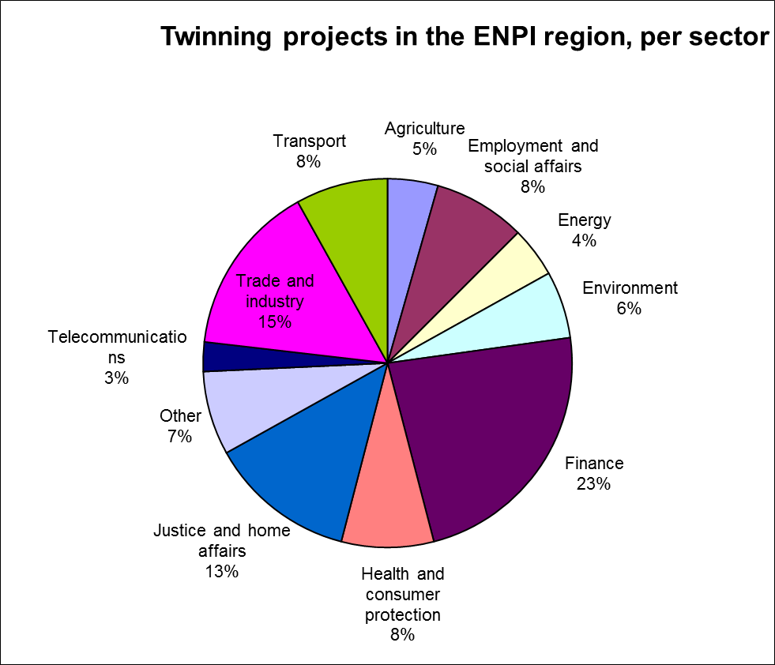
Source: European Commission

Number of Twinning proposals by Member States 2005-2012

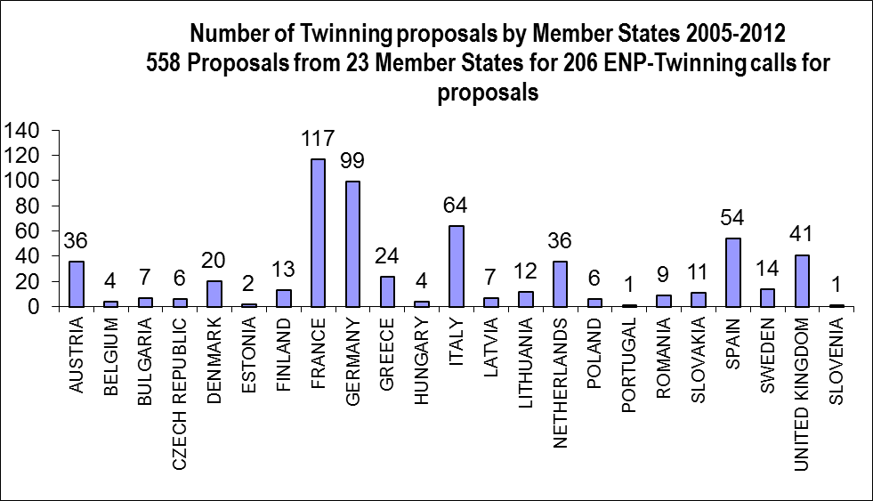
Source: European Commission

Member States selected in Twinning projects 2005-2012

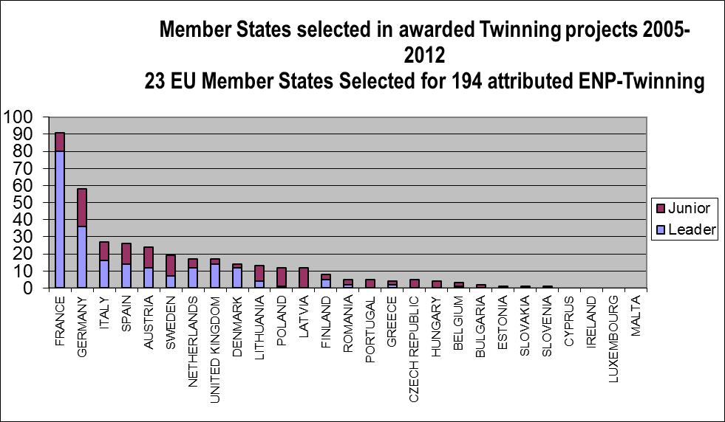
Source: European Commission

9. Neighbourhood Investment Facility projects in 2012

Projects in the ENP East region
The NIF contribution in the ten projects approved by the Operational Board for the East regions sums up a total of EUR 68.2 million. The total estimated cost for these ten projects amounts to EUR 1.18 billion.

Country | Title | Consortium of European Finance Institutions | Sector | NIF Contribution (in EUR million) | Total project cost (in EUR million)
Armenia | Yerevan Metro - 2nd phase | EBRD | Transport | 5 | 17.145
Armenia | Border Crossing and Infrastructure | EIB | Transport | 12 | 60.6
Azerbaijan | Regional Road Reconstruction Project | EBRD | Transport | 3.4 | 681
Georgia | Water Infrastructure Modernisation II | EIB | Water/Sanitation | 8 | 8
Georgia | Water Supply and sewage of Batumi and surrounding villages (Phase III) | KfW | Water/Sanitation | 4.5 | 58.1
Moldova | Moldoelectrica Power transmission Network Rehabilitation | EBRD | Energy | 8.0 | 36.6
Moldova | Balti Trolleybus Project | EBRD | Transport | 1.6 | 5
Regional | Grren for Growth fund for Eastern Region | Kfw | Energy | 12 | 166.1
Regional | Integrated Solid Waste Management in the Southern Caucasus | KfW | Water/Sanitation | 6 | 66
Regional | SBS Programme and EGP and BAS | EBRD | Private | 7.7 | 10.4
 |  |  | TOTAL | 68.2 | 1180.945

Source: European Commission

Projects in the ENP South region
The NIF contribution in the eight projects approved by the Operational Board for the South regions sums up a total of EUR 109 million. The total estimated cost for these eight projects amounts to EUR 1. 067 billion.
Country | Title | Consortium of European Finance Institutions | Sector | NIF Contribution (in EUR million) | Total project cost (in EUR million)
Egypt | Integrated and Sustainable Housing and Community Development Programme | EIB | Social | 30 | 175
Egypt | Cairo Metro Line 3 Phase 3 | AFD | Transport | 20
Morocco | Renforcement du réseau de transport électrique | AFD | Energy | 15 | 411
Lebanon | Kesrwan Wastewater | EIB | Water/Sanitation | 6
Lebanon | Lebanon Energy Efficiency and Renewable Energy Global Loan | EIB | Energy | 4 | 151
Regional | Renewable Energy and Energy Efficiency Project Preparation Initiative in support of the Mediterranean Solar Plan (MSP-PPI) | EIB | Energy | 5 | 5
Regional | Mediterranean Urban Project Finance Initiative (UPFI TA) | AFD | Multi-sector | 5 | 5
Regional | SME Guarantee Facility | EIB | Private | 24 | 320
 |  |  | TOTAL | 109 | 1067
Source: European Commission

Distribution of NIF Contribution by sector in 2012

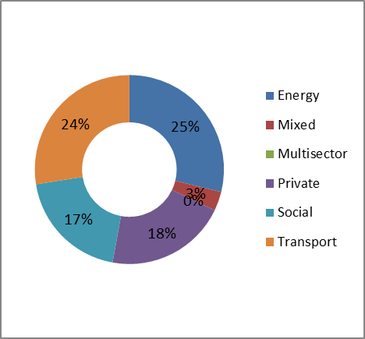
Source: European Commission

Distribution of NIF contributions by objectives in 2012

*
*Subject to the approval of Georgia East-West Highway (tbc)

Source: European Commission

Neighbourhood Investment Facility (NIF): Contributions pledged by Member States 2008-2012 (as of 31/12/2011)

Member State | Total Pledges 2008-2012 (in EUR million)
Austria | 3
Bulgaria | 1
Czech Republic | 2
Estonia | 2
Finland | 3
France | 20
Germany | 28
Greece | 1
Italy | 1
Luxebourg | 1
Poland | 3
Portugal | 1
Romania | 1
Spain | 2
Sweden | 1
TOTAL | 70

Source: European Commission

COM (2011) 303 of 25.05.2011
Ranking was adjusted for changes in methodology and any revision of data due to corrections. For more information see http://www.doingbusiness.org
Including country specific NIF payments
Action in support of employment and local development: location Algeria, Morocco, Tunisia and France
Including additional funds coming from EaPIC (EUR 15 million)
Including country specific NIF payments
Amount after the reduction NIP 2011-2013.
The initial NIP 2007-2010 was extended by one year.
Action covering migrants’ human rights along East Africa Route: location Egypt, Ethiopia and Sudan
Including additional funds coming from EaPIC allocation (EUR 22 million)
Including country specific NIF payments.
Including additional funds coming from EaPIC allocation (EUR 28 million).
Including country specific NIF payments.
Normally, an amount of EUR 425,5M is programmed to be spent during these two years, but uncertainties remain on two key programmes ("Support to Reform of Justice" and "Support to Green Business") whose formulation has not progressed.
This amount only includes disbursement in Syria, whereas the amount committed in 2012 also include activities in the neighbouring countries to address the Syrian crisis but disbursed by other delegations.
'including EUR150 million of additional funds
Action in support of Maghreb-Mashreq children: location Egypt, Morocco, Tunisia and Italy
Including Civil Society Initiative and Endowment for Democracy
Including Civil Society Initiative

