 | 
COUNCIL OF  THE EUROPEAN UNION |  |  | Brussels, 1 October 2013
 | Interinstitutional File:  2013/0187(COD)  2013/0186(COD) |  | 13877/13  ADD 1
AVIATION 157
CODEC 2072
INST 491
PARLNAT 225

COVER NOTE
from: | Portuguese Parliament
date of receipt: | 11 September 2013
to: | General Secretariat of the Council of the European Union
Subject: | Proposal for a Regulation of the European Parliament and of the Council amending Regulation (EC) No 216/2008 in the field of aerodromes, air traffic management and air navigation services  Doc. 11496/13 AVIATION 90 CODEC 1586  COM(2013) 409 final  Proposal for a Regulation of the European Parliament and of the Council on the implementation of the Single European Sky (recast)  Doc. 11501/13 AVIATION 91 CODEC 1588  COM(2013) 410 final  - Opinion on the application of the Principles of Subsidiarity and Proportionality

Delegations will find annexed a continuation the above-mentioned letter, the first part of which is contained in document 13877/13.

________________________

ANNEX
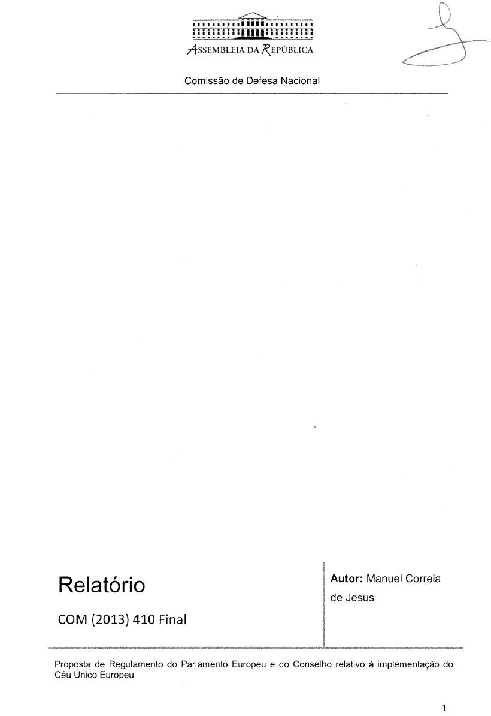
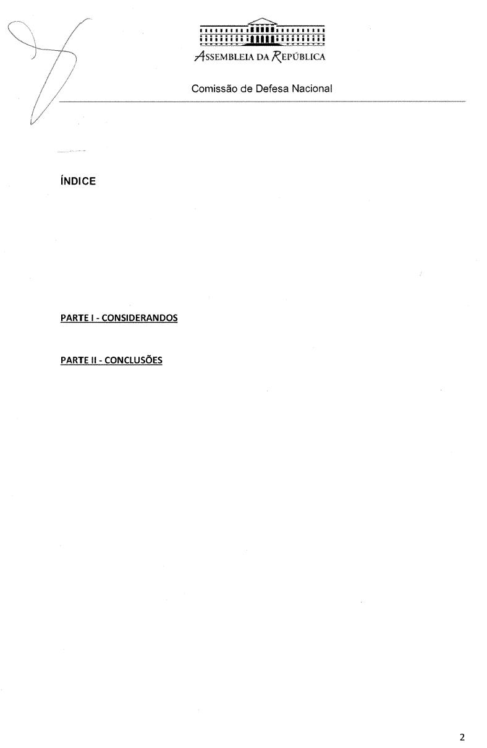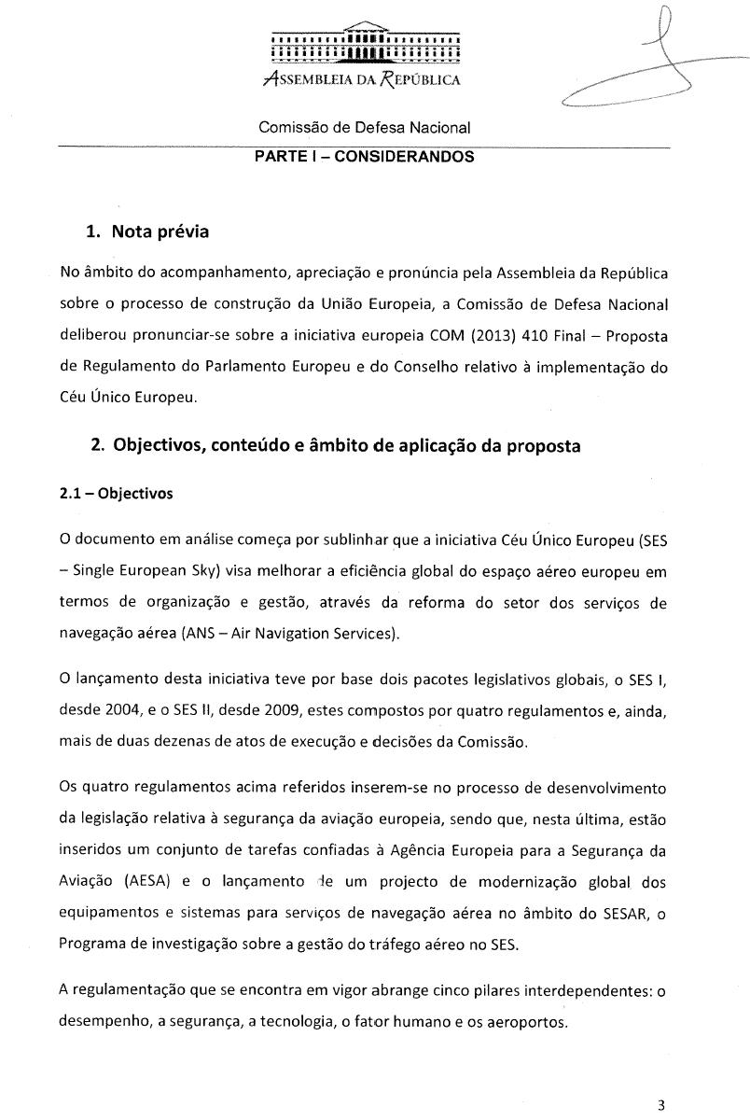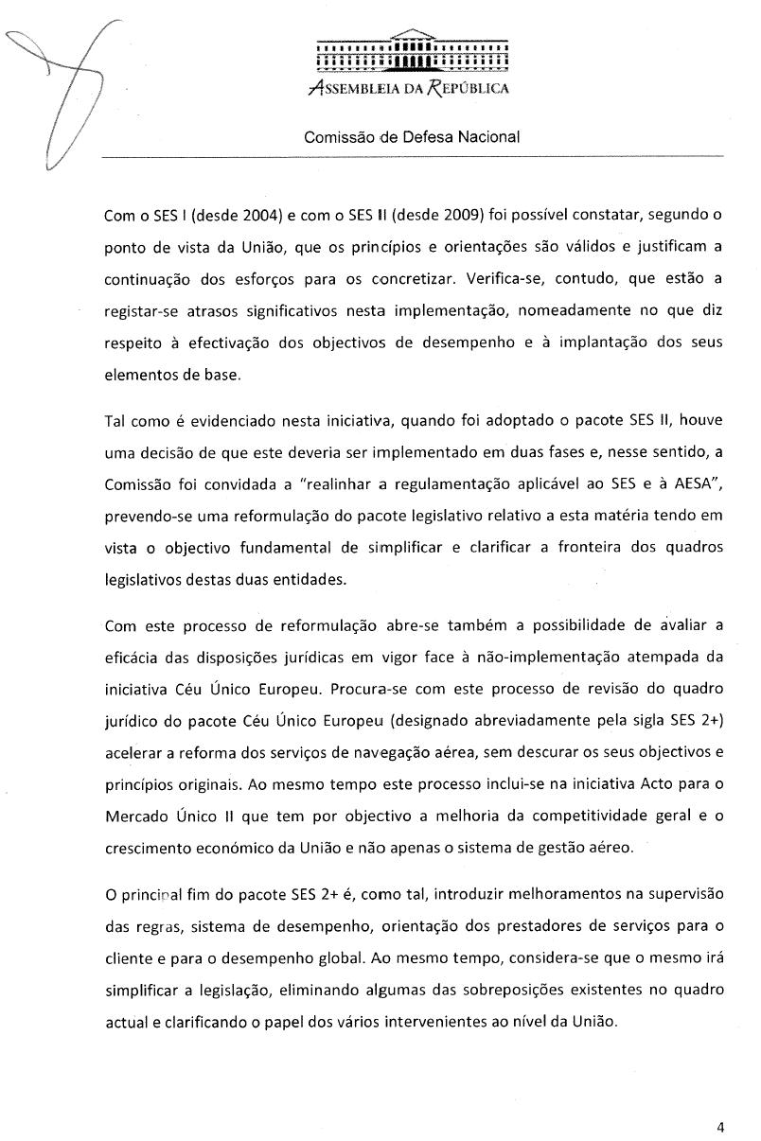_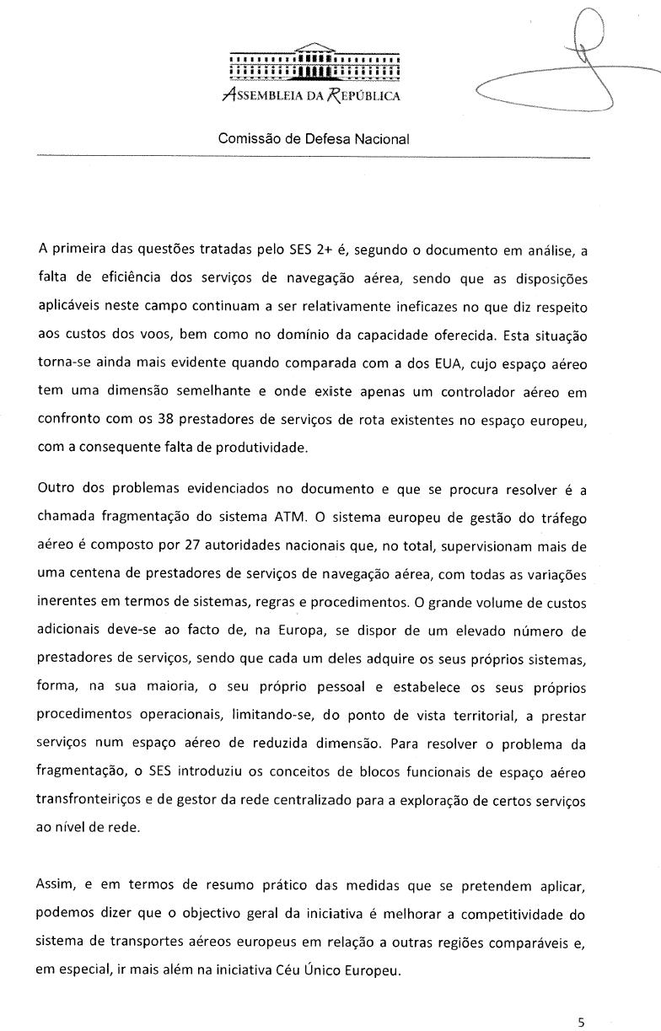
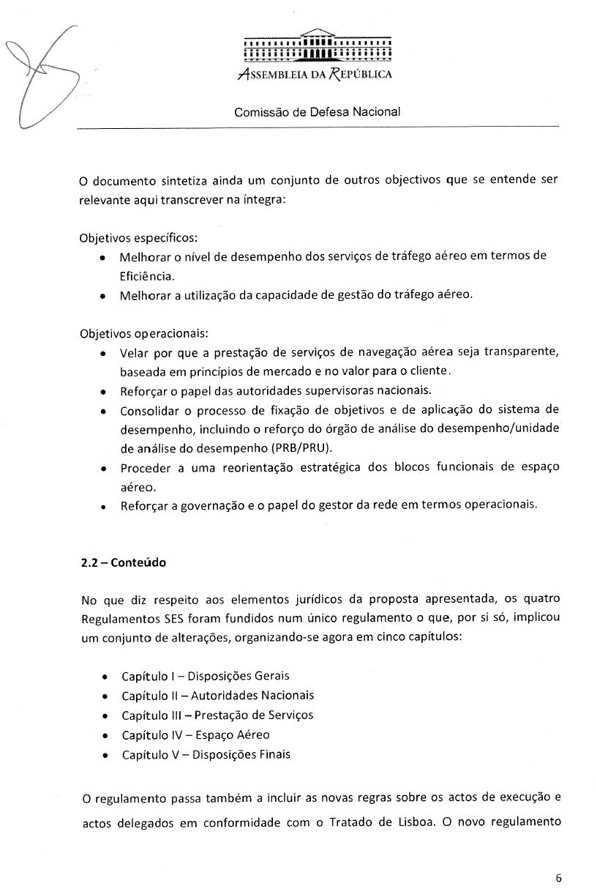
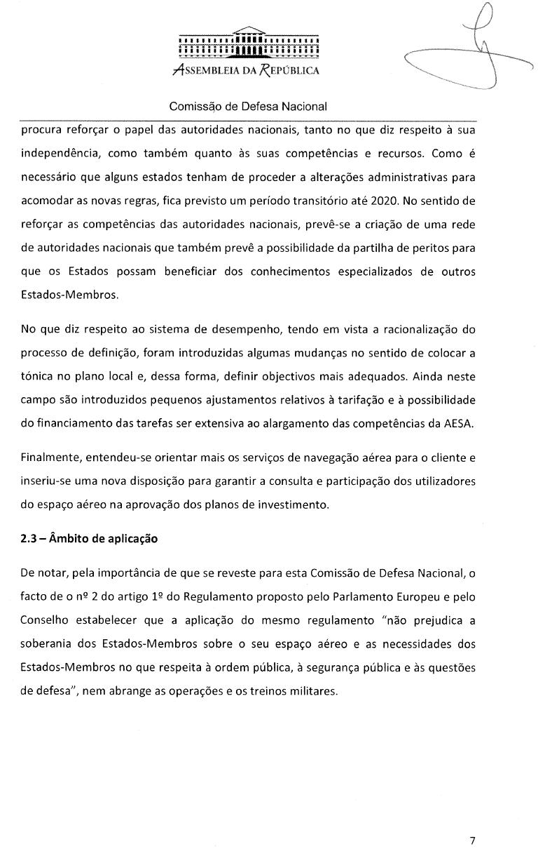
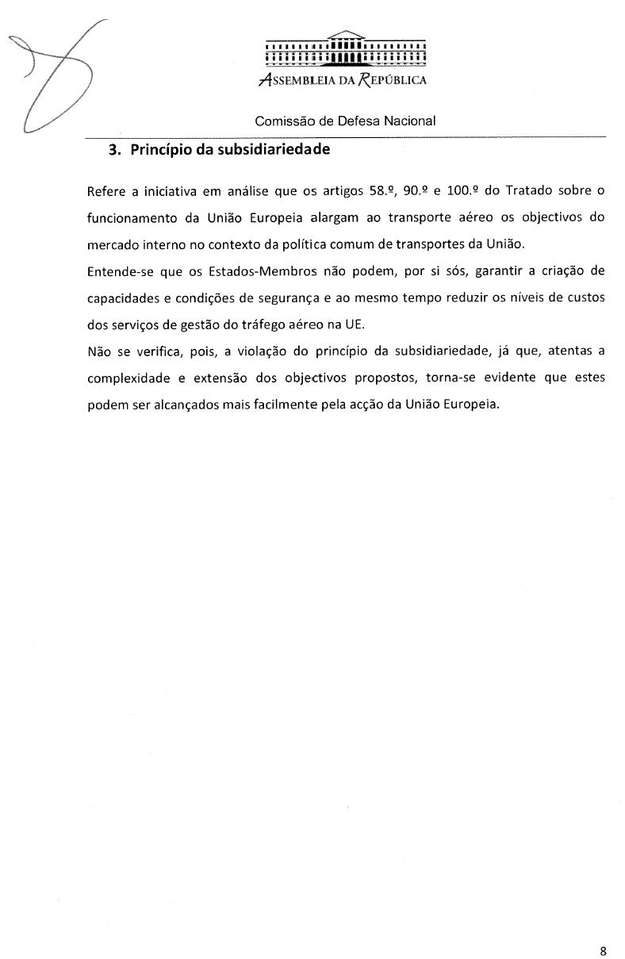
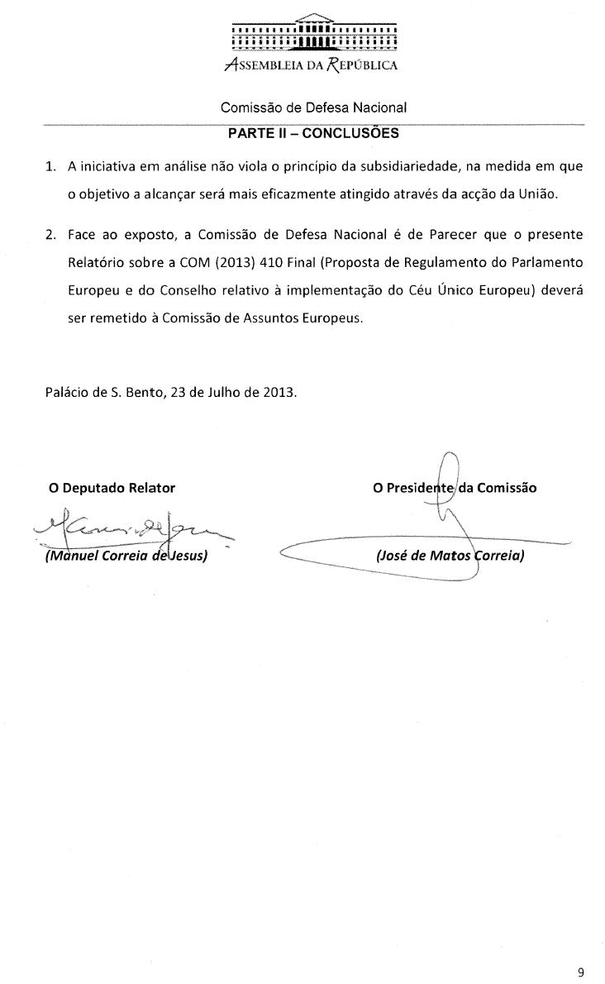
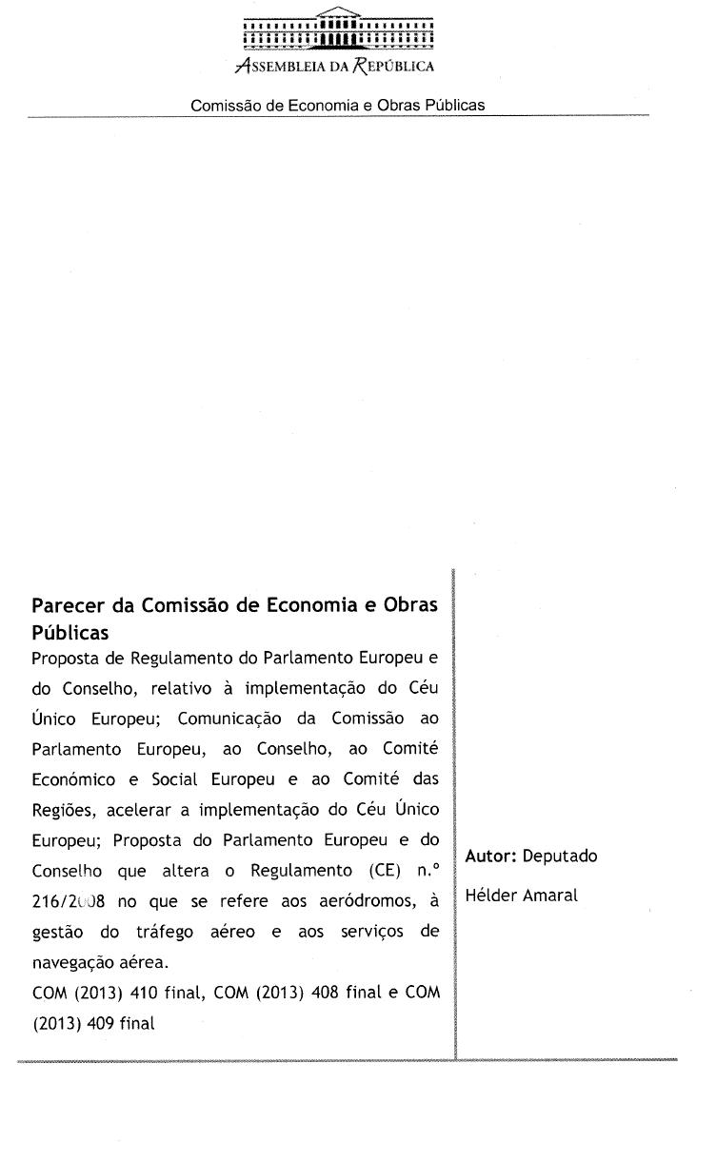
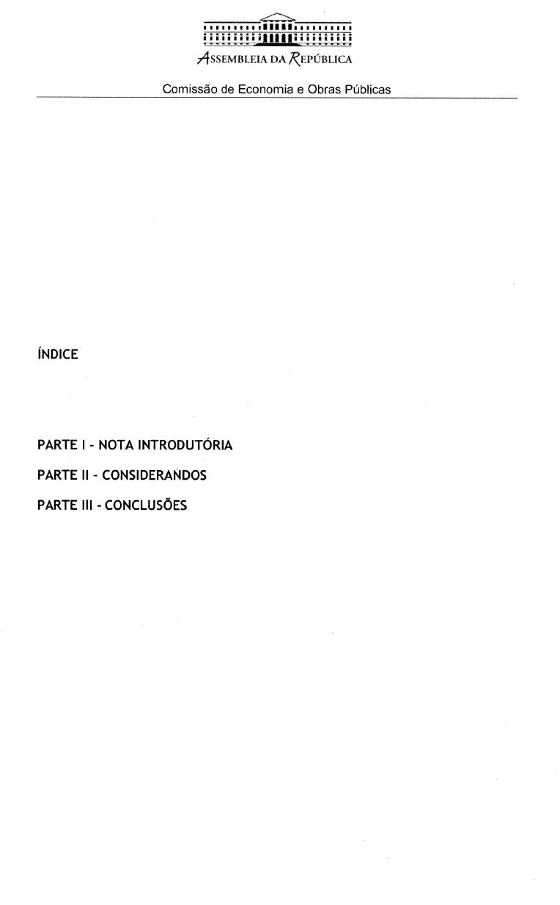
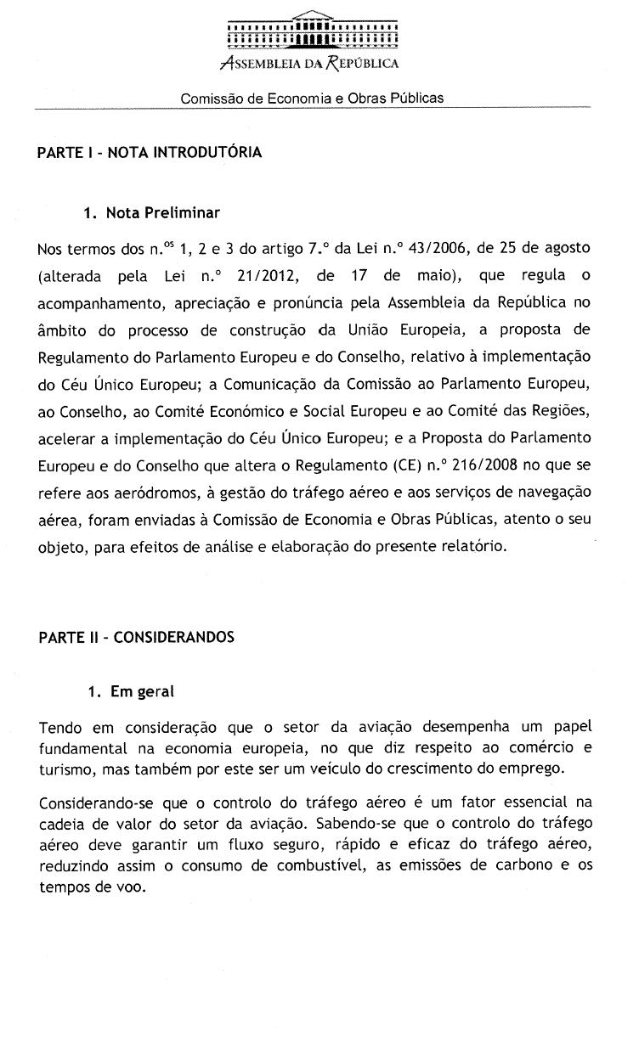
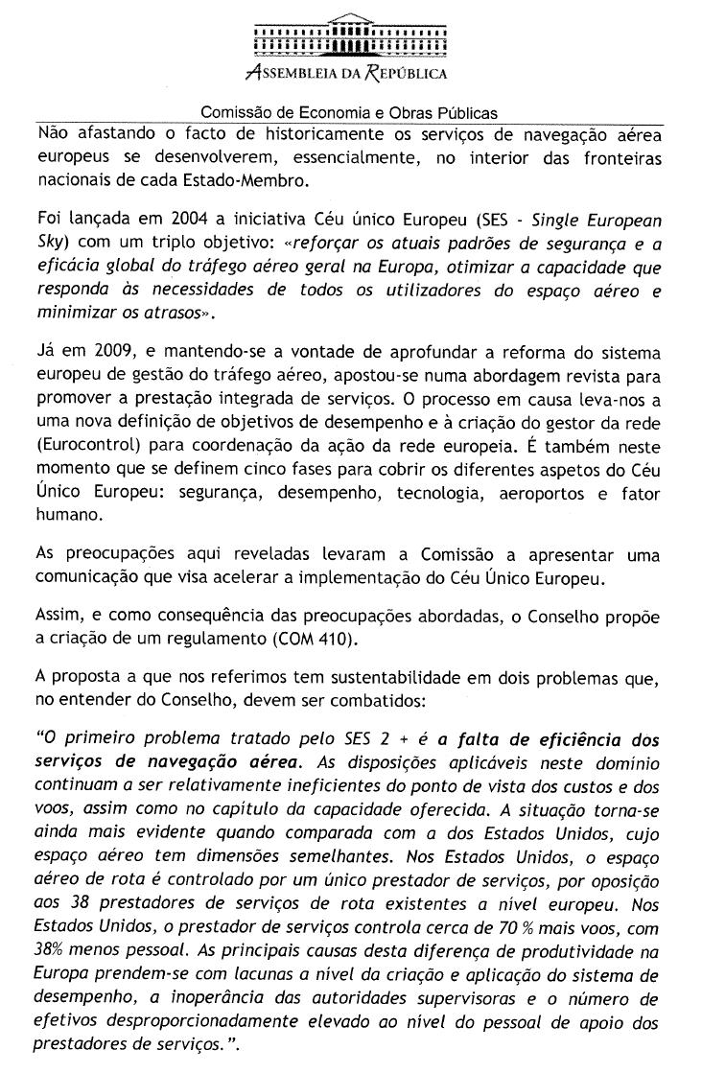
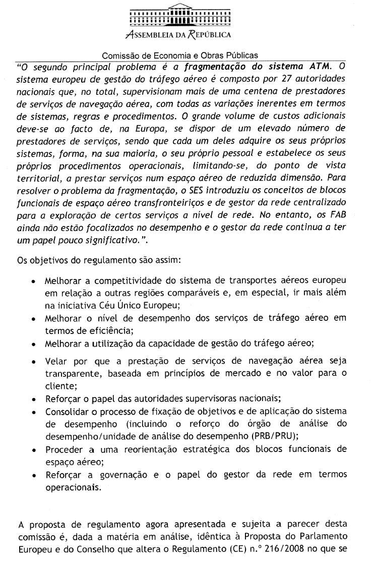
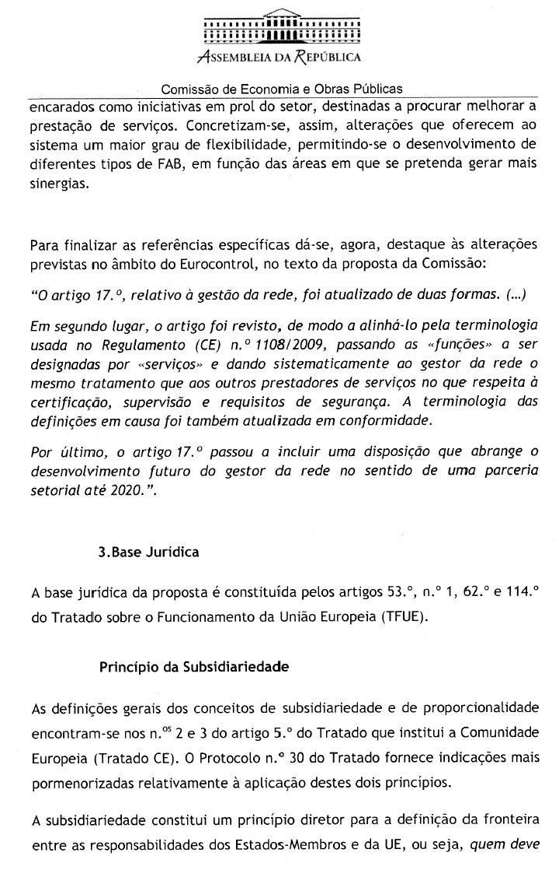
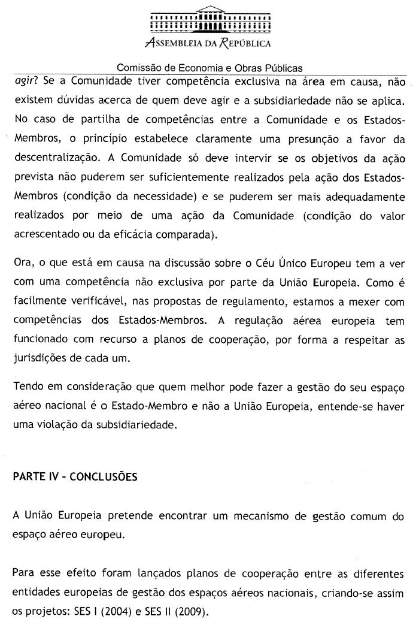
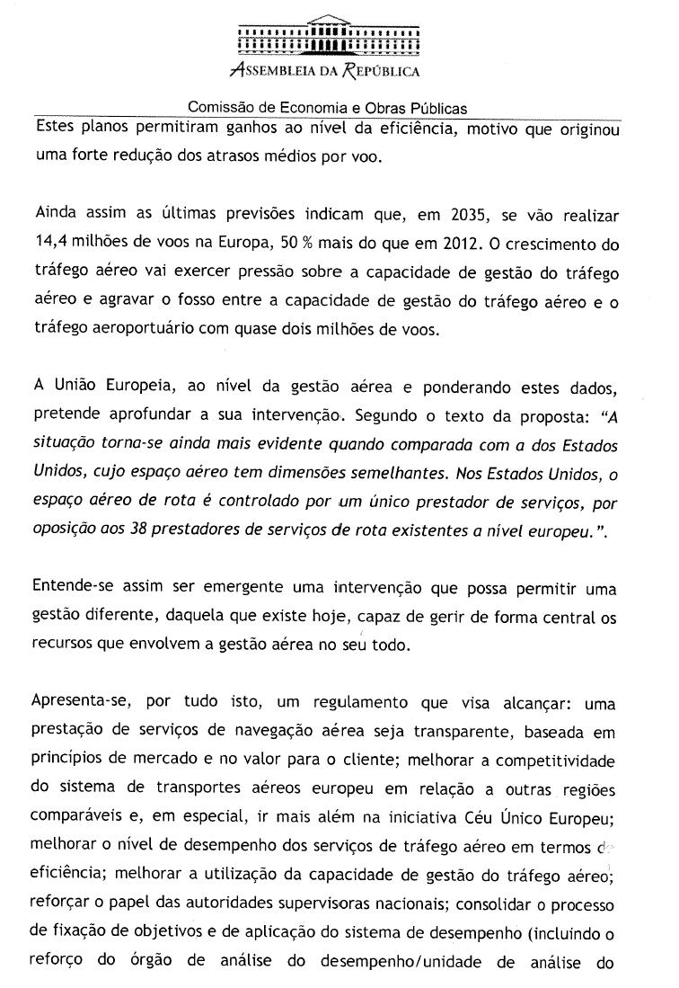
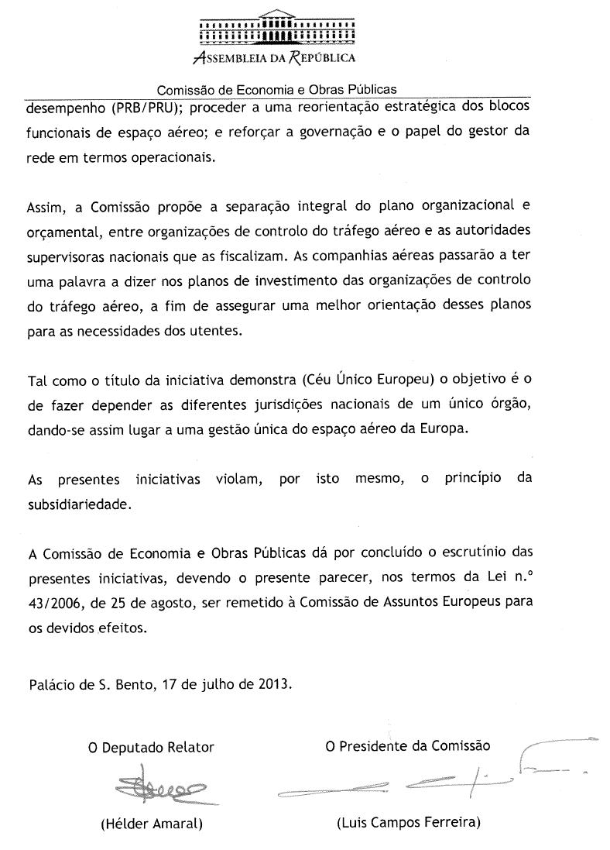

______________

Translation(s) of the opinion may be available in English on the Interparliamentary EU information exchange Internet site (IPEX) at the following address: http://www.ipex.eu/IPEXL-WEB/search.do

