SECTION I
WATER QUALITY AND AGRICULTURAL PRESSURES: STATUS AND TRENDS
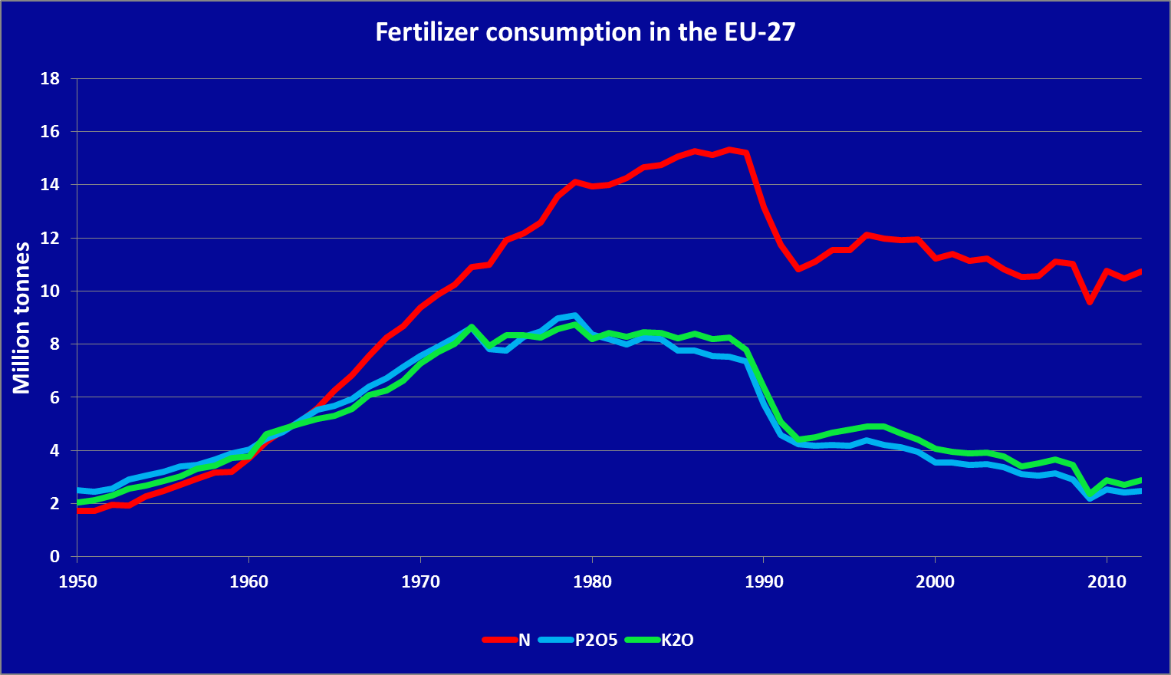
Figure 1. Fertilizer consumption in the EU 27 in million tonnes (Source: Fertilizers Europe).

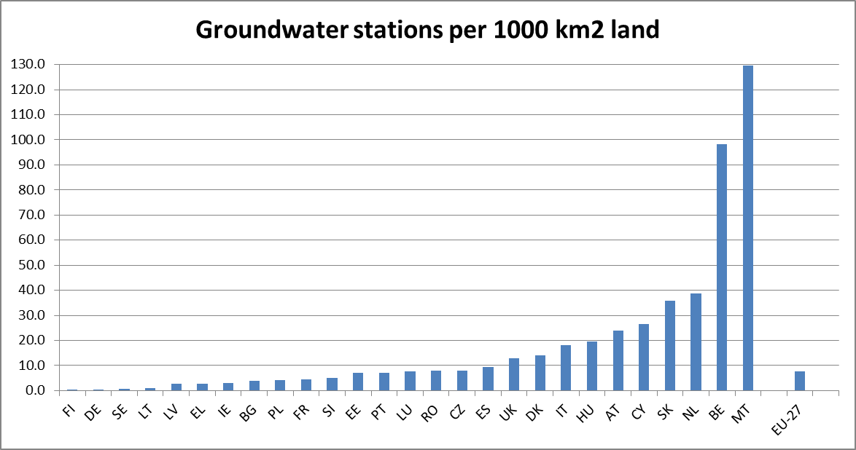
Figure 2. Groundwater station density.

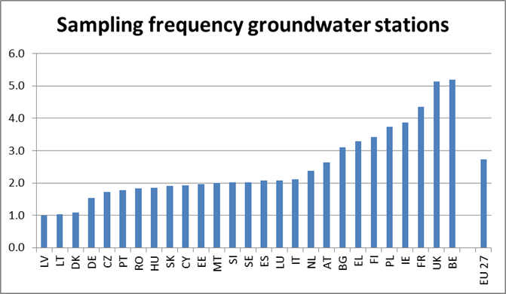
Figure 3. Groundwater sampling frequency per year.

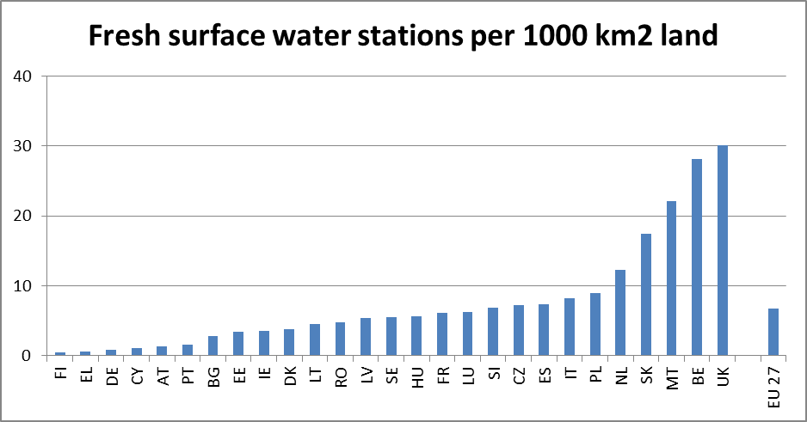
Figure 4. Fresh surface water station density.
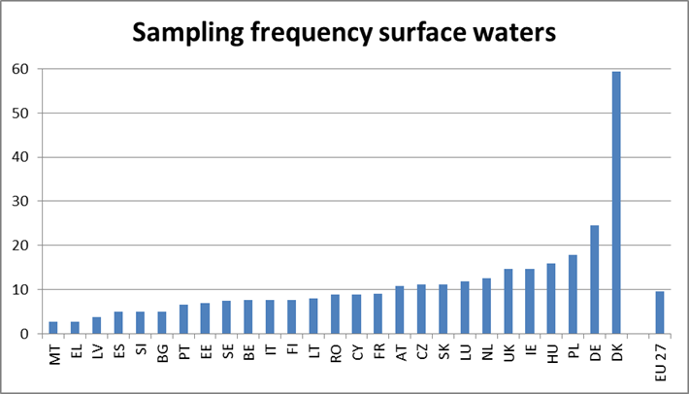
Figure 5. Surface water sampling frequency per year.

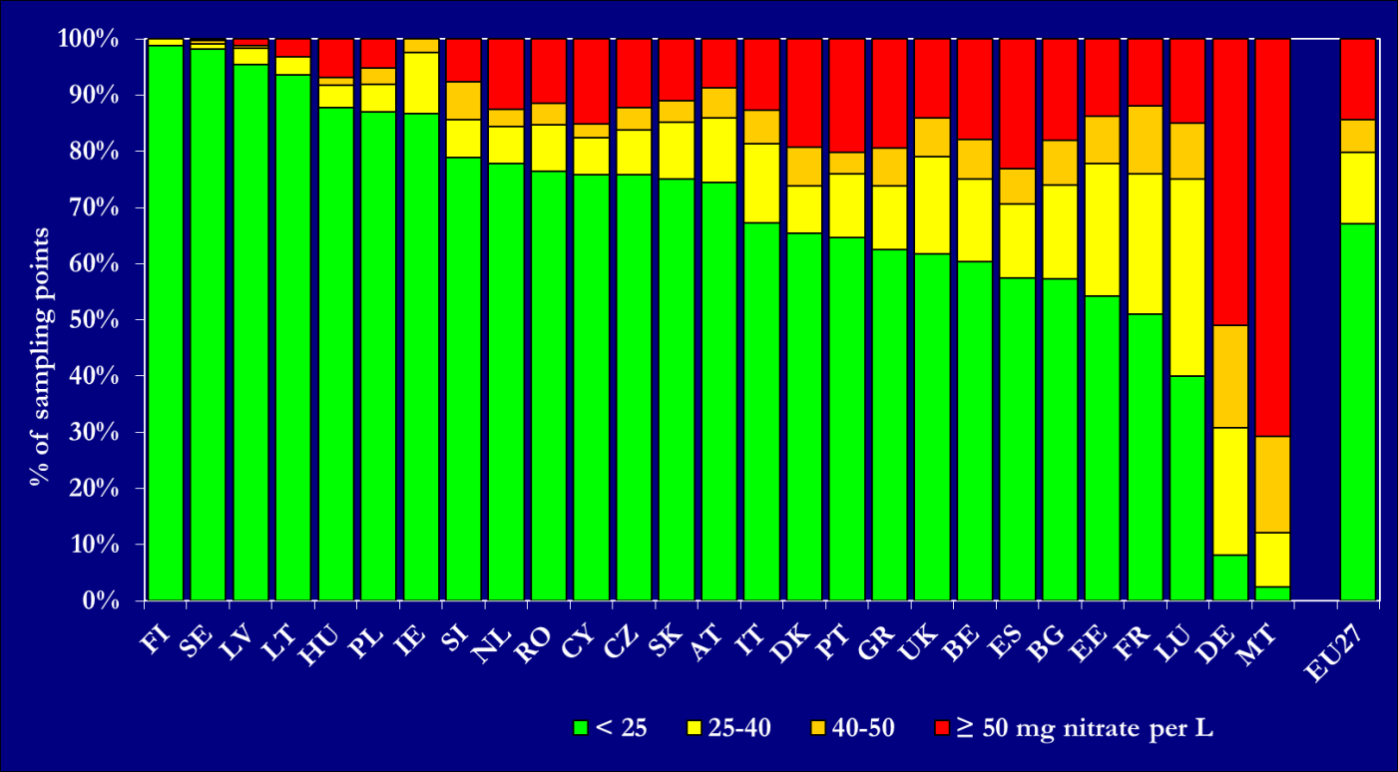
Figure 6. Frequency diagram of groundwater classes (Annual average nitrate concentrations),. Results are presented for all groundwater stations at different depths.
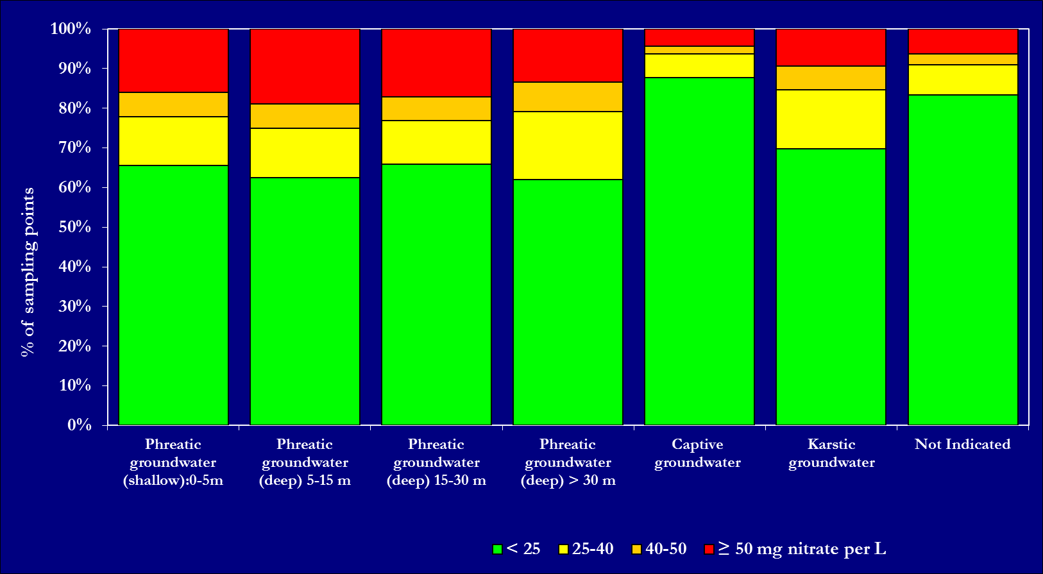
Figure 7. Frequency diagram of groundwater classes at different depths (annual average nitrate concentrations). Results are presented for all Member States.

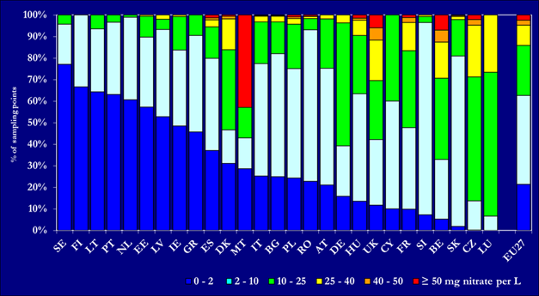
Figure 8. Frequency diagram of average nitrate concentrations in fresh surface water classes (annual average nitrate concentrations).
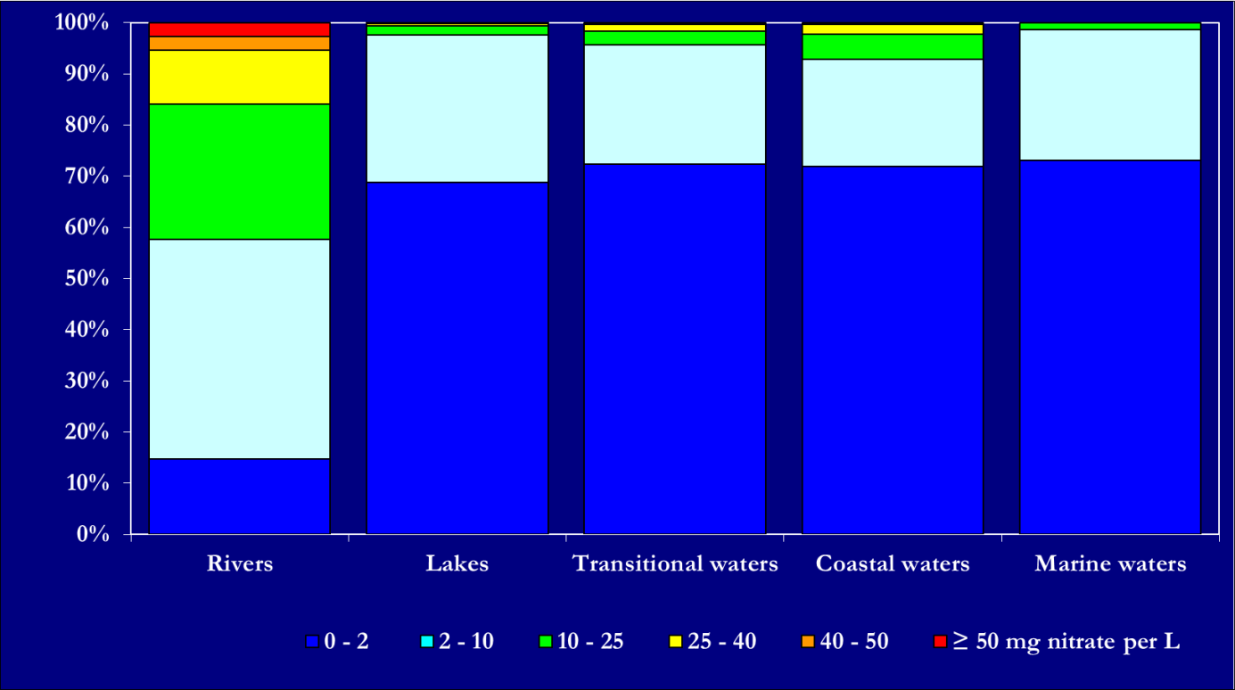
Figure 9. Frequency diagram of average nitrate concentrations in different surface water bodies.

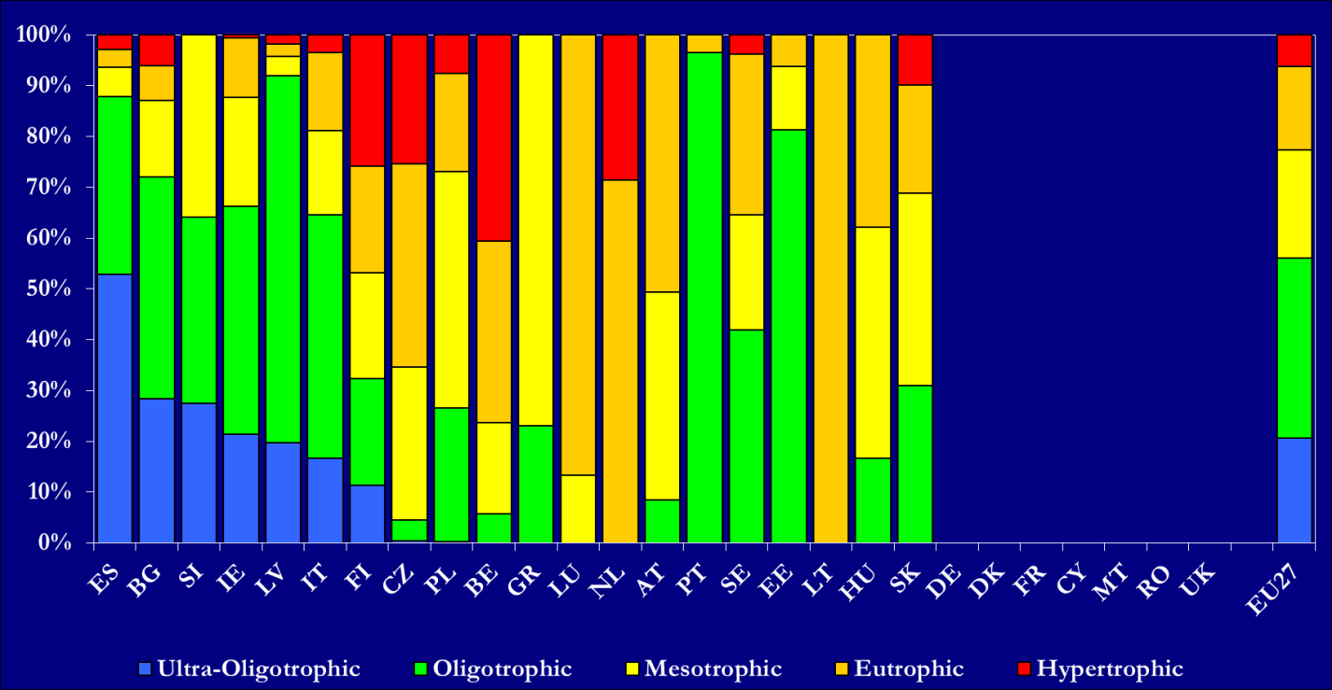
Figure 10. Frequency diagram of the trophic status of rivers (no data or incomplete data from Germany, Denmark, France, Cyprus, Malta and Romania. For the United Kingdom, only Northern Ireland reported digital data). The assessment of the trophic status varied widely among Member States, not only regarding the parameters used, but also concerning the methodologies for the definition of trophic status classes. Information on reference conditions is needed to provide a complete picture on eutrophication.

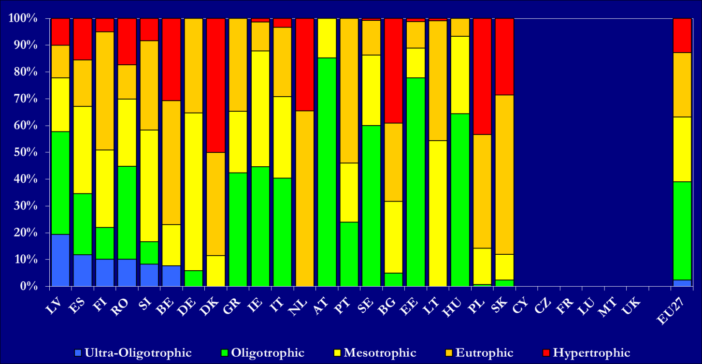
Figure 11. Frequency diagram of the trophic status of lakes (no data or incomplete data from Cyprus, Czech Republic, France, Luxembourg, Malta, and the United Kingdom). The assessment of the trophic status varied widely among Member States, not only regarding the parameters used, but also concerning the methodologies for the definition of trophic status classes. Information on reference conditions is needed to provide a complete picture on eutrophication.

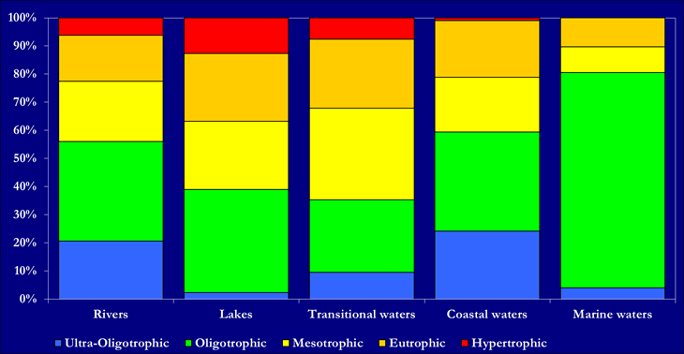
Figure 12. Frequency diagram of trophic status classes for different surface water bodies. The assessment of the trophic status varied widely among Member States, not only regarding the parameters used, but also concerning the methodologies for the definition of trophic status classes. Information on reference conditions is needed to provide a complete picture on eutrophication.
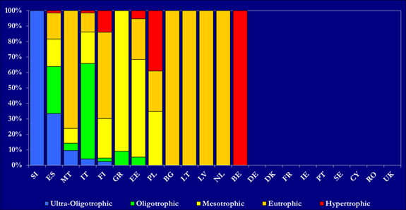
Figure 13a. Frequency diagram of trophic status classes of saline surface waters (no data from Cyprus, Romania, Germany, Denmark, France, Ireland, Portugal, Romania and Sweden. For the United Kingdom, only Northern Ireland reported digital data. For Belgium, only Flanders reported data.). The assessment of the trophic status varied widely among Member States, not only regarding the parameters used, but also concerning the methodologies for the definition of trophic status classes. Information on reference conditions is needed to provide a complete picture on eutrophication.

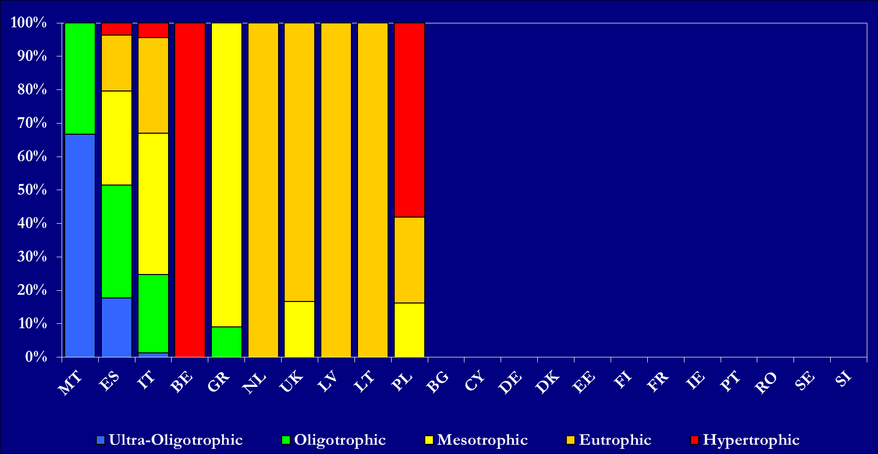
Figure 13b. Frequency diagram of trophic status classes of transitional surface waters (UK: Northern Ireland only; For Belgium, only Flanders reported data. No data from Bulgaria, Cyprus, Estonia, Germany, Denmark, Finland, France, Ireland, Portugal, Romania, Sweden, and Slovenia). The assessment of the trophic status varied widely among Member States, not only regarding the parameters used, but also concerning the methodologies for the definition of trophic status classes. Information on reference conditions is needed to provide a complete picture on eutrophication.
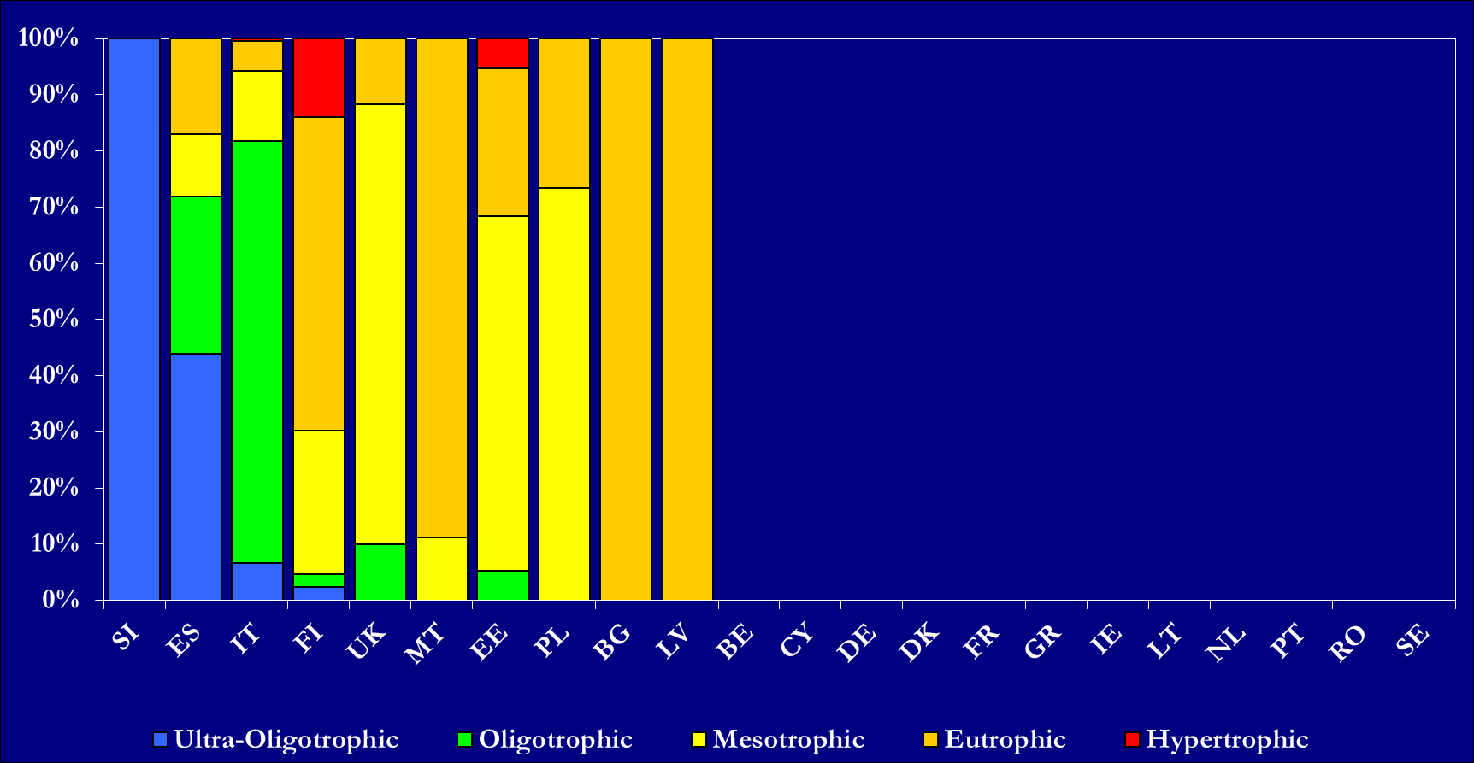
Figure 13c. Frequency diagram of trophic status classes of coastal surface waters (UK: Northern Ireland only; no data from Belgium, Cyprus, Germany, Denmark, France, Greece, Ireland, Lithuania, Netherlands, Portugal, Romania, and Sweden). The assessment of the trophic status varied widely among Member States, not only regarding the parameters used, but also concerning the methodologies for the definition of trophic status classes. Information on reference conditions is needed to provide a complete picture on eutrophication.

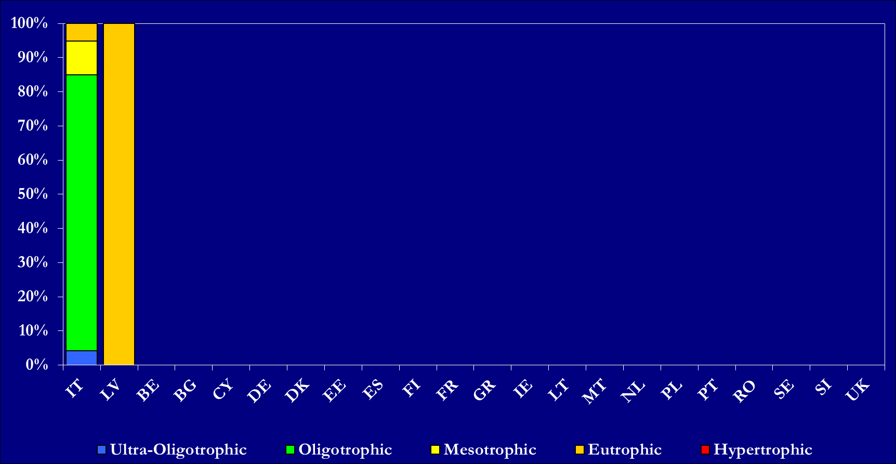
Figure 13d. Frequency diagram of trophic status classes of marine surface waters (data only from Italy and Latvia). The assessment of the trophic status varied widely among Member States, not only regarding the parameters used, but also concerning the methodologies for the definition of trophic status classes. The graph refers to trophic status, whereas information on reference conditions is needed to provide a complete picture on eutrophication.
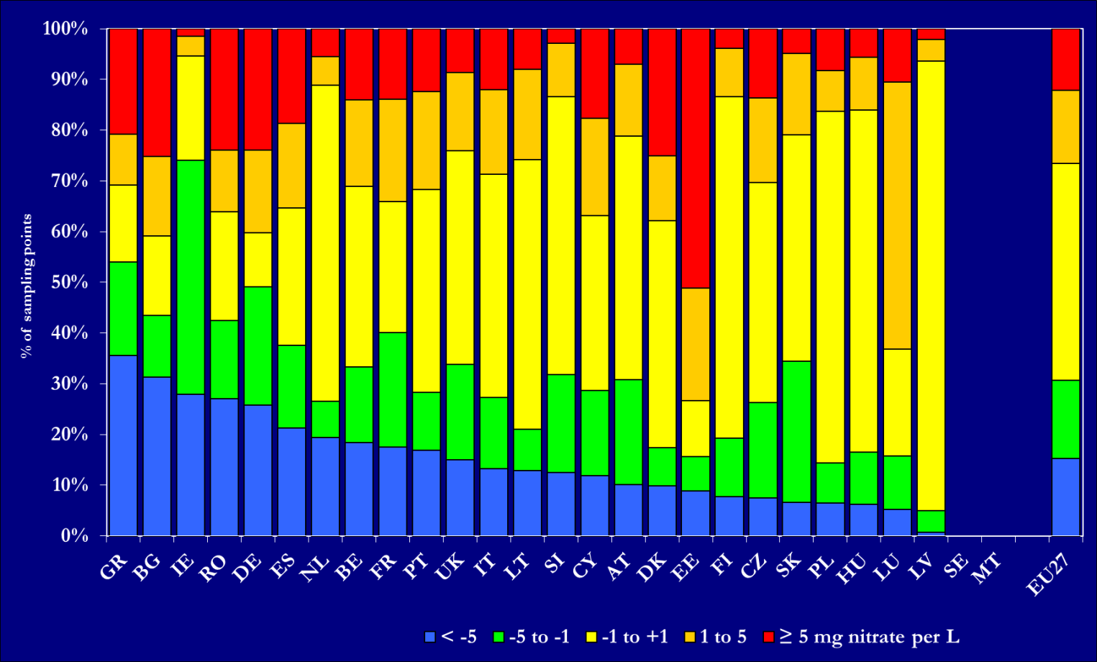
Figure 14. Frequency diagram of trends in groundwater classes (annual average nitrate concentrations). Comparability between the two reporting periods might be hampered by changes in the monitoring network. Sweden provided no data regarding trends of nitrate in groundwater as compared to the reporting period 2004-2007 but only a long term trend analysis. Malta did not report trends.

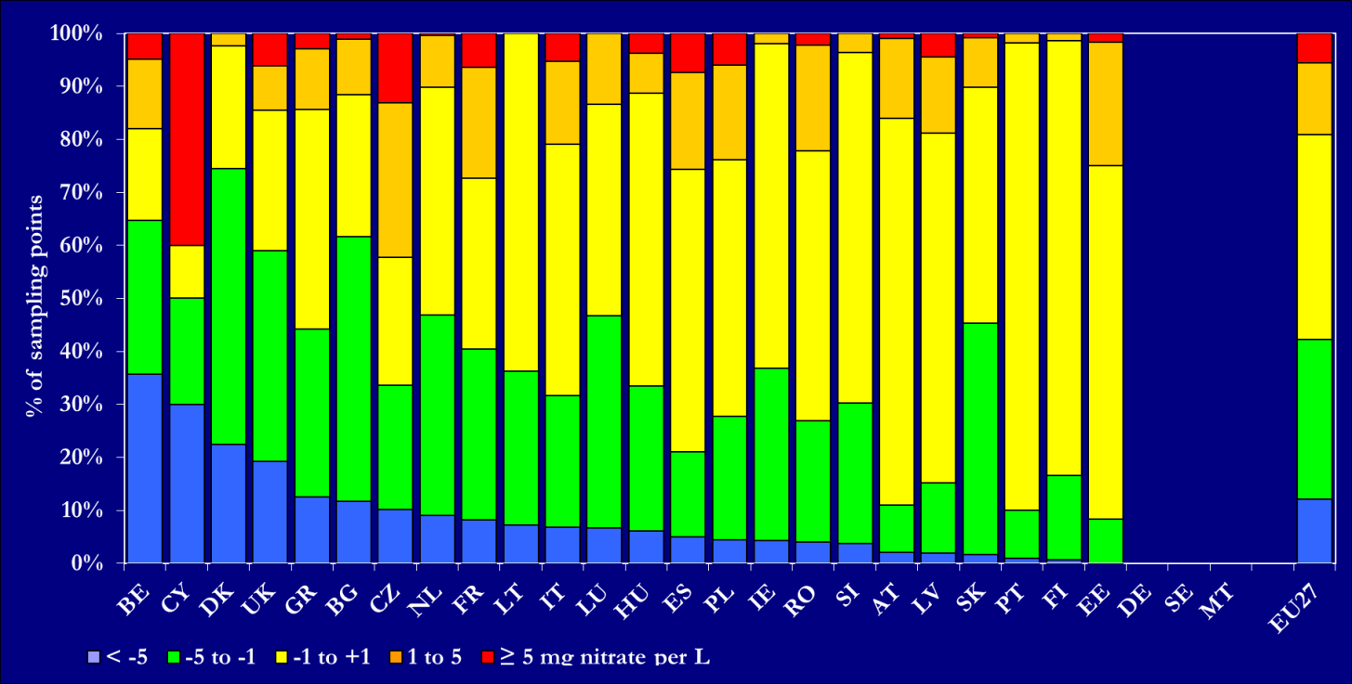
Figure 15. Frequency diagram of trends in fresh surface water classes (annual average nitrate concentrations). Comparability between the two reporting periods might be hampered by changes in the monitoring network. Sweden provided no data regarding trends of nitrate in fresh surface waters as compared to the reporting period 2004-2007 but only a long term trend analysis. Germany did not submit data regarding fresh surface water trends based on average concentrations. Malta did not report trends.

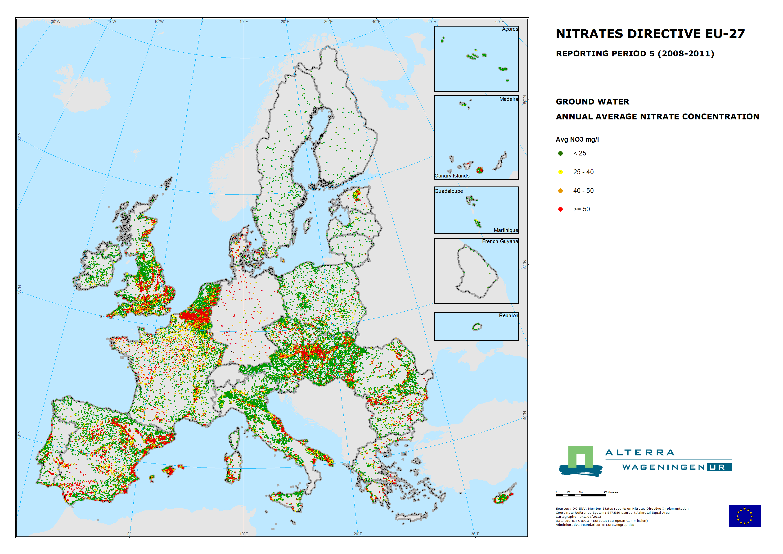
Map 1. Groundwater average nitrate concentrations for the reporting period 2008-2011.

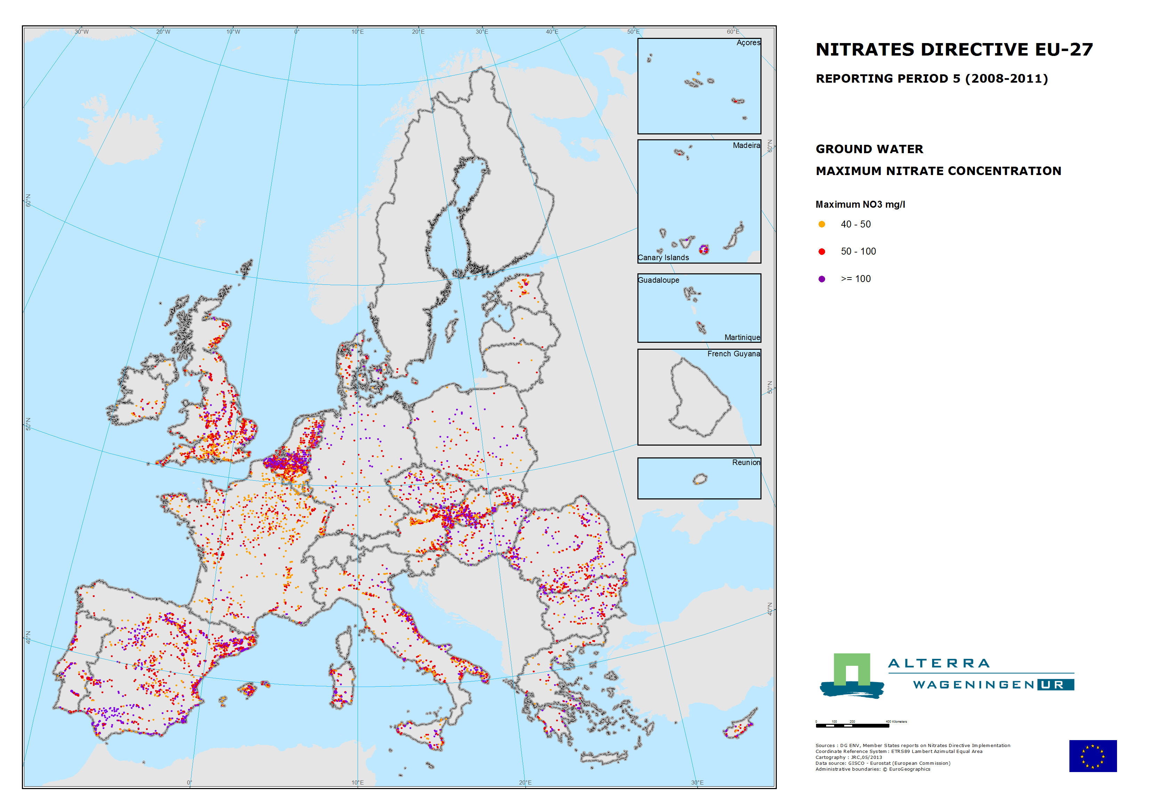
Map 2. Groundwater maximum nitrate concentrations for the reporting period 2008-2011.

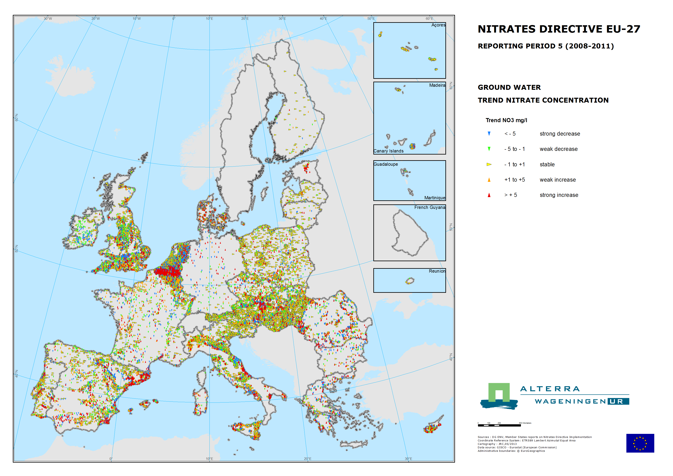
Map 3. Trends in groundwater nitrates concentrations between the reporting periods 2004-2007 and 2008-2011.

Groundwater stations with long-term low nitrate concentrations were not measured every four years in all cases. As a result, the figure may show a slightly over-populated percentage of stations with high nitrate concentrations.
Comparison of Figure 6 with Figure 2 of the Commission Staff Working Paper accompanying document to the report from the Commission to the Council and the European Parliament on implementation of Council Directive 91/676/EEC concerning the protection of waters against pollution caused by nitrates from agricultural sources based on Member State reports for the period 2004 -2007 may be hampered due to substantial differences in the number of the monitored stations (e.g. Austria, since it reported data for all monitoring stations in the period 2008-2011, while aggregated data were reported in the period 2004-2007).
Groundwater stations with long-term low nitrate concentrations were not measured every four years in all cases. As a result, the figure may show a slightly over-populated percentage of stations with high nitrate concentrations.

