Member State: Greece
Water quality
 | Monitoring stations with measurements | Monitoring stations with trends
Total groundwater stations | 370 | 370
Total fresh surface water stations | 105 | 104
Total saline water stations (transitional only) | 11 | 11
Table 1. Number of water monitoring stations.

Groundwater quality
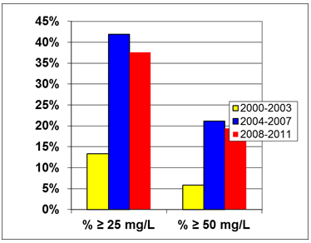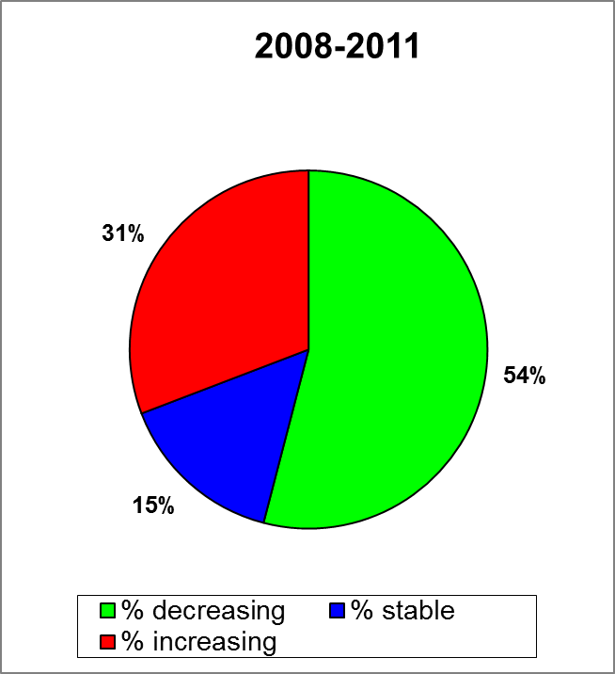
Figure 1. Percentage of groundwater stations exceeding 25 or 50 mg nitrate per L during the reporting periods 2000-2003, 2004-2007 and 2008-2011. Results are presented for all groundwater stations (at different depths). [x-axis: average concentrations of nitrates expressed as mg/l; y-axis: number of monitoring stations, in percentage]. For the period 2008-2011, data refer to the year 2008. | Figure 2. Trends in groundwater nitrate concentrations between the periods 2004-2007 and 2008-2011.Trends between the periods 2000-2003 and 2004-2007 are not available. For the period 2008-2011, data refer to the year 2008
Surface water quality

No surface freshwater stations exceeded 25 mg nitrate per L in the period 2008-2011.
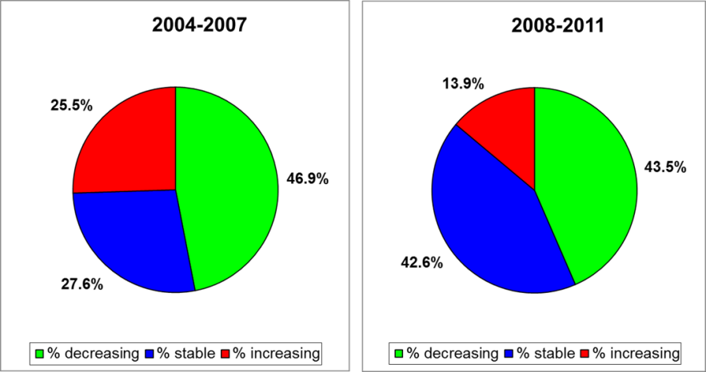
Figure 3. Trends in surface waters nitrate concentrations between the periods 2000-2003 and 2004-2007 (left) and 2004-2007 and 2008-2011 (right).

Eutrophication
Rivers and lakes
The trophic status of rivers was assessed on the basis of the average multi-annual nitrate concentrations. Also ammonium-N, total phosphorus and BOD were measured. The trophic status of lakes was assessed on the basis of summer chlorophyll-measurements; also total phosphorus and total nitrogen were monitored. According to the dataset, 62.9% of fresh waters were mesotrophic, 9.5% eutrophic and the remaining fraction was oligotrophic. However, according to the textual report, as regards lakes, out of a total of 27 sampling points in 21 different lakes in Greece, 11 points were designated as oligotrophic, 6 points were designated as mesotrophic and 10 points were designated as eutrophic. As regards rivers, the report presented 18 water bodies classified as oligotrophic and 71 water bodies classified as mesotrophic.
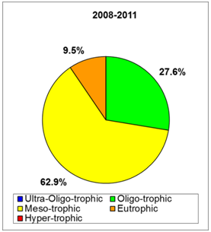
Figure 4. Fresh water eutrophication classification during the 2008-2011 reporting period
Saline waters
No methodology was presented as regards the assessment of the trophic status of saline waters. Only the trophic status of transitional waters was presented.
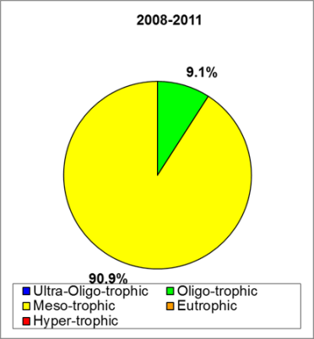
Figure 5. Saline water eutrophication classification during the 2008-2011 reporting period
Pressure from agriculture
The areas of agricultural and pasture land decreased by 15 and 47%, respectively, in 2008-2011 as compared to 2004-2007. The application of nitrogen from manure slightly increased while chemical fertilizers application decreased in the same period.
Designation of nitrate vulnerable zones
Nitrate vulnerable zones (NVZ) were first designated in 1999 (four areas) and then extended in 2001 (additional three areas) and 2010 (one additional area). At the end of 2012 the NVZ area covered 31962.81 Km², corresponding to 24.27% of the total land area.
Code of good agricultural practice
The code of good agricultural practice (CGAP) was first issued in 1994 and revised in 2000.
Action programme
Seven action programmes have been established for each of the NVZ areas, four in 2001 and three in 2006. No action programme has been established for the NVZ area established in 2010.
Member State: Hungary
Water quality
 | Monitoring stations with measurements | Monitoring stations with trends
Total groundwater stations | 1763 | 1720
Total fresh surface water stations | 525 | 212
Total saline water stations | Not applicable | Not applicable
Table 1. Number of water monitoring stations.

Groundwater quality
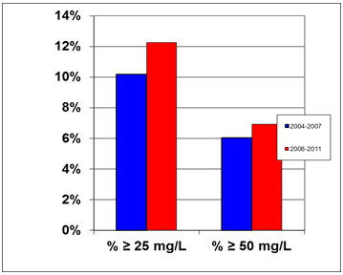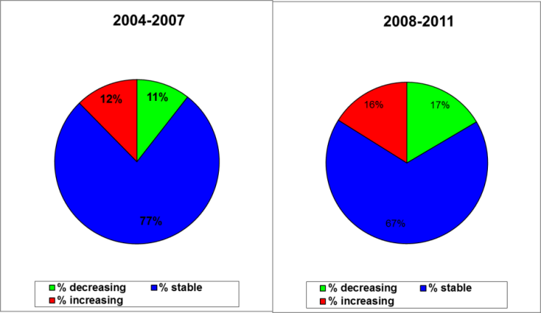
Figure 1. Percentage of groundwater stations exceeding 25 or 50 mg nitrate per L during the reporting periods 2004-2007 and 2008-2011. Results are presented for all groundwater stations (at different depths). [x-axis: average concentrations of nitrates expressed as mg/l; y-axis: number of monitoring stations, in percentage]. | Figure 2. Trends in groundwater nitrate concentrations between the periods 2000-2003 and 2004-2007 (left) and between the periods 2004-2007 and 2008-2011 (right).
Surface water quality
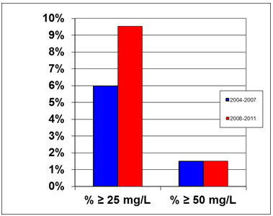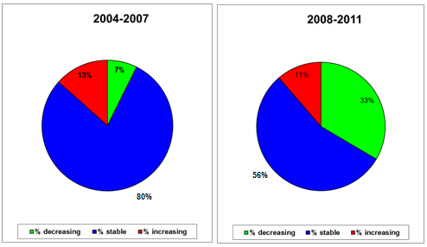
Figure 3. Percentage of surface fresh water stations exceeding 25 or 50 mg nitrate per L during the 2004-2007 and 2008-2011 reporting periods. [x-axis: average concentrations of nitrates expressed as mg/l; y-axis: number of monitoring stations, in percentage]. | Figure 4. Trends in surface fresh water nitrate concentrations between the periods 2000-2003 and 2004-2007 (left) and between the periods 2004-2007 and 2008-2011 (right).
Eutrophication
Approximately 35% of fresh water monitoring sites were eutrophic. This was mainly caused by rivers, of which 38% of sites were eutrophic, while the percentage of eutrophic lake monitoring sites was 7%. The proportion of eutrophic fresh water sites decreased between the reporting periods 2008-2011 and 2004-2007. However, a direct comparison is not possible due to the different classification systems used in the two reporting periods. The report presents a comparison between the 2004-2007 and 2008-2011 reporting periods, based on the individual parameters. These also indicate that the proportion of eutrophic surface fresh water sites decreased.
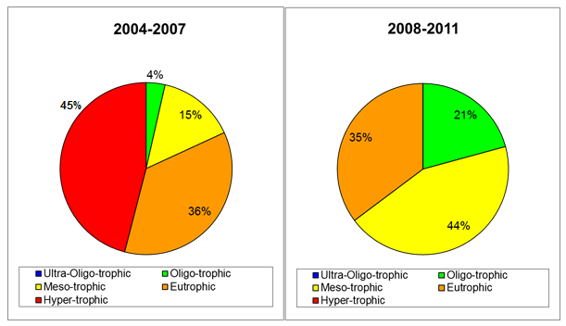
Figure 6. Surface fresh water eutrophication classification during the reporting periods 2004-2007 and 2008-2011
Pressure from agriculture
The agricultural pressure did not show significant changes. The assessment, however, is hampered by many changes in used methodologies. Inside the NVZs, nitrogen surpluses showed a gradual increase, remaining, however, negative.
The agricultural area decreased by 5% in the period 2008-2011 as compared to 2004-2007. The agricultural land available for application of manure decreased even further (-20%). The number of cattle and pigs decreased by 3% and 17% respectively, while the number of poultry increased by 30%. The use of manure increased by 13%, while the use of mineral fertilizer remained stable. Hungary reported a relative large amount of inorganic nitrogen from other sources than livestock (sewage sludge).
Designation of nitrate vulnerable zones
Hungary designated NVZs in 2007. The area remained unchanged in the 2008-2011 period, when the NVZ area was 42 519 km², corresponding to about 46% of the total territory.
Code of good agricultural practice
The code of good agricultural practice forms integral part of the action programme and applies to all farmers in the NVZs.
Action programme
The action programme was first published in 2001 and modified in 2008. Compliance with action programme measures is generally high (95 to 100% per provision), although poor data delivery by small farms and lack of financial resources for investments in manure storages were often observed during checks. In the 2008-2011 reporting period, compliance checks were carried out on 2.7% of the farms located within NVZ.
Member State: Ireland
Water quality
 | Monitoring stations with measurements | Monitoring stations with trends
Total Groundwater stations | 211 | 204
Total Fresh Surface water stations | 252 | 209
Total Saline water stations | 104 | 101
Table 1. Number of water monitoring stations

Groundwater quality
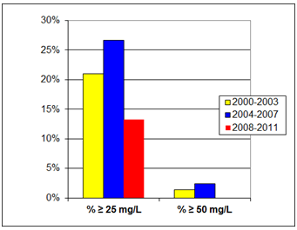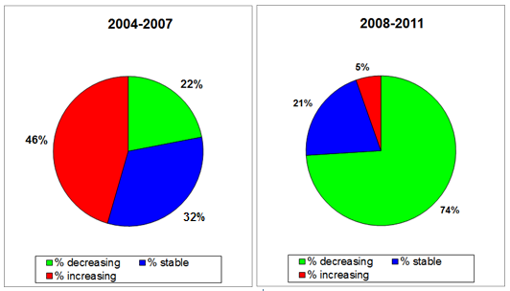
Figure 1. Percentage of groundwater stations exceeding 25 or 50 mg nitrate per L during the reporting periods 2000-2003, 2004-2007 and 2008-2011. Results are presented for all groundwater stations (at different depths). [x-axis: average concentrations of nitrates expressed as mg/l; y-axis: number of monitoring stations, in percentage]. No stations exceeded 50 mg nitrate per L in the reporting period 2008-2011. | Figure 2. Trends in groundwater nitrate concentrations between the periods 2000-2003 and 2004-2007 (left) and between the periods 2004-2007 and 2008-2011 (right).
Surface water quality

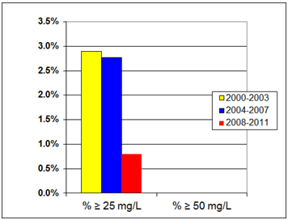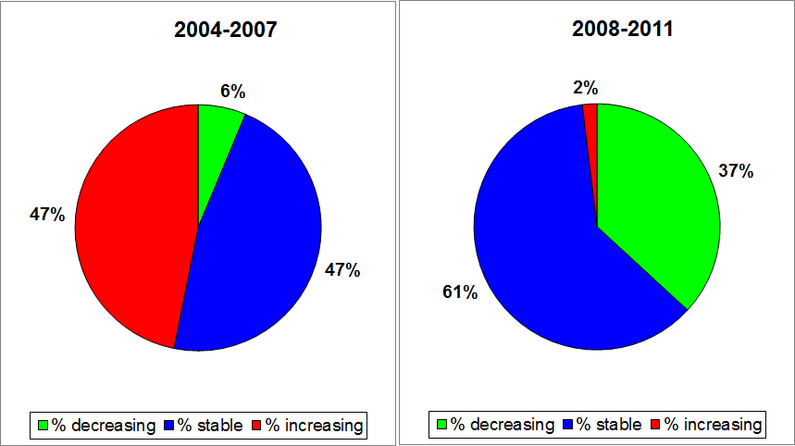

Figure 3. Percentage of surface fresh water stations exceeding 25 or 50 mg nitrate per L during the period 2000-2003, 2004-2007 and 2008-2011. [x-axis: average concentrations of nitrates expressed as mg/l; y-axis: number of monitoring stations, in percentage]. No stations exceeded 50 mg nitrate per L in all the reporting periods 2000-2003, 2004-2007 and 2008-2011. | Figure 4. Trends in surface fresh water nitrate concentrations between the periods 2000-2003 and 2004-2007 (left) and between the periods 2004-2007 and 2008-2011 (right).
Eutrophication
Rivers and Lakes
Trophic status in lakes was assessed using a modification of the OECD (1982) classification scheme, based on the annual maximum chlorophyll concentrations. Trophic status in rivers was assessed using both biological responses and additional physico-chemical elements (such as phosphate, nitrate, ammonia, dissolved oxygen and BOD).

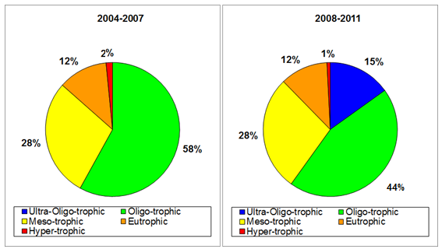
Figure 5. Surface fresh water eutrophication classification during the 2004-2007 and 2008-2011 reporting periods
Saline waters
The assessment of the trophic status of saline waters was carried out using the Trophic Status Assessment Scheme (TSAS) (EPA, 2005). None of the water bodies were found to be eutrophic, with stable trends in the trophic status in 88% of transitional and 100% of coastal waters.
Pressure from agriculture
Compared to the 2004-2007 period, in the period 2008-2011 the area of agricultural land increased, as well as the number of farmers. Animal numbers decreased, with consequent reduced animal manure N production. The application of N from mineral fertilizers slightly decreased as well. The total N discharge to the environment from agriculture declined.
Designation of nitrate vulnerable zones
No nitrates vulnerable zones have been designated in Ireland, since an action programme applies to its whole territory
Code of good agricultural practice
The code of good agricultural practice was first published in 1996. Since 2005 it has been superseded by the action programme applying to the entire territory.
Action programme
The action programme was first published in 2005 and revised in 2006, 2007, 2009 and 2010. The Country is divided into three zones for the purposes of the action programme application. These zones are related to the length of the growing season, climate, soil types and other parameters. The percentage of farmers inspected each year increased from 1% in the period 2004-2007 to 4% in the period 2008-2011.
Member State: Italy
Water quality
 | Monitoring stations with measurements | Monitoring stations with trends
Total groundwater stations | 5331 | 4201
Total fresh surface water stations | 2463 | 1754
Total saline water stations | 582 | 405
Table 1. Number of water monitoring stations.

Groundwater quality
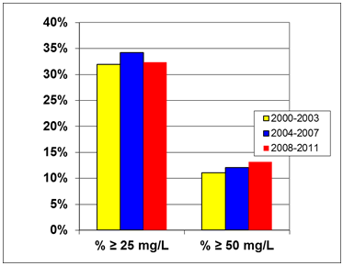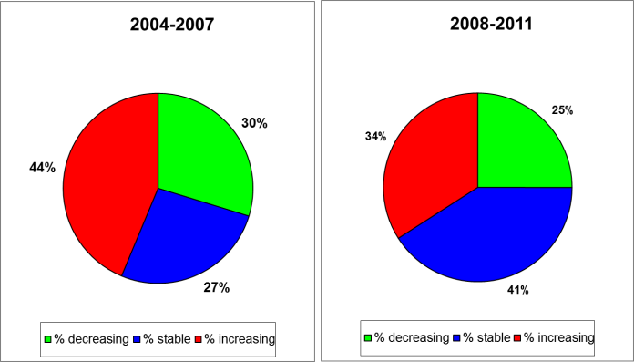
Figure 1. Percentage of groundwater stations exceeding 25 or 50 mg nitrate per L during the reporting periods 2000-2003, 2004-2007 and 2008-2011. Results are presented for all groundwater stations (at different depths). [x-axis: average concentrations of nitrates expressed as mg/l; y-axis: number of monitoring stations, in percentage].
Figure 2. Trends in groundwater nitrate concentrations between the periods 2000-2003 and 2004-2007 (left) and between the periods 2004-2007 and 2008-2011(right).

Surface water quality
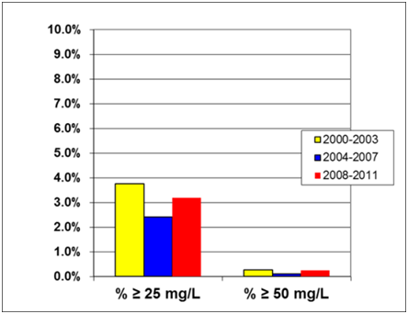 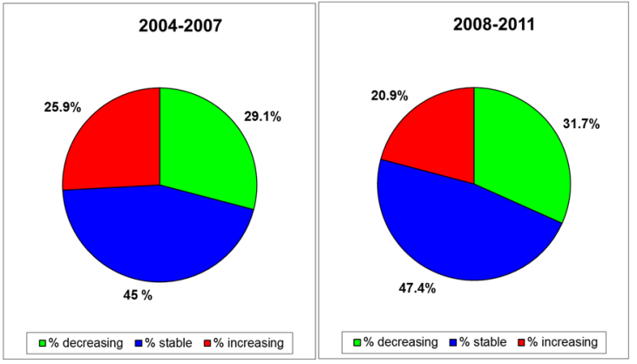
Figure 3. Percentage of surface fresh water stations exceeding 25 or 50 mg nitrate per L during the reporting periods 2000-2003, 2004-2007 and 2008-2011. [x-axis: average concentrations of nitrates expressed as mg/l; y-axis: number of monitoring stations, in percentage]. | Figure 4. Trends in surface fresh waters nitrate concentrations between the periods 2000-2003 and 2004-2007 (left) and between the periods 2004-2007 and 2008-2011 (right).
Eutrophication
Rivers and lakes
To assess the trophic status of rivers and lakes, the type-specific classification developed under the Water Framework Directive was used. In particular, the descriptors LIMeco for rivers and LTLeco for lakes were used. Expert judgment was used to transfer the measured data into the classification system used for the Nitrates Directive.
The majority of rivers and lakes was found to be oligotrophic or ultra-oligotrophic, 16% of them was classified as eutrophic and 4% as hypertrophic.
Saline waters
The trophic status of transitional waters was assessed by means of dissolved inorganic nitrogen and reactive phosphorus. The TRIX (Trophic State Index according to MEDPOL Convention) was used for coastal waters as well as for marine waters. Of all saline waters 61% was classified as oligotrophic, while 2% and 15% as hypertrophic and eutrophic, respectively. No data of previous periods were available for a comparison.
Pressure from agriculture
The pressure from agriculture decreased in the period 2008-2011 as compared to the period 2004-2007, especially regarding the amounts of nitrogen applied chemical fertilizers (-32%). The evolution of animal numbers showed an increase for pigs and poultry and a decrease for cattle.
Designation of nitrate vulnerable zones
Nitrate vulnerable zones cover 13.07% of the total Italian territory, which is slightly higher as compared to the previous reporting period.
Code of good agricultural practice
The code of good agricultural practice (CGAP) was first issued in 1999. Most regions make use of the national code. Exceptions are the Regions Apulia, Sicily and Autonomous Province of Bolzano, which have established regional codes.
Action programme
In total, eighteen action programmes have been established at regional level. Main problems with implementation of the action programme measures concern compliance with closed periods for fertilizers application, application near water courses and on snow covered, frozen and flooded grounds.
Member State: Latvia
Water quality
 | Monitoring stations with measurements | Monitoring stations with trends
Total groundwater stations | 174 | 140
Total fresh surface water stations | 339 | 157
Total saline water stations | 45 | 30
Table 1. Number of water monitoring stations.

Groundwater quality
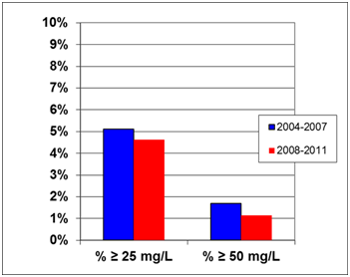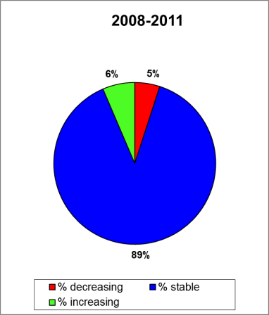
Figure 1. Percentage of groundwater stations exceeding 25 or 50 mg nitrate per L during the reporting periods 2004-2007 and 2008-2011. Results are presented for all groundwater stations (at different depths). [x-axis: average concentrations of nitrates expressed as mg/l; y-axis: number of monitoring stations, in percentage]. No stations exceeded 50 mg nitrate per L in both reporting periods 2004-2007 and 2008-2011. | Figure 2. Trends in groundwater nitrate concentrations between the periods 2004-2007 and 2008-2011

Surface water quality
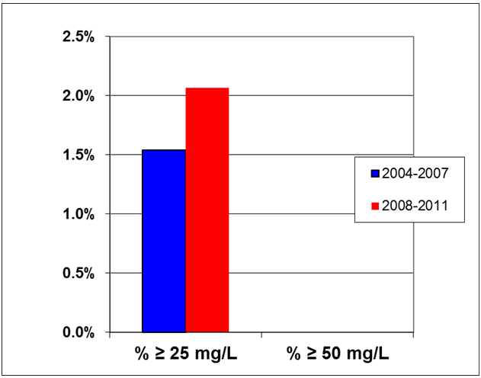 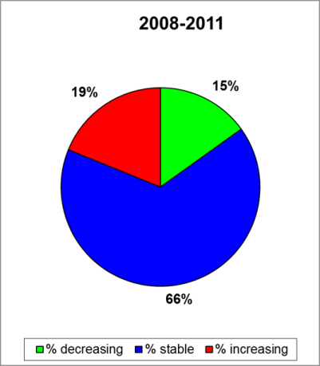
Figure 3. Percentage of surface fresh water stations exceeding 25 or 50 mg nitrate per L during the reporting periods 2004-2007 and 2008-2011. [x-axis: average concentrations of nitrates expressed as mg/l; y-axis: number of monitoring stations, in percentage]. No stations exceeded 50 mg nitrate per L in both reporting periods 2004-2007 and 2008-2011. | Figure 4. Trends in surface fresh water nitrate concentrations between the period 2004-2007 and 2008-2011
Eutrophication
Rivers and lakes
River trophic status was assessed by means of the annual average phosphate concentration, the total phosphorus concentration and the winter average nitrate concentration. In the 2008-2011 period, the concentrations of these parameters corresponding to the different trophic conditions of rivers, differed from those used in the 2004-2007. Therefore, the comparison between reporting periods may be hampered. Lake trophic status was assessed by means of the annual average concentration of total phosphorus, the annual average concentration of total nitrogen, as well as maximum chlorophyll-a concentration during the summer season.
Approximately 13% of surface fresh waters monitoring sites were either eutrophic or hypertrophic. This was mainly related to lakes, where 22% of sites were eutrophic or hypertrophic. The trophic status of fresh waters was stable in the reporting period 2008-2011 compared to 2004-2007.
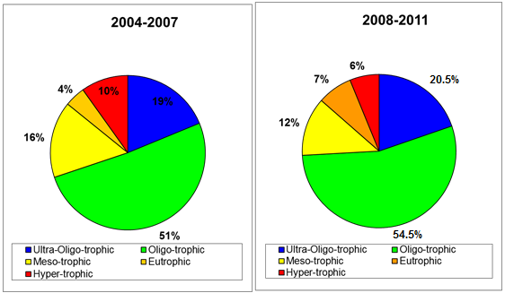
Figure 5. Surface fresh water eutrophication classification during the 2004-2007 and 2008-2011 reporting periods.
Saline waters
Saline waters trophic status was assessed by means of winter nitrate and phosphate concentrations and summer chlorophyll-a concentrations. In the 2008-2011 reporting period, all monitoring sites in saline waters were classified as eutrophic, while in the 2004-2007 reporting period all sites were in mesotrophic status.
Pressure from agriculture
In 2008-2011, a slight expansion of the agricultural area took place and mineral fertilizer use increased as compared to the period 2004-2007. At the same time, the pressure from livestock decreased, due to a reduction in the number of animals. The nitrogen balance was not reported and data on nitrogen discharge were incomplete for the previous period, making a comparison not possible.
Designation of nitrate vulnerable zones
Nitrate vulnerable zones were first designated in 2004 and revised in 2009. They cover a total land area of 8258.7 km², which is 12.8% of the area of Latvia and encompass the largest part of the Lielupe river basin, a small part of the Daugava and Gauja river basins and a minor part of the Venta river basin. In the previous period, the NVZ area was slightly smaller (8173.54 km²).
Code of good agricultural practice
The code of good agricultural practice (CGAP) was first issued in 1999 and revised in 2008. Some of the measures in the new edition of the CGAP are compulsory, but others have been included as voluntary agri-environmental measures in the Rural Development Plan.
Action programme
The action programme was first published in March 2004 and modified in January 2011. Changes related notably to closed periods, maximum nitrogen application rates, application rules on slopes, and temporary manure storage on fields. In the reporting period 2008-2011, between 1.4 and 3.5% of farms were inspected annually. The majority of irregularities were identified in relation to livestock manure storage vessels (identified in 9% of the inspections). Overall, 46.5% to 76.5% of agricultural holdings in the nitrates vulnerable zones were found to be compliant with environmental protection requirements.
Member State: Lithuania
Water quality
 | Monitoring stations with measurements | Monitoring stations with trends
Total groundwater stations | 62 | 62
Total fresh surface water stations | 291 | 69
Total saline water stations | 17 | 17
Table 1. Number of water monitoring stations.
Groundwater quality
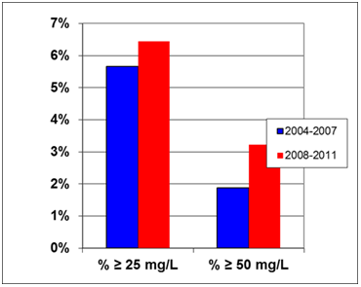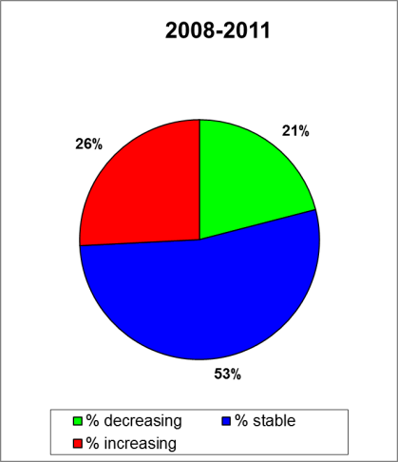
Figure 2. Percentage of groundwater stations exceeding 25 or 50 mg nitrate per L during the reporting periods 2004-2007 and 2008-2011. Results are presented for all groundwater stations (at different depths). [x-axis: average concentrations of nitrates expressed as mg/l; y-axis: number of monitoring stations, in percentage]. | Figure 3. Trends in groundwater nitrate concentrations between the periods 2004-2007 and 2008-2011.
Surface water quality
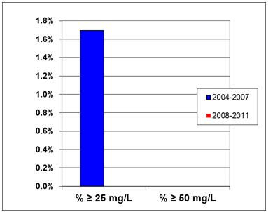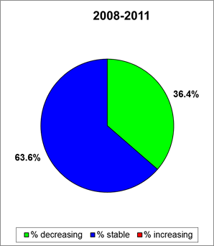
Figure 4. Percentage of surface fresh water stations exceeding 25 or 50 mg nitrate per L during the 2004-2007 and 2008-2011 reporting periods. [x-axis: average concentrations of nitrates expressed as mg/l; y-axis: number of monitoring stations, in percentage]. No stations exceeded 50 mg nitrate per L in both reporting periods 2004-2007 and 2008-2011. | Figure 5. Trends in surface fresh water nitrate concentrations between the periods 2004-2007 and 2008-2011.
Eutrophication
Rivers and lakes
The eutrophication status of surface fresh waters was assessed with chlorophyll-a (Vinberg’s scale). This parameter was measured in four large river monitoring stations, which were all found to be eutrophic, as in the previous reporting period. 46% of the monitored lakes or ponds were eutrophic or hypertrophic, which was nearly similar to the previous reporting period.
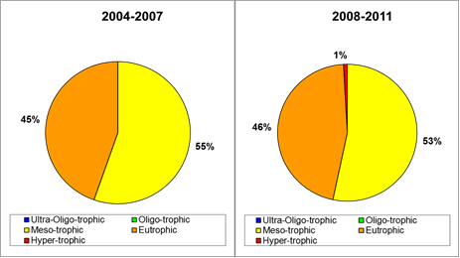
Figure 6. Surface fresh water eutrophication classification during the reporting periods 2004-2007 and 2008-2011.

Saline waters
The eutrophication status of transitional, coastal and open sea waters was assessed by means of chlorophyll-a and nitrate-N concentrations. The report contained information on annual, winter and maximum nitrate-N concentrations and changes compared to 2004-2007 period, as well as chlorophyll-a concentrations. The average summer chlorophyll-a concentrations in the coastal and open sea waters was respectively about 5,78 and 2,83 µg/l. However, the report did not conclude on the eutrophication status of coastal and marine waters.
As regards transitional waters, all of them were found to be eutrophic in the period 2008-2011.
Pressure from agriculture
In the period 2008-2011, the agricultural area remained stable as compared to the period 2004-2007. The number of cattle and pigs decreased, while the number of poultry slightly increased. The use of manure seems to be reduced drastically, but this is partly caused by a new calculation method used for assessing livestock nitrogen excretion. Information on nitrogen inputs from fertiliser and nitrogen discharges to the environment were not reported.
Designation of nitrate vulnerable zones
No nitrates vulnerable zones have been designated in Lithuania, since an action programme applies to its whole territory.
Code of good agricultural practice
Lithuania has implemented the Advanced Farming Rules and Guidelines for all farmers.
Action programme
The action programme was lastly modified in 2008. Much emphasis was laid on improving manure and slurry store facilities, including a minimum storage capacity of six months. Farmers were trained and educated in good agricultural practices improving nutrient efficiency.
Member State: Luxembourg
Water quality
 | Monitoring stations with measurements | Monitoring stations with trends
Total Groundwater stations | 20 | 19
Total Fresh Surface water stations | 16 | 16
Total Saline water stations | Not applicable | Not applicable
Table 1. Number of water monitoring stations
Groundwater quality
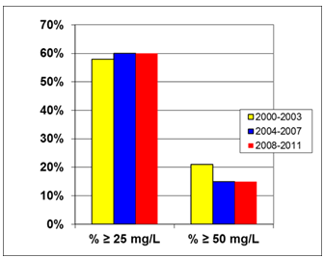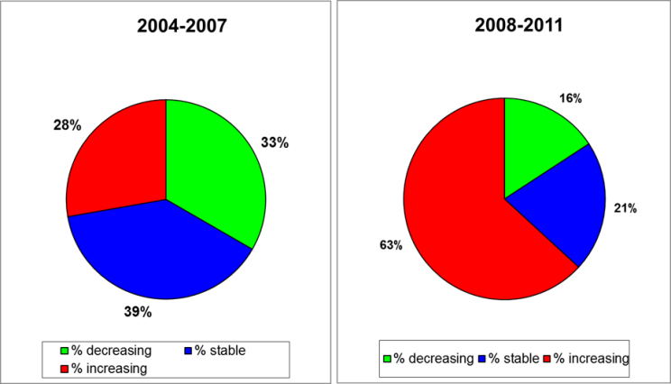
Figure 1. Percentage of groundwater stations exceeding 25 or 50 mg nitrate per L during the reporting periods 2000-2003, 2004-2007 and 2008-2011. Results are presented for all groundwater stations (at different depths). [x-axis: average concentrations of nitrates expressed as mg/l; y-axis: number of monitoring stations, in percentage]. | Figure 2. Trends in groundwater nitrate concentrations between the periods 2000-2003 and 2004-2007 (left) and between the periods 2004-2007 and 2008-2011 (right).
Surface water quality
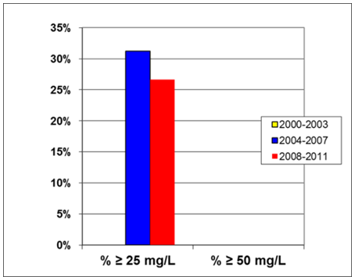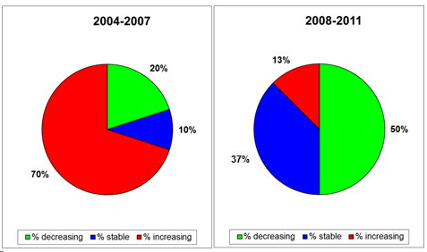
Figure 3. Percentage of surface fresh water stations exceeding 25 or 50 mg nitrate per L on average during the reporting periods 2004-2007 and 2008-2011. [x-axis: average concentrations of nitrates expressed as mg/l; y-axis: number of monitoring stations, in percentage]. No stations exceeded 50 mg nitrate per L in both reporting periods 2004-2007 and 2008-2011 | Figure 4. Trends in surface fresh water nitrate concentrations between the periods 2000-2003 and 2004-2007 (left) and between the periods 2004-2007 and 2008-2011 (right).
Eutrophication
The eutrophication status of fresh waters was assessed by means of nitrate, orthophosphate, total phosphate and chlorophyll-a concentrations, as well as indices based on diatoms and macrophytes. Results for lakes were not included in the report; those for rivers are presented in the figure below.

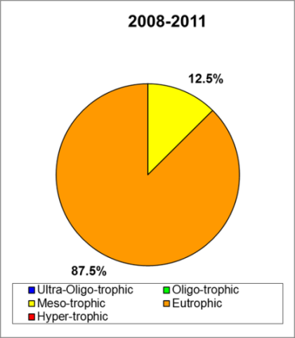
Figure 5. Surface fresh waters (rivers only) eutrophication classification
during the 2008-2011 reporting period
Pressure from agriculture
In 2008-2011, the agricultural area remained similar compared to the previous reporting period. The total nitrogen use from manure remained stable, whereas the use of mineral N decreased. The nitrogen discharge from agriculture decreased by around 7% compared to the previous reporting period.
Designation of nitrate vulnerable zones
No nitrates vulnerable zones have been designated in Luxembourg, since an action programme applies to its whole territory.
Code of good agricultural practice
The code of good agricultural practice was published in 2000.
Action programme
The action programme was first published in 2000 and revised in 2010 and 2012. The latest revision brought some changes in the periods of prohibition of fertilizer application, application of fertilizers on sloping ground and storage capacity requirements.
Due to the implementation of the action programme, a reduction in the use of mineral fertilizer has been observed, as well as an increase in the use of fertilizer plans and an increase in the total storage capacity. Other aspects, such as crop rotations and soil testing have also been developed. Considering controls, a breach to the regulations was found in 34% of the cases. The majority of these breaches related to nitrogen application standards or the maximum allowed amount of organic nitrogen per hectare per year.
Member State: Malta
Water quality
 | Monitoring stations with measurements | Monitoring stations with trends
Total Groundwater stations | 41 | 0
Total Fresh Surface water stations | 7 | 0
Total Saline water stations | 6 | 3
Table 1. Number of water monitoring stations
Groundwater quality
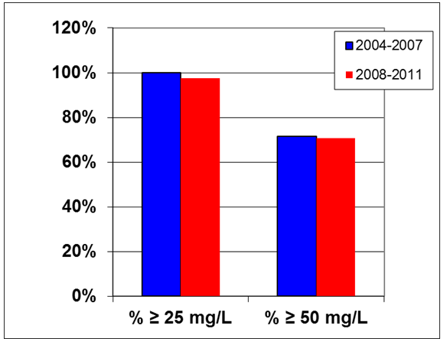
Figure 1. Percentage of groundwater stations exceeding 25 or 50 mg nitrate per L during the reporting periods 2004-2007 and 2008-2011. Results are presented for all groundwater stations (at different depths). [x-axis: average concentrations of nitrates expressed as mg/l; y-axis: number of monitoring stations, in percentage].
Groundwater quality trends were not reported.
Surface water quality
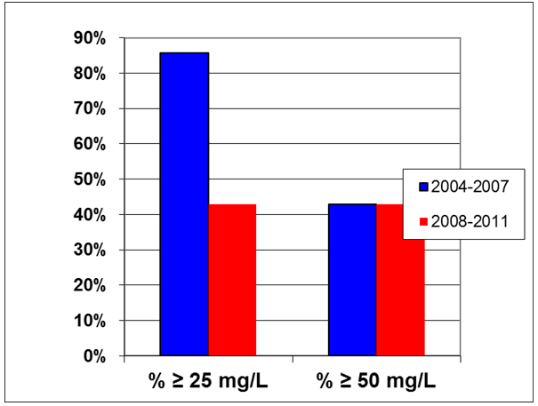
Figure 2. Percentage of surface fresh water stations exceeding 25 or 50 mg nitrate per L during the reporting periods 2004-2007 and 2008-2011. [x-axis: average concentrations of nitrates expressed as mg/l; y-axis: number of monitoring stations, in percentage]. In absence of data for the period 2008-2011, data for 2012 are presented

Surface waters quality trends were not reported.
Eutrophication
Rivers and lakes
The eutrophication status of fresh waters was based on nitrate concentrations. Results are presented in the figure below, for rivers and lakes.
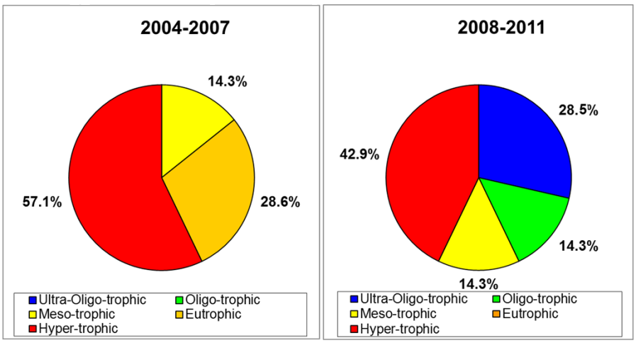
Figure 3. Surface fresh waters eutrophication classification during the reporting periods 2004-2007 and 2008-2011

Saline waters
The assessment of the eutrophication status of transitional waters was based on nitrate concentrations. Coastal waters are assessed with chlorophyll-a, dissolved inorganic nitrogen, total phosphorus and oxygen saturation (TRIX method). Marine sites were not reported. About 76 % of monitored saline sites were found eutrophic.
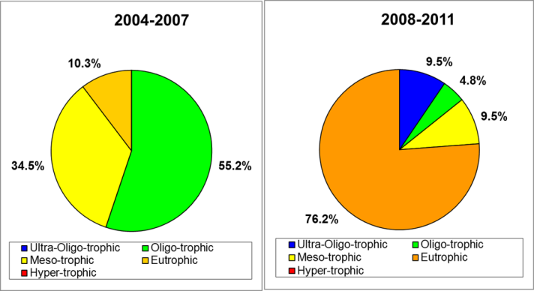
Figure 4. Saline waters water eutrophication classification during the reporting periods 2004-2007 and 2008-2011

Pressure from agriculture
The agricultural area has remained similar compared to the 2004-2007 reporting period. Based on Eurostat data, livestock numbers decreased by 5 to 20%, thus determining a reduction in nitrogen excretion as well. Information on nitrogen balance and nitrogen discharge into the environment were not reported or incomplete, making an assessment of trends not possible.
Designation of nitrate vulnerable zones
No nitrates vulnerable zones have been designated in Malta, since an action programme applies to its whole territory.
Code of good agricultural practice
The code of good agricultural practice was published in 2004.
Action programme
The action programme was first published in 2004 and then revised in 2011. Information and communication campaigns have accompanied the action programme implementation. Approximately 9% of all farmers were inspected during the last reporting period. The highest percentage of non-compliance (82%) was found for record keeping. Implementation of requirements relating to prohibition periods for manure application was also difficult in some cases. Storage volumes have been increasing.
Member State: Netherlands
Water quality
 | Monitoring stations with measurements | Monitoring stations with trends
Total groundwater stations | 1308 | 1247
Total fresh surface water stations | 457 | 266
Total saline water stations | 43 | 4
Table 1. Number of water monitoring stations.
Groundwater quality
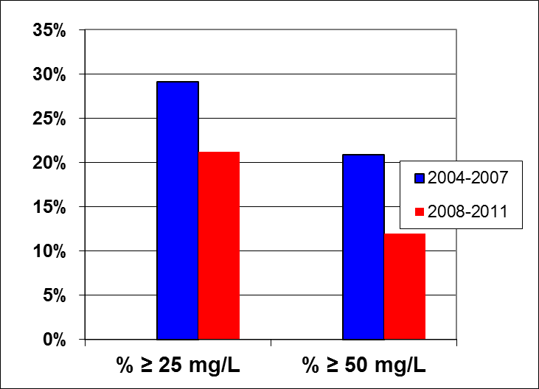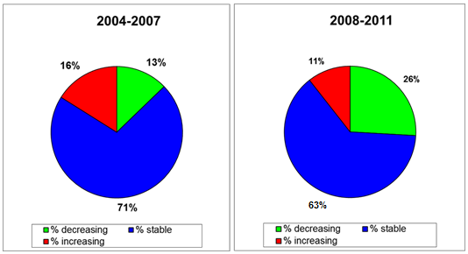
Figure 1. Percentage of groundwater stations exceeding 25 or 50 mg nitrate per L during the reporting periods 2004-2007 and 2008-2011. Results are presented for all groundwater stations (at different depths). [x-axis: average concentrations of nitrates expressed as mg/l; y-axis: number of monitoring stations, in percentage]. | Figure 2. Trends in groundwater nitrate concentrations between the periods 2000-2003 and 2004-2007 (left) and between the periods 2004-2007 and 2008-2011 (right).

Surface water quality
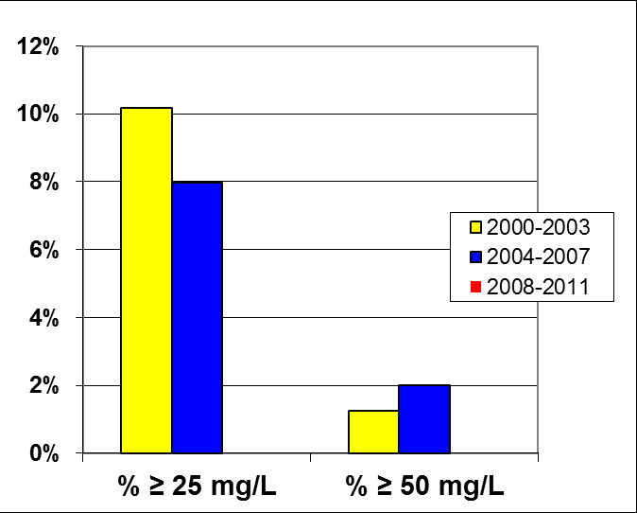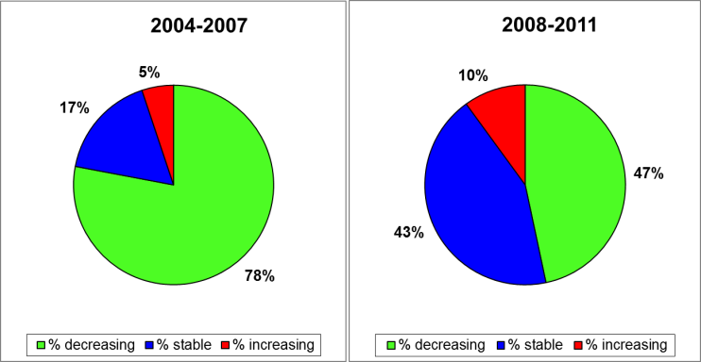
Figure 3. Percentage of surface fresh water stations exceeding 25 or 50 mg nitrate per L during the reporting periods 2000-2003, 2004-2007 and 2008-2011. [x-axis: average concentrations of nitrates expressed as mg/l; y-axis: number of monitoring stations, in percentage]. No stations exceeded 25 mg nitrate per L in the reporting period 2008-2011. | Figure 4. Trends in surface fresh water nitrate concentrations between the periods 2000-2003 and 2004-2007 (left) and between the periods 2004-2007 and 2008-2011 (right).

Eutrophication
In the 2008-2011 reporting period, all fresh and transitional waters were classified as either eutrophic or hypertrophic. The data did not include information on eutrophication for coastal and marine waters. The report, however, presented the chlorophyll-a concentrations for coastal and marine waters.
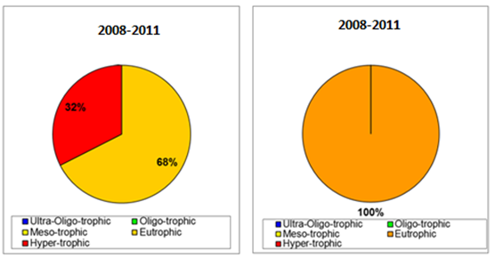
Figure 5. Surface fresh waters (left) and transitional waters (right) eutrophication classification during the reporting period 2008-2011. No data were available for the period 2004-2007.
Pressure from agriculture
The agricultural area decreased slightly due to urban and nature developments. The number of pigs and poultry increased by 7% and 8% respectively, while the number of cattle slightly increased. The use of manure remained at the same level, while the use of mineral fertiliser nitrogen was reduced (-18%). The nitrogen soil surplus decreased. The nitrogen discharge from agriculture to surface water increased, also relative to other sources of nitrogen emission to surface water.
Designation of nitrate vulnerable zones
No nitrates vulnerable zones have been designated in the Netherlands, since an action programme applies to its whole territory.
Code of good agricultural practice
A code of good agricultural practice was introduced in 1993 and is now part of the action programme.
Action programme
The action programme was modified in 2010 through a gradual tightening of the N and P application standards, an increase of the established efficiency coefficients for manure and a larger required storage capacity together with longer closed periods. Administrative checks performed in 2009 showed that 3% of the farms were fined for infringements.
Member State: Poland
Water quality
 | Monitoring stations with measurements | Monitoring stations with trends
Total groundwater stations | 1258 | 1125
Total fresh surface water stations | 2801 | 1579
Total saline water stations | 46 | 22
Table 1. Number of water monitoring stations.
Groundwater quality
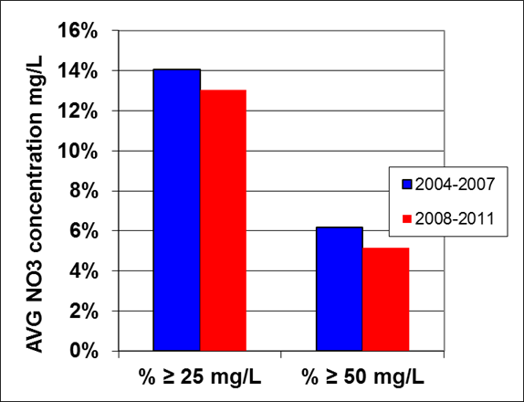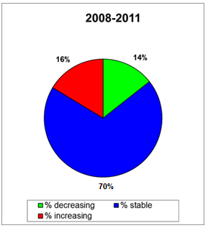
Figure 1. Percentage of groundwater stations exceeding 25 or 50 mg nitrate per L during the reporting periods 2004-2007 and 2008-2011. Results are presented for all groundwater stations (at different depths). [x-axis: average concentrations of nitrates expressed as mg/l; y-axis: number of monitoring stations, in percentage]. No reference year was specified for values reported in 2008-2011 | Figure 2. Trends in groundwater nitrate concentrations between the periods 2004-2007 and 2008-2011.
Surface water quality
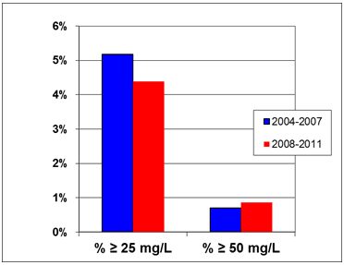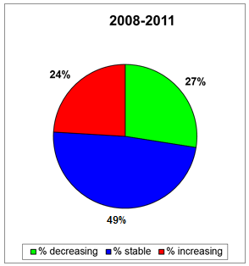
Figure 3. Percentage of surface fresh water stations exceeding 25 or 50 mg nitrate per L during the 2004-2007 and 2008-2011 reporting periods. [x-axis: average concentrations of nitrates expressed as mg/l; y-axis: number of monitoring stations, in percentage]. No reference year was specified for values reported in 2008-2011 | Figure 4. Trends in surface fresh water nitrate concentrations between the periods 2004-2007 and 2008-2011

Eutrophication
Rivers and lakes
The eutrophication status of rivers was assessed with nitrate concentrations, total nitrogen, total phosphate, and chlorophyll-a. The eutrophication status of lakes was assessed with total nitrogen, total phosphate, transparency and chlorophyll-a. Approximately 43% of fresh water sites were eutrophic or hypertrophic. Especially lakes had a high proportion of eutrophic and hypertrophic monitoring sites (86%).
Saline waters
The eutrophication status of transitional and coastal waters was assessed by means of nitrate concentrations, total nitrogen, total phosphate, transparency and chlorophyll-a. In transitional and coastal waters, 26% and 39% of monitoring sites were eutrophic or hypertrophic, respectively. Marine waters were not reported.

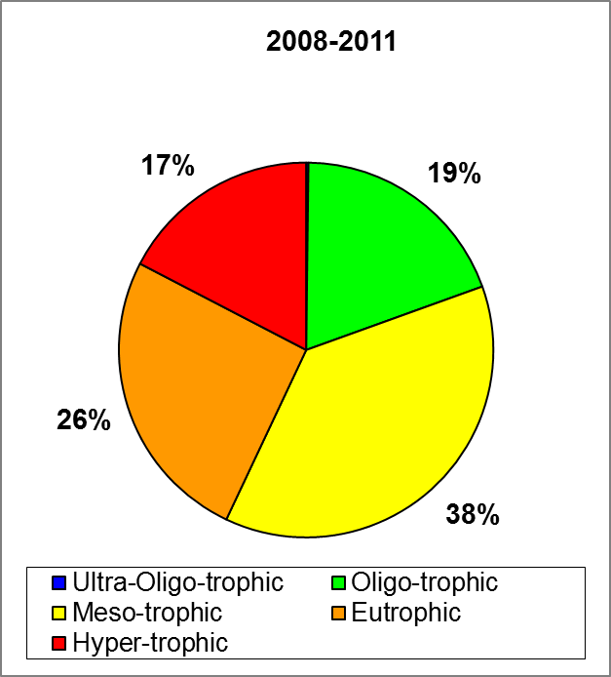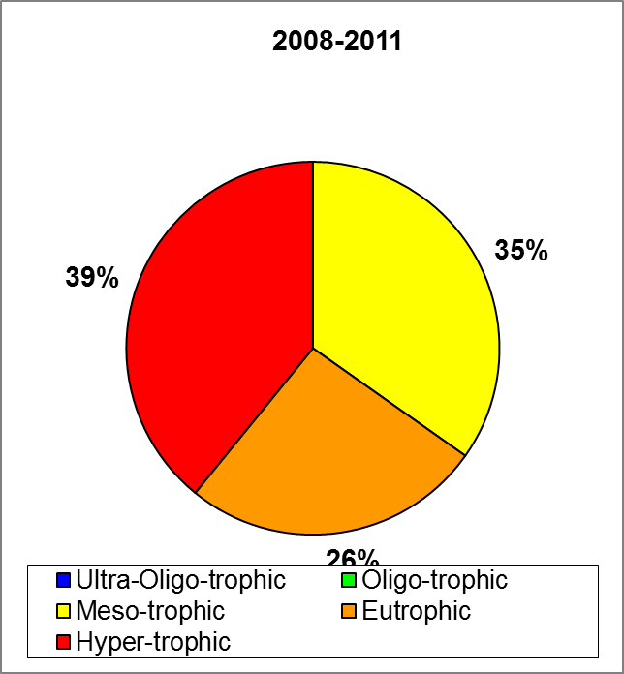
Figure 5. Surface fresh waters (left) and transitional and coastal waters (right) eutrophication classification during the 2008-2011 reporting period (no data for the previous period).
Pressure from agriculture
Agricultural pressure increased from the 2004-2007 to the 2008-2011 reporting period. The agricultural area decreased by 4%. The number of poultry increased significantly by 31%, while the number of pigs decreased by 12%. Cattle increased by 7%, while sheep showed a major decrease of 43%. The annual use of manure and fertilizer showed a small increase. Nitrogen surpluses were stable, but the nitrogen discharge from agriculture increased.
Designation of nitrate vulnerable zones
Poland designated 19 NVZ areas, corresponding to about 1.5% of the total territory in 2008. The NVZ area was reduced by 774 km² compared to the 2004-2007 reporting period. In 2012, Poland designated about 4.5% of its territory.
Code of good agricultural practice
Poland published the code of good agricultural practice in 2002. The last revision took place in 2004.
Action programme
Different action programmes were established in the NVZs. A revision took place in 2008 and then again in 2012. According to the reported information, compliance varied from 12 to 100%, depending on NVZ and measure.
Member State: Portugal
Water quality

 | Monitoring stations with measurements | Monitoring stations with trends
Total Groundwater stations | 657 | 586
Total Fresh Surface water stations | 148 | 110
Total Saline water stations | 55 | 2
Table 1. Number of water monitoring stations.

Groundwater quality
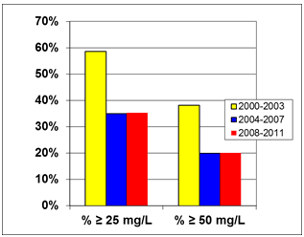 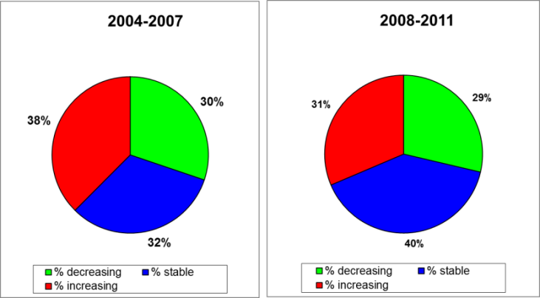
Figure 1. Percentage of groundwater stations exceeding 25 or 50 mg nitrate per L during the reporting periods 2000-2003, 2004-2007 and 2008-2011. Results are presented for all groundwater stations (at different depths). [x-axis: average concentrations of nitrates expressed as mg/l; y-axis: number of monitoring stations, in percentage]. | Figure 2. Trends in groundwater nitrate concentrations between the periods 2000-2003 and 2004-2007 (left) and between the periods 2004-2007 and 2008-2011 (right).

Surface water quality
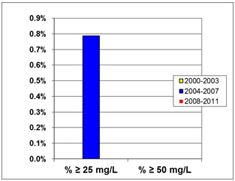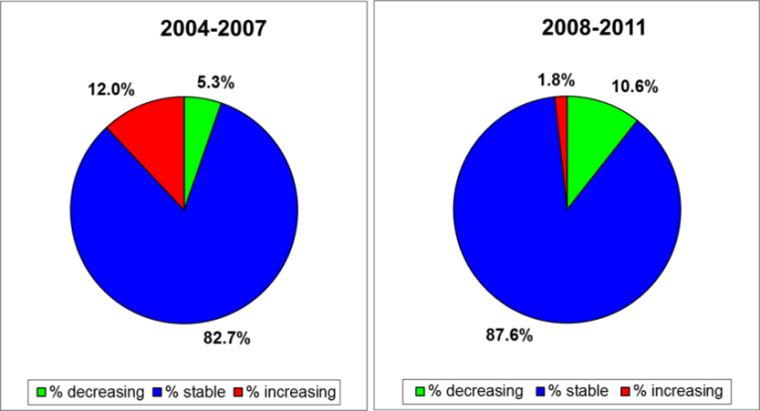
Figure 3. Percentage of surface fresh water stations exceeding 25 or 50 mg nitrate per L during the previous reporting periods 2000-2003, 2004-2007 and 2008-2011. [x-axis: average concentrations of nitrates expressed as mg/l; y-axis: number of monitoring stations, in percentage]. No stations exceeded 50 mg nitrate per L in reporting periods 2000-2003, 2004-2007 and 2008-2011 | Figure 4. Trends in surface fresh water nitrate concentrations between the periods 2000-2003 and 2004-2007 (left) and between the periods 2004-2007 and 2008-2011 (right).
Eutrophication
Rivers and lakes
The eutrophication status of rivers was assessed on the basis of dissolved oxygen, nitrate concentrations and total phosphorus (the worst of these three parameters). The trophic classes were defined differently for the northern and southern rivers, due to difference in calcium carbonate content. The assessment was originally reported as "good" or "less than good" status and later transformed into the classes used for the purposes of the Nitrates Directive (oligotrophic, mesotrophic, eutrophic and hypertrophic).
The eutrophication status of lakes was assessed by means of chlorophyll-a (Carlson index). The percentage of eutrophic water bodies was 4% for rivers and 54% for lakes.

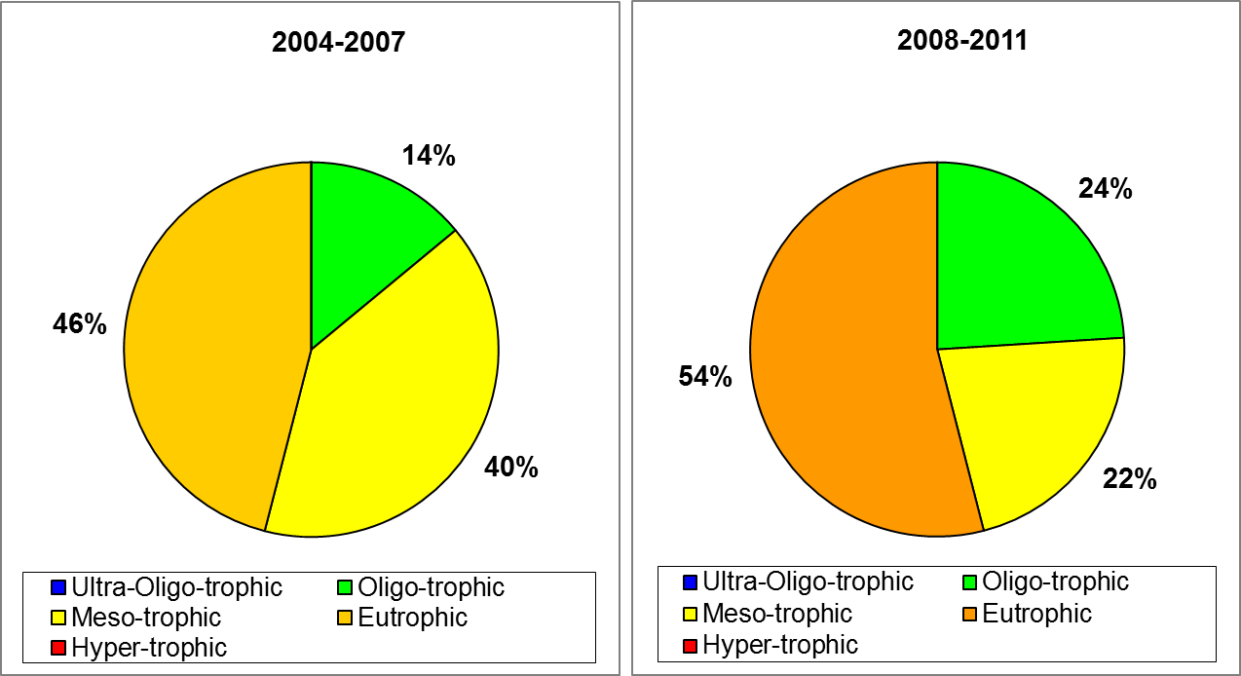
Figure 5. Surface fresh water eutrophication classification during
the 2004-2007 and 2008-2011 reporting periods
Saline waters
No information was presented on the eutrophication status of transitional, coastal and marine waters.
Pressure from agriculture
Land use did not change significantly. Nitrogen use from livestock manure and mineral fertilizer both substantially decreased. The number of pigs decreased by 24%, while the number of poultry increased by 21%. According to reported data, the total N surplus for all nitrates vulnerable zones amounted to -11.8 Mt N for livestock farms and 14.6 Mt N for arable farms. Nitrogen discharge into the environment was not reported in the previous period, making an assessment of the trend not possible.
Designation of nitrate vulnerable zones
At the end of the year 2012, the total NVZ area covered 4046.8 km², or 4.4% of the total territory. Mainland Portugal has nine NVZs (4011 km²) and the Azores Islands have eight NVZs (about 36 km²).
Code of good agricultural practice
Portugal first published a Code of Good Agricultural Practice (CGAP) in 1997, including management of livestock effluents and agricultural sludge recovery. At the time of reporting, the CGAP was under review, focusing on specific aspects such as: proximity to watercourses, effluent and sludge storage facilities, limitation of nitrogen flows, fertilisation plans and application records.
Action programme
In most NVZs, the action programme was first published in 1998 and revised several times until 2010. Several measures were reinforced through the different revisions. As regards controls, the number of farms visited varied from 1% to 26%, depending on the NVZ. The most challenging measures in terms of compliance related to storage capacity (40% of farms were found compliant), rational use of fertilizers (41%) and the 170 Kg/ha/year obligation (43%).
Member State: Romania
Water quality
 | Monitoring stations with measurements | Monitoring stations with trends
Total Groundwater stations | 1805 | 929
Total Fresh Surface water stations | 1116 | 888
Total Saline water stations | 54 | 41
Table 1. Number of water monitoring stations

Groundwater quality
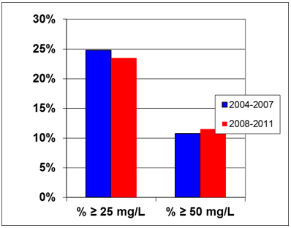 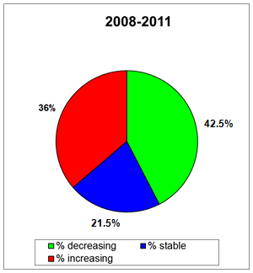
Figure 1. Percentage of groundwater stations exceeding 25 or 50 mg nitrate per L during the reporting periods 2004-2007 and 2008-2011. Results are presented for all groundwater stations (at different depths). [x-axis: average concentrations of nitrates expressed as mg/l; y-axis: number of monitoring stations, in percentage]. | Figure 2. Trends in groundwater nitrate concentrations between the periods 2004-2007 and 2008-2011.
Surface water quality
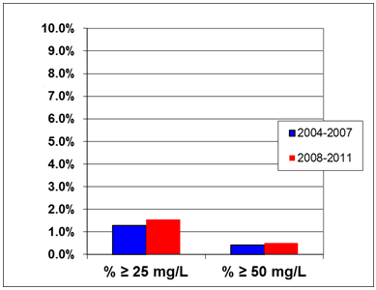 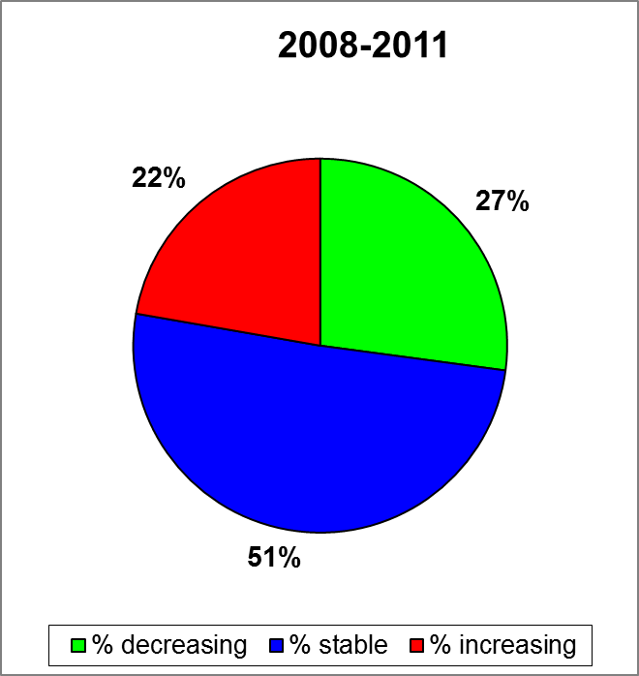
Figure 3. Percentage of surface fresh water stations exceeding 25 or 50 mg nitrate per L during the reporting periods 2004-2007 and 2008-2011. [x-axis: average concentrations of nitrates expressed as mg/l; y-axis: number of monitoring stations, in percentage]. | Figure 4. Trends in surface fresh water nitrate concentrations between the periods 2004-2007 and 2008-2011

Eutrophication
Rivers and Lakes
The trophic status of fresh waters was assessed by means of the following parameters: P-tot, N-tot, PO4, NO3, NO2, Chlorophyll-a, Secchi depth, BOD5, and DO. A detailed description of the threshold values for each parameter was not presented in the report. The trophic status was reported only for lakes.
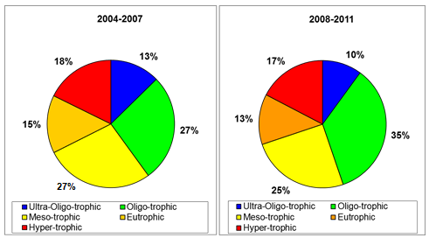
Figure 5. Surface fresh water (lakes only) eutrophication classification during the 2004-2007 and 2008-2011 reporting periods.
Saline Waters
Romania used P-tot, N-tot, PO4, NO3, NO2, Chlorophyll-a, DO and DIN as parameters for determining the trophic status of saline waters. However, no results were presented in the report.
Pressure from agriculture
As compared to the 2004-2007 period, in the 2008-2011 period the pressure from agriculture decreased regarding the numbers of animals, with a significant drop in cattle and pig numbers. The use of organic nitrogen also decreased while the application of mineral fertilizers increased. The N-balance in most NVZ areas was below 15 kg N per ha. The total N discharge from agriculture decreased.
Designation of nitrate vulnerable zones
Nitrate vulnerable zones were first designated in 2005 and then revised in 2008 and brought to a total area of 137803.8 km² (representing about 58% of the country).
Code of good agricultural practice
The code of good agricultural practice was first issued in 2003 and then revised in 2005. No changes were made in the 2008-2011 period.
Action programme
The action programme was first published in 2000 and then revised in 2010. New elements in the latest revision concerned the period of prohibition of manure application, the requirements for balanced fertilization, the rules for application of fertilizers in the proximity of water courses and on slopes, measures for crop rotation and keeping of records. 0.14% of the total number of farmers were visited in the reporting period. The degree of compliance depended on the measure. Notably, an average of 77.5% farmers within NVZ were compliant to requirements on storage capacity. Some difficulties in the implementation of the action programme related to lack of funds and lack of technical equipment and expertise, especially in small and medium-sized farms.
Member State: Slovakia
Water quality
 | Monitoring stations with measurements | Monitoring stations with trends
Total groundwater stations | 1717 | 681
Total fresh surface water stations | 852 | 236
Total saline water stations | Not applicable | Not applicable
Table 1. Number of water monitoring stations.

Groundwater quality
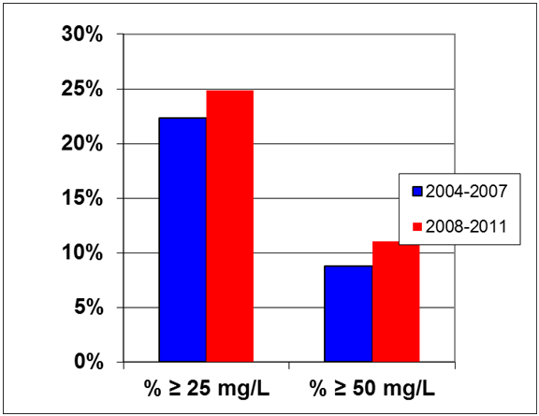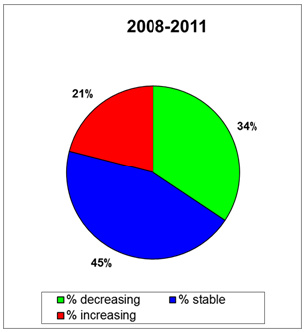
Figure 1. Percentage of groundwater stations exceeding 25 or 50 mg nitrate per L during the reporting periods 2004-2007 and 2008-2011. Results are presented for all groundwater stations (at different depths). [x-axis: average concentrations of nitrates expressed as mg/l; y-axis: number of monitoring stations, in percentage]. Comparability between the two periods might be hampered due to a substantial change in the monitoring network | Figure 2. Trends in groundwater nitrate concentrations between the periods 2004-2007 and 2008-2011
Surface water quality
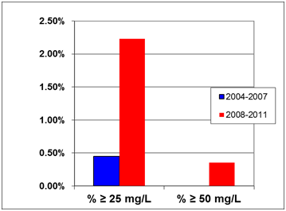 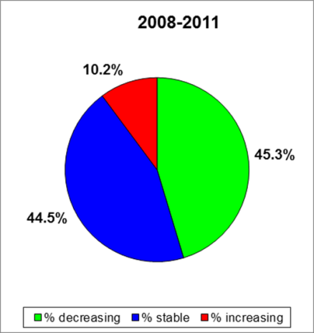
Figure 3. Percentage of surface fresh water stations exceeding 25 or 50 mg nitrate per L during the periods 2004-2007 and 2008-2011. In lakes, no stations exceeded 25 mg nitrates per L. [x-axis: average concentrations of nitrates expressed as mg/l; y-axis: number of monitoring stations, in percentage]. | Figure 4. Trends in surface fresh water (rivers only) nitrate concentrations between the period 2004-2007 and 2008-2011. Trends for lakes were not reported.
Eutrophication
The eutrophication status of rivers was assessed by means of chlorophyll-a, nitrate concentrations, orthophosphate and total phosphate concentrations. In lakes, total phosphate, chlorophyll-a and transparency were used.
Approximately 37% of fresh waters monitoring sites were either eutrophic or hypertrophic. This is mainly related to lakes, including reservoirs, where 88% of sites were eutrophic or hypertrophic. A direct comparison between the periods 2004-2007 and 2008-2011 is not possible for several reasons, including the fact that the 2004-2007 analysis only included 49 monitoring sites, while the 2008-2011 one was based on data from 398 monitoring sites.
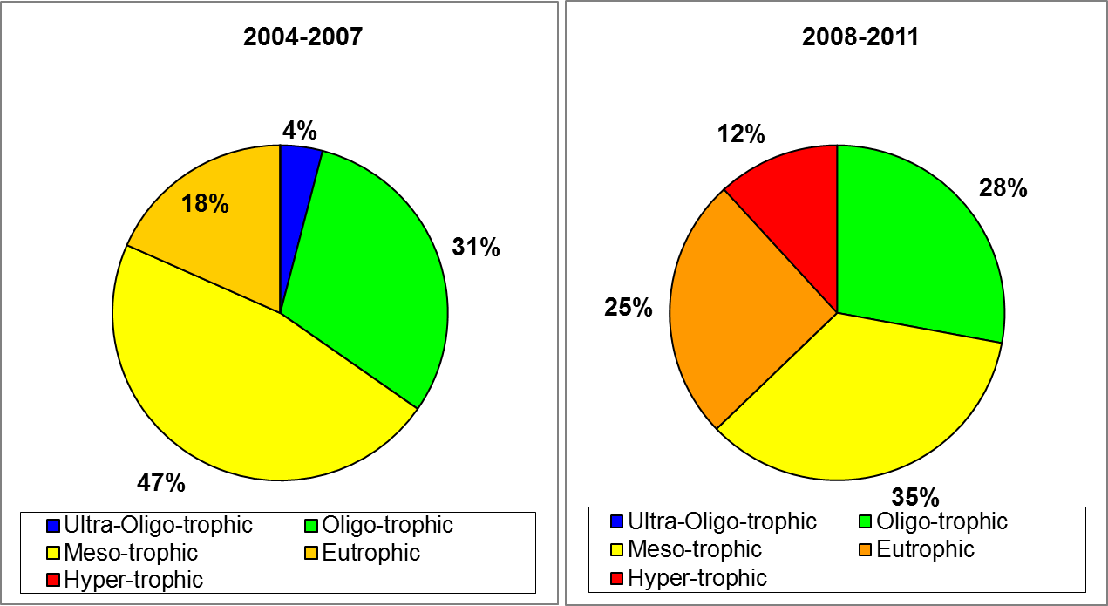
Figure 5. Surface fresh water eutrophication classification during the periods 2004-2007 and 2008-2011.

Pressure from agriculture
The nitrogen surplus in nitrate vulnerable zone was relatively low, being estimated at 14 kg N/ha in 2008-2011 and 2 kg N/ha in 2004-2007. Slightly increasing agricultural pressures were due the growth of mineral fertilizer use. At the same time, the pressure from livestock decreased, due to a reduction in the number of animals, especially pigs by 45%.

Designation of nitrate vulnerable zones
Nitrate vulnerable zones were first designated in 2003. In 2012, they covered a total land area of 14.622 km², which was 29.8 % of the territory of Slovakia.

Code of good agricultural practice
The code of good agricultural practice (CGAP) was issued in 2001 and never revised. It is estimated that approximately 30% of farmers outside nitrates vulnerable zones apply measures of the CGAP.

Action programme
The action programme was first published in 2004 and modified in 2008 and 2011. The action programme measures are differentiated in the three regions having low, medium and high level of farming restriction. These regions were defined based on soil, soil, hydrology, geography, and environmental parameters. As regards controls, in the reporting period 2008-2011, 98% to 100% of controlled farms were compliant with the action programme measures.
Member State: Slovenia
Water quality
 | Monitoring stations with measurements | Monitoring stations with trends
Total Groundwater stations | 104 | 104
Total Fresh Surface water stations | 139 | 109
Total Saline water stations | 5 | 5
Table 1. Number of water monitoring stations.

Groundwater quality
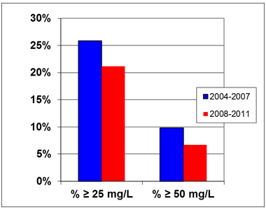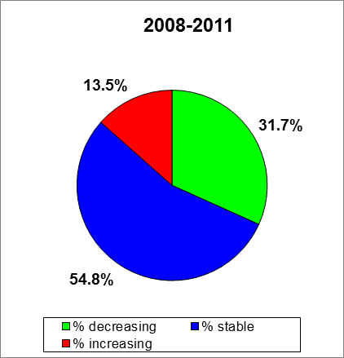
Figure 1. Percentage of groundwater stations exceeding 25 or 50 mg nitrate per L during the reporting periods 2004-2007 and 2008-2011. Results are presented for all groundwater stations (at different depths). [x-axis: average concentrations of nitrates expressed as mg/l; y-axis: number of monitoring stations, in percentage]. | Figure 2. Trends in groundwater nitrate concentrations between the periods 2004-2007 and 2008-2011.
Surface water quality
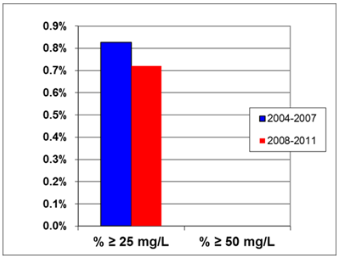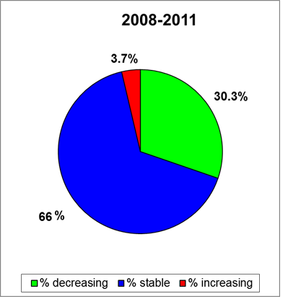
Figure 3. Percentage of surface fresh water stations exceeding 25 or 50 mg nitrate per L during the 2004-2007 and 2008-2011 reporting periods. [x-axis: average concentrations of nitrates expressed as mg/l; y-axis: number of monitoring stations, in percentage]. No stations exceeded 50 mg nitrate per L in both reporting periods 2004-2007 and 2008-2011 |  | Figure 4. Trends in surface fresh water nitrate concentrations between the periods 2004-2007 and 2008-2011

Eutrophication
Rivers and lakes
The eutrophication status of rivers is assessed by means of nitrate concentrations, phytobenthos and macrophytes. The eutrophication of lakes is assessed by means of phytoplankton biomass, average annual total phosphorus content, average annual nitrogen content, average annual and minimum transparency depth, and average annual and maximum chlorophyll content. Approximately 4% of fresh waters monitoring sites are either eutrophic or hypertrophic. This is mainly caused by lakes, of which 41.7% of sites were eutrophic or hypertrophic. No comparison is possible between the two reporting periods for rivers, as no data were reported in 2004-2007. As regards lakes, less monitoring sites were found in hypertrophic status.
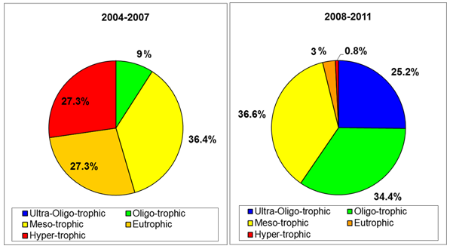
Figure 5. Surface fresh water eutrophication classification (left: period 2004-2007 (lakes only); right: period 2008-2011 (rivers and lakes).
Saline waters
The trophic status of coastal waters was assessed by means of chlorophyll-a content. All monitoring sites in coastal waters were ultra-oligotrophic. No data were reported for transitional and marine waters.
Pressure from agriculture
The agricultural area remained nearly similar as compared to the 2004-2007 reporting period. The number of pigs decreased by 27%, while the number of poultry increased by 30%. The use of manure and mineral fertilizer decreased by 3% and 10%, respectively.
Designation of nitrate vulnerable zones
No nitrates vulnerable zones have been designated in Slovenia, since an action programme applies to its whole territory.
Code of good agricultural practice
The code of good agricultural practice is included in the action programme and applies to all farmers.

Action programme
The action programme was first published in 2008 and modified in 2009. Farmers are trained and educated in good agricultural practices that improve nutrient efficiency. Controls were carried out, but exact data on non-compliance were not reported. In the 2008–2011 period, the agricultural inspectorate conducted 3346 inspections, giving an average of 837 inspections per year.

Member State: Spain
Water quality

 | Monitoring stations with measurements | Monitoring stations with trends
Total groundwater stations | 4770 | 2644
Total fresh surface water stations | 3733 | 2072
Total marine water stations | 631 | 629
Table 1. Number of water monitoring stations.

Groundwater quality
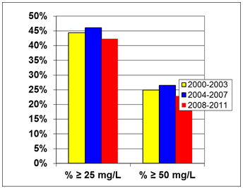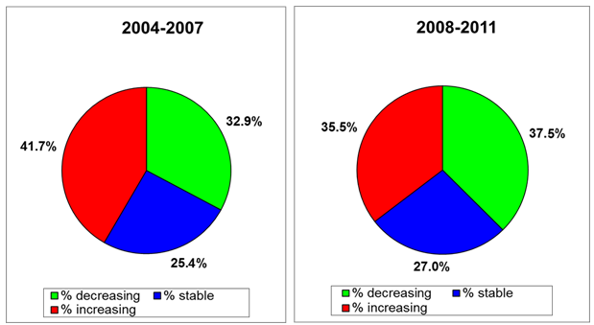
Figure 1. Percentage of groundwater stations exceeding 25 or 50 mg nitrate per L during the reporting periods 2000-2003, 2004-2007 and 2008-2011. Results are presented for all groundwater stations (at different depths). [x-axis: average concentrations of nitrates expressed as mg/l; y-axis: number of monitoring stations, in percentage] | Figure 2. Trends in groundwater nitrate concentrations between the periods 2000-2003 and 2004-2007 (left) and between the periods 2004-2007 and 2008-2011 (right).

Surface water quality
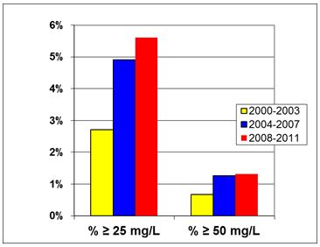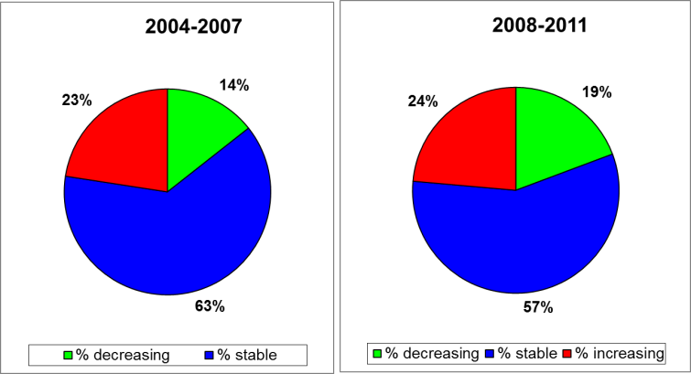
Figure 3. Percentage of surface fresh water stations exceeding 25 or 50 mg nitrate per L during the reporting periods 2000-2003, 2004-2007 and 2008-2011. [x-axis: average concentrations of nitrates expressed as mg/l; y-axis: number of monitoring stations, in percentage]. | Figure 4. Trends in surface fresh water nitrate concentrations between the periods 2000-2003 and 2004-2007 (left) and between the periods 2004-2007 and 2008-2011(right)

Eutrophication
Rivers and lakes
Spain used the following parameters to establish eutrophication for rivers and lakes: BOD-5, Chlorophyll-a, DO, NO2, NO3, N-tot, P-tot and Secchi depth. For fresh water the trophic status improved with an increase percentage of ultra-oligotrophic and oligotrophic stations and a decrease of the percentage of mesotrophic, eutrophic and hypertrophic stations.
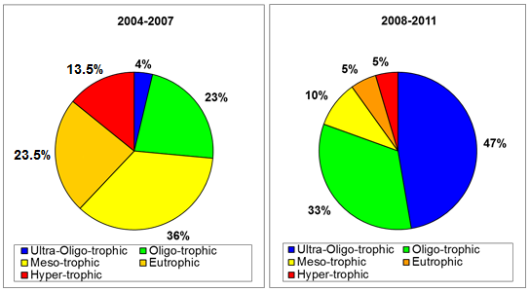
Figure 5. Surface fresh water eutrophication classification during the 2004-2007 and 2008-2011 reporting periods
Saline waters
Spain used the following parameters to establish eutrophication for saline waters: Chlorophyll-a, DIN, DIP, NO2, NO3, N-tot, P-tot and Secchi depth. In transitional and coastal waters the percentage of ultra-oligotrophic increased as well as eutrophic stations. In the period 2008-2011, no marine stations were reported. In the period 2004-2007, only 4 marine stations were reported.
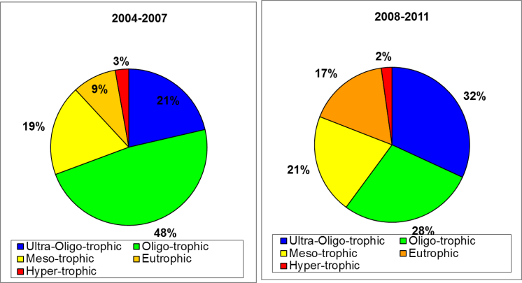
Figure 6. Transitional and coastal eutrophication classification during the 2004-2007 and 2008-2011 reporting periods
Pressure from agriculture
The pressure from agriculture decreased regarding the numbers of animals, animal manure use and the nitrogen balance. No conclusions regarding the N discharge into the environment can be made due to a lack of results on a national scale.
Designation of nitrate vulnerable zones
There have been changes regarding vulnerable zones in several autonomous communities in the years 2008-2011: Andalusia, Aragon, the Balearic Islands, Castile-La-Mancha, Castile-Leon, Catalonia, Rioja, Madrid, Murcia, Navarre, the Basque Country and Valencia. The total NVZ area covers 16.15% of the Spanish territory.

Code of good agricultural practice
During the 2008-2011 reporting period, the Codes of Good Agricultural Practice were revised in Castile-Leon (2009), Catalonia (2009), Basque Country (2010) and Valencia (2011).
Action programme
The dates of first publication and revisions vary for different autonomous regions. On a regional scale, the percentage of farmers visited each year is around 1%. Most farmers comply with the measures, but in certain regions manure storage capacity and the respect of the 170 kg N from manure limit are insufficient.
Member State: Sweden
Water quality
 | Monitoring stations with measurements | Monitoring stations with trends
Total groundwater stations | 326 | 0*
Total fresh surface water stations | 2455 | 0*
Total saline water stations | 235 | 0*
*Sweden reported trends on groundwater stations, fresh surface water stations and saline mater stations for longer periods than 4 years, only in the written report.

Table 1. Number of water monitoring stations.

Groundwater quality

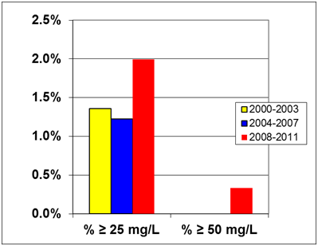
Figure 1. Percentage of groundwater stations exceeding 25 or 50 mg nitrate per L during the reporting periods 2000-2003, 2004-2007 and 2008-2011. Results are presented for all groundwater stations (at different depths). [x-axis: average concentrations of nitrates expressed as mg/l; y-axis: number of monitoring stations, in percentage]. No stations exceeded 50 mg per L in the reporting periods 2000-2003 and 2004-2007
Sweden provided no data regarding trends of nitrate in groundwater as compared to the previous reporting period 2004-2007 but only a long term trend analysis, which showed that, during the last three reporting periods, groundwater quality was stable in most stations. However, during the period 2001-2010, a small upward trend was found in a number of them.
Surface water quality
None of the fresh surface water measuring stations showed nitrate concentrations exceeding 25 mg/L. The long term trend analysis showed that, in the last 20 years, the nitrate concentration decreased by two-thirds. Regarding phosphate, water quality was found to be stable in most of the lakes.
Almost all stations in transitional, coastal and marine stations showed winter average nitrate values below 2 mg /L.
Eutrophication
Rivers and lakes
The eutrophication status of rivers and lakes was assessed using total N, total P and nitrates concentrations. Based on digitally provided data, which used total P for the classification, 42% of the rivers were classified as oligotrophic, 23% as mesotrophic, 32% as eutrophic and 4% as hypertrophic. For lakes these figures were 60%, 26%, 13% and 1%, respectively.

Saline waters
As regards the trophic status of marine waters, the Skagerrak deep-sea areas and Gulf of Bothnia were classified in good status; the Bothnian Sea in good/moderate status; the Skagerrak coastal areas and Kattegat deep-sea areas in moderate status; the Kattegat coastal areas in unsatisfactory/moderate status and the Baltic Proper in unsatisfactory status.
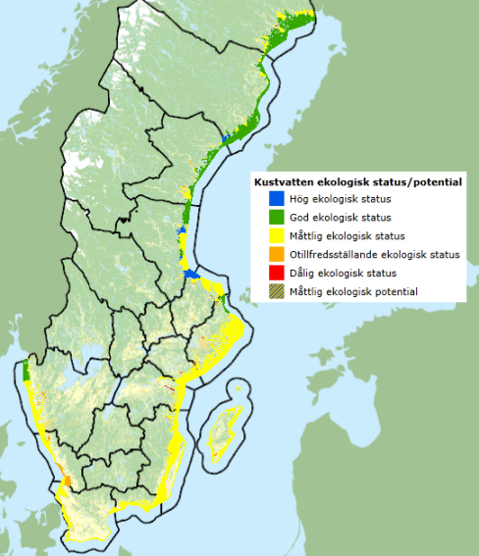
Figure 2. The quality status of coastal and marine waters in Sweden
Pressure from agriculture
The pressure from agriculture increased with respect to animal manure application, while the mineral fertilizer use decreased, leading to a reduction of the average nitrogen surplus by nearly 50% in 2009 as compared to 1995, when it was 58 kg N/ha. For holdings with more than 1 livestock unit per ha, an average N surplus of c.a. 65 kg N per ha was reported. In some areas the surplus decreased (e.g. Götaland southern plains) while in others it increased (e.g. Götaland central districts). The load of N to the sea kept fluctuating around 10000 tonnes per year and slightly increased in 2009 as compared to 2005. In the same period, the load of nitrogen to the sea from urban waste water increased by 4%, whereas the industrial load decreased by 19%.
Designation of nitrate vulnerable zones
Nitrate vulnerable zones were first designated in 1995 and revised in 2002, 2003 and lastly in 2011. In 2012, they covered approximately 50 % of the total agricultural land area in Sweden, corresponding to about 22% of the total land area.
Code of good agricultural practice
The code of good agricultural practice was issued in 2007 and revised several times, as part of the regulation SJVFS 2004:62.
Action programme
The action programme was first published in 1999 and modified several times, also in relation to the extension of the NVZ areas. The checks performed both inside and outside vulnerable zones showed that approximately 10% of the farmers were non-compliant regarding manure storage and less than 1% regarding stocking density and application of manure.
Member State: United Kingdom
Water quality
 | Monitoring stations with measurements | Monitoring stations with trends
Total Groundwater stations | 2533 (England) + 317 (Scotland) + 180 (Wales) + 58 (Northern Ireland) | 1998 (England) + 132 (Scotland) + 180 (Wales) + 13 (Northern Ireland)
Total Fresh Surface water stations | 5273 (England) + 311 (Scotland) + 1172 (Wales) + 621 (Northern Ireland) | 4519 (England) + 227 (Scotland) + 846 (Wales) + 555 (Northern Ireland)
Total Saline water stations | 638 (England) + 171 (Scotland) + 129 (Wales) + 126 (Northern Ireland) | 385 (England) + 54 (Scotland) + 74 (Wales) + 0* (Northern Ireland)
* Aggregated data on trends were reported only in the written report

Table 1. Number of water monitoring stations

Groundwater quality

ENGLAND
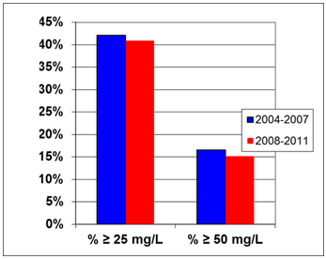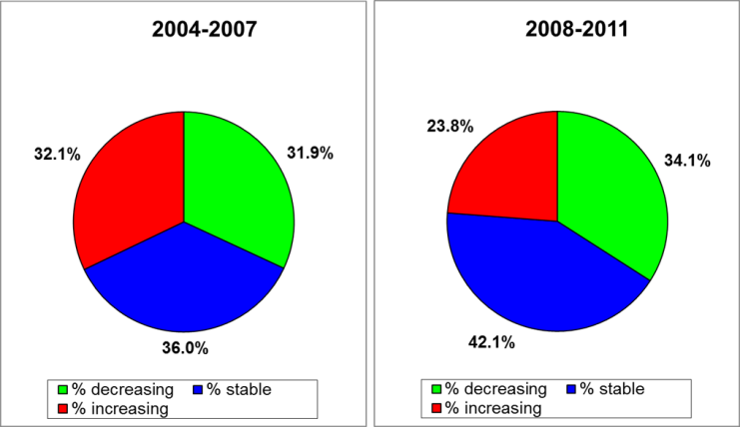
Figure 1. Percentage of groundwater stations exceeding 25 or 50 mg nitrate per L during the reporting periods 2004-2007 and 2008-2011. Results are presented for all groundwater stations (at different depths). [x-axis: average concentrations of nitrates expressed as mg/l; y-axis: number of monitoring stations, in percentage]. | Figure 2. Trends in groundwater nitrate concentrations between the periods 2000-2003 and 2004-2007 (left) and between the periods 2004-2007 and 2008-2011 (right).
SCOTLAND
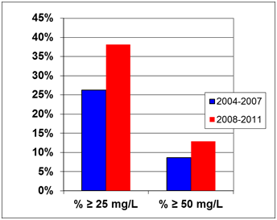 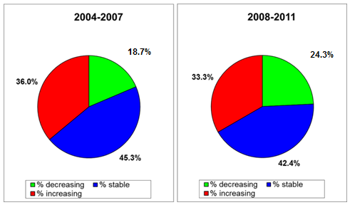
Figure 3. Percentage of groundwater stations exceeding 25 or 50 mg nitrate per L during the reporting periods 2004-2007 and 2008-2011. Results are presented for all groundwater stations (at different depths). [x-axis: average concentrations of nitrates expressed as mg/l; y-axis: number of monitoring stations, in percentage]. | Figure 4. Trends in groundwater nitrate concentrations between the 2000-2003 and 2004-2007 (left) and between the periods 2004-2007 and 2008-2011 (right).
WALES
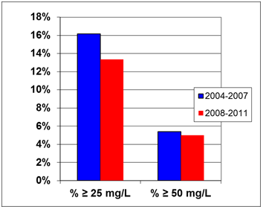 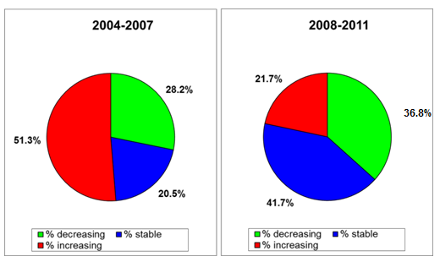
Figure 5. Percentage of groundwater stations exceeding 25 or 50 mg nitrate per L during the reporting periods 2004-2007 and 2008-2011. Results are presented for all groundwater stations (at different depths). [x-axis: average concentrations of nitrates expressed as mg/l; y-axis: number of monitoring stations, in percentage]. | Figure 6. Trends in groundwater nitrate concentrations between the periods 2000-2003 and 2004-2007 (left) and between the periods 2004-2007 and 2008-2011 (right).
NORTHERN IRELAND
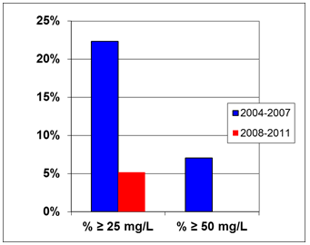 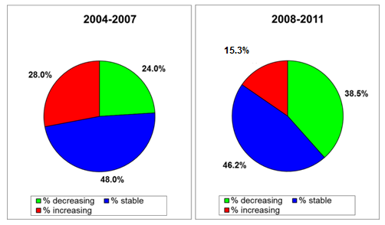
Figure 7. Percentage of groundwater stations exceeding 25 or 50 mg nitrate per L during the reporting periods 2004-2007 and 2008-2011. Results are presented for all groundwater stations (at different depths). [x-axis: average concentrations of nitrates expressed as mg/l; y-axis: number of monitoring stations, in percentage]. No stations exceeded 50 mg per L in the reporting period 2008-2011. | Figure 8. Trends in groundwater nitrate concentrations between the periods 2000-2003 and 2004-2007 (left) and between the periods 2004-2007 and 2008-2011 (right).

Surface water quality
ENGLAND
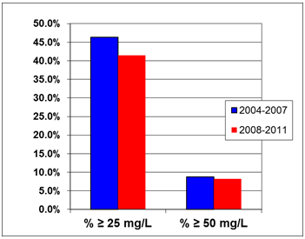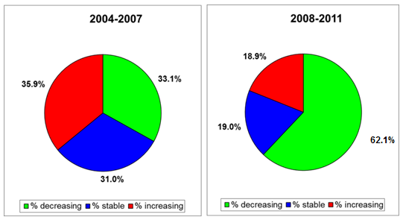
Figure 9. Percentage of surface fresh water stations exceeding 25 or 50 mg nitrate per L during the 2004-2007 and 2008-2011 reporting periods. [x-axis: average concentrations of nitrates expressed as mg/l; y-axis: number of monitoring stations, in percentage]. | Figure 10. Trends in surface fresh water nitrate concentrations between the periods 2000-2003 and 2004-2007 (left) and between the periods 2004-2007 and 2008-2011 (right).
SCOTLAND

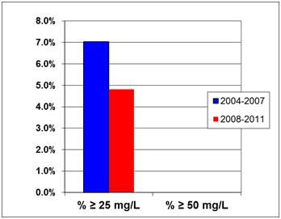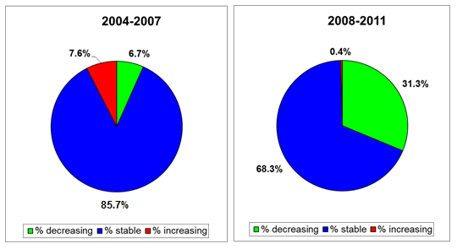
Figure 11. Percentage of surface fresh water stations exceeding 25 or 50 mg nitrate per L during the 2004-2007 and 2008-2011 reporting periods. [x-axis: average concentrations of nitrates expressed as mg/l; y-axis: number of monitoring stations, in percentage]. No stations exceeded 50 mg per L in both reporting periods 2004-2007 and 2008-2011. | Figure 12. Trends in surface fresh water nitrate concentrations between the periods 2000-2003 and 2004-2007 (left) and between the periods 2004-2007 and 2008-2011 (right).

WALES
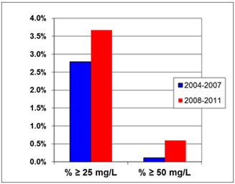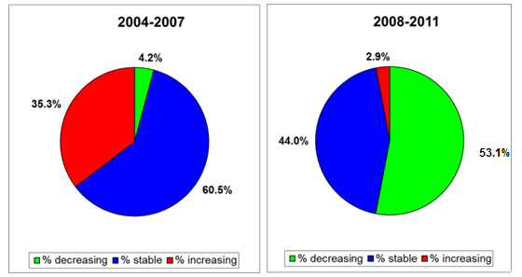
Figure 13. Percentage of surface fresh water stations exceeding 25 or 50 mg nitrate per L during the 2004-2007 and 2008-2011 reporting periods. [x-axis: average concentrations of nitrates expressed as mg/l; y-axis: number of monitoring stations, in percentage]. | Figure 14. Trends in surface fresh water nitrate concentrations between the periods 2000-2003 and 2004-2007 (left) and between the periods 2004-2007 and 2008-2011 (right).
NORTHERN IRELAND

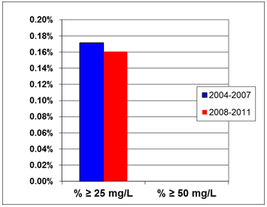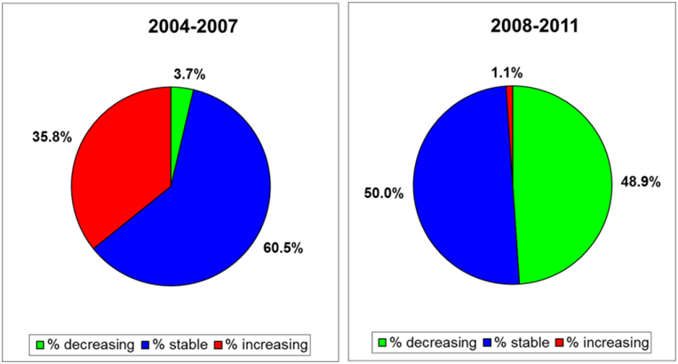
Figure 15. Percentage of surface fresh water stations exceeding 25 or 50 mg nitrate per L during the reporting periods 2004-2007 and 2008-2011. [x-axis: average concentrations of nitrates expressed as mg/l; y-axis: number of monitoring stations, in percentage]. No stations exceeded 50 mg per L in both reporting periods 2004-2007 and 2008-2011 | Figure 16. Trends in surface fresh water nitrate concentrations between the periods 2000-2003 and 2004-2007 (left) and between the periods 2004-2007 and 2008-2011 (right).

Eutrophication
Rivers and Lakes
The parameters considered for the assessment of the trophic status of fresh waters were the following: i) England and Wales: chlorophyll-a and orthophosphate concentrations; ii) Scotland: total P, chlorophyll-a and bio-indicators; iii) Northern Ireland: soluble reactive phosphorus, diatoms and macrophytes for rivers; total P, chlorophyll-a, diatoms and macrophytes for lakes.
England, Scotland, Wales presented results based on an expert review group and following the classification of the Water Framework Directive (WFD). In order to identify waters that are eutrophic or that in the near future may become eutrophic if preventive action is not taken, the review group considered the current condition of the water body, the presence of any undesirable effects (e.g. deoxygenation, algal blooms, etc.) and whether N is involved in causing (or being likely to cause) such phenomena. Northern Ireland also carried out a WFD assessment of the trophic status of water bodies, however also proposed a classification following the Nitrates Directive reporting guidelines, summarized in the figure below. Overall, 38 freshwater bodies were identified as eutrophic or likely to become so in England and Wales, no water bodies were identified in Scotland and 11 catchments in Northern Ireland.
Saline waters
The trophic status of marine waters was not reported. For transitional and coastal waters, England, Scotland and Wales adopted the same approach described for freshwaters. Northern Ireland assessed the trophic status based on the following parameters: dissolved inorganic N, dissolved oxygen, chlorophyll-a and macro-algae. 7 sites were identified as eutrophic or likely to become so in England and Wales, 1 in Scotland and 6 catchments in Northern Ireland. Northern Ireland also classified the monitored sites according to the Nitrates Directive reporting guidelines, as shown in the figure below.
NORTHERN IRELAND

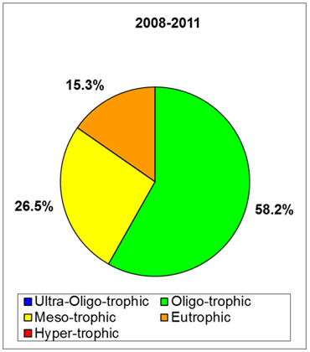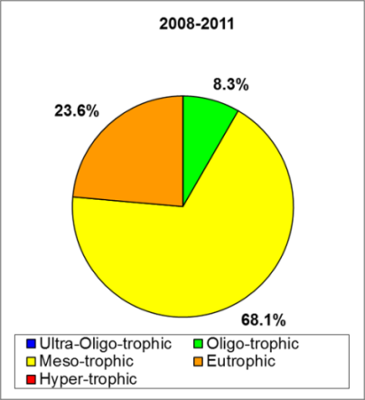
Figure 17. Surface fresh waters (left) and saline waters (transitional and coastal, right) eutrophication classification during the 2008-2011 reporting period

Pressure from agriculture
The area of agricultural land increased in England and Scotland and decreased in Northern Ireland. All animal numbers decreased, notably pigs in Scotland (-15%) and poultry in England (-9%), except small increases in pigs in Northern Ireland, poultry in Scotland and cattle in England. Application of N from manure and other organic sources and application of mineral fertilizers decreased in Scotland and Northern Ireland. Considering aggregated data from England and Wales, application of N from manure was stable and application of mineral fertilizers decreased. The N balance increased in Scotland and decreased in Northern Ireland. An assessment was not possible for England and Wales. The N discharge to the environment decreased in England and Northern Ireland and remained stable in Scotland, while an assessment was not possible for Wales.
Designation of nitrate vulnerable zones
During the 2008-2011 period, nitrate vulnerable zones increased in England and remained unchanged in Wales and Scotland. No nitrates vulnerable zones have been designated in Northern Ireland, since an action programme applies to its whole territory. The total percentage of land to which the action programmes apply, in UK as a whole, was 43.56% at the end of 2012.
Codes of good agricultural practice
The code of good agricultural practice for England was first issued in 1991 and then revised in 1998 and 2009. In Scotland, the code was first published in 1992 and revised in 1997 and 2005. In Wales, it was first published in 1998 and revised in 2002 and 2011. In Northern Ireland, it was first published in 1999, with revisions in 2002 and 2008. Implementation of the measures was reported as positive, for instance with increases in the percentage of holdings with a nutrient management plan and success stories in awareness raising campaigns.
Action programme
In England and Wales the action programme was first published in 1991 and revised in 1998 and 2009. In Scotland, it was first published in 2003 and revised in 2009. In Northern Ireland, the first publication was in 1999, followed by revisions in 2006 and 2010. Concerning compliance, the most difficult measure in the reporting period 2008-2011 was record keeping

