 | 
COUNCIL OF  THE EUROPEAN UNION |  |  | Brussels, 9 October 2013  (OR. en,el)
 | Interinstitutional Files:  2013/0222 (COD) |  | 14129/13
PHARM 53
SAN 357
MI 808
COMPET 683
CODEC 2140
INST 505
PARLNAT 232

COVER NOTE
from: | Hellenic Parliament
date of receipt: | 26 September 2013
to: | The President of the Council of the European Union
No Cion doc.: | 11862/13 PHARM 38 SAN 250 MI 603 COMPET 538 CODEC 1668 - COM(2013) 472 final
Subject: | Proposal for a REGULATION OF THE EUROPEAN PARLIAMENT AND OF THE COUNCIL on fees payable to the European Medicines Agency for the conduct of pharmacovigilance activities in respect of medicinal products for human use  - Reasoned opinion on the application of the Principles of Subsidiarity and Proportionality

Delegations will find attached for information a copy of the above opinion.

________________________

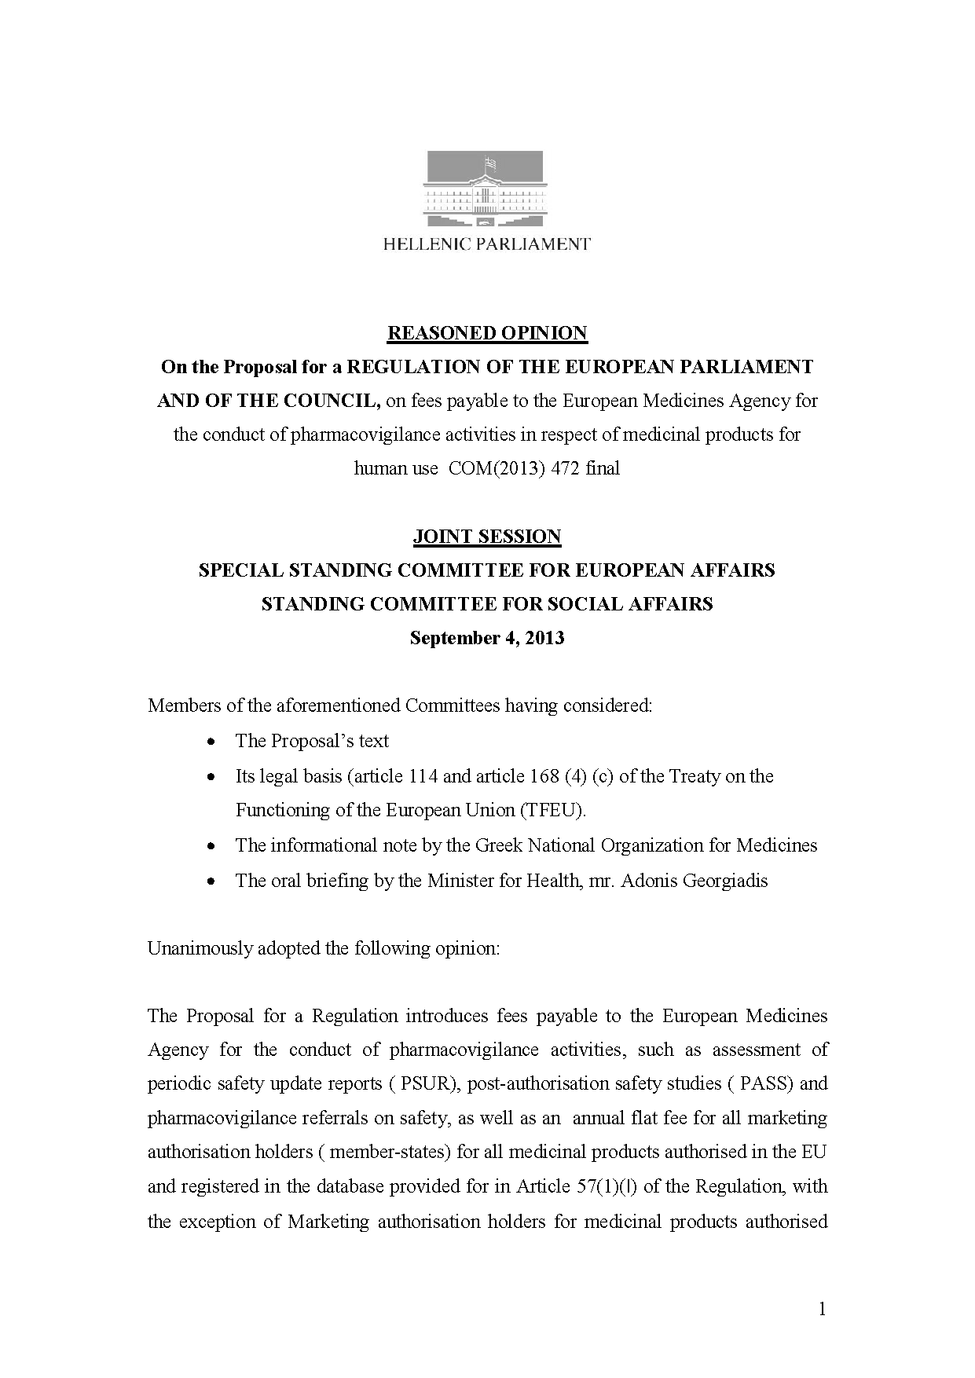

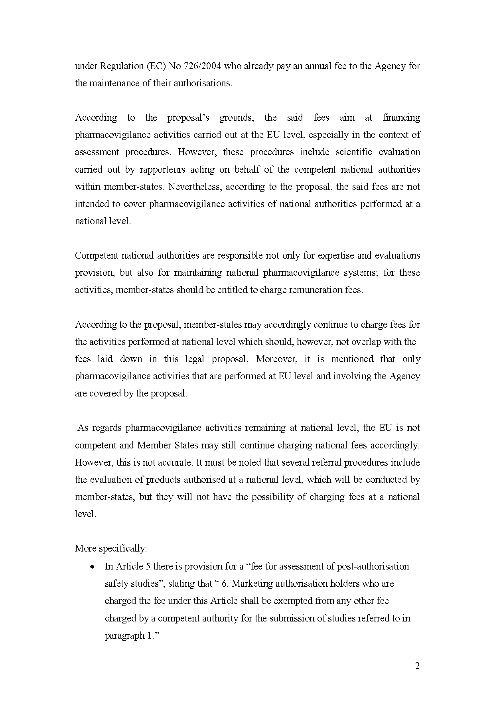

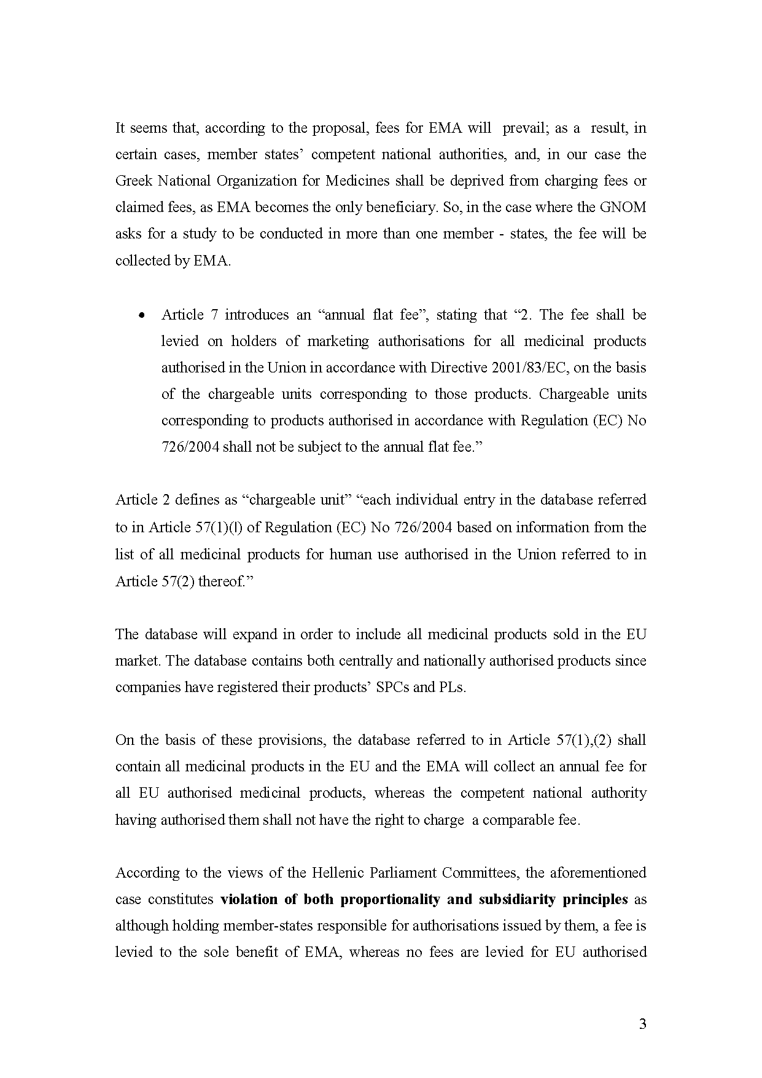

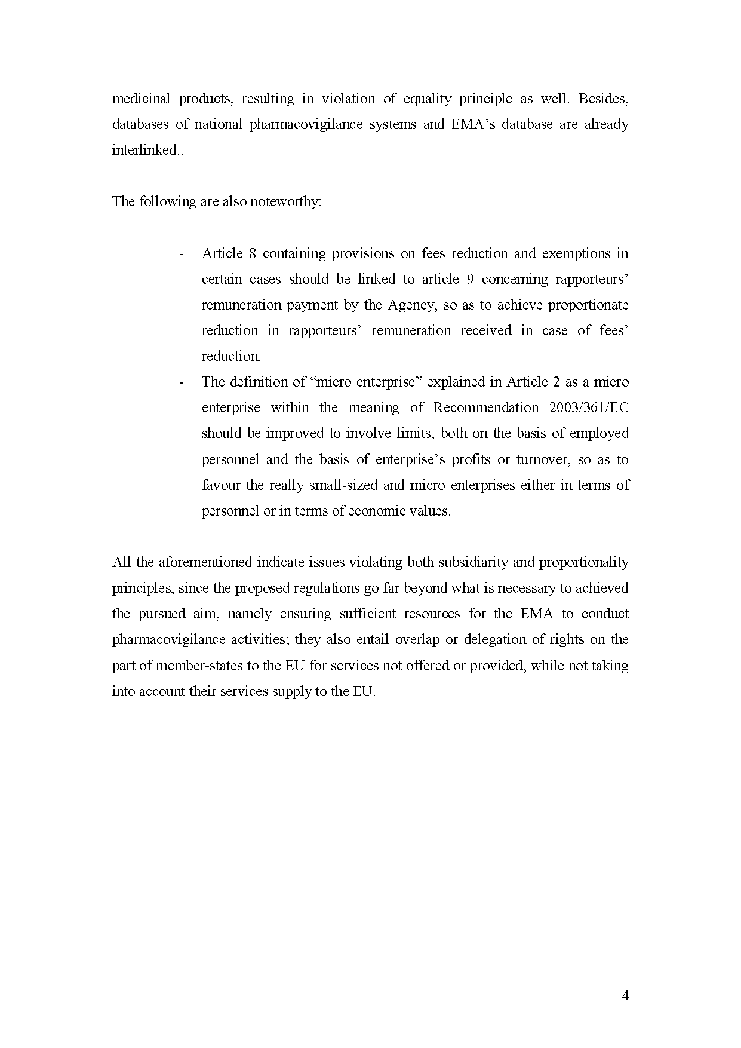

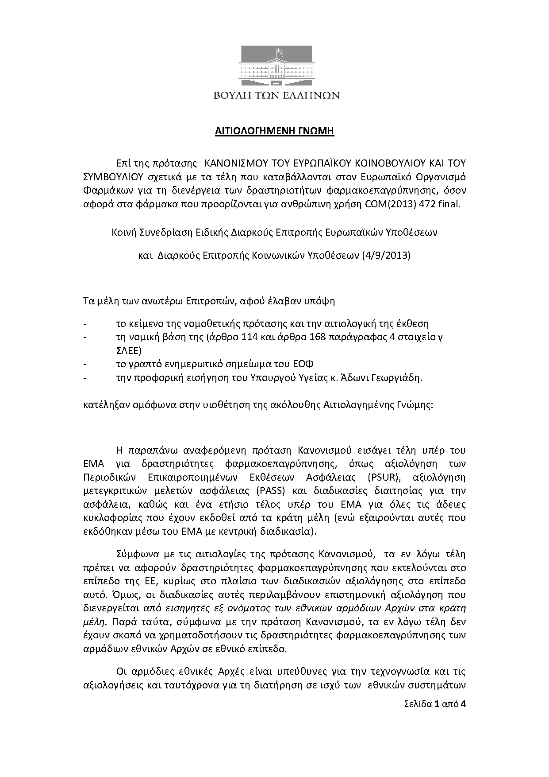

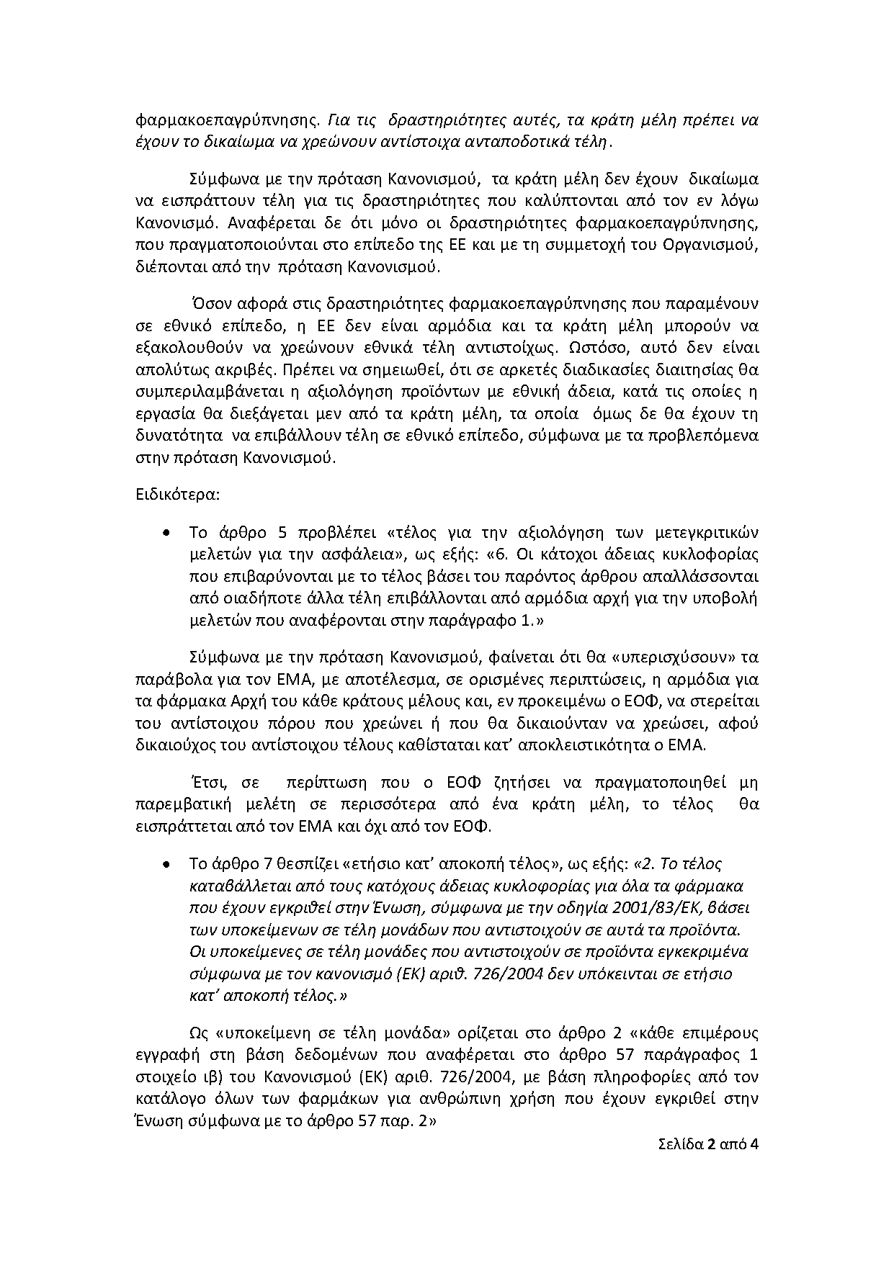

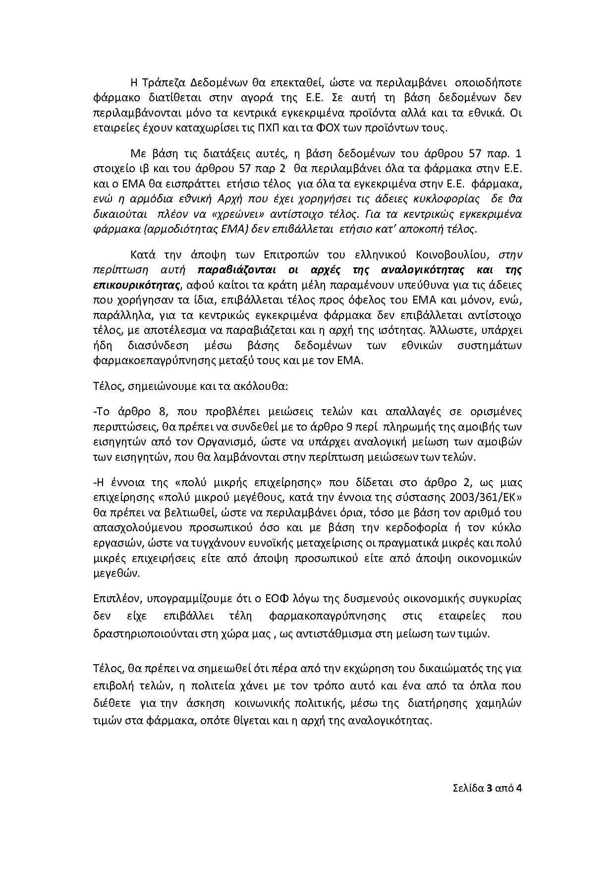
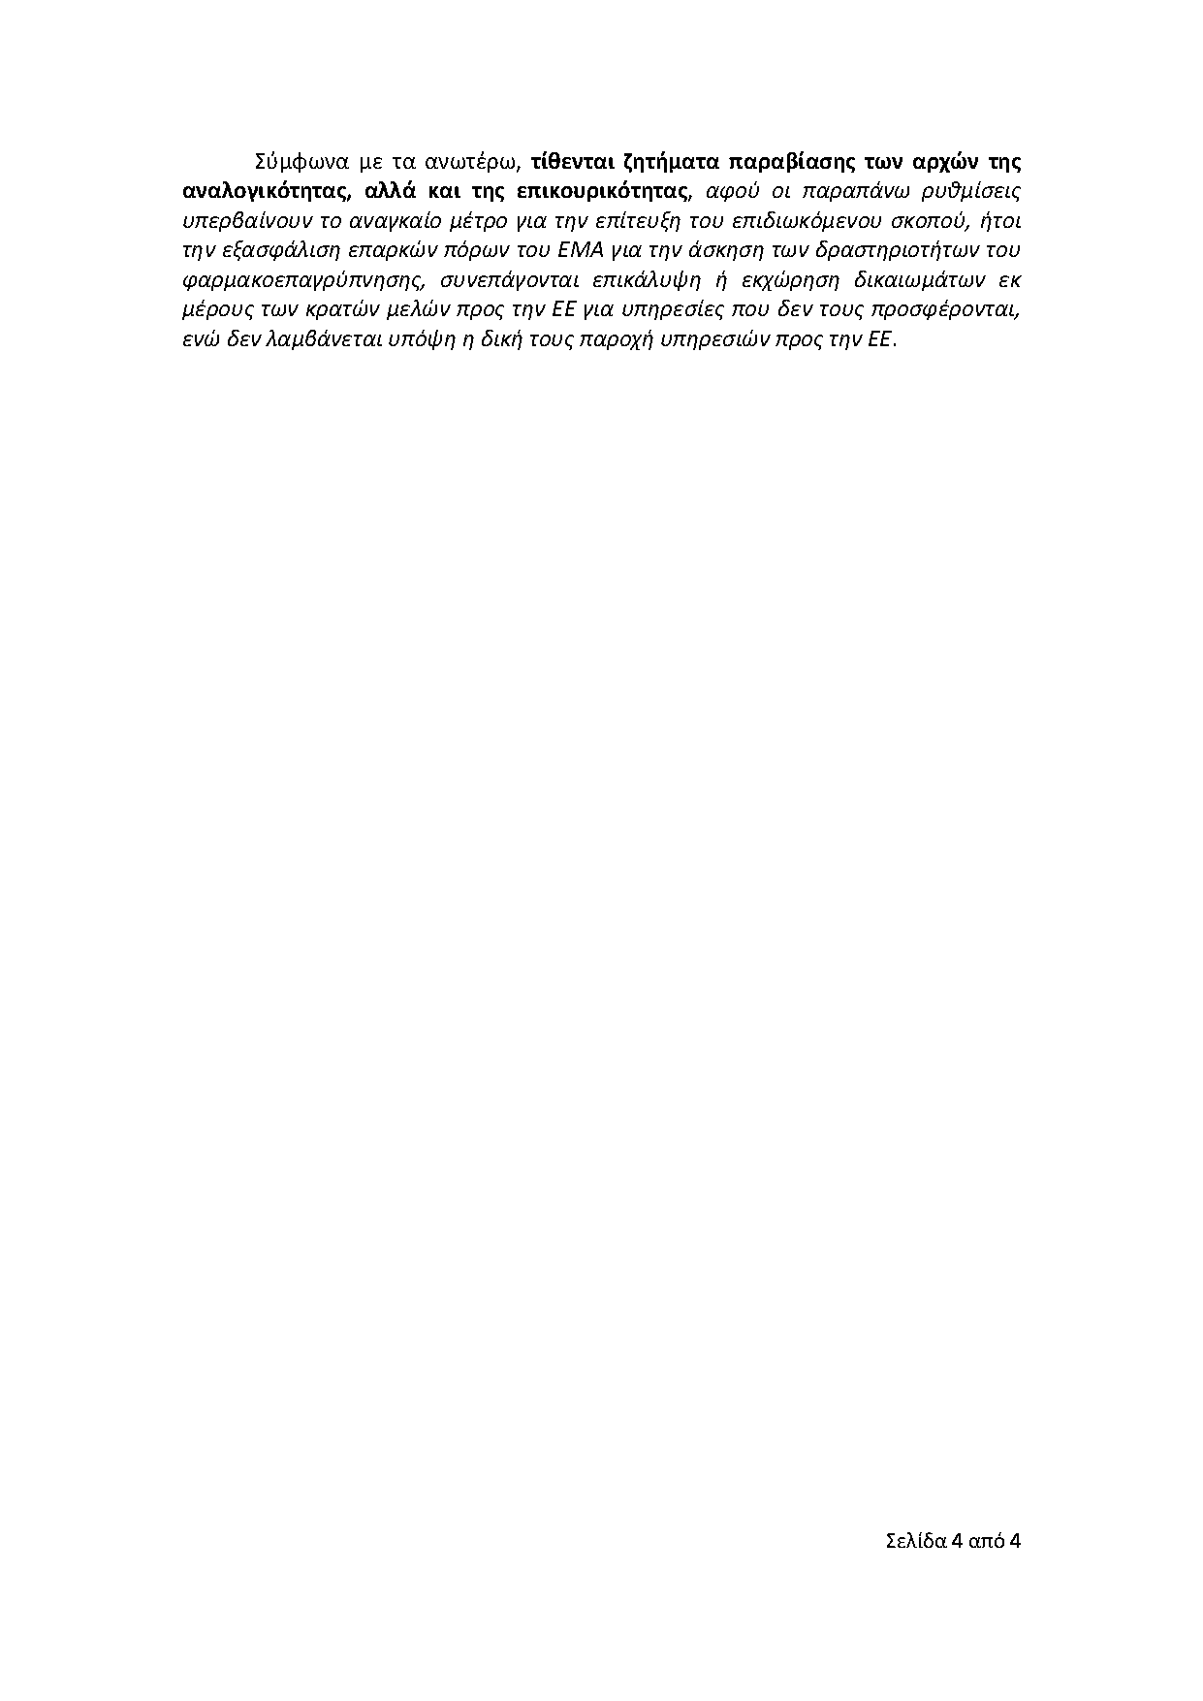

The translation can be found at the Interparliamentary EU information exchange site IPEX at the following addresses: http://www.ipex.eu/IPEXL-WEB/dossier/document/COM20130472.do#dossier-COD20130222

