 | 
COUNCIL OF  THE EUROPEAN UNION |  |  | Brussels, 16 October 2012
 | Interinstitutional File:  2011/0385 (COD)  2011/0386 (COD) |  | 14912/12
ECOFIN 839
UEM 290
CODEC 2378
INST 583
PARLNAT 326

NOTE
from: | The President of the Senatto de la Republica
date of receipt: | 11 October 2012
to: | The President of the Council of the European Union
Subject: | - Proposal for a Regulation of the European Parliament and of the Council on the strengthening of economic and budgetary surveillance of Member States experiencing or threatened with serious difficulties with respect to their financial stability in the euro area  [doc . 17230/11 ECOFIN 805 UEM 335 CODEC 2112- COM(2011) 819 final]  - Proposal for a Regulation of the European Parliament and of the Council on common provisions for monitoring and assessing draft budgetary plans and ensuring the correction of excessive deficit of the Member States in the euro area  [doc .17231 /11 ECOFIN 806 UEM 336 CODEC 2113- COM(2011) 821 final]  - Opinion on the Application of the principles of Subsidiarity and Proportionality

Delegations will find attached the above mentioned opinion.
________________________

Encl.:

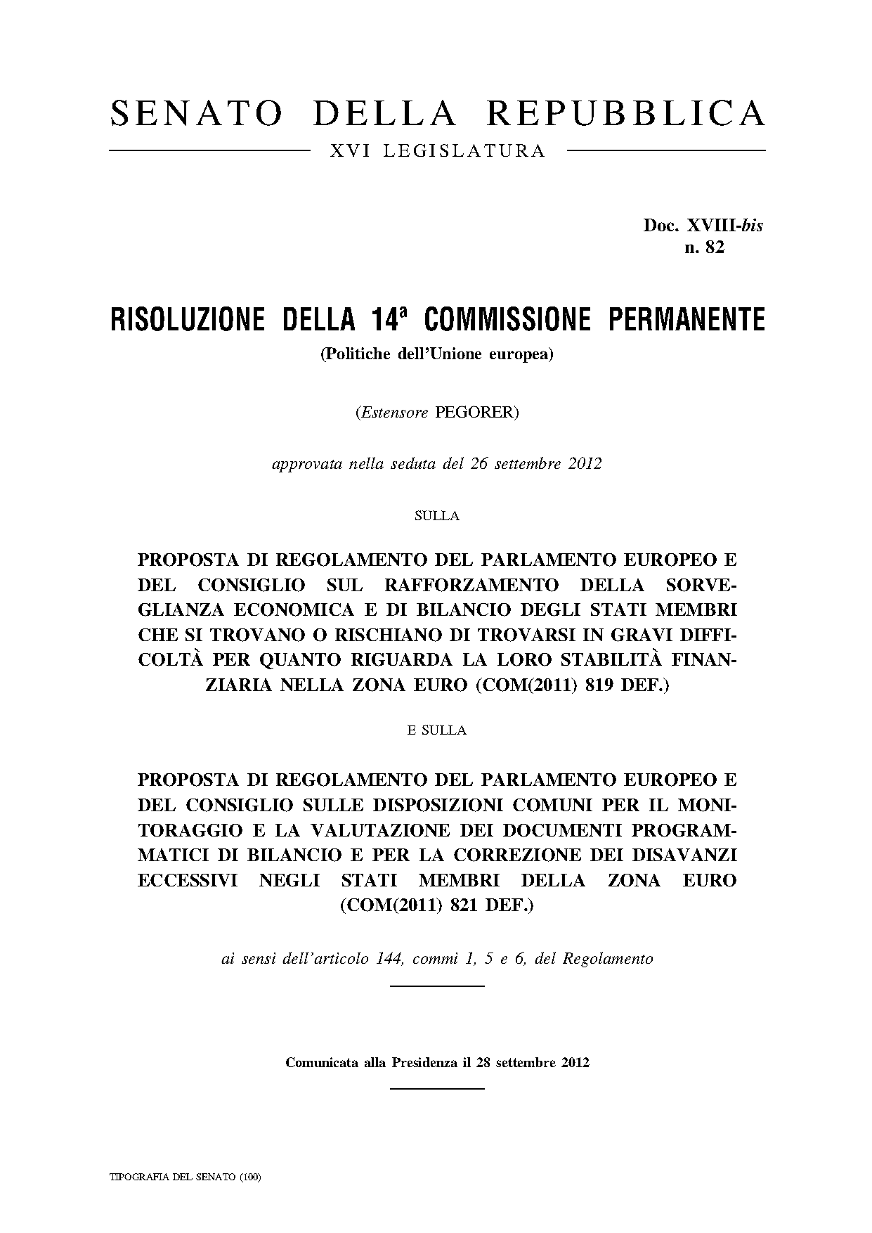
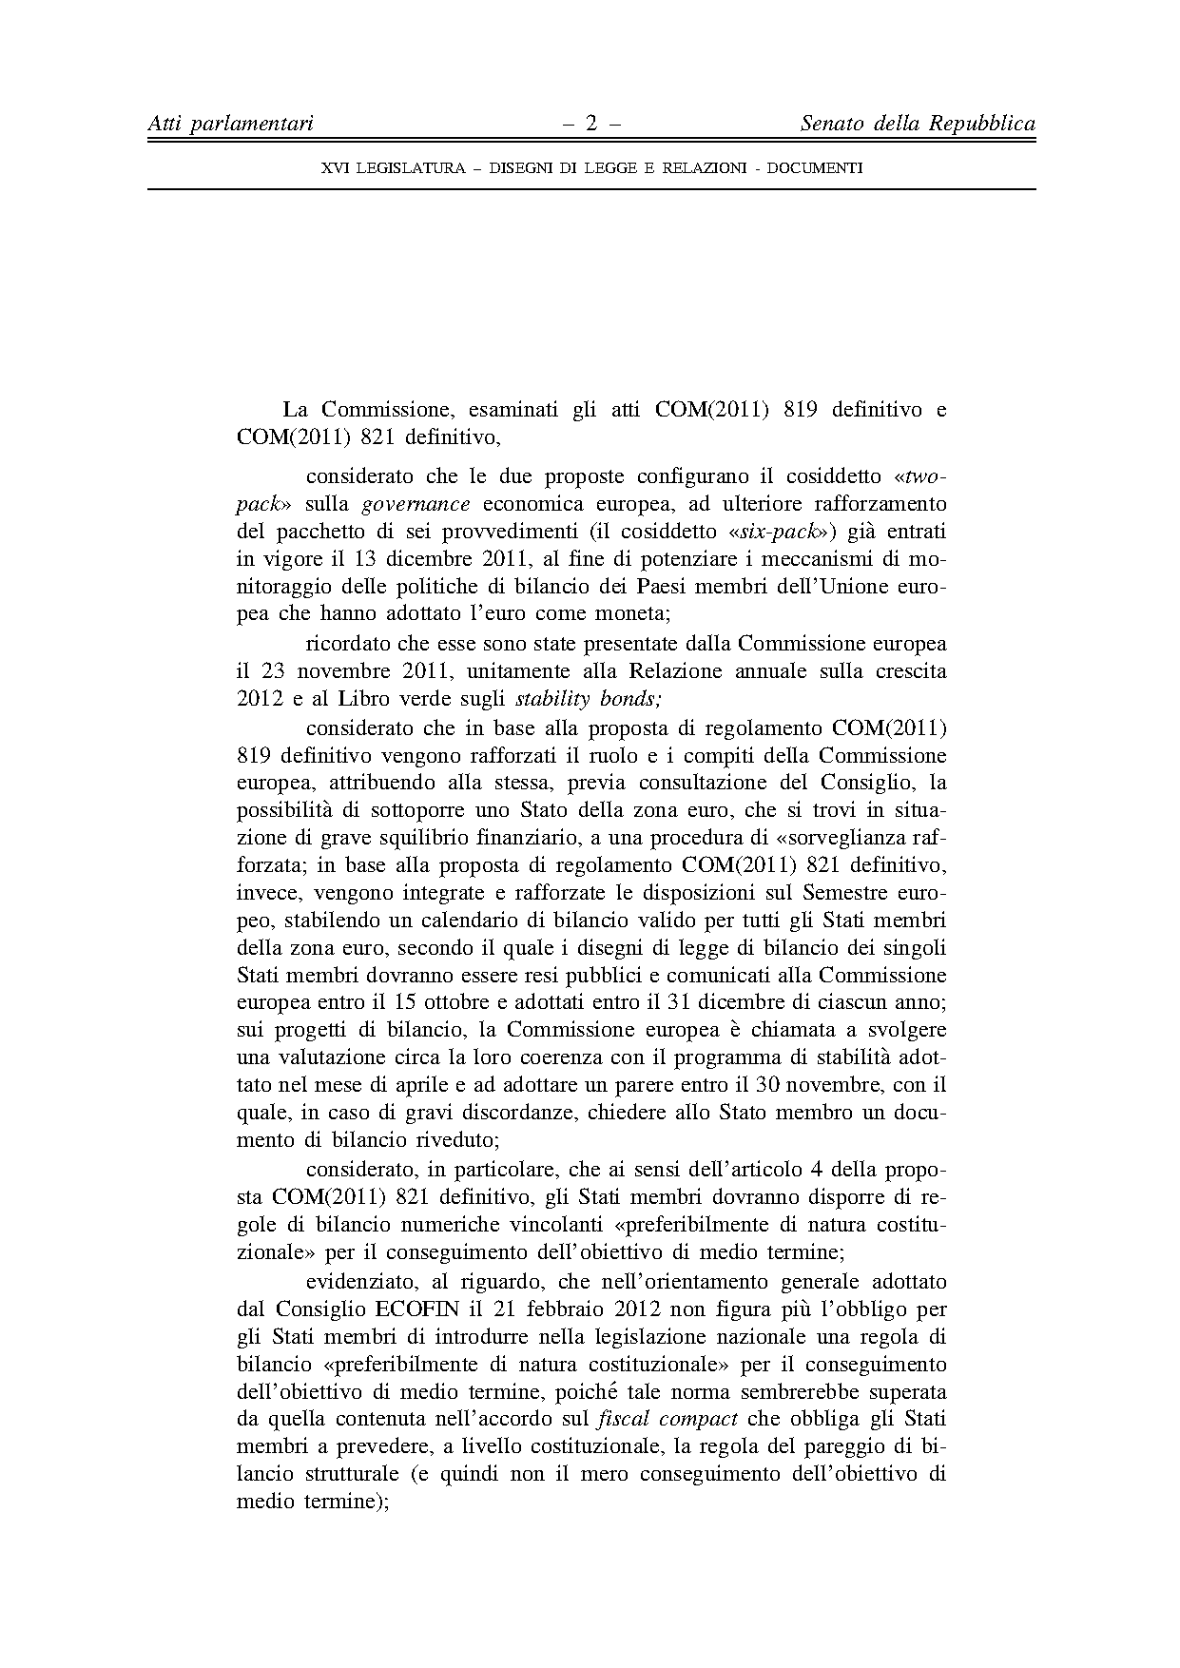
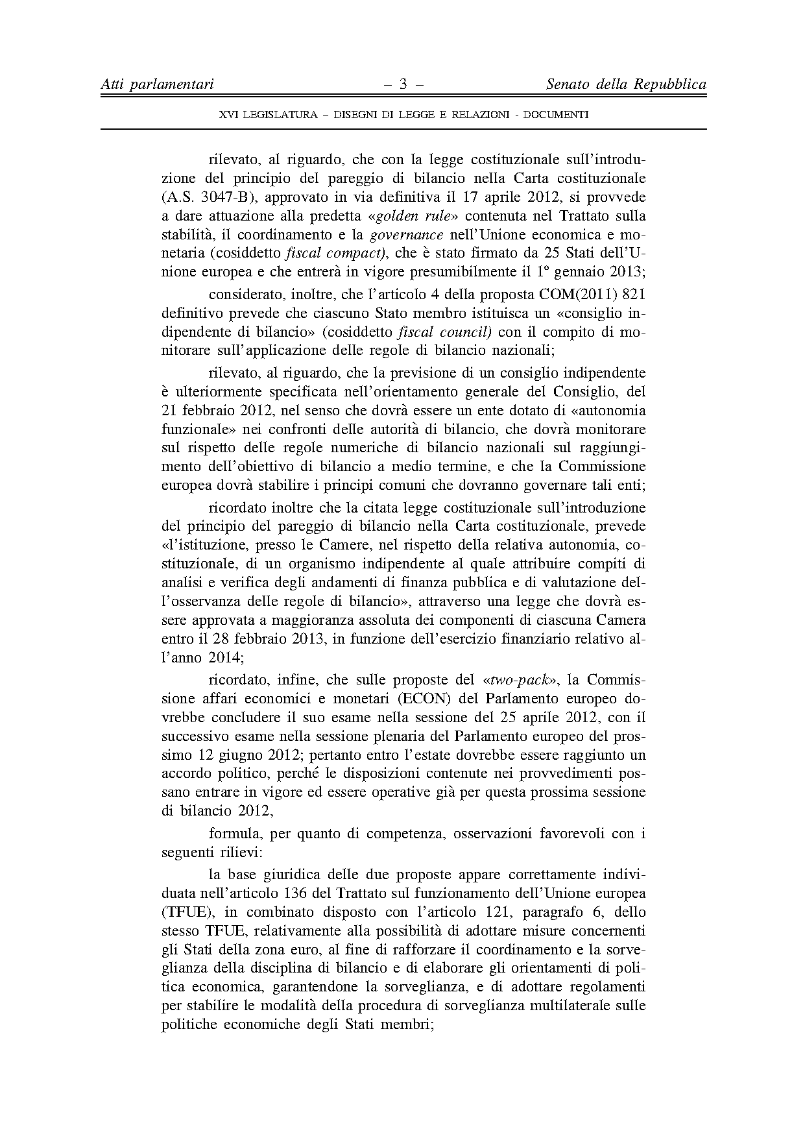
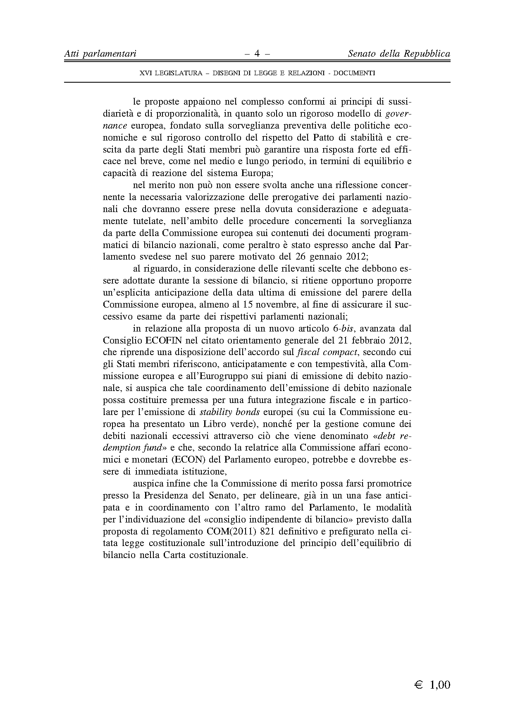

This opinion is available in English on the parliamentary EU http://www.ipex.eu/IPEXL-WEB/search.do

