TABLE OF CONTENTS
1. Introduction 3
2. Evolution of the regulatory framework 4
2.1. Amendments to Regulation (EC) No 428/2009 4
2.2. National implementing measures 5
2.3. Report on the introduction of EU General Export Authorisations 5
3. Implementation of the regulation – the state of play 6
3.1. Activities of the Dual-Use Coordination Group 6
3.2. EU Guidelines on Dual-Use Export Controls 6
3.3. Peer Visits 7
3.4. Exchange of information and introduction of a secure and encrypted electronic system 7
3.5. Transparency and dialogue with industry and academia 8
3.6. Export control monitoring and enforcement 8
4. EU export controls – Key Data 9
4.1. EU dual-use trade: items and destinations 9
4.2. Applications, licences, denials 10
5. EU export controls– impact on security and trade 12
5.1. Export controls: a key instrument to promote security in a globalised multipolar world 12
5.2. The elusive 'dual-use sector': a key to European innovation and competitiveness 13
5.3. The EU export control system: greater than the sum of its parts 13
5.4. Export control and competitiveness: distortions of competition and opportunities for a global level-playing field 14
6. EU export controls in a changing world – the export control policy review 15
6.1. Public consultations on export controls 15
6.2. Prospects for an evolution of the EU export control regime. 15
6.3. The EU export control policy review: next steps. 16
Annex I – List of acronyms 17
REPORT FROM THE COMMISSION TO THE COUNCIL AND THE EUROPEAN PARLIAMENT
on the implementation of Regulation (EC) No 428/2009 setting up a Community regime for the control of exports, transfer, brokering and transit of dual-use items

1. Introduction
Controls of exports of dual-use items and technology play a key role in the fight against the proliferation of Weapons of Mass Destruction (WMD) and conventional weapons and significantly contribute to regional and international security and stability. Regulation (EC) No 428/2009 setting up a Community regime for the control of exports, transfer, brokering and transit of dual-use items (hereunder 'the Regulation') implements international commitments under United Nations Security Council Resolution (UNSCR) 1540 (2004), international agreements such as the Chemical Weapons Convention (CWC) and the Nuclear Non-Proliferation Treaty (NPT), and multilateral export control regimes such as the Wassenaar Arrangement, the Nuclear Suppliers Group (NSG), the Australia Group and the Missile Technology Control Regime (MTCR).
The EU export control system was set up in the 1990s under Regulation (EC) No 3381/94 and Decision 94/942/CFSP, and was considerably strengthened with the adoption of Regulation (EC) No 1334/2000. Regulation (EC) No 428/2009 introduced significant improvements to the EU export control regime, in particular in response to the EU Strategy against WMD proliferation of December 2003 and in light of reports from exporters and industry. The Regulation provides for the free circulation of dual-use items – with some exceptions – inside the EU and lays down basic principles and common rules for the control of the export, brokering, transit and transfer of dual-use items, in the framework of the common commercial policy. It also provides for administrative cooperation and harmonised policies and tools for implementation and enforcement. The Regulation is directly applicable to 'exporters' but requires some additional implementing measures by the EU Member States under a 'hybrid' system, whereby national competent authorities are in particular responsible for licensing decisions.
Article 25 of Regulation (EC) 428/2009, as amended by Regulation (EU) No 1232/2011, calls for the Commission to present, every three years a “comprehensive implementation and impact assessment report” to the Council and Parliament including, as appropriate, proposals for amendments. Article 25(3) stipulates that special sections of the report shall deal with the activities of the Dual-Use Coordination Group (DUCG), the introduction of a secure and encrypted system for the exchange of information between Member States and the Commission, as well as implementation of Article 15(1) and (2) regarding updates to the control lists and Article 24 regarding national penalties in case of infringement to the Regulation. Furthermore, Article 25(4) requests that the Commission reports, no later than 31 December 2013, on the introduction of general export authorisations under Regulation (EU) No 1232/2011. Article 25 indicates that Member States shall provide to the Commission all appropriate information for the preparation of the report. This report provides information on the implementation and impact of the Regulation since its adoption until the beginning of 2013 and thus essentially covers activities in 2010, 2011 and 2012.

2. Evolution of the regulatory framework
Council Regulation (EC) No 428/2009 was adopted on 5 May 2009 and entered into force on 27 August 2009. It repealed Regulation (EC) No 1334/2000. With the entry into force of the Treaty of Lisbon, and in accordance with Article 207(2) of the Treaty on the Functioning of the European Union (TFEU), the procedure for amending the Regulation changed, and the ordinary legislative procedure became applicable.

2.1. Amendments to Regulation (EC) No 428/2009
Over the reporting period, the Regulation was amended twice:
- Regulation (EU) No 1232/2011 of the European Parliament and the Council of 16 November 2011 introduced 5 new EU General Export Authorisations (EUGEAs) for the export of certain dual-use items to certain destinations, in a bid to enhance the industry’s competitiveness and establish a level-playing field for EU exporters. With due consideration to the related risks, the new EUGEAs thus facilitate export of telecommunication equipment and chemicals to certain destinations, and the export of certain items after repair/replacement and for temporary exhibitions of fairs. Regulation (EU) No 1232/2011 also amended Article 25 of the Regulation and introduced reinforced provisions for reporting and transparency.
- Regulation (EU) No 388/2012 of the European Parliament and of the Council of 19 April 2012 updated the EU Control List in Annex I to the Regulation, and incorporated modifications agreed within the multilateral export control regimes in 2009 and 2010. The modifications include de-control of certain items and amendments to goods description and definitions. The new updated and consolidated EU Control List became applicable on 15 June 2012, thereby allowing the EU to adhere to its international commitments with regard to export controls and helping EU exporters where control parameters were relaxed.
Furthermore, in light of Article 15 of the Regulation stipulating that the EU Control List should be regularly updated in conformity with changes agreed within the multilateral regimes, the Commission adopted on 7 November 2011 a proposal for amending the Regulation and delegating the competence to update the EU Control List to the Commission (“delegated acts”). The proposal also introduced a delegation of competence to the Commission to amend Annex II of the Regulation in response to changing circumstances, and remove certain destinations and/or items from the scope of EUGEAs. The European Parliament adopted its position at first reading in October 2012, but this legislative proposal remains under discussion, with a view to its conclusion before April 2014.
Further evolution of the regulatory framework remains open for examination. Thus, upon adoption of the Regulation, the Council and Commission stated that the list of items for which a licence is required for intra-EU transfers would be assessed, bearing in mind the principles of Title II, Chapter 9 of the Euratom Treaty (The Nuclear Common Market) and Article 36 of the TFEU. Later, upon adoption of Regulation (EU) No 1232/2011, the Commission announced its intention to review the possibility of introducing an EUGEA for low-value shipments by the end of 2013. These issues are currently being considered as part of the on-going export control policy review, and an informal working group was set up at the beginning of 2013 to examine the list of items subject to transfer controls and the control modalities.

2.2. National implementing measures
The Regulation is binding in its entirety and directly applicable in all Member States, but, nevertheless, foresees that Member States should take measures in implementation of certain provisions, and that information on those measures should be published in the Official Journal of the European Union. Notices from Member States were published on 6 March 2012, and provide an overview of measures taken by Member States regarding e.g. the extension of brokering controls, the application of transit controls, the extension of controls to non-listed items for reasons of public security and human rights consideration, the introduction of national general export authorisations, the application of intra-EU transfer controls for non-listed items, as well as information relating to national export control authorities. Furthermore, a notice published on 19 September 2012 informs that Italy has notified the imposition of a specific national authorisation requirement on the export to Syria of certain telecommunication items not listed in Annex I for reasons of public security and human rights considerations. National implementing measures concerning the conditions and requirements chosen by Member States for the use of the EUGEAs are also subject to publication of an information notice.

2.3. Report on the introduction of EU General Export Authorisations
In light of Regulation (EU) No 1232/2011, and with due regard to Article 25(4) of the Regulation, as amended, the Dual-Use Coordination Group undertook to evaluate the implementation of the newly introduced EUGEAs. As indicated above, information about conditions and requirements for use was gathered for publication in the Official Journal. Furthermore, consultations with competent authorities led to the following conclusions:
- As regards conditions and requirements for use, most Member States have introduced registration requirements and also require a posteriori notification after first use although some Member States require prior notification. Most Member States require exporter information, item description & category, value & volume of transactions, destination and end-user information. Some Member States also make use of relevant customs data. Furthermore, most Member States have introduced regular reporting requirements, though the frequency varies, and some also have record-keeping and auditing obligations in place.
- In total, over 4000 notifications of use of EUGEAs have been received by competent authorities, and it is estimated that approximately 3500 companies use EUGEAs. All EUGEAs are being used by economic operators, though EUGEA 001 is the one most in use. Economic operators use EUGEAs in virtually all Member States, but economic operators in a few Member States have not yet used the new EUGEAs introduced in 2011.
- Virtually all categories of dual-use items are exported under EUGEAs, across a variety of sectors, including 'traditional' dual-use sectors such as aerospace, software and electronics, but also in other sectors such as the food or pulp and paper industry.
- Exports under EUGEAs are largely destined to the US and other 'EU001 countries' (Australia, Canada, Japan, Switzerland, Norway, New Zealand), but other destinations also benefit from EUGEAs, such as Brazil, China, South Korea, Russian Federation, South Africa and Turkey.

3. Implementation of the regulation – the state of play

3.1. Activities of the Dual-Use Coordination Group
Article 23 of the Regulation sets up a Dual-Use Coordination Group (DUCG) bringing together experts from the Commission and Member States to examine any issue concerning the application of export controls with a view to practically improving their consistency and effectiveness throughout the EU. The DUCG provides a unique forum for exchange of best practices and information between export control officials and forms the basis of an ‘EU network’ of export control agencies. Over the reporting period, the DUCG has met regularly. Since the entry into force of the Regulation 16 meetings were held. The DUCG held discussions on a number of topical issues concerning the implementation of the Regulation, such as Member State approaches to EU and National General Export Authorisations (NGEAs), export controls for the research sector etc. The DUCG also provided a forum for consultations on specific instances of application of controls including on issues reported by industry e.g. export of gas turbines to certain destinations, export of graphite and carbon components etc.
The DUCG regularly holds joint meetings with stakeholders, and in particular held two joint meetings with customs officials in October 2010 and September 2011, focusing on information exchange between licensing and customs authorities in order to avoid diversion and illicit exports. The DUCG also occasionally holds joint meetings with industry representatives and e.g. a joint seminar with the European Nuclear Energy Forum in February 2013 to discuss nuclear export controls and examine industry concerns regarding associated compliance costs, distortions of competition and intra-EU transfers of nuclear goods and technology.
The DUCG has also discussed options for strengthening technical capabilities and expertise, as a key element of the licensing process and enforcement at borders. Various national export control training initiatives exist, and technical seminars for export control licensing officers and technical experts have also been organised by the Commission’s Joint Research Centre in collaboration with national experts from the EU and US. In this context, the DUCG held pilot training sessions to prepare for a possible future structured “in-reach” EU export control training programme that should be aimed primarily at licensing, customs and technical experts as well as at other relevant government officials (foreign affairs, defence, intelligence).

3.2. EU Guidelines on Dual-Use Export Controls
The DUCG has developed "EU Guidelines on Dual-Use Export Controls" to support the practical implementation of export control measures and in particular clarify the various consultation and information-sharing procedures provided for under the Regulation. The EU Guidelines are currently intended for official use by the export control authorities of the Member States; they are not legally binding and are not for public release. The EU Guidelines constitute a living document that will be updated and expanded on a regular basis in order to respond to evolving needs and changing circumstances.
After the Commission conducted a survey in 2010, the DUCG prepared Guidelines to set up a 'Pool of Experts' i.e. a structured mechanism mutualising the expertise available in various Member States for the benefit of all, in support of consistent control decisions. The Guidelines establish standardised templates and procedures for the provision, on a voluntary basis, of non-binding advice to competent authorities on such highly technical issues as goods ratings and classification.
Figure 1: EU Dual-Use Pool of Experts concept

3.3. Peer Visits
Peer visits, organised jointly by the Commission and the EU Presidency, represent another key element of the EU export control network and provide an opportunity for extensive exchange of information focusing on a specific export control issue. A total of 6 peer visits were thus organised over the reporting period and were devoted to e.g. intra-EU transfer controls, application of catch-all controls, intangible technology transfers, control of information and communication equipment.

3.4. Exchange of information and introduction of a secure and encrypted electronic system
The Dual-use e-System (DUeS), a secure electronic system hosted by the Commission for exchanging information among Member States was launched in January 2011 and became fully operational in June 2012, with all Member States having access to and actively using the system. Since then, new versions have been developed, introducing additional functions and improvements, including, inter alia, the possibility to enter information concerning denials on dual-use items, to exchange documents in a library or to perform full data exports. The DUCG continuously works on further development of the DUeS to enable effective exchange of information between export control authorities and the Commission e.g. to include functions as required by the adoption of new legislation such as Regulation (EU) No 1232/2011 or restrictive measures (sanctions) on trade in dual-use items. Discussions have also been initiated regarding the possible extension of the DUeS to arms exports denials under Council Common Position 2008/944 and to the export of items denied under Regulation (EU) No 1236/2005 concerning trade in certain goods which could be used for capital punishment, torture or other cruel, inhuman or degrading treatment or punishment.
In addition to the DUeS, competent authorities also establish direct cooperation on specific cases on an ad hoc basis, using the contact points of the EU export control network, and some have taken specific measures as per Article 19(1) and (2) for exchange of information including, for example,, details of transactions.
The DUCG discussed and promoted the introduction of electronic licensing systems by competent authorities, as these systems simplify the licensing process and shorten processing times, while allowing for better oversight over licensing procedures and improved coordination within an administration. A total of 8 Member States now have e-systems in place, while 6 Member States are working on deploying such systems in 2012-2013, and three are taking preparatory steps.

3.5. Transparency and dialogue with industry and academia
In light of Article 23(2), the Commission has organised regular meetings with industry. The Commission held an industry forum in 2010 and organised an Exporters Conference in 2011, bringing together over 200 participants from industry, academia, public authorities and EU institutions in order to raise awareness about the new EUGEAs and the launching of a Green Paper public consultation. In 2013, further to the adoption of the Commission Staff Working Document (SWD (2013)7) drawing the conclusions from the public debate organised in the wake of the Green Paper, the Commission organises, jointly with the Irish Presidency, a 'Strategic Export Control Conference' to provide a forum to discuss priorities for the review of the EU export control system.
Competent authorities conduct significant industry outreach activities and provide as much information as possible to economic, academic and other stakeholders in the pre-licensing phase, so as to raise awareness for a responsible trade of dual-use items. Competent authorities mostly provide information on their website and occasionally by newsletter, and also typically maintain direct contact with operators and regularly organise either general information sessions – 'Export Control Day' - or specific seminars for operators. Some authorities release specific guidance documents in the sense of Article 19(5) e.g. leaflets concerning Internal Compliance Programmes (ICP), Intangible Transfers of Technology, brokering, and some make available a 'Handbook' of Export Control.
Some competent authorities report on trade in dual-use items to national parliaments and, in some Member States, that information is publicly available.

3.6. Export control monitoring and enforcement
The Commission promotes effective enforcement of export controls within the EU through various support actions such as the preparation of a 'correlation table' linking customs codes with dual-use classifications, inclusion of export control parameters into the EU's online customs tariff database, TARIC, and customs risk assessments, as well as export control awareness modules in training delivered by the Commission's Joint Research Centre, e.g. for border guards.
For their part, according to the Regulation, Member States must determine effective, proportionate and dissuasive penalties applicable to export control violations. They have introduced a range of diverse national administrative and criminal sanctions, typically including fines and confiscation of goods as well as imprisonment.
National authorities are primarily responsible for the enforcement of export controls. Over the reporting period, a few violations were reported e.g. for unlicenced export of items, resulting in the imposition of fines and/or seizure of the items, while a few cases were referred to courts.

4. EU export controls – Key Data
It is difficult to get reliable information on dual-use exports as there is no correspondingly defined economic sector, nor has a specific methodology been developed thus far for recording data and calculating statistics on the trade of dual-use items. However the Commission and Member States do collect data that allow for approximate estimates of exports of dual-use goods based, on the one hand, on customs commodities identified by the correlation table which include dual-use goods and, on the other hand, on specific data collected by competent authorities. To be noted, estimates of exports presented hereafter do not cover services and intangible technology transfers associated with the trade in dual-use goods.

4.1. EU dual-use trade: items and destinations
The Regulation primarily applies to the export of about 1600 dual-use items listed in Annex I – the EU Control list, as updated in 2012 – and classified in 10 categories (Figure 2).
Figure 2: Number of dual-use items listed in Categories of Annex I.
These dual-use items relate to circa 1000 customs commodities, including chemicals, metals and non-metallic mineral products, computers, electronic and optical products, electrical equipment, machinery, vehicles and transport equipment etc. and typically fall at the high–tech end of this large, mixed commodity area. It is estimated that, while the value of controlled dual-use export represents approximately 2% of total exports, controls indirectly affect an 'export domain' representing approximately 20% of total exports (Figure 3).
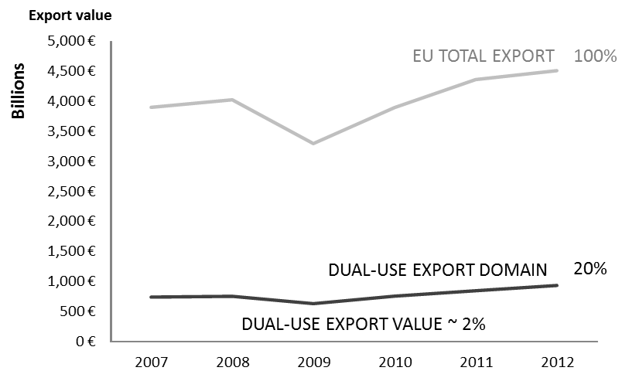
Figure 3: Estimated value of dual-use exports compared to the 'dual-use export domain' and total exports
A large part of the dual-use export domain concerns intra-EU trade or exports towards 'E001 countries' benefiting from general export authorisations. This reflects the EU export market structure in the relevant commodities as well as trade facilitation under EUGEAs (Figure 4).
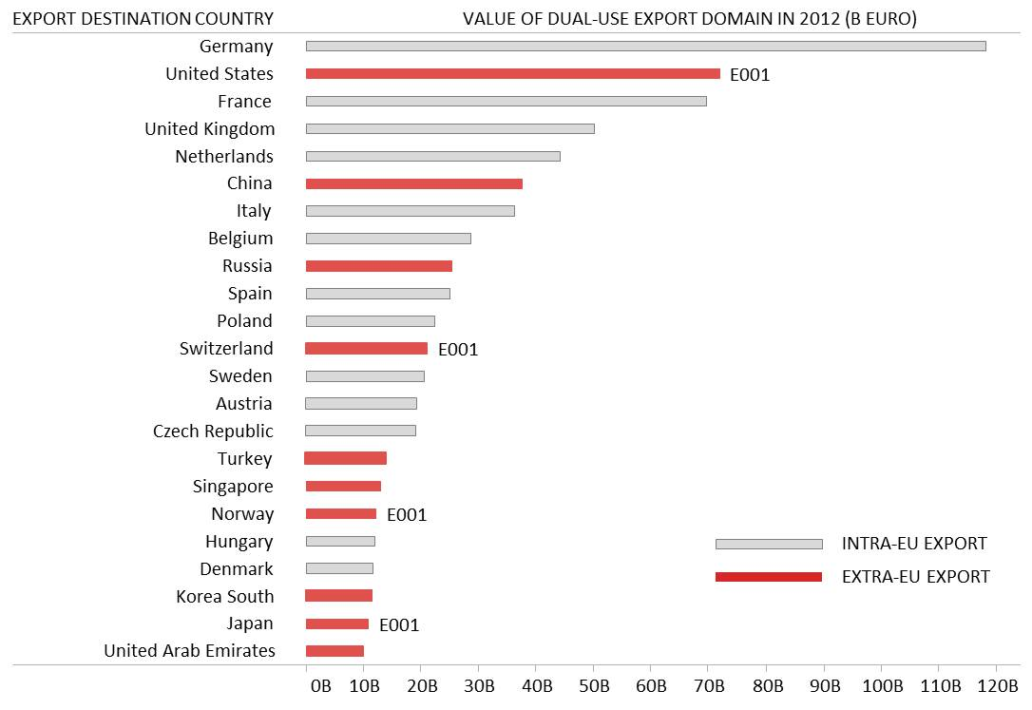
Figure 4: Destination countries for EU dual-use export domain in 2012.

4.2. Applications, licences, denials
The DUCG has exchanged information and collected data on trade in controlled items, in order to improve the understanding of export controls and their economic effect. Some data collected for the reporting period is reported below; it should be noted however that not all Member States collect all data. The information provided below thus represents approximate estimates of aggregate quantities and value within the limits of the data made available by the time this report was being drawn up.
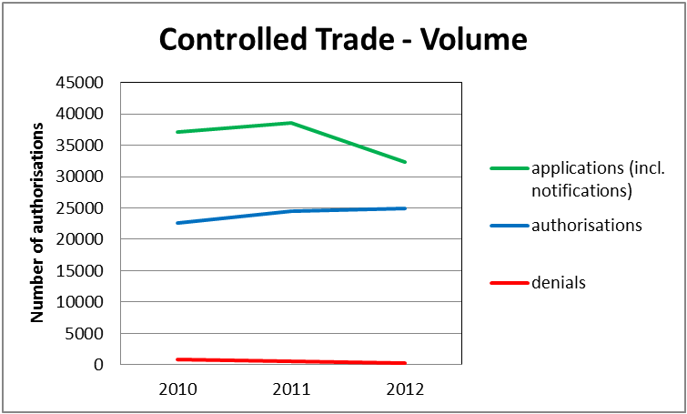
Figure 5: Number of authorisations and denials for 2010, 2011 and 2012
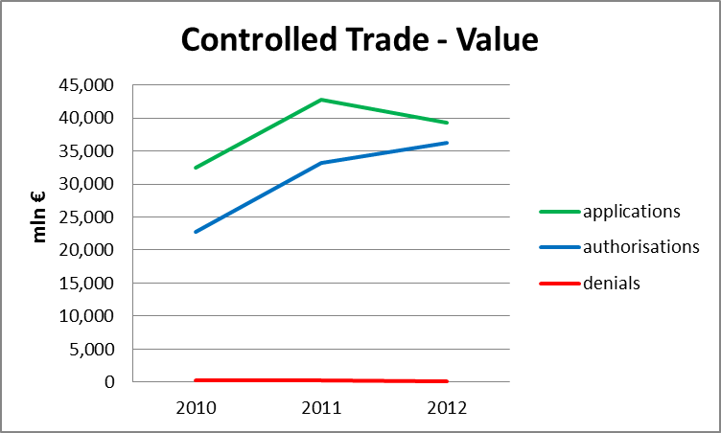
Figure 6: Value of authorisations and denials for 2010-2011 and 2012 (mln EUR)
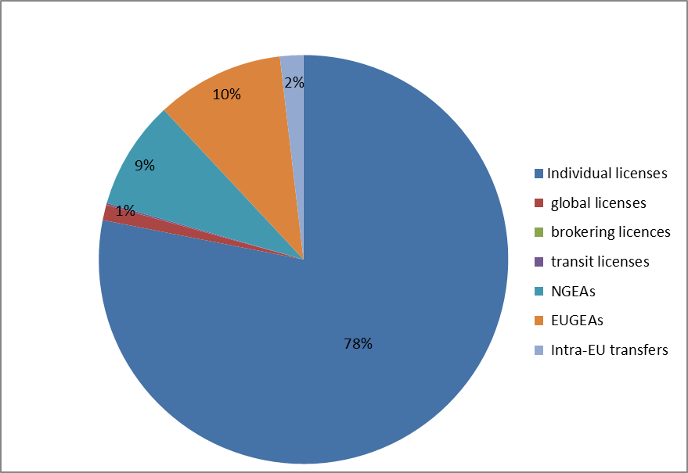
Figure 7: Comparative number of licences and authorisations per category (2011 data)
In total, applications now tend to exceed 30 bn EUR per year and represent approx. 2.5 % of EU external trade, while the approx. 3500 active denials represent about 0.01% of total EU external trade. Nevertheless, data estimates point to a marked increase of controlled trade over the last years. By contrast, the number of denials appears to be decreasing over the period.

5. EU export controls– impact on security and trade
In light of the call in Article 25(2) of Regulation (EC) No 428/2009, as amended, for the Commission to present a "comprehensive implementation and impact assessment" the report on the public consultation presented in SWD (2013)7 of January 2013 provides considerable inputs from stakeholders regarding the effects of export controls on both security and trade. The stakeholders input in this respect is summarised below.

5.1. Export controls: a key instrument to promote security in a globalised multipolar world
Stakeholders recognise that export controls, as a security-related trade instrument, remain, more than ever, at the forefront of international non-proliferation efforts, and need to adjust to the evolution of security risks and threats – including the various forms of terrorism and the efforts by some States and non-state actors to acquire weapons of mass destruction and corresponding carrier technology and armaments. Some stakeholders also argue that export controls need to adjust to political challenges and shifting EU foreign policy objectives, e.g. in relation to the Arab Spring and a rapidly changing geo-political landscape, or in terms of preventing human rights abuses caused in oppressive regimes through state control of information and communications technology.
Stakeholders identify a variety of challenges for export control policy. These concern the growing innovation and production capacities of emerging economies and resulting foreign availability of sensitive products, multinational companies and industrial processes within worldwide production networks and supply chains, and the globalisation and increasing volumes of trade. The rapid spread of technological and scientific developments and the mobility of knowledge, the emergence of new and advanced transformational technologies – such as cloud computing, cyber-tools, dual-use research in life sciences – also add to the complexity of export controls.

5.2. The elusive 'dual-use sector': a key to European innovation and competitiveness
Stakeholders generally agree that dual-use exports have a greater importance for the EU economy than the percentage of controlled transactions seems to indicate, as they significantly impact key sectors of the EU economy. In fact, controls of dual-use items affect research and development (R&D), production and trade across a wide-range of civil industries – e.g. energy (nuclear, oil and gas) aerospace, defence and security, lasers and navigation, telecommunications, life sciences, chemical and pharmaceutical industries, material-processing equipment, electronics, semiconductor and computing industries, medical, automotive - and controlled products enter into the international value chain on a broad base. Crucially, stakeholders emphasise that dual-use items often represent high-tech, advanced products in which EU companies have established themselves as leaders so that many cutting-edge technologies are affected in whole or in part by dual-use export controls.
Stakeholders stress that the EU's extensive 'dual-use-related industries' bring together thousands of small, medium and large companies providing high value-added jobs and know-how - including significant R&D work - across a wide range of key sectors of the EU economy. It supports a large portion of EU trade with strategic partners so that effective controls are crucial to the EU's drive towards innovation and competitiveness.

5.3. The EU export control system: greater than the sum of its parts
Most stakeholders are satisfied that the current EU export control regime provides a robust yet flexible framework and note that its construction is unique, in that it provides a uniform legal basis, with common rules, definitions, criteria for authorisations and a common control list, but combines EU-wide principles and regulations with national rules and decisions. Stakeholders recognise that the primary benefit of EU regulation derives from the free movement of dual-use items within the internal market. They also appreciate its relative simplicity (e.g. one single control list). Furthermore, many stakeholders emphasise the considerable – and positive - development of EU export controls over the last few years, thanks to important initiatives such as the adoption of Regulation (EC) No 428/2009, the introduction of new EUGEAs, the setting up of the DUeS, as well as proposals to ensure that the EU control list is regularly updated.
Some stakeholders, however, consider that the EU export control system still impedes competitiveness especially as political, regulatory and operational differences incorporated in the EU system may result in significant variations in terms of processing time for export licences and diverging interpretations of EU rules. They claim that the 'asymmetrical implementation' of EU export controls creates distortions of trade and sometimes results in a fragmented market affecting the equal treatment of European companies. They consider that EU export controls do not sufficiently address differentiated levels of risk, while enforcement remains sometimes fragmented for lack of systemic cooperation between relevant national authorities. From a security perspective, some stakeholders take the view that varying levels of control increase the risk of exposing 'weak links' in the export control chain and might compromise the overall effectiveness of EU export controls.
Furthermore, the projection of the EU export control system at the multilateral and international levels remains imperfect, as neither all Member States nor the EU participate in all multilateral export control regimes. In spite of this, throughout the period, the EU developed relations with key partners to discuss export control issues of common interest e.g. with US, Japan, China. In particular, the Commission and Member States closely follow the reform of US export controls and, since the introduction of the Strategic Trade Authorisation (STA) in 2011, have highlighted the need to extend it to all Member States.

5.4. Export control and competitiveness: distortions of competition and opportunities for a global level-playing field
Most stakeholders recognise that sound export controls are crucial to industry's reputation, but emphasise the high compliance costs associated with the management of export control procedures that represent a real administrative burden for certain industries. They generally consider that export controls have thus become a significant competitive factor as a result of interconnected supply chains and international collaboration in research and innovation. They stress that the combination of the foreign availability of certain dual-use items with the asymmetric implementation of international obligations through differentiated export control policies affect the competitiveness of certain EU economic operators. They suggest that distortions of competition may result from differences in laws and regulations including different exclusions and exemptions and other facilitation arrangements, from an outdated EU control list, from delays to delivery caused by licence application regimes that certain competitors do not have to contend. Less stringent or simpler export controls in third countries that do not participate in the multilateral export control regimes represent a particular issue. Companies operating on the global market demand a more level playing-field for EU industries to compete on equal terms and encourage more exchange of information and regulatory collaboration between major trade partners.
At the same time, stakeholders recognise that globalisation presents opportunities for a more level playing-field, since UNSCR 1540 requires all countries to have effective export controls and multilateral export control regimes conduct significant outreach to emerging suppliers of sensitive items. As a result, third countries outside the multilateral regimes are increasingly developing domestic export control systems in all regions of the world. Moreover, EU cooperation and outreach programmes, as well as the approximation of regulations in candidate countries through the enlargement process, promote international convergence, and it can be noted that the EU system has developed into an international benchmark.

6. EU export controls in a changing world – the export control policy review
Over the reporting period, in addition to the legislative amendments reported above, the Commission has also initiated a wide-ranging export control policy review.

6.1. Public consultations on export controls
The Commission regularly holds public consultations, asking stakeholders views regarding export controls. In April 2011, the Commission conducted a technical consultation concerning the EU control list to gather information about the foreign availability of items subject to controls.
In light of the requirements of Article 25, the Commission issued in June 2011 a Green Paper highlighting the development of the EU export control system over the last decade and launching a broad public debate concerning its functioning and future strategic options. The Green Paper marked the first step toward preparing the review required under Article 25 of the Regulation. As such, the Green Paper contained questions concerning the application of Regulation (EC) No 428/2009, but also more strategic questions designed to help establish in which direction the EU export control system should be evolving.
In January 2013, the Commission Staff Working Document “Strategic export controls: ensuring security and competitiveness in a changing world" reviewed over 100 contributions received and identified the main issues raised by stakeholders (Member States, including national parliaments and political parties, members of the European Parliament, industry associations and economic operators, civil society organisations and academia during the public consultation) who also laid out their views as regards the strengths and weaknesses of the EU export control system.

6.2. Prospects for an evolution of the EU export control regime.
The Staff Working Document also reports on stakeholders' views concerning possible improvements and evolutions towards a more integrated EU export control regime "in the information age" that would both ensure a level-playing field and "lift the common denominator". Some stakeholders in particular call for EU export control policy to be further harmonised and to take account of recent policy developments such as the use of ICT interception and monitoring items or 'cybertools'. Some stakeholders also recommend adjustments to improve the licensing framework, e.g. through an expanded and risk-based use of EUGEAs and a review of national controls. They call for an optimisation of the catch-all mechanism and a critical review of intra-EU transfers, in order to reduce distortions of competition within the EU Single Market. Some make suggestions to enhance brokering and transit controls and stress the importance for control lists to be regularly updated in light of technological and commercial developments.
Stakeholders also devote considerable attention to the effective implementation of controls and some promote ideas concerning the development of an EU export control network with enhanced infrastructure commonalities based e.g. on structured cooperation, pooling of resources and exchange of information, common tools, criteria and risk assessment, as well as training. They also call for more transparency and dialogue with the private sector and academia in order to enhance both legal certainty and the effectiveness of controls e.g. through the recognition of Internal Compliance Programmes (ICPs) and the provision of guidelines.

6.3. The EU export control policy review: next steps.
The Staff Working Document and the report to the European Parliament and Council thus form part of a broader review of the EU export control system. They open the way for the preparation of a Commission Communication to be issued early 2014 which could outline a long-term vision for EU strategic export controls and may announce concrete policy initiatives for the modernisation of the EU the export control regime and its adaptation to rapidly changing technological, economic and political circumstances, as mandated under Article 25 of the export control Regulation.
Annex I – List of acronyms
AG | Australia Group
CWC | Chemical Weapons Convention
DUCG | Dual-Use Coordination Group
DUeS | Dual-Use Electronic System
DUWP | Dual-Use Working Party
EU | European Union
EUGEA | EU General Export Authorisation
ICP  MTCR | Internal Compliance Programme  Missile Technology Control Regime
NPT  NSG | Non-Proliferation Treaty  Nuclear Suppliers Group
TARIC | Integrated Tariff of the European Communities
WMD | Weapons of Mass Destruction

OJ L 129, 16.5.2012, p. 12.
COM(2011) 704 final.
Statement by the Commission and Statement by the European Parliament, the Council and the Commission on low-value shipments attached to Regulation (EU) No 1232/2011.
OJ C 67, 6.3.2012, p. 1.
OJ C 283, 19.9.2012, p. 4.
The Pool of experts was initially created in response to a recommendation of the 2004 Peer Review, and was later formalized and reinforced in consideration of increasing demand.
The notion of dual-use export domain refers to the large, mixed commodity area which includes dual-use items. The trade of dual-use items takes place within this commodity area, but is not identical to it, since by far, not all of the commodities within the dual-use export domain are export-controlled, and dual-use items typically fall at the high–tech end of it. Measurements by the Commission's Joint Research Centre, based on Eurostat’s COMEXT database, result in a stable estimate of a 'dual-use export domain' representing about 20% of EU total exports (including intra-EU trade).
The 2012 applications decline (volume in Figure 5 and value in Figure 6) is due to incomplete data, as not all 2012 data had been gathered by the time of the report. It should also be noted that applications are not necessarily the sum of authorisations and denials, as a number of applications may be cancelled and some applications may not be finalised within the same year.
This figure refers to the total number of denials still valid at the end of the reference period, including denials issued earlier. By contrast, data in Figures 5 and 6 only refer to approximately 1700 denials issued over the reporting period.
Note that this may be attributed to different factors, including better awareness of companies about critical cases, the introduction of prohibition regimes (sanctions), etc.
The Commission – and, since the entry into force of the Lisbon Treaty, the EU – is a member of the Australia Group and the Commission is also an Observer in the NSG and actively takes part in the activities of these multilateral export control regimes. The EU does not have a formal status in the other export control regimes – the MTCR and the Wassenaar arrangement. Eight Member States are not members of the MTCR and Cyprus is also not a member of the Wassenaar Arrangement.
COM (2011) 393 of 30.6.2011.
SWD (2013)7 of 17.1.2013.

