 | 
COUNCIL OF  THE EUROPEAN UNION |  |  | Brussels, 5 September 2013
 | Interinstitutional Files:  2013/0222 (COD) |  | 13299/13
PHARM 46
SAN 318
MI 721
COMPET 621
CODEC 1945
INST 462
PARLNAT 217

COVER NOTE
from: | Italian Senate
date of receipt: | 20 August 2013
to: | The President of the Council of the European Union
No Cion doc.: | 11862/13 PHARM 38 SAN 250 MI 603 COMPET 538 CODEC 1668 - COM(2013) 472 final
Subject: | Proposal for a REGULATION OF THE EUROPEAN PARLIAMENT AND OF THE COUNCIL on fees payable to the European Medicines Agency for the conduct of pharmacovigilance activities in respect of medicinal products for human use  - Opinion on the application of the Principles of Subsidiarity and Proportionality

Delegations will find attached for information a copy of the above opinion.

________________________

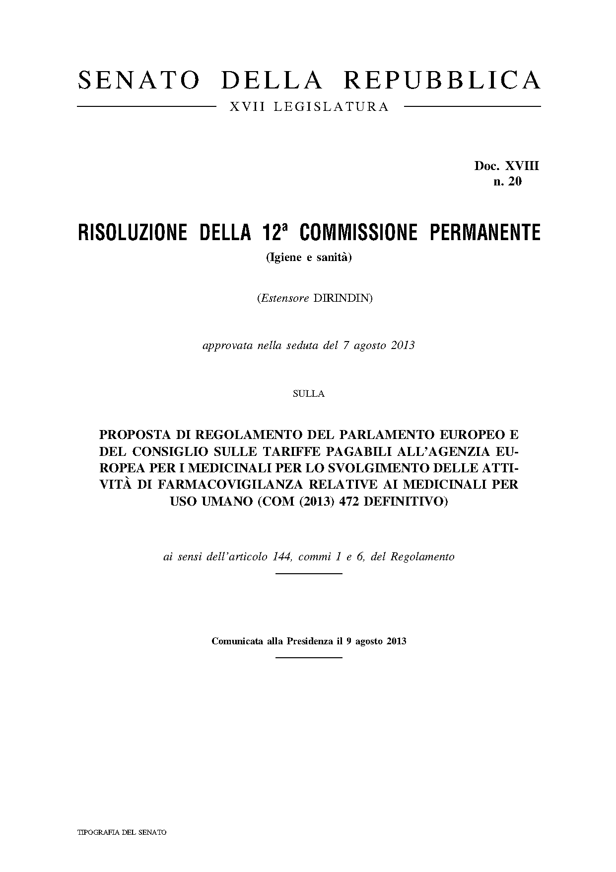
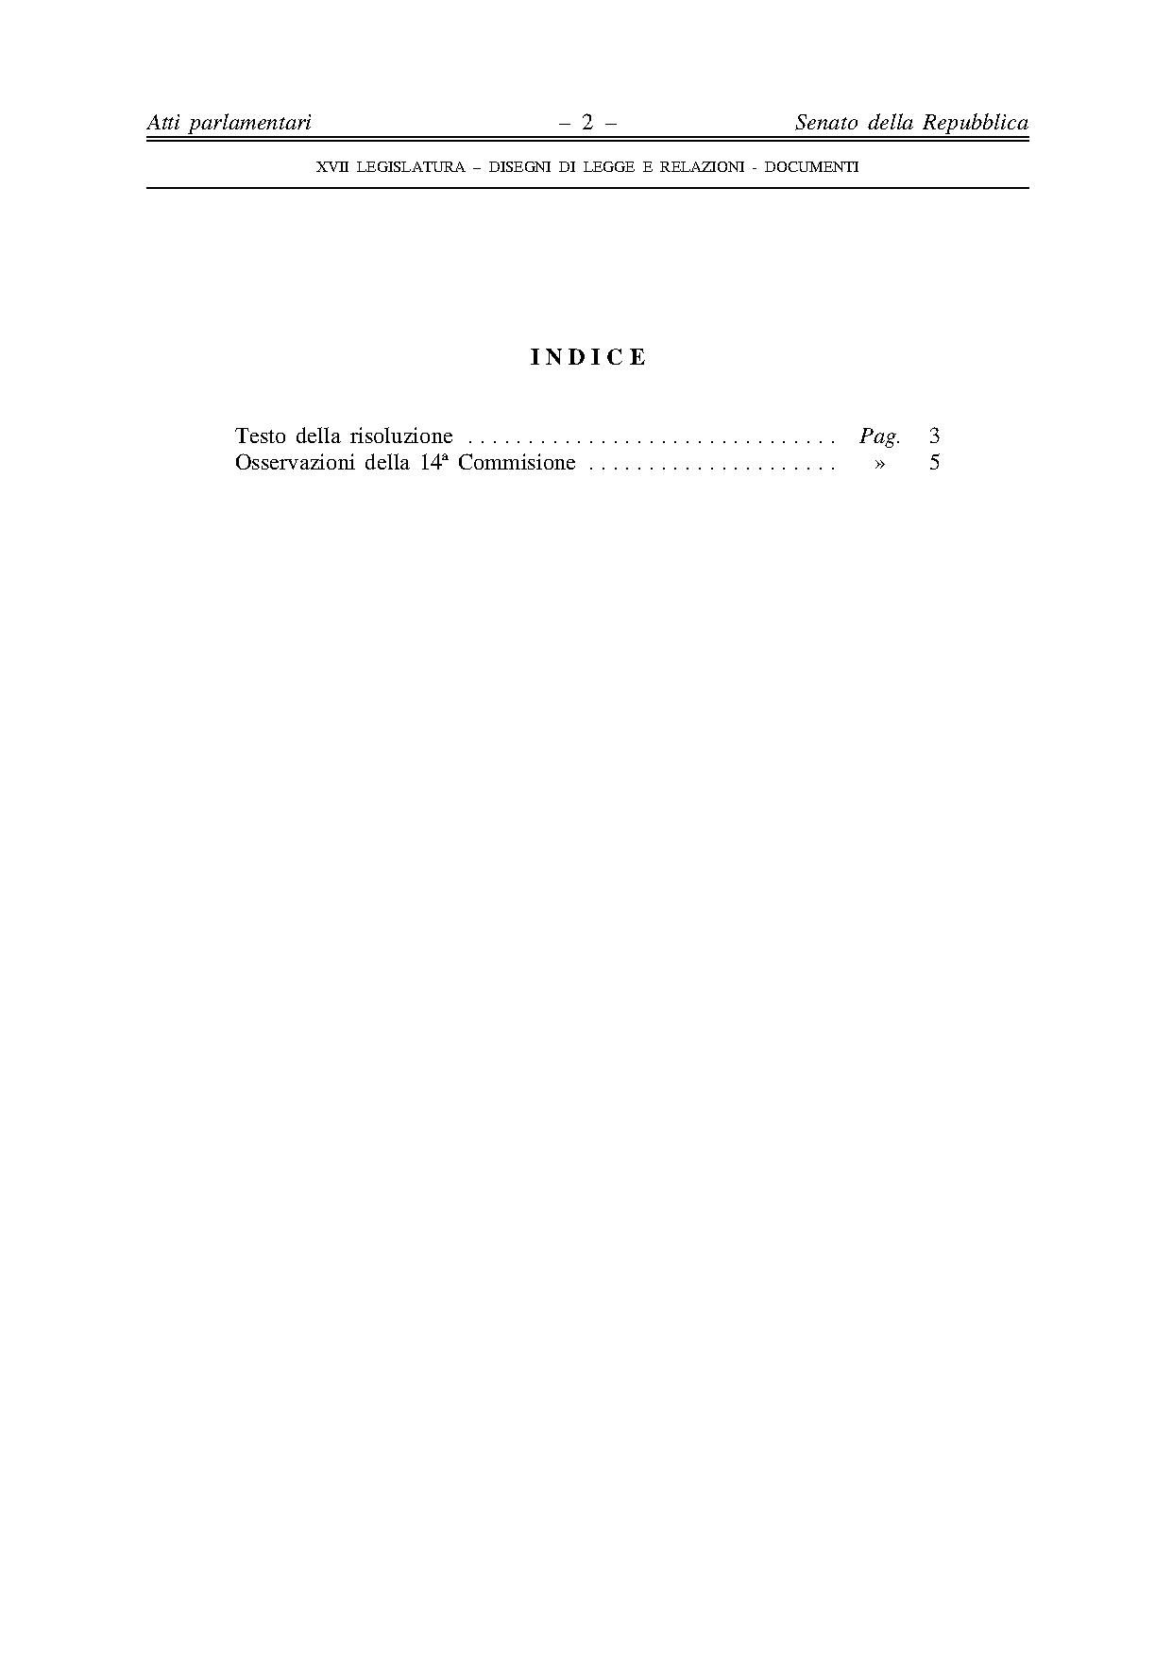
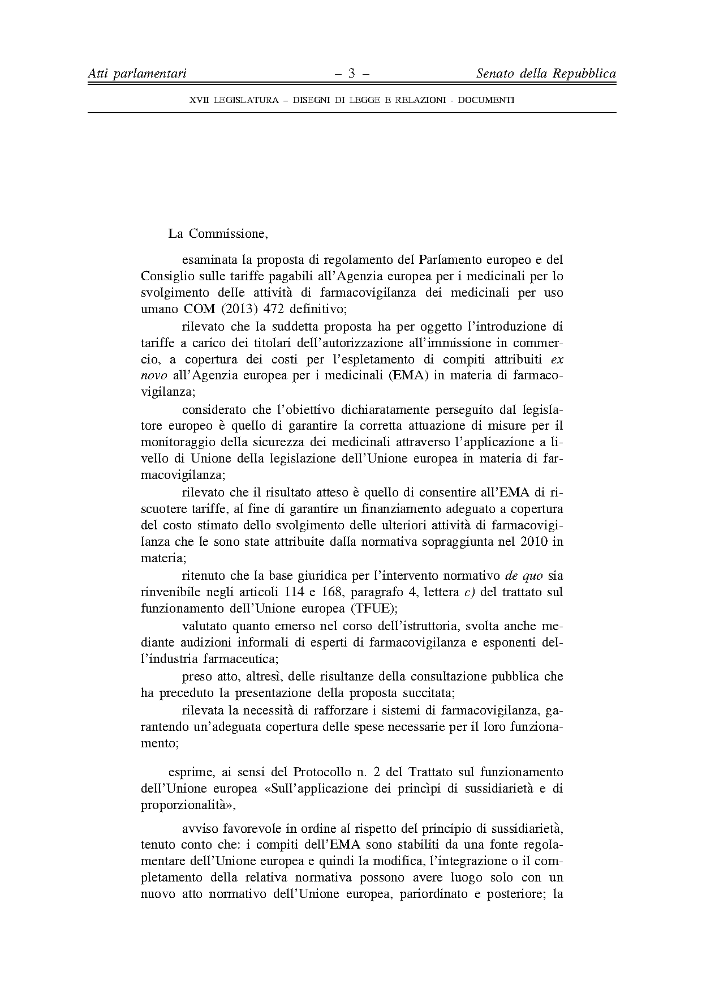

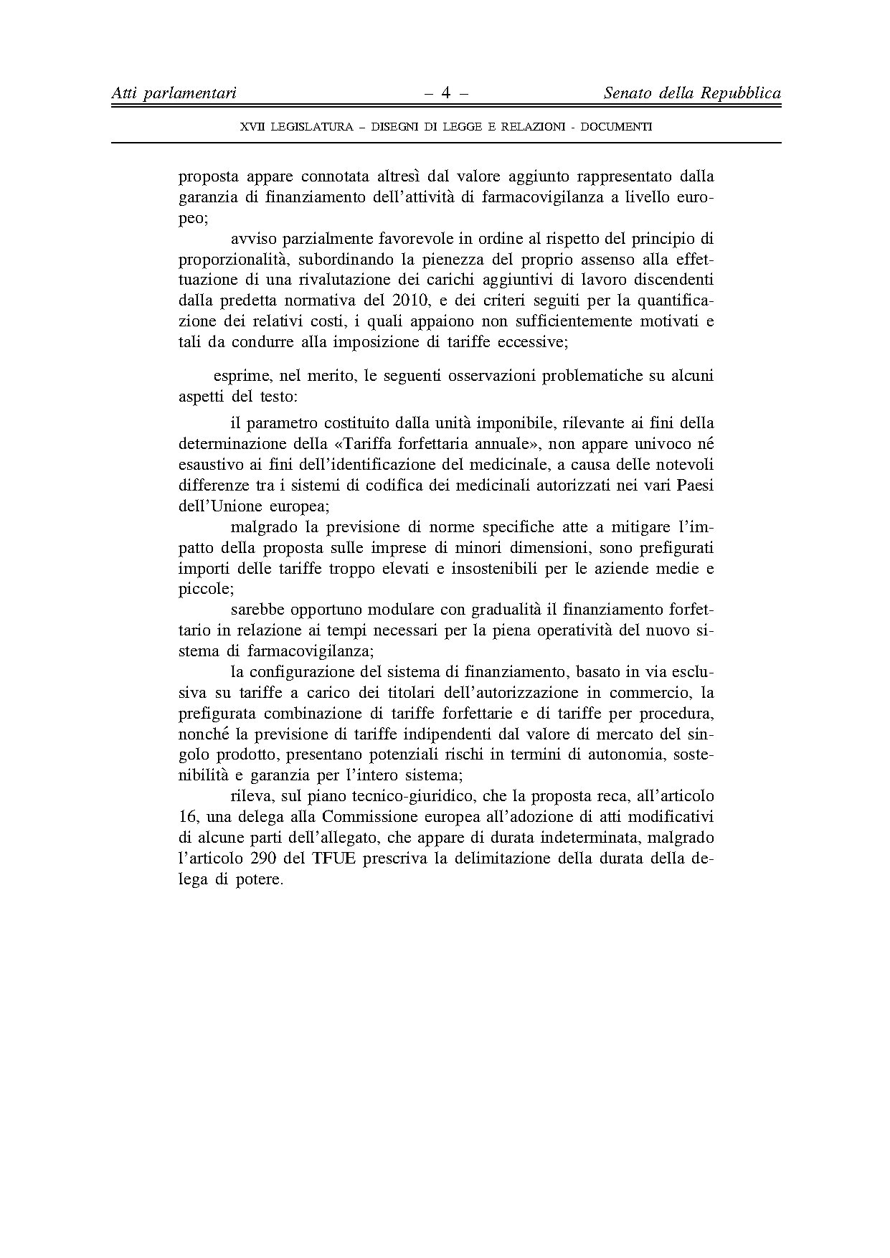

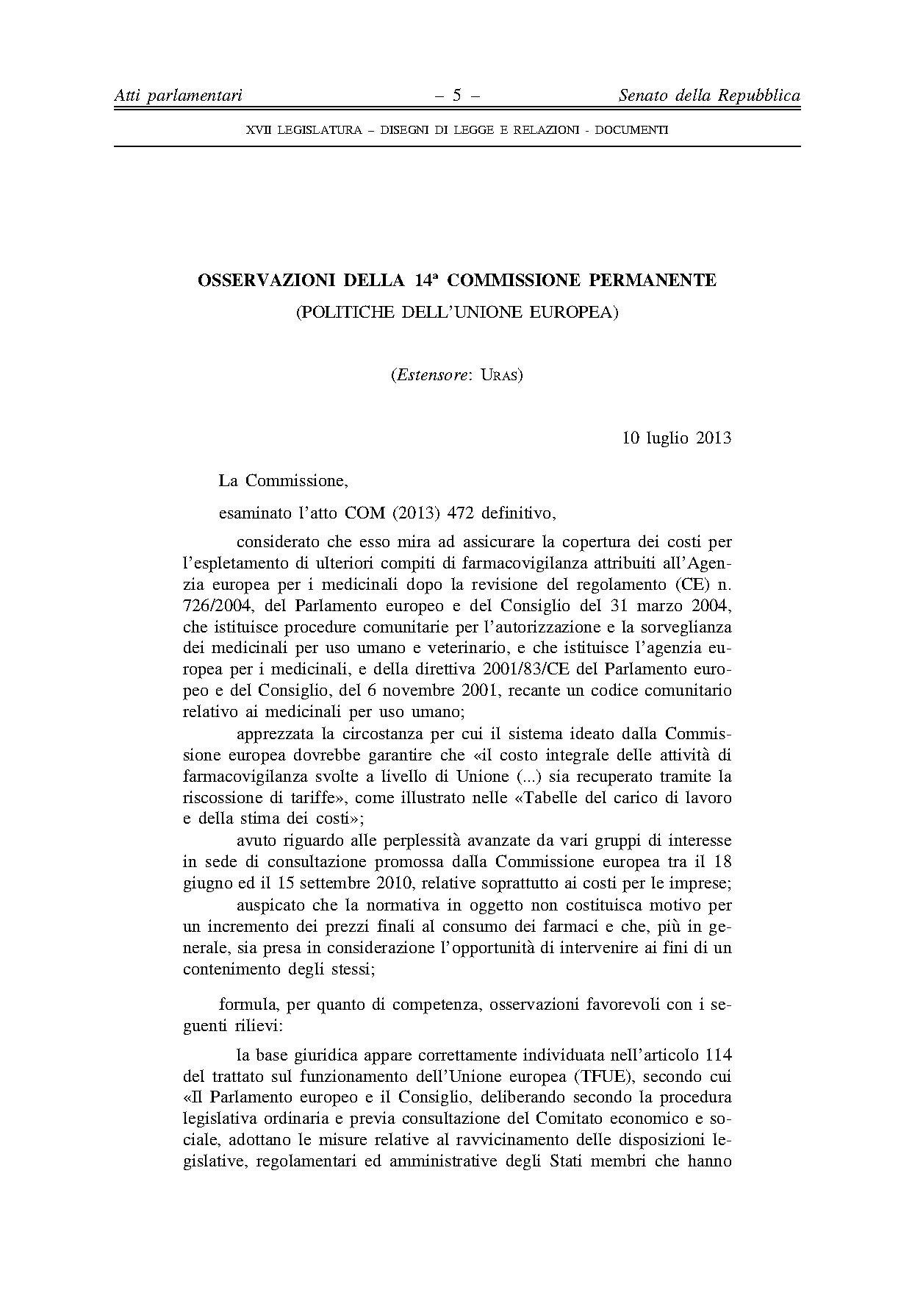

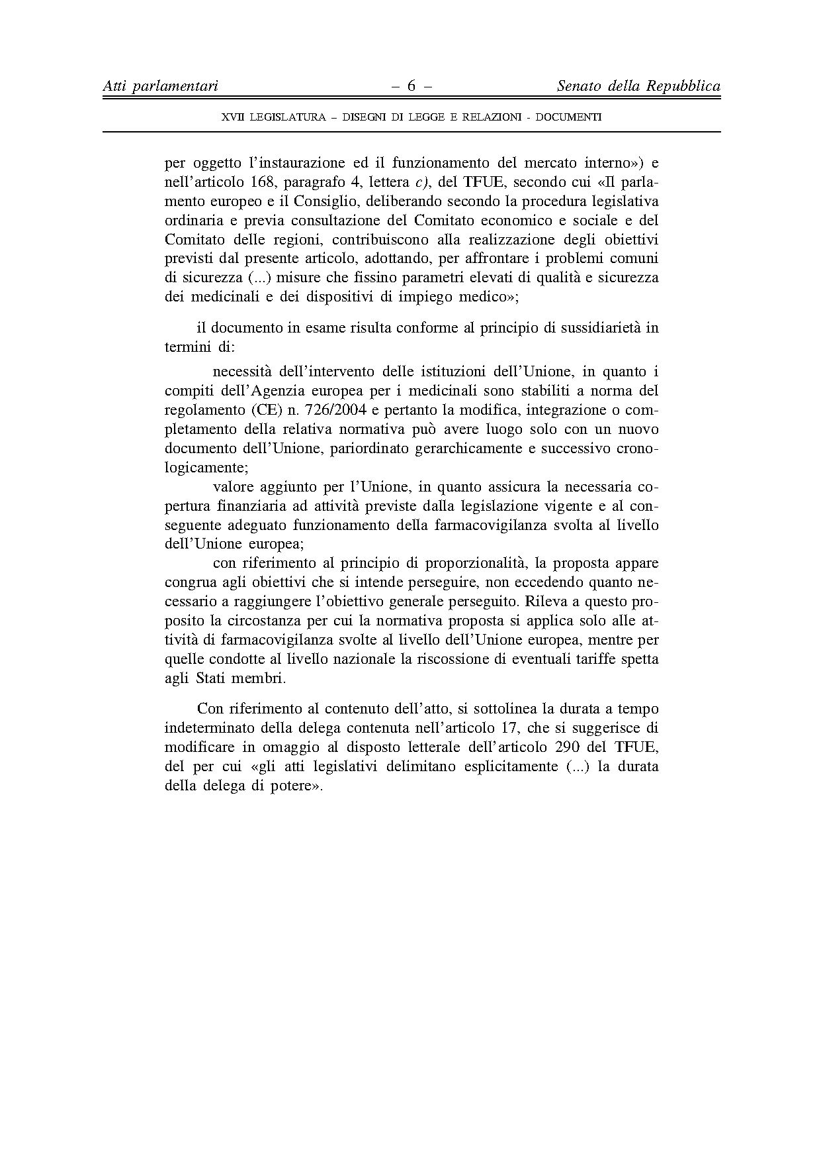
____________________

The translation can be found at the Interparliamentary EU information exchange site IPEX at the following addresses: http://www.ipex.eu/IPEXL-WEB/dossier/document/COM20130472.do#dossier-COD20130222

