 | 
COUNCIL OF  THE EUROPEAN UNION |  |  | Brussels, 10 June 2013
 | Interinstitutional File:  2013/0137 (COD) |  | 10785/13
AGRI 375
AGRILEG 77
CODEC 1412
PHYTOSAN 16
SEMENCES 8
INST 294
PARLNAT 138

COVER NOTE
from: | President of the Bundesrat of the Republic of Austria
date of receipt: | 5 June 2013
to: | President of the Council of the European Union
Subject: | Proposal for a Regulation of the European Parliament and of the Council On the production and making available on the market of plant reproductive material (plant reproductive material law) (Text with EEA relevance)  [doc. 9527/13 AGRI 304 AGRILEG 63 CODEC 1066 PHYTOSAN 12 SEMENCES 5 - COM(2013) 262 final]  - Opinion on the application of the Principles of Subsidiarity and Proportionality

Delegations will find attached the above-mentioned opinion.

________________________

ANNEX
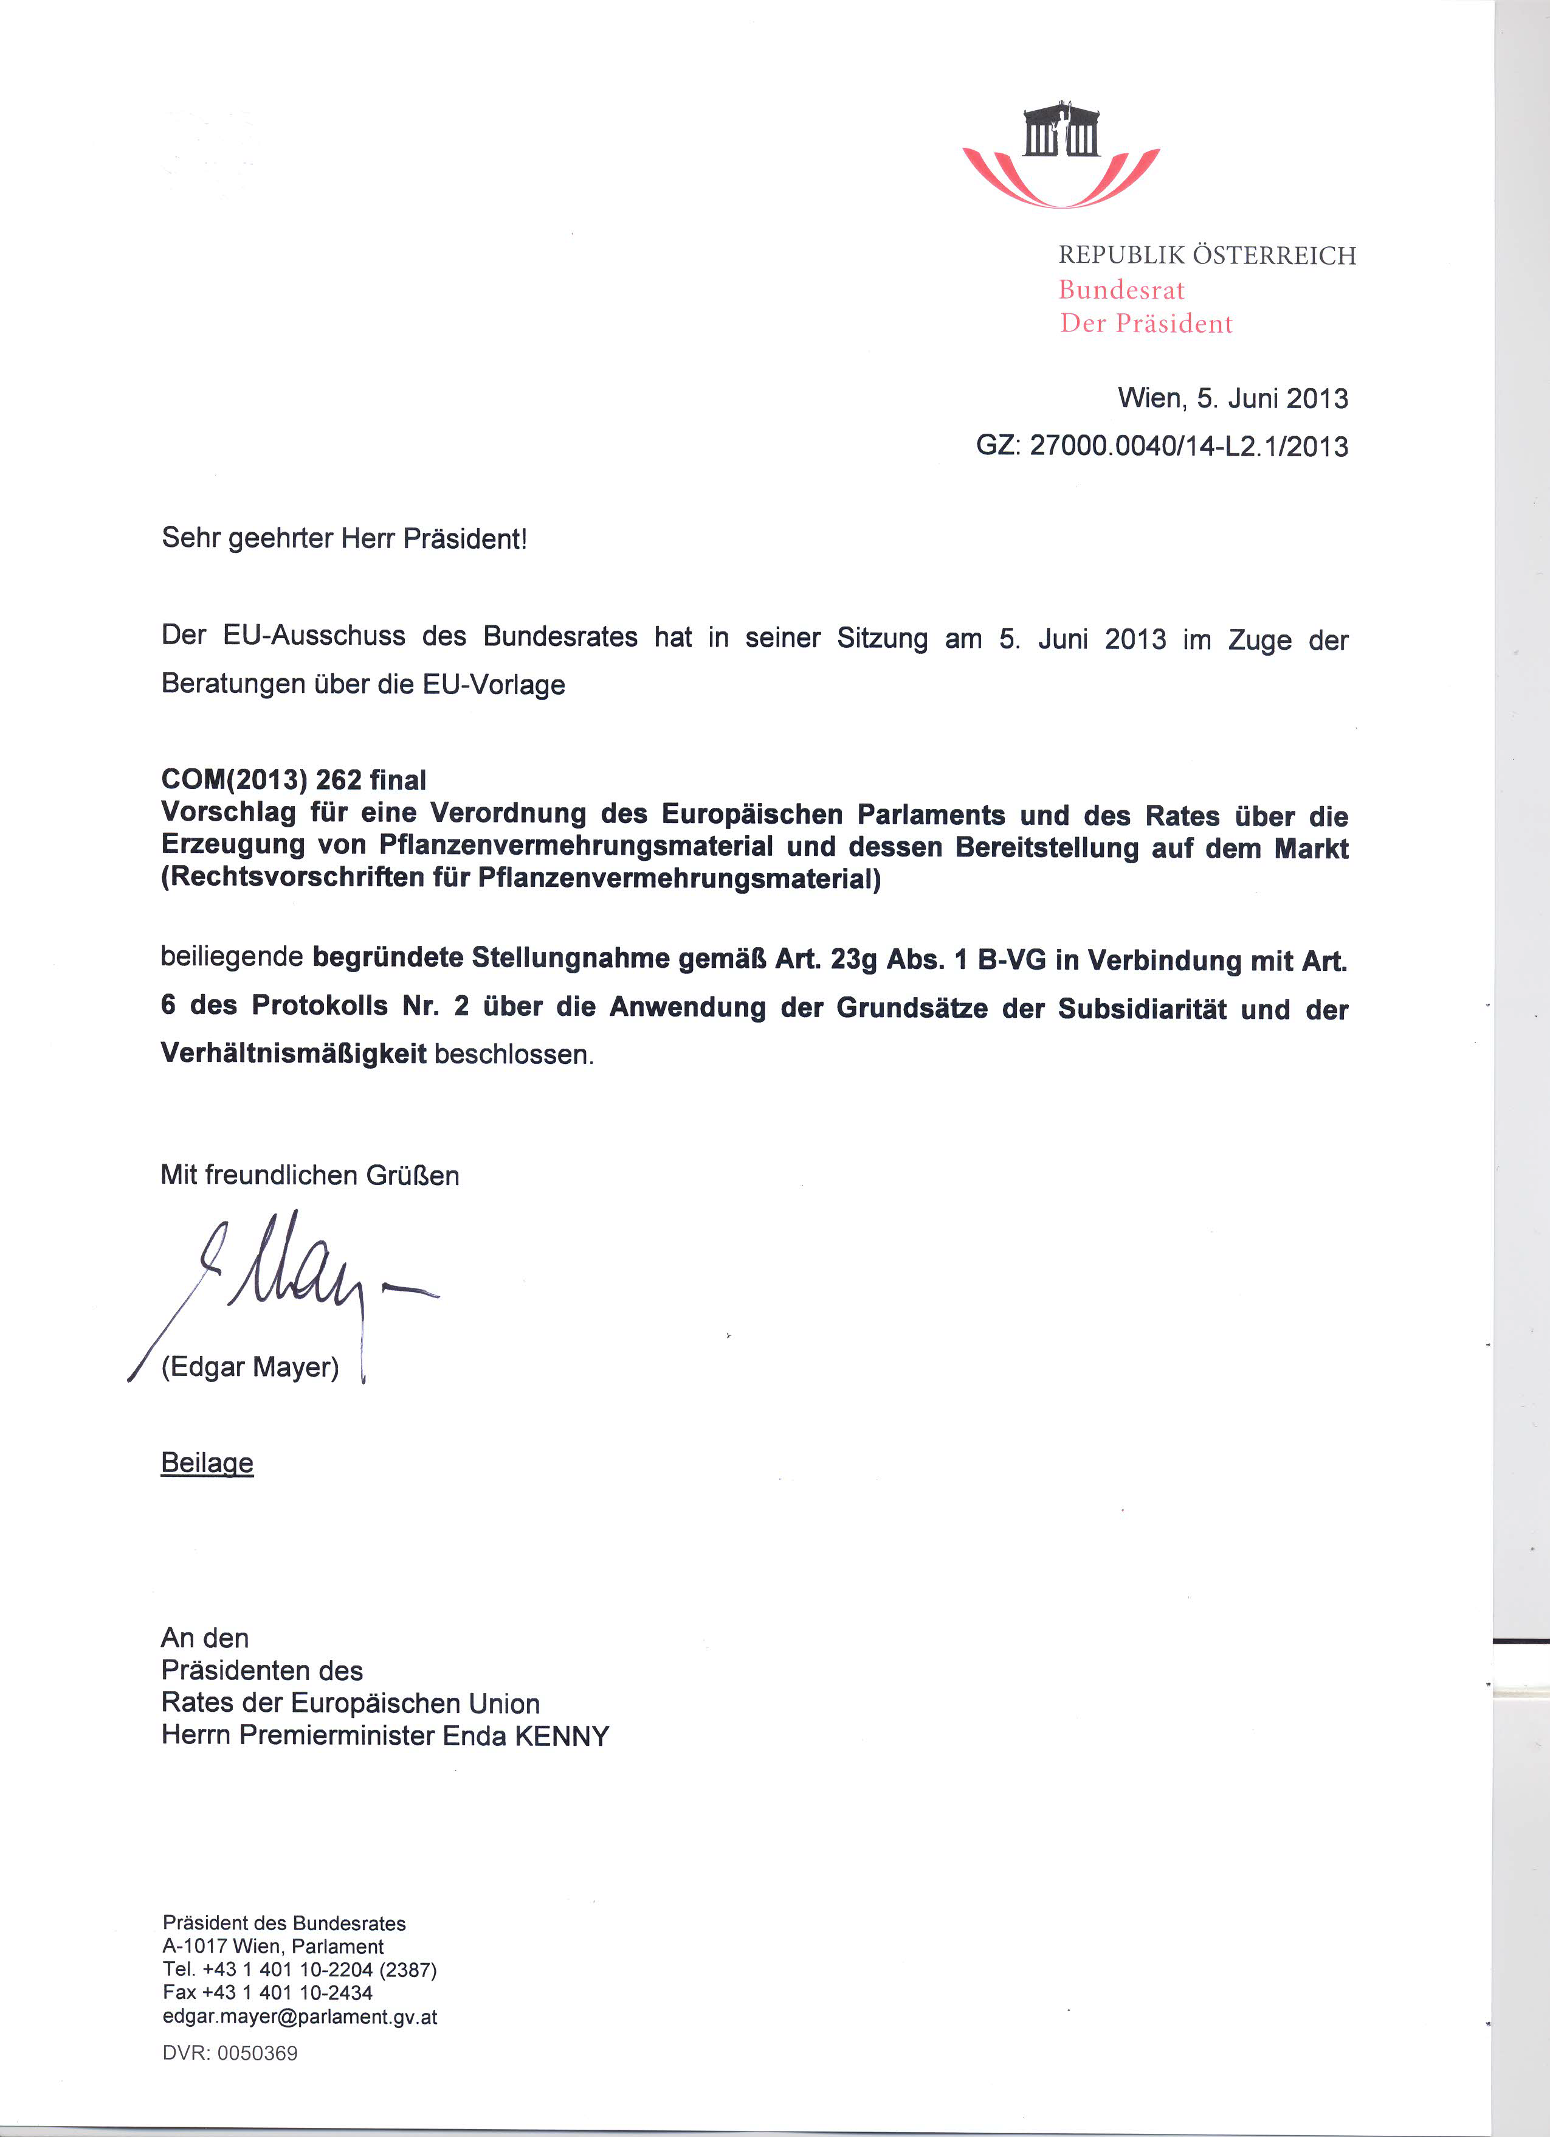
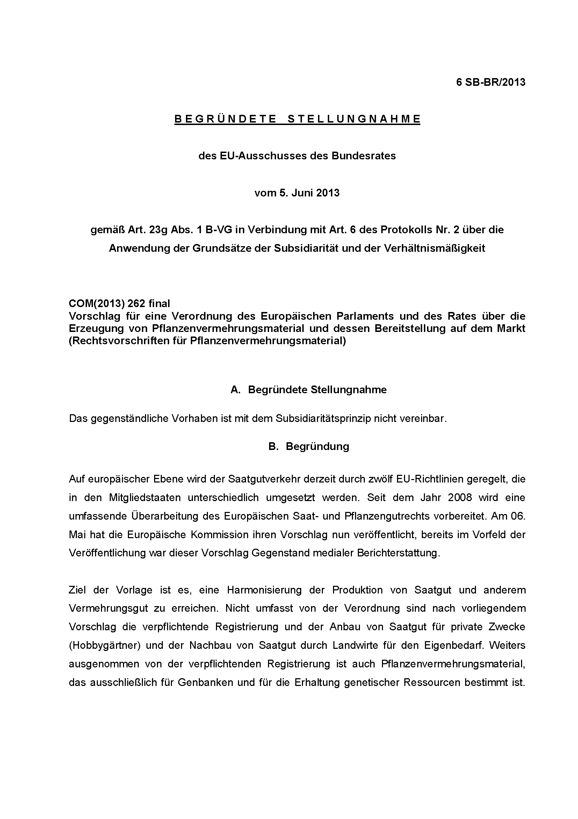
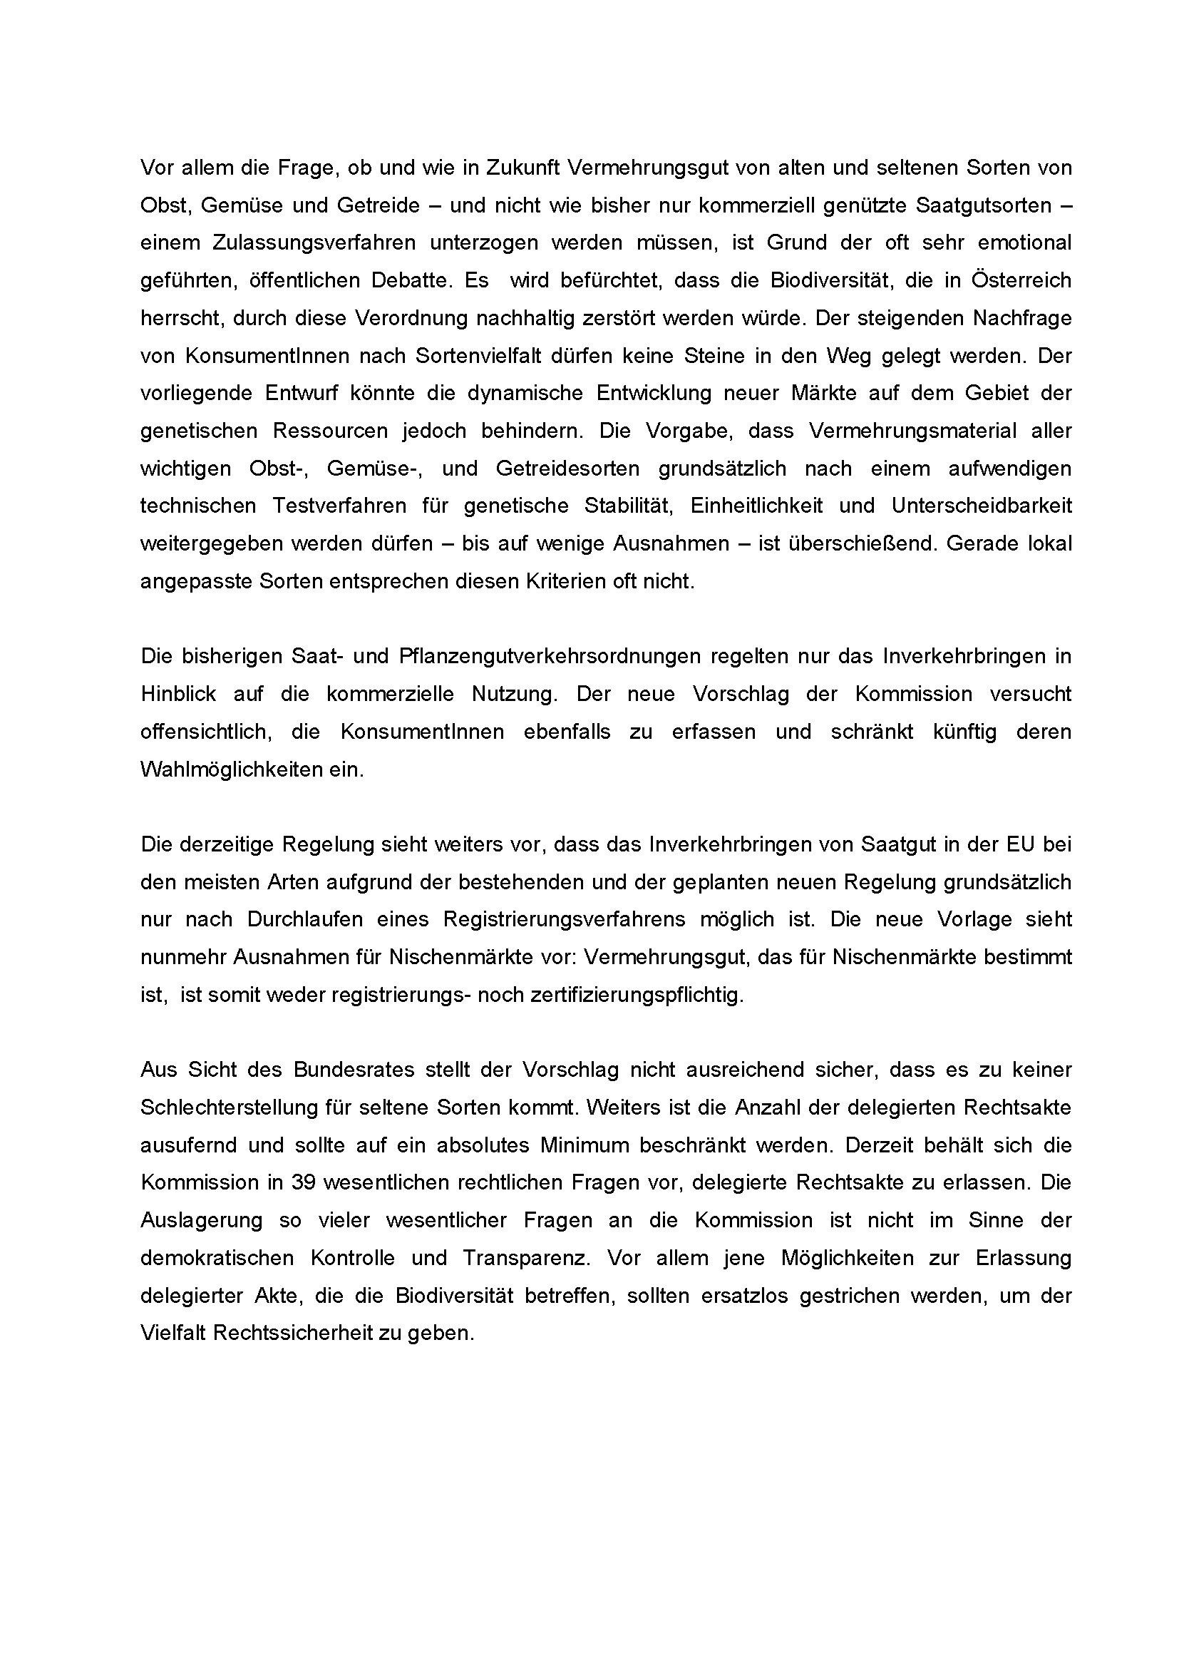
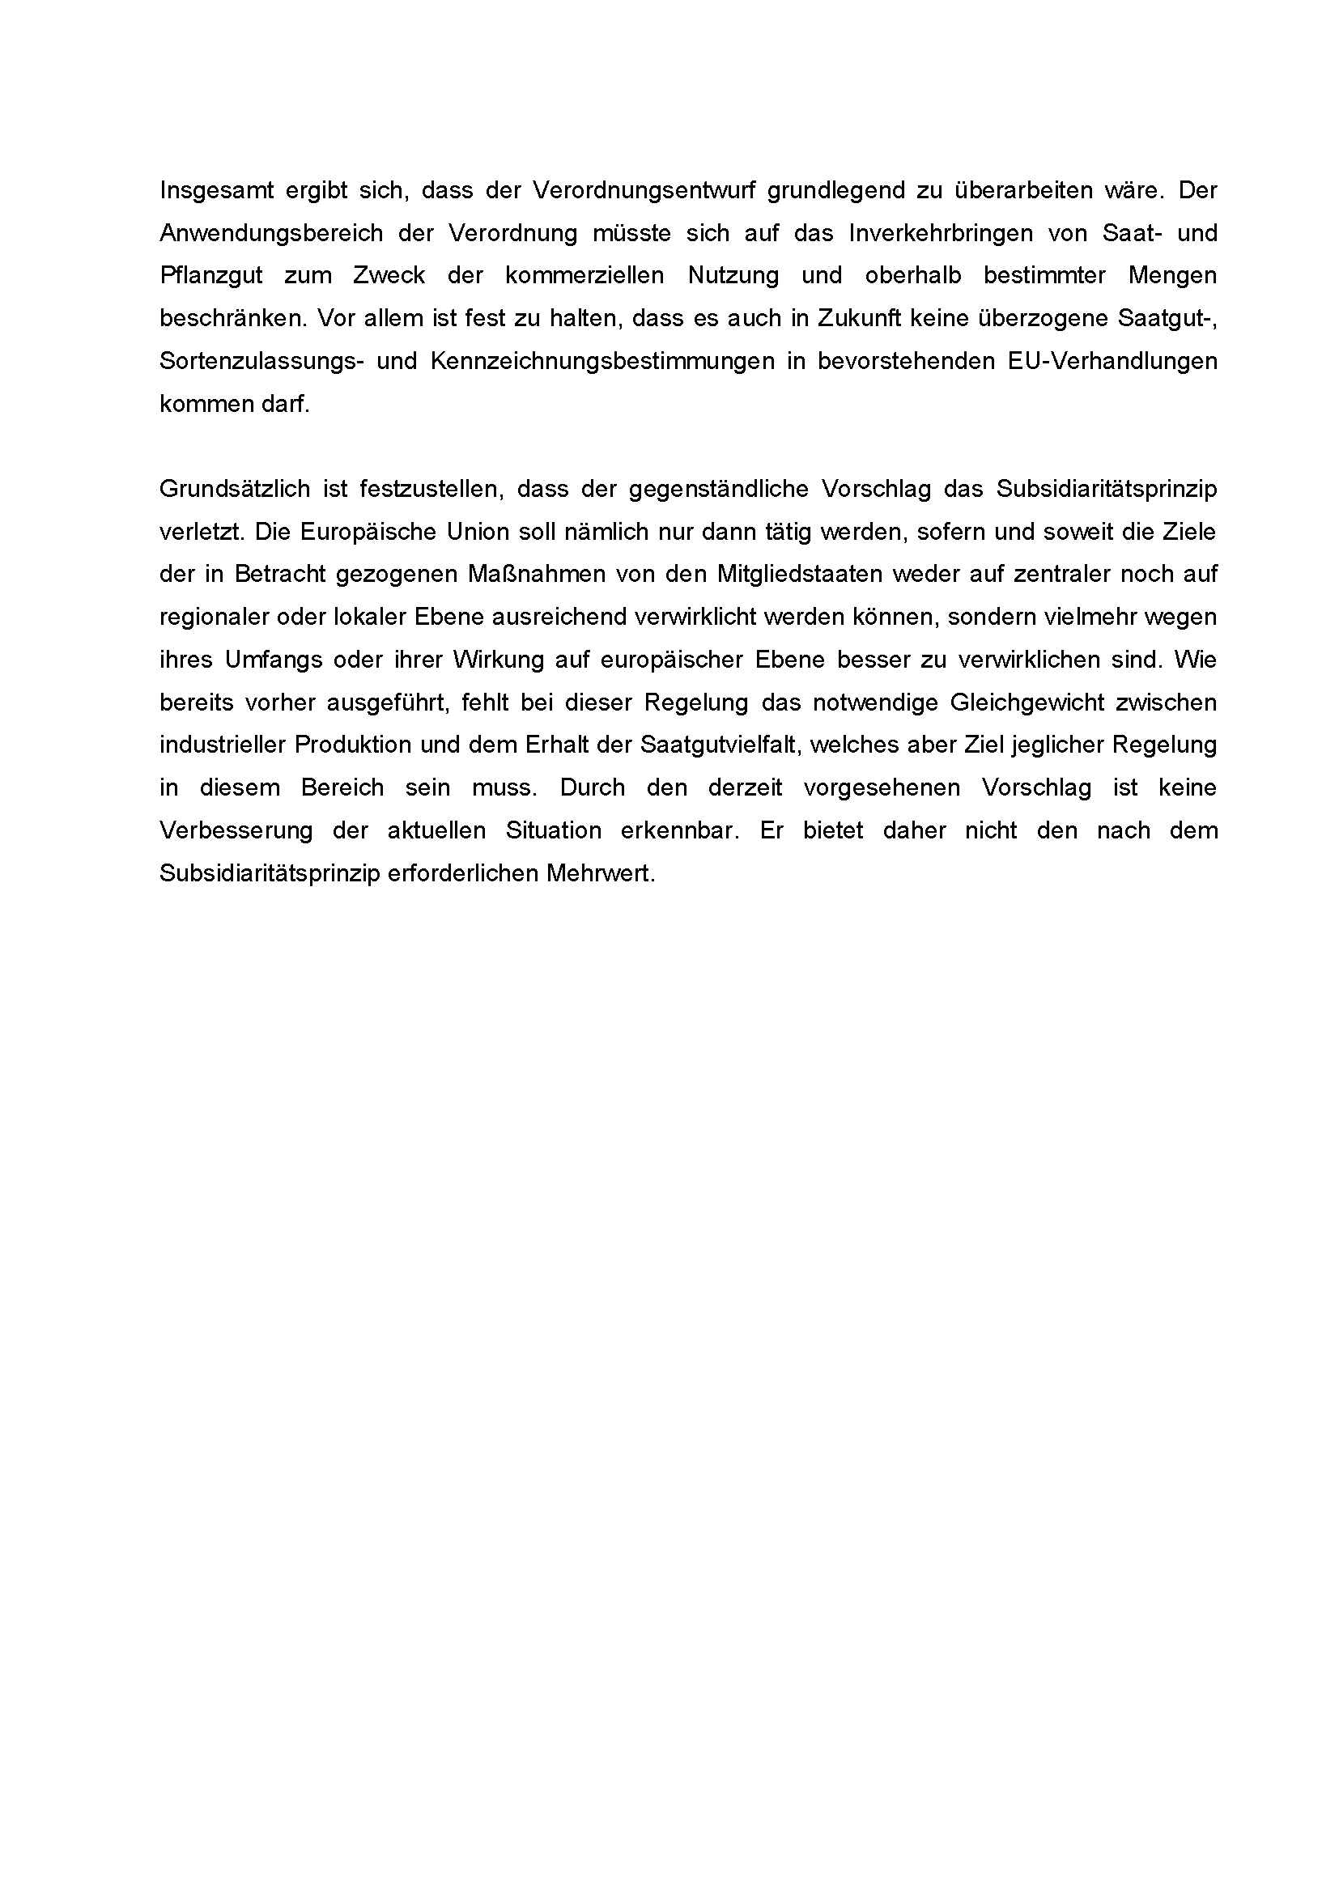

Translation(s) of the opinion may be available at the Interparliamentary EU information exchange site IPEX at the following address: http://www.ipex.eu/IPEXL-WEB/search.do

