COMMISSION STAFF WORKING DOCUMENT
IMPACT ASSESSMENT
Accompanying the document
Proposal for a Council Directive amending Directive 2009/71/EURATOM establishing a Community framework for the nuclear safety of nuclear installations
LIST OF ABBREVIATIONS
AC Alternating current
AHGNS Ad-hoc Group on Nuclear Security
BWR Boiling Water Reactor
CNS Convention on Nuclear Safety
DC Direct current
ENSREG European Nuclear Safety Regulators' Group
IAEA International Atomic Energy Agency
NPP Nuclear Power Plant
SAM Severe Accident Management
SAMG Severe Accident Management Guidelines
SBO Station Black-Out
OSART Operational Safety Review Team
PSA Probabilistic Safety Assessment
PSR Periodic Safety Reviews
TMI Three Mile Island
WANO World Association of Nuclear Operators
WENRA Western European Nuclear Regulators' Association

TABLE OF CONTENTS

INTRODUCTION
Section 1: Procedural issues and consultation of interested parties …8
Section 2: Problem definition 13
Section 3: Objectives 29
Section 4: Overview of the policy options 31
Section 5: Analysis of impacts of the policy options 33
Section 6: Comparing the policy options 43
Section 7: Monitoring and evaluation 46
ANNEX I 48
Comprehensive risk and safety assessments ('Stress Tests') of nuclear power plants in the European Union 48
ANNEX II 53
1.1. Overview of the results of the on-line public consultation on Areas of reinforcing the existing Euratom nuclear safety legislative framework 53
1.2. Overview of the contributions received from various stakeholders in addition to the on-line public consultation 68
ANNEX III 72
Socio-Economic role of Nuclear Energy to Growth and Jobs in the EU for time horizon 2020-2050 72
ANNEX IV 83
Examples of measures responding to the specific objectives 83
ANNEX V 89
Detailed description of the Policy Options analysed in the IA 89
ANNEX VI – Competitiveness Proofing Study (Separate document)

Introduction
On 11 March 2011, a magnitude 9.0 earthquake struck some 80 km off Japan's Tohoku coast. The ensuing tsunami set off by the earthquake devastated communities along the Japanese coast, killing some 16000 people. The natural disaster also triggered the shutdown and subsequent meltdown of three reactors at the Fukushima Daiichi Nuclear Power Plant (NPP). Some 100000 people had to be evacuated because of radioactive contamination, and the total costs of the accident have been estimated as high as $250 billion.
While Fukushima is not the world's worst nuclear accident, history has shown that each major nuclear accident (Three Mile Island (TMI) (USA, 1979), Chernobyl (Soviet Union, 1986)) has caused a re-examination of the risks of nuclear power leading to more stringent safety requirements. In Fukushima's aftermath came a vigorous reassessment of the safe use of nuclear energy in Europe and worldwide, firstly because it is a severe accident, and secondly because it occurred in a nation that was assumed to have a high standard of safety and technical expertise.
Although the technical challenges are different with each accident, the analysis of the Fukushima nuclear accident reveals quite substantial, well-known and recurring technical issues: faulty design, insufficient backup systems, human error, inadequate contingency plans, and poor communications.
Even more striking are the persistent institutional failures revealed by a comparison between the post-accident evaluations of 1979's TMI and 2011's Fukushima, including failure of voluntary self-regulation, denial of the reality of risk, lack of safety culture, lack of a comprehensive and consistent regulatory framework, failure to resolve outstanding safety issues, failure to add safety measures to existing reactors because of cost, and complexity and confusion in the response to a severe accident.
Fukushima has shown that well-known lessons learned from accidents decades ago have not been taken up voluntarily by parts of the industry and not sufficiently been enforced by regulators, even in a nation that was previously assumed to have a high standard of safety.
Nuclear energy currently generates close to 30% of all electricity in the EU and about two-thirds of its low-carbon electricity. Nuclear safety is of the utmost importance to the EU and its people. The costs of a nuclear accident could be so large, that they are potentially ruinous to national economies. It is therefore essential for society and the economy to avoid the occurrence of any nuclear accident in a Member State of the European Union (hereinafter referred to as 'Member State'), by ensuring the highest possible quality of regulatory oversight and standards of nuclear safety. The Fukushima nuclear accident has renewed political attention on the measures needed to minimise risk and guarantee the most robust levels of nuclear safety.
Based upon a clear mandate from the European Council at its meeting of 24-25 March 2011, the European Commission, together with the European Nuclear Safety Regulators Group (ENSREG), launched an EU-wide comprehensive risk & safety assessments of NPPs (hereinafter referred to as 'Stress Tests'). These tests identified a large number of shortcomings in nuclear safety approaches and industry practices in the participating countries.
In addition to the Stress Tests process, the mandate from the European Council included the request to the Commission to "review the existing legal and regulatory framework for the safety of nuclear installations" and to "propose by the end of 2011 any improvements that may be necessary". Initial views on potential areas of legislative improvements have already been included in the Commission Communication on the interim report on the comprehensive risk and safety assessments ('stress tests') of nuclear power plants in the European Union (hereinafter referred to as 'Commission interim stress tests report'). Any legislative proposals that could be put forward should take into account various sources, inter alia the conclusions of the Stress Tests, any lessons learned from the Fukushima nuclear accident, initiatives from various expert groups and international developments, as well as the results of the open public consultation and the stakeholders' input. The areas identified for revising the current Nuclear Safety Directive are described in more detail in the Communication from the Commission to the Council and the European Parliament on the comprehensive risk and safety assessments ("stress-tests") of nuclear power plants in the EU and related activities of 4 October 2012 (hereinafter referred to as 'Commission final stress tests report').
This Impact Assessment takes into account the above-mentioned factors. It defines in Section 2 the problems in ensuring sufficient levels of nuclear safety in the EU and the need for EU action to meet the challenges. It articulates in Section 3 the general and specific objectives for the enhanced prevention and mitigation of nuclear accidents. In Section 4 a number of policy options progressing steadily from the current starting point to more profound reforms are set out and analysed. Each option is assessed in Section 5 for its estimated safety, economic, environmental and social impacts. This sets the scene in Sections 6 and 7 for the selection of a preferred option to go forward.
The selected option amends the existing Council Directive 2009/71/Euratom establishing a Community framework for the nuclear safety of nuclear installations (hereinafter referred to as 'Nuclear Safety Directive'), by strengthening existing / introducing new general nuclear safety principles and requirements, complemented by harmonised Euratom nuclear safety criteria and procedures to verify their implementation at national level. It also provides for greater independence of the regulators and increased public transparency about the performance of the industry and the regulators. Based upon the principle of risk-informed decision making support, it avoids wholly new or unfamiliar approaches, and thereby avoids the risk of destabilising the currently best performing national nuclear safety regimes. While some of the underlying measures of the preferred option can be implemented without delay, others require technical development work with input from Member States to enable or complete their implementation.

Section 1: Procedural issues and consultation of interested parties
1.1. Timing and organisation
Timing
In the aftermath of the nuclear accident that occurred at the Fukushima NPP in Japan, the EU launched an immediate response. In addition to performing the extensive Stress Tests (presented in Annex I of the IA), the European Council also mandated the European Commission, in the Conclusions of the meeting of 24-25 March 2011, to "review the existing legal and regulatory framework for the safety of nuclear installations" and "propose by the end of 2011 any improvements that may be necessary". In a first response to this mandate, the Commission included initial views on potential areas of legislative improvement in the November 2011 Commission interim stress tests report. Next, the European Council called in the Conclusions of the meeting of 9 December 2011 that "continued priority to be given to the extensive review of nuclear safety, taking account of the Commission communication of 23 November". The areas which have been identified for revising the current Nuclear Safety Directive are described in the aforementioned Commission final stress tests report.
The European Parliament has also called for a review. In the Resolution of 5 July 2011 on energy infrastructure priorities for 2020 and beyond, it "considers that future legislative initiatives to set up a common framework for nuclear safety are essential in order to continuously improve safety standards in Europe". Furthermore, in the Resolution of 6 July 2011 on the Commission Work Programme 2012, it "calls for an urgent revision of the Nuclear Safety Directive with a view to its strengthening, namely by taking into account the results of the Stress Tests implemented in the aftermath of the Fukushima accident".
Organisation
For the purpose of developing the current Impact Assessment (IA), a European Commission inter-service Impact Assessment Steering Group (IASG) was established, led by DG ENER, and comprising representatives of other services i.e. SG, SJ, DG CLIMA, DG DEVCO, DG ECHO, DG ECFIN, DG EMPL, DG ENTR, DG ENV, DG HOME, DG JRC, DG RTD, DG SANCO. The IASG met four times, on 9 February 2012, 11 May 2012, 13 July 2012 and 6 September 2012.
The Impact Assessment Board (IAB) assessed the draft IA submitted for its attention on 19 September 2012, had its meeting on 17 October 2012 and issued an opinion on 19 October 2012.
In line with the opinion delivered, this impact assessment has been revised, in order to:
- Strengthen the problem definition, and in particular explain the current architecture for the regulatory framework governing nuclear safety in the EU, clarify the current roles and competences of the various players at national and international level and more clearly describe the various existing legal requirements at national, EU and international (see sections 2.1. and 2.2.);
- Add information on the views of various stakeholders (see sections 1.2.1.–1.2.3., 2.2.2.-2.2.5. and section 1.2. of Annex II);
- Add information on the specific weaknesses identified in the different Member States in the Stress tests (see mainly section 2.2.); it is better explained how these weaknesses are related to the deficiencies in the EU regulatory framework (see section 2.2.);
- Further justify why action is necessary at this stage (see mainly sections 2.2., 2.2.3. and 2.2.4.);
- Further develop the baseline scenario in order to demonstrate what would happen in the event of no EU action (see mainly section 2.5.);
- Better explain the content of the options (see sections 4., 5. and 5.4. as well as Annexes IV and V);
- Better assess and compare impacts (see section 6.).
- Moreover, Section 7 of the IA on monitoring and evaluation has been further developed.
1.2. Consultation and expertise
The input presented in Sections 1.2.1 – 1.2.3 below has been taken into account for the purposes of this IA.
1.2.1. On-line open public consultation
In line with its general principles of consultation and dialogue, the Commission launched an on-line public consultation (published on the Europa website), seeking views on Areas of reinforcing the existing Euratom nuclear safety legislative framework. The consultation was open during the period 21 December 2011 – 29 February 2012.
In response, the Commission received 134 contributions from nuclear regulatory authorities, other public authorities, companies, non-governmental organisations, as well as individuals. This public consultation offers therefore insights into a large range of stakeholder opinions.
In addition to gauging opinions in the frame of the review of the legal and regulatory framework for the safety of nuclear installations, the consultation also covered a number of other topics related to the use of nuclear power, i.e. enhancing emergency preparedness and response, nuclear liability, improving the global legal framework, and enhancing scientific and technological competence.
In relation to the areas of reinforcement of the existing Euratom nuclear safety legislative framework, opinions were sought on: the importance of setting up common rules for all Member States; the need to reinforce the existing legislation at Euratom level, given the trans-frontier aspects of radiological accidents; the preferred means for achieving this and the level of prescription needed (e.g. defining Euratom-wide basic principles only or complementing these with associated technical criteria); the need to bolster provisions for independence and transparency; the opportunity of strengthening the competencies of national regulators in the shaping and implementation of Euratom nuclear safety legislation.
The broad outcome of this on-line public consultation shows that more than 90% of respondents agree on the importance of a Euratom nuclear safety framework, setting up common rules for EU Member States, whilst 76% agree with the need to reinforce the existing safety legislative framework. The nuclear industry (operators, suppliers, associations) views as important the role of the Euratom nuclear safety legislative framework, but has a more divided view on the need for reinforcing the existing rules. Those favouring enhancement of the current rules prefer a combined approach of binding and non-binding Euratom legislation, principally in the areas of strengthening the role, competencies and independence of national regulatory authorities, and increasing transparency. Some also support the defining of EU-wide basic principles and requirements (with associated technical criteria) on the siting, design, construction and operation of NPPs. Many NGOs and interested citizens also consider the role of the Euratom legislative framework as important and agree with the need to reinforce the existing framework, mainly through strengthening and harmonizing national approaches. The outcomes of this on-line public consultation are summarised in Annex II (Section 1.1) of the IA.
1.2.2. Contributions from stakeholders
In addition to the on-line public consultation, the Commission has received both written and meeting-based contributions from various stakeholders, e.g. nuclear regulatory authorities, other public authorities, individual companies, industry associations and non-governmental organisations.
The European social partners from the Electricity Sectoral Social Dialogue Committee have also been consulted, and expressed the view that the nuclear industry needs to meet the highest levels of safety possible and consider that a European approach in this area is needed. The social partners will be further involved, through the consultation of the European Economic and Social Committee, in the process of the preparation of any legislative proposal based on Articles 31 and 32 Euratom Treaty.
A summary and analysis of the inputs received from these stakeholders is included in Annex II (Section 1.2) of the IA.
In addition, the Commission has organised with ENSREG several Conferences and public debates in Brussels together with a wide range of stakeholders, including NGOs, on the process, the intermediate and final results of as well as the conclusions from the Stress Tests: the 1st European Nuclear Safety Conference on 28-29 June 2011, a Stakeholders Conference on Peer Reviews on 17 January 2012, and a Public Debate on Stress Tests and Peer Review Results on 8 May 2012. This will be followed up by the 2nd European Nuclear Safety Conference, scheduled for June 2013 in Brussels.
1.2.3. Main information sources
- Information from the Member States based on the Article 33 Euratom Treaty submissions
According to Article 33 Euratom Treaty, Member States are bound to communicate to the Commission their draft legislation in order to ensure its conformity with basic standards. The Commission may make recommendations within a three-month period from the communication of these drafts.
The aim of the notification procedure laid down in Article 33 of the Euratom Treaty is to ensure harmonisation of the applicable provisions in the Member States. Thus, the submission of draft texts under Article 33 Euratom Treaty allows the Commission to make appropriate recommendations or remarks before the finalisation of the national procedure for the adoption of transposition measures, so that possible instances of non-compliance can be identified even before the texts are adopted.
In the framework of the Nuclear Safety Directive, 21 Member States (AT, BE, CY, CZ, EE, FI, DE, EL, EE, IT, LV, LT, LU, MT, NL, PT, PL, RO, SL, SK and SV) communicated draft transposing measures during the transposition period. Although most of them aimed to transpose individual Directive provisions and not the Directive as a whole, a large number of Member States argued that they already had legislation in force that would transpose important parts of the Directive.
Based on the Commission's preliminary assessment of the notified draft measures, it is concluded that, although they don’t contain elements deviating from the main requirements set by the Directive, the wide range of legal solutions, in particular to ensure the effective independence of the national regulatory body and the adequacy of its legal powers and its human and financial resources to the mission attributed by the national legal framework and the Directive provisions, could prevent the realisation of the Directive objectives in a harmonised way within the Community.
- Preliminary assessment of the Member States' transposition measures of the Nuclear Safety Directive
The preliminary assessment of the Member States' transposition measures of the Nuclear Safety Directive, although indicating that these largely meet the main requirements set by the Directive, has identified a number of areas where improvement would be needed (effective independence of the national regulatory authority and transparency).
- Results of the Stress Tests
An important input was the findings of the Stress Tests, which involved a range of stakeholders across the 15 Member States with NPPs in operation or being decommissioned (plus 2 neighbouring countries). In particular, the process involved the Commission and ENSREG, who, with the expertise of the Western Nuclear Regulators' Association (WENRA), developed the scope and modalities of the tests; the plant operators who carried out the assessments; the national regulators in the 15 countries who reviewed the reports; a team of 80 regulatory experts from 24 European countries who carried out the peer review of the national reports. The results and conclusions of the Stress Tests process therefore provide valuable input to the present consideration of areas of improvement to the legislative and regulatory framework.
- International dimension
In June 2011 a Ministerial Conference on Nuclear Safety was convened under the auspices of the International Atomic Energy Agency (IAEA), for the process of learning and acting upon lessons following the Fukushima accident in order to strengthen nuclear safety, emergency preparedness and radiation protection of people and the environment worldwide. The Ministerial Conference adopted a Ministerial Declaration that, inter alia, requested the IAEA Director General to develop a draft Action Plan on Nuclear Safety. Developed in intensive consultation with IAEA Member States, the Action Plan on Nuclear Safety was adopted by the IAEA's Board of Governors and subsequently unanimously endorsed by the IAEA General Conference in September 2011. The Ministerial Declaration and the subsequent Action Plan provide the international dimension to the sources of information considered in this IA.
In addition, during the 5th Review Meeting of the Convention on Nuclear Safety, the Contracting Parties in attendance agreed to hold an Extraordinary Meeting (EM) of the CNS, which was held in Vienna from 27-31 August 2012. The meeting aimed to enhance safety through reviewing and sharing lessons learned and actions taken by Contracting Parties in response to events at Fukushima and to reviewing the effectiveness and, if necessary, the continued suitability of the provisions of the Convention on Nuclear Safety.
The six topical discussions at the EM (External Events, Design Issues, Severe Accident Management and Recovery (on-site), National Organizations, Emergency Preparedness & Response and Post-accident Management (off-site), and International Cooperation) were used to identify the key actions taken, the challenges faced and the initial lessons learned by many Contracting Parties from the Fukushima Daiichi accident which were summarised in its Final Summary Report where the suggested steps to strengthen the effectiveness of the Convention were also included.
The other important sources of information mentioned in this IA are the official investigation reports into the Fukushima accident issued by the Japanese authorities. The reports of the Japanese Government to the IAEA (June and September 2011) contain a detailed description of the events in the accident sequence, accident response and initial lessons learnt. Separately, investigations were launched by the Governmental Cabinet Office ("Investigation Committee on the Accident at Fukushima Nuclear Power Stations of Tokyo Electric Power Company", final report July 2012) and another by the National Diet of Japan ("The Fukushima Nuclear Accident Independent Investigation Commission", final report July 2012). The latter two investigation reports contain testimonies of a larger group of affected persons and also contain a wider analysis of the accident causes and subsequent response.
- Results of Eurobarometer surveys
The Eurobarometer surveys are major policy instrument that enable citizens’ views to be taken into account in the framing of EU policies and initiatives. The Commission has taken into account the results of the latest Special Eurobarometer survey "Europeans and Nuclear Safety". The survey was conducted in the 27 Member States between September and October 2009 and the report was published in March 2010. Almost 26500 European citizens were interviewed face-to-face. The survey covers both the wider theme of nuclear issues in general and the topic of nuclear safety in particular.
Throughout the report, the results have clearly shown that nuclear safety aspects are of crucial importance against a background where the potential danger posed by nuclear power appears to be one of the major drivers of reluctance regarding nuclear energy. In this regard, one of the conclusions of the survey is that "European citizens are extremely conscious of the importance of safety and protection, as far as nuclear energy is concerned but most feel ill-informed about nuclear safety issues related to nuclear power plants". Furthermore, the survey seems to reveal that European citizens trust the European legislation and recognize the usefulness of a European framework.

Section 2: Problem definition
2.1. The problem that requires action
The accident at the Fukushima Daiichi NPP has resulted in significant environmental, economic and social damage, and raised concerns about possible health effects in the affected population in Japan. Although triggered by an earthquake and tsunami of an immense magnitude, investigations of the causes of the accident reveal a range of foreseeable factors which combined to produce a catastrophic outcome. In other words, although the tsunami was not an unforeseeable event (and thus clearly within the realm of risk-informed, probabilistic assessment), strong deficiencies of the plant’s design basis caused the accident. As the analysis of the Fukushima accident reveals quite substantial, well-known and recurring technical issues as well as persistent institutional failures that emerged to a large degree already from the post-accident evaluations of 1979's TMI and 1986's Chernobyl nuclear accidents, the attention of the public and policy makers focused on the safety and security risks associated with the NPPs in their own region. As with the TMI accident in 1979 and the Chernobyl accident in 1986, this latest nuclear accident once again undermined public confidence in the safety of nuclear power; and particularly so at a time when the increased use of nuclear power is being debated as possible option to meet global energy demands whilst addressing greenhouse gas emissions in a sustainable manner.
The EU has 132 operating reactors, representing about one-third of the 437 operating nuclear power reactors in the world. Many of the EU NPPs were constructed already three to four decades ago, and are based on designs and safety provisions that were continuously updated since then. In May 2011, the Commission together with ENSREG launched a comprehensive review of the NPPs in the EU and some neighbouring countries to assess if current safety margins are sufficient to cover various unexpected events. The results of these tests show various strengths and weaknesses, including the clear need to implement for a number of plants measures to increase the robustness against external hazards. The tests also showed significant differences in national approaches to beyond-design basis assessments that make an adequate assessment of current safety levels difficult or impossible. For example, in some cases earthquake risk was not considered in the original design basis but only introduced at a later stage or clearly underestimated. New methodologies in seismic hazard and risk assessment have since been developed, but not all operators have reassessed site hazards and seismic risks with recent methodologies.
These tests were organised taking due account of the distribution of current responsibilities among the various stakeholders in the area of nuclear safety. According to article 6 of the Nuclear Safety Directive, the prime responsibility for nuclear safety lies with the "licence holder" (i.e. the plant operator) under the supervision of the national competent regulatory authority. Member States are responsible for establishing and maintaining a national legislative, regulatory and organisational framework for nuclear safety. Under the Euratom Treaty, the Commission can make legislative proposals to create an EU legislative framework for nuclear safety,
Severe accidents leading to radioactive releases may result in the need for countermeasures such as sheltering or evacuation of the affected population. Estimates show that the number of people living close to NPPs in the EU vary significantly. However, as many as 1.74 million people live, for example, within 30km of one of the larger NPPs. Thus the practicalities of such large scale countermeasures point to the key importance of accident preventative measures.
The lessons from the Fukushima disaster and the outcome of the Stress Tests have provided a strong impetus for examining the factors shaping the technical safety and the safety governance of nuclear power in the EU. It is opportune to ask whether existing measures are sufficient; to what extent strengthened or additional requirements could prevent a similar disaster occurring in the EU; and what type of technical and organisational measures would be most effective.

2.2. Specific problems to be addressed
Based on various sources of expertise, such as corresponding initiatives by the IAEA and WENRA as well as lessons learned from the EU Stress Tests and Fukushima accident investigations, as well as from the prima facie assessment of the Member States' transposition measures of the Nuclear Safety Directive, key areas for improvement of nuclear safety have been identified. These problem areas are presented below under Sections 2.2.1 to 2.2.5 and concern technical issues (in particular plant siting and design), the regulatory oversight, aspects related to nuclear safety governance (regulatory independence and transparency) as well as the issue of emergency preparedness and response.
• Technical issues
• Regulatory oversight issues
• Regulatory independence issues
• Transparency issues
• Emergency preparedness and response issues

It is also explained below what are the main shortcomings identified in Member States, such as gaps in ensuring comprehensive and transparent identification and management of key safety issues, failure to implement important safety measures and last but not least the continued significant differences between Member States resulting in the absence of a consistent approach to regulation of nuclear safety despite its global nature.
Under each identified problem area presented below, the weaknesses of the current Euratom nuclear safety legislation, in particular of the Nuclear Safety Directive, to address them, are highlighted. This Directive sets up a legally binding Euratom framework based upon internationally recognised principles and obligations, underlying a nuclear safety legislative, administrative and organisational system.
Firstly, taking into account that the scope of this Directive is limited to overall principles, it can by no means address the technical issues identified as key risk contributors in the Fukushima nuclear accident and the Stress Tests, nor take account of initiatives from various expert groups and international developments in this area, as those matters are simply not covered by the scope of the current Directive. Examples are the methods and criteria used to assess the adequacy of existing safety margins of plant-specific safety functions against the various possible impacts from both internal and external hazards, the minimum provisions that need to be incorporated in the design of NPPs in order to achieve sufficient levels of safety, the minimum severe accident management provisions to be in place, etc. A detailed summary of the safety issues and good practices specific to each Member State and each NPP are described in the Staff Working Document accompanying the Commission Communication on the Stress Tests.
In the following text, it is explained that notwithstanding the role of the Stress Tests in enhancing the safety of EU NPPs, the weakness of this exercise is related to its non-binding nature. Indeed, the Stress Tests are only a voluntary exercise which does not guarantee that the recommended improvements will be (fully) implemented. Another weakness of the Stress Tests is that they are only a one-time, ad-hoc exercise. It does not guarantee that the identified measures will be regularly updated and implemented also in the future, where appropriate. Further, as the EU Stress Tests were developed in the light of the events which occurred at the Fukushima NPP in March 2011, they represent targeted reassessments of the safety margins of NPPs against impacts from a limited range of extreme external initiating events. Therefore, various important aspects of nuclear safety have not explicitly been treated, such as ageing of structures and components, human and organisational factors or independence of the regulator vis-à-vis the licensee.
Secondly, as explained below, the current provisions of the Directive concerning regulatory independence do not appear to be sufficient anymore in the light of the Fukushima nuclear accident, which showed the paramount importance of the independence of national regulatory authorities and the consequences of the lack of such independence. The preliminary assessment of the transposing measures in Member States has also identified the regulatory independence as an area where improvement would clearly be needed.
Moreover, the Stress Tests show that cooperation and coordination mechanisms between all parties having responsibilities for nuclear safety, such as peer reviews, should be strengthened beyond the current requirements of the Directive.
Thirdly, the lessons learned from the Fukushima nuclear accident, as well as the outcome of a prima facie check of the transposition measures of the existing requirements at Member State level suggest that the current provisions of the Directive concerning transparency should be further enhanced.
In addition, in the course of the public meetings held in the framework of the Stress Tests, demands have emerged to extend the assessment to emergency preparedness and response arrangements. In this context, the area of on-site emergency preparedness and response should be considered.
Following the events at Fukushima, IAEA Member States generally acknowledge the need to enhance the effectiveness, governance and enforceability of the international legal framework for nuclear safety. At international level, safety principles and standards governing nuclear safety have been developed and agreed. Through the IAEA, the main instruments governing nuclear safety are recommended IAEA safety "standards" and international Conventions. However, these safety "standards" are legally non-binding, while the international Conventions are legally binding but not enforceable. Thus, for example, the CNS does not provide sanctions, penalties or other types of coercive implementation mechanisms in case the Contracting Parties do not comply with its requirements. The CNS provides for a dispute-settlement mechanism which relies solely on consultations between Contracting Parties in case of a disagreement on the interpretation or application of the Convention. On the other hand, the Euratom legislation benefits from clear and strong mechanisms for sanction for its proper transposition and implementation,
Any revision of the international Conventions can be expected to take considerably longer than the possible Euratom legislative amendment process, due to the complex procedures in place, requiring consensus or the condition of attaining a certain quorum of the Contracting Parties' votes.
Moreover, the rules agreed at international level have a more general character, as they need to be applied worldwide, while Euratom legislation would be tailored to the specific needs and situations existing in the Member States.
2.2.1. Technical issues
- Observations from the Fukushima nuclear accident
- Plant Siting and Design: One lesson learned from Fukushima seems to be that the tsunami hazard was underestimated and thus not adequately reflected in the plant design, mostly due to systemic and organisational factors. A single external event (the tsunami) disabled all but one emergency diesel generators at the plant simultaneously, shutting down all safety systems of Units 1-4. Due to the multi-unit site layout, problems at one Unit created negative safety-related situations at adjacent Units. For example, the hydrogen explosion at Unit 3 disabled some fire pumps used for seawater injection at Unit 2. Units 5-6, which are far from Units 1-4, were unaffected by the hydrogen explosions at Units 1 and 3. Thus, Fukushima showed both the need for continuously updating a site's hazard profile with follow-ups, e.g. in the periodic safety reviews (PSR) (rather than in a one-shot exercise at the initial licensing stage), as well as for implementing – and for verifying implementation – of adequate risk reduction measures. This applies to possible impacts from seismic hazards, flooding and other external natural hazards, such as severe weather conditions or man-made external hazards, including combined hazards and multi-unit events and collocated nuclear and industrial facilities. Corresponding design-basis protection should be re-evaluated.
- Emergency Power following Beyond-Design-Basis Events: The loss of offsite power due to the earthquake and onsite AC power due to the tsunami, combined with rapid discharge of DC batteries led to a complete Station Blackout (SBO), which in turn led to fuel overheating and damage with consequent radiological implications.
- Reactor Containment and Hydrogen Management: SBO resulted in complete loss of the heat removal function. Deficient fuel cooling resulted in overheating of the fuel, enabling rapid oxidation of fuel cladding thus generating large amounts of hydrogen. The operators had to vent the containment manually to prevent containment over-pressurisation. Some vented gases leaked into the reactor building, which had no ventilation (again due to SBO), resulting in hydrogen accumulation and ultimately explosion of or damage within the reactor buildings at Units 1-4.
- Spent Fuel Pools: Design and location of the spent fuel pools in the upper part of the reactor buildings exposed them to damage from hydrogen explosions in reactor buildings at Units 1, 3 and possibly 4. The loss of spent fuel pool cooling due to SBO, and the large amount of debris accumulated in the spent fuel pools as a result of structural damage of the upper part of the reactor building affected the heat removal process. This concern led to one-week-long unconventional cooling efforts (e.g. helicopters, water cannons).
- Lessons learned from the Stress Tests
- The type of accident that occurred at Fukushima is well known in nuclear safety as the SBO scenario. Since decades, SBO has been one of the great concerns and been subject to detailed analysis and development of improvement measures. As dramatically proven in Fukushima and as confirmed also by the Stress Tests, SBO is the limiting case for many NPP Units, leading to fast reactor core heat-up if no counter-measures are implemented. However, despite being known since decades as limiting case, there is still need, also in a number of European NPPs, to implement effective preventive or mitigative measures.
- Fukushima highlighted once again the key importance of the containment function, which is critical as the last barrier to protect people and environment against radioactive releases resulting from an accident. Following the accidents at TMI and Chernobyl, urgent implementation of recognized measures to protect containment integrity was already considered crucial. The Stress Tests proved that even today, decades after TMI and Chernobyl, their implementation is still pending in some Member States.
- The Stress Tests identified a significant lack of consistency with respect to assessing and managing external hazards to plant safety. Already the national Stress Tests and their topical peer review (see Annex I) showed that there is no consistency in the handling of important safety margins against internal and external hazards across NPPs in Europe. This was then confirmed in the course of the country-specific peer reviews. Significant differences exist in national approaches and strong difficulties were encountered with corresponding beyond design basis margins and cliff-edge effects assessments, leaving the interpretation that what is considered a sufficient margin of safety is often left to expert judgment only. As an example, IAEA guidance suggests that minimum 0.1g horizontal peak ground acceleration should be adopted for seismic loading, where a national approach to seismic hazard assessment may indicate a lower level for design or reassessment. As shown in the Stress Tests, this minimum level has not yet been fully adopted in a number of Member States.
- As it is essential to ensure that severe accidents, should they occur, can be managed and mitigated properly, international standards require since some time Severe Accident Management Guidelines (SAMGs) to be available in all NPPs. Despite forming the organisational basis to successfully mitigate accidents once steps to prevent fuel damage have failed, the Stress Tests have shown that SAMGs are still lacking implementation, full scope application or even basic development in a large number of Member States.
- Provisions in the current Nuclear Safety Directive
At Euratom level, the current Nuclear Safety Directive defines the term "licence" as "any legal document granted under the jurisdiction of a Member State to confer responsibility for the siting, design, construction, commissioning and operation or decommissioning of a nuclear installation" [Article 3(4)]. It includes a general requirement that license holders, under the supervision of the regulatory authority, should regularly assess and verify, and continuously improve, as far as reasonably achievable, the nuclear safety of their nuclear installations in a systematic and verifiable manner [Article 6(2)]. This assessment must include verification that measures are in place for prevention of accidents and mitigation of consequences of accidents, including verification of the physical barriers and licence holder's administrative procedures of protection that would have to fail before workers and the general public would be significantly affected by ionising radiations [Article 6(3)].
However, the Directive does not include specific Euratom nuclear safety requirements or technical criteria on the siting, design & construction and operation of nuclear installations. Therefore, the risks from none of the above-described issues are managed by the provisions of the current Directive at the level of detail considered necessary.

2.2.2. Regulatory oversight issues
- Observations from the Fukushima nuclear accident
- The initial lessons from the Fukushima accident clearly indicated a serious failure in implementing requirements and recommended actions for protecting the plant against external hazards.
- One of the key findings of the 26 December 2011 Interim Report of the Investigation Committee on the Accident at Fukushima Nuclear Power Stations of Tokyo Electric Power Company (ICANPS) was that operators and the authorities had become complacent about nuclear safety standards in Japan, and a radical review is required. The official report of the Japanese parliament, National Diet of Japan, Fukushima Nuclear Accident Independent Investigation Commission (July 2012) referring to regulatory inadequacies notes that "The regulators did not monitor or supervise nuclear safety. The lack of expertise resulted in “regulatory capture,” and the postponement of the implementation of relevant regulations." It adds "Autonomy and transparency must be built into the new regulatory organizations to be created. They must have significant powers of oversight in order to properly monitor the operators of nuclear power plants."
- International developments
- The importance of "further strengthening the authority, competence and resources of national regulatory authorities" has been highlighted in the Declaration by the IAEA Ministerial Conference on Nuclear Safety and reiterated in the subsequent Action Plan on Nuclear Safety.
- In the Final Summary Report of the 2nd Extraordinary Meeting of the Contracting Parties to the CNS (Annex containing action-oriented objectives for strengthening nuclear safety), one of the items included therein is to "Ensure the effectiveness of its regulatory body by providing for adequate legal authority, sufficient human and financial resources, staff competence, access to necessary external expertise for its decision-making based on adequate scientific and technical knowledge, access to international cooperation, and other matters needed for fulfilling its responsibilities for the safety of nuclear installations."
- Lessons learned from the Stress Tests
- In the course of the Stress Tests, tangible safety improvements have been identified in all the participating countries, based on the lessons learned from Fukushima. The expenses for implementing these upgrading measures on a plant-specific basis are likely to be significant. However, the main weakness of the Stress Tests is the difficulty of giving a relative priority in terms of risk reduction to the hundreds of improvement measures identified. To be able to judge the importance of the different proposed measures, to prioritize between them and to allocate funding to those areas which would bring the greatest safety benefits, sufficiently consistent and comprehensive risk-informed methods and related criteria would need to be implemented in a consistent manner across the entire nuclear sector, in response to the urgent need to efficiently reinforce nuclear installation safety based on risk assessment conclusions. The Stress Tests have shown that operators and regulators in many Member States make already some use of risk-informed methods to help support regulatory oversight and decision-making when identifying weaknesses and prioritizing safety improvements. Probabilistic Safety Assessment (PSA) forms an essential part of these decision-making processes. However, as also shown by the Stress Tests, the scope and depth of these analyses significantly differ and in some Member States there is an urgent need to bring them up to accepted international standards. Fukushima reiterated the importance of harmonization of PSA and the urgent need to efficiently reinforce nuclear installation safety based on risk-informed conclusions.
- Individual Member States may implement all or some of the measures that were identified in the course of the Stress Tests, intensify regulation and oversight, but – considering the sobering experience from the aftermath of the accidents in TMI and Chernobyl decades ago (see above) – it is probable that this will concern particularly only those countries where the level of safety is already above average. Follow-up visits to the Stress Tests to verify plant-specific implementation of proposed improvement measures will not be sufficient as such an "ad-hoc approach" neither improves the underlying safety requirements and criteria used as a basis for regulatory decision-making in a sustainable manner nor does it strengthen the independent role of the regulator to control risks. What is currently missing is a coordinated European approach for cooperation between various competent regulatory authorities and international peer reviews.
- As a basis for efficient safety improvements, the Stress Tests confirmed the need for adequate staff training, including for extreme situations, as well as adequate human resources and expertise. Such requirements concerning training and expertise should apply to direct employees of the licence holder as well as to subcontractors working on the NPP sites.
- The using of subcontractors must not impair the organisational capacity of the licence holder who should preserve his full control and responsibility over the safety of the nuclear installation. Moreover, the licence holder must maintain his own internal competence in particular as regards the full control of the planning and quality of interventions.
- Provisions in the current Nuclear Safety Directive
At Euratom level, the current Nuclear Safety Directive obliges Member States to establish a competent regulatory, which is equipped with the required legal power, human and financial resources. It also enumerates in a general manner the main competencies of the national regulatory authorities [Article 5(3)].
However, the existing catalogue of regulatory competencies is not complete and could be strengthened. This reinforces the fundamental principle that only strong regulatory oversight can guarantee the safe operation of nuclear installations in the EU.

2.2.3. Regulatory independence issues
- Observations from the Fukushima nuclear accident
- One of the key lessons learned from the Fukushima accident is that the effective independence of the national regulatory authorities must be ensured. A culture where ties between the regulator and operator are too close, may lead to situations where recommended or even required actions are not properly implemented in the absence of control mechanisms and sanctions. There should be provisions de facto and de jure which allow an independent regulatory judgement and an effective enforcement.
- In the Additional Report of Japanese Government to IAEA - Accident at TEPCO's Fukushima Nuclear Power Stations(September 2011), it is mentioned that "Due to the unification of administrative organizations over the utilization and regulation of nuclear power and the non-centralized administrative organizations for ensuring nuclear safety, it was unclear until recently which organization has primary responsibility for disaster prevention and the protection of public safety. Reviews of such bodies and the enhancement of nuclear regulatory bodies need to be done promptly". The above-mentioned Fukushima Nuclear Accident Independent Investigation Commission (July 2012) report notes the lack of independence of the regulators in the Nuclear and Industrial Safety Agency (NISA), noting "…the problem was the fact that NISA was created as part of the Ministry of Economy, Trade & Industry (METI), an organization that has been actively promoting nuclear power."
- The IAEA Mission Report of the IAEA fact-finding expert mission of the Fukushima Dai-ichi NPP accident following the great East Japan earthquake and tsunami (24 May – 2 June 2011), mentions among the lessons learned that "Nuclear regulatory systems should ensure that regulatory independence and clarity of roles are preserved in all circumstances in line with IAEA safety standards".
- International developments
- The commitment of continuously ensuring the effective independence of the national regulatory authorities has been also affirmed in the Declaration by the IAEA Ministerial Conference on Nuclear Safety and reiterated in the subsequent Action Plan on Nuclear Safety.
- Also, in the Final Summary Report of the 2nd Extraordinary Meeting of the Contracting Parties to the CNS (Annex containing action-oriented objectives for strengthening nuclear safety), one of the items included therein is to "Ensure that its regulatory body is effectively independent in making regulatory judgments based on scientific and technological grounds and taking enforcement actions and that it has functional separation from entities having responsibilities or interests, such as the promotion or utilisation of nuclear energy (including electricity production), that could conflict with safety or other important regulatory objectives or otherwise unduly influence the decision making of the regulatory body."
- Provisions in the current Nuclear Safety Directive and preliminary assessment of transposition measures
- The effective independence of the national regulatory authority is one of the issues arising from a prima facie check of the transposition measures of the existing requirements at Member State level. This preliminary assessment shows that although the Nuclear Safety Directive contains minimal provisions underlying the independence of the national regulatory authorities (Article 5(2)), the existing requirements do not define benchmark criteria for ensuring their effective independence, thus not allowing for a consistent interpretation of the concept of "effective independence" throughout the Community. For instance, based on information available to the Commission from various sources, the current provisions of the Directive are not sufficient for avoiding or improving existing situations where, in some Member States, the regulatory responsibility is still split between several entities or is included directly in Ministries (Economy, Environment, etc.).
- Finally, it should be acknowledged that, since the adoption of the current Directive, the provisions therein on regulatory independence fall short of international requirements (e.g. Governmental, Legal and Regulatory Framework for Safety GSR part1, IAEA, 2010).

2.2.4. Transparency issues
- Observations from the Fukushima nuclear accident
- Another key lesson learned from Fukushima is the importance of enhancing transparency on nuclear safety matters.
- In the Additional Report of Japanese Government to IAEA it is mentioned that "In the initial stages of the accident, communication and cooperation between the central and local governments as well as between various relevant organizations were not achieved to a sufficient degree, due to the difficulty in securing means of communication and also due to the fact that the roles and responsibilities of each side were not always clearly defined." Furthermore, it is mentioned that "Especially immediately after this accident, actions were not sufficiently taken to provide local residents with information or easily-understood explanations about radiation, radioactive materials, or information on future outlooks on risk factors". The Fukushima Nuclear Accident Independent Investigation Commission report, commenting on the lack of openness of the operator even after the accident says that it: "… continued to avoid transparency in disclosing information. It limited disclosure to confirmed facts, and failed to disclose information that it felt was uncertain or inconvenient."
- International developments
- The Declaration by the IAEA Ministerial Conference on Nuclear Safety emphasised "the responsibility of the nuclear industry and operators in the implementation of nuclear safety measures and call upon them and their associations to fully support and actively contribute to international efforts to enhance nuclear safety by, inter alia, furthering transparency and prioritizing safety considerations". A number of measures aiming at enhancing transparency are included in the subsequent Action Plan on Nuclear Safety.
- In the Final Summary Report of the 2nd Extraordinary Meeting of the Contracting Parties to the CNS (Annex containing action-oriented objectives for strengthening nuclear safety), one of the items included therein is to "Ensure that its regulatory body operates in a transparent and open manner, taking into account legitimate concerns over security and other sensitive interests that might be adversely affected by the public disclosure of particular information."
- Lessons learned from the Stress Tests
- The transparent process of the Stress Tests, the public availability of documents, the involvement of safety authorities not operating nuclear installations have allowed interested parties to observe the progress of the work. For example, licensee reports, national reports and peer-review reports of the Member States have been made available on the ENSREG website. This openness has greatly added value to the exercise.
- Provisions in the current Nuclear Safety Directive and preliminary assessment of transposition measures
- Transparency is one of the issues arising from a prima facie check of the transposition measures of the existing requirements at Member State level. The existing provisions of the Nuclear Safety Directive contain indeed only generic requirements on public information (Article 8), without offering concrete guidance on implementation. For instance, the current Directive does not impose transparency obligations on the licence holders (who have the prime responsibility for nuclear safety). Moreover, it does not offer more specific indications on the types of information that should be provided, as a minimum, to the public by the competent regulatory authority.
- Expert groups' guidance
- Finally, it should be noted that ENSREG has already developed useful guidance on transparency matters (e.g. Guidance for National Regulatory Organisations, Principles for Openness and Transparency, HLG_p(2011-14)_57).

2.2.5. Emergency preparedness and response issues
- Observations from the Fukushima nuclear accident
- In the light of the Fukushima accident, the importance of improving emergency preparedness and response arrangements is clearly acknowledged. Apart from lack of sufficient severe accident prevention and mitigation measures, a major shortcoming of the safety of both the Fukushima plant and the surrounding communities was that the accident had not been assumed to occur as a complex disaster.
- In the Additional Report of Japanese Government to IAEA, it is mentioned that "Shortly after the accident, under the damage conditions caused by the earthquake and tsunamis, the securing of emergency response equipment and the mobilization of rescue teams to support accident control activities were not performed sufficiently". The Fukushima Nuclear Accident Independent Investigation Commission report mentions the problematic coordination of the emergency response, saying that "The Commission concludes that the situation continued to deteriorate because the crisis management system … did not function correctly. The boundaries defining the roles and responsibilities of the parties involved were problematic, due to their ambiguity."
- International developments
- In the Declaration by the IAEA Ministerial Conference on Nuclear Safety, the ministers emphasised "the need to improve national, regional and international emergency preparedness and response to nuclear accidents, including through the possible creation of rapid reaction capacity and the development of training in the field of crisis management at the regional and international levels, as well as to strengthen cooperation among national authorities, technical safety organizations, operators and among relevant intergovernmental and non-governmental organizations". A number of measures aiming at strengthening emergency preparedness and response are included in the subsequent Action Plan on Nuclear Safety.
- Lessons learned from the Stress Tests
- In the EU, specific actions and decisions in the area of preparedness and response in case of a nuclear emergency are taken mainly at national level. Following Fukushima, some Member States and neighbouring countries have now started to evaluate their emergency management provisions also under "beyond design-basis" accident conditions (i.e. accidents which are possible, but were not fully considered in the design because they were judged to be too unlikely) and identified possible improvements, as shown by the Stress Tests. However, the final report of ENSREG on the peer reviews of the EU Stress Tests summarises that: "One of the important results of the public interaction is a strong demand for a European initiative on off-site emergency preparedness".
- Provisions and mechanisms at EU and Euratom level
In the EU, specific actions and decisions in the area of emergency preparedness and response in case of nuclear and radiological emergences are taken mainly at national level. A range of relevant EU and Euratom legislative instruments are also in place, as well as several mechanisms which could be activated in case of a nuclear or radiological emergency.
The Community Mechanism for Civil Protection facilitates co-operation between the Member States in civil protection assistance interventions in the event of major emergencies taking place both inside and outside the Union for any type of disasters, including radiological and nuclear accidents (e.g. assistance through the Mechanism has been provided to Japan following the Fukushima accident). In addition, a number of activities are undertaken at EU level to promote prevention/risk management and enhance the level of preparedness through risk assessments, establishment of modules (including CBRN), training and exercises for large-scale disasters, scenario development and contingency planning.
Off-site emergency preparedness and response
For the purpose of this IA, a distinction is made between the off-site emergency preparedness and response on the one hand and the on-site emergency preparedness and response on the other.
Given the wide range of the off-site emergency preparedness and response responsibilities, this area is outside the scope of the current IA and will be treated in a separate process. The rest of this document only considers the on-site aspects.
On-site emergency preparedness and response
Further improvements in preparing and responding to a serious nuclear or radiological emergency could be made more effective, by strengthening on-site emergency preparedness and response arrangements.
The regulatory body and licence holder should have appropriate arrangements in place for emergency preparedness and response. The current Nuclear Safety Directive does not include provisions regarding on-site emergency preparedness and response, nor does it offer more specific indications on the types of measures and equipment that should be kept, as a minimum, by the licence holder.

2.3. Underlying drivers of the problem
Nuclear power technology is high-hazard, requiring stringent regulation

Accidents considered highly unlikely have occurred

Diverse reactor designs, ageing reactors

Potential cross-border nature of accident consequences

Socially unacceptable consequences of severe accidents – environmental, economic and social costs

- Technical issues
- Regulatory oversight issues
- Transparency issues
- Regulatory independence issues
- Emergency preparedness and response issues
- Shortcomings in existing nuclear safety legislative framework

Societal demand for low-risk, affordable and sustainable energy at high levels of availability

EU Stress Tests have revealed a number of significant recommended measures for improvements

Existing patchwork of basic regulatory approaches (e.g. more/less risk-informed)

Non-binding nature of international nuclear safety standards

Increased interest in nuclear power in some EU and neighbouring countries

2.4. Who is affected, in what ways, and to what extent?
Nuclear safety regulation affects:
- Workers who are exposed to ionising radiation;
- EU citizens, who, according to the conclusions of the latest 2010 Eurobarometer Europeans and Nuclear Safety, are extremely conscious of the importance of safety and protection, as far as nuclear energy is concerned;
- Industrial and private consumers, who pay the price of electricity;
- National regulatory authorities who have the responsibility for ensuring a high level of nuclear safety compliance;
- Operators and licence holders, who have the prime responsibility for the nuclear safety of nuclear installations;
- Research and technical support organisations, expert groups who provide the needed scientific and technical support, such as developing harmonised nuclear safety criteria.
- Member States, who are responsible for formulating national policies for nuclear safety.

2.5. Evolution of the problem all things being equal
Nuclear energy currently generates ~30% of the electricity consumed in the EU via operation of NPPs in 14 different Member States, 9 of which depend on more than 30% of their electricity generation on nuclear. This electricity is mainly stable and reliable base load, secure from a supply perspective, CO₂ free, and competitive/affordable. As a result, nuclear energy is a significant positive contributor to the EU economy, growth and jobs. The nuclear sector employs today ∼500000 persons in the EU, directly and indirectly. One might also count additional "induced" jobs – which then leads to a grand total of around 900000 persons employed. The corresponding total "valued added" for the European economy can be estimated to ∼70 Billion Euros per year. Despite the key contribution of nuclear energy to the competitiveness of the EU economy, the Commission remains committed to ensuring that the continued commercial use of nuclear power must not be undertaken in the form of a low-cost approach to nuclear safety. Currently, without uniform EU-wide standards, there remains a risk that operators could build NPPs in Member States with lower nuclear safety requirements. This is also important for fair competition in a liberalised electricity market.
Throughout the world, the accident at the Fukushima NPP has re-launched the public debate on the use of nuclear energy. Both in Europe and worldwide, countries re-examined their plans to introduce nuclear programmes, to construct new NPPs and to extend the operating life of existing plants. Some European countries, such as Germany, Belgium and Switzerland opted in the immediate wake of Fukushima for an early phase-out of their NPPs, while Italy voted in a public referendum against a return to generating nuclear electricity domestically.
It is obvious that a sudden phase-out of this technology due to another severe accident, particularly one in Europe, would result in severe difficulties to ensure the EU's continued energy security, affordability and achievement of its ambitious climate protection goals.
Therefore, strengthening the EU nuclear sector's capability to ensure that a severe accident will never occur at one of its NPPs is of vital interest for the European society as a whole.
Despite having set in 2009 the first steps towards a common Euratom nuclear safety legal framework via the Nuclear Safety Directive, based upon overall principles to which all national approaches have to commit, the Stress Tests have confirmed that there are not only continued significant differences between Member States, but that also significant gaps remain in ensuring comprehensive and transparent identification and management of key safety issues. Measures of crucial importance that have been identified decades ago as urgent for implementation still remain unaddressed in some Member States. Therefore, it can be assumed that baseline evolution will not lead to major reduction of the risks of NPPs in Europe.
As explained in Section 2.2., the scope of the Nuclear Safety Directive is limited to some important overall safety principles, without however addressing technical aspects. Therefore, this Directive does not respond to the needs stemming from the lessons learned from the Fukushima nuclear accident and the Stress Tests, nor take account of initiatives from various expert groups and international developments in the nuclear safety area.
As regards the Stress Tests exercise, due to the fact that it was a one-off, voluntary exercise, there is no obligation to be continued on a regular basis also in the future. As the Stress Tests were developed in the wake of the Fukushima nuclear accident, their scope is essentially limited to assessing the adequacy of existing safety margins against impacts from extreme external initiating events. Being an exceptional exercise, the Stress Tests do not deal with the appropriateness of the existing periodic safety assessments and inspection activities.
As regards coordinated Member States approaches, such as the WENRA Reference Levels, it should be noted that they might have an impact in the sense of guiding the regulatory national approaches. However, even if the WENRA Reference Levels have been established since 2006, they were not effectively transposed in the Member States' national regulatory frameworks EU-wide.
The nuclear safety international regime has an incentive, non-enforceable character, and does not assure the implementation of the relevant safety requirements set up therein.
In addition, as explained earlier in the document, the preliminary assessment of the Member States' transposition measures of the Nuclear Safety Directive has identified areas of improvement in terms of effective independence of the national regulatory authority and transparency.
Without new or revised Euratom legislation, the problem areas described in Section 2.2 will continue to exist and will show little prospect of improvement. This can particularly be expected in the case of countries where the level of safety is currently below average. Some improvements may occur in the area of international standards and Conventions but this is likely to be slow and less effective than common Euratom rules at sufficiently detailed levels.

2.6. Euratom competence, principles of subsidiarity and proportionality
The competence of Euratom to regulate in the field of the health protection against ionising radiation is explicitly recognised by the Euratom Treaty. In the Treaty's Preamble, the Member States declare themselves "anxious to create conditions of safety necessary to eliminate hazards to the life and health of the public". Pursuant to Article 2(b) of the Treaty, the Community is mandated to "establish uniform safety standards to protect the health of workers and of the general public and ensure that they are applied." Title II, Chapter 3 "Health and Safety", sets up a number of detailed provisions intended to establish, give effect and apply the basic safety standards mentioned in Article 2(b) of the Euratom Treaty. Article 30(1) of the Euratom Treaty establishes that "basic standards shall be laid down within the Community for the protection of the health of workers and the general public against the dangers arising from ionizing radiations."
Article 31 sets out the procedure for establishing the basic standards, while Article 32 provides that the basic standards may be revised or supplemented. The ruling of the Court of Justice of the EU in the Case C29/99 acknowledged that "it is not appropriate, in order to define the Community's competences, to draw an artificial distinction between the protection of the health of the general public and the safety of sources of ionising radiation". The basic safety standards aiming mainly at the protection of the health of the workers and the general public against the dangers arising from ionising radiation can be thus "supplemented", in the sense of the Euratom Treaty, with safety requirements. Consequently, the legal basis for regulating nuclear safety on Community level is defined by Articles 31 and 32 Euratom Treaty. Therefore the Nuclear Safety Directive is legally based on Articles 31 and 32 Euratom Treaty. For this reason, any legislative amendment of the Safety Directive in the scope of the "basic standards" as defined in Article 30 Euratom Treaty has to be based on the same Treaty provisions.
The legislative revision should build upon and enhance the approach of the current Nuclear Safety Directive.
As regards the competent regulatory authorities, any revision proposal should enhance the existing provisions, but aim at strengthening even further the role and independence of the regulators, as it is clear that only strong regulators endowed with all the necessary powers and independence guarantees can oversee and ensure the safe operation of nuclear installations in the EU. For this purpose, benchmark criteria could be defined for allowing for a consistent interpretation of the concept of "effective independence" throughout the Community. Close cooperation and information-sharing between regulators, taking into account the potential cross-border impacts of a nuclear accident, should be encouraged.
Given the cross-border consequences of a nuclear incident and particularly the public need for information, an EU wide approach on transparency issues is essential. This can ensure that, irrespective of state borders, the public is properly informed on all relevant nuclear safety matters to ensure uniform level of transparency and information throughout the EU.
It is evident that the effects of nuclear accidents do not stop at state borders and can entail potential harmful consequences for the health of workers and citizens but also wide-ranging economic implications. In Europe, the Stress Tests have confirmed that there are not only continued differences between the EU Member States in ensuring comprehensive and transparent identification and management of key safety issues, but that also significant gaps remain. Therefore, a strengthened Euratom legislation could include a set of technical provisions at an appropriate level of detail for a framework legal instrument. These provisions should ensure a common EU approach to nuclear safety, taking into account the progress towards harmonisation reflecting the consensus reached by the Member States in fora such as the IAEA or WENRA.
The experience from the Fukushima accident and the valuable insights coming from the Stress Tests have clearly shown that a strong and transparent monitoring system (including peer-reviews) is an essential element to ensure the effective and continuous implementation of any safety regime. Lessons learned from past major accidents have not been taken up voluntarily by parts of the industry and have not sufficiently been applied by regulators. Consequently, the envisaged revision of the Euratom nuclear safety legislation should ensure the effective implementation of the required nuclear safety measures throughout the EU.
At the international level, through the International Atomic Energy Agency (IAEA) the main instruments governing nuclear safety are the recommended safety "standards" and international Conventions. However, these safety "standards" are legally non-binding, while the international Conventions are legally binding but not enforceable. On the other hand, the Euratom legislation benefits from clear and strong mechanisms for sanction for its proper transposition and implementation.
In accordance with the proportionality principle, the envisaged revision should not go beyond what is necessary to achieve the objectives as defined under Section 3. Furthermore, taking into account the different situations in the Member States, a flexible and proportional approach as regards the level of applicability of the provisions of the Nuclear Safety Directive was already acknowledged in recital (10) of the current Directive's Preamble, which provides that national circumstances will be taken into account when developing the appropriate national framework. A possible revision of the Directive should reflect this requirement. For this purpose, a proportionate approach would have to be applied for those Member States without any nuclear installations or with minor ones falling under the scope of the Nuclear Safety Directive. For instance, the duties of the regulatory authority should reflect the scale and nature of their nuclear industry. However, clear regulatory responsibilities for aspects such as emergency preparedness and response, regular training programmes, availability of public information should be foreseen. When proposing new requirements, no unnecessary administrative burdens should be imposed on the Member States.
A flexible mechanism of developing EU-wide technical criteria with special regard to the principle of proportionality should be envisaged in which the knowledge and practical experience of the experts from the Member States is fully used.

Section 3: Objectives
3.1. General objectives
- To protect workers and the general public from dangers arising from ionising radiations from nuclear installations, by achieving proper operating conditions, preventing accidents and mitigating accident consequences;
- To maintain and promote the continuous improvement of nuclear safety and its regulation at Euratom level;
- To ensure that Member States provide for appropriate national arrangements to meet these objectives.
3.2. Specific objectives
In order to meet the general objectives, a number of specific objectives are identified below:
A) Continuously improving the overall nuclear safety architecture (e.g. by strengthening existing / introducing new general nuclear safety Principles and Requirements).
B) Continuously improving the specific nuclear safety architecture (e.g. by complementing the above-mentioned safety principles and requirements by Euratom Nuclear Safety Criteria).
C) Continuously improving the nuclear safety assessment methodologies (e.g. by encouraging the consistent and comprehensive use of risk-informed methods for decision-making support);
D) Ensuring cooperation and coordination between all parties having responsibilities for nuclear safety on technical matters, including peer-reviews;
E) Strengthening the role of the national regulatory authorities;
F) Strengthening the effective independence of the national regulatory authorities;
G) Enhancing nuclear safety transparency;
H) Reinforcing on-site emergency preparedness and response arrangements.
Examples of measures which could potentially respond to the specific objectives are presented in Annex IV to the IA.
3.3. The consistency of these objectives with other EU policies
Nuclear safety is a key area, supporting one of the main priorities of the current 2010-2014 Commission, i.e. building a Union of sustainable growth and solidarity. The Commission Communication of the Commission Work Programme 2012 – Delivering European renewal mentions under this heading that "a proposal to enhance the framework for nuclear safety will integrate lessons from the stress tests of EU nuclear power plants, technical progress and international regulatory developments".

The specified objectives, due to the fact that they ultimately aim at ensuring the protection of the workers and the general public against the dangers of ionising radiation (Article 31 Euratom Treaty), are in line with those of the Euratom radiation protection acquis, whose main pillar is the Basic Safety Standards Directive. It is not possible to achieve the protection of workers and the general public from the dangers of ionising radiation without controlling the potentially harmful sources of that radiation.
In addition, the objectives do not cover aspects falling under the general EU acquis in the field of health and safety of workers at work. The 'Framework' Directive 89/391/EEC of 12 June 1989 saw the introduction of measures to encourage improvements in the safety and health of workers at work. It establishes general principles for the prevention of occupational risks, requiring the employer to evaluate all risks relating to the health and safety of workers, to put in place preventative measures and to provide appropriate protection. In addition a number of individual Directives related to different aspects of workers health and safety have also been issued. These Directives establish minimum requirements for safety and health which shall be transposed by Member States into their national law. Member States are allowed to maintain or introduce more stringent protective measures compatible with the Treaties. Increasing the level of on-site nuclear safety would also contribute to a higher protection of the population and the environment by preventing and managing the risks of nuclear accidents. Thus, the objectives of the revision are consistent and complementary to the EU civil protection policy which sets the framework at EU level for the prevention, preparedness, response and recovery form all types of natural and man-made disasters, including nuclear accidents.
The objectives would also have potential beneficial impact on fundamental rights, as enshrined in the Charter of Fundamental Rights of the European Union, in particular those related to fair and just working conditions, health care and environmental protection.

Section 4: Overview of the policy options
A number of Policy Options is analysed under this IA, as summarised below. The detailed description of the Policy Options is presented in Annex V of the IA. Concrete examples of possible measures is provided in Annex IV of the IA
POLICY OPTION 0
Description: Consists in leaving the current situation unchanged (Business as usual).
- No new legislative action at Euratom level.
- Not amending the current Euratom framework Directive (Nuclear Safety Directive).
- At the same time, use the existing mechanism of cooperation between the European Commission and the Member States on the implementation of the measures arising from the Stress Tests process through ENSREG.
POLICY OPTION 1
Description: Proposing new Euratom legislation by strengthening existing / adding new general nuclear safety Principles and Requirements.
- Legislative action (legally binding act) at Euratom level.
- Amending the Nuclear Safety Directive by strengthening existing general Principles and Requirements (e.g. role & independence of the national regulatory authorities; transparency) and adding new general Principles and Requirements [e.g. on-site emergency preparedness and response; siting, design & construction, and operation (e.g. periodic safety assessments) of nuclear installations].
- At the same time, use the existing mechanism of cooperation between the European Commission and the Member States on the implementation of the measures arising from the Stress Tests process through ENSREG.
POLICY OPTION 2
Description: Proposing new Euratom legislation by strengthening existing / adding new general nuclear safety Principles and Requirements complemented by Euratom Nuclear Safety Criteria.
SUB-OPTION 2.1
- Legislative action (combination of legally binding & specifying legally non-binding acts) at Euratom level.
- Amending the Nuclear Safety Directive by strengthening existing / introducing new general Principles and Requirements (Policy Option 1) + Introducing in the Directive the mandate for the European Commission to to support a consistent implementation of the general Principles and Requirements, by developing legally non-binding Euratom Nuclear Safety Criteria (Commission Recommendations).
- These Euratom Nuclear Safety Criteria would be developed in close cooperation with experts from the Member States. One option might be that the existing mechanism of cooperation between the European Commission and the Member States through ENSREG and WENRA, could be used and further enhanced for this purpose.
SUB-OPTION 2.2
- Legislative action (combination of a legally binding act & specifying legally binding acts) at Euratom level
- Amending the Nuclear Safety Directive by strengthening existing / introducing new general Principles and Requirements (Policy Option 1) + Introducing in the Directive the mandate for the European Commission to to support a consistent and verifiable implementation of the general Principles and Requirements, by developing legally binding Euratom Nuclear Safety Criteria (Commission Regulations).
- In the first step, the nuclear safety criteria would be developed in close cooperation between expert working groups such as ENSREG and WENRA, and Commission experts. Subsequently, the nuclear safety criteria would be adopted as the Commission's "implementing acts" according to Article 291 TFEU and using the relevant "comitology" procedure laid down in Regulation 182/2011. For this purpose, a "comitology" committee, composed of representatives of all Member States, would be created by the legislative proposal to assist the Commission.
POLICY OPTION 3
Description: Proposing new Euratom legislation including the setting up of a Euratom nuclear safety regulatory Agency.
- Legislative action (legally binding act) at Euratom level
- Establishing a Euratom Nuclear Safety Regulatory Agency to administrate and further develop the Euratom nuclear safety acquis, as developed under Policy Option 2, under the supervision of the European Commission.
- With the mission to promote the highest common standards for safe generation of nuclear power in the EU.
- With the tasks:
- To assist the European Commission to develop harmonised technical nuclear safety requirements / standards / criteria, which would be incorporated in proposals for new Euratom nuclear safety legislation;
- To conduct inspections in order to monitor the correct implementation by national regulators and licence holders of this legislation and report back to the Commission;
- To develop an Euratom certification system of standard designs of nuclear facilities;
- To elaborate a uniform license content (including a minimum set of requirements for the applicants) & licensing procedure, as well as detailed guidance for its application;
- To intervene in case of nuclear accidents or incidents (e.g. sending its experts on site);
- To formulate opinions and recommendations to the Commission on nuclear safety matters;
- To collect and analyse data to further improve nuclear safety.

Table 1 – Policy Options according to type of Commission legislative action
 | TYPE OF COMMISSION LEGISLATIVE ACTION
 | Not proposing new Euratom legislation | Proposing new Euratom legislative action
 | Not proposing new Euratom legislation | Legally binding act | Legally non-binding act
Policy Option 0 | ✓
Policy Option 1 |  | ✓
Policy Option 2 (Sub-option 2.1.) |  | ✓ | ✓
Policy Option 2 (Sub-option 2.2.) |  | ✓
Policy Option 3 |  | ✓

Table 2 – Policy Options according to level of detail of the Commission legislative action
 | LEVEL OF DETAIL OF THE COMMISSION LEGISLATIVE ACTION
 | General Principles and Requirements | Basic Principles and Requirements complemented by Euratom minimum nuclear safety criteria | Euratom Regulatory Nuclear Safety Agency
Policy Option 0 | (current ones only)
Policy Option 1 | ✓
Policy Option 2 (Sub-option 2.1.) | ✓ | ✓
Policy Option 2 (Sub-option 2.2.) | ✓ | ✓
Policy Option 3 | ✓ | ✓ | ✓

Section 5: Analysis of impacts of the policy options
In this section, each of the policy options outlined in Section 4 is assessed on the basis of its most important and relevant likely impacts with regard to the effectiveness of the individual measures foreseen within the context of these options, i.e. with regard to:
- The extent to which they mitigate the risk of nuclear accidents (safety impact),
- Regulatory and compliance costs on Member States, industry and the Commission (economic impact),
- Environmental and social impacts.
The effectiveness of the proposed policy options in delivering the objectives set out in Section 3 and thus in reducing the probability and the consequences of accidents in nuclear installations is expressed largely qualitatively in terms of the extent to which the aim of the measure is likely to be attained. Estimating this effectiveness is a difficult task and can only be made by qualitative judgment based on the currently best available information.
- First, in line with the basic principle to give due priority to nuclear safety, the main objective of any policy action in the field of nuclear safety is to reduce the risk of accidents (i.e. in terms of both probability of occurrence and extent of consequences) and thereby to avoid human, environmental and economic losses. Therefore, the first criterion to be evaluated is the proposed policy's impact on mitigating the risk of nuclear accidents.
- Secondly, the additional financial and administrative costs of implementing the proposed policies to Member States, to NPP operators and to the Commission will be highlighted and to the possible extent quantified:
- These economic costs can be roughly divided into regulatory costs (the costs incurred by public authorities in providing the oversight necessary to effectively implement the policies, i.e. labor costs and other expenses (missions, studies, etc.) for developing new regulations, labor costs and other expenses (missions, studies, etc.) for performing plant-specific inspections and evaluating the results, financing of topical studies, general administrative costs) and compliance costs (the costs incurred by industry, i.e. labor costs and equipment costs (purchase, installation, testing, operation, maintenance) for implementing new regulations, financing of topical studies, general administrative costs).
- Regarding regulatory costs, the cost to the regulator of enforcing regulations is primarily the cost of the time taken to enforce and provide support to the operators as required.
- Finally, a section for each option summarizes other relevant environmental and social impacts associated with the policy option.
In the following Sections 5.1 - 5.4, safety benefits, costs, environmental and social impacts are presented for each individual policy option. As the policy options constitute a phased approach not only with regard to increasing scope and level of detail in the Commission's legislative action to deal with safety in a consistent and comprehensive EU-wide manner but also with regard to the time until the option could actually be implemented on national level, the benefits and costs will accrue with the execution of each policy option.
Section 6 then shows the incremental (aggregated) benefits and costs for all the policy options.

5.1. Policy Option 0
Policy Option 0 is the baseline option which leaves the status quo evolve. We describe this situation in more detail in Section 2 and in particular in Section 2.5. concerning "Evolution of the problem all things being equal".
- Safety Impact
Despite having achieved in 2009 to set-up for the first time the basics of a common Euratom nuclear safety legal framework by means of the current Nuclear Safety Directive, making the EU the first major regional nuclear actor to provide legally binding and enforceable rules to the main international nuclear safety standards, the scope of the existing Directive is limited to these overall principles. Though mandatory, their practical interpretation and transformation into more detailed safety requirements and criteria as well as their concrete implementation at national levels is difficult to monitor on the basis of the current Directive. To compensate for the absence of any European standards, the existing IAEA standards and recommendations, as well as WENRA reference levels or even requirements from the reactor vendor's country are currently used by Member States as guidance when establishing national requirements and criteria for nuclear safety.
The March 2011 nuclear accident at the Fukushima NPP and the consequential Stress Tests of nuclear installations in 15 Member States and 2 neighboring countries have shown that this current approach is no longer sufficient:
- As recognized by all European regulators at the end of the Stress Tests, the depth and detail of safety requirements as well as the way how regulations are implemented differ significantly between the countries. Whereas some countries are very specific in their requirements, others only define general safety goals.
- The Stress Tests have confirmed that there are not only continued significant differences between Member States, but that also significant gaps remain in ensuring comprehensive and transparent identification and management of key safety issues. Measures of crucial importance that have been identified decades ago as urgent for implementation remain still unaddressed in some Member States.
Moreover, we explain in more detail in Section 2 above that the current Stress Tests exercise, due in particular to its voluntary and ad-hoc nature, does not guarantee that the identified measures to improve safety of EU NPPs will be (fully) implemented and, where appropriate, also regularly updated in the future. We also recall above that the instruments existing at international level, i.e. the IAEA safety standards and Conventions cannot provide a solution to the identified problem areas mainly because they are not binding and/or enforceable. It also results from the detailed analysis conducted under Section 2 that the current Euratom nuclear safety provisions are no longer sufficient and that without new or revised Euratom legislation, the problem areas described in Section 2.2 will continue to exist and will show little prospects of improvement.
In view of the above, the baseline evolution with regard to safety could be summarized thus: substantial and transparent improvements to the overall level of risk and risk control in the EU as a whole by operators and regulatory authorities are not considered likely without an EU policy stimulus which goes substantially beyond the scope of the current Directive. Therefore, Policy Option 0 is very unlikely to reduce the current risks related to NPPs in Europe.

- Economic impact:
Compliance costs for operators:
Costs for NPP operators related to this policy option consist of their ongoing costs of implementing the provisions of their national safety requirements and criteria based upon the general principles included in the current Directive and their costs of implementing the national Stress Tests results.
Regarding the costs of implementing the current Directive, it has to be kept in mind that the current Directive was adopted only in 2009 and gave the Member States time until 22 July 2011 to comply with it. In some cases, this process is not yet finalized even in 2012. For these reasons, there is a lack of data currently available on the costs of implementing the current Directive for both operators and Member States.
Regarding costs for implementing the results of the Stress Tests, according to first estimates by the French regulator ASN (01/2012), the additional expenses for the French fleet for implementing the Stress Tests related upgrades are likely to cost "several billion Euros". This order of magnitude estimate was confirmed in the course of the peer reviews of the Stress Tests where the costs of additional safety improvement measures were estimated in the range from €30 million per reactor unit (e.g. Switzerland) to €200 million (e.g. Slovenia). Assuming a similar range of costs for most NPPs in Europe, an average of €100 million per reactor unit could be realistic, totaling ~€10 billion for all NPP units in the EU over the coming, say 5-10, years.
The distribution of this cost range across the different NPPs in the different Member States can only be assessed on the basis of the National Action Plans, which will describe the implementation of the recommendations from the stress tests peer review process at national level and which are expected to be submitted to the Commission by the end of 2012 (to be peer reviewed in early 2013). However, considering that the stress test peer reviews showed that (1) improvement measures are required at all NPP sites, (2) for many reactor units only relatively minor improvement measures need to be implemented, and (3) for only a few reactor units ones more effort might be necessary not only for implementation of available solutions but also for their development, the resulting cost distribution for all NPPs could have quite a positive skew with a weighted average of around ~€100 million per reactor unit (over 5-10 years).
This estimate of ~€10 million per reactor unit per year due to improvement measures originating from the Stress Tests is also confirmed by an on-going OECD-NEA study on the economics of long-term operation of NPPs which collected specific investment figures for post-Fukushima costs of compliance with national safety requirements in different OECD member countries. The resulting range for European countries is ~€400 - €800 per kWe nuclear generation capacity, i.e. up to ~€100 million per reactor unit, i.e. ~€10 million per reactor unit per year over the next ~5-10 years, ~10% of which is due to post Stress Tests improvements.
Regulatory costs and administrative burden for Member States:
Costs for Member States related to this policy option consist of their ongoing costs of enforcing their national regulations (based upon the general principles included in the current Directive and including Stress Tests follow-up).
This is assessed by using current figures of the costs of regulating the French nuclear fleet, taken from the 2012 Cour des comptes report on the past and current costs of the French nuclear program. As the French report is the only one currently available from Member States on the total costs of their national nuclear programs, and considering the large experience of the French regulator, this information is used to estimate a (conservative) EU average figure for the regulatory costs and administrative burden of Member States in the order of ~€3 million per reactor unit per year. The range of this figure across Europe could be from €1 million (UK (conservative estimate)) to €4 million (Switzerland) per reactor unit per year.
Regarding costs for carrying out the Stress Tests, in terms of man hours, reference to an overall estimate of ''roughly 500 man-years devoted to completing the stress tests and peer reviews'', covering the effort of both operators and regulators, was made at the second public meeting on the Post-Fukushima stress tests peer reviews, which took place in Brussels, on 8 May 2012.
Costs for Commission:
Costs for Commission related to this policy option correspond to the effort currently spent (=e₀).
Costs for Electricity Consumers:
Costs for electricity consumers related to this policy option correspond to the current costs for nuclear generated electricity (=f₀).
Table 3 – Summary of the Economic impact of Policy Option 0
Policy Option | Costs for Operators  (per reactor unit) | Costs for Member States  (per reactor unit per year) | Costs for Commission | Costs for Electricity Consumers
0 | Range: ~€30-200 million | ~€3 million  Range: ~€1-4 million | e₀ | f₀

- Environmental impact:
During normal operation, there is no difference in the environmental impact between the different policy options presented in this document. Only during accident conditions, the different policy options chosen are likely to result in different environmental impacts. As an increase in plant safety is, however, always correlated to corresponding decreases in (potentially harmful) environmental impacts, the environmental impact category is thus considered to be covered by the safety impact category.

- Social impact:
Europe's nuclear sector currently employs ~500000 people, including those in the associated supply chain. In France ~100000 people are employed in the nuclear sector. In the UK the figure is ~85000 of which 45000 work at the power plants and 40000 in the supply chain. In Finland, ~6000 people work at the 5 nuclear reactors. The jobs are well-paid and attract qualified people with a broad range of skills such as engineers, physicists, chemists, IT specialists, administrative and security staff. Because the average operational duration of a NPP is up to 60 years, jobs in the industry are typically secure and long-term.
The social impact related to this policy option is continuation of current figures on employment and current relatively high levels of affordability of energy (e.g. w.r.t. dependency on fuel imports and stability of electricity prices).
Table 4 – Summary of the Social impact of Policy Option 0
Policy Option | Employment in Europe's nuclear sector  (all MS) | Affordability of Energy  (all MS)
0 | ~500000 persons | High

5.2. Policy Option 1
- Safety impact:
The Fukushima nuclear accident has shown that the assumed compliance with general nuclear safety principles, as defined e.g. in the IAEA Convention on Nuclear Safety, is not a sufficient guarantee that these principles are correctly interpreted, implemented and reviewed at national and plant-specific levels. Therefore, by merely adding additional general principles to the current Framework Directive, only some gains in safety as compared to policy option 0 can be expected.
- Economic impact:
Compliance costs for operators:
Fulfillment of additional general principles, e.g. in relation to technical safety issues, transparency improvements, emergency preparedness & response improvements, requires the operator essentially to a re-adjustment and re-interpretation of some of its current practices, as defined by the national regulator. This limited effort can be expected to put no additional significant burden to the operators compared to policy option 0.
Regulatory costs and administrative burden for Member States:
Costs for Member States related to this policy option consist of their administrative costs of implementing the national Stress Tests results and the costs of implementing a Directive with additional Principles. As the additional principles would relate also to strengthening the role & independence of the national regulator, transparency improvements and emergency preparedness and response improvements, the corresponding administrative costs would certainly be somewhat higher than in policy option 0. However, as Member States are confronted with the need of an extension of ongoing activities rather than a complete revision of their current work, certainly not more than a doubling of expenses compared to policy option 0 can be expected, say ≤€5 million per reactor unit per year.
Costs for Commission:
Same as for policy option 0, i.e. e₁=e₀.
Costs for Electricity Consumers:
Same as for policy option 0, i.e. f₁=f₀.
Table 5 – Summary of the Economic impact of Policy Option 1
Policy Option | Costs for Operators  (per reactor unit) | Costs for Member States  (per reactor unit per year) | Costs for Commission | Costs for Electricity Consumers
1 | Range: ~€30-200 million | ≤€5 million | e₀ | f₀

- Environmental impact:
Same as for policy option 0.
- Social impact:
Apart from a few hundreds more specialists in certain areas (communication, emergency planning), no changes compared to policy option 0 can be expected.
Table 6 – Summary of the Social impact of Policy Option 1
Option | Employment in Europe's nuclear sector  (all MS) | Affordability of Energy  (all MS)
1 | ~500000 + ~500 | High

5.3. Policy Option 2
Note: Two sub-options have been designed for policy option 2, as presented in Section 4 above. As there are no differences in the technical contents of these two sub-options, the economic, safety, environmental and social impacts can be considered similar.
- Safety impact:
Extending the legislative action to the level of Euratom Nuclear Safety Criteria opens the way for an "objective" (i.e. more quantitative) review of plant-specific safety improvement measures against corresponding acceptance thresholds. Therefore, as correct interpretation and implementation of safety improvement measures can now be verified on a much more quantitative basis, significant further improvements to safety vis-à-vis policy options 0 and 1 can, at least for some NPPs in some Member States, be expected.
- Economic impact:
Compliance costs for operators:
Same as for policy option 0, plus the costs for implementing the requirements resulting from the updated Directive's safety criteria. Together with other sources, these safety criteria would largely be based on the lessons learned from the Stress Tests. As the related scope of safety assessment and upgrading work can, at least for some NPPs, be expected to be larger than past modernization programs, the higher end of the range of cost estimates from different countries as reported in the course of the Stress Tests (see Section 5.1) can be considered as lower bound value applicable for this particular policy option, i.e. €200 million per reactor unit or more, at least for some NPPs in some Member States.
Regulatory costs and administrative burden for Member States:
Costs for Member States related to this policy option correspond to about the same as for policy option 1. As each national regulator is already expected to have sufficient expertise to deal with all issues addressed in the current (detailed) national and in the current Framework legislation, an extended Euratom legislation addressing and providing for harmonisation of key safety criteria is not expected to result in the need for significant additional staffing.
Costs for Commission:
If the development work of detailed criteria is performed by Member States experts, assembled in Commission-coordinated EU Working Groups (e.g. ENSREG), very little additional costs for the Commission are expected, as compared to policy option 0.
Costs for Electricity Consumers:
The additional costs for safety will at least partly be shifted to the end-consumers, thus an increase in electricity prices due to safety upgrades can be expected: f₂>f₀. Due to the complexity of liberalized energy markets, it is, however, impossible to further quantify this impact. However, considering that nuclear operators in Europe are typically part of larger electricity generating companies with a broad portfolio of different generation sources, it can be expected that these additional expenses will internally be distributed in a way that does not endanger the overall market competitiveness of nuclear, which would lead to a minimal cost increase (see also Annex VI on the competiveness proofing study).
Table 7 – Summary of the Economic impact of Policy Option 2
Policy Option | Costs for Operators  (per reactor unit) | Costs for Member States  (per reactor unit per year) | Costs for Commission | Costs for Electricity Consumers
2 | ≥€200 million | ≤€5 million | e₀ | >f₀

- Environmental impact:
At least as beneficial as for policy option 1.
- Social impact:
A few hundreds more specialists in sectors supporting national regulators (TSOs, research/academia) can be expected vis-à-vis policy option 1.
Table 8 – Summary of the Social impact of Policy Option 2
Option | Employment in Europe's nuclear sector  (all MS) | Affordability of Energy  (all MS)
2 | ~500000 + ~500 + ~500 | ~High  (i.e. possibly lower in the short-term compared to options 0 and 1 due to investments needed over a few years for further safety improvements, but assumed to return to previous high levels afterwards as nuclear can then show its full competitiveness when public acceptance is improved and regulatory (and thus investment) risks become consequently reduced.

5.4. Policy Option 3
- Safety impact:
While similar significant gains in safety can be expected for Policy Option 3, one advantage of this option compared to Policy Option 2 would be that the existence of a central European Regulator, provided it could be established, is likely to speed-up the process of developing harmonized criteria.
The idea of setting up an Agency has been discussed since a long time. For instance, the European Parliament's Committee on Industry, External Trade, Research and Energy published in 2002 a report on the 'Commission report to the European Parliament and the Council: Operation of the Euratom Safeguards Office 1999-2000', with Paul Rübig as a rapporteur. In this report, it is mentioned that "Moreover the possibility of creating an independent Agency at Community level should be considered, in charge to directly supervise and carry out all nuclear Safety and Security controls in the member states, in close collaboration with IAEA."
- Economic impact:
Compliance costs for operators:
Same as for policy option 2.
Regulatory costs and administrative burden for Member States:
Same as for policy option 2.
Costs for Commission:
Considering the tasks of a Euratom nuclear safety regulatory agency as specified in Annex V, staff is required for both development (harmonization)/communication and for inspection tasks. Considering that ∼150 nuclear installations need to be covered by e.g. annual installation-specific inspections and further technical work on nuclear safety harmonization and safety communication needs to be performed, a staff of ∼250 persons (technical + non-technical) is required. Taking the mix between fixed and temporary positions as well as the figure on total staff expenses from another EU agency (e.g. from EASA, the European Aviation Safety Agency (http://www.easa.europa.eu)), ∼€25 million per year would be needed for staff expenses of a Euratom safety agency. In addition, the necessary annual budget allocation for inspection activities (excl. staff costs) is ∼€20 million. Together with some additional budget for the performance of the mentioned development/communication activities, say ∼€5 million (excl. staff costs), a total required budget of ∼€50 million per year in addition to current expenses seems a reasonable overall estimate.
Costs for Electricity Consumers:
Same as for policy option 2, i.e. f₃=f₂.
Table 9 – Summary of the Economic impact of Policy Option 3
Policy Option | Costs for Operators  (per reactor unit) | Costs for Member States  (per reactor unit per year) | Costs for Commission  (per year) | Costs for Electricity Consumers
3 | ≥€200 million | ≤€5 million | e₀ + €50 million | >f₀

- Environmental impact:
At least as beneficial as for policy option 1.

- Social impact:
Additional ~250 Agency staff vis-à-vis policy option 2.
Table 10 – Summary of the Social impact of Policy Option 3
Option | Employment in Europe's nuclear sector  (all MS) | Affordability of Energy  (all MS)
3 | ~500000 + ~500 + ~500 + ~250 | ~High

Section 6: Comparing the policy options

Table 11 – Comparison of the Policy Options in terms of their impacts
Policy Option | Safety Impact | Compliance costs for operators  (per reactor unit) | Regulatory costs and administrative burden for Member States  (per reactor unit per year) | Costs for EC  (per year) | Costs for Electricity Consumers | Environmental Impact | Employment in Europe's nuclear sector | Affordability of Energy
0 | Very unlikely to reduce risks | Range: ~€30-200 million | ~€3 million  Range: ~€1-4 million | e₀ | f₀ | Very unlikely to reduce risks | ~500000 persons | High
1 | Only some gains in safety | Range: ~€30-200 million | ≤€5 million | e₀ | f₀ | No significant risk reduction | ~500000 + ~500 | High
2 | Significant gains in safety at least for some NPPs in some Member States | ≥€200 million | ≤€5 million | e₀ | >f₀ | Significant improvements at least for some NPPs in some Member States | ~500000 + ~500 + ~500 | ∼High
3 | Significant gains in safety at least for some NPPs in some Member States | ≥€200 million | ≤€5 million | e₀ + ~€50 million | >f₀ | Significant improvements at least for some NPPs in some Member States | ~500000 + ~500 + ~500 + ~250 | ∼High

Table 12 – Comparison of the Policy Options in terms of their effectiveness, efficiency and coherence of responding to the specific objectives
Specific objectives | Policy option 0 | Policy option 1 | Policy option 2 | Policy option 3
Continuously improving the overall nuclear safety architecture (e.g. by strengthening existing / introducing new general nuclear safety Principles and Requirements). |  | + | + | +
Continuously improving the specific nuclear safety architecture (e.g. by complementing the above-mentioned safety principles and requirements by Euratom Nuclear Safety Criteria). |  |  | + | +
Continuously improving the nuclear safety assessment methodologies (e.g. by encouraging the consistent and comprehensive use of risk-informed methods for decision-making support). |  | + | + | +
Ensuring cooperation and coordination between all parties having responsibilities for nuclear safety on technical matters, including peer-reviews. |  | + | + | +
Strengthening the role of the national regulatory authorities. |  | + | + | Non-applicable
Strengthening the effective independence of the national regulatory authorities. |  | + | + | Non-applicable
Enhancing nuclear safety transparency. |  | + | + | +
Reinforcing on-site emergency preparedness and response arrangements. |  | + | + | +

Clearly Policy option 1 produces some beneficial effects on nuclear safety, due to the inclusion of additional legally binding and enforceable rules (even if these are only at the level of general principles and requirements). On the other hand, Policy Options 2 and 3 are likely to result in significantly further improvements to the safety of EU NPPs through the adoption of Euratom Nuclear Safety Criteria, which would provide for objective, verifiable safety benchmarks. Compared to Policy Options 0 and 1, the additional costs of Policy Options 2 and 3 of at least ~€200 million per reactor unit over the next ~5-10 years seem acceptable, in view of the progress made in nuclear safety area, especially when compared to the costs of a nuclear accident.
Policy option 3, which goes beyond Policy Option 2, is different from the other options, as it requires significant changes in the organisational setup of the Commission and in the current Euratom safety architecture. Therefore, as it requires a main change of the safety culture and architecture of the Member States, at this time, it cannot be considered as a realistic option to achieve immediate benefits for nuclear safety.
As regards Policy Option 2, both Sub-options 2.1 and 2.2 address the same objective to specify the legally binding and enforceable general principles and requirements, as provided for in Policy Option 1. In addition, both Sub-options provide for the development of Euratom nuclear safety criteria to support consistent implementation of those general principles and requirements.
Sub-option 2.1 provides for the European Commission to specify the general principles and requirements by developing legally non-binding Euratom nuclear safety criteria in the form of Commission recommendations whilst Sub-option 2.2 would make these criteria legally binding and enforceable.
A fully binding approach, as in Sub-option 2.2, would result in high level compliance with such criteria and thus in uniform and verifiable implementation of the new general principles and requirements across the EU. These criteria would be adopted as the Commission's "implementing acts" according to Article 291 TFEU (for instance Commission Regulations), and using the relevant "comitology" procedure. In principle, the use of "comitology" would allow for a swift adoption of any new criteria as well as their adaptation in the future, if necessary.
This has to be compared with Sub-option 2.1 which asks for the implementation of the same general principles and requirements, while offering a more flexible approach for the Member States with regard to the application of the recommended, and therefore legally non-binding, Euratom nuclear safety criteria. In particular, the advantage of this Sub-option would be that it would allow for most recent developments to be taken into account in a dynamic and innovative way. This option would allow for an even swifter adoption of the criteria and their update in the future.
To summarise, both sub-options allow for experience to be gained on how these criteria are applied in practice. Overall, the Sub-option 2.2 would be more effective as it would lead to a uniform and verifiable implementation of the new general principles and requirements throughout the EU. On the other hand, the advantage of Sub-option 2.1 is that it requires the implementation of these general principles and requirements, while offering a more flexible approach for the Member States to comply with the recommended Euratom nuclear safety criteria and make it possible to respond more quickly to new technical developments. Following a step-wise approach, it would also be possible, learning from the experience gained from the application of such criteria, to make them subsequently legally binding ones or subject to reporting should they remain only recommendations.

In conclusion, it is recommended to consider both Policy Option 2.1 and Policy Option 2.2.

The socio-economic part of the IA analysis is consistent with the results of a competitiveness proofing study performed in line with the Commission operational guidance on sectorial competitiveness (see Annex VI). This study shows that the likely impact of a proposed legislative revision of the Euratom nuclear safety legislation on the sector's cost and price competitiveness, on the sector's capacity to innovate and the sector's international competitiveness is mostly either neutral or even positive, both under mid- and longer-term perspectives.

Section 7: Monitoring and evaluation
The indicators of progress towards meeting the objectives are:
7.1. Status of the transposition of the new Euratom requirements into the national law of the Member States
The timely and correct transposition of the new requirements in national law will be a key indicator for their success.
The obligation of the Member States to "bring into force the laws, regulations and administrative provisions necessary to comply with this Directive" is already provided in Article 10 of the Nuclear Safety Directive,
The final transposition by the Member States of the new requirements needs to be accomplished by the prescribed transposition deadline.
7.2. Status of the practical implementation of the new Euratom requirements in the Member States
The effective implementation of the new requirements on the ground is another important progress indicator. The combination of the existing and of the new provisions concerning monitoring, verification and reporting allow for a thorough assessment of the status of the practical implementation.
7.2.1 Monitoring obligations and verification
Firstly, the Commission as "Guardian of the Treaties" has the right and the obligation to monitor the practical implementation of the Euratom provisions. Should the Commission come to the conclusion that the new provisions are not correctly applied in a Member State, it can intervene in accordance with the relevant provisions of the Euratom Treaty.
Secondly, the current provisions of the Nuclear Safety Directive on monitoring (to be found under the heading "reporting") are two-fold: they include a requirement for periodic self-assessment which is combined with the obligation to invite an international peer-review. This monitoring should be extended to areas other than the review of the national legislative, regulatory and organisational framework, i.e. to design and operational safety performance of each nuclear power plant.
Finally, it could be also considered to set up a verification scheme empowering the Commission to carry out, under certain, clearly defined, conditions, a verification mission in case of serious concerns about the full and effective implementation of the new obligations.
7.2.2 Reporting obligations
In line with Article 9(1) of the current Nuclear Safety Directive, the Member States should periodically submit a Report to the Commission on the implementation of the Directive, taking into account the timing for reporting and regular review meetings under the Convention on Nuclear Safety. On the basis of the Member States′ reports, the Commission shall submit a report to the Council and the European Parliament on the progress made with the implementation of this Directive. These reporting obligations should remain unchanged.
Moreover, in line with Article 9(3) of the current Nuclear Safety Directive, the Member States should report the outcomes of the international peer-reviews that they have the obligation to periodically invite, when such results are available, to the Member States and to the Commission.
7.3. Evaluation
Evaluation is also to be carried out in line with practical guide for Evaluation of the Commission services (i.e. ex-ante, mid-term, ex-post).

ANNEX I

Comprehensive risk and safety assessments ('stress tests') of nuclear power plants in the European Union

1.1. Background
The Fukushima-Daiichi nuclear accident in Japan following the earthquake and tsunami of 11 March 2011 resulted in unprecedented efforts to review the safety of nuclear installations in Europe and in many other countries. In the EU, the European Council at its meeting of 24 – 25 March 2011 mandated the Commission together with the European Nuclear Safety Regulators' Group (ENSREG) to define and carry out comprehensive risk and safety assessments of NPPs ("stress tests"). In addition, it asked the Commission to invite EU neighbouring countries to take part in the stress test process and to "review the existing legal and regulatory framework for the safety of nuclear installations" and to "propose by the end of 2011 any improvements that may be necessary".
The scope and modalities of these safety evaluation tests were developed in a coordinated framework making full use of available expertise (notably from the Western European Nuclear Regulators Association, WENRA). The European Commission and ENSREG reached an agreement on the criteria, methodology and timeframe for the assessments on 25 May 2011.
Specifications on the safety track of the stress tests defined three main areas to be assessed: extreme natural events (earthquake, flooding, extreme weather conditions), response of the plants to prolonged loss of electric power and/or loss of the ultimate heat sink (irrespective of the initiating cause) and severe accident management.
The Stress Tests were conducted according to a common methodology along two parallel tracks:
- A Safety Track to assess how individual NPPs can withstand the consequences of various unexpected events, ranging from natural disasters to human error or technical failure and other accidental impacts.
- A Security Track to analyse security threats and a methodology for the prevention of, and response to, incidents due to malevolent or terrorist acts. For the assessments under this second track, the Council set up the Ad-hoc Group on Nuclear Security (AHGNS).
The stress tests of all operating NPPs in the EU were carried out in all 14 Member States that operate NPPs (Belgium, Bulgaria, Czech Republic, Finland, France, Germany, Hungary, the Netherlands, Romania, Slovak Republic, Slovenia, Spain, Sweden, United Kingdom) and Lithuania, which is decommissioning its nuclear power producing units, agreed to participate in these voluntary tests. From neighbouring countries, Switzerland and Ukraine also participated in the process.

1.2. Safety track
The safety track of the Stress Test process was organised in three phases:
- Self-assessments by nuclear operators. Nuclear Licensees were asked to produce reports to national regulators by 31 October 2011;
- Review of the self-assessments by national regulators. National regulators reviewed the information supplied by Licensees and prepared national reports by 31 December 2011;
- Peer reviews of the national reports, conducted by national and European Commission experts in the period January – April 2012.
All national reports were submitted to the Commission within the agreed deadline.

The peer review process
In order to provide an objective assessment of the work done at national level and to maximise coherence and comparability, the national reports were subjected to a peer review process, organised in three phases:
- A desktop review phase where the 17 national reports were analysed by all the peer reviewers, who posed more than 2 000 written questions on the reports. The Stress Tests secretariat run by the Joint Research Centre of the Commission opened a dedicated website to gather questions from the public for the peer reviews.
- A peer review related to horizontal topics, comparing the consistency of the national approaches and findings in three key areas: extreme natural events, loss of safety functions and severe accident management. The topical review meetings were organised at the Commission premises in February 2012, and involved around 90 experts. National teams were called in and asked to answer the questions posed in the desktop review phase. The result is summarised in 3 topical reports and 17 draft country reports for each participating country, with a list of remaining open questions for the ensuing country peer reviews.
- A vertical, individual review of each of the 17 country reports. The country peer reviews took place in March 2012 and included NPP site visits. As a result, the country reports were finalised, providing the basis – together with the topical reports – for the overall peer review Board report. ENSREG and the European Commission adopted on 26 April 2012 the report on the results of the Stress Tests on European NPPs.
The peer review teams were composed of nuclear safety experts from Member States, Switzerland, Ukraine and from the Commission, with observers from third countries (Croatia, USA, Japan) and the IAEA.
All reports, including the licensee reports have been made available on the ENSREG website.

Main findings from the Stress Tests
In all the reviewed countries, the stress tests have identified strong features, weaknesses and indicated measures to increase plant robustness in light of the preliminary lessons learned from the Fukushima disaster. They include provisions of additional mobile equipment to prevent or mitigate severe accidents, installation of hardened fixed equipment, and the improvement of severe accident management, together with appropriate staff training measures.
In the course of the Stress Tests, EU-wide issues were identified through topical reviews. The peer review Board report identified four main areas for further improvement:
- Developing European guidance on the assessment of natural hazards and safety margins, to increase consistency between Member States;
- Using Periodic Safety Reviews (PSRs), at least every 10 years, to maintain and improve the safety and robustness of plants;
- Implementation of recognised measures to protect containment integrity as the last barrier to protect the people and the environment against radioactive releases;
- Preventing accidents resulting from natural hazards and limiting their consequences.

On a more technical detailed level, key findings for areas of improvements are:
Initiating events:
– External hazards (e.g. earthquake, flooding, extreme weather and accidents) and robustness of the plants against them should be reassessed as often as appropriate but at least every 10 years.
– Setting up an international benchmark exercise to evaluate the relative strengths and weaknesses of probabilistic and deterministic hazard assessment methods for external events is recommended.
– The evaluation of beyond design basis margins is not consistent in all participating countries. Technical work to develop guidance at European level on natural hazard assessments and on the assessment of safety margins beyond the design basis and cliff-edge effects needs to be developed.
– On-site seismic instrumentation should be in operation at each NPP. A study to investigate the overall cost-benefit and usefulness of automatic reactor shutdown induced by seismic instrumentation is recommended.
– The use of a ‘hardened core’ of safety-related systems, structures and components capable of withstanding earthquakes and flooding significantly beyond design basis has to be considered.
Loss of safety functions
– All countries assessed the cliff-edge effects related to various combinations of losses of electrical power and/or cooling water, and the time available before safety functions need to be restored. In terms of safety margins, Station Black-Out (SBO, i.e. total loss of AC power) is the limiting case for most reactors. For most reactor designs, SBO would typically lead to core heat-up after around 1-10 hours if no countermeasures were implemented. For some Boiling Water Reactor (BWR) designs SBO leads to core heat-up within 30-40 minutes, if no countermeasures are adopted.
– Availability of a variety of mobile devices should be guaranteed (such as mobile generators, mobile pumps, mobile battery chargers or mobile DC power sources, fire-fighting equipment, emergency lightning, etc.). Equipment should be stored in locations that are safe even in the event of general devastation caused by events significantly beyond the design basis.
– To increase the robustness of the ultimate heat sink function, it is strongly recommended to identify and implement also alternative means of cooling, e.g. by using alternative sources of water supply;
– For multi-unit sites, robustness could be enhanced if additional equipment and trained staff are available to effectively deal with events affecting all the units on one site.
Severe accident management
– Recognised existing measures to protect containment integrity should be urgently implemented where necessary (e.g. means to effectively depressurize the primary circuit, to prevent hydrogen explosions or to prevent containment overpressure, such as filtered venting).
– Severe Accident Management Guidelines (SAMGs) are mostly only developed for power operation and only in a few cases are there SAMGs for shutdown conditions, spent fuel pools or multi-unit events. SAMGs should be developed for all plant conditions, accidents in the spent fuel pools and long-duration events. Periodic validation of SAMGs, at least in the course of the PSRs, is also essential for ensuring their practicability, robustness and reliability and should form an intrinsic part of their implementation process.
– The methods and tools for SAM training and exercises are to be further enhanced, e.g. by including periodic exercises on severe accidents in very harsh conditions.
– Equipment needed for SAM, including instrumentation and communication means, needs to be resistant to external hazards and to severe accident conditions.
– On-site emergency centres should be available and designed against impacts from extreme natural and technological hazards.
– Radiation protection of all staff involved in severe accident management and emergency response should be assessed and ensured by, among other, guaranteed habitability of the facilities needed for accident control, and suitable availability of protective equipment and training.
– In some countries, centralised storage of emergency equipment has been set-up, shared among several NPP sites. It is important that such equipment is stored in locations that are safe even in the event of general devastation, and that it can be quickly supplied to the relevant NPP site.
Stress Tests Follow-up
In line with a Joint Declaration by the Commission and the ENSREG on 25 April 2012, ENSREG agreed in July 2012 on an Action Plan, which aims at ensuring that the recommendations from the peer review process will be implemented in a consistent and transparent manner. National action plans are to be submitted to the Commission by the end of 2012 and should be peer reviewed in early 2013. Further reporting should be established at regular intervals.

1.3. Security track
The Ad Hoc Group on Nuclear Security (AHGNS) of the Council of the EU was specifically established in July 2011 to deal with the assessment of nuclear security in the EU after the Fukushima accident of March 2011.
With a term of office being set at 12 months, the AHGNS work programme was articulated in three stages:
- Collecting information from Member States,
- Processing information,
- Preparing an interim report for the 2011 December European Council and the final report for the 2012 June European Council.
The interim report of the AHGNS which was submitted to the 2011 December European Council identified 32 elements of good practices which contribute to ensuring the highest possible level of nuclear security in the EU and which derive in several cases from Member States experience in implementing international guidance.
The interim report confirmed Member States commitment to the strengthening of nuclear security. The close link between the nuclear safety and security dimensions was emphasised, as well as the interfaces between nuclear security and counterterrorism strategies. The report also highlighted the need to enhance international cooperation including international peer review missions for verifying the level and efficiency of physical protection measures for NPPs and showed that there is a common understanding concerning the importance of developing and implementing adequate processes for risk management and the need to bridge the gaps between the relevant expert communities.
In the course of 2012, the Group has continued to work on encouraging exchange of existing practices and identifying possible improvements, with a view to focus primarily on good practices not currently elaborated upon in the existing IAEA guidance. The AHGNS held thematic discussions on concrete themes such as computer and cyber security of NPPs, the value of IAEA’s International Physical Protection Advisory Service (IPPAS) Missions, intentional aircraft crashes on nuclear facilities, nuclear contingency plans and exercises and trainings.
The final report of the Group as of 31.5.2012 presents conclusions on the five themes selected for detailed discussions, namely physical protection, malevolent aircraft crashes, cyber-attacks, nuclear emergency planning, and exercises and training. It also contains several recommendations to the Member States in order to strengthen nuclear security in the EU.

ANNEX II

1.1. Overview of the results of the On-line public consultation on Areas of reinforcing the existing Euratom nuclear safety legislative framework
1.1.1. Executive summary
An overwhelming majority of respondents to the public questionnaire (93%) considers itself as "very well" or "fairly well" informed about nuclear safety matters.
A. In the field of areas of reinforcing the existing Euratom nuclear safety legislative framework:
Referring to the general suggestions:
- There was broad agreement in acknowledging the importance of an Euratom nuclear safety legislative framework, setting up common rules for EU 27 (almost 92% of the respondents considered that this is "important" or "very important"). Almost 76% of the respondents agree with the need to reinforce the existing safety legislative framework.
Referring to the detailed suggestions:
- As concerns defining Euratom basic nuclear safety principles and requirements (complemented by associated technical criteria and/or procedures, as appropriate) on the siting, design & construction and operation of nuclear installations, a wide majority of contributions considers as necessary to set up a set of Euratom basic nuclear safety principles and requirements in these technical areas.
- Different views were expressed in the question of possible strengthening of the competencies of national regulatory authorities. A slight majority of stakeholders considers the existing core competencies of the regulators (as for example to require the licence holder to comply with the national nuclear safety requirements and the terms of the relevant licence; to require demonstration of this compliance; to verify this compliance through regulatory assessments and inspections and to carry out regulatory enforcement actions) as sufficient, whereas almost the same amount of respondents have the opposite opinion. More than 10% of the respondents have no firm views on this issue.
- Exactly the same evaluation can be made for the aspect of strengthening the independence of the national regulatory authorities. Half of the contributors is of the opinion that the existing criteria to assure the independence are sufficient; whereas the other half would prefer to strengthen certain requirements as the requirement of functional separation of the regulatory authority from anybody or organisation concerned with the promotion or utilisation of nuclear energy.
- When it comes to increasing transparency, which includes inter alia the obligation that Member States shall ensure that information in relation to the regulation of nuclear safety is made available to the workers and the general public and information shall be made available to the public in accordance with national legislation and international obligations, the views are again divided. A slight majority of respondents would like to have transparency increased, whereas almost the half of the respondents considers the existing provisions as satisfactory.
B. In the area of enhancing emergency preparedness and response, the following responses were received:
- In the field of usefulness to further reinforce the cross-border cooperation mechanisms between Member States, or between Member States and other neighbouring countries (non EU Member States) for ensuring the management of accidents and mitigation of accident consequences, broad agreement exists on the necessity of further reinforcement of these principles.
C. Concerning nuclear liability:
- For a wide majority of stakeholders the role of a Euratom nuclear liability legislative framework setting up common rules for all the 27 Member States, is important or very important.
- At the same time, there is a division in opinions regarding the necessity to introduce an Euratom nuclear liability legislative framework; a slight majority is against this proposal.
D. In the field of enhancing scientific and technological competence:
- A majority of respondents considers that scientific and technological competence is of foremost importance to ensure nuclear safety at all levels from design to construction, operation and decommissioning of nuclear facilities and therefore this technological leadership should be maintained, also in the framework of the Euratom Research Framework Programme. Nevertheless it should be stated that 30% of the contributors don’t agree with this approach.
- The same division of opinion can be stated as for the question if the Euratom Research Framework Programme should be enhanced in this context.
E. The last set of questions referred to the area of improving the global legal framework:
- In this context, The Convention on Nuclear Safety (CNS) is one of the cornerstones of the international legal regime of ensuring nuclear safety. An Extraordinary Meeting to analyse the relevant issues arising from the accident at the Fukushima Daiichi NPP and to review the effectiveness of the CNS provisions has been convened in August 2012. In responding to the question if EURATOM as a party to the Convention should support a change to the CNS, almost half of the stakeholders responded positively; whereas almost one third of contributors replied with no answer (which might be due to a lack of information on this specific issue).
- Concerning the question if Euratom as a Party to the Convention on Early Notification of a Nuclear Accident should play a leading role in submitting proposals to supplement the Convention in order to eliminate possible gaps in case of a review meeting in 2012, there is a balance in responses in favour of and against this proposal.

1.1.2. Detailed results to the questions

GENERAL INFORMATION ABOUT THE RESPONDENTS

This Section includes questions about the background of the respondents. Please note that this consultation is subject to a Data Privacy Statement.

A.2. Are you responding to this questionnaire on behalf of /as: -single choice reply- (compulsory)

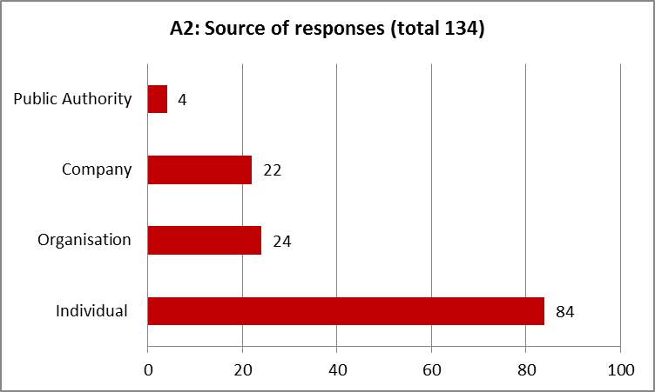

A.3. Please indicate your country -single choice reply- (compulsory)

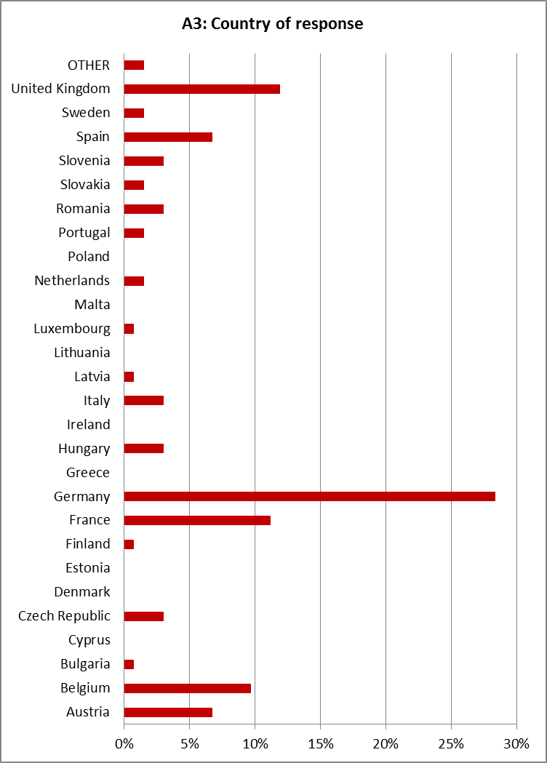

A.4. From which perspective are you interested in nuclear safety? -single choice reply- (compulsory)

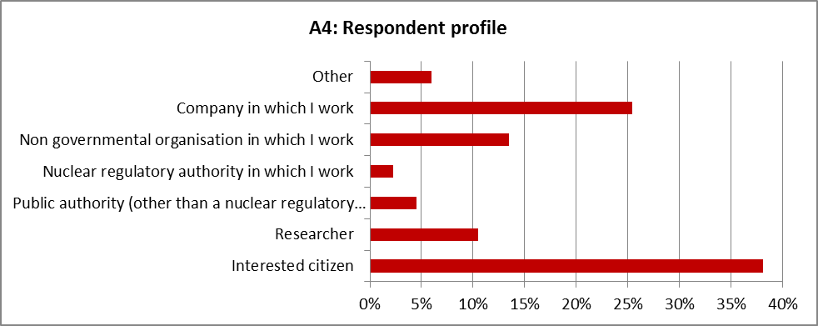A.5. How well informed do you consider you are about the nuclear safety of nuclear installations? -single choice reply- (compulsory)

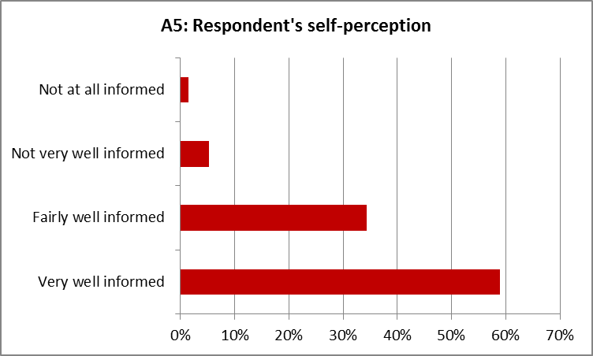

A.6. How would you prefer your contribution to be published on the Commission website, if at all? -single choice reply- (compulsory)

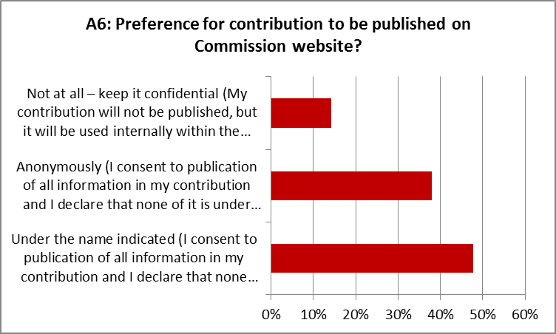

B. GENERAL SUGGESTIONS FOR AREAS OF REINFORCING THE EXISTING EURATOM NUCLEAR SAFETY LEGISLATIVE FRAMEWORK

B.1. In your opinion, the role of an Euratom nuclear safety legislative framework, setting up common rules for all the 27 EU Member States, is… -single choice reply- (optional)

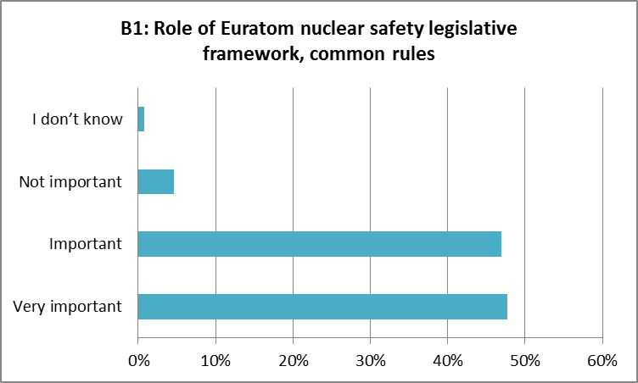

B.2. The consequences of nuclear and radiological accidents do not stop at national or regional borders ("an accident anywhere is an accident everywhere"). The Fukushima nuclear accident highlighted the need to consider new challenges and underlined the paramount importance of nuclear safety in the use of nuclear energy. In this context, do you consider necessary to reinforce the existing Euratom nuclear safety legislative framework? -single choice reply- (optional)

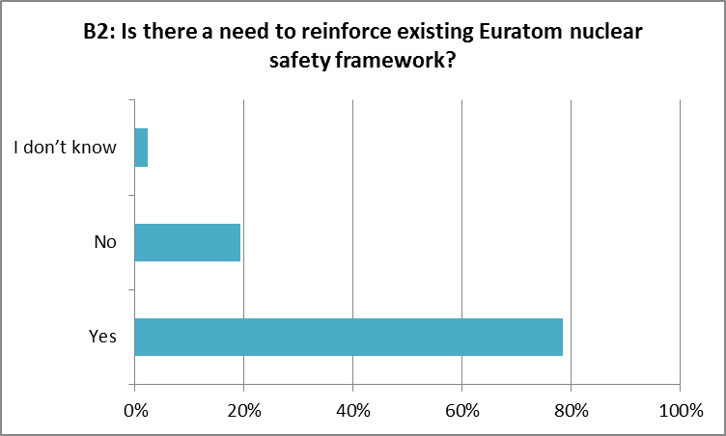

B.2.1. Which would be your preferred instrument of legislative intervention? -single choice reply- (optional)

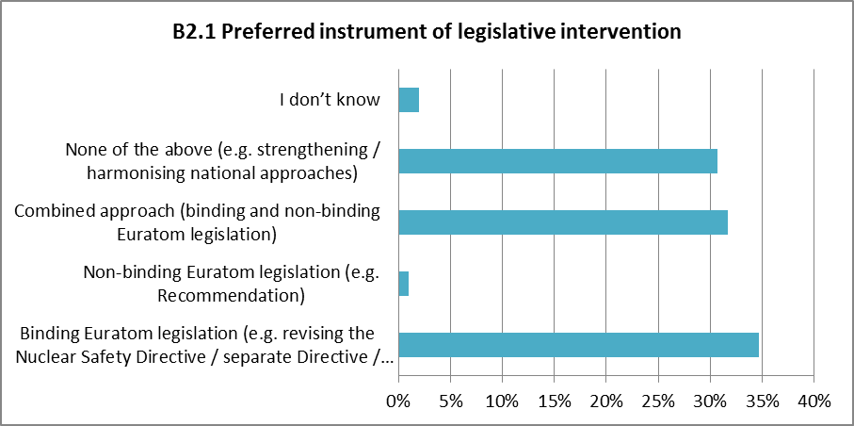

B.2.2. Which would be your preferred areas of additional intervention? -multiple choices reply- (optional)
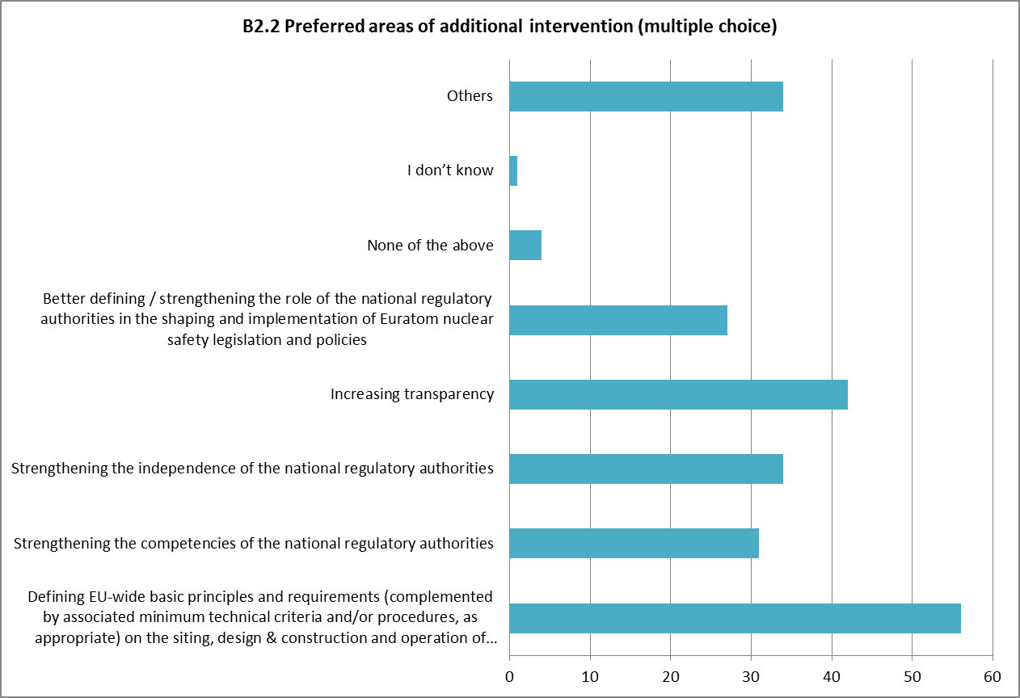

C. DETAILED SUGGESTIONS FOR THE AREAS PRESENTED IN QUESTION B.2.2.

C.1. Defining EU-wide basic principles and requirements (complemented by associated minimum technical criteria and/or procedures, as appropriate) on the siting, design & construction and operation of nuclear installations

In the judgement in the Case C-29/99, the Court of Justice of the EU acknowledged that Euratom possesses (shared) competencies under the Euratom Treaty in the fields relating to the siting, design & construction and operation of nuclear installations.

C.1.1. Do you consider that it is necessary to set up, in the Euratom nuclear safety legislative framework, a set of EU-wide basic principles and requirements (complemented by associated minimum criteria and/or procedures, as appropriate) in these technical areas? -single choice reply- (optional)
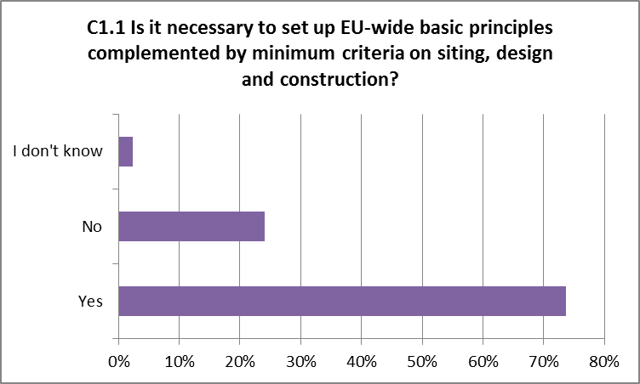

C.1.1.1. Do you consider that the provisions of Articles 17 (Siting), Article 18 (Design and construction) and Article 19 (Operation) of the IAEA Convention on Nuclear Safety could represent a basis for these new Euratom legislative provisions? -single choice reply- (optional)

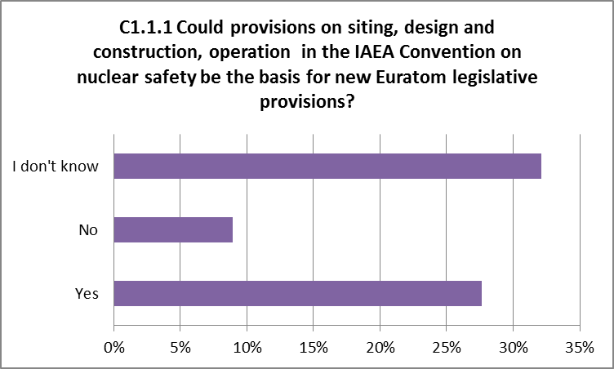

C.2. Strengthening the competencies of the national regulatory authorities
Currently, at Euratom level, the Nuclear Safety Directive [Article 5(3)] enumerates a number of core competencies of the national regulatory authorities (to require the licence holder to comply with the national nuclear safety requirements and the terms of the relevant licence; to require demonstration of this compliance; to verify this compliance through regulatory assessments and inspections and to carry out regulatory enforcement actions, including suspending the operation of nuclear installations).

C.2.1. Do you consider that this enumeration is sufficient to properly reflect the various competencies of the national regulatory authorities? -single choice reply- (optional)
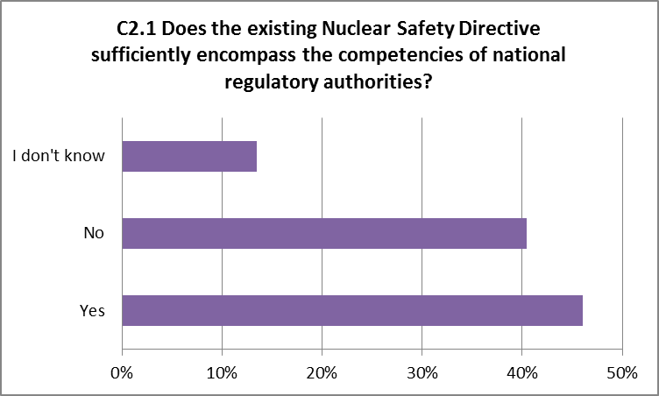

C.3. Strengthening the independence of the national regulatory authorities

Currently, at Euratom level, the Nuclear Safety Directive [Article 5(2) and (3)] contains a number of provisions underlying the independence of the national regulatory authorities (requirement of functional separation of the regulatory authority from any body or organisation concerned with the promotion or utilisation of nuclear energy, including electricity production, in order to ensure effective independence from undue influence in its regulatory decision-making; requirement that the regulatory authority is given the legal powers and human and financial resources necessary to fulfil its obligations in connection to the national framework).

C.3.1. Do you consider that these criteria are sufficient to guarantee the effective independence of the national regulatory authorities? -single choice reply- (optional)
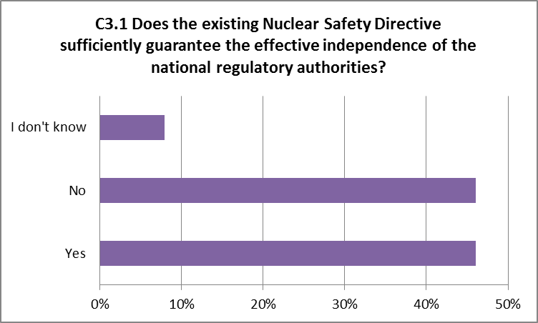

C.4. Increasing transparency

Currently, at Euratom level, the Nuclear Safety Directive [Article 8] contains requirements on public information (requirement that the EU Member States shall ensure that information in relation to the regulation of nuclear safety is made available to the workers and the general public; this obligation includes ensuring that the competent regulatory authority informs the public in the fields of its competence; information shall be made available to the public in accordance with national legislation and international obligations, provided that this does not jeopardise other interests such as, inter alia, security, recognised in national legislation or international obligations).

C.4.1. Do you consider that these provisions are satisfactory to provide you sufficient information on nuclear safety matters? -single choice reply- (optional)
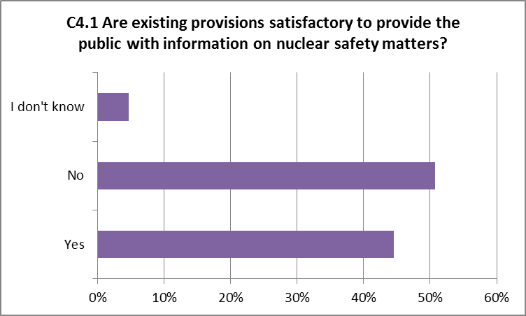

C.5. Better defining / strengthening the role of the national regulatory authorities in the shaping and implementation of Euratom nuclear safety legislation and policies
The national regulatory authorities are reunited in the High Level Group on Nuclear Safety and Waste Management (later renamed European Nuclear Safety Regulators Group – ENSREG), whose role is to advise and assist the European Commission in progressively developing common understanding and eventually additional European rules in the fields of the safety of nuclear installations and the safety of the management of spent fuel and radioactive waste.
In the area of nuclear safety, to date, ENSREG provided an important contribution to the elaboration of the Nuclear Safety Directive (e.g. by providing expert input), as well as to its implementation (e.g. by developing guidelines on reporting under the Directive, by establishing a first ten-years plan for the Member States' periodic international peer reviews). In addition, the Commission and ENSREG reached agreement on the criteria, methodology and timeframe for the EU comprehensive risk and safety assessments ('stress tests') triggered by the Fukushima nuclear accident and are cooperating closely in the various steps of this ongoing process.

D. QUESTIONS ON RELATED AREAS

D.1. ENHANCING EMERGENCY PREPAREDNESS AND RESPONSE
Actions to prevent, prepare for and deal with nuclear and radiological emergencies are often taken at national level. However, at EU level, there is a range of legislative instruments and mechanisms and special provisions relating to nuclear accidents, which can be activated in such events (including Basic Safety Standards Directive, the Public Information Directive, the ECURIE Decision, the Civil Protection Mechanism legislation, as well as the foodstuffs and feeding stuffs regulations).
More information on the Euratom radiation protection legislation
More information on the Euratom emergency preparedness and response mechanisms
More information on the Civil Protection Mechanism

D.1.1. Do you consider that it is useful to further reinforce the cross-border cooperation mechanisms between EU Member States, or between EU Member States and other neighbouring countries (non EU Member States) for ensuring the management of accidents and mitigation of accident consequences? -single choice reply- (optional)
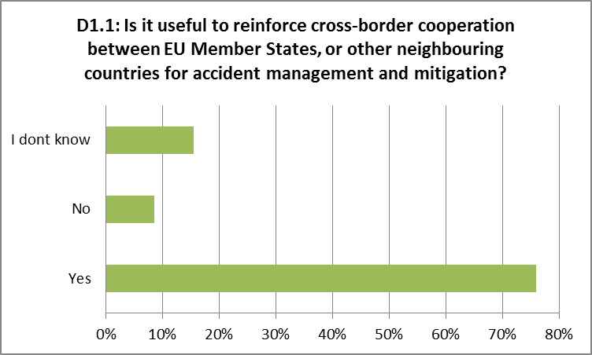

D.2. CLARIFYING QUESTIONS OF NUCLEAR LIABILITY

D.2.1. In your opinion, the role of a Euratom nuclear liability legislative framework setting up common rules for all the 27 EU Member States, is… -single choice reply- (optional)
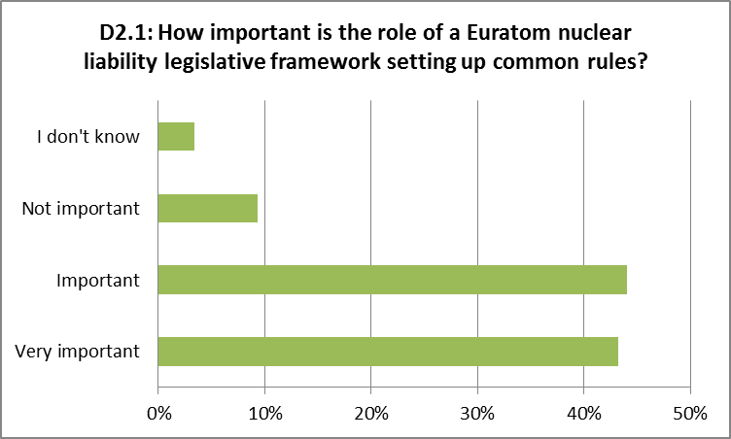

D.2.2. The consequences of nuclear and radiological accidents do not stop at national or regional borders ("an accident anywhere is an accident everywhere"). The Fukushima nuclear accident highlighted the need to consider new challenges and underlined the paramount importance of nuclear safety in the use of nuclear energy.

In this context, do you consider necessary to introduce, bearing in mind the existing international conventions (Paris Convention, Vienna Convention, Brussels Convention), a Euratom nuclear liability legislative framework? -single choice reply- (optional)
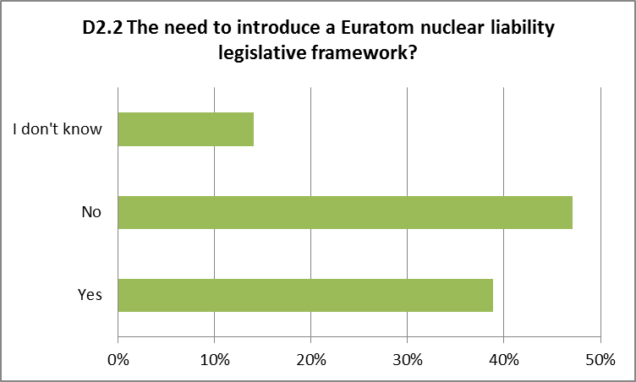

D.2.2.1. Which would be your preferred instrument of Euratom legislative intervention? -single choice reply- (optional)
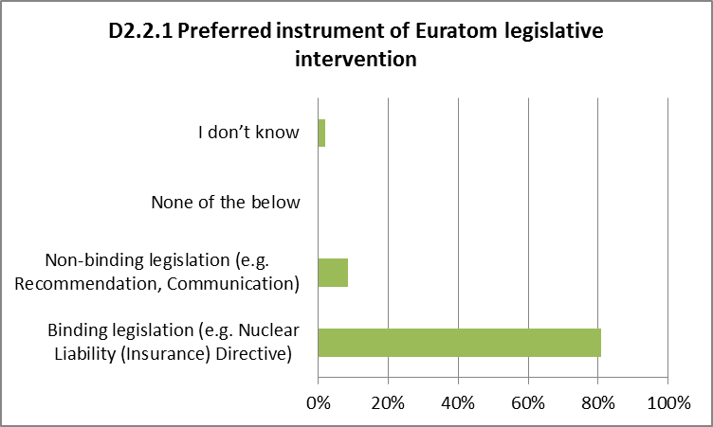

D.2.2.2. Which would be your preferred areas of Euratom legislative intervention? -multiple choices reply- (optional)
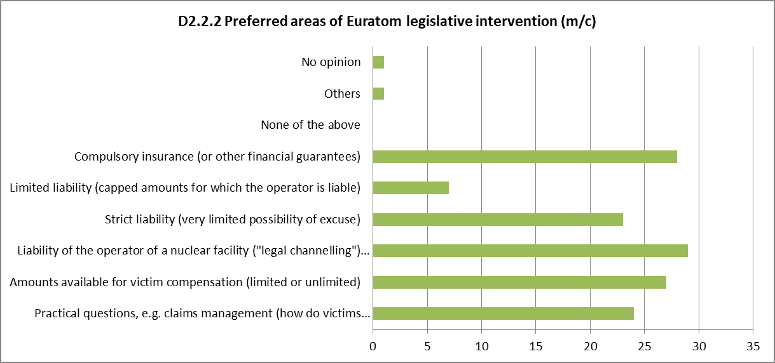

D.3. ENHANCING SCIENTIFIC AND TECHNOLOGICAL COMPETENCE

D.3.1. Scientific and technological competence is of foremost importance to ensure nuclear safety at all levels from design to construction, operation and decommissioning of nuclear facilities. It applies to nuclear power plants but also all other nuclear facilities. Nuclear research and development, innovation, education and training are therefore making an important chapter of the Euratom Treaty. Over the last decades, the Euratom Research Framework Programme has contributed to enhance the nuclear scientific and technological competence in the EU, making it a leading region in this field.

Do you consider that this scientific and technological leadership should be maintained?

-single choice reply- (optional)
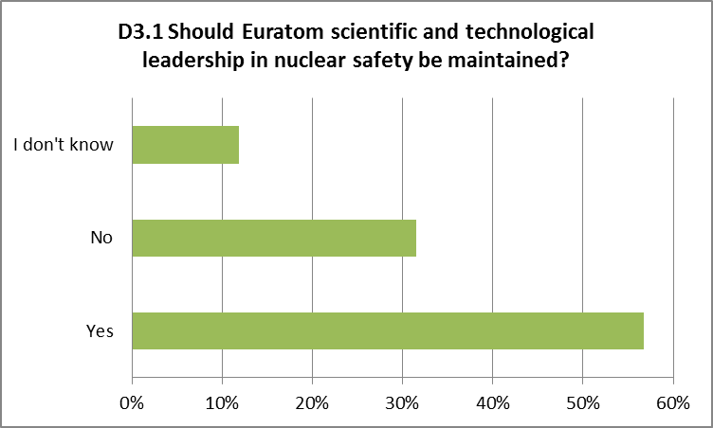

D.3.2. Do you consider that the Euratom Research Framework Programme should be enhanced to keep this scientific and technological leadership?

-single choice reply- (optional)
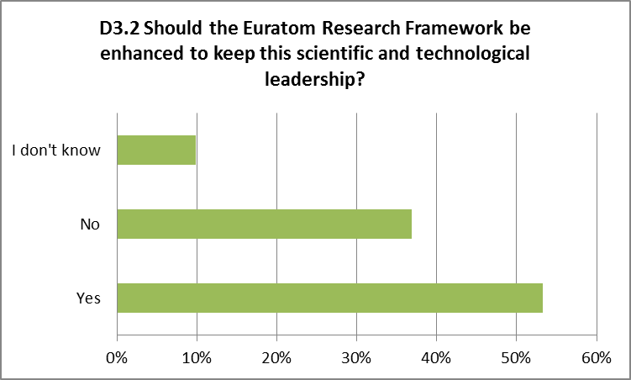

D.4. IMPROVING THE GLOBAL LEGAL FRAMEWORK

D.4.1. The Convention on Nuclear Safety (CNS) is one of the cornerstones of the international legal regime of ensuring nuclear safety. An Extraordinary Meeting to analyse the relevant issues arising from the accident at the Fukushima Daiichi nuclear power plant and to review the effectiveness of the CNS provisions has been convened in August 2012.

Do you consider that Euratom, as a Party to the Convention, should support a change to the CNS with a view to enhance the international nuclear safety regime?

-single choice reply- (optional)
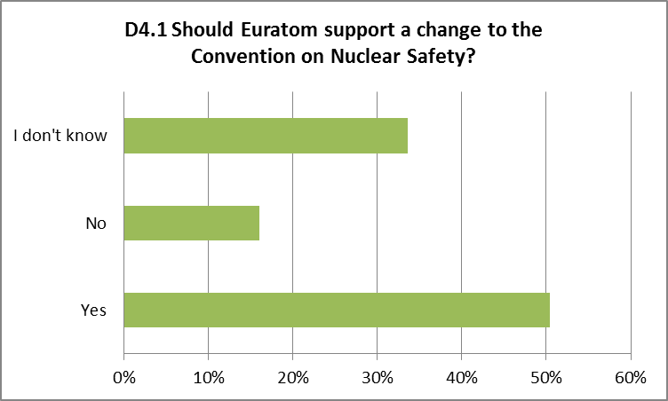

D.4.2. The accident the Fukushima Daiichi nuclear power plant has revealed possible deficiencies in the international legal regime of ensuring prompt provision of information on nuclear accidents, regulated primarily by the Convention on Early Notification of a Nuclear Accident.

Do you consider that Euratom, as a Party to the Convention, should play a leading role submitting proposals to supplement the Convention in order to eliminate these possible gaps in case of a review meeting for the Early Notification Convention is convened in 2012?

-single choice reply- (optional)
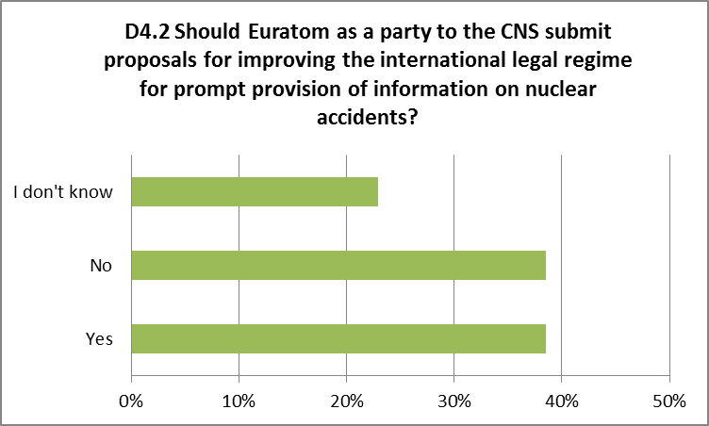

1.2. Overview of the contributions received from various stakeholders in addition to the on-line public consultation.
Several contributions from different stakeholders have been received by the Commission outside the on-line public consultation. Meeting based contributions have been received from non-governmental organisations such as Greenpeace. The analysis of the contributions shows that most of the stakeholders having submitted contributions see scope for reinforcement of the current Euratom nuclear safety framework and present various proposals for legislative improvements and harmonisation measures. Slightly fewer respondents though believe that instead of adopting new legislative provisions, the focus should be at this moment towards improving the implementation of existing mechanisms both at EU and international level. There is a general view that WENRA and ENSREG have so far been effective to enhance and harmonise nuclear safety and should be further involved. Several stakeholders also called for reinforced cooperation/coordination among and between Member States and enhanced peer review processes, including a suggestion for international inspections.
In the following text, a summary is provided of the contributions received.

VIEWS FROM ELECTRIC UTILITY COMPANIES
From the side of electric utility companies, the opinion was mentioned that, as for the reinforcement of legislation, the Commission should improve the implementation of existing provisions and promote harmonization measures taking into account the results of the on–going peer reviews and the work done by consolidated bodies like WENRA and ENSREG.
It was also claimed that there is no need to modify or improve the existing legislation in order to strengthen the concept of independence and to add further regulatory competencies to the nuclear regulatory body. The governments should have the freedom to detect the most suitable measures in order to give effect to the independence principle. As for the possible reinforcement of the principle of transparency, high levels of public information and transparency on nuclear safety matters are said to have been achieved and competent authorities provide public information via a number of tools.
It was recommended that any further harmonisation measures should be implemented through a bottom-up approach and not directly by the Commission with the adoption of binding legislation (i.e. top down approach).
In this respect, fields of further harmonization/coordination under ENSREG current scope of work could be the following:
- Design standardization: it is necessary to create at least homogeneous minimum safety levels in the whole European territory and a fair level playing field where no advantages are given to countries that use inadequate technologies;
- Licensing procedures for new plants: licensing procedures for new NPPs need to be made at least compatible, in order to minimise licensing risks among countries and to facilitate the development of licensing documents;
- Site safety and site hazard evaluation: it should be harmonized at the European level, through the definition of common hazard parameters, external event scenarios, assessment methodologies. Criteria for site exclusion and evaluation should be identified and applied in consistent way throughout Europe. Site safety assessment criteria should be adopted as a basis for uniform risk evaluation;
- Management of nuclear emergencies; etc.
On the other hand, from the perspective of an utility operating an important number of NPPs, a less favourable view to new harmonisation measures has been put forward: while there may be scope for improvements in legislation, the focus should now be on the effective implementation of the EU existing rules. The current nuclear safety legislation should be reviewed in the light of the Stress Tests and the experience of its implementation by Member States. New legislation should not be brought forward until there is a demonstrable need that cannot be satisfied adequately by existing mechanisms.
As for the question of further regulation of peer reviews and their scope, this more prudent opinion was that such reviews should not be overly prescribed by the legislation as this would be detrimental to the effectiveness of the process. An opinion was also expressed that the approach where these peer reviews might in future examine design as well as operational safety issues would be difficult to apply. It was also suggested that any move in this direction needs to be taken cautiously.
Finally, under this more cautious approach, the suggestion to specify minimum technical criteria relating to safety in areas covering siting, design, construction, and operation seems to risk challenging the primacy of the national safety regulator in these areas and could call into question the authority of the national safety regulator.

VIEWS FROM THE VENDOR'S SIDE
A contribution received form vendor specialized in nuclear reactor design and construction, and related services suggested that lessons to be drawn at the European level from the Fukushima accident and the stress tests mainly concern national safety organisation and allocation of responsibilities as well as emergency preparedness and response. A possibility was seen to reinforce the Euratom nuclear safety framework suggesting that the Euratom could adopt a comprehensive “nuclear safety partnership programme” covering the following issues: encouraging cooperation among safety authorities, promoting highest level safety standards for new builds, modernizing nuclear emergency tools, promoting transparency, developing education and training in nuclear safety and extending financing for R&D on nuclear safety.
Furthermore, it was recommended incorporating WENRA safety objectives in the Euratom framework by:
- Adding to the current recital of the 2009 Safety Directive referring to WENRA reference levels for existing NPPs, a new recital referring to the WENRA safety objectives for new build.
- Introducing a new article in the revised directive requesting Member States to enhance cooperation among their national safety authorities in order to define and implement common safety objectives and standards for new reactors.
- Complementing the new provisions of a revised directive with a non-binding document which could cite, in extenso, the seven WENRA safety objectives for new builds.
Finally, it was proposed that harmonisation of nuclear safety in Europe should be achieved through enhanced cooperation among European regulators gathered within WENRA and ENSREG aiming at:
- Safety objectives and standards: Cooperation should aim at systematically implementing the WENRA safety objectives for new projects in Europe and at further detailing these objectives (e.g. WENRA position papers)
- Harmonisation of licensing through progressive cross-recognition of assessments: aiming at the mutual recognition of analysis and assessments undertaken by national regulators; safety authorities could either define common methods, or recognize each other’s methods and analysis.
The safety authorities could therefore be tasked by Euratom to define a roadmap in these two domains: (1) European standard definition and implementation for new reactors, (2) harmonisation of licensing through progressive cross recognition of safety assessments.
Lastly, the opinion was brought forward that the scope of peer reviews could be extended to cover operational safety of nuclear power plants. Some elements of the design could be considered in the scope of these peer reviews.

VIEWS FROM A NUCLEAR INDUSTRY FORUM
A body, involving for example nuclear site licensees and other players who carry the responsibility for nuclear safety is of the view that there is no clear evidence at this moment for reinforcing the legislation as the peer reviews of the stress test results at European level are not yet complete and the full impact of the Nuclear Safety Directive implemented only last year is not yet known. It highlights that the authority and independence of the National Safety Regulator is essential to maintain and improve Nuclear Safety standards and that more prescription at the European level should not undermine this authority and independence.

VIEWS FROM NATIONAL NUCLEAR SAFETY AUTHORITIES
Both less and more favourable approaches as to the possible reinforcement of Euratom nuclear safety legislative framework have been identified in the contributions received from national nuclear safety authorities.
In this context, one opinion suggested that currently it is not yet possible to make the judgement as to whether a change is needed to the current European legal framework, including European legislation on technical measures for nuclear safety. The root lessons from the Fukushima accident should be considered to be more institutional and cultural than technical. However, it was recommended to take forward any initiatives to improve nuclear safety, in particular by taking into account amongst other aspects: the need to engender a culture of continuous improvement; clarity on the respective roles and responsibilities of governments, independent regulators and utilities; the need to enhance the independence and capabilities of nuclear regulators; and to have effective peer and periodic reviews. From this, it would therefore be sensible to consider such root lessons and whether change might best be achieved by ensuring the full implementation of the existing Directive, improving the implementation of existing mechanisms, enhancing peer review processes and amending guidance.

Conversely, other public authorities of some non-nuclear Member States were clearly in favour of some new legislative measures making some concrete proposals, such as:
- A list of concrete safety objectives should be included into a directive. These objectives should be the same for existing NPPs as for new builds. Since however not all objectives can be implemented in the existing NPPs appropriate compensatory measures should be permitted during a defined transition time.
- The legal powers of the competent authorities for nuclear safety in Member States that operate nuclear installations or that decide to build such installations should be further extended and those authorities should by fully independent from external influences.
- An obligation of organizing international inspections in the nuclear installations should be introduced. This could include OSART missions, but also cross inspections from inspectorates of one Member State in another Member State.
- It should be considered to permit national stakeholders and members of the competent authorities of neighbouring countries having nuclear installations close to their borders to take a part into the national consultation process concerning important decisions in the Member States with nuclear installations, such as the review of the legislative framework, relevant licensing procedures (new discharge limits, new builds, prolongations of lifetime) and important safety reviews (ex: stress test, PSA)
- Legislative initiative should be aiming at reinforcing the cooperation mechanisms between neighbouring countries (either Member States, or non-Member States) for ensuring the management of accident and mitigation of accident consequences.

VIEWS FROM EUROPEAN SOCIAL PARTNERS FOR THE ELECTRICITY INDUSTRY
In its response (Eurelectric for the employers and EPSU/Industri-All-Europe for the trade unions) the European Social Partners for the Electricity Industry considers very important the role of a Euratom nuclear safety legislative framework in setting up common rules for Member States. It favours additional intervention in defining Euratom-wide basic principles and requirements, complemented by associated technical criteria – but cautions that this should not imply reduction of standards through meeting just minimum levels. Better defining, and strengthening the role and competencies of national regulatory authorities in shaping and implementing nuclear safety legislation and policies are necessary. Applying the highest levels of health and safety, provisions for training, ensuring the qualified staff are available, and checking their skills and competencies are important issues for the workforce and particularly for sub-contractors. The lessons learnt from the stress-tests should be applied; the improvements identified in national action plans to should be made mandatory. Nuclear safety would benefit from regular international peer reviews, with more frequent peer reviews for older facilities. Off-site emergency preparedness in the event of a severe accident which has radiological consequences in nearby European countries is an important issue. In the area of effective regulatory independence, transparency and accountability are considered absolute necessities. Obligatory consultation of workers' representatives and trade unions by nuclear safety regulatory bodies would improve accountability.

ANNEX III

Socio-Economic role of Nuclear Energy to Growth and Jobs in the EU
for time horizon 2020-2050

The purpose of this paper is to present the results of an analysis of the impact that the contribution of nuclear energy to the low carbon energy mix will have in terms of job creation and growth (value added to the economy through investments in Billion Euros per year). The time horizon is 2020, 2030 and 2050.

The analysis is based on the scenario "Delayed CCS" of the EU Energy Roadmap 2050 – where nuclear is shown to contribute nearly 20% electricity in 2050.

The analysis is defining the "additional" jobs and value added to the economy coming from Lifetime Extension (LTO – Long Term Operation), New Built, Decommissioning and Geological Disposal programmes – over and above the jobs and economic benefits of the "regular operation" of the nuclear plants (900 000 jobs and 70 Billion Euros/year).

Key outcomes

Timeframe | Activity | JOBS | VALUE CREATED
2012-2050 | Regular Operation | 900 000 | 70 BEuros/y
2012-2020 | Stress Test (ST) | 10 000 | 1 BEuros/y
2012-2030 | LTO (including ST) | 50 000 | 4,5 BEuros/y
2012-2030 | Decommissioning | 7 000 | 1 BEuros/y
2012-2030 | Waste Mgt | 10000 | 2 BEuros/y
2030-2050 | New Built | 250 000 | 25 BEuros/y
2030-2050 | Decommissioning | 20 000 | 2,5 BEuros/y
2030-2050 | Waste Mgt | 10 000 | 2,5 BEuros/y

1. Background and Scenario Assumptions

Nuclear Energy is today providing slightly less than 30% of the electricity consumed in the EU. This electricity is mainly stable and reliable base load, secure from a supply perspective, CO2 free, and competitive/affordable. As a result, nuclear energy is today already a positive contributor to the EU economy, growth and jobs. A standard figure indicates that the nuclear sector employs today 500 000 people in the EU, directly and indirectly. One might also count additional "induced" jobs – which then leads to a grand total of around 900 000 persons employed. The corresponding total "valued added" for the European economy can be estimated to 70 Billion Euros per year, extrapolating from the same source under footnote 1.

The Energy Roadmap 2050 provides mainly 2 types of decarbonisation scenarios for the EU when looking at it from the nuclear perspectives: 2 scenarios going to nuclear phase out in 2050, and 3 scenarios leading to a fraction between 15 and 20% of electricity produced by nuclear energy. For this paper we take the 20% figure. This figure is lower than the projections by industry (Eurelectric Power Choices Scenario 2010 leading to 28% of nuclear electricity in 2050).

Due to the increased role to be played by electricity in the future low carbon economy, a quick calculation shows that the nuclear capacity in 2050 will have to be about the same as today, around 140 GWe (with a load factor of around 85-90%).
We analyse further here the impact on additional investment needs and jobs (in addition to the 900 000 jobs and 70 Billion Euros/year mentioned above) related to this transition from 30% electricity by nuclear today to 20% electricity by nuclear in 2050 coming from long term operation and new built construction programs, decommissioning and waste management activities.

A global overall look at the impact in terms of global investment needs and jobs is summarized at the end.

2. Nuclear Power Plants (Long Term) Operation and New Built

2.1 Storyboard: timelines for LTO and new built

Today over the total of about 150 plants of the EU, 135 (rounded number) are in operation. Their average age is nearly 30 years (see figure 1). Some Member States (MS) have taken the decision to close their plants: Germany's last unit will be stopped in 2022, Belgium plans are to close all its units between 2015 and 2025 and the UK will close all AGRs in the coming years. In other MS, long term operation (plant lifetime extension) of existing plants will most probably occur on economic grounds, even considering important investments for plants upgrades, including for safety concerns (ia outcomes of the post Fukushima Stress Tests).

A higher end estimation of the investment cost for LTO (including safety) upgrades is of the order of 900 Million Euros per unit.

The estimation of investment for a new built (EPR Olkiluoto) of the order of 5 Billion Euros for a plant expected to operate for 60 years.

Therefore, the investments in LTO make economic sense if it allows lifetime extension between 10 and 20 years – leading to a total lifetime of plants between 50 and 60 years – which are figures which seem reasonable today considering the safety issues at stake. The average lifetime of operating plants in the EU in 2020 will be around 40 years, 50 years in 2030 and 60 years in 2040 (see figure 1). This means that nearly all existing operating plants in the EU will be shutdown between 2020 and 2050, after respectively 40, 50 or 60 years of operation depending on the final decisions in terms of LTO (see figure 2).

From this information and the objective of 140 GWe nuclear electricity in 2050, as defined above, it is easy to derive that about 100 to 120 new nuclear power units will have to be built between now and 2050 – the more precise number being function of the rated power output of the individual units. We assume a round number of 100 new units in the rest of the paper. Figure 3 shows the new built under construction, approved and planned as of today. It shows the gap towards the objective of 140 GWe.

It is most probable that in MS who will continue to rely on nuclear energy for their mix, most plants will enter into LTO programmes and lifetime extensions between 50 and 60 years. The LTO programmes will be realised between roughly 2015 and 2035 and most existing operating plants will be shutdown between 2030 and 2050 – and new plants will have to be connected to the grid in the same period. Assuming a construction time of 7 years, the bulk of the construction of new plants will take place between 2025 and 2045 (anticipation is expected in the UK to replace the fleet of AGRs).
How can this "scenario" now be translated in investment needs (and so a contribution to the EU economy and growth) and jobs?
2.2 Impact of LTO and new built on jobs and investments

For investment one can use the rough figure of 900 MEuros per plant for LTO programmes (to be multiplied by roughly 100 units – the 135 in operation minus DE, BE and UK AGRs). For new built the 5 Billion Euros of EPR Olkiluoto gives a estimation which might be too high due the FOAK nature of the project but can be used as a first evaluation based on a real case. And about 100 new units will have to be built between now and 2050.

For defining jobs, the "regular functioning" of the nuclear plants will see a roughly constant manpower need over time from now until 2050 and beyond – the personnel needs of existing old plants being taken over by the personnel needs of the new built once in operation. So we do not count any additional jobs over time for the "regular operation of plants.

The additional manpower needs for LTO and new built programmes needs to integrate the manpower for supplementary design and licensing efforts, and the manpower for suppliers and the works on the sites. And all this can be refined into direct, indirect and "induced" jobs.

For the construction phase of new built, a rough estimation of personnel directly employed during construction of a single unit is 2700 people. If construction of the 100 new units takes place over the 20 years period 2025-2045, and the construction takes 7 years, it means that about 30 units will be, on average, under construction in parallel in the EU during that period, leading to a manpower of around 90 000 direct jobs over the whole period. Considering the indirect jobs one would reach 150 000 jobs for the construction of new built over a period of 20 years – 2025/2045. The grand total including the "induced jobs" would reach around 250 000 jobs.

For the LTO, considering that LTO activities are closer to new built than standard maintenance and operation, a first evaluation of supplementary jobs might perhaps best be estimated by taking the ratio of investments for LTO versus new built (1 to 5) – leading to 30 000 direct and indirect jobs over the period 2015-2035, and a grand total of 50 000 jobs including the "induced jobs".

Under LTO we have included the specific aspects of Stress Tests upgrades which might be somewhat anticipated in time versus LTO programmes per se. To refine, one might consider a rough estimation of 100 Million Euros per unit for post Stress Test specific safety upgrades, leading to 10 Billion in total for the 100 NPP who will undergo LTO. This would correspond in jobs, using the same rule as above to roughly 10 000 jobs (for period 2012-2020)

Conclusion for 100 plant undergoing LTO programmes and 100 new built (140 GWe) – in period between now until 2050:

- Total additional investment needs
(Beyond the standard value added of operation of nuclear plants)

Activity | Timeframe | Investment
LTO  (for extension 10 to 20 y) | 2015-2035 | 90 Billion Euros  (incl 10 Billion for post ST safety upgrades)
New Built  (for 60 y lifetime): | 2025-2045 | 500 Billion Euros

- Additional jobs
(Manpower needs in addition to "BAU" plants operation at large = 900 000 jobs in total)

Activity | Timeframe | Jobs
LTO  (for extension 10 to 20 y) | 2015-2035 | 50 000 jobs  (18 000 + 12 000 + 20 000) – of which 10 000 for post ST upgrades until 2020
New Built  (for 60 y lifetime): | 2025-2045 | 250 000 jobs  (90 000 + 60 000 + 100 000)

Jobs created: 300 000 jobs for duration of 20 years for an investment of 600 Billion Euros, corresponding to "100 000 Euros per job and year" including all equipment and material costs.

3. Impact of Decommissioning of Nuclear Power Plants on jobs and investments

In the above illustrated scenario of replacing closed down nuclear power plants by the construction of new reactors to maintain 20% of nuclear energy production capacity, the assumption is made that the operating staff would be re-deployed to operate the new facilities (no jobs lost due to final shut down of the nuclear power plant units). Although in reality, in the order of 10 to 20% of the staff will remain at the site and will become involved in the decommissioning of the nuclear power plant this scenario can be considered reasonable for an overall assessment of growth.

In terms of financing, EU regulations require that adequate funding provisions are being made during the operational lifetime of the facility and to be available when needed. Decommissioning is cash negative, with the investment being made to restore the environment rather than to generate new incomes. Nevertheless, the available decommissioning funding provisions will generate business in the decommissioning sector during the decommissioning phase.

The following figures provide a first very rough estimation to quantify available investments and jobs related to decommissioning:

Assumptions:
out of 135 operating nuclear power plants 35 will be closed down by 2025 (BE, DE and UK), the remaining 100 plants will be shut down in the period 2025 - 2050;
decommissioning costs per reactor unit: 500 million EUR (without waste management)
staff required for decommissioning per unit: 200

 | Until 2025 | 2025 - 2050
Available funds for investments in decommissioning (billion Euro) | 17 | 50
Jobs required for decommissioning | 7000 | 20 000

4. Impact of spent fuel and radioactive waste management and Geological Disposal on jobs and investments

The responsible use of nuclear technologies includes the responsible and safe management of the resulting waste materials. In 2011, binding rules have been defined in a dedicated Directive (hereinafter referred to as "Spent Fuel and Radioactive Waste Directive"). In line with similar EU legislation and international principles the Directive prescribes that waste generators are responsible for the complete financing of waste management up to and including disposal. Therefore EU funding is not applicable in this case. Nevertheless, the Directive requires Member States to ensure the safe management of spent fuel and radioactive waste without undue delays and to set up comprehensive national programmes until 2015 which is expected to speed up activities in this area and to lead to the creation of new jobs and investments up to 2050.
There are no statistics as to the number of jobs and planned/required investment cost in the EU. Therefore, a simplified estimate was done based on mean values and current assumptions for activities and needs in Member States. In particular it was assumed that Member States with less advanced programmes for developing disposal solutions will speed up their programmes in accordance with the requirements of the Spent Fuel and Radioactive Waste Directive. Assuming in an optimistic manner that construction of deep geological repositories will start in each Member State with NPP by 2050 at the latest, the estimate arrives at the following results which should be understood as indications rather than a detailed analysis.

JOBS | 2020 | 2030 | 2050
Jobs required | 36000 | 34000 | 35000
Of those already in place in 2012  Sub-set for Reprocessing and waste from Decommissioning | 29000  20000 | 28000  20000 | 26000  20000
Jobs required in addition to those already existing in 2012 (not to be cumulated!) | 7000 | 6000 | 9000
Sub-set triggered by Waste Directive | 3500 | 3500 | 5000

INVESTMENTS Million Euros | Until 2020 | 2021-30 | 2030-50
Required investments | 25000 | 19000 | 53000
Of those already firmly planned | 20000 | 10000 | 4000
Additional investments beyond those already firmly planned, triggered by Waste Directive | 5000 | 9000 | 49000

5. Additional elements

Benefits of nuclear energy cannot simply be expressed in terms of jobs and investment or value created. Indeed the quality level of the jobs and the nature of the investments have also to be considered.
Jobs in the nuclear area cover a wide range of scientific and industrial disciplines and secure a large number of highly skilled people in the European Union, not only on the sites of the nuclear plants but also in the supply industry, the authorities, etc. Even more a large community of scientists and researchers are in place in the EU and provide the needed scientific research base to underpin the top level quality of the industrial nuclear sector in the EU.
LTO and new built programmes will greatly help maintain these jobs and skills inside the EU. It will also help recreate the large supply industry base which was used in the 1970-1990 when the Generation II fleet was built in the EU.
One should also consider the developments in the nuclear power sector outside the EU. The European Industry, by maintaining important home based activities, will be stronger to implement the nuclear technologies abroad, promoting at the same time the highest nuclear safety standards.
Finally, the key contribution of nuclear energy to the European economy is the provision of highly reliable low carbon electricity with a high social value as being affordable for the consumers, either individual or industrial.

6. Conclusions

From where do we start?

Nuclear Energy in the EU in 2012
- 135 operating nuclear units
- a bit less than 30% electricity from nuclear
- jobs (extrapolated from PWC for FR): 900 000 Jobs = Direct 250 000 + Indirect 250 000 + Induced 400 000
- direct value generated (extrapolated from PWC for FR): 28 Billion Euros per year
- total value generated in the economy at large (Direct + Indirect + Induced): 70 Billion Euros per year

Where do we go?

Nuclear Energy in the EU in 2050
- 20 % electricity by nuclear in 2050,

What does it mean in terms of additional Jobs and Investments?

Considering that more or less the same number of nuclear units, or capacity, will be shutdown and constructed between now and 2050, we consider that the number of jobs and the "economic value" associated to the operation of the units will stay constant over time. We can now look at the "additional" number of jobs and additional "economic value" coming from the LTO, new built, decommissioning and ultimate waste disposal programmes.

See the following table

Conclusions | Figures
Between now and 2020, most activities will be dedicated to the safety upgrades resulting from the post-Fukushima ST and the launch of the studies and first implementations of the LTO Programmes. Impact on jobs and value creation will be rather limited: 10 000 Jobs and 1 Billion Euros per year. | Period 2012-2020: Stress Tests Upgrades  - 10 Billion Euros (100 Million per unit)  - 10 000 jobs over the period
Most LTO Programmes will be mainly implemented between 2015 and 2035, leading to total job creation of the order of 50 000 jobs and value created of the order of 4.5 Billion Euros per year. | Period 2015-2035: LTO Programmes (100 units)  - 90 Billion Euros  (including the 10 Billion ST)  - 50 000 jobs  (Direct 18 000 + Indirect 12 000 + Induced 20 000)
New Built Programmes will be mainly implemented between 2025 and 2045, leading to total job creation of the order of 250 000 jobs and value created of the order of 25 Billion Euros per year. | Period 2025-2045: New Built Programmes (100 units)  - 500 Billion Euros  (5 Billion per unit)  - 250 000 jobs  (Direct 90 000 + Indirect 60 000 + Induced 100 000)
To this figures one can add jobs and value created by decommissioning and waste management activities: in total 20 000 jobs and 3 Billion Euros per year until 2030, and 30 000 jobs and 5 Billion Euros per year after 2030 | Rounded numbers for Additional Jobs required for Decommissioning (135 NPPs) and Waste Management (including Geological Disposal) for Period 2020-2050  - Decommissioning:  - from 7000 jobs until 2025 to 20 000 jobs until 2050  - 17 Billion until 2025 and 50 Billion after till 2050  - Waste Management and GD:  - 10 000 jobs (adding to the 25 000 already today)  - 25 Billion + 19 Billion + 53 Billion (cumulative till 2020/2030/2050 respectively)

FIGURES

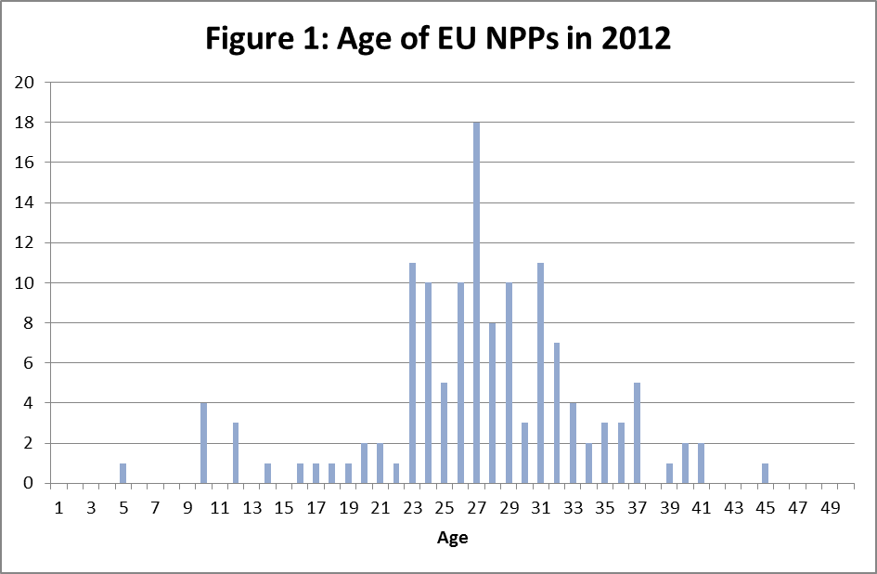

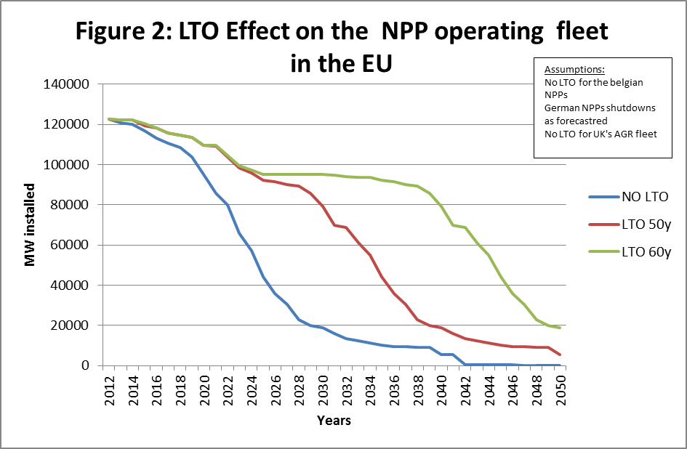

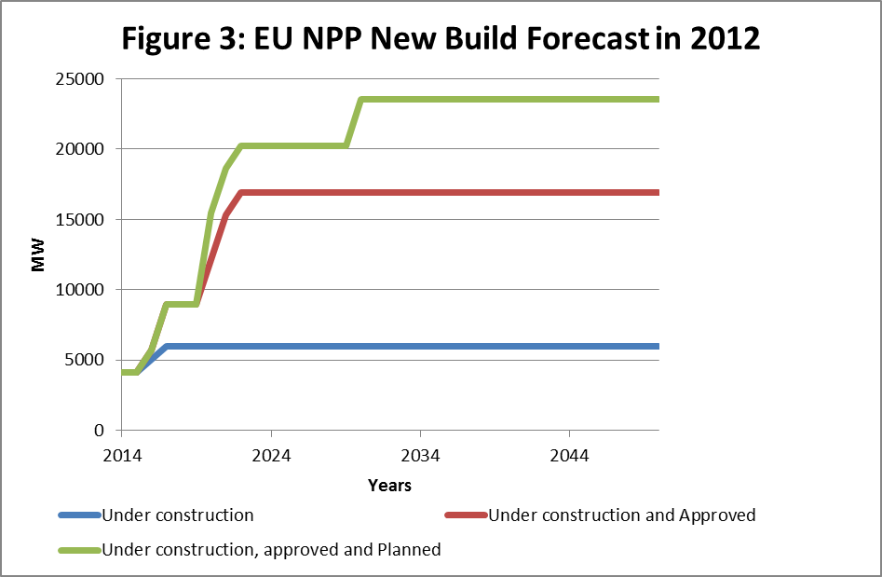

ANNEX IV

Examples of measures responding to the Specific Objectives

Specific objective | Example of measures
Continuously improving the overall nuclear safety architecture (e.g. by strengthening existing / introducing new general nuclear safety Principles and Requirements).  Continuously improving the specific nuclear safety architecture (e.g. by complementing the above-mentioned safety principles and requirements by Euratom Nuclear Safety Criteria).  Continuously improving the nuclear safety assessment methodologies (e.g. by encouraging the consistent and comprehensive use of risk-informed methods for decision-making support); | From Section 2.2 it follows that Fukushima and the Stress Tests highlighted the need to base decisions on the appropriateness of a site on a consistent, risk-informed set of principles and requirements, taking fully into account all possible site-related hazards, continuously update them and verify their proper implementation:  Examples of principles related to the siting of nuclear installations:  - Evaluation of all relevant site-related hazards likely to affect the safety of a proposed nuclear installation during its lifetime.  - Evaluation of the likely impact of a proposed nuclear installation at a specific site on human health and the environment during normal operation.  - Re-evaluation as necessary of all relevant hazards linked to possible emergency situations and to the availability of staff and resources to adequately address such situations.  Next, it follows the need to incorporate best technology available and continuously reduce vulnerabilities of a nuclear installation to both internal and external hazards, taking into account dependency effects, e.g. common cause failures due to multi-unit designs. This applies to both design and construction phases:  Examples of principles related to the design and construction:  - Requirement that the design of each new nuclear installation should be based on best technology available at the market when the plant is licensed such as to achieve a minimisation of risks.  - Reliable technologies incorporated in the design, manufacturing and construction of a nuclear installation are proven either in operation or by a test program or analysis consistent with internationally recognised quality, safety principles reflecting corresponding goals of the regulator, before operation begins.  - The design of a nuclear installation allows for reliable, stable and easily manageable operation, with specific consideration of adequate protection against accident, common cause failures and erroneous human intervention, as well as adequate provisions to address emergency requirements.  Examples of two (qualitative) safety criteria to implement requirements concerning design and construction of nuclear installations are:  - In the event of a leak in the fuel storage pool system, a refilling of the pool following isolation and sealing of the leak in the affected train must be possible.  - A limited refilling of the pool coupled with a restart of the pool cooling with at least one train must be possible even if the leak has not been sealed. The effectiveness of these provisions has to be such that: the stored fuel elements are still covered by water and no unacceptable pool temperatures are encountered.  Further, it follows the need to revise, throughout the operation of a nuclear installation, the conditions for safe operation on the basis of the results of plant-specific inspections or the analysis of operating experience from similar plants:  Examples of principles related to the operation of nuclear installations:  - The implementation of adequate accident prevention and mitigation measures should be further specified in the technical safety requirements. All these measures should be systemised together with other severe accident and emergency preparedness measures in the form of a site-specific Safety Management System (SMS) as essential part of the obligations of the license holder (see also Article 6(4) of the current Nuclear Safety Directive). These requirements should also be subject to periodic reviews, at least as part of the PSR, and be part of the scope of the international peer review (see also Article 9 of the current Directive).  - Operational limits and conditions derived from the installation-specific safety analysis, tests and operational experience are defined and revised as necessary for identifying safe boundaries for operation.  - Operation, maintenance, inspection and testing of a nuclear installation are conducted in accordance with approved procedures.  - The ageing and degradation of the plant structures, systems and components should be effectively managed through engineering, operations and maintenance actions to control within acceptable limits  - Procedures are established for responding to anticipated operational occurrences and to accidents.  - Necessary engineering and technical support in all safety-related fields is available throughout the lifetime of a nuclear installation.  - Incidents significant to safety are reported in a timely manner by the holder of the relevant licence to the regulatory authority.  - Programmes to collect and analyse operating experience are established, the results obtained and the conclusions drawn are acted upon and existing mechanisms are used to share important experience with international bodies and with other operating organizations and regulatory authorities.  The main findings and recommendations from the Stress Tests peer review process, as summarised in the April 2012 ENSREG Peer Review Report, confirm the importance of establishing common principles and requirements with a view to increase consistency between Member States in order to maintain and improve the safety and robustness of plants.  Examples of two (quantitative) safety criteria to implement requirements concerning operation of nuclear installations are:  - The Core Damage Frequency (CDF), which is calculated with independently verified and validated complete model of Probabilistic Safety Assessment (PSA), which represent the real and updated current state of the plant before the change and which is based on consideration of the applicable PSA standard, does not exceed significantly the value of 10⁻⁴ per reactor-year.  - The change of CDF due to the proposed change does not exceed 1% of the CDF and also, it does not exceed the value of 10⁻⁶ per reactor-year.
Ensuring further cooperation and coordination between all parties having responsibilities for nuclear safety on technical matters. | Complementing the existing international peer-review requirements: The existing requirements of Article 9.3 of the Nuclear Safety Directive could be complemented by requiring the Member States to periodically invite international peer-review missions for the area of NPPs design and operational safety performance (e.g. the IAEA Operational Safety Review Team – OSART, the peer-review missions of the World Association of Nuclear Operators - WANO). The peer-reviews are good means of building confidence, with the aim of developing and exchanging experience and ensuring the common application of high nuclear safety standards.
Strengthening the role of the national regulatory authorities. | From Section 2.2 it follows that establishing a reference catalogue of fundamental regulatory competencies is an objective that could be attained at Euratom level. Such a set of competencies could reflect recognised international safety standards, such as the IAEA Governmental, Legal and Regulatory Framework for Safety.  Examples of additional regulatory tasks:  - To provide guidance to the licence holder on adequately developing nuclear installation-specific safety assessments and presenting corresponding information to stakeholders as appropriate, to set minimum standards on adequately developing nuclear-specific safety assessment.  - To periodically confirm the competence of the personnel both at its level, as well as at the licence holder level. As regards examples of practical implementation, the regulatory authority should ensure that its staff has good academic qualifications, adequate work experience, necessary technical qualifications for performing regulatory functions, should establish a training policy, a training plan tailored for each employee, procedures for periodic review and updating of the training programme, should provide for budgetary provisions for training, etc. The training programme should also cover exercises which would allow practising real time emergencies and thus increase the level of preparedness. The regulatory authority should also make sure that such staffing criteria are in place at the level of the licence holder as well.  - As a technical basis for its decision making, to establish or adopt regulations and guides specifying the principles, requirements and associated criteria for safety upon which regulatory judgements, decisions and actions are based, taking into account international recommendations and state-of-the-art accreditation systems.
Strengthening the effective independence of the national regulatory authorities. | From Section 2.2 it follows that one of the key lessons learnt from Fukushima is that the independence of the national regulatory authorities must be ensured in an effective and verifiable manner.  Examples of strengthening the effective independence of national regulators:  - Introducing the requirement of designating a single regulatory authority at national level: Procedures and platforms should be established for cooperation and coordination with other concerned authorities such as public health, environment protection, civil protection etc.  - Examples of additional criteria:  - The regulatory authority should be legally distinct from any other public or private entity.  - The regulatory authority should ensure that its staff and the persons responsible for its management act independently and do not seek or take direct instructions from any government or other public or private entity when carrying out the regulatory tasks.  - The regulatory authority should exercise its powers impartially, based on nuclear safety objectives, clearly defined procedures, science, proven technology and relevant experience.  - The regulatory authority should have separate annual budget allocations, with autonomy in the implementation of the allocated budget. The autonomy requirement means that only the regulatory authority can decide on how the allocated budget is spent. It may neither seek nor receive any instruction on its budget spending.  - Independence in regulatory decision making should not obviate the need for an appeal process under which the license holders and other stakeholders are given the legal right to challenge regulatory decisions by means of appropriate legal procedures.
Enhancing nuclear safety transparency. | From Section 2.2 it follows that one of the key lessons learnt from Fukushima accident is to ensure appropriate transparency.  Examples of concrete measures applicable for the operators of a nuclear installation:  - Regular information on the operation of a nuclear installation, scheduled maintenance, investments projects, information of safety relevant events, like releases of radioactivity, incidents and accidents, as well as their rating according to international schemes should be available on the website of the operator on a timely basis. This regular information could be also part of a public register maintained by the competent regulatory authority for all nuclear installations in the territory of the Member State. This register can also contain information for nuclear risks coming from neighbouring countries which could have cross border impacts.  - Active and continuously updated public availability of preparatory information to local residents for emergency situations, effective communications to broadcast alerts, practicalities of evacuation of large populations, guidance in the use of stable iodine tablets, availability of detection equipment for large numbers of dose evaluations, common standards and criteria for countermeasures, arrangements to meet public and international demands for information, manpower and resources needed for environmental monitoring. The active and continuously updated preparatory information could be made public not only to the local population, but in the public register proposed above and thus become public nation-wide. The national regulatory authority can also provide guidance on raising the awareness of the citizens and increasing their overall level of preparedness.  - Local information meetings and visits to the installations should be organised regularly.  Examples of concrete measures applicable for the national regulatory authorities:  - National authorities should develop communication mechanisms to inform workers and the public about their activities, including regulatory decisions and justifications. They should have arrangements to provide information in case of emergencies. Safety events including their severity rating, should be publicised promptly and in an easily accessible manner. The public should also be given the possibility to express their views on the planning and siting of new installations.  - Member States with nuclear installations should be obliged to consult with neighbouring Member States on procedures adopted for hazard assessment and on the safety of proposed nuclear installations.
Reinforcing on-site emergency preparedness and response arrangements. | Examples of concrete measures:  - For each reactor unit in a Member State, if additional on-site capabilities are not sufficient, plant-external seismic- and flood-proof storage facilities for emergency equipment such as diesel generators, pumps, etc. should be put in place. These resources should be capable and sufficient to ensure each unit's continued core cooling, containment integrity and spent fuel pool cooling. Provisions for the quick transport of such equipment, e.g. by helicopter, should be made.  - On-site emergency preparedness & response should be reflected in the scope of future periodic safety reviews.  SAMGs and the potential hardware modifications needed should not only be implemented at all NPPs and spent fuel storages (SFS) but also validated taking into account of the potential long duration of an accident, the degraded NPP/SFS and the surrounding conditions.  Radiation protection of all staff involved in severe accident management and emergency response should be assessed and then ensured by, among other, guaranteed habitability of the facilities needed for accident control, and suitable availability of protective and mitigative equipment, and corresponding training. Such equipment shall be adequately qualified and stored, easily accessible and well-protected against external hazards or secondary effects of a severe accident.

ANNEX V

Detailed description of the Policy Options analysed under the IA

Policy Option 0 (Business as usual)

Euratom level | Member States level | Specific nuclear safety objectives attained (see Sub-section 3.2 of the IA)
→ No new legislative action at Euratom level  - Not amending the current Euratom framework Directive (Nuclear Safety Directive). | - Completing the transposition of the Nuclear Safety Directive (*for those MS which have not yet fulfilled this obligation).  - Continuing the implementation of the Nuclear Safety Directive.  - Implementing in parallel the measures arising from the Stress Tests process (i.e. national Stress Tests results and specific recommendations of the peer-review teams). | -
● At the same time, use the existing mechanism of cooperation between the European Commission and the Member States on the implementation of the measures arising from the Stress Tests' process, through ENSREG.

Policy Option 1 (General Principles and Requirements)
Euratom level | Member States level | Specific nuclear safety objectives attained(see Sub-section 3.2 of the IA)
→ Legislative action (legally binding act) at Euratom level  - Amending the Nuclear Safety Directive by strengthening existing general Principles and Requirements (e.g. role & independence of the national regulatory authorities; transparency) and adding new general Principles and Requirements [e.g. on-site emergency preparedness and response; siting, design & construction, and operation (e.g. periodic safety assessments) of nuclear installations]. | - Transposing the amendments to the Nuclear Safety Directive.  - Implementing the amended Nuclear Safety Directive.  - Implementing in parallel the measures arising from the Stress Tests process (i.e. national Stress Tests results and specific recommendations of the peer-review teams). | A), C), D), E), F), G), H)
● At the same time, use the existing mechanism of cooperation between the European Commission and the Member States on the implementation of the measures arising from the Stress Tests process, through ENSREG. |  | A), C), D), E), F), G), H)

Policy Option 2 (General Principles and Requirements + Euratom Nuclear Safety Criteria)
SUB-OPTION 2.1
Euratom level | Member States level | Specific nuclear safety objectives attained(see Sub-section 3.2 of the IA)
→ Legislative action (combination of legally binding & specifying legally non-binding acts) at Euratom level.  - Amending the Nuclear Safety Directive by strengthening existing / introducing new general Principles and Requirements (Policy Option 1) + Introducing in the Directive the mandate for the European Commission to specify the general Principles and Requirements, by developing legally non-binding Euratom Nuclear Safety Criteria (Commission Recommendations). | - Transposing the amendments to the Nuclear Safety Directive.  - Implementing the amended Nuclear Safety Directive.  - Following the technical guidance provided in the Recommendations.  - Implementing in parallel the measures arising from the Stress Tests process (i.e. national Stress Tests results and specific recommendations of the peer-review teams). | A), B), C), D), E), F), G), H)
● These Euratom Nuclear Safety Criteria would be developed in close cooperation with experts from the Member States. One option might be that the existing mechanism of cooperation between the European Commission and the Member States through ENSREG, could be used and further enhanced for this purpose. |  | A), B), C), D), E), F), G), H)
SUB-OPTION 2.2
Euratom level | Member States level | Specific nuclear safety objectives attained(see Sub-section 3.2 of the IA)
→ Legislative action (combination of a legally binding act & specifying legally binding acts) at Euratom level  - Amending the Nuclear Safety Directive by strengthening existing / introducing new general Principles and Requirements (Policy Option 1) + Introducing in the Directive the mandate for the European Commission to specify the general Principles and Requirements, by developing legally binding Euratom Nuclear Safety Criteria (Commission Regulations). | - Transposing the amendments to the Nuclear Safety Directive.  - Implementing the amended Nuclear Safety Directive.  - Implementing in parallel the measures arising from the Stress Tests process (i.e. national Stress Tests results and specific recommendations of the peer-review teams). | A), B), C), D), E), F), G), H)
- In the first step, the nuclear safety criteria would be developed in close cooperation between expert working groups such as ENSREG and WENRA, and Commission experts. Subsequently, the nuclear safety criteria would be adopted as the Commission's "implementing acts" according to Article 291 TFEU and using the relevant "comitology" procedure laid down in Regulation 182/2011. For this purpose, a "comitology" committee, composed of representatives of all Member States, would be created by the legislative proposal to assist the Commission. |  | A), B), C), D), E), F), G), H)

Policy Option 3 (Setting up an Euratom nuclear safety regulatory Agency)
Euratom level | Member States level | Specific nuclear safety objectives attained(see Sub-section 3.2 of the IA)
→ Legislative action (legally binding act) at Euratom level  - Establishing a Euratom Nuclear Safety Regulatory Agency to administrate and further develop the Euratom nuclear safety acquis, as developed under Policy Option 2, under the supervision of the European Commission  - With the mission to promote the highest common standards for safe generation of nuclear power in the EU,  - With the tasks:  - To assist the European Commission to develop harmonised technical nuclear safety requirements / standards / criteria, which would be incorporated in proposals for new Euratom nuclear safety legislation;  - To conduct inspections in order to monitor the correct implementation by national regulators and licence holders of this legislation and report back to the Commission;  - To develop an Euratom certification system of standard designs of nuclear facilities;  - To elaborate a uniform license content (including a minimum set of requirements for the applicants) & licensing procedure, as well as detailed guidance for its application;  - To intervene in case of nuclear accidents or incidents (e.g. sending its experts on site);  - To formulate opinions and recommendations to the Commission on nuclear safety matters;  - To collect and analyse data to further improve nuclear safety.  - Organized in a way to ensure that decisions on safety issues are free from all political interference; - therefore, safety decisions are taken by the Agency's Executive Director and since these decisions directly affect people and organizations, an independent Board of Appeal has the role to check that the Executive Director has correctly applied Euratom legislation in this field. The Executive Director is appointed by the Agency's Management Board. The Board, which brings together representatives of the Member States and the Commission, is responsible for the definition of the Agency's priorities, budget establishment and for monitoring the Agency's operation. An Advisory Board, comprising organisations representing NPP vendors, operators, trade unions, technical support organisations, training organisations, as well as NGOs, assists the Management Board in its work. | - Member States' authorities cooperate permanently with the Agency & provide access to information / facilities.  - National regulatory authorities maintain existing inspection powers.  - Member States' authorities remain responsible for the overall licensing process. | A), B), C), D), G), H)

ANNEX VI
COMPETITIVENESS PROOFING STUDY (see separate document attached)

National Police Agency of Japan (August 8, 2012) - http://www.npa.go.jp/archive/keibi/biki/higaijokyo_e.pdf
The Economist, March 10th 2012, Special Report Nuclear Energy
News on Japan. Com, “Fukushima clean-up could cost up to $250 billion,” 1 June 2011
In the course of the Chernobyl accident about 10 times more radioactive material leaked into the environment than during Fukushima.
M. Cooper, Nuclear Safety and Nuclear Economics, Vermont Law School, December 2011
EUCO 10 1/11
Peer review Report – Stress Tests performed on European nuclear power plants, 25 April 2012 (http://www.ensreg.eu/node/407)
COM(2011) 784 final
COM (2012) 571.
OJ L 172, 2.7.2009
EUCO 139 / 11
P7_TA(2011)0318
P7_TA(2011)0327
Invited to the IASG work, no nomination received,
‘Towards a reinforced culture of consultation and dialogue – General principles and minimum standards for consultation of interested parties by the Commission’ (COM(2002) 704 final).
http://ec.europa.eu/energy/nuclear/consultations/20120229_euratom_en.htm
http://www.eurelectric.org/media/26840/joint_position_securitysafety_nuclear_industry-final-06122011-2011-530-0008-01-e.pdf
INFCIRC/821 of 20 June 2011
GOV/2011-59-GC(55)14 of 5 September 2011
CNS/ExM/2012/04/Rev.2
http://www.iaea.org/newscenter/focus/fukushima/japan-report/
http://www.iaea.org/newscenter/focus/fukushima/japan-report2/
http://icanps. go.jp/.
http://www.naiic.jp/en/2012/
Special Eurobarometer 324, published in March 2010. Although conducted before the Fukushima accident in 2011, the findings mentioned here are still relevant and even likely to be reinforced
Nature.com, 21 April 2011, "Reactors, residents, risks"
The deadline by when the EU Member States had the obligation to bring into force the laws, regulations and administrative provisions to comply with the Directive and communicate them to the Commission elapsed on 22 July 2011.
Commission Staff Working Document: Technical summary on the implementation of comprehensive risk and safety assessments of nuclear power plants in the European Union, SWD(2012) 287 final, Brussels, 4.10.2012.
Communication from the Commission to the Council and the European Parliament on the comprehensive risk and safety assessments ("stress tests") of nuclear power plants in the European Union and related activities, COM(2012) 571 final, Brussels, 4.10.2012.
The IAEA safety standards reflect an international consensus on what constitutes a high level of safety for protecting people and the environment from harmful effects of ionizing radiation. See the IAEA web-site for the status of these standards http://www-ns.iaea.org/committees/files/CSS/205/status.pdf - updated November 2012
In particular the Convention on Nuclear Safety (INFCIRC/449 of 5 July 1994)
E.g. external fires, explosions, chemical releases after transport accidents, pipeline accidents, or industrial accidents.
Scientific American, 14 March 2011.
See reference in footnote 7 and 9
For a large Pressurized Water Reactor (PWR) at power before the initiating event, SBO would typically lead to core heat-up after around 1-4 hours. However, for some Boiling Water Reactor (BWR) designs SBO leads to core heat-up even within 30-40 minutes.
e.g. regarding emergency power supply, ventilation, feed and bleed, use of condensate storage tanks.
See reference in footnote 23
See reference in footnote 24
See reference in footnote 18
See reference in footnote 19
Risk-informed methods examine both the probability of an event and its possible consequences in order to understand its importance (risk). In other words, three questions are asked and responded in an integrated manner: what can go wrong, how likely is it, and what might be its consequences. The answers guide requirements and regulatory attention to the issues where the largest benefit for the safety of a nuclear installation can be obtained.
PSA is the only available comprehensive and consistent method to evaluate in absolute quantitative terms the current safety or risk level of a nuclear installation as well as the relative changes in safety or risk due to, for example, implementation of plant-specific safety improvement measures.
E. Raimond (IRSN, Nuclear Safety Division, France), Efforts to Progress in the Harmonization of L2 PSA Development and Their Applications in Europe - Status of Activities and Perspectives after the Fukushima accident, Nuclear Engineering and Technology, 2012.
See reference in footnote 22
http://www-pub.iaea.org/MTCD/Meetings/PDFplus/2011/cn200/documentation/cn200_Final-Fukushima-Mission_Report.pdf
http://www.ensreg.eu/node/407
Basic Safety Standards Directive (Council Directive 96/29/Euratom, under a recast procedure), the Public Information Directive (Council Directive 89/618/Euratom), the ECURIE Decision (Council Decision 87/600/Euratom), the Civil Protection Mechanism legislation (Council Decision 2007/779/EC, Euratom; Council Decision 2007/162/EC, Euratom; Commission Decision 2007/606/EC, Euratom; Commission Decision 2008/73/EC, Euratom; Commission Decision 2010/481/EU, Euratom) as well as the foodstuffs and feeding stuffs regulations following the Chernobyl accident (Council Regulation 733/2008/EC with the subsequent amendments) and special provisions in case of a future accident (Council Regulation 3954/87/Euratom with the subsequent amendments; Commission Implementing Regulation No 297/2011/EU with the subsequent amendments).
European Community Urgent Radiological Information Exchange (ECURIE), EUropean Radiological Data Exchange Platform (EURDEP), Reconciliating National Forecasts of Atmospheric Dispersion (ENSEMBLE), Radioactivity Environmental Monitoring (REM), the Community Civil Protection Mechanism in particular through its Monitoring and Information Centre (MIC) etc. In particular, it should be mentioned the ECURIE system, which is the technical implementation of the Council Decision 87/600/Euratom on Community arrangements for the early notification and exchange of information in the event of a radiological or nuclear emergency. All the 27 EU Member States as well as Switzerland, Croatia and FYROM have signed the ECURIE agreement.
Council Decision 2007/779/EC, Euratom establishing a Community Civil Protection Mechanism (recast) with a proposal for a new Union Civil Protection Mechanism COM(2011) 934 final under negotiation in the Council and the Parliament.
The Joint Statement of ENSREG and the Commission on the Stress Tests and peer-review process of 26 April 2012 mentions that "ENSREG and the European Commission share the understanding that work may be required in other areas than nuclear safety – such as off-site emergency preparedness and response". Further, a Commission Communication on nuclear emergency preparedness and response is part of the proposed Commission work programme for 2013. A corresponding survey study with an external contractor will be launched at the end of 2012, lasting for 1 year, and being supported by a Commission Task Force comprising several DGs and a Group of Stakeholders.
Belgium, Bulgaria, Czech Republic, Finland, France, Germany, Hungary, Netherlands, Romania, Slovak Republic, Slovenia, Spain, Sweden, United Kingdom.
France, Slovak Republic, Belgium, Hungary, Sweden, Bulgaria, Slovenia, Czech Republic and Finland.
As an example, Germany's sudden exit from nuclear in the days after Fukushima could cost the country as much as €1.7 trillion by 2030, or two thirds of the country's GDP in 2011, not including the effects on at least some of its neighbouring countries.
The results of an analysis of the impact that the contribution of nuclear energy to the low carbon energy mix will have in terms of job creation and growth are presented in a DG ENER paper entitled "Socio-Economic role of Nuclear Energy to the Growth and Jobs in the EU for the time horizon 2020-2050", enclosed in Annex III of this IA.
http://www.wenra.org/publications/
Judgement of 10 December 2002 in the Case C-29/99
COM(2011) 777 final
Council Directive 96/29/Euratom laying down basic safety standards for the protection of the health of workers and the general public against the dangers arising from ionising radiation
Independently of their employment status (e.g. sub-contractors)
See footnote 61
OJ L 183, 29.6.1989, p. 1–8
At present, 19 individual Directives are in force, some of them being of particular importance, for instance, Directive 89/654 (Workplace), Directive 2009/104 (Work equipment), Directive 89/656 (Personal protective equipment), Directive 92/57 (Construction sites), Directive 98/24 (Chemical agents at work), Directive 1999/92 (Explosive atmospheres), Directive 2004/37 (Carcinogens and mutagens at work) or Directives dealing with physical agents at work, i.e. Directives 2002/44 (Vibration), 2003/10 (Noise), 2004/40 (Electromagnetic fields) and 2006/25 (Artificial optical radiation).
Council Decision 2007/779/EC, Euratom establishing a Community Civil Protection Mechanism (recast) with a proposal for a new Union Civil Protection Mechanism COM(2011) 934 final under negotiation in the Council and the Parliament.
"Euratom Nuclear Safety Criteria" shall be understood here as specified (qualitative and/or quantitative) acceptance bounds on the value of a functional indicator or condition indicator used to assess the ability of a structure, system or component to meet its design and safety requirements.
On the general issue of regulatory agencies, see the doc. COM(2008)135 fin. "Communication from the Commission to the European Parliament and the Council "European Agencies – The way forward" SEC(2008)323).
see Nuclear Safety Directive
Namely the Fundamental Safety Principles established by the IAEA and the obligations emanating from the Convention on Nuclear Safety (CNS).
ENSREG Peer Review report – Stress Tests performed on European nuclear power plants, ENSREG, April 2011.
http://www.nuclearpowerdaily.com/reports/Nuclear_watchdog_urges_French_plants_to_boost_safety_999.html
Estimates as reported informally by respective national regulator and/or utility in the course of the Stress Test Peer Reviews. This range is supported by a recent US publication, stating that averaging out at USD 230 million per reactor, applied to the 104 reactors in the US, the final bill of the post-Fukushima safety improvements could be USD 23.5 billion (www.nuclearenergyinsider.com (082012).
As of 01/2012, there are 134 reactor units in operation in the EU Member States.
As many NPPs have a periodic safety review of 10 years, this is supposed to represent a realistic maximum period for complete implementation of all Stress Tests related recommendations.
NDC Study on Economics of NPP LTO, OECD-NEA, Paris, 2012 (on-going).
Cour des comptes, Les coûts de la filière électronucléaire, Paris, janvier 2012
See e.g. UK's Operating Reactors Programme in "Office for Nuclear Regulation – Corporate Plan 2011-15", ONR (2010), and Swiss "Aufsichtsbericht 2010 zur nuklearen Sicherheit in den schweizerischen Kernanlagen", ENSI (2010).
http://www.ensreg.eu/sites/default/files/15-Summary.pdf.
The Socio-Economic Benefits of Nuclear Energy, Foratom Fact Sheet, Brussels, March 2010.
On average for every job at a nuclear power plant there are three jobs in the supply chain. The latter includes specialised workers like electricians, mechanics, cleaning and maintenance staff, transporters, etc. For specific events at a power plant, such as outages for safety controls and refuelling, additional external staff is employed on limited contracts to work alongside permanent staff.
A5-0196/2002
This figure corresponds to the annual Euratom safeguards budget which is defined as the sum of two types of budget appropriations: (1) A general "functioning" appropriation involving the costs of Euratom Safeguards overheads such as general IT equipment, telecommunications etc., as well as a specific appropriation for the medical survey and the radiation protection of the inspectors. (2) Specific "operational" appropriations allocated for expenditure which is, directly related to nuclear safeguards such as mission costs, rental of offices on site, purchase of technical equipment, training, etc., necessary for Euratom Safeguards activities. The number of nuclear installations to be covered and the time effort to be spent for installation-specific inspections can be considered about the same for both Euratom safeguards and safety inspections (see e.g. http://eur-lex.europa.eu/Notice.do?mode=dbl&lang=en&ihmlang=en&lng1=en,de&lng2=da,de,el,en,es,fi,fr,it,nl,pt,sv,&val=278960:cs&page=).
http://ec.europa.eu/dgs/secretariat_general/evaluation/docs/eval_activities_en.pdf
See reference in footnote 7
Critical Review of the EU Stress Test performed on Nuclear Power Plants Study commissioned by Greenpeace Antonia Wenisch, Oda Becker Wien, Hannover, May 2012.
The figure of 500 000 Jobs (Direct + Indirect) in the EU is in line with the figure given for FR in the PWC Report. If one might assume a serie effect in FR, leading to a more effective use of labour force on sites of NPPs for maintenance, the front-end and back-end nuclear industry in FR is, on the other side probably providing more jobs than in other EU countries. The extrapolation could therefore be considered as acceptable.
Long Term Operation
Figures coming from FR sources indicate an expected increase from 40 BEuros to 50 BEuros for the LTO and Stress Tests adaptation programme for the French Gen II Fleet – going from 40 to 60 years. Another source was quoting 55 BEuros for the whole programme. For 58 units in operation it corresponds to around 900 Meuros per unit in the FR case. In the case of BE, GDFSUEZ has proposed an LTO programme of 1 Billion Euros for the 3 oldest units, which might be somewhat increased for additional post Stress Tests measures.
Figure used in the PWC Report.
First of a kind
PWC report mentioning 2700 Direct Jobs, 1900 Indirect Jobs and 3750 Additional Jobs. In total 8350 Jobs.
Business as usual
This fits with the PWC report value of 3 direct jobs per Million Euros invested, or 10 global jobs.
Council Directive 2011/70/Euratom of 19 July 2011 establishing a Community framework for the responsible and safe management of spent fuel and radioactive waste ( OJ L 199, 2.8.2011, p. 48–56)

