Competitiveness proofing of EU nuclear safety legislative revision
Ex-ante evaluation of competitiveness impacts of the Commission's policy proposal on revision of the European Atomic Energy Community (Euratom) nuclear safety legislative framework

Working Paper

Client: European Commission, DG Enterprise
Rotterdam, 10 September 2012

Client: European Commission, DG Enterprise

Rotterdam, 10 September 2012
About Ecorys
At Ecorys we aim to deliver real benefit to society through the work we do. We offer research, consultancy and project management, specialising in economic, social and spatial development. Focusing on complex market, policy and management issues we provide our clients in the public, private and not-for-profit sectors worldwide with a unique perspective and high-value solutions. Ecorys’ remarkable history spans more than 80 years. Our expertise covers economy and competitiveness; regions, cities and real estate; energy and water; transport and mobility; social policy, education, health and governance. We value our independence, integrity and partnerships. Our staff are dedicated experts from academia and consultancy, who share best practices both within our company and with our partners internationally.

Ecorys Netherlands has an active CSR policy and is ISO14001 certified (the international standard for environmental management systems). Our sustainability goals translate into our company policy and practical measures for people, planet and profit, such as using a 100% green electricity tariff, purchasing carbon offsets for all our flights, incentivising staff to use public transport and printing on FSC or PEFC certified paper. Our actions have reduced our carbon footprint by an estimated 80% since 2007.

ECORYS Nederland BV
Watermanweg 44
3067 GG Rotterdam

P.O. Box 4175
3006 AD Rotterdam
The Netherlands

T +31 (0)10 453 88 00
F +31 (0)10 453 07 68
E netherlands@ecorys.com
Registration no. 24316726

W www.ecorys.nl

Preface 4
1 Background and Objectives of the Study 5
1.1 Council Directive 2009/71/Euratom on a community framework for nuclear safety 5
1.1.1 Contents of directive 2009/71 5
1.1.2 Impact Assessment Results for the original nuclear safety Directive 5
1.2 Possible changes to the legislative framework 6
1.2.1 The interim stress test report and competiveness proofing 6
1.2.2 Baseline and revision scenarios 7
1.3 Objectives of the study 9
2 Description of the EU Nuclear Energy Sector 10
2.1 Nuclear power plants and nuclear power generation 10
2.2 Nuclear energy sector: vendors, regulators and research 13
2.2.1 Nuclear power plant vendors 14
2.2.2 Nuclear safety regulators 18
2.2.3 Technical support and research organisations 19
2.3 Value chains 21
2.4 Directly affected sectors: Productivity and competitiveness performance 23
2.4.1 Nuclear plant operators/utilities 23
2.4.2 Providers of technology for nuclear power plants 27
3 Assessment of Competitiveness Impacts 31
3.1 Likely impact of proposed legislative revision on cost and price competitiveness 31
3.1.1 Directly affected sectors 31
3.1.2 Indirectly affected sectors 34
3.2 Likely impact of proposed legislative revision on sectors capacity to innovate 35
3.2.1 Directly affected sectors 35
3.2.2 Indirectly affected sectors 37
3.3 Likely impact of proposed legislative revision on sector’s international competitiveness 37
3.3.1 Directly affected sectors 37
3.4 Summary of main impacts 39
Annex 1 – Bibliography 41

Preface
Ecorys Nederland BV - on behalf of the WIFO led Consortium – was contracted to conduct the study d “Ex-ante evaluation of competitiveness impacts of the Commission’s policy proposal on the revision of the European Atomic Energy Community (Euratom) nuclear safety legislative framework” under the framework contract n° ENTR/2009/033.

This working paper presents the main findings of the study, and includes a concise executive summary and conclusions. The working paper serves as a direct input into the overall regulatory impact assessment, to be finalised in September 2012 in time for the IA Board meeting of October / November 2012.

The study team consisted of Drs. Koen Rademaekers (team leader), Dr Floor Smakman (senior analyst) and Roel van der Veen (junior analyst).

This study was commissioned and financed but the European Commission. The views expressed herein are those of the Contractor, and do not represent an official view of the Commission

Background and Objectives of the Study
In this chapter, we describe shortly the current nuclear safety directive – the objectives of this directive and the results of the initial impact assessment for this directive – the proposed changes to the current legislation and the objectives of this study.

Council Directive 2009/71/Euratom on a community framework for nuclear safety
In 2009, the nuclear safety directive ‘Council Directive 2009/71/Euratom on a community framework for nuclear safety’ saw the daylight. The Council Directive 2009/71/Euratom establishing a Community framework for the nuclear safety of nuclear installations sets up a legally binding framework based upon internationally recognised principles and obligations, underlying a nuclear safety legislative, administrative and organisational system.

Contents of directive 2009/71
The objectives of the directive, as stated in the original text are:

(a) to establish a Community framework in order to maintain and promote the continuous improvement of nuclear safety and its regulation;
(b) to ensure that Member States shall provide for appropriate national arrangements for a high level of nuclear safety to protect workers and the general public against the dangers arising from ionizing radiations from nuclear installations.

Impact Assessment Results for the original nuclear safety Directive
The directive 2009/71 is aimed at establishing a regulatory framework on a community level and ensuring some health related arrangements on a member state level. The nature of the regulations is such that it will hardly affect the costs and/or competitiveness of the nuclear sector. The (ex-ante) EC and UK impact assessments of the directive thus find that the directive will have little impact.

According to the EC impact assessment, the Euratom directive will have a positive effect on the competitiveness of the nuclear sector. It is argued that implementing rigorous safety and quality standards allows greater standardization of designs and shorter and more predictable licensing processes, thus mitigating construction risks. These decreased risks are thought to reduce the interest rates for loans for nuclear operators.

A second impact assessment of the Euratom directive was done by the Department of Energy and Climate Change of the UK. Their conclusion regarding competitiveness is that the directive “will not directly or indirectly limit the range of operators. Nor will it limit the licence holders’ ability to compete or reduce their incentives to compete rigorously.”

Possible changes to the legislative framework
Following the nuclear accident at Fukushima-Daiichi Nuclear Power Station in Japan, the European Council of 24/25 March 2011 highlighted the importance of nuclear safety in the EU and beyond. It concluded that the safety of all EU nuclear power plants should be reviewed, on the basis of a comprehensive and transparent risk and safety assessment ('stress tests').

It has also mandated the European Commission to "review the existing legal and regulatory framework for the safety of nuclear installations" and "propose by the end of 2011 any improvements that may be necessary". In response to this mandate, the Commission included initial views on potential areas of legislative improvement in the Communication on the interim report on the comprehensive risk and safety assessments ('stress tests') of nuclear power plants in the European Union (Commission interim stress tests report) – Section 3 therein.

The nuclear safety legislative revision process would complement or strengthen certain aspects related to the regulation of nuclear safety, drawing from the results of the EU comprehensive risk and safety assessments and the evolution of the existing international trend supporting the improvement of the nuclear safety standards and legislation. Important is that the requirements will be of a more specific and practical nature than those in the current directive and as such, compulsory to implement.

The revisions are expected to aim at:
- Implementation of severe accident management guidelines and emergency operating procedures for all plant states,
- Seismic and flooding reinforcements
- Increasing of electrical autonomy in case of off-site power loss

The interim stress test report and competiveness proofing
As stated in the Commission interim stress tests report, the Commission sees scope for legislative improvement in the following areas:
- Improving technical measures for safety, and strengthening the necessary oversight to ensure full implementation;
- Improving the governance as well as the legal framework of nuclear safety;
- Improving emergency preparedness and response;
- Reinforcing the EU nuclear liability regime and
- Enhancing scientific and technological competence.

The Commission has made proposals for the first three areas, which are now subject to a regulatory Impact Assessment under the guidance of an inter-service IA Steering Committee, led by DG ENER.D1

The proposed changes are likely to have a direct impact on nuclear power plant operators and providers of technology for nuclear power plants, and an indirect impact on electricity providers and consumers. Therefore, as part of the overall IA, competitiveness proofing is necessary on selected policy options.

Baseline and revision scenarios
The policy options to be studied include a baseline scenario of no legislative action and a scenario with legislative action at the Euratom level. Both scenarios will also have implications at Member States’ level (see table 1 below).

Table 1 Policy scenarios for competitiveness proofing
Euratom level | EU Member States level
Baseline scenario
- No new legislative action at Euratom level | - Continuing the implementation of the Nuclear Safety Directive – for the time being, due to the fact that the 2009 Directive had to be imple,mented by Member States into national legislation only very recently, little or no experience with practical implementation has so far been gained. However, the impacts are estimated to be marginal (compared to the situation before the introduction of the directive) due to the generic nature of the safety provisions of the Directive.  - Implementing in parallel on a voluntary basis and in a non-verifiable manner the measures arising from the EU ‘stress tests’ process (i.e. national ‘stress tests’ results and specific recommendations of the peer review teams)
Legislative action at Euratom level
- Amending the existing Nuclear Safety Directive by complementing the General Safety Principles by introducing quantitative technical EU-wide minimum Safety Criteria in the Directive for the various stages of the lifetime of nuclear installations. Such criteria would then make the safety standards accessible for control (i.e. verifiable). | - Transposing the amendments to the existing Nuclear Safety Directive.  - Implementing the amended Nuclear Safety Directive.  - Implementing in parallel the measures arising from the EU ‘stress tests’ process (i.e. national ‘stress tests’ results and specific recommendations of the peer review teams).

Given the nature of the 2009 EU nuclear safety Directive and the conclusions of the impact assessment, we assume that this Directive did not significantly change the nuclear power sector (mainly due to the fact that the – so far – voluntary IAEA safety principles can be assumed to have, although in different ways, already been implemented by essentially all EU Member States.

For this study, we take the investment plans as they existed before the Fukushima accident as a baseline scenario, given the fact that essentially no data is available on the impacts of the implementation of the initial Directive (see above). As such, the impacts discussed in chapter 3, are the expected impacts related to expected legislative action (as explained in table 1) or in other words, impacts related to the post Fukushima period.

At this moment, the European Commission is drafting the revision of the current directive in response to the Fukushima accident, the exact contents of which are not known yet.

The key areas that are considered for improvement (and will most likely feature in some way in the new legislation) were outlined in the European Nuclear Safety Regulators group (ENSREG) Peer Review Report based on the stress tests performed on European NPPs. The report identified four main areas of improvement at European level:

- European guidance on assessment of natural hazards and margins. The peer review Board recommended that WENRA, involving the best available expertise from Europe, develop guidance on natural hazards assessments, including earthquake, flooding and extreme weather conditions, as well as corresponding guidance on the assessment of margins beyond the design basis and cliff-edge effects.

- Periodic safety reviews. The peer review Board recommends that ENSREG underline the importance of periodic safety review. In particular, ENSREG should highlight the necessity to re-evaluate natural hazards and relevant plant provisions as often as appropriate but at least every 10 years.

- Containment integrity: Urgent implementation of the recognised measures to protect containment integrity is a finding of the peer review that national regulators should consider. The measures to be taken can vary depending on the design of the plants. For water cooled reactors, they include equipment, procedures and accident management guidelines to:
- depressurize the primary circuit in order to prevent high-pressure core melt;
- prevent hydrogen explosions;
- prevent containment overpressure.

- Prevention of accidents resulting from natural hazards and limiting their consequences. Necessary implementation of measures allowing prevention of accidents and limitation of their consequences in case of extreme natural hazards is a finding of the peer review that national regulators should consider. Typical measures which can be considered are bunkered equipment to prevent and manage severe accident including instrumentation and communication means, mobile equipment protected against extreme natural hazards, emergency response centres protected against extreme natural hazards and contamination, rescue teams and equipment rapidly available to support local operators in long duration events

The measures thus include a mix of investment and instalment of new equipment, development of new procedures and management practices as well as regular reviews and assessments based on clearly formulated guidelines. They would involve actions at the level of the plant operators as well as at the level of national regulators.

Objectives of the study

Objectives
This study aims to provide an empirical ex-ante evaluation of the impacts of the proposed options on competitiveness and identify corrective or mitigating measures if needed in line with Task 3 of the specific contract on Competitiveness Proofing: “Data collection and analytical work on the impact of the preferred options on the competitiveness of EU industry.”

Competitiveness impact assessment dimensions
As stated in the Commission’s Operational Guidance for Competitiveness Proofing the relevant dimensions of competitiveness are:
- Cost competitiveness (cost of inputs, capital, and labour; other compliance costs; cost of production, distribution and after sales service; and price of outputs).
- Capacity to innovate (capacity to produce and bring R&D to the market; capacity for product and process innovation; and access to risk capital).
- International competitiveness (market shares internal and external markets; revealed comparative advantage).

The study assessed the impact of the policy options along these three dimensions.

Scope
The study concerns a basic assessment, and includes a qualitative assessment with basic quantification of the magnitude of the impacts, their timing, duration and risks and uncertainties.

The sector concerned is understood to include:
- The EU nuclear energy sector: power plant vendors, nuclear power plant operators / utilities, nuclear safety regulators, technical support organisations (safe operations of plants), and research / academia (knowledge base).
- The sector’s product: the safe generation of electricity at competitive prices for industry and private consumers.
- The sector’s value chain across the lifecycle of nuclear generation - from uranium mining all the way to radio-active waste management.

The focus of the study has been on the following directly affected sectors:
nuclear power plant operators and providers of technology for nuclear power plants

Indirectly affected sectors included in the study are electricity providers and consumers.

Political influences on the nuclear industry are beyond the scope of this study. This study aims to assess the consequences of the revised directive, based on economic considerations.

Description of the EU Nuclear Energy Sector

Nuclear power plants and nuclear power generation
In 2011, the nuclear power sector produced 27.4% of the EU’s electricity in 132 reactors. About half of the generation capacity is located in France, where over 75% of the electricity is produced in nuclear power plants (NPPs). NPP are in operation in 14 EU MS.

The amount of nuclear energy produced in these NPPs was equivalent to just over 236.5 million tonnes of oil equivalent power. Table 2 provides an overview of production by MS.

Table 1 EU primary nuclear power generation* 2005-2010 (1,000 tonnes of oil equivalent)
Year  Country | 2005 | 2006 | 2007 | 2008 | 2009 | 2010 | Share of total 2010
EU27 | 257,516 | 255,499 | 241,410 | 241,909 | 230,767 | 236,563 | 100.0%
Belgium | 12,277 | 12,032 | 12,440 | 11,754 | 12,181 | 12,367 | 5.2%
Bulgaria | 4,826 | 5,042 | 3,798 | 4,088 | 3,958 | 3,956 | 1.7%
Czech Rep. | 6,405 | 6,744 | 6,775 | 6,872 | 7,042 | 7,248 | 3.1%
Denmark | 0 | 0 | 0 | 0 | 0 | 0 | 0.0%
Germany | 42,061 | 43,148 | 36,251 | 38,305 | 34,806 | 36,257 | 15.3%
Estonia | 0 | 0 | 0 | 0 | 0 | 0 | 0.0%
Ireland | 0 | 0 | 0 | 0 | 0 | 0 | 0.0%
Greece | 0 | 0 | 0 | 0 | 0 | 0 | 0.0%
Spain | 14,842 | 15,510 | 14,214 | 15,212 | 13,610 | 15,991 | 6.8%
France | 116,474 | 116,128 | 113,430 | 113,357 | 105,693 | 110,539 | 46.7%
Italy | 0 | 0 | 0 | 0 | 0 | 0 | 0.0%
Cyprus | 0 | 0 | 0 | 0 | 0 | 0 | 0.0%
Latvia | 0 | 0 | 0 | 0 | 0 | 0 | 0.0%
Lithuania | 2,713 | 2,279 | 2,582 | 2,597 | 2,846 | 0 | 0.0%
Luxembourg | 0 | 0 | 0 | 0 | 0 | 0 | 0.0%
Hungary | 3,585 | 3,487 | 3,799 | 3,836 | 3,991 | 4,078 | 1.7%
Malta | 0 | 0 | 0 | 0 | 0 | 0 | 0.0%
Netherlands | 1,031 | 895 | 1,083 | 1,075 | 1,091 | 1,024 | 0.4%
Austria | 0 | 0 | 0 | 0 | 0 | 0 | 0.0%
Poland | 0 | 0 | 0 | 0 | 0 | 0 | 0.0%
Portugal | 0 | 0 | 0 | 0 | 0 | 0 | 0.0%
Romania | 1,433 | 1,453 | 1,989 | 2,896 | 3,031 | 2,998 | 1.3%
Slovenia | 1,518 | 1,431 | 1,469 | 1,618 | 1,480 | 1,459 | 0.6%
Slovakia | 4,626 | 4,702 | 4,004 | 4,356 | 3,686 | 3,819 | 1.6%
Finland | 6,003 | 5,909 | 6,042 | 5,922 | 6,069 | 5,881 | 2.5%
Sweden | 18,670 | 17,277 | 17,275 | 16,480 | 13,458 | 14,917 | 6.3%
UK | 21,054 | 19,463 | 16,258 | 13,539 | 17,824 | 16,029 | 6.8%
* The heat produced in a reactor as a result of nuclear fission is regarded as primary production of nuclear heat, or in other words nuclear energy. It is either the actual heat produced or calculated on the basis of reported gross electricity generation and the thermal efficiency of the nuclear plant.
Source: Eurostat, SBS

The table clearly illustrates the geographical concentration of the sector in some MS (notably Belgium, France, Germany, Spain, Sweden and the UK, as well as several of the newer MS).

It has been estimated that the nuclear sector employs approximately 500,000 people in the EU, directly and indirectly. Adding to this number "induced" jobs then leads to a grand total of around 900,000 persons employed. The corresponding total "valued added" for the European economy can be estimated to be approximately 70 Billion per year.

Age and cost structures of EU NPPs
Most of the reactors in the EU27 have been constructed between 1960 and 1980, with only few new constructions in the EU27 since 1990. The mean age of NPPs in the EU is currently 28 years (Figure 1 ).

Figure 1 Age of the European nuclear power plants as of 1 May 2012
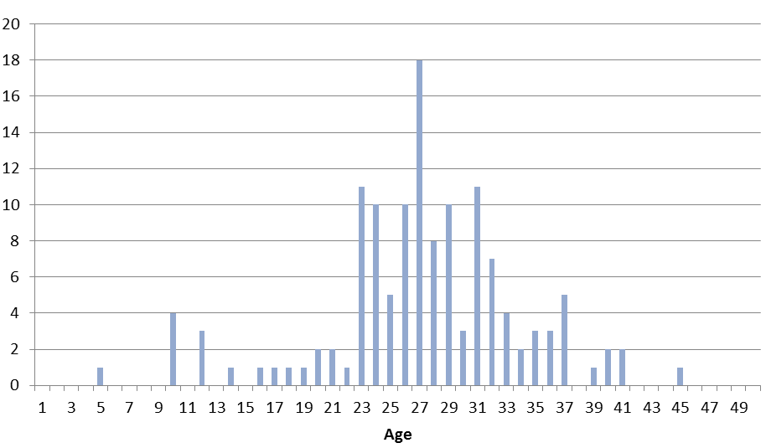
Source: Schneider and Froggatt, 2012

The costs of nuclear energy are mainly determined by the construction costs of the power plant (funding for nuclear waste and dismantling costs is generated from funds accumulated during the NPP operational period). The investment for a new NPP is estimated to be in the range of € 2 to 3.5 billion (for 1,000 MWe to 1,600 MWe respectively), but these figures are highly debated since recent NPP construction projects have often gone far over budget.

The weight of the different factors that make up the production cost of nuclear electricity is displayed in the figure below. The cost structure for the various generation options is given for a weighted average cost of capital of 5% and 10% respectively.

Figure 2 Cost structure of power generation
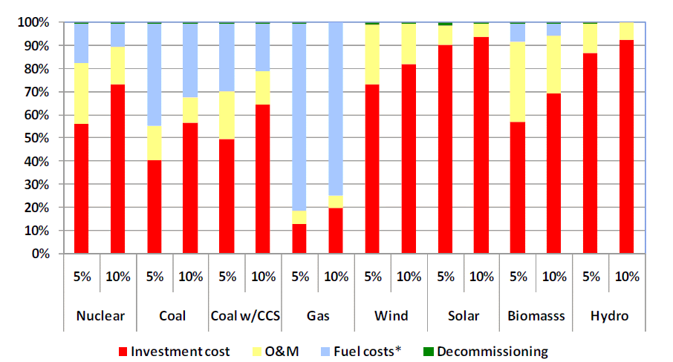
* The fuel costs for nuclear include the costs for reprocessing or disposal of the spent fuel.
Source: NEA/IEA 2010

The figure shows that – as already mentioned above – the investment cost for a new NPP is the main component determining the cost of nuclear power. It is important to note that this cost structure does of course NOT apply to existing NPPs that have already been amortised. In this case the investment costs have already been paid for and the production costs will be much lower. Figure 1 shows that the ‘mean’ age of NPPs is 28 years. Although the depreciation period of a NPP differs per country and per operator, it is typically well below 28 years. In France, the country with the largest nuclear reactor fleet in Europe, 75% of the reactors were already amortised in 2010. This figure is more or less similar for the rest of Europe, with the exception of Eastern Europe, where few but relatively new power plants are operating.

Nuclear energy prices
The price of electricity on the market is determined by the marginal costs of the most expensive power plant operational at a given time. These marginal costs are the costs of producing an additional MWh of electricity. There is no additional investment in the power plant required for each additional unit of energy produced, so the marginal costs are determined by the fuel costs and variable O&M costs only. Figure 2 shows that these marginal costs of nuclear power production are the lowest of all conventional power production. Nuclear power plants, due to their low marginal (fuel + O&M) production costs and their long start up and shut down periods, are used as ‘base load’ power. This means that these plants are producing power almost continuously, except during the maintenance period.

The figure below shows the order of dispatch for power plants, according to their marginal costs.

Figure 3 The merit order, dispatch of power plants

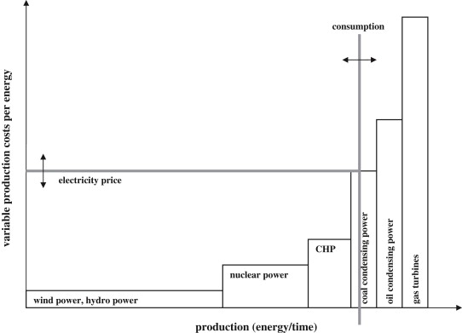
Source: Sensfuß, Frank & Ragwitz, Mario & Genoese, Massimo, 2008, "The merit-order effect: A detailed analysis of the price effect of renewable electricity generation on spot market prices in Germany," Energy Policy, Elsevier, vol. 36(8), pages 3076-3084, August.

Figure 3 shows that the electricity price is determined by the most expensive (highest marginal costs) power plant that is dispatched at that particular moment. All power that is produced at that moment is bought for this price. The high margin on nuclear power is needed to recoup the higher investment costs.

Gas turbines are most easy to regulate and are thus most suitable to respond to rapid changes in demand or supply. The electricity price in the European market is therefore typically determined by the marginal cost of gas generated electricity (at the far right of Figure 3).

Since nuclear power is ‘base load’ electricity, its marginal production costs does not directly influence the market price of electricity. Even doubling the marginal costs of nuclear power production would not influence the electricity price, as can be seen in Figure 3. In this sense, nuclear provides a key contribution to ensuring affordability of energy in the EU.

Nuclear energy sector: vendors, regulators and research
Apart from the NPPs as described above, the nuclear energy sector also comprises a number of supplying and supporting industries. The most important players in the nuclear sector are briefly described below.

Nuclear power plant vendors
Nuclear power plant vendors include suppliers of a wide variety of specialised equipment, services and other inputs to NPP operators to support the construction, refurbishment / repairs and operation of NPPs. This includes companies active in the design, engineering and construction (including refurbishment) of NPPs, Uranium suppliers, and processing of nuclear fuel (UF6 conversion, uranium enrichment and fuel fabrication services). In addition, a special category of vendors can be distinguished at the back-end of NPP operations and the nuclear fuel cycle: companies providing services for the collection and treatment of nuclear waste including spent fuel processing and recycling facilities.

Unfortunately most of these vendors fall under broader industry categories in the relevant statistical databases. For instance, there is no separate category for construction of NPPs in SBS. The sector code that relates to NPPs is 25.30 (Manufacture of steam generators, except central heating hot water boilers), which includes steam generators for non-nuclear facilities as well. Likewise nuclear waste collection and treatment is included in the same category as all other hazardous waste collection and treatment. In addition, many NPP vendors are integrated companies, conducting both design & construction and waste management activities.

PRODCOM does provide data on the sales value of nuclear reactors and parts of nuclear reactors. As Figure 5illustrates, EU total production value of nuclear reactors has increased between 2005 and 2010, although it seems to have levelled off in the last few years.

Figure 4 Sales value of nuclear reactors produced (EU27) 2005 – 2010 (millions of EUR)
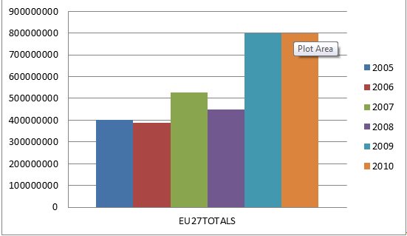

Source: PRODCOM

Figure 5 below presents the sales value for parts of nuclear reactors, which is clearly substantially higher than that for nuclear reactors. This is likely to be due to the fact that few new plants have been built since the 1990s and most construction thus involved refurbishment and replacement investments for existing plants.

Figure 5 Sales value of parts of nuclear reactors produced (EU27) 2005 – 2010 (million EUR)

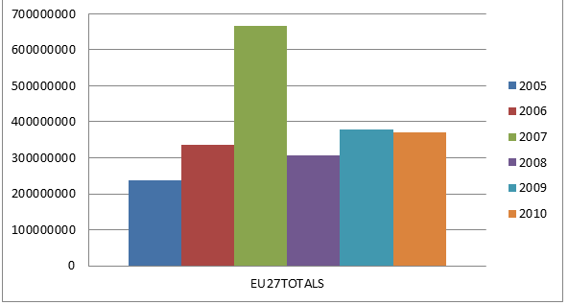

Source: PRODCOM

Unfortunately data by individual country are rather incomplete (most likely due to sensitivity issues), making it hard to establish with certainty which countries produced these reactors and parts. This segment is highly concentrated though and it is clear that the major producers include France, Spain, and the UK, while likely Germany accounts for part of the production as well (no data were available for Germany).

To complete this picture, we have consulted a number of industry sources to provide additional data and information on vendors in the nuclear energy sector, as presented below.

Nuclear fuel processing
There are only a few nuclear fuel processing plants in the EU and world wide. This includes AREVA in France and Sellafield Ltd in the UK.

Design engineering and construction of nuclear power plants
A number of big specialised engineering companies in the EU are involved in the construction of NPPs. These include notably AREVA, the biggest nuclear power group globally (French, state owned), ENSA (Spain) and Babcock from the UK. In Germany, Siemens was responsible for building all 17 of Germany's existing nuclear power plants. But more recently, the firm has limited itself to providing the non-nuclear parts of plants being built by other firms, including current projects in China and Finland.

Nuclear waste collection and management
Nuclear waste collection and processing is a highly regulated and scrutinized part of the nuclear energy chain and is often directly governed by state owned or linked organisations, such as the Nuclear Decommissioning Authority (NDA) in the UK.

Nuclear power is the only large-scale energy-producing technology which takes full responsibility for all its wastes and fully costs this into the product (i.e. electricity). The cost of managing and disposing of nuclear power plant wastes is estimated to represent about 5% of the total cost of the electricity generated. Used nuclear fuel may be treated as a resource for recycling or simply as a waste. In most EU MS (e.g. France, UK, Germany) fuel is reprocessed.

Three types of radio-active waste can be distinguished:
- Low-level waste (LLW) is generated from hospitals and industry, as well as the nuclear fuel cycle. It comprises paper, rags, tools, clothing, filters etc., which contain small amounts of mostly short-lived radioactivity. It comprises some 90% of the volume but only 1% of the radioactivity of all radioactive waste.
- Intermediate-level waste (ILW) contains higher amounts of radioactivity and some requires shielding. It typically comprises resins, chemical sludges and metal fuel cladding, as well as contaminated materials from reactor decommissioning. Smaller items and any non-solids may be solidified in concrete or bitumen for disposal. It makes up some 7% of the volume and has 4% of the radioactivity of all radioactive waste.
- High-level waste (HLW) arises from the 'burning' of uranium fuel in a nuclear reactor. HLW contains the fission products and transuranic elements generated in the reactor core. It is highly radioactive and hot, so requires cooling and shielding. It can be considered as the 'ash' from 'burning' uranium. HLW accounts for over 95% of the total radioactivity produced in the process of electricity generation.

Clearly HLW is an important waste stream from the nuclear energy sector.

The nuclear and radioactive waste management industries work to well-established safety standards. International and regional organisations such as the IAEA, NEA (OECD), the European Commission (EC) and the International Commission on Radiological Protection (ICRP) develop standards, guidelines and recommendations under a framework of co-operation to assist countries in establishing and maintaining national standards. National policies, legislation and regulations are all developed from these internationally agreed standards, guidelines and recommendations. Nuclear waste management is regulated at the EU level. As radioactive waste is not only produced in MS with NPP for electricity generation, but also by many other applications (e.g. radiotherapies or industrial tests) its safe management is considered relevant for all Member States.

On 19 July 2011, the Council adopted the "radioactive waste and spent fuel management directive". The Directive entered into force in September 2011, and Member States have to submit the first national programmes in 2015. It requires that all Member States deal with radioactive waste in a responsible and transparent manner and establish national frameworks and programs for the management of all types of radioactive waste and spent fuel.

While low and medium level radioactive waste is increasingly being taken care of, there is not yet a single final repository for high-level radioactive waste and spent fuel. It is likely, however, that the first such repositories will be opened between 2020 and 2025 in several EU Member States.

National policies dictate the waste management for used fuel and HLW from nuclear power reactors in EU MS. See Table 2 below.

Table 2 Waste management for used fuel and HLW from nuclear power reactors in a number of EU MS
Country | Policy | Facilities and progress towards final repositories
Belgium | Reprocessing | Central waste storage at Dessel  Underground laboratory established 1984 at Mol  Construction of repository to begin about 2035
Finland | Direct disposal | Program start 1983, two used fuel storages in operation  Posiva Oy set up 1995 to implement deep geological disposal  Underground research laboratory Onkalo under construction  Repository planned from this, near Olkiluoto, open in 2020
France | Reprocessing | Underground rock laboratories in clay and granite  Parliamentary confirmation in 2006 of deep geological disposal, containers to be retrievable and policy "reversible"  Bure clay deposit is likely repository site to be licensed 2015, operating 2025
Germany | Reprocessing  but moving to direct disposal | Repository planning started 1973  Used fuel storage at Ahaus and Gorleben salt dome  Geological repository may be operational at Gorleben after 2025
Spain | Direct disposal | ENRESA established 1984, its plan accepted 1999  Central interim storage at Villar de Canas from 2016 (volunteered location)  Research on deep geological disposal, decision after 2010
Sweden | Direct disposal | Central used fuel storage facility – CLAB – in operation since 1985  Underground research laboratory at Aspo for HLW repository  Osthammar site selected for repository (volunteered location)
United Kingdom | Reprocessing | Low-level waste repository in operation since 1959  HLW from reprocessing is vitrified and stored at Sellafield  Repository location to be on basis of community agreement  New NDA subsidiary to progress geological disposal
Soure: www.world-nuclear.org/info/inf04.html

Companies specialising in solutions at the back-end of the fuel cycle – spent fuel processing plants – mostly focus on their domestic markets, although some international trade does take place, mostly under contracts with foreign utilities. Limited trade is probably in part due to the fact that reprocessing technology is highly sensitive from a non-proliferation point of view – as such reprocessing is limited to a small number of countries or subject to multilateral control.

In general, utilities remain responsible for the management of radioactive waste arising in their plants, at least until it is transferred to a national authority or agency responsible for its disposal.

Utilities may outsource part of waste treatment, e.g. from decommissioning, to specialised companies, often operating in different parts of the nuclear energy cycle.

Integrated services
Given the fact that the nuclear energy sector is such a highly specialised and heavily regulated sector, many vendors provide services throughout the lifecycle of nuclear power plants, integrating design, operations, management and waste management activities. State owned AREVA, mentioned above, is an example of such an organisation. The box below provides an example of a privately owned integrated services company in the UK.

Babcock International Group – Nuclear Division
Babcock is the UK's largest specialist nuclear support services organisation, employing over 3,500 nuclear engineers, scientists and technicians. The company provides solutions for the entire nuclear lifecycle, from design and build, through operation and maintenance, to decommissioning, waste management and remediation.

Examples of projects that the company works on include, e.g. at the back-end of the cycle a contract to manage the decommissioning, demolition and clean-up of the Dounreay nuclear site. This contract was awarded to BDP (a joint venture between Babcock, CH2M Hill and URS) by the Nuclear Decommissioning Authority (NDA), and involved a share transfer making BDP the new Parent Body Organisation for Dounreay. In relation to design and construction, Babcock in alliance with URS, has been awarded a specialist design, engineering and safety case assessment contract of up to 15 years by Sellafield Ltd. The contract, known as the Design Services Alliance (DSA), will deliver design, engineering and safety case assessments to a range of different project types. These include new assets (such as new infrastructure, or nuclear waste processing or storage facilities); modification of assets (including refurbishment or enhancement of plant and equipment) to support production or decommissioning; safety cases and engineering studies to support continued operation of facilities; and operations support.
Source: http://www.babcockinternational.com/about-us/divisions/support-services/nuclear/

Nuclear safety regulators

At EU level
At the EU level, the nuclear energy sector is regulated by the Euratom Treaty and the European Nuclear Safety REgulators Group (ENSREG). This is an independent authoritative expert body composed of senior officials from national regulatory or nuclear safety authorities from all 27 member states in the EU. ENSREG was established as the High Level Group on Nuclear Safety and Waste Management.
ENSREG’s aims are to maintain and further improve the:
- Safety of nuclear installations in the EU;
- Safety of the management of spent fuel and radioactive waste in the EU;
- Financing of the decommissioning of nuclear installations in the EU.

At MS level
While only 16 MS have NPPs on their territory, all have a national regulator responsible for nuclear safety, e.g. in relation to medical and industrial radioactive sources. The table below provides an overview of all national regulators.

Figure 6 EU National Regulators for Nuclear Energy and Waste
EU MS | National Regulator
Austria | Federal Ministry of Agriculture, Forestry, Environment and Water Management.
Belgium | Federal Agency for Nuclear Control;  ONDRAF (National Agency for radioactive waste and enriched fissile materials).
Bulgaria | Nuclear Regulatory Agency of the Republic of Bulgaria.
Cyprus | Ministry of Labour and Social Insurance.
Czech Republic | State Office for Nuclear Safety.
Denmark | National Institute of Radiation Protection;  Danish Emergency Management Agency.
Estonia | Estonian Radiation Protection Centre.
Finland | STUK (Radiation and Nuclear Safety Authority);  Ministry of Employment and the Economy.
France | ASN (Nuclear Safety Authority);  Ministry for Ecology, Sustainable Development and Spatial Planning.
Germany | Federal Ministry for the Environment, Nature Conservation and Nuclear Safety.
Greece | Greek Atomic Energy Commission.
Hungary | Hungarian Atomic Energy Authority.
Ireland | Radiological Protection Institute of Ireland.
Italy | National Agency for the Protection of Environment (ISPRA, ex-APAT);  Ministry of Economic Development.
Latvia | Radiation Safety Centre;  Ministry of the Environment.
Lithuania | Lithuanian State Nuclear Safety Inspectorate (VATESI).
Luxembourg | Ministry of Health.
Malta | Radiation Protection Board.
The Netherlands | Ministry of Economic Affairs, Agriculture and Innovation.
Poland | National Atomic Energy Agency.
Portugal | The Centre for Nuclear Physics of the Lisbon University;  Nuclear Technology Institute.
Romania | National Commission for Nuclear Activities Control;  National Agency for Radioactive Waste.
Slovak Republic | Nuclear Regulatory Authority of the Slovak Republic.
Slovenia | Slovenian Nuclear Safety Administration.
Spain | Nuclear Safety Council;  Ministry of Industry, Tourism and Trade.
Sweden | SSM (Swedish Radiation Safety Authority).
United Kingdom | Office for Nuclear Regulation (An agency of the Health and Safety Executive).
Source: ENSREG (www.ensreg.eu/members-glance/national-regulators)

Technical support and research organisations

Technical support organisations
Technical support organisations in the sector comprise notably testing and certification companies. Precise data on the number such organisations specialised in nuclear related testing is not readily available (the SBS sector ‘Technical testing and analysis’ includes a wide variety of testing activities, including testing of physical characteristics and performance of materials, such as strength, thickness, durability, radioactivity, etc. and certification of products, including consumer goods, motor vehicles, aircraft, pressurised containers, nuclear plants etc.). In addition, testing, assessments and verification take place in public institutions as well.

Examples of testing and safety organisations specialised in nuclear safety testing include e.g. the German Gesellschaft für Anlagen- und Reaktorsicherheit (GRS) – a non-profit, independent organisation – which carries out research and surveys in the area of reactor safety, radioactive waste management as well as radiation and environmental protection; Belgian AVN/VNS, a licensed agency for inspection and safety review of nuclear installations; and the French IRSN, a national public expert organisation in nuclear and radiological risks – as a research and expert appraisal organization, IRSN acts as support for the public authorities competent in nuclear safety and radiation protection for civil and defense activities, and safety of nuclear facilities and materials within the framework of international treaties.

According to the Council Directive 2009/71/EURATOM
“In the past, self-assessments have been carried out in Member States in close connection with international peer reviews under the auspices of the IAEA as International Regulatory Review Team or Integrated Regulatory Review Service missions. These self-assessments were carried out and these missions were invited by Member States on a voluntary basis in the spirit of openness and transparency. Self-assessments and accompanying peer reviews of the legislative, regulatory and organisational infrastructure should be aimed at strengthening and enhancing the national framework of Member States, whilst recognising their competencies in ensuring nuclear safety of nuclear installations on their territory. The self-assessments followed by international peer reviews are neither an inspection nor an audit, but a mutual learning mechanism that accepts different approaches to the organisation and practices of a competent regulatory authority, while considering regulatory, technical and policy issues of a Member State that contribute to ensuring a strong nuclear safety regime.”

The nature of the 2009 Directive retained the principle of voluntary assessments. With the new proposed legislative changes (binding EU regulations) there will likely be an emphasis on mandatory regular reviews and assessments and possibly the role of external, either public or private testing and certification bodies could become more important.

Research / academia establishing knowledge base
The nuclear energy sector is firmly embedded in civil and military research and numerous research institutions and programmes exist at EU and MS level in support of the sector. Much of the research takes place or is funded by the public sector. For instance, R&D in the French nuclear programme amounted in 2010 to about 1 billion Euro a year (see footnote Error: Reference source not found)).

At EU level, research takes place under the FP research programmes. In FP7 Euratom there are two associated specific programmes, one covering indirect actions in the fields of fusion energy research and nuclear fission and radiation protection, the other covering direct actions in the nuclear field undertaken by the Commission's Joint Research Centre (JRC).

Table below summarises the amounts which have been allocated since FP4 Euratom in the research projects on fusion, fission and radiation protection and in the JRC

Table 3 Fund allocations FP4-7 Euratom (Eur million)
N° FP | Period | Fusion | Fission | JRC | Total
FP4 | 1994-1998 | 794 | 170 | 271 | 1,235
FP5 | 1998-2002 | 788 | 191 | 281 | 1,260
FP6 | 2002-2006 | 824 | 209 | 319 | 1,352
FP7 | 2007-2011 | 1947 | 287 | 517 | 2,751
Source: http://ec.europa.eu/energy/nuclear/research_en.htm

In addition to the support to R&D projects through the FP Euratom, the EU is actively involved in two important initiatives regarding Fission and Fusion: (1) The Sustainable Nuclear Energy Technology Platform (SNETP) (launched in 2007) aimed at coordinating Research, Development, Demonstration and Deployment (RDD&D) in the field of nuclear fission energy. It gathers stakeholders from industry (technology suppliers, utilities and other users), research organisations including Technical Safety Organisations (TSO), universities and national representatives. (2) A Joint Undertaking for fusion and the Development of Fusion Energy, established to promote scientific research and technological development in the field of fusion.

Other research initiatives at EU level include e.g. NUGENIA, an EU level network organisation promoting R&D by bringing together key actors in the sector – from industry, research, safety organisations and academia – committed to develop joint R&D projects in the field of nuclear fission technologies, with a focus on Generation II and III nuclear plants.

All MS with NPPs, but even some without, have dedicated research institutions and agencies for nuclear energy research. In some case (e.g. Sweden) these are private institutions, in other they are Government owned (e.g. France). Generally these institutions or their fore-runners were established when the first nuclear plants were built and / or as part of the miltary complex.

Many cooperate in associations and networks with the industry and with similar organisations in other MS or even internationally.

Value chains
The two key value chains related to the nuclear energy sector revolve around the production of nuclear power plants and the production of electricity using nuclear energy. These two value chains are depicted in Figure 7 and Figure 8 below.

Figure 7 Nuclear energy cycle: production of nuclear plants
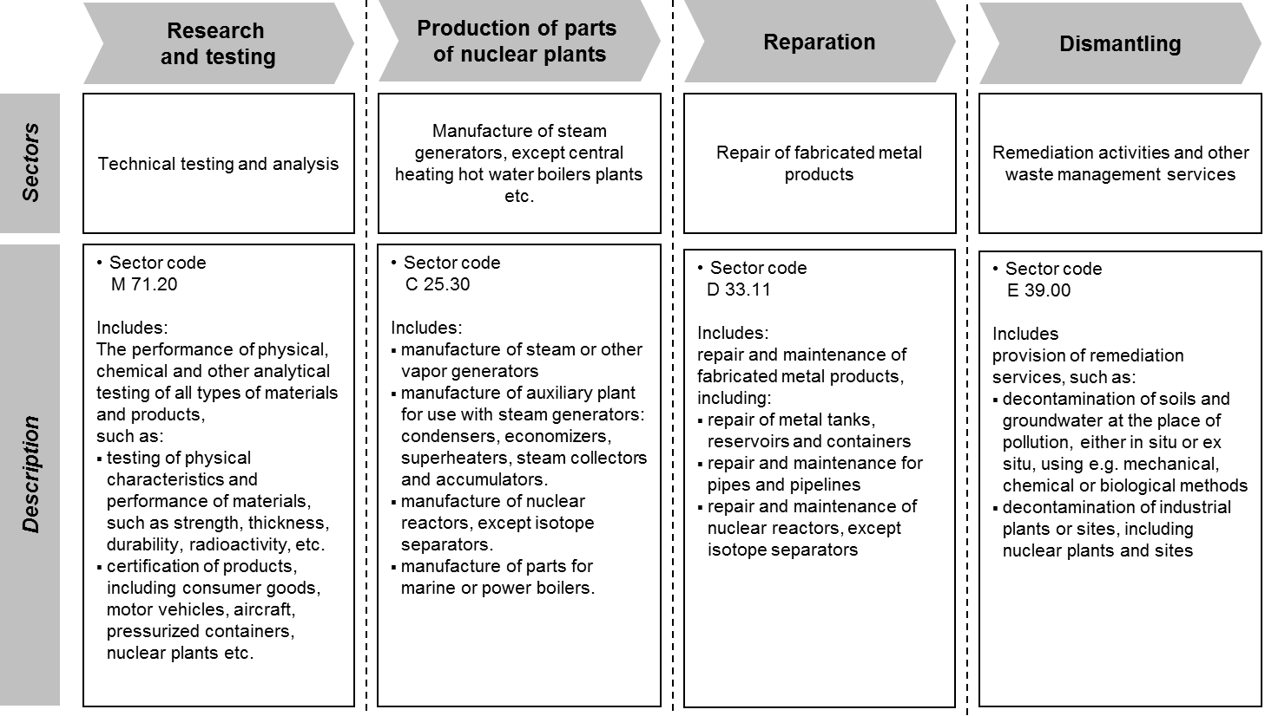

Figure 8 Nuclear energy cycle: production of electricity using nuclear energy
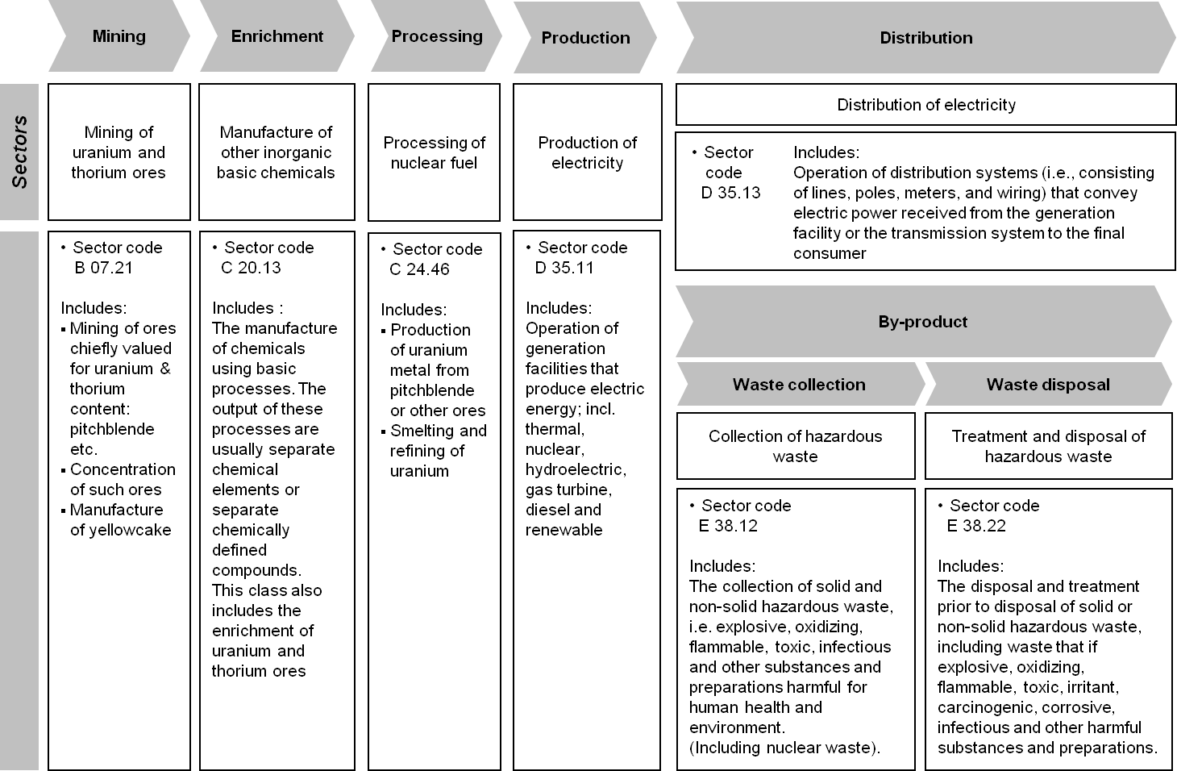

When identifying and assessing potential impacts of the proposed legislative changes these value chains serves as a basis for tracing direct and indirect impacts further up and downstream in the chain. In addition, the impacts may be felt outside the chain, e.g. through knock-on effect on electricity prices and the effects of these on other – especially energy intensive – sectors.

In our assessment we focus on the segment within the value chain where direct effects will be felt, i.e. nuclear power production), while merely describing qualitatively the further impact along the chain..

In addition, we focus mostly on the Member States where the nuclear energy sector plays an important role in overall energy generation.

Directly affected sectors: Productivity and competitiveness performance

Nuclear plant operators/utilities
Before the Fukushima incident the expansion of the nuclear industry was already restrained by high construction costs and fierce competition with fossil and renewable generation. According to a report by the MIT on ‘The Future of Nuclear Power After Fukushima’ “it is clear that the accident at Fukushima will contribute to a reduction in future trends in the expansion of nuclear energy”. A review by the UBS –‘Can Nuclear Power Survive Fukushima’ - estimates “the capital costs for new nuclear to be US$5,000-6,000/kW in the US and Europe and about US$2,000/kW in China—about two to eight times the cost of new fossil-fuelled capacity. In this situation, we think investor-owned utilities are unlikely to consider nuclear a good risk-reward option.” In a comment on his paper regarding the costs of nuclear energy, Cooper (2010) argued that "(….) nuclear construction is not only unaffordable now, but it is very likely to become even more cost prohibitive”. The investment risk of building new NPPs is thus considerable and may become prohibitively high.

Having said that, as most of the European NPPs are already amortised they are highly profitable. Extending the lifetime of these old power plants has the lowest levelised costs of electricity generation. As an example, the figure below depicts the projected cost of electricity in Belgium from nuclear plants with an extended lifetime, LTO 10 and 20 years, compared to alternative sources. This example is representative for most other major nuclear energy producers in the EU.

Figure 9 Projected costs of electricity generation in Belgium, at 8% real discount rate (in USD2010/MWh)
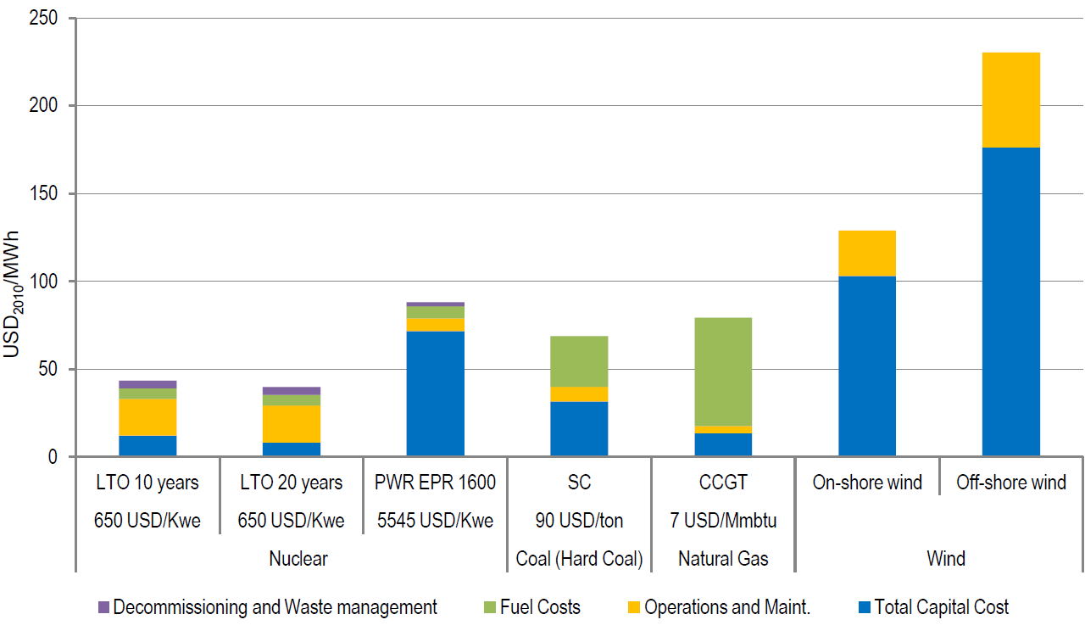

Source: OECD/NEA, 2012

Knowledge & capital intensity
As was described in section 2.1, nuclear power plants are highly capital intensive with high initial investment costs. In addition, the sector relies on advanced knowledge, as becomes clear from the substantial R&D investments and the large number of technological and research institutions supporting the sector.

Most EU MS, even those with just moderate nuclear energy sectors (e.g. the Netherlands) have dedicated research institutions and much of the R&D in the sector is conducted in public institutions, or in partnerships (e.g. industry associations), often involving different MS or even international partners. Examples are the Belgian Nuclear Research Centre, the French Commissariat a l’Energie Atomique (CEA) and public company Studsvik in Sweden. This is illustrative of the fact that the sector was originally strongly publicly driven (State-owned), yet also reflects high costs of R&D, and issues of national strategic importance (safety and security). Many MS, e.g. France, Belgium, Germany, have also built research reactors.

Clearly, knowledge and R&D are crucial elements of the sector’s competitiveness and the EU nuclear sector, with its long history, is among the most advanced sectors globally.

To support knowledge development and the retention and development of the necessary knowledge and skills in the sector, several initiatives promote nuclear education and training in the EU. For instance, the European Nuclear Education Network (ENEN), a non profit international organization established in 2003, is aimed the preservation and further development of expertise in the nuclear fields by higher education and training (e.g. harmonisation of nuclear MA and PhD curricula across MS). The organisation has 64 members, including mostly academic organisations, technological institutes, etc. across Europe.

World market shares
In terms of nuclear energy production, the EU accounts for approximately a third of all NPPs and almost 30% of uranium needs globally. Moreover, the EU has the largest share of ‘nuclear electricity’ in its total generated electricity (30% compared to 13.5% on average globally). See Table 4.

Table 4 World Nuclear Power Reactors and Uranium Requirements (2012)
COUNTRY*** | Nuclear electricity generation (2011 ) |  | Reactors operable* (sept. ’12) | Reactors under construction** (sept. ’12) | uranium required 2012
COUNTRY*** | billion kWh | % e | No. | No. | tonnes U
Argentina | 5,9 | 5.0% | 2 | 1 | 124
Armenia | 2,4 | 33.2% | 1 | 0 | 64
Bangladesh | 0 | 0.0% | 0 | 0 | -
Belarus | 0 | 0.0% | 0 | 0 | -
Belgium | 45,9 | 54.0% | 7 | 0 | 995
Brazil | 14,8 | 3.2% | 2 | 1 | 321
Bulgaria | 15,3 | 32.6% | 2 | 0 | 313
Canada | 88,3 | 15.3% | 17 | 3 | 1,694
Chile | 0 | 0.0% | 0 | 0 | -
China | 82,6 | 1.8% | 15 | 26 | 6,550
Czech Republic | 26,7 | 33.0% | 6 | 0 | 583
Egypt | 0 | 0.0% | 0 | 0 | -
Finland | 22,3 | 31.6% | 4 | 1 | 471
France | 423,5 | 77.7% | 58 | 1 | 9,254
Germany | 102,3 | 17.8% | 9 | 0 | 1,934
Hungary | 14,7 | 43.2% | 4 | 0 | 331
India | 18,9 | 3.7% | 20 | 7 | 937
Indonesia | 0 | 0.0% | 0 | 0 | -
Iran | 0 | 0.0% | 1 | 0 | 170
Israel | 0 | 0.0% | 0 | 0 | -
Italy | 0 | 0.0% | 0 | 0 | -
Japan | 156,2 | 18.1% | 50 | 3 | 4,636
Jordan | 0 | 0.0% | 0 | 0 | -
Kazakhstan | 0 | 0.0% | 0 | 0 | -
Korea DPR (North) | 0 | 0.0% | 0 | 0 | -
Korea RO (South) | 147,8 | 34.6% | 23 | 4 | 3,967
Lithuania | 0 | 0.0% | 0 | 0 | -
Malaysia | 0 | 0.0% | 0 | 0 | -
Mexico | 9,3 | 3.6% | 2 | 0 | 279
Netherlands | 3,9 | 3.6% | 1 | 0 | 102
Pakistan | 3,8 | 3.8% | 3 | 2 | 117
Poland | 0 | 0.0% | 0 | 0 | -
Romania | 10,8 | 19.0% | 2 | 0 | 177
Russia | 162 | 17.6% | 33 | 10 | 5,488
Saudi Arabia | 0 | 0.0% | 0 | 0 | -
Slovakia | 14,3 | 54.0% | 4 | 2 | 307
Slovenia | 5,9 | 41.7% | 1 | 0 | 137
South Africa | 12,9 | 5.2% | 2 | 0 | 304
Spain | 55,1 | 19.5% | 8 | 0 | 1,355
Sweden | 58,1 | 39.4% | 10 | 0 | 1,394
Switzerland | 25,7 | 40.8% | 5 | 0 | 527
Thailand | 0 | 0.0% | 0 | 0 | -
Turkey | 0 | 0.0% | 0 | 0 | -
Ukraine | 84,9 | 47.2% | 15 | 0 | 2,348
UAE | 0 | 0.0% | 0 | 1 | -
United Kingdom | 62,7 | 17.8% | 16 | 0 | 2,096
USA | 790,4 | 19.2% | 104 | 1 | 19,724
Vietnam | 0 | 0.0% | 0 | 0 | -
WORLD** | 2518 | 13.5% | 433 | 65 | 67,990
EU | 861,5 | 30.3% | 132 | 4 | 19,449
EU share world | 34.2% | n.a. | 30.5% | 6.2% | 28.6%
* Operable = Connected to the grid;
** Under Construction = first concrete for reactor poured, or major refurbishment under way;
*** While some countries in the list do not currently have any operable NPPs or NPPs under construction, they may have planned or proposed plants (e.g. Poland, Thailand, and Vietnam).

Source: http://www.world-nuclear.org/info/reactors.htmlhttp://www.world-nuclear.org/info/reactors.html
Reactor data: WNA to 1/9/12 (excluding 8 shut-down German units)
IAEA- for nuclear electricity production & percentage of electricity (% e) (13/4/12).
WNA: Global Nuclear Fuel Market report Sept 2011 (reference scenario) - for Uranium requirements.

NB: New plants coming on line are largely balanced by old plants being retired. Over 1996-2009, 43 reactors were retired as 49 started operation. There are no firm projections for retirements over the period covered by this Table, but WNA estimates that at least 60 of those now operating will close by 2030, most being small plants. The 2011 WNA Market Report reference case has 156 reactors closing by 2030, and 298 new ones coming on line.

While the EU is the dominant producer and consumer of nuclear energy, planned or proposed new capacity is mostly taking place outside the EU and especially in emerging markets and the Middle East. For instance, China has 51 planned and 120 proposed new reactors, India has 18 planned and 39 proposed and Russia has 17 planned and 24 proposed new reactors.

As regards trade in nuclear energy, France is the world’s largest net exporter of electricity from nuclear generation, as it has very low cost of generation. Estimated benefits from this export are EUR 3 billion per year.

Comparative advantages
As was indicated in section 2.1, the average age of EU NPP is 28 years, implying that production costs are relatively low as investment costs have been largely paid off. This is a comparative advantage vis-à-vis countries relying on newer NPPs.

While the EU nuclear energy sector is at the forefront of technology development and use and has a highly skilled labour force, some concerns exist over the future supply of skilled labour. A 2008 study commissioned by the EC found that the number of new graduates and the attractiveness of nuclear studies has decreased and shortages in the near future are likely (see box below). This causes some concern for the future competitiveness situation of the EU sector vis-à-vis the sector in emerging economies in particular, where knowledge and skills are quickly being developed.

Nuclear Safety in a Situation of Fading Nuclear Experience
In 2008, the European Commission launched and published a study entitled Nuclear Safety in a Situation of Fading Nuclear Experience with the aim of analysing the availability of nuclear safety staff. This study revealed a situation of concern for the period to 2020, based on the following facts:
- the number of students and graduates with a strong background in nuclear sciences is insufficient;
- the nuclear sector does not attract university graduates;
- continuing education for nuclear sector staff is not ensured.

The study thus demonstrated the need for a regular supply and demand analysis at EU level concerning the qualitative and quantitative needs for new staff and continuous monitoring of the challenges identified.
Proposed initiatives included the enhancement of university studies in nuclear sciences and techniques by the Commission. The ENEN Association, would have a role to play in this respect. In addition the introduction of incentives for graduates to take up jobs in the nuclear sector was proposed and in January 2010, the European Nuclear Energy Leadership Academy (ENELA) was established by a number of leading European companies in the nuclear energy sector, including AREVA, Axpo, EnBW, E.ON Kernkraft, URENCO and Vattenfal, to provide young science graduates, or managers with experience, with the skills and expertise they will need to become future leaders in the field of nuclear energy.
Other proposed initiatives included the development of post-graduate and professional training, and the improvement of expertise and mobility.

Source: http://europa.eu/legislation_summaries/energy/nuclear_energy/en0034_en.htm

Competition, concentration, structure
The nuclear energy production sector (NPPs) is a highly concentrated sector with relatively few and large operators. It is also concentrated in a limited number of countries within EU and globally. Barriers to entry are high as the sector is highly regulated (licences, restrictions), often has substantial state involvement and initial investment cost are (prohibitively) high.

Providers of technology for nuclear power plants
As discussed above, the nuclear industry provides a wide variety of specialised equipment and services to support the construction and operation of NPPs. “The markets to provide these have changed substantially as they have evolved from the government-led early stages of the nuclear industry to predominantly competitive, commercial markets today.”

The high tech and knowledge intensive nature of the nuclear energy production segment applies to the entire nuclear energy sector. This is also reflected in the fact that the various actors in the sector – NPP operators, utilities and vendors – are all represented in the research and education networks and associations at EU and national MS levels (see above). Often these networks also have strong international (extra-EU) links

World market share
We were not able to calculate world market shares for EU nuclear energy products, but below we present trade data for six specific product categories based on COMTRADE and PRODCOM databases and our own calculations.

Clearly, the EU has trade surpluses in all but one of the product categories in 2010 and for most product this surplus has been consistent albeit decreasing, while in the category Nuclear reactors, boilers, machinery and mechanical appliances it concerns a sizeable trade and trade-surplus.

Table 5 EU exports and imports of nuclear energy products 2007-2010 (millions of EUR)
Year | 2007 | 2008 | 2009 | 2010 | 2011

Product | Imp | Exp | Balance | Imp | Exp | Balance | Imp | Exp | Balance | Imp | Exp | Balance | Imp | Exp | Balance
Spent (irradiated) fuel elements (cartridges) of nuclear reactors | 0,15 | 0,26 | 0,11 | 0,08 | 0,20 | 0,12 | 0,00 | 0,00 | 0,00 | 0,00 | 0,17 | 0,17 | 0,00 | 0,00 | 0,00
Nuclear reactors, boilers, machinery and mechanical appliances; parts thereof | 229.679,33 | 335.624,35 | 105.945,03 | 244.281,02 | 378.777,38 | 134.496,36 | 184.725,47 | 299.040,19 | 114.314,72 | 218.113,90 | 330.718,51 | 112.604,61 | 242.148,32 | 359.315,19 | 117.166,87
Nuclear reactors; fuel elements (cartridges), non-irradiated, for nuclear reactors; machinery & apparatus for isotopic separation. | 329,89 | 342,42 | 12,54 | 275,15 | 493,75 | 218,60 | 404,23 | 558,85 | 154,61 | 677,41 | 501,29 | -176,12 | 677,57 | 838,85 | 161,28
Nuclear reactors | 0,01 | 12,31 | 12,29 | 0,01 | 3,88 | 3,88 | 0,00 | 10,31 | 10,31 | 0,10 | 4,39 | 4,29 | 0,01 | 0,83 | 0,82
Fuel elements (cartridges), non-irradiated | 296,87 | 178,22 | -118,65 | 223,12 | 249,31 | 26,19 | 328,87 | 251,87 | -77,00 | 611,01 | 147,33 | -463,68 | 607,35 | 400,74 | -206,61
Parts of nuclear reactors | 32,98 | 151,61 | 118,63 | 51,96 | 237,17 | 185,21 | 73,36 | 173,49 | 100,13 | 63,88 | 203,81 | 139,93 | 69,41 | 259,67 | 190,26

Source: Eurostat and own calculations

Comparative advantages
EU MS, particularly countries with a clear nuclear strategy such as France, have since long been active in developing nuclear technology for different applications (power generation, combined power & heat generation, industrial applications, research applications, medicine), and reactors, fuel products and various related services are major export products for these countries.

Competition, concentration, structure
Competition in NPP vendor markets is quality/technology/skills based. Generally the markets for NPP vendors are highly concentrated, with the market for uranium enrichment and fuel processing at the extreme end, with the biggest suppliers having more than 30% of the market and others 20-30%. Other segments are less concentrated and generally the market is not as extremely concentrated as other engineering based industries with complex high tech products such as the aerospace industry.

Some of the biggest global NPP vendors are EU companies, such as French AREVA and Spanish Ensa. However, most of the vendors are multinational companies with their original bases in the major nuclear energy markets such as Canada, but with operations worldwide, including in the EU.

Assessment of Competitiveness Impacts

Likely impact of proposed legislative revision on cost and price competitiveness

Directly affected sectors

Nuclear power plant operators

Additional direct costs
The exact nature of the proposed changes for the directive is not known yet. Following the Fukushima accident, national regulators all over the world have reviewed the safety of their nuclear sector. Subsequently, regulators came up with recommendations for new legislation.

The French Nuclear Safety Authority (ASN) issued recommendations to tighten safety regulations. Following these recommendations, the Court of Audit of France (Cour des comptes) assessed the financial consequences of implementing these regulations in France. The nuclear sector in France had already planned €50b of long term operation (LTO) investments for the coming 15 years. The necessary measures to comply with the ASN recommendations would require investments adding up to around €10b for this period. Part of these proposed measures, worth €5b, were already planned within the initial €50b package. Thus the required additional investments due to tightened regulations are the remaining €5b, adding up to a total investment of €55b, an estimated 10% cost increase. This corresponds with the estimated additional post-Fukushima LTO investments that some other European countries have reported.

Expected safety investments have been published for some other countries (USA, Japan) as well but there is no clear distinction made between the initially planned (baseline) investments and the Fukushima-induced investments.

Required investments in power plants are expected to be the main direct financial consequence of the revised directive. Operation and maintenance costs of nuclear power plants do not seem to be affected by the new measures.

Additional indirect costs
The new regulations will apply to the operation of nuclear power plants and thus are not expected to have any effect on the cost (per unit) of inputs such as fuel and labour. While additional capital investments will have to be made, these fall under compliance cost, as discussed above.

The new regulation is also not expected to affect the behaviour of suppliers / vendors, although it may provide opportunities for the latter as existing plants will need to be refurbished.

Impacts on consumer choice and retail prices
The new nuclear safety regulations are not expected to have any direct influence on the electricity prices. As explained in section 2.1, nuclear energy is base load power and its marginal costs (i.e. the combined costs of variable O&M and fuel) will not influence the electricity price, unless these costs increase to the extent that nuclear becomes the option with the highest marginal costs. As explained before, this would require these costs to increase dramatically – much more dramatically than our estimated increase due to the new regulations. The new regulations will not influence the fuel price, and the operation and maintenance costs are also not expected to be affected significantly (as noted above). Hence, we do not expect the revised directive to have a direct influence on the electricity price.

A potential indirect effect could follow from the possibility that new standards will force an operator to shutdown a NPP. In that case, additional capacity is needed to compensate for the loss of the NPP. This additional capacity may be more expensive than the one that previously determined the market price, thus resulting in an increased market price.
Whether plants will be decommissioned due to the new regulations is subject to debate. A Vermont law school report concludes that “the increase in safety requirements may call license extensions and uprating of existing reactors into question”, whereas the Nuclear Energy Institute said it is unlikely that tightened regulations will lead to any plant shut-downs. Other factors may play a much bigger role in this respect.

Another effect of the new directive could be that increasing costs due to tightened regulations force electricity producers to increase the production price of all power plants in their portfolio to remain profitable, including those that determine the market price. In this case the electricity price could be affected.

However, in both the aforementioned scenarios, a potential increase of the electricity price is expected to be small.

Concluding, the production costs of nuclear energy has hardly any impact on the market price of electricity in the short term. In the long term, an increase of production costs could result in a lower share of nuclear energy in the EUs energy mix. The electricy price could be influenced in function of the chosen replacement capacity. .

Qualitative assessment of the magnitude of cost impacts
Tightened regulations are expected to increase the capital costs of new NPPs and demand significant investments for existing facilities. Accidents with nuclear power plants in the past have proven to cause a trend break in the investment costs for nuclear power. The figure below shows the construction costs of nuclear power plants before and after the Three Mile Island (TMI) (aka Harrisburg) incident in the US. Note that this figure concerns new plants.

Figure 10 Nuclear construction cost: reactors completed before and after TMI
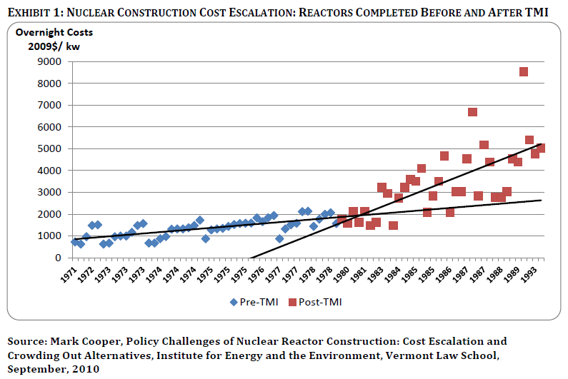

Given the fact that the newest NPPs (Generation 3) will probably already comply with most or all of the new regulations, the additional investment in EU NPPs due to Fukushima will be very small. Preliminary calculations in Japan suggest that the additional safety measures there will increase the cost of building a nuclear reactor by about 5%. This percentage may be lower in the EU as the risks from natural hazards are lower and the current public pressure for strict legislation is probably not as high as in Japan.

The potential effects of new legislation on the construction of new power plants will mainly be felt in the long term. Most nuclear operators in Europe are currently aiming at a lifetime extension of their NPPs. In this scenario, most existing operating NPPs will be decommissioned between 2030 and 2050. The majority of new nuclear power plants thus has to come on line in roughly the same period. The effect of more stringent safety legislation on new construction will thus be felt mainly in the long term.

The consequences for existing nuclear power plants in Europe are expected to be much smaller. Substantial investments in the nuclear power sector were already envisaged in the BAU scenario. As most of the European NPPs are already amortised they are highly profitable. Extending the lifetime of these old power plants has the lowest levelised costs of electricity generation.

Although the required investment to comply with new regulations can be substantial for some NPPs, they are expected to remain profitable. Based on the data available today, the additional investments due to post-Fukushima safety requirements are within 10-15% of the investments that were already planned to extend the lifetime of aging NPPs. In this scenario, the continued operation of NPPs will remain profitable. This percentage would correspond to Fukushima induced investments at the EU level of roughly €10b in the period 2012-2020.

Another point to be considered is related to insurance costs and liability. Although, increased efficiency and level of detail of safety regulation could save costs for insurance and liability, it will probably be outweighted by the increased pressure on operators to comply with regulations before governments agree to back them up financially in the case of an accident (also due to the financial consequences of Fukushima.

Finally, there is little information on the consequences of these investments for the financial position of the nuclear operators. Goldman Sachs mentioned “the potential squeeze from additional nuclear safety costs” as one of the key uncertainties for the shares of EDF (the French utility and the world’s largest nuclear power operator). The financial markets seem to have little confidence in the profitability of new nuclear power. “The announcement of starting a new project is now enough to shave significant value from any utility share price, while companies rethinking nuclear projects are being rewarded with multiples re-ratings”.

Concluding, the already high investment costs for new nuclear power plants will slightly increase as a result of the revised directive. However, most existing NPPs in the EU are already amortised and highly profitable. The required additional investments of 10-15% will likely not threaten this profitability.

Indirectly affected sectors
Since we do not expect the electricity price to be directly affected by the new legislation, the impact on electricity providers and consumers is also expected to be small. Still, the new legislation may have other indirect consequences for costs in this market. For these impacts, we distinguish between those caused by the required investments in the existing reactor fleet and the potential impacts of the construction of new reactors.

Existing NPPs
An estimated €10b of additional investments is required to comply with upcoming safety legislation. This investment is expected to generate roughly 10,000 jobs during the period in which the plants are upgraded. This number includes both directly and indirectly induced jobs. An additional 10,000 jobs is a modest increase on a European scale, given the fact that the sector employs, directly and indirectly, an estimated 900,000 people. Moreover, they concern temporary ‘jobs’, which most likely will be filled by existing staff of specialised technology and services suppliers to NPPs.

An important factor in the future of nuclear energy is the public opinion. The Fukushima accident has put additional pressure on the public support for nuclear energy. When a required investment in the nuclear sector with a magnitude of around €10b becomes public, this may have additional negative consequence for the support base for nuclear power.

New NPPs
In an EC non-paper on the contribution of nuclear energy to growth and jobs in the EU, the job consequences for the nuclear industry were assessed for a scenario where nuclear has a 20% share in the European power generation in 2050. This scenario was taken from the Energy Roadmap 2050, and is lower than the projected 28% share by the industry.

In this scenario there would be significant new nuclear construction between 2025 and 2045 to compensate for the expected decommissioning of many existing plants in that period. This new construction is projected to directly create and indirectly induce a total of 250,000 jobs. Any negative consequences of new regulations for new construction plans will thus have negative consequences for the generation of nuclear related employment as well. It is difficult to predict the actual job creation and even more difficult to make any estimation of the possible prevented job creation due to the new regulations.

Many of the expected revisions of the directive concern revisions of the regulatory and management framework, such as improving guidance and safety reviews. This will not only require a substantial effort from the operators but also from regulators. Besides the financial impact, this will also have consequences for staff requirements. There is already a lack of skilled personnel in the nuclear industry. This is a growing concern since many of the specialists are approaching retirement. Additional safety requirements will put an extra pressure on the staff and will thus likely exacerbate this problem.

The expected cost increase of NPP construction due to more regulation could maybe lead to further reluctance by investors to reconsider investments in nuclear power (due to the already existing high administrative, technological, environmental and financial barriers, not forgetting public opinion and politics). This could lead to fewer orders for new construction and thus also for the supplying third parties. On the other hand, the required retrofits due to tightened regulations will provide them with extra work.

As the regulation is not directed at waste management as such (a separate Directive already governs this segment) we expect no impacts here.

Likely impact of proposed legislative revision on sectors capacity to innovate

Directly affected sectors

Capacity for in-house R&D
To compensate for the additional investment costs, NPP operators may have to cut expenses elsewhere. When facing budget cuts, R&D expenditures tend to be among the first areas to be targeted. When utilities decide to reduce their R&D expenses, they will most likely cut on fundamental research activities. The focus of their investments is expected to be on performance enhancement and finding solutions to problems they are confronted with. One of these problems may be the increased safety demands. As such, tightening regulations may spur some safety related innovation.

As indicated, however, the profitability of EU nuclear generation is still comparatively high and knowledge, R&D and innovation are cornerstones of the sector’s competitiveness, so it seems unlikely that plant operators will cut their research budgets substantially, although working in partnership with other institutions may become even more common, especially at EU level.

Capacity for R&D externalisation
As much of the R&D that takes place in the sector already involves public institutions or specialised organisations funded either by the industry or public money, it is unlikely that the revised regulations would affect the capacity of the sector to externalise R&D. This seems more dependent on general trends in the sector (e.g. reduced interest in the sector) than on the legislation per se.

Capacity for in-house product and process innovation, supply of skills and VC
The revised regulation is not foreseen to have any noticeable impact on the capacity for in-house product and process innovation and supply of skills. If anything the new guidelines and requirements may encourage innovation as a means to comply, but also to enhance competitiveness, as similar processes are taking place world-wide. The required additional skills would most likely be related to procedures and management, which likely could be developed in-house with proper training and assistance from designated institutions. The cost for this form part of compliance cost (see section 3.1). The only issues here may be the threat of skilled labour shortages in the near future, however the new regulation has no specific bearing on this issue.

The extent to which venture capital could still be obtained for investments in the sector is hard to predict, but unlikely to be strongly affected by the regulation as such. Again, this depends much more on issues such as perceived risk and yield of the investment, which in turn is more related to the long term prospects of the nuclear energy sector in the EU and the cost of alternatives. It is possible that the revised legislation would be seen as reducing risks, which could have a positive effect on VC availability. It could also be argued, however, that news of further cost increases to the already high investment costs for new NPP could scare potential investors off.

Capacity to produce and acquire industrial patents
The capacity to innovate is often measured by looking at the number of patent applications. Based on this measure, Carrere, Hamanaka & Lévêque (2010) considered the innovation trends in nuclear energy generation between 1978 and 2005. They found that innovation in nuclear energy was strongly related to oil prices:

“When oil price (Refiner Acquisition Cost of Imported Crude Oil, inflation adjusted) increases, grants and subsidies for nuclear R&D also increase, and consequently the number of patent applications.”

In addition they found that while innovations in clean tech increased since the early 1990s, innovation in nuclear by contrast declined. Both sources of energy generation have a low carbon footprint, but clearly there has been more interest in clean tech development than in nuclear development. This trend is likely to have continued in recent years.

Finally, national policy towards nuclear energy did not necessarily seem to play a substantial role, as the authors also found that Germany seemed to innovate more in nuclear technology than France, despite the latter actively promoting nuclear energy and the former actively discouraging it.

Overall, we therefore expect the revised regulations to have a minor impact on the sector’s capacity to produce patents, as this is more driven by other factors (which to some extent are taking place as part of the baseline developments) and therefore would not be attributable to the revised legislation.

To the extent that the revised regulations require new or improved equipment, some of the innovations thus stimulated could be considered for patent applications by nuclear power generators or their direct suppliers. This is dependent on whether the required adjustments can be made with existing technology or would require new or substantially adjusted technologies.

As the regulation is not directed at waste management as such (a separate Directive already governs this segment) we expect no impacts here.

Indirectly affected sectors
Considering the limited direct expected impacts of the revised legislation, indirect impacts on the innovation capacity of electricity suppliers and consumers are not foreseen. The main indirect impact channel is through cost / prices; the nature of business for indirectly affected sectors will not be changed.

Likely impact of proposed legislative revision on sector’s international competitiveness

Directly affected sectors

International trade and competition
Only France is a net exporter of nuclear generated electricity and its exports are all destined to other EU countries and Switzerland. However, since the electricity price is unlikely to be affected and since post Fukushima similar adjustment are expected to take place worldwide and especially in developed countries, this trade is not expected to be affected by the revised legislation.

The construction industry for nuclear power plants is highly globalised, and highly concentrated. European constructors like French Areva and Spanish Ensa compete with Japanese, Korean and American companies for NPP construction contracts. They will all have to meet the same requirements of their client. These requirements are expected to be similar for most of the main nuclear players as the safety regulations are reviewed in many countries following the Fukushima accident. To the extent that other countreis will follow suit in making similar safety regulations compulsory and vendors can capitalise on the fact that they have had to adjust their products and services already and can apply this to international markets, there may even be a slight first mover advantage for EU nuclear energy sector vendors..

Competitive position in single and external market
Increasing homogeneity in safety regulations in Europe will create a level playing field and as such improve the conditions for a healthy competition. Currently, differences in safety regulation between European countries is seen to distort technology competitiveness and market competition.

As the revised legislation would be effected at the Euratom level, implications would be similar for all EU MS, although costs may vary considering the current state of the sector in the specific MS and the extent to which under national regulations/initiatives and/or as part of the previous revisions adjustments have already been made.

Particularly for the sub-segment of testing and certification organisations, the market may actually grow due to the new regulation, creating more work and possibly jobs.

The competitive position of the sector in global markets is not expected to change significantly due to the revised regulation, although on-going other trends may affect this position. With the rise of nuclear energy generation capacity in emerging markets, EU knowledge, technology and standards, could become a source of competitiveness in its own right and the adjustments made based on the revised legislation could add to this body of knowledge, which could be in demand for developments elsewhere. This would apply to NPP operators as well as providers of technology, providing best international practices.

Summary of main impacts
Competitive impact | Nuclear energy sector |  | Timing of impacts | Risk and uncertainty
Competitive impact | Directly | Indirectly | Timing of impacts | Risk and uncertainty
Cost and price competitiveness | 1.NPP operators  2.NPP vendors |  | 1. ST: 0 / LT: –  2. ST: 0 / LT: – | 1. ST: Low, LT: High  2. ST: Low, LT: High
Cost and price competitiveness |  | Electricity suppliers & consumers | ST: 0 /LT: 0 | Low
Capacity to innovate | 1.NPP operators  2.NPP vendors |  | ST: 0 / LT: 0  ST: 0 / LT: + | 1. Low  2. High
Capacity to innovate |  | Electricity suppliers & consumers | ST/LT: 0 | Low
International competitiveness | 1.NPP operators  2.NPP vendors |  | ST: 0 / LT: 0  ST: 0 / LT: + | 1. Low  2. Low
International competitiveness |  | Electricity suppliers & consumers | ST: 0 / LT: 0 | Low
Note: ST: Short Term; LT: Long Term; 0 means that we don’t expect any impact; -: a negative impact; +: a positive impact

Cost and price competitiveness
The chance seems small that the new regulations will render existing plants unprofitable; the required investments to comply with new regulations add a mere 10-15% to already planned LTO investments. We therefore believe short term risks are low for NPP operators. The economics of new NPPs, however, are uncertain but appear to be under pressure and may be at a tipping point. Additional investments triggered by new regulations, although relatively small, could prove to be the drop that makes the bucket overflow. The risk is that there will be hardly any new NPP construction and the share of nuclear energy in the EUs energy mix will decrease. Many orders for new NPPs are currently put on hold and the future development for new NPPs is uncertain. On the short term, this is partly compensated by the additional work that is required for the refurbishment of the existing plants.
The production costs of nuclear power do not directly influence the retail price of electricity. There may be effects, but they will be indirect and limited, both on the short and the long term.

Capacity to innovate
R&D and innovation are cornerstones of the sector’s competitiveness, so it seems unlikely that plant operators will cut their research budgets substantially. Stricter safety standards force NPP vendors to come up with (innovative) solutions. This may increase the focus on R&D. Yet the risk is high; with an uncertain long-term future for nuclear fission, the innovative capacity of vendors is equally uncertain.
Considering the limited direct expected impacts of the revised legislation, indirect impacts on the innovation capacity of electricity suppliers and consumers are not foreseen. The main indirect impact channel is through cost / prices, the nature of business for indirectly affected sectors will not be changed.

International competitiveness
The competition of nuclear power producers with competitors outside of Europe is very limited. Theoretically, less strict regulations in for instance Russia could allow Russian operators to provide their electricity at lower rates. This risks seems low as for instance grid connections would have to be increased substantially.
A competitiveness impact for vendors, if any, could consist of the first mover advantage enforced by the legislation.

Annex 1 – Bibliography
EC, 2012, non-paper on the contribution of nuclear energy to growth and jobs in the EU.
EDF, A utility opinion about the impact of the European Research Area. Jean-Pierre HUTIN, Director, EDF
ASN, 2012, Evaluations complémentaires de la sûreté des installations nucléaires prioritaires au regard de l’accident survenu à la centrale de Fukushima Daiichi, RAPPORT IRSN N° 708
CEC, 2009, IMPACT ASSESSMENT {COM(2008) 790 final} {SEC(2008) 2893}, COMMISSION STAFF WORKING DOCUMENT Accompanying document to the Proposal for a COUNCIL DIRECTIVE (Euratom) setting up a Community framework for Nuclear Safety IMPACT ASSESSMENT {COM(2008) 790 final} {SEC(2008) 2893}
Cooper, M., 2010, Policy Challenges of Nuclear Reactor Construction, Cost Escalation and Crowding Out Alternatives: Lessons From the U.S. and France for the Effort to Revive the U.S. Industry With Loan Guarantees and Tax Subsidies (September, 2010): http://www.vermontlaw.edu/Documents/IEE/20100909_cooperStudy.pdf.
Cooper, M., 2012, “Nuclear Safety and Nuclear Economics, Fukushima Reignites the Never-Ending Debate: Nuclear Safety at an Affordable Cost, Can We Have Both? Is Nuclear Power Not Worth the Risk at Any Price?”, Institute for Energy and the Environment, Vermont Law School, March 2012
Cour des comptes, 2012, Les coûts de la filière électronucléaire : Rapport public thématique. Cour des Comptes, janvier 2012, 430 p.
Cour des Comptes, 2012, The costs of the nuclear power sector - Summary in English (Report), Cour des Comptes, January 2012
DECC, 2011, Transposition of Council Directive Establishing a Community Framework for the Nuclear Safety of Nuclear Installations (Euratom 2009/71), IA No: HSE0058 Date: 21/07/2011
EC, 2012, non-paper on the contribution of nuclear energy to growth and jobs in the EU
'Energy roadmap 2050' (COM(2011) 885 final of 15 December 2011
ENSREG (2012) www.ensreg.eu/members-glance/nuclear-eu
ENSREG, 2012, Peer review report - Stress tests performed on European nuclear power plants. Accessed at: http://www.ensreg.eu/sites/default/files/EU%20Stress%20Test%20Peer%20Review%20Final%20Report_0.pdf
Eurelectric Power Choices Scenario 2010
Fabrice Carrere, Blaise Hamanaka and François Lévêque, Mines ParisTech, posted May 9th, 2010: http://www.energypolicyblog.com/2010/05/09/innovation-trends-in-nuclear-power-generation/
Florence School of Regulation, 2011, Competition, Energy Law and Nuclear Safety Regulation. François Lévêque and Florent Silve, Professor of Law and Economics, Mines ParisTech Sciences-‐Po Paris Florence School of Regulation EU Energy Law & Policy Workshop -‐ 20 May 2011
http://ec.europa.eu/energy/nuclear/research_en.htm
http://ec.europa.eu/energy/nuclear/waste_management/waste_management_en.htm
http://www.businessweek.com/news/2011-11-15/japan-s-nuclear-safety-steps-may-cost-19-billion-yen-per-reactor.html
http://www.energysolutions.ie/Europe%E2%80%99s_Aging_Nuclear_Power_Plants/Default.396.html
http://www.reuters.com/article/2011/07/13/us-usa-nuclear-idUSTRE76C4BO20110713
http://www.world-nuclear.org/info/reactors.html
Interview with Michael Sailer from the Eco-Institute in Darmstadt Copyright: Goethe-Institut e. V., Online-Redaktion, August 2006
Lekander, et al., 2011, Can Nuclear Power Survive Fukushima, UBS, April 4
MIT, 2012, The Future of Nuclear Power After Fukushima, Paul L. Joskow and John E. Parsons, February 2012 CEEPR WP 2012-001
OECD/NEA, 2012, Study on the Economics of Long Term Operation of NPPs, A. Lokhov. R. Cameron, IAEA-CN-194-005
Personal communication with Alexey Lokhov, Nuclear energy analyst at the OECD Nuclear Energy Agency (NEA)
Schneider M., Froggatt, A., 2012, World Nuclear Industry Status Report 2012
Signature Global analysis, 2012, Nuclear Renaissance: What’s next after Fukushima?
Taylor, M. (2008) Market competition in the nuclear industry. Facts and opinions, NEA News 2008 – No. 26
The EU has virtually no internal uranium supply but is dependent for this on the main suppliers globally, such as Australia, Canada and Kazakhstan (among others). Some uranium is produced as a result of decommissioning activities, e.g. in Germany. Given the fact that the EU Uranium supply is negligible, this sub-sector will not be considered further.
The Wall Street Journal, July 31, 2012, 5:16 a.m. ET, UPDATE: EDF Keeps Its Guidance Despite Lower Nuclear Output, http://online.wsj.com/article/BT-CO-20120731-705439.html
WNA (2010), http://www.world-nuclear.org/info/inf04.html
WNA, July 2012 (/www.world-nuclear.org/info/inf40.html)
www.nugenia.org/

P.O. Box 41753006 AD Rotterdam
The Netherlands

Watermanweg 44
3067 GG Rotterdam
The Netherlands

T +31 (0)10 453 88 00
F +31 (0)10 453 07 68
E netherlands@ecorys.com

W www.ecorys.nl

CEC, 2009, IMPACT ASSESSMENT {COM(2008) 790 final} {SEC(2008) 2893}, COMMISSION STAFF WORKING DOCUMENT Accompanying document to the Proposal for a COUNCIL DIRECTIVE (Euratom) setting up a Community framework for Nuclear Safety IMPACT ASSESSMENT {COM(2008) 790 final} {SEC(2008) 2893}
DECC, 2011, Transposition of Council Directive Establishing a Community Framework for the Nuclear Safety of Nuclear Installations (Euratom 2009/71), IA No: HSE0058 Date: 21/07/2011
ENSREG, 2012, Peer review report - Stress tests performed on European nuclear power plants. Accessed at: http://www.ensreg.eu/sites/default/files/EU%20Stress%20Test%20Peer%20Review%20Final%20Report_0.pdf
i.e. making the voluntary overall IAEA safety principles mandatory and binding rules for all EU Member States.
ENSREG, Stress Test Peer Review Board. Peer review report : Post-Fukushima accident. Stress tests performed on European nuclear power plants. v
While uranium mining is part of the nuclear power value chain, it will not be included under the scope of this study as it concerns largely non-European assets..
Schneider M., Froggatt, A., 2012, World Nuclear Industry Status Report 2012
ENSREG (2012) www.ensreg.eu/members-glance/nuclear-eu
Source: EC, 2012, non-paper on the contribution of nuclear energy to growth and jobs in the EU.
CEC, 2009, IMPACT ASSESSMENT {COM(2008) 790 final} {SEC(2008) 2893}, COMMISSION STAFF WORKING DOCUMENT Accompanying document to the Proposal for a COUNCIL DIRECTIVE (Euratom) setting up a Community framework for Nuclear Safety
Cour des Comptes, 2012, The costs of the nuclear power sector - Summary in English (Report), Cour des Comptes, January 2012
http://www.energysolutions.ie/Europe%E2%80%99s_Aging_Nuclear_Power_Plants/Default.396.html
The EU has virtually no internal uranium supply but is dependent for this on the main suppliers globally, such as Australia, Canada and Kazakhstan (among others). Some uranium is produced as a result of decommissioning activities, e.g. in Germany. Given the fact that the EU Uranium supply is negligible, this sub-sector will not be considered further.
WNA (2010), http://www.world-nuclear.org/info/inf04.html
Ibid.
Ibid.
http://ec.europa.eu/energy/nuclear/waste_management/waste_management_en.htm
Taylor, M. (2008) Market Competition in the Nuclear Industry. Facts and opinions, NEA News 2008 – No.26
http://ec.europa.eu/energy/nuclear/research_en.htm
www.nugenia.org/
MIT, 2012, The Future of Nuclear Power After Fukushima, Paul L. Joskow and John E. Parsons, February 2012 CEEPR WP 2012-001
Lekander, et al., 2011, Can Nuclear Power Survive Fukushima, UBS, April 4
Cooper, M., 2010, Policy Challenges of Nuclear Reactor Construction, Cost Escalation and Crowding Out Alternatives: Lessons From the U.S. and France for the Effort to Revive the U.S. Industry With Loan Guarantees and Tax Subsidies (September, 2010): http://www.vermontlaw.edu/Documents/IEE/20100909_cooperStudy.pdf.
Interview with Michael Sailer from the Eco-Institute in Darmstadt Copyright: Goethe-Institut e. V., Online-Redaktion, August 2006
OECD/NEA, 2012, Study on the Economics of Long Term Operation of NPPs, A. Lokhov. R. Cameron, IAEA-CN-194-005
R&D in the nuclear sector is a broad topic. It consists of improving competitiveness (fuel management, reliability, availability, lifetime extension, etc....), improving safety & radioprotection and emission control, developing long term solutions for reducing nuclear waste, increasing proliferation resistance and also the development of sustainable nuclear fuel cycles. Knowing also that many R&D investments are done by the public sector, that there is an overlap between civil and military applications and overall, data lacks (even on national level), it is not possible to give a clear figure about the R&D share. From the literature (Cour des comptes, 2012), we know that total R&D in the French nuclear programme is about 1 billion euro a year (1056 million euros in 2010). However, knowing that most R&D in the nuclear sector comes from public programmes, the share of R&D in the total cost structure of nuclear energy producers is limited. We take as example EDF. The R&D EU budget for EDF in 2010, allocated to nuclear, was 295 M€ (of which 158M€ internal, the rest with partners). This money is mainly targeted at the following research areas: safety and public acceptance, cost-effectiveness, lifetime management, and preparing for the future.. Given EDF’s turonover of more than 50 billion euro, the nuclear R&D investment is raher small (less than 1%). Source: Les coûts de la filière électronucléaire, Jan. 2012, Cour des Comptes.
Planned = Approvals, funding or major commitment in place, mostly expected in operation within 8-10 years; Proposed = Specific program or site proposals, expected operation mostly within 15 years.
http://www.world-nuclear.org/info/reactors.html
WNA, July 2012 (/www.world-nuclear.org/info/inf40.html)
Taylor, M. (2008) Market competition in the nuclear industry. Facts and opinions, NEA News 2008 – No. 26
Taylor, M. (2008) Market competition in the nuclear industry. Facts and opinions, NEA News 2008 – No. 26
ASN, 2012, Evaluations complémentaires de la sûreté des installations nucléaires prioritaires au regard de l’accident survenu à la centrale de Fukushima Daiichi, RAPPORT IRSN N° 708
Cour des comptes, 2012, Les coûts de la filière électronucléaire : Rapport public thématique. Cour des Comptes, janvier 2012, 430 p.
OECD/NEA, 2012, Study on the Economics of Long Term Operation of NPPs, A. Lokhov. R. Cameron, IAEA-CN-194-005
Personal communication with Alexey Lokhov, Nuclear energy analyst at the OECD Nuclear Energy Agency (NEA)
Cooper, M., 2012, “Nuclear Safety and Nuclear Economics, Fukushima Reignites the Never-Ending Debate: Nuclear Safety at an Affordable Cost, Can We Have Both? Is Nuclear Power Not Worth the Risk at Any Price?”, Institute for Energy and the Environment, Vermont Law School, March 2012
http://www.reuters.com/article/2011/07/13/us-usa-nuclear-idUSTRE76C4BO20110713
http://www.businessweek.com/news/2011-11-15/japan-s-nuclear-safety-steps-may-cost-19-billion-yen-per-reactor.html
EC, 2012, non-paper on the contribution of nuclear energy to growth and jobs in the EU
Interview with Michael Sailer from the Eco-Institute in Darmstadt Copyright: Goethe-Institut e. V., Online-Redaktion, August 2006
OECD/NEA, 2012, Study on the Economics of Long Term Operation of NPPs, A. Lokhov. R. Cameron, IAEA-CN-194-005
OECD/NEA, 2012, Study on the Economics of Long Term Operation of NPPs, A. Lokhov. R. Cameron, IAEA-CN-194-005
EC, 2012, non-paper on the contribution of nuclear energy to growth and jobs in the EU
The Wall Street Journal, July 31, 2012, 5:16 a.m. ET, UPDATE: EDF Keeps Its Guidance Despite Lower Nuclear Output, http://online.wsj.com/article/BT-CO-20120731-705439.html
Signature Global analysis, 2012, Nuclear Renaissance: What’s next after Fukushima?
EC, 2012, non-paper on the contribution of nuclear energy to growth and jobs in the EU
EC, 2012, non-paper on the contribution of nuclear energy to growth and jobs in the EU
'Energy roadmap 2050' (COM(2011) 885 final of 15 December 2011
Eurelectric Power Choices Scenario 2010
CEC, 2009, IMPACT ASSESSMENT {COM(2008) 790 final} {SEC(2008) 2893}, COMMISSION STAFF WORKING DOCUMENT Accompanying document to the Proposal for a COUNCIL DIRECTIVE (Euratom) setting up a Community framework for Nuclear Safety IMPACT ASSESSMENT {COM(2008) 790 final} {SEC(2008) 2893}
A utility opinion about the impact of the European Research Area. Jean-Pierre HUTIN, Director, EDF
Fabrice Carrere, Blaise Hamanaka and François Lévêque, Mines ParisTech, posted May 9th, 2010: http://www.energypolicyblog.com/2010/05/09/innovation-trends-in-nuclear-power-generation/
This finding was based on the so-called innovation index, defined as the number of yearly national patent applications in nuclear technology divided by the number of yearly national patent applications in all technological fields, on which Germany scored higher than France.
Florence School of Regulation, 2011, Competition, Energy Law and Nuclear Safety Regulation. François Lévêque and Florent Silve, Professor of Law and Economics, Mines ParisTech Sciences-‐Po Paris Florence School of Regulation EU Energy Law & Policy Workshop -‐ 20 May 2011
long term operation

