 | 
COUNCIL OF  THE EUROPEAN UNION |  |  | Brussels, 1 July 2013
 | Interinstitutional File:  2013/0081 (COD) |  | 11747/13
MIGR 71
RECH 324
EDUC 282
CODEC 1641
INST 352
PARLNAT 158

COVER NOTE
from: | Italian Senate
date of receipt: | 28 June 2013
to: | President of the Council of the European Union
Subject: | Proposal for a Directive of the European Parliament and of the Council on the conditions of entry and residence of third-country nationals for the purposes of research, studies, pupil exchange, remunerated and unremunerated training, voluntary service and au pairing (Recast)  [doc. 7869/13 MIGR 27 RECH 87 EDUC 97 CODEC 669 + ADD 1, ADD 2-  COM(2013) 151 final]  - Opinion on the application of the Principles of Subsidiarity and Proportionality

Delegations will find attached a copy of the above opinion.

.

________________________

ANNEX
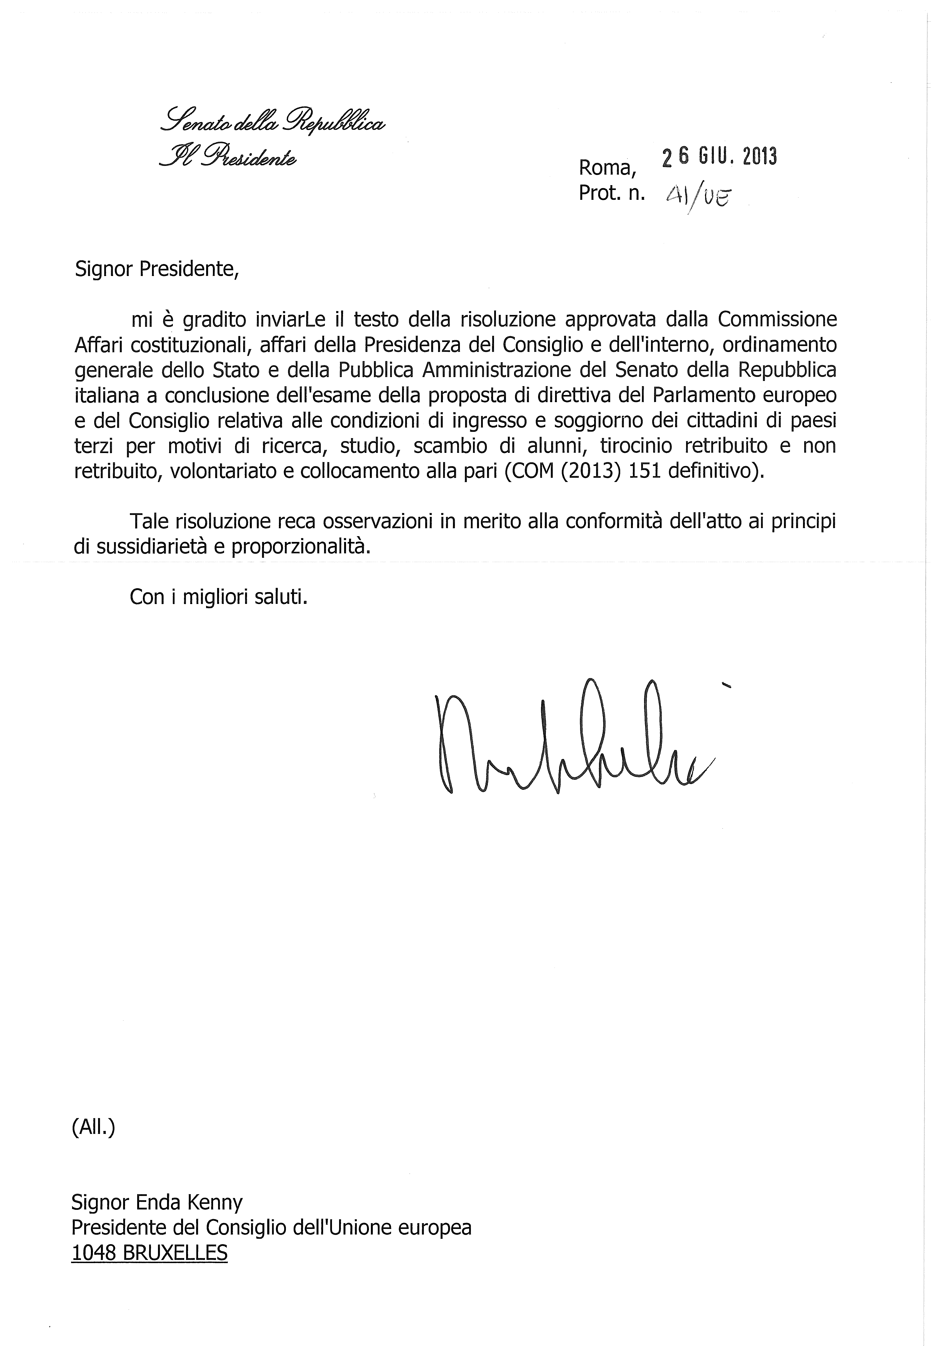

This opinion is available in English on the Interparliamentary EU information exchange Internet site (IPEX) at the following address: http://www.ipex.eu/ipex/cms/home/Documents/pid/10

