 | 
COUNCIL OF  THE EUROPEAN UNION |  |  | Brussels, 3 June 2013
 | Interinstitutional File:  2013/0081 (COD) |  | 10418/13
MIGR 58
RECH 225
EDUC 196
CODEC 1313
INST 277
PARLNAT 131

COVER NOTE
from: | President of the Assembly of the Republic of Portugal
date of receipt: | 30 May 2013
to: | President of the Council of the European Union
Subject: | Proposal for a Directive of the European Parliament and of the Council on the conditions of entry and residence of third-country nationals for the purposes of research, studies, pupil exchange, remunerated and unremunerated training, voluntary service and au pairing (Recast)  [doc. 7869/13 MIGR 27 RECH 87 EDUC 97 CODEC 669 - COM (2013) 151 final]  - Opinion on the application of the Principles of Subsidiarity and Proportionality

Delegations will find attached the above mentioned opinion.

________________________

ANNEX
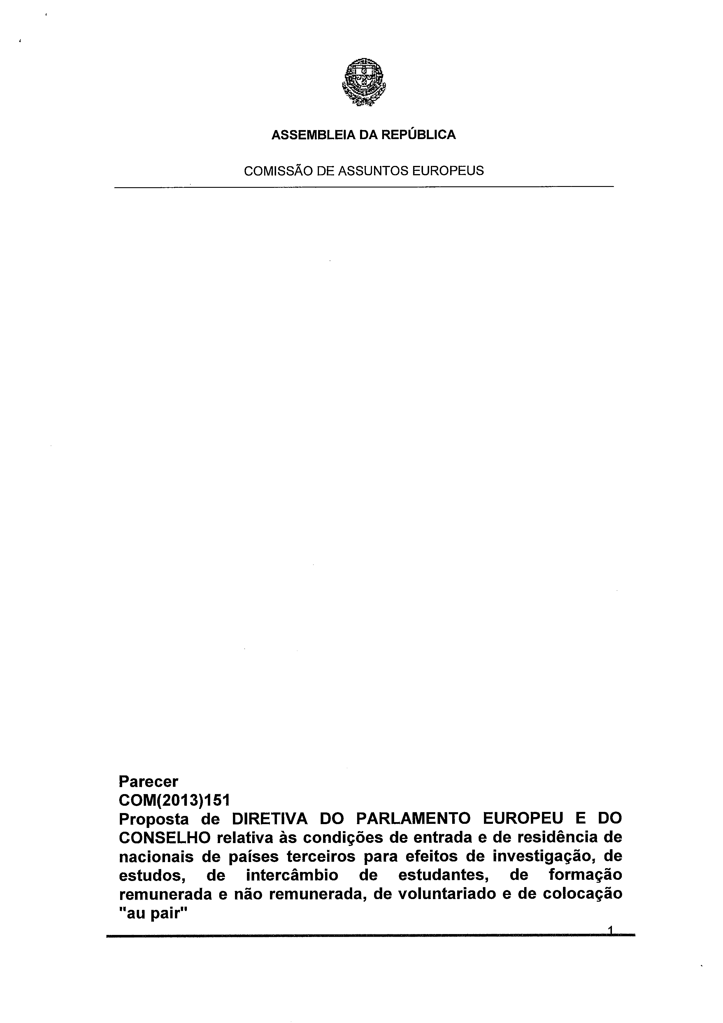
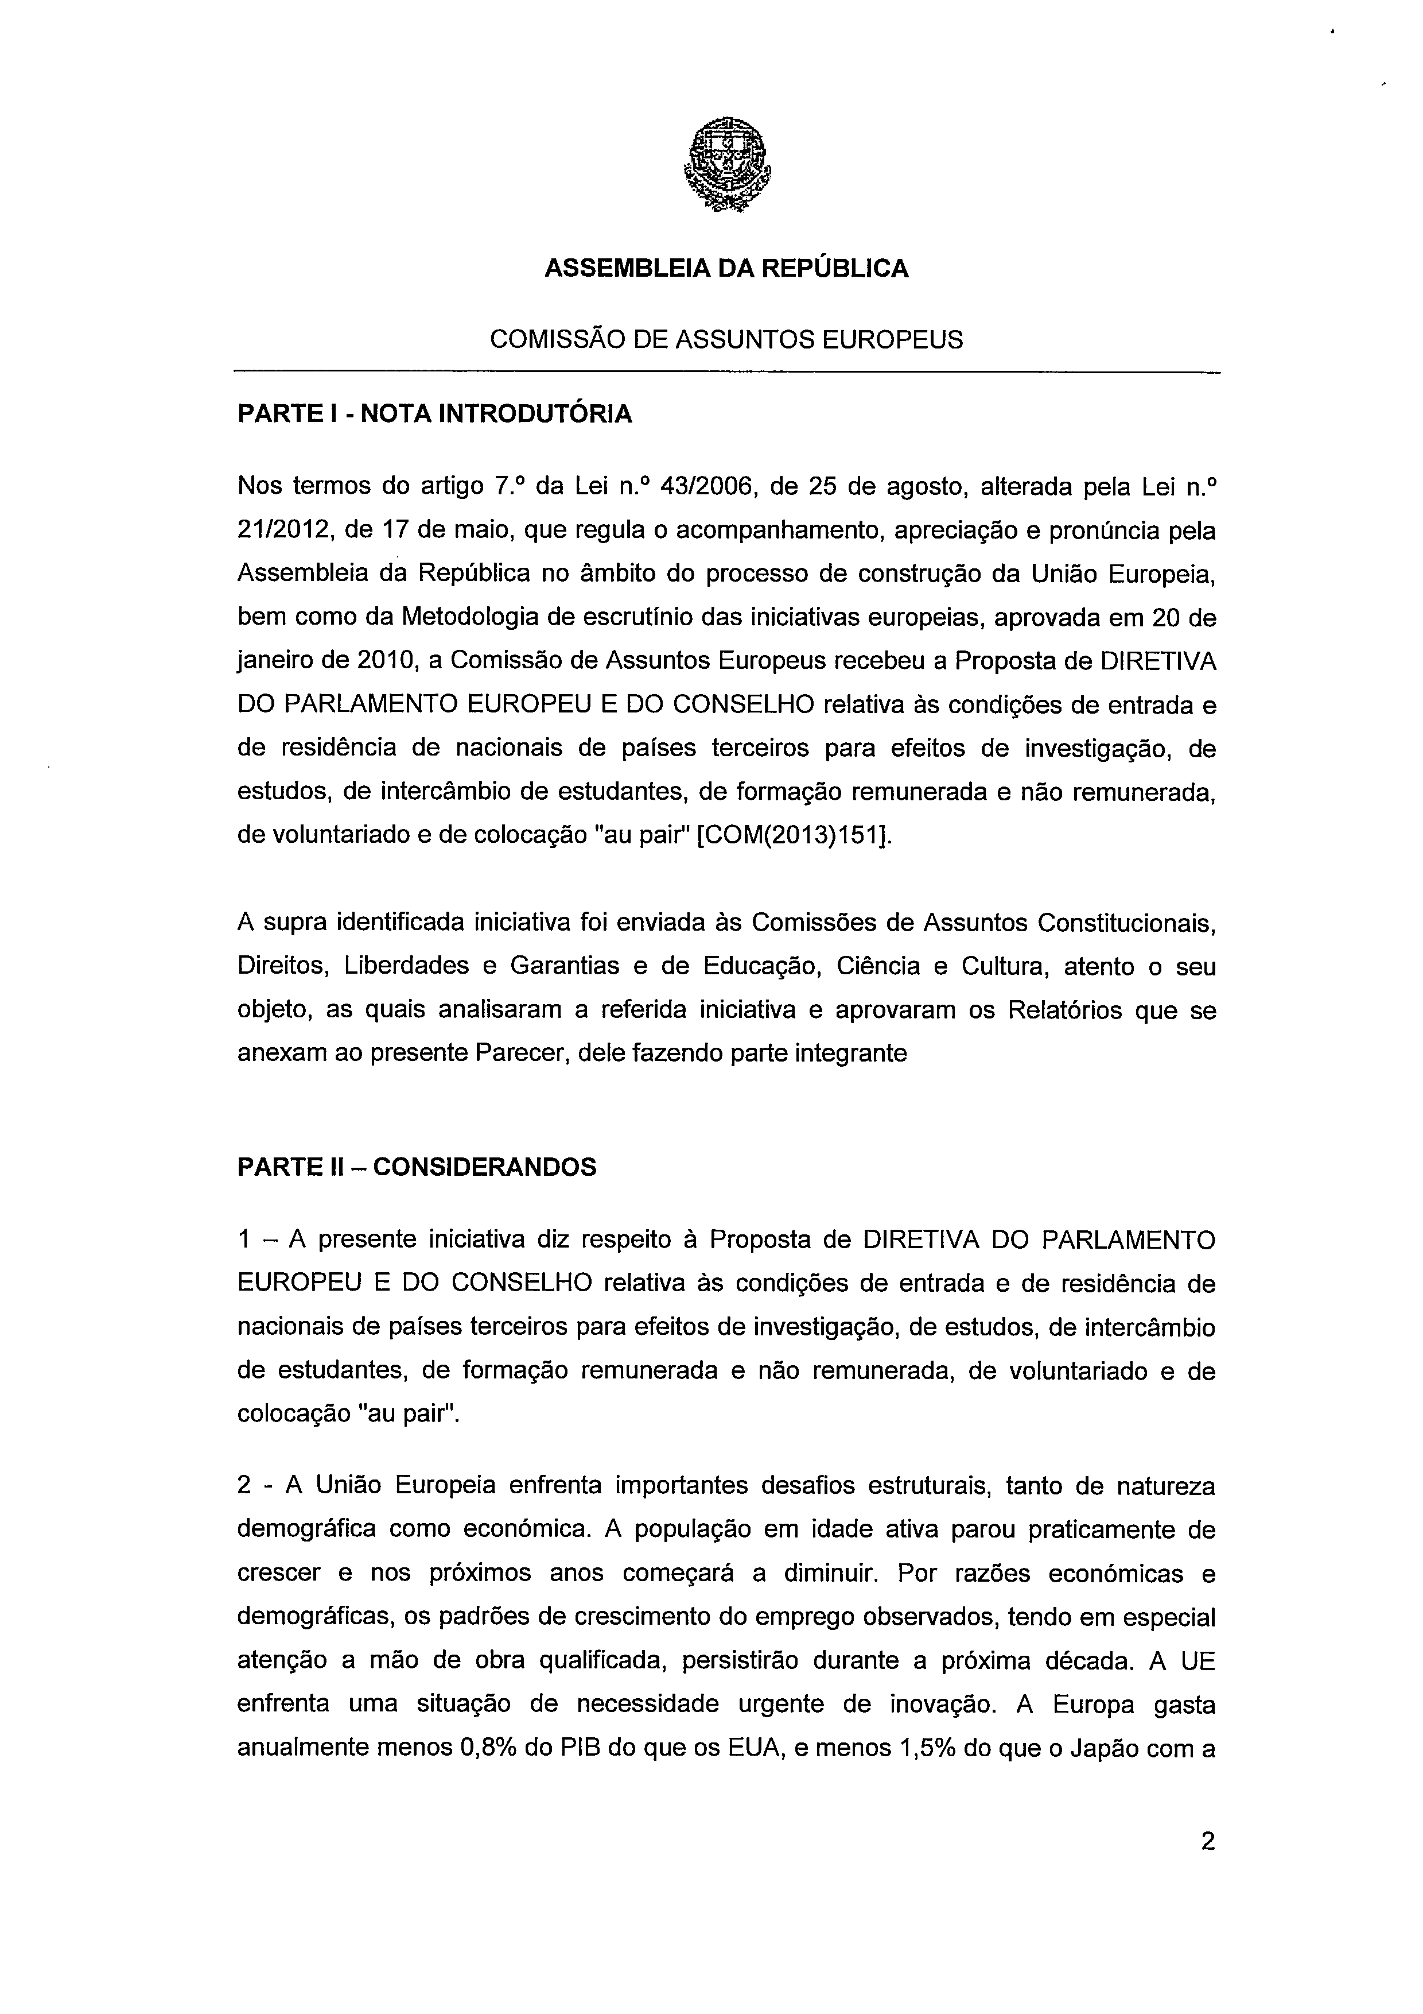
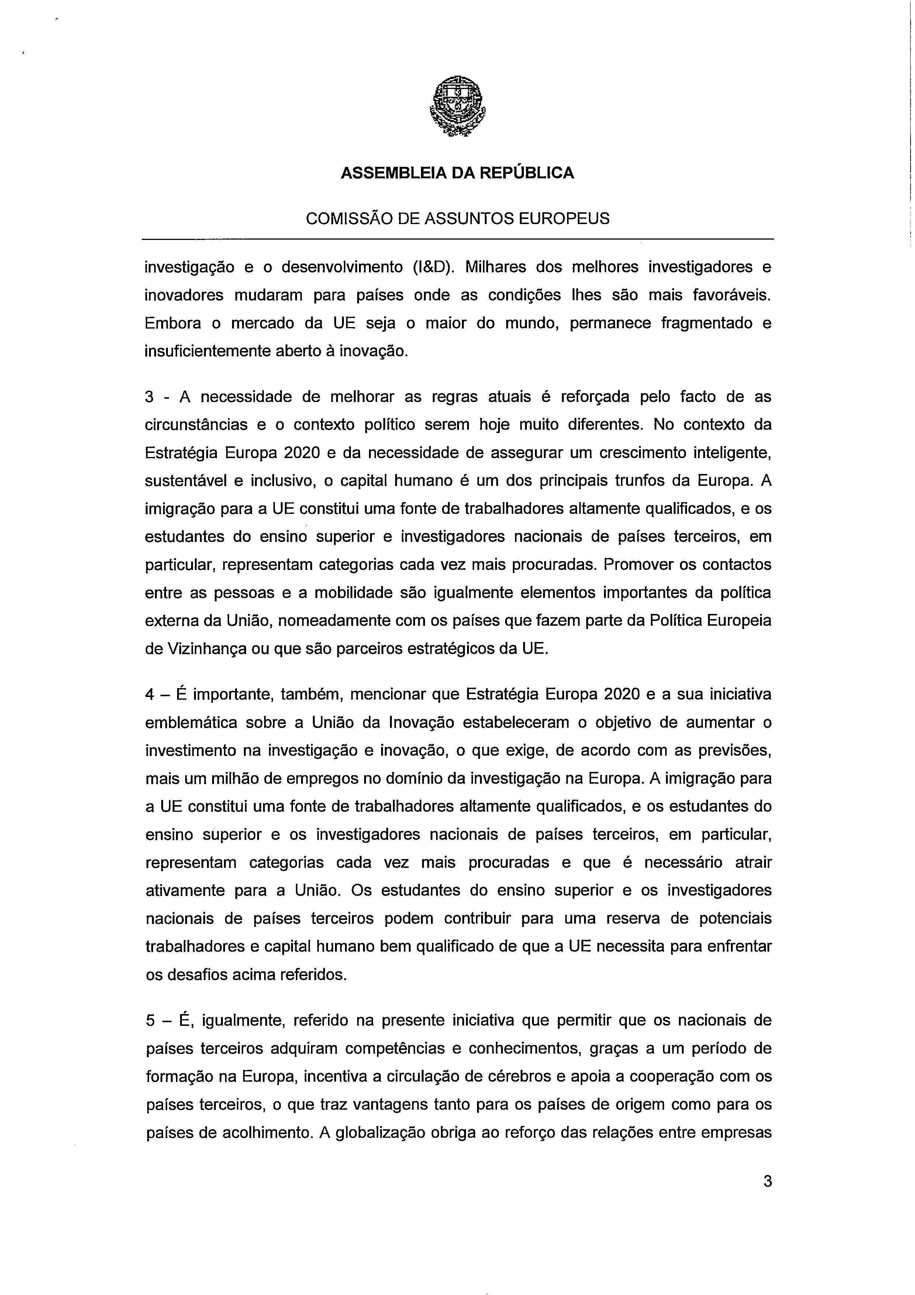

For available translations of this opinion see the Interparliamentary EU Information Exchange site (IPEX) at the following address: http://www.ipex.eu/IPEXL-WEB/search.do

