 | 
COUNCIL OF  THE EUROPEAN UNION |  |  | Brussels, 31 May 2013
 | Interinstitutional File:  2013/0080 (COD) |  | 10358/13
TELECOM 150
COMPET 386
CODEC 1295
INST 268
PARLNAT 127

COVER NOTE
from: | Romanian Chamber of Deputies
date of receipt: | 29 May 2013
to: | The President of the Council of the European Union
Subject: | Proposal for a Regulation of the European Parliament and of the Council on measures to reduce the cost of deploying high-speed electronic communications networks  - Opinion on the application of the Principles of Subsidiarity and Proportionality  [doc.7999/13 TELECOM 60 COMPET 177 CODEC 686  + ADD1 +ADD2 + ADD3 + ADD4 + ADD5 + ADD6 COM(2013) 147 final]

Delegations will find attached for information a copy of the above opinion.

_____________________

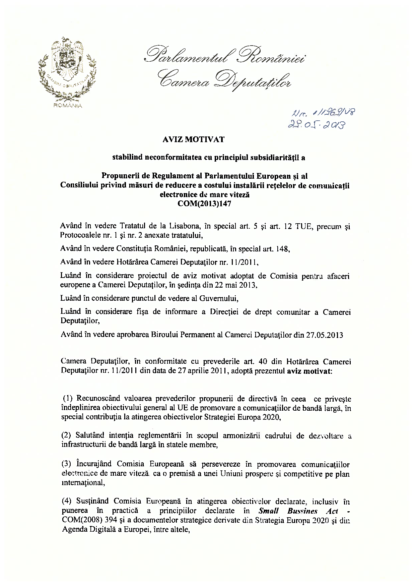
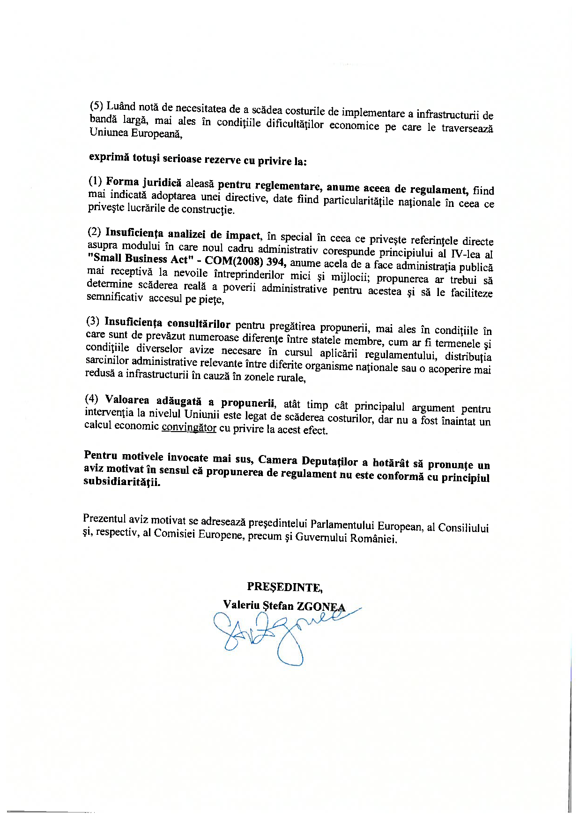
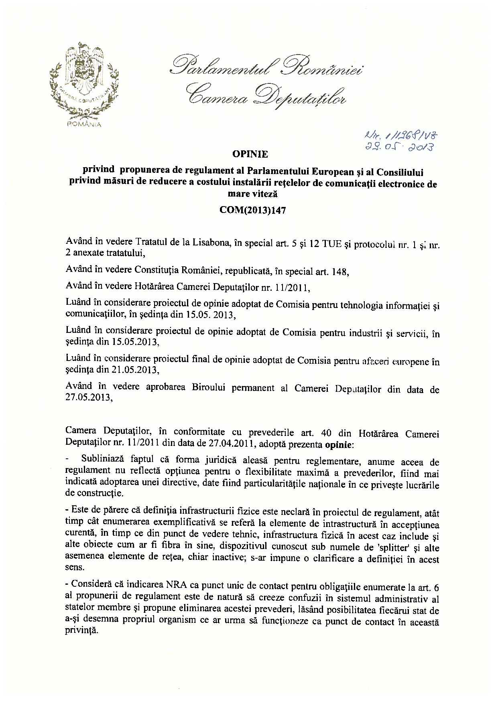
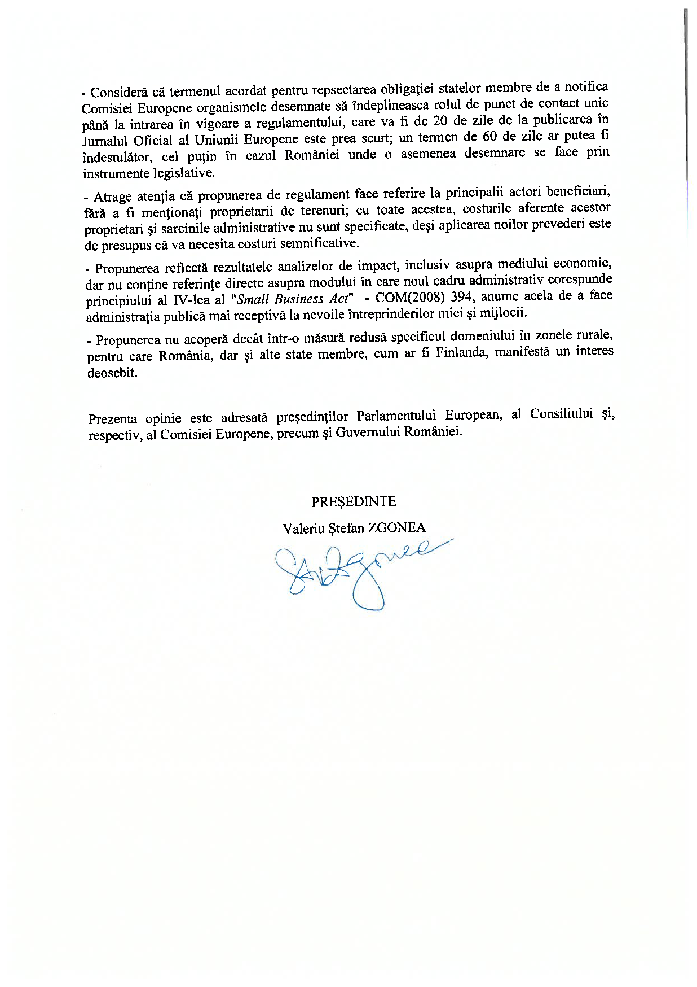

The translation can be found at the Interparliamentary EU information exchange site IPEX at the following address :http://www.ipex.eu/IPEXL-WEB/search.do

