 | 
COUNCIL OF  THE EUROPEAN UNION |  |  | Brussels, 27 May 2013
 | Interinstitutional Files:  2012/0035 (COD) |  | 9704/13
PHARM 21
SAN 171
MI 417
COMPET 311
CODEC 1117
INST 242
PARLNAT 114

COVER NOTE
from: | Spanish Parliament
date of receipt: | 14 May 2013
to: | The President of the Council of the European Union
No Cion doc.: | 7452/1/13 REV 1 PHARM 12 MI 197 SAN 93 ENT 77 CODEC 571 - COM(2013) 168 final
Subject: | Amended proposal for a Directive of the European Parliament and of the Council on the transparency of measures regulating the prices of medicinal products for human use and their inclusion in the scope of public health insurance systems  - Reasoned opinion on the application of the Principles of Subsidiarity and Proportionality

Delegations will find attached for information a copy of the above opinion.

________________________
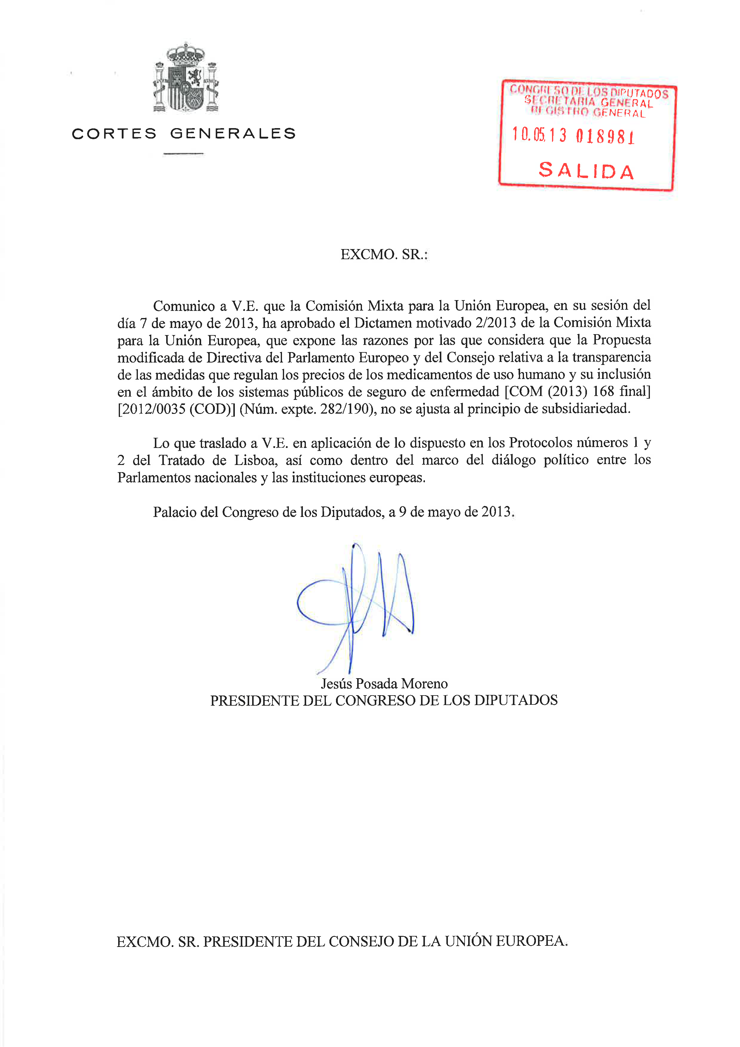
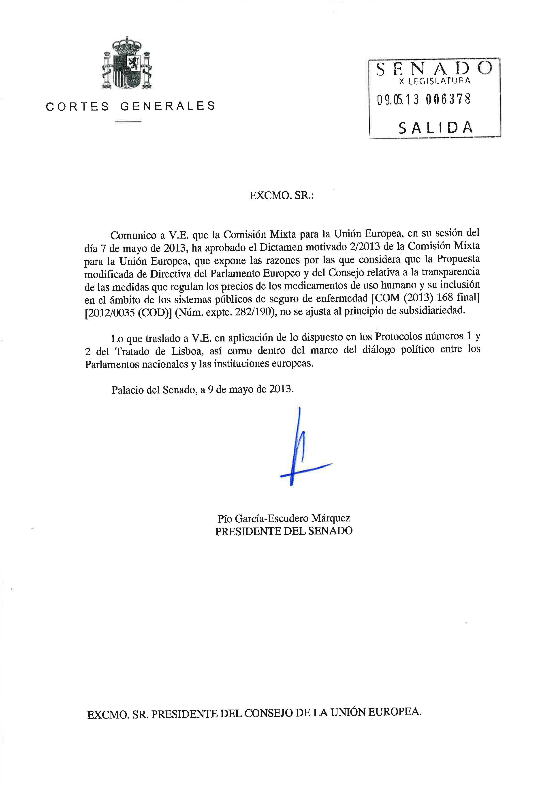
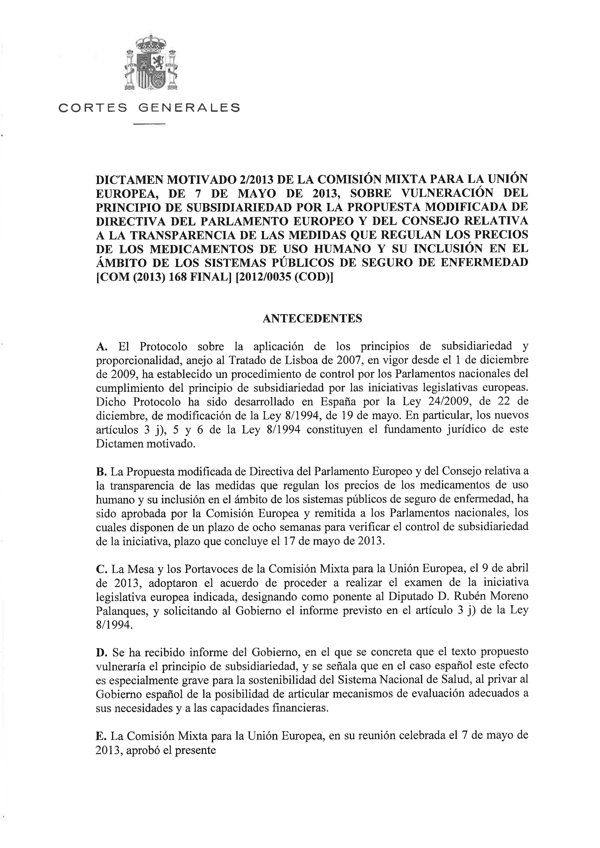
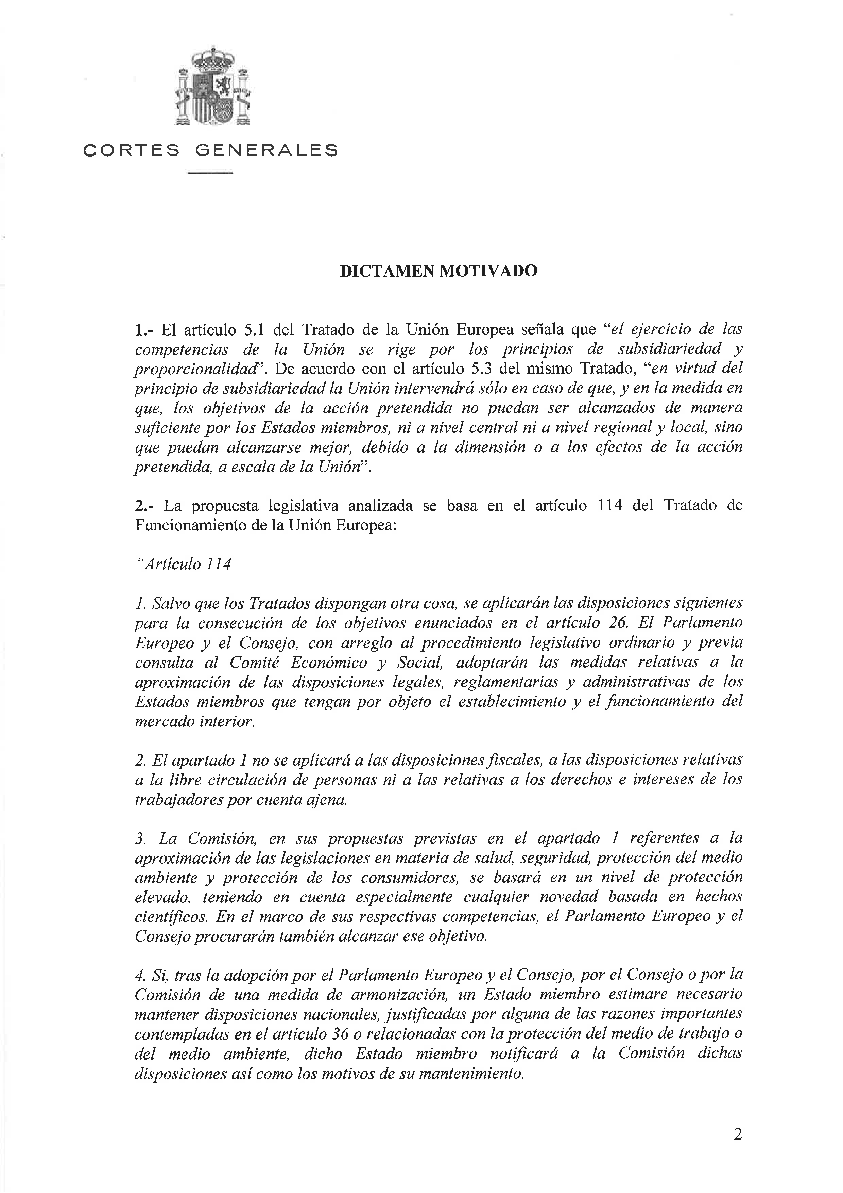
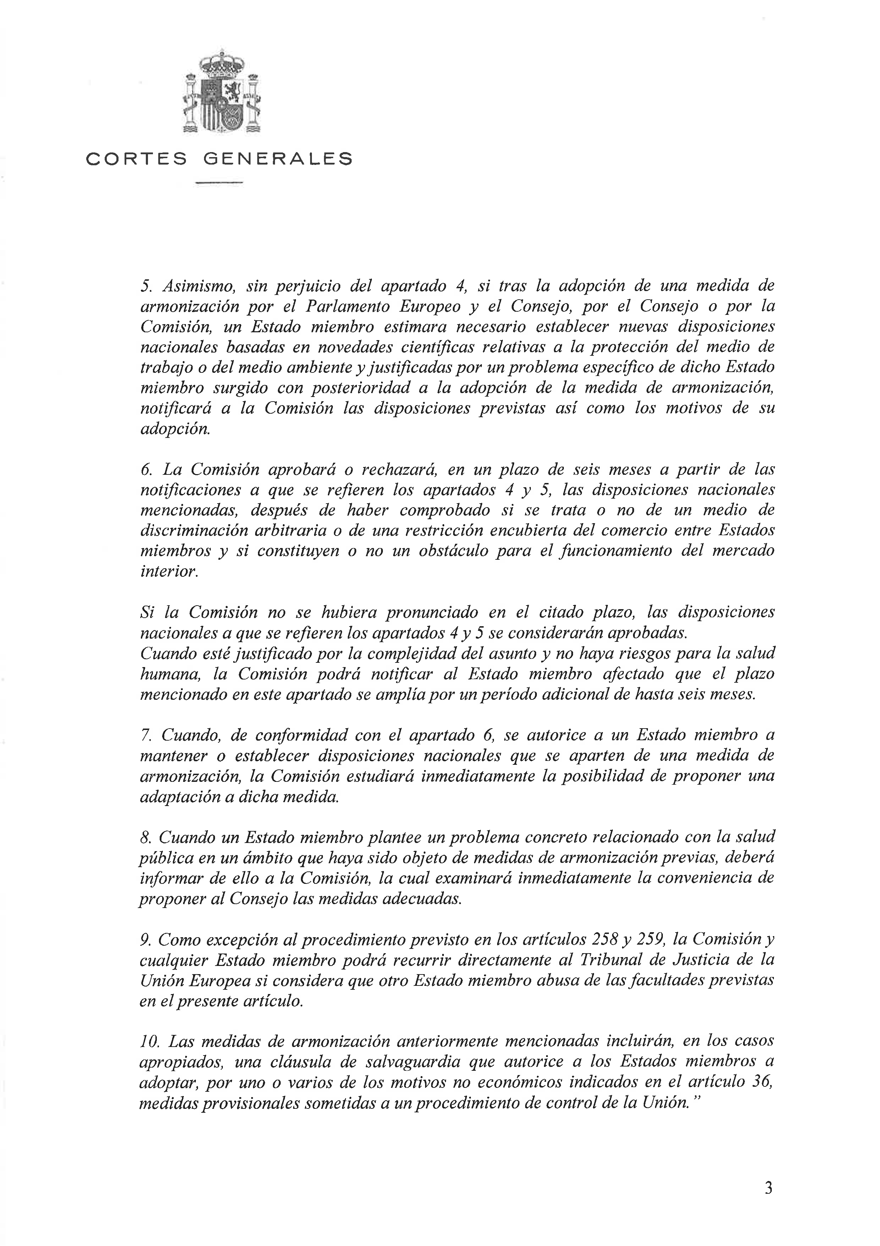
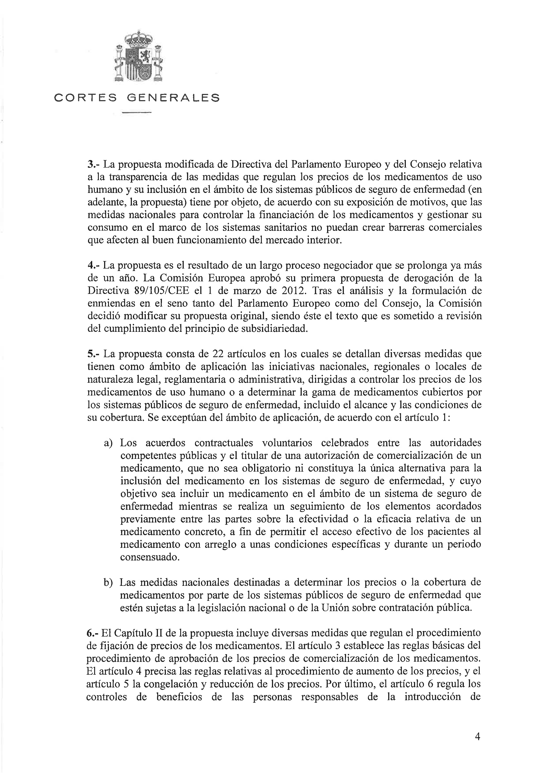
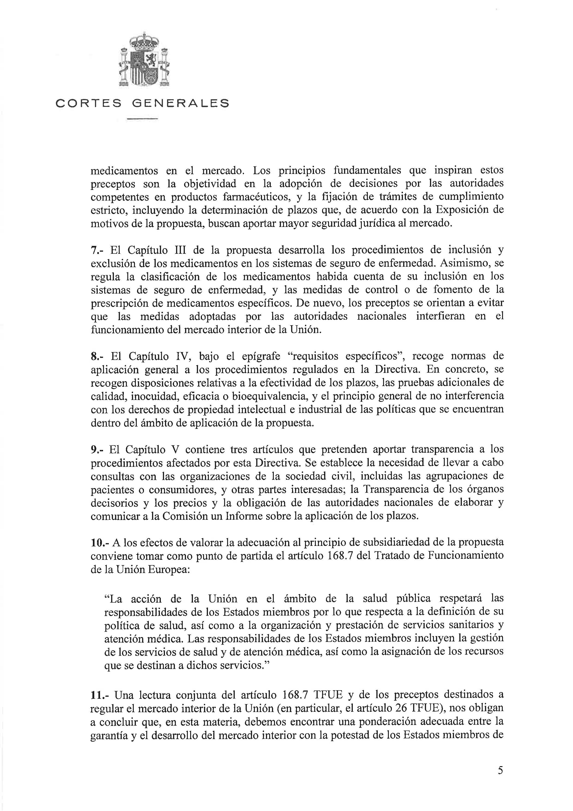
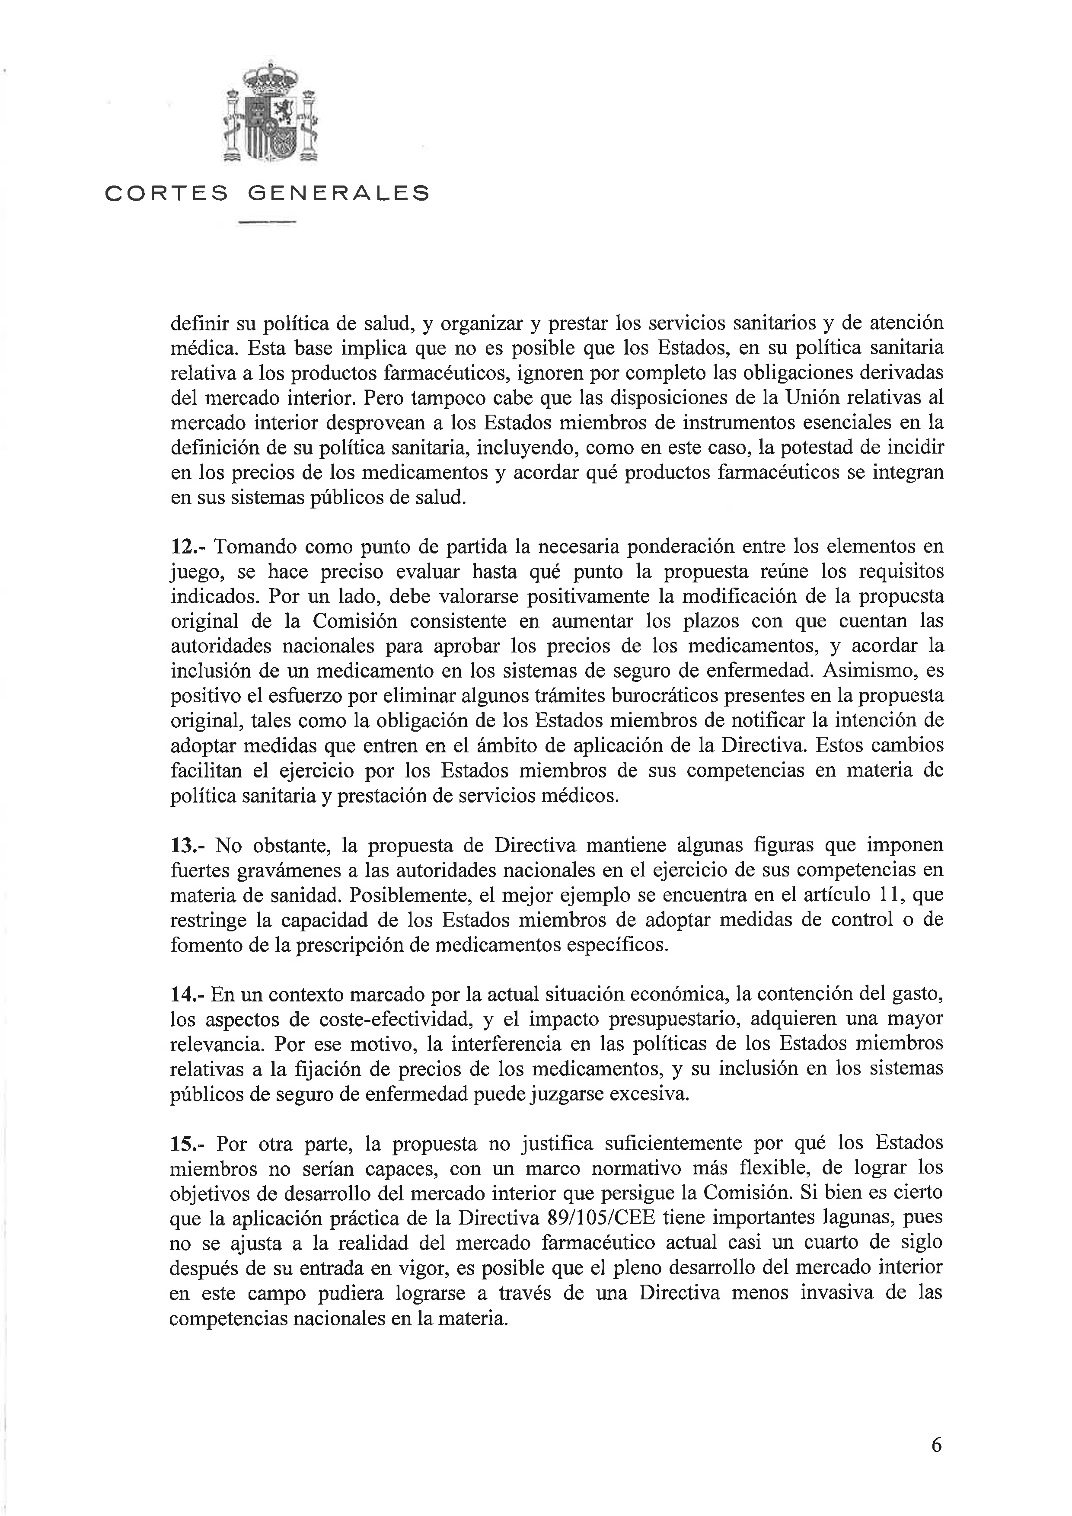
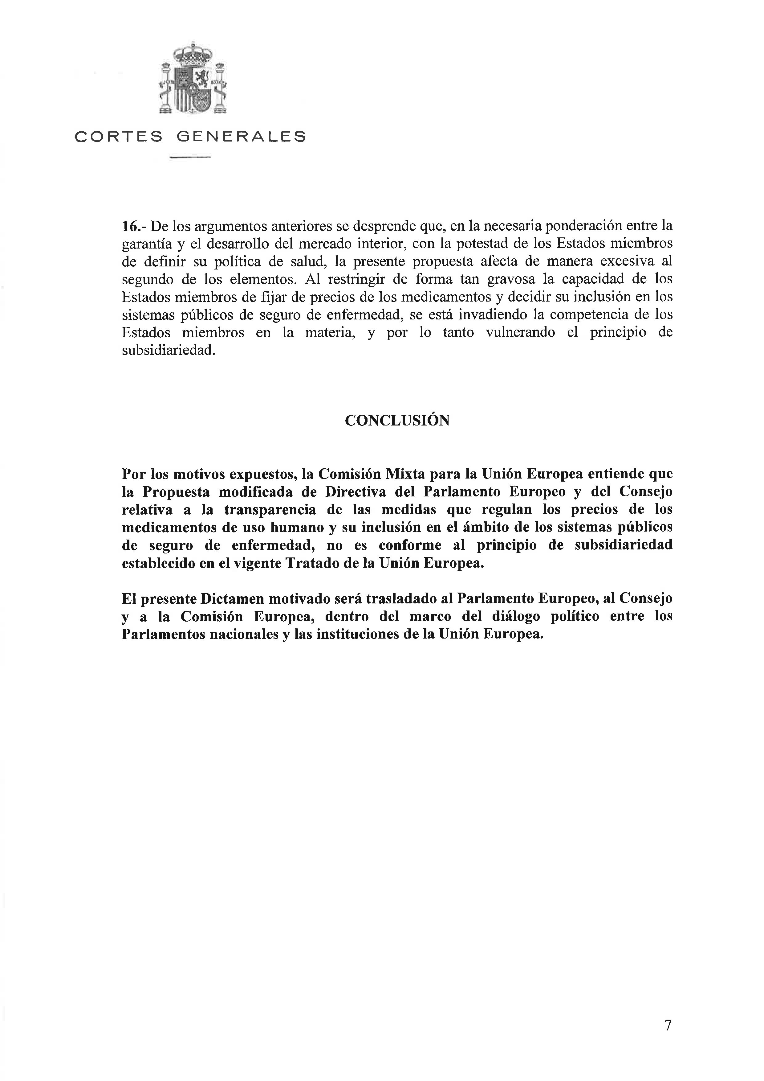
____________________

The translation can be found at the Interparliamentary EU information exchange site IPEX at the following addresses: http://www.ipex.eu/IPEXL-WEB/dossier/document/COM20130168.do#dossier-COD20120035

