REPORT FROM THE COMMISSION
30TH ANNUAL REPORT ON MONITORING THE APPLICATION OF EU LAW
(2012)

Introduction
Effective application of EU law is essential if the European Union is to meet its policy objectives. While Member States are responsible for the timely and accurate transposition of directives as well as the correct application and implementation of the entire acquis, the Commission has to monitor the Member States’ efforts and ensure that their legislation complies with EU law.
The Commission has a wide array of tools to assess whether EU policies are properly implemented. It also relies on information from citizens, businesses, NGOs and other stakeholders that point to potential problems concerning the application of EU law. For many of these issues the Commission works closely with Member States to find an efficient and satisfactory solution without resorting to formal legal actions. If this partnership does not produce desired results and if Member States' do not respect their obligation under EU law, the Commission launches formal infringement procedure (under Article 258 TFEU). Should cases be referred to the Court under Article 260(2) TFEU for not having complied with a prior judgment and Article 260(3) TFEU, for late transposition of directives, sanctions can be proposed by the Commission and decided by the Court.
The 30th Annual Report on monitoring the application of EU law reviews the performance on key aspects of the application of EU law and highlights strategic issues. The performance and the challenges in the application of EU law are broken down by Member States and thematic areas in the Staff Working Documents accompanying this Report.

1. Transposition of directives

1.1. Overview of the 2012 transposition work
Reducing late transposition is a Commission priority. The Commission proposes fines under the special penalty regime established by Article 260(3) TFEU against Member States, if they do not transpose directives in time (details in point 1.2 below).
There were less directives to transpose in 2012 compared to the previous years (i.e. 56 in contrast to 131 in 2011 and 111 in 2010). Accordingly, there was a decrease in late transposition infringements in 2012 compared to the previous year (447 late transposition infringements in 2012 compared to 1185 procedures in 2011 and 855 in 2010). 418 late transposition cases were open at the end of 2012, which represents a 45 % decrease when compared to the 763 cases at the end of 2011.
The following chart contains the key figures on late transposition infringements initiated by the Commission during 2012:
The following table shows late transposition infringements by Member State:
The four policy areas where the most late transposition infringements were launched in 2012 were transport (115 procedures), health & consumers (108), environment (63) and internal market & services (53).
Late transposition infringements were launched against more than two thirds of the Member States for some directives. For example, the Commission launched procedures against 24 Member States concerning late transposition of the Directive on buildings' energy performance.
Similarly, 23 Member States were involved in late transposition infringements under the so-called Omnibus I Directive; 20 procedures were launched concerning the Directive on intelligent road transport systems; and the directive amending the Community code of medicinal products for human use triggered 19 procedures. Finally, 18 Member States received a letter of formal notice due to the late transposition of the modifications in the so-called Prospectus Directive.

1.2. Referrals to the Court under Articles 258 / 260(3) TFEU
Under Article 260(3) TFEU, when referring a late transposition infringement to the Court according to Article 258 TFEU, the Commission may specify financial penalties without having to wait for a first judgment. The purpose of this innovation in the Lisbon Treaty is to give a stronger incentive to Member States to transpose directives within the deadlines laid down by the legislator.
In 2012, the Commission referred a number of late transposition infringements to the Court with a request for financial sanctions under Article 260(3) TFEU. Twelve Member States were involved in 35 such decisions in 2012: Poland (10 cases), Slovenia (5), the Netherlands, Finland (4 each), Belgium, Cyprus (3 each), Germany, Bulgaria, Slovakia, Luxembourg, Portugal and Hungary (one each). The proposed daily penalty ranged from € 5,909.40 to € 315,036.54. Lump sum payments were not requested.
The Member States’ infringement profiles in the Commission Staff Working Document (Part I) contain more detailed information on these cases.

2. Incorrect transposition and bad application of EU laws
While the Commission in its duty as the Guardian of the Treaties conducts its own enquiries to detect infringements of EU law (point 2.1.2), citizens, businesses and stakeholder organisations make a significant contribution to monitoring by reporting shortcomings in the transposition and/or application of EU law by Member State authorities (see complaints under point 2.1.1). Once detected, problems are followed up by bilateral discussions between the Commission and the Member State concerned in order to remedy them using the EU Pilot platform (point 2.1.3).

2.1. Detection of problems and informal solutions

2.1.1. Complaints
Citizens, businesses, NGOs or other organisations file complaints to the Commission frequently. The Commission laid down its complaint handling rules in a Communication issued in 2002. Improvement and expansion of methods to properly register and treat correspondence from complainants concerning the application of Union law, the entry into force of the TFEU and the need for some linguistic clarification called for an update.
This Communication was updated in June 2012. It maintains the existing general framework of complaint handling. It reaffirms the administrative measures to be complied with by the Commission when handling complaints including proper recording of every complaint received, sending an acknowledgment of receipt, informing the complainant on any steps taken by the Commission in further processing his/her complaint, and giving prior notice to the complainant before closing a file.
The chart below shows the key data on citizens’ complaints in 2012:
3141 new complaints – The three Member States against which the most complaints were filed were: Italy (438), Spain (306) and France (242). Similar to 2011, citizens, businesses and organisations reported irregularities especially in connection with environment, justice and internal market & services (588, 491 and 462 complaints, respectively).
2859 processed complaints – Following an initial assessment of more than 2800 submissions in 2012, the Commission opened bilateral discussions with the Member State concerned in relation to 621 complaints in order to clarify whether EU rules had been breached. Complaints that led to bilateral discussions were most frequently related to environment, internal market & services and taxation & customs union (131, 130 and 92 files opened under EU Pilot, respectively).
Petitions by citizens to the European Parliament as well as questions from Members of Parliament could also raise perceived deficiencies in the way Member States apply EU law. Most frequently, these concerned environmental issues. On this basis, the Commission has sent two letters of formal notice under Article 258 TFEU (to the United Kingdom and Greece) and launched further 22 investigations in EU Pilot. The Commission received seven petitions from the European Parliament in relation to regional policy and four on health and consumers matters. Two EU Pilot files were launched upon written questions from the Parliament in the areas of agriculture, two in internal market and three in transport. More detailed information on petitions and written questions is provided in the Commission Staff Working Document (Part II pages on Environment, Agriculture, Internal Market & Services, Transport, Justice, Fundamental Rights & Citizenship, Regional Policy and Health & Consumers).

2.1.2. Own initiative cases
The Commission's own findings also reveal potential infringements of EU law. Similar to complaints, the Commission initiates first a bilateral discussion with the Member State concerned with a view to finding a solution complying with EU law. 791 investigations were launched during 2012. Environment, internal market and services and transport were the three policy areas where the most potential infringements were identified (386, 196 and 164 new files, respectively). The Member States primarily concerned were France, Spain and Italy (112, 110 and 107 new files, respectively).

2.1.3. Partnership with Member States: EU Pilot
EU Pilot is a Commission initiative aimed at responding to questions and identifying solutions to problems related to the application of EU law. It is supported by an on-line database and communication tool. EU Pilot provides the opportunity to resolve problems before entering into formal infringement procedures. Given that cases should, in principle, be dealt with within 20 weeks, EU Pilot dialogue facilitates speedy resolution of problems for the benefit of citizens and businesses and achieving compliance with EU law obligations.
The gradual phase-in of Member States to EU Pilot has finished in June 2012, when the two remaining Member States, Luxembourg and Malta, signed up to the system. Accordingly, all Member States have become participants in EU Pilot. The following chart contains the main EU Pilot figures for 2012:
1405 new dossiers during 2012 – This figure is composed of 621 complaints confirmed by the Commission and 784 new own initiative files.
1175 files were closed during 2012 – Of the 1175 EU Pilot files in 2012, the Commission closed 803 files because the Member State provided a satisfactory response. This is a 68.34 % resolution rate for the Member States (a 4.16 % decrease from the 2011 rate of 72.5 %).
1326 files remained pending – By the end of 2012, most of the EU Pilot files were addressed to Italy (135), followed by Spain (107) and Greece (82). From the point of view of policy areas, environment remained the leading field with 400 open dossiers before internal market & services (176) and justice & fundamental rights (125).
The Commission closed 334 EU Pilot files in 2012 by launching formal infringement procedures. Solutions were not found for 84 environment, 42 taxation & customs union and 42 transport cases. Italy, France and Spain had the highest number of such transfers to infringement proceedings (29, 28 and 26 files, respectively).
There were only two formal infringement procedures in 2012 that the Commission had launched directly by sending a letter of formal notice under Article 258 TFEU, without using EU Pilot.

2.2. Infringement procedures
If a Member State does not resolve the alleged breach of EU law, the Commission launches infringement procedures under Art 258 TFEU and may eventually refer the dispute to the Court of Justice of the European Union (the “Court”).
At the end of 2012, 1343 infringement cases were open. The number of open infringement cases has continued to fall – from nearly 2900 cases in 2009, to 2100 cases in 2010 and to 1775 cases in 2011. The following charts break down the total number of infringement cases and late transposition infringements according to Member States and policy areas:
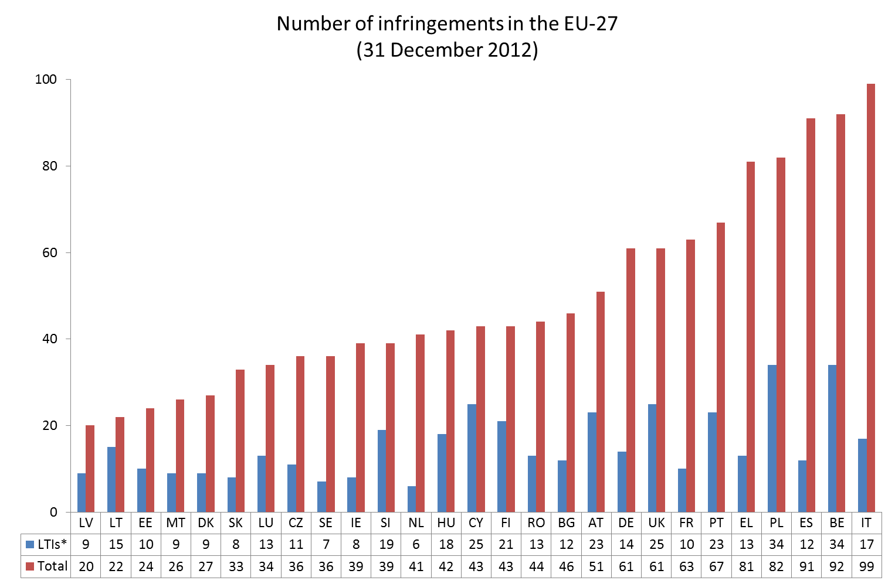
* LTIs: Late transposition infringements

Discussions between the Member State and the Commission continue during the formal procedure, in order to bring national law or its application in line with EU legislation. Statistics confirm that Member States make serious efforts to settle their infringements without Court procedures. During 2012:
- the Commission closed 661 infringements after sending the letter of formal notice;
- 359 cases were solved after reasoned opinion were sent to the Member State; and
- 42 infringements were closed (or withdrawn from the Court) after the Commission decided to refer the case to the Court.
In total, 1062 infringement cases were closed because the concerned Member States had demonstrated their compliance with EU law. The Court delivered 46 judgements under Article 258 TFEU in 2012, out of which 42 judgments (91 %) were in favour of the Commission. The Court passed the most judgments against Belgium (6 of which 1 was in favour of the Member State), Portugal (5/0), the Netherlands (4/1) and France (4/0). Environment (16), taxation & customs union (11) and internal market & services (6) were the three policy areas with the most judgments delivered by the Court during 2012.
While Member States frequently take the necessary measures to comply with the judgment of the Court in a timely manner, at the end of 2012, the Commission still had 128 open infringement procedures open because it could not yet confirm whether the Member States concerned complied with Court judgments under Article 258 TFEU. Most of these cases concerned Portugal (14), Greece (13) and Spain (12) and were related to environment (54), internal market & services (17) and taxation & customs union (16).
Out of these 128 cases, 11 had already been referred to the Court for the second time. Three Court judgements were delivered under Article 260(2) TFEU last year, two against Ireland and one against Spain. In principle, a Court judgment under Article 260(2) TFEU can impose lump sum and / or a (daily) penalty payment on the defaulting Member State. The latter must pay immediately the lump sum while paying the daily penalty until it reaches full compliance with the first and second Court judgment.

3. Policy developments

3.1. EU Regulatory Fitness
European lawmakers need to be attentive to unnecessary burden and red tape. In a Communication published at the end of 2012, the Commission launched its Regulatory Fitness and Performance Programme (known as REFIT) strengthening its Smart Regulation tools and governance. This includes:
- Enhanced assistance to Member States in transposing EU directives (including implementation plans);
- More systematic, risk-based conformity assessments of national implementing rules; and
- Fast problem-solving mechanisms before formal legal action (guaranteed by EU Pilot).

3.2. Better Governance for the Single Market
From 2001 on, Heads of State and Government of the European Union agreed on a number of targets that Member States should achieve in order to improve their transposition records as regards the implementation of EU Single Market law (SM). Internal Market Scoreboards assess regularly how Member States performed against SM targets.
Important steps were also taken in SM governance. "Core EU Single Market laws" are listed in the Annex of the Communication on the governance of the Single Market adopted in June 2012. To accelerate Member States' full compliance with the SM rules, the Communication identified new targets for handling infringements of core EU Single Market law:
- 'Zero tolerance' (0 %) as regards the timely and correct transposition of core EU Single Market law. This target is stricter than the general 1 % transposition deficit agreed in relation to EU Single Market law;
- Reduction of the duration of infringement procedures to 18 months; and
- Achieving full compliance with the judgments of the Court within 12 months.
The Commission has identified infringement procedures which involve the core EU Single Market laws and has focused its efforts on attaining full implementation of these laws.
In addition, the Communication encourages the Member States to submit draft implementation measures and explanatory documents (see point 3.3 below) in relation to core EU Single Market laws.

3.3. Explanatory documents for directives transposed by Member States
The 2011 Annual Report described the solution agreed between the EU institutions, in the form of Joint Political Declarations, as regards the provision of 'explanatory documents' by Member State authorities upon notifying their transposition measures for a given directive.
Member States are invited to explain how their national transposition rules responded to the objectives laid down in a number of directives. Examples include:
- The Directive on energy efficiency;
- The Directive concerning the control of major-accident hazards involving dangerous substances; and
- The Directive on waste electrical and electronic equipment.
As agreed in the Joint Political Declarations, the Commission will report on the implementation of these instruments by 1 November 2013.

4. Conclusions
Member States still have to meet major challenges in complying with EU law. There was a significant decrease in the number of late transposition infringements during 2012, which was distributed proportionally between Member States. The transposition performance of the Netherlands and that of Sweden have particularly improved but in general the ranking of Member States as regards late transposition infringements did not change. Despite the positive tendency, a large number of directives still have to be transposed and implemented. Member States are therefore invited to keep up efforts to transpose EU law correctly.
Member States have demonstrated great willingness to solve problems before formal steps are taken. With the joining of Malta and Luxembourg, all 27 Member States participate in EU Pilot, the on-line platform operated by the Commission to assist fast problem-solving. Exchanges of views in EU Pilot allowed for a quick resolution of nearly 1,200 potential infringements in 2012.
Together with the decrease of the number of formal infringement procedures, there were also fewer cases that the Commission had to refer to the Court. The general ranking of Member States as regards the total number of infringement did not change materially: those Member States had the fewest and the most infringement proceedings which had similar results in the previous year. Environment, transport, taxation and internal market remained the policy areas where the Commission initiates infringements most frequently.
This general trend is partly attributable to the successful co-operation between the Member States and the Commission. Where the Commission launched formal procedures, Member States have made further attempts to achieve compliance with EU law.
As the Guardian of the Treaties, the Commission will continue the active monitoring of the application of EU law. Proper implementation is an indispensable ingredient in regulatory fitness and performance.

By the end of 2012, the acquis of the EU consisted of 9576 regulations (2011: approx. 8900) and 1989 directives (2011: approx. 1900) in addition to the primary law (the Treaties).
It should be noted that infringement procedures can also be initiated under other provisions of EU law, for example Article 106 TFEU in combination with Articles 101 or 102 TFEU.
Commission Communication on 'A Europe of results – Applying Community law', COM(2007)502 final, p. 9.
From the sum of the 2011 open LTIs and the 2012 new LTIs (763+447=1210), the number of closed LTIs is deducted (1210-792=418).
The table below indicates the number of late transposition infringements open on 31 December 2012, irrespective of the year when the infringement was opened. By contrast, the section “Transposition of directives” in the Member State pages of Part I of the Commission Staff Working Document shows how many new late transposition infringements were initiated against the Member States in 2012.
Directive 2010/31/EU on the energy performance of buildings
Directive 2010/78/EU of the European Parliament and of the Council of 24 November 2010 amending several Directives in respect of the powers of the European Supervisory Authority (European Banking Authority), the European Supervisory Authority (European Insurance and Occupational Pensions Authority) and the European Supervisory Authority (European Securities and Markets Authority)
Directive 2010/40/EU of the European Parliament and of the Council of 7 July 2010 on the framework for the deployment of Intelligent Transport Systems in the field of road transport and for interfaces with other modes of transport
Directive 2010/84/EU amending, as regards pharmacovigilance, Directive 2001/83/EC on the Community code relating to medicinal products for human use
Directive 2010/73/EU amending Directives 2003/71/EC on the prospectus to be published when securities are offered to the public or admitted to trading and 2004/109/EC on the harmonisation of transparency requirements in relation to information about issuers whose securities are admitted to trading on a regulated market
Communication from the Commission - Implementation of Article 260(3) of the Treaty
Communication from the Commission to the Council and the European Parliament on updating the handling of relations with the complainant in respect of the application of Union law, COM(2012) 154 final
From the sum of the 2011 open complaints and the 2012 new complaints (2234+3141=5375), the number of processed complaints is deducted (5375-2859=2516).
The rest of the complaints have not been further processed because either EU laws were not breached or the Commission lacked competence or the correspondence did not qualify as complaint. It is also noted that in urgent and exceptional cases, the Commission may decide to address a letter of formal notice (Article 258 TFEU) to the Member State without prior bilateral discussion.
From the sum of the 2011 open EU Pilot files and the 2012 new EU Pilot files (1096+1405=2501), the number of processed files is deducted (2501-1175=1326).
Report from the Commission – 29th Annual Report on monitoring the application of EU law (2011), COM(2012) 714 final, p. 8.
Both cases concerned Hungarian measures. Further details may be found on the Member State page of Hungary in Part I of the Commission Staff Working Document.
Or under other provisions of the TFEU, see footnote 2 above.
This includes all procedures where the Member State has received at least a letter of formal notice from the Commission under Article 258 TFEU.
The following figures were calculated for all infringement cases irrespective of their origin (i.e., complaint, own initiative of the Commission or late transposition of directives by Member States).
Commission v Ireland, Cases C-374/11 (lump sum payment: € 2,000,000; daily penalty: € 12,000 per day) and C-279/11 (lump sum payment: € 1,500,000)
Commission v Spain, C-610/10 (lump sum payment: € 20,000,000; daily penalty: € 50,000 per day pending compliance with the Court judgment)
Communication from the Commission to the European Parliament, the Council, the European Economic and Social Committee and the Committee of the Regions on EU regulatory fitness, COM(2012) 746 final (12 December 2012)
Both the historical developments and the exact target rates can be found in the Internal Market Scoreboards.
Communication from the Commission to the European Parliament, the Council, the European Economic and Social Committee and the Committee of the Regions on better governance for the Single Market, COM(2012) 259
Report from the Commission – 29th Annual Report on monitoring the application of EU law (2011), COM(2012) 714 final, p. 12.
Explanatory documents have to illustrate the relationship between national transposing rules and the specific provisions of a given directive. They may take the form of a correlation table.
Directive 2012/27/EU on energy efficiency, amending Directives 2009/125/EC and 2010/30/EU and repealing Directives 2004/8/EC and 2006/32/EC
Directive 2012/18/EU on the control of major-accident hazards involving dangerous substances, amending and subsequently repealing Council Directive 96/82/EC
Directive 2012/19/EU on waste electrical and electronic equipment (WEEE)

