AUSTRIA
GENERAL STATISTICS
With 51 open cases at the end of 2012, Austria had the 18th highest number of infringement cases in the EU-27. In 2012, the Commission launched 31 new infringement procedures against Austria by sending letters of formal notice.
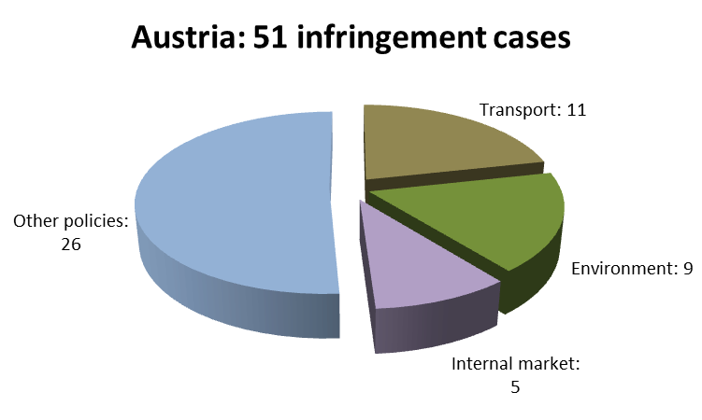
Austria’s performance remained the worst in its reference group; Bulgaria had 46 open infringement cases and Sweden had 36. However, Austria ended the year with fewer infringements than in 2011 (65) and 2010 (57). The following chart shows the policy areas in which Austria was most frequently subject to infringement procedures:

The Commission did not bring any cases against Austria before the Court in 2012 (compared to two referrals in 2011). In Austria’s reference group, Bulgaria and Sweden had two and one referrals, respectively.
TRANSPOSITION OF DIRECTIVES
The Commission opened 24 infringement procedures against Austria for late transposition of various directives in 2012 (46 in 2011). In Austria’s reference group, only six such cases were launched against Sweden, and 13 against Bulgaria. With 23 open late transposition infringement cases by the end of 2012, Austria (and Portugal) had the 5th worst performance in the EU-27.
Austria faced major challenges in transposing EU directives in the policy areas of transport and health & consumers (six new late transposition infringements were opened in both areas).
COMPLAINTS
In 2012, the Commission received 116 complaints against Austria, the ninth-highest figure in the EU-27.
The areas in which most complaints were received were: justice (22 complaints, particularly on free movement of people and equal treatment); environment (21, many on nature protection, water protection and management, environmental impact assessments); internal market (21, mainly free provision of services and regulated professions). There were also complaints about nationality-based discrimination in relation to public-sector posts and public-transport fares. Other complaints concerned, among other, taxation of pensions, obstacles to the online sale of goods, and family benefits for migrant workers.
EARLY RESOLUTION OF INFRINGEMENTS
At the end of 2012, the Commission and the Austrian authorities were working on 46 open EU Pilot files, a significantly lower figure than the 102 files at the end of 2011. The Commission opened 41 new EU Pilot files with Austria in 2012. By decreasing its average EU Pilot response time to 62 days (from 77 in 2011), Austria managed to respect the 10-week target.
The Commission closed a number of infringement cases in 2012 because of action taken by the Austrian authorities: Austria carried out an ex-post environmental impact assessment for the project to expand Vienna Airport to identify the mitigation and compensation measures needed; it modified the rules relating to the acquisition of agricultural real estate in Tyrol to respect the free movement of capital; and it fully transposed the Blue Card Directive (on highly-skilled third-country employees) and the Directive on defence procurement.
IMPORTANT JUDGMENTS
The Court declared that Austrian law had not ensured the independence of the Data Protection Commission (Datenschutzkommission or DSK) because its managing member was a federal officer subject to supervision, the DSK was part of the Federal Chancellery and the Federal Chancellor’s information rights were too broad. In addition, the reduced transport fare system put in place for students was found to contradict the general rules on the free movement of people because students residing in Austria could benefit from the reduction only if their parents were entitled to the Austrian family allowance. Finally, Austria was condemned for not issuing or renewing permits for several industrial installations under the Integrated Pollution Prevention and Control Directive, which requires compliance with a number of environmental criteria.
In a preliminary ruling addressed to the Austrian judiciary, the Court confirmed that a collective employment contract was in line with the Employment Equality Framework Directive, if the contract’s terms determined pay grades solely on the basis of professional experience gained at a specific airline and excluded employees’ identical experience obtained at other airlines.
Key infringement proceedings
- Rights of the public to challenge decisions on environmental impact assessments
- Restricting extended family members’ rights granted by the Free Movement Directive
- Inaccurate transposition of the Railway Safety Directive as regards its scope and definitions)

Belgium
GENERAL STATISTICS
With 92 open infringement cases at the end of 2012, Belgium had the second worst result in the EU-27. In 2012, the Commission launched 29 new infringement procedures against Belgium by sending letters of formal notice.
Belgium’s performance was below average in its reference group: the Czech Republic Romania had 36 open infringement cases, the Netherlands had 41, Hungary 42, Romania 44, Portugal 67 and Greece 81. However, Belgium closed the year with fewer infringements than in 2011 (117) and 2010 (126). The following chart shows the policy areas in which Belgium was most frequently subject to infringement procedures:
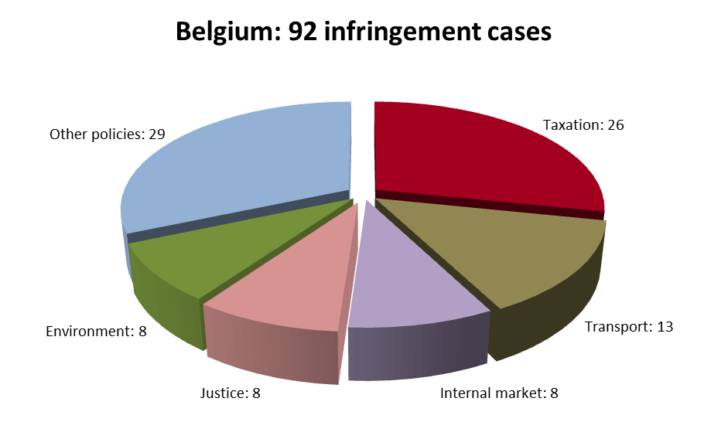
The Commission decided to bring six cases against Belgium before the Court in 2012 (there were six in 2011). It contested in particular Belgium’s non-compliance with the obligation to issue passports containing fingerprint strips. There were four referrals each against the Netherlands, Portugal and Hungary, two against Greece but none against the Czech Republic and Romania.
The Commission filed one case to the Court against Belgium under Article 260(2) TFEU with a proposal for financial sanctions, due to Belgium’s incorrect implementation of the first judgment on awarding ‘must-carry’ status to content broadcast in the Brussels region.
TRANSPOSITION OF DIRECTIVES
The Commission opened 21 infringement procedures against Belgium for late transposition of various directives in 2012 (there were 45 in 2011). In the reference group, Belgium’s performance was better than that of Greece (22 new late transposition infringements), Hungary (26) and Portugal (34) but worse than that of the Netherlands (six), Romania (15), and the Czech Republic (13). With 34 late transposition infringements open at the end of 2012, Belgium ranked last in the EU-27 (with Poland).
Belgium faced significant challenges in transposing directives in the areas of transport (six new late transposition infringement cases), health & consumers (four), and internal market (three).
Due to the late transposition of the E-money Directive and two telecom directives, the Commission referred Belgium to the Court with a proposal for financial sanctions (Article 260(3) TFEU).
COMPLAINTS
In 2012, the Commission received 108 complaints against Belgium, which ranks Belgium sixteenth in the EU-27.
Most complaints were received in the areas of taxation (31 complaints, mainly discriminatory taxation of foreign financial service providers, cross-border workers and individuals’ securities income); justice (20, in relation to free movement of persons and the European Arrest Warrant); and environment (17, impact assessments and nature protection). Other complaints concerned e.g. airport charges, public procurement and the recognition of professional qualifications.
EARLY RESOLUTION OF INFRINGEMENTS
In 2012, 54 new EU Pilot files were sent to Belgium. The Commission and the Belgian authorities were working on 49 open files at the end of the year (42 in 2011). Belgium’s average EU Pilot response time (75 days, in 2011: 71) was above the 10-week target.
Belgium aligned several of its disputed laws with EU rules, so the Commission was able to close several infringement cases in 2012. For example, Belgium made it possible for beneficiaries to receive pension payments in bank accounts anywhere in the EU; it eliminated delays to payments for workers’ paid annual leave; it complied with the Directive on the recognition of professional qualifications; it notified the Commission of measures put in place to improve waste management; and it ensured that its laying hens would be kept in enriched cages.
IMPORTANT JUDGMENTS
In 2012, the Court delivered six judgments against Belgium under Article 258 TFEU. In one of the two taxation-related judgments, it declared that the structure of taxation on income from capital and immovable property unjustifiably favoured resident companies. The Court also found that requiring systematically the certificate of conformity to carry out roadworthiness test on vehicles already registered in another Member State, by ignoring the results of such tests performed in another Member State, went against the free movement of goods, and that the prior declaration requirement for self-employed service providers from countries other than Belgium went against the freedom to provide services. Finally, the Court ruled that the Brussels and Walloon regions had failed to implement the EU water legislation ensuring and improving water quality in river basins.
Key infringement proceedings
- Non-transposition of the e-money directive
- Discrimination in company and inheritance tax, and in the notional interest deduction; excluding non-residents from personal income tax deductions
- Non-transposition of the Directive facilitating intra-EU transfers of defence products

Bulgaria

GENERAL STATISTICS
With 46 infringement procedures open at the end of 2012, Bulgaria ranked 17th in the EU-27. The Commission launched 27 new infringement procedures against Bulgaria in 2012 by sending letters of formal notice.
Bulgaria’s performance was average in its reference group. Sweden had 36 open infringement cases, while Austria had 51. Bulgaria closed the year with fewer infringements than in 2011 (54) and slightly more than in 2010 (44). The following chart shows the main policy areas in which Bulgaria was most frequently subject to infringement procedures:
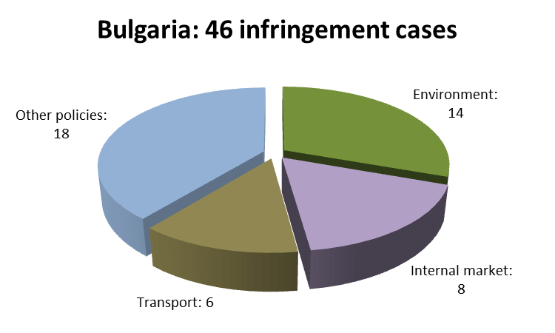
The Commission took Bulgaria to Court once in 2012. One referral was due to its failure to fully implement the First Railway Package, specifically the part on the charges that railway companies have to pay for access to infrastructure, the other was for late transposition of a directive (see below). Within Bulgaria’s reference group, one case was submitted against Sweden and there were none against Austria.

TRANSPOSITION OF DIRECTIVES
The Commission launched 13 infringement procedures against Bulgaria for late transposition of various directives in 2012 (there were 36 in 2011). In the reference group, Bulgaria's performance was better than Austria’s (24 new late transposition infringement cases) but worse than Sweden’s (6). With 12 open late transposition infringement cases at the end of 2012, Bulgaria was ranked 11th in the EU-27 (with Spain).
The policy areas in which Bulgaria faced particularly significant challenges in transposing EU directives were: environment, transport, and health & consumers (three late transposition infringement cases in each of these sectors).
The Commission referred Bulgaria to the Court with a proposal for financial sanctions under Article 260(3) TFEU due to the late transposition of the EU Waste Framework Directive.

COMPLAINTS
The Commission received 133 complaints against Bulgaria in 2012, the 20th highest figure in the EU-27.
The areas in which most complaints were received were: justice (23 complaints, mainly on free movement of people and consumer law), environment (21, especially on nature protection, Natura 2000, waste management and landfills); and energy (21, among other, on support schemes for renewable energy plants, grid access tariffs for electricity made from renewable energy sources, heating/hot water consumption billing and metering and protecting individuals against the dangers of ionising radiation caused by medical exposure).
Other complaints concerned e.g. the non-compliant transposition of the Data Retention Directive, direct payments in agriculture and rural development, food safety, public procurement rules and the free movement of capital.

EARLY RESOLUTION OF INFRINGEMENTS
The Commission and the Bulgarian authorities were working on 62 open files in EU Pilot at the end of 2012 (75 at the end of 2011). The Commission opened 65 new files in 2012. Bulgaria is among the 19 Member States whose average EU Pilot response time (68 days, 67 in 2011) is below or equal to the 10-week target.
Bulgaria introduced several measures to ensure compliance with EU law, so the Commission was able to close several infringement cases in 2012, including on: air pollution caused by the installation of three thermal power plants; animal welfare (implementing the ban on ‘‘unenriched’’ cages for laying hens); ground handling at Sophia airport; discriminatory VAT deduction practices; and failure to notify the Commission of transposition measures for the Waste Framework Directive.

IMPORTANT JUDGMENTS
There were no judgments against Bulgaria in 2012.

Key infringement procedures
- Exceeding EU air quality (PM10) limit values in several zones and agglomerations
- Lack of transparent conditions for access to natural gas transmission networks
- Restrictive application criteria for the digital broadcasting spectrum
- Exclusion of voluntary health insurance from the EU non-life insurance directives
- Incorrect transposition of the GMO Directive
- Duty and tax relief rules in a pre-accession bilateral agreement with the US

CYPRUS
GENERAL STATISTICS
With 43 open infringement cases against it at the end of 2012, Cyprus ranked joint 14th in the EU-27 (together with Finland). In 2012, the Commission launched 29 new infringement procedures against Cyprus by issuing letters of formal notice.
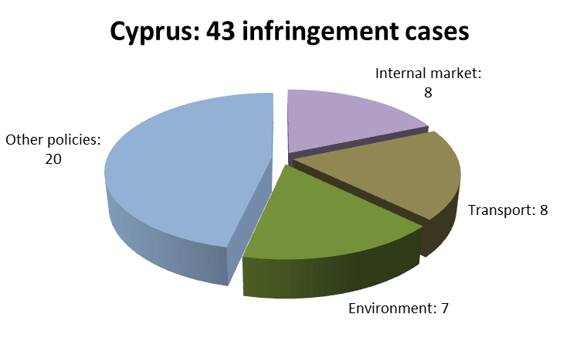
Although Cyprus ended 2012 with significantly fewer infringement cases than in 2011 (59) and almost the same number as in 2010 (44), its performance was the worst in its reference group: Latvia only had 20 open infringement cases; Estonia had 24, Malta 26, Luxembourg 34 and Slovenia 39. The following chart shows the areas in which Cyprus was most frequently subject to infringement procedures:

The Commission brought four cases against Cyprus before the Court in 2012 (one in 2011). One of them was because two of the country’s major landfills still operate without the infrastructure required by the Landfill Directive (the three other were due to directives' late transposition, see below). Full compliance can only be expected by 2015, despite the closing down or rehabilitation of many other landfills. In the reference group, there were no referrals against Latvia, Estonia and Malta, one was against Luxembourg and five against Slovenia.
TRANSPOSITION OF DIRECTIVES
The Commission opened 24 infringement procedures against Cyprus for late transposition of various directives in 2012 (compared to 63 in 2011). Cyprus’ performance remained the worst in its reference group (5, 10, 12, 16 and 18 new late transposition infringements against Estonia, Latvia, Luxembourg, Slovenia and Malta, respectively). With 25 open late transposition infringement cases by the end of 2012, Cyprus ranked joint 24th in the EU-27 (together with the United Kingdom).
Cyprus has found it particularly challenging to transpose EU directives in policy areas such as: health and consumers (seven new late transposition infringement cases), transport (six), and internal market and services (four).
The Commission referred Cyprus to the Court with a request for financial sanctions under Article 260(3) TFEU due to late transposition of the Mediation Directive, the directive on environmental crime and the Driving Licence Directive.
COMPLAINTS
The Commission received 83 complaints against Cyprus in 2012, the 13th lowest figure in the EU-27.
The areas in which most complaints were received were: home affairs (19 complaints, especially on incorrect refusal of asylum requests and restrictive admission of third-country students); internal market (17, mainly freedom to provide services and regulated professions); and justice (16, many on residence rights for EU citizens’ third-country partners and unfair terms of consumer contracts). Complaints also addressed nationality-based discrimination on public transport and flaws in nature protection, urban waste-water treatment and car taxation.
EARLY RESOLUTION OF INFRINGEMENTS
The Commission and the Cypriot authorities were working on 32 open EU Pilot files by the end of 2012 – a caseload that increased compared to the figure at the end of 2011 (23 files), but that was still below average. The Commission sent 38 new EU Pilot files to Cyprus in 2012. The average EU Pilot response time (60 days) improved significantly as compared to the 2011 average (70 days) and met the 10-week target.
The Commission closed several infringement cases in 2012 because Cyprus: amended its laws restricting the acquisition of secondary residences by EU citizens; modified car taxation rules, which discriminated against non-Cypriot EU citizens who brought their car into Cyprus; designated the Oroklini lake as a specially protected area under the Habitats Directive and put in place preservation measures; ensured that the conditions under which wild animals were kept in the Limassol Zoo were in accordance with the Zoos Directive; and, finally, fully transposed the Waste Framework Directive and the Blue Card Directive (on highly-skilled third-country employees).
IMPORTANT JUDGMENTS
In 2012, the Court delivered two judgments under Article 258 TFEU. In the first, it found Cypriot legislation non-transparent in authorising telecommunications equipment (e.g. masts and antennae) because of: (i) the overlaps between the competences of the authorities dealing with the requests and (ii) inclusion of environmental aspects into the applications’ evaluation without any such requirement existing under national law. In the second, Cyprus was found in breach of EU environmental law as it failed to designate the Paralimni Lake as a proposed Site of Community Interest under the Habitats Directive and did not take the requisite measures to protect the Cypriot grass snake population.
Key infringement proceedings
- Cypriot teachers’ pension: taking into account service periods spent in Greece
- Restrictions on the free movement of persons (disproportionately high fees and sanctions)
- Incomplete software assurance for air navigation service providers

CZECH REPUBLIC
GENERAL STATISTICS
With 36 open infringement cases at the end of 2012, the Czech Republic had the 8th lowest number of infringements out of all the EU-27 Member States (together with Sweden). In 2012, the Commission launched 20 new infringement procedures against the Czech Republic by sending letters of formal notice.
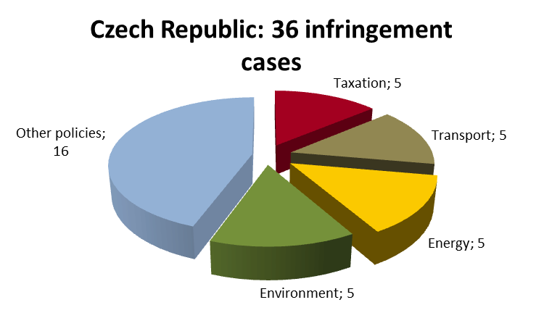
The Czech Republic’s performance was the best in its reference group: the Netherlands had 41 open infringement cases, Hungary had 42, Romania 44, Portugal 67 and Greece 81 and Belgium 92. The Czech Republic ended the year with significantly fewer infringements than in 2011 (65) and in 2010 (48). The following chart shows the policy areas in which the Czech Republic was most frequently subject to infringement procedures:

The Commission did not bring any cases against the Czech Republic before the Court in 2012 (there had been four cases in 2011). As for the other countries in the Czech Republic’s reference group, there were also no referrals against Romania. The Commission brought two cases against Greece before the Court, four each against the Netherlands, Hungary and Portugal, and six against Belgium.
TRANSPOSITION OF DIRECTIVES
The Commission opened 13 infringement procedures against the Czech Republic for late transposition of various directives in 2012 (there were 54 such procedures in 2011). In the reference group, only the Netherlands had fewer new late transposition infringement cases in 2012 (six). The Czech Republic performed better than Romania (15), Belgium (21), Greece (22), Hungary (26) and Portugal (34). With 11 open late transposition infringement cases by the end of 2012, the Czech Republic ranked 10th in the EU-27.
The policy areas in which the Czech Republic faced significant challenges in transposing EU directives in 2012 were: transport and health & consumers (four new late transposition infringement cases each). In addition, two directives in the area of internal market have not been transposed yet.
COMPLAINTS
In 2012, the Commission received 57 complaints against the Czech Republic, the ninth-lowest figure in the EU-27.
The areas in which most complaints were received were: environment (13 complaints, in particular nature protection and lack of or incomplete environmental impact assessments); justice (10, e.g. sale of consumer goods, personal data protection and equal treatment in employment); and enterprise & industry (7, including obstacles to the free movement of various products). There were also complaints concerning e.g. the national rules transposing the Data Retention Directive, the billing and metering of hot water and heating consumption, renewable energy issues (access to the distribution grid; changes in support schemes for renewables) and a major tender procedure carried out for a nuclear power plant.
EARLY RESOLUTION OF INFRINGEMENTS
By the end of 2012, the Commission and the Czech authorities were working on 28 open files in EU Pilot. This caseload is below average and has decreased compared to the number of files at the end of 2011 (73). The Czech Republic received 30 new EU Pilot files from the Commission in 2012. The average EU Pilot response time (71 days) improved slightly when compared to the 2011 average (72 days) and was very close to the 10-week target.
The Czech Republic took the Commission’s position into account in several areas and introduced measures to ensure compliance with EU law, so the Commission was able to close a number of infringement cases in 2012. For example, the Czech authorities changed their law and practice so that entitled unemployed people would receive sickness benefits irrespective of whether they were resident in the Czech Republic or not. The Czech Republic also corrected partial non-conformity of Czech implementing laws with the Directive on waste electrical and electronic equipment (including adjustments to the scope of electronic equipment covered by these rules and requirements for distance traders).
IMPORTANT JUDGMENTS
The Commission requested the Court to rule on the sales designation ‘pomazánkové máslo’ (butter spread), as this product’s milk-fat content was not high enough to be called butter (‘máslo’) under EU law. The Court found that this butter spread did not comply with the criteria laid down in the applicable regulation, and it was not listed among the products benefiting from a statutory derogation. The Court also ruled out automatic derogation being granted (i.e. without the Commission’s prior authorisation) to certain milk products.
Key infringement proceedings
- Incomplete transposition of the Renewable Energy Directive
- Undue administrative burden on EU citizens applying for residence permits
- Obstacles to non-Czech EU citizens joining a political party or founding one
- Failure to respect air quality (PM10) limit values in several zones and agglomerations

Denmark
GENERAL STATISTICS
There were 27 infringement cases open against Denmark at the end of 2012, ranking Denmark’s performance fifth best in the EU-27, same as in 2011. The Commission launched 22 new cases against Denmark in 2012 by sending letters of formal notice.
Denmark’s performance was above average in its reference group: Slovakia had 33 open infringement cases, Ireland had 39 and Finland had 43. Only Lithuania had fewer open infringement cases (22). Denmark closed the year with fewer infringement cases than in 2011 (37) and almost the same number as in 2010 (29). The following chart shows the four policy areas in which Denmark was most frequently subject to infringement procedures:
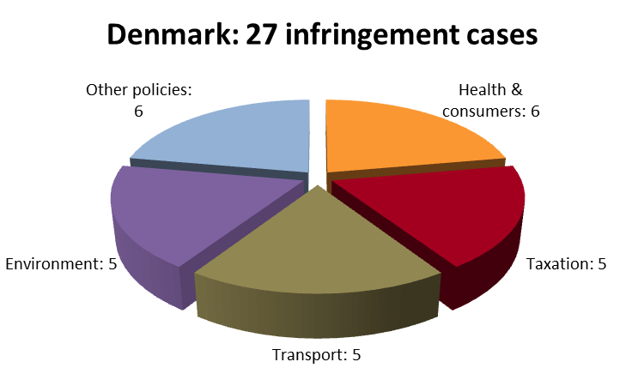
The Commission did not bring any cases against Denmark before the Court in 2012 (there were two cases in 2011). In Denmark’s reference group, there were no cases against Lithuania or Slovakia, one case against Ireland and Slovakia, and six against Finland.
TRANSPOSITION OF DIRECTIVES
The Commission opened 17 infringement procedures against Denmark for late transposition of various directives in 2012 (there were 28 in 2011). Denmark's performance was better than that of Finland (21 new late transposition infringement cases) but worse than that of Slovakia (7), Ireland (8) and Lithuania (10). With nine open late transposition infringement cases at the end of 2012, Denmark ranked fifth in the EU-27.
The policy areas in which Denmark faced the most significant challenges in transposing EU directives were: health & consumers (seven new late transposition infringement cases), internal market and transport (three in each policy area).
COMPLAINTS
The Commission received 60 complaints against Denmark in 2012, which, was the tenth lowest figure in the EU-27.
Areas in which most complaints were received were: taxation (14 complaints, mainly in relation to imported cars), environment (9, concerning e.g. wind farm developments) and social security issues (8, especially on refusal of benefits).
EARLY RESOLUTION OF INFRINGEMENTS
The Commission and the Danish authorities were working on 26 files in EU Pilot at the end of 2012 (there were 84 at the end of 2011). This is a small caseload. Relatively few new files were opened in 2012 (34). Denmark’s average EU Pilot response time (70 days, it was 81 days in 2011) remained within the 10-week target.
Denmark introduced a number of measures to ensure compliance with EU law, so the Commission was able to close several infringement cases in 2012, including on: transposition of the First Railway Package; the Working Time Directive; failure to notify the Commission of measures transposing the Waste Electrical and Electronic Equipment Directive; the Directive on the transfer of defence products; and provisions on driving licenses.
IMPORTANT JUDGMENTS
There were no judgments against Denmark in 2012.
Key infringement proceedings
- Transposition of the Tobacco Directive — sale of loose snus
- Incorrect application of the Single Sky Regulations

Estonia
GENERAL STATISTICS
There were 24 infringement cases open against Estonia at the end of 2012, the third best result in the EU-27 (with Latvia and Malta). The Commission launched 11 new infringement cases against Estonia in 2012 by sending letters of formal notice.
Estonia’s performance (along with Latvia’s) was above average in its reference group: Latvia had 20 open infringement cases, Luxembourg had 34, Slovenia 39 and Cyprus 43. Estonia ended the year with fewer infringement cases than in 2011 (36) and in 2010 (40). The following chart shows the three policy areas in which Estonia was most frequently subject to infringement procedures:
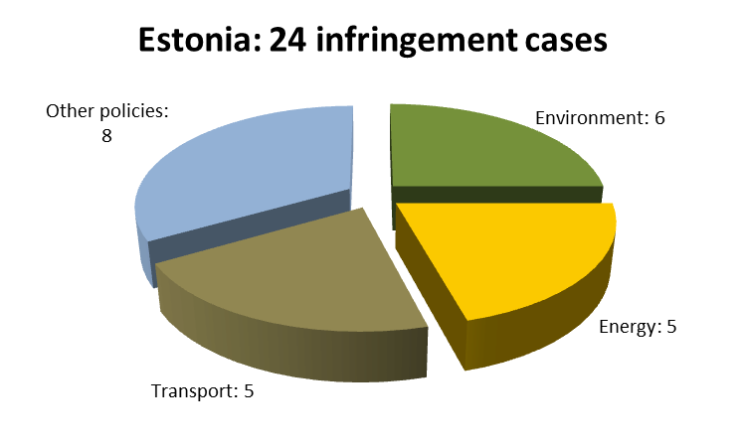
The Commission did not bring any cases against Estonia before the Court in 2012 (there was one case in 2011). In Estonia’s reference group, no referrals were made against Latvia and Malta. One case was filed against Luxembourg, four against Cyprus and six against Slovenia.
TRANSPOSITION OF DIRECTIVES
The Commission launched five infringement procedures against Estonia for late transposition of various directives in 2012 (there were 28 in 2011). This was the best performance in Estonia's reference group and in the EU-27: 10 such cases were launched against Latvia, 12 against Luxembourg, 16 against Slovenia and 24 against Malta. With 10 open late transposition cases at the end of 2012, Estonia ranked 9th in the EU-27 (together with France.
Estonia faced some challenges in transposing EU directives in the transport area (two new late transposition infringement cases).
COMPLAINTS
Estonia only received 11 complaints in 2012, the lowest number in all the Member States. Most complaints concerned: justice (3 complaints, especially on parent visitation rights), foreign affairs (3, mainly on free movement of people); and health & consumers (2, on marketing of medical devices).
EARLY RESOLUTION OF INFRINGEMENTS
The Commission and the Estonian authorities were working on 18 open files at the end of 2012 (at the end of 2011: 30 files). This is considered a light caseload. The Commission opened 25 new EU Pilot files on Estonian issues in 2012. With this moderate caseload, Estonia’s average EU Pilot response time (67 days) was slightly below the 10-week target.
Estonia introduced several measures to ensure compliance with EU law, so the Commission was able to close quite a number of infringement cases in 2012, including on: failure to notify the Commission of measures transposing the Waste Framework Directive; and failure to transpose the Directive on public procurement in the defence and security sector. Estonia also completed transposition of the green vehicle procurement rules.
IMPORTANT JUDGMENTS
The Court delivered a judgment in which it stated that Estonia infringed the EU legislation on the free movement of workers by excluding non-resident pensioners from tax allowances when their pensions were not taxed in their country of residence because of their modest amount.
Key infringement proceeding
- Ensuring independence of national regulatory authorities in the telecommunications sector

Finland
GENERAL STATISTICS
There were 43 infringement cases open against Finland at the end of 2012, the fourteenth highest number in the EU-27. The Commission opened 28 new infringement cases against Finland in 2012 by sending a letter of formal notice.
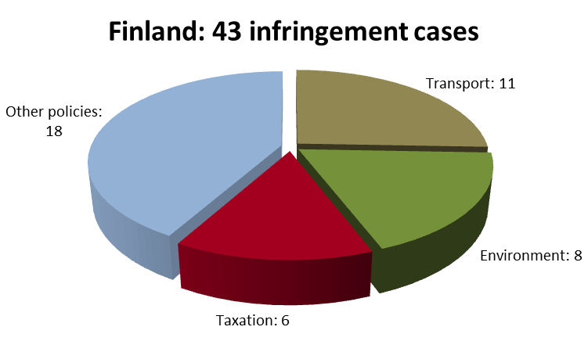
Finland’s performance was the worst in its reference group: Lithuania had 22 open infringement cases, Denmark had 27, Slovakia 33 and Ireland 39. Finland ended the year with fewer infringement cases than in 2011 (55), but more than in 2010 (42). The following chart shows the policy areas in which Finland was most frequently subject to infringement procedures:
The Commission referred six cases against Finland to the Court in 2012 under Article 258 TFEU (there were two in 2011). Two of them concerned Finland’s failure to update its minimum physical and mental requirements for drivers (the four other referrals were due to late transposition, see next section).
In Finland’s reference group, no cases were filed to the Court against Lithuania and Denmark, and one case against each of Ireland and Slovakia.
TRANSPOSITION OF DIRECTIVES
The Commission opened 21 infringement procedures against Finland for late transposition of various directives in 2012 (there were 62 in 2011). Finland's performance was the worst in its reference group: Sweden, Ireland, Lithuania and Denmark had fewer new infringement cases for late transposition (7, 8, 10 and 17, respectively). With 21 open late transposition infringement cases at the end of 2012, Finland ranked 21st in the EU-27.
The policy areas in which Finland faced significant challenges in transposing EU directives were: transport (seven new late transposition infringement cases) and health & consumers (five).
The Commission referred Finland to the Court with a request for financial sanctions in 2012 (Article 260(3) TFEU) due to Finland’s failure to fully transpose the Directives on: the internal electricity market, the internal market in natural gas, the green vehicle procurement rules and road infrastructure safety management (road safety impact assessments, safety audits, inspections and rankings).
COMPLAINTS
The Commission received 34 complaints against Finland in 2012, the fourth lowest figure in the EU-27.
Most complaints concerned: taxation (five complaints, especially on excise or car tax, discriminatory taxation of cross-border workers); environment, (five, mainly on waste management and nature protection); and justice (four, e.g. on ethnic discrimination). Other complaints concerned for example, public procurement and the free movement of persons.
EARLY RESOLUTION OF INFRINGEMENTS
The Commission and the Finnish authorities were working on 28 open files in EU Pilot at the end of 2012 (57 at the end of 2011). This is a low caseload, including the 34 new files the Commission opened on Finnish issues in 2012. Finland is one of the Member States whose average EU Pilot response time (66 days) met the 10-week target (80 days in 2011).
Finland introduced a number of measures to ensure compliance with EU law, so the Commission could close several infringement cases in 2012. These include cases on Finland’s failure to notify the Commission of measures transposing EU rules on the procurement of green vehicles, on transferring defence products within the EU (counteracting defence market fragmentation), on waste management, and on end-of-life vehicles. Moreover, Finland ensured that its coordination of social security systems was compliant with EU law to avoid situations in which a person receiving benefits in another Member State could not be insured in Finland.
IMPORTANT JUDGMENTS
The Court condemned Finland for a scheme under which dividends paid to non-resident pension funds were taxed in a discriminatory way (restriction of free movement of capital).
Key infringement proceedings
- Incomplete transposition of the Directives of the Third Energy Package
- Non-application of the working time rules to self-employed drivers
- Lack of adequate protection of the Saimaa ringed seal
- Spring hunting of eiders in Åland and summer hunting of eiders in mainland Finland

France

GENERAL STATISTICS
There were 63 infringement cases open against France at the end of 2012, the seventh highest number in the EU-27. The Commission launched 25 new cases in 2012.
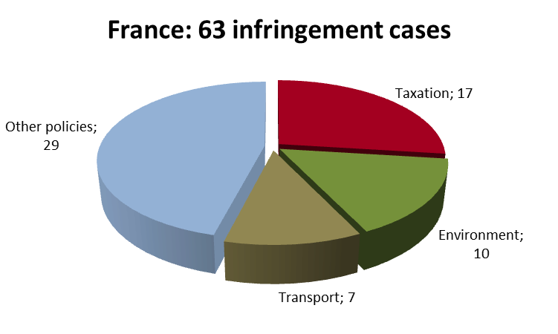
France’s performance was average in its reference group. Germany and the UK had 61 open infringement cases each, Poland had 82, Spain 91 and Italy 99. France ended 2012 with fewer infringement cases than in 2011 and 2010 (95 in both years). The chart shows the policy areas in which France was most frequently subject to infringement procedures:

The Commission brought four cases against France to Court (seven in 2011), including for: insufficient designation of nitrate-vulnerable zones and lack of adequate measures to combat nitrate water pollution, operating installations without air permits issued under the IPPC Directive and failing to comply with the Urban Waste Water Directive. In France’s reference group, there was one referral against Spain, 3 against Italy, 6 against the UK, 7 against Germany and 12 against Poland.

TRANSPOSITION OF DIRECTIVES
14 infringement procedures were opened against France in 2012 for late communication of national transposition measures (42 in 2011). France's performance was second best in its reference group, after Germany (11 new late transposition cases) but before Spain (16), Poland (18), the UK (24) and Italy (36). With ten open late transposition cases by the end of 2012, France ranked 9th in the EU-27 (together with Estonia).
The policy areas in which France faced challenges in transposing EU directives were: health & consumers, transport (3 late infringement cases in each area), internal market and justice (2 in each area).

COMPLAINTS
The Commission received 242 complaints against France in 2012, the third highest number in the EU-27 (along with Germany).
Most complaints concerned: free movement of workers (43 complaints, especially levying double social security contributions, discrimination between EU and French citizens in access to residence-based health care systems and nationality condition for certain private sector jobs), justice (37, e.g. on free movement of persons, civil justice and fundamental rights) and internal market (31, mainly free provision of services, regulated professions and public procurement).
Other complaints covered e.g. the tax of foreign charities and companies' 'exit tax', VAT, wine and spirits, car registration, zootechnics (stud-books for horses, animal welfare), water protection and management, nature protection and marine equipment.

EARLY RESOLUTION OF INFRINGEMENTS
The Commission and the French authorities worked on 78 EU Pilot cases at the end of 2012 (53 in 2011). 112 new French cases were launched in 2012. France's average response time (83 days) exceeded the 10-week target (84 days in 2011).
Several cases could be closed against France in 2012, including those on regulated electricity prices and keeping laying hens in un-enriched cages. Fiscal discrimination against certain ‘‘Schumacker’’ non-residents and gender discrimination in pension benefits were eliminated. France adopted a national aviation security programme and complied with several environmental directives and the Directive on personal protection equipment.

IMPORTANT JUDGMENTS
The Court condemned the French VAT-reductions for opening night receptions in theatres and for the supply of race horses as well as the local electricity taxes. When France banned the marketing of certain medicinal veterinary products in a procedure falling also under EU rules, the Court specified the role of the "reference Member State" when several Member States work together to authorise a medicinal product.
In preliminary rulings, the Court clarified that: a Member State that receives an asylum request must meet the minimum conditions for receiving asylum seekers even if it considers that another Member State should examine the application; France could not have different tax rules for nationally-sourced dividends received by resident and non-resident UCITS ; and a minimum of 10 days’ work or one month’s actual work during the reference period cannot be the condition of paid annual leave.

Key infringement proceedings
- VAT: reduction on e-books and race horses, exemption for pleasure boat leases and for boats navigating on the high seas
- Non-compliance with the Gas Directive
- Application of the Working Time Directive to doctors and fire-fighters
- Taxing milk producers even if the national quota is not exceeded
- Additional requirements on EC-marked construction products
- Inadequate protection of the brown bear in the Pyrenees (Habitats Directive)
- Late transposition of the E-money Directive

Germany

GENERAL STATISTICS
There were 61 infringement cases open against Germany at the end of 2012, the eighth highest number in the EU-27 (same as the UK). The Commission launched 23 new cases against Germany in 2012 by sending a letter of formal notice.
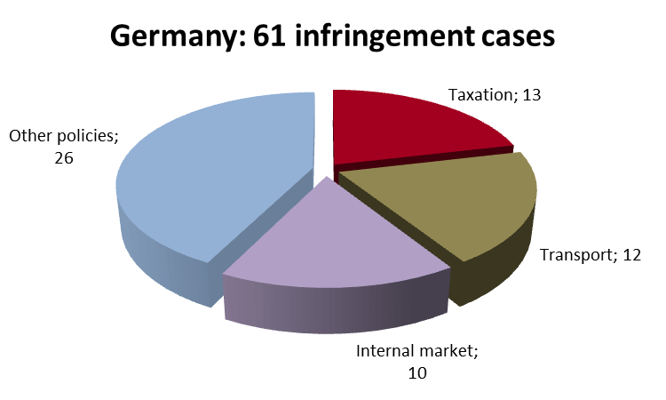
Germany (and the UK) had the fewest infringements cases its reference group: France had 63 open infringement cases, Poland had 85, Spain 91 and Italy 99. Germany ended the year with fewer infringement cases than in 2010 (79) and 2011 (76). The following chart shows the policy areas in which Germany was most frequently subject to infringement procedures:

The Commission brought seven cases against Germany before the Court in 2012 (there were no referrals in 2011). Three out of Germany's seven referrals related to tax discrimination. They concerned: lower tax-free allowances for non-residents in the area of inheritance tax, hidden reserves (e.g. favourable fiscal treatment made conditional on gains being reinvested in domestic permanent establishments) and tax treatment of group companies being reserved for companies with statutory seats and effective management in Germany. Two other referrals concerned single market rules in the construction sector (discrimination against ‘EC’-marked products if they do not have the national ‘Ü’ mark), and one concerned the incorrect transposition of the Water Framework Directive (the seventh was due to late transposition, see below). In its reference group, there was one case against Spain, three against Italy, four against France, six against the UK and twelve against Poland.

TRANSPOSITION OF DIRECTIVES
The Commission opened 11 infringement procedures against Germany because it was late in informing the Commission about national implementing measures for various directives (there were 31 in 2011). Germany’s performance was the best in its reference group: 14 new late transposition infringements were initiated against France; 16, 18, 24 and 36 against Spain, Poland, the UK and Italy, respectively. With 14 open late transposition cases by the end of 2012, Germany ranked 16th in the EU-27.
The policy area in which Germany faced the most significant challenges in transposing EU directives was transport (5 new late transposition infringement cases).
The Commission referred Germany to the Court with a proposal for financial sanctions (Article 260(3) TFEU) due to late transposition of the Data Retention Directive.

COMPLAINTS
Germany (and France) had the third highest number of complaints in the EU-27 in 2012 (242).
The areas in which most complaints were received were: internal market (47 complaints, mainly public procurement, freedom to provide services and regulated professions), environment (36, e.g. violation of the Habitats Directive) and taxation (36, especially discrimination against non-German companies, pension taxation and double taxation). Several complaints concerned shortcomings in the social security area (e.g. problems with granting family benefits for migrant workers and healthcare for pensioners), the free movement of non-EU family members and application of the Family Reunification Directive.

EARLY RESOLUTION OF INFRINGEMENTS
The Commission and the German authorities were working on 65 open files in EU Pilot at the end of 2012. The caseload has considerably decreased since 2011 (193 open files). The Commission opened 64 new EU Pilot files on German issues in 2012. Germany’s average EU Pilot response time improved to 61 days, which is below the 10-week target (65 days in 2011).
Germany introduced several measures to ensure compliance with EU law, so the Commission was able to close a number of infringement cases in 2012. For example, Germany completed transposing the Waste Framework Directive and opened Frankfurt airport’s ground handling services up to competition.

IMPORTANT JUDGMENTS
The Court delivered a number of preliminary judgments which guided the German judiciary. These included the following clarifications: even private-law bodies must respect the free movement of goods principle, if the law consider the products they certify as compliant with national legislation and this restricts the marketing of products they did not certify; the exclusive right to distribute copies of a licensed computer programme expires with its first sale; compensation that is paid to a severely disabled worker in the context of early retirement and is lower than the amount paid to a non-disabled worker is considered discrimination.
Key infringement proceedings
- Trade barriers on EC-marked construction products
- Incorrect transposition of the Water Framework Directive

Greece
GENERAL STATISTICS
There were 81 infringement cases open against Greece at the end of 2012, the fifth worst result in the EU-27. The Commission launched 34 new cases in 2012 by sending a letter of formal notice.
Greece’s performance was second worst in its reference group: Romania had 44 open infringement cases, Hungary had 42, the Czech Republic 36, the Netherlands 41, Portugal 67 and Belgium 92. However, Greece ended the year with fewer infringements than in 2011 (123) and in 2010 (125). The following chart shows the policy areas in which Greece was most frequently subject to infringement procedures.
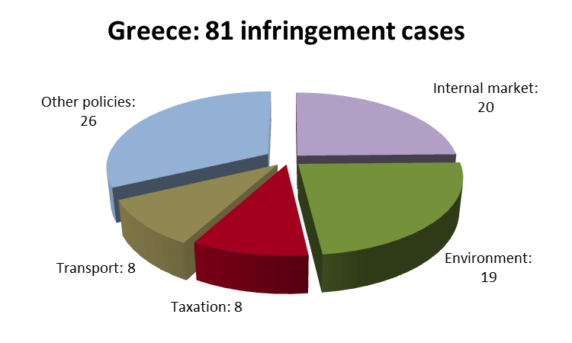
The Commission brought two cases against Greece before the Court in 2012 (there were four referrals in 2011). They concerned: the landfill in Zakynthos not being compliant with the Landfill Directive, the Waste Framework Directive and the Habitats Directive, and public tender procedures. In Greece’s reference group, there were no referrals against the Czech Republic and Romania. There were four referrals each against Portugal, Hungary and the Netherlands, and six against Belgium.
TRANSPOSITION OF DIRECTIVES
The Commission opened 22 infringement procedures against Greece for late transposition of various directives in 2012 (there were 55 in 2011). Greece's performance was average in its reference group: better than that of Hungary and Portugal (26 and 34 new late transposition cases, respectively) but worse than that of the Netherlands, the Czech Republic, Romania and Belgium (6, 13, 15 and 21, respectively). With 13 open late transposition cases by the end of 2012, Greece ranked 13th in the EU-27.
The policy areas in which Greece faced particularly significant challenges in transposing EU directives were: environment (six new late transposition infringement cases), transport (five) and internal market (four).
COMPLAINTS
The Commission received 188 complaints against Greece in 2012, the fourth highest figure in the EU-27.
Most complaints concerned the following areas: internal market (46 complaints, mainly on public procurement, regulated professions and freedom to provide services); taxation (30, e.g. car taxation) and environment (26, many on waste management and nature protection). Other complaints concerned among other, discriminatory airport charges and failure to take into account professional experience gained in another Member State before being authorised to practice a profession in Greece.
EARLY RESOLUTION OF INFRINGEMENTS
The Commission and the Greek authorities were working on 82 new EU Pilot files at the end of 2012 (there were 43 at the end of 2011). There were 92 new Greek files opened in EU Pilot during 2012. Greece was among the Member States whose average EU Pilot response time (65 days) met the 10-week target (63 days in 2011).
Greece corrected a number of its national rules to comply with EU law, so the Commission was able to close several cases in 2012. These include cases on: Greece not informing the Commission of its measures transposing the new EU waste regime; the impact of motorway E 65 on Natura 2000 sites and protected species; obstacles to the free movement of bake-off products; the entry into service of certain gas installations; and the allocation and use of rights of way for electronic communications networks.
IMPORTANT JUDGMENTS
The Court condemned Greece for incorrectly transposing the First Railway Package, because Greece did not put in place incentives to reduce access charges. The Court also ruled against Greece for failing to adopt and notify the Commission of river basin management plans and because Greece set up investment restrictions in so-called ‘strategic companies’, which created a risk of discrimination.
The Court also issued preliminary rulings related to Greece, including on a deadline for publishing river management plans and a margin for assessing projects’ impact on plans and programmes, at the discretion of Member States.
Key infringement procedures
- Excessive working time for doctors in public hospitals
- Operation of illegal landfills
- Restrictions on free movement of capital and the right of establishment

HUNGARY
GENERAL STATISTICS
With 42 open infringement cases at the end of 2012, Hungary had the 13th best performance out of all the EU-27 Member States. In 2012, the Commission launched 36 new infringement procedures against Hungary by sending letters of formal notice.
In its reference group, Hungary’s performance was slightly above average; Romania had 44 open infringement cases, Portugal had 67, Greece 81 and Belgium 92. However, there were only 36 open infringement procedures against the Czech Republic and 41 against the Netherlands. Hungary ended the year with fewer infringements than in 2011 (54) and 2010 (53). The following chart shows the policy areas in which Hungary was most frequently subject to infringement procedures:
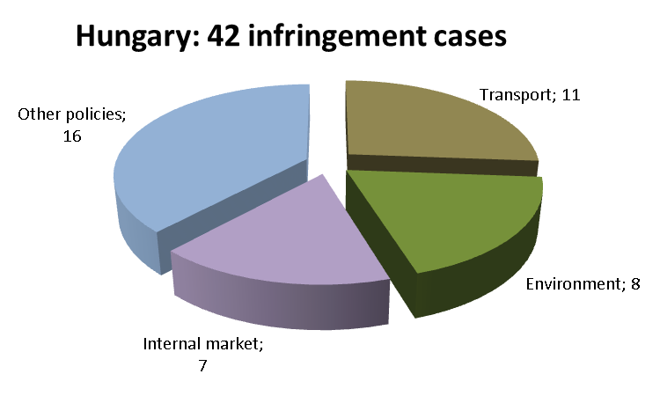
The Commission referred Hungary to the Court four times in 2012, as it maintained its concerns as regards: (i) Hungary’s new laws on the retirement age of judges, prosecutors and public notaries being compatible with the Equal Treatment Directive (see also the last section); (ii) the independence of Hungary’s data protection supervisory authority; and (iii) Hungary’s sector-specific tax levied on telecommunication companies being compliant with the Authorisation Directive (the fourth referral was due to late transposition, see below). In Hungary’s reference group, two cases against Greece, four each against Portugal and the Netherlands, and six against Belgium reached the Court (there were no referrals for the Czech Republic and Romania).
TRANSPOSITION OF DIRECTIVES
The Commission launched 26 infringement cases against Hungary for late transposition of directives in 2012 (in 2011: 70 such cases). In the reference group, Hungary’s performance was worse than that of the Netherlands, the Czech Republic, Romania, Belgium and Greece (6, 13, 15, 21 and 22 new late transposition cases, respectively) but better than that of Portugal (34). With 18 open late transposition cases by the end of 2012, Hungary ranked 19th in the EU-27.
The policy areas in which Hungary faced significant challenges in transposing EU directives in 2012 were: transport (eight new late transposition cases), health and consumers (seven) and environment (four).
The late transposition of the Waste Framework Directive resulted in the Commission referring Hungary to the Court with a proposal for financial sanctions under Article 260(3) TFEU.
COMPLAINTS
In 2012, the Commission received 79 complaints against Hungary, the twelfth-lowest figure in the EU-27.
The areas in which most complaints were received were: internal market and services (15 complaints, mainly freedom to provide services and intellectual property); taxation (14, especially on sector-specific taxes); and justice (13, e.g. on free movement of people, equal treatment, consumer protection and civil justice). There were also complaints about the so-called ‘study grant contracts’ ( it requires recipients to work in Hungary for a period equal to the duration of financed studies and could limit future workers’ free movement), environment (on impact assessment, nature protection and waste management), labelling (origin and quality of foodstuffs) and air services rules.
EARLY RESOLUTION OF INFRINGEMENTS
At the end of 2012, the Commission and Hungary were working on 46 open files in EU Pilot at the end of 2011: 87 files). The Commission opened 53 new EU Pilot files on Hungarian issues in 2012. Hungary’s average response time (65 days) met the 10-week target (66 days in 2011).
Hungary eliminated a number of inconsistencies between national and EU law, so the Commission was able to close several infringement cases in 2012. For example: Hungary amended its laws to address shortcomings in the transposition of the Mining Waste Directive, and it extended the scope of its national flood management rules to comply with the Floods Directive. In addition, Hungarian rules now effectively forbid keeping laying hens in unenriched cages, as required by the corresponding directive. Hungary also withdrew rules that restricted lessees in deducting VAT from fees paid on open-ended car lease contracts. Finally, Hungary completed transposition of the Directive on the re-use of public sector information, in particular by more clearly explaining individuals’ rights.
IMPORTANT JUDGMENTS
The Court confirmed unjustified age discrimination in the claim contesting the new mandatory retirement age for judges, prosecutors and public notaries when they reach the age of 62.
A preliminary ruling to Hungarian courts interpreted the freedom of establishment (in principle, a national law that only governs the conversion of companies based in Hungary and not cross border conversion is considered an unjustifiable restriction).
Key infringement proceedings
- Restrictions on issuers of luncheon, leisure and holiday vouchers
- Exemption from excise duties for fruit distillates (‘pálinka’)
- Sector-specific taxes on telecommunications and retail companies
- Restrictive application of the Environmental Impact Assessment Directive

Ireland

GENERAL STATISTICS
There were 39 infringement cases open against Ireland at the end of 2012, so Ireland’s performance was seventeenth best in the EU-27 (with Slovenia). The Commission launched 14 new infringement cases against Ireland in 2012 by sending a letter of formal notice.
Ireland’s performance was below average in its reference group: Lithuania had 22 open infringement cases, Denmark had 27, Slovakia 30. However, it was better than Finland’s (43). Ireland ended the year with fewer infringement cases than in 2010 (58) and 2011 (42). The following chart shows the policy areas in which Ireland was most frequently subject to infringement procedures:
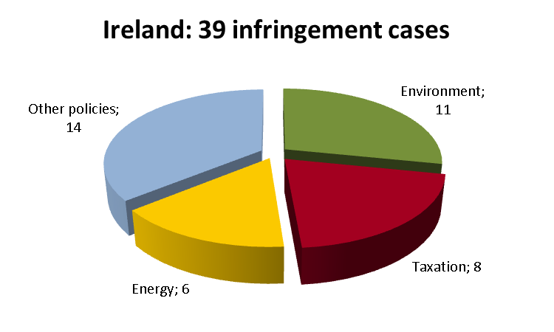
The Commission brought one case against Ireland before the Court in 2012 (there were two referrals in 2011), because the conditions for accessing the natural gas transmission networks were not transparent enough and because Ireland failed to take effective remedial action. In Ireland’s reference group, there were no referrals against Lithuania and Denmark. There was one referral against Slovakia and six against Finland.
The Commission referred Ireland to the Court with a request for financial sanctions under Article 260(2) TFEU because it failed to remedy its non-compliance with EU rules on assessing various projects’ environmental effects.

TRANSPOSITION OF DIRECTIVES
The Commission opened eight infringement procedures against Ireland for late transposition of various directives in 2012 (there were 28 in 2011), which shows significant improvement in this area. Ireland’s performance was the very good in its reference group: better than that of Lithuania, Denmark and Finland (10, 17 and 21 new late transposition cases, respectively), only Slovakia performed better (7). With 8 open late transposition cases by the end of 2012, Ireland ranked 3rd in the EU-27.
The policy area in which Ireland faced challenges in transposing EU directives was health and consumers (three late transposition cases).

COMPLAINTS
The Commission received 110 complaints against Ireland in 2012, the eleventh-lowest figure in the EU-27.
The areas in which most complaints were received were: environment (43 complaints, mainly on environmental impact assessment, waste water treatment, nature protection – Natura 2000); justice (28, especially on free movement of people); and internal market (11, many on public procurement, regulated professions). Other complaints concerned amongst others, the principle of free movement of goods (use of label of origin) and direct taxation (termination of payments).

EARLY RESOLUTION OF INFRINGEMENTS
The Commission and the Irish authorities were working on 43 open files in EU Pilot at the end of 2012, a much lower number than at the end of 2011 (118 open files). The Commission opened 40 new files on Irish issues in 2012. Ireland’s average EU Pilot response time (78 days) did not meet the 10-week target (75 days in 2011).
Ireland introduced several measures to ensure compliance with EU law in 2012. For example, it put in place measures to ensure that the National Development Plan conforms to the relevant environmental legislation; it implemented the First Railway Package; and it brought its direct taxation legislation in line with EU law by eliminating the discriminatory aspects of agricultural tax relief. Accordingly, these case were closed.

IMPORTANT JUDGMENTS
The Court imposed financial penalties on Ireland for failure to comply with two judgments on environmental laws. The first judgment concerned projects that were likely to have an impact on the environment, but which were not subject to any prior environmental assessment. In its other judgment, the Court found that Ireland had failed to fully adopt the measures necessary to implement the previous judgment on the incorrect transposition of waste legislation. The Court took into account the economic situation and in particular the recent trends in inflation and the GDP at the time of the Court's examination of the facts when it calculated Ireland’s penalty.

Key infringement proceedings
- Lack of transparency of conditions for access to the natural gas transmission networks
- Alleged failure to protect peat bogs
- Restrictions on foreign travel agencies irrespective of their country of establishment
- Separation of accounts of railway undertakings and railway infrastructure managers
- Restrictive exit tax for companies when they cease to be tax residents
- Discriminatory tax exemption of termination payments
- Reduced VAT rate on race horses and greyhounds

Italy

GENERAL STATISTICS
99 infringement cases were open against Italy at the end of 2012, the worst result in the EU-27. The Commission launched 58 cases in 2012.
In Italy's reference group, Spain had 91 open cases, Poland had 82, France 63, and Germany and the UK 61 each. Italy closed the year with fewer infringements than in 2011 (135) and 2010 (128) and was most often subject to infringement procedures in the following policy areas:
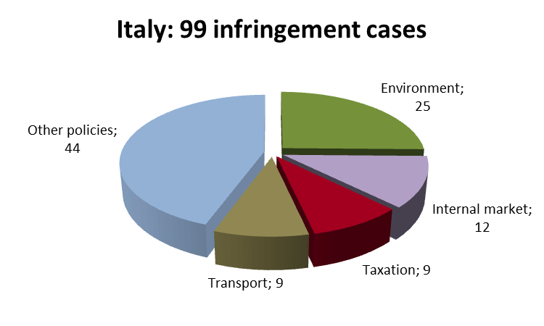
Three cases were brought against Italy to the Court in 2012 (4 in 2011) due to its: non-compliance with EU rules on buildings’ energy performance certificates and on air-conditioning systems' inspections; incorrect implementation of the Directive on collective redundancies; and inadequate urban waste-water treatment in some areas. In the reference group, there was 1 referral against Spain, 4 against France, 6 against the UK, 7 against Germany and 12 against Poland.
Italy had one second referral proposing fines under Article 260(2) TFEU because it had failed to clean up hundreds of illegal landfills.

TRANSPOSITION OF DIRECTIVES
The Commission opened 36 infringement procedures against Italy for late transposition of directives (73 in 2011). Italy’s performance was the worst in its reference group: 11, 14, 16, 18, and 24 new late transposition cases were launched against Germany, France, Spain, Poland and the UK, respectively. With 17 open late transposition cases by the end of 2012, Italy ranked 18th in the EU-27.
Environment (11 new late transposition cases), health & consumers (10) and transport (7) directives posed the main challenges to Italy.

COMPLAINTS
438 complaints were received against Italy in 2012, the highest figure in the EU-27.
Most concerned environment (124 complaints, many on waste, nature protection and impact assessment), internal market (72, mainly public procurement, regulated professions and provision of services) and taxation (64, e.g. companies' 'exit tax' and foreign real estates).
Other complaints dealt with taking into account working periods acquired in other Member States, home-grown sport players, legal migration, equality, civil justice, labour law, health and safety, organic farming, biofuels, air passenger rights and discrimination on public transport.

EARLY RESOLUTION OF INFRINGEMENTS
There were 135 open files in EU Pilot at the end of 2012, the highest caseload in the EU-27. Italy received 107 new EU Pilot files in 2012. Its average EU Pilot response time was 69 days, meeting the 10-week target (72 days in 2011).
The Commission could close several cases in 2012 because Italy: corrected its tax on port dues and vessels' VAT exemption; respected EU marketing authorisation laws for generic drugs; removed unjustified trade obstacles on amusement machines and bottled drinking water; duly transposed the SEA Directive; and granted family allowances to frontier and migrant workers.
IMPORTANT JUDGMENTS

The Court condemned Italy for inadequate urban waste water treatment in specific areas and for the excessive PM10 concentrations in ambient air in 55 agglomerations during the years 2006 and 2007.

The Court also ruled that: when establishing employees’ seniority, the duration of fixed-term contracts at the same public authority should also be taken into account unless deduction is justified on ‘objective grounds’; long-term resident, third-country nationals should be treated similarly to EU citizens in allocating housing benefits; the rule that allowed the taxpayer to close a pending case before the court of last resort by paying 5% of the claim, if such case had been initiated for more than 10 years ago and the taxpayer's claim was upheld by both at the first and second instance is compatible with EU law; cultivating GMOs already authorised by the EU could not be made conditional on national authorisation and that even if Member States may adopt coexistence measures, this cannot extend to a general ban of GMOs authorised under EU law.
Key infringement proceedings
- Waste pre-treatment in Malagrotta and other Lazio landfills
- Bad application of certain EU asylum laws
- Doctors' working time in public hospitals
- Limited discretion of the national authority regulating electronic communications
- Non-compliance with the Directives on buildings' energy performance, on health & safety at work and laying hens' keeping conditions
- Visa exemption for Chinese diplomatic passports
- Discriminating cheaper tobacco products
- Restrictions on non-Italian water-polo players
- Lack of monitoring and proper enforcement of EU rules on using drift nets
- Access of Italian vessels to third country waters (EU exclusive competence)
- Awarding public service contracts to regional shipping companies without public tenders
- Non-recovery of illegal state aid for firms investing in municipalities affected by natural disasters

Latvia
GENERAL STATISTICS
With 20 infringement cases open at the end of 2012, Latvia had the best performance in the EU–27. The Commission launched 17 new infringement cases against Latvia in 2012.
Latvia’s performance was also the best in its reference group: Estonia had 24 open infringement cases, Malta had 24, Slovenia 39, Luxembourg 34 and Cyprus 43. Latvia ended the year with fewer infringement cases than in 2011 (23) and 2010 (26). The following chart shows the policy areas in which Latvia was most frequently subject to infringement procedures:
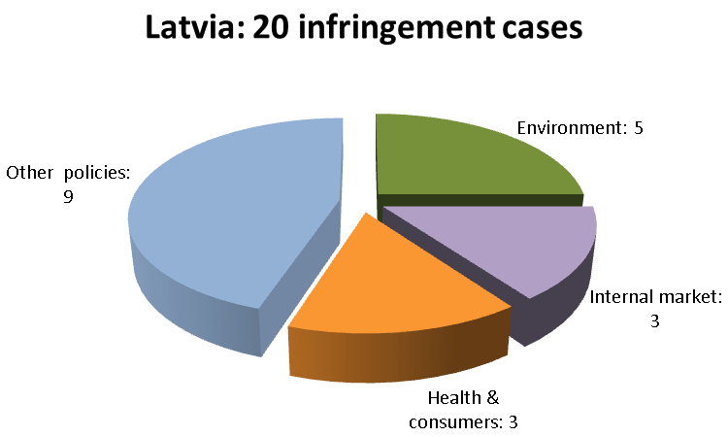
The Commission did not refer any cases against Latvia to the Court in 2012 (this situation remains unchanged since 2009). In Latvia’s reference group, there was one referral against Luxembourg, four against Cyprus and five against Slovenia.
TRANSPOSITION OF DIRECTIVES
The Commission opened 10 infringement procedures against Latvia for late transposition of various directives in 2012 (there were 24 such cases in 2011, Latvia’s performance was second best in its reference group: Estonia had fewer new late transposition cases (5), Luxembourg, Slovenia, Malta and Cyprus had more (12, 16, 18 and 24, respectively). With 9 open late transposition cases by the end of 2012, Latvia ranked 5th in the EU-27.
Latvia faced significant challenges in transposing EU directives in the health and consumers area (four new late transposition cases).
COMPLAINTS
The Commission received only 17 complaints against Latvia in 2012. Latvia ranked second in the EU-27.
Most complaints concerned: international affairs (three complaints, such as the entry of third country nationals into the territory of the EU: three complaints), justice (three, e.g. on the right of establishment); and environment (three, mainly on nature protection: three).
EARLY RESOLUTION OF INFRINGEMENTS
The Commission and the Latvian authorities were working on 28 EU Pilot files at the end of 2012, one of the lowest caseloads in the EU-27 (there were 30 files at the end of 2011). The Commission opened 35 new Latvian files during 2012. Latvia’s average EU Pilot response time (81 days) was over the 10 week target (in 2011, it was 62 days).
Latvia aligned a number of its national measures and practices with EU law, so the Commission was able to close a number of cases, including on the wrong application of the directive on protecting laying hens and the directive on airport charges. Latvia also solved the problem of not designating enough Special Protection Areas for bird species in danger of extinction, bird species considered vulnerable or migratory birds.
IMPORTANT JUDGMENTS
There were no such judgments.
Key infringement proceedings
- Non-compliance with EU legislation on Tetraourogallus hunting
- Non-compliance with EU rules on separating accounts in railway financing

Lithuania
GENERAL STATISTICS
With 22 infringement cases open at the end of 2012, Lithuania ranked second best in the EU-27. The Commission launched eleven new cases against Lithuania in 2012 by sending a letter of formal notice.
Lithuania’s performance was the best in its reference group: Denmark had 27 open infringement cases, Slovakia had 33, Ireland 39, and Finland 43. Lithuania ended the year with fewer infringement cases than in 2011 (36) and 2010 (24). The following chart shows the policy areas in which Lithuania was most frequently subject to infringement procedures:
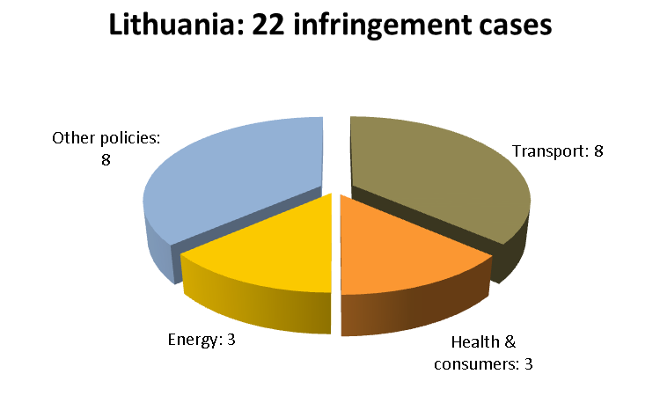
The Commission did not refer any cases against Lithuania to the Court in 2012 (this situation remains unchanged since 2009). In Lithuania’s reference group, there was one referral each against Ireland and Slovakia, and six against Finland but none against Denmark.
TRANSPOSITION OF DIRECTIVES
The Commission opened ten infringement procedures against Lithuania for late transposition of various directives in 2012 (there were 34 in 2011). In its reference group, Lithuania performed better than Finland and Denmark (21 and 17 new late transposition cases, respectively), but worse than that of Slovakia and Ireland (7 and 8 cases, respectively).
The policy areas in which Lithuania faced the most significant challenges in transposing EU directives were: transport (three new late transposition infringement cases) and health and consumers (three).
COMPLAINTS
The Commission received 36 complaints against Lithuania in 2012, the seventh lowest figure in the EU-27.
The areas in which most complaints were received were: justice (six complaints), internal market (five, mainly public procurement); and regional policy (five). Other complaints concerned transposition of the Directive on package travel, package holidays and package tours and EU funding.
EARLY RESOLUTION OF INFRINGEMENTS
The Commission and the Lithuanian authorities were working on 30 open files in EU Pilot at the end of 2012 (at the end of 2011: 65 files), an average caseload. The Commission opened 32 new files on Lithuanian issues in 2012. Lithuania respected the 10-week target for providing replies in EU Pilot; it submitted its responses within an average of 63 days (62 days in 2011).
The Lithuanian authorities actively sought to settle their infringement cases in 2012 by ensuring that national legislation complied with the Directive on packaging and packaging waste. In addition, Lithuania transposed provisions on geological storage of carbon dioxide and on energy labelling. As a result, the Commission closed these infringement procedures.
IMPORTANT JUDGMENTS
There were no such judgments in 2012.
Key infringement proceedings
- Ban on registering right-hand drive cars
- Klaipeda state seaport — priority for current cargo handling operators renewing their port land lease
- Expelling or denying entry to people in cases that are not sufficiently serious or do not present a danger to public security
- Insufficient designation of Special Protection Areas (SPAs) for birds

Luxembourg

GENERAL STATISTICS
With 34 infringement cases open against Luxembourg at the end of 2012, Luxembourg’s performance was seventh best in the EU-27. The Commission launched 21 new infringement cases against Luxembourg in 2012 by sending letters of formal notice.
Luxembourg’s performance was average in its reference group: Latvia had 22 open infringement cases, Estonia had 24, Malta 26, Slovenia 39 and Cyprus 43. Luxembourg ended the year with fewer infringement cases than in 2010 (41) and 2011 (76). The following chart shows the policy areas in which Luxembourg was most frequently subject to infringement procedures:
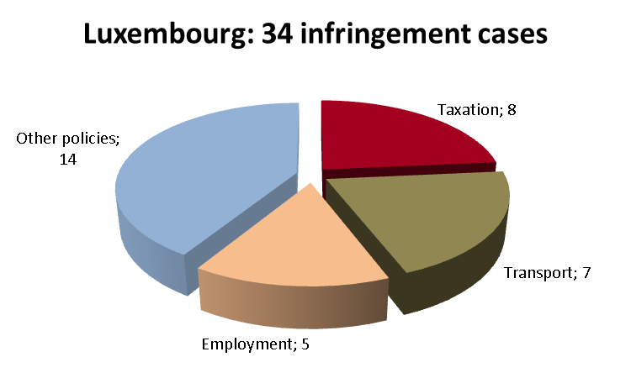
Like in 2011, the Commission referred one case to the Court against Luxembourg in 2012 (see the section on the transposition of directives). In Luxembourg’s reference group, there were four referrals against Cyprus and five against Slovenia but none against Latvia, Estonia or Malta.

TRANSPOSITION OF DIRECTIVES
The Commission opened 12 infringement procedures against Luxembourg for late transposition of various directives in 2012 (there were 44 in 2011). Luxembourg ranked 19th in the EU-27, and its performance was above average in its reference group: worse than that of Estonia (five new late transposition cases) and Latvia (ten), but better than that of Slovenia (16), Malta (18) and Cyprus (24). With 13 open late transposition cases by the end of 2012, Luxembourg ranked 13th in the EU-27.
The policy areas in which Luxembourg faced significant challenges in transposing EU directives were: transport (five new late transposition infringement cases) and health and consumers (three).
The Commission referred Luxembourg to the Court with a request for financial sanctions under Article 260(3) TFEU due to late transposition of the Directive on public procurement in the defence and security sector.

COMPLAINTS
The Commission received 20 complaints against Luxembourg in 2012, the third lowest figure in the EU-27.
Most of the complaints concerned: taxation (five complaints, mostly on discriminatory taxation on transfer of residence (‘exit tax’) and discriminatory treatment of capital gains); external relations (three, especially the free movement of people in the context of the EU/Switzerland Agreement); and social security (three, e.g. on family benefits for migrant workers). Other complaints concerned for example, inadequate environmental impact assessments.

EARLY RESOLUTION OF INFRINGEMENTS
The Commission sent Luxembourg 17 files since Luxembourg joined EU Pilot in June 2012. It was working with Luxembourg’s national authorities on 12 open files at the end of 2012. Luxembourg’s average EU Pilot response time (67 days) met the 10-week target.
The Commission was able to close some infringement cases in 2012, because amongst others, Luxembourg ensured compliance with EU rules on water (the Quality Assurance Quality Control Directive) and chemicals (the Classification, Labelling and Packaging Regulation).

IMPORTANT JUDGMENTS
The Court clarified in a preliminary ruling that restricting a Member State’s recruitment subsidies for employment placements to people registered in that Member State goes against EU law.

Key infringement proceedings
- Reduced VAT rates on e-books
- Restrictive access to study grants for family members of migrant workers
- Failure to bring urban waste water treatment up to EU standards despite Court judgment
- Non-transposition of the Directive on public procurement in the defence and security sector

MALTA
GENERAL STATISTICS
With 26 open infringement cases at the end of 2012, Malta had the fourth-best performance out of all the EU-27 Member States. In 2012, the Commission launched 22 new infringement procedures against Malta by sending letters of formal notice.
In its reference group, Malta's performance remained above average; only Latvia and Estonia had fewer open infringement cases (20 and 24 respectively). Luxembourg had 34, Slovenia 39 and Cyprus 43. Although Malta ended the year with fewer infringements than in 2011 (36), its 2010 result was even better (22). The following chart shows the policy areas in which Malta was most frequently subject to infringement procedures:
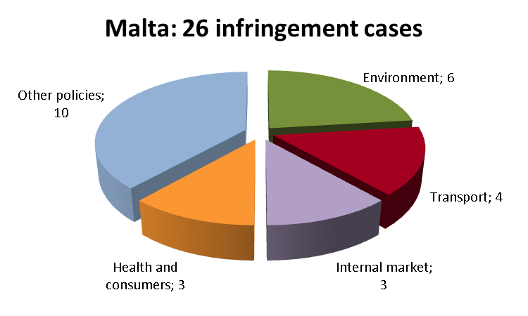
The Commission did not bring any cases against Malta before the Court in 2012, (there had been one referral in 2011). In Malta's reference group, there was one referral against Luxembourg, four against Cyprus and five against Slovenia but none against Estonia and Latvia.
TRANSPOSITION OF DIRECTIVES
The Commission opened 18 infringement procedures against Malta for late transposition of various directives in 2012 (there were 40 such procedures in 2011). In Malta’s reference group, only Cyprus had more new late transposition infringement cases in 2012 (24). Estonia, Latvia, Luxembourg, and Slovenia performed better than Malta (with five, 10, 12 and 16 such infringements, respectively). With only nine open late transposition infringement cases by the end of 2012, Malta ranked 5th in the EU-27 (together with Latvia and Denmark).
The policy areas in which Malta faced significant challenges in transposing EU directives in 2012 were: health and consumers (6 new late transposition infringements) and environment (4). In addition, three infringement cases were still open in 2012 due to the late transposition of transport-related directives.
COMPLAINTS
In 2012, the Commission received 35 complaints against Malta, the fifth-lowest figure in the EU-27.
The areas in which most complaints from citizens and businesses were received were: justice (eight complaints, especially on the free movement of people and non-residents' energy tariffs) and taxation (four, e.g. registration tax and VAT on used vehicles imported from other Member States, taxation of internet bills). There were also complaints concerning e.g. nationality-based discrimination on public transport and in relation to child allowance, the illegal killing and hunting of birds, and inadequate waste management. In addition, the Commission learnt of a case in which the Maltese authorities demanded a proof of earning average wage (instead of the statutory minimum amount) from a third-country national in order to grant her long-term resident status.
EARLY RESOLUTION OF INFRINGEMENTS
Malta joined EU Pilot in June 2012. By the end of the year, the Commission and the Maltese authorities were working on 27 open files in EU Pilot – a workload that rose rapidly but is still below average. The Commission opened 28 new files on Maltese issues by the end of 2012. The Maltese authorities’ average EU Pilot response time (87 days) was above the 10-week target.
Malta eliminated a number of inconsistencies between national and EU law in 2012. For example, it established noise maps for its major roads, made them publicly available and informed the Commission about them as required by the Environmental Noise Directive. Malta also put in place measures that ensure competitive ground-handling services (such as aircraft refuelling services) at Luqa airport, as requested by the Commission. Lastly, Malta removed the nationality requirement for public notaries.
IMPORTANT JUDGEMENTS
There were no Court judgments concerning the Malta.
Key infringement proceedings
- Reducing Maltese pensions for beneficiaries who also receive a pension from another Member State
- Incomplete transposition of the Omnibus I and Prospectus Directives
- Nationality-based discrimination in charging fees for water and electricity
- Marsa Power Station: operating hours in excess of the limits set by the Large Combustion Plant Directive

the Netherlands

GENERAL STATISTICS
There were 41 infringement cases open against the Netherlands at the end of 2012, the sixteenth highest number in the EU-27. The Commission launched 14 new cases in 2012 by sending letters of formal notice.
The Netherlands’ performance was above average in its reference group: Romania had 44 open infringement cases, Hungary had 42, the Czech Republic 36, Portugal 67, Belgium 92 and Greece 81. The Netherlands ended the year with fewer infringement cases than in 2010 (62) and 2011 (71). The following chart shows the policy areas most frequently subject to infringement procedures:
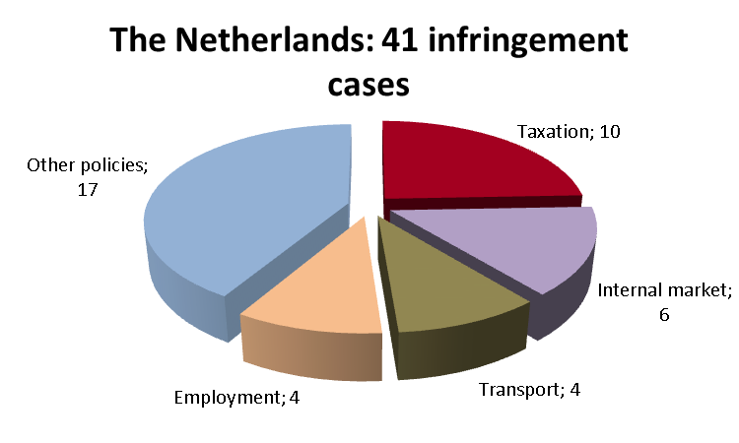
The Commission referred four cases against the Netherlands to the Court in 2012 (there were also four in 2011), all of them were due to late transposition of directives (see below). In the Netherlands’ reference group, there were no referrals against Romania or the Czech Republic, two against Greece and four each against Hungary and Portugal, and six against Belgium.

TRANSPOSITION OF DIRECTIVES
The Commission opened six infringement procedures against the Netherlands for late transposition of various directives in 2012 (there were 32 in 2011). Its performance was best in its reference group: the Czech Republic had 13 new late transposition cases, Romania had 15, Belgium 21, Greece 22, Hungary 26 and Portugal 34.
The Netherlands faced significant challenges in transposing EU directives in the area of transport (three late transposition infringement cases).
The Commission referred the Netherlands to the Court with a proposal for financial sanctions under Article 260(3) TFEU due to late transposition of: the Directive on defence procurement; the Mediation Directive; the Citizens’ Rights Directive; and the Better Regulation Directive. With 6 open late transposition cases by the end of 2012, the Netherlands ranked 1st in the EU-27.

COMPLAINTS
The Commission received 100 complaints against the Netherlands in 2012, the 14th highest figure in the EU-27.
Complaints concerned especially: environment (17 complaints, many on nature protection and air quality); internal market (16, mainly public procurement, freedom to provide services and regulated professions); justice and free movement of workers (16, e.g. free movement of people and social security issues). Other complaints focused on nationality-based discrimination on public transport, discrimination in the taxation group relief regime and tax obstacles to the cross-border provision of pensions.

EARLY RESOLUTION OF INFRINGEMENTS
The Commission and the Dutch authorities were working on 38 open files in EU Pilot at the end of 2012 (2011: 98). The Commission opened 38 new EU Pilot files on Dutch issues in 2012. The Netherlands’ average EU Pilot response time (64 days) met the 10-week target (67 days in 2011).
Due to the measures of the Dutch authorities put in place to improve compliance with EU law, the Commission could close a number of cases in 2012. The Netherlands revoked the discriminatory taxation of capital held by foreign charities, made their national legislation compliant with the Racial Equality Directive and brought the Dutch Crisis and Recovery Act in line with the Environment Impact Assessment Directive.

IMPORTANT JUDGMENTS
Three judgments of the Court found that the Netherlands failed to comply with its obligations under EU law. First, it found that the Dutch authorities were imposing disproportionate charges for granting residence permits to third-country nationals, in breach of the Long-Term Resident Directive. Second, it ruled that according to EU rules, if a contracting authority requires that certain products it orders be derived from organic agriculture or fair trade, it must provide detailed specifications instead of referring to eco-labels or specific labels. Finally, the Court ruled that making study abroad funding subject to a Dutch residence permit gives rise to unequal treatment of Dutch and migrant workers, which is incompatible with the free movement of workers.
Among the preliminary rulings addressed to the Dutch judiciary, the Court ruled that work carried out on drilling platforms at sea, on the continental shelf adjacent to a Member State, must be regarded as work carried out on the territory of that country (so that invalidity benefits are due).

Key infringement proceedings
- Failure to halt the on-going deterioration of the Western Schelde estuary (Natura 2000 site)
- Non-transposition of the directive on public procurement in the defence and security sector
- Discriminatory tax rules on cross-border pensions
- Reduced VAT rate on race horses
- Failure to comply with the Court ruling addressing residence conditions being attached to payment of study grants for children of migrant workers

POLAND

GENERAL STATISTICS
82 infringement cases were open against Poland at the end of 2012, the 4th worst performance in the EU-27. The Commission launched 28 cases in 2012 by sending letters of formal notice.
Poland’s performance was average in its reference group: Germany and the UK each had 61 open infringement cases, France had 63, Spain 91 and Italy 99. Poland ended the year with fewer cases than in 2011 (95) and 2010 (91). Poland was most frequently subject to infringement procedures in the following policy areas:
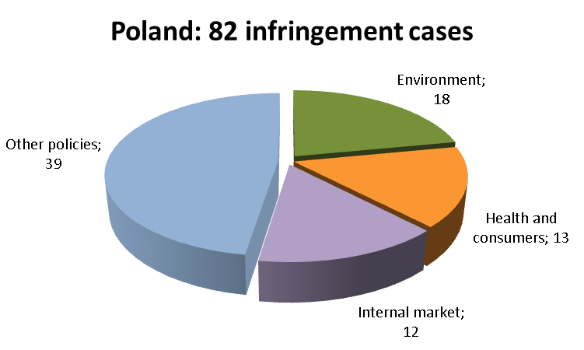
The Commission brought 12 cases against Poland to the Court in 2012 (seven in 2011). All were due to late transposition of directives (see next section). In Poland’s reference group, there was one referral against Spain, three against Italy, four against France and six against the UK and seven against Germany.

TRANSPOSITION OF DIRECTIVES
The Commission opened 18 infringement cases against Poland for late transposition of EU directives in 2012 (44 in 2011). In its reference group, Poland’s performed better than the UK (24) and Italy (36), but worse than Germany (11), France (14) and Spain (16). With 34 open late transposition cases by the end of 2012, Poland ranked last in the EU-27 (with Belgium).
Poland faced the most challenges in transposing EU directives in the areas of transport and health & consumers (5 new late transposition cases each) and internal market (3).
Poland was referred to the Court with a proposal for financial sanctions under Article 260(3) TFEU due to late transposition of the Audiovisual Media Services Directive, the Marine Strategy Framework Directive, the Waste Framework Directive, the Airport Charges Directive, the Maritime Accident Investigation Directive, the Citizens’ Rights Directive, the Better Regulation Directive, the Defence Procurement Directive and the Third Energy Package. Referrals without a proposal for financial sanctions were due to late transposition of the Railway Interoperability Directive and the Conservation and Amateur Vegetable Varieties Directive.

COMPLAINTS
The Commission received 156 complaints against Poland in 2012, the 7th highest figure in the EU-27.
Most complaints concerned: environment (37 complaints, many on water management, impact assessment and nature protection); justice (30, including equal treatment in work, residence rights of third-country spouses of EU citizens); and taxation (18, cars' excise tax, electricity and energy taxes, VAT Directive).
Other complaints targeted e.g., the transposition of the Data Retention Directive, marketing of medical devices, free provision of services and public procurement, limitations on direct payments from the EU’s agricultural support schemes, and a nationality condition for public sector jobs.

EARLY RESOLUTION OF INFRINGEMENTS
There were 64 files open in EU Pilot at the end of 2012, an above-average caseload that decreased since 2011 (78). Poland received 59 new files in 2012. Its average EU Pilot response time was 69 days, which met the 10-week target.
Cases were closed against Poland at an early stage as it complied with EU law on, for example: environment (impact assessment of the EU-co-financed S3 motorway that crosses Natura 2000 sites, which led to Poland adopting a package of compensatory measures); transport (adoption of the national aviation security programme); and equal treatment of men and women in access to employment.

IMPORTANT JUDGMENTS
The Court ruled that: Polish legislation violated EU rules by allowing in certain circumstances foreign medicinal products to be placed on the market without EU market authorisation; and Poland had failed to protect wild birds as required by the Birds Directive.
The Court also made clear that parts of the Polish gambling law may constitute ‘technical regulations’ under the directive on technical standards. So Poland should have sent the draft measures to the Commission before their adoption in so far as it is established that those provisions constitute conditions which can significantly influence the nature or the marketing of the product concerned, which is a matter for the referring court to determine.

Key infringement proceedings
- Incomplete transposition of the Directives of the Third Energy Package
- Incorrect implementation of the Laying Hens Directive
- Non-transposition of the Waste Framework Directive
- Failure to implement the Court judgment on incomplete transposition of the Automotive Framework Directive
- Non-transposition of the Directive on public procurement in the defence and security sector

Portugal

GENERAL STATISTICS
With 67 infringement cases open at the end of 2012, Portugal’s performance was the 6th worst in the EU-27. The Commission launched 46 new cases against Portugal in 2012 by sending letters of formal notice.
Portugal’s performance was below average in its reference group: the Czech Republic had 36 infringement cases, the Netherlands had 41, Hungary 42, Romania 44, Greece 81 and Belgium 92. Portugal ended the year with fewer infringement cases than in 2011 (84) and 2010 (98). Portugal was most frequently subject to infringement procedures in the following policy areas::
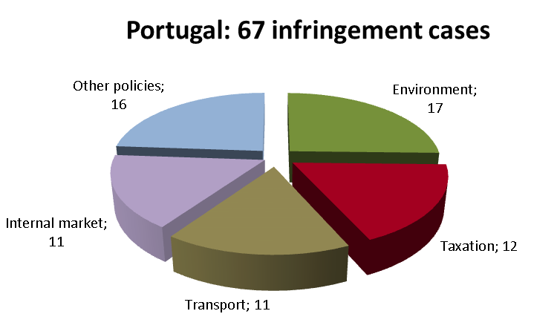
Four cases were brought before the Court against Portugal in 2012 (3 in 2011). They challenged: Portugal’s refusal to pay duties on un-exported sugar surplus stocks; its missing transposition measures of the Directive updating driving licence requirements; and the incorrect transposition of EU law on distance marketing of consumer financial services. The fourth referral was due to late transposition (see below). In Portugal’s reference group, there were no cases against the Czech Republic and Romania. Greece had two referrals, Hungary had four and Belgium six.
Portugal was referred to the Court with a proposal for financial sanctions under Article 260(2) TFEU, because it had not designated a universal service provider in the telecom sector as required by the Universal Service Directive.

TRANSPOSITION OF DIRECTIVES
34 infringement procedures were launched against Portugal for late transposition of various directives in 2012 (50 in 2011). Portugal’s performance was the worst in its reference group: 6, 15, 21, 22, 24 and 26 new late transposition cases were launched against the Netherlands, Romania, Belgium, Greece, the Czech Republic and Hungary, respectively. With 34 open late transposition cases by the end of 2012, Portugal ranked last in the EU-27 (with Belgium).
Portugal faced challenges in transposing EU directives in the policy areas of environment (10 new late transposition cases), transport (8) and health and consumers (6).
Portugal was referred to the Court with a proposal for financial sanctions under Article 260(3) TFEU due to its late transposition of EU telecommunications rules under the Citizens’ Rights Directive.

COMPLAINTS
67 complaints were received against Portugal in 2012, the 11th highest figure in the EU-27.
Most complaints concerned environment (12 complaints, e.g. nature protection, water protection and management, waste management), taxation (10) and internal market (seven, for example, public procurement). Other complaints concerned transport (air passenger rights and registration of documents for vehicles), agriculture (organic farming) and employment (aggregation of insurance periods, fixed-term employment of teachers).

EARLY RESOLUTION OF INFRINGEMENTS
The Commission and the Portuguese authorities were working on 52 open EU Pilot files at the end of 2012 (153 at the end of 2011). 62 new files were opened on Portuguese issues in 2012. Portugal's average EU Pilot response time (68 days) remained within the 10-week target (60 days in 2011).
Portugal aligned a number of its national laws with EU law in 2012, so several cases could be closed. For example, Portugal: implemented correctly the ban on un-enriched cages for laying hens; gave consumers who exercise the right to withdraw from a service contract the right to automatically cancel any additional contracts; complied with the Equal Treatment Directive; applied working time rules to self-employed drivers; and fixed bird hunting periods to respect EU rules on wild birds' conservation, to avoid overlaps with reproduction/pre-nuptial migration periods.

IMPORTANT JUDGMENTS
The Court ruled that Portugal: failed to publish and transmit to the Commission the river basin management plans required under the Water Framework Directive; exceeded for the years 2005 to 2007 the PM10 values for air quality required under the Air Quality Directive; breached the VAT Directive by applying a special scheme exempting farmers from paying VAT and involving the application of a flat-rate compensation percentage at a nil rate; violated EU rules by taxing immediately the unrealized capital gains, if a Portuguese company removed its seat and management to another Member State or if a parent company relocated the assets of its Portuguese subsidiary to another Member State when purely national operations were not subject to such tax; failed to fully transpose Directives from the First Railway Package by requiring the government to approve decisions on acquiring or transferring holdings in the capital of Comboios de Portugal (the public rail transport company) and by not ensuring that the accounts of the infrastructure manager REFER were balanced.

Key infringement proceedings
- Automatic exclusion of projects covered by a land-use plan from Portuguese environmental impact assessment law
- Lack of independence of the Portuguese airport slot coordinator
- Restrictions on tobacco products (excise duties-tax marks)
- Restrictive exit taxes for individuals
- Late transposition of the ‘‘e-money’’ Directive, the Directive on the type-approval of tractors and the Employers Sanctions Directive
- Excessive fixed-term employment contracts for state-sector teachers without measures preventing abuse by employers

Romania

GENERAL STATISTICS
With 44 infringement cases open at the end of 2012, Romania ranked 16th in the EU-27. The Commission launched 30 new infringement cases against Romania in 2012.
Romania’s performance was average in its reference group: the Czech Republic had 36 infringement cases, the Netherlands had 41, Hungary 42, Portugal 67, Greece 81 and Belgium 92. Romania ended the year with fewer infringement cases than in 2011 (47), but more than in 2010 (36). The following chart shows the policy areas in which Romania was most frequently subject to infringement procedures:
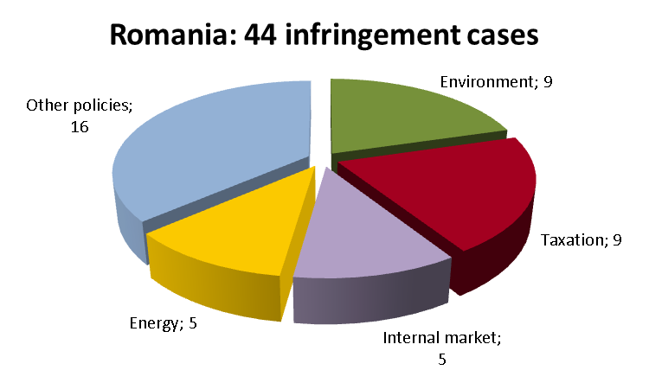
The Commission did not bring any cases against Romania before the Court in 2012 (like in 2011). In Romania’s reference group, there were no referrals against the Czech Republic, there was two against Greece four each against the Netherlands, Portugal and Hungary, and six against Belgium.

TRANSPOSITION OF DIRECTIVES
The Commission opened 15 infringement procedures against Romania for late transposition of various directives in 2012 (there were 46 in 2011). Romania's performance was worse than that of the Czech Republic (13 new late transposition cases) and the Netherlands (6), but better than that of Belgium (21), Greece (22), Hungary (26) and Portugal (34). With 13 open late transposition cases by the end of 2012, Romania ranked 13th in the EU-27 (together with Greece and Luxembourg).
The policy area in which Romania faced challenges in transposing EU directives was transport (four new late transposition infringement cases).

COMPLAINTS
The Commission received 105 complaints against Romania in 2012, the 13th highest figure in the EU-27.
Most complaints concerned the following areas: taxation (23 complaints, especially on excise duties and discriminatory treatment of permanent establishments); internal market (19, mainly public procurement); and justice (19, mainly on civil and criminal law, the functioning of the judiciary, fundamental rights). Other complaints concerned: energy (including consumer provisions on the internal energy market, billing and metering of heating/hot water consumption); environment (e.g. inadequate impact assessment, industrial emissions, nature protection – Natura 2000); agriculture (for example, rural development, direct payments and organic farming); health and consumers (particularly food safety); and transport (such as public service obligations).

EARLY RESOLUTION OF INFRINGEMENTS
The Commission and the Romanian authorities were working on 51 cases at the end of 2012. The Commission opened 57 new cases in 2012. With an average EU Pilot response time of 77 days, Romania was among the Member States that did not respect the 10-week target.
Romania put in place a number of measures to ensure compliance with EU law. For example, it removed the Romanian nationality condition for becoming a public notary, changed its end-user price regulation schemes to give consumers the freedom of choice (by phasing-out regulated electricity end-user prices), addressed its inadequate transposition of the Waste Electrical and Electronic Equipment Directive (especially on financial guarantees incumbent to individual producers), and modernised/replaced laying-hen cages to fully implement the ban on un-enriched cages.

IMPORTANT JUDGMENTS

There were no such judgments.

Key infringement proceedings
- Inadequate nature protection in the Sulina Danube Delta beach development project
- Gas export ban
- Lack of transparency in the conditions for accessing the natural gas transmission networks
- Non-transposition of the Data Retention Directive,the Directive on simplified reporting of rules on mergers and divisions and the Directive on the transfer of defence-related products within the EU
- Transparency and equal treatment concerns when awarding a public works contract for modernising Bucharest’s road infrastructure
- Non-compliance with the Racial Equality Directive (direct and indirect discrimination, burden of proof)
- Disadvantageous tax treatment of permanent foreign legal companies established in Romania
- Failure to correctly implement the ban on un-enriched cages for laying hens

SLOVAKIA
GENERAL STATISTICS
With 33 open infringement cases at the end of 2012, Slovakia had the sixth-best performance out of the EU-27. In 2012, the Commission launched 18 new infringement procedures against Slovakia by sending letters of formal notice.
Slovakia’s performance was average in its reference group: Lithuania had 22 open infringement cases, Denmark had 27, Ireland 39 and Finland 43. Slovakia ended the year with fewer infringement cases than in the two preceding years (41 cases in 2011 and 38 in 2010). The following chart shows the policy areas in which Slovakia was most frequently subject to infringement procedures:
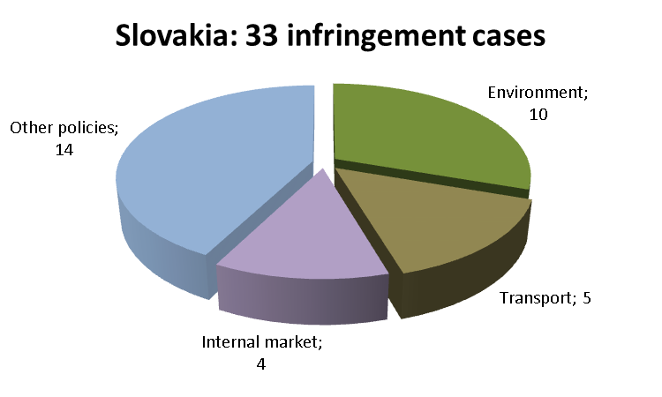
The Commission brought one case against Slovakia before the Court in 2012 (there was one in 2011) because of late transposition of a directive (see below). In Slovakia’s reference group, no cases against Denmark and Lithuania were brought before the Court, and the Commission decided on one referral against Ireland and six against Finland.
TRANSPOSITION OF DIRECTIVES
The Commission opened seven infringement procedures against Slovakia for late transposition of various directives in 2012 (there were 36 such procedures in 2011). This result is better than for the other Member States in Slovakia’s reference group: Ireland had 8 new late transposition cases, Lithuania had 10, Denmark 17 and Finland 21. With only eight open late transposition cases by the end of 2012, Slovakia ranked joint 3rd in the EU-27 (with Ireland).
This significant improvement means that, apart from the two new late transposition infringement cases in the area of transport, Slovakia did not face major challenges in transposing EU directives prior to the end of 2012.
The Commission referred Slovakia to the Court with a request for financial sanctions (Article 260(3) TFEU) due to the late transposition of the Waste Framework Directive
COMPLAINTS
The Commission received 55 complaints against Slovakia in 2012, the eighth-lowest figure in the EU-27.
The areas in which most complaints were received were: environment (12 complaints, especially waste management, nature protection and missing environmental impact assessments); free movement of workers (10, particularly as regards the nationality and residence conditions for taking up certain posts in the public sector); and justice (eight, for example, equal opportunities and equal treatment of men and women in employment matters). Other complaints concerned e.g. public procurement.
EARLY RESOLUTION OF INFRINGEMENTS
At the end of 2012, the Commission and Slovak authorities were working on 33 EU Pilot open files – a caseload that is lower than the number of open files at the end of 2011 (42). In 2012, the Commission invited Slovakia to give its opinion on 39 new EU Pilot files. As in 2011 with 57 days, Slovakia had the best average EU Pilot response time (51 days) in the EU-27.
The Slovak authorities eliminated a number of inconsistencies between national and EU law, so the Commission was able to close a number of infringement cases in 2012. Slovakia clarified the scope of its rules transposing the End of Life Vehicle Directive and these now include improved measures that encourage carmakers to avoid using hazardous materials. It ensured the independence of the infrastructure manager and the regulatory body in implementing the First Railway Package. Lastly, it allowed consumer associations to claim injunctions against firms based in other Member States that applied unfair marketing techniques.
IMPORTANT JUDGMENTS
In 2012, the Court delivered an important preliminary ruling on public procurement. In a legal dispute related to a tender for motorway toll collection services, the Court confirmed that the Public Procurement Directive obliges contracting authorities to request an explanation from tenderers who offer abnormally low prices, and that contracting authorities may not waive this obligation. The Court also clarified that national provisions might allow contracting authorities to ask tenderers to clarify their offers but in doing so, they must treat all tenderers equally.
Key infringement proceedings
- Denial of Christmas pension supplement (vianočný príspevok) to non-residents
- Denial of carers’, disability and cash allowances to non-residents
- Obstacles on car rug market (e.g. a requirement for type approval and for appointment of a local representative)
- Failure to respect air quality (PM10) limit values in several zones and agglomerations
- Removing health insurance firms from the scope of the Non-life Insurance Directives

SLOVENIA
GENERAL STATISTICS
With 39 open infringement cases at the end of 2012, Slovenia had the tenth-best performance out of all the EU-27 Member States, together with Ireland. In 2012, the Commission launched 27 new infringement cases against Slovenia by sending letters of formal notice.
However, Slovenia’s performance was below average in its reference group; Latvia had 20 open infringement cases, Estonia had 24, Malta 26, Luxembourg 34 and Cyprus 43. Slovenia ended the year with fewer infringement cases than in 2011 (46), but more than in 2010 (33). The following chart shows the policy areas in which Slovenia was most frequently subject to infringement procedures:
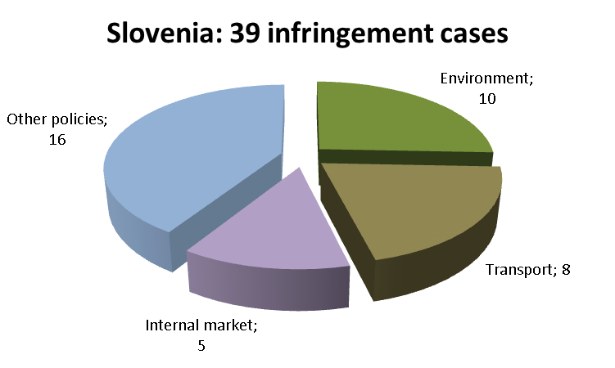
The Commission brought five cases against Slovenia before the Court in 2012 (there had been one referral in 2011). In Slovenia's reference group, there was one referral against Luxembourg, four against Cyprus but none against Estonia, Malta and Latvia.
TRANSPOSITION OF DIRECTIVES
The Commission opened 16 infringement procedures against Slovenia for late transposition of various directives in 2012 (there were 43 such procedures in 2011). In Slovenia’s reference group, this result is better than that of Malta (18 new late transposition cases) and Cyprus (18) but Luxembourg, Latvia and Estonia performed better (with 12, 10 and five such infringement cases, respectively). With 19 open late transposition infringements by the end of 2012, Slovenia ranked 20th in the EU-27.
The policy areas in which Slovenia faced major challenges in transposing EU directives were health and consumers (6 new late transposition cases) and transport (4).
The Commission referred Slovenia to the Court with a proposal for financial sanctions under Article 260(3) TFEU due to late transposition of five directives: the Better Regulation Directive, the Directive on users' rights in electronic communications networks, the Directive on defence procurement and the Gas and the Electricity Directives in the Third Energy Package.
COMPLAINTS
The Commission received 35 complaints against Slovenia in 2012, the fifth-lowest figure in the EU-27.
The areas in which most complaints were received were: internal market and services (11 complaints, mainly free movement of services and public procurement); environment (nine, most on nature protection, environmental impact assessment and waste management); and justice (six, on free movement of people). There were also complaints about the system of study grants, which requires recipients to work in Slovenia for a period equal to the duration of financed studies, and about nationality-based discrimination on public transport.
EARLY RESOLUTION OF INFRINGEMENTS
At the end of 2012, the Commission and the Slovene authorities were working on 33 open files in EU Pilot – a caseload that is below average and has substantially decreased compared to the number of files at the end of 2011 (67). The Commission opened 37 new EU Pilot files on Slovene issues in 2012. Slovenia’s average EU Pilot response time, 64 days, remains below the 10-week target and shows a slight improvement as compared with the year before (67 days).
Out of the open infringement cases, the Slovene authorities could finish transposing the Waste Framework Directive. As regards the municipal land use plan in Rova-South, Slovenia repeated the assessment procedure required by national rules implementing the Strategic Environmental Assessment Directive. The Commission also received the Slovenian implementing measures for the Blue Card Directive (designed to facilitate the admission of highly-skilled workers from third countries into the EU). As a result, the corresponding cases were closed in 2012.
IMPORTANT JUDGMENTS
The Court ruled on the compatibility of the Slovenian complementary health insurance laws with the First and Third Non-Life Insurance Directives and found that these directives do not allow the national supervisory authority to request insurers to regularly submit their current insurance terms and conditions for prior approval (including cases in which they decide to raise premiums).
Key infringement proceedings
- Disregard of other Member States’ transitional periods under the Directive on drivers’ certificates of professional competence
- Deficiencies in the transposition of the Environmental Impact Assessment Directive
- Incomplete transposition of the Directives of the Third Energy Package

Spain

GENERAL STATISTICS
With 91 infringement cases open at the end of 2012, Spain’s performance was third worst in the EU-27. The Commission launched 32 new infringement cases against Spain in 2012.
Spain’s performance was below average in its reference group: Germany and the UK had 61 infringement cases each, France had 63, Poland 82 and Italy 99. However, Spain ended the year with fewer infringement cases than in 2011 (99) and 2010 (109). The following chart shows the policy areas in which Spain was most frequently subject to infringement procedures:
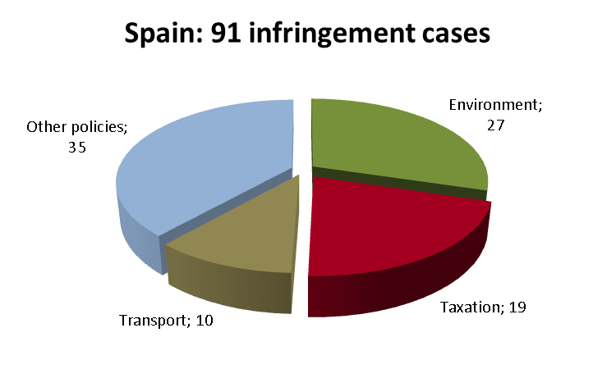
The Commission referred Spain to the Court once in 2012 (there were 6 referrals in 2011), because of barriers to importing heavy goods vehicles. Spain refused to allow road haulage operators to use the first vehicle in their fleet for commercial purposes, if it was over five months old. Spain had the lowest number of referrals in its reference group. There were twelve referrals against Poland, seven against Germany, six against the UK, four against France and three against Italy.

TRANSPOSITION OF DIRECTIVES
The Commission opened 16 infringement cases against Spain for late transposition of various directives in 2012 (43 in 2011). Spain performed better than Poland (18), the UK (24) and Italy (36), but worse than Germany (11) and France (14). With 12 open late transposition cases by the end of 2012, Spain ranked 11th in the EU-27 (together with Bulgaria).
The policy areas in which Spain faced challenges to transposing EU directives were: environment (six new late transposition cases), health and consumers (four) and transport (three).

COMPLAINTS
The Commission received 306 complaints against Spain in 2012. Spain ranked second in the EU-27.
Most complaints concerned: environment (73 complaints, many on inadequate water protection and management, waste management, nature protection); internal market (43, mainly public procurement, freedom to provide services and regulated professions); and protection of workers (35, non-implementation of the rules on health and safety at work, non-acceptance of European Health Insurance Cards (EHIC) of citizens from other Member States, refusal to treat citizens based on their EHIC, if covered by private health insurance, minimum right to paid annual leave for police forces in the Basque Autonomous Region: 35). Other complaints concerned for example, the automotive sector, direct payments and quality schemes in agriculture, zootechnics (stud-books for horses), airport charges, free movement of people and civil justice.

EARLY RESOLUTION OF INFRINGEMENTS
At the end of 2012, 107 files on Spanish issues were open in EU Pilot (at the end of 2011: 365), the second highest caseload in the EU-27. Spain had the second highest number of new EU Pilot files in 2012 (110). Its average EU Pilot response time (74 days) was above the 10-week target (it was 82 days in 2011).
The Commission closed a number of infringement cases after Spain introduced measures to comply with EU law. The Spanish authorities removed: obstacles to exporting pharmaceutical products (requirement to notify them about medicines to be exported to other Member States); discrimination in access to the security guard and archaeologist professions; discrimination of people with work experience in other Member States and applying for public sector jobs; and excessive conditions for approving associations that maintain stud-books for registered horses.

IMPORTANT JUDGMENTS
The Court ordered Spain to pay a lump sum of € 20 million and a daily penalty of € 50 000 for failing to comply with its 2002 judgment under Article 108 TFEU, ordering compliance with the Commission’s decision on recovering unlawful state aid paid to companies part of the Magefesa group. In another ruling, the Court held that Spain did not adopt and notify to the Commission and the other concerned Member States a number of river basin management plans, and failed to initiate public consultations on these plans in several areas. The Court also found that Spain’s restrictive tax provisions for individuals moving to another Member State went against the freedom of movement of workers and the freedom of establishment.
In a preliminary ruling, the Court clarified the calculation of pension contributions for part-time workers and found Spain’s legislation to be discriminatory because it required a proportionally longer contribution period for part-time workers, mostly women.

Key infringement proceedings
- Failure to bring urban waste water treatment up to EU standards in small agglomerations
- Monopoly in the system for recruiting port workers (dockers)
- Discriminatory taxation of investments in non-Spanish EU public bonds
- Real estate tax regime discriminatory against non-residents
- Unlawful VAT-exemption of notary services connected with financial transactions
- Wrong application of the Framework Directive on health and safety at work to workers of the Guardia Civil (in particular as preventive services)
- Restrictions on film distribution in Catalonia
- Failure to correctly implement the ban on un-enriched cages for laying hens
- Failure to take into account employment in international organisations when calculating pensions rights
- Incomplete transposition of the Directive on energy performance of buildings

Sweden
GENERAL STATISTICS
With 36 infringement cases open at the end of 2012, Sweden’s performance was eighth best in the EU-27. The Commission opened nine new infringement cases against Sweden in 2012.
Sweden’s performance was best in its reference group: Bulgaria had 46 open infringement cases and Austria had 51. Sweden ended the year with fewer infringement cases than in 2011 (60) and 2010 (53). The following chart shows the policy areas in which Sweden was most frequently subject to infringement procedures:
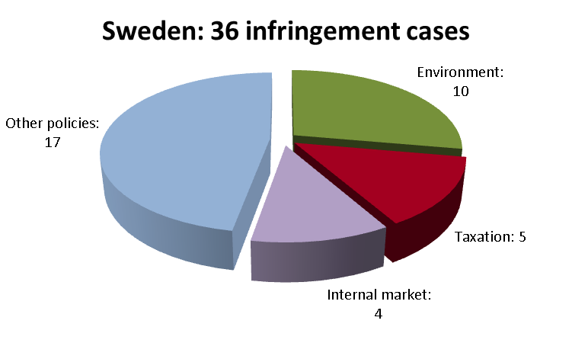
The Commission referred one case against Sweden to the Court in 2012, because Sweden’s national legislation did not comply with the Directive on Waste Electrical and Electronic Equipment (specifically waste storage sites). In Sweden’s reference group, there were two referrals against Bulgaria but none against Austria.
TRANSPOSITION OF DIRECTIVES
The Commission opened six infringement procedures against Sweden for late transposition of various directives in 2012 (there were 31 in 2011). Sweden’s performance was the best in its reference group: 13 new late transposition infringements were initiated against Bulgaria and 24 against Austria. With 7 open late transposition cases by the end of 2012, Sweden ranked 2nd in the EU-27.
Sweden faced some challenges in transposing EU directives in the area of transport (two new late transposition infringement cases).
COMPLAINTS
The Commission received 111 complaints against Sweden in 2012, the 18th highest figure in the EU-27.
Most complaints concerned: health and consumers (22 complaints, especially on the reimbursement of medical costs); justice (18, most on the free movement and residence rights); and taxation (14, limitation of deduction rights for company groups and congestion tax). Other complaints concerned, for example, nature protection (in particular wolf hunting) and public procurement.
EARLY RESOLUTION OF INFRINGEMENTS
The Commission and the Swedish authorities were working on 34 open files in EU Pilot at the end of 2012 (at the end of 2011: 84 files), which is an average caseload. The Commission opened 38 new files on Swedish issues in 2012. Sweden met the 10-week target for providing replies in EU Pilot and submitted its responses within an average of 61 days (it was 81 days in 2011).
The Swedish authorities actively sought to settle infringement procedures, so the Commission could close a number of cases in 2012. For example, Sweden transposed provisions on the recovery of petrol vapour that would otherwise be emitted into the air during vehicle refuelling and common rules for the internal market in electricity and in natural gas. It also rectified the incorrect application of EU legislation on the working time of self-employed drivers. It put national legislation in line with the directive on strategic environmental assessment and with the directive on recognising professional qualifications. It also allowed registration of double surnames for children of dual nationality.
IMPORTANT JUDGMENTS
The Court established that Sweden had failed to respect the Directive on integrated pollution prevention and control because there remained some industrial installations in Sweden that had not yet received new or renewed permits in accordance with the above directive.
Key infringement procedures
- Wolf hunting practices inconsistent with EU nature protection provisions
- Full implementation of the judgment on licensing high polluting installations
- Possibly abusive extensions of fixed-term employment contracts
- Failure to transpose the Data Retention Directive
- Infringement of rules on free movement of people
- Discriminatory taxation of foreign pension funds

United Kingdom

GENERAL STATISTICS
There were 61 infringement cases open against the UK at the end of 2012, the eighth-highest number in the EU-27 (equal with Germany). The Commission launched 34 new infringement cases against the UK in 2012 by sending a letter of formal notice.
The UK’s performance (along with that of Germany) was the best in its reference group: France had 63 open infringement cases, Poland had 82, Spain 91, and Italy 99. The UK ended the year with fewer infringement cases than in 2010 (72) and 2011 (76). The following chart shows the policy areas in which the UK was most frequently subject to infringement procedures:
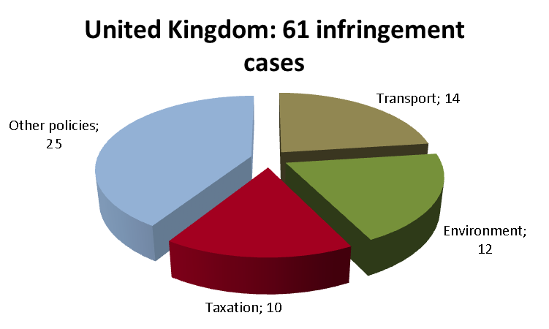
The Commission brought six cases against the UK before the Court in 2012 (only two in 2011). Four of these concerned taxation, and more specifically: (i) UK legislation making it excessively difficult for undertakings to benefit from cross-border loss relief (against the ‘Marks & Spencer’ Court ruling); (ii) UK taxation of assets transferred abroad (iii) discriminatory attribution of capital gains to members of non-resident undertakings; and (iv) UK legislation making it excessively difficult for taxpayers to exercise their right to be paid back taxes that had been levied in breach of EU rules. Another referral concerned the UK’s refusal to compensate for duties that its customs authorities failed to collect in the past and that should have been paid into the EU budget. The UK was also referred to the Court for not offering maximum interconnection capacity in its gas market. Within the UK’s reference group, there were twelve referrals against Poland, seven against Germany, four against France, three against Italy and one against Spain.

TRANSPOSITION OF DIRECTIVES
The Commission opened 24 infringement procedures against the UK for late transposition of various directives in 2012 (there were 57 in 2011). The UK's performance was worse than that of Germany, France, Spain and Poland (11, 14, 16 and 18 new late transposition cases, respectively) but better than that of Italy (36). With 25 open late transposition cases by the end of 2012, the UK ranked 24th in the EU-27.
The policy areas in which the UK faced significant challenges in transposing EU directives were: transport (six new late transposition cases), health and consumers (four), internal market (three) and enterprise and industry (three).

COMPLAINTS
The Commission received 197 complaints against the UK in 2012, the fifth highest number in the EU-27.
Most complaints concerned: the free movement of people (60 complaints, in particular difficulties in obtaining residence cards, requiring a visa from family members of EU citizens, refusing visas for reasons prohibited by EU law). Other complaints concerned the following areas: internal market (32, mainly public procurement, regulated professions and freedom to provide services) and environment (44, especially on nature protection and air quality). There were also many complaints about the residence requirement for certain posts.

EARLY RESOLUTION OF INFRINGEMENTS
The Commission and the UK authorities were working on 67 open files at the end of 2012 (at the end of 2011: 192), the third highest caseload in the EU-27. The Commission sent the UK 64 new EU Pilot files in 2012. The UK kept its average EU Pilot response time (70 days) within the 10-week target (it was 66 days in 2011).
The Commission was able to close a number of infringement cases in 2012 because the UK complied with its obligations. For instance, the UK: modified its legislation to allow EU-qualified pharmacists to be responsible for new pharmacies; accepted that family members of pensioners who lived abroad could independently claim sickness benefits; correctly applied the Landfill Directive with regard to site closure and aftercare. The UK also conducted a comprehensive reform of its anti-avoidance regime (CFC-legislation) to prevent tax abuse while not compromising the intra-EU establishment.

IMPORTANT JUDGMENTS
The Court found that the UK violated its obligations under the Urban Waste Water Directive by failing to ensure: appropriate urban waste water collection in certain parts of London and Whitburn and proper urban waste water treatment in the plants at Beckton, Crossness and Mogden.
The Court also issued a number of preliminary rulings in 2012. For example, it clarified in a landmark judgment concerning avoidance of double economic taxation of dividends, in particular dividends paid by third countries subsidiaries of EU companies.

Key infringement proceedings
- Discriminatory taxation of assets transferred abroad and of capital gains attributed to members of non-resident undertakings
- Violation of free movement of people (rights of family members, exemptions from the visa requirement, permanent residence of EU citizens from countries that have recently joined the EU)

Directive 2009/50/EC and IP/12/167 on the earlier reasoned opinion
Directive 2009/81/EC and IP/12/533 on the earlier reasoned opinion
Commission v Austria, C-614/10
Directive 2004/38/EC
Commission v Austria, C-75/11
Directive 2008/1/EC
Commission v Austria, C-352/11
Directive 2000/78/EC
Tyrolean Airways Tiroler Luftfahrt, C-132/11
Directive 2004/38/EC
Directive 2004/49/EC
IP/12/1247
Commission v Belgium, C-134/10
IP/12/1144
Directive 2009/110/EC and Directives 2009/140/EC and 2009/136/EC, respectively, and IP/12/1248 (E-money) and IP/12/524 (telecom directives)
IP/11/419 on the earlier reasoned opinion
IP/11/1417 on the earlier reasoned opinion
Directive 2008/98/EC
IP/12/47 on the earlier reasoned opinion
Commission v Belgium, C-387/11
Commission v Belgium, C-150/11
Commission v Belgium, C-577/10
Commission v Belgium, C-366/11
IP/12/418
IP/12/408
IP/12/61
IP/12/281
IP/12/651
IP/12/53
IP/12/422 and Directive 2008/98/EC
Directive 2006/24/EC
Maritza-IztoK Energy Complex
Directive 2008/98/EC
IP/13/47
IP/11/1437
IP/12/298
IP/12/72
IP/12/403 and Directive 2009/41/EC
IP/12/672
Directive 1999/31/EC
IP/12/655
Directives 2008/52/EC, 2008/99/CE and 2006/126/EC, respectively and IP/12/1016, IP/12/296 and IP/12/1237 and IP/12/642
IP/11/1442 on the earlier Court referral
IP/11/1277 on the earlier Court referral
Directive 1992/43/EC
Directive 1999/22/EC
Directive 2008/98/EC
Directive 2009/50/EC
Commission v Cyprus, C-125/09
Commission v Cyprus, C-340/10
MEMO/13/375
Directive 2006/24/EC
Directive 2002/96/EC
Regulation (EC) No 1234/2007
Commission v the Czech Republic, C-37/11
IP/11/1446
IP/12/75
IP/13/47
Directive 1991/440/EEC and Directive 2001/14/EC
Directive 2003/88/EC
Directive 2002/96/EC
Directive 2009/43/EC
Directive 2006/126/EC
Directive 2001/37/EC
Regulation(EC) No 482/2008 and Regulation (EU) No 1034/2011
Directive 2008/98/EC
Directive 2009/81/EC
Directive 2009/33/EC
Commission v Estonia, C-39/10
IP/12/630
Directives 2009/112/EC and 2009/113/EC and IP/12/56
Directive 2009/72/EC and IP/12/1236
Directive 2009/73/EC and IP/12/1236
Directive 2009/33/EC and IP/12/270
Directive 2008/96/EC and IP/12/641
Directive 2009/33/EC
Directive 2009/43/EC and IP/12/651 on the earlier reasoned opinion
Directive 2008/98/EC
Directive 2000/53/EC
Regulation (EC) No 883/2004
Commission v Finland, C-342/10
IP/12/410 and Directives 2009/72/EC and 2009/73/EC
Directive 2002/15/EC and IP/12/409
This seal is a freshwater subspecies, found only in the Saimaa Lake system in south-eastern Finland. It is protected under Directive 92/43/EC.
Directive 2009/147/EC
IP/12/170
Directive 2008/1/EC
Directive 91/271/EEC
IP/06/1768
Directive 1999/74/EC
Persons who receive part of their income in a Member State where they are not resident.
Directives 94/62/EC, 2002/96/EC and 2011/92/EU
Directive 89/686/EC and IP/11/610
Commission v France, C-119/11
Commission v France, C-596/10
Commission v France, C-164/11
Directive 2001/82/EC
Commission v France, C-145/11
Cimade & GISTI, C-179/11
Undertakings for collective investments in transferable securities; Santander Asset Management SGIIC, C-338/11
Dominguez, C-282/10
MEMO/12/794
IP/09/1459
MEMO/12/876
Commission v France, C-197/12
IP/06/1768
Directive 2003/88/EC
MEMO/12/708
Directive 92/43/EEC
IP/12/418
IP/12/1018
IP/12/1019
IP/12/83
Directive 89/106/EEC
Directive 2000/60/EC
Directive 2006/24/EC
Directive 92/43/EEC
Directive 2003/86/EC
Directive 2008/98/EC
Directive 96/67/EC
Fra-bo v DVGW, C-171/11
UsedSoft GmbH v Oracle International Corp., C-128/11, Court press release No 94/12
Dr Johann Odar v Baxter Deutschland GmbH, C-152/11, Court press release No 161/12
IP/12/648
IP/12/536 and Directive 2000/60/EC
IP/12/1023 and Directives 1999/31/EC, 2008/98/EC and 92/43/EC
IP/12/1249 and Directive 2004/18/EC
Directives 2008/98/EC and 92/43/EC
IP/11/1415
Directives 97/23/EC and 2009/142/EC
Directives 2002/20/EC and 2002/21/EC
Directives 1991/440/EEC and 2001/14/EC, and Commission v Greece, C-528/10
Directive 2000/60/EC and Commission v Greece, C-297/11
Commission v Greece, C-244/11
Nomarchiaki Aftodioikisi Aitoloakarnanias and others, C-43/10
Syllogos Ellinon Poleodomonkaichorotakton, C-177/11
IP/11/1121 and Directive 2003/88/EC
IP/12/1023
IP/12/420
Directive 2000/78/EC
IP/12/395 (on both cases)
Directive 2002/20/EC and IP/12/286
Directive 2008/98/EC
IP/12/422
Directive 2006/21/EC
Directive 2007/60/EC
Directive 1999/74/EC
Directive 2003/98/EC
Commission v Hungary, C-286/12
VALE Építési Kft., C-378/10
MEMO/12/876
IP/12/674
MEMO/12/876
IP/12/656
IP 12/52
IP/12/657
Directive 2001/42/EC
Directive 91/440/EEC amended by directives 1995/18/EC and 2001/14/EC
Commission v Ireland, C-279/11,Court press release No171/12
Commission v Ireland, C-374/11, Court press release No171/12
IP/12/52
IP/11/730
Directive 91/440/EEC as amended by Directive 2001/12/EC
IP/11/78
IP/12/411
IP/12/1145
IP/12/658
IP/12/1140
Application of Directive 2003/109/EC to long-term residents.
Fixed-term employment in schools and for university language teachers.
IP/12/48
IP/10/1220
Directive 2001/42/EC
Commission v Italy, C-565/10
Commission v Italy, C-68/11
Valenza and Others, C-302/11
Kamberaj, C-571/10
3M Italia, C-417/10
Pioneer Hi Bred Italia, C-36/11 and Directive 2001/18/EC
IP/12/538
MEMO/13/122
Directive 2002/91/EC and IP/12/411
Directive 89/391/EC
IP/12/629
MEMO/12/794
IP/12/637
Directive 1999/74/EC and IP/12/47
Directive 2009/12/EC
Directive 2009/147/EC
This bird, also known as the wood grouse, is the largest member of the grouse family and is protected by Directive 2009/147/EC.
Directive 1991/440/EEC
Directive 1990/314/EEC
Directive 1994/62/EC
Directive 2009/31/EC
Directive 2010/30/EU
Directives 1970/311/EEC and 2007/46/EC and IP/11/1251
IP/12/636
Directive 2004/38/EC
Directive 2009/147/EC and IP/07/938
Directive 2009/81/EC
Directive 2009/90/EC
Regulation (EC) No 1272/2008
Caves Krier Frères Sàrl, C-379/11, Court press release No 167/12
Commission v Luxembourg, C-576/11
Directive 2009/81/EC
Directive 2002/49/EC and IP/10/1416 on the earlier Court referral
IP/11/188 on the earlier Court referral
IP/07/1510 on the earlier reasoned opinion
IP/13/249
Directives 2010/78/EU and 2010/73/EU
Directive 2001/80/EC and IP/12/660
IP/12/1020 and Directive 2009/81/EC
MEMO/12/708 and Directive 2008/52/EC
IP/12/524 and Directive 2009/136/EC
IP/12/1016 and Directive 2009/140/EC
Directive 2000/43/EC
Directive 85/337/EEC now repealed by Directive 2001/42/EC
Commission v Netherlands, C-508/10, Court press release No 52/12 and Directive 2003/109/EC
Directive 2004/18/EC
Commission v Netherlands, C-368/10 and Court press release No 60/12
Article 45 TFEU and Regulation (EC) No 1612/68 as amended, now codified in Regulation (EU) No 492/2011
A. Salemink, Case C-347/10 and Court press release No 1/12
MEMO/12/794
Directive 2009/81/EC and IP/12/76
MEMO/12/876
Directive 2007/65/EC
Directive 2008/56/EC
Directive 2008/98/EC
Directive 2009/12/EC
Directive 2009/18/EC
Directive 2009/136/EC
Directive 2009/140/EC
Directive 2009/81/EC
Directives2009/72/EC and 2009/73/EC
These directives do not fall under Article 260(3) TFEU.
Directive 2011/18/EU
Directive 2009/145/EC
Directive 2006/112/EC
Directive 2006/24/EC
Directive 2001/83/EC
Commission v Poland, C-185/10 and Court press release No 36/12
Directive 2009/147/EC and Commission v Poland, Cases C-192/11 and C-46/11
Directive 98/34/EC
Fortuna sp. z o.o. and others, joined cases C-213/11, C-214/11 and C-217/11
IP/12/56
Directive 2002/65/EC
IP/12/50
IP/12/287 and Directive 2002/22/EC
IP/12/524 and Directive 2009/136/EC
Directive 2000/43/EC
Commission v Portugal, C-223/11 and Directive 2000/60/EC
Commission v Portugal, C-34/11 and Directive 2008/50/EC
Commission v Portugal, C-524/10
Commission v Portugal, C-38/10
Commission v Portugal, C-557/10
MEMO/12/876
MEMO/13/22
IP/12/675
IP/09/1635
IP/12/418 and Directive 2009/109/EC
MEMO/12/876 Directive2010/62/EU
IP/12/531 and Directive 2009/52/EC
IP/11/414
Directive 2002/96/EC
IP/12/47
IP/12/422 on the earlier referral decision and Directive 2008/98/CE
Directive 2000/53/EC
IP/11/93 on the earlier reasoned opinion
IP/09/1438 on the earlier reasoned opinion
IP/12/184 on the earlier reasoned opinion
Directive 2004/18/EC
SAG ELV Slovensko and Others, C-599/10
MEMO/12/876
MEMO/12/794
IP/13/47
Directives 73/239/EEC and 92/49/EEC
Directive 2009/140/EC and IP/12/524
Directive 2009/136/EC and IP/12/524
Directive 2009/81/EC and IP/12/1020
Directives 2009/72/EC and 2009/73/EC and IP/12/1139
Directive 2008/98/EC
Directive 2001/42/EC
Directive 2009/50/EC
IP/12/529
Directives 73/239/EEC and 92/49/EEC
Commission v Slovenia, C-185/11
Directive 2003/59/EC
Directive 2011/92/EU
Directives 2009/72/EC and 2009/73/EC, and IP/12/1139
IP/12/649
Directive 89/391/EC
IP-11-708
Commission v Spain, C-610/10
Commission v Spain, C-403/11 and Directive 2000/60/EC
Commission v Spain, C-269/09
Elbal Moreno, C-385/11
IP/12/1022
MEMO/12/708
MEMO/12/794
IP/12/663
IP/12/629
IP/11/1447
Directive 2002/96/EC and IP/12/1024
Directive 2009/126/EC
Directive 2002/15/EC
Directive 2001/42/EC
Directive 2005/36/EC
IP/12/644 and Directive 2004/38/EC
Commission v Sweden, C-607/10 and Directive 2008/1/EC
IP/11/732 and Directive 1992/43/EC
Directive 2008/1/EC
Directive 1999/70/EC
Directive 2006/24/EC and IP/12/530 on the partial withdrawal
Directive 2004/38/EC and IP/12/646
IP/12/284
The possibility for a parent company to deduct the losses of its subsidiary established in another Member State, if all other possibilities have been exhausted.
Marks & Spencer plc v David Halsey, C-446/03
IP/12/1017
IP/12/1147
IP/12/1146
IP/12/64
IP/12/632
IP/12/52
Directive 2004/38/EC
Directive 92/43/EEC
Directive 1999/31/EC
IP/11/606
Directive 91/271/EEC
Commission v United Kingdom, C-301/10 and IP/09/1488
Test Claimants in the FII Group Litigation, C-35/11
IP/12/646

