AGRICULTURE & RURAL DEVELOPMENT
GENERAL STATISTICS
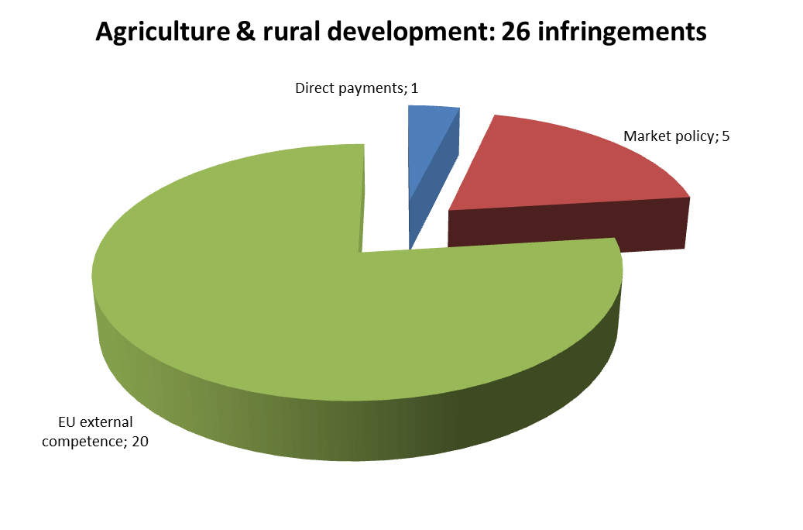
There were 26 open infringement cases in the area of agriculture & rural development at the end of 2012. This was the 11th highest number of cases in the Commission’s 21 reporting policy areas. They can be broken down as follows:
The Commission launched one infringement procedure in the area of agriculture in 2012 by sending a letter of formal notice. The case was against France for imposing a tax on milk producers who exceeded their individual milk quotas, although the national quota had not been exceeded. The French tax significantly interferes with the functioning of the system of milk quotas and surplus levies, as established by the Single CMO.
TRANSPOSITION OF DIRECTIVES
The Commission did not open any late transposition infringement cases in the area of agriculture in 2012.
COMPLAINTS
The Commission received 59 complaints in the agricultural area in 2012, substantially fewer than in 2011 (86). It fully closed 45 of these and transferred 11 to EU Pilot for pre-infringement discussions with Member States.
Complaints mainly concerned: wine and spirits (use of protected designations, membership in a producers’ group, respecting the Single CMO rules and principles); quality schemes; and organic farming. The Commission received many complaints about a new piece of Polish legislation on state-owned agricultural estate management, which limited the size of agricultural land leased to farmers and obliged leaseholders to purchase farms within a certain timeframe. As in previous years, many complaints concerned the granting of direct payments and national authorities’ selection of rural development support beneficiaries.
Petitions received from the European Parliament resulted in EU-Pilot files being sent to: Ireland (for using the ‘‘Farmed in the Republic of Ireland’’ logo on milk and cream products); and Greece (on single payment deductions made by the Agricultural Bank of Greece).
OWN-INITIATIVE CASES
The Commission launched cases in the wine sector and on the compulsory use of language in labelling. It opened many own-initiative EU Pilot files on organic farming. The press had revealed serious cases of fraud in labelling non-biological products as organic ones in two Member States. Information collected showed significant deficiencies in the monitoring of organic production in these Member States. The Commission had to ensure that national authorities adopted or were about to adopt measures to improve and strengthen their monitoring systems and to take measures in relation to the fraudulently-labelled products still in circulation. One of these cases is still pending, as the replies to certain questions were not satisfactory.
EARLY RESOLUTION OF INFRINGEMENTS
The Commission opened and processed 22 new EU Pilot files on agricultural issues in 2012. In 21 cases, it accepted the Member State’s explanation or commitments (95 % acceptance rate). At the end of 2012, 17 files were still open.
The Commission closed the Italian case on fraudulently-labelled organic products because the Italian national authorities provided accurate and detailed information, seriously addressed the problem and took appropriate remedial measures (legislative or other).
IMPORTANT JUDGMENTS
In 2012, the Court delivered one judgment under Article 258 TFEU in the area of EU agricultural law. It confirmed that the Czech Republic had failed to fulfil its obligations under the Single CMO Regulation by allowing a milk product that cannot be classified as ‘‘butter’’ to be marketed under the ‘pomazánkové máslo’ (butter spread) sales designation.
In a preliminary ruling on the nature of sanctions in the CAP area, the Court confirmed the view of the Commission and judged that sanctions on direct payments were of an administrative nature. Therefore, a sanction imposed by a national paying agency due to over-declaration of areas does not prevent the farmer’s prosecution under national criminal law.
Outlook
Important implementation work in 2013 includes:
- Cases in which Member States do not apply common rules and therefore jeopardise the common agricultural policy’s effectiveness
- Pursuing infringement cases under the reformed CMO rules in the wine sector and those affecting the direct payment regime
- Use of the clearance of accounts procedure to ensure that Member States maintain proper management and control systems
Further information is available at:
http://ec.europa.eu/dgs/agriculture/index_en.htm

FINANCIAL PROGRAMING AND BUDGET
In 2012, the Commission detected only 138 anomalies in the area of traditional own resources (there were 309 in 2011) and set 56 value added tax (VAT) and 255 gross national income (GNI) reservations. Correspondingly, 680 accounting actions for traditional own resources (844 in 2011) and 465 for VAT/GNI (185 in 2011) were chosen for potential corrective payments, which would have included principal amounts and belated interest to be paid by Member States. Most of the newly detected anomalies were solved at an early stage in bilateral discussions with Member States, including senior-level management meetings, or in the Advisory Committee on Own Resources.
Further information is available at:
http://ec.europa.eu/dgs/budget/index_en.htm

CLIMATE ACTION
GENERAL STATISTICS
There were 35 open infringement cases in the climate action area at the end of 2012, the tenth highest caseload in the Commission’s 21 reporting policy areas. The cases can be broken down as follows:
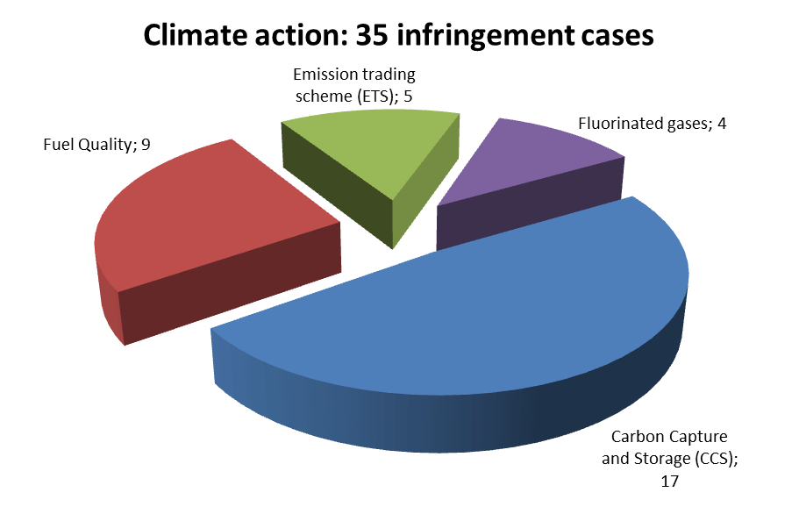
The Commission opened 19 infringement cases in the climate action area in 2012, mostly due to late transposition. These included in particular cases against Greece and Poland for failure to notify the Commission about putting in place certification and training systems for companies and personnel working with fluorinated gases, as required by the Regulation on certain fluorinated greenhouse gases.
None of the climate action cases were referred to the Court in 2012. There were also no Court judgments under Article 258 TFEU in the field of climate action.
TRANSPOSITION OF DIRECTIVES
The Commission launched 11 infringement cases in 2012 because of missing or partial national implementing rules. It launched six late transposition cases due to delays in communicating national implementing measures for the directive on fuel quality. Several Member States notified the Commission of their implementing rules, so some of these cases were closed by the end of 2012. Still, there remained 31 open late transposition cases in the area of climate action by the end of 2012.
COMPLAINTS
The Commission received six complaints on climate issues in 2012 (there were 6 cases in 2011, too). It handled eight and transferred three to EU Pilot for discussion with Member States.
OWN-INITIATIVE CASES
In addition to launching the infringement cases against Greece and Poland (mentioned above), the Commission also sent reasoned opinions to Malta and Italy for incorrectly applying the regulation on fluorinated greenhouse gases.
EARLY RESOLUTION OF INFRINGEMENTS
The Commission opened 17 files on climate action in EU Pilot in 2012. It assessed 30 files in 2012 and accepted 16 Member State replies (53 % success rate). There remained 5 open EU Pilot files in this area by the end of 2012.
IMPORTANT JUDGMENTS
The Court did not deliver any judgments or preliminary rulings in the area of climate action in 2012.
Outlook
Important implementation work in 2013 includes:
- Verifying that national transposition measures comply with the four flagship directives (aviation in emissions trading, extension of the emissions trading system, fuel quality rules and geological storage of CO₂)
- Continuing to monitor the correct application of the regulations on fluorinated greenhouse gases and ozone depleting substances

Further information is available at:
http://ec.europa.eu/clima/news/index_en.htm

COMMUNICATIONS NETWORKS, CONTENT & TECHNOLOGY
GENERAL STATISTICS
There were 24 open infringement cases in the area of communications networks, content & technology at the end of 2012. This was the 12th highest number of cases in the Commission’s 21 reporting policy areas. The cases can be broken down as follows:
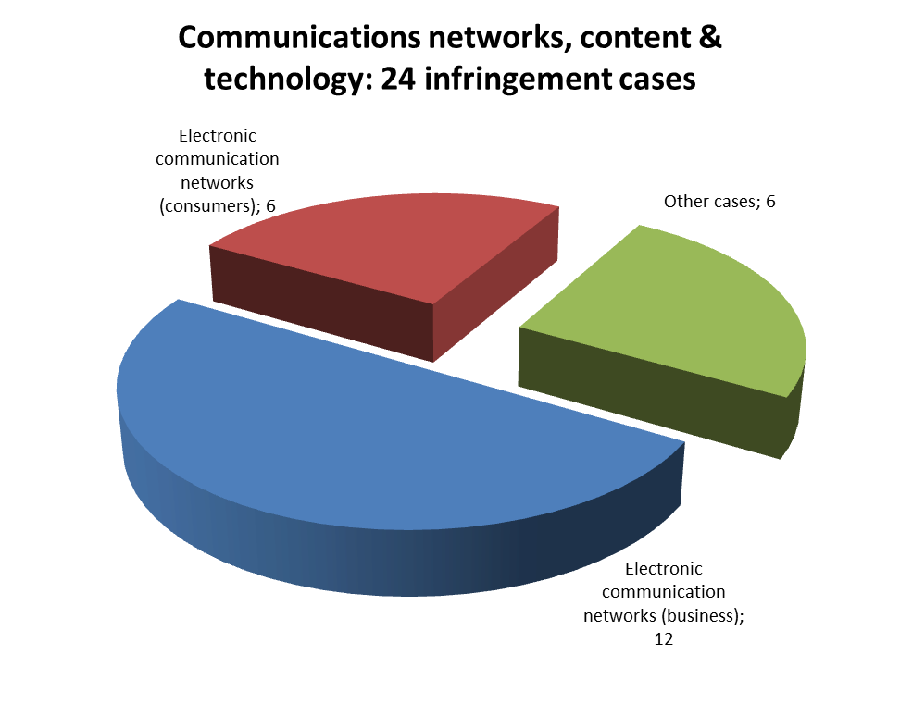
The Commission launched four new infringement cases in this area in 2012 by sending letters of formal notice. In addition, it sent reasoned opinions to the Netherlands and Italy for non-compliance with the requirements of the Framework Directive and the Access Directive (Dutch legislation interferes with the National Regulatory Authority’s independence, tasks and responsibilities, while Italian legislation pre-empts the National Regulatory Authority’s margin of discretion in using its regulatory powers to ensure that the measure adopted is appropriate to tackle the competitive problems reported in the market analysis).
The Commission referred 13 cases to the Court in 2012 in relation to telecommunication issues. It contested Hungary's special tax on telecom operators. There were two referrals under Article 260(2) TFEU (see next paragraph) and ten under Article 260(3) TFEU (see next section).
At the end of 2012, five cases that were launched due to non-compliance with a Court judgment under Article 258 TFEU were still open. For two of them, a letter of formal notice was sent to Belgium and Portugal under Article 260(2) TFEU and then the cases were referred to the Court. The Commission asked the Court to fine Portugal for not respecting a 2010 Court judgment requiring compliance with EU telecoms rules when deciding who should provide universal service in Portugal.
TRANSPOSITION OF DIRECTIVES
No infringement cases caused by late transposition in the area of communications networks, content and technology were launched in 2012 (39 in 2011). Seven on-going late transposition infringement cases were still open at the end of 2012.
The Commission referred ten cases to the Court under Article 260(3) TFEU, proposing financial sanctions because of late transposition of: the Citizens’ Rights Directive (Belgium, the Netherlands, Poland, Portugal and Slovenia); the Better Regulation Directive (Belgium, the Netherlands, Poland and Slovenia); and the Directive amending the Audiovisual Media Services Directive (Poland).
COMPLAINTS
The Commission received 28 complaints relating to communication networks in 2012 (32 in 2011). Of the 34 complaints the Commission processed in 2012, it fully closed 13 and transferred 17 to EU Pilot for discussion with Member States. As in previous years, most complaints received in 2012 concerned national telecommunications rules.
OWN-INITIATIVE CASES
The Commission assessed Member States’ compliance with the Audiovisual Media Services Directive and identified issues with implementing EU laws on electronic communications (e.g. independence of the national regulators). It sent Estonia a reasoned opinion and urged it to ensure the national regulator’s independence, as required by the Framework Directive.
EARLY RESOLUTION OF INFRINGEMENTS
The Commission opened 34 new EU Pilot files on electronic communications issues and processed 49 in 2012. In 29 cases, it accepted the Member State’s explanations or actions (59 % success rate). At the end of 2012, 54 files were still open.
Several cases of non-conformity with EU electronic communications rules were closed in 2012 before the Court issued a judgment because Member States complied with EU law. They included cases against Greece, Hungary, the United Kingdom and Denmark. A case against Hungary on the incorrect transposition of the directive on re-using public sector information was also closed because Hungary complied with EU rules.
IMPORTANT JUDGMENTS
There were no particularly important judgments in the area of communications networks, content and technology in 2012.
Outlook
Important implementation work in 2013 includes:
- Monitoring correct transposition of the ‘revised framework for electronic communications’ (Citizens’ Rights and Better Regulation Directives); priorities include: independence of national regulators, respect for consultation procedures and consumer protection.
- Monitoring the correct implementation of the Audiovisual Media Services Directive

Further information is available at:
http://ec.europa.eu/dgs/connect/index_en.htm
COMPETITION
PRIORITY AREAS
In 2012, the Commission focused on monitoring the non-discriminatory assignment of broadcasting spectrum freed by the introduction of digital terrestrial television broadcasting (the so called ‘digital dividend’). It investigated several Member States to establish whether they have assigned parts or all of the ‘digital dividend’ by using open and transparent procedures, which are based on proportionate, objective and non-discriminatory criteria.
In particular, the Commission sent a reasoned opinion to Bulgaria because of the limitations and prohibitions laid down in its legislation on tenders for assigning the digital terrestrial broadcasting spectrum appeared to be in breach of the competition directive, the framework directive and the directive on authorising electronic communications networks.
The Commission also handled a number of complaints concerning the postal sector, as 2012 was the last year before the Postal Directives’ full liberalisation obligation entered into force. For example, the Commission's action resolved a situation where a Member State attempted to protect the incumbent by imposing excessive registration requirements for alternative postal operators.
FOLLOW-UP OF STATE AID DECISIONS
The Commission launched two infringement proceedings against Italy for failure to implement two Court judgments, which ordered the recovery of incompatible state aid provided to enterprises that invested in the communities hit by the 2002 natural disasters and to those located in the Venice and Chioggia areas.
Proceedings under Article 260 TFEU, which obliges a Member State to recover incompatible state aid following a Commission Decision, remain an important part of the Commission’s infringement work in this area. In 2013, the Commission will continue to refer long standing non-recovery cases to the Court to ensure effective recovery.
IMPORTANT JUDGMENTS
The Court annulled the 2008 Commission Decision that found Greece to be infringing Articles 106 and 102 TFEU by giving the Public Power Corporation (PPC) privileged access to lignite, which created unequal opportunities in electricity production and enabled PPC to maintain or reinforce its dominant position on the Greek wholesale market. In a parallel dispute between the same parties, the Court has also annulled the 2009 Commission Decision that imposed specific remedies proposed by Greece to resolve this competition problem. The Commission has appealed both judgments.
The Court condemned Spain under Article 260(2) TFEU for failing to recover aid granted to Magefesa and imposed a lump sum and daily penalty payments.
Further information is available at:
http://ec.europa.eu/dgs/competition/index_en.htm
EDUCATION AND CULTURE
There were eight open infringement cases on education and culture issues at the end of 2012.
The Commission launched three new infringement cases in this area in 2012 by sending letters of formal notice. One was against the Netherlands for discriminating against students from other Member States in matters of access to higher education. The second was also against the Netherlands, for applying residence requirements to eligibility for lower statutory tuition fees at Dutch universities. The third was against Slovakia for indirectly discriminating against nationals of other Member States by making the examination requirements for the traditional academic title most easily met by Slovak nationals.
The Commission received 34 complaints relating to education and culture in 2012. Out of the five complaints it assessed, three were closed and two were transferred to Member States for discussion within the framework of EU Pilot.
The Court issued one judgment in 2012, against Austria. It found that Austria was in breach of its obligations under the Treaty (Articles 18, 20 and 21 TFEU) and the Free Movement and Residence Directive, because it granted reduced public transport fares only to students whose parents received Austrian family allowances.
Further information is available at:
http://ec.europa.eu/dgs/education_culture/index_en.htm

ECONOMIC AND FINANCIAL AFFAIRS
In January 2012, the Commission opened an infringement procedure against Hungary for an alleged breach of the Central Bank’s independence under Article 130 TFEU. It voiced concerns about national legislation amendments that provided for various possibilities to influence the Hungarian Central Bank. The Commission closed this infringement procedure when the Hungarian Central Bank statute and transitional provisions of the Fundamental Law were put in line with Article 130 TFEU. Moreover, the Ministry of Finance stopped issuing press releases that aimed to influence the Hungarian Central Bank’s monetary policy.
However, shortly afterwards, Hungary adopted the Law on the Financial Transaction Duty, which affected the independence of the Hungarian Central Bank. It was to come into force on 1 January 2013 and would have restricted the Bank’s ability to freely select the monetary policy instruments needed to reach its primary objective of price stability, thereby hampering its independence. In addition, the financial transaction duty to be paid by the Bank would have been equivalent to 0.4 % of Hungary’s Gross Domestic Product, 10 times higher than the bank’s annual operational budget. This kind of credit to the public sector would have been a breach of the prohibition of monetary financing under Article 123 TFEU. Therefore, another infringement case on the Bank’s independence was planned for 2012, but Hungary amended the law after discussions with the Commission.
Further information is available at:
http://ec.europa.eu/dgs/economy_finance/index_en.htm

ENLARGEMENT
An earlier judgment of the Court in this area condemned the Netherlands for charging disproportionately high fees when issuing residence permits to Turkish nationals who acquired the right of residence. The Dutch authorities aligned the fees with those charged for similar documents issued to EU citizens, but the question of possible reimbursement of Turkish citizens who had paid disproportionately high fees in the past remains. The Commission is in contact with the Dutch government on this issue.
The Court issued a number of judgments in 2012 on interpretation of the EU-Turkey association law referred by national jurisdictions for preliminary ruling. The Commission continues to receive complaints on the application and interpretation of certain provisions of the EU-Turkey association law, in particular on the alleged violation by a number of Member States of the standstill clauses set out in the instruments governing the relations between Turkey and the EU.
Further information is available at:
http://ec.europa.eu/enlargement/index_en.htm

EMPLOYMENT, SOCIAL AFFAIRS & INCLUSION
GENERAL STATISTICS
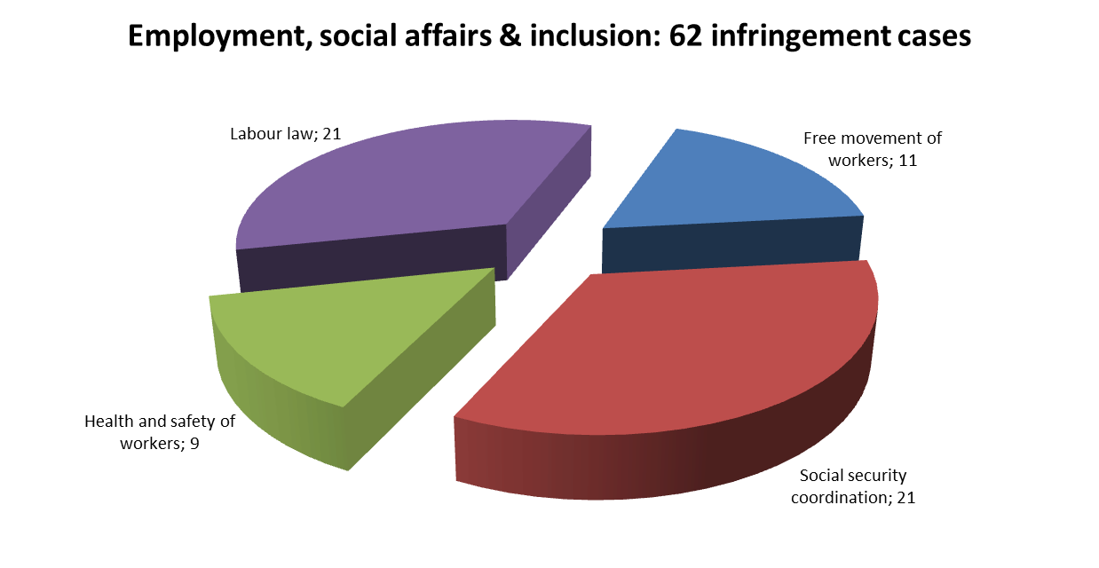
There were 62 open infringement cases in the area of employment in 2012. This was the seventh highest number of cases in the Commission’s 21 reporting policy areas. The areas can be broken down as follows:

The Commission launched 41 infringement cases in the employment area in 2012. For example: Slovakia refused to pay certain disability allowances to eligible people residing in another Member State; Luxembourg limited to 12 years the duration of foreign professional experience that could be taken into account in determining public sector employees’ working conditions; in France, doctors’ working time in public hospitals did not respect the minimum rest periods under the Working Time Directive and the conditions for using the ‘opt-out’ clause.
The Commission referred Italy to the Court in 2012 because its legislation and practice excluded managers from procedural guarantees (information and consultation of workers’ representatives) in case of collective layoffs.
By the end of 2012, Germany and the Netherlands had not complied with Court judgments made under Article 258 TFEU, which condemned the residence conditions when granting benefits for the blind, deaf and disabled and for migrant workers and dependent family members to pursue higher education abroad, respectively.
TRANSPOSITION OF DIRECTIVES
The Commission launched 25 infringement cases in 2012 because of failure to transpose of the Temporary Agency Work Directive (15 cases) and the directive on occupational limit values for chemical agents. (10 cases) Only six late transposition cases were still open at the end of 2012.
COMPLAINTS
The Commission received 309 complaints on employment issues in 2012, more than in 2011 (269).
In the area of the free movement of workers, most complaints concerned: access to and working conditions in the public sector (especially recognition of professional experience and qualifications acquired in other Member States); access to study grants (restrictive criteria for providing study grants, employment obligation for graduates); and obstacles to the free movement of professional sports players. There were several complaints on social security coordination rules, including on determining the applicable legislation, levying social security contributions, refusal to issue or accept the European Health Insurance Cards, granting healthcare to pensioners, non-export of long-term care benefits, access to special non-contributory benefits, entitlement to and calculation of pensions. Health and safety complaints mainly concerned the incorrect or bad application of the Framework Directive, the Construction Sites Directive and the Asbestos Directive. There were 33 labour law complaints on breaches of the Working Time Directive, including on paid annual leave for police forces in the Basque Region. Numerous complaints concerned fixed-term employment in the education sector, especially in schools.
The Commission handled 298 complaints in 2012. It closed 193 and transferred 44 to EU Pilot for discussion with Member States.
EARLY RESOLUTION OF INFRINGEMENTS
The Commission opened 61 files in EU Pilot and processed 50 in 2012. In 32 cases, it accepted the Member State’s explanations or commitments (64 % success rate). At the end of 2012, 42 files were still open.
Potential cases were resolved early in several areas, including: the free movement of workers (Greece started to recognise post-graduate diplomas acquired abroad when deciding on workers' salaries and promotions) health and safety (the UK complied with the Asbestos Directive); and labour law (Belgium removed rules under which certain workers were obliged to postpone their right to annual leave for up to 12 months, which goes against the Working Time Directive).
IMPORTANT JUDGMENTS
The Court ruled that: a Member State can grant family benefits to posted or seasonal workers who are resident in another Member State. If they do this, they cannot exclude workers entitled to comparable benefits in another Member State; study grants for children of migrant workers could not be dependent on the country of residence; frontier workers’ working conditions could not be less favourable than those of national workers and accordingly, the salary top-up paid to frontier workers who work part time before retiring cannot be calculated in a way that penalises them in comparison with national workers; and according to the Working Time Directive, Member States cannot make paid annual leave conditional on a minimum period of 10 days’ work or one month’s actual work during the reference period and the paid annual leave cannot be affected by an employee’s sick leave.
Outlook
Important implementation work in 2013 includes:
- Access to benefits based on residence, public sector posts and study grants for workers and their families
- Issuance and acceptance of the European Health Insurance Card
- Occupational health and safety: implementation of the directive on sharp injuries
- Correct transposition of the Temporary Agency Work Directive

Further information is available at:
http://ec.europa.eu/social/home.jsp
ENERGY
GENERAL STATISTICS
There were 93 open infringement cases in the area of energy at the end of 2012 (as compared to 149 in 2011). This was the sixth highest number of cases in the Commission’s 21 reporting policy areas. The Commission’s total caseload was broken down as follows:
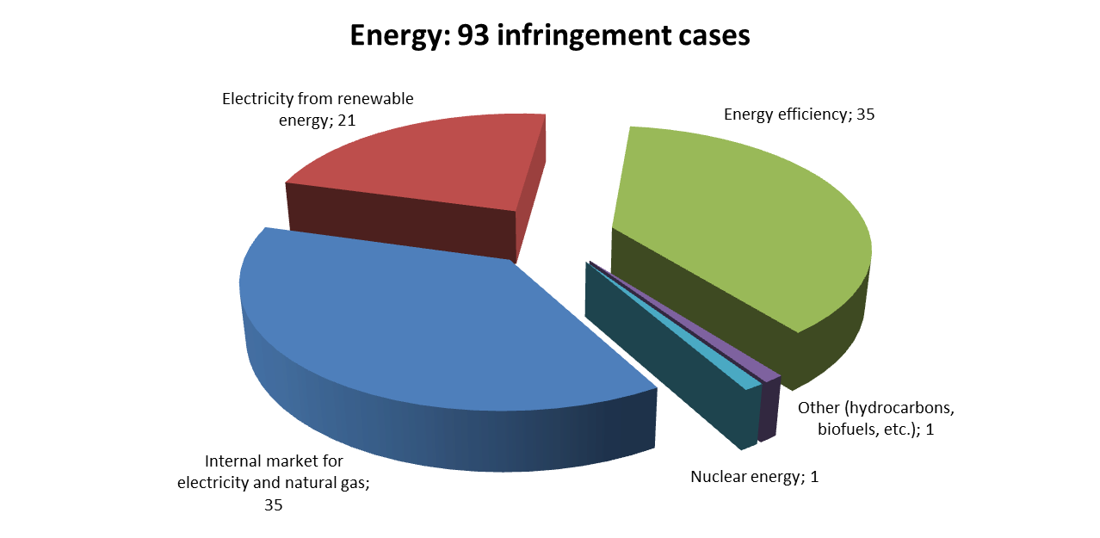
In 2012, the Commission launched 27 new energy infringement procedures by sending letters of formal notice. Most of these cases were launched because of the Member States not or only partially transposing directives by the transposition deadlines (see below). Romania and the Czech Republic received a letter of formal notice due to insufficient reporting under the Gas Supply Regulation and the Renewable Energy Directive, respectively.
The Commission referred nine energy infringement cases to the Court in 2012. Italy was referred because it did not correctly implement the former Directive on buildings’ energy performance as regards energy performance certificates and inspections of air-conditioning systems. The UK and Ireland failed to make the necessary arrangements to ensure the maximum interconnection capacity between their gas transmission systems, as the pipeline connecting Northern Ireland and Ireland was not open to the market. The other six referrals were because of incomplete transposition of two energy directives (see below).
TRANSPOSITION OF DIRECTIVES
The Commission launched 24 new late transposition infringements in the area of energy in 2012 (121 in 2011). By the end of 2012, there were 75 open late transposition infringement procedures in this area.
All 24 new late transposition infringement cases were due to Member States failing to transpose, entirely or partly, the new Directive on buildings’ energy performance.
As a number of Member States notified the Commission of measures fully transposing the two directives in the Third Energy Package, many of the corresponding infringements could be closed. The Commission however, had to refer Finland, Poland and Slovenia to the Court with a proposal for penalties under Article 260(3) TFEU since these countries only partially transposed the directives.
COMPLAINTS
The Commission received 71 complaints on energy matters in 2012, a slight increase compared to 2011 (57 incoming complaints). Two-thirds of these complaints concerned renewable energy and the internal market in electricity and gas. The other complaints were about energy efficiency, licences for prospection and expropriation of hydrocarbons, and nuclear energy. The Commission processed 47 energy complaints. Most complainants (28) received a full response, but 17 files had to be transferred to EU Pilot for further discussion with the Member States.
OWN-INITIATIVE CASES
The Commission launched all the new energy infringement cases in 2012 and referred others to the Court (see the ‘General statistics’ section above) on its own initiative. In addition to the progress made in these cases, the Commission also sent an additional reasoned opinion concerning another own-initiative case claiming that the system of regulated gas prices in France did not comply with the Gas Directive.
EARLY RESOLUTION OF INFRINGEMENTS
The Commission opened 50 new EU Pilot files on energy issues and processed 39 files during 2012. In 32 cases, the Commission accepted the Member State’s explanation and/or commitments made (82 % success rate). By the end of 2012, 29 energy files were still open in EU Pilot.
The Commission closed a number of cases in 2012 due to several Member States bringing their price regulation systems in compliance with EU law (adoption of legislation phasing out regulated electricity prices in France and Greece; adoption of legislation phasing out regulated electricity and gas prices in Portugal and Romania).
IMPORTANT JUDGMENTS
The Court annulled the Council Regulation on the notification of investment projects in energy infrastructure because its legal basis had not been selected correctly. The Court took the view that this Regulation should have been adopted under the new legal basis for energy legislation in the Treaty (Article 194(2) TFEU), which requires an ordinary legislative procedure, and not under Article 337 TFEU, which requires the Council’s simple majority. The effects of the annulled Regulation are maintained until a new regulation is adopted on the correct legal basis enters into force.
Outlook
Important implementation work in 2013 includes:
- Timely transposition of the Directive on spent nuclear fuel and radioactive waste
- Conformity checks under the Third Energy Package and the Nuclear Safety Directive
- Conformity checks under the Directive on buildings’ energy performance

Further information is available at:
http://ec.europa.eu/dgs/energy/index_en.htm
ENTERPRISE & INDUSTRY
GENERAL STATISTICS
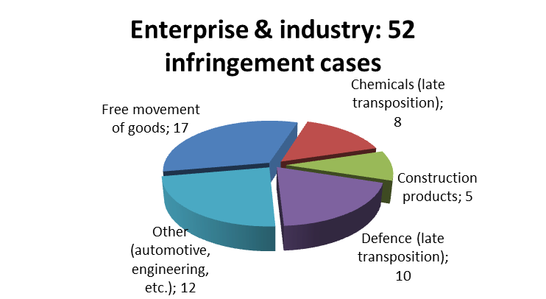
There were 52 open infringement cases in the area of enterprise & industry at the end of 2012. This is the ninth highest number of cases in the Commission’s 21 reporting policy areas. The caseload was broken down as follows:

The 29 new enterprise infringement cases related mostly to provisions ensuring the free movement of goods. Letters of formal notice were sent to, among others: Poland (concerning import rules on the fast-growing food supplement market); Romania (due to its gas export ban); and Germany (because it set conditions for marketing chemical substances beyond those of the REACH Regulation).
The Commission brought three enterprise cases before the Court. Two of them contested the additional German requirements on construction products already bearing the CE-mark; the judgment could impact the so-called Bauregellisten. Spain was referred to the Court because of Spain’s import barriers on heavy-goods vehicles.
At the end of 2012, only two Court judgments made under Article 258 TFEU in this area still had to be implemented by the Member States. In one of these cases, the Commission opened the procedure under Article 260(2) TFEU as the Member State did not make sufficient progress in complying with the judgment.
TRANSPOSITION OF DIRECTIVES
The Commission launched 19 new enterprise infringement procedures in 2012 because of Member States’ missing or partial national transposition measures for various directives. In all, 24 late transposition cases were still open at the end of 2012.
Eight infringement procedures had to be launched because of missing or partial updates to the defence-related products list. Further eight procedures were also launched under the Directive on the identification and traceability of civil explosives.
COMPLAINTS
The Commission received 152 new complaints concerning enterprise in 2012, a moderate increase over 2011 (124 incoming complaints). Most complaints received concerned national laws on motor vehicles (registration rules) going against the Treaty’s free movement of goods provisions. Other complaints related to pharmaceutical products, foodstuffs and food supplements, and construction products.
From the 133 processed enterprise complaints in 2012, the Commission closed most of them (63) by sending a full response to the complainant and transferred 54 to EU Pilot to be discussed with the Member States.
EARLY RESOLUTION OF INFRINGEMENTS
The Commission opened 62 new EU Pilot enterprise files in 2012 and processed 37 files. 17 assessments were positive, i.e. the Commission accepted the Member State’s explanation or actions (46 % success rate). In all, 60 files were still open in EU Pilot at the end of 2012.
Member States settled many major enterprise infringement cases with the Commission without litigation or before a Court judgment was delivered. For example: Spain modified its rules on the prior notification of medicines for export; the new French rules on the safety requirements for fire fighters’ hoods now respect EU standards; Italy repealed the law that restricted the import of bottled drinking water; and Greece annulled surface area requirements for preparing ‘bake-off’ products.
IMPORTANT JUDGMENTS
The Court passed one judgment under Article 258 TFEU in the field of enterprise in 2012: The Belgian car registration laws were condemned as they were not in line with the Treaty’s rules on the free movement of goods (such as the systematic requirement of the vehicle’s certificate of conformity and the rejection of roadworthiness tests carried out in other Member States).
The Court’s preliminary rulings confirmed that private law bodies must respect the principle of the free movement of goods, if the products these bodies certify are legally considered compliant with national law. It also found that parts of the Polish gambling law could constitute ‘technical regulations’ in so far as it established that the provisions in question constituted conditions which can significantly influence the nature or the marketing of the product concerned, which is a matter for the referring court to determine. In such a case their drafts should be cleared with the Commission before being adopted. Finally, the Court upheld retailers’ right to import tobacco from other Member States, which could impact state monopolies.
Outlook
Important implementation work in 2013 includes:
- Ensuring timely and correct transposition of the Late Payment Directive
- Following up the correct application of the Construction Products Regulation
- Subject to Court judgments, verification of registration rules for right-hand drive vehicles.

Further information is available at:
http://ec.europa.eu/enterprise/index_en.htm

ENVIRONMENT
GENERAL STATISTICS
Most of the on-going infringement cases at the end of 2012 (272) concerned the environment, as in previous years. They can be broken down as follows:
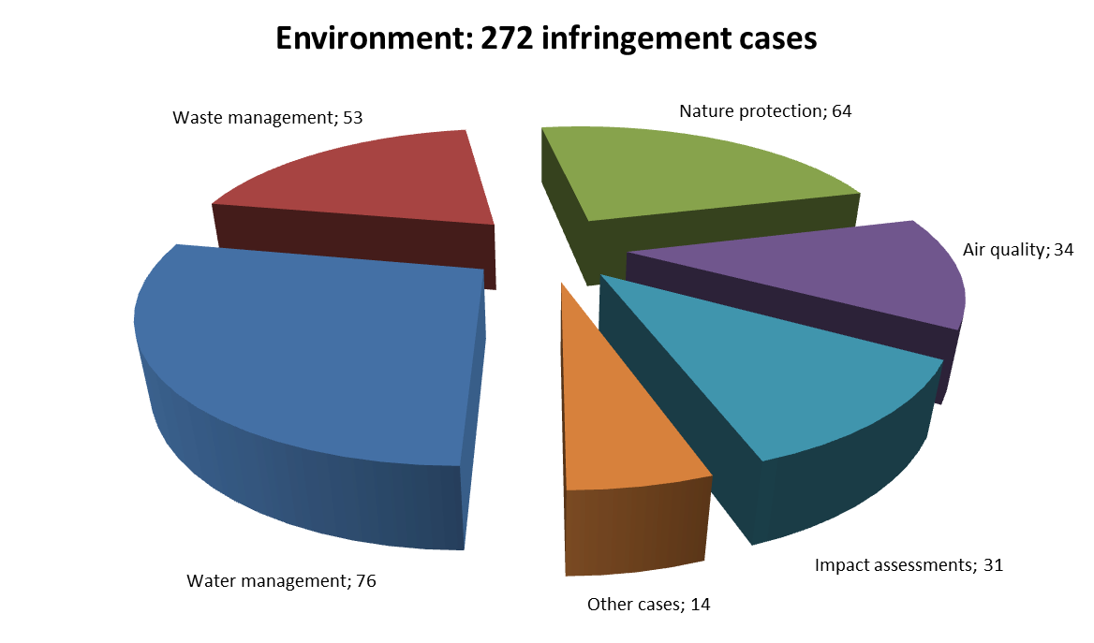
The Commission launched 138 environmental infringement cases in 2012. Several concerned the incorrect transposition of the Environmental Impact Assessment Directive (the screening procedure, interpretation of ‘development consent’), failure to ensure adequate protection of species, and Natura 2000 sites.
The Commission referred 16 environmental cases to the Court, including four for late transposition of the Waste Framework Directive, three for operating landfills below EU standards, and three on water, for narrow interpretation of ‘water services’ in the Water Framework Directive, inadequate treatment of urban wastewater, insufficient designation of zones vulnerable to nitrates and inadequate protection of water from nitrate pollution.
At the end of 2012, Member States had still not fully implemented 35 Court judgments. Correct implementation of EU waste law remains a main challenge. The Commission launched a second referral against Italy in 2012 due to landfill operation. It referred Ireland to the Court for failing to assess all the matters required by the Directive on environmental impact assessment, not ensuring coordination of the authorities during the assessment, and excluding demolition works from the scope of transposing legislation.
TRANSPOSITION OF DIRECTIVES
The Commission launched 63 cases in 2012 due to late transposition of environmental directives.
These included cases against 11 Member States for failing to transpose the Directive on petrol vapour recovery during vehicle refuelling. There remained 13 open late transposition cases in the area of environment by the end of 2012.
The Commission referred Bulgaria, Hungary, Poland and Slovakia to the Court proposing financial sanctions under Article 260(3) TFEU for late transposition of the Waste Framework Directive. It also referred Poland for partial transposition of the Directive on marine strategy.
COMPLAINTS
The Commission received 588 environment complaints in 2012, slightly fewer than in 2011 (604).
Most concerned: nature protection (200); environmental impact assessment (80); waste (70); and water (60). The Commission processed 512 environmental complaints in 2012. It fully closed over half of them (293) and transferred 131 to EU Pilot for discussion with Member States.
The Commission launched two infringement cases (against the United Kingdom and Greece) and 22 EU Pilot discussions with Member States following petitions and questions from the European Parliament. Most of them concerned nature protection, environmental impact assessment and waste management.
OWN-INITIATIVE CASES
The Commission addressed incorrect transposition of key environmental directives, especially in the nature, impact assessment, waste and water sectors. It focused on the fulfilment of strategic obligations under the environmental acquis (e.g. waste collection, recovery and recycling targets) and focused on breaches of protection requirements and quality standards (e.g. misapplied hunting derogations, non-compliant landfills and inadequate wastewater treatment).
EARLY RESOLUTION OF INFRINGEMENTS
The Commission opened 386 environment files in EU Pilot and processed 354 in 2012. In 265 cases, it accepted the Member State’s response (75 % success rate). At the end of 2012, 400 files were still open.
Several important environmental cases were closed in 2012 because of Member States' compliance with EU law. These included cases against 12 Member States for late transposition of the Waste Framework Directive. The Czech Republic, Romania and Denmark respected the Directive on electrical and electronic waste. Hungary complied with the Directives on mining waste and floods. Lithuania and France implemented the Packaging Waste Directive and Slovakia the End-of-life Vehicles Directive. France complied with the Environmental Impact Assessment Directive and Italy with the Directive on strategic environmental assessment. The Markinch combustion plant in the UK is in line with the Large Combustion Plant Directive as its net rated thermal input has been decreased.
IMPORTANT JUDGMENTS
The Court delivered two judgments against Ireland and imposed financial penalties because of its failure to respect earlier judgments on impact assessment of certain agricultural projects and on setting up an inspection system for septic tanks. It established that Belgium, Greece, Portugal and Spain did not adopt the River Basin Management Plans required by the Water Framework Directive.
The Court also delivered a number of important preliminary rulings in 2012.
Outlook
Important implementation work in 2013 includes:
- Monitoring the adequacy of urban waste water treatment rules and adoption of the River Basin Management Plans
- Verifying the timely transposition of the new Industrial Emissions Directive
- Monitoring the transposition of the Air Quality Directive
- Follow-up on Member States’ obligation to designate Special Areas of Conservation under the Habitats Directive
- Court judgments interpreting the Water Framework Directive, the Directive on public participation in strategic environmental assessment and the Aarhus Convention

Further information is available at:
http://ec.europa.eu/dgs/environment/index_en.htm

STATISTICS ON EUROPE

The infringement procedure on Greece’s violation of statistical principles is on-going. The Commission is analysing the current situation and progress made in Greece with a view to determining the actions to take.
The Commission launched two EU Pilot investigations on statistical issues in 2012. One of them concerned national accounts; the other dealt with a farm structure survey. The Commission made progress on investigations launched in the following statistical fields: tourism, carriage of goods by road, science and technology, and structure and activity of foreign affiliates.
Further information is available at:
http://epp.eurostat.ec.europa.eu/portal/page/portal/eurostat/home

HOME AFFAIRS
GENERAL STATISTICS
There were 22 open infringement cases in the area of home affairs at the end of 2012 (60 in 2011). This is the 13th highest number of cases in the Commission’s 21 reporting policy areas. They can be broken down as follows:
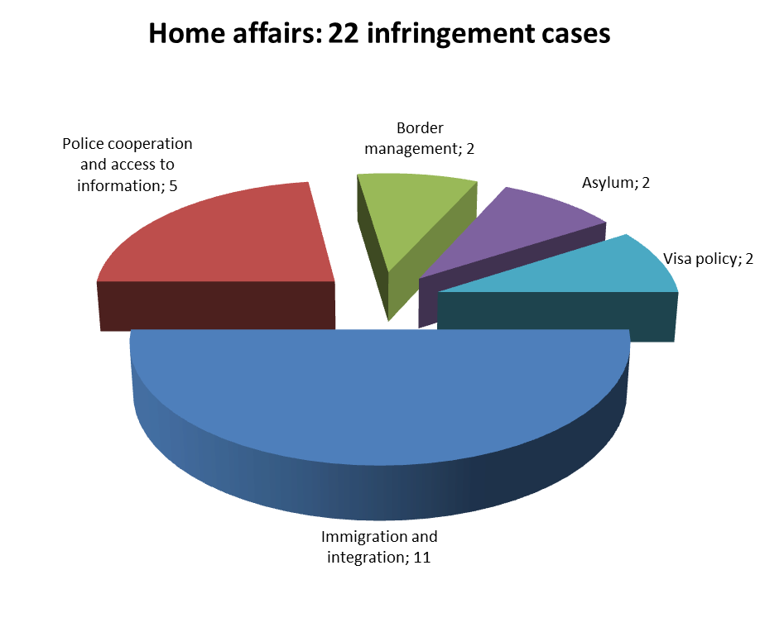
The Commission launched 4 home affairs infringement cases in 2012 against: Belgium for not informing it of transposition measures for the Data Retention Directive; Italy for incorrectly applying the ‘Dublin II Regulation’, the Reception Conditions Directive, the Asylum Procedures Directive, the Qualification Directive, and the Charter of Fundamental Rights; and Austria and Slovakia for obstacles to fluid traffic flow at their common border.
The Commission referred Belgium to the Court for not complying with EU law on security standards and biometrics in passports (Belgium is the last Member State to not issue biometric passports).
At the end of 2012, two cases on non-compliance with a Court judgment made under Article 258 TFEU were still open. The Commission requested only lump sum penalty against Sweden because the transposing measures for the Data Retention Directive were notified during the Court procedure.
TRANSPOSITION OF DIRECTIVES
The Commission launched one late transposition infringement case on home affairs (76 in 2011). At the end of 2012, there were 13 open cases on late transposition of directives.
Germany was referred to the Court with a proposal for financial sanctions under Article 260(3) TFEU due to its incomplete transposition of the Data Retention Directive.
COMPLAINTS
132 home affairs complaints were received in 2012, more than in 2011 (123). Most concerned visas, immigration, asylum, border management, and return policy.
From the 104 home affairs complaints that the Commission processed in 2012, 65 were closed with full response and 9 were sent to EU Pilot for further discussion with Member States.
OWN-INITIATIVE CASES
In 2012, the Commission used EU Pilot to address several Member States because: their bilateral local border traffic agreements with third countries did not comply with the Local Border Traffic Regulation; or they seem to have implemented the Visa Code, the Family Reunification Directive or the Long-Term Residents Directive incorrectly; or they created obstacles to fluid traffic flow at internal borders (e.g., speed limits not based only on road-safety considerations).
EARLY RESOLUTION OF INFRINGEMENTS
The Commission opened 45 home affairs files in EU Pilot and processed 23 in 2012. In 11 cases, it accepted the Member State’s explanations or actions (48 % success rate). At the end of 2012, 40 files were still open.
IMPORTANT JUDGMENTS
The Court ruled against the Netherlands for imposing excessive and disproportionate charges when granting residence permits to third-country nationals seeking long-term resident status.
In preliminary rulings, the Court held that: a Member State should allocate housing benefits also to long-term resident third-country nationals, if they are available to EU citizens; the concept of persecution for religious reasons covers only acts which violate severely basic human rights, whether they interfere with a person’s freedom to practice his faith in private or to live that faith publicly; a Member State must grant the minimum conditions for receiving asylum seekers until the applicant’s transfer, even if it considers that another Member State is responsible for examining the application; a Member State must recognise a person as refugee, if the protection she previously received from United Nations bodies ceased due to reasons beyond her control or independently from her will; and the Schengen Borders Code allows checks at the internal border on foreign nationals to combat illegal stay, under certain guarantees.
Outlook
Important implementation work in 2013 includes:
- Monitoring the transposition of the Directives on the Blue Card, employer sanctions, return, critical infrastructures, long term residents and family reunification
- Court judgments on the Data Retention Directive
- Transposition of the Directives on extending the long-term residents Directive to beneficiaries of international protection, preventing trafficking in human beings and the Qualification Directive
- National provisions on the right to appeal against visa refusals

Further information is available at:
http://ec.europa.eu/dgs/home-affairs/index_en.htm
JUSTICE, FUNDAMENTAL RIGHTS & CITIZENSHIP
GENERAL STATISTICS
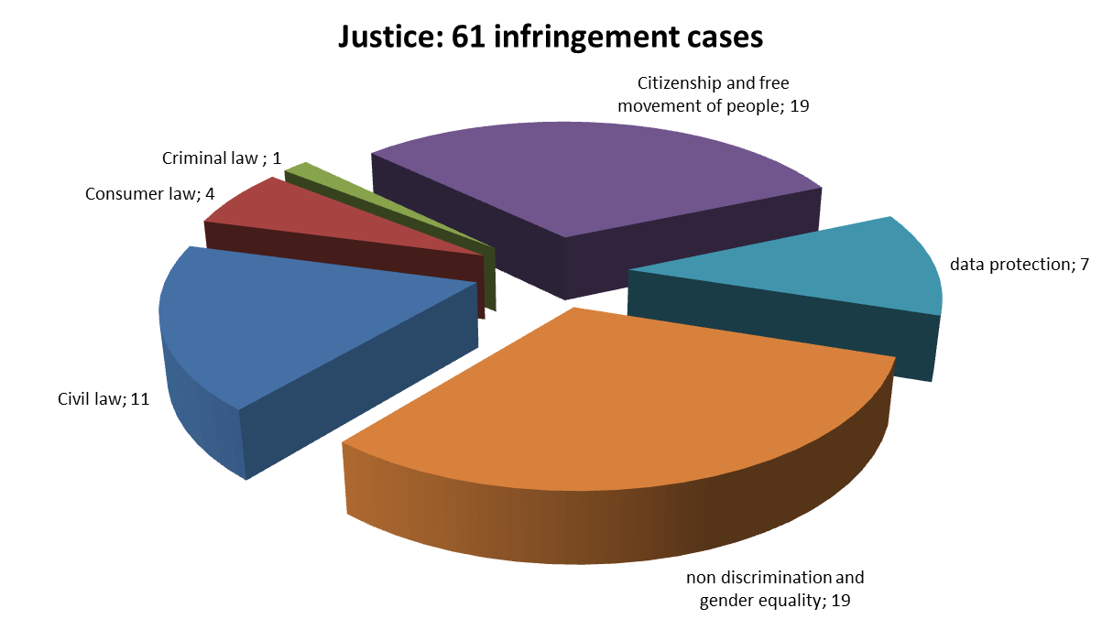
There were 61 open infringement cases in the area of justice at the end of 2012 (72 at the end of 2011). This was the eighth highest number of cases in the Commission’s 21 reporting policy areas. The caseload was broken down as follows:

In 2012, the Commission launched 26 new justice cases by sending letters of formal notice. These included: a case against Malta on discriminating non-Maltese EU citizens in their eligibility for reduced water and electricity tariffs; eight procedures caused by delayed ratification of two international agreements; and cases against Czech Republic and Bulgaria to defend citizens’ political rights (membership in political parties and non-discriminatory participation in local and European Parliament elections).
The Commission referred 7 justice cases to the Court. In particular, it contested Hungary’s new laws on judges’ retirement age as age-based discrimination and argued that Hungary violated the independence of its Data Protection Supervisory Authority. Three referrals were due to late transposition (see below).
By the end of 2012, Member States had not yet complied with 3 justice judgments under Article 258 TFEU. A letter of formal notice was sent to one of them under Article 260(2) TFEU. Member States were still working on the implementation of the two other judgments, which had been passed in late 2012 (see section on important judgments).
TRANSPOSITION OF DIRECTIVES
10 infringement cases were launched in 2012 because of missing or only partially notified national transposition rules for the Directives on parental leave and gender equality in self-employment. 11 late transposition cases were still pending at the end of 2012.
3 late transposition cases were referred to the Court with a request for financial sanctions under Article 260(3) TFEU because Cyprus and the Netherlands had only partially transposed the Mediation Directive and Cyprus did the same for the Environmental Crime Directive.
COMPLAINTS
There were 491 complaints concerning justice in 2012 (433 in 2011). Most concerned the free movement of people, citizenship rights, various forms of discrimination, fundamental rights, civil justice and consumer law.
The Commission fully closed 312 out of the 358 justice complaints it handled in 2012 by sending a full response. It transferred 27 complaints to EU Pilot to be discussed with the Member States.
A question from the European Parliament led to an EU Pilot enquiry that in the end confirmed that Austria correctly implemented a preliminary ruling.
OWN-INITIATIVE CASES
The Commission’s next step was to send reasoned opinions to six Member States because of their incomplete implementation of the Free Movement Directive.
EARLY RESOLUTION OF INFRINGEMENTS
The Commission opened most of the 103 justice files new in EU Pilot in 2012 on its own initiative, to verify the correct transposition of various directives. From the 57 processed EU Pilot files, the Commission accepted 28 Member State responses (49 % success rate). 125 justice files were still open in EU Pilot at the end of 2012.
Important cases closed in 2012 include: acceptance of the registration of double surnames for Swedish children who also have another EU nationality and whose double surname was already registered by another Member State, and alignment of the Equality Act with the Directive on equal treatment in employment in the UK.
IMPORTANT JUDGMENTS
The Court ruled that: the Hungarian laws on the compulsory retirement of judges, prosecutors and notaries when they reach the age of 62 constituted age-based discrimination and the Austrian Data Protection Supervisory Authority lacked the independence required by the Data Protection Directive.
A preliminary ruling of the Court also clarified how Member States should treat EU nationals’ applications for non-EU family members to enter and stay in a Member State.
Outlook
Important implementation work in 2013 includes:
- Full implementation of the Free Movement Directive based on impact studies
- Enforcing citizens’ political rights stemming from the Treaty and secondary law
- Verifying the correct implementation of the Gender Equality Directives
Further information is available at:
http://ec.europa.eu/justice/index_en.htm

MARITIME AFFAIRS AND FISHERIES
GENERAL DEVELOPMENTS
EU maritime laws ensure, inter alia, the direct electronic exchange of fisheries-related data and the monitoring of fishing vessels’ engine power in order to allow the Commission to verify Member States’ compliance. In this framework, the Commission addressed irregularities in the fisheries control systems of Italy and Spain, by launching an inquiry and an action plan, respectively, and monitored the implementation of the action plan adopted with Malta in 2011.
COMPLAINTS
The Commission received four new complaints on fisheries matters during 2012 and treated 12, out of which 3 were transferred to EU Pilot to obtain clarifications from the Member State concerned.
OWN-INITIATIVE CASE
The Commission learnt that Italy gained access to certain Mediterranean third countries' waters via bilateral agreements, which violates the EU’s exclusive external competence under the Common Fisheries Policy (CFP). It sent Italy a letter of formal notice under Article 258 TFEU. By the end of 2012, the Italian authorities had responded constructively and committed to withdrawing the non-compliant provisions of the agreements. The next step will depend on Italy providing evidence of this remedial action.
EARLY RESOLUTION OF INFRINGEMENTS
In 2012, the Commission opened 42 new EU Pilot files on matters related to the CFP, bringing the number of EU Pilot cases in the maritime field to 55. Of the 46 files treated during 2012, the Commission assessed 32 positively (70 % success rate).
FOLLOW-UP TO COURT JUDGMENTS
The Court ruled against Italy in 2009 for failure to prohibit the use of illegal driftnets, as is required by EU rules. Italy’s remedial action was not satisfactory, so the Commission sent a letter of formal notice under Article 260(2) TFEU. In response, the Italian authorities referred to a series of adopted or planned measures that would remedy the situation. The Commission monitored the Italy's progress in 2012 also via local inspections. Due to the inconclusive results, the decision on whether to refer the case to the Court for a second time (with a proposal for financial sanctions) is still pending.
The Court ruled against Spain in 2008 for insufficient monitoring of landings and marketing of undersized fish and inadequate action against breaches of the corresponding EU rules. The Spanish authorities notified the Commission of a number of measures they had taken in order to implement the judgment. The Commission carried out several inspections in late 2011 and in 2012 to verify whether these measures were sufficient. It found Spain’s progress satisfactory and closed the case.
Further information is available at:
http://ec.europa.eu/dgs/maritimeaffairs_fisheries/index_en.htm

INTERNAL MARKET AND SERVICES
GENERAL STATISTICS
At the end of 2012, 167 internal market cases remained open, the 4th highest number in the Commission’s 21 reporting policy areas. The Commission’s total caseload was broken down as follows:
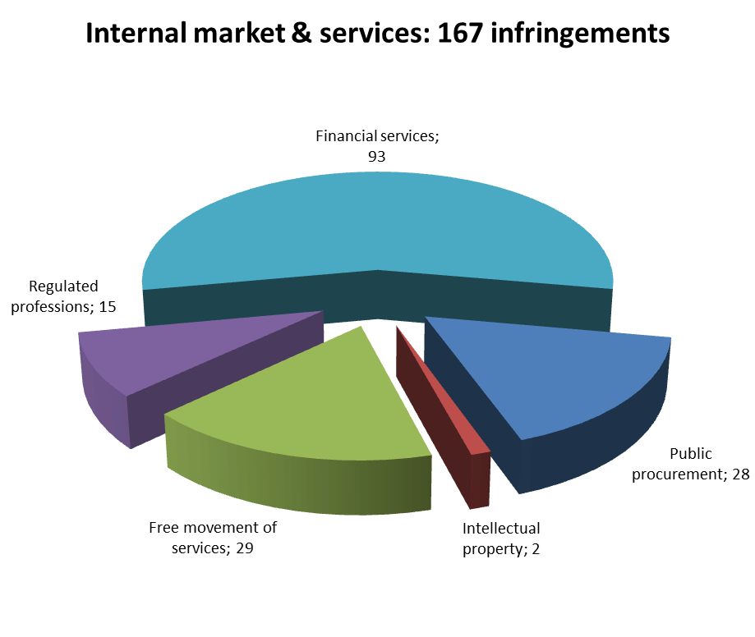
The Commission's letters of formal notice launched 72 internal market infringement cases in 2012 against, for example: Italy (failure to publish tenders for public health services); Slovakia (exemption of health insurance companies from the Non-Life Insurance Directives); and Bulgaria (charging privatised assets with state mortgages).
Amongst others, the Commission referred Greece to the Court because it had disregarded EU public procurement rules when purchasing an IT system for the Social Security Foundation (IKA).
At the end of 2012, 17 internal market judgments made by the Court under Article 258 TFEU had not yet been implemented by Member States. In 7 cases, the Commission started infringement procedures under Article 260(2) TFEU because Member States did not sufficiently progress in complying with the judgment. The Commission had already referred two cases to the Court requesting financial sanctions.
TRANSPOSITION OF DIRECTIVES
53 infringement cases were launched in 2012 due to missing or only partially notified national transposition measures for internal market directives. In all, 77 such cases remained open at the end of 2012.
In particular, 18 late transposition cases were started under the Prospectus Directive.
The Netherlands, Luxembourg, Poland and Slovenia were referred to the Court with a proposal for financial sanctions under Article 260(3) TFEU due to the late transposition of the Directive on defence procurement and so was Belgium for the incomplete transposition of the eMoney Directive.
COMPLAINTS
In 2012, 462 internal market complaints were received (530 in 2011), mostly on public procurement, services and regulated professions.
The Commission closed 303 of the 469 internal market complaints it handled in 2012 by sending a full response. It transferred 130 to EU Pilot for discussion with Member States.
Upon the European Parliament’s questions, electrical service providers’ authorisation and the purchase of diesel trains without public tender were investigated.
OWN-INITIATIVE CASES
Own-initiative investigations targeted problems mostly in public procurement, services and regulated professions.
EARLY RESOLUTION OF INFRINGEMENTS
The Commission opened 196 internal market files in EU Pilot in 2012, and processed 141. In 115 cases, it accepted Member States’ responses (81 % success rate). At the end of 2012, 176 internal market files remained open in EU Pilot.
Member States’ actions settled many disputes before Court procedure. For example: Romania and Malta removed their nationality condition for public notaries; Bulgaria annulled a security services contract for its national electricity company due to misapplied EU public procurement rules; France modified its sector-based authorisation procedure for foreign investments; and Cyprus corrected its rules on buying secondary residences.
IMPORTANT JUDGMENTS
Among other, the Court ruled that: the prior authorisation system for investors' acquisitions in strategic Greek companies goes against the freedom of establishment; and Belgium’s Limosa system is incompatible with the free provision of services.
The Court’s preliminary rulings clarified: that hosting service providers could not be obliged to invest in filtering systems that prevent violation of audio-visual works’ copyright, if these systems extended to all users and content stored, without time limits; the circumstances in which a piece of information would be deemed precise enough to constitute insider information under the Market Abuse Directive; that when buying dual-use military materials, public tenders may be avoided under certain conditions; the extent to which the exception based on horizontal cooperation between public authorities can be invoked in public procurement; whether the right of distribution also applies to software downloaded from the internet once its holder conferred the right of use; and whether trade mark applicants may seek protection for an entire range of goods or services by referring to class headings of the Nice Classification.,
Outlook
Important implementation work in 2013 includes:

- Transposition assistance and conformity checks of key Single Market directives
- Follow-up of the transposition of the Directive on alternative investment fund managers
Further information is available at:
http://ec.europa.eu/dgs/internal_market/index_en.htm

MOBILITY & TRANSPORT
GENERAL STATISTICS
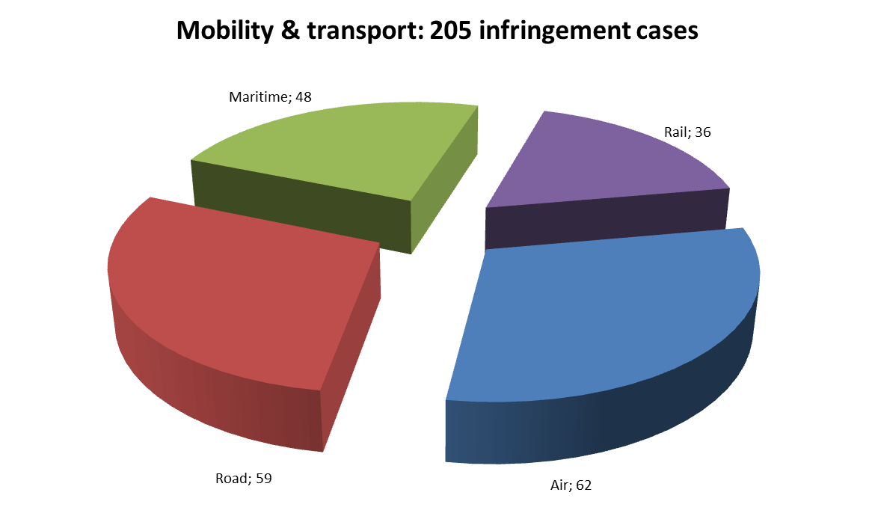
There were 205 infringement cases open in the area of transport at the end of 2012. This is the second-highest number of cases in the Commission’s 21 reporting policy areas. The cases can be broken down as follows:

148 transport cases were launched in 2012, including letters of formal notice against: Lithuania, Ireland, Belgium, Slovenia and Germany for failure to separate the accounts of railway undertakings and railway infrastructure managers; Spain, Greece, Germany and the United Kingdom due to lack of port security plans; Portugal and Spain due to lack of airport slot coordinators' independence; Belgium and Greece for failing to ratify the Western Balkans Aviation Agreement; and Spain for increasing airport charges without the consultation required by the Airport Charges Directive.
The Commission referred ten transport infringement cases to the Court in 2012, including a case against Bulgaria due to incorrect implementation of the First Railway Package as regards railway track access charges. Nine referrals were due to late transposition of directives (see next section).
By the end of 2012, Member States had not complied with the two Court judgments made in the transport area under Article 258 TFEU in late 2012 (see last section).
TRANSPOSITION OF DIRECTIVES
The Commission launched 115 late transposition infringement cases in the transport area in 2012 (240 in 2011). At the end of 2012, 99 were still open.
Of the six transport-related directives with a 2012 transposition deadline, late transposition infringement cases were launched on two of them: intelligent transport systems for road transport and ships’ reporting formalities.
The Commission referred the following Member States to the Court proposing financial sanctions under Article 260(3) TFEU: Finland (late transposition of the Clean Vehicles Directive and the Road Safety Management Directive); Cyprus (Driving Licence Directive); and Poland (Maritime Accident Investigation Directive and Airport Charges Directive). The Commission referred four other late transposition cases to the Court, against: Finland (in connection with driving licence rules – two cases); Portugal (driving licence rules); and Poland (a railway interoperability directive).
COMPLAINTS
The Commission received 68 complaints on transport issues in 2012, slightly more than in 2011 (65).
Most concerned violations of air and rail passenger rights. There were also numerous complaints on the road safety sector (e.g. driving licences). From the 91 transport-related complaints handled in 2012, the Commission closed 64 and transferred 20 to EU Pilot for discussion with Member States.
Upon a petition from the European Parliament, the Commission investigated Malta’s bus fare system and urged Austria to put in place a public service obligation and a system for differentiating toll rates.
OWN-INITIATIVE CASES
The infringement cases discussed in the general statistics section (except for the Spanish one) were launched on the Commission’s own initiative. The Commission also continued to extend the social protection afforded by the Drivers’ Working Time Directive to self-employed drivers.
EARLY RESOLUTION OF INFRINGEMENTS
The Commission opened 164 new transport files in EU Pilot and processed 141 in 2012. In 96 cases, it accepted the Member State’s explanations or actions (68 % success rate). 117 transport files remained open in EU Pilot at the end of 2012.
Important infringement cases closed in 2012 include three cases on implementing the First Railway Package in Ireland, Denmark and Slovakia. In addition, Italy justified its lower port taxes on intra-EU sea traffic and Spain introduced a non-discriminatory port charge system following a Court judgment.
IMPORTANT JUDGMENTS
The Court found that Greece failed to adopt the tariff units used for calculating railway infrastructure costs and that Portugal kept the state railway company’s capital transactions under government control and failed to ensure that the infrastructure manager’s accounts were balanced.
Outlook
Important implementation work in 2013 includes:
- Analysing the impact of four key judgments relating to the First Railway Package
- Application of the internal market principle in the port sector
- Directives on airport charges and ships’ reporting formalities: conformity checks

Further information is available at:
http://ec.europa.eu/transport/index_en.htm

REGIONAL POLICY
GENERAL STATISTICS
The Commission received considerably fewer complaints in the area of regional policy in 2012 than it did in 2011. The number of new EU Pilot files on regional policy has therefore been stable. Although the Commission handled many complaints on regional policy in 2012, it did not open any new infringement procedures in this area. One case (concerning Puerto Punta Langosteira in Spain) was closed in September 2012.
COMPLAINTS
The Commission received 33 new complaints on regional policy in 2012. The number of complaints has decreased by two-thirds since 2011, when 92 complaints were received.
Most complaints concerned the selection of projects under funding programmes. As in previous years, the main reasons were: rejection of financial support, individual projects’ non-compliance with EU law on environment or public procurement, and problems with specific infrastructure projects (e.g. wastewater treatment plants).
The Commission processed 106 complaints related to regional policy in 2012. It fully closed most of them (84). It transferred three to EU Pilot for discussion with Member States.
The European Parliament sent the Commission seven petitions on regional policy.
EARLY RESOLUTION OF INFRINGEMENTS
The Commission opened three new files based on complaints in EU Pilot and processed 15 in 2012. In 11 cases, it accepted the Member State’s explanations or commitments (73 % success rate). At the end of 2012, eight files were still open in EU Pilot.
Since 2012, files that are subject to procedures set up solely to ensure the legality of payments and/or sound financial management of resources available from EU funds are not subject to the EU Pilot procedure. Files subject to procedures that go beyond financial aspects and concern the correct application of EU law must go through EU Pilot.
IMPORTANT JUDGMENTS
The Court made fourteen judgments on regional policy issues in 2012. In most of these cases, the Court rejected Member States' appeals against Commission decisions making financial corrections due to irregular public procurement procedures and ineligible expenditure.
Further information is available at:
http://ec.europa.eu/regional_policy/index_en.cfm

HEALTH & CONSUMERS
GENERAL STATISTICS
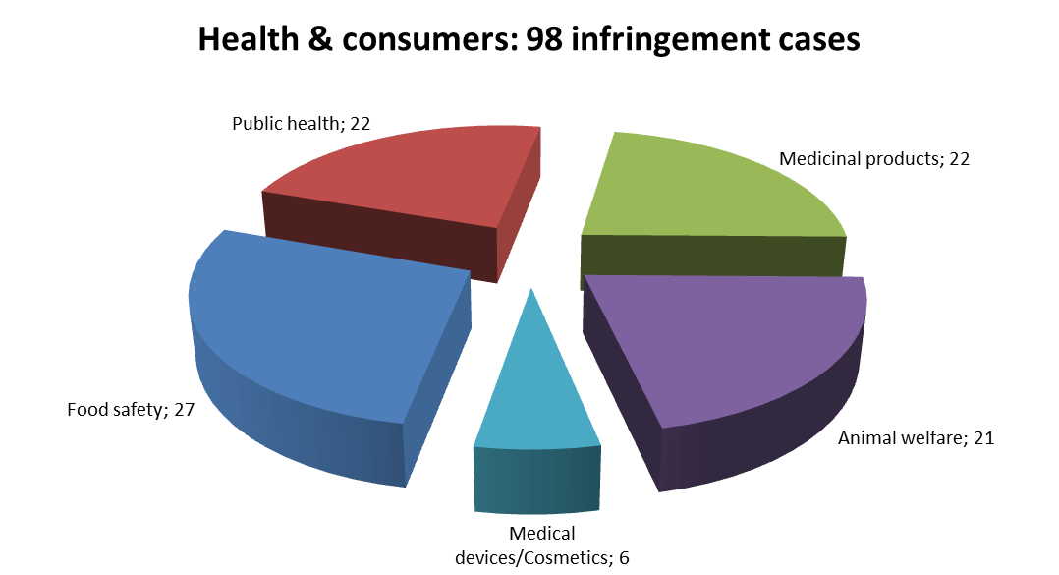
There were 98 open infringement cases in the health and consumers area at the end of 2012. This is the fifth highest number of cases in the Commission’s 21 reporting policy areas. The cases can be broken down as follows:

The Commission launched 132 infringement cases in the health and consumers area in 2012. These included cases on implementing the ban on ‘un-enriched cages for laying hens, a case against Latvia for not protecting sufficiently consumers’ collective interests with injunctions, and a case against Denmark for allowing the sale of loose snus.
The Commission referred two disputes on issues of EU health and consumer law to the Court in 2012. One case against Portugal concerned transposition of the directive on distance marketing of consumer products; Portuguese law does not allow a consumer withdrawing from a service contract to automatically cancel all linked contracts. Another was brought against Poland due to its failure to simplify its mechanism for putting ‘old’ vegetable seeds on the market.
TRANSPOSITION OF DIRECTIVES
In 2012, the Commission opened 108 infringement cases due to missing or partial national transposition measures for directives in the health and consumer area. There remained 57 open late transposition cases in this area by the end of 2012.
Of the directives with transposition deadlines in 2012, two were most problematic. The Commission launched cases against 19 Member States for failing to notify their transposition measures on pharmacovigilance (the Directive amending the Community code relating to medicinal products for human use). It launched cases against 17 Member States for late transposition of the Directive on standards of quality and safety of human organs intended for transplantation.
COMPLAINTS
The Commission received 125 complaints on health and consumers issues in 2012, which is an increase over 2011 (99 incoming complaints).
Most complaints concerned public health, food safety and animal welfare. Medical devices and medicinal products were two new areas in which complaints were received in 2012.
The Commission processed 106 health and consumers complaints in 2012. It fully closed more than half of them (60) and transferred 36 to EU Pilot so that Member States could react to them.
At the request of the European Parliament, the Commission investigated four petitions on EU rules on animal by-products, public health and food safety.
OWN-INITIATIVE CASES
In 2012, the Commission worked on ensuring that the directive on protection of pigs was properly transposed and that compliance was achieved, in particular on the welfare of sows. In addition, the Commission pursued conformity assessments on the proper transposition of Human Blood Directives. Furthermore, continued efforts were necessary to ensure proper application of other provisions on animal welfare and on genetically-modified organisms (GMOs).
EARLY RESOLUTION OF INFRINGEMENTS
The Commission opened 72 EU Pilot files on health and consumers issues and processed 57 in 2012. In 42 cases, it accepted the Member State’s explanations or commitments (74 % success rate). At the end of 2012, 66 files were still open in EU Pilot.
The cases against Latvia and Slovakia for incorrect transposition of the directive on protecting consumers’ interests with injunctions were closed in 2012 without being referred to the Court. The cases on protecting laying hens against Belgium, Bulgaria, France, Hungary, Latvia, the Netherlands, Portugal and Romania were closed as well.
IMPORTANT JUDGMENTS
The Court ruled that by allowing in certain circumstances the import of non-authorised medicinal products, Poland has infringed the medicinal product code. It also clarified the powers of a Member State validating a marketing authorisation application. It ruled that France infringed EU legislation on veterinarian medicinal products by refusing to authorise the marketing of two of them. When France banned the marketing of certain medicinal veterinary products in a procedure falling also under EU rules, the Court specified the role of the "reference Member State" when several Member States work together to authorise a medicinal product.
Outlook
Important implementation work in 2013 includes:
- Follow-up of transposition of Directives on cross-border health care and on falsified medicines
- Pursuing Member States that fail to fully comply with the pig protection directive (to implement group housing of sows)
- Monitoring the correct transposition of the Consumer Credit Directive

Further information is available at:
http://ec.europa.eu/dgs/health_consumer/index_en.htm

TAXATION & CUSTOMS UNION
GENERAL STATISTICS
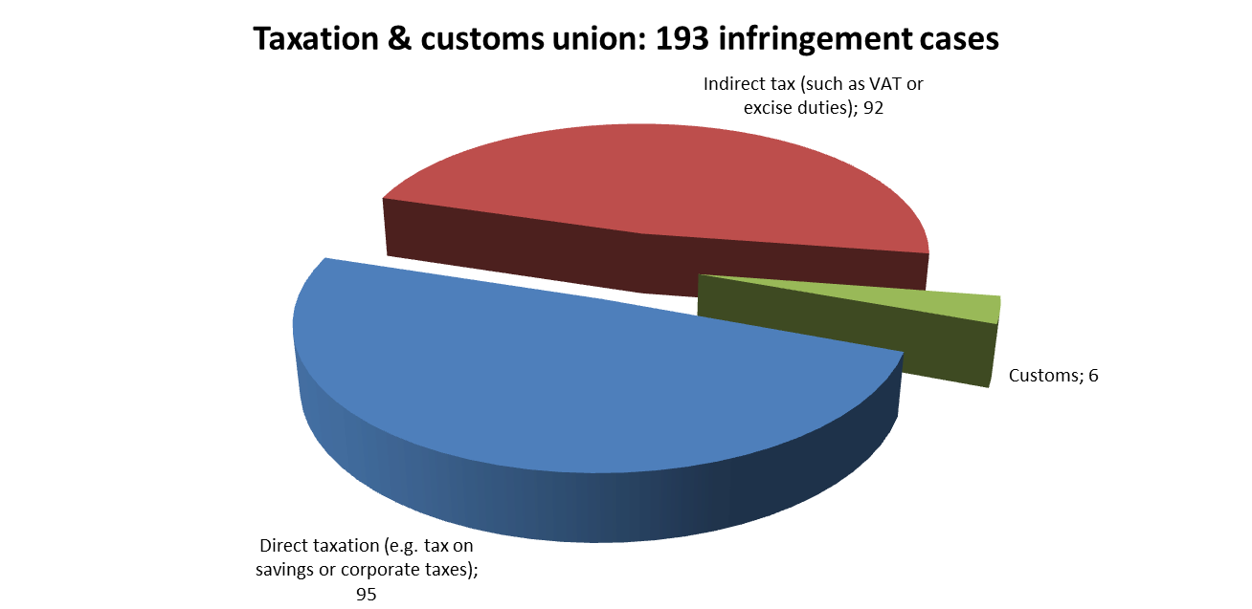
There were 193 open infringement cases in the taxation area at the end of 2012. This is the third highest number of cases in the Commission’s 21 reporting policy areas. The cases can be broken down as follows:

The Commission launched 49 taxation cases in 2012. It delivered reasoned opinions to: France and Luxembourg on their reduced VAT rates for electronic books (e-books); Hungary on its retail and telecommunication taxes; and Bulgaria on certain duty and tax relief provisions included in a bilateral agreement on technical assistance concluded with the United States.
The Commission brought seven taxation cases before the Court in 2012, including: three against the UK (tax legislation on cross-border loss relief, taxation system for assets transferred abroad, attribution of gains to members of non-resident companies); and one against Germany for excluding certain non-resident companies from the benefits of its corporation tax fiscal unity regime.
At the end of 2012, Member States had still not complied with 16 Court judgments under Article 258 TFEU. They may face financial sanctions under Article 260(2) TFEU.
TRANSPOSITION OF DIRECTIVES
The Commission opened 18 infringement cases due to partial or incomplete communication of national implementing rules in 2012. However, only four of these were still open at the end of the year, because Member States acted quickly to ensure compliance with EU law.
Three tax directives had a transposition deadline in 2012. There were only three infringement cases for partial or incomplete communication on transposing the Directive on the taxation system applicable to parent companies and subsidiaries in different Member States. The other two directives with transposition deadlines in 2012 were: the Directive on administrative cooperation in the field of taxation and the Directive on mutual assistance for the recovery of claims relating to taxes and duties.
COMPLAINTS
The Commission received 384 complaints on taxation issues in 2012, slightly fewer than in 2011 (411 complaints).
In the direct taxation area, most complaints concerned: the discriminatory taxation of cross-border workers; inheritance and gift taxes; and the discriminatory taxation of companies or individuals moving abroad (exit tax). In the indirect taxation area, most complaints concerned VAT and car registration taxes. Most customs-related complaints concerned customs fees and direct representation.
The Commission processed 396 tax complaints in 2012. It fully closed 286 of them and transferred 89 to EU Pilot for discussion with Member States.
OWN-INITIATIVE CASES
The Commission addressed the lack of import control systems. It continued to scrutinise tax exemptions and to ensure strict interpretation of the rules, because of the potential impact of tax exemptions on the EU’s own resources. It also continued to monitor the correct application of the Court’s case law on leasing and use of company cars. It launched several own-initiative cases on discriminatory inheritance and gift taxes and ‘‘exit taxes’’ (paid when companies or individuals move abroad).
EARLY RESOLUTION OF INFRINGEMENTS
The Commission opened 132 taxation-related files in EU Pilot and processed 130 in 2012. In 74 cases, it accepted the Member State’s explanations or commitments (57 % success rate). At the end of 2012, 119 were still open in.
Several important cases were resolved before the Court made a judgment under Article 258 TFEU because Member States complied with EU law. They included cases on discriminatory car taxation rules in Cyprus and on taxes applied to controlled foreign corporations (CFCs) in the UK.
IMPORTANT JUDGMENTS
The Court of Justice ruled that the following tax regimes were discriminatory: exclusion of non-resident pensioners from tax allowances granted under Estonian law because, due to the modest amount of the pension, it was not taxable in the Member State of residence;;in Finland, taxation of dividends paid to non-resident pension funds by foreign companies based in Finland for tax purposes; in Spain, restrictive exit tax on individuals who cease to be tax resident in Spain; the French VAT reduction for opening night receptions in theatres and for the supply of race horses, as well as France's local electricity taxes;and in Portugal, the exemption of farmers from paying VAT.
In a preliminary ruling, the Court confirmed that France cannot tax nationally-sourced dividends received by UCITS resident abroad, while exempting such dividends from tax if they are received by UCITS resident in France.
Outlook
Important implementation work for 2013 includes:
- EU-wide initiative to remove the discriminatory taxation of mobile persons
- Continuing EU-wide initiatives to remove discriminatory taxation of cross-border workers and cross-border inheritances
- Using the Customs Monitoring Programme to detect infringements related to Remission and Recovery, Simplified Procedure and Tariff/Taric

Further information is available at:
http://ec.europa.eu/taxation_customs/index_en.htm

Common organisation of the markets in agricultural products
Commission v the Czech Republic, C-37/11
Regulation (EC) No 1234/2007
Bonda, C-489/10
Regulation (EC) No 1553/1989 and Regulation (EC) No 1150/2000.
The two above-mentioned Regulations establish a conciliation mechanism, whose function is similar to that of EU Pilot.
Regulation (EC) No 842/2006
Directive 2011/63/EC
IP/12/415
Directive2008/101/EC
Directive2009/29/EC
Directives 2011/63/EC and 2009/30/EC
Directive 2009/31/EC
Regulations (EC) Nos 842/2006 and 1005/2009
Directive 2002/21/EC
Directive 2002/19/EC
IP/12/286
Commission v Portugal, C-154/09
IP/12/287
Directive 2009/136/EC
Directive 2009/140/EC
Directive 2007/65/EC
IP/12/630
Directive 2003/98/EC
Directive 2002/77/EC
Directive 2002/21/EC
Directive 2002/20/EC
IP/12/298
Directive 97/67/EC
Dimosia Epicheirisi Ilektrismou AE (DEI) v Commission, T-169/08
Commission v DEI, C-553/12 P and Commission v DEI, C-554/12 P
Commission v Spain, C-610/10
Commission v Austria, C-75/11
Directive 2004/38/EC
Commission v the Netherlands, C-92/07
In particular, the 1970 Additional Protocol and Decision No 1/80 of the Association Council.
MEMO/12/794
Directive 2003/88/EC
IP/12/1145
Commission v Germany, C-206/10
Commission v the Netherlands, C-542/09
Directive 2008/104/EC
Directive 2009/161/EU
Directive 89/391/EEC
Directive 92/57/EEC
Directive 2009/148/EC
Hudziński and Wawrzyniak, C-611/10 and C-612/10
Commission v Netherlands, C-542/09
Erny, C-172/11
Dominguez, C-282/10
Directive 2010/32/EU
Directive 2008/104/EC
Regulation (EU) No 994/2010
Directive 2009/28/EC
Directive 2002/91/EC
IP/12/411
IP/12/52
Directive 2010/31/EU
Directives 2009/72/EC and 2009/73/EC
IP/12/1139 and IP/12/1236
Directive 2009/73/EC and IP 06/1768
IP 06/1768 on the earlier reasoned opinion
IP 09/1035 on the earlier letter of formal notice and MEMO 09/926
IP/11/590 on the earlier reasoned opinion
IP/11/414 on the earlier reasoned opinion
Regulation (EU, Euratom) No 617/2010
Parliament v Council, C-490/10
Directive 2011/70/Euratom
Regulation (EC) No 1907/2006
The CE marking proves that the product had been assessed before it was placed on the market.
Construction products list (explanation).
IP/12/648
IP/12/649
Directive 2012/10/EU
Directive 2012/4/EU
Articles 34 to 36 TFEU
IP/11/610 on the earlier reasoned opinion
IP/10/1220 on the earlier reasoned opinion
IP/11/1415 on the earlier referral decision
Fra.bo, C-171/11
As defined by Directive 98/34/EC
Fortuna and Others, C-213/11
ANETT, C-456/10
Directive 2011/7/EU
Regulation (EC) No 305/2011
Commission v Poland and Commission v Lithuania, cases C-639/11 and C-61/12
Directive 2011/92/EU
Directive 2009/147/EC
Directive 92/43/EEC,
Directive 2008/98/EC, IP/12/422
Directive 1999/31/EC, IP/12/1140, IP/12/655 and IP/12/1023
Directive 2000/60/EC, IP/12/536
IP/12/658
IP/12/170
IP/12/1140
Directive 1985/337/EEC, IP/12/657
Directive 2009/126/EC
Directive 2008/98/EC and IP/12/422
Directive 2008/56/EC
Directive 2002/96/EC
Directive 2006/21/EC
Directive 2007/60/EC
Directive 94/62/EC
Directive 2000/53/EC
Directive 2011/92/EU
Directive 2001/42/EC
Directive 2001/80/EC
Commission v Ireland, cases C-279/11 and C-374/11
Commission v Belgium, C-366/11; Commission v Greece, C-297/11; Commission v Portugal, C-223/11; and Commission v Spain, C-403/11 and Directive 2000/60/EC
E.g. cases Solvay and others, C-182/10; Flachglas Torgau, C-204/09; Syllogos Ellinon Poleodomonkaichorotakton, C-177/11; Nomarchiaki Aftodioikisi Aitoloakarnanias and others, C-43/10; and Amia, C-97/11.
Directive 2010/75/EU
Directive 2008/50/EC
Directive 2003/35/EC and Council Decision 2005/370/EC
Directive 2006/24/EC
Regulation (EC) No 343/2003
Directive 2003/9/EC
Directive 2005/85/EC
Directive 2004/83/EC
IP/12/1247
Commission v Sweden, C-270/11
IP/12/530
Regulation (EC) No 1931/2006
Regulation (EC) No 810/2009
Directive 2003/86/EC
Directive 2003/109/EC
Commission v the Netherlands, C-508/10, Court press release No 52/12
Kamberaj, C-571/10, Court press release No 48/12
Y and Z, joined Cases C-71/11 and C-99/11, Court press release No 108/12
Cimade and Groupe d’information et de soutien des immigrés (GISTI), C-179/11, Court press release No 119/12
Abed El Karem El Kott and Others, C-364/11
Atiqullah Adil v Minister voor Immigratie, Integratie en Asiel, C-278/12
Directives 2009/50/EC, 2009/52/EC, 2008/115/EC, 2008/114/EC, 2003/109/EC and 2003/86/EC
Commission v Sweden, C-270/11 and Commission v Germany, C-329/12
Directive 2011/51/EU
Directive 2011/36/EU
Directive 2011/95/EU
Regulation (EC) No 810/2009
The Bunker Convention (Austria, the Czech Republic, Poland, Portugal, Slovakia and Sweden) and the 2004 Protocol amending the Paris Convention on third-party liability in the field of nuclear energy (Italy and Belgium).
IP/12/395 and Directive 2000/78/EC.
IP/12/395 and Directive 95/46/EC.
Directive 2010/18/EU.
Directive 2010/41/EU
IP/12/1016 and Directive 2008/52/EC
IP/12/296 and Directive 2008/99/EC
Report on the Application of the EU Charter of Fundamental Rights
Waltraud Brachner v Pensionsversicherungsanstalt, C-123/10
29th Annual Report on monitoring the application of EU law, p. 53.
IP/12/646 (Austria, Germany and Sweden), IP/12/417 (the United Kingdom), IP/12/75 (the Czech Republic and Lithuania) and Directive 2004/38/EC
IP/12/644
Directive 2000/78/EC
Commission v Hungary, C-286/12 and Directive 2000/78/EC
Commission v Austria, C-614/10 and Directive 95/46/EC
Secretary of State for the Home Department v Muhammad Sazzadur Rahman a.o., C-83/11
Directive 2004/38/EC
Directives 2004/113/EC and 2006/54/EC
Commission v Italy, C-249/08
Commission v Spain, C-189/07
Directives 73/239/EEC and 92/49/EEC
IP/12/1249
Directive 2010/73/EU
IP/12/1020 and Directive 2009/81/EC
IP/12/1248 and Directive 2009/110/EC
IP/11/715 on the earlier reasoned opinion
IP/06/1353 on the earlier reasoned opinion
IP/11/416 on the earlier reasoned opinion
Commission v Greece, C-244/11
Limosa is a prior declaration scheme for all posted workers. Commission v Belgium, C-577/10
SABAM, C-360/10
Directive 2003/6/EC and Geltl, C-19/11
Insinööritoimisto InsTiimi, C-615/10
ASL Leece, C-159/11
UsedSoft, C-128/11
The Nice Classification is a WIPO database. Chartered Institute of Patent Attorneys, C-307/10
See the annex of the Communication on ‘Better Governance for the Single Market’ (COM(2012) 259/2).
Directive 2011/61/EU
Directive 91/440/EEC
Directive 2005/65/EC
Regulation (EEC) No 95/93
Directive 2009/12/EC
IP/12/53; a detailed description on the First Railway Package is available here.
Directive 2010/40/EU
Directive 2010/65/EU
IP/12/270 and Directive 2009/33/EC
IP/12/641 and Directive 2008/96/EC
IP/12/1237 and Directive 2006/126/EC
IP/12/643 and Directive 2009/18/CE
IP/12/1143 and Directive 2009/12/EC
As the directives in question were not adopted by legislative procedure, Article 260(3) TFEU does not apply.
IP/12/56 and Directive 2009/112/EC and Directive2009/113/EC
IP/12/56 and Directive 2009/113/EC
IP/12/1136 and Directive 2011/18/EU
Directive 2002/15/EC
IP/10/807
Commission v Spain, C-18/09
Commission v Greece, C-528/10
Commission v Portugal, C-557/10
Commission v Hungary, C-473/10, Commission v Spain, C-483/10, Commission v Austria, C-555/10 and Commission v Germany, C-556/10; and Court Press Release No 20/13
For example: Portugal v Commission, T-111/10; Spain v Commission, joined cases T-178/10, T-263/10 and T-265/10; Hungary v Commission, cases T-89/10 and T-407/10; Germany v Commission, cases T-265/08 and T-270/08; GAMP, C-579/11; Portugal v Commission, C-246/11; TME v Commission, T-329/11; Région Poitou-Charentes v Commission, T-31/12; and Spain v Commission, T-96/12.
According to Directive 1999/74/EC, as from 1 January 2012 all laying hens must be kept in ‘enriched cages’ with extra space to nest, scratch and roost, or in alternative systems. Cages can be used only if they provide each hen with at least 750 cm² of cage area, a nest-box, litter, perches and claw-shortening devices (IP/12/47).
Directive 2009/22/EC
Directive 2001/37/EC prohibits placing ‘tobacco for oral use’ on the market (with an exception for Sweden), MEMO/12/794
Directive 2010/84/EU
Directive 2001/83/EC
Directive 2010/53/EU
Directive 2008/120/EC
Directive 2002/98/EC and Directives 2004/33/EC, 2005/61/EC and 2005/62/EC
Commission v Poland, C-185/10 and Directive 2001/83/EC
Commission v France, C-145/11 and Directive 2001/82/EC
Directive 2001/82/EC
Commission v France, C-145/11
Directive 2011/24/EU
Directive 2011/62/EU
Directive 2008/48/CE
MEMO/12/794
MEMO/12/876
IP/12/672
IP/12/1017
IP/12/1147
IP/12/1146
IP/12/283
Directive 2011/96/EU
Directive 2011/16/EU
Directive 2010/24/EU
Member States tend to follow their own policies after the Council refused the Commission’s proposal for a harmonisation directive in 2005.
IP/11/1277
IP/11/606
Commission v Estonia, C-39/10
Commission v Finland, C-342/10
Commission v Spain, C-269/09.
Commission v France, C-119/11
Commission v France, C-596/10
Commission v France, C-164/11
Commission v Portugal, C-524/10
UCITS: undertakings for collective investments in transferable securities.
Santander Asset Management SGIIC, joined cases C-338/11 and C-347/11

