 | 
COUNCIL OF  THE EUROPEAN UNION |  |  | Brussels, 22 October 2013
 | Interinstitutional File:  2013/0220 (COD) |  | 15185/13
JUSTCIV 232
INST 548
PARLNAT 249
CODEC 2347

COVER NOTE
from: | the Portuguese Parliament
Date of receipt: | 19 September 2013
to: | Algirdas Butkevičius, President of the Council of the European Union
Subject: | Proposal for a Regulation of the European Parliament and of the Council adapting to Article 290 of the Treaty on the Functioning of the European Union a number of legal acts in the area of Justice providing for the use of the regulatory procedure with scrutiny  [doc. 12539/13 JUSTCIV 172 CODEC 1793 - COM(2013) 452 final]  - Opinion on the application of the Principles of Subsidiarity and Proportionality

Delegations will find attached a copy of the above mentioned opinion.

_______________________

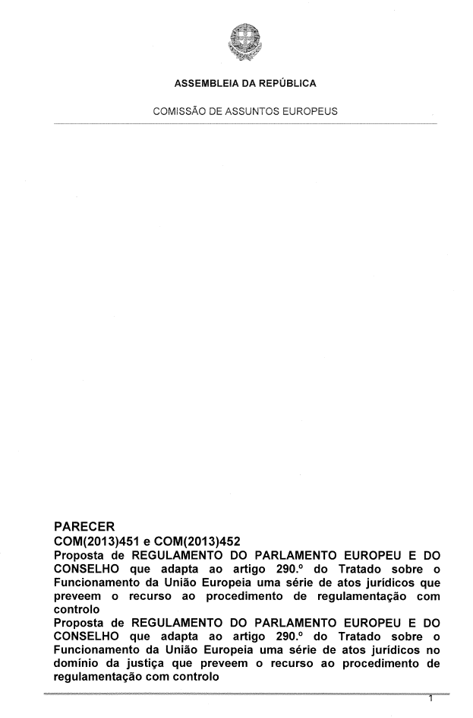

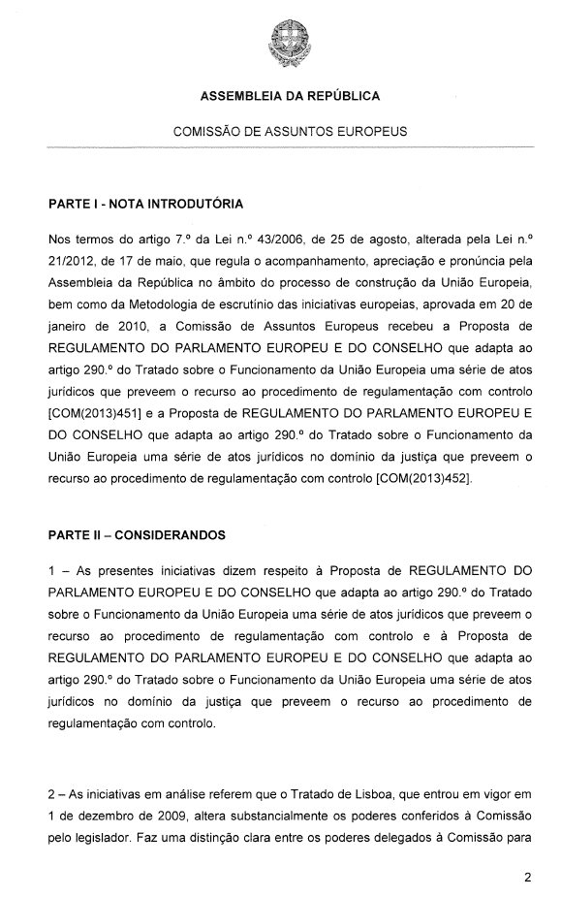
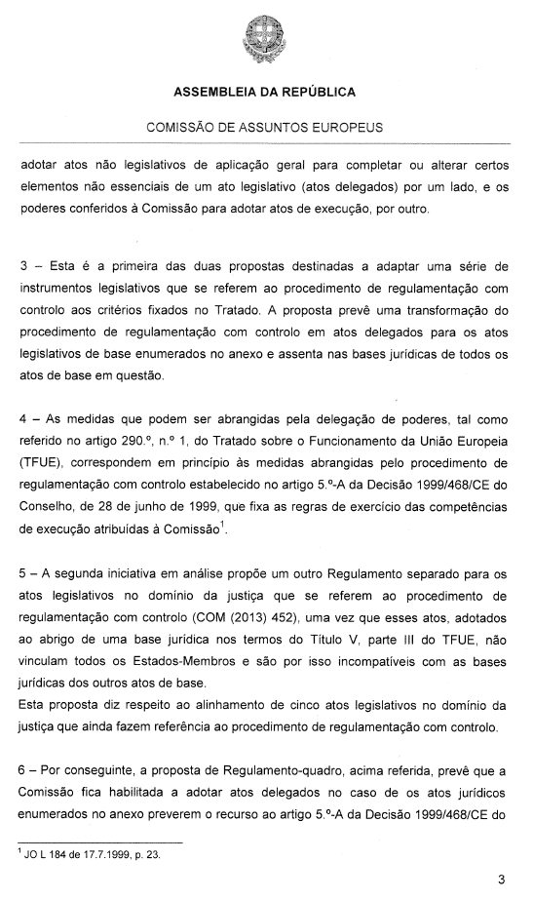

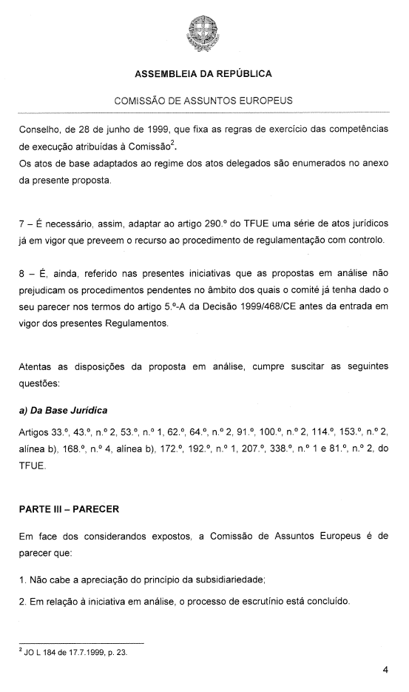
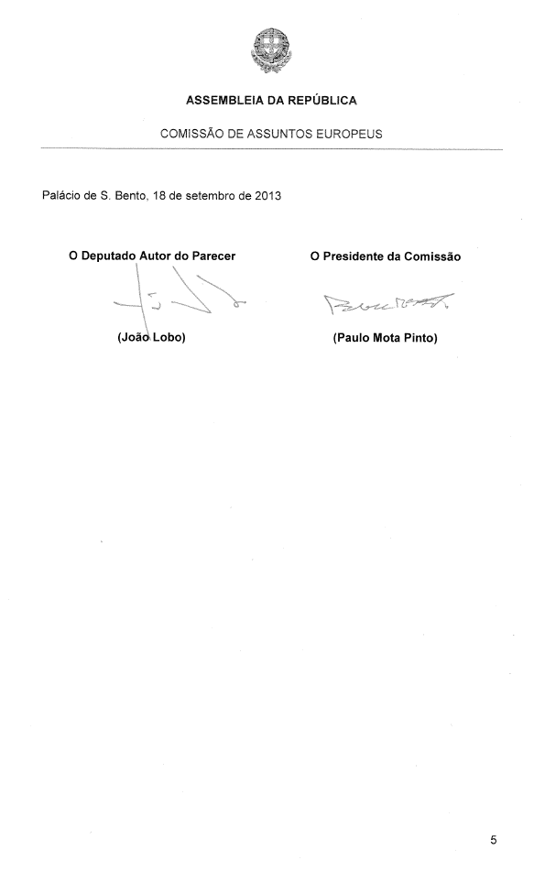
_______________

For other available language versions of the opinion, reference is made to the Interparliamentary EU information exchange Internet site (IPEX) at the following address: http://www.ipex.eu/IPEXL-WEB/search.do

