 | 
COUNCIL OF  THE EUROPEAN UNION |  |  | Brussels, 11 February 2013
 | Interinstitutional File:  2011/0276 (COD) |  | 6195/13
FSTR 7
FC 6
REGIO 16
SOC 87
AGRISTR 13
PECHE 50
CADREFIN 30
CODEC 275
INST 63
PARLNAT 36

COVER NOTE
from: | The Portuguese Parliament
date of receipt: | 7 February 2013
to: | Mr Uwe CORSEPIUS, Secretary-General of the Council of the European Union
Subject: | Amended proposal for a Regulation of the European Parliament and of the Council laying down common provisions on the European Regional Development Fund, The European Social Fund, the Cohesion Fund, the European Agricultural Fund for Rural Development and the European Maritime and Fisheries Fund covered by the Common Strategic Framework and laying down general provisions on the European Regional Development Fund, the European Social Fund and the Cohesion Fund and repealing Regulation (EC) No 1083/2006 [doc. 13730/12 - COM(2012) 496 final]  - Opinion on the application of the Principles of Subsidiarity and Proportionality

Delegations will find attached the above mentioned opinion.

________________________

Encl.

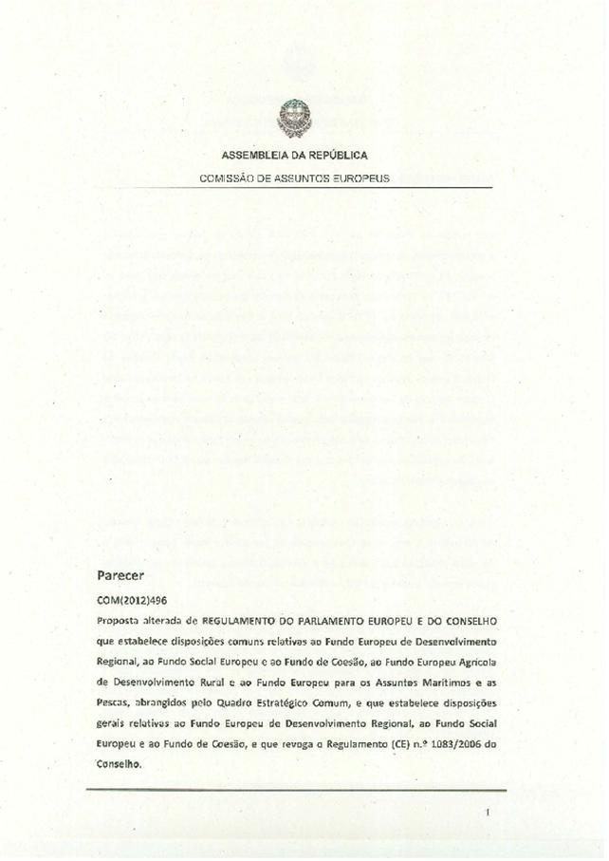
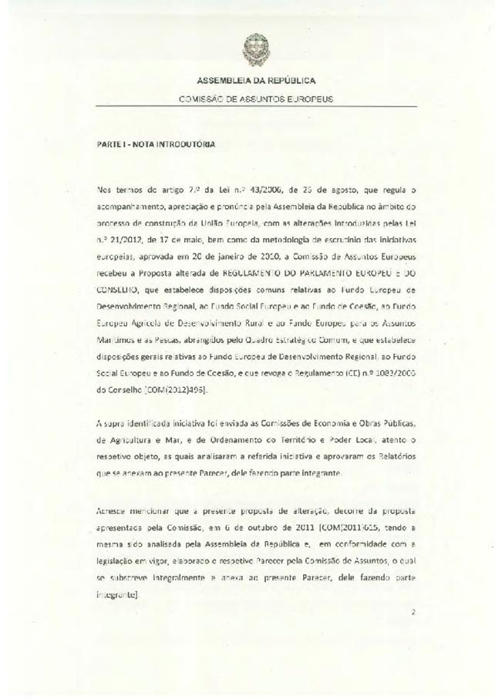
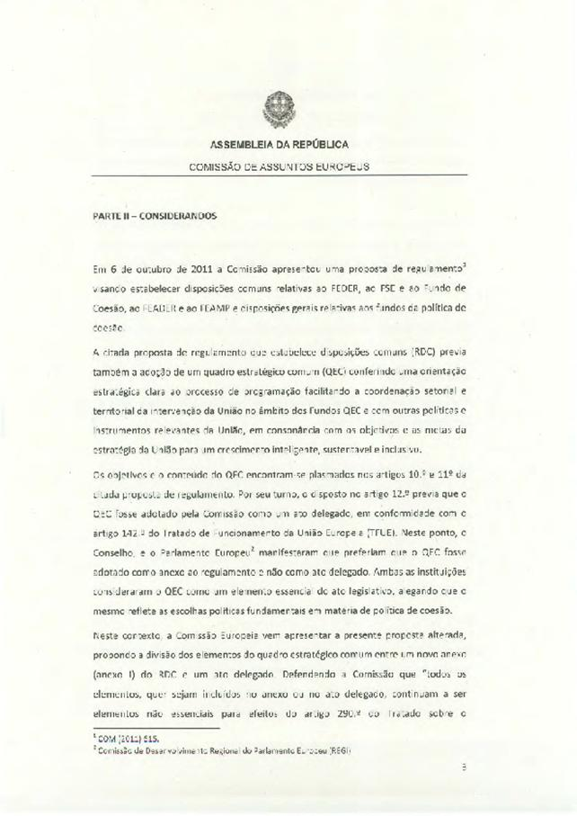
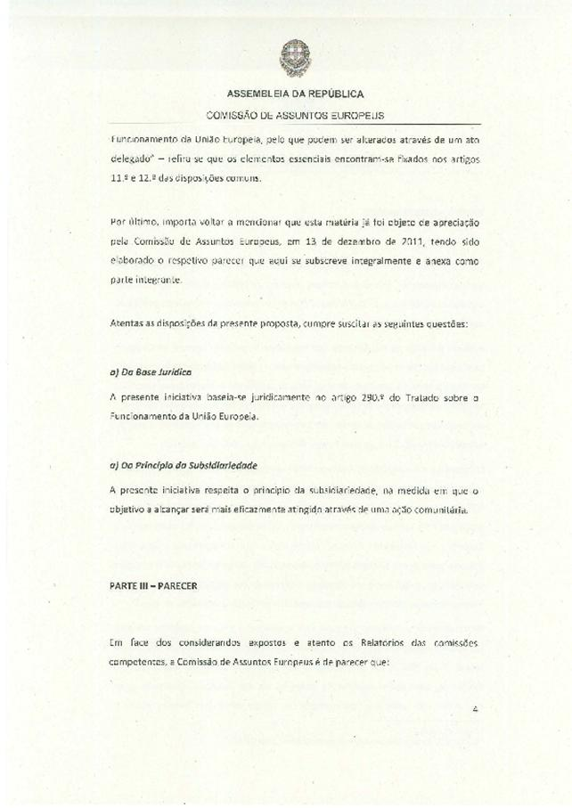
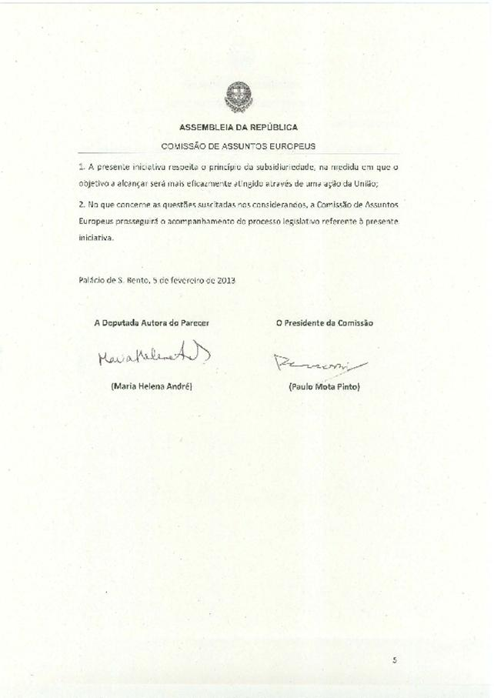
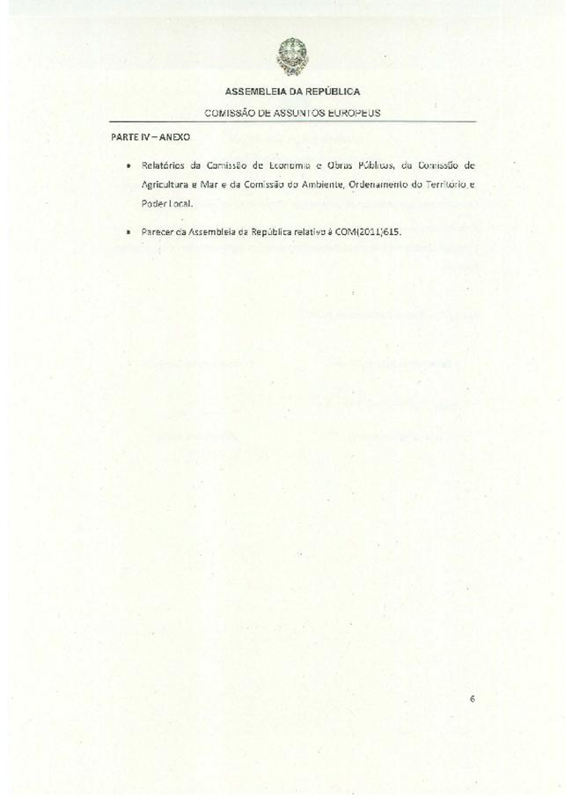
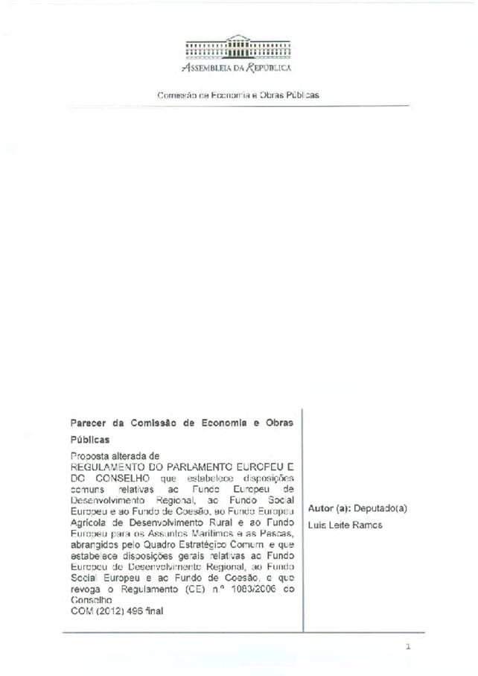
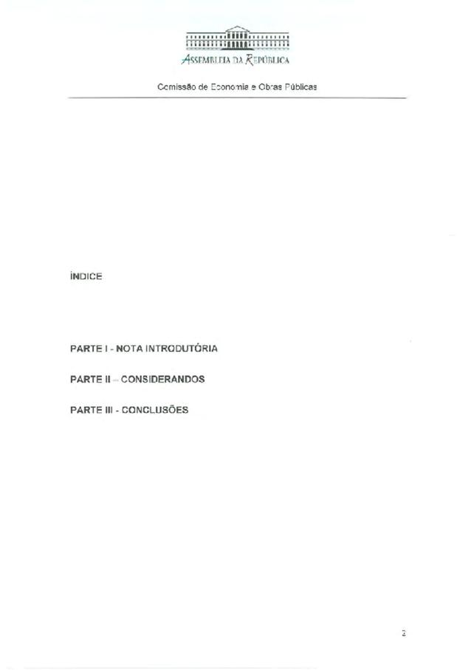
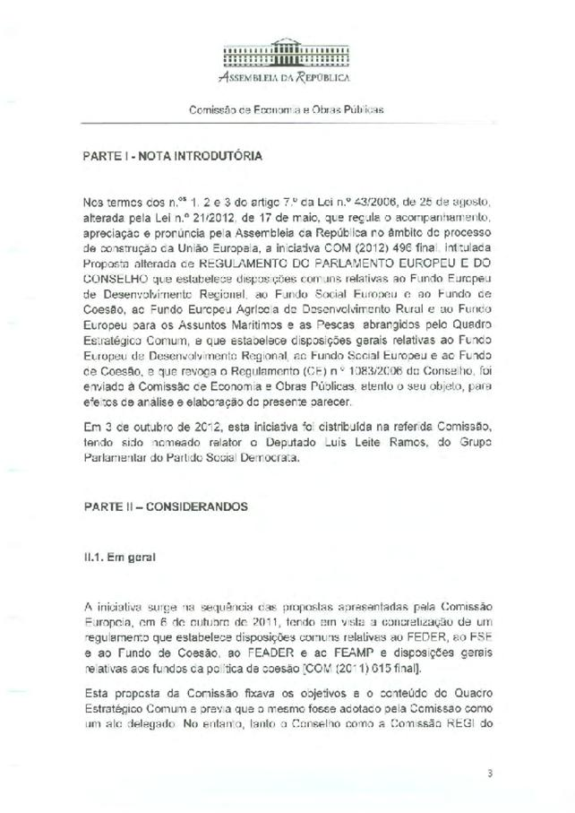
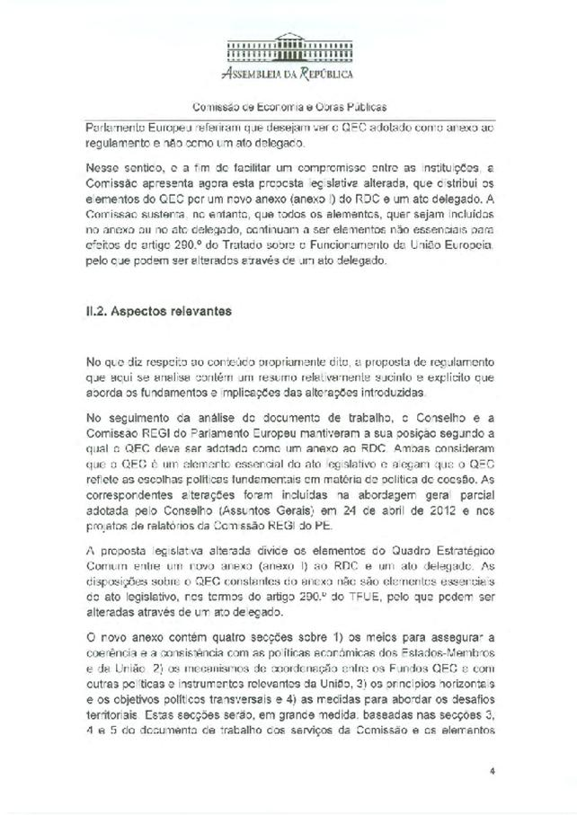
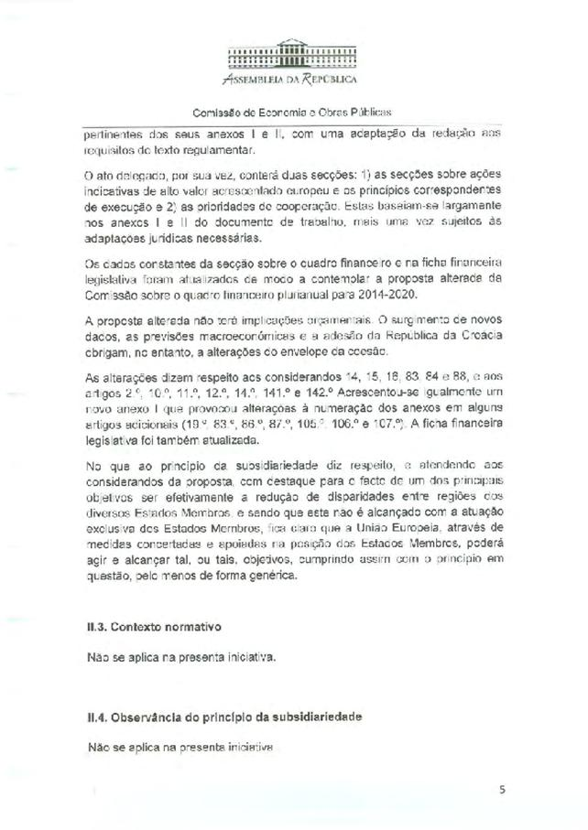
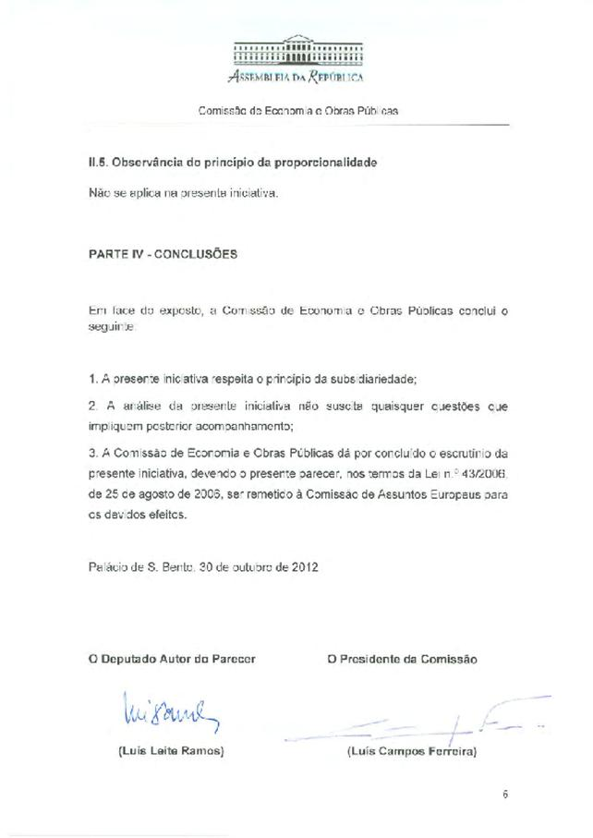
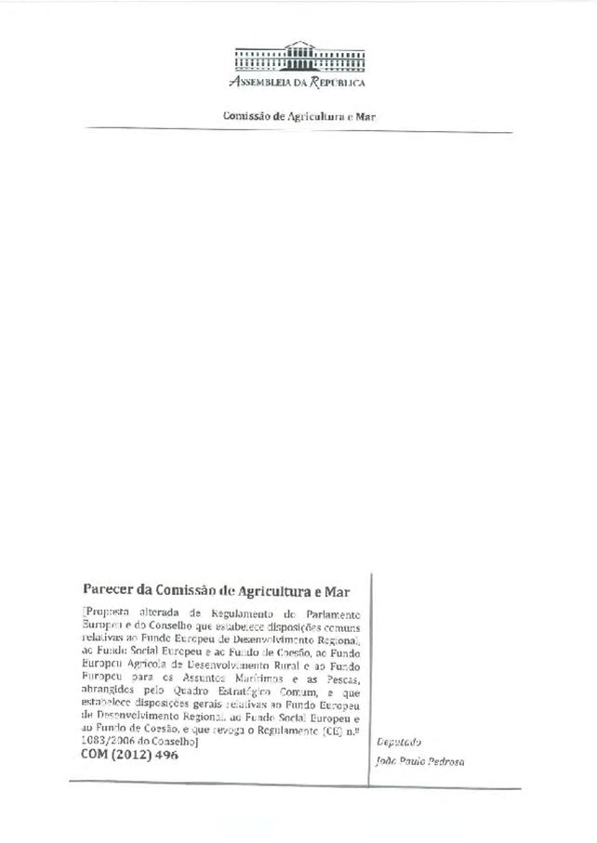
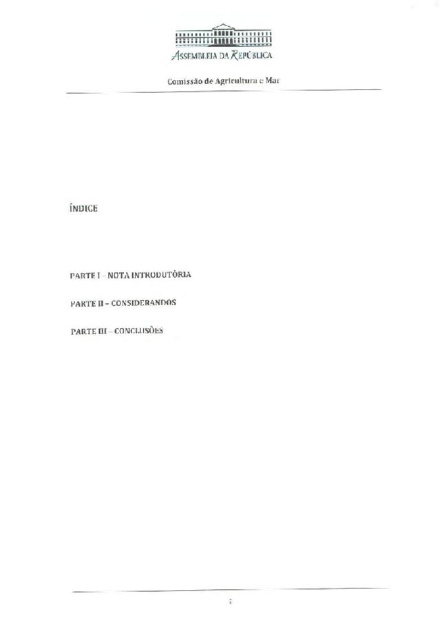
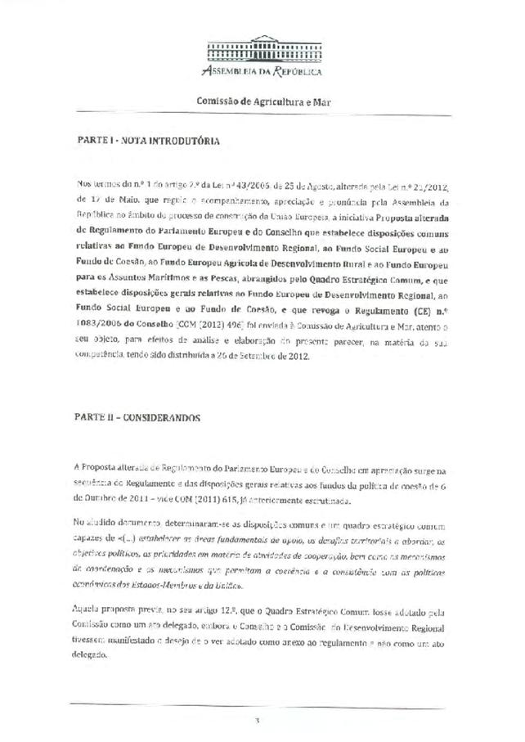
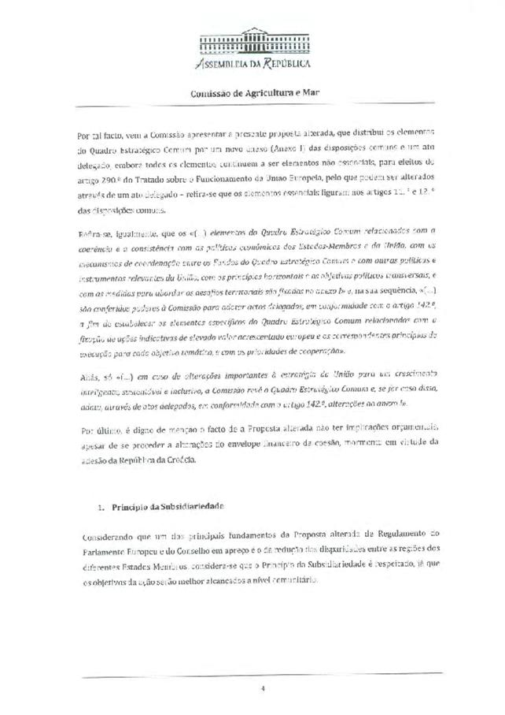
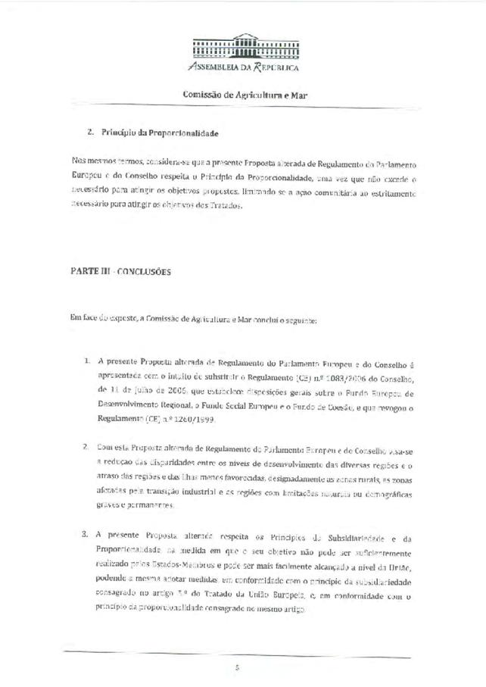
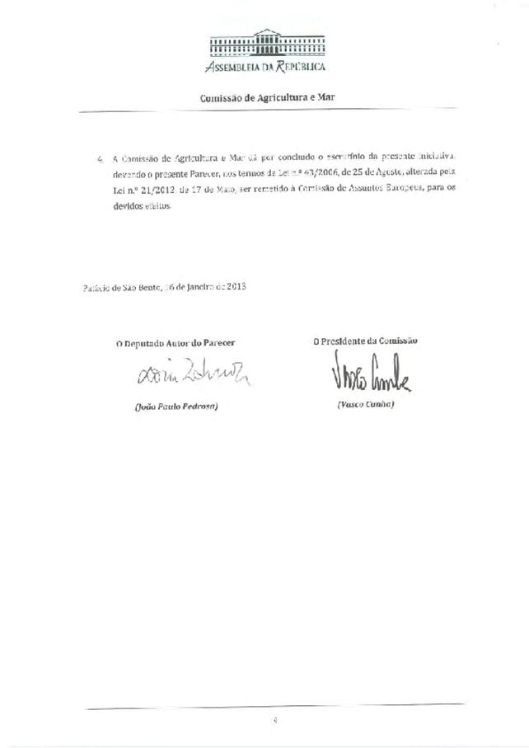
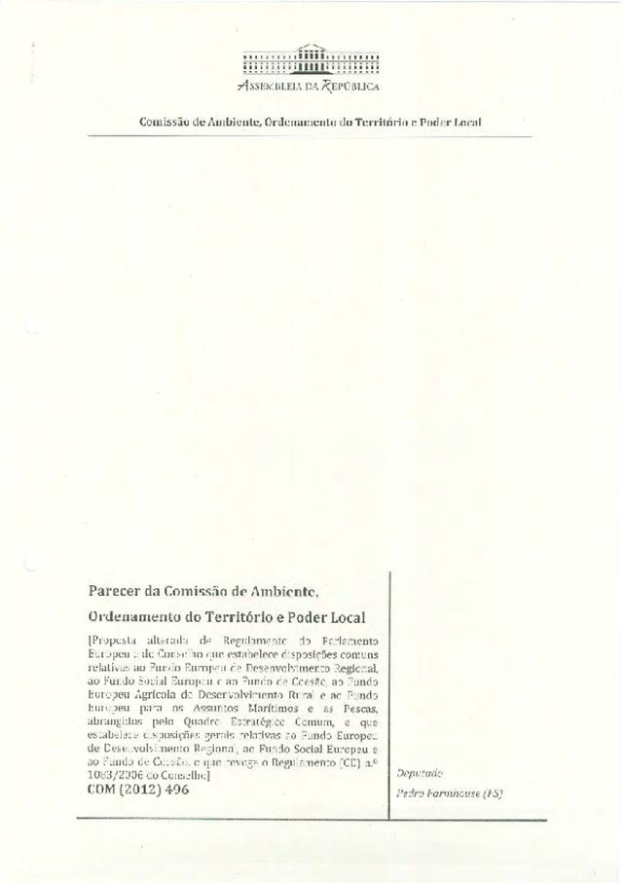
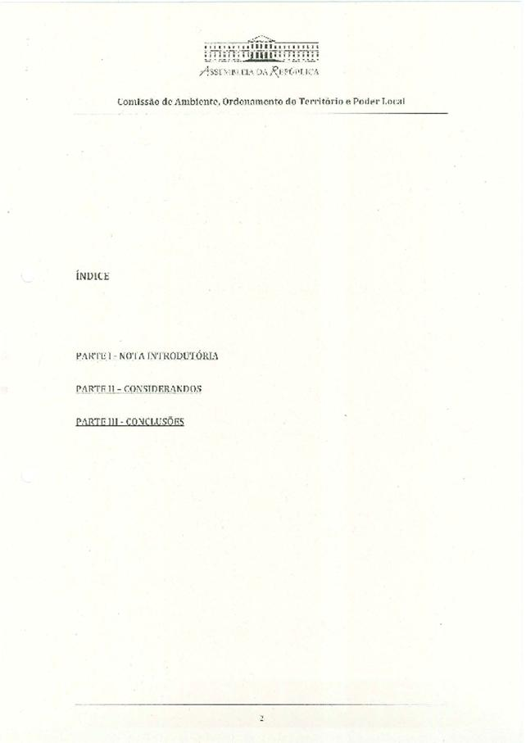
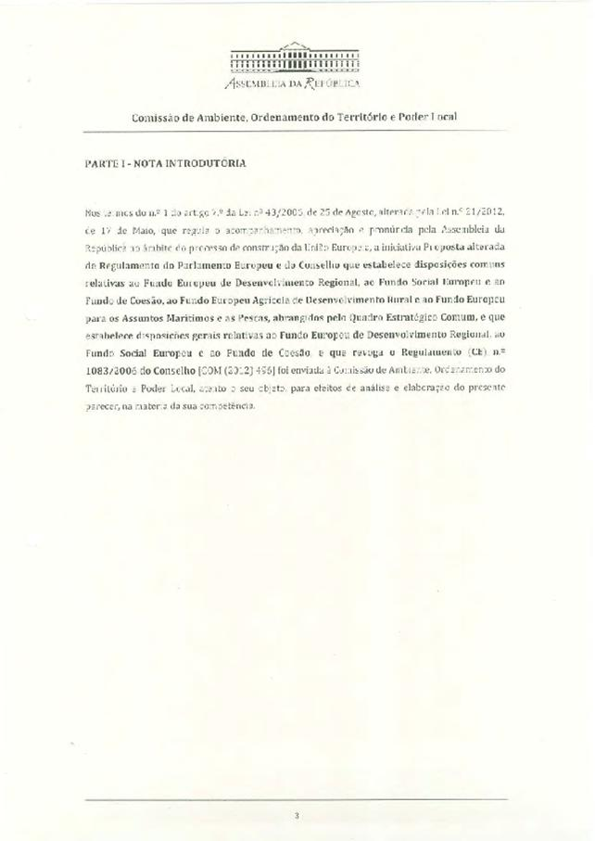
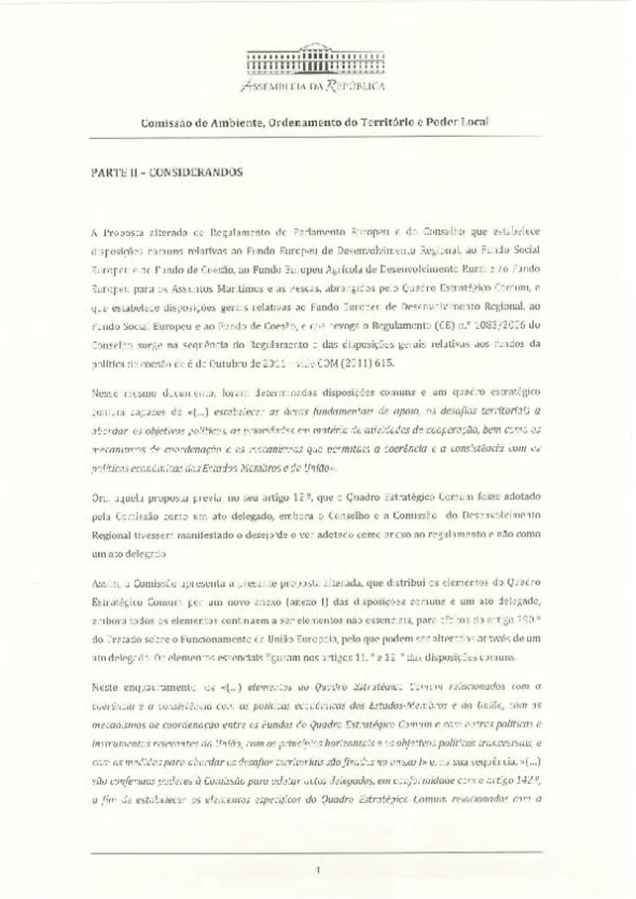
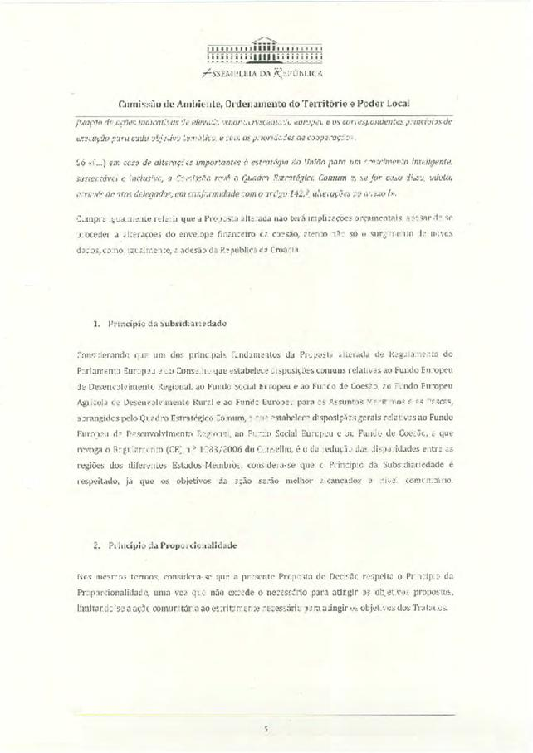
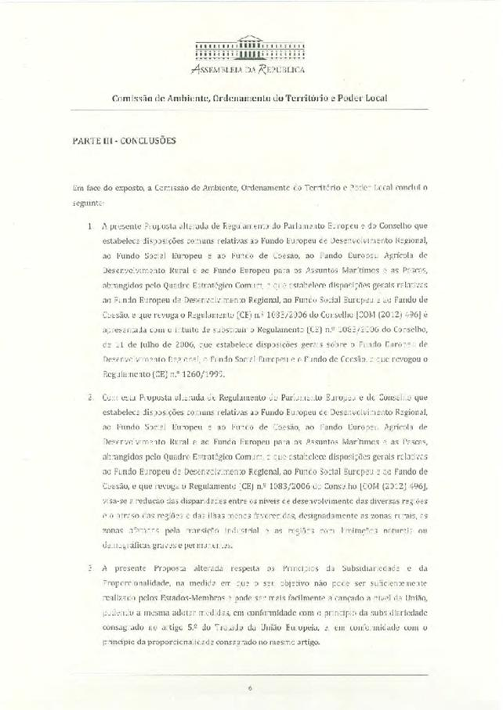
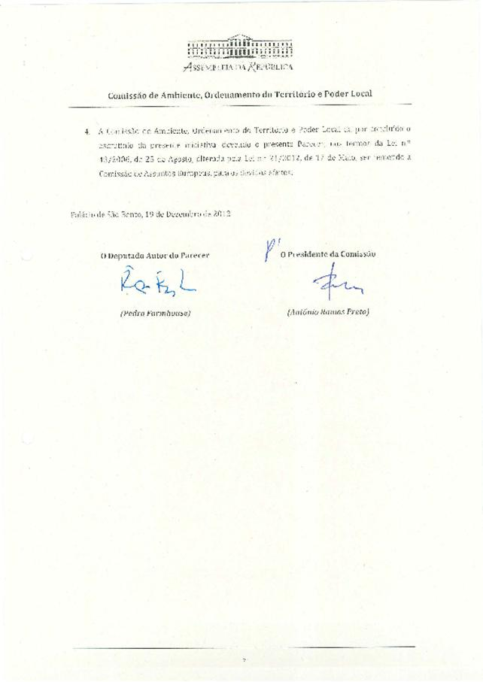

This opinion is available in English on the interparliamentary EU information exchange site (IPEX) at the following address: http://www.ipex.eu/IPEXL-WEB/search.do

