 | 
COUNCIL OF  THE EUROPEAN UNION |  |  | Brussels, 3 May 2013
 |  |  | 9201/13
CONSOM 81
MI 357
ENT 117
JUSTCIV 111
INST 221
PARLNAT 103

OPINION
from: | The Portuguese Parliament
date of receipt: | 2 May 2013
to: | President of the European Union
Subject: | Green Paper on unfair trading practices in the business-to-business food and non-food supply chain in Europe (Text with EEA relevance)  [doc. ST 6122/13 CONSOM 19 MI 94 ENT 40 JUSTCIV19 - COM(2013) 37 final]  - Opinion¹ on the application of the Principles of Subsidiarity and Proportionality

Delegations will find attached the abovementioned opinion.

___________________

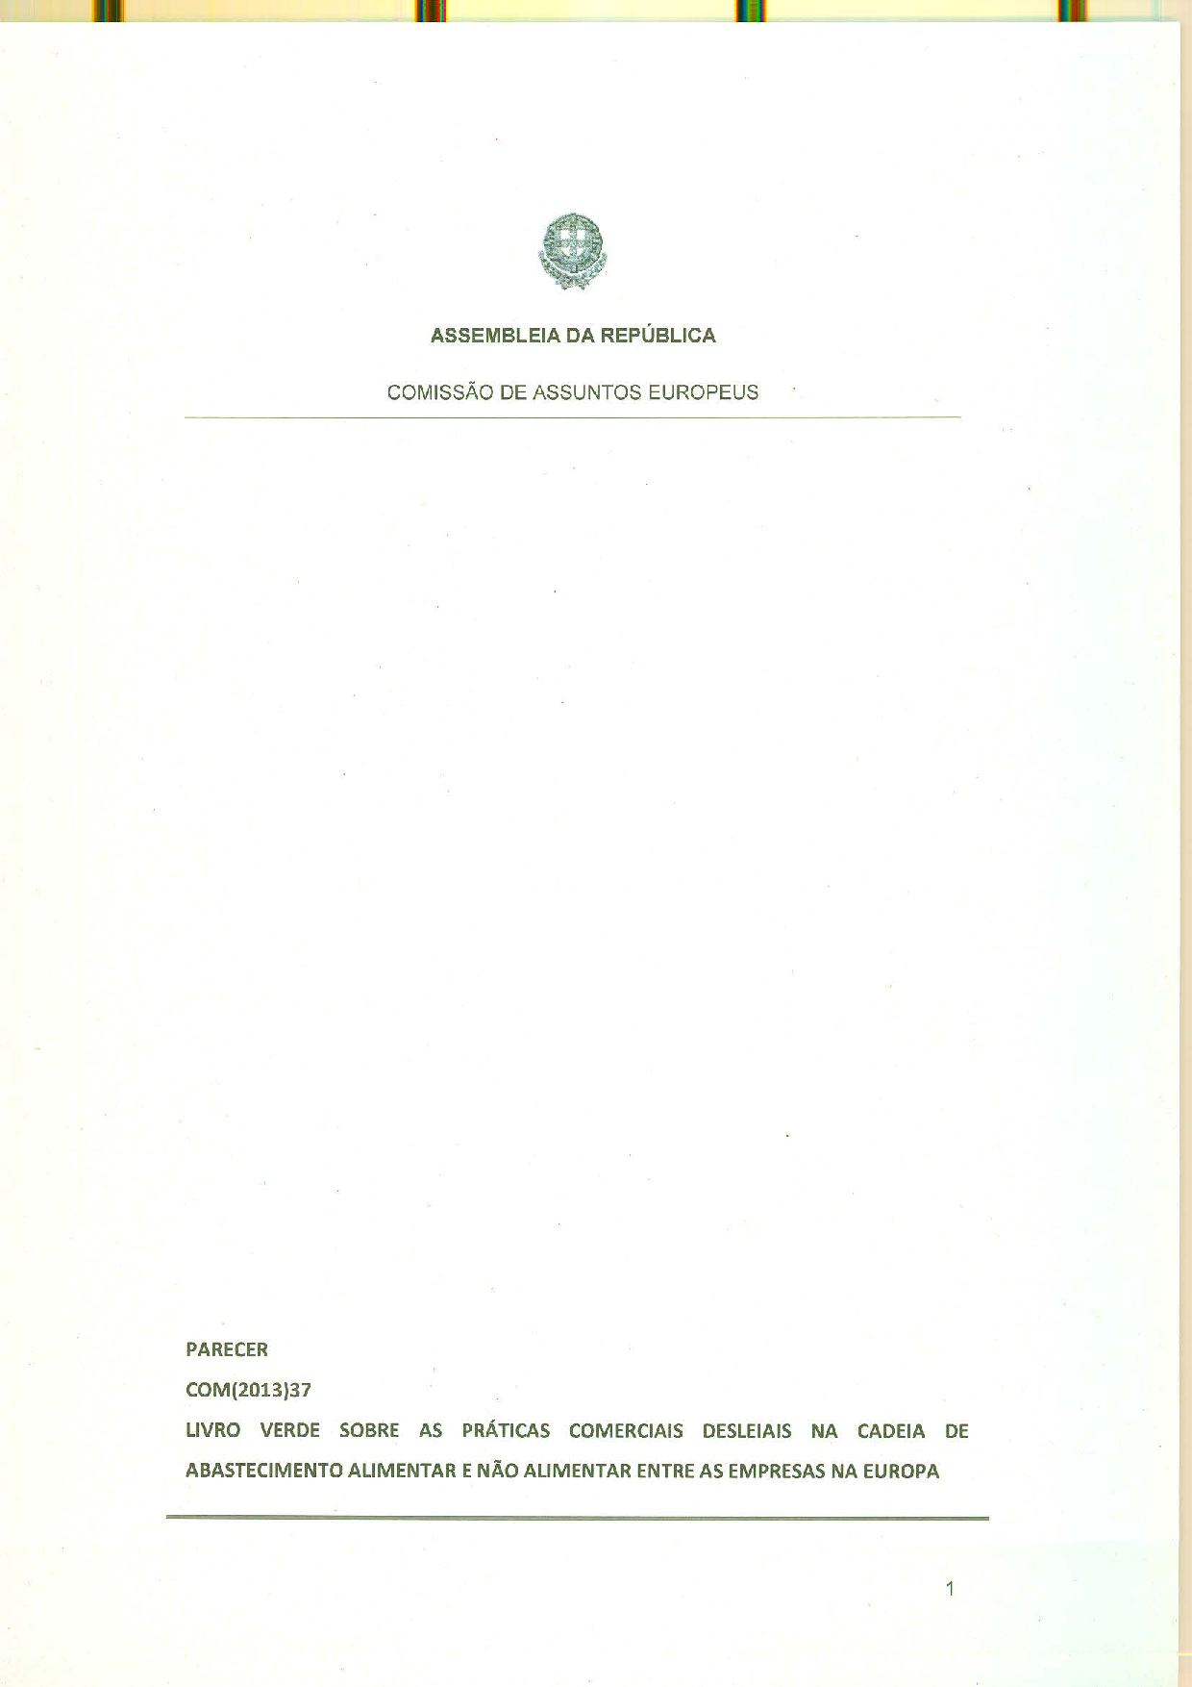
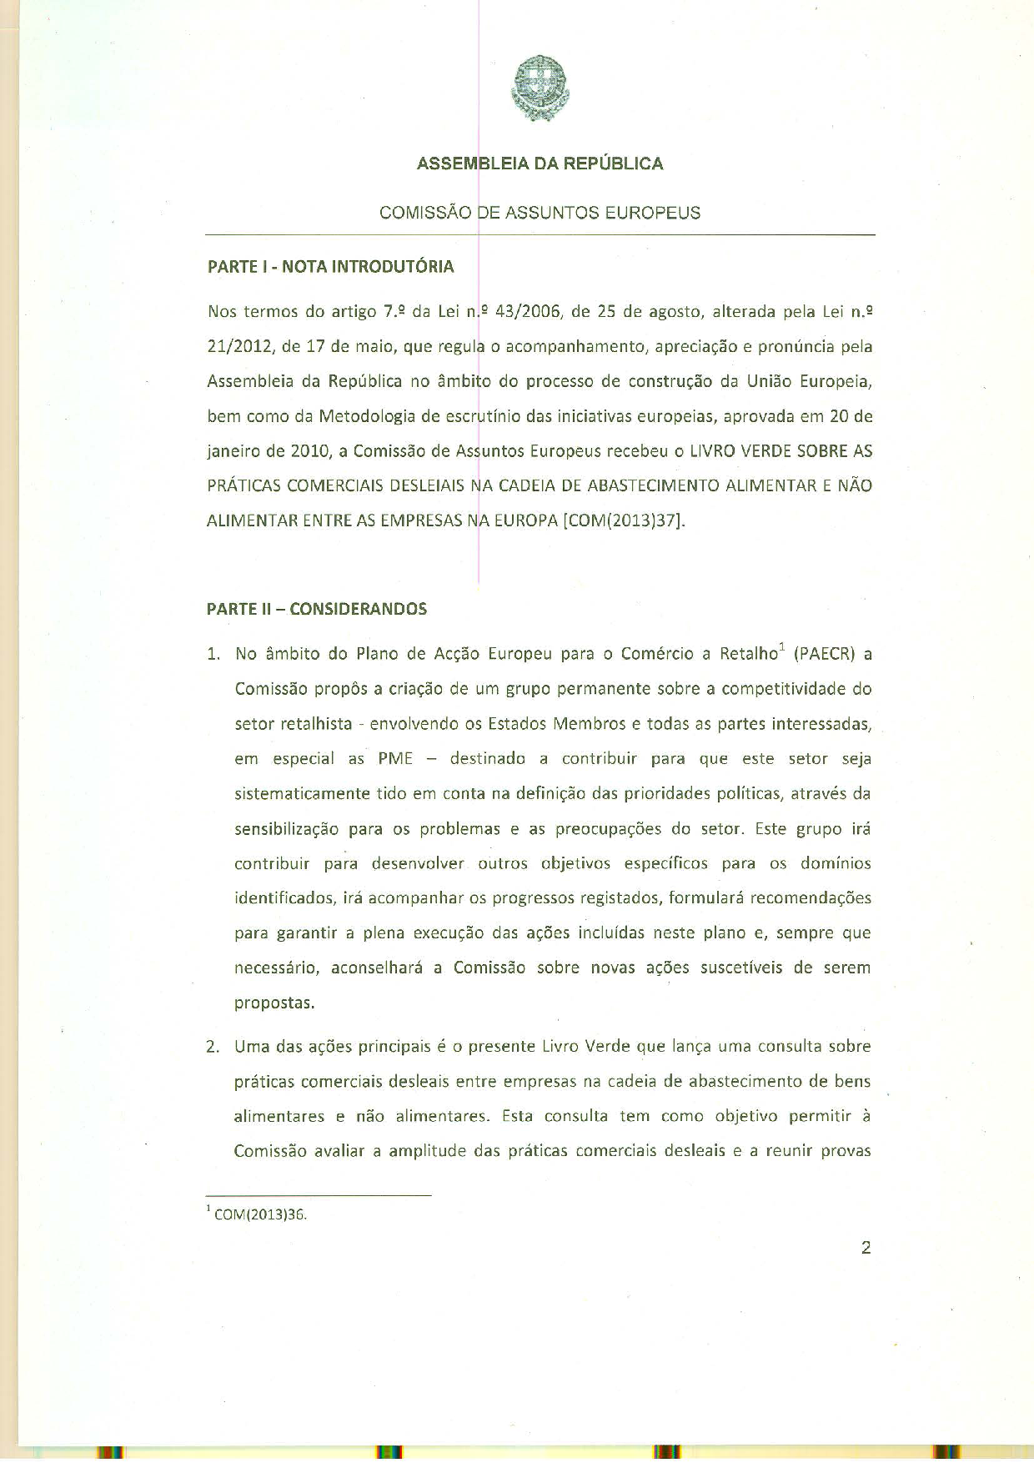
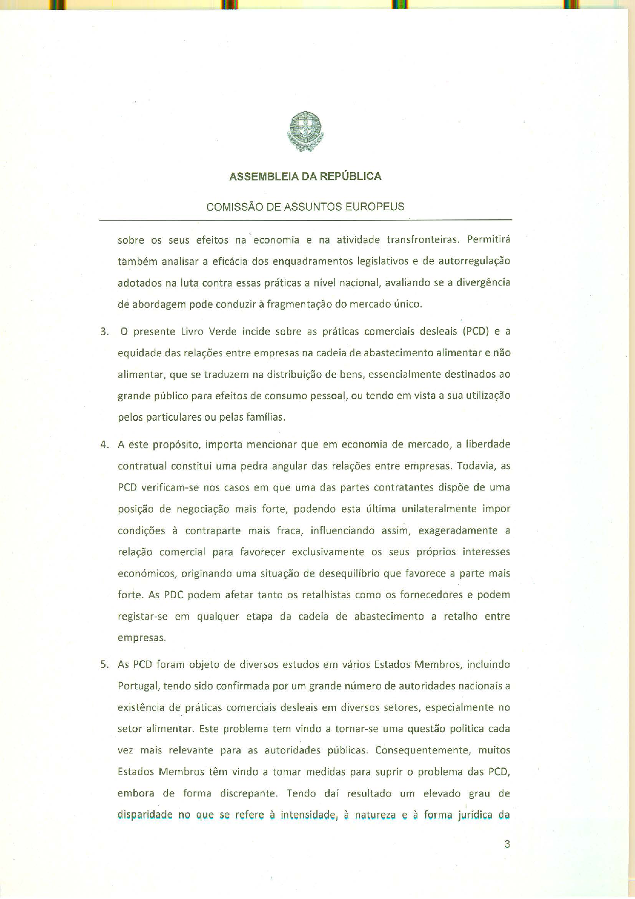
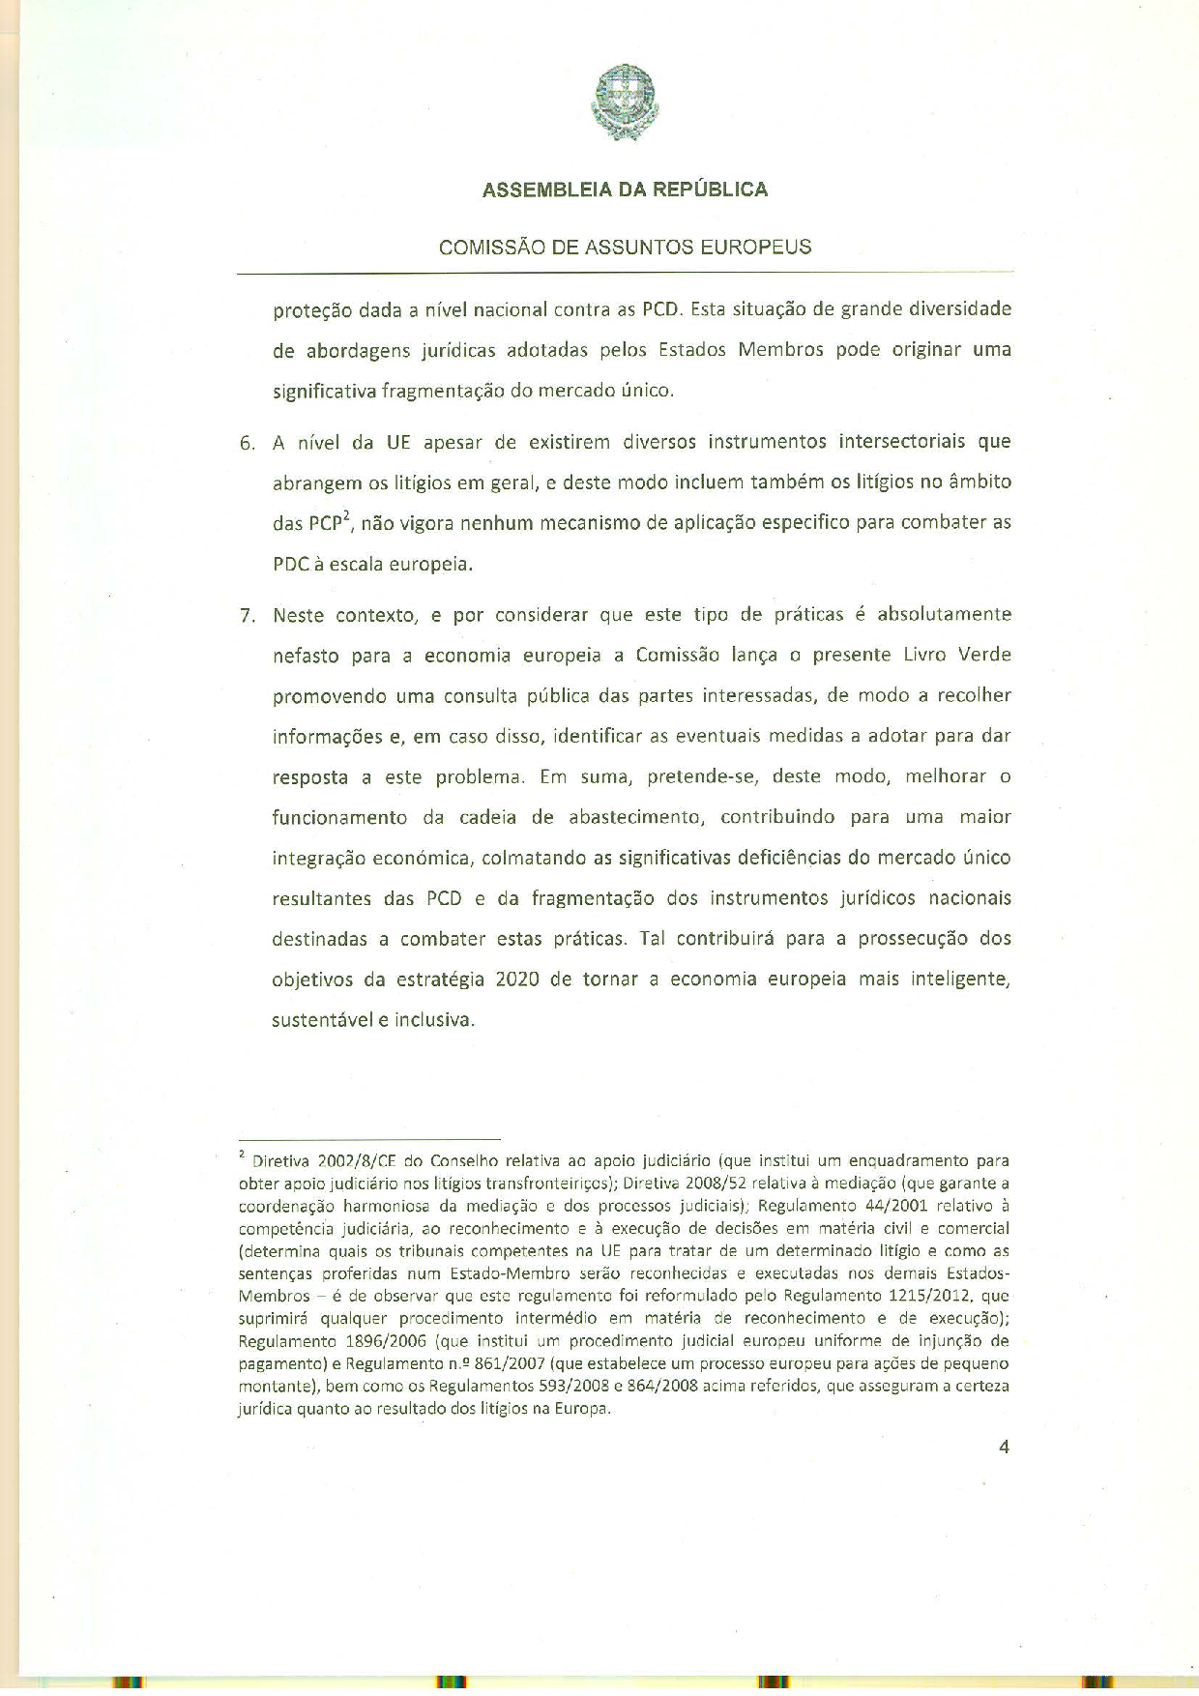
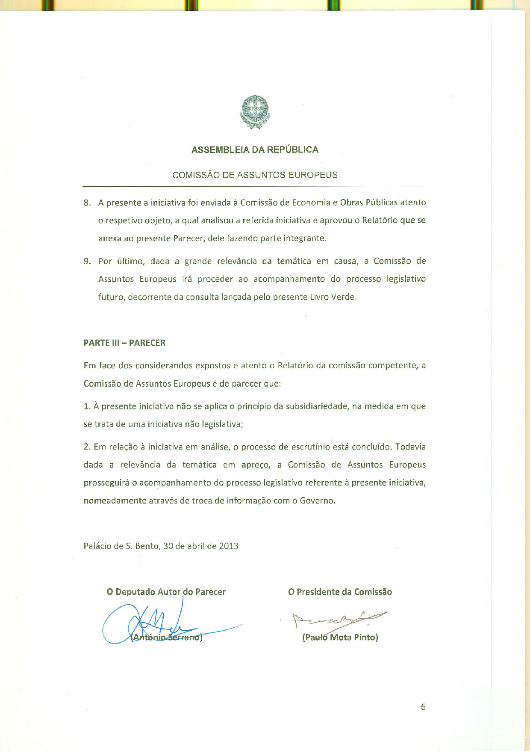
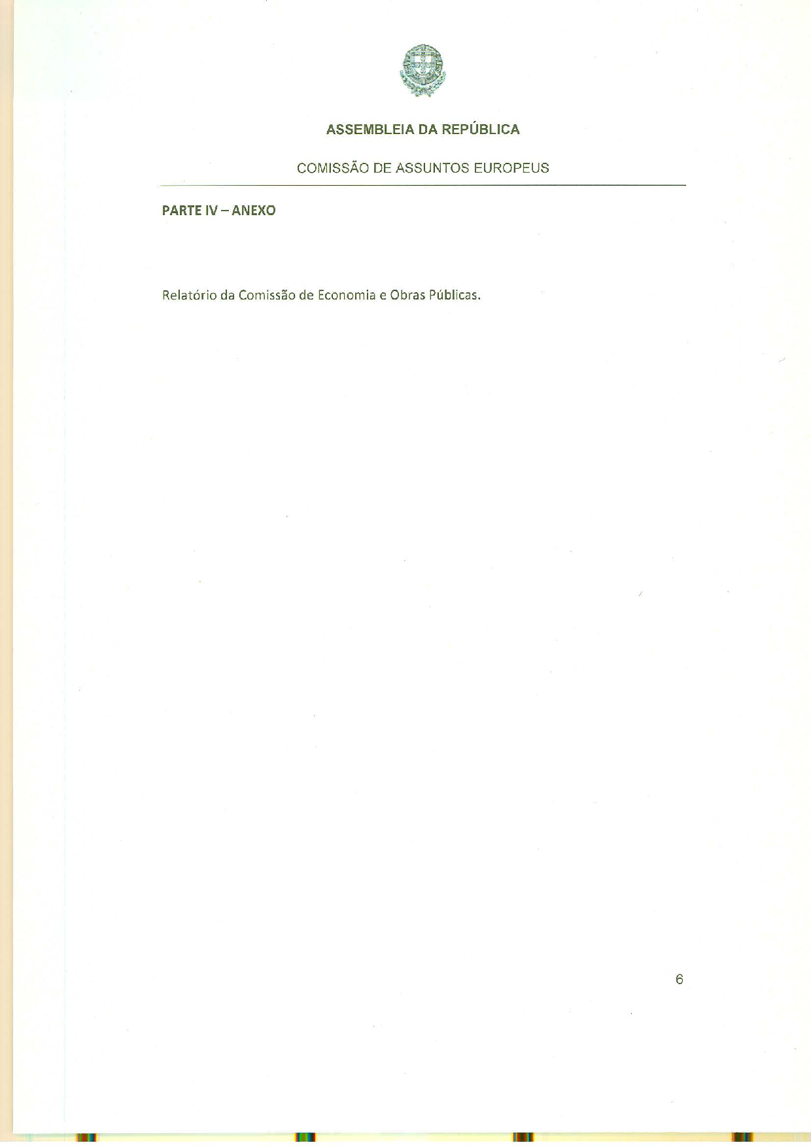
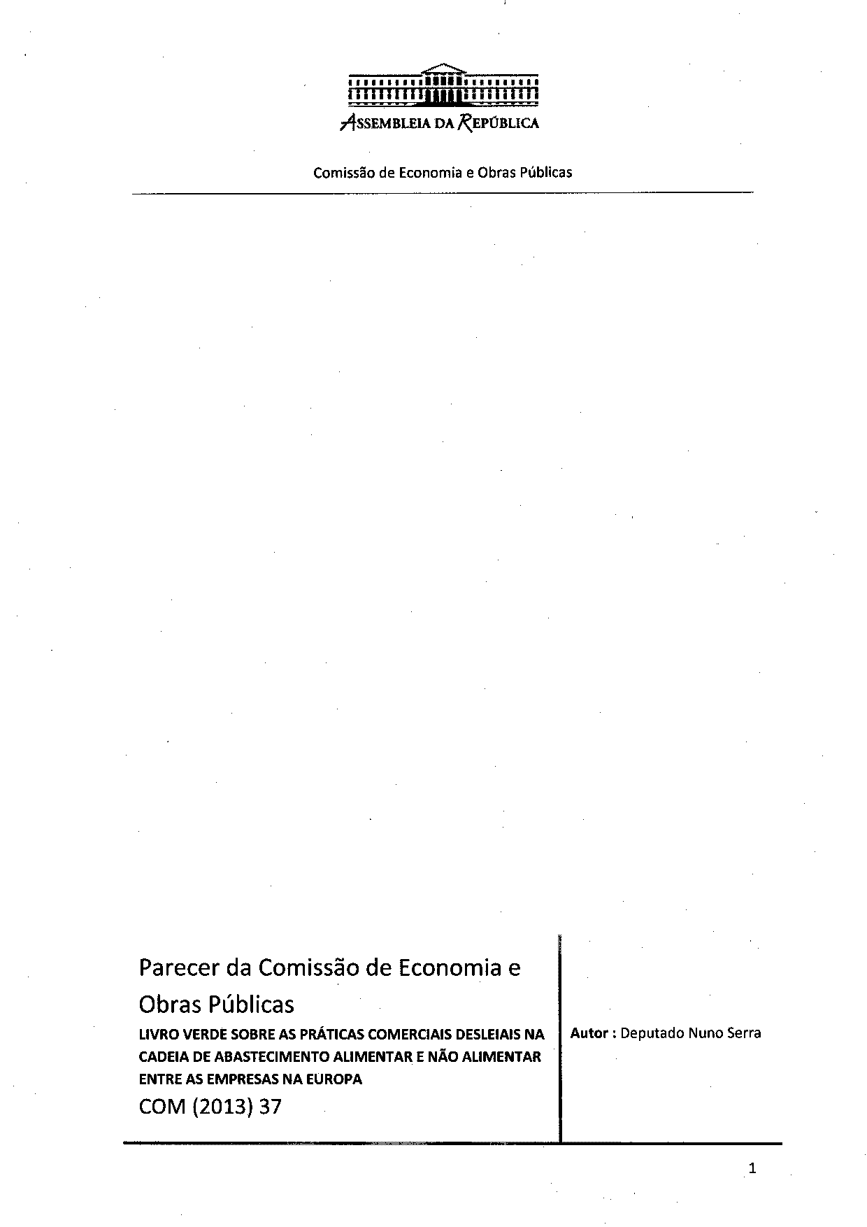
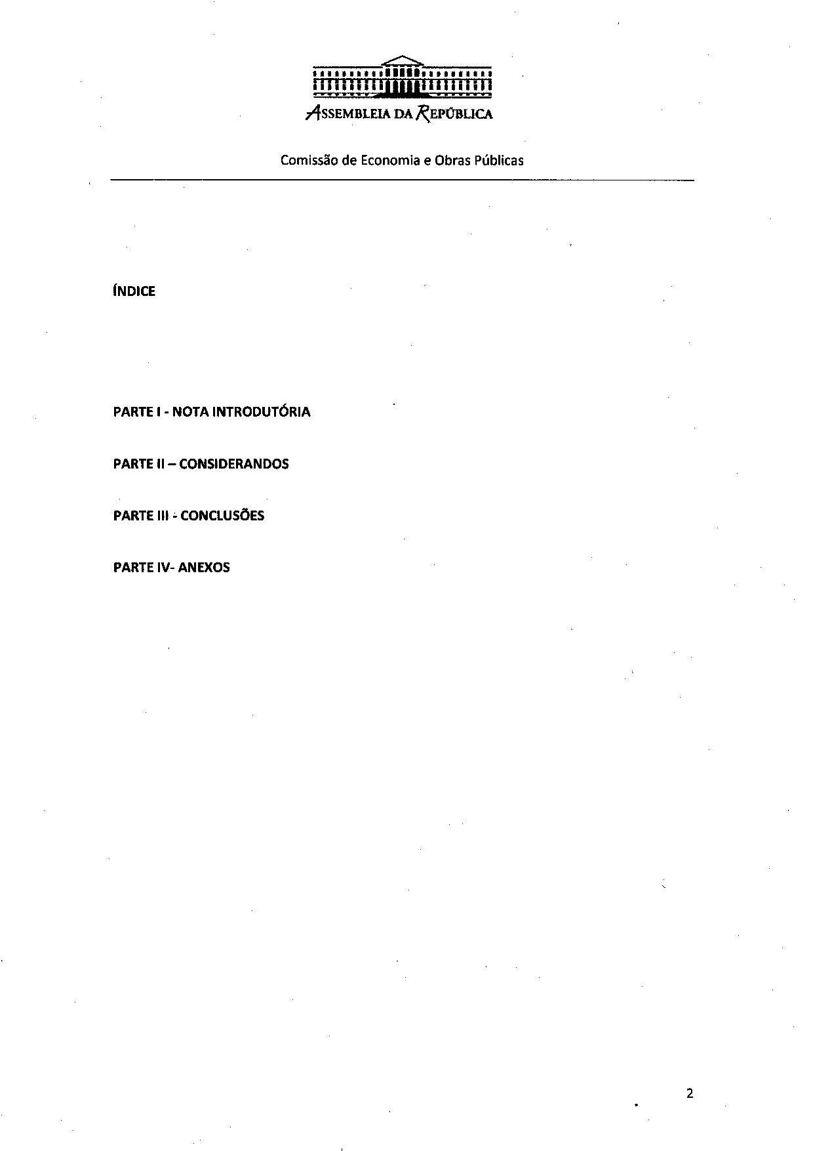
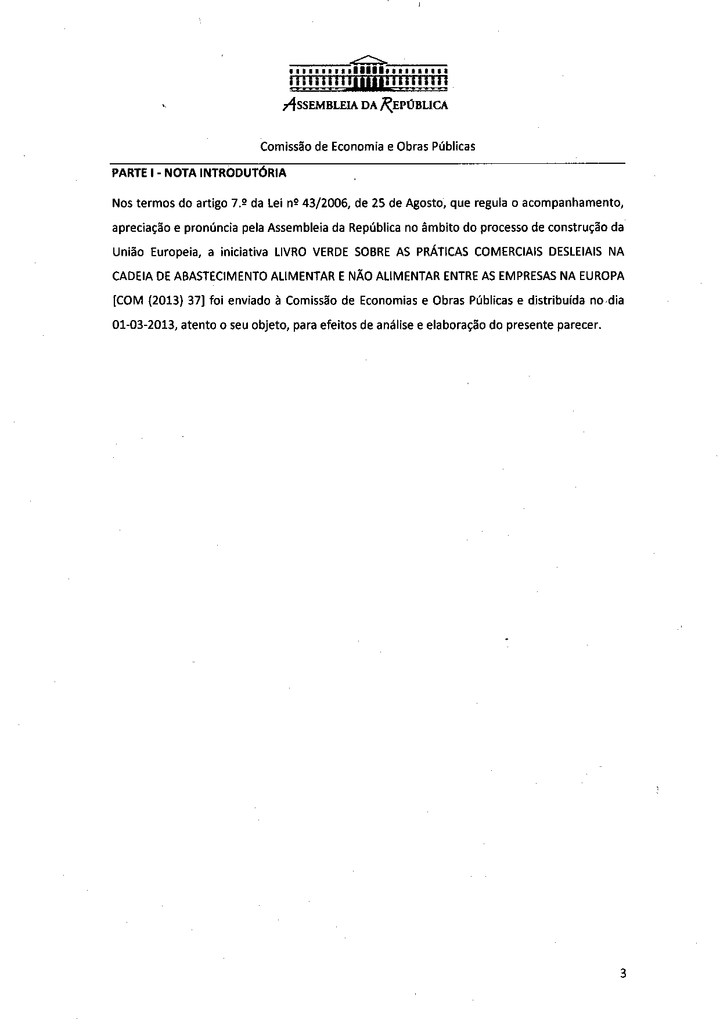
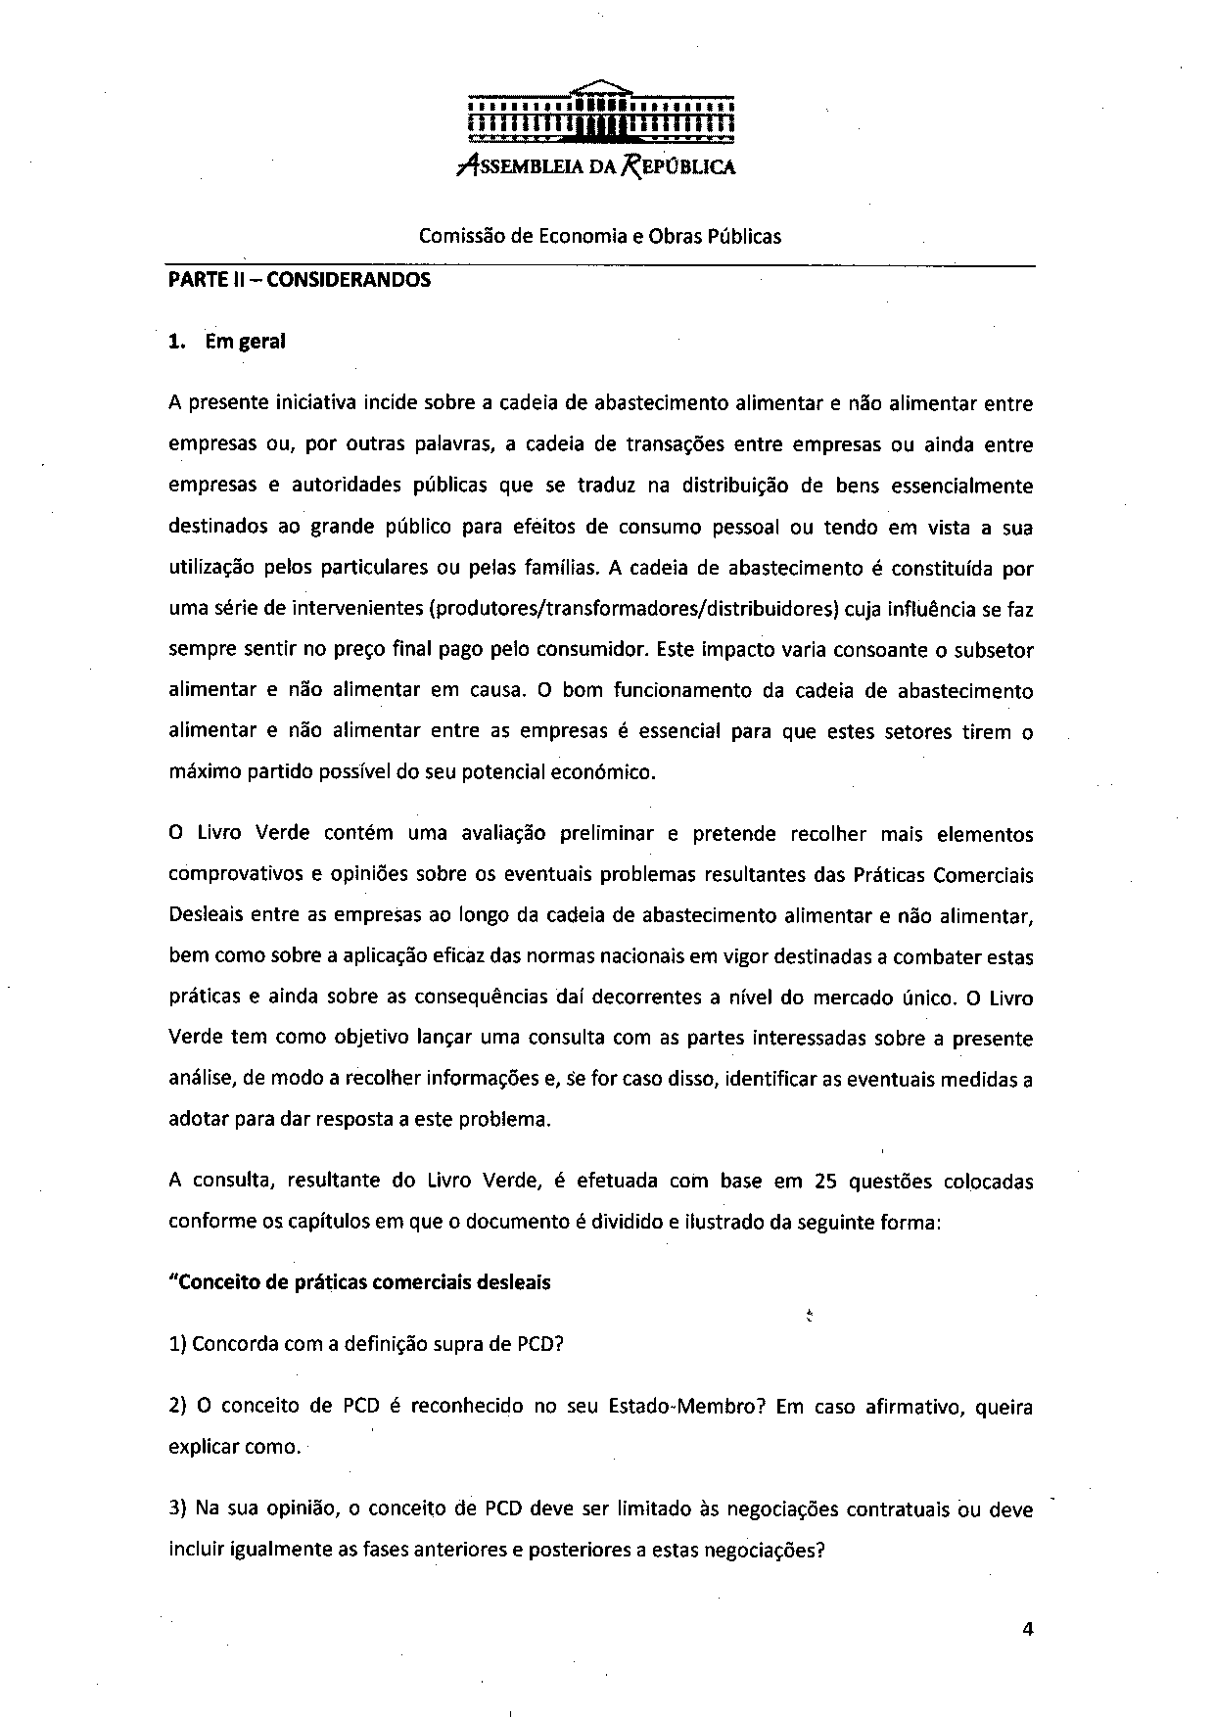
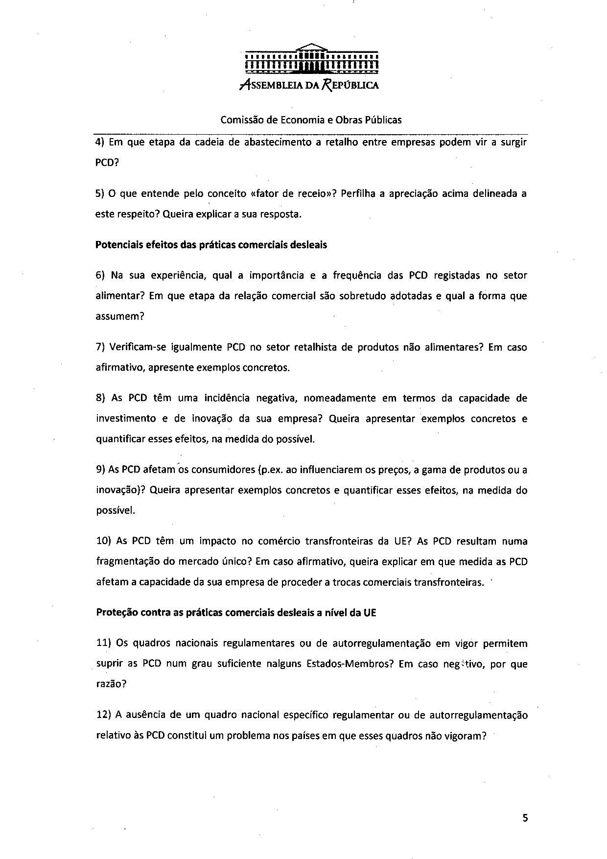
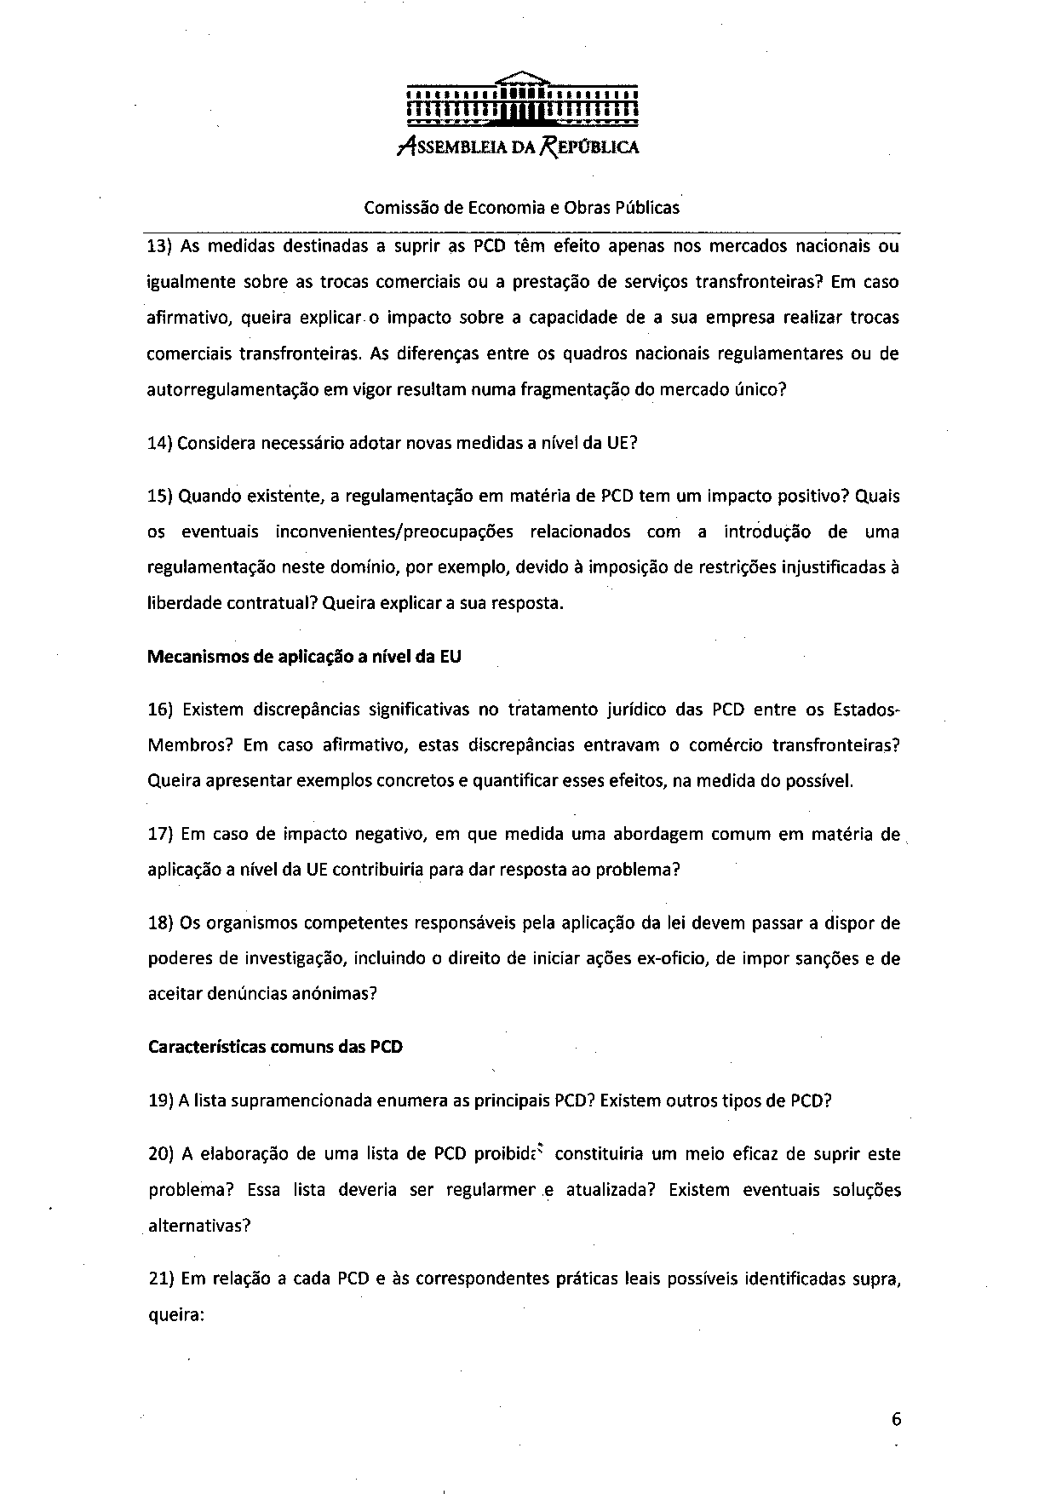
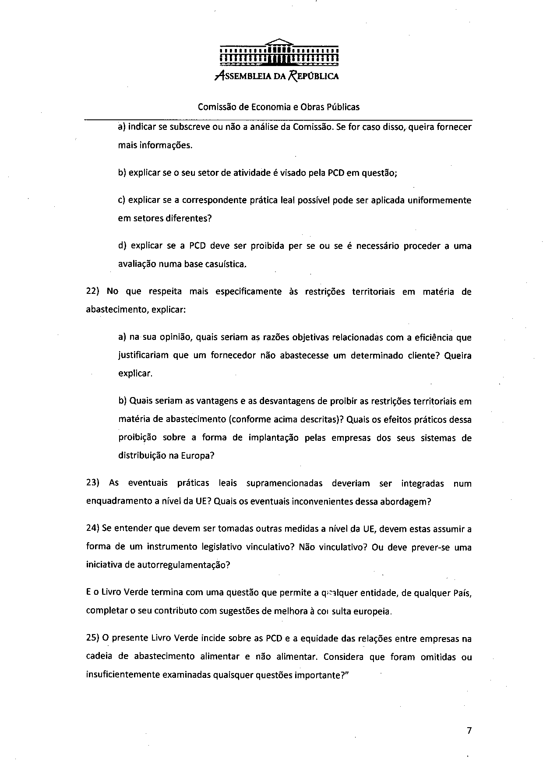
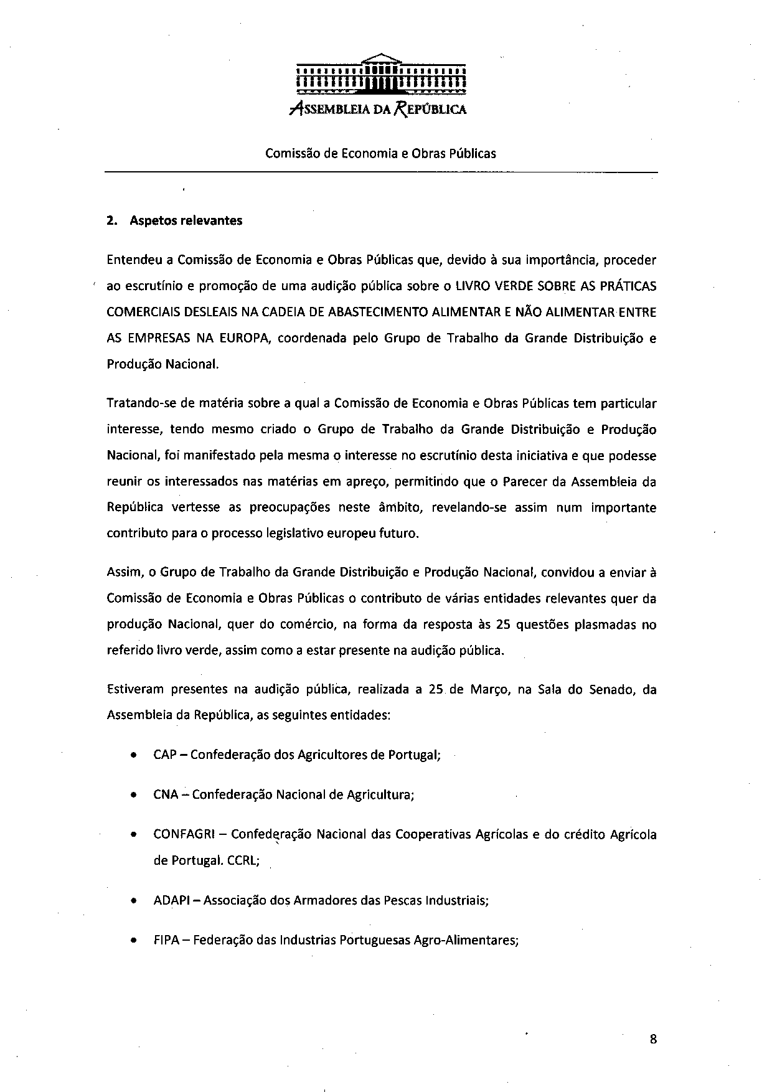
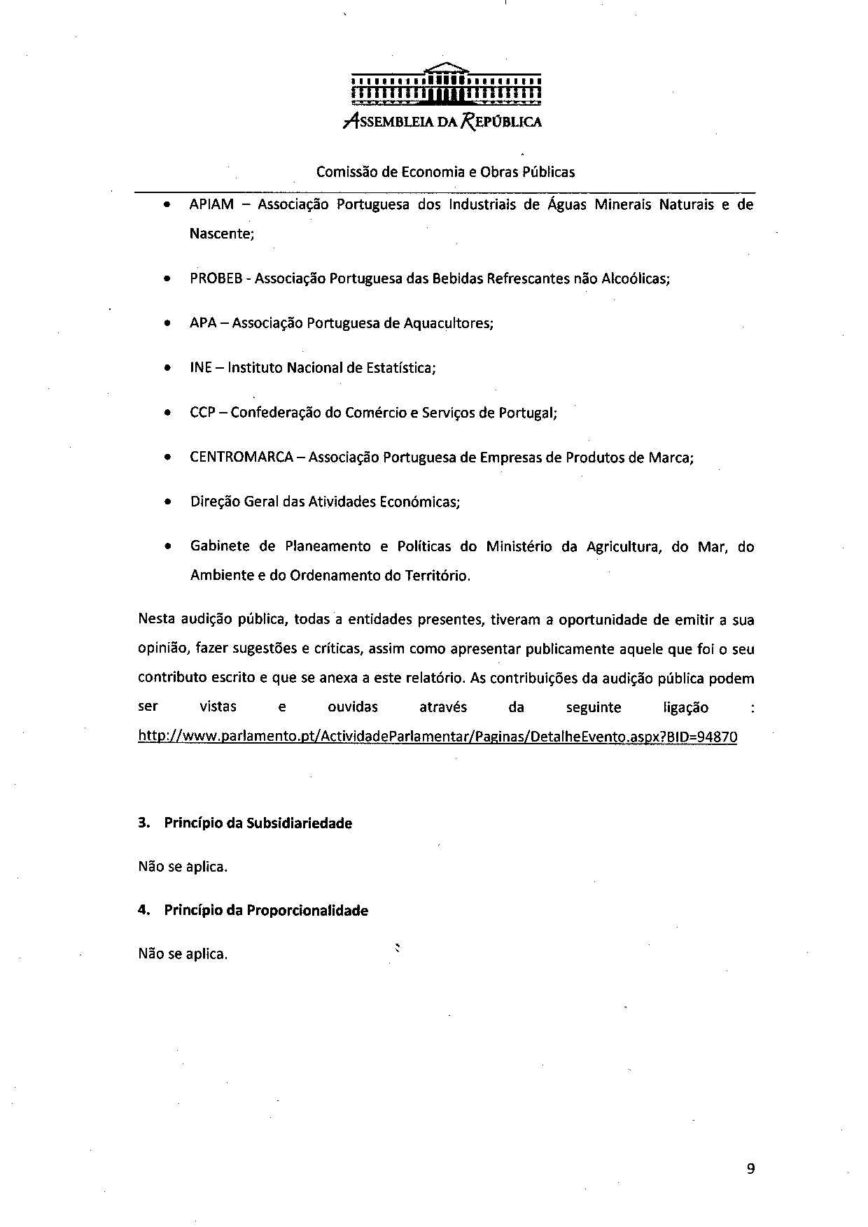
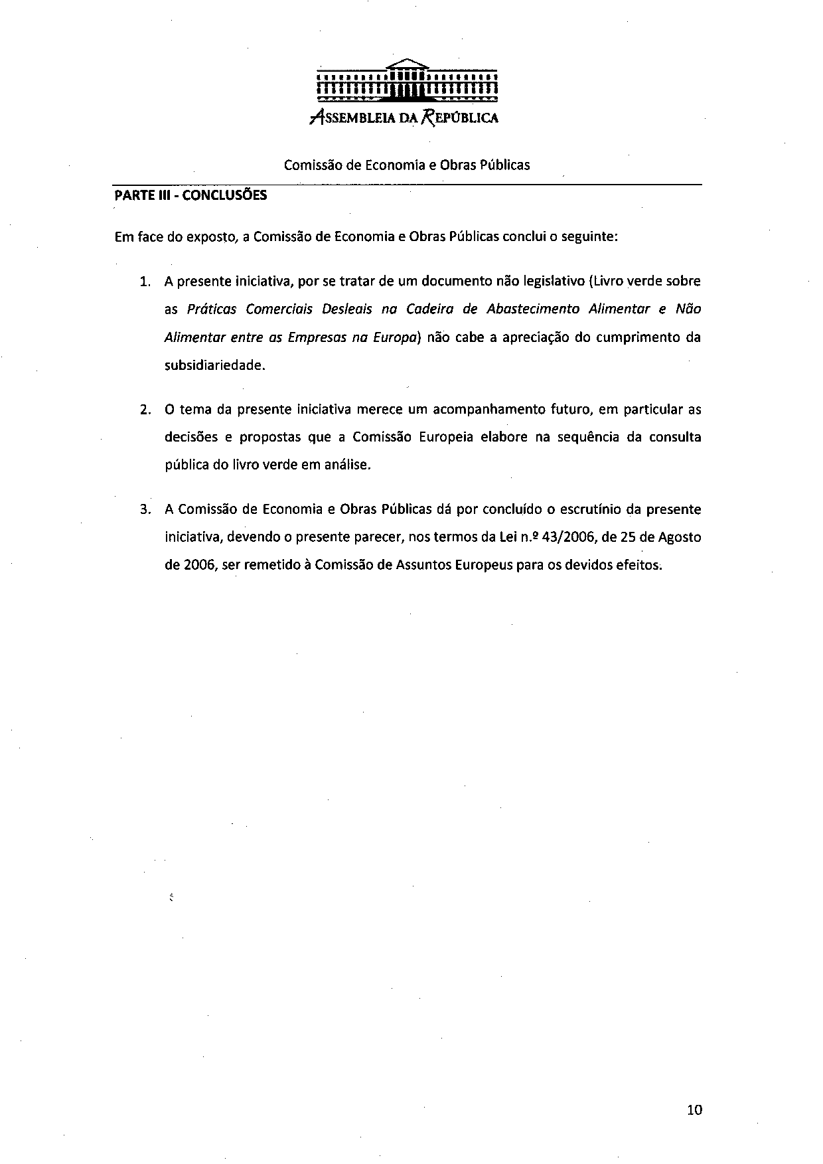
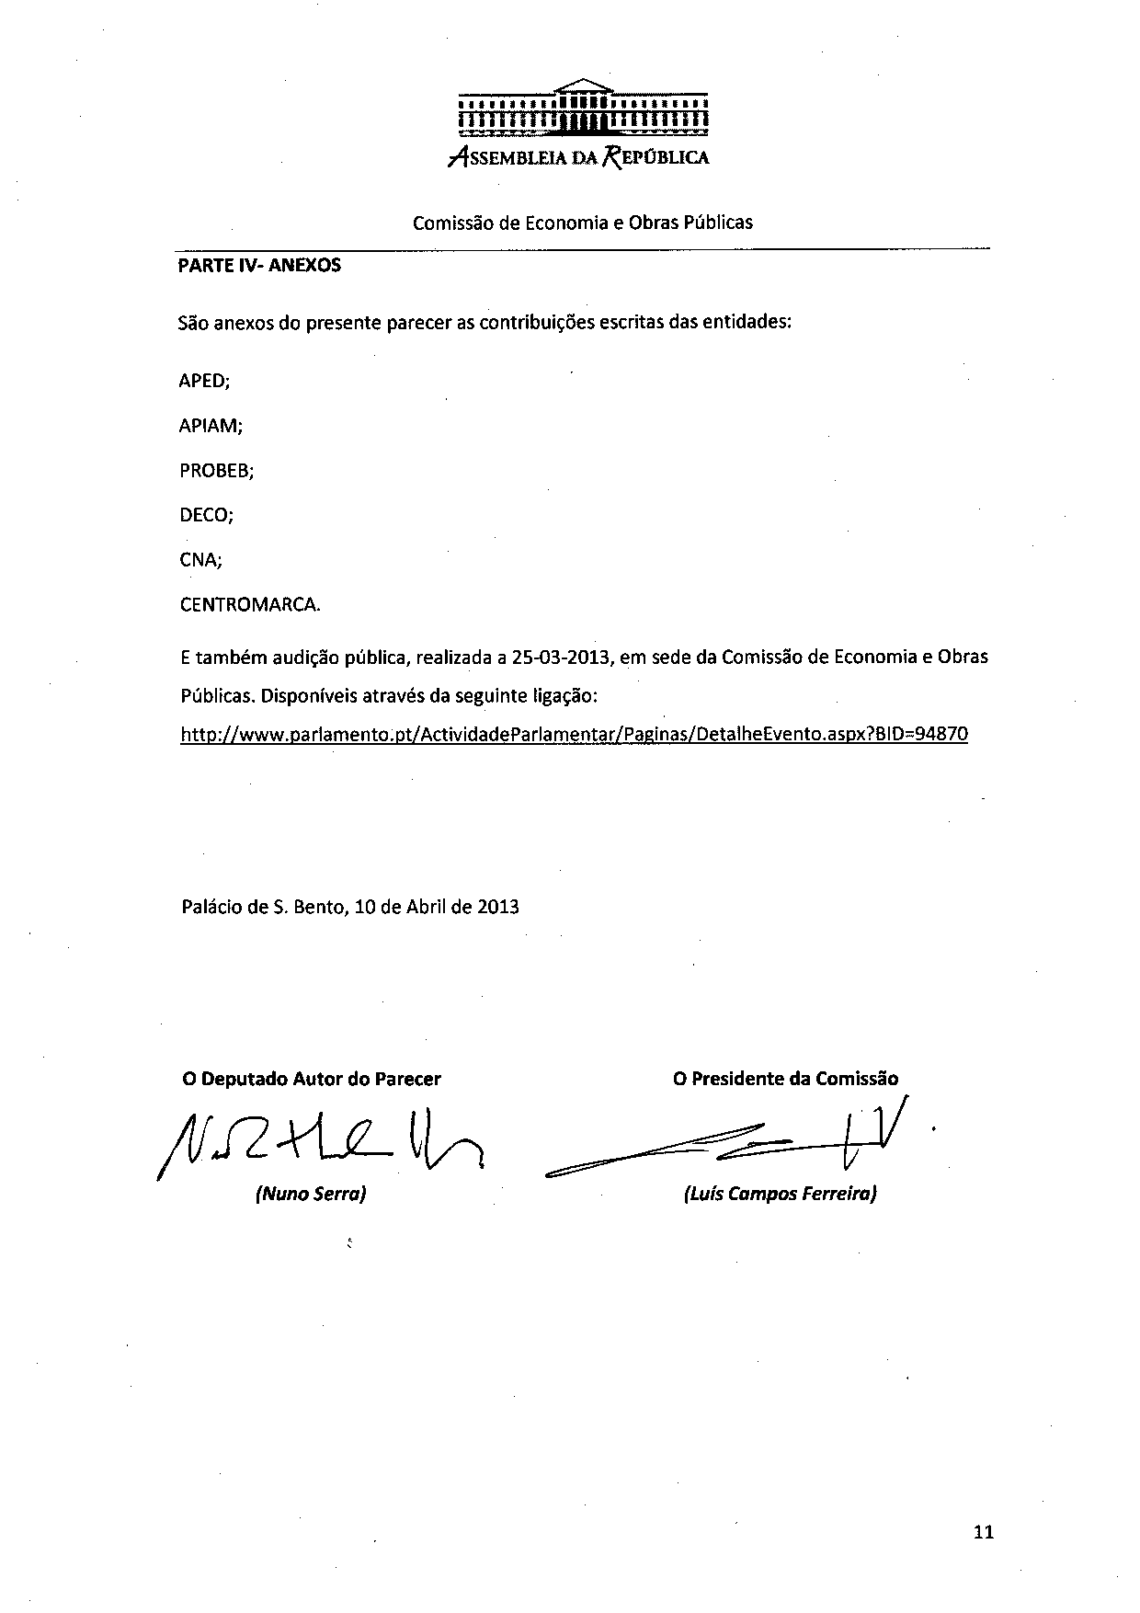
_______________________

Translations of the opinion may be available in the Interparliamentary EU information exchange site IPEX at the following address: http://www.ipex.eu/IPEXL-WEB/dossier/document/COM20130037.do

