 | 
COUNCIL OF  THE EUROPEAN UNION |  |  | Brussels, 26 April 2013
 | Interinstitutional File:  2013/0064 (COD) |  | 8936/13  ADD 2
ESPACE 27
COMPET 245
IND 121
RECH 125
TRANS 188
COSDP 373
CSC 40
CIVCOM 175
CODEC 927
INST 207
PARLNAT 100

COVER NOTE
from: | Portuguese National Parliament
date of receipt: | 24 April 2013
to: | The President of the Council of the European Union
Subject: | Proposal for a Decision of the European Parliament and the Council, Establishing a Space Surveillance and Tracking Support Programme  [doc. 6952/13 ESPACE 18 COMPET 120 IND 54 RECH 52 TRANS 83  COSDP 87 CSC 19 CIVCOM 88 CODEC 547 - COM(2013) 107 final]  - Opinion on the Application of the Principle of Subsidiarity and Proportionality

Delegations will find attached the third part of the opinion from the Portuguese Parliament.

________________________

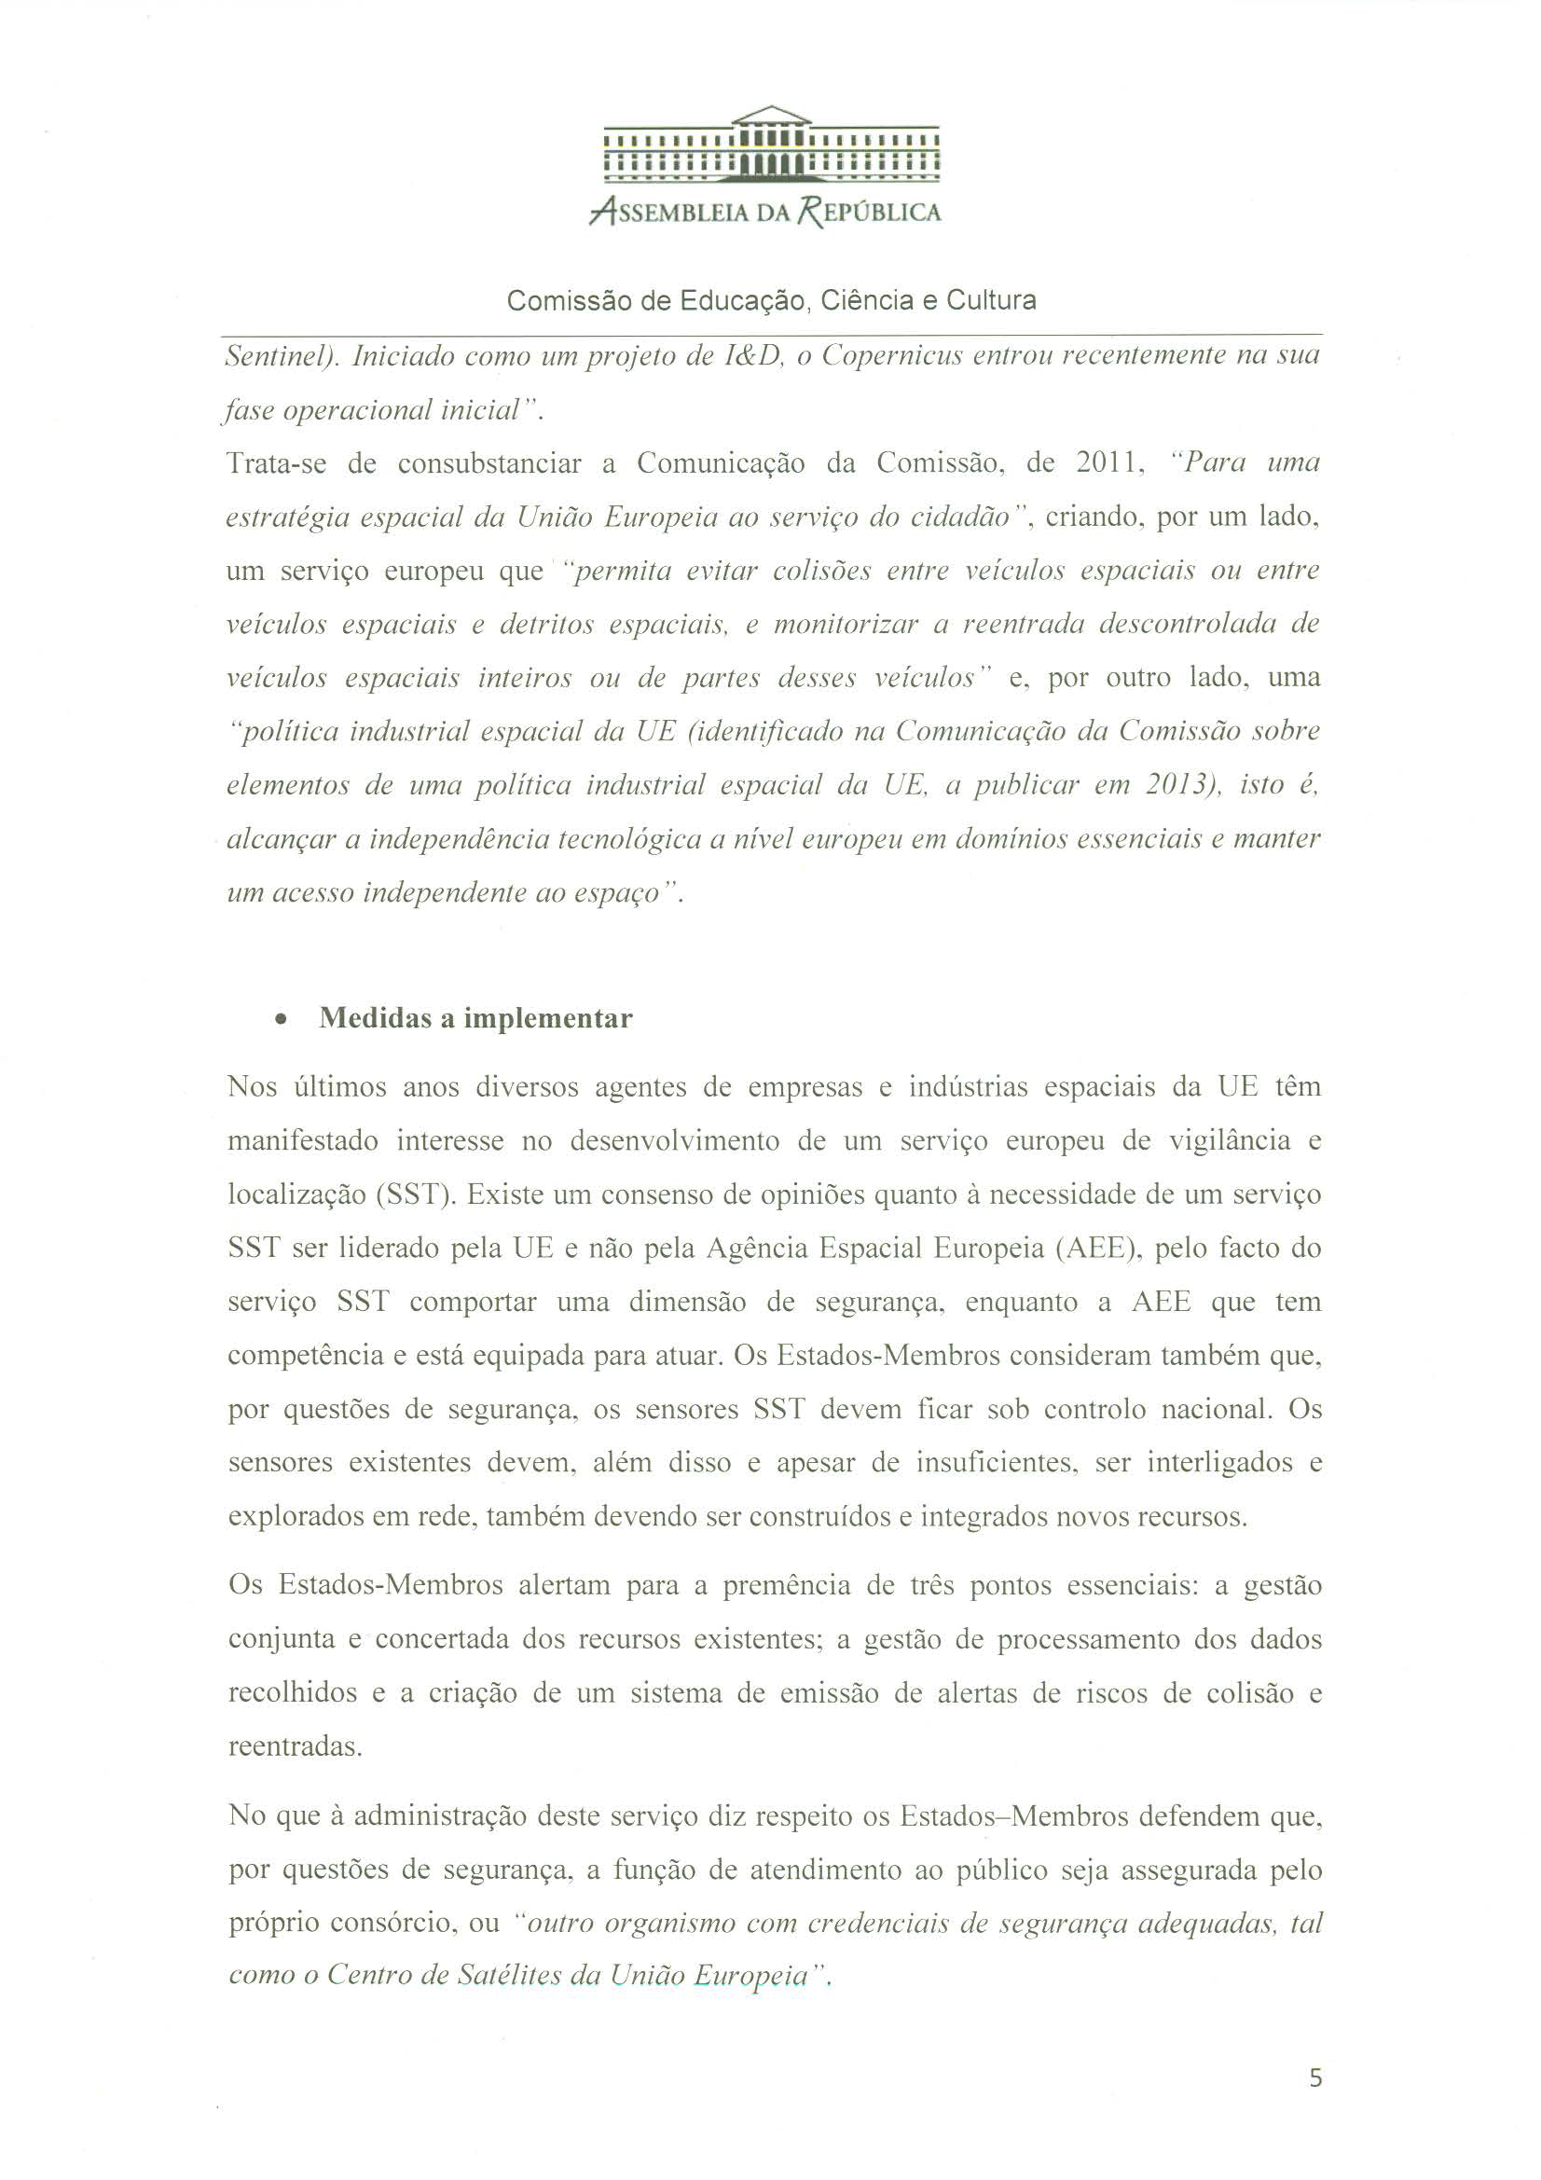
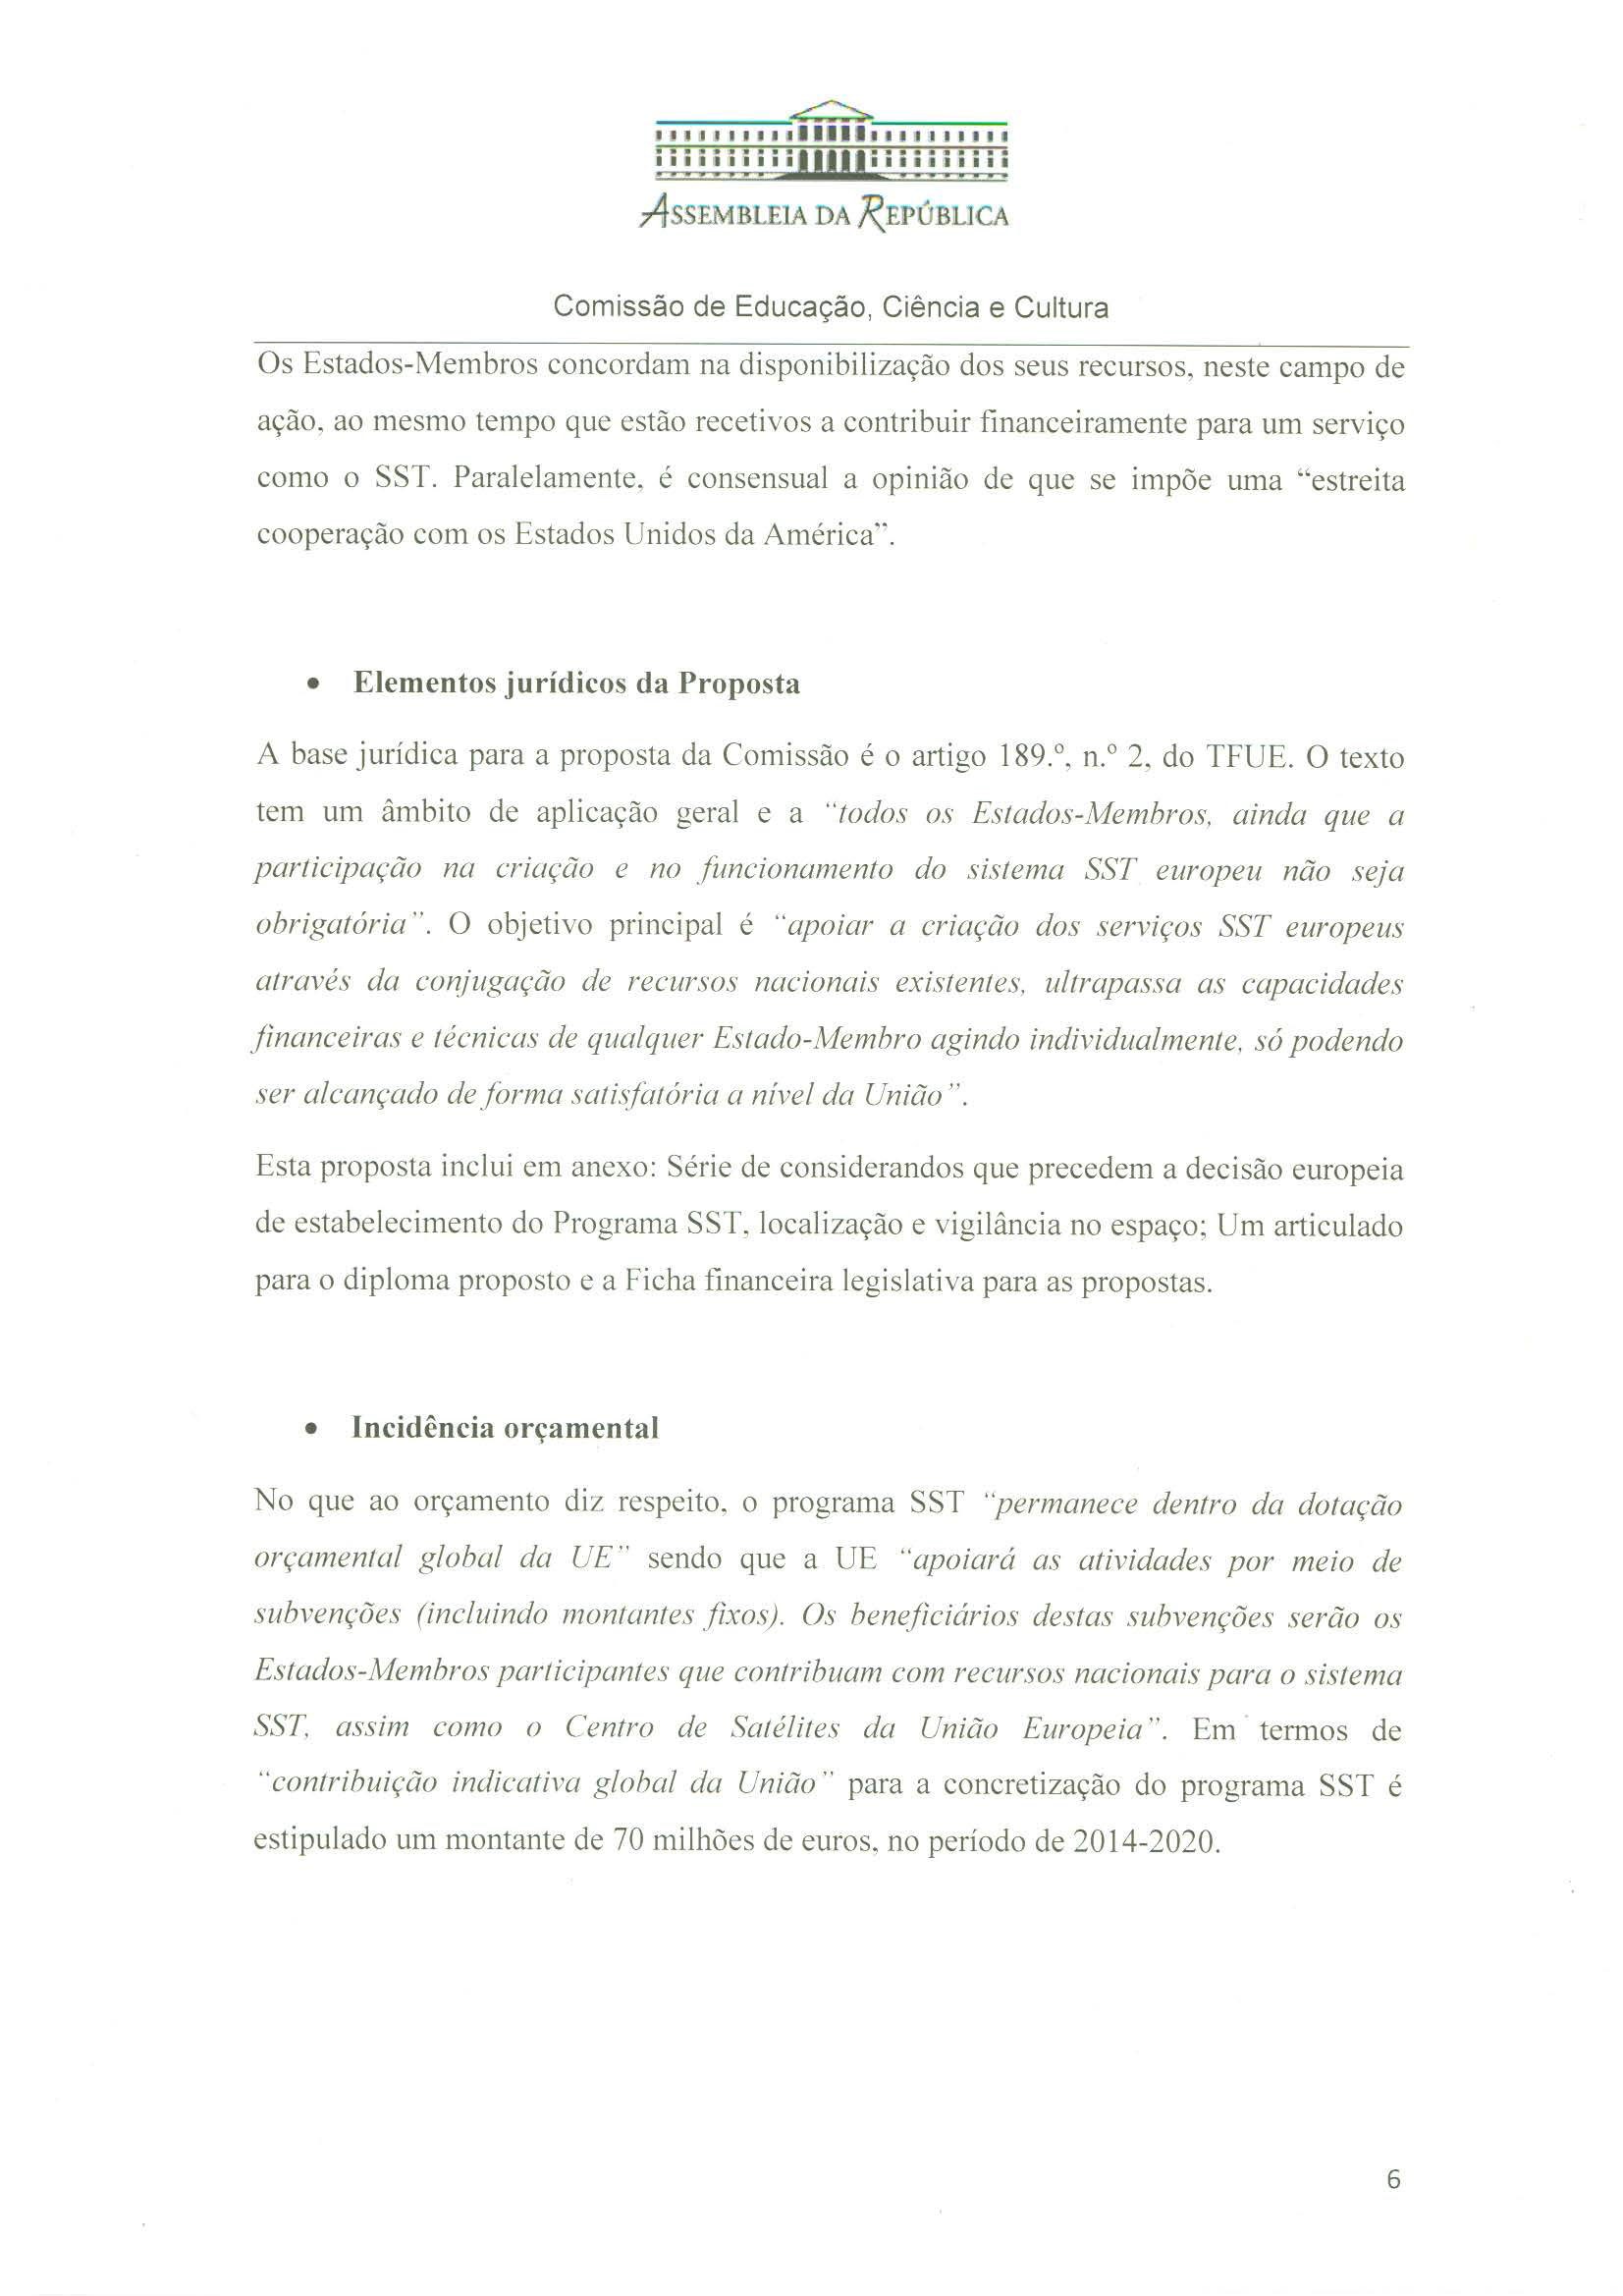
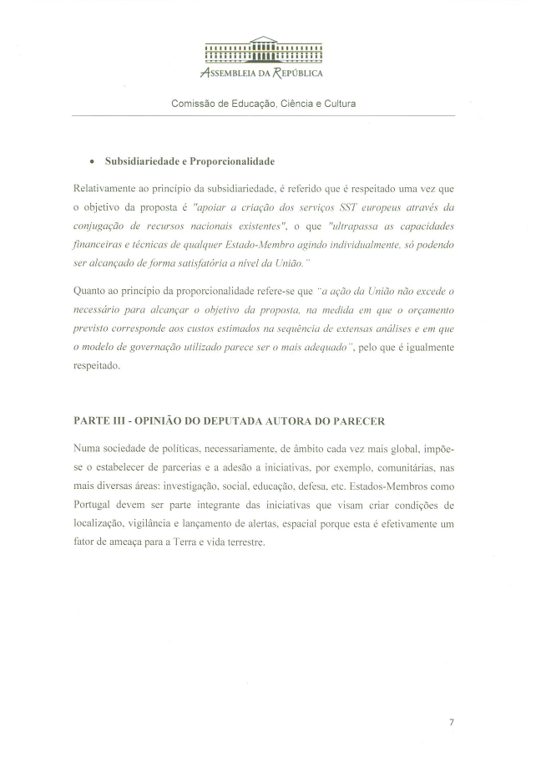
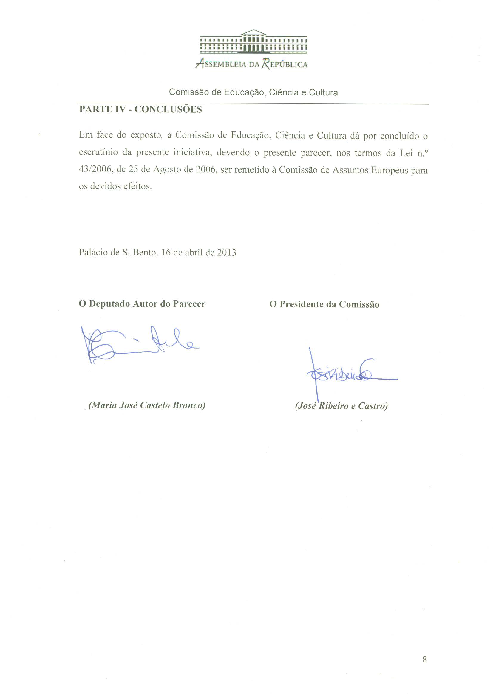

Translation(s) of the opinion may be available on the Interparliamentary EU Information Exchange site IPEX at the following address: http://www.ipex.eu/IPEXL-WEB/search.do

