 | 
COUNCIL OF  THE EUROPEAN UNION |  |  | Brussels, 10 April 2013
 | Interinstitutional File:  2013/0025 (COD) |  | 8314/13
EF 64
ECOFIN 247
DROIPEN 34
CRIMORG 59
CODEC 772
INST 165
PARLNAT 77

COVER NOTE
from: | The Portuguese Parliament
date of receipt: | 4 April 2013
to: | President of the European Union
Subject: | Proposal for a DIRECTIVE OF THE EUROPEAN PARLIAMENT AND OF THE COUNCIL on the prevention of the use of the financial system for the purpose of money laundering and terrorist financing  [doc.6231/13 EF 24 ECOFIN 103 DROIPEN 15 CRIMORG 15 CODEC 282 - COM(2013) 45 final]  - Opinion on the application of the Principles of Subsidiarity and Proportionality

Delegations will find attached the above mentioned Opinion.

________________________

Encl.:

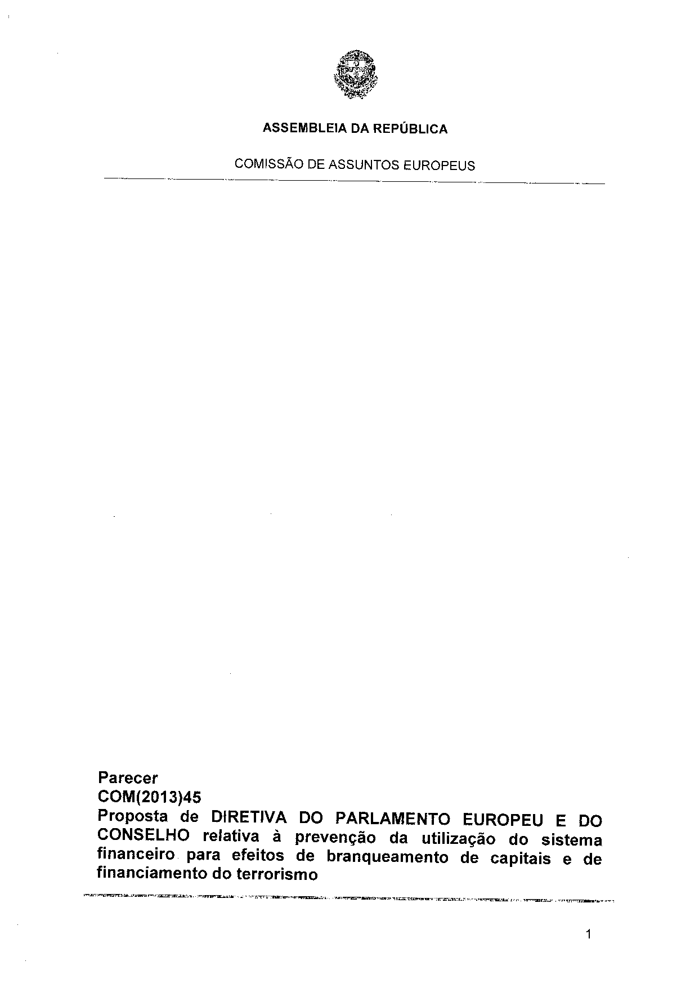
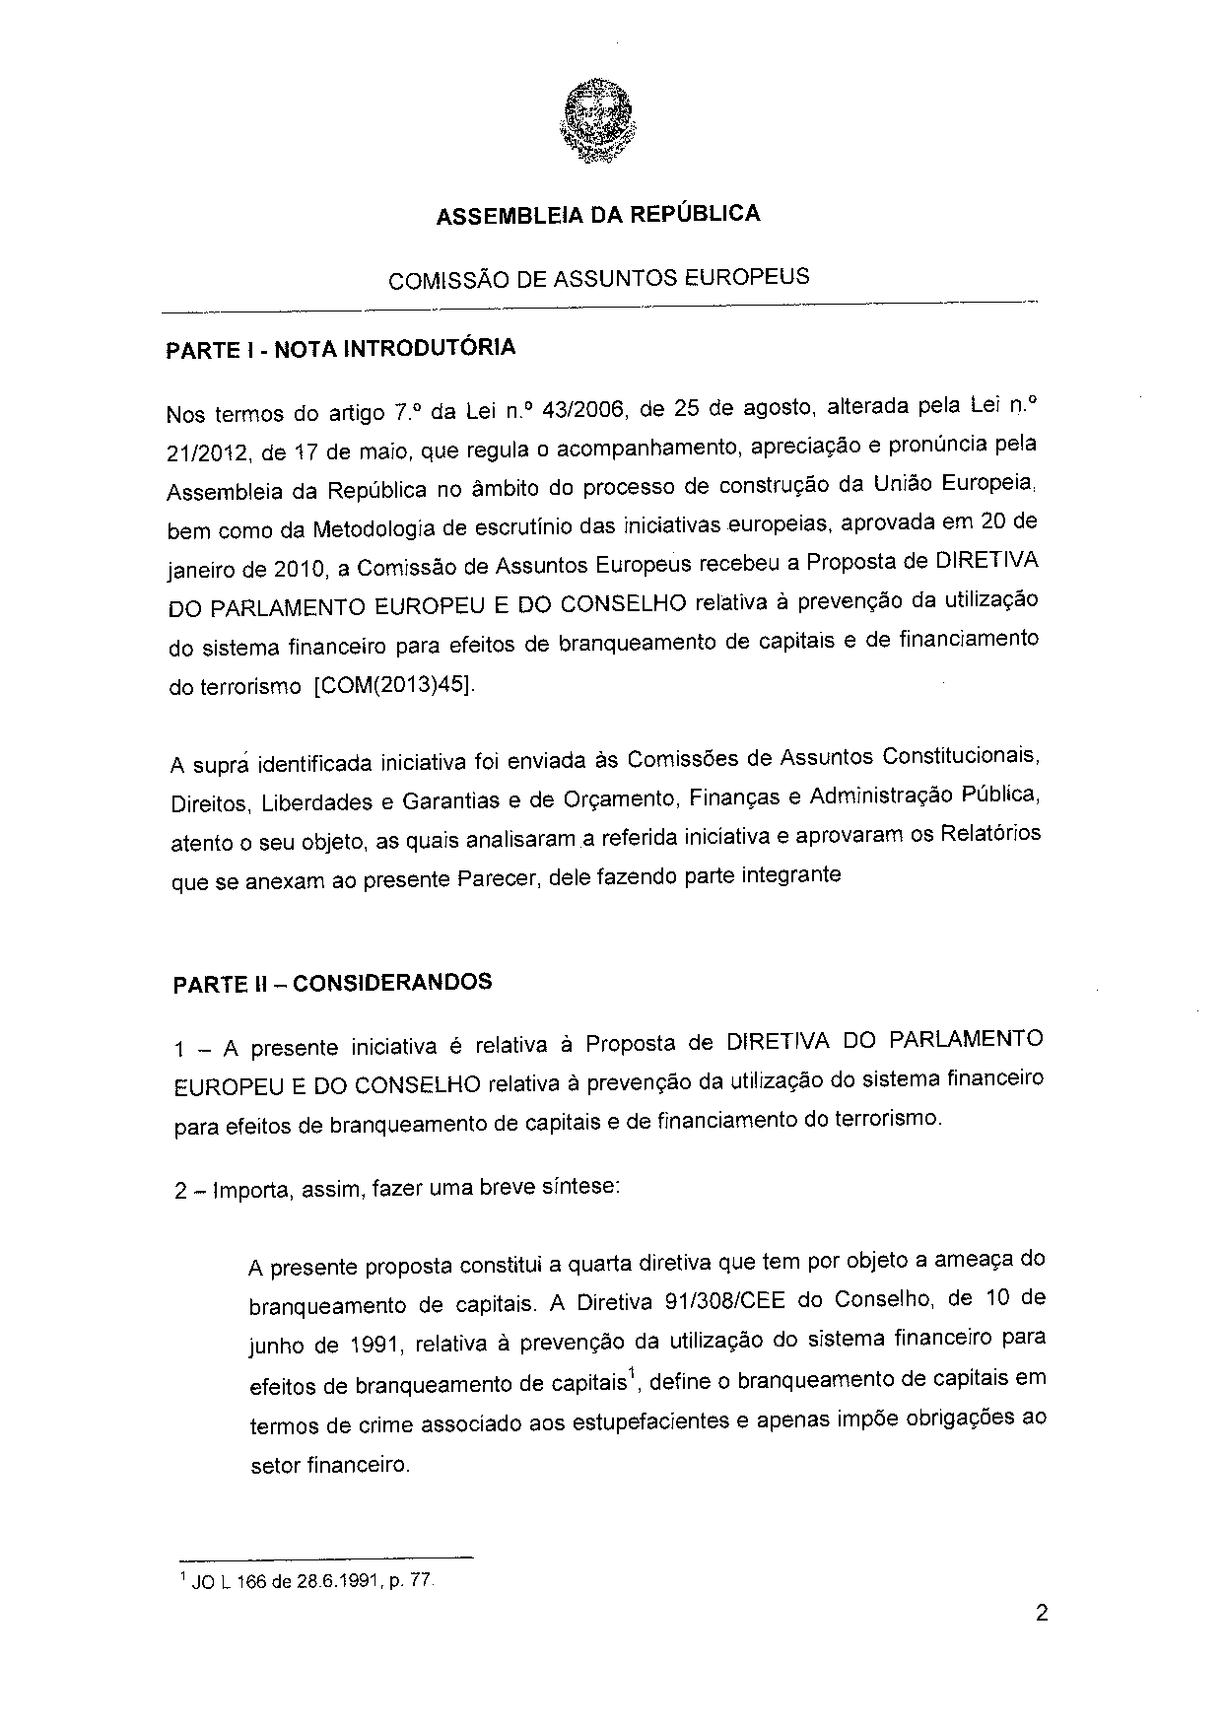
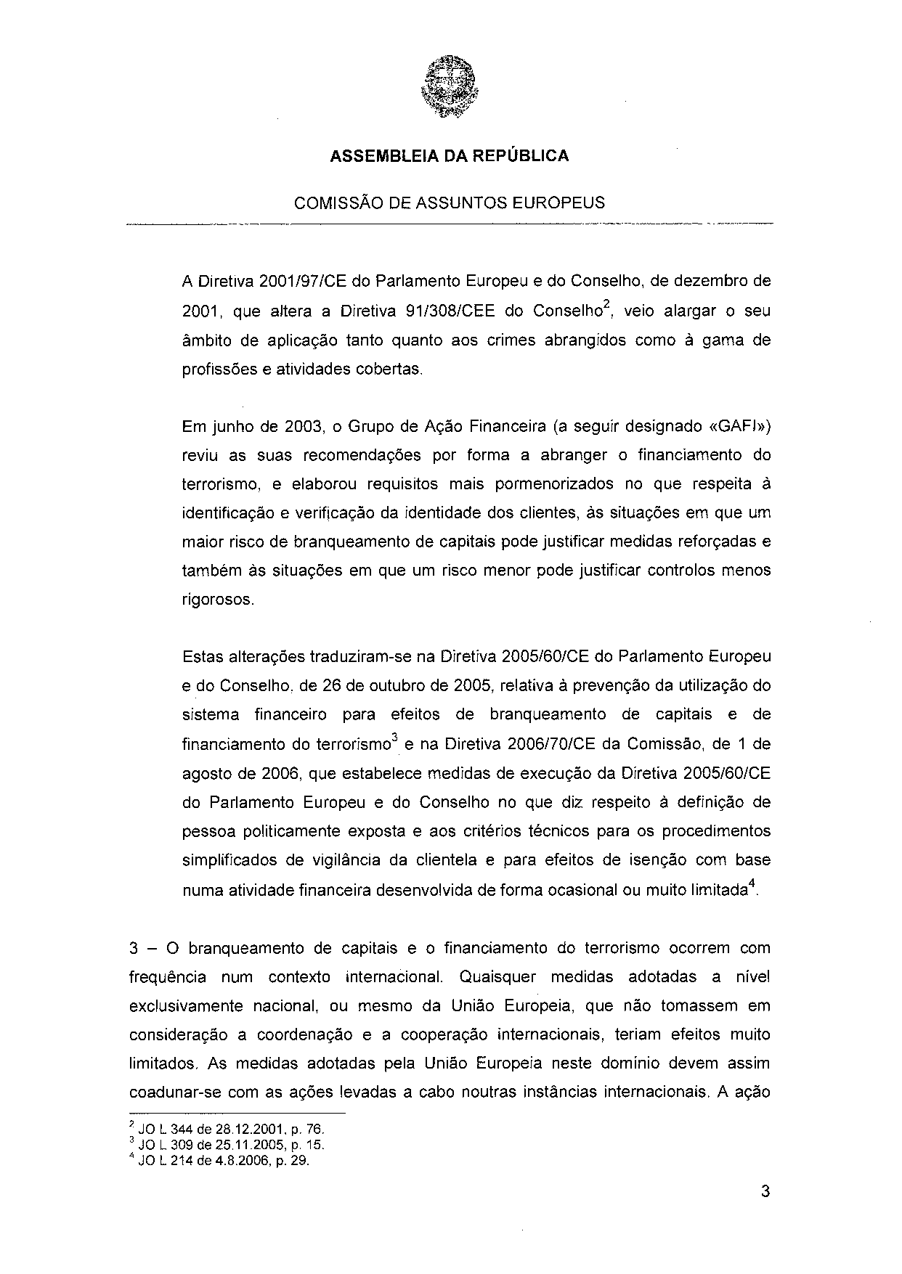
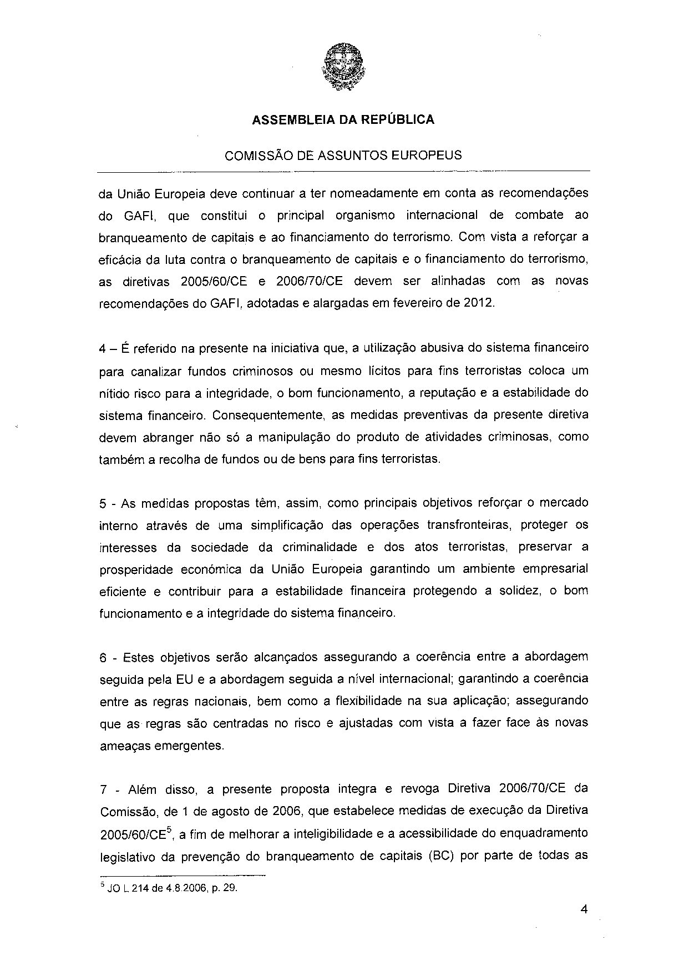
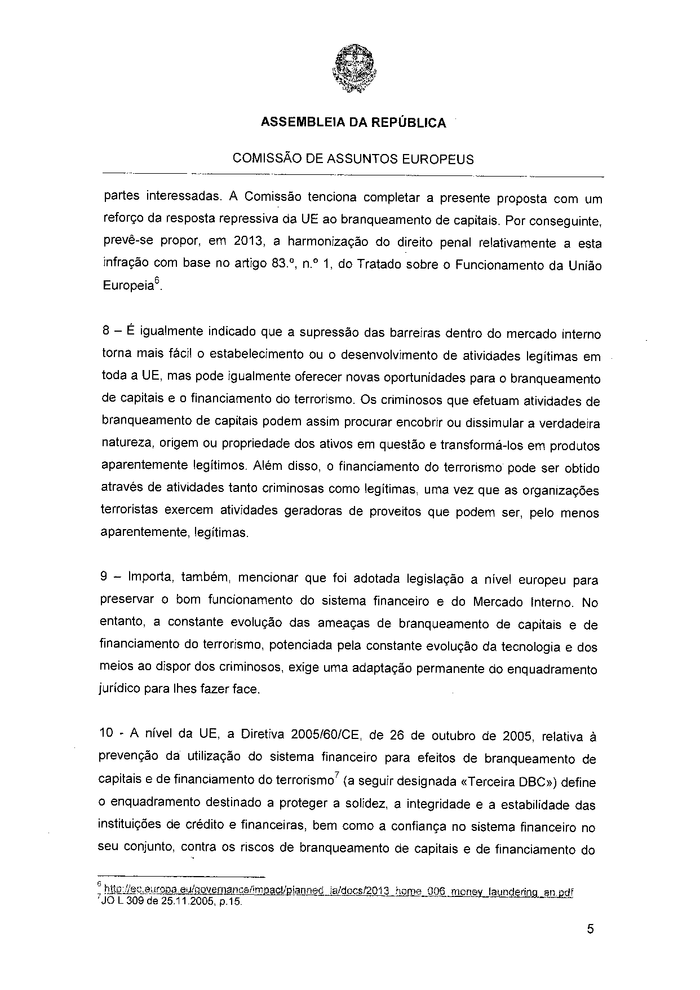
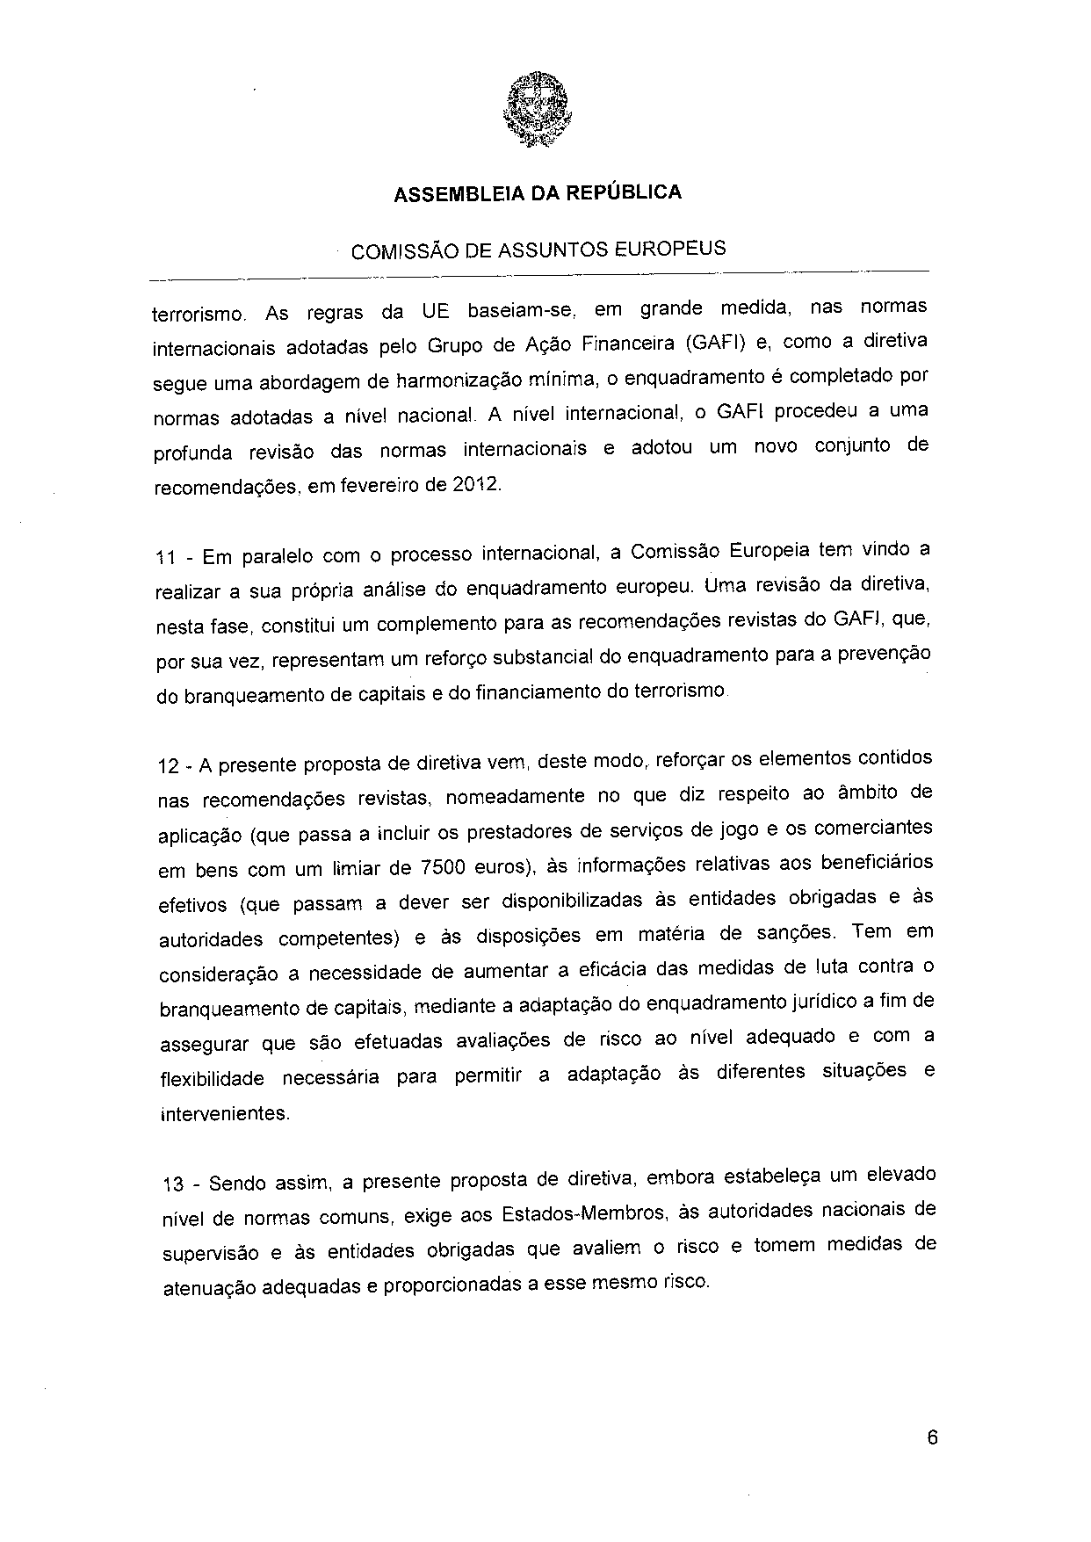
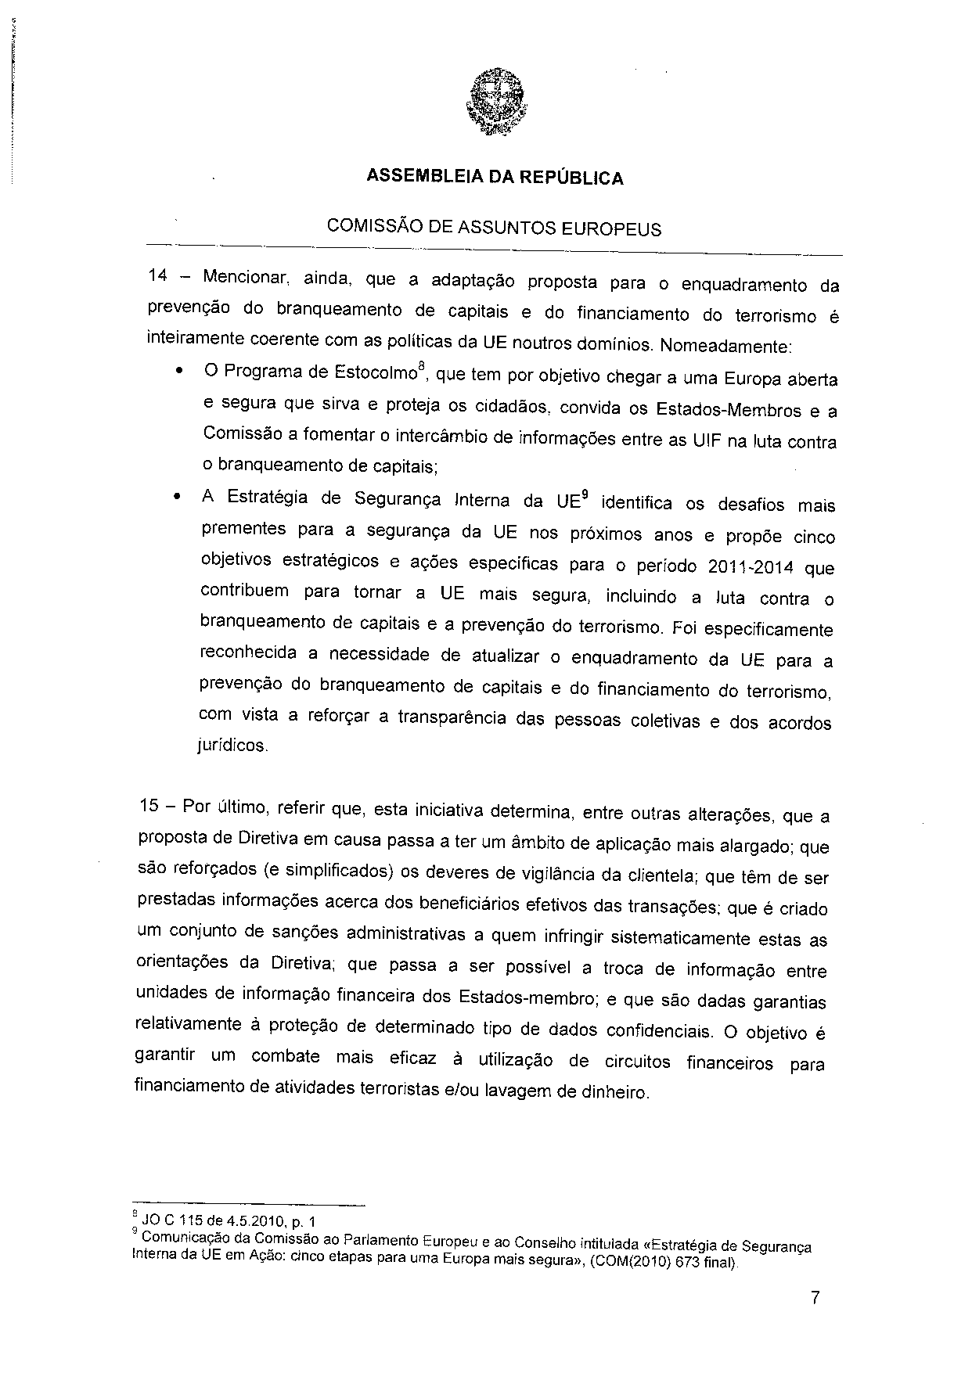
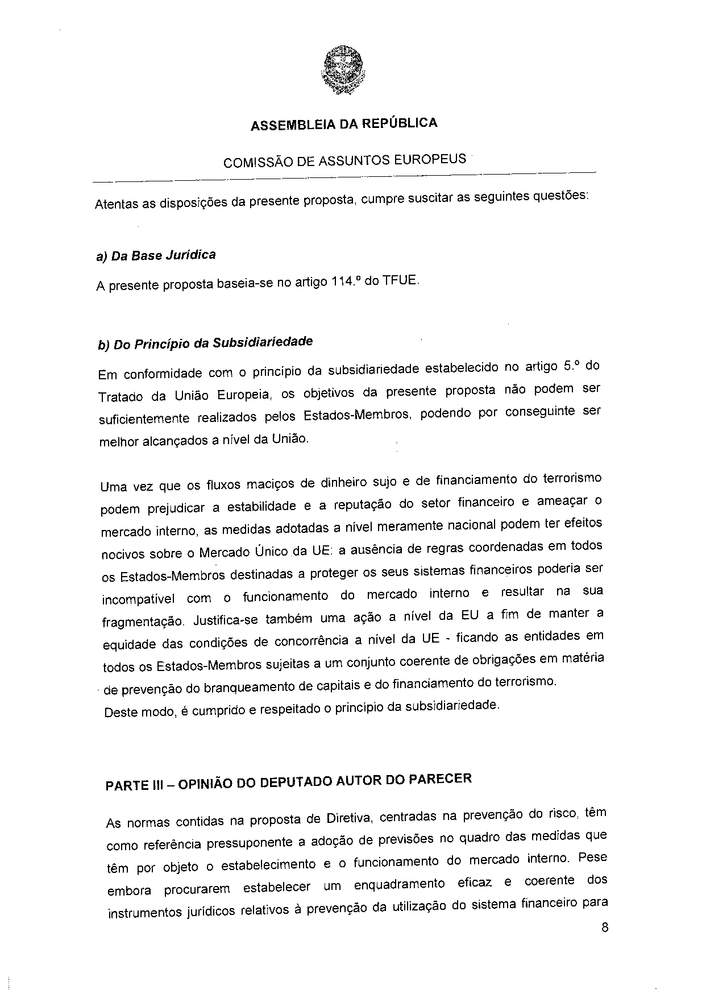
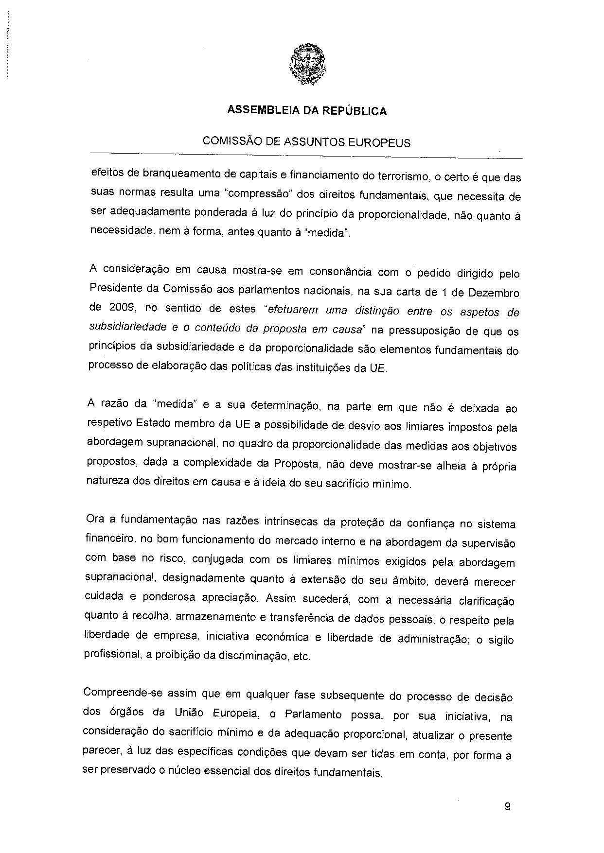
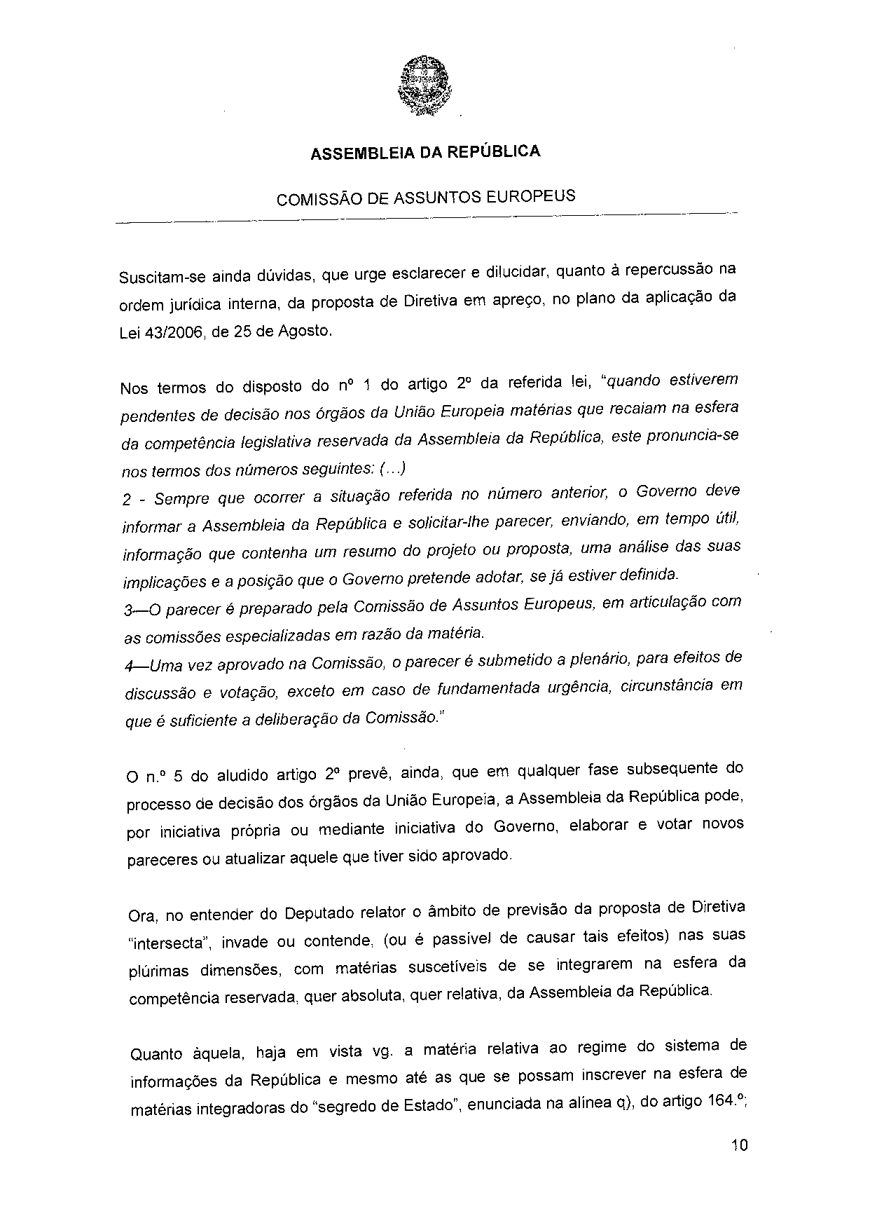
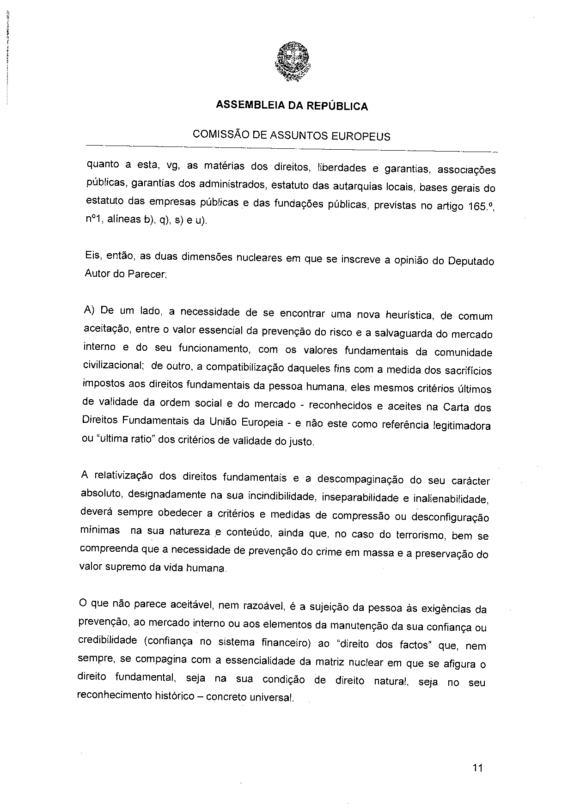
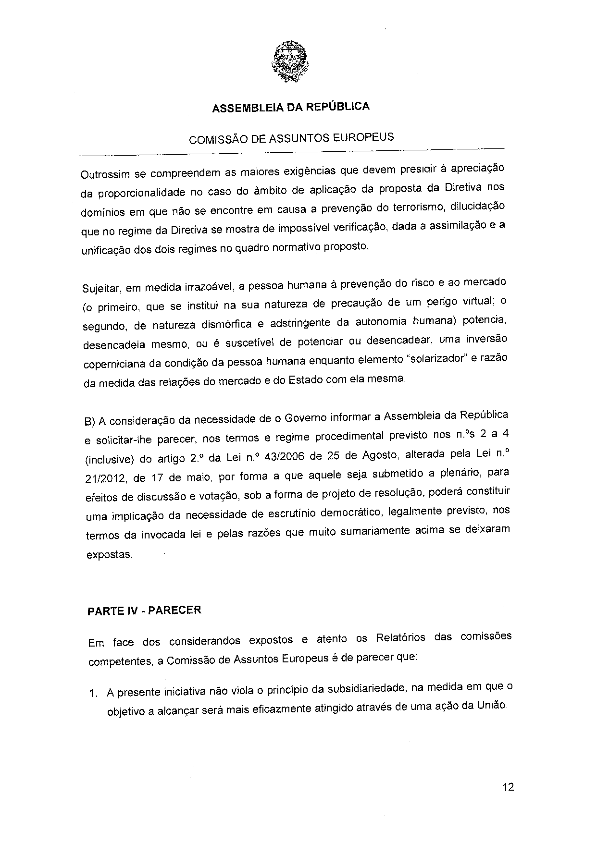
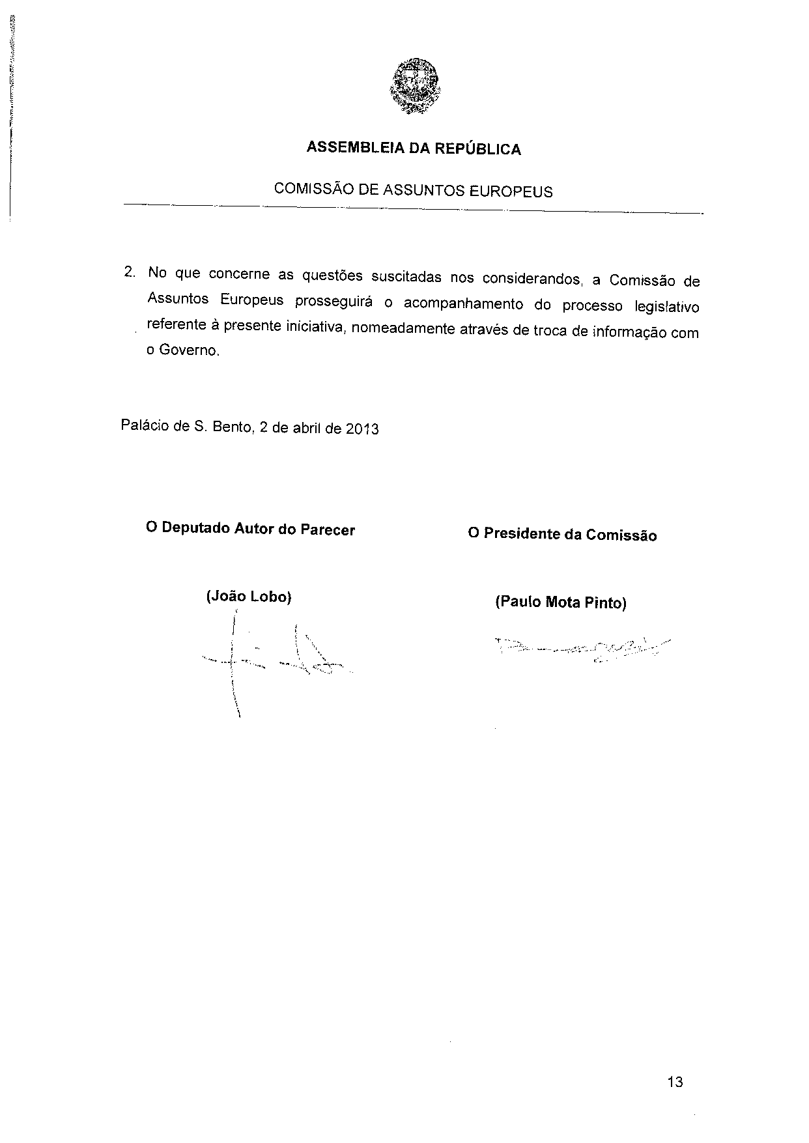
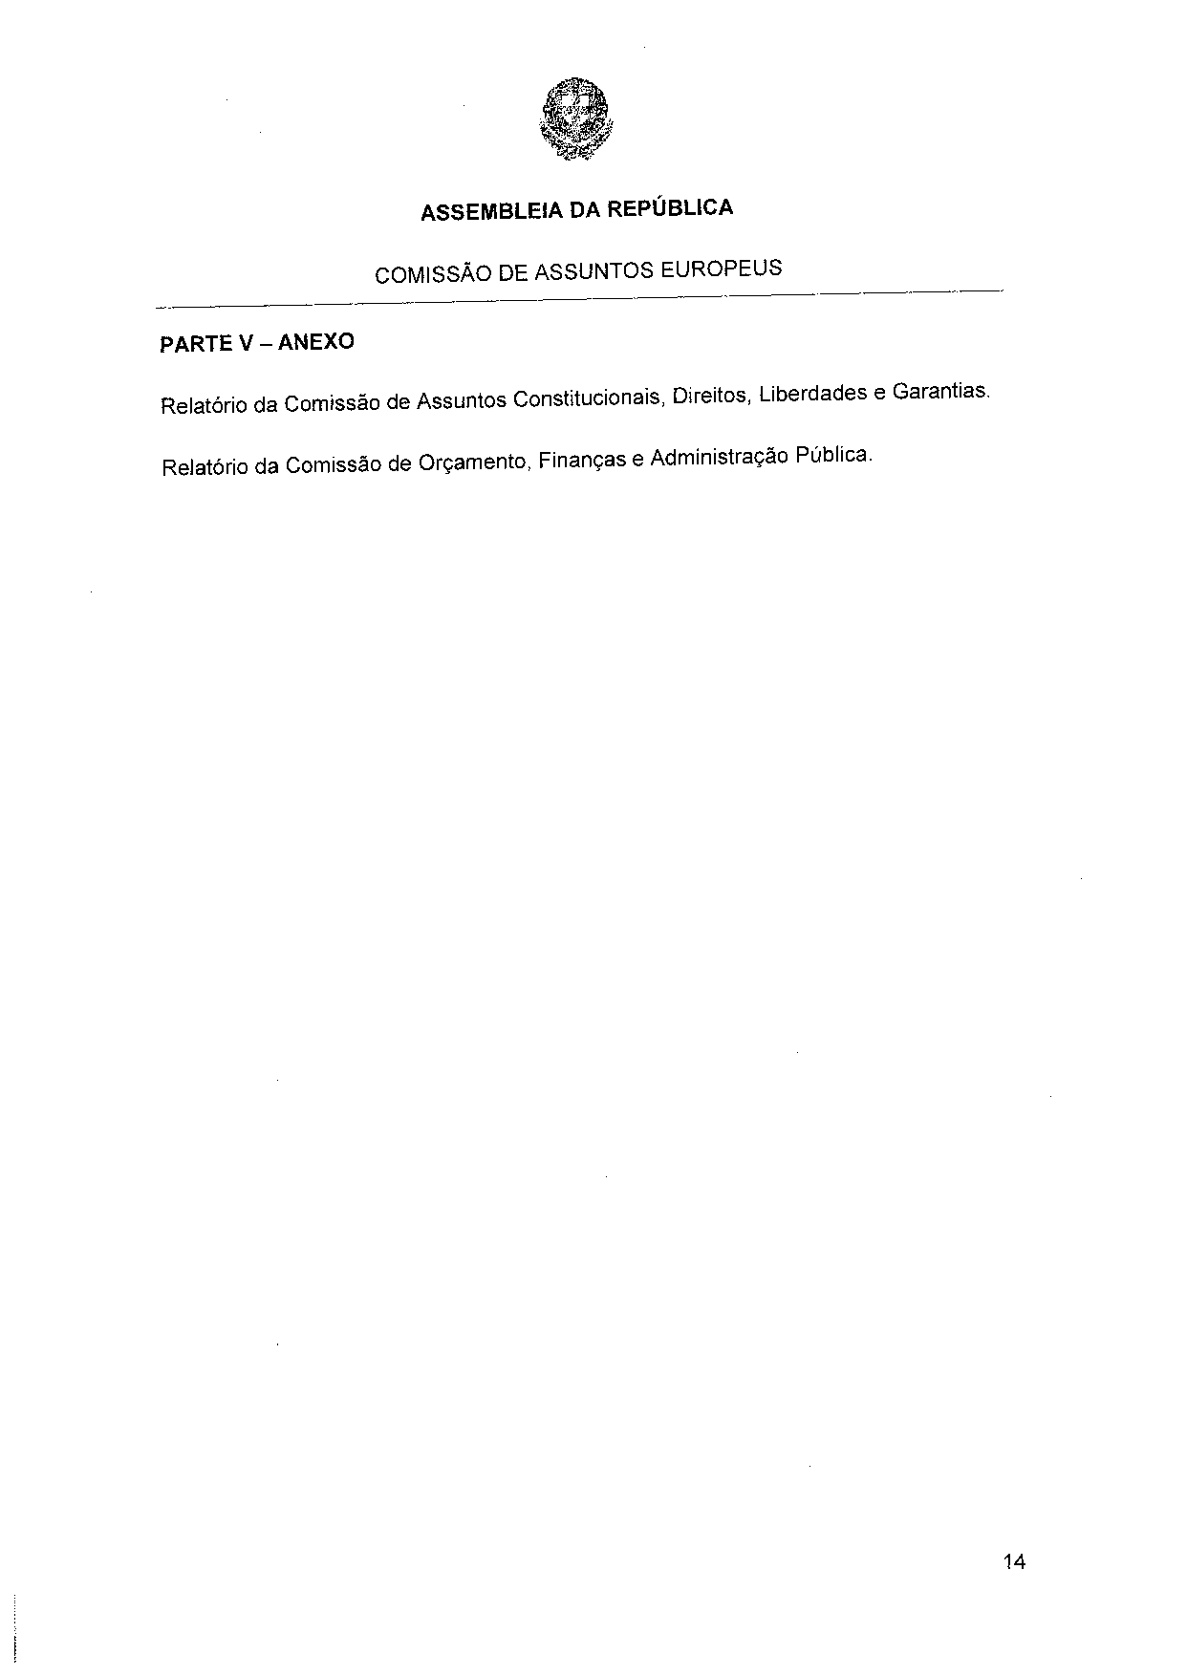
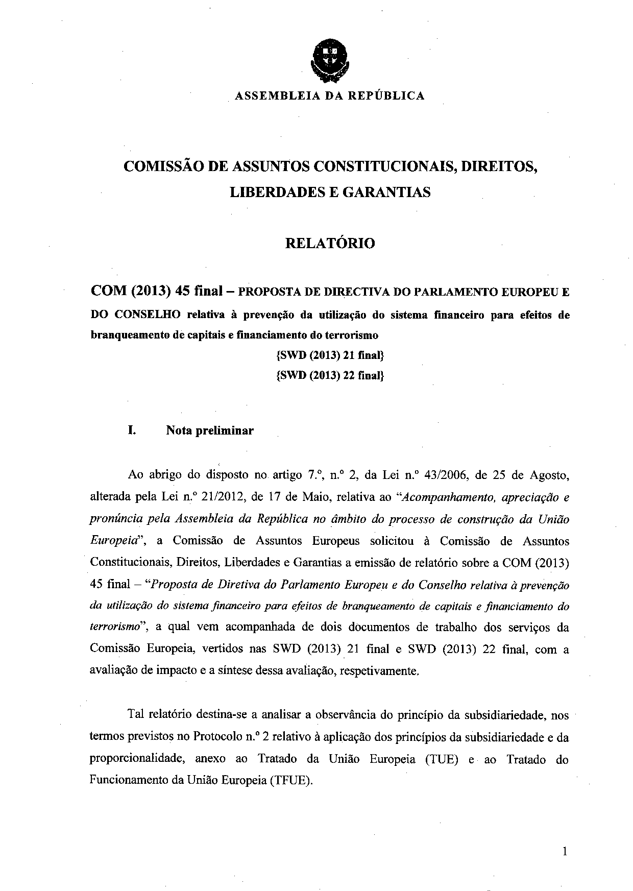
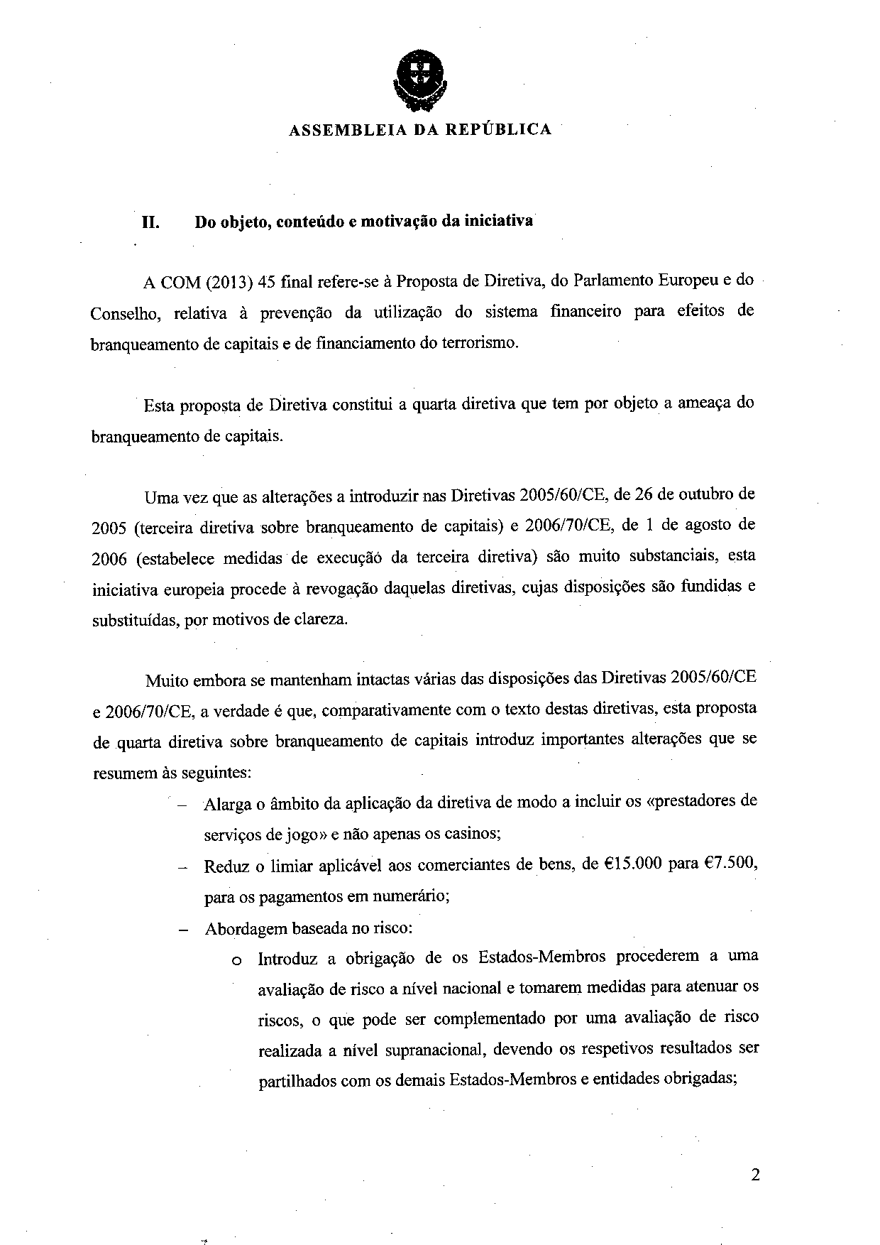
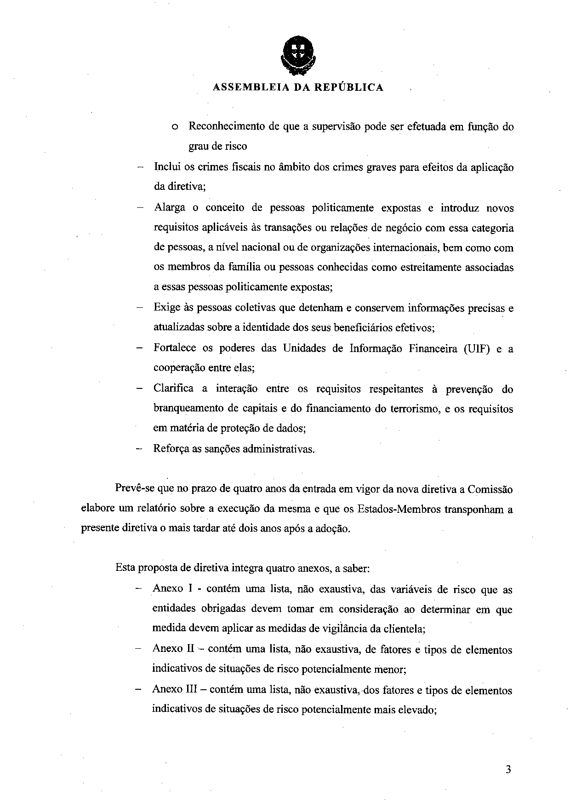
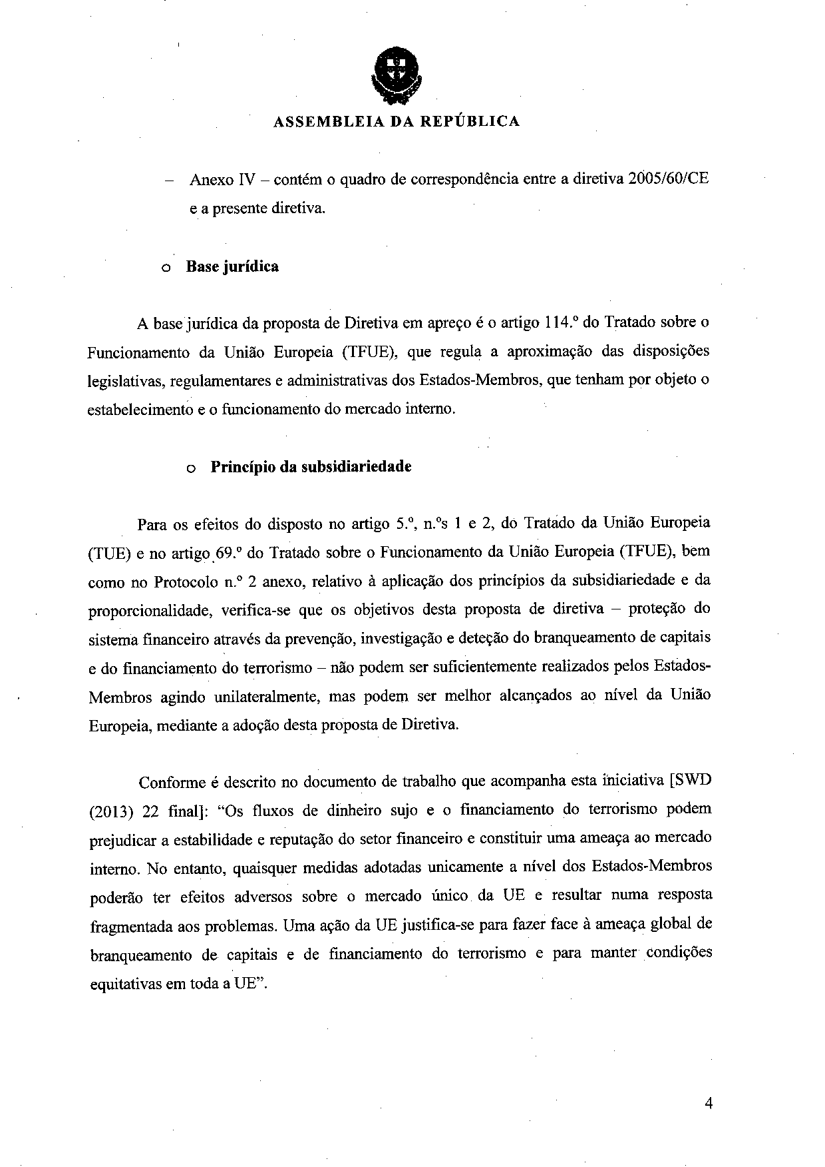
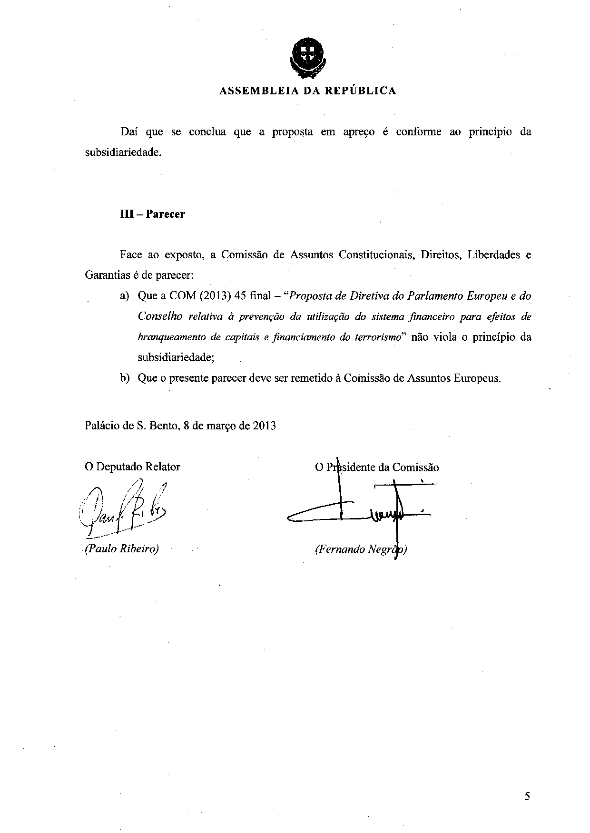
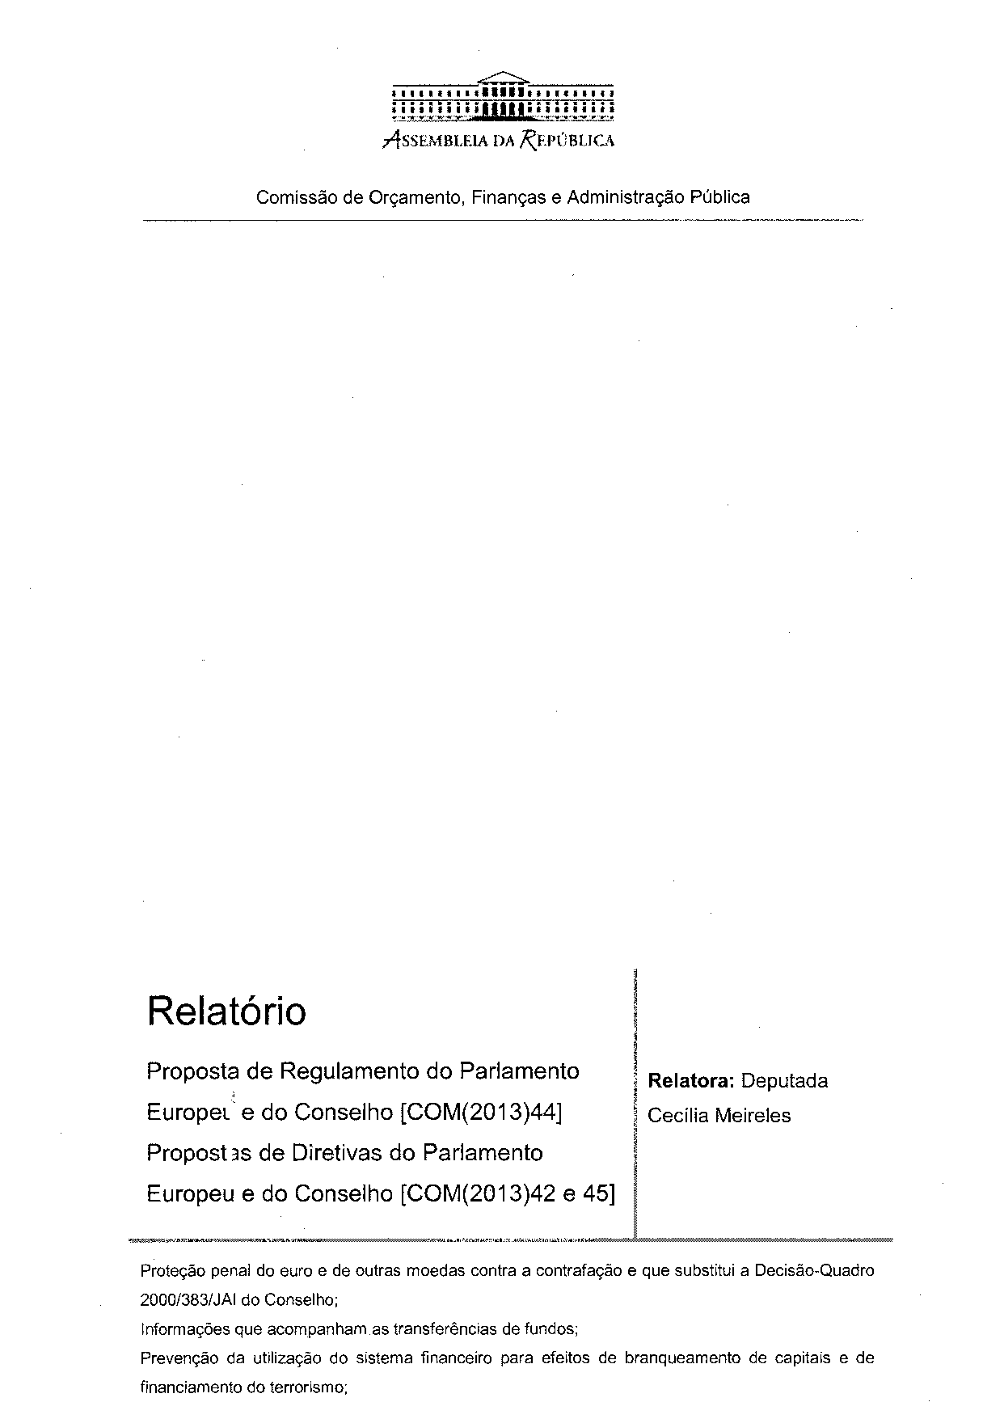
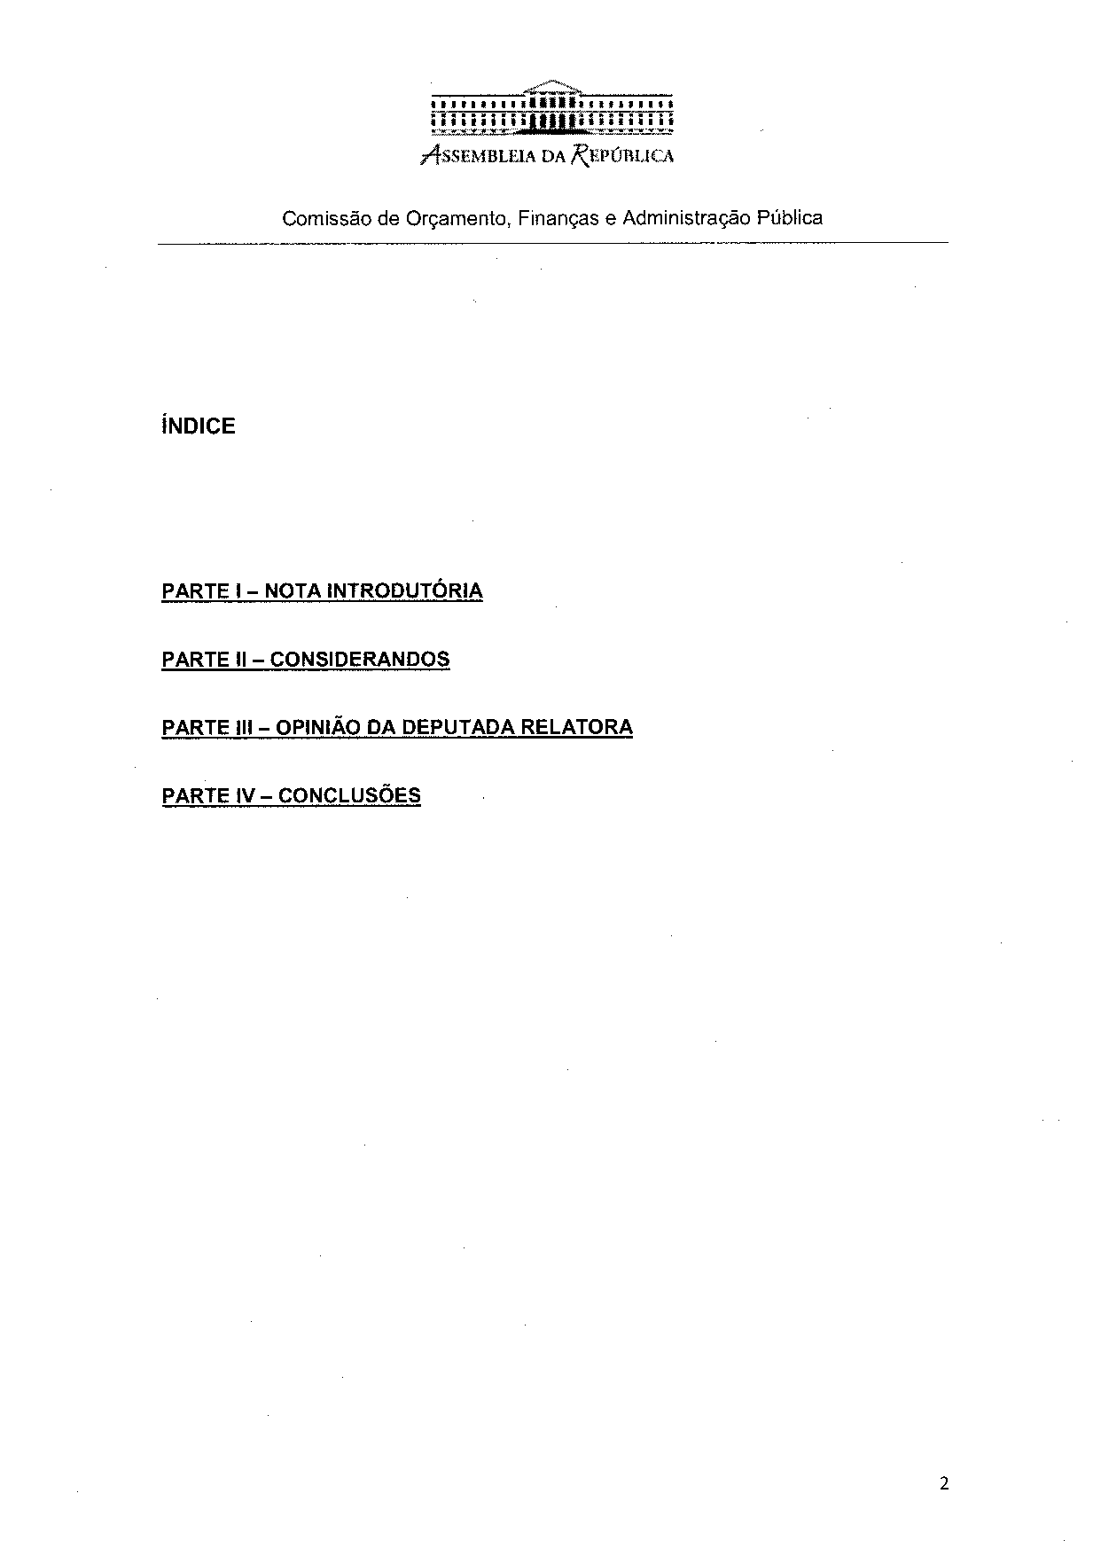
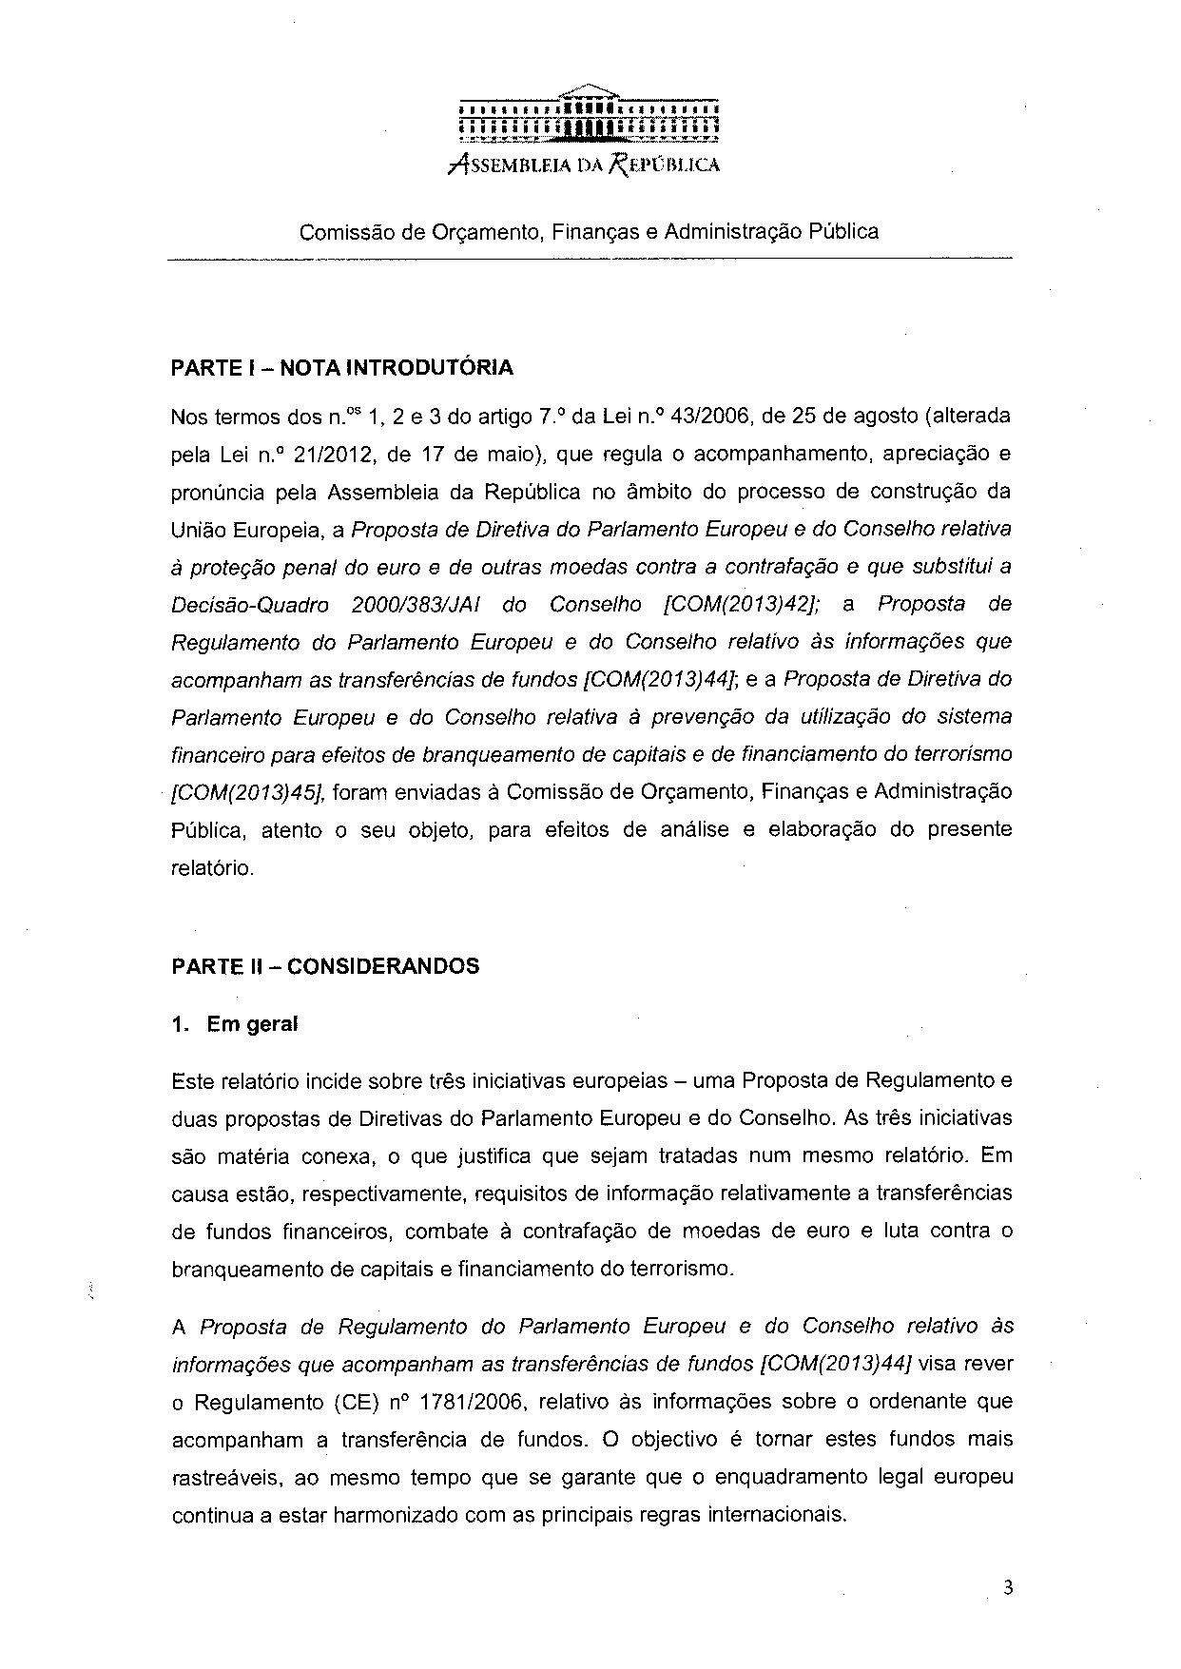
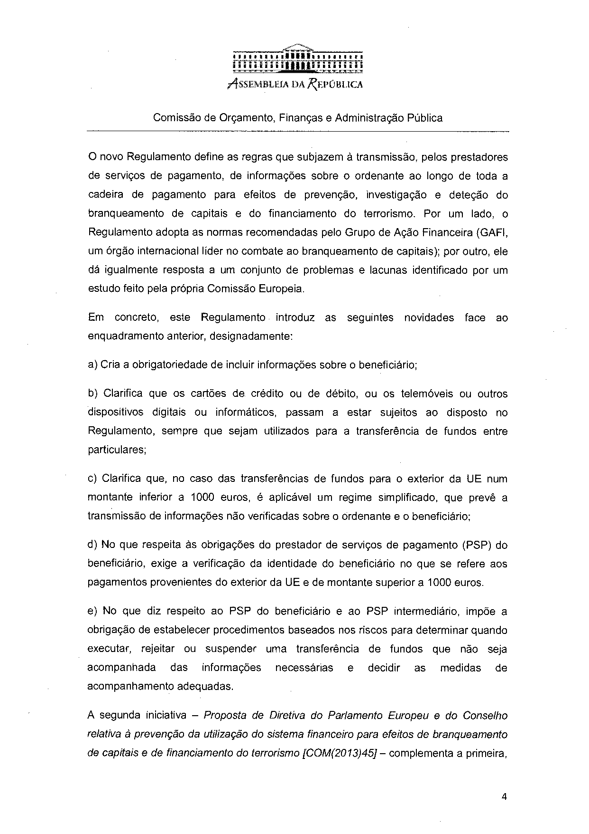
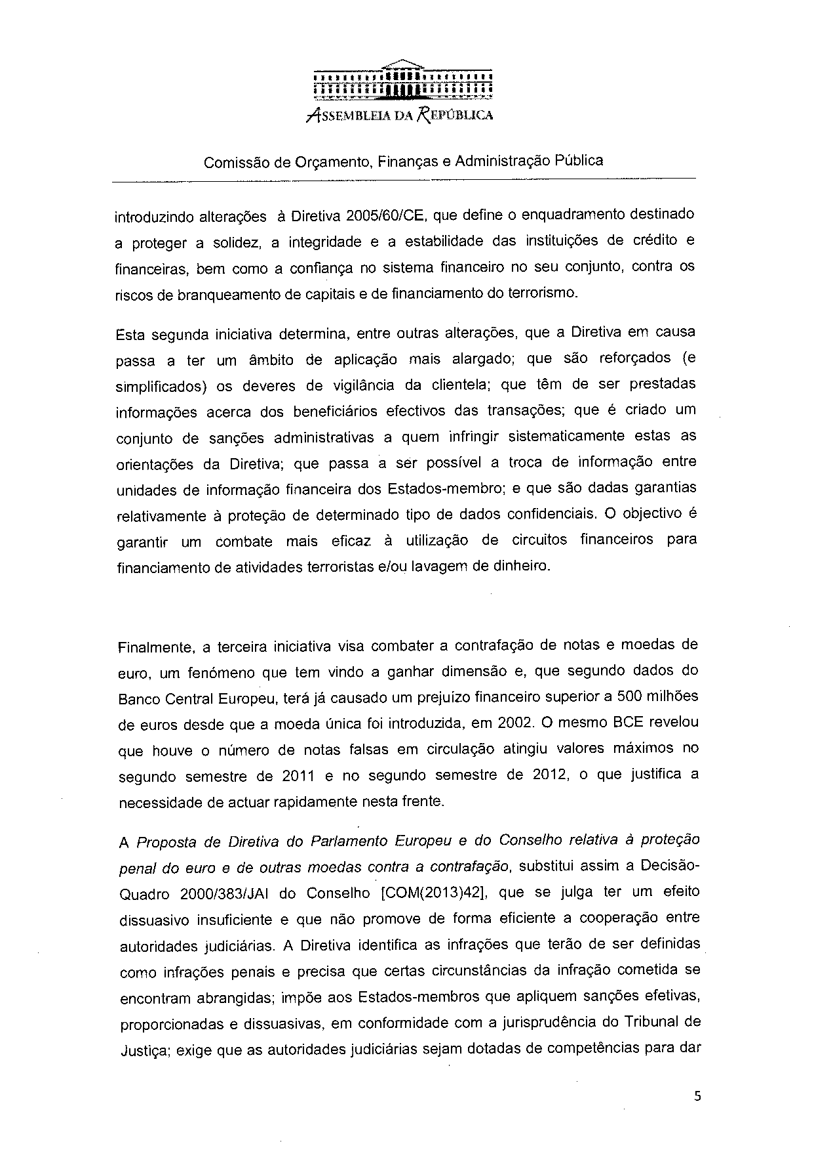
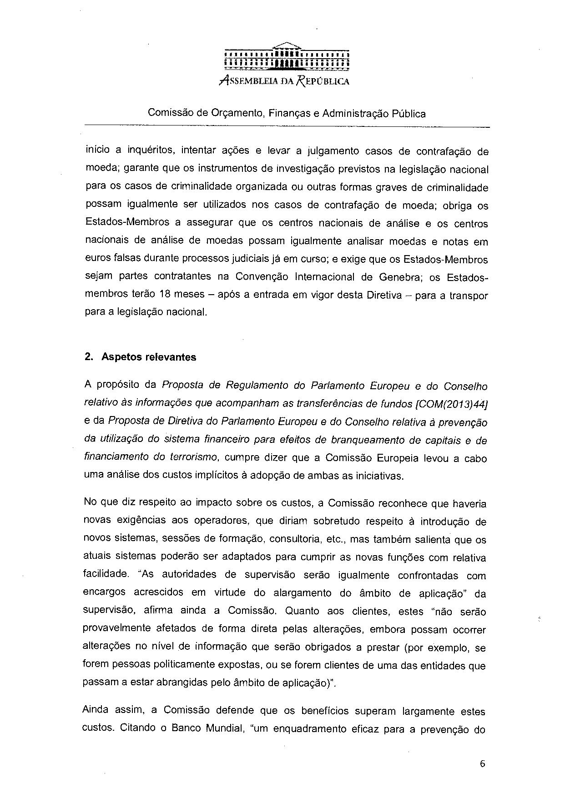
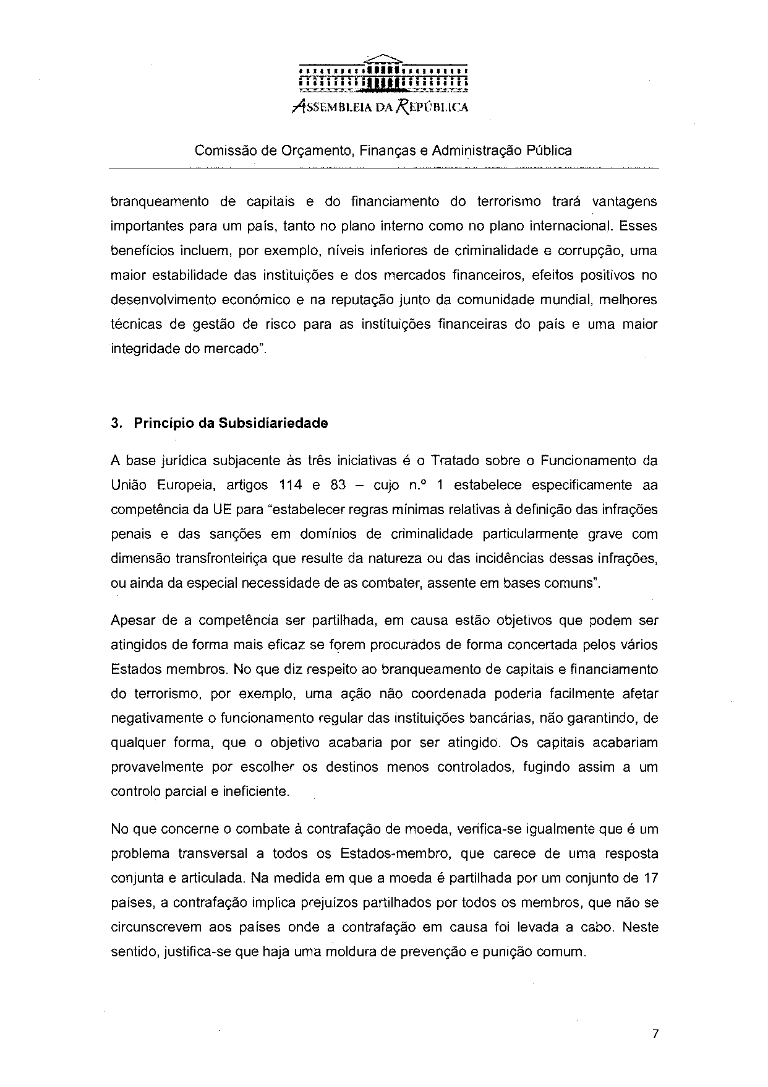
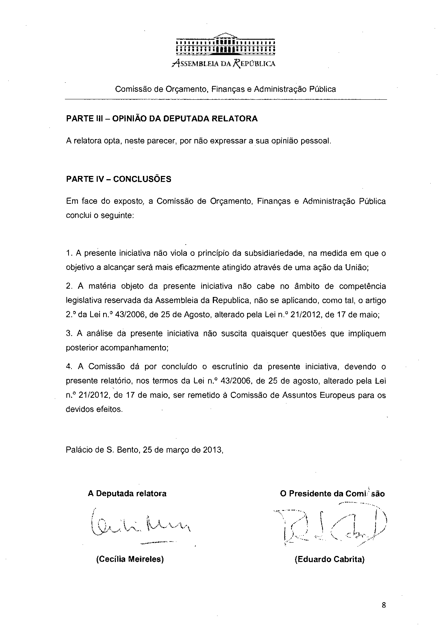

Translation(s) may be available in the Interparliamentary EU information exchange site IPEX at the following address: http://www.ipex.eu/IPEXL-WEB/search.do

