 | 
COUNCIL OF  THE EUROPEAN UNION |  |  | Brussels, 6 March 2013
 | Interinstitutional File:  2012/0366(COD) |  | 7117/13
SAN 82
MI 174
FISC 44
CODEC 481
INST 113
PARLNAT 53

COVER NOTE
from: | Danish Parliament
date of receipt: | 5 March 2013
to: | The President of the Council of the European Union
No Cion doc.: | 18068/12 SAN 337 MI 206 FISC 850 CODEC 3117 - COM(2012) 788 final
Subject: | Proposal for a Directive of the European Parliament and of the Council on the approximation of the laws, regulations and administrative provisions of the Member States concerning the manufacture, presentation and sale of tobacco and related products (Text with EEA relevance)  - Opinion on the application of the Principles of Subsidiarity and Proportionality

Delegations will find attached for information a copy of the above opinion.

________________________

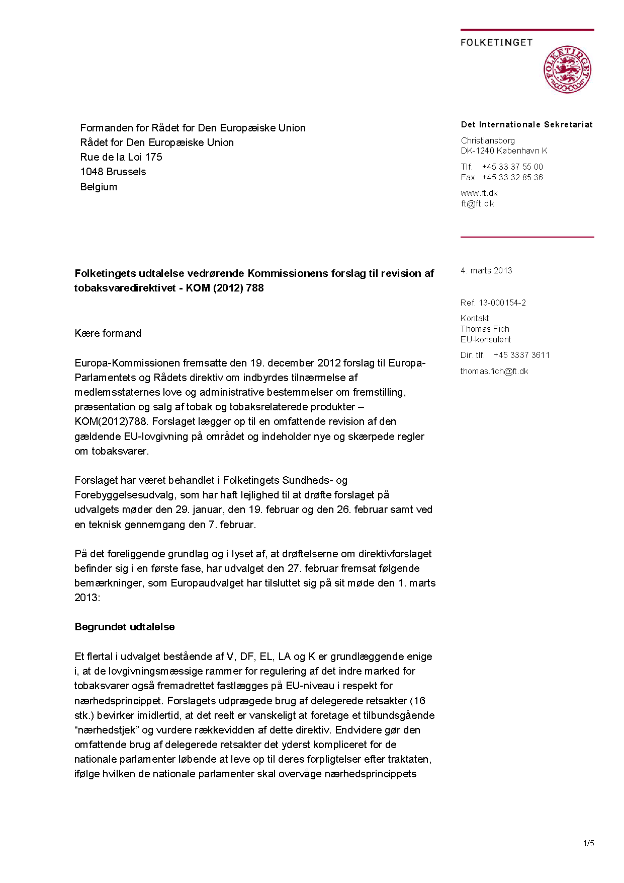
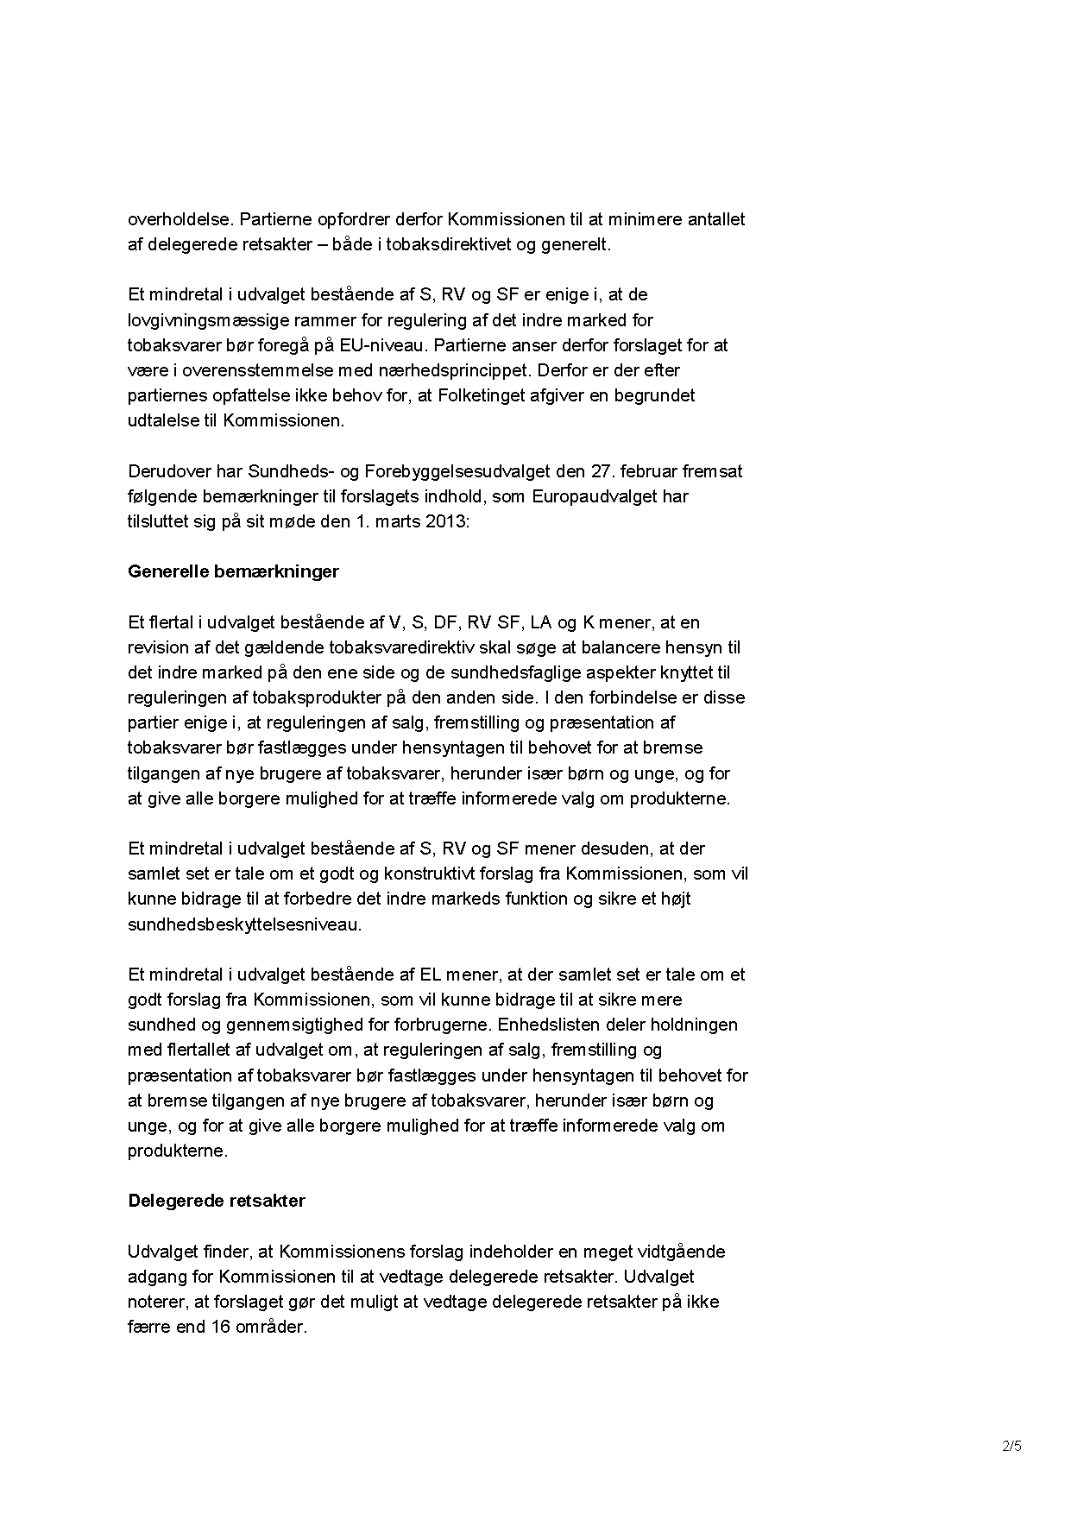
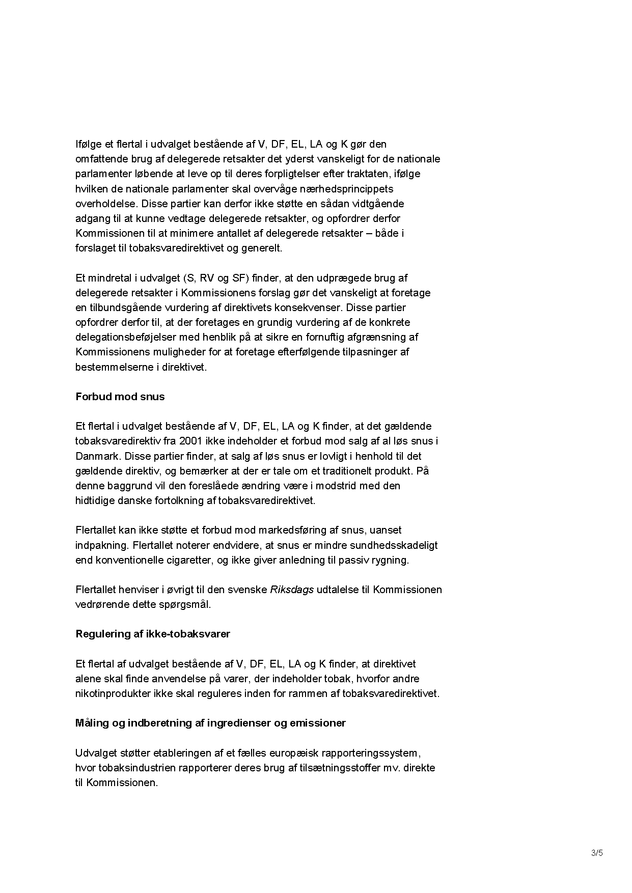
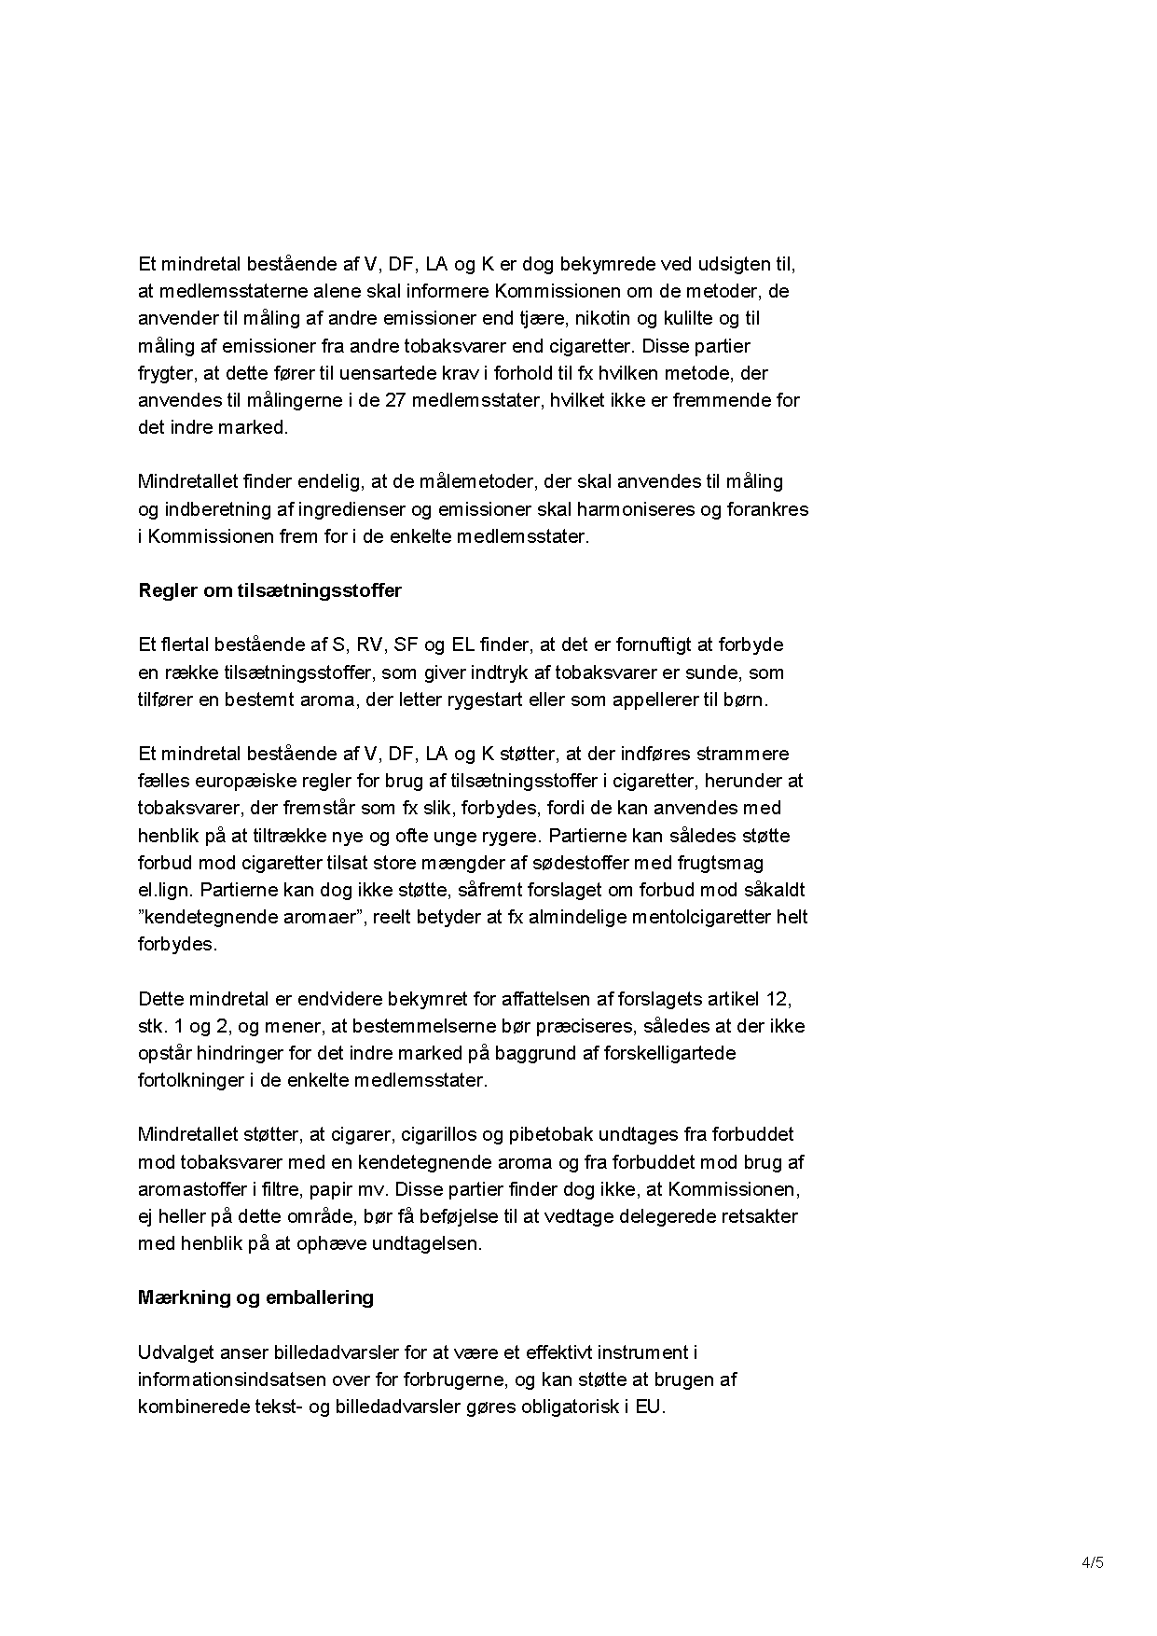
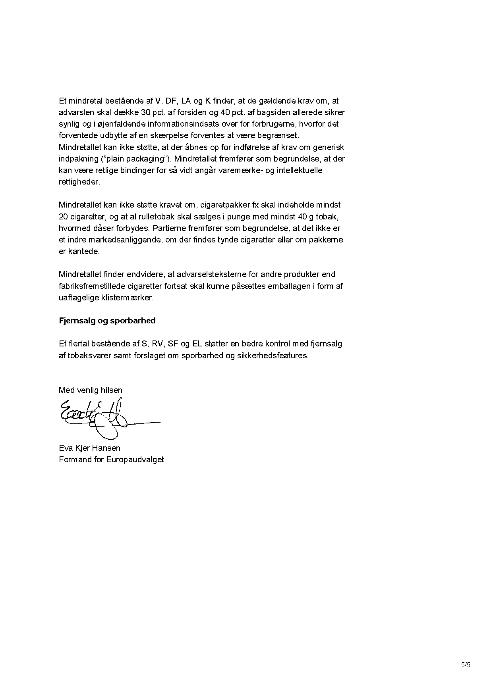

The translation can be found at the Interparliamentary EU information exchange site IPEX at the following address: http://www.ipex.eu/IPEXL-WEB/dossier/document/COM20120788.do#dossier-COD20120366

