REPORT FROM THE COMMISSION TO THE EUROPEAN PARLIAMENT AND THE COUNCIL
On the implementation, functioning and effectiveness of the .eu Top-Level Domain
(Text with EEA relevance)

1. Background
In April 2013, the .eu Top-Level Domain (TLD) celebrated its 7th anniversary. During those first seven years, the .eu TLD became the 11th largest TLD and the 6th largest country code TLD in the world. The position of the .eu TLD slipped slightly against previous years because of the aggressive marketing campaigns of two other TLDs, namely .tk and .cn. With more than 3.7 million registrations, the .eu TLD has become a valued option for Europeans when choosing a domain name for their Internet presence.
This Report to the European Parliament and the Council concerns the implementation, effectiveness and functioning of the .eu TLD over the past two years. In line with Article 8 of Regulation (EC) No 733/2002 on the implementation of the .eu Top-Level Domain, the Commission is required to submit a report to the European Parliament and the Council one year after the adoption of the Regulation and every two years thereafter.
This Report follows on from the Reports of 2007, 2009 and 2011, and covers developments of the .eu TLD from 1 April 2011 to 31 March 2013.

2. The .eu legal framework and basic principle
The .eu TLD was established by the following legal acts:
- Regulation (EC) No 733/2002 of the European Parliament and of the Council of 22 April 2002 on the implementation of the .eu Top Level Domain (as amended) (the Framework Regulation);
- Commission Regulation (EC) No 874/2004 of 28 April 2004 laying down public policy rules concerning the implementation and functions of the .eu TLD and the principles governing registration (as amended) (the PPR Regulation).
In the reporting period, Commission Regulation (EC) No 560/2009, which amended Commission Regulation (EC) 874/2004 in order to introduce Internationalised Domain Names (IDNs) under the .eu TLD, was subject to a Corrigendum in order to correct obvious mistakes in the list of reserved domain names from the Annex. The Corrigendum was adopted on 20 March 2012.
The Registry selected by the Commission, EURid (European Registry for Internet Domains), is responsible for the organisation, administration and management of the .eu TLD. It is an independent organisation that takes all necessary decisions autonomously, in line with the Framework Regulation.
At the moment this report was drafted, the Commission services were assessing the need to amend Commission Regulation (EC) No 874/2004 in order to include provisions related to homoglyph bundling, accession of Croatia to the EU and the fact that Serbia, Montenegro and the former Yugoslav Republic of Macedonia (fYRoM) are now candidates to the EU, access of the EFTA/EEA members to register names under .eu and corrections of some reserved names containing German Sharp S (ß) and Greek Final Sigma (ς).

3. Registration and use of .eu domain names
In the reporting period, the .eu TLD continued to grow steadily in line with the other European country code TLDs. The .eu TLD has reached a total of 3.7 million registrations, making the domain the eleventh largest TLD in the world and Europe’s fourth most popular ccTLD. This represents an increase of 0.3 million registrations since the last report submitted to the European Parliament and the Council.
In Europe, only .de (Germany), .uk (UK) and .nl (the Netherlands) remain in a stronger position in terms of registration numbers. Globally, .com, .net, .org and .info and two ccTLDs .tk for Tokelau and .cn for China have more registrations (see Annex 1). The largest markets for the .eu domain are Germany (30.4 %), the Netherlands (13 %), France (9.1 %), the United Kingdom (9 %) and Poland (6.5 %) (see Annex 4).
The .eu market has fluctuated in several EU countries. However, despite the economic and financial crisis, the .eu TLD has consolidated its growth and even experienced better performances in some countries.
The renewal rate of .eu domain names remains at an average of 80%, against an industry average of 73%.
Industry rivalry has been intensifying in the past 5 years, following the liberalisation of certain ccTLDs and the introduction or rebranding of existing TLDs, e.g. .co, .me. In addition, the arrival of more than 1,000 new gTLDs will be a huge market shock, likely to prove disruptive to existing business models and that will further intensify industry rivalry.
Given the historical trend and the current market situation, EURid’s goal is to maintain a steady growth rate in registrations of around 5-8 % per year. The Registry has a yearly Marketing and Communications Plan in place to help it achieve these objectives.

4. Internationalised Domain Names (IDNs)

4.1. .eu IDNs
The introduction of IDNs at the top level, i.e. on the right-hand side of the last dot of a domain name, is a matter that falls within the competence of ICANN. On 16 November 2009, ICANN launched the IDN country code TLD Fast Track Process to facilitate the introduction of Internet Top Level Domain extensions representing country codes (e.g. .gr, .bg, .eu) using non-Latin characters (e.g. Cyrillic, Greek, Arabic and Chinese characters). The process entails three steps: (i) the registry of a country applies to operate an IDN ‘string’ (the given version of its country code [cc] TLD in another script), together with the support of the Internet community in its territory (‘community support’) and the reason for its choice (‘meaningfulness’ criterion); (ii) the requested string is then evaluated by ICANN who passes it on to an independent committee to check for possible conflict with existing TLD strings (‘confusability’ criterion); (iii) once approved, the new string is allocated to the Registry (‘delegation’).
EURid submitted an application to ICANN to open registration for the Cyrillic and Greek versions of the .eu TLD on May 2010. Its application was based on submissions to the Commission from Cyprus, Greece and Bulgaria of their preferred versions of the .eu suffix (.ευ in Greek and .ею in Cyrillic respectively).
ICANN confirmed the fulfilment of the first two criteria (community support and meaningfulness.
On February 2012, IANA/ICANN informed EURid that the evaluation of the Cyrillic string (.ею) had been successfully completed, but that the Greek string did not pass the technical evaluation step of the process for the reason that it is “either visually identical to or visually confusable with at least three ISO 646-BV strings “eu”, “ev”, and “ev””. The Commission instructed EURid to put on hold the possible request of delegation of the Cyrillic string (.ею) until the clearance of the issues linked to the Greek string (.ευ), because this could be interpreted as accepting the ICANN decision.
In August 2012, EURid submitted a study on the visual representation of the Greek string (.ευ) to ICANN. Based on cognitive neuroscience, the study concluded that the chance of the Greek string (.ευ) being confused with the strings mentioned in the ICANN evaluation was very limited, especially if the approach that the second level script has to match the top-level script is enforced. In the meantime, the ccNSO (Country Code Names Supporting Organisation) moved forward with the Policy Development Process of the IDN ccTLD Fast Track to introduce an appeal process for rejected strings so that they could be re-evaluated by a panel of linguistic experts. At the time of writing this report, the ccNSO recommendation to review the IDN ccTLD process is going through the ccNSO Council vote step and will then be submitted to the ccNSO membership and the ICANN Board for the subsequent voting procedure.

5. Functioning of the Registry

5.1. The Registry
EURid was appointed by the Commission as the .eu Registry in 2003 following a call for expressions of interest.
On 12 October 2004, the Commission and EURid concluded a Service Concession Contract, which was renewed in 2009 until 12 October 2014.
EURid is a Europe-wide non-profit organisation with its head office in Diegem (Belgium) and regional offices in Stockholm, Prague and Pisa.

5.2. Relations with registrars
The .eu Registry itself does not act as Registrar. The top priority for EURid remains to provide quality service to its 780 accredited registrars. The number of accredited registrars has dropped in the last two years following the consolidation of certain registrar accounts. EURid evaluates .eu registrar satisfaction on a regular basis. According to the latest Registrar Satisfaction Survey for the .eu domain, carried out in Q4 2012, 95% of those who took part in the survey said they were either satisfied or extremely satisfied (2011: 93%). 80% gave a rating of at least 8 out of 10 when asked if they would continue to use EURid rather than moving to another provider. The investment in a .eu domain continues to be seen as sound, and this perception has also improved at the top end (47% of the customers interviewed rated this aspect at least 8 out of 10, while it was 44% in 2010).
Furthermore, EURid has started to interact with the registrar community social media, including Facebook, Twitter and the YouTube channel, where over 100 clips of .eu testimonials can be viewed.
During the past two years, the Registry has worked on introducing changes in the trade and transfer procedures, which became effective as of 21 November 2012; the registry lock feature that adds an extra layer of security on .eu domain names; the launch of multi-year registrations on 7 April 2011 (during Q1 2013, 6 466 new registrations with a registration period of more than one year were made; these represented 3.1% of all new registrations in Q1, in line with the volumes of multi-year registrations under other TLDs); and the offer of new services to its registrars. Over the past two years the Registry has partnered with its registrars to promote the .eu TLD via the Co-funded Marketing Programme and other incentive schemes. The Programme has become increasingly successful amongst registrars and furthermore, has also been introduced by other registries.
Moreover, the Registry has worked on increasing .eu awareness by launching dedicated display actions and by having a billboard campaign in four European airports (Brussels, Copenhagen, Milan Linate and Munich). All campaigns land on the Registry’ dedicated marketing website (ambitionhasanaddress.eu) where Internet users can see testimonials by companies and individuals that have chosen a .eu domain name to present themselves and/or their products online.

5.3. Financial situation
The financial situation of the .eu Registry remained stable in the reporting period.
The financial strength of the Registry is a key element in ensuring credibility of the .eu domain. The Commission closely scrutinises the financial situation of the Registry in line with the provisions of the legal framework and the Service Concession Contract. The supervisory role of the Commission is exercised by means of various tools including reviews of the auditors’ remarks, quarterly and annual financial reports, quarterly progress reports, budget proposals, and strategy and marketing plans. Financial matters are regularly discussed with the Registry at quarterly meetings and service-level meetings.
At the start of the .eu TLD operations, revenues generated by the large number of domain registrations were significantly higher than the costs of the Registry. The consequent annual surpluses were transferred to the EU budget. The Registry has gradually reduced the various fees for EURid registrars. In February 2012, following the Registry internal and external consultations both the fees for reactivations and transfers from quarantine were aligned to EUR 4. As a result of the increasing domain name portfolio, the revenues originating from domain name renewals have been increasing. In order to remain in line with its contractual obligation to work at cost, the Registry decided to change the renewal and term extension fee of a domain name from EUR 4,00 to EUR 3,75 as of 1 January 2013.
The key financial aspects of the Registry remained stable in 2011 and 2012. Both the revenues and costs of the Registry have been around €13 million for both years. Consequently, the net financial result has been more balanced than in previous years with a surplus to the benefit of the EU budget of €772,892 for accounting year 2011 and €443,117 for 2012.
Changes in the budgeted and actual costs of the Registry were closely scrutinised by the Commission, in particular costs relating to marketing (€2.8 million in 2011 and €2.7 million in 2012) and human resources (€4.0 million in 2011 and €4.4 million in 2012). The increase in costs was justified by the need for enhanced quality of service and increased security levels.
The Registry maintains four types of financial reserves: depreciation, investments, social liabilities and legal liabilities. Over the reporting period, the total level of reserves remained stable: €5.4 million in 2011 and €5.0 million in 2012. At the end of 2012, this total was divided between the reserve for depreciation (€1.0 million), the reserve for investments (€0.5 million), the reserve for social liabilities (€2.7 million) and the reserve for legal liabilities (€0.8 million). Furthermore, a provision of €150,000 was added to promote and incentivise the Alternative Dispute Resolution.

5.4. Business continuity, resilience and quality

5.4.1. Business continuity
On 12 December 2012, to test its crisis management capabilities, EURid successfully ran an unannounced Business Continuity Plan (BCP) exercise. The exercise focused on switching the EPP, Registrar Extranet, Registrar DAS and Registrar WHOIS services from one data centre to another and back again. The impact on the registrar infrastructure was minimal -a temporary interruption of approximately 15 minutes-, provided registrars had implemented the best practices EURid introduced in the 2011 BCP exercise. The use of Fully Qualified Domain Names (FQDNs) to the registrar services guaranteed a transparent failover while the switch was in progress.
After simulating an issue in the main data centre, EURid failed over to the second data centre by means of a DNS update. After this change was propagated, the correct registrar services were accessible within 10 minutes, provided registrars were using FQDNs (if not, a manual update was required). After two hours, EURid updated the FQDNs to once again point to the main data centre. Gradually, systems failed back over to the main data centre once the FQDNs were picked up by the .eu registrars’ DNS servers. The entire exercise was audited by PricewaterhouseCoopers.

5.4.2. Security
EURid organised training seminars for .eu registrars to encourage them to promote DNSSEC (protocol designed to protect Internet users from forged DNS data) to their customers, who in turn disseminate the protocol to the Internet players (ISPs, webmasters, etc.). A so-called DNSSEC reduction (€0.02 discount on the domain name fee per correctly-signed domain name per month) was introduced in 2013 to further support the implementation of DNSSEC at the registrar level.

5.4.3. Phishing and other malicious activities
The Registry has been applying measures to counter phishing and other types of malicious online behaviour on a daily basis. Domain names in particular are checked against compliance with the eligibility criteria and new registrations are screened for suspicious patterns or other anomalies on a daily basis.
Also on a daily basis, the Registry is informed of suspected or proven misconduct by private security organisations or by public authorities.
As a result, a suspicious domain name may be withdrawn. In the reporting period the number of suspicious domain names withdrawn decreased dramatically thanks to the actions taken by the registry: from 2 in January 2011 (against 81 in January 2010) to no domains withdrawn in Q4 2012.
Furthermore, the registry has strengthened the dialogue with law enforcement authorities to prevent and fight against possible abuses in the .eu system. That has led to the conclusion of a Memorandum of Understanding between the Commission, CERT-eu and EURid signed in October 2012.

5.5. The profile of a .eu user
Consumers register the .eu domain for many purposes (business, social activities, presence of institutions on the Internet, etc.). The latest report on the usage of websites with the .eu TLD shows that around 31.4% are business-related.
For the third year in a row, .eu has demonstrated a strong business profile, confirming its unique position as a TLD for businesses and SMEs with a cross-border dimension. The report concludes that the older generic top-level domains (gTLDs) still have distinct profiles. The main example is .org, which has a very high percentage of community websites. In this, the gTLDs differ from the national country code top-level domains (ccTLDs), which are all used for very similar purposes. .eu has a lot in common with both the ccTLDs and with certain gTLDs (mainly .net, but also .biz and .com).

5.6. Legal proceedings and disputes concerning domain names

5.6.1. Cases before the General Court and the Court of Justice of the European Union
General Court: none
Court of Justice of the European Union: 1 preliminary ruling.
The Court of Appeal of Brussels referred two questions to CJEU in the "lensworld.eu" case – case C-376/11 Pie Optiek vs. Bureau Gevers.
On 19 July 2012, the CJEU ruled that: “The third subparagraph of Article 12(2) of Commission Regulation (EC) No 874/2004 of 28 April 2004 laying down public policy rules concerning the implementation and functions of the .eu Top Level Domain and the principles governing registration must be interpreted as meaning that, in a situation where the prior right concerned is a trade mark right, the words ‘licensees of prior rights’ do not refer to a person who has been authorised by the proprietor of the trade mark concerned solely to register, in his own name but on behalf of that proprietor, a domain name identical or similar to that trade mark, but without that person being authorised to use the trade mark commercially in a manner consistent with its functions.”
The Brussels Court of Appeal is expected to render its final decision in the autumn of 2013.

5.6.2. Alternative Dispute Resolution procedure
Any disputes between .eu domain name holders or claims against decisions of the .eu Registry, can be submitted to the Alternative Dispute Resolution (ADR) provider — the Prague-based Arbitration Court (Czech Arbitration Court or CAC).
Complaints are mostly initiated against .eu domain name holders. This is because any party may initiate ADR proceedings against the domain name holder and claim that the registration is speculative or abusive under Article 21 of Commission Regulation No 874/2004.
During the past two years, an average of 12 cases has been filed per quarter(see Annex 3).
In 2011, 52 decisions were rendered by the CAC. 73% of the complaints were accepted.
In 2012, 44 decisions were rendered by the CAC. 81% of the complaints were accepted.
The fees for ADR proceedings are based on the cost recovery principle.
On 27 June 2012, the Czech Arbitration Court (CAC) and the .eu Registry announced a special fee reduction to make the .eu Alternative Dispute Resolution (ADR) process even more accessible to the European public. The cost of a basic proceeding was cut by 50%, starting from 1 July 2012. This move came in response to recommendations made in an external audit of the .eu ADR service (“The .eu ADR procedure is functioning well but, according to the audit, a fee reduction would further raise the visibility of the service and improve access”). Since the introduction of the reduced fee in July 2012, the average number of ADR cases filed per month has risen by 80%.

5.6.3. Court proceedings
In the reporting period, EURid has been a party in the following cases:
Zheng: Zheng appealed a decision of the Brussels Court of First Instance. The claim was rejected by the Brussels Court of Appeal in its decision of 21 September 2010. Following the final closure of the court case in 2011, the domain names held by Zheng (more than 9,000) were released for general registration on 24 October 2011. Case is terminated.
Ovidio: The parties reached a settlement in February 2011, which has been officially recorded by the Brussels Court of First Instance during the termination of all pending proceedings on 9 September 2011. As part of the settlement, Ovidio has paid €45,000 to EURid. Case is terminated.
Topeu (a.o. sex.eu): The decision of the Court of Appeal of Brussels was served upon the Hungarian company Sex Bt on 4 August 2011. The appeal period ended on 4 December 2011 and on 6 December 2011 the decision of the Court of Appeal of Brussels became final. On 12 December 2011, EURid activated the domain name SEX.eu in the name of the first successful Sunrise applicant, Yellow Register On Line AB (whose application was originally accepted, but because of the ongoing court case the domain name, was never activated until then). Case is terminated.

6. EMAS registration
In 2011, EURid started the process to become the first EMAS-certified registry in Europe. The registration process was completed on 23 May 2012. The registration number is BE-VL-000016.
EURid has started to inform all of its stakeholders about its commitment to a greener Internet via a series of initiatives. An event was organised at the European Parliament in Strasbourg from 21-23 May 2012 to launch EURid’s EMAS registration.

7. Conclusions
The .eu TLD model has been successfully implemented and is operating effectively.
Over the past two years, the .eu TLD has strengthened its position as one of the biggest and most popular Top-Level Domains in Europe and the world. It remains successful despite the continued, although slower, growth of the 27 national country-code TLDs in the Member States and the availability of generic TLDs such as .com and .org. At the moment this report will be sent to the European Parliament and to the Council, Croatia will be the 28th member of the European Union.
ICANN has not yet completed the changes in the ccTLD IDN strings evaluation procedure allowing for the re-assessment of the rejected string (.ευ in Greek because of allegedly confusingly similarity with other strings). The Commission has urged ICANN to complete this process as soon as possible. It has made it clear that the future rules establishing a ‘permanent’ IDN application procedure should be designed in such a way as to avoid any undue delays. This is one of the public policy issues that the Commission will continue to raise in the Governmental Advisory Committee which provides advice to ICANN.
The financial situation of the Registry remained stable in 2011 and 2012.
The ADR system provided by the Czech Arbitration Court allows for the protection of the rights of registrants in all the EU languages. The Commission monitors the actual use of the system. Following recommendations by auditors, EURid has implemented an ADR fee reduction to ensure better accessibility of the ADR to individuals and SMEs who have reasons to believe that their .eu names have been improperly registered by third parties.
In the years to come, the Registry should work on strengthening and developing the perception of the .eu TLD amongst different target groups in order to expand its penetration of the European domain name market and to reinforce public awareness of the TLD. The stability and security of the associated TLD services must be ensured in accordance with the best standards in the field. Given the dynamic nature of the TLD environment, the Registry should continue to maintain and expand its dialogue and exchanges with the European and international Internet community. The Commission will continue to cooperate closely with the Registry, as set out in the terms of the legal framework.
ANNEXES
Annex 1: World's top TLDs as of 31 March 2013
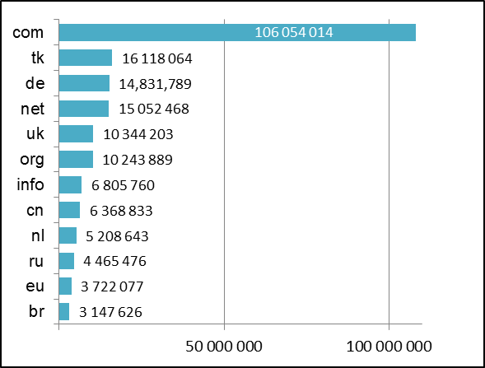
Source: EURid’s Quarterly Progress Report, Q1 2013
ANNEX 2: .eu registrations by quarter
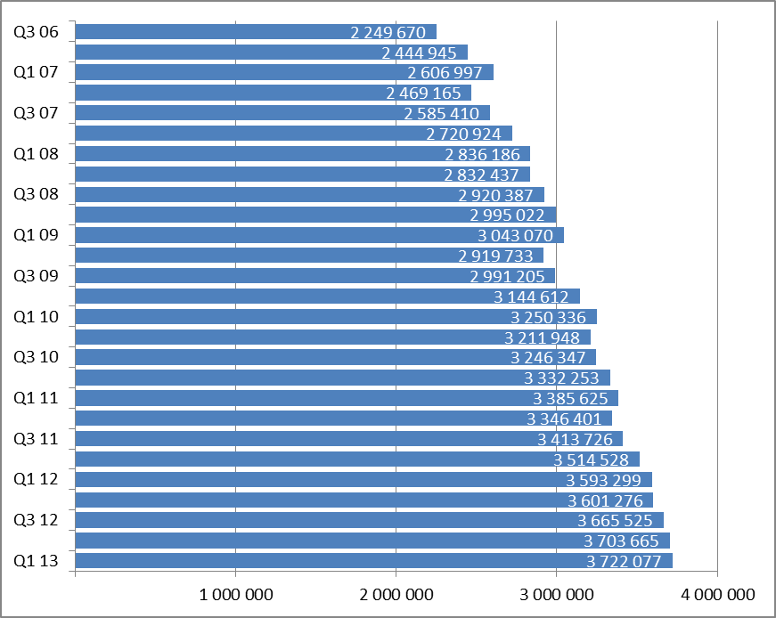

ANNEX 3: Overview of the decisions taken by the Czech Arbitration Court in .eu cases
ADR decisions rendered | 2011 |  |  |  | 2011
ADR decisions rendered | Rejected | Accepted | Defective  complaint | Other (withdrawn  settlement) | Decision per month
January |  | 2 |  |  | 2
February | 1 | 7 |  |  | 8
March |  | 3 | 1 | 2 | 6
April |  | 3 | 2 |  | 5
May | 1 | 3 |  |  | 4
June | 1 | 3 |  | 1 | 5
July |  | 5 |  |  | 5
August |  | 1 | 1 | 1 | 3
September |  | 2 | 1 |  | 3
October | 1 | 4 |  |  | 5
November |  | 1 |  | 1 | 2
December |  | 4 |  |  | 4
Total | 4 | 38 | 5 | 5
Total decisions  per year | 52
Complaint  accepted | 73 %

ADR decisions rendered | 2012 |  |  |  | 2012
ADR decisions rendered | Rejected | Accepted | Defective complaint | Other (withdrawn  settlement) | Decision per month
January |  | 2 | 1 | 1 | 4
February |  | 2 | 1 |  | 3
March |  | 8 |  |  | 8
April |  | 3 |  | 1 | 4
May |  | 7 |  |  | 7
June |  | 1 | 1 |  | 2
July |  |  |  |  | 0
August |  |  |  |  | 0
September |  | 3 |  |  | 3
October | 2 | 3 |  |  | 5
November |  | 3 |  |  | 3
December | 1 | 4 |  |  | 5
Total | 3 | 36 | 3 | 2
Total decisions  per year | 44
Complaint  sccepted | 81 %

ANNEX 4: Total number of .eu domain names by country of registrant
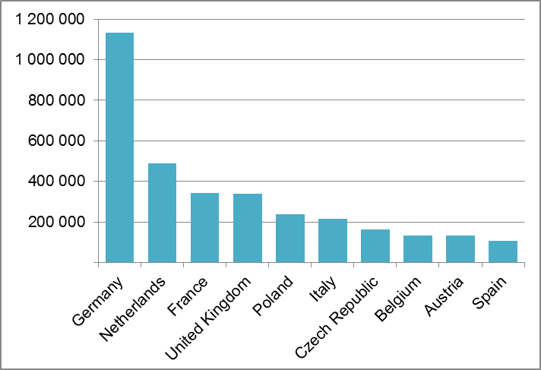
Source: EURid’s Quarterly Progress Report, Q1 2013
ANNEX 5: .eu domains per 1,000 inhabitants
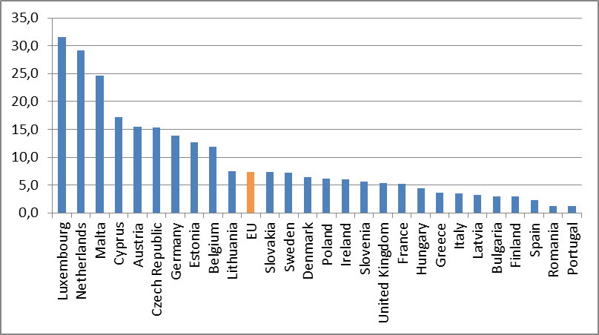
Source: EURid’s Quarterly Progress Report, Q1 2013

ANNEX 6: IDN registrations under .eu
Quarter | IDN names | Fraction
Q4 2009 | 56 036 | 1.8%
Q1 2010 | 62 609 | 1.9%
Q2 2010 | 65 109 | 2.0%
Q3 2010 | 67 074 | 2.1%
Q4 2010 | 57 826 | 1.7%
Q1 2011 | 56 961 | 1.7%
Q2 2011 | 58 424 | 1.7%
Q3 2011 | 58 332 | 1.7%
Q4 2011 | 56 699 | 1.6%
Q1 2012 | 58 455 | 1.6%
Q2 2012 | 60 681 | 1.7%
Q3 2012 | 61 752 | 1.7%
Q4 2012 | 58 211 | 1.6%
Q1 2013 | 57 157 | 1.5%

Source: EURid’s Quarterly Progress Report, Q1 2013

COM(2007) 385 final, Communication from the Commission to the European Parliament and the Council — Report on the implementation, functioning and effectiveness of the “.eu” TLD (6 July 2007).
COM(2009) 303 final, Report from the Commission to the European Parliament and the Council on the implementation, functioning and effectiveness of the “.eu” TLD (26 June 2009).
COM(2011) 616 final, Report from the Commission to the European Parliament and the Council on the implementation, functioning and effectiveness of the .eu Top Level Domain (5 October 2011).
Regulation (EC) No 1137/2008 of the European Parliament and of the Council of 22 October 2008 adapting a number of instruments subject to the procedure laid down in Article 251 of the Treaty to Council Decision 1999/468/EC with regard to the regulatory procedure with scrutiny — Adaptation to the regulatory procedure with scrutiny — Part One (OJ L 311, 21.11.2008, p. 1).
Commission Regulation (EC) No 1654/2005 of 10 October 2005 (OJ L 266, 11.10.2005, p. 35), Commission Regulation (EC) No 1255/2007 of 25 October 2007 (OJ L 282 26.10.2007, p. 16) and Commission Regulation (EC) No 560/2009 of 26 June (OJ L 166, 27.6.2009, p. 3).
Commission Decision of 21 May 2003 on the designation of the .eu Top Level Domain Registry.
See recitals 9 and 12, Articles 2(a), 3(1)(c), 3(2) of Regulation (EC) No 733/2002.
ICANN (Internet Corporation for Assigned Names and Numbers) is a non-profit, private-sector corporation. For more information, see: http://www.icann.org/.
For more information on the Fast Track Process, see: http://www.icann.org/en/topics/idn/fast-track/.
Cyprus and Greece (October 2008); Bulgaria (February 2009).
Article 3(1)(b) of Regulation (EC) No 733/2002.
For more information about EURid access http://www.eurid.eu/en/about-us
See Article 3(4) of Regulation (EC) No 733/2002.
Facebook (EUregistry), Twitter (@Euregistry), YouTube (Europeanregistry).
Three seminars were held in 2012: 17 April, Bratislava; 11 May, Milan; 31 July, Budapest.
Phishing is the acquisition of personal and financial information (user names, passwords, etc.) through deceptive means such as fraudulent emails or copies of legitimate websites. Warehousing is the practice of ‘holding’ domain names in order to resell them at a higher price. Cyber-squatting is registering, trafficking in or using a trademark of another individual or organisation in a domain name in bad faith, with the intent of profiting from the goodwill of someone else’s trademark. Cyber-squatters resell the domain name in question to the trademark holder at an inflated price. Domainers are a colloquial term for domain name speculators.
For eligibility criteria see Article 4(2(b) of Regulation 733/2002. The Registry has the right to verify the validity of a registration (Article 3 of Regulation 874/2004). The registration policy requires the registrant to keep personal data complete and accurate and the email address functioning for communication with the Registry, which reserves the right to revoke the domain name of a non-functioning address.
For example, Internet Identity, Arbor Network, MarkMonitor, the Federal Computer Crime Unit (FCCU) in Belgium, the Internal Revenue Service (IRS) of the US Treasury Department.
See the Q4 2012 Report of EURid, available at: http://www.eurid.eu/files/publ/quarterly_2012_Q4.pdf
“Website usage trends among top-level domains”, November 2011, available at eurid.eu/insights
See Article 4(2)(d) of Regulation (EC) No 733/2002 and recital 15, Articles 22 and 23 of Commission Regulation 874/2004.
Memorandum of Understanding (2005) between EURid and the Czech Arbitration Court attached to the Economic Chamber of the Czech Republic and the Agricultural Chamber of the Czech Republic.
The number of ADR cases initiated before the CAC has declined significantly since 2006 from approximately 200 cases per quarter to the current level.
See Article 4(2)(d) of Regulation (EC) 733/2002.
The EU Eco-Management and Audit Scheme (EMAS) is a management tool for companies and other organisations to evaluate, report and improve their environmental performance.
More information on the EURid environmental commitment is available at: http://www.eurid.eu/en/about-us/going-green

