COMMISSION STAFF WORKING DOCUMENT
Implementation Plan
Accompanying the document
Proposal for a Directive of the European Parliament and of the Council
on the protection of undisclosed know-how and business information (trade secrets) against their unlawful acquisition, use and disclosure

1. Introduction
This Implementation Plan deals with the risks and challenges which could result from the transposition and implementation of the proposal for a Directive of the European Parliament and of the Council on the protection of undisclosed know-how and business information (trade secrets) against their unlawful acquisition, use and disclosure.
This Implementation Plan is provided for information purposes only. It does not legally bind the Commission on whether the identified actions will be pursued or on the form in which they will be pursued.

2. Contact point
The responsible service within the Commission for this proposal is:
DG Internal Market and Services
Intellectual Property Directorate
Unit D3 – Fight against counterfeiting and piracy
Head of unit: Jean Bergevin
E-mail address: MARKT-IPRENFORCEMENT@ec.europa.eu
Specific website:
http://ec.europa.eu/internal_market/iprenforcement/trade_secrets/index_en.htm

3. Deliverables and implementation challenges

3.1. The objectives and content of the proposal for a Directive
The objective of the initiative is to foster the smooth functioning of the Internal Market for research and innovative activities, by improving conditions for R&D, knowledge sharing and innovation. Specifically, it aims at establishing a sufficient and comparable level of civil redress throughout the Internal Market against the unlawful acquisition, use or disclosure of trade secrets by third parties, while providing for safeguards to prevent abusive litigation.
Thus, the proposal for a Directive lays down rules on the unlawful acquisition, disclosure and use of trade secrets and on the measures, procedures and remedies which provide for civil law redress thereof:
- The scope of protection of trade secrets is essentially determined by defining a ‘trade secret’ (point (a) of Article 2) and establishing the conduct (acquisition, use or disclosure) which should be considered unlawful (Article 3).
- The measures, procedures and remedies include interim and precautionary measures (Articles 9 and 10) as well as measures on the merits of the case (Articles 11 to 14).
- A statute of limitations is provided for in Article 7.
- Rules on the preservation of trade secrets during litigation are included in Article 8.
- Sanctions for non-compliance with the measures, procedures and remedies are provided for in Article 15 and for abusive litigation in Article 6.

3.2. Deliverables
National transposition measures are required to integrate the Directive provisions into national law.
Once the directive transposed, the fulfilment of the rules’ objectives will be dependent on the judicial application of the rules.
This distinction between transposition and subsequent application by judicial authorities is taken into account in the identification of the challenges.

3.3. Challenges
(A) Ensuring the timely transposition of the Directive into national law
The transposition of this Directive should not pose excessive or insurmountable problems to Member States.
- Timing challenges. Member States will benefit from the standard period (24 months) to adopt the national rules transposing the Directive into national law and no additional timing constraints are imposed (e.g. the initiative does not impose a short transposition deadline, nor does it require that national transposition measures enter into force at the same time). As a result, no particular timing challenges are expected.
- Technical challenges. The solutions proposed by the proposal for a Directive are already known to Member States legal systems, either because of the content of the Agreement on Trade-Related Aspects of Intellectual Property Rights (as regards trade secrets and intellectual property rights) or because of Directive 2004/48/EC (on intellectual property rights). Similar provisions to those of the proposal are already contained in Directive 2004/48/EC on the enforcement of intellectual property rights and the transposition of that directive did not raise any particular technical difficulty in relation to the legislative technique. Therefore, no specific technical difficulties are envisaged.
- Compliance/institutional challenges. Beyond the drafting of the national legislation, no deliverables are requested: i.e. no enactment of a new institutional framework is foreseen.
However, the following measures will be taken to ensure a smooth transposition process and timely delivery.
Actions on timely transposition:
- Network of national correspondents. As provided for in Article 16 of the Directive, Member States will be requested to provide a correspondent for the purposes of the implementation of the Directive. National correspondents should endeavour to inform the Commission services of transposition problems/difficulties and alert them of possible delays in the process. The list of correspondents will be updated where necessary.
- Monitoring the transposition process. The Commission services will monitor the transposition process and regularly request information from the national correspondents on the stage of their national procedures. Persuasive action will be taken by the Commission services, at appropriate levels, in the event that a Member State would be identified as lagging behind schedule compared to the other Member States.
(B) Ensuring the harmonised transposition of the Directive into national law
An important challenge is to ensure that the Directive rules are understood by Member States in the same manner and that therefore transposition into national law does not lead to diverging results.
In carrying out their respective transposition processes, Member States may require assistance and technical support from the Commission services and other Member States to address this challenge. Also, national best practices will help other Member States. Moreover, sharing of information among Member States would allow for the identification of any problems and difficulties emerging in the transposition process and find common solutions. In this context, the Commission will implement the following measures during the transposition period.
Actions on assistance and support to ensure harmonised transposition of the Directive into national law:
- Multilateral transposition workshops with Member States, in order to support their legislative efforts (e.g. facilitate the understanding of the Directive rules and their smooth integration into national law).
- Bilateral transposition meetings with interested Member States, when needed.
- Information sharing on national best practices (within or outside transposition meetings).
- Focus on problems/difficulties emerging during the preparation of the national measures (within or outside transposition meetings).
- Up-dating the Commission services website on trade secrets with relevant information on the new Directive.
In addition, it is important to ensure that transposition of the Directive is correct. The Commission will remain responsible for securing the proposed Directive (as for any EU rule) is respected. Therefore, as a first step of the Commission services’ monitoring process, it will be necessary to monitor whether national transposition is in conformity with the directive rules. The following actions will be considered.
Monitoring Actions:
- Concordance tables: the Commission services will provide a template for a "concordance table" which could be used by Member States to illustrate the correlation between the provisions of the Directive and the national transposition measures adopted. Even if the submission of explanatory documents are not formally required by the Directive, the Commission services will encourage Member States to use this template when complying with their obligation to inform the Commission of the transposition measures adopted.
- Conformity assessment: the Commission services will verify whether national transposition is complete and conforms to the Directive rules.
(C) Ensuring the smooth application of the Directive rules transposed into national law
Once national transposition measures are in place, a second step is to ensure the smooth application of the rules so that they provide comparable protection to trade secrets against their unlawful acquisition, use or disclosure.
The role of judicial authorities will be key in this regard. Judicial authorities will be in charge of effectively applying the rules of the Directive whenever cases will be brought before them. As in any judicial case, they will have to arbitrate between the interests of the parties and to take the decisions on the interpretation of the Directive. The Directive gives them some margin of manoeuvre to ensure that the application of the rules is proportionate to the circumstances of the case (cf. Articles 6, 8(3), 10(2), 12(1) and 14(3)). The judicial authorities have also a key role in defending the objectives of the Directive as they will have powers to sanction non-compliance with their decisions and to also sanction any abusive litigation.
Given that the enforcement of the Directive will be decentralized, the main challenges are therefore to ensure that all judicial authorities carry out a proportionate enforcement of the rules and that there are no material divergences among different judicial authorities. For this, judicial authorities will need to get prepared.
Other actors are also concerned. The parties to judicial cases and their lawyers will have an interest in promoting the interpretation of the Directive which will be the most favourable to them but also which will have the highest changes of success, considering previous decisions. For this, they will need to monitor what judicial authorities decide.
However, there should not be consistency problems with other areas of law. In particular, the proposed Directive does not interfere with labour law and criminal law.
Therefore, it is appropriate to foresee some actions to contribute to the smooth application of the Directive rules transposed into national law. Those actions are mostly of an informative nature.
Information actions towards stakeholders:
- Meetings with relevant stakeholder groups, in order to explain the directive's rules, discuss any emerging difficulty and issues arising from the practical application of the rules.
- Promote mutual learning and exchange of best practices among stakeholder groups.
- Meetings with relevant judicial authorities, in order to explain the directive's rules and discuss any emerging difficulty and issues arising from the practical application of those rules.
- Promote mutual learning and exchange of best practices among judicial authorities.
- Up-dating the Commission services website on trade secrets with relevant information on the new Directive
These information actions could be carried out within the activities of the European Observatory on Infringements of Intellectual Property Rights.
In addition, it is important to ensure that transposition of the Directive is correct. As a second step of the Commission services’ monitoring responsibility as guardian of the Treaty, it will be necessary to monitor whether the application of the national transposition measures is in conformity with the directive's rules. The following actions will be considered.
Monitoring Actions
- Regular implementation meetings with national correspondents: the Commission services will hold regular meetings with Member States, once the Directive transposed, to discuss issues arising from the practical implementation of the rules.
- Preparatory work on the methodology and data collection for the monitoring and evaluation of the application of the Directive. A working group, possibly organised within the European Observatory on Infringements of Intellectual Property Rights and with the participation of Member States and stakeholders, will define, before the end of the transposition period, the data needs for the future monitoring of the new rules and any subsequent evaluation. This group would also set a strategy for the collection of such data.
- Report on litigation trends: to be carried out 3 years after the end of the transposition period by the European Observatory on Infringements of Intellectual Property Rights.
- Intermediate application report: to be carried out by the Commission 4 years after the end of the transitional period.
- Evaluation of the policy: to be carried out by the Commission 8 years after the end of the transitional period.

4. Support Actions
Implementation challenge | Support Action | Timing
(A) Ensuring timely transposition of the Directive into national law | Network of national correspondents | As soon as proposal adopted
 | Monitoring the transposition process | As soon as proposal adopted
(B) Ensuring harmonised transposition of the Directive into national law | Multilateral transposition workshops with Member States | Starting 2 months after the adoption of the proposal; during the transposition period
 | Bilateral transposition meetings with interested Member States | During the transposition period
 | Spread of national best practices (within or outside transposition meetings) | During the transposition period
 | Focus on problems/difficulties emerging during the preparation of the national measures (within or outside transposition meetings) | During the transposition period
 | Up-dating the Commission services website on trade secrets with relevant information on the new Directive | As soon as proposal adopted
 | Voluntary concordance tables | 6 months before the end of the transposition period
 | Conformity assessment | During the 12 months following the end of the transposition period
(C) Ensuring the smooth application of the Directive rules transposed into national law | Meetings with relevant stakeholder groups | As soon as proposal adopted
 | Promote mutual learning and exchange of best practices among stakeholder groups | As soon as proposal adopted
 | Meetings with relevant judicial authorities | As soon as proposal adopted
 | Promote mutual learning and exchange of best practices among judicial authorities. | As soon as proposal adopted
 | Up-dating the Commission services website | As soon as proposal adopted
 | Regular implementation meetings with national correspondents | After the end of the transposition period
 | Preparatory work on the methodology and data collection for the monitoring and evaluation of the application of the Directive. | Starting 6 months before the end of the transposition period
 | Report on litigation trends | 3 years after the end of the transposition period
 | Intermediate application report | 4 years after the end of the transposition period
 | Evaluation report | 8 years after the end of the transposition period

Timeline*
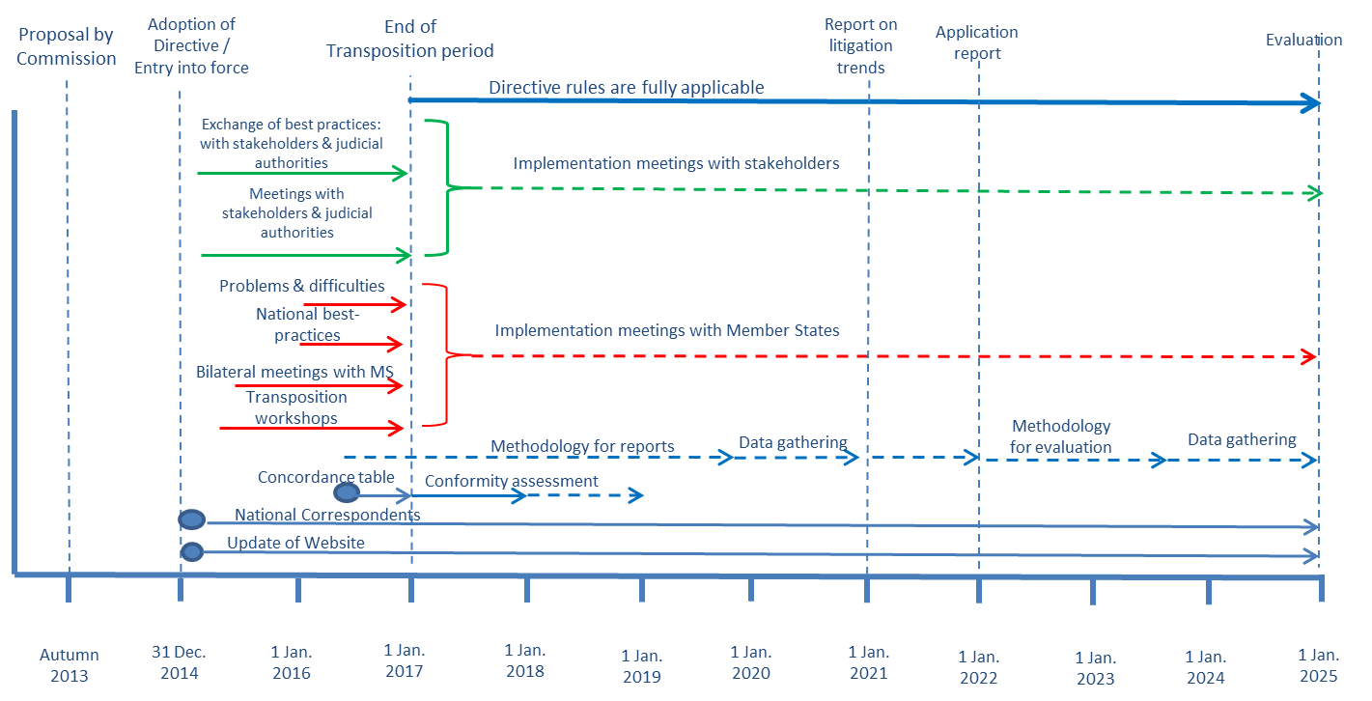
* Assuming that the proposal for a Directive is adopted by the Commission in autumn 2013 and that the adoption of the text by the European Parliament and the Council could take place end 2014. Dates would need to be adapted if these two assumptions do not hold true.

Parties will often be businesses. In some cases, employees may also be concerned.

