COMMISSION STAFF WORKING DOCUMENT
Accompanying the document
REPORT FROM THE COMMISSION TO THE EUROPEAN PARLIAMENT AND THE COUNCIL
ON 2012 EIB EXTERNAL ACTIVITY WITH EU BUDGETARY GUARANTEE

1. Introduction
This Staff Working Document (SWD) reviews the implementation of the current EIB external mandate at regional and country level as well as the contribution of EIB financing operations to the fulfilment of external policy objectives, taking into account the operational objectives of the EIB.
The following tables summarise the EIB own resources lending activity in the regions covered by the mandate: overall signatures (Table 1), the signatures and available headroom under the mandate (Table 2) and the signatures and available headroom under EIB own risk facilities (Table 3).
Table 1: Overview of overall EIB lending signatures in the regions covered by the Decision
Table 2: EIB lending signatures under the current Decision
Table 3: EIB lending signatures under EIB own risk facilities
The chart below illustrates the sectoral distribution of EIB total financing (EUR 6.5bn) under the Mandate and under the EIB own-risk Facilities in 2012. Credit lines for SMEs (38%), transport (23%), energy (12%), industry and services sectors (12% together) remained key priorities for EIB financing with more than EUR 3bn invested in 2012 outside the EU.
Chart 1: Regional and sectoral breakdown of signatures under Mandate and Facilities in 2012
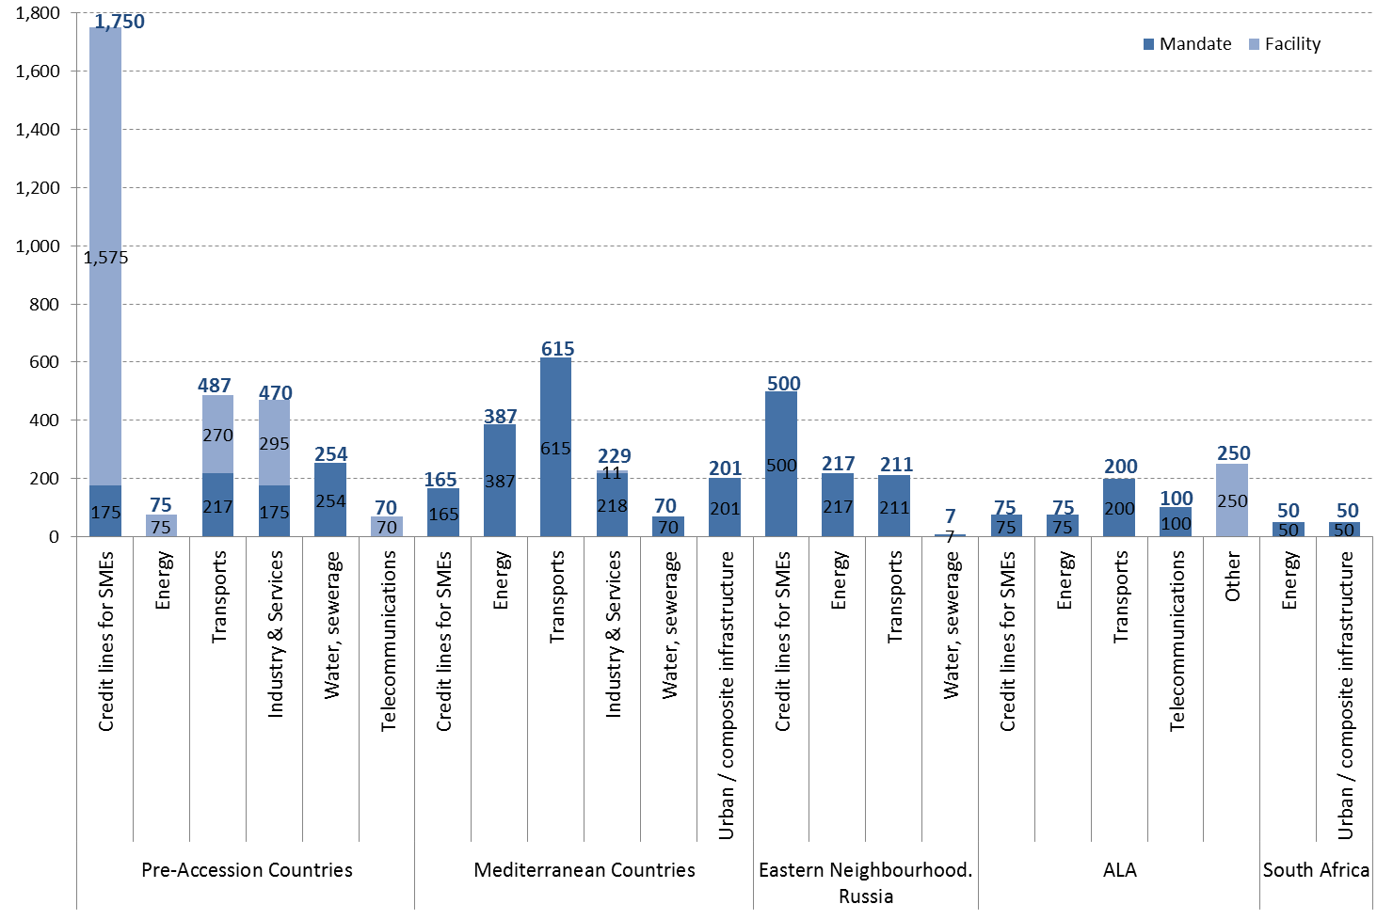

2. Overall contribution to EU policy objectives
The objective of EIB operations under the guarantee is to support relevant external policy objectives of the EU. In particular, the Decision provides for some specific policy goals to be addressed through EIB external operations. The following chart illustrates the EIB contribution to the high-level objectives of the Decision based on the existing stock of operations signed over the period of implementation of the Decision (1/08/2007-31/12/2012). Considering that the objectives are not mutually exclusive, some operations contribute to more than one objective; e.g. sustainable transport project may, in addition to economic infrastructure, contribute to climate change mitigation.
Chart 2: Expected contribution to mandate objectives based on signatures under Mandate and Facilities in 2007-2012
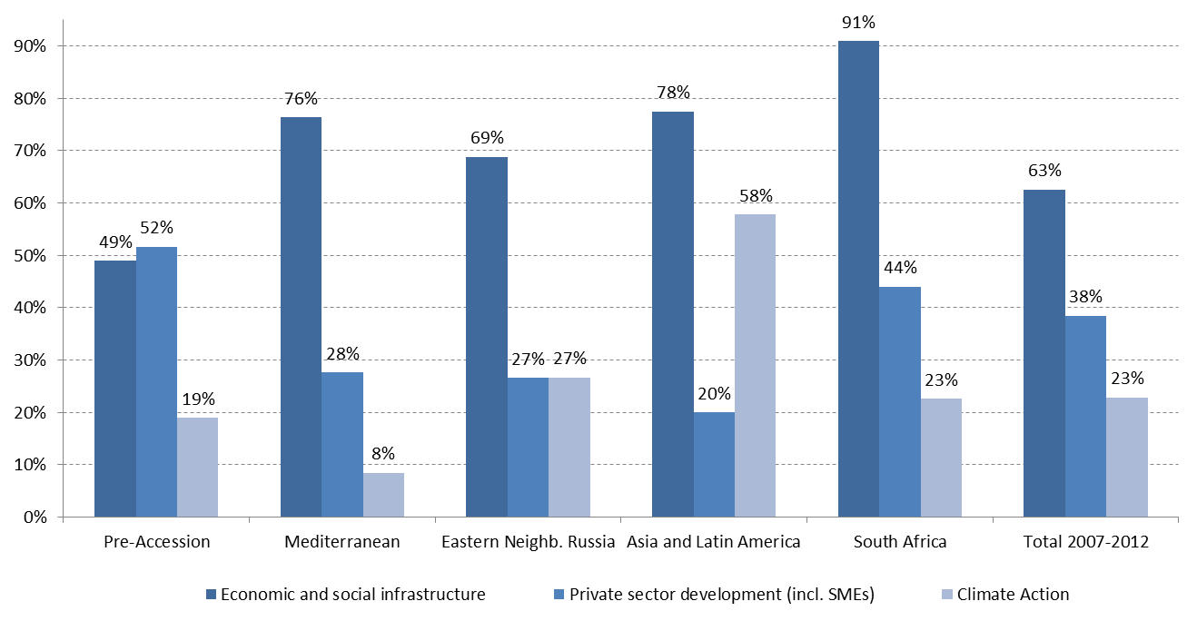
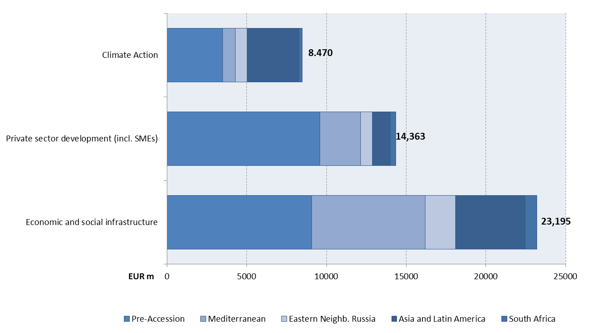

2.1. Climate change mitigation and adaptation
As regards climate action, 2012 overall EIB signatures amounted to EUR 1.6 bn, representing 24% of total EIB financing in the regions covered by the Decision (29% of signatures under the EU guarantee, either under the general or the climate change mandate envelopes). This proportion is in line with the EIB’s global target of 25% of overall lending (increased from 20% in 2010), and relatively more than in 2010 when broadly an equal volume of EUR 1.6 bn in climate action signatures accounted for 21% of total financing in the regions covered by the Decision (15% of signatures under the EU guarantee).
More precisely, projects contributing to climate action signed under the EU guarantee in 2012 comprised:
- In the Pre-Accession countries, two projects signed in Turkey and one in Montenegro, the latter comprising an urgent flood relief and prevention project. In Turkey too, the climate action projects comprised a proportion (EUR 10 mn) of EUR 100 mn loan for flood prevention and protection as well as an environmental loan of EUR 75 mn for financing of small and medium-scale projects carried out by local authorities;
- in the Mediterranean, five projects of which three under the Climate Change Mandate: a loan in Lebanon to a financial intermediary for on-lending to private sector companies for energy efficiency and renewable energy, two projects in Morocco, supporting the first phase of a solar power complex, and upgrading of public irrigation systems, a project in Egypt supporting an extension of the Cairo metro, and a combined heat and power plant in Israel;
- in Eastern Neighbourhood: a loan in Ukraine for hydropower infrastructure rehabilitation along the river Dnieper;
- in Asia, under the Climate Change Mandate, a loan in Vietnam to financial intermediaries for on-lending for renewable energy, energy efficiency and other climate operations;
- in Latin America, in Ecuador, the construction of Quito’s first metro line;
- in South Africa, a loan for the construction and operation of a solar tower renewable energy plant.
Complementing the Bank’s climate action financing under the EU guarantee, the following operations were financed in 2012 under the EIB own-risk facilities:
- in Pre-Accession, three intermediated loans via local financial institutions signed in Turkey for on-lending primarily to small and medium-sized enterprises for renewable energy and energy efficiency projects, and one direct loan for research and development in Turkey for energy improvement technology in motor vehicles;
- in Asia, one intermediated framework loan in China for financing of forestry projects contributing to climate change mitigation through carbon sinking and avoidance of greenhouse gas emissions;
- in the Mediterranean, one direct loan for research and development in Israel for electric vehicle infrastructure and service.
The Bank calculates the carbon footprint of all projects directly financed (or through fully appraised framework loan allocations) which emit more than 100kt of CO2equivalent (CO2eq) per year (absolute emissions) or lead to an emission variation of more than 20kt of CO2eq per year compared to a baseline. A previous sample revealed that the application of these thresholds captures 95% of all emissions from projects financed directly. The data for 2012 were still under elaboration at the time of the drafting of this report. As a matter of example the projects financed under the Mandate in 2011 accounted for annual absolute emissions of 7.97 mn tCO2eq. However the relative emissions of this same group of projects were minus 1.58 mn tCO2eq (i.e. emission reductions compared to the baseline).

2.2. Development of social and economic infrastructure
Over the years 2007-2012, the EIB has provided more than EUR 23.2 bn for the financing of social and economic infrastructure, including transport, energy, environmental infrastructure and information and communication technology.
Chart 3: Breakdown of energy and transport signatures under Mandate and Facilities in 2007-2012
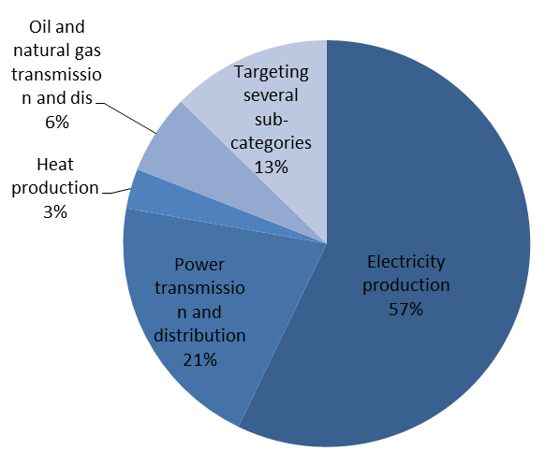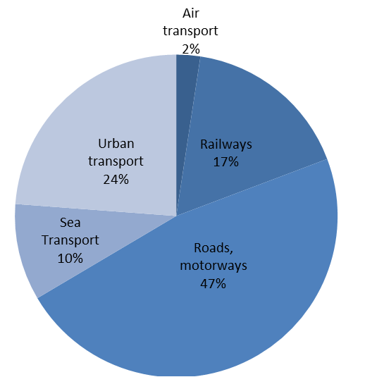
Since 2007, EIB has contributed to the development of sustainable and secure energy systems that meet partner countries’ economic, social and environmental needs, by providing more than half of its energy lending for system expansion in terms of generation capacity / electricity production. Another 20% was invested in energy transmission and distribution. Over the period, investments in renewable energy and in energy efficiency represented approximately 55 % of total energy lending.
Developing more efficient sustainable transport systems, offering upgraded networks and improved public transport services have been priorities for EIB with over 80% of transport financing aimed at improving roads, motorways, railways and urban transport. These projects not only benefit the local communities by offering improved transport networks, accessible and affordable transport services, reductions in traffic congestion, fuel consumption, and air pollution, but the projects also generate economic activity and contribute to a more sustainable development. Moreover, improving transport networks is a crucial element in regional integration at local, national and regional levels, thus supporting trade, employment opportunities and social cohesion.
In 2012, EIB financed 34 projects across all regions in support of social and economic infrastructure, predominately under Mandate.
- Out of 9 energy projects signed, 6 concern renewable energy, including the first tranche of EUR 100m (out of EUR 300m approved) financing for the Ouarzazate Concentrated Solar Power Plant in Morocco, the first large-scale plant of this kind in North Africa. A EUR 75m framework loan for financing small and medium-scale renewable energy and energy efficiency projects in Turkey was the only energy investment under EIB own risk facilities in 2012.
- Another 9 projects targeted the transport infrastructure, mainly roads and motorways, almost exclusively under the Mandate. Significant projects include the construction of two motorway sections in Bosnia and Herzegovina, connecting the country with international transit corridors to Croatia and Hungary, the construction of dual two-lane motorway on new alignment bypassing Fier in Albania, the construction of a key link to the motorway network in Morocco (Autoroute El Jadida) and the Georgia East-West Highway project – all key in contributing to regional integration and economic development in the regions.
- 2 urban transport projects were financed for the construction of a metro line in Ecuador and in Egypt that will provide improved, accessible, affordable and efficient transport service in Quito and Cairo, alleviating urban congestion and pollution and promoting the use of public transport, thus contributing to more sustainable development of both cities.
- 7 operations supported environmental infrastructure, more specifically water and sanitation, including a rehabilitation of water supply, sewerage and sewage treatment facilities of 17 small towns throughout Armenia, benefiting approximately 300,000 inhabitants, primarily lower-income groups, by improving the quality and continuity of water supply as well as improving wastewater collection and treatment.
- The EIB’s support to the development of knowledge economy and social infrastructure is highlighted by two large-scale programmes implemented with the Scientific and Technological Research Council of Turkey (Tübitak), which aim at strengthening the country’s research and innovation capacity.
- 2 projects, one in Brazil and another in Turkey, were financed in support of information and communication technology by increasing the capacity and extending the geographical coverage of broadband networks and developing new technologies and services by facilitating the local business environment.

2.3. Local private sector development, support to SMEs
In many countries covered by the Decision, long-term funds are in short supply which creates a serious obstacle to private enterprise expansion. The purpose of EIB's lending is to help overcome such local market gaps. SME investment projects are mostly too small to justify a direct EIB intervention but can be handled by local banks. These projects may receive indirect support from the EIB in the form of global loans, i.e. credit lines opened to certain intermediary banks for a number of small and medium sized projects which remain to be identified by the intermediaries within a given allocation period.
Partner banks are carefully selected by the EIB, notably regarding their capacity to assess projects and their compliance with international regulations against fraud and other prohibited practices. The intermediary banks on-lend the EIB’s long-term funds to private enterprises subject to their own project and borrower appraisal, and to an allocation decision by the EIB in respect of the proposed investment projects. The intermediary banks assume detailed reporting obligations on projects and end-borrowers. They often provide in parallel loans (usually of shorter term) from their own resources. Subsidiaries of European banks, affiliates of regional banking groups as well as local banks count among the EIB’s global loan partners. At the end of 2012, the EIB authorised the “Loan for SMEs and Mid-Caps” product to be used in all regions outside the EU, which had been successfully pioneered within the EU since 2008, later also in the Pre-Accession region and in some countries of the Eastern Neighbourhood. This product allows for more flexible funding of individual projects.
Over the past three years, the EIB has provided a total of EUR 4.5 bn in long-term finance via credit lines to financial intermediaries, reaching more than 14,000 SME and MidCap beneficiaries in the regions covered by the Decision. While Pre-Accession countries received more than 80% of this volume, the Eastern Neighbourhood recorded the strongest growth in signatures with 6 new loans signed in 2012 totalling EUR 500 mn of which EUR 350 mn targeting SME beneficiaries. In Turkey, the number of intermediaries has been increasing over the years, with the aim to ensure a good geographical coverage of attribution of EIB funds throughout the country.
Table 4: Credit lines for SMEs and MidCaps in 2010-2012
Allocations of funds made in 2012 under credit lines amounted to EUR 1.7 bn, contributing to almost 4,800 investment projects undertaken by SMEs and MidCaps with total investment cost of EUR 3.6 bn. In the SME segment, i.e. enterprises of less than 250 employees, the average allocation size was EUR 315,000, and half of the allocations were smaller than EUR 50,000. A limited number of allocations (6%) went to MidCaps, i.e enterprises of between 250 and 3,000 employees. In this segment, the average allocation size was EUR 1.5 mn. Larger allocations with individual size of more than EUR 3 mn represented only 3% of the total number of allocations made. Certain credit lines, in particular those signed in 2011 and 2012 with the ProCredit Group in several Eastern Neighbourhood and Pre-Accession countries were particularly successful in addressing the lower end of the SME target group. The first allocations under these credit lines materialised quickly and a year after signature, already 330 allocations had been made. 65% of these are in support of enterprises of less than 10 employees.
EIB funding through credit lines supports a diversified range of activity sectors. The largest in 2012 were manufacturing (37%), agro and food processing (15%), commerce (12%), hotels and tourism (11%), energy (8%) and construction (5%). More detail on the expected results of EIB support to SMEs based on credit lines approved in 2012 is provided in Section 3.
Apart from intermediated lending, the EIB also supports local private sector development through direct loans to larger private enterprises, mainly in the industrial and services sectors. These investments often induce employment and investment effects also in the local supplier base. Direct lending to local private sector is essentially provided at EIB’s own risk under the Pre-Accession Facility (EUR 440 mn signed in 2012) or under the Decision in Pre-Accession (EUR 175 mn) and Mediterranean countries (EUR 328 mn).
Besides long-term lending, the EIB invests in funds which provide equity to SMEs as well as to micro-enterprises. Such investments are carried out not from EIB’s own resources, but using third party money, such as the EU budgetary funds for risk capital operations under the European Neighbourhood Partnership Instrument. This is in consideration of the high-risk nature of the operations and the fact that the EU Guarantee under the Mandate only covers political risks.
In 2012, 19 SME-focused equity funds were in their investment phase, investing some EUR 100m in favour of SMEs in the Mediterranean region. At the end of 2012, the stock of investments being held and actively followed up by the funds' management comprised 142 investee companies. Considering that EIB is known as one of the key investors in SME funds in Mediterranean countries, its participation encourages contributions from other sources. Based on existing stock, EIB participation has a leverage effect of 5.3x in the Mediterranean equity funds.
The Bank also uses the EU’s loan-grant blending mechanisms to finance technical assistance to banks, micro-finance institutions and SMEs. Implementation of such support schemes in the Mediterranean region went ahead in 2012 and included MicroMed, a large technical assistance scheme to support microfinance institutions in Tunisia (EUR 4m of which half funded by Luxembourg). The potential for Mesofinance - a bridge between microfinance and the banking sector - is being studied for the whole region. As mobile finance is making great progress, EIB presented the first regional study on this topic during a workshop in November 2012 and is preparing a working group and further technical assistance for the region in the context of the Deauville Partnership.

2.4. Contribution to other aspects – Regional integration and European FDI
Regional integration has been supported mainly in EIB financing of social and economic infrastructure. Over the past six years, EIB has financed 26 projects (EUR 2.5 bn) contributing to regional integration, of which 45% was signed in the Mediterranean countries, followed by 42% in Pre-Accession. Promotion of the regional integration dimension was one of the reasons for developing the Western Balkans Investment Framework jointly by the Commission, the EIB, the EBRD, the Council of Europe Bank and other donors. Besides the more traditional financing of integrated regional and cross-border networks of transportation and energy, EIB projects fostering regional integration include certain information and communications technology projects as well as investments for the development of knowledge economy, particularly scientific research, tertiary education, innovation and the financing of academic research programme promoting the integration with the European Research Area.
By foreign direct investment, the EIB is supporting the internationalisation of the EU economy, which aims at promoting EU competitiveness while bringing substantial benefits to the economies outside the EU. Over the past six years, the EIB has financed 30 projects (EUR 3.8 bn) in Pre-Accession, Mediterranean and Latin America, mostly in the energy, industry, and telecommunication sectors. Turkey and Brazil are by far the largest recipients of EIB supported FDI with a combined inflow of EUR 1.7 bn (45% of total FDI) between 2007-2012. In 2012, five projects (EUR 474 mn) supported EU FDI including mobile broadband network project in Brazil, R&D and start-up of electric vehicle infrastructure and service scheme in Israel, modernisation of a plant producing a redesigned range of light and medium-sized commercial vehicles in Turkey and two projects in Morocco (automotive industry and technology parks), all of which support the development of private sector economic activities in the regions.

3. Actual and Expected Results of EIB operations: REM

3.1. The REM framework
In line with the former frameworks, projects are rated according to three “pillars”:
- Pillar 1 rates the expected contribution to the three high level objectives mentioned in section 3.2, as well as to the countries' and EU priorities. As the distribution of Pillar 1 ratings shows, more than half of the operations approved are expected to make an excellent contribution to mandate objectives, meaning that they are not only fully in line with the objectives for that region, but they are also aligned with the countries’ development objectives and the EU priorities for the country and/or region. Those projects that will make a “good” contribution are in line with mandate objectives but not necessarily featuring as high priority in terms of the country’s own development objectives or those of the EU.
- Pillar 2 measures the expected results, the quality, and the soundness of projects. Nearly 20% of operations approved received an excellent rating, indicating that results, either in terms of net economic gains to society (for direct projects) or results of intermediated operations are expected to be excellent, i.e. economic rate of return (ERR) greater than 15%. More than 80% of operations are expected to be “good”, with an average ERR of 10% to 15%.
- Pillar 3 measures the EIB’s expected additionality which inlcudes, inter alia, how the capacity of the beneficiaries of EIB financing is expected to be reinforced also with technical assistance. About 17% of operations approved this year are expected to have high additionality – typically, extending the longest maturity of debt available to the borrower from the market by more than 100%; matching economic life of the assets to be financed by at least 80%; taking a lead role in project preparation, structuring and/or implementation support. Another 67% are considered good, providing significant additionality – typically, combining significant financial additionality with significant technical and sector contribution or standards and assurance. The 16% of approved operations that were rated as expecting moderate additionality were typically standard products where limited contribution to project design, structuring or implementation was necessary.
The three pillars of the REM are based on a logical framework approach, which serves to show how EIB inputs (e.g. loan), generate outputs (e.g. an electricity transmission line, a training programme), which enable outcomes (e.g. improved access to energy, improved institutional capacity) and, over time, lead to impacts (development of economic infrastructure, regional integration) which are in line with the Bank’s mandate objectives.
Figure 1: REM conceptual Framework
Pillar ratings are assigned according to a four-point scale (4-excellent, 3-good, 2-acceptable, 1-marginal) and are based on a series of objectively measurable indicators and guidelines. No overall project rating is provided. An example of the REM framework applied to an EIB project is included in Annex.
The REM framework provides an assessment of project results throughout the lifecycle. At the outset, standardized and monitorable indicators are identified, with baselines and targets that capture expected economic, social, environmental, and governance outputs and outcomes of the operation. Achievement against these specified benchmarks will be monitored throughout the project life and will be reported at two milestones -- at project completion and 3 years after project completion (“post completion”) for direct operations, and at the end of the investment (or allocation) period and end of life of the fund for indirect (intermediated) operations. REM indicators will also be used for ex-post evaluation. REM results indicators are - to the extent possible - being harmonised with other International Financial Institutions to simplify client reporting requirements for co-financed operations.

3.2. Actual results based on selected case studies
Four case studies are presented here to provide examples of actual results achieved by implemented projects following the REM methodology. As they were approved before the introduction of the REM framework, no REM assessments were carried out at the approval stage. During the first couple of years, the REM framework will not produce actual results until they can be measured for the projects approved under the new framework. During this time, the reporting on actual results will be based on selected case studies.
MANILA WATER COMPANY – SUPPORTING DEVELOPMENT OF ECONOMIC INFRASTRUCTURE
Project Description
The Manila Water Company (MWC) provides water and wastewater services to over 6 million people in the East Zone of Manila, the capital of the Philippines. The growing population and the increasing number of households connected to the water system in Metropolitan Manila lead to the growing demand for water supply services. Population groups who do not have access to direct connections with the city water system have to purchase bottled water and water from commercial vendors at a much higher cost than municipal water or use water from contaminated sources. The objective of the project was to continue MWC’s improvements to the water supply service in eastern Manila and bring clean water and sanitation to population groups not yet served. The EIB loan of EUR 60m over 10 years helped finance a capital investment programme with a total cost of EUR 157m.
Table 5: Project Results Summary – Manila Water Company
Outputs | Outcomes | Impacts
All water treatment plants were renovated  223 km of pipeline replaced  3,850 km of pipeline expanded and rehabilitated  710,000 service pipes replaced  249,000 additional connections installed | 100% compliance with water quality standards  1,120 m litres clean water delivered per day (increase of 233 MLD)  1.1 m additional people with access to clean water at an affordable cost  Of these, 900,000 people in low-income households.  99% of households with water available 24 hrs./day  Non-revenue water decreased from 34% to 11% | Improved health  Decrease in outbreaks of diseases Better quality of life  Greater proportion of household budget available for other uses  Positive environmental impact of more efficient water use
TUNISIA HEALTH I (SANTÉ TUNISIE I) - SUPPORTING DEVELOPMENT OF SOCIAL INFRASTRUCTURE
Project Description
This project focused on modernising the hospital infrastructure and equipment for diagnosis and treatment in 30 hospitals throughout Tunisia, in response to the increasing reliance on hospital-based, specialised services in the country and the priority of the Ministry of Health (MoH) to reduce infant and maternal mortality. The project comprised a EUR 110m loan to the MoH and the Ministry of Equipment, used to purchase equipment (EUR 80m) and renovate hospital buildings (EUR 30 m). The total project cost was EUR 224.5m, of which the Government contributed 51%.
Table 6: Project Results Summary -- Santé Tunisie I
Outputs | Outcomes | Impacts
State of the art equipment installed in 30 Tunisian hospitals  230 haemodialysis machines available per million inhabitants  12.4 CT scanners available per million inhabitants  30 hospitals in Tunis and other Governorates expanded and modernized  59 specialists available per 100,000 inhabitants  373 paramedics per 100,000 inhabitants | Approx. 4,500 scans per year performed with each machine  Public health expenditure increased from 5.6% of GDP (2003) to 6.2% of GDP (2011)  4,000 new jobs created in health sector | Through coordinated actions with MoH, contributed to:  improved health care standards;  improved health of population  decreased maternal and infant mortality
VOIRIES PRIORITAIRES IV - SUPPORTING ECONOMIC INFRASTRUCTURE
Project Description
The project objective was to improve the urban road infrastructure in Tunisia; it consisted of five sub-projects in Greater Tunis and three sub-projects on arterial roads in the vicinity of other major cities. The interchanges, new roads and road widening in Greater Tunis entailed improvements to key roads that are subject to very heavy traffic and increasingly heavy traffic jams. The other three subprojects involved the construction of urban bypasses at Sahline, Ksar Hellal-Moknine and Médenine. By reducing congestion and facilitating traffic flows the project has created considerable economic, social and environmental benefits for the country.
Table 7: Project Results Summary – Voiries Prioritaires IV
Outputs | Outcomes | Impacts
13 km of roads constructed in Greater Tunis  13.5 km of interchanges and bridges reconstructed  21.9 km of roads upgraded and with improved lighting and drainage  24.5 km of bypasses constructed around Sahline, Ksar Hellal-Moknine and Médenine | Travel time savings estimated at a value of EUR 454 m p.a.  Travel time savings for working commuters at peak traffic estimated at average 1 hour/day  Vehicle operating cost savings estimated at EUR 93 m p.a.  Lower CO2 emissions, according to ex-post Environmental Impact Assessment (EIA)  Road fatalities saved -- estimated at 18 p.a.  ERR: 16% (sub-projects range from 13% to 28%)  2,100 man/years created during construction; 50 permanent jobs after completion | Improved traffic conditions and reduced congestion  Improved traffic flow and connectivity among four Tunis districts  Improved business environment.  Improved living conditions for the population of Greater Tunis  Regional integration: improved links with neighbouring Algeria and Libya

MOBIASBANCA–SOCIETE GENERALE -- LOCAL PRIVATE SECTOR DEVELOPMENT, SUPPORT TO SMEs
Project Description
The project objective is to promote private sector development by supporting micro, small and medium enterprises (MSMEs) in Moldova through a EUR 20m credit line to Mobiasbanca – Société Générale (MBSG). Moldova’s banking market was concentrated on large firms and the public sector, with scarce availability of long-term financing for MSMEs. This project aimed at supporting MSMEs by extending the maturity of the Bank’s funding base and lowering the cost, thus providing a source of longer-term funding for MSMEs permanent working capital and long-term investments.
Table 8: Project Results Summary -- Mobiasbanca–Société Générale
OUTPUTS | OUTCOMES | IMPACT
Longer-term funding of MBSG increased by EUR 20 m | 117 loans to MSMEs (of which 6 micro, 111 SMEs)  5 start-up companies financed  Average loan size EUR 88,000  Total disbursed EUR 20m; last disbursement on April 2012.  Average loan tenor weighted by loan size: 51 months  Average cost savings to MSMEs -- 204 bps  MBSG improved reporting and accountability  Financial performance of MBSG improved (ROE from 0.9% in 2009 to 7.9% in 2012; Capital Adequacy Ratio from 37.1% to 44.5%)  491 jobs sustained. | Strengthened financial performance and improved competitiveness of MSMEs.  Capital markets better developed  Increased access to financing for MSMEs, leading to higher GDP growth
Additionality
Key aspects of the contribution of the four case study projects in terms of additionality (Pillar 3) are summarised in the table below. EIB funding extended loan terms by at least two times the commercially available maturities, thus improving the asset matching profile of investments. Compared with total project value, leverage was 2.0 to 2.5 times EIB’s contribution. Resource mobilisation was significant in MWC (water) and MBSG (banking), with successful private funding participation. Public funding matched EIB resources in the two infrastructure projects in Tunisia. There was cooperation with other IFIs in all four cases.
Table 9: EIB Additionality in case study projects
 | Maturity Extension | Asset Matching  Improvement | Leverage | Private Funding | IFI Cooperation
Manila Water | 2.0x | √ | 2.5x | √ | IFC
Santé Tunisie | 2.0x | √ | 2.0x |  | IBRD
Voiries Prior. | 2.5x | √ | 2.0x |  | AfDB
MBSG | 2.0x | √ | 2.0x | √ | EBRD

3.3. Expected development results of EIB operations approved in 2012
In 2012, the EIB approved 90 operations totalling EUR 8.1 bn outside the EU (including ACP). 69 operations totalling nearly EUR 7.1 bn were approved in the regions covered by the Decision. Of these, 39 operations (EUR 4.4 bn) were approved under the EU guarantee and 27 (EUR 2.6 bn) under EIB own-risk facilities. Most of the operations (22; EUR 2.4 bn) to be financed at EIB own risk will be financed under the Pre-Accession Facility, while the others (5; EUR 260 mn) will be financed under the Energy Sustainability Facility. Finally, 3 operations (EUR 39 mn) will be financed with third party resources .
Out of the 69 approved operations, 50 were either direct projects supporting infrastructure development or indirect projects supporting micro, small and medium-sized enterprises (MSMEs), the two main focus areas of EIB intervention. Of the 32 infrastructure operations, 9 direct and 5 indirect projects were for energy, mainly electricity production, transmission and distribution, and 12 were for transport -- roads, railways, air traffic and urban transport. Of the latter, the financing of the Cairo Metro (EUR 600 mn) was the largest single project approved in 2012. Credit lines to intermediaries for on-lending to MSMEs accounted for 28 of the approved operations.
In terms of regional distribution, the largest amounts approved were for the Pre-Accession region (EUR 3.0 bn) and Mediterranean countries (1.77 bn). There were significant sectoral differences between regions, for example, in the Pre-Accession region, more than half of approvals were for support to SMEs, reflecting the importance of supporting the private sector for economic growth and convergence with the EU.
The 69 operations approved in 2012 covered 28 countries, in addition to several regional projects. 15 projects (EUR 2.0 bn) were approved for Turkey, other important countries in terms of approvals included Egypt (EUR 650 mn), Ukraine (EUR 637 mn), Croatia (EUR 562 mn) and Morocco (EUR 463 mn).

3.3.1. Expected Contribution to EIB’s objectives and EU priorities (Pillar 1)
Pillar 1 assesses the extent to which approved projects are expected to contribute to the three high-level and one cross-cutting objectives of the Mandate. Nearly two-thirds of projects approved in 2012 will contribute directly to more than one objective. More than 70% of operations are expected to contribute to private sector development and nearly 60% to the development of social and economic infrastructure. It is expected that 35% of projects will contribute to climate change mitigation and adaptation, while 30% will contribute to regional integration.
Chart 4: Contribution to mandate objectives – Number and Percentage of Projects

Chart 5: Projects contributing to social and economic infrastructure by sector | Chart 6: Projects contributing to local private sector development by type of operation | Chart 7: Projects contributing to climate change by sector
As chart 5 shows, the projects contributing to the social and economic infrastructure comprise both direct infrastructure development projects, mainly transport and energy, but also services and water, and indirect (intermediated) operations providing loans to SMEs and mid-caps, which will finance priority projects to extend and strengthen local and regional infrastructure in areas such as transport and renewable energy.
Chart 6 shows the projects contributing to local private sector development, in particular support to SMEs. The majority of these are the indirect operations that provide loans to financial intermediaries for on-lending to MSMEs or invest in private equity funds, but about one third of them are direct projects that also contribute to private sector development, by supporting manufacturing, SMEs, particularly in the energy or tourism sectors, or research and development leading to improved products.
Chart 7 shows that approximately 40% the operations contributing to climate change mitigation are in the energy sector, including projects such as the Bangladesh power energy efficiency project, two hydropower projects in Costa Rica and El Salvador, and a number of intermediated loans to support investments, which contribute to climate change mitigation through projects in the renewable energy and energy efficiency sectors. Of the 12 operations approved in 2012 for Asia and Latin America (ALA), 10 will contribute to climate change adaptation or mitigation, reflecting the emphasis on climate action in the ALA region.

3.3.2. Expected development results of operations approved in Mandate regions in 2012 (Pillar 2)
This section analyses by sector the expected results for projects approved in 2012 by the Bank for regions covered by the Mandate in terms of the inputs, expected outputs and outcomes. Table 10 summarises the REM standard sector indicators and values. Potential longer term impacts are described wherever possible.
Energy: In 2012, the EIB approved 14 loans in the energy sector (total EIB financing EUR 1.3 bn; total project value EUR 3.2 bn), comprising 9 direct operations and 5 loans to intermediaries for on-lending, which address different aspects of energy production, transmission and distribution, as well as energy efficiency. Expected outputs are significant system expansion (7 projects - 1500 MW additional capacity; 3 projects – 6000 km of additional power lines) resulting in outcomes of more reliable energy produced and delivered to more consumers (153,000 additional households). The credit lines are earmarked for on-lending to SMEs for projects in energy efficiency and renewable energy sources. Energy projects also contribute to wider economic, social and environmental impacts. By promoting the use of renewable energy sources - solar, wind, geothermal and hydropower, energy efficiency and the replacement of fossil fuels, the EIB supports climate change mitigation by reducing the production of greenhouse gases (GHG).
Transport: In 2012, EIB approved 12 investment loans totalling EUR 1.5 bn, which will support projects costing a total of EUR 5.2 bn, in the subsectors roads, railways, air and urban transport. Expected outputs include upgraded transport networks and more efficient public transport services, resulting in increased capacity, with reductions in traffic congestion, fuel consumption, and air pollution, as well as time savings for passengers and freight. Upgrading road corridors and border crossings will promote trade and regional integration; the railway projects will reduce transport costs and promote the switch from road to rail transport; the air transport projects aim at improving air traffic management and increasing safety; and the metro projects will provide more capacity, safety and efficiency, and encourage modal shift from cars and buses. For the urban transport schemes, the population potentially benefitting from access to improved services is based on catchment populations and for this reason, the number of people served by these projects, as reflected in Table 10, is of an order of magnitude higher than for projects providing direct interventions.
Water, sewerage and waste: EIB approved 3 loans in the sector (total EIB loans EUR 147 mn; total project value EUR 304 mn). Two projects will provide access to clean water and improved sanitation and the third one will help to protect people and their land from the potentially disastrous effects of floods. Expected outputs are extension of supply networks, upgrading and expansion of water and sewage treatment plants, improved sanitation and environmental protection. Expected outcomes include additional households provided with safe water and sanitation services, annual increases in treated water and sewage, reduction in water losses, water resources protected and managed, and populations protected.
Urban development and housing: Urban areas, which are key drivers for economic growth and employment, require adequate public infrastructure and services, as well as affordable housing. Two EIB urban development loans were approved in 2012 (total EIB loans EUR 120 mn; total project value EUR 400 mn), which will not only benefit the population living in the areas served by the improved local services, but also help develop local SMEs, create jobs in construction, services and related sectors, attract private sector investment and support economic growth. For the urban development schemes, the population potentially benefitting from access to improved services is based on catchment populations and is therefore higher than for projects providing direct interventions.
Health and Education: The one direct operation for health and education approved in 2012, (EIB loan EUR 300 mn; total project value EUR 660 mn), improves the structural resilience of health and education buildings that are vulnerable to earthquakes in Istanbul, Turkey, thus ensuring more sustainable provision of essential services. In Table 10, the number of additional patients treated per year in these improved facilities is the aggregate value including inpatients, day cases and outpatients treated.
Manufacturing industries, which employ a large share of the labour force, are crucial for economic growth and a modernising economy. EIB is supporting 5 projects (total loans EUR 415 mn; total value of projects EUR 1.2 bn) contributing to manufacturing production, promotion of innovation and the introduction of new technologies. The expected outputs of these projects are increased production capacities installed, while the outcomes are the additional production volumes expected.
Services (including Research and Development): These include facilities such as hotels and restaurants (1 project), research and development operations (3 projects), and a services fund. The expected outputs and outcomes for hotels are increased accommodation, job opportunities and local demand for services, and in the longer term a stimulus for local economic activity and diversification. The Research and Development projects help countries modernise their industries and services, promote innovation and employ clean technologies.
Telecommunications is a crucial component in developing economic and modern infrastructure services and plays a significant role in regional integration. EIB supported this sector through a loan to an R&D operation (EUR 70 mn) and investment in a private equity fund (EUR 4 mn).
Agriculture, forestry and fishing: Three EIB projects (total EIB contribution EUR 70 mn; total project value EUR 297 mn) were approved in 2012. Two are for private equity funds that will invest in forest protection, thus contributing to climate change mitigation, and the third aims at improving irrigation and water economy. The wider impacts of these projects include promotion of sustainable livelihoods, climate change mitigation, biodiversity conservation and improved natural resources management, as well as catalysing private sector involvement and investments.
Overall contributions to expected results
A wide range of indicators have been employed to describe the projects referred to above and their expected outputs and outcomes. Many are project specific, but some are more widely applicable. However, care must be taken in attempting to aggregate the results (expected and ultimately achieved), as the definitions of what they cover may be different, as explained in the sections above. Comparison of outcome indicators across sectors is not recommended, as these can be specific to each sector and the sample (comprising only projects approved in 2012) is too small to draw conclusions and avoid distortions.
Table 10 below summarises the expected results for the operations approved in 2012 under three key headings: Customers reached (Direct provision of services); Access to improved services (Indirect provision); and, Additional production or quantity of services produced.
Table 10: Expected Project Results Summary
Outcome Indicators | No. of Projects | Expected Results
Customers reached with improved services (direct)
Additional households connected to electricity (Hh) | 2 | 153,000
Additional households connected to water services (Hh) | 1 | 3,000
Additional households connected to sewers (Hh) | 1 | 400
Population with access to improved services (indirect)
Improved urban transport services (No.) | 2 | 4,380,000
Reduced risk of flooding (No.) | 1 | 97,000
Health – additional patients treated (No./yr) | 1 | 740,500
Urban development – new infra service coverage (No.) | 3 | 3,413,000
Additional production or services delivered (annual)
Energy produced and/or transported (GWh/yr) | 10 | 56,500
Transport -Increase in passengers served (No/yr) | 1 | 30,000
Transport- Increase in freight services provided etc. (Tonnes/yr) | 2 | 1,300,000
Industry - additional annual production (Tonnes/yr) | 3 | 2,301,500

Support to SMEs
In 2012 the Bank approved 21 loans through financial intermediaries (FIs) for on-lending to support small and medium enterprises (SMEs) and mid-caps, providing loans with a longer tenor, at attractive interest rates and often in local currency. These operations are expected to contribute to relieving significant constraints regarding access to finance, strengthen businesses and contribute to private sector development.
Table 11: Expected Results of Support to SMEs
EUR billion |  | ALA |  | EAST |  | MED |  | Pre-Accession |  | TOTAL
EIB financing approved |  | 0.2 |  | 0.6 |  | 0.2 |  | 1.6 |  | 2.6
Total on-lending |  | 0.5 |  | 1.2 |  | 0.4 |  | 2.5 |  | 4.6
Thousands
Number of Loans |  | 6.4 |  | 2.6 |  | 0.3 |  | 17.0 |  | 26.2
Jobs sustained |  | 47.0 |  | 68.0 |  | 38.4 |  | 224.6 |  | 377.9
Table 11 shows that more than 60% of the resources approved for lending to SMEs went to Pre-Accession countries (EUR 1.6 bn) , and the region with the next largest share was the Eastern Neighbourhood and Russia. The EUR 2.6 bn of credit lines approved for SMEs are expected to generate about 26,000 loans to final beneficiaries for a total on-lent amount of EUR 4.6 bn. The average tenor of loans to final beneficiaries is more than 10 years, improving access to much needed long-term resources which are generally not available in these markets. The 21 credit lines for SMEs approved this year are expected to support roughly 782,000 jobs of which approximately 463,000 in Pre-Accession countries.
The Bank also approved an innovative guarantee instrument designed with other IFls (SME Guarantee Facility) for EUR 120 mn for the Mediterranean region. This mechanism is a risk-sharing facility that provides the intermediary banks with a partial risk guarantee covering up to 50% of the principal losses incurred under their portfolios of eligible SME loans.
In the Western Balkans, the EIB Group, together with the Commission and EBRD, launched in December 2012 the Enterprise Development and Innovation Facility (EDIF) initiative aiming to promote the emergence and growth of innovative, high-potential SMEs. It will complement the SME lending activities with venture capital, equity and guarantees.
Support to Microenterprises through Banks and Microfinance Institutions
In 2012, the EIB approved one loan for a microfinance facility in the regions covered by the Mandate: the “Mediterranean Microfinance Facility II” (EUR 15 mn). This operation will increase the availability of local currency funding for four to six microfinance institutions, which are expected to provide 35,000 to 40,000 loans, with an average loan size of EUR 800, to microenterprises in the region, thereby contributing to the promotion of entrepreneurship, job creation and economic growth in the Mediterranean partner countries.
Private Equity Funds
During 2012, EIB approved investments in four Private Equity Funds for EUR 51m, which are expected to mobilise a total of EUR 350 mn. The sectors that these equity funds target are forestry, ICT and SMEs. These four funds are expected to reach approximately 46 investee companies with an average investment size of EUR 7 mn, and generate about 2,800 direct jobs. The expected impact of the investments is significant in terms of leverage of EIB contribution (6 x) vis-à-vis the total project values, and the catalytic effect of private sector equity mobilisation.
Jobs
Of the 37 direct operations approved, 19 are expected to create roughly 6000 new permanent full-time jobs during operation. In addition, 33 are expected to create roughly 260,000 person-years of employment during construction - or 260,000 temporary jobs. Moreover, the 26 intermediated operations are expected to support an additional 898,000 permanent jobs.
Table 12: Expected employment impact of EIB operations
OUTPUT INDICATORS | VALUES | Number of projects
Employment - during operation (#FTE, Thousands) | 6 | 19
Employment - during construction (Person-years (N°), Thousands) | 262 | 33
Jobs sustained through intermediaries (Thousands) | 898 | 26

3.3.3. Quality of operations
Overall Assessment (REM Pillar 2)
Pillar 2 rates the quality and soundness of an operation and its ability to achieve the expected results. For direct operations, the pillar 2 rating is based on the soundness of the project, the financial and economic sustainability and the environmental and social sustainability. For indirect projects, the rating is based on the expected results, weighted by risk considerations as measured by the soundness of the intermediary and the quality of the operating environment.
As Chart 8 shows, the expected overall quality of the projects approved in 2012 was rated as good or excellent. There were some sectoral differences, although given the limited number of projects per sector, it is not possible to establish general trends at this stage, except to note that the social infrastructure sectors (water, health and education) typically have lower rates of return than economic infrastructure (energy, transport and manufacturing). Credit lines to SMEs were less likely to receive an excellent rating. This was either because they were already in developed financial markets and were therefore not expected to have a significant impact on increasing access to finance or developing the financial sector (e.g. in Pre-Accession countries) – or because they were in riskier operating environments and therefore the likelihood of outcomes being achieved was lower (e.g. some Mediterranean countries).
Chart 8: Pillar 2 ratings by sector
Economic and Financial Sustainability
For direct projects, the financial rate of return (FRR) and the economic rate of return (ERR) are measures of the financial and economic sustainability. Overall, with an average FRR of 10.3% and ERR of 15.3%, operations are expected to be financially and economically sustainable. For indirect projects, the average expected rates of return on equity (ROE), at 12.8%, are higher than their opportunity costs and sufficient to sustain EIB’s support program for SMEs. The portfolio soundness of the financial intermediaries, measured in terms of expected non-performing loans (NPLs) of 5.9%, is higher than for investment grade banks, reflecting the relatively higher market operating risk. With an expected average (CAR) of 18.9%, financial intermediaries seem adequately capitalized.
Environmental and Social Safeguards
The EIB requires that all the operations it approves comply with its environmental and social standards. In addition, some projects that the Bank finances make a positive contribution to either the protection and enhancement of the environment or to the promotion of sustainable communities. The overall environmental and social assessment rates the acceptability of a project for EIB financing in terms of its expected environmental and social impact, including the residual impacts, legal compliance, environmental management, and any significant social issues. All projects approved in 2012 have been rated either good or excellent in terms of environmental and social safeguards.
Regarding indirect operations, loans through financial intermediaries are required to finance SMEs that comply with EU or international environmental and social standards, which is reflected in the satisfactory rating given to loans to most financial intermediaries supporting SMEs.
Energy efficiencies
For every project approved, expected energy efficiency gains attributed to the project have been calculated either as the difference between general energy consumption before and after the project or as reduction of energy consumption per unit of output. There are 15 projects (out of a portfolio of 69 projects) which are expected to deliver energy efficiency gains during the whole lifetime of the project.
Energy efficiency gains are produced by different types of projects. In the electricity sector, these efficiencies are produced by improvements in the networks (transmission and distribution) which reduce technical losses, or through the modernisation or replacement of production equipment/plants by new equipment/plants which are more efficient. Further efficiency gains are achieved through the insulation of buildings. Other sources of energy efficiencies will be in the transport sector. The replacement of individual transport (mainly cars) by public transport systems will lead to significant energy efficiencies.
Human Rights
As an EU body, EIB is legally bound to the provisions of the Charter of Fundamental Rights of the European Union, including the commitment to upholding human rights. EIB’s understanding of sustainable development is guided by a human rights-based approach, and this is reflected in the EIB’s aim to have a transparent, responsible attitude to its project financing. Human rights considerations are already an integral feature of the EIB Social Standards: at a general level, the EIB “restricts its financing to projects that respect human rights” and this is partly achieved by excluding specific types of projects or activities from EIB financing. More specifically, at project appraisal level, a number of Human Rights considerations, including economic environmental and social rights, are integrated into the five existing “Social Assessment Guidance Notes” (SAGNs) appended to the “Environmental and Social Practices Handbook”.
In 2012, the EIB completed a Human Rights Gap Analysis exercise with the aim to assess the existing SAGNs against European and international human rights instruments and provisions and, thereby, to help determine the degree of relevance and of compliance of these EIB SAGNs, as well as identify potential areas for alignment improvement. The outcome of this exercise is guiding the on-going review of the SAGNs. It is expected that the recasting of the SAGNs later in 2013 will be an important step in the process of further mainstreaming human rights considerations from a practical point of view into EIB financing activities.
Furthermore, the development of the REM framework is considered to be an important building block in the Bank’s enhanced due diligence on, and monitoring of, social aspects, human rights considerations, corporate social responsibility, decent work, environmental principles and good governance in its projects financed.

3.3.4. EIB Additionality (Pillar 3)
Within the REM framework, Pillar 3 measures the financial and non-financial additionality of EIB operations, covering the necessary inputs brought by EIB that could not be provided by market alternatives. The three areas of EIB additionality are financial, technical, and standards and assurance.
Financial additionality
Financial additionality comprises the extension of typical maturity, match with asset life, local currency funding, grant element and innovative product. As the table below shows, infrastructure projects, which typically have a long asset life, benefit from the longest financing, with an average tenor of more than 19 years, while the average loan tenor provided to financial sector clients in 2012 was 11.8 years. In table 13 below, the average tenor of EIB loans is compared to typical tenors estimated to be otherwise available.
Table 13: EIB Financial Additionality – Average term of financing (2012 approvals)
 | EIB Tenor  (years) | Typical tenor  (years) | Extension factor
Infrastructure | 19.1 | 8.4 | 2.3 x
Intermediated loans | 11.8 | 4.4 | 2.7 x
Manufacturing | 8.9 | 4.3 | 2.1 x
Other | 10 | 5.7 | 1.8 x
Where relevant instruments are available, significant additionality is also achieved through blending. This is the case for 10 (14.5%) of the projects approved in 2012, corresponding to total EIB loans of nearly 1.0bn.
Technical and sector contribution
In addition to financial additionality, EIB provides advisory services in those areas in which it has specialised expertise, e.g. infrastructure, energy efficiency, environmental capacity building, climate adaptation and financial intermediaries. The technical and sector contributions captures EIB’s improvement of project characteristics in business, developmental, social, environmental or corporate governance terms, including through the use of Technical Assistance. This is of particular importance to the Mediterranean region where 50% of approved projects will receive “high” or “significant” levels of technical contribution.
Standards and assurance
This rating covers added value in terms of demonstration effects, structuring, raising environmental, social, governance and procurement standards, mobilizing other financial resources and cooperation with other IFIs. Two thirds of projects were rated high or significant on these aspects, while one third was expected to have moderate results.
Resource Mobilisation
EIB operations approved in the regions covered by the External Mandate in 2012, totalling EUR 7.1bn, will contribute to projects with an expected total value of EUR 18.2bn. This mobilisation of EUR 11.1bn represents a leverage of 2.7 times the EIB contribution. Chart 9 below illustrates this resource mobilisation, broken down by private sector (5.0bn) and public sector (6.1bn).
Chart 9: Expected resource mobilisation for EIB operations approved in 2012
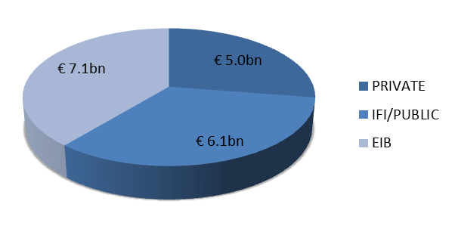

4. Contribution of EIB lending activity per geographical region
This section provides more detailed information at regional, country and project level of operations signed in 2012.

4.1. Pre-Accession Countries

4.1.1. Activity by Country
Table 14: Summary of lending signatures under EU guarantee by Country (number of operations and volume)
The amount of EUR 695 million for Turkey in 2011 includes EUR 150 million under Climate Change mandate
By the end of 2012, EIB had reached 93% of the Pre-Accession countries regional mandate ceiling (net of cancellations) with total cumulative lending between 2007-2012 equating EUR 8,636m (of which EUR 150m under the Climate Change Mandate). In 2012, EIB lending under mandate in the region amounted to EUR 821m, a decrease of 25% from the previous year. At the same time, an additional EUR 2,285m corresponding to 74% of EIB total financing in the region was carried out at EIB’s own risk under the Pre-Accession Facility. Out of the 38 projects signed in Pre-Accession countries in 2012, 29 projects were signed with private sector counterparts under the Pre-Accession Facility (PAF).

4.1.2. Activity by Objective
Table 15: Summary of signatures under mandate by region-specific key lending objectives
* The above numbers cannot be added as a single operation may contribute to several objectives
EIB support for social and economic infrastructure accounted for 60% of overall EIB signatures under Pre-Accession mandate in 2012. Six projects, totalling EUR 646m, contribute to the development of social and economic infrastructure, including the construction of two motorway sections: first, 31 km on Corridor Vc in Bosnia and Herzegovina, connecting the country with international transit corridors to Croatia and Hungary; and second, the construction of around 22 km of dual two-lane motorway on new alignment bypassing Fier near coast in central Albania. Both projects will contribute to regional integration.
In addition, the EIB financed a large Research Promotion project in Turkey - a EUR 175m loan for financing of academic research and an industrial RDI programme implemented through the Scientific and Technological Research Council. The project promotes the integration of the Turkish Research Area with the European Research Area which is consistent with European policy objectives aimed at the development of the knowledge economy, particularly scientific research, tertiary education and private sector innovation activities. Moreover, by strengthening the knowledge economy, the project offers the potential to boost the productivity and competitiveness of Turkey’s economy.
Two loans for EUR 120m in total were signed specifically targeted at flood prevention. The first loan of EUR 100m is for the implementation of range of flood prevention and protection schemes in various river basins in Turkey over period 2013-2015. This project focusses on protection rather than development of social and economic infrastructures as it aims to help protect people and their livelihood against the disastrous effects of floods. The second project was the Urgent Flood Relief and Prevention Framework Loan for EUR 20m for the reconstruction and rehabilitation of basic infrastructure, such as roads, damaged by floods in December 2010 in Montenegro. Both projects and the Iller Bank Environmental Loan in Turkey (EUR 150m) for financing of small and medium-scale investment schemes in the water and solid waste sector carried out by local authorities; contribute to the development of social and economic infrastructure objective as well as climate action.
Support for the local private sector represented EUR 350m or 32% of lending under mandate in 2012, with the Tubitak Research Promotion Project, and two intermediated loans for SMEs in Turkey, signed with Eximbank (EUR 75m) and Ziraatbank (EUR 100m).
Activity by Sector
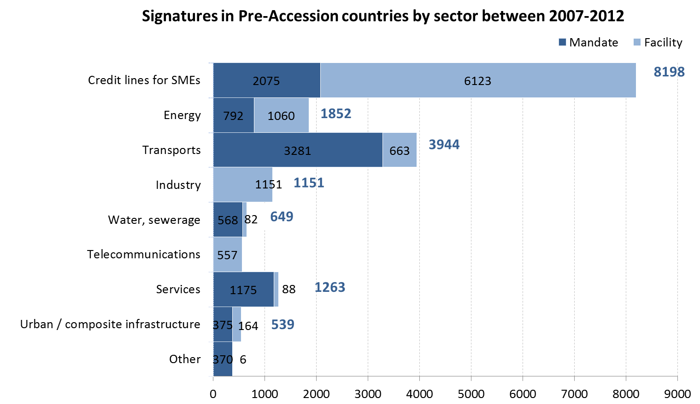

4.2. Mediterranean Partner Countries

4.2.1. Activity by Country
Table 16: Summary of lending signatures under EU guarantee by Country (number of operations and volume)
Despite the continued instability following the Arab Spring, the EIB’s financing activity under the mandate in Mediterranean countries increased by 44% to EUR 1,655m in 2012, reaching 81% of the regional mandate ceiling. The largest concentration of new signatures was in the Maghreb region with record high 11 projects in Morocco and 2 in Tunisia for a total of EUR 1,170m in 2012. In the Mashreq / Near East region, 6 projects were signed in Egypt, Israel and Lebanon for a total of EUR 485m.
In addition to EIB lending under mandate, one loan of EUR 10.8m was provided under the Mediterranean Partnership Facility II at EIB own risk. The loan is for R&D and start-up of electric vehicle infrastructure and service scheme in Israel.
Private equity operations on third party resources amounted to EUR 24m, comprising 3 operations (EUR 19m) signed under the FEMIP (ENPI) Risk Capital envelope and one operation in Jordan (EUR 5m) under the FEMIP Trust Fund. The operations signed under the FEMIP Risk Capital include an equity participation in Moroccan generalist equity fund for EUR 5m, a EUR 4m equity participation in venture capital fund supporting start-up and expansion investment in SMEs in fields of technology, media and telecommunications in Jordan and a EUR 10m participation in a closed-end multi-sector private equity fund investing growth capital in SMEs established in Maghreb region.
Moreover, a total of 15 Technical Assistance operations were signed in 2012, of which 4 under the Technical Assistance Support Fund, 3 under the NIF Southern Neighbourhood and the 8 under the FEMIP Trust Fund.

4.2.2. Activity by Objective
Table 17: Summary of signatures under mandate by region-specific key lending objectives
* The above numbers cannot be added as a single operation may contribute to several objectives
EIB support for social and economic infrastructure accounted for 55% of the overall EIB signatures in the Mediterranean region in 2012. 13 projects were signed supporting the development of social and economic infrastructure, including the Urban Rehabilitation project in Tunisia (EUR 70m) and the Community Development Program in Egypt (EUR 45m) both aimed at improving the general living standards primarily in urban areas, including social and community services, basic infrastructure and housing improvement.
To address the growing energy needs of the region, the EIB financed 3 large energy infrastructure projects, totalling EUR 380m, in Morocco and Israel. The first two of the following projects contribute also to the climate objective:
Centrale Solaire De Ouarzazate – a EUR 100m for the construction of a first phase of solar power complex in in Morocco, designed to increase solar power generation and reduce greenhouse gas emissions.
Israel Chemicals Ltd IPP, a EUR 100m loan for the construction and operation of a Combined Cycle Gas turbine and Combined Heat and Power plant and its associated grid connections and gas pipelines. The project will contribute to developing economic energy infrastructure through increased generation capacity and electricity production, improved availability and reliability of heat and power supply, reduction of carbon emissions from the high clean technology investment. Moreover, the project supports the country strategy of increasing private sector participation in energy generation.
ONEE - Reseaux Electriques III project (EUR 180m) in Morocco for the reinforcement and extension of electricity transmission infrastructure. This project should further contribute to developing economic energy infrastructure as well as supporting climate change and regional integration among Partner countries as the interconnection with Spain should be more reliable and the project should indirectly contribute to the increase transmission capacity between Morocco and Algeria.
In the transport sector, the EIB financed four investment projects, of which three projects specifically focussed on improving roads and motorway networks in the region whereas the fourth project concerned the extension of Cairo’s metro line. The Cairo metro project was the largest transport sector operation with EUR 200m signed as a first tranche of EUR 600m EIB financing approved. The project will extend Line 3 to serve the main transportation corridors of urban greater Cairo, involving 17.7 km of new track and 15 stations. It will provide improved and efficient transport service to greater Cairo area, alleviate urban congestion and pollution and promote the use of public transport, thus contributing to more sustainable development of the city. The project will enhance mobility and access to jobs and social services, particularly among the poorer citizens of Cairo.
EIB also financed the Autoroute El Jadida project, a loan of EUR 240m for the construction of a key link to the motorway network in Morocco between El Jadida and Safi ports. The 142km motorway section will provide an essential logistical service to the industrial platforms of the ports and in broader terms will contribute to regional integration as the motorway corridor joins the major trans-European axes extending to the neighbouring countries.
Similarly, the Lebanese Highways II Project (EUR 75m) to enlarge and reconstruct a section of A1 motorway between Beirut-Tripoli will support the development of an international multimodal transport network in the region, fostering international trade and general improved access from the ports to the wider Lebanese region. In addition, the Bank co-financed with AFD through its Mutual Reliance Initiative, the Routes Rurales IV project in Morocco which forms part of the national strategy in support of the economic and social development of rural areas for the construction of rural roads.
In the water and sewage sector, the EIB part-financed Morocco’s national irrigation water saving programme through its EUR 42.5m loan to Plan Maroc Vert Pneei Project, contributing towards the Green Morocco Plan’s overall objective of developing a modern, high value-added agricultural sector ensuring effective, sustainable management of water resources.
Finally, EUR 20m loan was signed under mandate for the installation, rehabilitation and extension of wastewater collection networks and the construction of wastewater treatment plants by the Office National de l’Eau Potable in 27 small and medium-sized towns in Morocco with a population of between 5,000 and 80,000. The Programme National d’Assainissement was one of the pilot projects of the Mutual Reliance Initiative, led by AFD.
Support for local private sector development:
EIB support for local private sector development accounted for 26% of the overall EIB signatures in the Mediterranean in 2012. 10 projects, totalling EUR 627m, were signed supporting local private sector development, including the modernisation of Morocco’s Group OCP plants, part of an 11 year investment programme aimed at upgrading and expanding one of Morocco’s largest industrial enterprises, the Technopoles Maroc Project (EUR 100m) for the construction of seven technology parks under national economic strategy and industrial development plan (2009-2015); the upgrading and expansion of all-inclusive hotel resort on the northern coast of Morocco and the construction of low-cost vehicle manufacturing plant in Melloussa free economic zone, 30 km from port of Tangiers.
PG VI Tunisie (EUR 100m) and Private Sector Facilities III credit line in Lebanon (EUR 55m) contribute to the local private sector and SMEs in particular through selected financial intermediaries in Tunisia and Lebanon.
Support for climate action:
In terms of climate action, EIB continued to support climate change mitigation and adaptation in the Mediterranean by financing 5 projects under mandate for total climate support of EUR 463m of which 3 projects (EUR 350m) under the Climate Change Mandate in 2012. The projects ranged from sustainable transport in Cairo to renewable energy and energy efficiency projects carried out by private sector companies.
Activity by Sector

4.3. Eastern Europe, the Southern Caucasus and Russia

4.3.1. Activity by Country
Table 18: Summary of lending signatures under EU guarantee by Country (number of operations and volume)
In 2012, EIB lending in the Eastern Europe, Southern Caucasus and Russia reached EUR 934m, with 38% increase compared to volumes signed in the previous year. Since the start of the implementation of the Mandate, EIB signatures reached 69% of the regional ceiling.
EIB continued to expand its significant involvement in Ukraine and in Moldova with total financing of EUR 667m signed under Mandate in 2012. In addition, lending under Mandate grew substantially in Southern Caucasus (Armenia and Georgia) with total signatures amounting to EUR 267m, equivalent to 28% of overall lending in the region in 2012.

4.3.2. Activity by Objective
Table 19: Summary of signatures under mandate by region-specific key lending objectives
* The above numbers cannot be added as a single operation may contribute to several objectives
EIB support for social and economic infrastructure accounted for 46% of the overall signatures in Eastern Europe, Southern Caucasus and Russia in 2012. Six projects were signed supporting the development of social and economic infrastructure, including the construction and modernisation of the border crossing points on the Armenian border with Georgia, the upgrade of the western section of East-West highway from Zestaponi to Batumi-South (10 km from Turkish border) and the reconstruction of 14.3 km of six main roads in Chisinau in the Republic of Moldova.
The Georgia East-West Highway (EUR 170m) is the first EIB loan supporting the road sector and the largest EIB loan ever in Georgia. The project will upgrade and improve the most western part of the East-west highway, considered a priority road for Georgian government as it is an important transport corridor, connecting two ports on the Black Sea and the Turkish border with Tbilisi and the Red Bridge border with Azerbaijan. Indeed, it is one of five major transnational axes in neighbourhood countries and key in contributing to regional integration as well as achievement of sustainable economic growth and alleviation of poverty in Georgia. This project is expected to be financed by loans from EIB, Asian Development Bank and Japanese International Cooperation Agency. In addition, EIB will administer a EUR 20m grant from Neighbourhood Investment Facility and EIB will provide strong support to the project in the form of Technical Assistance which will be financed from the loan.
Similarly to the Georgia East-West Highway project, the Chisinau Urban Roads project (EUR 10.3m) will also contribute to the achievement of sustainable economic growth through the reconstruction of six main roads in Chisinau as well as the modernisation of public lighting, traffic signals and utilities such as the upgrade of water drainage infrastructure in the city centre of Chisinau. The project will provide improved transport fluidity to centre, alleviate urban congestion and pollution contributing to more sustainable development of the city.
To address the rehabilitation and development of energy infrastructure and to promote the regional integration of energy markets, the EIB financed two important energy infrastructure projects, totalling EUR 217m, in Ukraine and in the Republic of Moldova. These included:
Hydro Power Plants Rehabilitation project in Ukraine is a loan of EUR 200m, co-financed with the EBRD, for upgrading and refurbishing 21 hydropower plants along river Dnieper. The project is part of a larger, long-term programme of the promoter to refurbish nine hydro plants, thus increasing capacity and extending the lifetime of these renewable energy assets, meeting technical requirements for the Ukrainian power system’s integration into the European transmission system (UCTE/ENTSOE). The project contributes to EIB’s priority energy lending objectives related to renewable energy, external energy security, economic development and climate action.
Moldelectrica Power Transmission, Republic of Moldova is a EUR 17m loan, co-financed with the EBRD, to upgrade the domestic power transmission network throughout Moldova, bringing it closer to the ENTSO-E standards. This project will not only result in the Republic of Moldova’s improved energy security as a result of better integration of the country’s electricity network into regional networks, but it will also promote economic development in the country.
In the water and sewage sector, the EIB co-financed with the EBRD Armenia’s Water sector project (EUR 6.5m), contributing towards the rehabilitation of water supply, sewerage and sewage treatment facilities of 17 small towns throughout country, improving the quality of service provided to approximately 300,000 people by raising substantially the continuity and the quality of drinking water supply. This project will also benefit from an additional EUR 7m NIF grant.
Support for local private sector development:
EIB support for local private sector development accounted for 44% of the overall EIB signatures in Eastern Europe, Southern Caucasus and Russia in 2012. Six loans, totalling EUR 500m, were signed with strong financial intermediaries in support of local private sector development (a total of EUR 410m is expected to target private beneficiaries). These include Ukreximbank SME and Energy Efficiency / Environment Loan in Ukraine (EUR 100m) and TBC Bank SME and Energy Environment Loan in Georgia (EUR 50m) specifically for financing of energy and environmental projects carried out by SMEs, mid-caps and to lesser extent by public entities, through leasing schemes. Additional three credit lines with Prominvestbank (EUR 200m), Unicredit (EUR 140m) in Ukraine and a regional Loan for SMEs and priority projects with ProCredit Bank (EUR 10m) were signed in 2012 for financing of small and medium-scale projects carried out by SMEs.
Activity by Sector
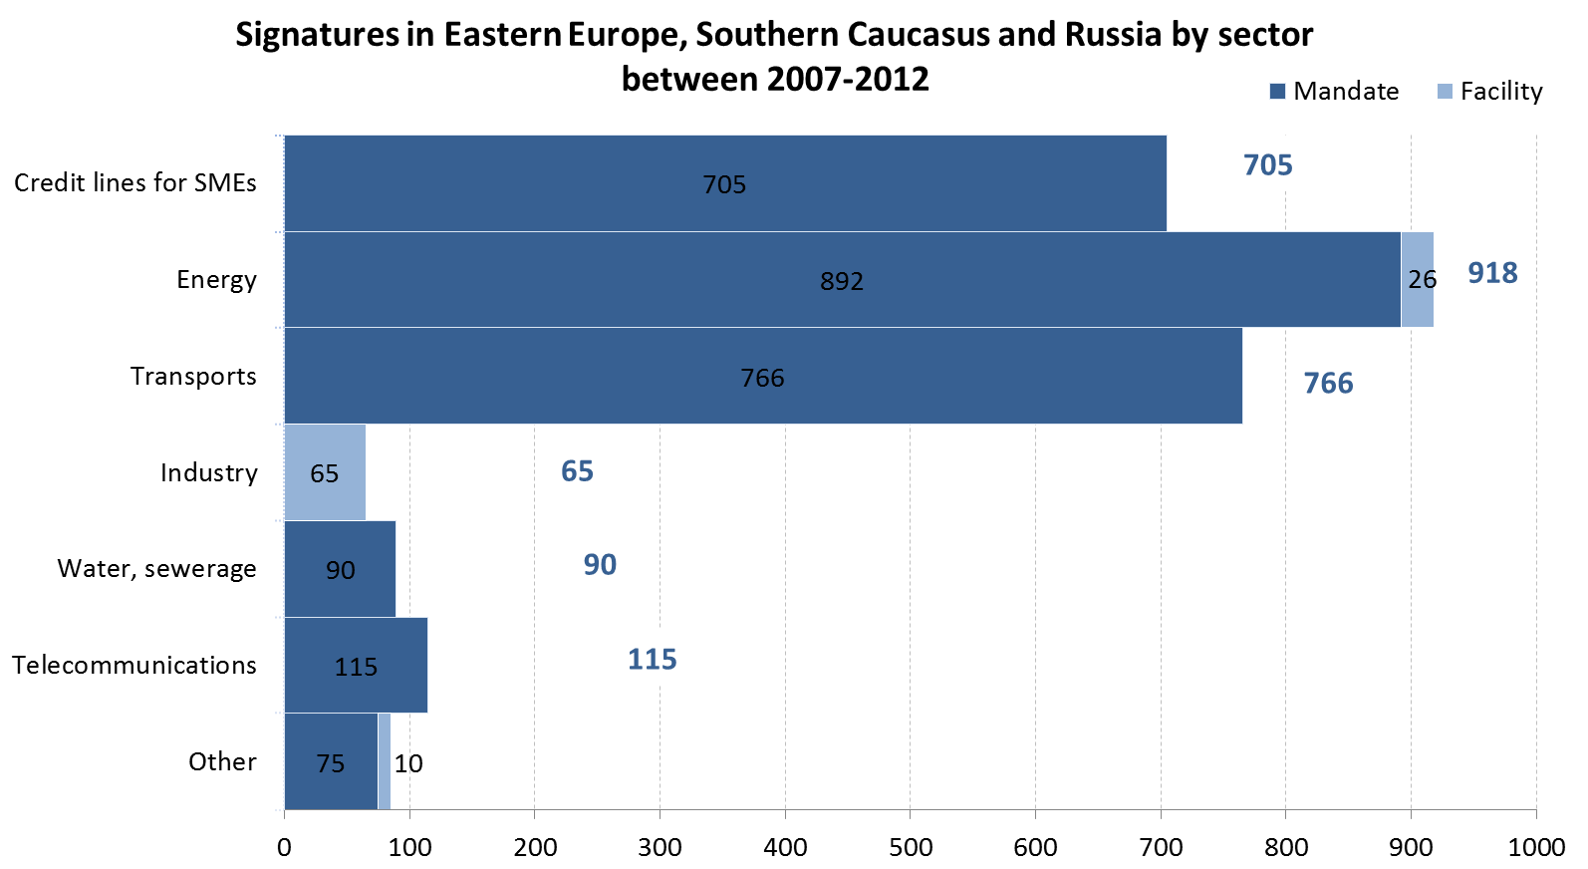

4.4. Asia and Latin America

4.4.1. Activity by Country
Table 20: Summary of lending signatures under EU guarantee by Country (number of operations and volume)
By the end of 2012, EIB had achieved 73% of the Asia and Latin America (ALA) regional mandate ceiling with Asia reaching 75% and Latin America 72% of their sub-ceilings. EIB lending under mandate in ALA in 2012 amounted to EUR 450m, an increase 45% from the previous year. 2012 saw a continuation of lending in Brazil, resumed activity in Vietnam, the first signature in ALA under the Climate Change Mandate, and a new signature in Ecuador. In addition to lending under the Mandate, EIB signed a EUR 250m forestry framework loan in China under EIB own risk Energy Sustainability Facility.

4.4.2. Activity by Objective
Table 21: Summary of signatures under mandate by region-specific key lending objectives
* The above numbers cannot be added as a single operation may contribute to several objectives
The October 2011 Decision marked the formal introduction of the local private sector development and social and economic infrastructure as new objectives in ALA.
In 2012, EIB financed three projects in the region that contribute to climate change mitigation and the development of social and economic infrastructure objectives, these are:
- TIM Mobile Broadband Network Project in Brazil - the second EUR 100m tranche of a loan approved in 2011 to support EU Foreign Direct Investment (FDI) project aiming at the expansion of the GSM and UMTS mobile broadband networks in Brazil and, as such, promoting interoperable technologies and the transfer of EU technology.
Metro de Quito Project in Ecuador - a EUR 200m loan for the construction of Quito’s first metro line, forming part of the local and national plan to promote sustainable development and improve people’s quality of life. The project will provide a safe and efficient transport service for more than 400 000 people a day. The new line will help to ease traffic congestion in Ecuador’s capital city and its suburbs, improve the efficiency of public transport and reduce fuel consumption and therefore greenhouse gas emissions. It is foreseen to be co-financed with the Inter-American Development Bank (IADB) and Corporación Andina de Fomento (CAF).
Vietnam Climate Change Global Loan, of EUR 150m, is the 3rd multi-scheme loan to Vietnam, targeting climate change mitigation projects in renewable energy and energy efficiency sectors. Similarly to the previous operations, the funds will be granted by the Ministry of Finance to four intermediary state-owned banks. Notably, it entails the first signed project under the Climate Change Mandate in ALA.
Beyond the Mandate, ALA received EIB’s support with an additional financing of EUR 250m for China Forestry Framework Loan, provided under EIB own risk Energy Sustainability Facility (ESF). This multi-investment scheme aims to strengthen the strategic partnership and cooperation with China in the area of Climate Change through the restoration of existing forest and forest management improvement; protective forest projects and coastal protective forest projects; forest biomass; new forest and economic tree plantation; and a technical training and technical assistance to address proper forest management capacity building.
Activity by Sector

4.5. South Africa

4.5.1. Signatures by Objective
Table 22: Summary of signatures under mandate by region-specific key lending objectives
* The above numbers cannot be added as a single operation may contribute to several objectives
By the end of 2012, EUR 748m representing 80% of the revised mandate sub-ceiling for South Africa had been signed. With loan cancellations netted out, the mandate commitment level stood at 74%.
In 2012 two loans for a total amount of EUR 100m were signed in support of the renewable energy sector and municipal infrastructure sector.
Khi Solar One Tower Project - a EUR 50m loan for the construction and operation of a 50 MW grid-connected solar tower power plant, the first solar tower project in the world to employ superheated steam technology during the electricity generation process on a commercial scale. The project will generate electricity from solar energy, stimulate the nascent renewable energy industry in South Africa and contribute to improving the environmental impact of power generation and security of energy supply in the country. Moreover, this project should contribute to regional integration among partner countries as it will enhance the capacity of South Africa to meet its growing electricity demands and contribute to possible exports of energy to neighbouring countries in the Southern Africa Power Pool.
Ethekwini Municipal Infrastructure – a EUR 50m loan to finance multi-sector investments from the eThekwini Municipality capital expenditure programme for the period 2011-2014. It comprises in total 31 sub-projects involving the refurbishment, upgrading and extension of municipal infrastructure and facilities in the Municipality of eThekwini. The project is fully in line with the general mandate and regional objectives, focussing specifically on infrastructure projects of public interest.
Reflecting the lending priorities under the mandate for South Africa, the development of social and economic infrastructure remained a key focus area for the EIB financing. The Bank also continued to support the development of the private sector (including SMEs) and projects contributing to climate change mitigation and adaptation.
Activity by Sector

5. List of loans signed in the regions covered by the Decision in 2012
Loans signed in the Pre-Accession countries under the EU Guarantee
 | Country | Project Description | Loan Amount (EUR m) | Political Risk Guarantee
 | Albania | Construction of around 22 km of motorway on new alignment bypassing Fier near coast in central Albania | 35 | No
 | Bosnia and Herzegovina | Construction of two motorway sections totalling 31 km in corridor Vc in Bosnia-Herzegovina | 166 | No
 | Montenegro | Reconstruction and rehabilitation of basic infrastructure damaged by December 2010 floods | 20 | No
 | Turkey | Implementation of range of flood prevention and protection schemes in various river basins over period 2013-2015 | 100 | No
 | Turkey | Financing of small and medium-scale projects carried out by local authorities | 150 | No
 | Turkey | Financing of academic research funding programme and industrial RDI programme implemented via Scientific and Technological Research Council | 175 | No
 | Turkey | Financing of small and medium-scale projects | 75 | No
 | Turkey | Financing of small and medium-scale projects | 100 | No
 |  |  | 821

Loans signed under the Pre-Accession Facility
 | Country | Project Description | Loan Amount (EUR m)
 | Bosnia and Herzegovina | Financing of small and medium-scale projects carried out by SMEs | 20
 | Bosnia and Herzegovina | Financing of small and medium-scale projects carried out by SMEs | 20
 | Croatia | Financing of small and medium-scale projects mainly carried out by SMEs and mid-caps | 50
 | Croatia | Financing of projects carried out by SMEs and midcaps | 250
 | FYROM | Financing of small and medium-scale industrial projects carried out by SMEs | 100
 | FYROM | Financing of small and medium-scale projects carried out by SMEs | 10
 | Montenegro | Financing of small and medium-scale projects | 25
 | Serbia | Financing of small and medium-scale projects carried out by SMEs and midcaps | 100
 | Serbia | Financing of small and medium-scale projects carried out by SMEs and midcaps | 50
 | Serbia | Financing of small and medium-scale projects carried out by SMEs and midcaps | 35
 | Serbia | Financing of small and medium-scale projects mainly carried out by SMEs and mid-caps | 40
 | Serbia | Financing of small and medium-scale projects carried out by SMEs and midcaps | 50
 | Turkey | Financing of small and medium-scale projects carried out by SMEs and midcaps | 150
 | Turkey | R&D aimed at improving performance and broadening home appliance product portfolio | 100
 | Turkey | Financing of projects carried out by SMEs | 75
 | Turkey | Construction and operation of Eurasia tunnel under Bosphorus in Istanbul | 270
 | Turkey | Modernisation of plant for production of redesigned range of light and medium-sized commercial vehicles in Koçaeli | 190
 | Turkey | RDI involving development of new, light-weight vehicle interior components in several countries | 5
 | Turkey | Financing of projects carried out by SMEs and midcaps | 150
 | Turkey | Financing of small and medium-scale projects carried out by SMEs and midcaps | 100
 | Turkey | Framework loan for financing small and medium-scale renewable energy and energy efficiency projects | 75
 | Turkey | Financing of small and medium-scale projects carried out by SMEs and midcaps | 75
 | Turkey | R&D concerning fixed line, mobile and internet services | 70
 | Turkey | Financing of small and medium-scale projects carried out by SMEs and midcaps | 200
 | Turkey | Financing of small and medium-scale projects carried out by SMEs | 75
 |  |  | 2,285
Loans signed in the Mediterranean countries under the EU guarantee
 | Country | Project Description | Loan Amount (EUR m) | Political Risk Guarantee
 | Egypt | Extension of metro line 3 to serve main transport corridors of greater Cairo area | 200 | No
 | Egypt | Community development programme to help develop a modern, high value-added agricultural sector by substantially increasing current crop yields and boosting agricultural incomes for the 7 772 small farmers affected by the project which in turn will promote economic growth. | 45 | No
 | Israel | Construction of combined cycle gas turbine combined heat and power plant near Sdom (southern part of Dead Sea) | 100 | Yes
 | Lebanon | Enlargement and reconstruction of 10.3 km section of A1 motorway (Beirut-Tripoli) including upgrading of three access roads and two intersections in Beirut | 75 | No
 | Lebanon | Financing of renewable energy and energy efficiency projects carried out by private sector companies | 50 | No
 | Lebanon | Financing of small and medium-scale projects carried out by SMEs | 15 | Yes
 | Morocco | Construction of motorway between El Jadida and Safi | 240 | No
 | Morocco | Construction of first phase of solar power complex in Ouarzazate | 100 | No
 | Morocco | Construction of two sulphuric acid production plants in Safi and two low-grade phosphate processing plants in Mea and Halassa near Khouribga | 130 | No
 | Morocco | Reinforcement and extension of electricity transmission infrastructure | 180 | No
 | Morocco | Part-financing of national irrigation water saving programme comprising upgrading of public irrigation systems | 42.5 | No
 | Morocco | Modernisation of wastewater collection networks and construction of treatment plants in 27 small and medium-sized towns throughout Morocco | 20 | No
 | Morocco | Construction of low-cost vehicle manufacturing plant in Melloussa free economic zone, 30 km from port of Tangiers | 73.5 | Yes
 | Morocco | Third phase of national rural roads programme | 100 | No
 | Morocco | Construction of seven technology parks under national industrial development plan (2009-2015) | 100 | No
 | Morocco | Upgrading and expansion of all-inclusive Club Med village near Tetouan on northern coast of Morocco | 13.7 | No
 | Tunisia | Financing of small and medium-scale projects carried out by SMEs | 100 | No
 | Tunisia | Improvement of poor urban areas through provision of basic public amenities | 70 | No
 |  |  | 1,655

Loans signed under the Mediterranean Partnership Facility II
Country | Project Description | Loan Amount (EUR m)
Israel | R&D and start-up of electric vehicle infrastructure and service scheme | 11
 |  | 11

Loans signed in Eastern Europe, Southern Caucasus and Russia under the EU guarantee
Country | Project Description | Loan Amount (EUR m) | Political Risk Guarantee
Armenia | Rehabilitation of water supply, sewerage and sewage treatment facilities of 17 small towns throughout country | 7 | No
Armenia | Construction and modernisation of crossing points on border with Georgia at Bagratashen, Bavra and Gogavan | 30 | No
Georgia | Upgrading of western section of East-West highway from Zestaponi to Batumi-South (10 km from Turkish border) | 170 | No
Georgia | Financing of small and medium-scale projects carried out by SMEs | 10 | Yes
Georgia | Financing of energy and environmental projects carried out by SMEs, mid-caps and public entities through leasing schemes | 50 | Yes
Moldova, Republic of | Reconstruction of 14.3 km of six main roads in Chisinau | 10 | No
Moldova, Republic of | Upgrading of domestic power transmission network throughout country | 17 | No
Ukraine | Upgrading and refurbishment of 21 hydropower units along river Dnieper | 200 | No
Ukraine | Financing of small and medium-scale projects carried out by SMEs and midcaps | 200 | Yes
Ukraine | Financing of small and medium-scale projects carried out by SMEs | 100 | No
Ukraine | Financing of small and medium-scale projects carried out by SMEs | 140 | Yes
 |  | 934

Loans signed in Asia and Latin America under the EU guarantee
Country | Project Description | Loan Amount (EUR m) | Political Risk Guarantee
Brazil | Extension of geographical coverage and increase of capacity of TIM Celular's GSM and UMTS mobile broadband networks | 100 | Yes
Ecuador | Construction of Quito's first metro line, including 15 stations | 200 | No
Viet Nam | Financing of renewable energy, energy efficiency and climate change mitigation projects | 150 | No
 |  | 450

Loans signed in Asia and Latin America under the Facility for Energy Sustainability and Security of Supply at EIB own risk
Country | Project Description | Loan Amount (EUR m)
China | Financing of forestry projects contributing to climate change mitigation through carbon sinking and avoidance of greenhouse gas emissions | 250
 |  |  | 250

Loans signed in South Africa under the EU guarantee
 | Country | Project Description | Loan Amount (EUR m) | Political Risk Guarantee
 | South Africa | Refurbishment, upgrading and extension of municipal infrastructure and facilities in city of eThekwini | 50 | Yes
 | South Africa | Construction and operation of greenfield solar tower with 50 MW nominal power generating capacity | 50 | Yes
 |  |  | 100

6. List of EC-EIB initiatives / partnerships in the regions covered by the Decision
Cooperation between the EIB and the Commission is daily and pervasive throughout much of the EIB activities. A substantial part of operational cooperation and coordination between the Commission and the EIB, involving also other IFIs and European Bilateral Financing Institutions, takes place within the various regional blending mechanisms set up by the Commission including the Western Balkans Investment Framework (WBIF), Neighbourhood Investment Facility (NIF), Asia Investment Facility (AIF), Latin America Investment Facility (LAIF) and Investment Facility for Central Asia (IFCA).
38% of the volume signed under the Mandate in 2012 is associated with grants under the blending mechanisms, namely NIF (11 projects) and WBIF (2 projects) or under the EIB-managed EU budget funded TA in the Mediterranean (3 projects) or direct grants (1 project in Pre-Accession). The EIB is the largest financier in terms of volumes lent for NIF projects: it has co-financed two-thirds of the projects (50 out of 75) approved by the NIF Board since the inception of the Facility. By end-2012, the WBIF had provided approximately EUR 280 mn in grants to 138 projects which have attracted investment loans worth EUR 7.7bn (of which EUR 2.3 bn signed) from International Financial Institutions. EIB has co-financed approximately 40% of the projects benefiting from WBIF grants.
Beyond the strong cooperation under the above facilities, as referred to in the main report, a close policy dialogue takes place between the Commission, the EEAS and the EIB. This dialogue is particularly emphasized whenever stressed political and economic circumstances call for a coordinated approach between the two institutions.
In November 2012, the EIB participated in the 18th Conference of the Parties (COP 18) to the UN Framework Convention on Climate Change, held in Doha, Qatar. The EIB was recognised by a broad range of political, civil society, private and public sector stakeholders as a major financier of climate action within and outside Europe, and was credited both for developing and rolling out innovative financing, and for identifying and applying robust climate-related performance standards to the projects it finances. The Bank is supporting the leadership role taken by the EU on this important global issue, in close coordination with the Commission. At COP 18, the EIB also co-hosted with the African Development Bank a public event at which the harmonized approach of Multilateral Development Banks towards the tracking of financing for adaptation and mitigation was presented.
Apart from the regional blending mechanisms, the rest of this section provides an overview of other main instruments funded by the EU budget complementing the EIB external mandate and own risk facilities within which the Commission and the EIB cooperated in 2012, with the aim to maximise synergies and to provide coherent support for the regions outside the EU. At the end of the section, a summary table provides a breakdown of the EU budgetary funds provided to date to complement EIB financing in the regions covered by the Decision. Section 7 provides the list of projects signed by the EIB and co-financed with other IFIs or with the Commission.
Pre-Accession Countries
- 2 Energy Efficiency Finance Facilities (EEFF) were launched in 2006 and 2007 to tackle the Climate Change issue. They aim at stimulating the energy efficiency and renewable energy investments in all types of building and in the industry sector by making appropriate financing available. The EEFF combines IFI credit lines extended to financial intermediaries with incentives to improve the cost effectiveness of equipment and make the energy investment more attractive, and fees to the benefit of local financial intermediaries to encourage them to lend for the purpose of energy efficiency financing. At the end of 2012, the total grant contribution made available by the EC amounted to EUR 19.5 mn and the EIB lending commitment is at least 78 mn.
- Since 2001, the Commission and the EIB are co-operating under the SME Finance Facility (SMEFF), merging the grant support with the EIB lending to help developing the SME lending capacities of Participating Financial Institutions in the eligible countries. In July 2011, an Energy Efficiency window was introduced under the SME FF programme. Total grants available under this EE window amount to EUR 25m and the EIB lending commitment is EUR 75 mn. At end 2012, the EIB’s total grant available for the SME FF under the PHARE Program was EUR 47 mn, and the EIB has committed to provide debt financing of at least EUR 470 mn.
- Since 2003, the Municipal Finance Facility (MFF) aims to encourage local financial intermediaries to extend loans to municipalities. The mechanism of the programme is similar to the SMEFF. In July 2011, an Energy Efficiency window was introduced under the MFF programme. Total grants available amount to EUR 3 mn and the EIB lending commitment is EUR 15 mn. At end 2012, the EIB’s total grant available for the MFF under the PHARE Program was EUR 54 mn, and the EIB has committed to provide debt financing of at least EUR 432 mn.
Mediterranean countries
- The EIB manages in the context of FEMIP and on behalf of the EU, a budgetary envelope of EUR 32 mn per year under the inter-regional ENPI programme for risk capital investments and technical assistance.
- The FEMIP Trust Fund (FTF), a replenished financial envelope of EUR 40 mn funded by contributions of 17 Member States and the Commission, provides resources to upstream technical assistance and studies, targeted equity operations designed to support innovative private sector companies and concrete initiatives for Mediterranean partner countries committed to the transition to democracy. Since its creation in 2004, the FEMIP Trust Fund has given solid added value to the Bank’s activities in the region. It has been operating as a think tank by financing research in new areas likely to help to develop the private sector in the region. In 2012, eight new TA contracts and one risk capital operation amounting to EUR 10.6 mn were signed.
Global
- The Global Energy Efficiency and Renewable Energy Fund (GEEREF) is an innovative fund of funds sponsored by the Commission, Germany and Norway, and advised by the EIB and EIF, to provide clean energy to emerging countries and economies in transition.
Table 21: Signatures/Commitments of EU budget resources under EIB management and/or contributing to EIB financed projects in the regions covered by the Decision

7. Co-Operation with European Ombudsman
The Memorandum of Understanding (MoU) signed between the EIB and the European Ombudsman (EO) in 2008 sets the basis for the two stages of the EIB Complaints Mechanism – the internal (EIB-CM) and the external (EO) – approved by the EIB Board of Directors in 2010 after extensive public consultation. It achieves a common understanding of purpose and consistency of application across its internal and external parts, with a specific focus on:
The European Ombudsman commitment to use its own initiative power systematically in order to handle complaints when the complainant is not a citizen or resident of the European Union;
The existence of an effective internal Complaints Mechanism (the EIB-CM);
The scope of the EO’s review, with the recognition of the EIB-CM as the required prior approach.
Table 22: Project related complaints lodged with the internal part (EIB-CM) of the EIB Complaints Mechanism 2008-2012
 | 2008 | 2009 | 2010 | 2011 | 2012 | 5 years
EU Member States | 3 | 5 | 13 | 13 | 11 | 45
Non-EU, of which | 3 | 8 | 7 | 9 | 10 | 37
in External Mandate regions | 1 | 6 | 3 | 8 | 8 | 26
in ACP, OCTs | 2 | 2 | 4 | 1 | 2 | 11
TOTAL | 6 | 13 | 20 | 22 | 21 | 82
The outcome of the complaints handling process varied from “allegations not grounded” to “areas for improvement recommended”. In two cases, the project has been abandoned after the complaint: (i) South Sinaï Power Plant in Egypt – led to a recommendation to the Bank not to finance the project and consequently the project promoter abandoning the project and transferring it to a new location; (ii) Barro Blanco Hydropower in Panama – led to the project promoter to withdraw the request for EIB financing.
At 31.12.2012, the EIB-CM was handling 27 registered project related complaints, of which 9 in the regions covered by the External Mandate. Of those, it is worth mentioning:
Panama Canal Expansion Project – alleged negative environmental and social impacts of the project;
Municipal and Regional infrastructure Loan and Belgrade By-pass Project, both in Serbia - alleged non-compliance with national law and with EIB social standards;
Cairo Metro Line Project in Egypt – alleged lack of proper public consultation and negative construction impacts.
Project related complaints escalated to external part (EO) of the EIB Complaints Mechanism 2008-2012
Since 2008, only 5 cases of project related complaints have been escalated to the Ombudsman, with 4 still on-going at 31.12.2012, of which only one is related to a project outside of the EU, in Uganda. Since the signature of the MoU between the EO and the EIB, i.e. between 2008 and 2012, there has been no critical remark by the EO against the Bank. In the 13 cases closed during that period, no maladministration has been found, and/or the cases have been settled by the Bank.

8. List of 2012 operations co-financed with other IFIs and the Commission
Mandate/  Facility | Country | Name | Project cost  (EURm) | EIB loan signed in 2011  (EURm) | Multilat. Financing Inst. | European Bilateral Inst. | EU budget contribut.
Pre-Acc. Mandate | Albania | FIER BYPASS | 81.20 | 35.00 | X |  | WBIF
Pre-Acc. Mandate | Bosnia and Herzegovina | CORRIDOR VC - SECOND PHASE | 339.62 | 166.00 | X |  | WBIF
Pre-Acc. Mandate | Turkey | FLOOD PREVENTION AND PROTECTION | 202.00 | 100.00 |  | X
Pre-Acc. Mandate | Turkey | EURASIA TUNNEL (PPP) / A and B | 813.09 | 269.52 | X
Pre-Acc. Mandate | Turkey | ILLER BANK ENVIRONMENTAL LOAN | 300.00 | 150.00 |  |  | MFF
Pre-Acc. Mandate | Turkey | FORD OTOSAN II A and B | 569.30 | 190.00 | X
Pre-Acc. Mandate | Turkey | YAPI KREDI BANK LOAN FOR SMES II | 150.00 | 75.00 | X
Pre-Acc. Mandate | Turkey | ISBANK CLIMATE CHANGE FACILITY | 150.00 | 75.00 | X
Clim. Chge Mandate | Egypt | CAIRO METRO LINE 3 (PHASE 3) A | 2417.90 | 200.00 |  | X | NIF
ENP MED. Mandate | Egypt | COMMUNITY DEVELOPMENT PROGRAM | 90.00 | 45.00 |  |  | NIF,  FEMIP TF
Med Partnership Facility II | Israel | BETTER PLACE ELECTRIC VEHICLE SERVICE | 380.84 | 10.80 |  |  | RSFF,  EU grant
ENP MED. Mandate | Lebanon | LEBANESE HIGHWAYS II | 150.00 | 75.00 |  |  | FEMIP TA
Clim. Chge Mandate | Morocco | CENTRALE SOLAIRE DE OUARZAZATE | 696.00 | 100.00 | X | X | NIF
ENP MED. Mandate | Morocco | ROUTES RURALES IV | 300.00 | 100.00 |  | X
ENP MED. Mandate | Morocco | TECHNOPOLES Morocco | 280.00 | 100.00 |  | X
ENP MED. Mandate | Morocco | PROGRAMME NATIONAL ASSAINISSEMENT | 176.00 | 20.00 |  | X | NIF
ENP MED. Mandate | Morocco | ONEE - RESEAUX ELECTRIQUES III | 442.78 | 180.00 | X | X | NIF
ENP MED. Mandate | Morocco | AUTOROUTE EL JADIDA - SAFI | 493.50 | 240.00 | X
Clim. Chge Mandate | Tunisia | LEBANON ENERGY EFFICIENCY AND RENEWABLES GL | 147.00 | 50.00 |  | X | NIF
ENP MED. Mandate | Tunisia | REHABILITATION URBAINE TUNISIE | 217.50 | 70.00 |  | X
ENP MED. Mandate | Morocco | PLAN MAROC VERT | 85.65 | 42.50 | X | X | FEMIP TA
ENP EAST Mandate | Armenia | ARMENIA WATER SECTOR PROJECT | 21.70 | 6.50 | X |  | NIF
ENP EAST Mandate | Armenia | BORDER CROSSING AND INFRASTRUCTURE | 60.63 | 30.32 | X |  | NIF
ENP EAST Mandate | Georgia | GEORGIA EAST - WEST HIGHWAY - A | 592.14 | 170.00 | X |  | NIF
ENP EAST Mandate | Republic of Moldova | MOLDELECTRICA POWER TRANSMISSION | 39.92 | 17.00 | X |  | NIF
ENP EAST Mandate | Republic of Moldova | CHISINAU URBAN ROADS | 28.30 | 10.30 | X
ENP EAST Mandate | Ukraine | HYDRO POWER PLANTS REHABILITATION | 40.00 | 200.00 | X |  | NIF
ALA Mandate | Ecuador | METRO DE QUITO | 1361.00 | 200.00 | X

9. Results Measurement Framework – Worked example

70 % of the signed amount is estimated to benefit SMEs and 30 % is dedicated to other priority projects undertaken e.g. by local authorities. Notably, in all these operations, the Bank offered its new product in the region, the "Loan for SMEs and Mid-Caps".
Pillar 3 ratings for additionality are slightly different: 4-high, 3-significant, 2-moderate, 1-low.
Risk capital envelopes for the Mediterranean funded by the EU budget and the Kingdom of Spain.
The estimates of the number of jobs (FTEs) generated by the loans to MSMEs resulting from approved EIB operations are based on the definitions used in the World Bank Group’s Enterprise Surveys together with the IFC’s Financial Markets definition. According to this methodology, the employment multiples are linked to loan size to calculate number of jobs sustained.
EIB Statement of Environmental and Social Principles and Standards” (2009), Para 45, p. 17.
list of EIB excluded activities: http://www.eib.org/attachments/documents/excluded_activities_2012_en.pdf
The five Social Assessment Guidelines are: 1) Involuntary Resettlement; 2) Rights and Interests of Vulnerable Groups; 3) Labour Standards; 4) Occupational and Community Health and Safety; and 5) Public Consultation and Participation.
The Political Risk Guarantee column highlights the operations where, in contrast to sovereign or sub-sovereign operations covered by the Comprehensive Guarantee, the EU assumes defined political risks while the EIB assumes all other risks.

