REPORT FROM THE COMMISSION TO THE COUNCIL AND THE EUROPEAN PARLIAMENT
Seventh Report on the Statistics on the Number of Animals used for Experimental and
other Scientific Purposes in the Member States of the European Union
I. INTRODUCTION
The objective of this report is to present statistical data on the number of animals used for scientific purposes in the Member States of the European Union during the year 2011 in accordance with provisions of Article 26 of Directive 86/609/EEC of 24 November 1986 regarding the protection of animals used for experimental and other scientific purposes.
The first two statistical reports drafted in accordance with the provisions of the above mentioned directive which were published in 1994 and 1999, covering data on experimental animals collected in 1991 and 1996 respectively, allowed only a limited amount of statistical analysis due to the absence of a consistent system of reporting the data on the use of experimental animals. In 1997 an agreement was reached between the competent authorities of the Member States and the Commission to submit data for future reports under a format of eight harmonized tables. The Fifth Statistical report published in 2007 contained for the first time data collected in the 10 Member States which joined the EU in 2004. The Sixth Statistical Report published in 2010 gave an overview of the number of animals used in the year 2008 in 27 Member States.
This Seventh Statistical Report contains the results of the data collected by all 27 Member States in 2011 with the exception of one (France) which provided data from 2010.
The Commission Staff Working Document accompanies the Report from the Commission to the Council and the European Parliament – Seventh Report on the Statistics on the Number of Animals used for Experimental and other Scientific Purposes in the Member States of the European Union.

II. DATA SUBMITTED AND GENERAL ASSESSMENT

II.1. Data submitted by the Member States
As in 2008 all 27 Member States submitted the data in the agreed format. The data quality control revealed some minor errors but the overall assessment showed acceptable quality for the data submitted in 2011.
The individual data from the Member States can be found in the Staff Working Document.

II.2. General assessment
It should be noted that this is the last time that animal use data will be collected in accordance with the requirements of Directive 86/609/EEC. This Directive has been replaced by Directive 2010/63/EU on the protection of animals used for scientific purposes, and the submission and publication of data have been completely revised with effect from 10 May 2013.
Due to differences in the reporting year and an increase in the number of Member States over the years, it is not possible to draw accurate quantitative conclusions on the evolution of the use of animals for experimental purposes in the EU. However, some trend comparisons have been made, and any significant changes in use have been highlighted in the report.
In the EU, the total number of animals used for experimental and other scientific purposes from the data collected in 2011 in accordance with the provision of the Directive for this report is just under 11,5 million (with data from France from 2010). This is a reduction of over half a million animals used in the EU from the number reported in 2008.
As found in previous reports, rodents and rabbits account for 80% of the total number of animals used in the EU. Mice are the most commonly used species with 61% of the total use, followed by rats with 14%.
The second most used group of animals was, as in previous years, the cold-blooded animals which represent almost 12,5%. The third largest group of animals used was birds with 5,9% of the total use.
As stated in the previous three statistical reports no ‘Great Apes’ were used in experiments in the EU in 2011.

III. RESULTS

III.1. Results of EU Table 1: Species and number of animals

III.1.1. Treatment and interpretation of the data of table 1.1
Mice (60,9%) and rats (13,9%) are by far the most commonly used species.
Rodents together with rabbits represent 80% of the total number of animals used. The second most used group is represented by cold-blooded animals namely reptiles, amphibians and fish at 12,4% Followed by birds with 5,9%.
The Artiodactyla and Perissodactyla group including horses, donkeys and cross-bred animals (Perissodactyla), pigs, goats, sheep and cattle (Artiodactyla) represent only 1,2% of the total number of animals used in the Member States. Carnivores (which include dogs and cats) represent 0,25% of the total number of animals used and non-human primates represent 0,05% of the animals used in 2011.

III.1.2. Comparison with the data of the previous reports
The aim of this report is to indicate whether important changes have occurred in relation to the use of different species. However, one should bear in mind that rigorous comparisons cannot be made with previous reports given that France reported for a different year than the other Member States in all but one of previous reports.
Comparison between proportions of classes of animals used in 1996, 1999, 2002, 2005, 2008 and 2011
Class of species | 1996(*) | 1999 | 2002(**) | 2005(***) | 2008(****) | 2011(*****)
% Rodents-rabbits | 81,3 | 86,9 | 78,0 | 77,5 | 82,2 | 80,0
% Cold-blooded animals | 12,9 | 6,6 | 15,4 | 15, | 9,6 | 12,4
% Birds |  | 4,7 | 5 | 5,4 | 6,4 | 5,9
% Artio and Perissodactyla |  | 1,2 | 1,2 | 1,1 | 1,4 | 1,2
(*) 14 Member States reporting for 1996, one for 1997
(**) 14 Member States reporting for 2002, one for 2001
(***) 24 Member States reporting for 2005, one for 2004
(****) 27 Member States reporting for 2008, one for 2007
(*****) 27 Member States reporting for 2011, one for 2010
The percentage of rodents and rabbits shows some fluctuation, but remains close to 80%. The proportion of cold-blooded animals used in 1996, in 2002, in 2005 and 2008 is between 9,6 to 15%. However, in 1999 a much lower percentage of 6,6% was observed. In 2011 the use of cold-blooded animals increased from the last report but the percentage of animals used seems to fit perfectly into the cohort from 9,6 to 15% of the total number of animals.
Birds representing the third largest percentage of animals, seem to have reached a plateau in 2008. For the first time in 2011 the number of birds has decreased (by over 88 000). The group of horses, donkeys and cross-bred animals (Perissodactyla) and pigs, goats, sheep and cattle (Artiodactyla) fluctuates at around 1%.
The effect of the inclusion of the data from new Member States since 2005 i.e. Bulgaria and Romania, did not lead to an increase in the total number of animals. On the contrary, a decrease was reported in 2008 and this downwards trend continued in 2011 (by more than 500 000 animals). However, the use of some individual species has increased.
There is a clear increase in the total numbers of five species out of the 25 species reported. For other species a net decrease is observed.
The highest increase is noted for fish (310 307) in comparison to 2008 and for rabbits (25 000). For species used in lower numbers (i.e. in the thousands range) there is an increase in the number of animals in the category other carnivores (2 129), horses, donkeys and cross-breds (710) and other mammals (2 184).
The largest decrease observed in 2011 for the more commonly used species is for rats with a reduction of more than 500 000 animals. In the same range there is also a reduction in the use of mice (122 876). There is also a significant reduction in the use of 'other birds' (more than
85 000) and guinea-pigs (49 401).
There is a clear decrease in the use of prosimians and non-human primates. The most notable proportional reduction is in the use of prosimians (1 178) which represents a decrease of 94%. The total number of new world monkeys is down from 904 in 2008 to 700 in 2011 (22,5%), and use of old world monkeys has also decreased from 7 404 to 5 312 (28%).
No use of great apes has been reported in EU since in 1999.
Member States submitted a breakdown of the category 'other', for the following species:
Other Rodents: gerbils, old world jerboas (Jaculus jaculus); chinchillas, beavers, ground squirrels, hamsters, grey dwarf hamsters (Cricetulus migratorius) and different species of mice.
Other Carnivores: wild-life species used for zoological and ecological studies e.g. foxes, badgers, seals, otters and fitchew.
Other Mammals: boars, bats and shrews, llamas, moles, European bison and red deer.
Other birds: mainly Japanese quail (coturnix japonica) and bob-white quail, poultry species, and zebra finches, canary, parakeet, parrot and farmed avian species for example, chickens (Gallus gallus domesticus).

III.2. Results of EU Table 1: Origin of animals used
Figure 1.2 represents the percentage of animals from the reported origin versus the species. According to the standardised tables the origin must only be reported for certain selected animal species.
The chart indicates that the majority of species used in 2011 originate from EU breeding centres. However certain species such as cats, dogs, ferrets and old world monkeys originated from both EU and non-EU breeding centres.
The general pattern shown in figure 1.2 on the origin of species remains rather similar to that of previous reports, with clear preference for animals which are bred in the EU. There is an increase in the use of dogs of EU origin from 72% to 85%, ferrets from 71% to 76% and old world monkeys from 54% to 66%. However, there is a decrease in use of new world monkeys of EU origin from 99% to 92% and quails from 96% to 87% bred in the EU.

III.3. Results of EU Table 2: Purposes of the experiments
More than 60% of animals were used for research and development in the fields of human medicine, veterinary medicine, dentistry and in biological studies of fundamental nature. (Fig 2) Production and quality control of products and devices in human medicine, veterinary medicine and dentistry required the use of 14% of the total number of animals. Toxicological and other safety evaluation represents 8,75% of the total number of animals used for experimental purposes.
Other purposes of procedures represents 9% of the total number of animals and covers a wide range of experiments such as virology, immunology for production of monoclonal and polyclonal antibodies, physiology of foetal-maternal interaction in mouse gene transgensis, oncological treatment, pharmaceutical research and development, combined drug testing and genetics.
The most significant change since 2008 is that the number of animals used for research and development for human medicine, dentistry and veterinary medicine has dropped, as it did between 2005 and 2008. This time the drop is from 22,8% to 18,8% (in terms of animal numbers the decrease is 575 518 animals). There is a reduction of more than 62 000 fish and 41 500 'other birds' whereas the percentage of animals used for fundamental biological research has increased sharply from 38% to 46% (715 519 animals). Both fundamental biological research and research and development in human and veterinary medicine are the areas using by far the highest number of animals for scientific purposes in the EU.
The number of animals used for toxicological and other safety evaluation amounts to 8,75% of the total. This represents 1 004 873 animals in this report.
The decrease in the numbers of animals used for toxicological and other safety evaluations since the report of 2008 is modest but represents nevertheless 37 280 animals.
The percentage of animals used for toxicology and safety evaluation was 9.9% in 2002, 8,2% in 2005, 8,7% in 2008 and 8,75% for this report which indicates a trend of stability for this area of use.
The number of animals used for production and quality control of devices for medicine, veterinary medicine and dentistry has gone down by approximately 192 000 animals. In spite of the overall decrease, the use of rabbits has increased by more than 81 000 animals for production and quality control of products and devices for human medicine and dentistry.
Further substantial increases since 2008 have been observed for mice (521 000) and fish
(324 000) used in larger numbers for fundamental biological studies.
There is also an increase in the use of fish (above 83 000) and birds (above 10 000) for 'other experiments'.
Regarding the increase of mice for biological studies of a fundamental nature, Member States indicated that it was due to an increase in research using transgenic mice as specific models for e.g. ocular research, bone metabolism and fertility. The type of studies include LD50, ED50, potency testing and immunogenicity testing, studies in the area of neuroscience, of immunology, studies on physiopathological mechanisms of tumours and research to gain experience for the determination of mechanisms of action of diseases for therapeutic purposes.
The increased use of fish in the area of fundamental research was attributed to studies on fish production, genetics, bio-molecular studies, cancer research, physiopathology and diagnosis. Fish have also been used for neurology and cardiovascular studies, and due to the bio-energetic properties of their cardiac cells.
The increase in fish numbers in the category of ‘other experiments’ was attributed to single testing of biocides and to telemetric monitoring of some common species in the environment. Fish are also exclusively used under this heading by some Member states for vaccine studies.

III.4. Results of EU Table 3: Toxicological and safety evaluation by type of product/endpoint
The number of animals used for toxicological and other safety evaluation for different products, or for testing potential contaminants to the environment amounts to 1 004 873 which represents only 8,75% of the total number of animals used for scientific purposes in 2011.
Of this total, animals used for toxicological or other safety evaluations of products or devices used for human medicine, veterinary medicine and dentistry was 39,8% and represents thus the largest sector of use of experimental animals. The percentage of animals used for toxicological evaluation of industrial and agricultural products represent 15,9% of the animals used for toxicological and other safety evaluations. The percentage of animals used for toxicological evaluation of three groups of products/substances, i.e. additives in food for human consumption, cosmetics and household products, is very small (0,35%) when compared to the other product groups. Other toxicological and safety evaluation was 34,3% and is therefore the second purpose using the largest number of animals.
There is little change with regard to the number of animals used for toxicological tests for products intended for industry and for agriculture in comparison to 2008, but there is a net increase in the number of animals used for potential contaminants of the environment. The increase is from around 65 000 to approximately 92 000.
A significant decrease has been observed in the number of animals used for testing food for animal consumption in comparison to 2008 from 54 000 to 4 600 which is more than a ten-fold decrease but also for cosmetics and toiletries where the decrease is from 1 960 to 90 animals. This is important to highlight as there has been a testing ban in the EU for cosmetics and cosmetic ingredients in place since 2009.
There is, however, a substantial increase in the number of animals used for tests for other toxicological or safety evaluations from 223 000 to 345 000 animals (roughly 122 000 animals which represent an increase of 54%). An increase was also observed in the 2008 report. Member States reported that under this heading, animals are used in metabolic studies and preclinical research, testing substances and products in human and veterinary medicine and in teratology studies. They are also used in toxicity tests on aquatic vertebrates not included in other categories, in LD50, ED50, pyrogen testing and testing for algae biotoxins and other foodstuff contaminants.

III.5. Results of EU Table 4: Animals used for studies of diseases
The number of animals used in 2011 for studies of both human and animal diseases represented roughly 57,5 % of the total number of animals used for experimental purposes. The proportion of animals used for studies of human diseases represents more than 90% of the total number of animals used for all disease studies. (see Fig 4.1)
In 2011 the overall number of animals used for studies on human and animal diseases has increased by a little more than 276 000 animals. The use of animals for specific studies on animal diseases in 2011 (which had a decrease of 50% in 2008) is comparatively unchanged from the 2008 report. There is a reduction in the use of cold-blooded animals by just under 22 500.
It is important to note that there has been a net increase of more than 115 000 animals used for studies on cardiovascular diseases, and of more than 250 000 for human cancer studies. In comparison to 2008, increases in the use of animals have also been observed for dogs, totalling above 1 000; for other carnivores about 500; for other mammals a little above 300 and for other birds above 2 500.
On the other hand the number of rats used for studies on diseases has decreased by more than 250 000 animals.
In Figure 4.2 the top of each bar shows the relative percentage of animals used for studies on specific animal diseases. For this category a significant decrease in numbers of both Artiodactyla and Perissodactyla, has been recorded. However, an increase in the numbers of carnivores was observed for the same purpose.
In addition to the year 2011 having been relatively quiet from a zoo-sanitary point of view and thus the pressure for testing in farm animals relatively low, other reasons indicated by Member States for a decrease in this area include:
- reduction of livestock housing capacity;
- move away from large animal-based to more basic laboratory-based bioscience type studies (on tissue culture, cell lines etc.);
- as the larger animals models are particularly expensive to run, it was suggested that they may have become unsustainable for some laboratories;
- larger animal models are normally used just before going into clinical trials and as such are cyclical.
Regarding the increased use of carnivores Member States indicated that these animals have been used in veterinary clinical trials, studies on genetic diseases, for research and development of products and devices for veterinary medicine and for vaccine studies (e.g. leishmania).
The data on the use of most species for all types of studies on both human and animal diseases show a similarity to the report of 2008. However, there is a substantial decrease in the use of 'other rodents' for studies of human diseases in particular 'human nervous and mental disorders'.

III.6. Results of EU Table 5: Animals used in production and quality control of products for human medicine and dentistry and for veterinary medicine
The number of animals used in tests for the production and quality control of products for human medicine and dentistry and for veterinary medicine represents 13,9% of the total number of animals used for experimental purposes.
The largest proportion of animals in this area (47%) was used to simultaneously satisfy requirements from several pieces of legislation emanating from the EU, the Council of Europe, from national legislation and from legislation outside of the EU. The testing carried out to satisfy EU legislation including the European Pharmacopoeia covered 35,9% of the animals used in this area.
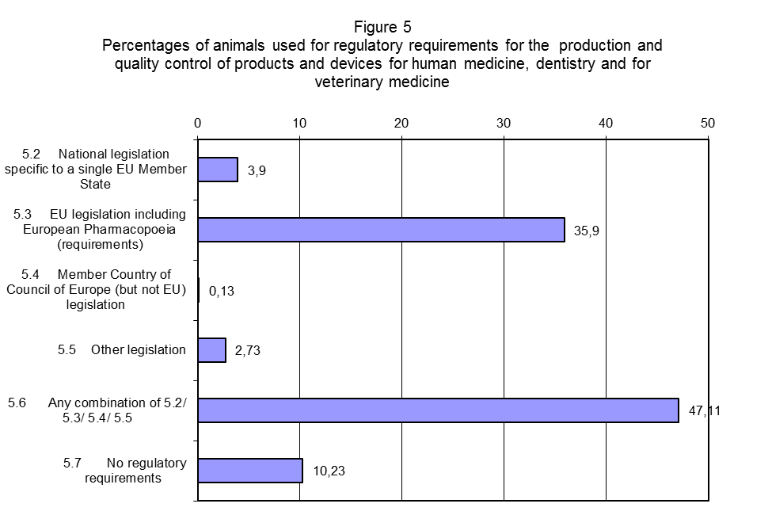
In comparison to the report of 2008 it is important to note that there is an increase in the number of animals used for 'no regulatory requirements'. It should also be noted that, there is a slight increase in the number of animals used to satisfy national legislation, despite the fact that there is a net reduction of the total number of animals used in this sector (192 000).

III.7. Results of EU harmonized Table 6: Origin of regulatory requirements for animals used in toxicological and other safety evaluations
As pointed out earlier, the number of animals used in toxicological or other safety evaluation represents 8,75% of the total number of animals used for experimental purposes in the EU.
Of this total, animals used to simultaneously satisfy regulatory requirements from several pieces of legislation covered 56% of the animals used in this area. The testing required under EU legislation including the European Pharmacopoeia accounted for the second highest percentage in this area, namely 21,27%. (see Fig 6)
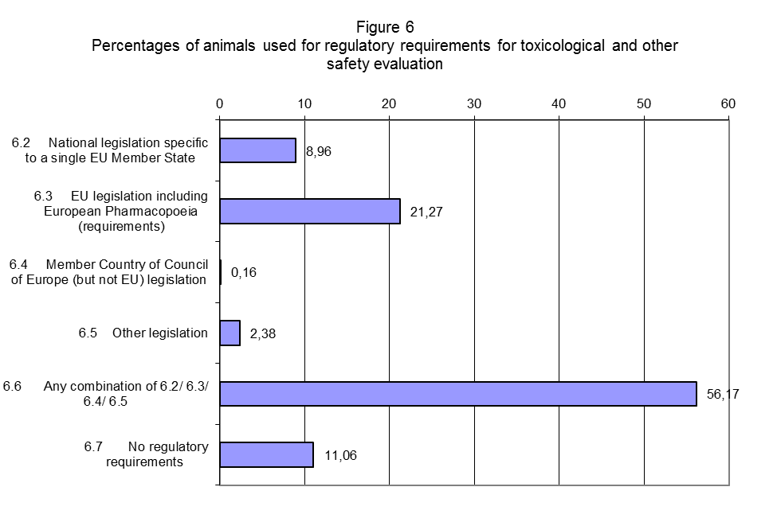
A positive result in comparison to 2008 is that the percentage of the use of animals to satisfy requirements of different legislation has increased from fewer than 50% to more than 56%.
There is also a decrease in the number of animals used for 'no regulatory requirements'.
In addition to examples of the type of testing reported under no regulatory requirements’ in the last report (namely those of in-house methods to verify the safety and efficacy of veterinary biologicals and medicinal products carried according to company’s or known international standards), Member States reported preliminary studies for trial of doses, optimization of numbers and candidates (e.g. animal species, breeds, age), and probing mechanism of action of toxicities associated with clinically approved drugs or combination studies involving clinically approved drugs.

III.8. Results of EU Table 7: Animals used in toxicity tests for toxicological and other safety evaluations
The largest percentage (47,5 % ) of use of animals in toxicological and other safety evaluation is by far due to acute and sub-acute toxicity tests. Nearly 15% animals were used for testing carcinogenicity, mutagenicity and toxicity to reproduction. The second largest percentage of 22% is to cover other toxicological and safety evaluation. (see Fig.7)
In addition to the type of testing reported under ‘other toxicological and safety evaluation’ in the previous report (namely those of neurotoxicity, toxicokinetics, testing of biological evaluation of medical devices: intracutaneous testing of reactivity in rabbits, studies into the penetration of nanoparticles through tissue and their biocompatibility, studies into the evaluation of sensitization potential of dyestuffs used in the textile industry and pharmacological studies included in safety tests), Member States reported that this heading covered also target animal studies carried out on companion animals to different regulatory standards e.g. US EPA, FDA, tests to determine the residues of veterinary medicaments in calves and in broilers, test to determine the non-toxicity and irreversibility of toxins and efficacy of vaccines (blue tongue, clostridium).
By looking both at numbers and relative percentages of use of animals in comparison to the previous reports there are two noticeable changes:
There is a continuous increase over the last four reports in the proportion of animals used for acute and sub-acute tests, from 36%, 42%, 45% to 47,5% respectively. This represents in animal numbers an increase of more than 8 400 animals since the last report.
In contrast to the previous three reports where a steady decrease was observed, for 2011 the number of the animals used for reproductive toxicity testing has increased from 9% in 2008 to 11,35%. In terms of animal numbers this means an increase of almost 19 000 animals.

III.9. Results of EU Table 8: Type of toxicity tests carried out for toxicological and other safety evaluations of products
Figure 8 shows that the majority of animals tested in acute/sub-acute toxicity are intended for the purpose of 'human medicine, dentistry and veterinary medicine' and for 'other toxicological and safety evaluation'. For irritation/sensitization properties and for carcinogenicity/mutagenicity and reproductive toxicity the three categories of uses; human medicine, agriculture and industrial products show a similar pattern of use of animals. Whereas the largest number of animals used in sub-chronic and chronic toxicity test are carried out mainly for human medicine, dentistry and veterinary medicine.
Overall products intended for medicine, dentistry and veterinary medicine required the highest proportion of animals for the different types of tests i.e. approximately 39%. In comparison to 2008 the amount of animals used in 2011 has been reduced by more than 130 000.
The next highest proportion is for 'other' toxicological evaluations, above 34%, (22% in 2008) this means an increase of use of 122 000 animals. The third type of test using the largest number of animals is that used for potential and actual contaminants in the general environment with
92 000 animals or 9%.

Except for one Member State reporting for 2010
OJL 358, 18.12.1986, p.1.
COM (94) 195 final
COM (1999) 191 final
COM (2007) 675 final
COM (2010) 511 final/2

